

**Rotary Peace Fellow**

**Maj. abdifatah sayid ahmed abdi**

**Location – Somalia**

**Start Date: April 2022**

**End Date: August 2022**

**SOCIAL CHANGE INITIATIVE**

**Strengthening Ex-combatant Reintegration in Somalia**

**TABLE OF CONTENT**

1. ABSTRACT
2. CHAPTER ONE
   1. INTRODUCTION AND BACKGROUND
      1. THE RISE OF THE TERROR
   2. PROBLEM STATEMENT
   3. GOALS AND OBJECTIVES
   4. SOCIAL CHANGE INITIATIVE GOALS
   5. SOCIAL CHANGE INITIATIVE OBJECTIVES
      1. Objective 1
      2. Objective 2
      3. Objective 3
      4. Objective 4
   6. Objective Summary
   7. Challenges and mitigation strategies
3. CHAPTER TWO
   1. LITERATURE REVIEW
   2. THEORETICAL UNDERPINNINGS
   3. CHANGE THEORY AND HOW IT WAS APPLIED
   4. CHANGE PATHWAY
   5. METHODS AND DESIGN
   6. DEFECTOR TRAINING PROGRAM
4. CHAPTER THREE
   1. INTERVENTIONS AND ACTIVITIES
   2. KEY FINDINGS / IMPACT
5. CHAPTER FOUR
   1. GENERAL CONCLUSION
   2. RECOMMENDATIONS / IMPLICATIONS FOR POLICY
   3. SUSTAINABILITY PLAN
   4. APPENDICES
      1. PICTORIALS
      2. INTERVIEWEES
      3. BIBLIOGRAPHY

**Table of Acronyms**

AMISOM The African Union Mission in Somalia

ARS Alliance for the Re-Liberation of Somalia

ADR Alternative Dispute Resolution

CT Counter. Terrorism

DDR Disarmament Demobilization and Reintegration

DRP Defector’s Rehabilitation Programme

FGS Federal Government of Somalia

GCTC Global Counter-Terrorism Centre

ICU Islamic Courts Union

IDP Internally Displaced Persons

IOM International Organisation for Migration

MOIS Ministry of Internal Security

NISA National Intelligence Security Agency

PCVE Preventing and Countering violence Extremism

RST Rehabilitation Support Team

SCI Social Change Initiative

SNA Somali National Army

SPF Somali Police Force  
UN United Nations  
UN DDR United Nations Disarmament, Demobilization, and Reintegration

1. **Abstract**

A soft approach to counter-terrorism and violent extremism is most successful when there are alternative options for youngsters, such as excellent education, employment opportunities, social care, and so forth. Unfortunately, in many regions of Africa, our young generation's youthful resource is squandered by the family, community, and authorities, allowing terrorist and armed organizations to exploit and utilize our youth as a weapon to thrash us. (Delgado, 2020)

Ten years after the inception of defector rehabilitation centers in Somalia, over five thousand Somali youth,[1] male and female juveniles, have benefitted from Defector Rehabilitation Programs. In addition, the Somali Government and its international partners have attempted to actively interact with the defectors (Ex-combatants) and their families to allow them to reintegrate tolerably into the society. However, the rehabilitation programs in Somalia merits for improvement on various levels of the program, e.g., mental and confidence building, trustworthiness, and vocational education for the defectors; these deficiencies had a negative effect on some defectors to successfully reintegrate into the society. (Muggah & O’Donnell, 2015)

This Social Change Initiative will assist the defectors' smooth reintegration into society and prepare them for the challenges they might face in the future. It will also channel their positive energy into community service as peace ambassadors and attorneys for those affected by terrorist ideology or those involved in an armed activity such as robbery, gangs, clan disputes, etc.

**Keywords:** *Ex-combatants, DDR, Deradicalisation, Rehabilitation, Reintegration, Defector, Al-Shabaab*

**Definition:**

In this report, *defector* means ex-combatants from terrorist organizations who left the group voluntarily and denounced the terrorist ideology and activity. We have chosen this because the Somali Government uses the word defector in all their communication regarding the rehabilitation of former terrorist combatants.

1. **CHAPTER ONE** 
   1. **Introduction and Background**

Somalia has been at war since 1991, following the ousting of military dictator Siad Barre by the armed opposition established against his 21-year reign. During the first phase of the civil war, all of the country’s infrastructure suffered catastrophic damage, leading to severe starvation and droughts, forcing rural pastoral communities to flee to cities and resulting a large number of internally displaced people (IDPs) to live in the country. In search of safe life, Others migrated to Kenya and other neighbouring countries in pursuit of a better life. (Powell, B., Ford, R., & Nowrasteh, A. (2008).

In the first decade of the conflict in Somalia, philanthropic organizations from Arab countries filled the vacuum of primary education in the country. They set up Madrasas (Arabic school type) as an alternative to Primary and Secondary schools, significantly spreading Salafi jihadi ideology among the younger generation. (Sage, 2001)

The banned (2004) Saudi Organization known as Alharamayn Alkheiria was one of the first organizations that spread the ideology in Somalia. Banned (2004)

These education programmes were primarily based on Salafi Jihadi ideology and significantly impacted many young individuals who later joined Al-Itihad - al-Islami, the first armed Islamic organisation in Somalia. Their early actions targeted Kismayu and Bossaso port cities to control and generate income in the lifeline of the south and northeastern regions of Somalia. (Sage, 2001)

However, following fifteen years of civil war and chaos brought on by warlords in the nation, residents of Mogadishu, primarily from the Hawiye clan, created separate clan-based Islamic courts in the city and later decided to unify all clan courts under one umbrella to combat warlords. (Abbink, 2008)

In a union conference in 2015, Hassan Dahir Aweys, former Al-Itihad leader, was elected to lead the board of the Islamic Courts Union. The surfacing of the Islamic Courts Union (ICU) (*based on clan social contracts on ensuring peace with their neighbouring clans*) gave a chance to radical scholars trained in Afghanistan to join and take leadership roles in the ICU. (Hoehne, 2009)

Ethiopian forces backing the Transitional Federal Government (TFG) invaded South and Central Somalia in response to the rapidly expanding ICU, which had taken control of most of the regions in the south and center of Somalia. Following the invasion, the Islamic court immediately shifted its focus to resistance, with strong backing from the Somali people inside and outside the country. Furthermore, famous Islamic clerics in Somalia supported the opposition by urging everyone to participate in the struggle to liberate the country from invaders. (Bamfo, 2010) & (Roque, 2009).

Nevertheless, during the fight with the Ethiopian army in 2007, as Abbink (2008) mentioned, the ICU fighters enjoyed wealth support from the community, which provided a variety of luxuries that attracted many young people to join them, such as:

1. Weapons
2. Vehicles
3. Mobile phones,
4. Free Calling cards
5. and monthly stipends,

In 2009, the Islamic Courts Union (ICU), the Alliance for the Re-Liberation of Somalia (ARS) leaders, and the Transitional Federal Government (TFG) reached a peace agreement in Djibouti that called for forming a coalition government and completely withdrawing Ethiopian forces from Somalia. (Hoehne, 2009)

However, Al-Shabaab, under the leadership of Mukhtar Robow, Hizbul Islam, led by Hassan Dahir Aweys, and Raskambooni, under the leadership of Ahmed Mohamed Islam Ahmed Madoobe, opposed the formation of the new TFG under the leadership of Sharif Shaikh Ahmed, their former ICU leader. (Abbink, 2008)

* + 1. **The Rise of the Terror**

In the late 1990s, Adam Hashi Eyrow returned to Somalia after finishing his training in Afghanistan. There, he met Osama Bin Laden, who influenced and encouraged him to establish a terror organization in Somalia, leveraging his clan-controlled area and their influences. Eyrow started training young talented men in secret bases in Mogadishu and the Lower Shabelle region. Every agent he recruited had gone through deep scrutiny, background check, talent examination, and deep roots of Salafi doctrine. During their first five years, they were recruiting and training their members; they developed secrecy of their organization to the highest level and invited some wanted Alka’ida figures to Somalia for training. After the Al-Qaida attack on the twin towers, Eyrow's activities attracted the CIA to Somalia, signing an agreement with several warlords to arrest and deport these wanted criminals. Furthermore, Eyrow and his team took advantage of the ICU and merged their Alka’da organization with the unification of Mogadishu Islamic courts by taking several leadership positions in ICU. In 2008, an American airstrike in Dhusamareeb city in Central Somalia killed Eyrow. (Maruf Harun, Joseph Dan 2018)

Between 2009 and early 2011, Al-Shabaab grew into a massive organization that absorbed all other groups and factions after receiving the substantial assistance that ICU previously enjoyed. (Maruf Harun, Joseph Dan 2018)

In 2010, they expelled Raskambooni from Kismayu and gained control of the major seaport city. They also compelled Hizbul-Islam to join them. (Alkaff, 2013)

Finally, in late 2010, they revealed their allegiance with Al-Qaeda, thereby ending all diaspora support and labeling them as an International Terrorist group following attacks on Kenyan land and kidnappings of aid workers from Dadaab refugee camps within Kenya. (Ingvild Magnæs Gjelsvik, 2019)

With the support of its partners, the Transitional Federal Government – TFG decided to launch a counter-terrorism operation against Al-Shabaab and its affiliates. All viable alternatives were on the table, including a soft counter-terrorism approach and a presidential pardon as an amnesty plan to safeguard anyone who voluntarily relinquishes the group and denounces the terror ideology. (Seth G. Jones, Andrew M. Liepman, 2016)

* 1. **Problem Statement**

The presidential pardon in 2010 prompted many ex-combatants (Defectors) to abandon terrorist organizations for amnesty, rehabilitation, and reintegration into their community. (France24 & CNN, 2011)

However, most defectors prefer to reintegrate into the security forces rather than becoming ordinary citizens because of their personal security concerns and fear of Al-Shabaab targeting them, plus the community acceptance, stigmatization, and a lack of job opportunities. (Ubink & Rea, 2017)

On the contrary, when ex-combatants are reintegrated into the security forces, they encounter a slew of unseen issues. During our field visits, we interviewed[2] several of them in the security forces and discovered that they encountered problems that they had never anticipated, such as:

1. Abuse because of their profile
2. Becoming tools for committing illicit activities
3. They do not have protection and basic rights, and they cannot raise a complaint against their commanding officers
4. They get paid less, or they do not get their monthly stipend
5. Conducting risk operations in the most dangerous areas because no one cares about them as humans.

In three years, screening teams recorded roughly 20 defectors slain in various ways, undermining the goal of ex-combatants' peaceful reintegration.[3]

* 1. **Goals and Objectives**

This Social Change Initiative activity has a set of goals and objectives to address and solve the challenges of defector reintegration into the community in Somalia.

* 1. **SCI Goals**
* Defector’s smooth reintegration into the community
* Community acceptance of defectors
* Creating peace ambassadors
  1. **SCI Objectives** 
     1. **Objective 1**

To identify challenges defectors encounter during the rehabilitation and reintegration process.

* + 1. **Objective 2**

Training Social Workers to guide ex-combatants through their rehabilitation and reintegration

* + 1. **Objective 3**

To change ex-combatants' attitudes, behaviour, and perceptions through a set of training so they can choose direct integration into the community and promote the prevention of violent extremism.

* + 1. **Objective 4**

Raising community awareness to support defector reintegration and safety in the community.

* 1. **Objective Summary**

In 2010, President Sheriff Sheikh Ahmed issued a presidential pardon with full amnesty for any combatants who left Al-Shabaab and terror groups. This strategic move attracted many young men who left the terrorist groups. (France24 & CNN, 2011)

As a result, following the liberation of most of the Lower and Middle Shabelle regions in 2012, a considerable number of militants, about 250, defected from Al-Shabaab in Middle Shabelle. Ministry of Interior and Internal Security placed them in a temporary rehabilitation center at the Marina air force base for reintegration. (AMISOM, 2012).

International donors secretly supported the initiative, and the Somali Government successfully reintegrated all militants into the Somali National Army (SNA). Michael Taarnby, (2018) Therefore, in 2012, the Ministry of Interior initiated Serendi Center as the first rehabilitation center for defectors, followed by the Baidoa center, which was officially opened in 2013 with the support of the German Government. (Nelson, 2016)

During the time that these centers were working to improve the rehabilitation and reintegration process, the Government established a policy[4] that included the five faces of the National Program as follows:

* **Outreach** – through direct/indirect Communication, Messaging, Media, Leaflet drops, and close family members.
* **Reception** – through SNA/ African Union Mission in Somalia (AMISOM) forward bases, MPs, State administrations, clan elders, and family members
* **Screening** – Trained National Intelligence and Security Agency (NISA) officers conducted this operation to identify risks related to each combatant and labeled them as – Low Risk, Middle risk, or High risk.
* **Rehabilitation** – a voluntary program where every combatant will get three meals, a bed, recreation/sports area, primary education up to secondary level, skills such as sewing, welding, auto mechanic training, computer skills, etc.
* **Reintegration** – ex-combatants are reintegrated into the community through programs designed for them after completing their program. Some of them choose a secure area in their community and business startup.

There are different sets of programs in Somalia for the reintegration of former combatants. For example, both Baidoa and Kismayu Centers give defectors reintegration packages for business startups in their reintegration process (Taylor et al., 2019). In contrast, Mogadishu Center provides the ex-combatants reinsertion into the program as family support.

However, all these efforts did not serve the purpose of amnesty, rehabilitation, and reintegration because defectors are still victims of their past.[5] Some of them prefer staying at the centers longer than planned because they do not feel safe outside the rehabilitation centers. Others choose to be reintegrated with the security forces, while others meet their fate in the oceans, fleeing to Yemen or Europe.

To strengthen the reintegration process, this SCI aims to facilitate the voluntary and peaceful reintegration of defectors into the community through education while training social workers and the defectors to enable them easy reintegration into their community.

* 1. **Challenges and mitigation strategies**

Rehabilitation of former terrorist members in Somalia is a challenging program managed by the Ministry of Internal Security at the Federal and state levels and is fully funded by international partners. Usually, third-party organizations implement donor-funded programs that focus donor strategy on the program, primarily supporting low-risk defectors from terrorist groups, minors, and women. Nonetheless, during our implementation, we encountered several challenges, from the center management and defector security forces thinking that this SCI is a donor-funded project under a rehabilitation program, so we should go under the rehabilitation program. Jubbaland State security ministry thought we had hidden Counter Terrorism (CT) or Prevention and Countering Violence Extremism (PCVE) agenda, which needed more explanations.

Contrarily, donors and implementing partners requested further explanation of the SCI activity involved in their funded projects since they have restricted media policy to safeguard the project's information. They believe that every piece of information from the centers could implicate the dignity of the funding countries. Additionally, donors were more focused on the safety and security of the center workers and the beneficiaries.

Therefore, the benefit of being a former commanding officer of defector programs and the friendship gave us an excellent opportunity to engage all parties involved in the rehabilitation programs. Finally, the Director of the Rehabilitation Program agreed with the concept of this useful SCI and supported the implementation of my social change initiative without any interruptions.

To gain the confidence of all parties, we engaged all parties and convinced them with the aim of our SCI. First, before any activity in the centers, we explained our program's purposes, target audiences, and what we expected from this SCI. Secondly, centers presented their media policy and privacy issues that limited our ability to get much-needed digital recordings of the activities. However, they allowed us to take pictures that did not show the faces of the defectors and their social workers.

1. **CHAPTER TWO** 
   1. **Literature Review**

The rehabilitation and reintegration of defectors in Somalia did not get equitable research which would have allowed researchers access to various academic publications. There are view research publications by the implementing partners, donors, and their military or strategic research institutions. However, they could not easily reach the host community because of hostility and active terrorist activities.

Parrin A. (2016) believes there should be a legal framework for the defection process in Somalia, emphasizing the lack of information from the defector rehabilitation programs in Somalia because of the "secrecy," which includes international donors supporting deradicalization programs that keep their involvement out of the radar.

Taylor C. (2019) and her associates also believe that defections in Somalia never got the importance of research since there is not much literature about the subject, except the interrogation or investigation reports recorded during the early defection of the individuals. Though this team mainly focused on the defection of the defectors as they interviewed many of them, they also stated the challenges faced by the defectors during their community reintegration that are not limited to their vulnerability to Al-Shabaab attacks, community acceptance, and security forces intimidations.

Few law scholars focused on the Justice side of rehabilitation and reintegration programs in Somalia by examining the transitional justice and local customary law (*Xeer Jabab),* believing this ethno-justice (*Xeer*) is not an equal opportunity for all defectors because of clan classifications in Somalia. (Ubink & Rea, 2017)

Financial and security vulnerabilities are also considered hurdles to defectors' reintegration into their communities, preventing many defectors from being reintegrated into their families' rural locations. It also hinders monitoring and protecting defectors from the danger of Al-Shabaab attacks and forces their social workers and defector security units to monitor them by phone, which will not help them considerably. Nagai Y. (2021) made an excellent analysis of what impedes defectors' reintegration in Somalia, Highlighting, firstly, "*lack of knowledge, as well as an absence of accountability and transparency; secondly, additional associated problems, such as severe unemployment, unstable security, financial difficulty, and distrust of the current government, which has devastating consequences for reintegration*."

Security concerns also limited countless researchers' ability to conduct interviews and meet defectors. For example, Orlay Stern (2019) produced a valuable study on women's defection and reintegration in Somalia. However, she noted the difficulty in contacting female defectors and their families due to security concerns, and her research relied on male defectors in a rehabilitation program in Mogadishu.

On the opposite side, the reintegration of former terrorist combatants in more stable countries such as Kenya, Nigeria, and some other western countries enjoyed the benefit of that stability. As a result, their researchers got the chance to interview former combatants in rehabilitation centers/ prison centers or back in their communities. However, as Mercy Juman and John Mwangi (2021) noted in their research on "communities' perceptions of reintegration of Al-Shabaab returnees in Mombasa and Kwale counties in Kenya" found that the community does not smoothly accept those who joined terrorist groups, and they face stigma and mistrust upon their return.

On the other hand, the amount of information that is generally available is limited for the fourth-generation DDR. No prior studies have concentrated on the research of what is now known as active conflict DDR, which primarily focuses on the DDR aspect in the era of terrorism and active conflicts without a peace deal. According to Onapajo & Ozden (2020), many international researchers find it challenging to perform proper research due to the risk posed by terrorism, active conflict, secrecy, and hostile armed groups that use aggressive techniques to create fear among ordinary civilians.

To fill the research gap, there is an urgent need to rectify this problem and conduct research on defections, rehabilitation, and reintegration of former terrorist combatants. Meanwhile, I could not find valuable studies even in the Somali language, and pieces of raw information are drying in the papers because of the limited number of researchers willing to contribute to this field. Furthermore, research institutions and private researchers fear the consequences of terror activities that may lead them to become on the target list of the terror groups. However, government security institutions could lead such initiatives if they get the courage and the resources they need.

However, during my service time as the Head of the National Program for Handling and Treatment of Disengaged Combatants and the commander of screening, we collected primary data that became very useful for my literature review. Although most of these data were collected from individuals of different ages, levels, and categories, these raw data were never used for research and publication except for security purposes.[6]

Finally, many institutions worldwide and countries affected by terrorism produced plenty of research on correction/rehabilitation and reintegration of former terrorist members back into the community. For example, international organizations and governments compiled the best reintegration practices adopted in the *"Rome Memorandum on Good Practices for Rehabilitation and Reintegration of Violent Extremist Offenders"*by the Global counter-terrorism center GCTC in 2016. These best practices were collected from recommendations of centers and international organizations that conducted a deep study on offenders' rehabilitation and reintegration. In addition, some research institutions spent millions of dollars to produce quality materials to guide governments in dealing with violent extremism. Of course, the recommendations and the best practices of GCTC in reintegration are the best if implemented in a stable country. Still, in Somalia, these recommendations will need further illustrations to consider challenging matters that must be addressed, such as government institutional capacity, financial capacity, security and stability, and community awareness to underline issues that must be dealt with within the process.

* 1. **Theoretical Underpinnings**

Generally, youth in Somalia face many challenging issues that force them to commit different types of suicidal activities that cause death, including but not limited to piracy, emigration through deserts and seas, drug abuse, and radicalization. The underlying issues that cause youth to become immoral by prolonged conflicts, poverty, and lack of proper education. In addition, climate change-induced drought affected 70% of our nomad communities, forcing many families to abandon their villages and live in IDP camps in the big cities.[7] All these reasons forced our young generation to become victims of every evil.

However, youthful energies can occasionally be overwhelmed by their chosen struggles. At this point, many of the youth decide to retake control of their life, believing that a second chance would provide the opportunity to return to their families, lead regular lives, find love, and work. Therefore, many defectors kept their family communication window open, which gave them the advice to leave Al-Shabaab and to register themselves as returnee or ex-combatants, promising them that there is a better opportunity for education in the government centers and skills that would enable them to do some work.

For instance, due to our institutions' brittleness and inadequate capacity, defectors' expectations are not met throughout the entire process of defection, rehabilitation, and reintegration; additionally, they face the danger of their former comrades who target them to avoid detection by the law enforcement. Consequently, it is hard-hitting for the local communities to accept those chosen to be part of a terror group that killed their figures, robbed their wealth, and caused devastation like the 14 October 2017 bombing in Mogadishu.

For the years I have worked as the head of the National Program for Handling and treatment, my screening team and I interviewed 176 low-level (foot soldiers and those who operated on low-level positions) male defectors over a period of one year. Our primary goal was to gain insight into why young men join terrorist organizations. What inspires them? What are the pull and push factors? Their level of literacy? Time spent with the terrorist group? Their involvement in the group? Why did they leave?

The findings of this basic questionnaire were the key to analysing why youth joined mainly the Terror groups. Furthermost, many of the debriefed defectors originally hailed from south and central Somalia regions, while few hailed from North East (Puntland) and other regions. Furthermore, the defectors' age group was mainly youth, with 39% between 21 to 27 years old, 38% between 18 to 21, and 13% between 14 to 18 years old. However, their literacy level was horrible as 48% of them were total illiterate while 13% could read Qur'an up to the first Section (Juz), though a small percentage of them, about 6%, reached high school. Finally, the pull factor actors that attracted the most were not ideological beliefs, as only 15% of them joined the group because of ideological beliefs.[8]

In comparison, the most significant number, 35% of them, joined Al-Shabaab for financial reasons. Conversely, 30% of them joined the group because they lived most of their age in Al-Shabaab-controlled regions and never encountered government administration. Professionally, 88% were foot soldiers, while 9% worked in low-level administration. In terms of duration of stay with the group and if they were happy to stay with the group, we found that only 7% seemed to be satisfied to stay with the group until a late stage, while 31% of them remained with the group for about nine years. In addition, 46% of them claimed that they had no choice but to stay with the group because they had families in Al-Shabaab controlled areas that could be harmed or did not have family members or elders that would facilitate their defection on the government side. In comparison, 35% claimed they did not get away out because their operation areas are far away from cities with government presence.[9]

The pull factor that encouraged many of them to leave the group was the influence of their family, as 18% of them were influenced by family members, especially; mothers, sisters, and wives who married. In comparison, 12% of others were encouraged by friends who left earlier and joined either SNA, Police, or NISA or others who adopted accessible community life. However, 15% of them left the group because they could not realize their dreams while in the group, and 16% of them believed that they felt there was no future with the group.[10] Additionally, 10% of the defectors claimed they wanted to take the presidential pardon opportunity though most of them agreed that they realized the reality of the group during their stay. [11]

During the defection, their expectations were very high, as 50% believed that the Government would automatically reintegrate them into the National Army, Police, or NISA. In comparison, about 40% thought they would be trained in rehabilitation centers with different skills and would be given good money to open a new business.

Therefore, the majority of these guys are victims of poverty, conflicts, absence of functioning Government, lack of education, imported radical ideology, and climate change caused droughts in our country. Realistically, they are primary victims of terrorism since they face all types of injustice and abuse during their stay with the group.

To align defector expectations with the reality on the ground, I decided to initiate this Social Change Initiative to train social workers and case handlers on how to deal with individuals that had been in such traumatic experiences with such expectations. Also, discussing with the community an alternative dispute resolution (ADR) mechanism to accept these individuals since they need to be hosted as community members. At the same time, training defectors with self-dependence techniques using their gained skills from the rehabilitation centers without expecting much welfare from Government and other NGOs.

* 1. **Change theory and how it was applied**

During our survey, we discovered that IF we train rehabilitation social workers on how to deal with and guide persons affected by radical extremist ideology and conflicts THEN, they can convince ex-combatants to be reintegrated back into their community peacefully, BECAUSE, 1) they will change attitude and perception of ex-combatants 2) they will train them to adopt everyday life and engage peaceful dialogue with the community and 3) they will have the confidence to work as peace ambassadors.

To achieve the best of our SCI, we used the training of the social workers and the defectors as an input tools. This tailored training package focused on dealing with trauma and perception change of individuals suffering from radicalization and terror.

* 1. **Change Pathway**

1. Training Social workers with needed skills in trauma dealing and problem-solving
2. Training Defectors on change of attitude, perception, and behaviour
3. Training Defectors with basics of peace
4. Training Defectors as peace ambassadors/peace enablers to support defection
5. Peaceful reintegration and community service to raise awareness

This two components will support defectors to live in peace with their communities, also they will contribute to their community in various ways

**Basics of Peace and Community Support**

This two components will support ex-combatants to change their behavior of communication, dealing with problems and also will open their minds to non-violent solutions.

It will also encourage them to pass peace messages to their former collogues in the jungle.

**Attitude and change and Defection Support**

**A**

**B**

**C**

**D**

* Behavior change
* Problem solving
* Non-violence solutions

**Attitude Change**

* Peaceful Mind
* Concept of Peace
* Peaceful reintegration

**Basics of Peace**

* Community service participation
* Truth telling & Trauma
* ADR

**Community Service**

- Peace Ambassador/ enabler

- Peace voice / Outreach

**Defection Support**

These two components will support defectors to live in peace with their communities, also they will contribute to their community in various ways

**Basics of Peace and Community Support**

**Attitude change and Defection Support**

These two components will support ex-combatants to change their behavior of communication, dealing with problems and also will open their minds to non-violent solutions.

It will also encourage them to pass peace messages to their former collogues in the jungle.

* 1. **Methods and Design**

We design our program with the compatibility of the environment and with our capacity on the ground. For example, our social change initiative focused on Mogadishu and Kismayu centers because of the accessibility and security.

As proposed, we started our activity with a survey and fact-finding by interviewing Center managers, active social workers, center liaisons, and defectors in the centers and those integrated into the community and security services.

The survey's primary goal was to discover the realities on the ground and why the reintegration of defectors in Somalia is so tricky. Before designing our training packages, we focused on the emergencies the centers face during the defectors' rehabilitation, specifically during reintegration. We also focused on how they respond to these challenges and emergencies. Common factors and the type or category of most groups affected, their age, knowledge, and the regions they hail.

After concluding our first face survey in late March 2022, we started preparing our training package for the target centers (Mogadishu and Kismayu). We planned to train ten social workers for the two centers and 20 defectors approaching the reintegration period.

We designed our training program in two faces, the first face for the social workers and the second face for the defectors.

**Session One – Social Worker Training**

1. Non-violence communications
2. Identifying/ dealing with trauma
3. Solving problems without conflict/ violence
4. Problem-solving techniques
5. Psychosocial support

**Session Two – Social Worker Training on**

1. Monitoring and Evaluation
2. Feedback and reporting

Defector training included extra sessions concentrating on behaviour improvements, attitude adjustments, and peaceful reintegration into their group. These courses consisted of ten days of instruction over a period of two weeks, with breaks and refreshments in between.

Although some trainers had English presentations, all training packages were given entirely in the Somali language; thus, there was never a requirement for translations that may have taken up more of our time.

**SCI Design**

**Community Reintegration**

-Peace Ambassador / enablers

-Peace Voice / Outreach

-Community service

-Identifying Problems

-Seeking solutions

-Dealing with problems

without violence

-Alternative dispute resolutions

**Problem Solving**

-Non-violence communication

-Presenting views and ideas

-Accepting different views

-Negotiation skills

-Avoiding violence

**Change of Perception/ Attitudes**

-Skills to guide Defectors

-Problem Solving

-Trauma Identifying/healing

-Non-violence communication

**Training of Social Workers**

- 8 Pillars of Positive peace.

- Positive peace as a solution to all problems

**Positive peace**

-Peace in Islam

-Human live and peace

-Rights of other for peace

-Rule of Law

-Traditional peacemaking in Africa/Somalia

**Concept of Peace**

-How to recover from trauma

-Seeking psychosocial support

-Mental wellbeing

-Truth telling / story telling

-Self-confidence and acceptance

**Training of Ex-combatants on recovery**

* 1. **Defector Training Program**

Defector training programs were organized in a set of workshops to inject the objective of the social change initiative to prepare them for smooth reintegration into the community.

**First weeks**

**Session 1- Concept of Peace –**

1. Peace in Islam
2. Positive peace principles
3. African / Somali Traditional Peacemaking

Session 2- Understanding Conflict

Session 3- non-violence communication

Session 4- Basics of Problem-solving

Session 5- Dealing problems without conflict

**Second Week**

Session 6- Avoiding violence in a conflict/Tension situation

Session 7- Presenting views/ideas without violence

Session 8- Using skills as peace tools (Arts, Poetry, songs, etc.)

Session 9- Truth-telling as trauma healing

Session 10- Peaceful mind – seeking psychosocial support

Session 11- Peace Voice – Outreach

1. **CHAPTER THREE** 
   1. **Interventions and Activities**

This social change initiative was challenging the reality on the ground, and the perception of the defectors, guiding them through an easy reintegration process with self-confidence. However, some interviewed defectors and judicial bodies believe that defectors are categorized unfairly since screening officers decide the category of the defector without a judicial system. In addition, many defectors think they don't enjoy the amnesty benefit as their former commanders, as they get high-level security protection, positions in the Government, and even relocation and housing in and outside Somalia. [12]

Similarly, some high-risk individuals handled by security forces were quickly reintegrated into the government forces, especially NISA, where they held high-level positions in the agency, disappointing unlucky ones that never got such an opportunity. Besides, some defectors believe that defection is beneficial when you are from a particular clan because they get the attention of their clan.[13]

To develop an intervention strategy for the defector's perceptions, I interviewed former minister of Justice, H.E. Avv. Hassan Hussein Haji in Mogadishu in early August 2022. Minister Haji believes Somalia's rehabilitation programs are not designed in a retributive justice way. *It's instead a security design program which is not assisting the purpose of deradicalization since the screening tool is practiced only by” NISA officers; the judiciary process is upsent from there. Defectors are transferred from NISA holdings to the centers, and juvenile justice is not correspondingly practised; in NISA, they use judgments that may not be just for some individuals.*

The minister also believes that *the Government should reexamine the rehabilitation program policy and institutionalize it under justice programs in the country*. [14]

All these claims could be valid since there is no clear Amnesty Law or policy to guide the defection process and the categories of individuals leaving terror groups. Nevertheless, with the reconciliation in mind, this had given many high-level defectors to get more protection and even political positions in the Government. In contrast, their victims (low level / low risk/juvenile) defectors undergo severe screening and rehabilitation programs without gaining much reintegration support from the Government.[15]

The current Government is prioritizing the liberation of Al-Shabaab controlled regions, this will create mass defections of foot soldiers from Al-Shabaab, which controls a large area in the south and central Somalia, and all these individuals will need rehabilitation and reintegration into the community.[16]

Our intervention strategy is based on changing the perception and attitude of defectors to ensure the safe reintegration of current defectors and preparing for the smooth passage of future defectors. Furthermore, our program focused on community-based perception change since defectors are seen as dangerous human begins in some areas.

At the beginning of our activities, we were overwhelmed by the need for this social change initiative because all parties were interested in this type of intervention and bringing new ideas to the table, while others worried if the programs could exist in coming years because of the lack of funds from donors.

During our delivery period, we discovered that most social workers were afraid of dealing with defectors since they came from terror groups, and they kept their distance by avoiding anything that may cause a pleasant reaction from the defectors.

The first package of training we delivered changed the perception of the social workers and how they engage with the defectors using skills acquired from our social change initiative. In addition, social workers were able to develop a psychosocial support mechanism for the incoming defectors in the programs. Though social workers were getting training from the center and the implementing partners, the confidence was not there because they never had a third party that could talk to these defectors openly and asks them what they wanted to be in the future and why. Their limited numbers and the workload were other challenges for them as some of them were handling more than ten cases, and each case might have several mental and physical problems. Our training came as a relief to the social workers. Many of them highlighted that they needed these types of exercises, especially in identifying and dealing with trauma, which gave them both techniques of identifying the problem and dealing with it simultaneously.

Equally important, our beneficiaries - those who participated in our training - paraded a very positive sign of adopting the training activities, showing signs of behaviour and attitude changes towards reintegration into their community. Also, the training changed the defectors' mindset; some agreed to demonstrate their art skills, such as poetry, hand drawings, making clothes, and even acting. But, unfortunately, these particular activities were ignored before our training. Moreover, most of the participants (defectors) were expecting to be reintegrated into the Somalia National army before conducting the training. However, they are currently willing to be reintegrated as civilians into their community in safe areas, especially government-controlled areas.

On the community side, we learned that this initiative might require a robust media campaign, truth-telling initiatives, and alternative dispute resolution programs that will morally support terrorist victims, foster an environment that will mend the wounds of the victims, and grant second chances to those who committed crimes against their fellow Somali brothers.

However, our intervention and activities made significant progress convincing defectors of the reality of self-sufficient progress that will give them peace of mind and peace in life. In contrast, it gave the social workers courage and skill to deal with the defectors early in their rehabilitation process.

The Director of the Defector Rehabilitation Program (DRP) agreed to support our initiative after explaining the initiative's goal and believing that it is the best option available at the time, given the program's implementation and practice results. However, participants and center management believed this is the most effective strategy for managing defector expectations and ensuring successful reintegration.

* 1. **Key findings/impact**

This social change initiative made significant progress in reintegrating the defectors. Although throughout the defection process, defectors expect to be given particular priority from the Government and the centers they will be heading to, the significant impacts of our social change initiative were:

* ***Creating confidence in the social workers*** was a special gift for the social workers who believed that they had to deal with the danger of these individuals at their own risk.
* ***Training Social workers with highly needed skills,*** all trained social workers displayed a positive response during and after the training by complementing our effort that gave them options to deal with the defectors.
* ***Preparing social workers for Monitoring, Evaluation, and Reporting.*** This training was also one of the needs of the social workers who handle many defectors and need reporting skills, and we supported them with M&E format so that they could record all information easily. In addition, social workers promised voluntarily to support our SCI with M&E and reporting.
* ***Mental rehabilitation of defectors,*** ex-combatants are abuse victims or have gone through a traumatic experience that changed their behaviour, thinking level, patience, and attitudes. For instance, healing their wounds and giving them peace lessons were the practical lessons that gave them mental recovery from radicalization through Islamic and Somali traditional ways. Therefore, they actively participated in the training sessions, especially the peace in Islam and the respect for humans living in Islam. Similarly, this training covered human rights in Islam as it's the basics of human life, that even Islamic greetings are a blessing with peace as every one of us is greetings with (Peace be upon you). This session also covered the rights of everybody for peace and not to kill or judge people, harmony, and support to every living creature. They were all actively engaging with presenters and asking questions their former colleagues wrongly interpreted.
* ***Attitude and perceptions change.*** The defectors who were preparing for the reintegration face needed understanding and avoiding conflict skills. They required characteristics and behaviours to enable them to live peacefully with their community. Notwithstanding Al-Shabaab's aggressive attitude and response to any argument, the beneficiaries of the SCI were trained with the skill of nonviolent communication to deal with tension in conflict situations, dealing with problems without conflict, and the basics of problem-solving.
* ***Concept of Peace,*** we trained them with the concept of Peace in Islam, the root of the word Islam. Which refers to “*making peace, being in a mutually peaceful environment, greetings, rescue, safety, being secure, finding peace, reaching salvation and well being or being far from danger, attaining goodness, comfort, and favour, keeping away from troubles and disasters, submitting the self and obeying, respect, being far from wrong*.”

The prophet said, “*A Muslim is one from whose hand and tongue people are safe. A believer is one from whom people know that their wealth and lives are safe*.” It becomes thus amply clear that Islam is primarily a religion of peace having nothing to do with violence. “*Or the violence prevalent in the contemporary world has no sanction from the Quran or the life of the prophet of Islam*.” (Nursita & Sahide, 2019)

Although this topic shook the roots of the debate, defectors were very open to the discussions as all of them agreed the interpretation of Al-Shabaab to Islam is wrong and should be raised by the religious leaders in Somalia to tell the truth about al-Shabaab and Islam in Public.

* ***Problem Solving,*** fundamental problem solving, was one of the skills defectors needed in their reintegration period. For example, knowing how to highlight the problems, finding the source of the problems, listing solutions, and choosing the easiest and the best solution to solve them was a positive technique that all beneficiaries appreciated. Moreover, the training highlighted the solution to the problems by consulting with family members or their social workers and seeking psychosocial support. The social workers also appreciated this skill set as they needed it for their daily work.
* ***Positive peace concept,*** most of the defectors felt that the eight pillars of positive peace are the imagination of utopia (impossible), which is not possible to implement in Africa at large, specifically in Somalia. However, they believe that a well-functioning government is the only one we need in Somalia currently, and getting most of the pillars will stop all sorts of conflicts in the country. Otherwise, this was positive feedback from defectors who witnessed the destruction and human suffering of conflicts.
* ***Reintegration into the community,*** most of the defectors believed that they could not go back to their community quickly because Al-Shabaab or government security forces might target them. Some of them believed that they would be ashamed or stigmatized by the society, and others believed they should be reintegrated into a place where no one would recognize them or should be reintegrated to the National Security forces. However, after this SCI, the defectors who benefited are ready to be reintegrated into their community; they have self-confidence and readiness to present themselves as returnees who will play their part in community development.
* ***Peace voice,*** many ambitious defectors promised to take ambassadorial roles to preach peace among the community and back to their former comrades in the jangle to tackle violent extremism.

1. **CHAPTER FOUR** 
   1. **General Conclusion**

This Social Change Initiative seeks solutions to the problems related to ex-combatants' peaceful reintegration into their community. It also focuses on the possibility of former terrorist combatants (defectors) easy reintegration into the community and how they can be beneficial for the efforts of preventing violent extremism among youth.

Since they are leaving terrorist groups, defectors always come with high expectations from the mighty Government of Somalia, expecting their demands and expectations to be satisfied. However, things change when they reach rehabilitation centers. These imaginative expectations were created by the nomadic culture of individuals coming from populations who never attended schools and have minimum knowledge of city life or seeing some high-level guy reintegrating easily with the Government. Therefore, many defectors believe it’s better to stay at the centers as a transition until they join national security forces, as happened when 300 men defected from Al-Shabaab in 2011 in Jowhar town. AMISOM Press (2012),

This choice was not easy because many defectors integrated into the security forces face different kinds of abuse. At the same time, some of them met their fate in dangerous operations or as a result of an unknown situation.[17]

This social change initiative has shown the potential for Somalia's future peacebuilding and conflict transformation. Despite many challenges, we managed to play a good role in reintegrating defectors into their community. As a result, all trained defectors are ready to be reintegrated into their community while planning to start a small business by applying skills they learned from the rehabilitation centers.

We believe that this social change initiative came at the right time when the Somali Government is preparing to liberate regions under al-Shabaab control which will influx a mass defection of foot soldiers and low-level members of Al-Shabaab.

* 1. **Recommendations / implications for Policy**

Rehabilitation and Reintegration of defectors (Ex-combatants from terrorist groups) in Somalia should gain the government's attention and should be streamlined in standardized implementation guidelines.

* **National Program Policy,**
* The Federal Government of Somalia (FGS) should take ownership of the defector rehabilitation programs by adopting the national program policy drafted in 2014 and reviewed in 2016, which is still pending for cabinet approval.
* The government should prioritize setting policy and guidance to institutionalize Defector Rehabilitation Programs.
* The government should review the presidential pardon and should produce an Amnesty law or policy to guide defection programs.
* **Rehabilitation Program’s fund and Resources**,
* Given the crucial relevance of mental rehabilitation (behaviour and attitude change) in the rehabilitation/reintegration process, the Somali Government should allocate adequate resources for the rehabilitation programs. Sufficient resources will result in better-designed and managed programs, which will result in tangible scores.
* Resources should be funnelled to the areas of greatest need. Ongoing analysis should be conducted to ensure resources are allocated where the most significant societal impact will be achieved.
* The government should allocate Appropriate and sustained resourcing (funds, expertise, capacity, etc.) for the rehabilitation programs to win the war against terrorists in Somalia.
* **Rehabilitation Process and Staff Capacity**
* Effective multi-agency collaboration, including clear duties, roles, and responsibilities, regular information sharing, consistency in approaches, and intervention coordination. Each Ministry of the Federal Government should take its responsibility towards the rehabilitation and reintegration of defectors. For example, the Ministry of religious affairs should play its role in deradicalization and mental rehabilitation. At the same time, the health ministry should take responsibility for the defectors' physical and psychological health.
* Social Workers who are incredibly knowledgeable and experienced in their professional work may find it difficult to operate in this environment, as rehabilitating violent extremists requires different skills and aptitudes. Therefore, assessing the social worker's willingness and ability to work in the therapeutic environment should be a critical factor in the selection process.
* Supervision of staff and peer-to-peer support may be essential to allow space to reflect on their work, its impact, and the staff's relationship with these individuals.
* Particular challenges faced by staff working with these defectors should be recognized by center managers, including transparent reporting lines if issues arise and strong support by leadership.
* **Reintegration and Aftercare programs**
* Reintegration and aftercare programmes are most effective where the rehabilitation system is well-ordered and respects human rights. Therefore, reintegration programmes should start at the rehabilitation centers, and the whole period of rehabilitation should reinforce their aims.
* Reintegration requires a multidisciplinary and holistic strategy, with good coordination among many players involved. Government should include various actors, including civil society groups, the business sector, NGOs, families, and communities.
* Reintegration programmes must take account of their cultural context, and even if the majority of principles identified as good practices may be transferable, they should be tailored to specific national conditions and traditions.
* Various interventions should be available to support reintegration efforts (e.g., social, psychological, spiritual, vocational, etc.) for both defectors and the community.
* Engaging the private sector for resources, traineeships, job placements, etc.
* Invest in community awareness and preparedness, focusing on the role of media, (local) governments and politicians, etc.
* **Quick Actions required by the Government**
* The Federal Government should also be responsible for encouraging and promoting research. However, there is a particular need for additional research on the process of Rehabilitation and Reintegration of defectors, as well as on the role of rehabilitation centers' environments in the deradicalization process.
* The Government should ensure effective monitoring and evaluation programmes that make clear what is to be measured and by whom.
* Government alone will not be able to ensure a complete reintegration of individuals if society does not accept them. Therefore, aftercare is a domain where civil society actors can be instrumental and are crucial partners to engage.[18]
* In order to create an enabling environment for reintegration and reduce stigmatization, educating society and public opinion is necessary to develop social awareness and try to break barriers around defectors (prejudices).
  1. **Sustainability Plan**

To sustain this Social Change Initiative, we developed a training set for the Defector Rehabilitation Program (DRP) that will support training their social workers for the skills needed to deal with the defectors. We also agreed with their program developers to use mental rehabilitation tools (change of attitude, perception, and concept of peace in Islam) used in this SCI to change the perception and expectation of the defectors. On the other side, setting monitoring, evaluation, and reporting plans will guide social workers to keep in touch with the defectors reintegrated into their chosen community and how they cope with the environment.

We also set a plan to monitor and evaluate the impact of the training on the beneficiaries and how they cope with the community after reintegration.

* 1. **APPENDICES**
     1. **PICTORIALS**

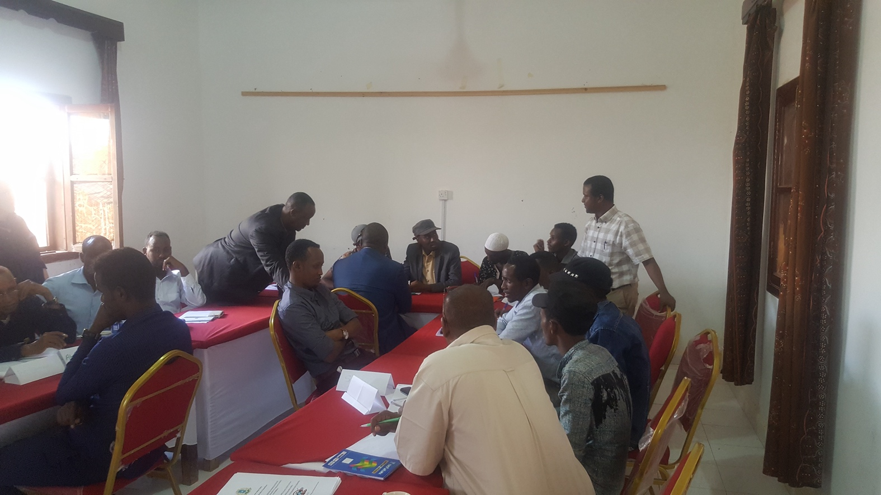

The first workshop for the center staff, Screening team, and Social Workers

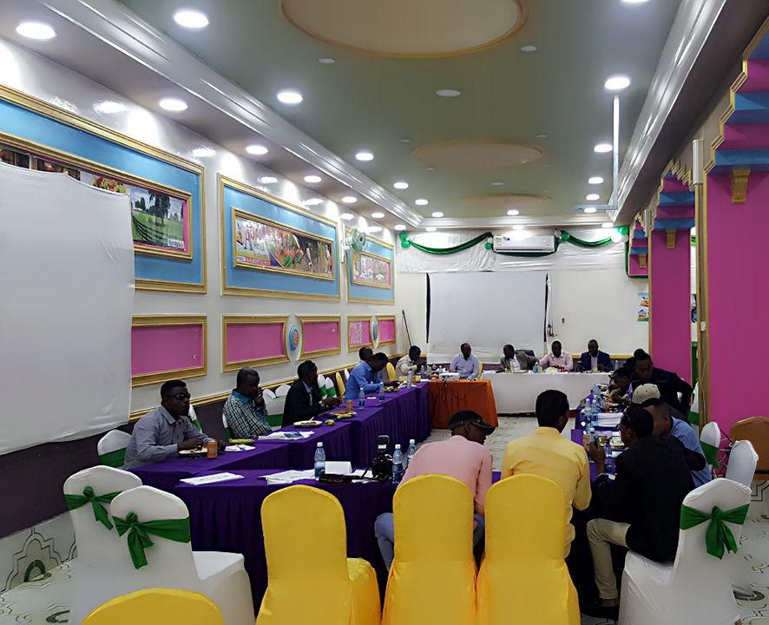

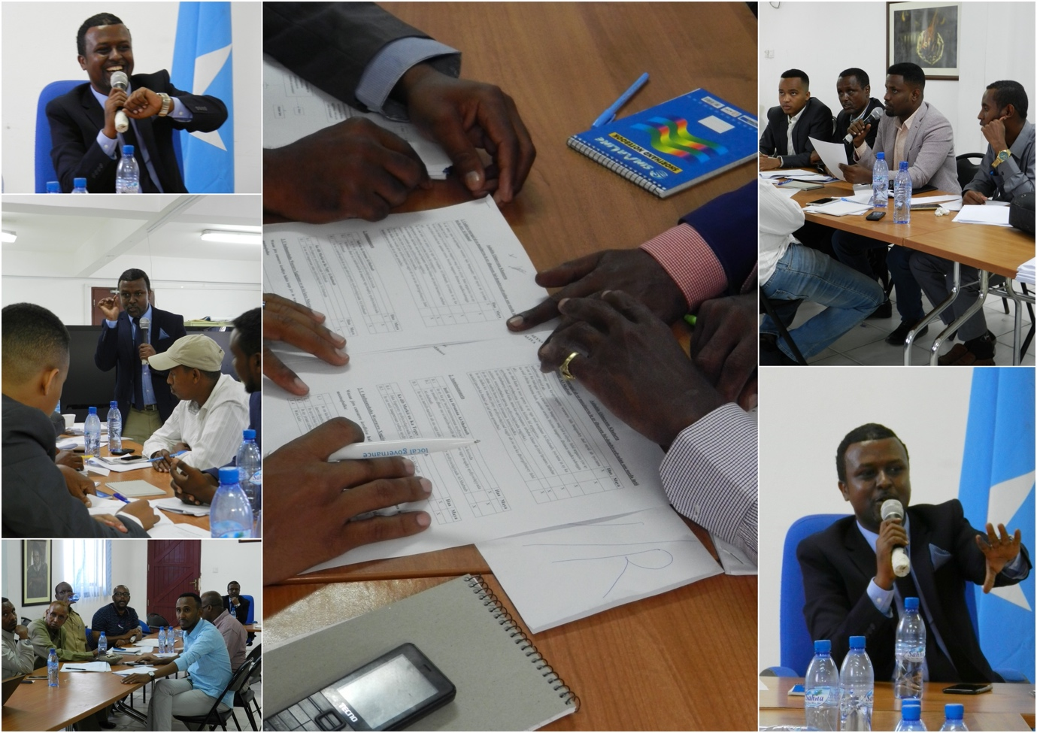

Social Worker Training, face two.

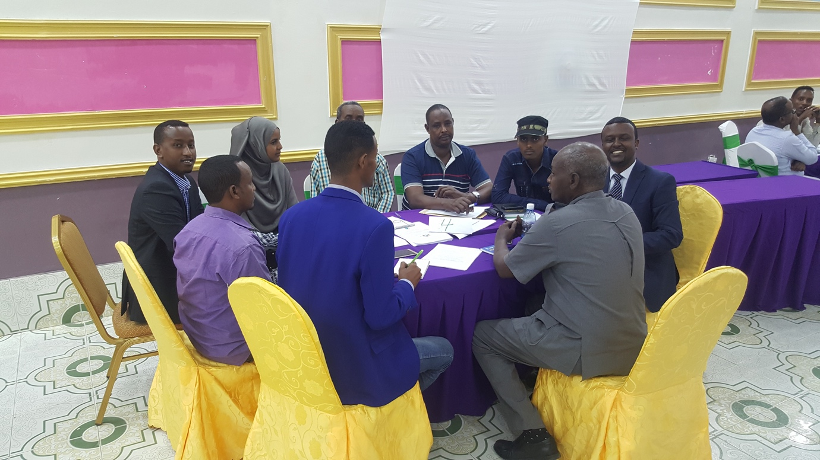

Discussion Table, Reintegration strengthening Workshop.

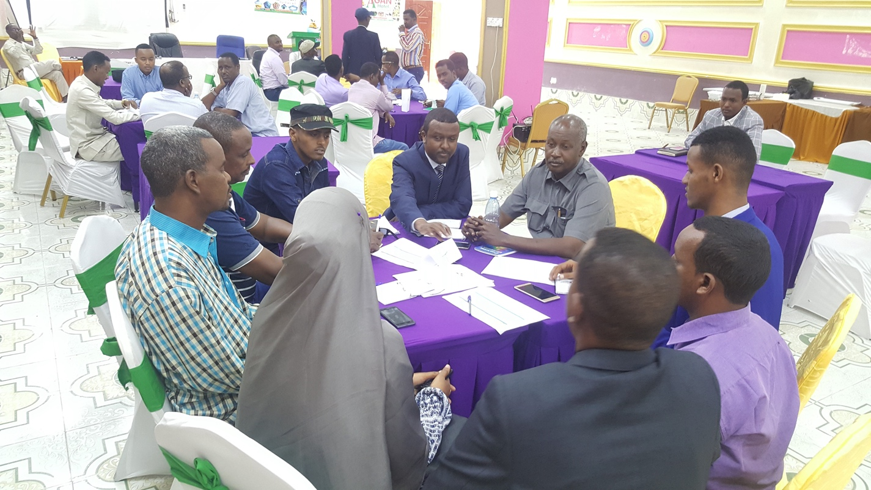Discussion Table, Reintegration strengthening training.

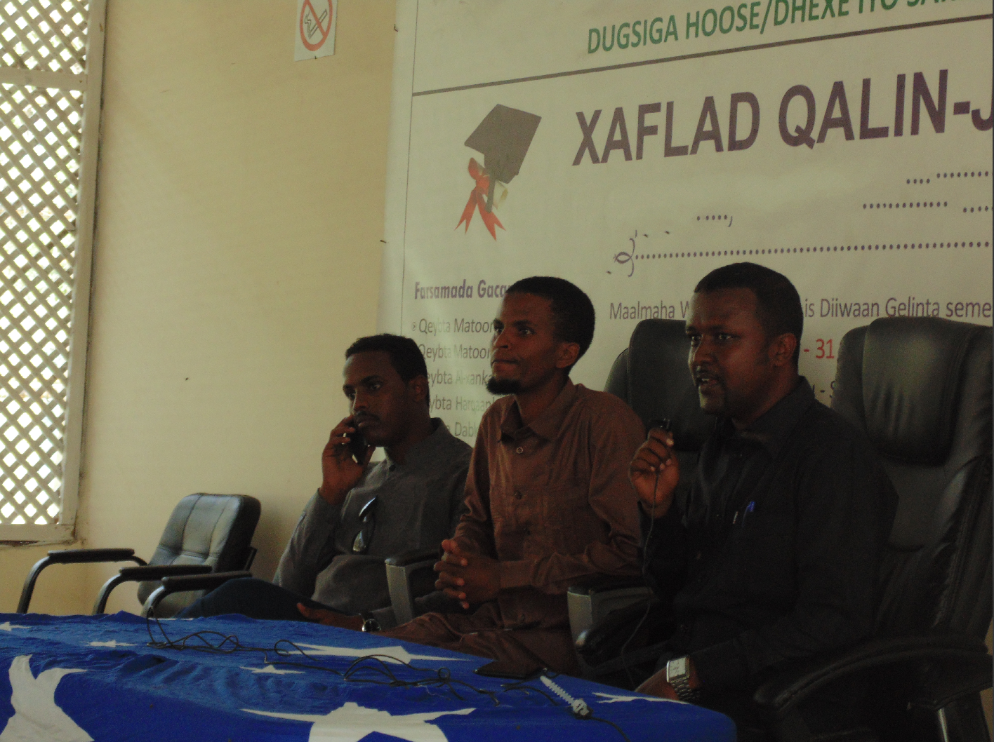

Clearances/ Permission letters Participant

Training defectors with the Concept of Peace in Islam, the middle man is Sheikh Ibrahim Nadara, a former Alshabaab radicalization who defected in 2016. He played a perfect role in PCVE

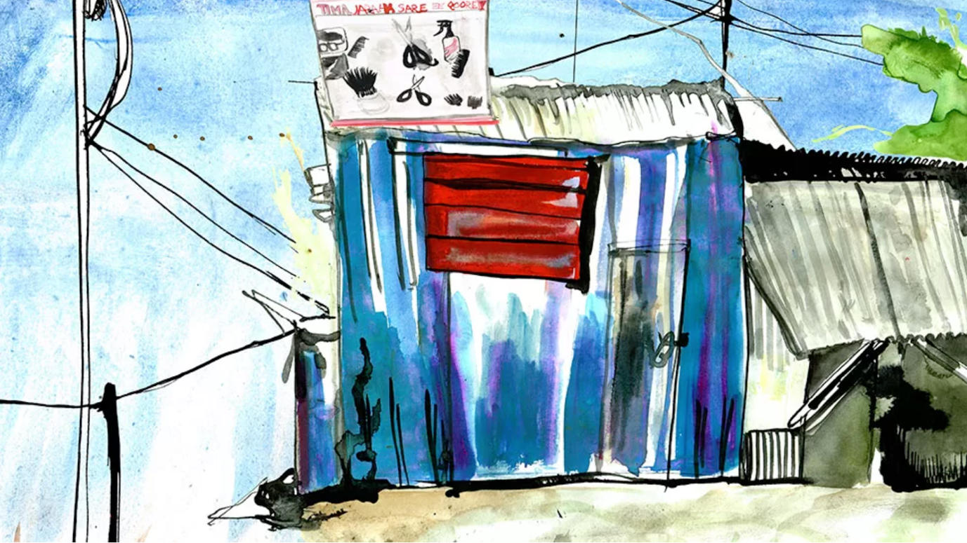

Hand drawing of defectors, part of trauma healing,

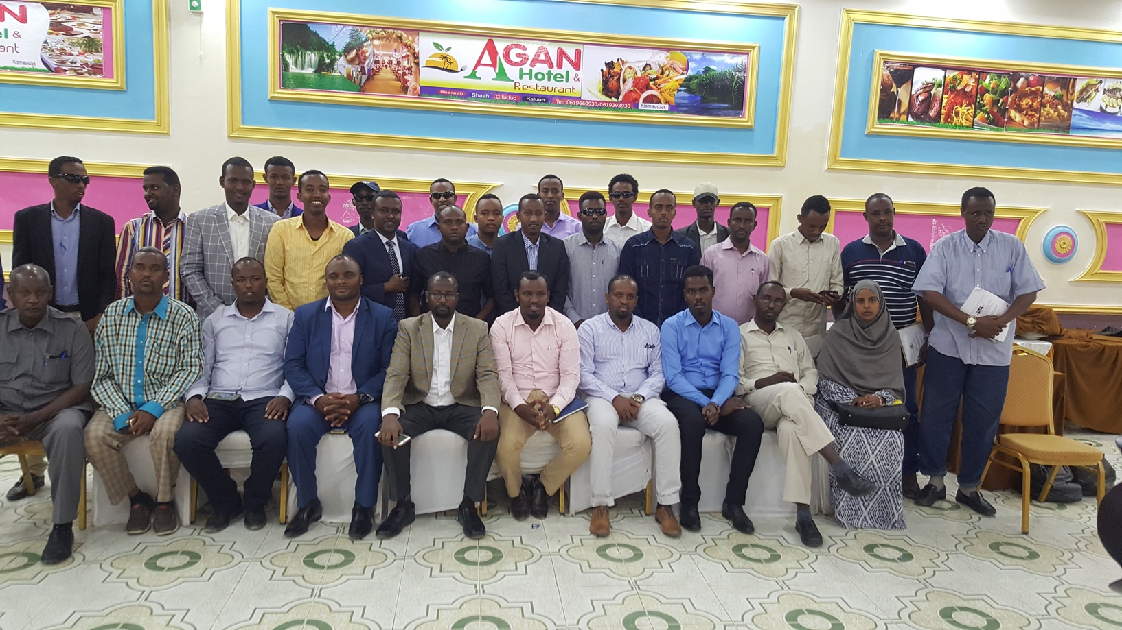

* + 1. **Interviewees**

1. H.E Hassan Hussein Haji, member of the senate and former Minister of Justice of Somalia.
2. Gen. Abdirahman Mohamed Turyare, former National Intelligence and Security Agency – NISA director.
3. Abdinasir Aden Osman, Member of the regional parliament of Galmudug and former director of Serindi center.
4. Salad Jilao, director of the Defector Rehabilitation Program,
5. Abdalla Nor Jara’id, long-serving administrator of Serendi center,
6. Shiekh Ibrahim Nadaara, former Alshabaab high level on radicalization,
7. The screening team consists of five trained NISA officers who support DRP in screening defectors. (Because of the program's media policy, we cannot disclose their names).
8. Social Workers; participated in the assessment and the training, (because of the media policy of the program, we cannot disclose their names).
9. Five defectors integrated into the Police and NISA (we concealed their names for security purposes)
10. Chosen Defectors in Serindi and Mogadishu for training need assessments one and two. (Because of the program's media policy, we cannot disclose their names).
    * 1. **Bibliography**

Abbink, J. (2008). The islamic courts union: The ebb and flow of a Somali islamist movement. *Movers and Shakers: Social Movements in Africa*, *8*, 87–113. https://doi.org/10.1163/ej.9789004180130.i-260.33

Ingvild Magnæs Gjelsvik. (2019). Disengaging from violent extremism – ACCORD. *Accord*. https://www.accord.org.za/conflict-trends/disengaging-from-violent-extremism/

Maruf Harun, J. D. (2018). INSIDE ALSHABAAB: The secret history of Al-Qaeda’s Most Powerful Ally. In *Indiana University Press* (Vol. 001, Issue December). https://lccn.loc.gov/ 2018019388

Muggah, R., & O’Donnell, C. (2015). Next generation disarmament, demobilization and reintegration. *Stability*, *4*(1), 1–12. https://doi.org/10.5334/sta.fs

Nursita, R. D., & Sahide, A. (2019). The Concept of Peace in Islam and Its Relevance to International Relations. *Al-Albab*, *8*(2), 211–224. https://doi.org/10.24260/alalbab.v8i2.1218

Onapajo, H., & Ozden, K. (2020). Non-military approach against terrorism in Nigeria: deradicalization strategies and challenges in countering Boko Haram. *Security Journal*, *33*(3), 476–492. https://doi.org/10.1057/s41284-020-00238-2

Parrin, A. (2016). Creating a Legal Framework for Terrorism Defectors and Detainees in Somalia. *Columbia Journal of Transnational Law*, *55*. https://heinonline.org/HOL/Page?handle=hein.journals/cjtl55&id=231&div=&collection=

Roque, P. C. (2009). The battle for Mogadishu: Revealing Somalia’s fluid loyalties and identities. *African Security Review*, *18*(3), 74–79. https://doi.org/10.1080/10246029.2009.9627544

Stern, O. M. (2019). Invisible Women of al-Shabaab. *Adam Smith International*, 21–48. https://doi.org/10.2307/j.ctt1h1htgx.6

Taylor, C., Semmelrock, T., & McDermott, A. (2019). The cost of defection: The consequences of quitting al-shabaab. *International Journal of Conflict and Violence*, *13*, 1–13. https://doi.org/10.4119/UNIBI/ijcv.657

Ubink, J., & Rea, A. (2017). Community justice or ethnojustice? Engaging with customary mechanisms to reintegrate ex-combatants in Somalia. *International Journal of Transitional Justice*, *11*(2), 276–296. https://doi.org/10.1093/ijtj/ijx009

Saferworld. (2019). Thinking beyond ‘ countering violent extremism ’ in Somalia : local views on an international ‘ project .’ *Saferworld*, 1–4.

Khalil, J., Horgan, J., & Zeuthen, M. (2022). The Attitudes-Behaviors Corrective (ABC) Model of Violent Extremism. *Terrorism and Political Violence*, *34*(3), 425–450.

Powell, B., Ford, R., & Nowrasteh, A. (2008). Somalia after state collapse: Chaos or I mprovement?. *Journal of Economic Behavior & Organization*, *67*(3-4), 657-670

Richards, J. (2018). High Risk or Low Risk: Screening for Violent Extremists in DDR Programmes. *International Peacekeeping*, *25*(3), 373–393.

Ingvild Magnæs Gjelsvik. (2019). Disengaging from violent extremism – ACCORD. *Accord*. https://www.accord.org.za/conflict-trends/disengaging-from-violent-extremism/

Ubink, J., & Rea, A. (2017). Community justice or ethnojustice? Engaging with customary mechanisms to reintegrate ex-combatants in Somalia. *International Journal of Transitional Justice*, *11*(2), 276–296.

Muggah, R., & O’Donnell, C. (2015). Next generation disarmament, demobilization and reintegration. *Stability*, *4*(1), 1–12.

Abbink, J. (2008). The islamic courts union: The ebb and flow of a Somali islamist movement. *Movers and Shakers: Social Movements in Africa*, *8*, 87–113.

Khalil, J., Brown, R., Chant, C., Olowo, P., & Wood, N. (2019). Deradicalisation and Disengagement in Somalia Former Members of Al-Shabaab Deradicalisation and Disengagement in Somalia. *RUSI Whitehall Report*, 1–50.

Nagai, Yosuke (2021) "Reintegration of Al-Shabaab’s Defectors in Somalia: An Examination of Conditions for Successful Reintegration," Peace and Conflict Studies: Vol. 27 : No. 3, Article 5.

Altai. (2017). LOW-LEVEL DEFECTORS REHABILITATION PROJECT. *FCO and Altai Consulting*, *March 2017.*

GCTF. (2017). For purposes of this document, “prisons” is meant to refer not only to prisons themselves but to other civilian institutions where offenders might be incarcerated, such as pre-trial detention centers. The focus of these good practices on civilian prisons. *Global Counter Terrorism Centre*, 1–14.

Richards, J. (2018). High Risk or Low Risk: Screening for Violent Extremists in DDR Programmes. *International Peacekeeping*, *25*(3), 373–393.

Gjelsvik, I. M. (2019). Should I stay or should I go ? Security considerations for members leaving al-Shabaab in Somalia. *Norwegian Institute for International Affairs (NUPI)*.

GCTF. (2015). Rome Memorandum on Good Practices for Rehabilitation and Reintegration of Violent Extremist Offenders Introduction. *Global Counterterrorism Forum*, *7*(1), 37–72.

Juma, M. N., & Githigaro, J. M. (2021). Communities’ Perceptions of Reintegration of Al-Shabaab Returnees in Mombasa and Kwale Counties, Kenya. *Journal for Deradicalization*, *26*, 71–109.

JUMA, M. N. (2020). EXITING TERRORISM: REHABILITATION AND REINTEGRATION OF AL-SHABAAB RETURNEES IN KENYA’S MOMBASA AND KWALE COUNTIES, 2015 – 2020. *UNITED STATES INTERNATIONAL UNIVERSITY – AFRICA*, *4*(1), 1–9.

Dzinesa, G. (2008). the Role of Ex-Combatants and Veterans in Violence in Transitional Societies. *CENTRE FOR THE STUDY OF VIOLENCE AND RECONCILIATION*, *MAY*, 1–19.

Rolston, B. (2007). Demobilization and reintegration of Ex-combatants: The irish case in international perspective. *Social and Legal Studies*, *16*(2), 259–280.

John, H., & Braddock, K. (2010). Rehabilitating the terrorists?: Challenges in assessing the effectiveness of de-radicalization programs. *Terrorism and Political Violence*, *22*(2), 267–291.

Federal Republic of Somalia (2016). *National Programme Policies and Procedures.* Ministry of Internal Security, Defectors Rehabilitation Programme, 1 July 2016.

[Michael Taarnby](https://www.amazon.com/s/ref=dp_byline_sr_book_1?ie=UTF8&field-author=Michael+Taarnby&text=Michael+Taarnby&sort=relevancerank&search-alias=books), (2018), Serendi: Inside Somalia’s Terrorist Rehabilitation Project, *CreateSpace Independent Publishing Platform; 1st edition,* pg476

France24 (2011), Al Shabaab rebels offered amnesty after Mogadishu pullout,*France 24 Press* <https://www.france24.com/en/20110809-shebab-islamists-insurgents-offered-amnesty-after-mogadishu-pullout-withdrawal-somalia> (accessed on 18th August 2022)

CNN wire staff (2011), Amnesty offer extended to insurgents in Somalia,*CNN NEWS*<http://edition.cnn.com/2011/WORLD/africa/08/07/somalia.insurgent.amnesty/index.html> (accessed on 18th August 2022)

AMISOM Press (2012), **Al Shabaab suffer significant setback as over 200 militants disengage near Jowhar,** *AMISOM Press Release 22 September, 2012,* <https://amisom-au.org/2012/09/al-shabaab-suffer-significant-setback-as-over-200-militants-disengage-near-jowhar/> (accessed on 20th August 2022)

ReliefWeb, Somalia: Drought - 2015-2022, Dare Humanitarian Situation in Somalia, *relief web***,** <https://reliefweb.int/disaster/dr-2015-000134-som>, accessed on 29 August 2022

Banned (2004) Sa'udi Organization Al-haramain al-kheiria, <https://bit.ly/3CzhNnR> accessed on 10th November, 2021.

1. Screening Team interview 2022.
2. Defector 1 Interview,
3. Interview with center managers and screening team 2022.
4. Federal Republic of Somalia (2016). *National Programme Policies and Procedures.* Ministry of Internal Security, Defectors Rehabilitation Programme, 1 July 2016.
5.
6. Defector assessment report 2018, was a unclassified document prepared to assess pull and push factors of AlShabaab Recruitment and why the young generation choose to join terror groups, on the other hand it was assessing defection purposes and why they leave the group.
7. Somalia: Drought - 2015-2022,<https://reliefweb.int/disaster/dr-2015-000134-som>,
8. Defector assessment Report 2018
9. Defector assessment report 2018
10. Defector assessment report 2018
11. Defector assessment report 2018
12. Survey 1. Defectors in Serendi believes that low risk and low-level defectors do not get the chance that are given to the high level and high-risk defectors, this concern was also the debate of the amnesty policy in Somalia.
13. Survey1 and 2, defector in serendi center and another one in Kismayu,
14. One on one interview with Avv. Hassan Hussein Haji, former Minister of Justice in Somalia.
15. Interview with H.E. Abdinasir Aden Osman, former serendi center director and current Galmudug regional MP.
16. Current government policy and priority August 2020
17. Interview with five defectors integrated to NISA and Police,
18. UNCCT, UNICRI and the Government of Turkey in Istanbul, on 19-20 May 2014.