

**ROTARY PEACE CENTER**

**DEPARTMENT OF RELIGION AND PEACE STUDIES COLLEGE OF HUMANITIES AND SOCIAL SCIENCES MAKERERE UNIVERSITY**

**SOCIAL CHANGE INITIATIVE (SCI) REPORT**

**Improved Awareness of Sexual and Reproductive Health and Rights (SRHR) and GenderBased Violence (GBV) among Conflict-Affected Females in Fako Division, Cameroon**

**By**

**NKONGHO NCHONG ACHERE MPH, PhDc**

**March 2023 – September 2023**

Contents

ABSTRACT/SUMMARY 3

CHAPTER ONE 4

1. INTRODUCTION AND BACKGROUND 4

2. PROBLEM STATEMENT 6

3. GOAL AND OBJECTIVES 7

3.1. Goal 7

3.2. Objectives 7

4. CHALLENGES AND MITIGATION STRATEGIES 7

CHAPTER TWO 9

1. LITERATURE REVIEW 9

2. THEORETICAL UNDERPINNINGS 10

3. CHANGE THEORY AND HOW IT WAS APPLIED 12

4. METHODS AND DESIGN 14

I. Preparatory activities 15

II. Logical Framework 16

CHAPTER THREE 17

1. INTERVENTIONS AND ACTIVITIES 17

i. Literature Review to Identify Gaps 17

ii. Training of facilitators (SRHH/GBV expert volunteers) 17

iii. Community mobilization 17

iv. Community outreach/campaign 17

v. Media Outreach/Engagement 17

2. KEY FINDINGS/IMPACT 18

CHAPTER FOUR 19

1. GENERAL CONCLUSION 19

2. RECOMMENDATIONS/IMPLICATIONS FOR POLICY 19

3. SUSTAINABILITY PLAN 19

APPENDICES 21

1. REFERENCES 21

2. PICTORALS 23

# ABSTRACT/SUMMARY

Sexual and reproductive health and rights (SRHR) violation and gender-based violence (GBV) increases in conflict settings and mostly affects women and girls. In the over five years of conflictaffected setting of Fako Division, Southwest Region, Cameroon, where the Mile-16 community is hardest hit, most women and girls are vulnerable due to limited awareness about their SRHR and GBV.

This social change initiative (SCI)aimed at improving the awareness of SRHR and GBV among women and girls in the conflict-affected setting of Fako Division, Cameroon.

The SCI project utilized a sequential and community-based design and targeted (270 participants); over 200 community members for the SRHR/GBV awareness raising campaigns, 50 women and girls and 20 community leaders in providing sensitization on GBV and SRHR. The sensitization was implemented with support from recruited community focal points and SRHR/GBV expert community volunteers’ due security and inaccessibility constraints. The awareness raising sessions covered topics such as women’s SRHR, GBV, identifying SRHR violations, existing laws and supportive structures for women, and how community leaders can champion the fight against GBV and women/girls SRHR violations.

Through mass community sensitization at churches and media most utilized by community members, engagements with community leaders and focus group discussions with young men and women, over 2030 participants; 2000 community members were reached through mass sensitization through TV, radio and churches, 20 young girls with one-to-one focus group engagements and ten community leaders were bought-in as champions of SRHR and non-GBV.

The project realised commitments from community leaders and women group representatives to utilise their existing structures in supporting victims and enacting punishments for perpetrators. Though several challenges, such as insecurity, financial gaps, and health effects, existed, selffunding and using volunteers were utilised as mitigation measures.

The project recommends expansion of women’s SRHR and GBV sensitisation to wider community members and long-term focused implementation for sustained impact while strengthening existing community structures.

# CHAPTER ONE

# 1. INTRODUCTION AND BACKGROUND

Women’s poor awareness of their sexual and reproductive health and rights (SRHR) is a primary global development problem. Worse, their inability to control their sexual and reproductive health in conflict-affected settings is a gross violation of women’s rights, affecting the lives and physical and mental health of millions globally (Heidari and Moreno, 2016; WHO, 2021).

Gender-based violence (GBV) against women and girls starts at a young age and has remained overwhelmingly persistent (WHO, 2021). Over the past decade, globally, every 1 in 3 women, around 736 million, have been subjects of physical or sexual violence by an intimate partner or sexual violence from a non-partner (WHO, 2021). Before reaching their mid-twenties, 1 in 4 young women (aged 15-24 years) who have been in a relationship will experience violence by an intimate partner (WHO, 2021).

Fako Division, the Southwestern region of Cameroon, has been in a conflict-related humanitarian crisis since 2016 (UNOCHA, 2019). A humanitarian needs assessment of the region, as shared by UNOCHA in 2019, revealed that more than 85% of respondents, women and girls, experience rape, sexual assault, intimate partner violence, denial of resources/opportunities, psychological abuse, physical violence, and early marriage (UNOCHA, 2019). In addition, more than 70% of women and girls have expressed an increase in security concerns affecting women and girls and a noticeable increase in reported rape cases since the start of the crisis (UNOCHA, 2019). Furthermore, 58% of respondents in this assessment stated that most survivors do not tell or seek assistance when they experience violence because they think people will not believe them (UNOCHA, 2019). Fako Division's prevalence is over 50% (UNOCHA, 2019).

Sexual and reproductive health and rights entail holders to claim their rights. In a similar setting in Kenya, SRHR unawareness limits women and girls' ability to claim these rights and equally results in low SRH outcomes (Center for Reproductive Rights, 2021). A qualitative study conducted in

2021 on adolescents and young women’s SRHR in slums in Uganda revealed that participants were uneducated and unaware of their SRHR and felt that education and training would greatly aid them (McGranahan et al., 2021).

A study in Mbouda, Cameroon and reported by Nansseu et al, identified that one of the main reasons preventing women from upholding and practising some of their SRHR, such as contraception, was lack of knowledge (31.4%), with 42.4% of these women expressing the willingness to start using contraception if they received more information about the subject (Nansseu et al., 2015).

Thus, educating women and girls in conflict-affected settings on GBV and their SRHR, as in the case of the targeted conflict-affected Fako Division, improved their awareness on SRHR and GBV.

From previous experiences, the Mile-16 community (one of the hardest hit conflict-affected communities of Fako Division) is known for violent extremism, inaccessibility and continuous violation of women and girls’ SRHR and gender-based violence. An assessment of recruited volunteers from this community, by the peace fellows through a one-to-one in-depth interview indicated that;

* Sexual health violations included rape, physical and psychological abuse.
* Sexual rights violations included forced marriages.
* Reproductive health violations included limited access to quality healthcare.
* Reproductive rights violations included lack of access to family planning and little or no childbearing rights.

Compared to the situation before (2016), community volunteers and young girls reported to the peace fellow and community focal points respectively issues such as gender-based violence in the context of physical and sexual violence among intimate and non-intimate partners who are mostly exploited through sexual exploitation in the context of exchange for sex, aggravated during the ongoing conflict-related crisis. Issues such as abuse of power, cultural standards, current armed conflict, and COVID-19 exacerbated the situation in the Mile-16 community.

Based on the perspective of the community volunteers living in Fako Division and supporting the SCI project, the Mile-16 community is hardest hit and not accessible by humanitarian entities. Therefore, it was essential to target and prioritize this community, and work alongside community leaders in fostering sustainable change. As a result, the focus of this SCI, was on SRHR and GBV, at the Mile-16 community, and geared towards improving their awareness amongst women and girls through mass community sensitization at churches and media most utilized by community members, engagements with community leaders and focus group discussions with young men and women on SRHR and GBV, existing laws and community support structures and how community leaders can champion women’s SRHR and GBV.

This project therefore contributes to peacebuilding by addressing conflict drivers of inequitable access to services and community engagement through awareness raising at churches, media and women/community leaders’ social groups, offers platforms for integrating peacebuilding and social cohesion components, and supports educational, livelihood and economic potential of young girls. The SCI project also supports access to justice for victims of sexual violence, including through participation in transitional justice and peace processes, addresses conflict factor of perceived injustice and improves access to justice, increases awareness of sexual and gender-based violence as part of the foundation for reconciliation, enhances recovery and well-being of victims of violence, and increases community social cohesion and resilience. Fako Division being one of the six divisions of the Southwest region of Cameroon, with Mile 16 community as one of the severely conflict-hit localities in the Fako Division benefitted in enhanced peacebuilding through SRHR and GBV awareness raising from this SCI project.

# 2. PROBLEM STATEMENT

At least 1 in 3 women globally and over 60% of the women and girls in Cameroon go through some form of violence and SRHR violation. The Southwest Region of Cameroon, with a population of 1,515,888, 60% aged 15 years and above (BUCREP, 2014), has been grossly affected by the ongoing armed conflict since 2016, hosts over 300, 000 internally displaced persons (IDPs) and has been hit with less than 50% of health facilities being functional, increase violence on women and girls and SRHR violations whereby only 6% of women give birth at the hospital in 2018, as compared to 93% before the crisis (International Medical Corps, 2018). With its devastating effects, over 80% of women and girls in the conflict-affected setting of Fako Division, with a population of about 600,000 persons, go through some form of violence and SRHR violation (International Medical Corps, 2018).

Several studies have proven that while SRHR violation and GBV worsen in conflict settings, a key reason for this worsened outcome has been poor awareness of women and girls on GBV and their SRHR. In the conflict-affected Mile-16 community, social and cultural norms, displacement, frequent armed exchanges, poor education, and loss of jobs make the community hardest hit.

As a result, women and girls have been unable to claim their rights or seek support as victims from community supportive structures resulting in continuous unplanned pregnancies, STIs and sexual exploitation, especially in the context of exchange for sex.

Therefore, there is a need to increase women's and girls’ awareness about GBV and their SRHR. This will consequently limit SRHR violation and GBV prevalence, foster awareness on GBV victim-support sites for full recovery, enable the creation of more support sites by community leaders, decrease sexually transmitted infections (STIs) and the number of young girls who drop out of school due to unplanned pregnancies associated with sexual exploitation in the context of exchange for sex. Thus, fostering goal 3 of the sustainable development goals: good health and wellbeing. It does not flow.

As crucial partners in economic recovery, social cohesion and political legitimacy, women’s enhanced SRHR/GBV awareness, safety, and prospective active participation in community awareness, resilience, and mediation processes will ensure more inclusive and diversified community members’ engagement in the peace process and end prevailing negative vices on women, girls, children and other vulnerable groups. Too long a sentence; break it down for clarity.

# 3. GOAL AND OBJECTIVES

### 3.1. Goal

To improve the awareness of sexual and reproductive health and rights (SRHR) and gender-based Violence (GBV) among conflict-affected girls and women in Fako Division, Southwest Region, Cameroon.

### 3.2. Objectives

1. To enhance awareness among conflict-affected women and girls on gender-based violence and sexual and reproductive health and rights
2. To incorporate community leaders as champions of GBV and women’s SRHR
3. To enhance community awareness (men inclusive) of gender-based violence and sexual and reproductive health and rights.

# 4. CHALLENGES AND MITIGATION STRATEGIES

1. Insecurity and Inaccessibility: As one of the hardest-hit communities of the ongoing conflict, continuous gunshots, road blockages, and limited community trust posed challenges at the beginning of the SCI. As a result, two paid community volunteers who were experts in GBV and SRHR and familiarised with the community from previous non-government organisations (NGO) humanitarian projects on SRHR and GBV were recruited to facilitate community campaign and media sessions in hard-to-reach areas of the Mile 16 community, and Fako Division in general. In addition, two community mobilisers/focal points who resided in the community and could foster trust and rally targeted groups for the SCI were recruited as points of entry to the community.
2. Financial Challenges: the project was self-funded and entailed out-of-pocket payment of volunteers and mobilisers for the duration of the SCI. This included stipends, transportation, feeding etc. In addition, radio stations, TV stations (CM

TV, LDTV, Prime TV) community groups, women leaders groups, and community heads like the chiefs, teachers, council members etc, requested payments before any form of engagements through their platforms could be conducted, including participation were made available. Participants who were being educated on SRHR and GBV also requested transport and feeding to receive any intervention from the SCI. Furthermore, visibility materials such as banners had to be printed. As a result, cost-effective radio stations (such as Bonakanda community radio) in more remote settings of the community, which was quite insecure, were utilized. The lack of funding equally emanated from delay from the prospective partner international organisation whose representative that had approved the partnership, travelled for an eight months international mission before an official documented agreement and did not return to release the funds or assign a representative prior to implementation as promised.

1. Delays: Due to lockdowns, such as every Mondays (a mandatory strategy since

2018 by the separatist arm of the ongoing conflict to portray the conflict’s severity and indigenes to showcase their solidarity for the conflict and lives lost), and rainy season, scheduled activities were postponed for safety and health reasons. In addition, due to periodic rainy season flu and flooding, the peace fellow and volunteers fell sick periodically, for over two months, due to weather changes and early postpartum vulnerabilities.

# CHAPTER TWO

# 1. LITERATURE REVIEW

This chapter provides in-depth insights into sexual and reproductive health and rights (SRHR), and gender-based violence (GBV), from a global and country perspective, as well as theoretical underpinnings of SRHR and GBV. According to the United Nation’s Human Rights Office of the High Commissioner (OHCHR), women’s sexual and reproductive health relates to multiple human rights, including the right to life, the right to be free from torture, the right to health, the right to privacy, the right to education, and the prohibition of discrimination (OHCHR, 2021). The Swedish International Development Cooperation Agency (SIDA) defines SRHR as the physical, emotional, psychological and social wellbeing in relation to all aspects of sexuality and reproduction. In essence, it refers to more than just the absence of disease, dysfunction, and injuries. It is very vital to note that everyone has the right to make decisions regarding their own body and to have access to healthcare and other health-promoting initiatives.

SRHR involves four areas: sexual health, sexual rights, reproductive health, and reproductive rights (Global Citizen, 2021). Sexual health refers to physical, mental, and social well-being in terms of sexuality. This means safety from sexual illnesses and violence. Sexual rights refer to the ability to decide on your own about sexuality. It means expressing your sexuality by making your own decisions about partners, privacy, and pleasure. A typically issue for women is forced marriage, with 1 in 3 women below 15, and 18 years of age, being forced into marriage, which violates their sexual rights. Assault, especially rape of young women, is particularly prominent in crisis and conflict settings, which in most cases, are forced to marry their assaulter, violating the sexual rights of victims (Global Citizen, 2021). Reproductive health entails having a healthy reproductive system and healthy pregnancies through access to healthcare, medication, and education. In most poor communities and developing countries, though particularly susceptible to reproductive illnesses, women do not have access to reproductive health care and end up with reproductive illnesses, such as obstetric fistula. In addition, a major concern of reproductive health is unsafe pregnancy due to lack of access to proper medical care, thus giving birth at home and resulting in pregnancy and childbirth as a leading cause of death for women, particularly girls aged 15-19 (Global Citizen, 2021). Reproductive rights entail the right to decide if and when to have children. However, couples should be able to plan and make a well-informed decision about having children; that is not the case in most settings due to limited education and access to family planning tools.

Emergency outcomes in conflicts, such as lockdowns, and their social and economic impacts increase women’s exposure to abusive partners and known risk factors while limiting their access to services (WHO, 2021). During humanitarian crises and displacement in conflict settings, as in the case of Southwestern Cameroon, these may exacerbate existing violence, such as by intimate partners, as well as non-partner sexual violence, and may also lead to new forms of violence against women (WHO, 2021).

According to UNOCHA, the ongoing anglophone crisis in Cameroon has caused about 52% of the over 600,000 displaced persons to be women, with children representing 44.5% of the IDP population (UNOCHA, 2020). The UNHCR shared that, with multiple occurrences of lockdowns in the SW region, the security situation remains volatile and unpredictable, especially for women and girls (UNHCR, 2019). With over 70% of women and girls in crisis going through some form of SRHR violation and intimate partner violence, 88% of survivors in the Southwest region are females and reported incidents include emotional abuse, denial of resources or opportunities, physical assault, sexual abuse, forced marriage and rape; 56% survivors are host community members, 36% are internally displaced persons (IDPs), and 8% are returnees (UNOCH, 2021).

In Mbouda, Cameroon, it was identified that one of the main reasons preventing women from upholding and practising some of their SRHR, such as contraception, was lack of knowledge (31.4%), with 42.4% of these women expressing the willingness to start practising contraception if they received more information about the subject (Nansseu et al., 2015).

In conflict settings, these prevailing gaps in knowledge provide the need to improve women and girls' awareness of their SRHR and intimate partner violence in Fako Division of the Southwest region of Cameroon. The project therefore enhances women and girls’ knowledge on GBV and their SRHR, existing supporting structures for GBV victims and foster community leaders as women and girls’ SRHR champions.

# 2. THEORETICAL UNDERPINNINGS

Tabassum and Nayak (2021) provided a reflection of several theories on GBV and women’s

SRHR violation, three of which are;

1. Social role theory, where women are seen to be nurturing and thus easily exploited by the more assertive men. This is similar to the Fako division setting where most women stay at home to cater for families and equally engage in survival sex and as weapons of war.
2. Role congruity theory, whereby there is prejudice against potential female leaders, especially in communities, thus promoting exploitation and limiting SRHR and GBV change champions who are victims of and aware of the plights of women and girls in conflict-affected settings.
3. Feminism, whereby in most developing countries, socio-cultural factors such as patriarchal dominance influence behaviours towards moderate feminism as women face rejection, and their behaviours are considered non-conforming to be respected by most males and, consequently, sexual violence.

Work on the flow.

However, Lau et al. (2022) depicted that several internal and external environmental interactions affect women’s SRHR and GBV, as in the ecological theory. This theory shows how women intersected within interpersonal microsystems, organisational microsystems, macro-systems, and chrono-systems. The ecological model also identifies and describes barriers to women’s SRHR and is enlisted with examples below.

* 1. Public Policy (e.g., legal frameworks)
  2. Community (e.g., social and gender norms)
  3. Institutional (e.g., human resources policies)
  4. Interpersonal (e.g., sexual harassment), and
  5. Individual (e.g., imposter factors).

Using an external environmental tool like PESTLE showcases alignment with this theory

(Freeman et al., 2018) through integration of institutional, community and public policy factors.

1. Political Factors: Government regulatory systems and legal frameworks
2. Economic Factors: employment rate, inequality index, workforce productivity, inflation rate
3. Social Factors: levels of social concerns and awareness, societal norms, education, family size and structure
4. Technological Factors: transparency and digital drive, internet, technological infrastructure and use of social media
5. Legal Factors: health, safety and protection laws, anti-discriminatory law
6. Environmental Factors; social responsibility culture.

As a result, integrating the ecological model to the pestle framework will provide a holistic and sustainable community-based solution in fostering women’s SRHR and ending all forms of GBV. However, due to time constraints, the SRHR Alliance’s Theory of Change defined in section three below was utilized for this SCI.

Therefore, addressing these barriers through enhancement of women and girls’ awareness of GBV and their SRHR, as well as integrating local actors and leaders as champions of change, boosts opportunities and creates sustainable impacts that have multiple positive effects like breaking down stereotypes on women in being aware, leading and championing the rights of other women and encourage women in pursuit of their safety and wellbeing. This prompted broader culture change with a strong representation that women, too can own their SRHR and augment community resilience, development, peace and growth.

# 3. CHANGE THEORY AND HOW IT WAS APPLIED

Using Lewin’s change management theory (Cummings et.al, 2016) of unfreezing, transition and freezing, whereby the change process is created through a perception of the need for change, then moving towards the newly desired change and later solidifying that new behaviour as a norm, provision of behavioural change skills was integrated by community sensitisation. This incorporated three levels of the ecological model: individual, interpersonal and community levels of interaction through addressing imposter factors, sexual harassment, and social and gender norms, respectively. Consequently, women and girls’ awareness of GBV and their SRHR improved through education, community mobilisation awareness raising and recommendations on existing community victim support structures and creating new ones where possible (figure 1). Thus, claiming their rights and limiting GBV and SRHR prevalence.

Improved women and girls’ awareness on GBV and their SRHR

|  |  |  |  |  |
| --- | --- | --- | --- | --- |
| What to Change |  | What to Change to |  | How to cause the change |

|  |  |  |  |  |  |
| --- | --- | --- | --- | --- | --- |
| |  |  |  | | --- | --- | --- | | Poor awareness on  GBV and SRHR amongst women and  girls in conflict affected settings |  | Women and girls’ improved awareness  on GBV and their SRHR  in a conflict affected  setting | | |  | | --- | | -Women and girls’ education on GBV and their SRHR  -Community mobilization and awareness raising, that also targets men and boys -Engagement and commitment enactment by community leaders through championing change  -Recommendations on existing community victim support structures and creation of  new ones where possible | |

Figure 1. SCI Implementation Strategy/Theory of Change

From the literature review elaborated in chapter two, women and girls in Fako Division have poor awareness of GBV and their SRHR. However, by understanding that this needs to change by unfreezing and addressing individual lack of self-esteem and courage to stand up for their rights, through education on GBV and SRHR pushed through a transition stage of an expected outcome (improved SRHR awareness and decreased GBV/SRHR violations prevalence). To broaden the impact and addressing interpersonal gaps, the entire community is involved through mobilization and awareness raising that incorporates media coverage and community campaigns. Additionally, sustainability is upheld by ensuring community norms are gender equitable and victims have accessible support structures from existing female and male community leaders.

In alignment to the SRHR Alliance’s Theory of Change which is based on the multi-component conviction approach of realising most effective results, this SCI project integrated three change components from the Alliance’s change theory, which includes; increasing SRHR supply, increasing SRHR demand and creating an enabling environment by increasing SRHR support.

This project primarily worked with community leaders and influencers in the community as a means for effective and sustainable change. The three change components from the SRHR

Alliance’s Theory of change utilized were;

**i. Increasing SRHR and non-GBV Supply**

A focus group discussion was conducted with 20 internally displaced persons (IDPs) (women and girls) and survivors of GBV and SRHR violation. This was aimed at obtaining in-depth information on concepts, perceptions and issues emanating from Gender Based Violence and Sexual Reproductive Health Rights as experienced by women and girls in the conflict-affected Mile 16 community and Fako division in general; raise awareness about the negative implications that violence, abuse and the non-respect of women’s SRHR, have on women and girls in such a conflict-setting. The FGD was utilized as a tool and opportunity to create a coalition team of experts in that community, who could handle various cases and be a medium in the community in which persons suffering from GBV could easily lay a complaint and specific actions undertaken. As an adjunct, education on SRHR and GBV was later provided to community leaders, women groups, TV and radio stations most listed by the indigenes, and churches.

1. **Increasing SRHR and non-GBV Demand**

Through mass sensitization at churches on the importance of power balance and deconstruing patriarchy, most male participants and community leaders requested for awareness raising at their social groups, as they had buy-in and could equally encourage their partners to engage in such awareness raising. These men acted as champions, and even requested that more sessions should be held across the community. Women leaders and chiefs through their existing structures, acted as supportive constructs, with enforcement of punishment of violators of women’s rights across social groups, and their platforms as supportive referral structures for victims of SRHR violation and GBV.

1. **Creating an Enabling Environment by Increasing SRHR and non-GBV Support**

Women were encouraged to engage in financial empowering activities to boost their financial autonomy and reduce vulnerabilities. The education provided to these women and girls also incorporated being each other’s keepers. Due to championing by women group leaders and influential male community leaders on the fight against GBV and women/girls’ SRHR violation, they announced their structures as supportive platforms for victims and enactment of punishments to violators. The church also acted as a supportive structure and primary referral, including the chief and women group leaders who were so passionate about ending the suffering victims faced in the ongoing conflict.

# 4. METHODS AND DESIGN

A sequential study design was used comprising of a cross-sectional review of literature to help identify gaps on which the intervention study will be developed, and a community-based education campaign on GBV and women’s SRHR. Implementation took three months (May, June, July) and participants included all men and women in most conflict-affected hit areas of Fako Division (including one-to-one focused GBV/SRHR sensitisation at Mile-16 community), Southwest region of Cameroon.

The targeted sample size was;

-Minimum 20 community leaders as champions of SRHR and GBV

-Minimum 50 women and girls trained by GBV/SRHR expert volunteers on SRHR and GBV to enhance their awareness and

-Minimum 200 community members (men, women, boys, girls) sensitised on SRHR and GBV for the campaign.

- A Focus Group Discussion aimed at immediate impact evaluation to assess improved knowledge and willingness of community members to support GBV victims and champion change.

## I. Preparatory activities

1. **Recruitment and Training of Volunteers**

Four volunteers were recruited to foster accessibility: two with expertise in SRHR and GBV and prior experience in the Mile 16 community, and two community focal points/mobilisers who lived in the Mile-16 community, acted as community entry points and fostered access to social groups, leaders, and indigenes. The SRHR/GBV community volunteer experts received reinforced training on SRHR and GBV from the Rotary Peace fellow, the SCI project and community sensitivities by the Rotary Fellow, and the expert community volunteers conducted one-to-one training on focal points covering topics such as community mobilization, culture and GBV sensitivities.

1. **Community mobilisation**

The community focal points provided carried out prior visits to and obtained consent from community leaders and social group heads such as chiefs and women group leaders, ensuring their presence and setting a schedule for the sensitisation. This also included consent from the lead of the Catholic church.

## II. Logical Framework

|  |  |  |  |  |
| --- | --- | --- | --- | --- |
| Objective | Outputs | Indicators | Outcomes | Impact |
| Improved awareness of SRHR and GBV among Women and  Girls in Fako Division | 50 women and  girls trained on  GBV and SRHR | Number of women and girls trained and provided with social support structural awareness on  GBV and their  SRHR | Women and girls have necessary skills to transform their thinking, make a change, utilize support structures and claim their rights | Women and  girls as agents and champions of their SRHR and claim their rights  -Community  leaders as champions of women’s SRHR |
| 200 community members reached on awareness campaign about GBV and respecting women and girls SRHR | Number of community members reached with GBV and women’s SRHR awareness messaging | Community leaders champion women’s SRHR  and create/champion support structures |

Immediate impact was measured through participant interviews of their understanding of SRHR and GBV immediately after the one-to-one and groups sensitization on GBV and SRHR, community leaders’ commitments in support of victims and allocation of supportive structures for victims by male and female community leaders.

# CHAPTER THREE

# 1. INTERVENTIONS AND ACTIVITIES

## i. Literature Review to Identify Gaps

Several articles were reviewed to identify specific prevalent and knowledge gaps which guided the implementation approach.

## ii. Training of facilitators (SRHH/GBV expert volunteers)

Facilitators were selected based on their expertise in the subject area, for at least a year, and within the intervention sites. This fostered acceptance and diminished gender-sensitive community resistance.

## iii. Community mobilization

This was led by community focal points and involved approval and integration of community leaders, women, youth and other social actors/groups.

## iv. Community outreach/campaign

Though 200 were targeted, over 500 women, men, girls and boys were sensitized on SRHR and GBV at the Mile 16 Catholic church. In addition, 20 women and girls were provided a one-to-one participatory session on the subject matter.

## v. Media Outreach/Engagement

More than 1500 women, men, girls and boys were sensitized by GBV/SRHR media education on SRHR and GBV through programs most listened to by indigenes of Fako Division and Mile 16 community. This included HiTV, CBC radio and Bonakanda community radio. During these media sessions, participants asked multiple questions to enhance their comprehension and better support community members, partners and victims of violence.

**vi. Local Leaders Engagement**

To foster male involvement, sustainability, and championing of SRHR and non-GBV, a session was held amongst 10 women group leaders, male group leaders and community influencers to discuss about the underlying issue, challenges and identify strategies to end these issues. The session ended with community leaders wanting more of the engagement and announcing commitments to support victims through their already existing structures such as the women groups and chiefs and ensuring punishment for violators.

# 2. KEY FINDINGS/IMPACT

* 70% of women and girls were unaware of GBV and their SRHRs.
* 50% women did not perceive physical and sexual abuse and lack of control of their reproductive rights as GBV or violation of their SRHR.
* 100% male and female community leaders were willing to champion the fight against GBV and SRHR violations.
* There were existing but unutilized and non-strengthened supportive structures for victims of GBV/SRHR violation, such as the church and Mile 16 community women social group.
* Women and girls were willing to act as one another’s keepers and utilised their women groups to foster awareness on the subject matter.
* Community leaders committed to utilising their structures in punishing violators and supporting victims, including limiting exposures.
* Community leaders/representatives perceived the community needed long-term and increased participant coverage on GBV/SRHR sensitization as they reported a want for more GBV/SRHR awareness raising sessions for those who not present during outreach sessions.

# CHAPTER FOUR

# 1. GENERAL CONCLUSION

Sexual and reproductive health and rights, and gender-based violence are prevalent in hardest hit and most inaccessible conflict-affected communities, with women and girls being most affected. This social change initiative project aimed at improving the awareness of women and girls in Fako division on gender-based violence and their sexual and reproductive health and rights, secure community leaders’ commitments towards support for GBV/SRHR violated victims, championing the change process, and creating awareness to GBV victims about existing supportive structures such as the church, chiefs and women lead groups. Through community engagement, use of media, community women social groups, the church, and community leaders buy-in, the SRHR and GBV awareness and championing was enhanced. However, there is need for long-term sensitization on GBV/SRHR, increased participants, and enforcement of protective laws and financial supportive mechanisms for female victims.

# 2. RECOMMENDATIONS/IMPLICATIONS FOR POLICY

* Sustainable GBV and SRHR change requires long-term and focused behavioural change interventions.
* Funding for community-based initiatives should be made available to community representatives of existing structures who are less likely informed, to strengthen these systems and foster sustainability and ownership.
* Equitable SRHR/GBV interventions should be geared towards vulnerable communities in hard-to-reach conflict settings and research should include these vulnerable groups.

# 3. SUSTAINABILITY PLAN

* Women leaders through their community meetings and groups such as “njangi” groups committed to continuing GBV sensitization to other women.
* Male leaders such as chiefs, through their existing structures, championed and announced commitments towards enforcing GBV/SRHR victim support and punishment for perpetrators.
* Young girls and Catholic church representatives committed to continuing the outreach measures.
* The Rotary Peace Fellow plans to apply for grants and conduct detailed research on specificities of existing SRHR/GBV gaps in conflict-affected settings of Cameroon, identify more sustainable change approaches and implemented identified solutions for long lasting change.

# APPENDICES

# 1. REFERENCES

BUCREP (2014) *National Report on the State of Cameroon Population.* Available at; [http://www.bucrep.cm/index.php/fr/ressources-et-documentations/telechargement/category/60rnep-2014](http://www.bucrep.cm/index.php/fr/ressources-et-documentations/telechargement/category/60-rnep-2014) (Accessed: 06 March 2023)

Center for Reproductive Rights (2021) *Lack of Access to SRHR Information in Kenya.* Available at; <https://reproductiverights.org/es/report-highlights-lack-of-access-to-srhr-information-in-kenya/>(Accessed: 17 February 2023).

Cummings, S., Bridgman, T., and Brown, K. G. (2016). Unfreezing change as three steps:

Rethinking Kurt Lewin’s legacy for change management. *Human Relations*, *69*(1), 33–60.

Available at: <https://doi.org/10.1177/0018726715577707>(Accessed: 02 September 2023)

Freeman, R.E., Mead, J. and Manthy, L. (2018) *Gender Issues in the Workplace: Harvard Business Review Case Study.* Available at: https://embapro.com/frontpage/pestelcase/11421-workplacesexual (Accessed: 06 March 2023)

Global Citizen (2021) *What is SRHR?* Available at; <https://www.globalcitizen.org/en/content/what-is-srhr/>(Accessed: 06 March 2023).

Heidari, S. and Moreno, C.G. (2016) ‘Gender-based violence: a barrier to sexual and reproductive health and rights’ *Reprod Health Matters*, 24: 1–4.

International Medical Corps (2018) *Needs Assessment Report: South-West Region*. Available at; [https://reliefweb.int/report/cameroon/needs-assessment-report-south-west-region-cameroon-july2018](https://reliefweb.int/report/cameroon/needs-assessment-report-south-west-region-cameroon-july-2018) (Accessed: 06 March 2023)

Lau, V. W., Scott, V., Warren, M. A. and Bligh, M. (2022) ‘Moving from problems to solutions:

A review of gender equality interventions at work using an ecological systems approach’ *Journal of Organizational Behavior,* 1–20. Available at: <https://doi.org/10.1002/job.2654>(Accessed: 08 March 2023).

McGranahan, M., Bruno-McClung, E., Nakyeyune, J. et al. (2021) ‘Realising sexual and reproductive health and rights of adolescent girls and young women living in slums in Uganda: a qualitative study’ *Reprod Health*, 18: 125.

Nansseu, J.R.N., Nchinda, E.C., Katte, J.C. et al. (2015) ‘Assessing the knowledge, attitude and practice of family planning among women living in the Mbouda health district, Cameroon’ *Reprod Health*, 12: 92.

OHCHR (2021) *Sexual and reproductive health and rights.* Available at; <https://www.ohchr.org/en/issues/women/wrgs/pages/healthrights.aspx> (Accessed: 08 March 2023).

Tabassum, N. and Nayak, B. S. (2021) ‘Gender Stereotypes and their Impact on Women’s Career

Progressions from a Managerial Perspective’ *IIM Kozhikode Society & Management Review*, 10(2), 192–208. Available at: <https://doi.org/10.1177/2277975220975513>(Accessed: 08 March 2023).

UNHCR (2019) *Cameroon UNHCR Buea IDP Response Operational Update: North West and South West Regions (18 - 22 February 2019).* Available at; [https://reliefweb.int/report/cameroon/cameroon-unhcr-buea-idp-response-operational-updatenorth-west-and-south-west-10](https://reliefweb.int/report/cameroon/cameroon-unhcr-buea-idp-response-operational-update-north-west-and-south-west-10) (Accessed: 08 March 2023).

UNOCHA (2019) *Cameroon: South West Region GBV Rapid assessment.* Available at [https://www.humanitarianresponse.info/en/operations/cameroon/document/cameroon-south-westregion-gbv-rapid-assessment-%E2%80%93-key-findings-january](https://www.humanitarianresponse.info/en/operations/cameroon/document/cameroon-south-west-region-gbv-rapid-assessment-%E2%80%93-key-findings-january) (Accessed: 10 February 2023).

UNOCHA (2020) *Cameroon: Humanitarian snapshot in North West and South West Regions.* Available at; [https://reliefweb.int/report/cameroon/cameroon-humanitarian-snapshot-north-westand-south-west-regions-april-2020](https://reliefweb.int/report/cameroon/cameroon-humanitarian-snapshot-north-west-and-south-west-regions-april-2020) (Accessed: 08 March 2023).

UNOCHA (2021) *Cameroon Humanitarian Bulletin Issue N°27-November 2021.* Available at; <https://reliefweb.int/report/cameroon/cameroon-humanitarian-bulletin-issue-n-27-november-2021> (Accessed: 08 March 2023).

WHO (2021) *Violence against women*. Available at; [https://www.who.int/news-room/factsheets/detail/violence-against-women](https://www.who.int/news-room/fact-sheets/detail/violence-against-women) (Accessed: 08 March 2023).

WHO (2021) *Violence against Women*. Available at: [https://www.who.int/news/item/09-03-2021devastatingly-pervasive-1-in-3-women-globally-experience-violence](https://www.who.int/news/item/09-03-2021-devastatingly-pervasive-1-in-3-women-globally-experience-violence) (Accessed: 10 February 2023).

# 2. PICTORALS

1. **ORIENTATION AND REINFORCEMENT OF EXPERT VOLUNTEERS ON SRHR/GBV**

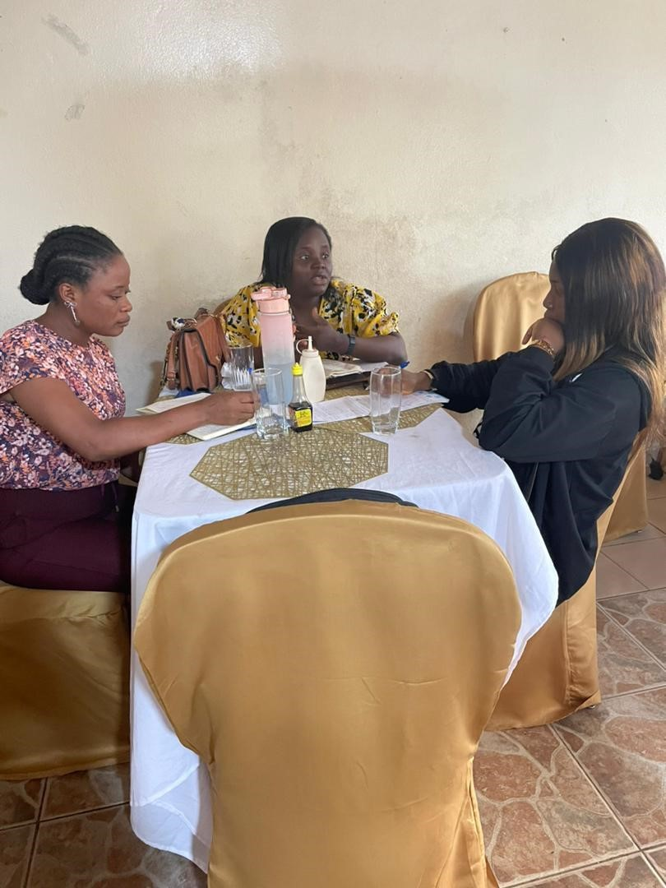

1. **A TALK /FGD ON SRHR/GBV WITH COMMUNITY WOMEN AND GIRLS AT MILE 16**

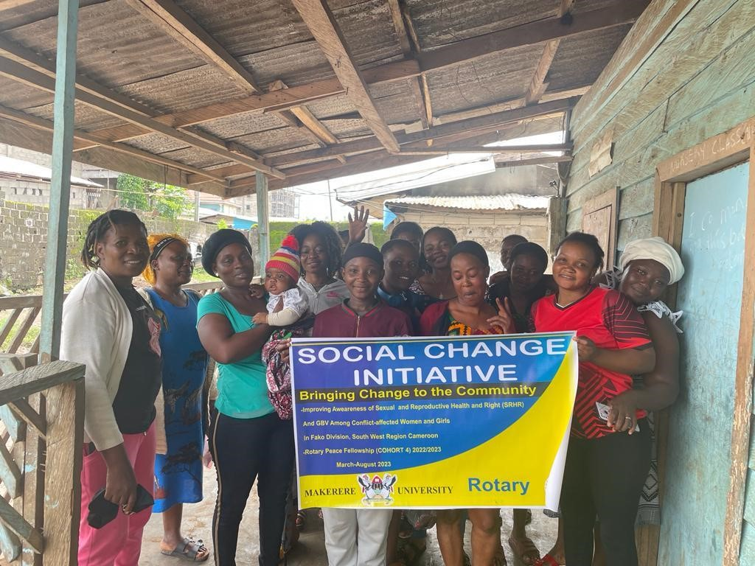

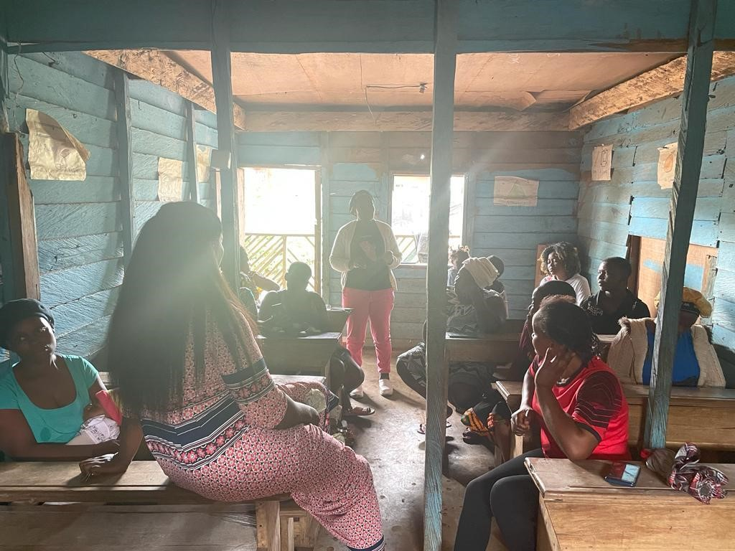

1. **A MEDIA CAMPAIGN ON GBV/SRHR AT HI TV STATION, BUEA**

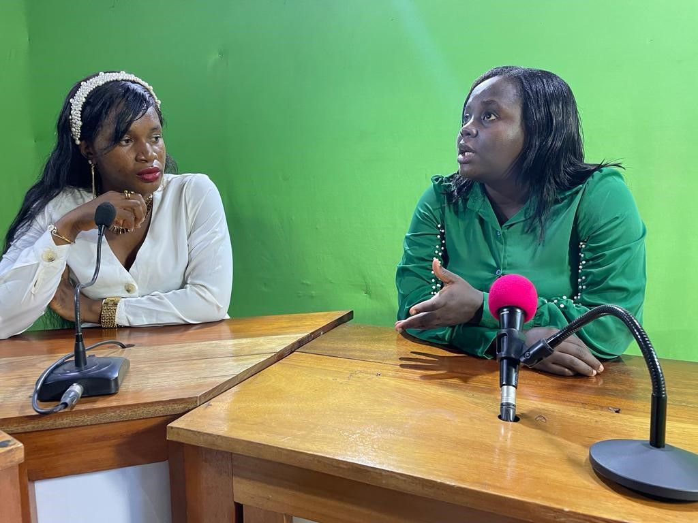

1. **A RADIO TALK SHOW ON SRHR/GBV WITH CBS RADIO STATION, BUEA, FAKO DIVISION**

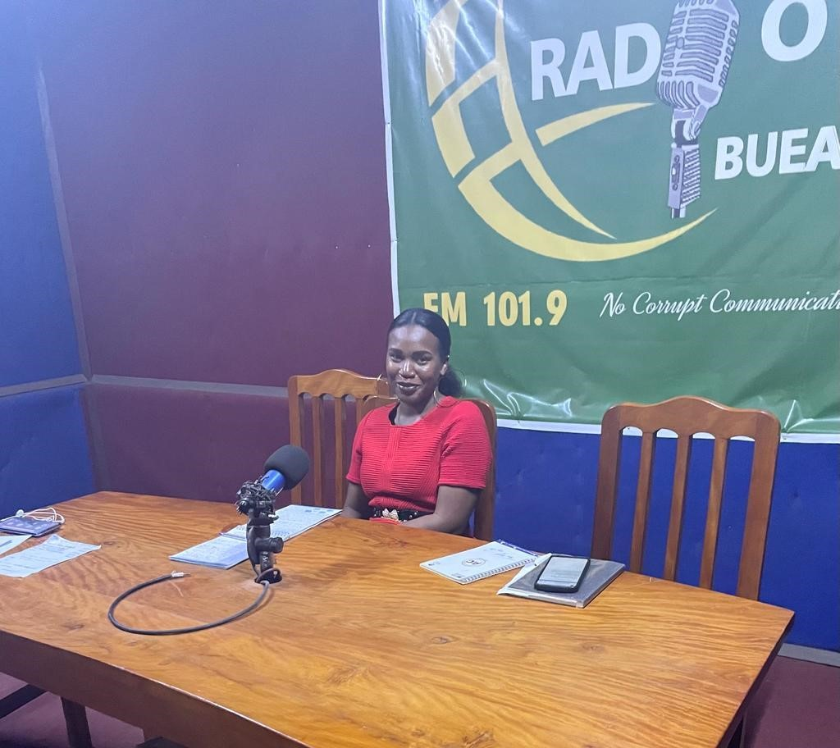



1. **MASS SENSITIZATION OF MEN AND WOMEN ON SRHR/GBV AT THE CATHOLIC CHURCH MILE -16**

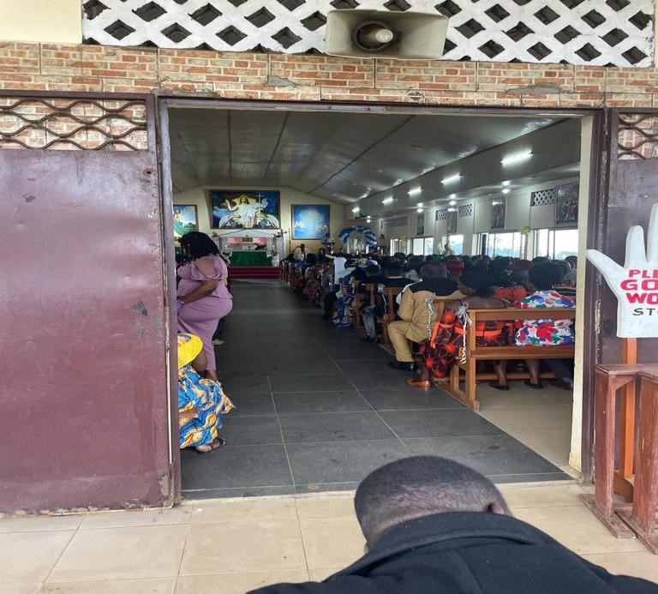

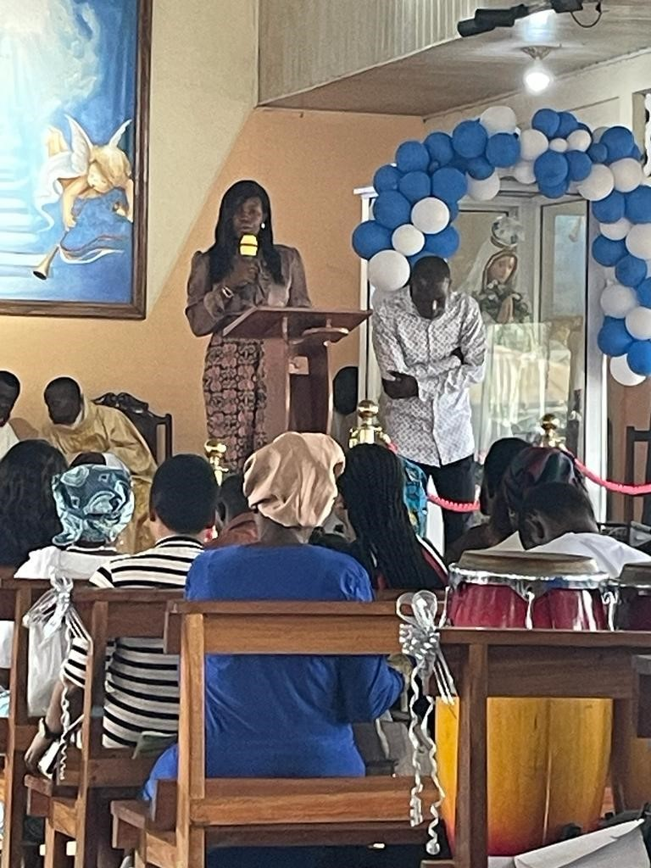

1. **ENGAGING COMMUNITY LEADERS ON SRHR AND GBV AT THE MILE 16 COMMUNITY**

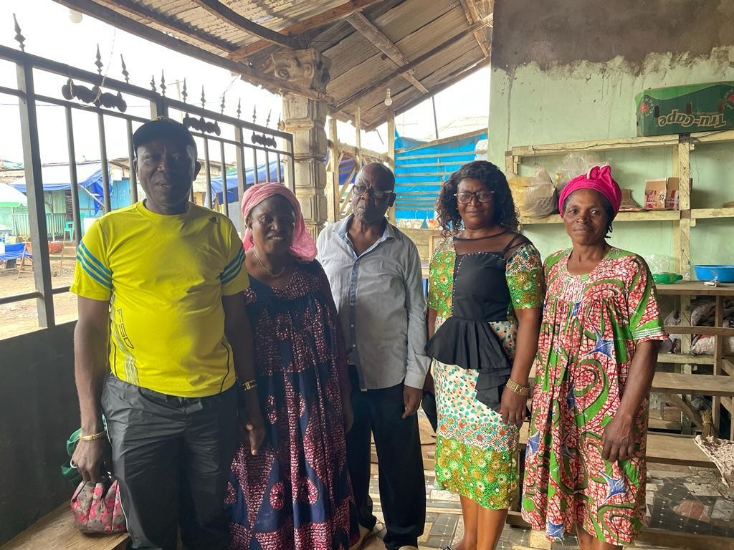

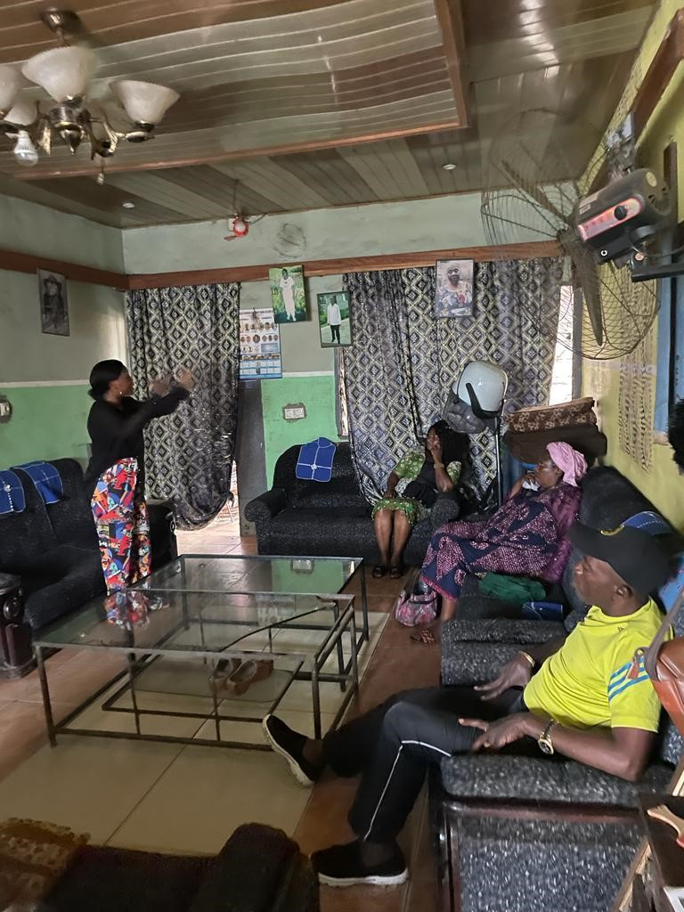

1. **A CAMPAIGN ON SRHR/GBV AT THE BONAKANDA RADIO STATION**

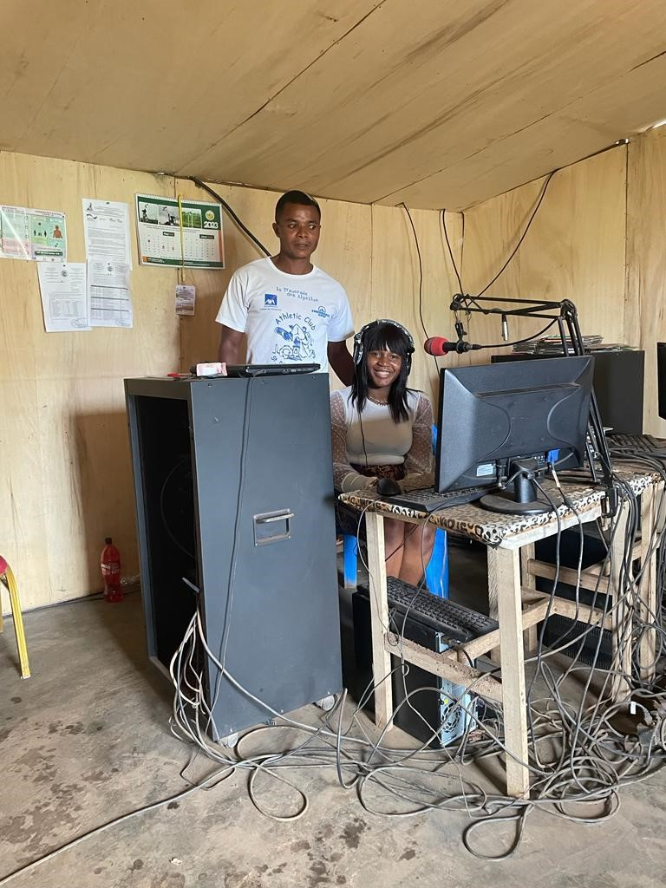

**e. Recommendation letter from Rotary Peace Center**

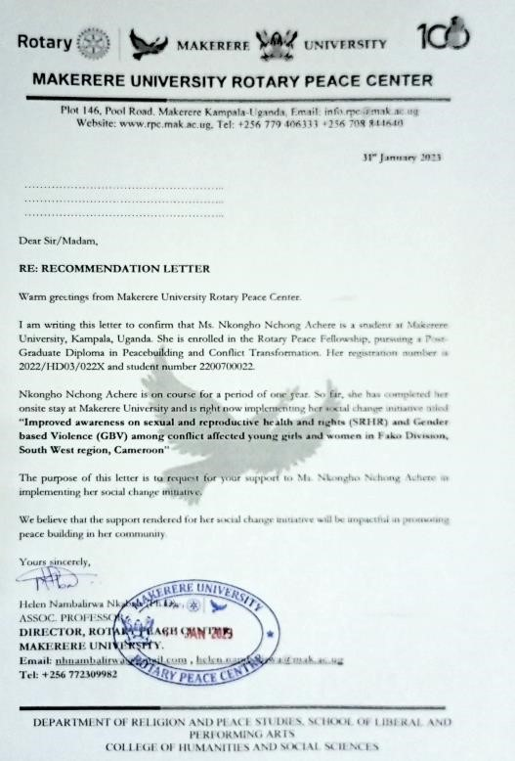

Please note that due to security and safety concerns from community members, they do not consent to taking their videos or signing any form of consent letters. In fact, successfully implementing the SCI project in such highly hit conflict areas was an immeasurable risk. Therefore, participant testimonial videos have not been included in this report. However, for evidence purposes, such videos and excerpts from the awareness raising at the Catholic church Mile 16, and radio stations, and a short video from some community leaders, have been shared with my mentor through WhatsApp with the advise that she does not share externally.