

**SOCIAL CHANGE INITIATIVES IMPLEMENTATIONS**

**ROTARY PEACE FELLOW**

**Title: Peace Building through empowering Marginalized groups and advocating system inclusivity**

**Project location:**

**Bosaso, Kismayo Somalia**

**November 2021 – August 2022**

**Final report**

**Abstract**

A Peace Building through empowering Marginalized groups and advocating system inclusivity project has been implemented from Feb-Aug. 2022 as requirement to obtain Postgraduate Diploma in Peacebuilding and conflict transformation at Makerere university and successfully complete a yearlong fellowship at Rotary Peace Center in Makerere University.

The project provided workshop and trainings in the concept of positive peace, state inclusivity, structural violence to traditional elders of the dominant and marginalized groups, state officials, youth and women leaders with aim of building social trust and state inclusivity from bottom-up level.

The project was implemented in Bosaso and Kismayo coastal districts of Somalia with direct beneficiary of 50 community members and 1000 indirect beneficiaries. (20 from Bosaso and 30 from Kisamyo). A network of volunteers has been established for the project to maintain the continuation of the project after the end of the trainings and educate the community about discrimination, self-hatred and violence against the marginalized community. Also, to follow up the ultimate change caused and ensure that representation is given to marginalized communities.

The participants of the workshop were selected for their social impact and competence in bringing about real change. Therefore, the participants were representatives of the civil society and officials of the state authority. There was a member from the lower house of the parliament of Somalia who was attracted by the project and became part of the network that was formed after the end of the project. This the report of the implemented project and consists of four chapters, namely the introductory chapter which discusses the background of the project, problem statements, and its objectives, the second chapter which is a literature review of the project which compares the similar studies that have been done before, the third chapter which emphasizes the intervention and the activities carried out. during the project and the last chapter is the conclusion of the report.

**CHAPTER ONE**

**Background 800**

Somalia’s peace and state building process become old-age problem to the region and to the continent. The approach was to invite the functional armed groups in fear that they wouldn’t let the reconciliation conferences products functional if they aren’t given priorities at the initial stage of the peace building process. This approach made the armed and powerful groups superpowers as they dominate both political and state building projects and the little humanitarian and development resources that some generous countries supported in response to the natural and manmade disasters, while marginalized groups story become untold and underneath. The issue of the Somalia’s minorities needs to be considered in the state building process of Somalia. Identification of the problem will assist getting its permanent solutions. Other than that, will be doing the same thing and expecting different results.

Before seeking to comprehend the meaning of minorities or identify who we mean minorities in the project areas, its essential to understand the meaning of inclusivity and its importance to the stability, peace and prosperity of the community. Firstly, it’s important to keep in mind that there are no single globally agreed definition for inclusivity but we will refer state inclusivity as governments that direct policies address the needs of all, and also respects the voice of all its citizens equally (Haan, 2008). In addition to that, the world submits for social development held in Copenhagen in 1995 declared a ‘social for all’[1]. For instance, article 26 of ICCPR states that “All persons are equal before the law and are entitled without any discrimination to the equal protection of the law. In this respect, the law shall prohibit any discrimination and guarantee to all persons equal and effective protection against discrimination on any ground such as race, color, sex, language, religion, political or other opinion, national or social origin, property, birth or other status (Declaretion, 1995).

Member states suggested eradication of hunger, injustice, unemployment and promote social integration, coexistence, tolerance, respect for diversity, prohibition of discrimination and equally sharing the opportunities by the citizens.

The issue wasn’t significantly address in the world submit and has been reviewed in 2005 and realized that social integration was essential element that will determine the development of communities suffering with wide spread poverty, high rate of unemployment. In addition to that, the member states viewed failure to effective community cooperation and system inclusivity will lead severe community fragmentation, inequalities and long-lasted grievances.

The issue of social integration and system inclusivity is not only important eradicating poverty or upgrading life status of the people but become an important factor for providing services including, education, health services, employment. On top of that, social exclusion created lack of access to justice and vulnerability of arbitrary killing to the marginalized groups in fragile states, and/or excluding part of community from the shared resource or banning to run state offices due to clan ratios. Examining the concept of social inclusivity with specific groups in mind, it’s an importance locating exclusion in social framework. There are substantial differences in countries regarding the social exclusion and marginalization of certain groups. Women, youth, law income people, immigrants, certain ethnic or sub-ethnic groups and so on. Most of scholars believe that Somalis are one homogenous group but that remains myth[2]. Somalia language containing two main dialects- May-May and Mahaa tiri. May is widely spoken in South-Central parts of Somalia and mainly by the agricultural-societies while Mahaa-tiri is spoken in North east- and North west and some parts of the South-central including the capital city of Mogadishu. other several languages are widely spoken in the country such as Barwanis, Mashaguli (Mashaguli is very close to Kiswahili and widely spoken districts along with the river Juba and some coastal towns of Marca, Kismayo). Other than the language diversity, the Somali people have their ethnic diversity resulted from an ancient immigration and some indigenous people who have been marginalized by nomadic communities that expanded to the riverine areas towards the southern party of the country (Enow, 2008).

The majority groups of the country are considered to Dir, Darod, Hawiye and Digil iyo Mirifle. Digil iyo Mirifle also known as Rahanwayn are settled agricultural societies while the rest three are nomic pastoralist community. The armed nomic considered themselves as noble people of their resilience to the challenges of the life and are always armed and fighters. While Barawenes, Ayle-Tunnie, Bantus and others are considered marginalized groups.

Brawenes and Banadiri communities are descendants of ancient Portuguese immigrants dated back to seventeen centuries, as well descendants of Asian (Turkish, Arabs and Indian) commercials or servants of colonial masters (Lewis, 1994). These groups are mainly found in the coastal towns of the southern Somalia. Also, Somalia has a great number of Bantus community who dominate the river areas of the country such as Kismayo and small number that has been brought during slave trade to the north-eastern region’s coastal towns such as Bosaso. Some of the latter groups have completely infiltrated with nomadic (Small number are scattered in the coastal districts of Bari region) pastoralist groups and lost their Bantu identity at all.

Other than that, the Somalis clan lineage is another important factor that ensures the existence of minority communities.

To quote UN Office of the High Commissioner on Human Rights (OHCHR):  
“Somalis are divided into clans and numerous sub-clans and the clan structure remains  
socially and politically important in every aspect of Somali life. The main four clans are:  
Darod, Hawiye, Digil and Mirifle (sometimes referred to as Rahanweyn) and Dir.” [3]

**Problem statements**

After Somalia’s state collapse in 1991, the state building process has been established based on clan power sharing system as the conflict rooted to clan contest over the power. The biggest ratios were given to the armed pastoralist communities while underestimated the coastal and agricultural societies who are mainly unarmed (Hill, 2010). Similarly, city council and local governments followed the same system approach and excluded these groups from the any existing institutions both public and private, boycotted little services that governments provide including resources, employment opportunities, education and any other services to be provided by the state authorities including humanitarian aid supports.

The socioeconomic and political exclusion faced by minorities existed prior to the civil war. Nevertheless, the former government was capable to provide security, socioeconomic and political participations. Some of the key ministerial positions were held by the competent individuals hailed from these communities. Regrettably, these groups become a soft target and there vulnerability double in the absence of the statehood. These minorities have been considered inferior, with less rights than others -Faiso from Kismayo Mashaguli community considered herself as non-Somalia-, Therefore, there demoted socioeconomic and political participation forced them to accept the status que and consider themselves as non-Somali and stateless community.

These people have been systematically excluded from normal government and business positions. Its rare to see one person from these communities in the mainstreams of privately companies such as telecommunications, export and import companies as well. the little number who held positions had no authority to speak on behalf of their community due to the fear to lose their job or and personnel safety reasons.

Goals:

* Promoting positive peace through addressing circumstances that feed structural challenges of the community
* Minimizing barriers and bottlenecks that contributed the existance of structural violence among the diverse community of Somalia

Objective:

* Contributing to building the social cohesion and peace through empowering marginalized groups
* Up-shifting community leaders’ concepts of peace by conducting workshops from twenty community leaders gathered from different community groups
* Build community networks that sustain after the workshop to continue fight for equality among the people

Challenges and Mitigations 400

Since 1991, when Somalia last government collapse, Somalia remains a lawless country whereby most of the cities are governed by warlords and elite groups backed by the international community. The rural areas are either governed by radical fundamentalist groups or clan elders under the customary laws. Due to the lack of functioning state, the country hosted all the international illegal activities such as terrorist and piracy groups. Because of this, Somalia’s affairs become spotlight of the international groups and several peace building and reconciliation missions has been hugely invested since then. Unfortunately, Somalia still remains practically ungoverned territory and if it’s to be formed a functional and sustainable state, its essential to consider the structure of the Somalia community which is based on clans from various sub-ethnic or ethnic groups (Lewis, 1994). The former reconciliation efforts denied the diversity of the Somali community and only focused the armed groups while underestimated the existence of large amount of the community. The presence of agricultural and coastal community. This social change has focused a least addressed topic which is building the Somalia peace from the bottom up by giving a chance to the ordinary citizens to talk about how best they can remain in peace. Thus, for being new approach of reconciliation, the activity needed to continue longer than the scheduled duration of nine months. However, the intellectual community members, leaders, and state members guaranteed that the effort will continue in a sense of ownership and will periodically conduct workshops and conferences to follow up updates and the progress of this effort.

Another main challenge faced during the implementation of advocating system inclusivity and empowering marginalized groups was that the issue was not much interested by the elite and political leaders due to the effect of droughts to the people’s livelihood and imposed economic crises. Thus, this project was seen irrelevant and unimportant in the current context.

In addition to that, this project was addressing a very fresh project that never been talked about and required a huge investment, but for this time it was only funded by the SCI implementor as sense of return to community.

Lastly, but not least, due to security challenges, the facilitator of this activity, members of the community leaders and state officials were not able to visit areas controlled by the armed radical groups and anti-government elements.

**Chapter two**

**Literature review**

The research conducted critical and documentary review through the use of official documents, personal experiences as the source of the information. Similarly, content analysis involved studying existing information recorded from traditional elders, long served politicians and technocrats from the project location.

**Somalis’ unique clan-based system of governance: The pastoralist power**

The clan remains essential for accessing political positions and other social involvement in Somalia including marriage. The two main pastoralist communities dominated majority of the commonly shared resources and represented the Somali people plus the Rahanweyn or Digil and Mirifle (Agropastoral society that dominate south-west of the country and scattered in other parts of Somalia) (Hill, RedressSomalia's forgotten minorities, 2013). Therefore, both scholars, international humanitarian workers and regions organization who involve the Somali politics in one way or other ignored the existence of large number of Somali people which are the Somali Bantus, the Somali Asian descents. Most of the anthropologists considered Somalis as homogenous people.

These groups area fanatic armed groups that dominate both urban and rural areas of the country before and after the independence. In the modern history of Somalis from independence to dictatorship, to collapse and in the current political chaos Somali is completely reflected by only these armed pastoralist groups.

While the excluded minority sought out new contemporary economic and political roles, some economically distressed majority members have entered professions that were previously held exclusively by certain minorities, such as shoemaking, leatherworking, and construction.

However, the data obtained for this analysis still makes clear past patterns of clan-based dominance and majoritarian abuse of minority' human rights.

For instance, denying the right to self-determination and the ability to hold public office.

**Somalis marginalized groups: a legacy of exclusion from public institutions**

According to the UN Declaration on the Rights of Persons Belonging to National or Ethnic, Religious, or Linguistic Minorities, Somalia's minorities are various and are not just defined by components of ethnic, religious, or linguistic distinction.

These differences between minorities and the pastoralist majority populations mentioned in the previous section are based on social and historical distinctions.

Three separate, non-violent social groups—the Bantu, Benadiri, and "occupational groups"—make up the majority of minorities.

In addition to sharing a common language and a variety of cultural traits with the majority population, all minorities are also Somali.

The majority of minority groups have ties to certain historical and cultural contexts.

Bantu are a relic of the Zanzibar-based Arab slave trade during the nineteenth century, when Somalis were bought and sold for the benefit of abducted Africans from east and southern Africa.

Banadir are descended from immigrants from the Arabian Peninsula who settled in foreign trading communities in southern coastal cities up to 1,500 years ago.

Traditionally, pastoralists received services from the inferior, non-pastoralist "occupational groups" in a segregated manner.

Bantu were originally concentrated in the inter-riverine farming and forested regions of southern Somalia before large-scale internal population relocation because of conflict began in 1991.

While occupational groups were dispersed throughout the majority of rural and urban areas in tiny settlements, the Benadiri dwelt in southern coastal towns. Bantu and occupational groups were typically in a slave or tied relationship with specific local clans and lineages.

These interconnected links, known as sheegat, slid away when an individual or family fled, relocated, or lost their patron, setting them free but leaving them exposed.

Some people made an attempt to get away by leaving and redefining their ancestry in order to pose as a member of a clan, frequently their former protective clan.

All three minority groups experience marginalization, discrimination, and general bans on inter-clan marriage, which has kept them largely apart from the majority for generations.

The well-known Somali proverbs, which summarize the social marginalization of Bantu and "occupational groups," the most segregated and discriminated-again minorities, are ‘No-one will weep for you’ (looma-ooyaan in Somali) and ‘No-one will avenge your death’ (looma-aaran), indicating that minorities cannot expect redress if their rights are violated. 25 Majority clans traditionally refused to marry people belonging to minorities or eat with them (considering some of their dietary habits unclean).

**Theoretical underpinning 1000**

The heterogeneity, clan structure and cultural identifies in Somalia together clan contest of the scarce resource makes Somalia a vulnerable country for structural violence and inequalities among the people of the country. The theory of peace has undergone several changes and has been broaden the views from the absence of violence. Galtung distinguished the peace into two more broader pillar. Positive peace which is the absent of psychological and physical violence and fear. And Negative peace defined as addressing peace in institutional concepts. Evaluating factors that contribute social unrest such as economic injustice, structural violence and absence of institutions that maintain peace. Galtung has always seen peace more than absence of negative peace and instead focus on positive peace which is absence of structural violence, social mistrust, exclusion and denial of rights and acceptance of each other. Furthermore, the modern-day institutions have been trusted that adult citizens rights and endorsement of democratization principles in every corner of the world and every society in this planet is a must and good move. Democratization is substantial for ensuring the stability and prosperity of the country through building inclusive system of governance that considered all the sectors of the society. John S. Dryzek, University of Malbourne.

The fragmentation of the Somali community created socioeconomic and political marginalization to the minority groups that resulted denial of all the basic rights. Before we discuss out intervention to this matter, let us theoretical_M`````````0nd denial of rights in more academic bases.

Silver 1994 describes theory of exclusion according to three different prospective. Solidarity, Specialization and Monopoly.

According to Silver, In the solidarity paradigm exclusion refers to a rupture of social ties in society. The paradigm is moral and cultural rather than economically focused. Here, according to the principle of solidarity, the State h the collective responsibility to repair this fragmentation through a third way between liberalism and socialism.

Exclusion in the specialization paradigm refers to the division of labor and functional realms, emphasizing contractual exchanges between rights and obligations of individuals in line with the neoliberal model.

Individual liberty can transcend boundaries due to the "specialization" of functions, and discrimination occurs when a person or group is prevented from fully engaging in social trade due to exclusion from the action sphere.

According to the monopoly paradigm, monopolies are created as a result of exclusion.

The interests of those who are included are served by exclusion, which results from the interaction of class, status, and political power (Silver 1994).

The establishment of a monopoly group aims to forge a tie of shared interest among "unequal insiders," who then exclude and rule the outsiders. Formal rights like citizenship and membership extensions help to overcome exclusion. Summarizing Silver's case, it is evident that conceptualizing exclusion is more of a political activity than a purely academic or theoretical one. This is especially true of the European discussion, where exclusion was employed more frequently than in other regions of the world as a political notion.

**Theory of Change and how it was applied 800**

The social change implementation was channeled on building system inclusivity through upgrading the knowledge and the skills of the stakeholders on the matters related to social inclusion, political participation, and effects of structural violence.

Stakeholders are classified in two main groups in this social change.

1. The public servants and state drivers
2. The community based organization, such as religious leaders, dominant and minorities cultural leaders and youth umbrellas

Both of the groups have role to lead a change to the community and can significantly contribute to the fight against any forms of social exclusion from bottom-up level. Elders represent the community of all sectors in the bases of clan identify and they certainly influence the society and aware the them the bad effects of exclusion and fragmentation of the community.

Public servants at the district and ministerial level are informative to the problems that structural violence caused the community. They’re able to drive the system thinking peace building concept to the decision-making tables. Hence, there presence and participation to this program is key and vital for its success and even sustainability.

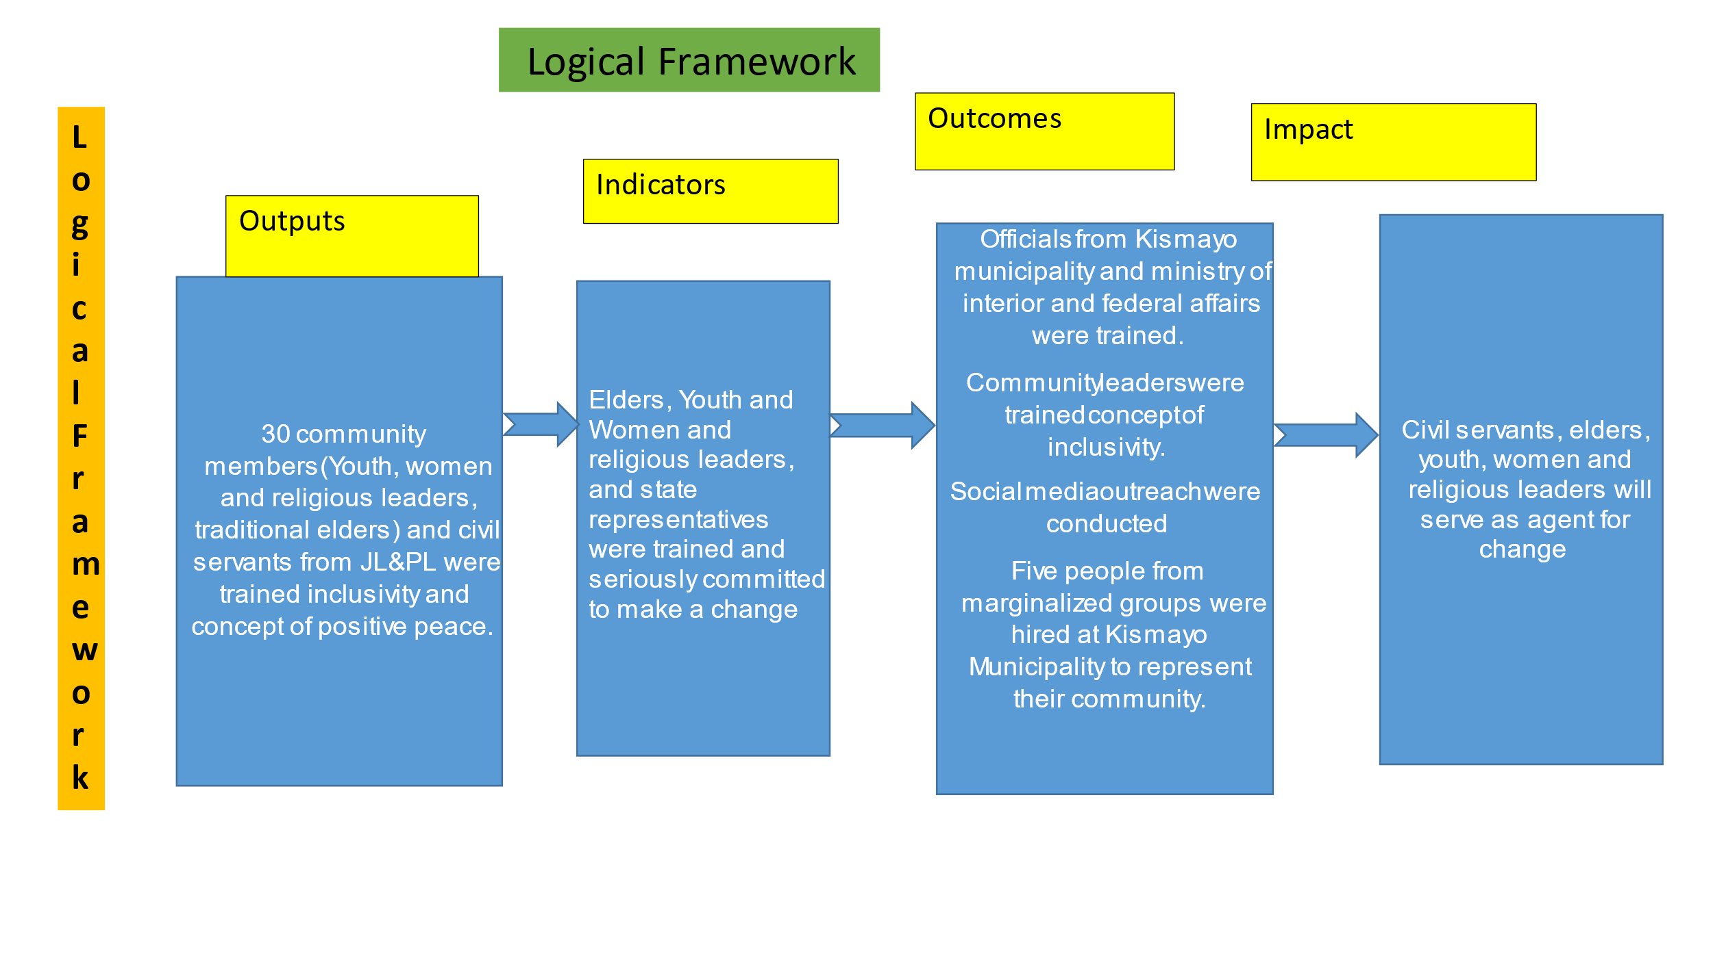

**Logical framework**

**Methods and Design (800words)**

The project is aimed to work the common interest for the people of Somalia as contributing to building their social cohesion and peace through empowering marginalized groups. Somalia has been a classical example of a failed and clan fragmented state since 1991. In 2004 an international community led state building efforts has been established endorsed a federal system in Somalia based on clan-based formula of 4.5 (The four-armed groups should obtain higher positions and key ministerial) The armed groups should be considered as 0.5 which means someone from this group can’t run for Presidential, Prime Minister, Parliamentary speakers. Also, should be appointed to the key ministers in the cabinet such as the Ministry of Defense, Foreign Affairs, Interior, Education and Health of the central government.

In response to such challenge this social change initiatives implemented in forementioned Federal Member states with following activities conducted:

1. **Engagement with the community leaders:**

* February 5-17, 2022, I have engaged with the political leaders of Jubaland state of Somalia to discuss their political agenda of marginalized groups.

1. To build a sense of ownership we must build trust in the system. Institutions of the government. Said by Mayor of Kismayo Mr. Omar Farole. He added that the marginalization based on the clan brings their people in constant chaos saying “Some of the community believes that they come here (the state) while others have been removed by force”. If this is the idea, those who’re recently in power will one day be replaced by others. But an inclusive system should be stable and sustainable.

* On the other hand, I have met the Director General of the Ministry of Interior and Reconciliation and Federalism of Jubaland state of Somalia. His excellency Darwish. The Minister stated their state level policy towards tackling the clan-based system into a more modern democratic system of governance. And He said, we have clear plan.
* To remove the clan system and build community-based organizations and unions such as farms and agricultural society.
* Citizen registration without requiring his clan identity
* Preparation of one person one vote for all local councils of Jubaland, this policy will end the clan nomination for their representatives of the government

**2.      Awareness on the importance of community cohesion:**

On March 17-28 a workshop has been conducted in Bosaso, Puntland state of Somalia and covered the following points:

a.      Importance of community shared system of governance

b.      The equal rights of citizens in system of governance and services provided by the state

c.      Consequences of exclusion and discrimination among the community in district level, region and nation wide

twenty members from local NGOs of Bossaso, social activities, religious leaders, clan elders have attended the workshop to discuss the issue. They all underlined the importance of building social trust through creating a platform and political space for the discriminated groups of their areas.

**3.      Fruits of discussion:**

1. Five people from the marginalized groups will be employed by the Ministry of Interior, Reconciliation and Federalism of Jubaland State.
2. A Bajuni origin professional will be appointed as the Head of department of Kismayo Municipality.

|  |  |
| --- | --- |
| **Methods** | **Criteria / Description** |
| Preparation of the training and learning materials | The following items were provided to the participants   * the agenda of the trainings with list of participants invited * Reading materials for the concept of Negative and Positive Peace, Structural violence, Copenhagen declarations of human rights and inclusivity. * Preparation of conducive environment for the trainings * Note books, pends, flipcharts * Refreshments |
| Engagement with CBO Religious Leaders, women and traditional elders | * Traditional elders of both dominant and marginalized groups were engaged to discuss the issue. The trained the concept of positive, importance of community cohesion challenges imposed by the exclusion to the society wellbeing. |
| Activating city councils of Kismayo | The SCI implementor invited the city council and Mayor of Kismayo to discuss the importance of creating representation space to the marginalized resident of the city |
| FGS-House of the people engagement | * Engagement with the members of Parliament of the Federal government of Somalia that represent the dominant and marginalized citizens. |
| Social Media engagement | * Due to financial restraints the project wasn’t able to afford radio broadcasting and alternatively used social media platforms to attract the attention of good wishers, decision makers and other potential leaders of the community. |

**CHAPTER THREE**

**Interventions and Activities: 2O0 words)**

The intervention of social change is designed to engage with the different potential stakeholders. The project used from bottom-up approach of building the system of inclusivity categorized the stakeholders into three main groups. These groups were trained the concept of peace through empowering the marginalized group and removing all barriers that created or motivated division and subjection against part of the people,

1. State representees and civil servants: the project has engaged with the city council of Kismayo district, Mayor, high rank officials from the ministry of interior, reconciliation and federal affairs.
2. Community Leaders: The project has engaged with leaders of the women organizations, youth umbrellas, religious scholars, and traditional elders of the communities of Bossaso, Kismayo and surrounding areas.
3. Leaders of the Marginalized groups: The project has approached to the leaders of the Mashanguli, Jareer and Barwains to study the state exclusion context in Somalia and experience of the excluded groups. Also, to identify approaches that can be used to restore their citizen rights and system inclusivity.

**Key findings / impact: 800 WORDS**

According to Nina Evason 2019, Somali people has their unique structure of clan based. Society are linked up in clan bases and membership of the clan is determined by parental lineage from the father side. Everyone can easily trace back his roots from this lineage from generation to generations. Also can determine his or her blood line relations to other people. And due to the absence of functional system of governance, everyone is dependent on his clansmen alternatively to the governance system. This means if the person hails from the dominant groups has good access to employment opportunities, health facilities, education, food aid programs and many other. On the other hand, the marginalized groups aren’t given single slice portion of the cake.

Furthermore, marginalized groups are soft target as they are nickname “LOOMA OOYAAN” meaning NO ONE CRIES FOR THEM.

Moge a TVET center instructor who himself among the Mashunguli community that lives Kismayo and its outskirts claimed that they feel safer now compared to the before establishment of Jubaland regional authority. However, a participant who preferred anonymity for security reason pointed out that the marginalized people of Jubaland state particularly Kismayo and outskirts are denied to access the food aid programs that intended to internally displaced people. Our farms has been illegally confiscated by Alshabab as they governance the river basin areas of Jubaland and we have no access to work in the town as all the sources of employment are dominated by the other group, another participant added.

On top of that, the young girls works as home maids in Kismayo to generate some income that they can support to their families. Unfortunately, due to lack protective mechanisms in place some has been killed by their masters and their cases weren’t even seriously prosecuted.

In Bosaso, the coastal town of the north-eastern region of Somalia marginalized groups face similar challenges to those of Kismayo. They’re discriminated to the community integration such as marriage. Ali confirmed that he was threated for dating a lady from the dominant group. Hassan A leader from the marginalized groups of Bosaso confirmed that many people has been killed for marrying majority groups. Similarly, they’re excluded from the decision making tables has they have no single police officer in Puntland Police services who hails from them or representatives in the city councils, parliaments and other government institutions to represent the interest of their community.

**Impact analysis – Measuring the change and impact**

The project has learned that this problem can only be solved to Somali led initiative in bottom up approach. Thus, the traditional elders, religious leaders, youth and women networks and civil servants were trained to the importance of system inclusivity for all the citizens. Everyone realized the importance of co-existence and acceptance of each other and guaranteed to promote inclusivity based on his or her capacity. The following change was achieved during the project implementation:

* The Mayor of Kismayo municipality has appointed a head of department to a Bajuni professional to promote system inclusivity.
* Five people from the marginalized groups have been employed by the Ministry of Interior, Reconciliation and Federalism of Jubaland State.
* A religious leaders conducted preaches the people to the equality that has been talked in the holy Kuran and Islamic principles.

**Biography of the participants**

The participants of this projects are traditional leaders, government officials and youth and women networks and was selected based on their competence to influence other decision makers and public outreach. Also, the project gave consideration to gender inclusivity.

**CHAPTER TOUR**

**General Conclusion**

A definition of inclusive states might be governments that direct policies for addressing the needs of all, also respecting the rights of citizens to exercise voice and influence on which services are provided and how they are delivered. In concrete terms, inclusive states should have an interest in strengthening the social contract with their citizens. The opposite of this, structural inequality, is a condition arising from unequal status attributed to a category of people in relation to others, a relationship perpetuated and reinforced by unequal relations in roles, functions, decision rights and opportunities. (Dani, 2008)

Article 4th of the Somali constitution states the citizens are have equal rights and promotes participatory consultative and inclusive government to ensure the interest of all the people are represented equally. But this remains only theoretically and minorities of Somalia face severe challenge to access political participation, and difficult to access the basic citizen rights.

The state building projects that has been led by the African union, the UN and regional organizations were only favored to the pastoralist dominant Somalis. The prolonged-civil war and armed conflicts of Somalia motivated to fucus only the armed groups and violation of human rights and system exclusion against minorities of Somalia has been discounted.

The clan structure denied competent personnel from this group to participate serving for the state and represented the interest of their community particularly. Thus, they become misfortunate for accessing education, health, and humanitarian aid services provided by the international nongovernmental organizations.

However, the different stakeholders that has been engaged by the project has realized the importance of inclusivity in good governance, prosperity, lasting peace for their community and are strongly committed to build bridges and mechanisms to tackle this problem.

**Recommendations / implications for Policy: (500 words)**

The implementation of this social change of supporting state inclusivity through empowering marginalized groups by advocating. The project outreached senior government staff, members of the house of the people, elders from both dominant and marginalized groups in Somalia and they all appreciated. One of the participants pointed out that his feeling has been talked about and with community work can be solved.

Intellectual participants of the community showed their interest of peacefulness and lowering graveness among the community.

Practicing the principles of no one left behind and creating state inclusivity that represent all the sectors of the society will minimize the chance of occurring structural violence, also the demand of everyone will be heard by the community members. Thus, its essential to encourage conducting such projects. Furthermore, the project discovered that humanitarian aid programs are not equally shared to the Somali citizens as people from the least represented left behind.

In conclusion, inclusivity in the state building process requires political decisions that can only be reached in the highly protected areas. However, engagement with government officials and community leaders should assist reaching in those offices and solving grievances from bottom.

**Sustainability plan: (800words)**

Beneficiaries of this social change formed social clubs that will voluntarily continue to advocate the state inclusivity in their respective. Also, members from house of the people of the Federal government of Somalia.

The provision of this kind of workshop builds not only their view to peace but also helps to evaluate the existing peace and future threats and injustices that might emerge due to structural violence and or lack of equal representation in government offices.

The direct beneficiaries become members to the first rotary club established in Somalia. The rotary club of Somalia to engage with more capacity building training and contribute changing the status que. Furthermore, the participants established a permanent network and assured to continue building social trust through:

* Providing training sessions to the other occupation peers to spread the concept of peace building through inclusivity
* Conducting awareness against marriage discrimination through Mosque preaching and campaigning other community centers
* Placement of certain technocrats from the marginalized groups to represent the interest of their community.
* Advocating laws and policies toward state inclusivity at the lower house of the people.

**Appendix**

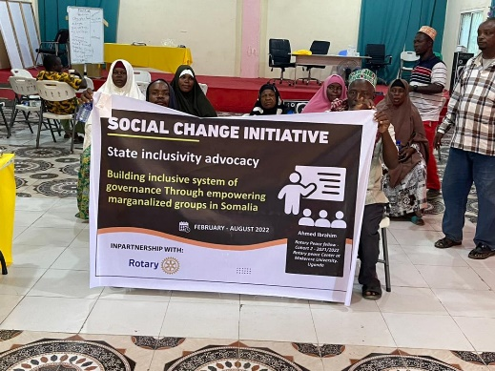

System inclusivity workshop help in Kismayo

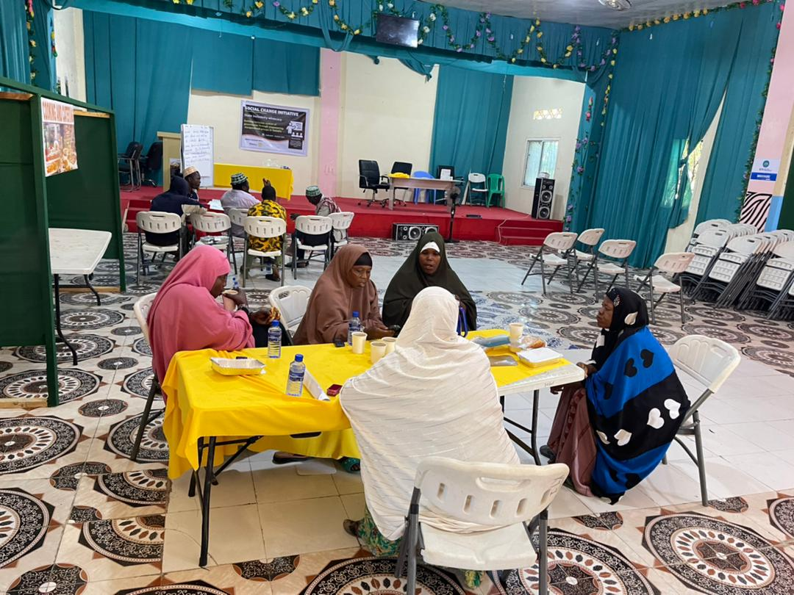

Participants discussing their experience of structural violence

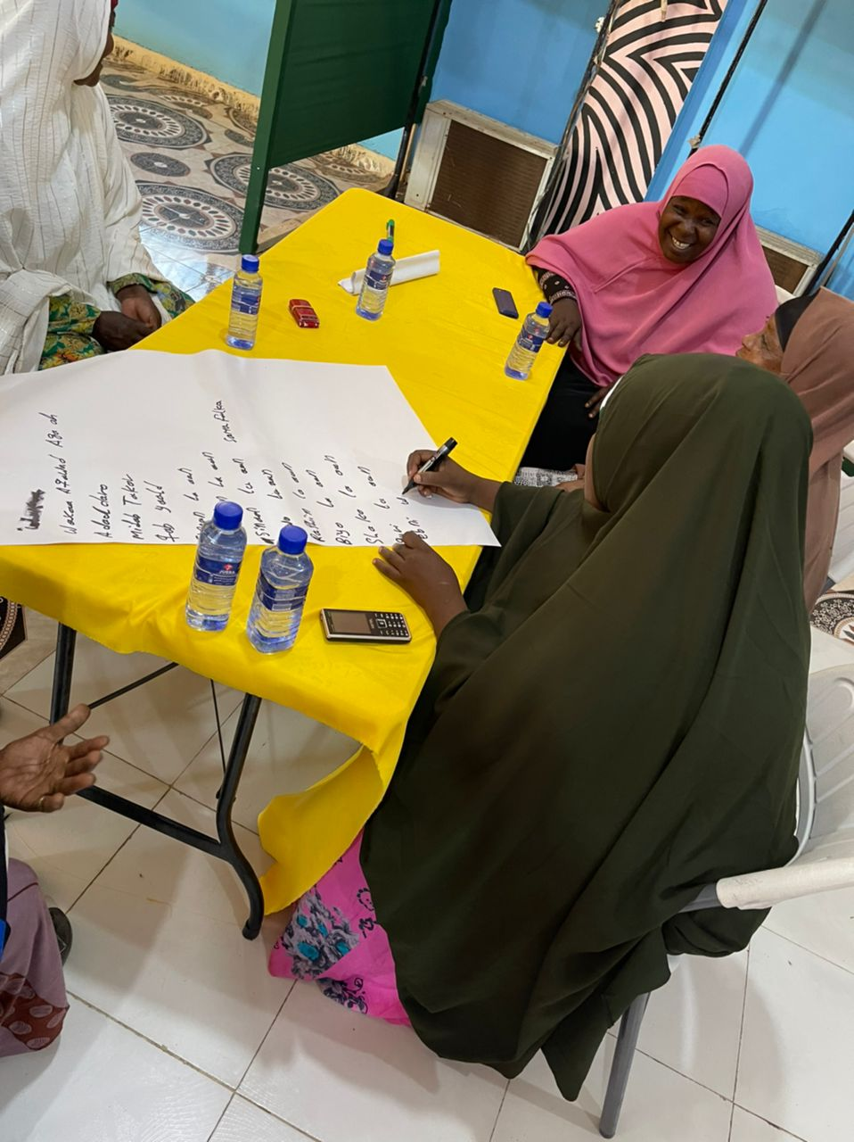

Group activities conducted by the participants.

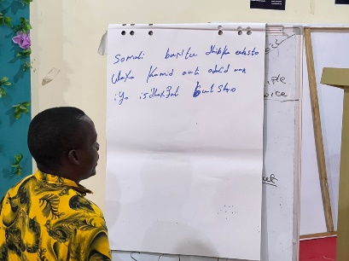

Marginalized groups in Kismayo faces discrimination

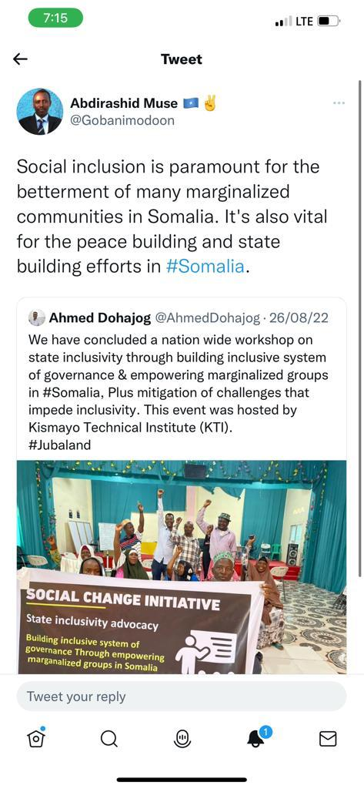

Communication advisor to the office of the PM advocating the project through Twitter space

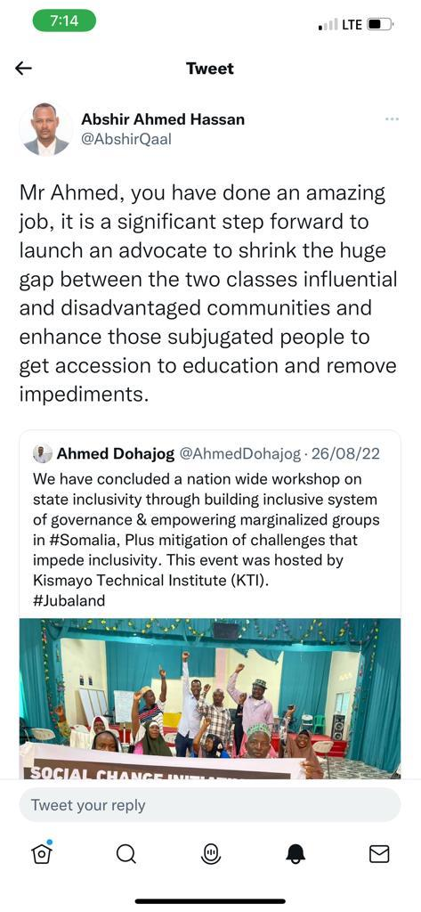

Senior Advisor of Bosaso Municipality appreciated the project.

1. <https://www.ohchr.org/en/professionalinterest/pages/ccpr.asp>
2. “At the end of the colonial era Somalia was arguably in ethnic terms the most homogeneous country in sub-Saharan Africa.”  
   https://www.economist.com/middle-east-and-africa/2013/05/11/the-centre-holds-but-only-just  
    Expert anthropologist personal communication to the auth
3. in Somalia, UN OCHA 2002: https://reliefweb.int/report/somalia/study-minorities-somalia  
    Voices Unheard, OHCHR, 2019: https://unsom.unmissions.org/sites/default/files/voices_unheard_english_final.pdf  
    No Redress: Somalia’s Forgotten Minorities, Martin Hill, Minority Rights Group, 2010, p 11.