**STRENGTHENING CAPACITY OF NATIONAL GOVERNMENT ADMINISTRATIVE OFFICERS (NGAOS) FOR A DUAL APPROACH TO CALIBRATING AND PREVENTING VIOLENT EXTREMISM IN KENYA**

**Graham Amakanji Oluteyo**

**A Social Change Initiative Implementation Report by Graham Amakanji Oluteyo of Registration Number 2300700002 between January and October 2024 in Kenya submitted to the Rotary Peace Center, Makerere University, Kampala-Uganda**

**August, 2024**

# ACKNOWLEDGEMENTS

I would like to express my sincere gratitude to all the lecturers at the Rotary Peace Center, Makerere University, who, during my three-month stay at the Center, overtly helped shape and refine this Social Change Initiative (SCI) through their thought-provoking classes. Your guidance and expertise laid a strong foundation for this initiative. I extend my heartfelt appreciation to the Center Director, Prof. Helen Nkabala, and the dedicated staff members Richard, Seera, and Cissy, who were not only supportive during my stay at the Center but also provided continuous assistance throughout the implementation of the SCI.

My deepest thanks go to Dr. Chris Tuhirirwe, my SCI implementation supervisor, who, despite working remotely, diligently guided me through the entire process, offering invaluable advice and mentorship. I am equally grateful to my team of research assistants, Steve Otieno and Ainsworth Obwaka, for their tireless dedication and hands-on support in ensuring the successful execution of this initiative.

Special thanks are extended to the great people of Mount Elgon and the National Government Administrative Officers (NGAOs) at the Western Regional Headquarters, who played a pivotal role in this journey by actively participating in the training sessions. Your receptiveness, enthusiasm, and ownership of this initiative made it possible to effect real change on the ground. As I present this SCI during the Capstone Week in October 2024, I am deeply appreciative of your commitment to implementing the project and contributing to its success.

I also wish to acknowledge the Faculty members of the School of Disaster Management and Humanitarian Assistance at Masinde Muliro University of Science & Technology for allowing me time off to study at Makerere University and for providing unwavering support during the SCI implementation. Your encouragement and understanding have been instrumental in achieving this milestone.

To my family – Eeden, Hami, Lydia, Brian, and Mama – thank you for your love, patience, and unwavering belief in me. You have held my hands throughout this journey, and your support has been my greatest strength.

I would be remiss if I did not recognize the Rotary Peace Foundation for its tireless conflict prevention efforts and for creating opportunities for initiatives such as this, which truly make a difference. Finally, I am profoundly grateful to God for the gift of good health, strength, and guidance throughout this journey.

I am immensely proud that today, the work of my hands is contributing to changing the security architecture of Kenya, and I look forward to continued progress in building a more peaceful and resilient society. Thank you all.

# ABSTRACT

Over the 10-month implementation period, this social change initiative aimed to contribute to a safer and more resilient society by enhancing the capabilities of National Government Administrative Officers and communities in addressing and preventing violent extremism. The overall objective of the study was to Strengthen Capacity of National Government Administrative Officers for a Dual Approach to Calibrating and Preventing Violent Extremism in Kenya. The specific objectives of the initiative were to: Enhance NGAOs capacity in applying violent extremism measurement; Develop targeted and customized tool for calibrating risk of extremism using a participatory approach; Develop targeted and customized tool for prevention of the risk of recidivism using a participatory approach and to apply the customized tool for measuring the risk of extremism. The study was guided by a theory of change. The study triangulated three theories namely: diffusion of innovation, transformation learning and social cognitive

theories. The combined impact of the specific objectives was expected to result in more accurate assessments of risk for recruitment into or support for violent extremism, targeted interventions, reduced risk of recidivism, higher rates of successful reintegration, and a knowledge-sharing community that fosters continuous improvement in countering violent extremism efforts. The project is anchored on a number of national, regional and global legal and policy frameworks- Sustainable Development Agenda 2030, Positive Peace Framework, African Union Agenda 2063, Kenya’s Vision 2030 and accelerate the attainment of the Bottom-up Economic Transformation Agenda of Kenya.

**Key words**: *Calibrate, Capacity, Extremism, NGAOs, Risk*.

# TABLE OF CONTENTS

**ACKNOWLEDGEMENTS** ii

**ABSTRACT** iii

**TABLE OF CONTENTS** iv

**LIST OF FIGURES** vii

**LIST OF TABLES** viii

**LIST OF PLATES** ix

**LIST OF APPENDICES** x

**CHAPTER ONE: INTRODUCTION** 1

1.1 Background 1

1.2 Statement of the Problem 2

1.3 Project Goals and Objectives (400) 2

1.4 Legal & Policy Frameworks Guiding the Initiative 3

1.5 Project Beneficiaries 3

1.6 Intermediate Outcomes 3

1.7 Long-Term Impact 4

1.8 Challenges and Mitigation Strategies 4

**CHAPTER TWO: LITERATURE REVIEW** 6

2.1 Empirical Literature Review 6

2.1.1 Drivers of Radicalization 6

2.1.1.1 Ideological Drivers 6

2.1.1.2 Socio-economic Drivers 6

2.1.1.3 Political Drivers 7

2.1.1.4 Personal Drivers 7

2.1.1.5 Global/Geopolitical Drivers 7

2.1.1.6 Technological Drivers 7

2.1.2 Agents of Radicalization 7

2.1.2.1 Educational Institutions 8

2.1.2.2 Religious Institutions 8

2.1.2.3 Internet and Mass media 8

2.1.2.4 Remand Centers and Prisons 8

2.1.2.5 Refugee Camps 9

2.1.2.6 Neighborhood Dynamics 9

2.1.2.7 Training Camps Locally and Abroad 9

2.1.3 Phases of Radicalization 9

2.1.4 Approaches to Prevention of Violent Extremism 10

2.1.4.1 Level One - General Preventive Efforts 10

2.1.4.2 Level Two - Specific Preventive Efforts 10

2.1.4.3 Level Three - Individually Oriented Preventive Efforts 10

2.1.5 Work Pillars for CVE 10

2.1.5.1 Psychosocial Pillar 10

2.1.5.2 Education Pillar 11

2.1.5.3 Political Pillar 11

2.1.5.4 Security Pillar 11

2.1.5.5 Faith Based and Ideological Pillar 11

2.1.5.6 Training and Capacity Building Pillar 11

2.1.5.7 Arts and Culture Pillar 12

2.1.5.8 Legal and Policy Pillar 12

2.1.5.9 Media and Online Pillar 12

2.2 Conceptual Framework 12

2.2.1 Diffusion of Innovation Theory by Everett Rogers, 1982 13

2.2.2 Transformation Learning Theory by Jack Mezirow 15

2.2.3 Social Cognitive Theory by Albert Bandura 15

2.2.4 Theory of Change 17

2.2.5 Conceptual Framework Model 18

**CHAPTER THREE: METHODOLOGY** 19

3.1 Study Area 19

3.2 Target Population 19

The target population comprised 25 participants. These included 19 gate keepers and 6 NGAOs in the study areas. 19

3.3 Social Change Initiative Procedures 19

3.4 Ethical Guidelines in the Implementation of the SCI 20

**CHAPTER FOUR: INTERVENTIONS, ACTIVITIES, OUTPUTS, IMPACTS AND OUTCOMES OF THE SOCIAL CHANGE INITIATIVE** 21

4.1 Presentation of the Social Change Initiative to MMUST Directorate of Research and Postgraduate Support (DRPS) 21

4.2 Baseline Survey of Current Capacity of NGAOs 22

4.3 Capacity Enhancement of NGAOs and communities at risk of extremism 23

4.4 Collaborative Development of Customized Tools for Detection and Prevention 26

4.5 Application of Customized Tools 29

4.6 Monitoring & Evaluation of Customized Tools 30

4.7 Project Implementation Matrix 32

4.8 Key Findings of the Social Change Initiative 32

**CHAPTER FIVE: CONLUSIONS, RECOMMENDATIONS AND PROJECT SUSTAINABILITY PLAN** 34

5.1 Conclusion 34

5.2 Recommendations 34

5.3 Project Sustainability Plan 35

References 37

Appendices 38

# LIST OF FIGURES

Figure 2.1: Conceptual Framework Model Guiding the Social Change Initiative on Strengthening Capacity of NGAOs in Detecting Risk and Preventing Recidivism in Kenya 18

# LIST OF TABLES

Table 1.1: Table Showing the Theory of Change 17

Table 3.1: Distribution of Target Population 19

Table 4.1: Table Showing Activities, Outputs, Impacts, Outcomes and Impacts for Activity One 21

Table 4.2: Table Showing Activities, Outputs, Impacts, Outcomes and Impacts for Activity Two 22

Table 4.3: Table Showing Activities, Outputs, Impacts, Outcomes and Impacts for Activity Three 23

Table 4.4: Table Showing Activities, Outputs, Impacts, Outcomes and Impacts for Activity Four 26

Table 4.5: Table Showing Activities, Outputs, Impacts, Outcomes and Impacts for Activity Five 29

Table 4.6: Table Showing Activities, Outputs, Impacts, Outcomes and Impacts for Activity Six 30

Table 4.6: Project Implementation Matrix Showing Status of Implementation Per Activity 32

# LIST OF PLATES

Plate 4.1: Plate Showing ongoing problem solving workshop with NGAOs at the Dean’s Office at MMUST, Kenya 24

Plate 4.2: Plate showing ongoing consultations with NGAOs at MMUST 25

Plate 4.3: Plate showing workshop participants at MMUST 25

Plate 4.4: Researcher leading community gatekeepers (male) on the basics of the SCI in Mount Elgon Region 27

Plate 4.5: Researcher Training Male Community Gatekeepers in a Church in Mount Elgon Region 28

# LIST OF APPENDICES

Appendix I: Draft Training Program 38

Appendix II: Draft Tool for the Dual Role 41

Appendix III: Draft Monitoring and Evaluation (M&E) Template 45

# CHAPTER ONE

# INTRODUCTION

## 1.1 Background

Kenya has faced terrorism since 1998, making it the nation's most significant security threat. Initially, foreign interests in Kenya were the main targets, but Kenyans were the majority of the victims. In 1998, Al Qaeda attacked Kenya with the twin bombings of the US embassies in Nairobi and Dar-es-Salaam. In 2002, Al Qaeda struck again on the Kenyan coast, targeting an Israeli hotel and airline. By 2006, the lack of governance and security in neighboring Somalia allowed the rise of Al Shabaab (Harakat Al-Shabaab Al-Mujahidin), Al Qaeda’s affiliate in the Horn of Africa. Al Shabaab launched several attacks across Kenya’s northeastern border, abducting and killing foreign aid workers and tourists, severely impacting Kenya’s tourism industry. In 2011, Kenyan troops entered Somalia to stop these cross-border attacks and later joined AMISOM to help stabilize the region and reduce the opportunities for terrorist activities.

Kenya has become a key target in Al Shabaab's ongoing plan to establish an Eastern African region within a global caliphate. The terrorists aim to secure a steady stream of recruits by radicalizing and enlisting vulnerable Kenyan youths, often through networks that include online recruitment. The Salafi-Jihadi ideology, promoted by terrorist organizations like Al Qaeda and Al Shabaab, has gained traction with the rise of Dae’sh. The five-year civil war in Syria, the instability in Iraq, and the chaos following the 2011 overthrow of Muammar Gaddafi in Libya have created new and complex international terrorist networks. The limited presence of state institutions in parts of the Sahel, West Africa, and the Horn has attracted terrorist groups, leading to widespread instability and disorder in largely ungoverned areas. Consequently, the threat of terrorism and violent extremism remains dynamic and extremely dangerous, not only in Kenya but also globally, as it continues to evolve and adapt to countermeasures.

In recent years, the global landscape has witnessed an increasing challenge in the form of violent extremism, necessitating a robust and strategic response from governments and organizations worldwide. Kenya, as a nation, stands at the forefront of addressing this complex issue, recognizing the imperative role of its National Government Administrative Officers in both calibrating and preventing violent extremism. As we embark on the cusp of a new decade, the need to fortify the capacities of these officers becomes not just a priority but a cornerstone for sustainable peace and societal well-being.

Kenya's National Government Administrative Officers (NGAOs) play a pivotal role in maintaining public order, delivering essential services, and safeguarding the nation's security. However, the dual responsibility of calibrating and preventing violent extremism demands refined skill set that goes beyond traditional administrative roles. Recognizing this imperative, the proposed social change initiative aims to empower these officers with specialized training, tools, and collaborative platforms to enhance their effectiveness in countering the evolving threats posed by violent extremism.

## 1.2 Statement of the Problem

While NGAOs are instrumental in ensuring the stability and security of the nation, the contemporary challenges posed by violent extremism require a targeted and multifaceted approach. This study contends that, current gaps exist in the officers' capacity to effectively measure, calibrate, and prevent violent extremism, potentially hindering the nation's ability to address this critical issue comprehensively. Furthermore, the successful reintegration of returnee offenders into society remains a pressing concern, demanding an all-inclusive strategy to mitigate the risk of recidivism and foster societal harmony.

This initiative identifies the pressing need for a focused intervention to equip NGAOs with the necessary skills, tools, and support systems. By addressing these challenges head-on, the initiative aspires to contribute to a safer and more resilient Kenya, where the officers serve as proficient guardians of peace, understanding the complex nature of extremism and facilitating successful reintegration for a harmonious society.

## 1.3 Project Goals and Objectives (400)

1. Enhance NGAOs capacity in applying violent extremism measurement
2. Develop targeted and customized tool for calibrating risk of extremism using a participatory approach
3. Develop targeted and customized tool for prevention of the risk of recidivism using a participatory approach
4. Apply the customized tool for measuring the risk of extremism

## 1.4 Legal & Policy Frameworks Guiding the Initiative

1. Positive Peace Pillar: Pillar 1: Well-Functioning Government with the effect spilling over to all other pillars. I argue that when the NGAOs capacity is strengthened, they will be able to detect grievance, risk of escalation of extremism and thus prevent by recommending solutions based on community needs. The SCI therefore, will enhance a well-functioning government since the NGAOs are at the epicenter of the Kenyan government. The spill-over effect will be on all other pillars based on the recommendations.
2. Rotary International Area of Focus: Peace and conflict prevention/resolution: The SCI seeks in the first place to prevent escalation of conflicts through early detection and thus reducing opportunities for violent conflicts.
3. Sustainable Development Agenda 2030: Goal number 16 on Peaceful, Just and inclusive societies.
4. African Union Agenda 2063
5. National Strategy to Counter Violent Extremism in Kenya, 2016- strategic priorities that seek to develop radicalisation early warning and early intervention measures; rehabilitation and reintegration support for individuals who disengage from violent extremism; develop expertise in non-coercive approaches to CVE in the Government of Kenya; effective utilisation of law enforcement to deter and prosecute radicalisers.
6. Kenya’s Vision 2030 & Bottom-up Economic Transformation Agenda (BETA) of Kenya: This initiative contends that for Kenya to successfully pursue its national development agenda, there is need to address salient issues such as violent extremism which ranks among the core national security threats.

## 1.5 Project Beneficiaries

The whole community since the effects of violent extremist activities affect the communities as a whole.

## 1.6 Intermediate Outcomes

1. Ongoing training programs and resources sustain and continuously enhance officers' capacity.
2. Integration of the customized tool into standard operating procedures for extremism calibration.
3. Continued success in preventing the risk of recidivism through the use of the specialized tool.
4. Officers actively use the customized measurement tool to inform decision-making in preventing and addressing violent extremism.

## 1.7 Long-Term Impact

1. Reduced incidents of violent extremism, enhanced community safety, and increased societal resilience.
2. National Government Administrative Officers actively contribute to the collective knowledge and effectiveness in countering violent extremism.
3. Trust and confidence in the capacity of National Government Administrative Officers to address and prevent violent extremism.

## 1.8 Challenges and Mitigation Strategies

In the implementation of this social change initiative, a number of challenges were encountered. These are documented alongside how the researcher mitigated them in an effort to ensure a valid implementation of the SCI.

1. First,insufficient financial, human, or material resources may have hindered the full implementation of training programs. While applying for supplementary grants promised to be the best method, this did not come in handy. To this end, therefore, a number of mitigation strategies were pursued. First, the project took the route of multi-sectoral collaboration with the fellow bringing in a number of organizations such as MMUST, National Police Service of Kenya, Ministry of Interior and National Administration of Kenya. These organizations made it easy to reach the target populations at minimal cost. Secondly, the project targeted officers and members of society at positions of influence as these would eventually take up the training duties in an effort to entrench the tools at community level.
2. While the project anticipated resistance to change by the participants to the adoption of new tools, this did not really suffice much as a challenge when it came to the actual implementation of the project. The participatory approach used to design the tools seemingly helped to address some of these concerns. In addition, the fact that the project lead had already used these tools in a known volatile area and with publications in high impact journals available online helped alleviate this anticipated challenge.
3. Lastly, monitoring and evaluation (M&E) presented an issue from the conception of the SCI as this also weighed in on the available resources to engage an active M&E team throughout the project implementation period. This challenge was surmounted by engaging the services of an expert M & E albeit remotely. In addition, the project lead developed an M & E template for use by the expert as from February 2025.

# CHAPTER TWO

## LITERATURE REVIEW

## 2.1 Empirical Literature Review

## 2.1.1 Drivers of Radicalization

The term ‘drivers’, as used herein, refers to experiences, perceptions and narratives that provide entry points for violent extremism.

### 2.1.1.1 Ideological Drivers

Violent extremist ideologies come in various forms, with some being secular and others claiming religious legitimacy. Currently, the ideology most responsible for radicalization in Kenya is propagated by terrorist organizations such as Al Qaeda, Dae’sh, and Al Shabaab. Their Salafi Jihadi ideology (or violent Salafism) selectively interprets certain Islamic texts and histories to justify terrorist violence in the name of defending and advancing Islam. These groups exploit narratives of global and local victimization of Muslims to recruit militants who are willing to carry out suicide and mass casualty attacks on civilians and infrastructure. They often express a desire to establish an Eastern African region of a global caliphate that would replace secular legal and governance systems, which they portray as illegitimate under Islam. This ambition, as seen in the actions of groups like ISIS, poses a significant threat to global peace and serves as a powerful motivator for thousands of young people worldwide to join their cause. However, experts in Islamic religion globally have strongly denounced these groups' claims to religious legitimacy. In reality, their ideologies are not supported by religion; they are driven by a desire for power over populations and nation-states. Their ideologies are radically anti-democratic and, in their authoritarianism, willingness to use mass violence, and intolerance of diverse beliefs, they are comparable to Stalinism or Nazism.

### 2.1.1.2 Socio-economic Drivers

Unfavorable socioeconomic conditions lead to heightened frustration and a sense of powerlessness, creating an ideal environment for persuading groups and individuals to adopt violent extremism and resist the political, social, and legal status quo.

### 2.1.1.3 Political Drivers

Real or perceived exclusion from political representation, discrimination, mis-governance and narratives of historical injustice are powerful drivers of radicalization. Violent extremists often invoke such injustices to inspire opposition to national political structures.

### 2.1.1.4 Personal Drivers

These factors include the pursuit of status, meaning, power, a sense of belonging and identity, or a comprehensive theory to explain personal crises. Individuals who are particularly vulnerable to radicalization often experience low self-esteem, feelings of victimization or alienation from mainstream social networks, boredom, frustration, and a sense of powerlessness.

### 2.1.1.5 Global/Geopolitical Drivers

Global and geopolitical factors in Kenya reflect the local impact of international conflicts between violent extremists and their global opponents. Anger over Western policies and interventions in the Middle East, as well as actions perceived to be part of a 'Western' agenda—such as Kenya and AMISOM's intervention against Al Shabaab in Somalia—fuel reactions in Kenya from those sympathetic to violent extremists. Moreover, advocates of extremist ideologies abroad fund and support the spread of ideological extremism under the guise of religion.

### 2.1.1.6 Technological Drivers

Technological drivers include the widespread availability of social media platforms—such as blogs and chat rooms—for spreading extremist propaganda. The growing affordability of smartphones and data has created borderless connectivity, enabling extremist ideologies produced far from Kenya to reach millions of Kenyans. This facilitates self-radicalization, as well as clandestine recruitment and training online. Additionally, encryption technologies for digital communications further aid radicalizers in spreading their messages while evading detection.

## 2.1.2 Agents of Radicalization

As of early 2016, key radicalization hotspots included Nairobi, the Coast region—particularly Mombasa, Kwale, and Kilifi—and the North East, especially Isiolo County, Moyale Sub-County, and Marsabit town. However, due to the ease of communication, radicalization can quickly spread across the country. Effectively targeting Countering Violent Extremism (CVE) efforts requires state actors to have precise and continually updated knowledge of the locations and methods of radicalization.

### 2.1.2.1 Educational Institutions

Extremist elements and actual terrorist operatives have successfully infiltrated various educational institutions, including primary and secondary schools, as well as colleges and universities. They spread terrorist ideologies, often exploiting environments that promote free speech and inquiry to mask their true intentions. The social and economic conditions that facilitate radicalization—such as unemployment and underemployment—tend to have the most significant impact on a rapidly growing youth population with high expectations for social and economic advancement.

### 2.1.2.2 Religious Institutions

Extremist clerics aim to take control of mosques, madrassas, and Islamic welfare institutions in Kenya, sometimes inciting radicalized youth to use violence to seize these places. Gaining control over these institutions provides them with opportunities to further radicalize Kenyans.

### 2.1.2.3 Internet and Mass media

Kenya boasts one of the highest internet connectivity rates in Africa. Many Kenyans, especially the youth, increasingly obtain their news and perspectives from social media, blogs, and chat rooms. Additionally, electronic media (such as videos and CDs), mass media, and smartphone communication apps are widely used. These platforms offer anonymous spaces for disseminating violent extremist ideas and false propaganda, as well as for recruiting, training, and coordinating attacks.

### 2.1.2.4 Remand Centers and Prisons

Remand facilities and prisons are crucial in the radicalization process, offering jailed terrorists and their supporters a captive audience of disaffected individuals. Recruiters take advantage of the prisoners' vulnerability by providing prayers, psychosocial support, and financial assistance both during their incarceration and after their release.

### 2.1.2.5 Refugee Camps

The large refugee populations in Dadaab and Kakuma camps have given extremist elements a platform for radicalization and recruitment, as well as for supporting terrorist activities. Violent extremists exploit the refugees' protected and isolated status to conduct recruitment and offer logistical support to their associates.

### 2.1.2.6 Neighborhood Dynamics

Certain communities and neighborhoods create fertile grounds for radicalization. While this issue spans all economic levels, it is most prevalent in poorer urban areas. In these regions, rapid demographic changes due to urbanization often exceed the economy's capacity to support the population. This frustration is heightened by a significant lack of social amenities that could positively engage the youth. Additionally, there is frequently a growing generational divide between parents and their children in terms of worldview, accompanied by increased resistance by the youth to traditional authority figures.

### 2.1.2.7 Training Camps Locally and Abroad

Active and sleeper training camps, both within Kenya and abroad, provide recruits with operational and tactical training, offering them practical experience within radical groups.

## 2.1.3 Phases of Radicalization

Countering violent extremism involves employing both soft and hard crime prevention strategies to address four key phases of radicalization. Pre-Radicalization is the initial stage where individuals are exposed to radical ideologies, appealing narratives, and inducements from recruiters. Self-Identification occurs when individuals start exploring radical ideologies and extremist group memberships, distancing themselves from their previous identities and aligning with radicalized individuals while adopting extremist beliefs. Indoctrination is the phase where an individual deepens their commitment to extremist ideology, fully embraces it, and decides that action is necessary to advance the cause. Violent Extremism describes individuals who are ready to engage in or actively support acts of violence to promote radically illiberal or undemocratic political systems or ideologies.

## 2.1.4 Approaches to Prevention of Violent Extremism

There are three levels of prevention.

### 2.1.4.1 Level One - General Preventive Efforts

This level focuses on Kenyan society as a whole to address the conditions that facilitate the spread and adoption of violent extremist ideologies. Interventions at this level aim to build community resilience by enhancing social cohesion, fostering civic engagement, promoting patriotism, and reinforcing African values of unity and social harmony.

### 2.1.4.2 Level Two - Specific Preventive Efforts

This level targets environments that enable the early stages of radicalization. In the specific context of the present threat in Kenya, it is crucial to inform, educate and empower Sheikhs, Alims, Imams, and local communities to be able to resist the threat posed by extremists. Specific preventive efforts will also target prisons and remand facilities.

### 2.1.4.3 Level Three - Individually Oriented Preventive Efforts

At this level, efforts are directed towards individuals who are in the process of radicalization or are involved with violent extremist groups and may be motivated to disengage. This usually includes those who are not currently targeted by counter-terrorism operations or within the criminal justice system for terrorist-related offenses. The goal is to provide these individuals with an opportunity to disengage before it is too late.

## 2.1.5 Work Pillars for CVE

CVE work, and particularly counter-radicalization at the general, specific and individual level, are organized into a number of pillars.

### 2.1.5.1 Psychosocial Pillar

Addressing the psychosocial needs of individuals who have been radicalized or have joined violent extremist networks is crucial, as well as supporting their families who often endure trauma, fear, and shame. The focus should be on rehabilitation and reintegration, helping reformed extremists transition back into society while also providing support to their families and social networks. Ongoing support is essential for rehabilitated and reintegrated former extremists to ensure their successful reintegration. Additionally, early warning and intervention measures are necessary to prevent radicalization from escalating into violent extremism. Supporting families is also important to prevent the radicalization of other members and assist those involved in violent extremism in disengaging from these activities.

### 2.1.5.2 Education Pillar

The goal is to tackle radicalization within educational institutions at all levels, from elementary through tertiary and higher education. Emphasis is placed on developing programs that promote cooperation, free thought, and a positive acceptance of ethnic, racial, and religious diversity within these institutions.

### 2.1.5.3 Political Pillar

In a democratic country, engaging political leaders at the local, county, and national levels is crucial for countering radicalization. Agencies will collaborate with these leaders to support their efforts in advocating for greater social cohesion, patriotism, and the rejection of extremist ideologies rooted in religious or ethnic dogma.

### 2.1.5.4 Security Pillar

The objective here is to address radicalization with the full force of the law whenever and wherever possible. It is equally important that counter-terrorism (CT) and countering violent extremism (CVE) efforts are carried out in accordance with legal standards and best practices to avoid causing alienation and further radicalization of citizens.

### 2.1.5.5 Faith Based and Ideological Pillar

The aim of this pillar is to 'immunize' the Kenyan population against violent extremist ideologies by promoting values of freedom, democracy, and interfaith tolerance. A key priority will be to engage Faith-Based Organizations in countering violent extremism by highlighting the errors and inaccuracies of extremist ideologies and denying anti-democratic and anti-cohesion forces a platform.

### 2.1.5.6 Training and Capacity Building Pillar

This pillar will ensure that government institutions, political and religious leaders, and all relevant actors have the necessary skills, tools, and awareness to effectively counter radicalization.

### 2.1.5.7 Arts and Culture Pillar

Radicalization fundamentally assaults the cultures and heritage of the Kenyan people, driven by an ideology that vehemently rejects and seeks to violently "cleanse" or dismantle the cultural traditions and histories of African and other peoples. Art, as a domain of creation and freedom of expression, serves as a potent counter to the authoritarian and fanatical ideologies of violent extremists and is essential for communal and national resilience. Under this pillar, action priorities include supporting cultural and artistic activities that highlight Kenya and Africa’s diverse viewpoints, histories, and cultural expressions, promoting coexistence and unity.

### 2.1.5.8 Legal and Policy Pillar

Relevant laws and policy frameworks must support countering violent extremism (CVE). An annual review of the effectiveness of these laws and policies should be conducted, coordinated by the National Counter Terrorism Center (NCTC) and involving key government actors such as the Attorney-General, Director of Public Prosecutions (DPP), Ministry of Interior, National Police Service (NPS), and National Intelligence Service (NIS). Additionally, input from political leaders at both local and national levels, communities, civil society organizations, and researchers should be sought.

### 2.1.5.9 Media and Online Pillar

As violent extremist networks increasingly pursue their objectives online, efforts under this pillar focus on deploying counter-narratives on digital platforms, educating media outlets to avoid inadvertently spreading images or messages that support terrorism, and engaging the private sector in communications technologies. Additionally, the pillar aims to encourage citizens to recognize and resist extremist content online.

## 2.2 Conceptual Framework

This section presents the three theories that were triangulated to guide the social change initiative. These are the Diffusion of Innovation, Transformation learning and Social cognitive theories. The conceptual framework model is also presented.

### 2.2.1 Diffusion of Innovation Theory by Everett Rogers, 1982

The diffusion of Innovations provides a framework for understanding how innovations are adopted and spread within a social system. The diffusion of innovations theory describes the pattern and speed at which new ideas, practices, or products spread through a population. The main players in the theory are innovators, early adopters, early majority, late majority, and laggards.

The diffusion process comprises five stages: knowledge, persuasion, decision, implementation, and confirmation. Each stage represents a step in the adoption journey.

The Diffusion of Innovations theory strongly emphasizes the individual’s rational decision-making process, assuming adoption is a deliberate and conscious choice. However, it neglects the role of social influence, subjective norms, and emotional factors that can significantly impact an individual’s adoption decision.

It was developed by Everett Rogers, an American sociologist, in 1962, has been widely recognized as a significant contribution to understanding how innovations spread and are adopted within societies. However, it is not without its criticisms and limitations.

One criticism of the theory is that it tends to oversimplify the diffusion process by focusing primarily on the characteristics of the innovation and the adopters while overlooking the broader social, economic, and cultural factors that influence adoption. In addition, the theory assumes a linear and homogeneous diffusion process, whereas, in reality, diffusion can be nonlinear and controlled by complex interactions among various factors.

Another critique is that the theory needs to adequately address the role of power dynamics and inequalities in the diffusion process. For example, it overlooks that certain groups or individuals may have more resources, access to information, and influence, allowing them to adopt and diffuse innovations more quickly than others. This can result in the exclusion or marginalization of specific segments of society from benefiting from innovations.

The theory has a number of elements: An innovation refers to a new idea, product, technology, or practice being introduced into a social system. It can range from a simple invention to a complex technological advancement. In this study, the innovation was the tool to calibrate and prevent the risk of extremism. Adopter categories categorize individuals or groups based on their relative readiness to adopt an innovation. Everett Rogers identified five adopter categories: Innovators: These are the first to adopt an innovation. They are venturesome, risk-takers, and eager to try new ideas; Early Adopters: Early adopters are opinion leaders and influencers who adopt innovations after the innovators. They have a higher social status, are respected within their social networks, and are open to new ideas- In this study, NGAOs were assumed to be the early adopters because of the respected and influential roles they hold in the societies in Kenya. Early Majority: The early majority represents individuals who adopt innovations after a substantial portion of the population has already adopted them. They are deliberate and cautious in their decision-making and rely on the experiences of others before adopting; Late Majority: The late majority comprises individuals who adopt innovations after most of the population has already adopted them; Laggards: Laggards are the last to adopt an innovation. They are resistant to change, skeptical, and often rely on traditional practices.

Communication channels are the means to disseminate information about innovation. These include interpersonal communication, mass media, social media, organizational channels, and personal experiences. The diffusion process takes place over time. The entire population only sometimes adopts innovations. The rate and speed of adoption can vary depending on factors such as the innovation’s complexity, compatibility with existing practices, and the social context.

The theory has a number of stages. The knowledge stage is the first stage of the diffusion process. During this stage, individuals or groups become aware of the existence of an innovation and gain knowledge about its features, benefits, and potential applications. This awareness can occur through various channels, such as mass media, interpersonal communication, or formal education.

In the persuasion stage, individuals or groups actively seek information and evaluate the innovation’s advantages and disadvantages. They weigh the benefits against the potential risks and uncertainties. Persuasion efforts, such as marketing campaigns, demonstrations, testimonials, or expert opinions, aim to influence individuals’ attitudes and beliefs about innovation.  The decision stage involves individuals deciding to adopt or reject the innovation. They consider factors such as the innovation’s compatibility with their needs and values, its relative advantage over existing alternatives, its complexity, and the social pressure or norms associated with adoption. The implementation stage occurs when individuals or groups put the innovation into practice. They begin using or applying innovation in their daily lives, organizations, or communities. This stage may involve overcoming barriers or challenges associated with integrating the innovation into existing systems or routines. The confirmation stage is the final stage of the diffusion process. During this stage, individuals evaluate their experience with the innovation and determine whether to continue using or adopting it. They seek confirmation of their decision based on their satisfaction and observed outcomes.

### 2.2.2 Transformation Learning Theory by Jack Mezirow

Transformative learning is one theory of learning, and particularly focuses on adult education and young adult learning. Transformative learning is sometimes called transformation learning, and focuses on the idea that learners can adjust their thinking based on new information. Mezirow's transformative learning is defined as “an orientation which holds that the way learners interpret and reinterpret their sense experience is central to making meaning and hence learning.” Put in simple terms, transformative learning is the idea that learners who are getting new information are also evaluating their past ideas and understanding, and are shifting their very worldview as they obtain new information and through critical reflection. It goes beyond simply acquiring knowledge, and dives into the way that learners find meaning in their lives and understanding. This kind of learning experience involves a fundamental change in our perceptions—learners start to question all the things they knew or thought before and examine things from new perspectives in order to make room for new insights and information. Many learners and experts agree that this kind of learning leads to true freedom of thought and understanding.

Mezirow says that transformative learning has two basic focuses-instrumental learning and communicative learning. Instrumental learning focuses on task-oriented problem solving, and evaluation of cause and effect relationships. Communicative learning focuses on how people communicate their feelings, needs, and desires. Both of these elements are important in transformative learning- students need to be able to focus on different types of their understanding and view new perspectives that are both logical and emotional in order to challenge their previous understanding.

### 2.2.3 Social Cognitive Theory by Albert Bandura

The theory emphasizes the dynamic interaction between people (personal factors), their behavior, and their environments. This interaction is demonstrated by the construct called Reciprocal Determinism. Bandura’s Social Cognitive Theory proposes that people are driven not by inner forces, but by external factors. This model suggests that human functioning can be explained by a triadic interaction of behaviour, personal and environmental factors. This is often known as reciprocal determinism. Environmental factors represent situational influences and environment in which behaviour is preformed while personal factors include instincts, drives, traits, and other individual motivational forces. Several constructs underlie the process of human learning and behaviour change. These variables may also intervene in the process of behaviour change. Self-efficacy refers to a judgment of one’s ability to perform the behaviour. Outcome expectations refers to a judgment of the likely consequences a behaviour will produce. The importance of these expectations (that is, expectancies) may also drive behaviour. Self-control refers to the ability of an individual to control their behaviours. Reinforcements refers to something that increases or decreases the likelihood a behaviour will continue. Emotional coping refers to the ability of an individual to cope with emotional stimuli. Observational learning refers to the acquisition of behaviors by observing actions and outcomes of others’ behavior.

To increase levels of self-efficacy it may be important to provide resources and support to raise individual confidence. Others have suggested that to raise self-efficacy behavior change should be approached as a series of small steps. Bandura writes that even when individuals have a strong sense of efficacy they may not perform the behavior if they have no incentive. This seems to suggest that if we are interested in getting others to enact behavior change it may be important to provide incentives and rewards for the behaviors. Shaping the environment may encourage behavior change. This may include providing opportunities for behavioral change, assisting with those changes, and offering social support. It is important to recognize environmental constraints that might deter behavior change.

### 2.2.4 Theory of Change

##### Table 2.1: Table Showing the Theory of Change

|  |  |  |  |
| --- | --- | --- | --- |
| **Activity 1**: **Training of NGAOs: Enhance officers' capacity in applying violent extremism measurement with the view of increasing proficiency in the application of the tool** | | | |
| **Objective** | **Baseline** | **Indicators** | **Verification** |
| **Improved accuracy and effectiveness**:  Officers contribute to more accurate assessments of violent extremism, leading to targeted interventions and prevention strategies. | No officers trained on application of tools | Percentage increase in officers demonstrating an improved understanding and application of violent extremism measurement tools. | Baseline survey results of officers' current capacities.  Number of training programs implemented.  Completion of training modules by officers  Training manuals  Trained participant lists |
| **Activity 2**: **Develop customized tool: Develop targeted and customized tool for calibrating risk of extremism** | | | |
| **Objective** | **Baseline** | **Indicators** | **Verification** |
| **Precision in calibration of extremism**.  Officers employ a tool tailored to the national context, improving the accuracy and relevance of extremism calibration efforts. | No customized tool of calibrating risk of violent extremism | Successful development and implementation of a customized tool for calibrating extremism. | Completion of tool for calibration by stakeholders  Validation of tool  Duly filled participants list in the validation workshop.  Pilot results for the customized tool.  Percentage improvement in the precision of extremism calibration efforts |
| **Activity 3: Develop customized tool: Develop customized prevention tool for risk of recidivism** | | | |
| **Objective** | **Baseline** | **Indicators** | **Verification** |
| **Long-Term Stability**.  The tool contributes to a measurable reduction in the risk of repeat offenses, fostering long-term stability. | No customized tool for preventing the risk of recidivism exist | Successful development and implementation of a tool to prevent the risk of recidivism among returnee offenders. | Completion of tool for prevention of risk of recidivism by stakeholders  Validation of tool  Duly filled participants list in the validation workshop.  Pilot results for the customized tool.  Percentage reduction in the risk of repeat offense.  Improvement in long-term stability indicators. |
| **Activity 4: Tool Application: Apply the Customized Tool for Measuring the Risk of Extremism** | | | |
| **Objective** | **Baseline** | **Indicators** | **Verification** |
| **Timely and Accurate Risk Assessments**:  Officers apply the customized measurement tool to assess the risk of extremism, facilitating timely and accurate interventions. | No tools currently being applied to achieve the dual role of calibrating and preventing extremism | Successful integration and application of the customized measurement tool in the day-to-day activities of NGAOs. | Availability of duly filled tool  Availability of duly filled assessment form.  Feedback forms from the officers on areas to improve the measurement tool. |

**Source**: Author (2023)

### 2.2.5 Conceptual Framework Model

**Independent Variable**

**Project Activities**

* Baseline Survey of Current Capacity
* Capacity Enhancement of NGAOs
* Development of Customized Tools
* Application of Customized Tools
* Monitoring of Customized Tools

**Dependent Variable**

* Improved Accuracy in Measurement of Violent Extremism
* Reduction in Extremism and Recidivism Rates
* Enhanced Community Resilience to resist and prevent violent extremism

**Moderating Variables**

* Effectiveness of existing tools
* Community Participation
* Policy and Institutional Support
* NGAOs' Attitudes and Beliefs
* Prevailing socio-economic factors
* Monitoring and evaluation mechanisms

#### Figure 2.1: Conceptual Framework Model Guiding the Social Change Initiative on Strengthening Capacity of NGAOs in Detecting Risk and Preventing Recidivism in Kenya

# CHAPTER THREE

# METHODOLOGY

## 3.1 Study Area

The Social Change Initiative was implemented in Mount Elgon Region of Bungoma County- Kenya and Kakamega County of Kenya. Mount Elgon was selected due to its unique socio-political and security challenges related to violent extremism and also having a considerable population of former participants in acts of extremism. On the other hand, Kakamega County was chosen because it serves as the Western Kenya Regional headquarters for NGAOs and the National Police Service.

## 3.2 Target Population

## The target population comprised 25 participants. These included 19 gate keepers and 6 NGAOs in the study areas.

##### Table 3.1: Distribution of Target Population

|  |  |  |
| --- | --- | --- |
| **Population Category** | **Gender** | **N** |
| NGAOs | 5 males  1 female   * 2 Assistant County Commissioners * 4 Police Officers in the rank of ISP (1 female) | 6 |
| Community Gatekeepers | 19   * 11 male community gatekeepers * 8 female community gatekeepers | 19 |
| **Total** | **16 males (64%)**  **9 female (36%)** | **25** |

**Sourc**e: Author (2024)

## 3.3 Social Change Initiative Procedures

In the implementation of the SCI, the following procedures were followed.

1. Presentation of the SCI at MMUST DPRS
2. Baseline survey of current capacity of the target population
3. Development of a draft training program
4. Sampling and identification of study population
5. Capacity building problem solving workshops
6. Participatory too development
7. Piloting of the tool
8. Refinement of the tool
9. Application of the tool
10. Monitoring and evaluation of the tool

## 3.4 Ethical Guidelines in the Implementation of the SCI

1. Informed consent
2. Voluntary participation
3. Respect for persons
4. Accurate reporting of SCI outcomes

# CHAPTER FOUR

# INTERVENTIONS, ACTIVITIES, OUTPUTS, IMPACTS AND OUTCOMES OF THE SOCIAL CHANGE INITIATIVE

This chapter presents the project interventions, activities, outputs, impacts and outcomes of the social change initiative. It also presents an implementation matrix with key performance indicators as well as key findings.

## 4.1 Presentation of the Social Change Initiative to MMUST Directorate of Research and Postgraduate Support (DRPS)

##### Table 4.1: Table Showing Activities, Outputs, Impacts, Outcomes and Impacts for Activity One

|  |
| --- |
| **Presentation of the Capacity Building Program at Masinde Muliro University of Science & Technology** |
| **Objective**: To familiarize the University of the proposed social change initiative and bring them on board as project stakeholders/collaborators.   * Notification of the Dean of School of Disaster Management and Humanitarian Assistance (SDMHA) of the social change initiative * Presentation of SCI at the MMUST Directorate of Research and Postgraduate Support during the first cycle schedule for research writing workshops on February 8, 2024. * Project given nod and adopted as a joint venture between the fellow, MMUST, Makerere University- Rotary Peace Center and all other stakeholders. * Drafting of the training program for use in capacity building of NGAOs and community gatekeepers. |
| **Output**   * Formal notification of the Dean SDMHA at MMUST about the SCI. * SCI presented at MMUST DPRS workshop on February 8, 2024 signalling MMUST commitment to being part of the SCI. * SCI formally approved and adopted as a joint venture among the fellow, MMUST, Makerere University-Rotary Peace Center, National Police Service, National Counter Terrorism Center and other stakeholders. * Draft training program for capacity building of NGAOs and community gatekeepers is developed. |
| **Outcome**   * Increased stakeholder engagement and collaboration with the SCI taking a multi-disciplinary approach. * Ground work for the comprehensive training program during the SCI laid. |
| **Impact**   * Strengthened institutional support especially with MMUST’s involvement enhanced the legitimacy and scope of the SCI. |

**Source**: Author (2024)

## 4.2 Baseline Survey of Current Capacity of NGAOs

##### Table 4.2: Table Showing Activities, Outputs, Impacts, Outcomes and Impacts for Activity Two

|  |
| --- |
| **Baseline Survey of Current Capacity of NGAOs and Community Gatekeepers to Detect Violent Extremism and Prevention of the Risk of Recidivism** |
| **NGAOs**  **Objective:** Assess the existing capabilities of NGAOs in detecting and preventing violent extremism and recidivism.  **Activities**   * Questionnaire Survey administered to NGAOs and community gatekepers with items testing the current capacity to detect and prevent the risk of recidivism * Development of a comprehensive questionnaire focusing on NGAOs' and community gatekeepers current skills, knowledge, and resources. * Administration of the survey to NGAOs and community gatekeepers across various regions. * Analysis of survey data to identify gaps and areas for improvement. * Conduct the survey to gather data on their current capabilities and challenges. * Analysis of survey data to understand community needs and readiness. |
| **Outputs**  **NGAOs & Gatekeepers**   * Questionnaire developed with test items focusing on assessment of current skills and resources of NGAOs and community gatekeepers in detecting and preventing violent extremism and recidivism. * Questionnaire survey administered via a google form targeting NGAOs and community gatekeepers from across Kenya. * Data analysis and reporting identifying gaps in current capabilities of NGAOs and community gatekeepers- especially, that of lack of tools used for detecting and preventing recidivism. |
| **Outcomes**  **NGAOs and Community Gatekeepers**   * Identification of training needs and areas where NGAOs and gatekeepers require additional training and resources, particularly in using tools for recidivism detection and prevention. * Gained knowledge on development of customized and targeted tools to suit the specific needs of NGAOs and community gatekeepers. * The results revealed a significant gap in the community readiness to detect and prevent violent extremism and recidivism, thus a need for capacity building. |
| **Impacts**  **NGAOs and Community Gatekeepers**   * The need for significant enhancement of NGAOs capacity to detect and prevent violent extremism and recidivism, driven by the development and implementation of appropriate tools and training programs. * The need to adopt a systematic approach to detecting and preventing recidivism, resulting in more effective interventions and reduced risks of extremism. |

**Source**: Author (2024)

## 4.3 Capacity Enhancement of NGAOs and communities at risk of extremism

##### Table 4.3: Table Showing Activities, Outputs, Impacts, Outcomes and Impacts for Activity Three

|  |
| --- |
| **Capacity Enhancement of NGAOs and communities at risk of extremism** |
| **Objective**: Improve NGAOs' ability to detect and prevent violent extremism and recidivism.  **Activities**   * Development of targeted training programs and problem solving workshops for NGAOs. * Awareness workshops and seminars for gatekeepers. * Designing training- manuals, outlines and toolkits on extremism detection and prevention. * Training on violent extremism detection and prevention as per the draft training program designed. |
| **Outputs**  **Targeted Training Workshops Conducted**   * Targeted training programs and participatory problem-solving workshops were successfully conducted for 6 NGAOs, including 4 police officers and 2 assistant county commissioners. * Awareness workshops and seminars were delivered to 19 community gatekeepers, covering a range of topics related to violent extremism detection and prevention as derived from the training module developed. * Distribution of training manuals, outlines, and toolkits on extremism detection and prevention were designed and distributed to all 25 participants. * Training content aligned with the needs identified in the baseline survey, ensuring relevance and applicability.   **Participants Trained in Numbers**   * A total of 25 trainees were trained, including 6 NGAOs trained as Trainers of trainees and 19 community gatekeepers. * Gender distribution of trainees- 11 males and 8 females among community gatekeepers; 1 female and 3 males among police officers and 2 male assistant county commissioners. * 16 males and 9 females trained. |
| **Outcomes**  **Enhanced Detection and Prevention Capabilities**   * NGAOs, including police officers and assistant county commissioners, now possess improved skills and knowledge to detect and prevent violent extremism and recidivism within their jurisdictions. These categories were trained as Trainer of Trainees. * Community gatekeepers have a stronger understanding of the signs of violent extremism and the necessary steps to prevent it, leading to more proactive and informed community-level interventions. * The training programs facilitated relationship-building and trust between law enforcement and community leaders, enhancing the overall effectiveness of prevention efforts. * Better equipped trainees able to identify and address challenges related to violent extremism, thanks to the problem-solving workshops and the practical tools provided during the training. |
| **Impacts**  **Reduction in violent extremism and cases of recidivism**   * Over time, the SCI anticipates enhanced capabilities of NGAOs and community gatekeepers are expected to lead to a measurable reduction in instances of violent extremism and recidivism in the targeted communities. * The proactive detection and prevention strategies implemented by trained individuals contribute to a safer and more secure environment.   **Community resilience**   * The training and capacity-building efforts have laid the foundation for sustained resilience within the communities at risk of extremism. The empowered gatekeepers are likely to continue their roles as first responders and leaders in extremism prevention efforts.   **Institutionalization of Best Practices in CVE**   * The SCI anticipates that the development and dissemination of training manuals and toolkits may lead to the institutionalization of best practices within both the NGAOs and the communities, creating a lasting impact on the region's ability to address violent extremism. * As trained individuals share their knowledge with peers, the impact of the initiative may extend beyond the initial group of 25, further amplifying the program's effectiveness. In particular, the 6 trainer of trainees (ToTs) are expected to leverage their positions to train more groups in their respective areas of jurisdiction. |

**Source**: Author (2024)

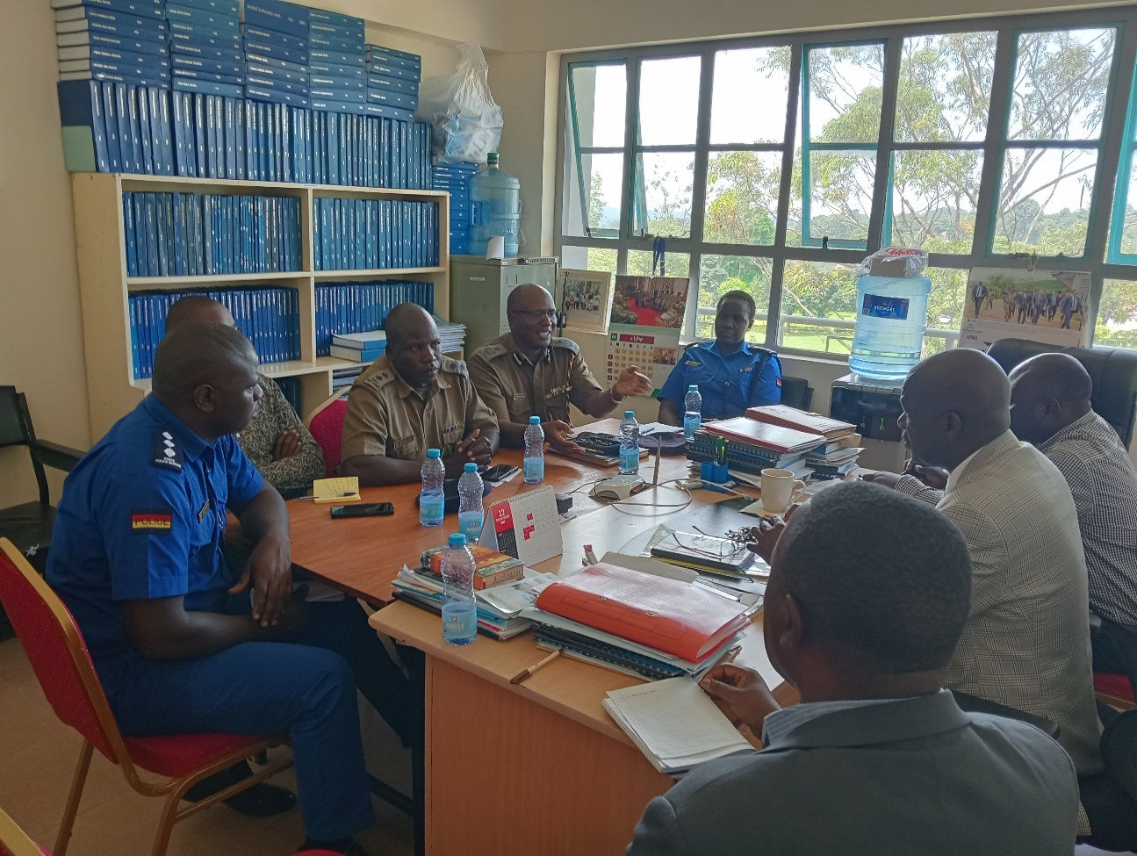

###### Plate 4.1: Plate Showing ongoing problem solving workshop with NGAOs at the Dean’s Office at MMUST, Kenya

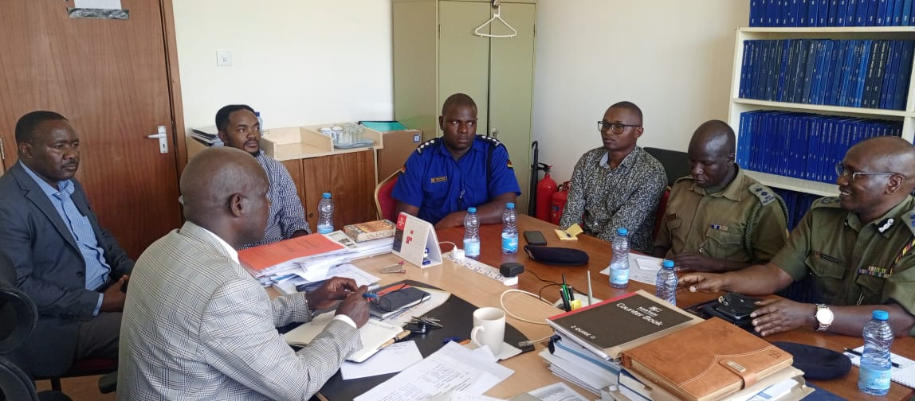

###### Plate 4.2: Plate showing ongoing consultations with NGAOs at MMUST

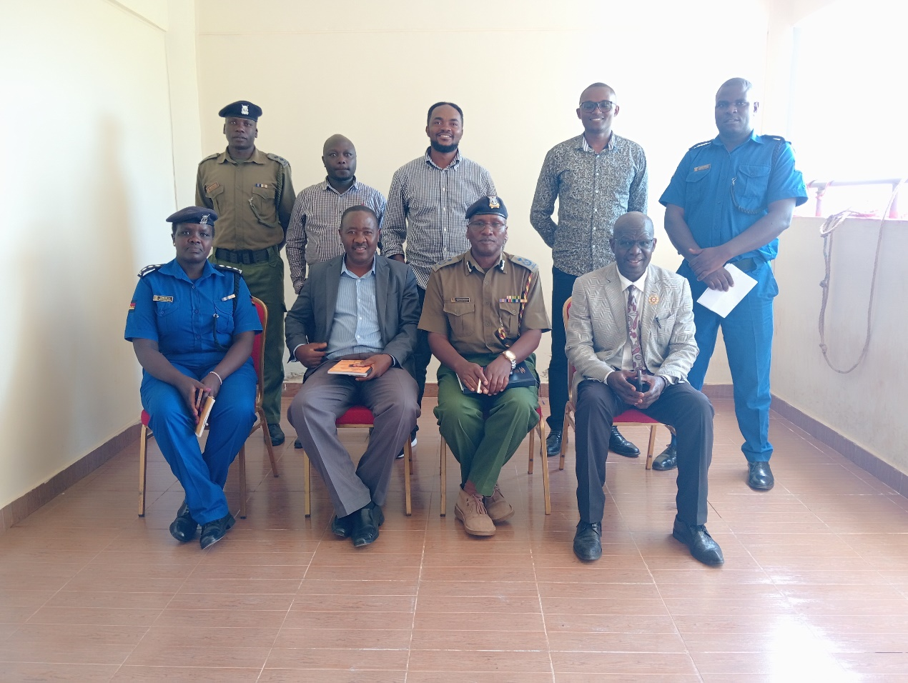

###### Plate 4.3: Plate showing workshop participants at MMUST

###### 

## 4.4 Collaborative Development of Customized Tools for Detection and Prevention

##### Table 4.4: Table Showing Activities, Outputs, Impacts, Outcomes and Impacts for Activity Four

|  |
| --- |
| **Collaborative Development of Customized Tools** |
| **Tool for Calibrating Risk of Extremism**  **Objective**: Develop a tool to assess and measure extremism risks and mitigate the risk of recidivism.  **Activities**   * Formation of a working group with NGAOs, police officers and security stakeholders. * Adopting a participatory method to design and develop the tool. * Conducting a pilot testing and gather feedback for refinement. * Redesigning the tool based on identified needs and existing gaps. * Final approved tool for use by NGAOs and community gatekeepers * Training of NGAOs and community gatekeeper on using the customized tools. |
| **Outputs**  **Formation of working group (3 groups formed for the 25 participants)**   * A multidisciplinary working group was established, including NGAOs, police officers, community gatekeepers and other security stakeholders, ensuring a community-wide diversity of ideas in the tool development process based on previous lessons.   **Participatory tool development through a problem solving workshop**   * A draft tool for calibrating the risk of extremism was collaboratively designed using a participatory approach, incorporating input from all relevant stakeholders.   **Pilot of the draft tool**   * The tool was pilot tested with selected participants, including both NGAOs and community gatekeepers, to gather practical feedback on its effectiveness and usability.   **Tool refinement based on feedback from community members and former combatants (extremists)**   * The tool was redesigned and refined based on feedback from the pilot testing, ensuring it addresses identified needs and gaps in extremism detection and recidivism prevention.   **Finalized tool**   * A final, approved tool was produced, ready for deployment by NGAOs and community gatekeepers in their efforts to assess and mitigate the risk of extremism.   **Refresher training on tool application conducted**   * Refresher training for all 25 participants (19 community gatekeepers and 6 NGAOs), ensuring they are well-equipped to use the customized tool in their work. |
| **Outcomes**  **Enhanced risk assessment capabilities**   * The SCI anticipates that NGAOs and community gatekeepers now have a practical, tailored tool to assess and measure extremism risks effectively, leading to more accurate and timely interventions.   **Improved Collaboration and Coordination**   * In essence, the SCI anticipates that the collaborative development process built stronger relationships and coordination between NGAOs, community gatekeepers, and other security stakeholders, promoting a unified approach to extremism prevention. |
| **Impacts**  **Reduced risk of extremism and recidivism**   * The SCI anticipates that the use of the customized tool is expected to lead to a significant reduction in the risk of extremism and recidivism, as NGAOs and community gatekeepers are better equipped to identify and address potential threats early on.   **Strengthened community security**   * As community gatekeepers and NGAOs effectively implement the tool, communities are likely to experience heightened security and resilience against violent extremism. |

**Source**: Author (2024)

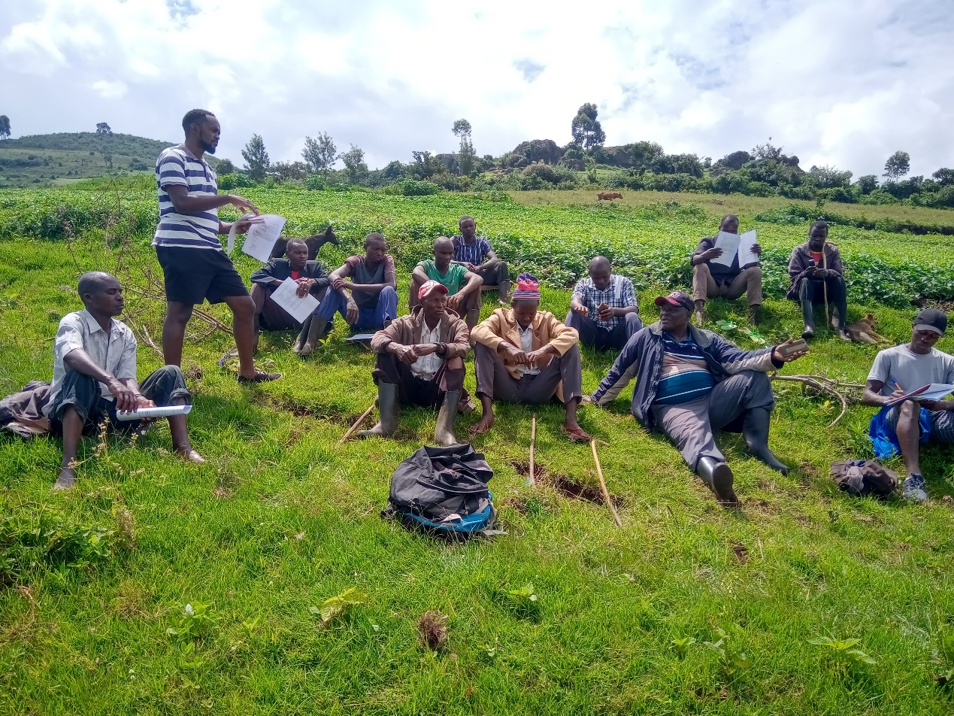

###### Plate 4.4: Researcher leading community gatekeepers (male) on the basics of the SCI in Mount Elgon Region

## 

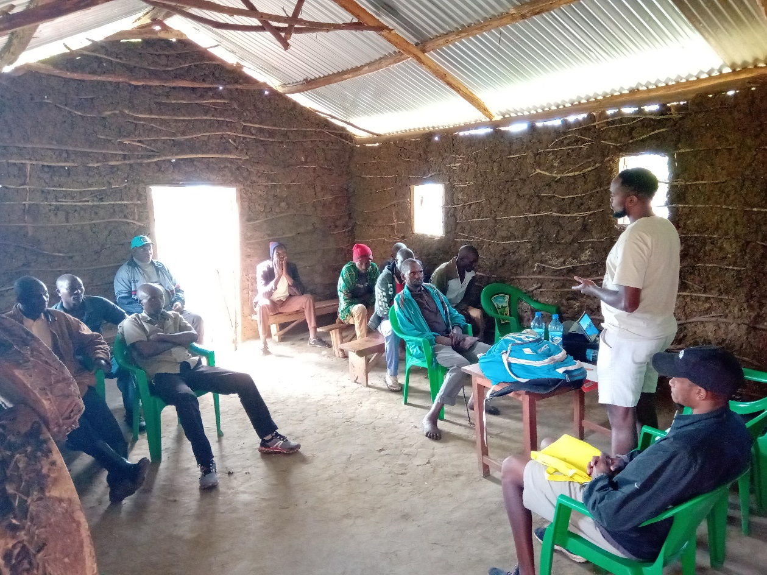

###### Plate 4.5: Researcher Training Male Community Gatekeepers in a Church in Mount Elgon Region

## 4.5 Application of Customized Tools

##### Table 4.5: Table Showing Activities, Outputs, Impacts, Outcomes and Impacts for Activity Five

|  |
| --- |
| **Application of Customized Tools** |
| **Objective**: NGAOs & gatekeepers implementing the developed tools at community level.  **Activities**:   * Roll out the tools in selected areas and monitor their use. * NGAOs and community gatekeepers taking to the ground to apply the tool. * NGAOs taking a role as master trainers of trainees at community level * NGAOs collecting data on user experiences of the tools. |
| **Outputs**  **Deployment of tools**   * The customized tools for calibrating the risk of extremism were successfully rolled out in selected areas, with all 25 trained individuals actively participating in the implementation.   **Ground-level application**   * NGAOs and community gatekeepers effectively utilized the tools in their respective communities, applying the risk assessment and prevention measures learned during the training.   **Master trainers established**   * NGAOs assumed the role of master trainers, leading the training of additional community members in the use of the tools, thereby expanding the reach and impact of the initiative. |
| **Outcomes**  **Increased community-level engagement**   * The active participation of community gatekeepers in applying the tools fostered greater community engagement in preventing violent extremism, with more community members becoming aware of and involved in the initiative.   **Enhanced detection and prevention**   * The application of the tools by NGAOs and community gatekeepers led to more effective detection of extremism risks and prevention of recidivism, resulting in early interventions and reduced threats.   **Capacity building extended by ToTs**   * As NGAOs trained additional community members, the capacity for extremism prevention at the grassroots level was further enhanced, leading to a broader and more sustained impact. |
| **Impacts**  **Strengthened community security and resilience**   * The SCI anticipates that widespread application of the tools contributed to strengthened security in the selected areas, with communities becoming more resilient to the threat of violent extremism.   **Sustainable extremism prevention practices**   * The SCI anticipates that the initiative fostered sustainable extremism prevention practices, as the tools became integrated into the regular operations of both NGAOs and community leaders, ensuring long-term vigilance and proactive measures.   **Expansion of best practices across regions**   * The SCI anticipates that as NGAOs and community gatekeepers shared their experiences and successes, the best practices identified during the application of the tools are likely to be adopted in other regions, amplifying the overall impact of the initiative. |

**Source**: Author (2024)

## 4.6 Monitoring & Evaluation of Customized Tools

##### Table 4.6: Table Showing Activities, Outputs, Impacts, Outcomes and Impacts for Activity Six

|  |
| --- |
| **Monitoring of Customized Tools** |
| **Monitoring of customized tools**  **Objective**: Evaluating the performance and impact of the tools.  **Activities**:   * Developing monitoring and evaluation frameworks to assess tool effectiveness. * Collection and analysis data on the use and impact of the tools. * Conducting regular reviews and updates based on monitoring findings.   **Evaluation of capacity enhancement**  **Objective**: Assessing the overall impact of capacity enhancement activities.  **Activities**:   * Conducting follow-up surveys and interviews with NGAOs and communities. * Analysis of changes in capacity, knowledge, and effectiveness. * Reporting findings and making recommendations on improvements for future initiatives. |
| **Anticipated Outputs**  **Monitoring and evaluation frameworks developed**   * Comprehensive frameworks for monitoring and evaluating the effectiveness of the customized tools are developed and put in place. * Clear indicators and metrics for assessing the tools' performance are established.   **Data collection and analysis**   * Data on the usage and impact of the tools is collected from NGAOs and community gatekeepers. * Detailed analysis of the data, highlighting trends, successes, and areas needing improvement.   **Follow-up surveys and interviews**   * Follow-up surveys and interviews with NGAOs and community gatekeepers are conducted to gather qualitative and quantitative data on the capacity enhancement outcomes.   **Reports and Recommendations:**   * Comprehensive reports are generated based on the monitoring data and evaluation findings. * Recommendations for improving the tools and capacity-building initiatives for future projects are compiled. |
| **Anticipated Outcomes**  **Enhanced understanding of tool effectiveness**   * A clear understanding of how well the customized tools are performing in detecting and preventing violent extremism and recidivism. * Identification of any gaps or challenges in tool application, leading to informed decisions on necessary updates or modifications.   **Improved capacity and knowledge**   * Evidence of increased capacity and knowledge among NGAOs and community gatekeepers as a result of the capacity enhancement activities. * Highlight of specific areas where further training or support may be needed.   **Data-driven decision making**   * The collected data and evaluation findings provide a robust basis for decision-making, ensuring that future initiatives are guided by empirical evidence and real-world experiences. |
| **Anticipated Impacts**  **Long-term effectiveness of customized tools**   * Continuous monitoring and evaluation ensure that the customized tools remain effective and relevant over time, leading to sustained success in preventing violent extremism and recidivism.   **Adaptive and responsive strategies**   * The initiative becomes more adaptive and responsive to changing dynamics on the ground, with the ability to quickly address new challenges or threats as they arise.   **Empowered communities and NGAOs**   * Through ongoing evaluation and feedback, communities and NGAOs are empowered to take a proactive role in maintaining security and preventing extremism, leading to a more resilient society.   **SCI replication and scaling**   * Successful evaluation of the tools and capacity enhancement activities may lead to the replication and scaling of the initiative in other regions or contexts, amplifying the impact beyond the initial target areas. |

**Source**: Author (2024)

\*\*\*\***Notes on SCI Monitoring and Evaluation**

*Proposed M & E specialist: Henry Mlinde* (Cohort VI: Already has a grasp of the SCI and what it is all about)

## 4.7 Project Implementation Matrix

##### Table 4.6: Project Implementation Matrix Showing Status of Implementation Per Activity

|  |  |  |  |  |  |
| --- | --- | --- | --- | --- | --- |
| **Activity** | **Fully Implemented** | **Not Implemented** | **Implementation Ongoing** | **Partial Implementation** | **To be implemented** |
| Baseline Survey of Current Capacity of NGAOs |  |  |  |  |  |
| Baseline Survey of Current Capacity of Community Gatekeepers |  |  |  |  |  |
| Capacity Enhancement of NGAOs |  |  |  |  |  |
| Capacity Enhancement of Community Gatekeepers |  |  |  |  |  |
| Collaborative Development of Customized Tool for Calibrating Risk of Extremism |  |  |  |  |  |
| Collaborative Development of Customized Tool for Preventing Recidivism |  |  |  |  |  |
| Application of Customized Tools |  |  |  |  |  |
| Monitoring and Evaluation of Customized Tools |  |  |  |  |  |

**Definitions for the implementation matrix**

|  |  |
| --- | --- |
| **Fully Implemented** | The activity has been completed according to the planned objectives and timeline |
| **Not Implemented** | The activity has not yet started or is not planned to be undertaken. |
| **Implementation Ongoing** | The activity is currently in progress but is not yet completed. |
| **To Be Implemented** | The activity is planned for the future and has not yet started. |
| **Partial Implementation** | The activity has been started but is not fully completed or has not met all the intended objectives. |

## 4.8 Key Findings of the Social Change Initiative

Based on the implementation of the social change initiative, the report notes the following as key findings.

1. Based on the baseline survey conducted, NGAOs and community gatekeepers had no tools used to detect violent extremism and the risk of recidivism. The baseline survey revealed that NGAOs lacked tools and structured methods for detecting and preventing violent extremism and recidivism. Most respondents reported limited knowledge and resources in these areas.
2. A total of 25 trainees were capacity built on the subject matter of violent extremism. These included 19 community gatekeepers and 6 NGAO officers. The gender factor was adhered to during the training programs. Training programs for NGAOs and community gatekeepers were partially implemented, with positive feedback indicating improved understanding and skills in extremism detection and prevention. However, there were challenges related to the adequacy and relevance of the training materials for different regions.
3. All the trainees through a collaborative problem solving workshop were involved in the development of customized tools for a dual role in detecting the risk of violent extremism and the risk of recidivism. These tools were well-received by NGAOs and community gatekeepers during the pilot testing phase.
4. All the trainees were involved in the application of the customized tools which began in August 2024. Preliminary reports indicate that NGAOs and community gatekeepers are actively using the tools in their respective areas. However, challenges have been noted in consistent application and integration into existing practices.
5. As of mid-August 2024, the Monitoring and Evaluation (M&E) activities are yet to be fully implemented. However, plans are in place to develop frameworks for assessing tool effectiveness, collect and analyze data, and report findings.
6. The project has the capacity to transform, create safer and more resilient societies against violent extremism.

# CHAPTER FIVE

# CONLUSIONS, RECOMMENDATIONS AND PROJECT SUSTAINABILITY PLAN

This chapter presents the conclusion, recommendations and the project sustainability plan.

# 5.1 Conclusion

The SCI on "Strengthening Capacity of National Government Administrative Officers for a Dual Approach to Calibrating and Preventing Violent Extremism in Kenya" has made significant progress in enhancing the capacity of NGAOs and community gatekeepers to address violent extremism. While some activities are ongoing and M&E is yet to be fully implemented, the preliminary outcomes are promising. Continued efforts and adjustments will be crucial in ensuring the long-term success and sustainability of the initiative. Similarly, the initiative demonstrated a solid commitment to improving local and national capabilities in countering violent extremism, and highlights the potential for significant contributions to community safety and resilience against violent extremism in Kenya.

# 5.2 Recommendations

Based on the conclusion made, a number of recommendations arise. These recommendations are made on the basis of the activities and are targeted to specific actors.

1. The need for strengthened integration of the tools into the daily practises of NGAOs, community gatekeepers and the society as well. This recommendation requires a multi-sectoral approach of project initiators that is- the fellow, MMUST, RPC and the Ministry of Interior and National Administration of Kenya who are mandated with the day to day operations in the realm of national security.
2. The need to support ongoing refresher courses for the trainers of trainees not only on the subject matter but also on the general trends with regards to violent extremism in the region. This recommendation will be best implemented through collaboration between the project initiators and the Kenya School of Government- Security Management Institute which trains NGAOs on matters of violent extremism. Similarly, the National Police Training College may adopt this course for use for officers joining the service in the rank of police cadets.
3. Joint certification of this training program by MMUST, Makere University Rotary Peace Center and the Kenya School of Government with the SCI becoming part of the officers’ day to day operations. This certification will not only ensure career progression but also seek to entrench the culture of detecting and prevention of violent extremism as a daily practise. Similarly, these institutions should consider awarding certificates to committed defenders against violent extremism in the name of gatekeepers.
4. The Ministry of Interior and National Administration should lead the implementation of a robust system to monitor application of the developed tools.
5. The initiative lead investigator to finalize and implement a comprehensive M&E framework to assess the impact and effectiveness of the tools and capacity-building activities.
6. The project initiators in an effort to sustain the SCI should leverage and strengthen partnerships with local organizations and stakeholders to support the sustainability of the initiative and enhance local ownership. In addition, they should develop virtual platforms that support knowledge sharing and best practices among NGAOs, community gatekeepers, and other relevant actors.

# 5.3 Project Sustainability Plan

1. Develop short course professional certificate program for calibrating and preventing the risk of extremism for NGAOs and staff working at violent extremism rehabilitation centers in Kenya to administered through the School of Disaster Management & Humanitarian Assistance of Masinde Muliro University of Science & Technology (MMUST). This can be a joint venture between MMUST, Makerere University- Rotary Peace Center and the Kenya School of Government.
2. Collaboratively work with stakeholders in the Ministry of Interior and Administration of National Government and Kenya School of Government (KSG) for inclusion of this capacity building tool in the NGAOs curriculum.
3. Train all key stakeholders in the National Security architecture- National Police College, Kenya School of Government (KSG), International Peace Support Training College and the National Defense University of Kenya (NDU-K) on inclusion of tools in the curriculums.
4. Training of 6 Trainer of Trainees trained (4 police officers and 2 assistant county commissioners) will for a start go a long way in bolstering efforts for the dual role the SCI sought to achieve.

# References

Amakanji, G. O., Okoth, P. G., & Maloba, E. W. (2023). The Cursed Promised Land? Demographic Risk Factors for Homegrown Extremism in the Squatter Enclaves of Mount Elgon Region of Western Kenya. *Journal of Asian and African Studies*, *0*(0). <https://doi.org/10.1177/00219096231197777>.

Amakanji, Graham Oluteyo; Okoth, Pontian G.; and Were, Edmond Maloba (2023) "Leveraging Devolution as a Pathway to the Management of Homegrown Extremism over Intractable Land-use Conflicts in Chepyuk Settlement Schemes, Kenya," *Journal of African Conflicts and Peace Studies*: Vol. 5: Iss. 2,.Available at: <https://digitalcommons.usf.edu/jacaps/vol5/iss2/4>.

Borum, R. (2023). Mapping the terrain: The current state of risk and threat assessment practice in the violent extremism field. *Violent extremism: A handbook of risk assessment and management*.

Breidlid, T. (2021). Countering or contributing to radicalisation and violent extremism in Kenya? A critical case study. *Critical Studies on terrorism*, *14*(2), 225-246.

Cooke, D., & Logan, C. (2021). Violent extremism: The practical assessment and management of risk. In *Terrorism Risk Assessment Instruments* (pp. 99-115). IOS Press.

Dean, G., & Pettet, G. (2017). The 3 R’s of risk assessment for violent extremism. *Journal of forensic practice*, *19*(2), 91-101.

Gill, P., Marchment, Z., Seaward, A., Doherty, P., & Goodman, K. How can general violence risk assessment and management inform that of violent extremist risk? 1. *The Routledge Handbook on Radicalisation and Countering Radicalisation*, 476-497.

Gill, P., Marchment, Z., Zolghadriha, S., Salman, N., Rottweiler, B., Clemmow, C., & Van Der Vegt, I. (2020). Advances in violent extremist risk analysis. In *Radicalization and Counter-Radicalization* (Vol. 25, pp. 55-74). Emerald Publishing Limited.

Pressman, D. E., & Davis, N. (2022). Violent extremism risk assessment and screening analysis: applicability, challenges, and new developments. *Journal of policing, intelligence and counter terrorism*, *17*(3), 301-313.

Pressman, D. E., & Davis, N. (2022). Violent extremism risk assessment and screening analysis: applicability, challenges, and new developments. *Journal of policing, intelligence and counter terrorism*, *17*(3), 301-313.

Van der Heide, L., Van der Zwan, M., & Van Leyenhorst, M. (2019). *The Practitioner's guide to the galaxy: a comparison of risk assessment tools for violent extremism*. The Hague: International Centre for Counter-Terrorism.

# Appendices

Appendix I: Draft Training Program

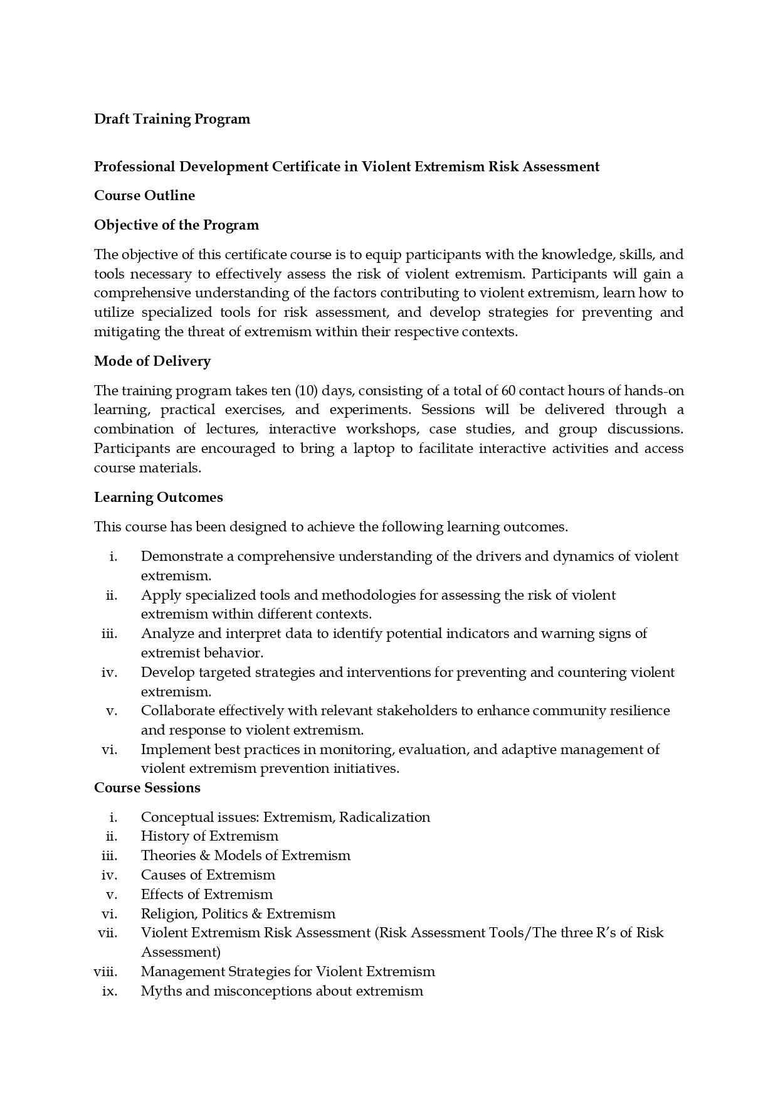

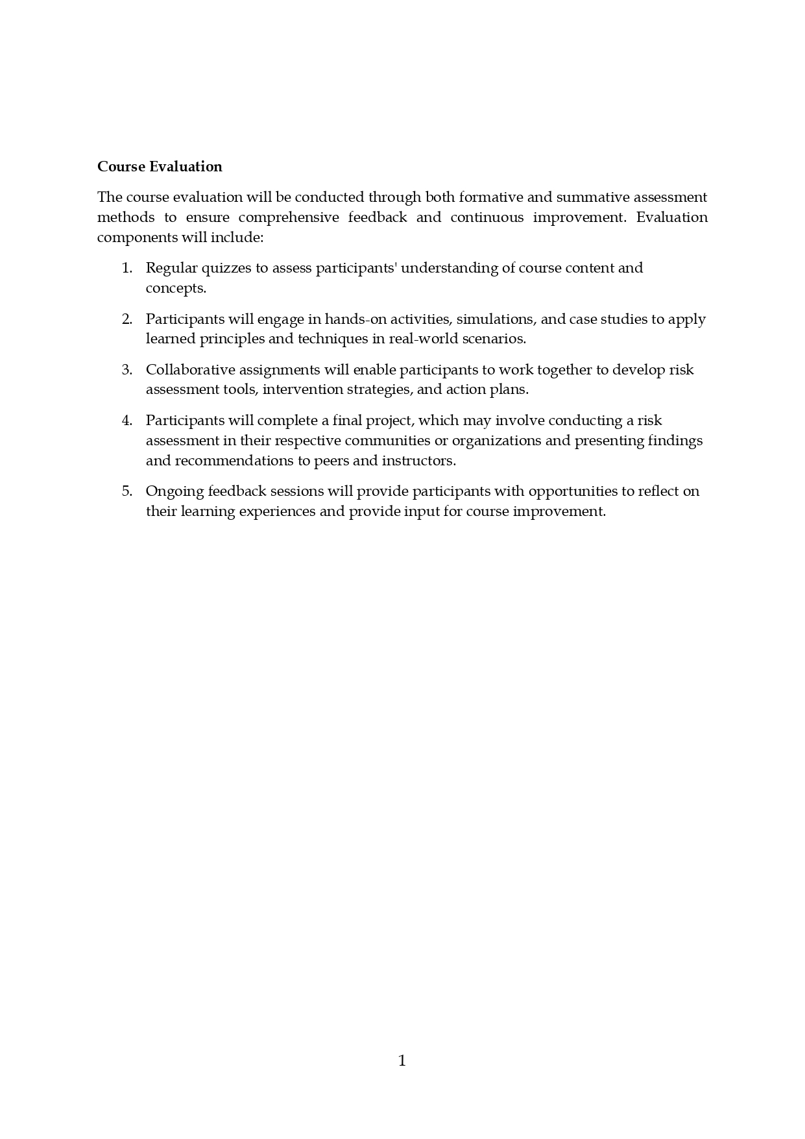

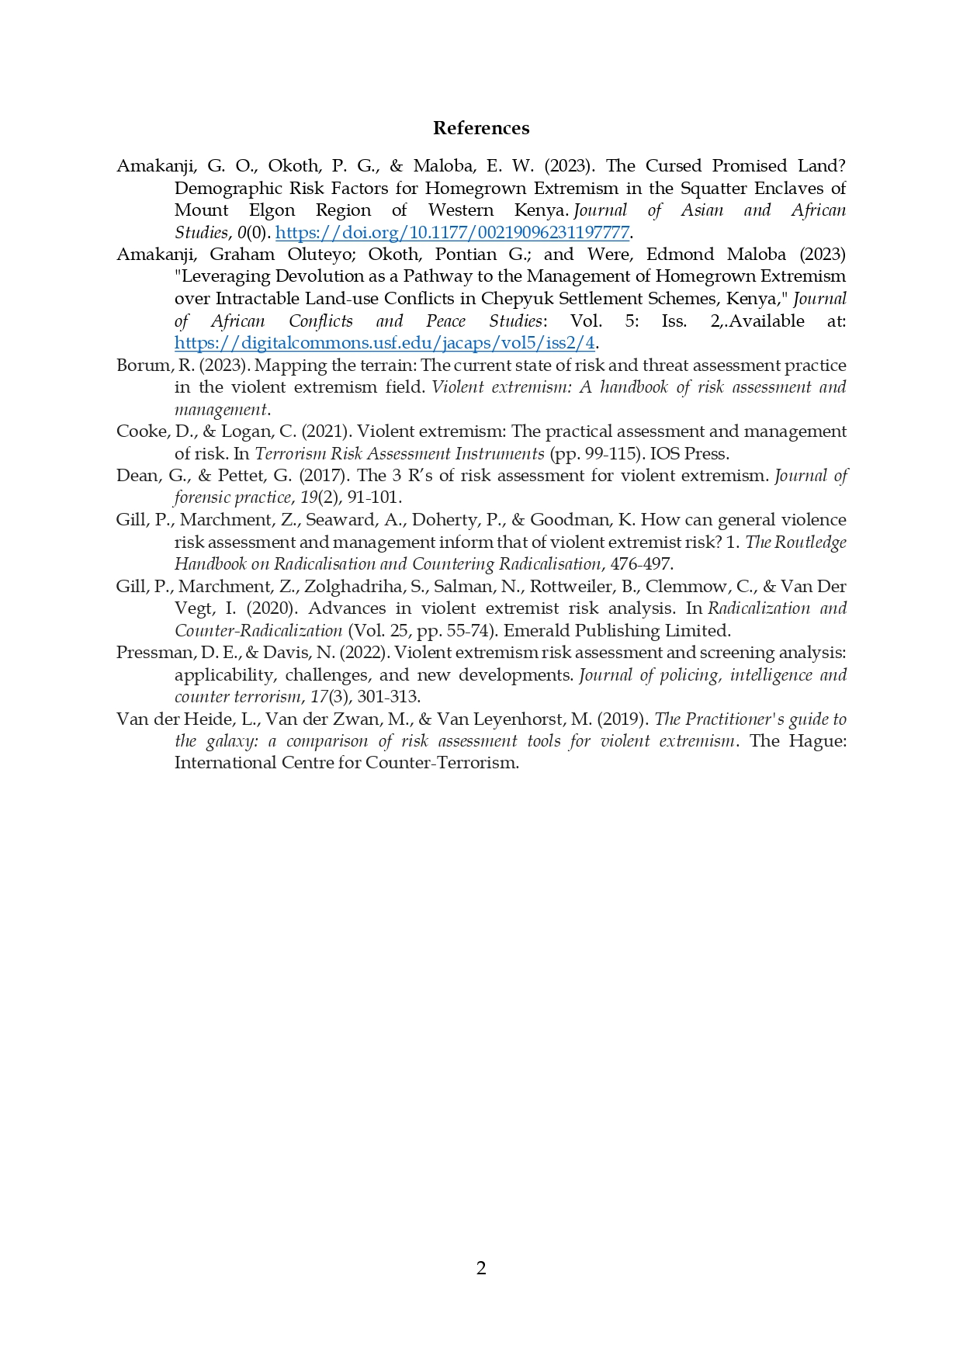

Appendix II: Draft Tool for the Dual Role

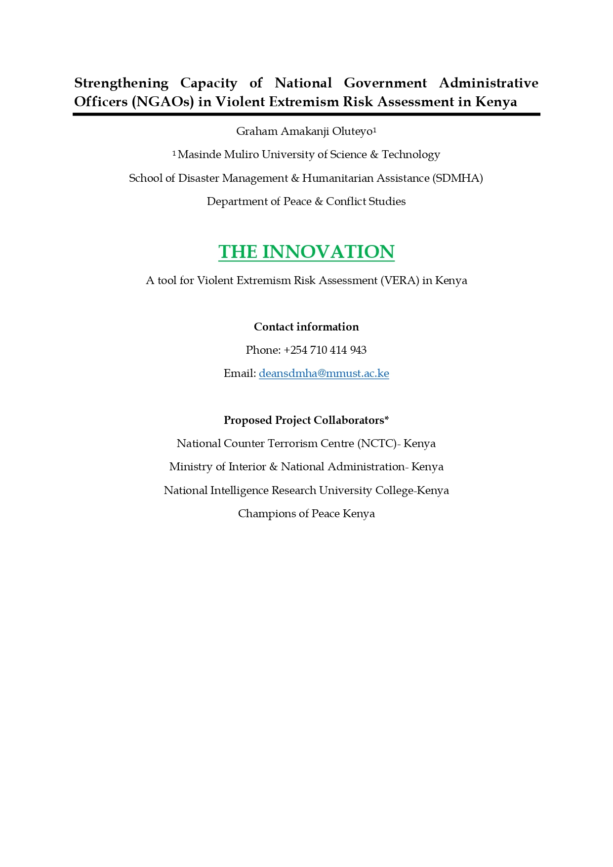

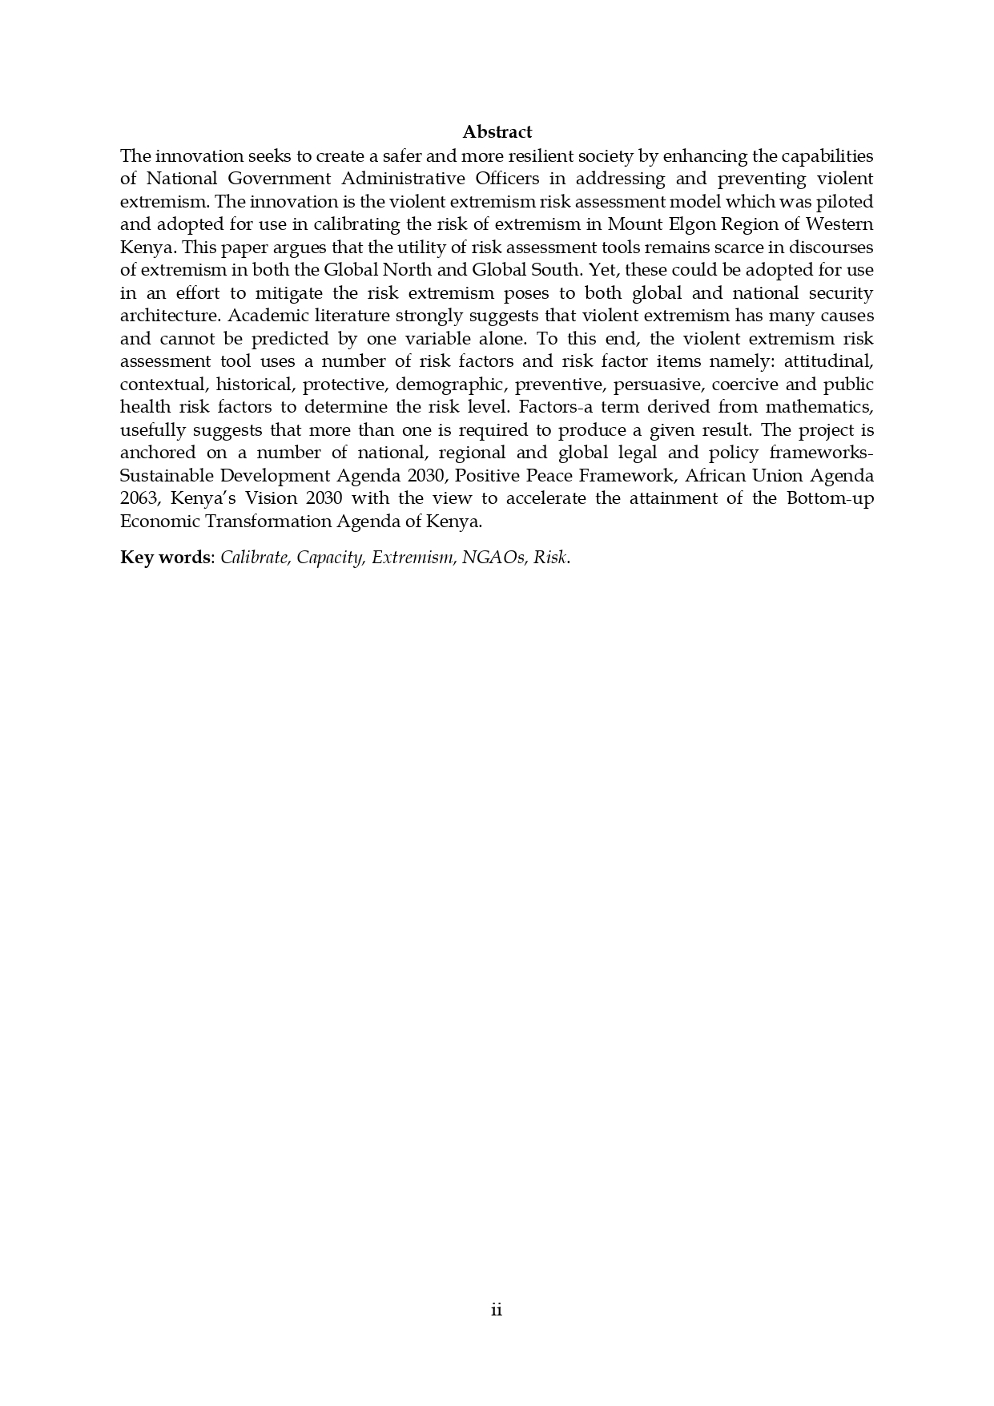



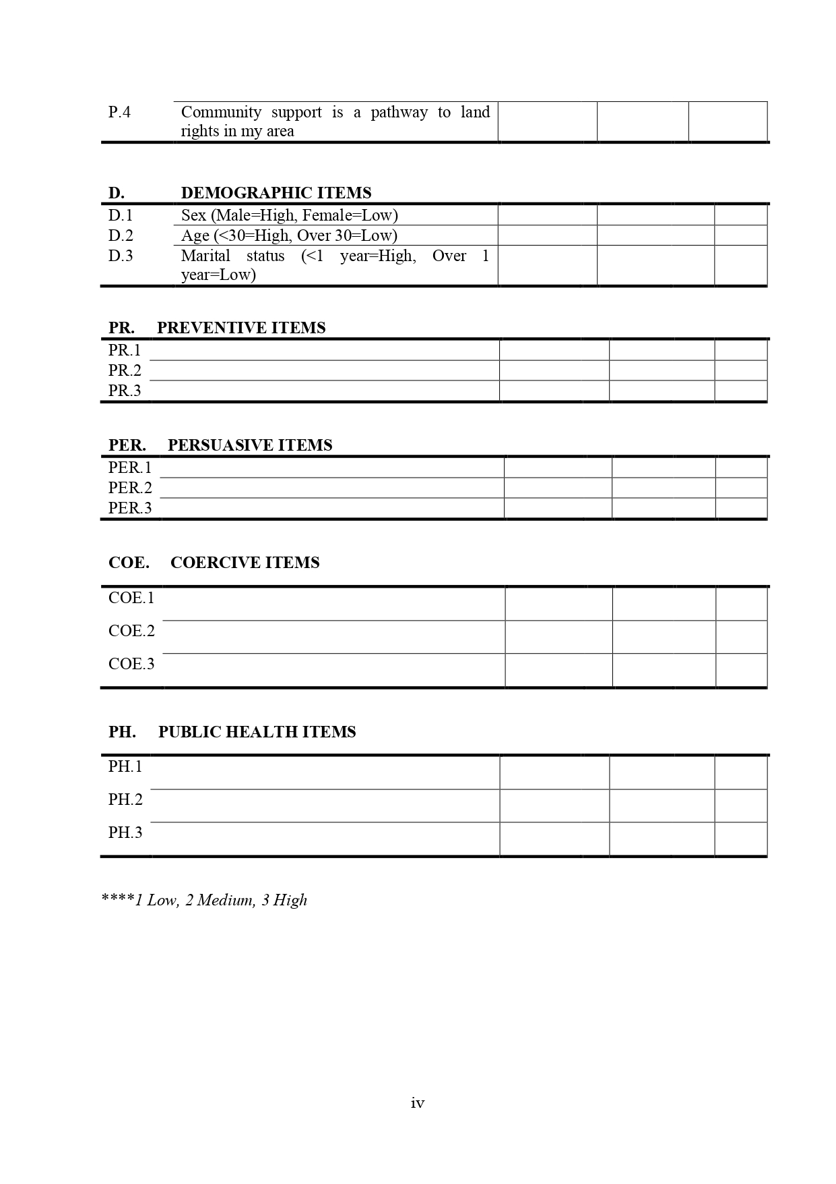

Appendix III: Draft Monitoring and Evaluation (M&E) Template

**Social Change Initiative:** Strengthening Capacity of National Government Administrative Officers (NGAOs) for a Dual Approach to Calibrating and Preventing Violent Extremism in Kenya

**Implementation Period:** February 2024 - Ongoing

**Monitoring Framework**

**Objective:** Ensure effective implementation of activities and track progress toward achieving project goals.

|  |  |  |  |  |  |
| --- | --- | --- | --- | --- | --- |
| **Activity** | **Status** | **Indicators** | **Data collection methods** | **Frequency** | **Responsible unit** |
| Baseline Survey of Current Capacity of NGAOs | Fully implemented | Survey conducted and data collected | Survey data analysis | One-time (February 2024) | M&E Specialist |
| Baseline Survey of Current Capacity of Community Gatekeepers | Fully implemented | Survey conducted and data collected | Survey data analysis | One-time (February 2024) | M&E Specialist |
| Capacity Enhancement of NGAOs | Fully implemented | Training programs conducted, feedback from participants | Training reports, Surveys | Ongoing (March 2024 - Ongoing) | M&E Specialist |
| Capacity Enhancement of Community Gatekeepers | Fully implemented | Workshops and seminars conducted, feedback from participants | Training reports, Surveys | Ongoing (March 2024 - Ongoing) | M&E Specialist |
| Collaborative Development of Customized Tool for Calibrating Risk of Extremism | Fully implemented | Tool developed and approved | Documentation review, Feedback | One-time (July 2024) | M&E Specialist |
| Collaborative Development of Customized Tool for Preventing Recidivism | Fully implemented | Tool developed and approved | Documentation review, Feedback | One-time (July 2024) | M&E Specialist |
| Application of Customized Tools | Ongoing | Tools applied and monitored | Tool usage data, Feedback | Ongoing (August 2024 - Ongoing) | M&E Specialist |
| Monitoring and Evaluation of Customized Tools | To be implemented | Evaluation frameworks developed, data collected and analyzed | Surveys, Interviews, Observations | Quarterly (Starting November 2024) | M&E Specialist |

**Evaluation Framework**

**Objective:** Assess the effectiveness and impact of the initiative’s activities and outcomes.

|  |  |  |  |  |
| --- | --- | --- | --- | --- |
| **Evaluation Area** | **Indicators** | **Data collection method** | **Frequency** | **Responsible unit** |
| Effectiveness of Capacity Enhancement Activities | Improvement in capabilities and skills of NGAOs and gatekeepers | Follow-up surveys, Interviews | Quarterly | M&E Specialist |
| Impact of Customized Tools | Effectiveness of tools in detecting and preventing extremism | Tool feedback, User experience surveys | End of implementation | M&E Specialist |
| Sustainability and Scalability | Continued use and potential for expansion | Follow-up surveys, Interviews | End of implementation | M&E Specialist |
| Overall Project Success | Achievement of project goals and objectives | Comprehensive evaluation report | End of implementation | M&E Specialist |

**Key**

**Objective**: What the project aims to achieve.

**Indicator**: Specific, measurable signs that show whether objectives are being met.

**Measurement Method**: How the data will be collected.

**Data Source**: Where the data will come from.

**Frequency**: How often the data will be collected or the task will be performed.

**Responsibility**: Who is responsible for the activity.

**Status**: Current state of the task.

**Comments**: Additional notes or observations.