

**COLLEGE OF HUMANITIES AND SOCIAL SCIENCE**

**DEPARTMENT OF PEACE AND RELIGION STUDIES**

**POSTGRADUATE DIPLOMA IN PEACE BUILDING AND CONFLICT TRANSFORMATION**

**SOCIAL CHANGE INITIATIVE: YOUTH CAPACITY BUILDING ON WASTE TO FOOD-CLIMATE SMART AGRIBUSINESS**

**Location: Tseda Community, Gondar, Ethiopia**

**From January to September, 2024**

By

Assefa Adane Atinafu (Rotary Peace Fellow)

Student number: 23070006

Mentor: Dr. Erie Serwaji

**Submitted to: Rotary Peace Center, Makerere University**

**Submission date: October 2024**

**Table of Contents**

List of Tables I

List of Figures III

List of Acronyms IV

Abstract V

CHAPTER ONE: INTRODUCTION 1

1.1. Background 1

1.2. Problem Statement 2

1.3. Goals and objectives 3

1.4. Challenges and Mitigation strategies 4

CHAPTER TWO: REVIEW OF LITERATURE 5

2.1. Local agri-food waste, climate change and development challenges in Ethiopia 5

2.2. Climate-Smart Agriculture 5

2.3. Youth Engagement in Climate Smart Agribusiness 6

2.5. Challenges in Youth engagement with CSA 7

2.6. Strategies for Promoting Youth Participation in CSA 8

2.2. Theoretical Underpinnings 9

2.4. Methods and Design 11

CHAPTER THREE: SCI INTERVENTION 12

3.1. Interventions and Activities 12

3.2. Key Findings/impact 14

CHAPTER FOUR: CONCLUSION AND RECOMMENDATIONS 16

4.1. Conclusion 16

4.2. Recommendations/Implications for policy 16

4.3. Sustainability Plan 16

References 18

Annex I: Need assessment 21

Annex II: Preliminary community observation 22

**List of Tables**

Table 1 : Stakeholder interest, contribution and influence 12

Table 2 : Overall training evaluation findings 14

Table 3 : Youth perception on waste to food climate smart agribusiness 15

**List of Figures**

Figure 1 : Conceptual framework on youth engagement in CSA 8

Figure 2 : Theory of Change and its application of SCI 10

Figure 3 : Youth capacity building training on waste to food CSA 14

**List of Acronyms**

|  |  |
| --- | --- |
| CSA | Climate Smart Agribusiness |
| SCI | Social Change Initiative |
| IPCC | Intergovernmental Panel on Climate Change |
| GHG | Greenhouse Gas |
| LF | Logical Framework |
| FGD | Focus Group Discussion |
| KII | Key Informant Interview |
|  |  |

**Abstract**

Climate change, youth unemployment and resource scarcity are becoming a critical challenge in achieving sustainable development especially in developing countries like Ethiopia. These add pressure on community structures, and the decrease in livelihood opportunities can expose household and community-level vulnerabilities, impact livelihoods, compound economic inequality, and erode social structures. This social change initiative was carried out January to August 2024 with the main aim of addressing the socio-economic challenges in Tseda kebele of the peri-urban community through youth empowerment on waste to food climate smart agribusiness practices. A total of 22 (9 male and 13 female) youth were targeted for this SCI. Its main objective is to enhance youth engagement on climate resilient and sustainable agribusiness through cooperative action and application of climate smart agricultural principles, tools, and technologies. Preliminary assessment and stakeholder identification by participatory appraisal; problem identification, prioritization, and possible solutions suggested by the target group through workshop meetings followed by capacity building through youth centered training facilitation were some of the methods applied for implementation. The key finding of SCI is youth capacity building on local waste recycling and reusing, increased production and income through CSA, and disseminating scalable practices to the community. It aligns to climate action (environment protection) and growing local economies thematic areas of rotary international. In addition, it is inline to positive peace pillars of a sound business environment, & high level of human capital primarily, equitable distribution of resources & good relationship.

**Keywords:** Agribusiness, Capacity Building, Climate Smart, Waste to Food, and Youth

# CHAPTER ONE: INTRODUCTION

## Background

The 21st century presents a complex tapestry of challenges. Feeding a burgeoning global population, estimated to reach 9.7 billion by 2050, demands a significant increase in food production (FAO, 2019). However, climate change casts a long shadow, with rising temperatures, erratic precipitation patterns, and extreme weather events jeopardizing agricultural productivity (IPCC, 2021). This confluence of issues necessitates a paradigm shift in agricultural practices. Climate-Smart Agriculture (CSA), an approach promoting food security while mitigating climate change impacts and reducing greenhouse gas (GHG) emission (FAO, 2013). Nestled within the broader CSA framework lies a promising concept, waste-to-food CSA. This approach focuses on utilizing organic waste streams as a resource to improve soil fertility, decrease dependence on chemical fertilizers, and cultivate sustainable food production.

Traditional agricultural practices, however, are under immense pressure due to climate change. The intergovernmental Panel on Climate Change (IPCC) highlights the intricate relationship between agriculture and climate change. While agriculture contributes to GHG emissions through land use change, livestock production, and certain practices, it also suffers significantly from the adverse effects of climate change, jeopardizing crop yield and food security (IPCC, 2021). The solution has not just innovative approaches but also in harnessing the potential of the world’s largest youth population in history- 1.2 billion strong aged 15-24 (UN Youth Envoy, 2023). Unfortunately, this demographic often faces underemployment and limited access to resources and education. However, young people possess multiple qualities that make them ideal agents of change.

The current food system, often referred to as a “business as usual” model, generates significant waste throughout the production and consumption chain (FAO, 2019). This waste has severe environmental consequences, contributing to methane emissions from landfills (EPA, 2023) and depleting valuable resources such as water and land (World Bank, 2020). The agricultural sector itself is a major contributor to greenhouse gas (GHG) emissions, responsible for an estimated 21 to 37% of the global total GHG emission (FAO, 2021). However, agriculture is also highly vulnerable to the impacts of climate change. Farmers, particularly in developing countries like Ethiopia, often witness the effects of climate change shocks firsthand (UNEP, 2021).

Integrating climate change adaptation and mitigation strategies with peace building efforts is crucial for fostering resilient and sustainable communities (World Bank, 2023). Technical and intervention strategies are needed to analyze and address climate-related security risks and enable timely responses (FAO, 2020). Gondar, Ethiopia, Faces significant challenges in managing its waste stream. The Tseda community, in particular, struggles with improper waste disposal, leading to environmental degradation, health hazards, and a lack of sustainable livelihood opportunities for youth (WHO, 2023). Traditionally, Gondar has relied on rudimentary waste management methods like open dumping, which pose significant health and environmental risks (WB, 2013). The effects of climate change are particularly severe in fragile and conflict prone communities (UN Office for Disaster Risk Reduction, 2023). Women and children are disproportionately impacted by climate change induced shocks and conflict due to social, economical, and cultural factors (UN Women, 2021). To address these international issues, a social change initiative has been launched in the Tseda community. This initiative “Waste to food-climate smart agribusiness” aims to transform local waste into food through the implementation of Climate-Smart Agriculture practices. The initiative focuses on empowering young people to become agents of change in the community and beyond.

## Problem Statement

World Bank (2023) warns that a declining youth population in rural areas weakens the agricultural workforce, hinders innovation, and threatens food insecurity. Climate change adds pressure on state and community structures, the decrease in livelihood opportunities caused by changing climate can expose household and community level vulnerabilities, impact livelihood, compounded economic inequality, and erode social cohesion that would normally offer support and protections. Youth out migration from rural areas reduces agricultural productivity and increases pressure on remaining resources, potentially leading to social unrest (Jayne et al., 2022). Climate security and peace building are deeply interconnected for several reasons. For instance, extreme weather events brought forward by climate change can lead to reduced access to natural resources, which in turn would result in hostility. Further,conflicting situations make climate action more challenging to implement as governments and their development partners are unable to neither mitigate nor support climate change adaptation. Moreover, efforts to fight against climate change can limit access to land, water, and food resources; over time this can increase disputes over natural resources in a way that can turn violent.

The Tseda community of Gondar town is grappling with the dual challenges of waste management and food insecurity exacerbated by climate change induced effects and conflict over limited natural resources like land, water, etc. Improper waste disposal practices have resulted in pollution, land degradation and health risks for residents. At the same time, there is a lack of sustainable income-generation opportunities for youth, leading to unemployment and economic hardship. Additionally, frequent drought and floods are undermining food security, increasing competition over scarce resources, and exacerbating existing community tensions. In communities like Tseda where coping capacities are limited and there is high dependency on shrinking natural resources and ecosystem services, such as water, and fertile land, grievances and tensions can explode, complicating efforts to prevent conflict and to sustain peace. People who are already in conflict situations, including those living in poverty, experience impacts more acutely because of less capacity for coping and fewer resources with which to build resilience.

* 1. **Goals and objectives**

The primary goal of this initiative is to empower youth in the Tseda community to become agents of change by converting local wastes through climate smart agribusiness practices for resilient and peaceful societal development. The main objective of this initiative is to empower youth in Tseda community, Gondar, Ethiopia, with the knowledge and skills to engage in waste to food-climate smart agribusiness practices for sustainable societal development.

The objective of the initiative specifically are;

* Raise awareness about the importance of local waste reduction and climate smart agribusiness in the community
* Provide capacity building training in sustainable agribusiness practices
* Foster youth engagement in peace building advocacy and climate action in the community
* Develop common youth platform for CSA and peace building
* Establish youth-led Vermicomposting that convert local wastes into usable fertilizer and other inputs

## Challenges and Mitigation strategies

Several challenges arose during implementation of this initiative, including resource limitations, technical expertise, resistance to change. Resource limitation posed a major hurdle. Limited resources restricted the scope of the stakeholder consultation, workshops, training sessions, democratization and youth support systems. A lack of necessary equipment and materials, such as compost bins, and other tools hinder the practical demonstration of local waste conversion. Additionally, security concerns stemming from the ongoing conflict between local militia and Ethiopian national defense force in the area creates a hostile environment, deterring participation and limiting access to resources. Restricted movement of participants, trainers, and resources significantly disrupted project activities delivery. Furthermore, stakeholder perception and support systems was one of the hurdles. Resistance to change from community members, government officials and traditional leaders, particularly regarding local waste recycling and agribusiness practices for climate resilient and peaceful community development. To address these challenges some of the mitigation strategies employed are seeking partnership and collaboration with local government agencies, NGOs and private business to secure resources and support; engaging community leaders to promote the initiative and active participation; equipping youth with the necessary skills and knowledge to practice local waste conversion and utilization.

# 

# CHAPTER TWO: REVIEW OF LITERATURE

## 2.1. Local agri-food waste, climate change and development challenges in Ethiopia

Ethiopia experiences substantial food waste throughout its food supply chain, from production to consumption. Alemie (2020) conducted a study in Gondar city hotels, revealing high levels of food waste generation. Their findings highlight the specific challenges faced by the hospitality industry in managing food waste. Taking a broader national perspective, Berhane and Mekonnen (2019) explore food waste characteristics and management practices across Ethiopia. Their research finding identifies inefficiencies in storage, handling, and consumer behavior as key contributors to food waste.

## 2.3. Youth Engagement in Climate Smart Agribusiness

Youth engagement in climate smart agribusiness has the potential to significantly impact peace building and development in communities and beyond. Several studies have highlighted the positive outcomes of fostering youth involvement in sustainable agribusiness practices and entrepreneurship, particularly in the context of fostering peace, stability and economic growth.

One study by Njuki et al., (2016) emphasized the role of agribusiness as a means to address food insecurity, poverty, and conflict in rural areas. The study found that engaging youth in climate-smart agriculture not only improved food production, and income generation but also contributed to social cohesion and conflict resolution within the communities. Additionally, a study by IFAD (2020) focused on the role of youth-led agribusiness initiatives in creating employment opportunities, fostering innovation, and promoting social inclusion in rural communities. By supporting young entrepreneurs in agriculture, communities can boost economic growth, reduce youth unemployment, improve social cohesion, ultimately contributing to peace building efforts. Furthermore, research by FAO (2018) depicted the importance of empowering young farmers with the knowledge and skills to adopt climate-smart practices, such as conservation agriculture, and agroforestry. By promoting sustainable farming techniques, youth can mitigate the impact of climate change, enhance food security, and promote environmental conservation, which are essential components of peace building and sustainable development. There is a growing recognition of the transformative power of youth engagement in climate smart agriculture (CSA) for fostering peace and development (Jonsen et al., 2016). In conclusion, the literature suggests that youth engagement in climate smart agribusiness can have a transformative impact on community peace building and development by addressing food insecurity, poverty, environmental sustainability, and social cohesion.

**2.4. Pathways to Peace and Development through Youth-led CSA**

A study by Vermeulen et al. (2022) in global environmental change revealed how youth engagement in CSA empowers them economically, reduces their vulnerability to exploitation, and provides alternatives to violence and conflict. Youth-led agribusiness has an important role in creating sustainable livelihoods, promoting social cohesion, and reducing the risk of conflict over scarce resources (UNDP, 2023). In addition, a study by World Agroforestry (ICRAF) (2021) demonstrates that youth-led CSA initiatives that specifically target women and marginalized groups can promote social inclusion and empower them to participate in the agricultural sector. Youth-led adoption of CSA practices like improved soil management and reduced deforestation can significantly contribute to climate change mitigation strategies (Verchot et al., 2022). Youth-led agribusiness ventures in Africa can generate significant income and improve livelihoods in rural communities (Wiggins et al., 2020). The CGIAR research program on Climate Change, Agriculture and Food Security (CCAFS, 2023) highlights the importance of gender inclusive CSA training programs to ensure equitable participation of young women in agribusiness ventures. CSA helps communities to adapt to climate change by improving soil health, reducing water use and increasing resilience to drought and floods (IISD, 2022).

## 2.5. Challenges in Youth engagement with CSA

## Youth involvement in climate smart agribusiness is crucial for ensuring a sustainable and food secure future. However, several challenges and gaps hinder their active engagement in this field. Technical skill gaps, land ownership, credit facilities, and essential agricultural inputs are often out of reach, making it difficult for them to establish themselves in CSA ventures (Chibonga, 2016). Policy frameworks often fail to prioritize youth involvement in agribusiness. Supportive policies that Incentivize youth participation, promote access to resources, and encourage innovation are lacking (Jaleta, et al., 2019). There is a need for training programs that address the specific challenges and opportunities of climate smart agriculture (Bullock et al, 2020). Additionally, research opportunities focused on CSA and tailored needs are often limited (Jaleta, et al 2019). Traditional farming is often perceived as a low-income, labor intensive field, discouraging youth who seek modern and profitable careers (Chibonga, 2016). The absence of mentorship programs and strong youth networks within the agricultural sector limits access to guidance, experience sharing and peer support (Bullock et al, 2020). Effective communication strategies are needed to bridge the gap between existing successful CSA practices and youth. Information on available opportunities, success stories, and the potential of CSA careers needs to be disseminated in ways that resonate with young people (Jaleta, et al 2019).

## 2.6. Strategies for Promoting Youth Participation in CSA

Integrating climate-smart agricultural practices and technologies into agricultural education programs equips youth with the necessary knowledge (FAO, 2016). Additionally, connecting young people with experienced farmers and agribusiness professionals through mentorship programs and on-the-job training fosters practical skills development (KIPPRA, 2022). Highlighting success stories of young entrepreneurs thriving in CSA through targeted communication campaigns and showcasing positive role models can change perceptions (Singh, B., et al. 2020). Equipping youth with entrepreneurship skills and business management knowledge empowers them to establish and manage profitable CSA enterprises (Jaleta, et al. 2019). Utilizing digital platforms for knowledge sharing, disseminating information on CSA practices, market opportunities, and available resources can effectively reach geographically dispersed youth (KIPPRA, 2022). Engaging young people through social media campaigns that showcase the innovative and exciting aspects of CSA can spark interest and encourage participation (FAO, 2016). Policymakers can introduce incentives such as tax breaks, subsidies, and grants to encourage youth investment in CSA practices (Jaleta, et al. 2019). Investing in research institutions and agricultural extension services to prioritize youth training and capacity building in CSA is crucial (Singh, B., et al. 2020).

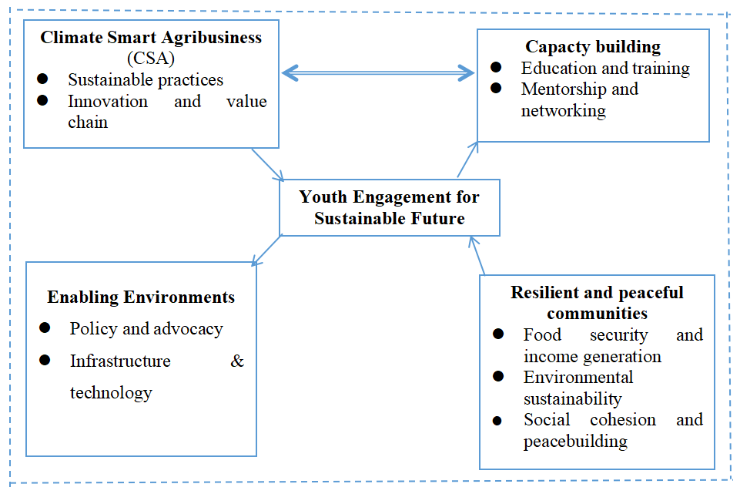

Figure 1: Conceptual framework on youth engagement in CSA

Author, 2024

## 2.2. Theoretical Underpinnings

This social change initiative is drawn upon several theoretical frameworks that underpin the concept of youth empowerment, sustainable development and climate smart agribusiness. These frameworks provide a theoretical foundation for the initiative, guiding its design, implementation and evaluation. Youth empowerment theories emphasize the importance of providing young people with the knowledge, skills and opportunities to participate meaningfully in decision making processes and to shape their future (Yound and Inder, 2010). This initiative aims to empower youth by equipping them with skills and resources necessary to become active agents of change in their community. Sustainable development seeks to balance economic growth, social justice, and environmental protection. This initiative aligns with the principles of sustainable development by promoting economic opportunities, social inclusion and environmental sustainability through waste to food agribusiness practices.

Social capital theory emphasizes the importance of social networks, trust, and reciprocity in promoting collective action and community development (Bourdien, 1986). This initiative seeks to foster social capital among youth and community members through collaborative activities and community engagement. Furthermore, the initiative aims to promote climate smart agriculture among youth in the community to address the challenges of climate change and food security. Climate smart agriculture emphasizes the need for agricultural practices that are productive, resilient, and low-emission (FAO, 2018). Moreover, the initiative is grounded on transition theory as it focuses on the processes of social and technological change, emphasizing the role of agency, structure and discourse in shaping societal transformation (Geels, 2002). The combination of these theoretical frameworks provided a foundation for youth capacity building initiative on waste to food climate smart agribusiness in Tseda community, Gondar,Ethiopia.

**2.3. Change Theory and How it was Applied**

The initiative applied a participatory approach to change, involving community members, youth, and stakeholders in the implementation process. Appreciative inquiries as a positive approach to change applied in this initiative through identifying and building upon the existing strengths and assets of Tseda community’s organizations, local knowledge and cultural values. Lewin’s force field analysis is a model which conceptualizes change as a process of overcoming opposing (driving and restraining) forces. Driving forces for this social change initiative are the desire for sustainable development, food security, peaceful co-existence and climate resilience. On the other hand, restraining forces for the initiative includes resource limitation, security concerns and stakeholders resistance. The initiative seeks to promote the diffusion of waste-to-food agribusiness practices by targeting early adopters through providing training, support, and incentives. Diffusion of innovation theory explains how new or improved ideas and practices are adopted by individuals or communities over time. Theory of planned behavior suggests that an individual's intention to perform a behavior is influenced by their attitude, subjective norms and perceived behavioral control. The initiative tried to influence youth’s intention to engage in waste-to-food agribusiness practices by promoting positive attitudes, social support, and opportunities for skill development. By empowering youth to take ownership of the project and actively participate in the design and implementation, the initiative attempted to create sustainable and impactful change in the community. Youth engagement in climate smart agribusiness practices for resilient and peaceful community development applied the change theories as illustrated in the figure below.

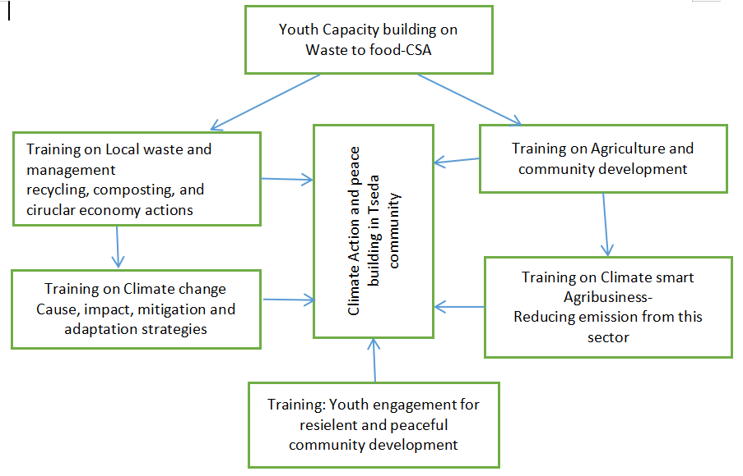

Figure 2: Theory of Change and its application of SCI

Author, 2024

## 2.4. Methods and Design

In this initiative several methods employed to achieve the desired outcome. The main methods applied in the implementation of the initiative are discussed as follows.

Community meeting and discussion: To foster dialogue and collaboration throughout the initiative implementation discussion were held to engage various stakeholders, including community leaders, local women and youth affairs unit leaders, local agriculture nd environment officer. The meeting facilitated the exchange of ideas and built consensus on the initiative’s goals.

A need assessment was conducted using questionnaire and direct interview with key community actors. This assessment aimed to understand the community’s perspective on youth empowerment on waste-to food climate smart agribusiness practices, as indicated in Annex I.

Besides, participatory observation conducted to capture a real-time insight into community dynamics and the likelihood of the initiative to meet needs.

Following the initial discussions and need assessment the target group identification and training preparation on waste to food climate smart agribusiness carried-out. 22 youths (13 female and 9 male) target groups were selected with the support of local youth groups.

Capacity building training on waste to food climate smart agribusiness conducted for three days. These sessions covered various topics, including waste reduction, climate change, waste recycling and utilization (circular business models), income generating activities, agribusiness planning and financial literacy.

The initiative employed a participatory action research approach, involving community members at all stages, from need assessment to implementation and evaluation. This approach ensured the initiative was highly aligned to the community and responsive to the needs. Mentorship programs provided ongoing guidance, encouragement and practical advice to ensure the success of the initiative, to the youth, helping them apply their knowledge, skills and aspirations effectively to waste to food climate smart agribusiness practices in the community.

# CHAPTER THREE: SCI INTERVENTION

## 3.1. Interventions and Activities

The intervention and activities of this social change initiative are indicated as follows. Preliminary data collected and consultation meeting held with concerned local government agencies, community leaders, and other stakeholders to ensure the success of this initiative in Tseda community. The main government agencies consulted and requested for support by any means for the successful implementation of the initiative are local agriculture office, environmental office, youth and women affairs office, and Tseda local administration.

**3.1.1. Need assessment** conducted by considering key stakeholders for the initiative to assess the challenges, gaps and needs on waste reduction and climate smart agribusiness for resilient and peaceful community development in Tseda community. The findings of the need assessment presented on annex I-table indicated that there have been little attempts and initiatives in waste reduction, recycling and reuses in the community.

**3.1.2. Stakeholder Matrix**

Table 1: Stakeholder interest, contribution and influence

|  |  |  |  |
| --- | --- | --- | --- |
| **Stakeholders** | **Interest** | **Power/influence** | **How could the stakeholder contribute?** |
| Tseda Youth | high | Positive | Active engagement and long lasting operation of the initiative in the community |
| Local community | high | Positive | Willingness, sense of ownership and showcase for the successful implementation of SCI |
| Local Authorities | high | Positive | Creating cooperation, financial, material and regulatory support |
| Agricultural Extension Agents | high | Positive | Support services for technical operations for best agribusiness practices |
| NGOs & Donors | medium | Positive | Foster SCI operation through financial, material and non-material incentives |
| Universities & Research Institutions | medium | Positive | knowledge, skill, innovation and technologies |

**3.1.3. Capacity building workshops on Local waste-to-food climate-smart agribusiness**

With its main objective to empower Tseda community youth engagement in local waste to food- climate smart agribusiness practices and peace building capacity building training held for three days. The workshop provided a comprehensive knowledge, skills and tools to build a successful CSA through conversion of local waste to usable inputs and products. This will enhance the principles and tools of circular economy (resource recycle, recovery and reuse) in the community. The training was held with 26 target groups of which 22 youth (10 male and 12 female) and one individual from each local government agencies team leaders for agriculture, environment, youth and women affairs, waste management. Day one introduced the participant to the climate change’s impacts on agriculture and socio-economic development and the benefits of waste to food-climate smart agribusiness practices. Through need assessment and brainstorming sessions, the workshop identified specific challenges in the community and explored suitable CSA approaches to the local context. The following day (day two), delved deeper into local waste recycling compost and vermicomposting practices through interactive presentations, discussions, and success stories sharing of CSA. This fostered peer to peer learning and encouraged discussions. Finally, day three focused on planning and a common platform for resource, knowledge and experience sharing of the trainees to scale up their CSA practices. Participants learned the essentials for starting CSA and then they generated ideas that help to craft business plans of their choice CSA practices. This initiative used a participatory approach, ensuring attendee engagement through interactive activities, discussions, and case studies. Feedback gathered after the workshop to consider gaps for modification for future events and amendments during monitoring and support systems.

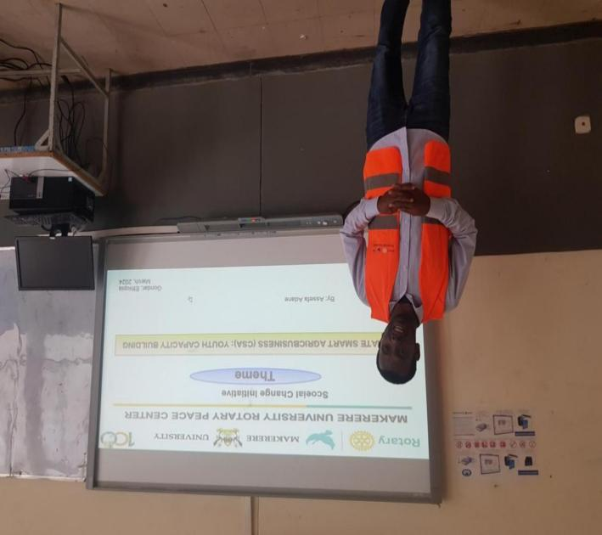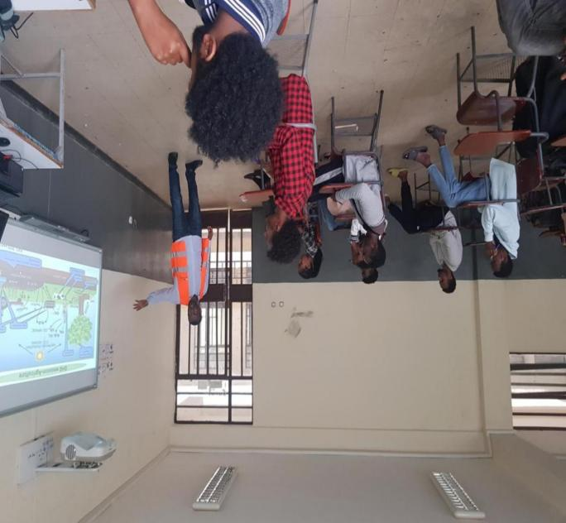

Figure 3: Youth capacity building training on waste to food CSA

**3.1.4. Support systems for youth in Tseda community**

To empower individuals in developing and running successful waste to food climate smart agribusiness ventures, this initiative provides a comprehensive support system. It starts by building interest through awareness campaigns and capacity building workshops that challenge negative perceptions and showcase success stories. As per the response of target groups the workshop program equips them with knowledge and skills, while mentorship offers personalized guidance. Business development support includes generating ideas, crafting plans, and conducting market research. Furthermore, the initiative facilitates access to crucial resources like financing. Finally, it is in a position to offer ongoing support after launch through monitoring, evaluation, and networking opportunities, ensuring long-term success.

## 3.2. Key Findings/impact

Based on the post-training evaluation the preliminary findings indicated in table 2 participants have gained valuable skills and knowledge in local waste recycling and reusing climate smart agribusiness. The establishment of the waste management (recycle and reuse) system will lead to a reduction in waste pollution and an increase in agricultural productivity. Six individual target groups attested as they will practice vermicomposting and its integration with dairy farming. Based on the evaluation indicated in table 3 the target group have reported their expectation as they will have improved income generation and food security, contributing to overall community well-being while ensuring planetary health through local waste reduction, recycle and reuse in agricultural production.

Table 2: Overall training evaluation findings

|  |  |  |
| --- | --- | --- |
| **Training materials relevance** | **Frequency** | **Percent** |
| Yes | 17 | 77.27 |
| No | 5 | 22.73 |
| **Application of knowledge and skills** |  |  |
| Yes | 16 | 72.73 |
| No | 6 | 27.27 |
| **Mentorship and technical assistant need** |  |  |
| Yes | 21 | 95.45 |
| No | 1 | 4.55 |
| **Need for additional training** |  |  |
| Yes | 19 | 86.36 |
| No | 3 | 13.64 |
| **Financial support need** |  |  |
| Yes | 22 | 100 |

Table 3: Youth perception on waste to food climate smart agribusiness

|  |  |  |  |
| --- | --- | --- | --- |
| **S.No.** | **Statements** | **Youth perception index (YPI)** | **Rank** |
| 1 | Was the training relevant to your needs and aspirations? | 64 | 2nd |
| 2 | Did the training address the specific challenges faced | 50 | 6th |
| 3 | Did the training provide practical knowledge and skills that can be immediately applied | 58 | 4th |
| 4 | How satisfied were you with the training content? | 62 | 3rd |
| 5 | How satisfied were you with the training delivery | 66 | 1st |
| 6 | How satisfied were you with the training facilitators? | 56 | 5th |

These findings highlights the positive impact of the training on the participants, indicating a strong foundation for continued success on waste to food climate smart agribusiness.

The initiative focused on youth capacity building on waste to food climate smart agribusiness effectively equipped participants with knowledge of waste management, climate change and agribusiness. It promoted sustainable practices, foster an enterprenueral mindset, and encouraged community engagement. The initiative’s impact on reducing waste, improving soil health, and creating economic opportunities demonstrates its potential for positive changes in the community.

## CHAPTER FOUR: CONCLUSION AND RECOMMENDATIONS

## 4.1. Conclusion

The social change initiative has made significant strides in addressing local waste management, resource recovery, CSA practice application and peace building in the Tseda community. It has demonstrated the potential of waste to food-climate smart agribusiness in addressing the social, economical and environmental challenges. By empowering youth to engage in climate smart agribusiness, the initiative is expected to promote the main pillars of sustainability (social, economical, and environmental) dimensions in the target community and beyond. Addressing complicated and pressing challenges like, climate change, and peace building to foster enabling environment in community development require an unreserved effort to harness potential of youth in CSA for sustainable socio-economic development. Efforts in capacity building and support systems specifically, designed in climate smart-agribusiness to empower youth from farming households is vital to enhance sustainable development. Promoting youth-led CSA models can serve as a powerful avenue that inspires others and drives a positive change in the community and beyond.

## 4.2. Recommendations/Implications for policy

* To sustain the initiative and scale up its success in the community, it is recommended that local government authorities and policymakers integrate climate smart agribusiness capacity building in community service programs and development initiatives.
* Additionally, policies that support youth entrepreneurship and sustainable agriculture should be developed to create an enabling environment for similar initiatives in the future.
* It is imperative to enhance youth capacity in teamwork and peace building for resilient and sustainable socio-economic development.

## 4.3. Sustainability Plan

To ensure the long term sustainability of the initiative, a comprehensive plan has been developed as mentioned below.

* Continued follow up and mentorship for target group to enhance their skills and knowledge application into practices
* Establishment of youth cooperative and common platform for sustainable share of experience, and resources in CSA practices in their community.
* Development of partnership with local business and markets to support youth-led CSA initiatives in the community and beyond
* Integration of climate smart agribusiness practices into community development programs and initiatives
* Regular monitoring and evaluation to track progress and identify areas for improvement
* Dissemination of scalable CSA practices to the large mass of the community

## References

Allemie G, Kebede T, & Gebremariam Z. (2020). Food Waste assessment in the Ethiopian hotel industry: A case study of Gondar City hotels. Journal of Hospitality and Tourism management, 42, 140-148.

Berhane, G., & Mekonen, M. (2019). Food waste characteristics and management practices in Ethiopia. Sustainability, 11(12), 3337.

Bullock R, Huyer S, Shai T, and Nyasimi M. (2020). The CCAFS Youth and Climate-Smart Agriculture (CSA) Strategy. CCAFS Working Paper no. 332. Wageningen, the Netherlands. CGIAR Research Program on Climate Change, Agriculture and Food Security (CCAFS).

CCAFS. Youth Engagement in Climate-Smart Agriculture in Africa: Opportunities and Challenges. [https://cgspace.cgiar/handle/10568/92979](https://cgspace.cgiar/handle/10568/92979.)/

CGIAR Research Program on Climate Change, Agriculture and Food Security (CCAFS). (2023). Gender and Climate-Smart Agriculture: Pathways to Equity. <https://gender.cgiar.org/collections/gender-CSA>

CSAYN. From Food To Money in The Pocket: Engaging African youth in climate-smart agriculture. (csaynglobal.org).

FAO, (2020). Building Resilience Against Climate Shocks. <https://www.fao.org/policy-support/tools-and-publications/resources-details/en/c/427091/>

FAO, (2019). Food Loss and Waste Reduction. <https://www.fao.org/policy-support/policy-themes/food-loss-food-waste/en/>

FAO, (2021). The State of World Agriculture 2021: Transforming Food Systems for improved food and nutrition security. <https://www.fao.org/documents/card/en?details=cb4474en>

Intergovernmental Panel on Climate Change (IPCC). (2021). *Climate Change 2021: The Physical Science Basis*. <https://www.ipcc.ch/report/ar6/wg1/>

International Fund for Agricultural Development (IFAD). (2020). Rural youth employment opportunities: A pathway to peace and prosperity.

International Fund for Agricultural Development. (2018). Transforming Food Systems for Youth: A Framework for Action. <https://www.ifad.org.en/rural-development>-report/

International Institute for Sustainable Development (IISD). (2022). Climate-Smart Agriculture for Food Systems Transformation.

International Labour Organization (ILO). (2021). World Employment and Social Outlook-The greening of jobs. [World Employment and Social Outlook Trends 2023 (ilo.org)](https://webapps.ilo.org/wcmsp5/groups/public/---dgreports/---inst/documents/publication/wcms_865332.pdf)

Jayne T. S, Argawings-Kodhek E., & Minten B. (2022). Out-migration, agricultural productivity, and institutional change in rural Africa. Journal of Rural Studies, 87, 232-247.

Jones A, et al (2023). The role of digital Agricultural Technologies in Transforming food systems for youth. Journal of Agricultural Education and Extension, 29(2), 181-190.

Nenya Institute of Public Policy Research and Analysis (KIPPRA). (2022). No. 07/2022-2023. Supporting Youth involvement in Climate-Smart Agriculture <https://kippra.or.ke/repository>

Office of the United Nations Youth Envoy. (2023). *Facts and Figures About Youth*. <https://www.un.org/en/global-issues/youth>

Singh B, et al (2020). Strategies for mainstreaming Climate-Smart Agriculture (CSA) Practices: Lessons Learned from Expressions in Eight Developing Countries (Report). International Fund for Agricultural Development (IFAD).

Tesfaye Y, & Megersa M. (2016). Food waste valorization: Composting for resource recovery and circular economy in developing countries. Journal of material Cycles and Waste management, 18(5), 682-696.

UN Environment Program (UNEP( (2021). Climate Change and Least Developed Countries. <https://www.unep.org/topics/climate-action>

UN Office for Disaster Risk Reduction, (2022). Climate Change and Fragile States. <https://www.undrr.org/>

UN Women, (2021). Gender and Climate Change. <https://www.un.org/womenwatch/feature/climate_change/>

United States Environmental Protection Agency (EPA). (2023). Landfills and methane Emissions. <https://www.epa.gov/lmop>

United Nations Development Program (UNDP). (2023). Empowering youth for Sustainable Development: Goals 13-Climate Action. <https://www.undp.org/asia-pacific/empowering-youth>.

Verchot L., et al. (2022). Decarbonizing agriculture through youth leadership. Nature Sustainability, 5, 1024-1030.

Vermeulen S, et al., (2022). Youth, agriculture, and climate change in the post-2015 development agenda. Global Environmental Change, 77, 102683.

Wiggins S. (2020). Transforming Food Systems: Youth and Agribusiness in Africa. Journal of Development Studies, 56(1), 146-164.

World Agroforestry (ICRAF). (2021). *Gender and Climate-Smart Agriculture: Closing the Gap.* <https://cgspace.cgiar.org/items/908a9723-843b-46a1-86b8-edf208b3982d>

World Bank (2020). Climate Change and Agriculture. <https://www.worldbank.org.en.topic.climate-smart-agriulture>

World Bank (WB). (2023). World Development Report 2023: Finance for a More Equitable World. <https://wwwworldbank.org/en/publication/wdr2023/data>

World Bank, (2018). Solid Waste Management in Africa. <https://www.worldbank.org/en/topic/urbandevelopment/brief/solid-waste-management>

World Economic Forum (WEF). (2022). Unlocking the Potential of Agtech for a Sustainable Food Future. <https://www.weforum.org/agenda/2024/01/unlock-agtech-ggrowth-agriculture-farmers/>

**APPENDICES**

**Annex I: Need assessment**

Annex table 1" Socioeconomic characteristics

|  |  |  |  |  |  |
| --- | --- | --- | --- | --- | --- |
| **Variables** | **Observation** | **Mean** | **Std. Dev.** | **Min** | **Max** |
| **age** | **15** | **33.4** | **8.9026** | **24** | **56** |

Annex table 2: Educational level by sex

|  |  |  |  |  |  |
| --- | --- | --- | --- | --- | --- |
|  | **Educational level** | | | |  |
| **Sex** | **Illiterate** | **primary** | **secondary** | **tertiary** | **Total** |
| **Male** | 1 | 3 | 6 | 0 | 10 |
| **Female** | 1 | 1 | 1 | 2 | 5 |
| **Total** | 2 | 4 | 7 | 2 | 15 |

Annex table 3: Perception on agribusiness and waste reduction, recycle and reuse

|  |  |  |
| --- | --- | --- |
| **Interest in agriculture** | **frequency** | **Percent** |
| Yes | 13 | 86.67 |
| No | 2 | 13.33 |
| **Type of agriculture farming** |  |  |
| livestock | 6 | 40.00 |
| crop | 4 | 26.67 |
| Horticulture | 3 | 20.00 |
| Integrated | 2 | 13.33 |
| **Participation in agriculture** |  |  |
| Yes | 11 | 73.33 |
| No | 4 | 26.67 |
| **Interest in waste recycling** |  |  |
| Yes | 13 | 86.67 |
| No | 2 | 13.33 |
| **Local waste recycling initiatives** |  |  |
| Yes | 5 | 66.67 |
| No | 10 | 33.33 |
| **Know-how on CSA** |  |  |
| Yes | 7 | 46.67 |
| No | 8 | 53.33 |
| **Waste disposal techniques** |  |  |
| landfill | 5 | 33.33 |
| Composted | 6 | 40.00 |
| Burned | 3 | 20.00 |
| Others (like open dumping, …) | 1 | 6.67 |
| **Access to resources (land)** |  |  |
| Yes | 10 | 66.67 |
| No | 5 | 33.33 |
| **Total** | **15** | **100.00** |

**Annex II: Preliminary community observation**

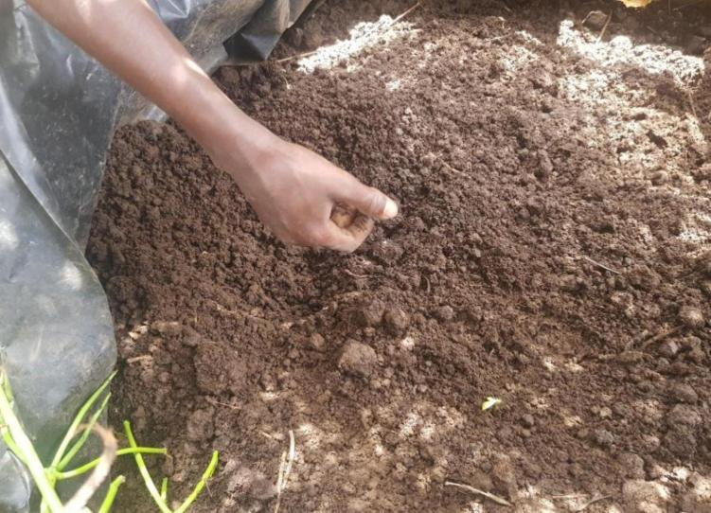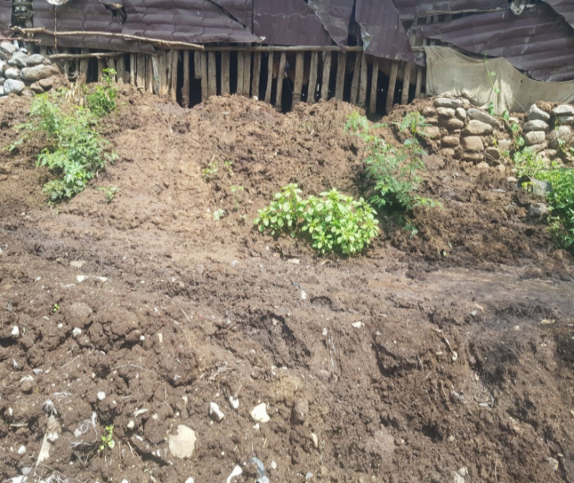

Annex figure 1: vermicomposting (worm rearing) and waste recycling

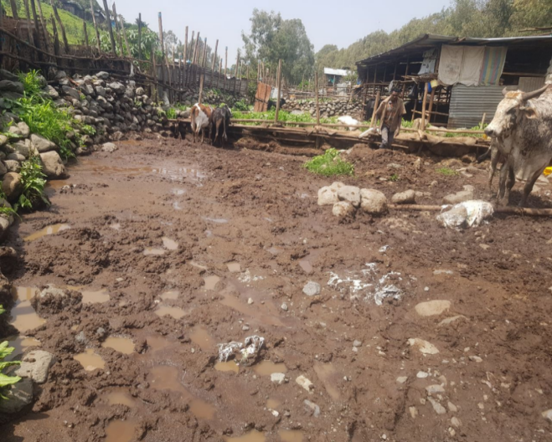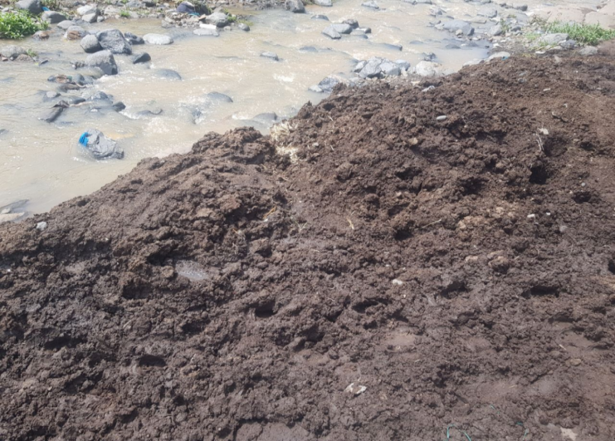

Annex figure 2: Animal dungs and waste disposal to the river point

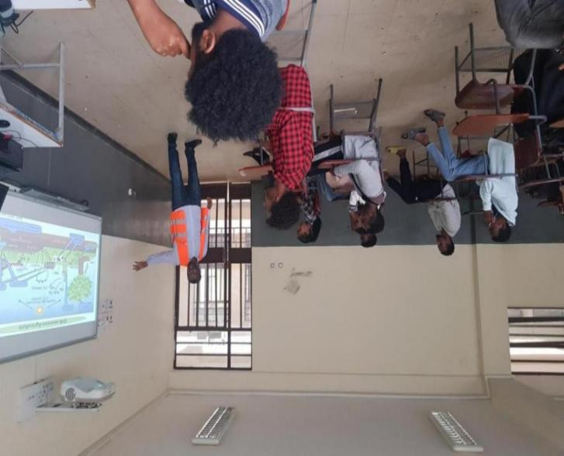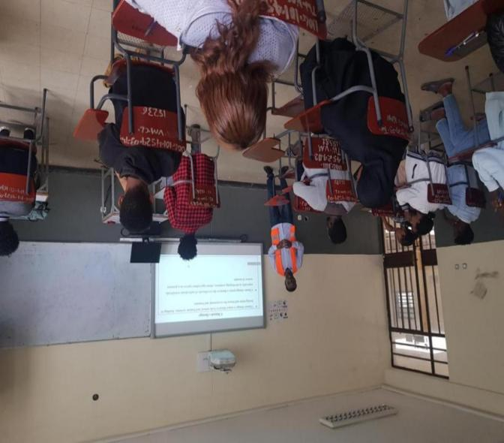

Annex figure 3: Training on waste to food-CSA practices

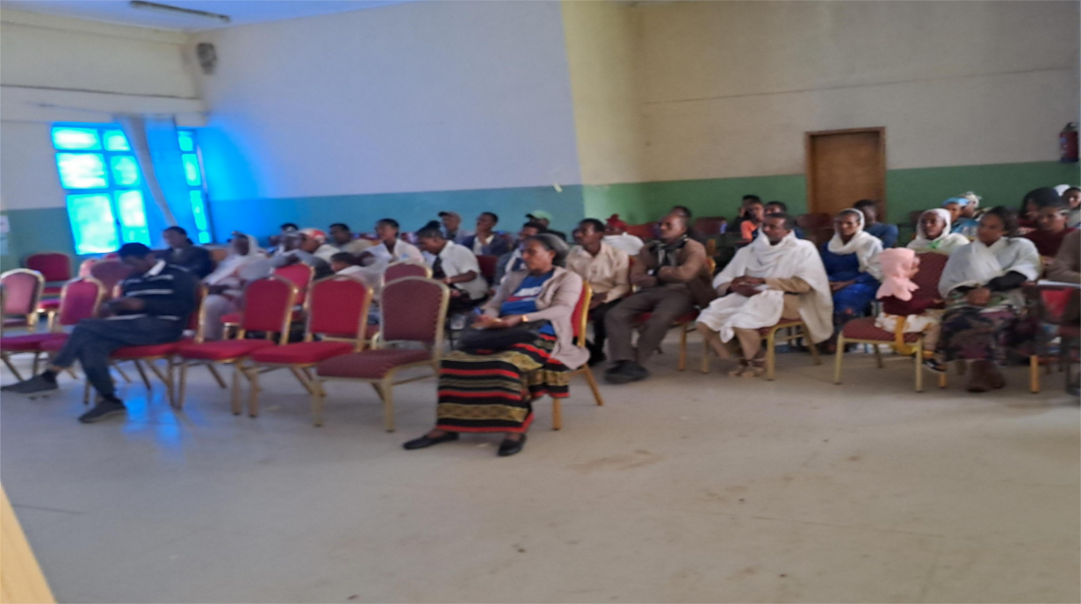

Annex figure 4: Advocacy on peace building in a community meeting

