**Christopher FON ACHOBANG,**

**Student No: 2200700006, Reg. No. 2022/HD03/006X**

**COHORT 3 ROTARY PEACE FELLOW**

**TITLE: Genocide Alert Magazine and Petitions for Independence of Ambazonia**

**LOCATION: Online and printed hard copies**

**START & COMPLETION DATE: June 2022 to January 2023**

**ABSTRACT**

My Social Change Initiative was informed by lack of reliable information on Ambazonia. It started as a series of tweets, WhatsApp chats, online news articles, a magazine and petitions. It evolved and culminated as a full book project to alert the international community and multinational stakeholders about the ongoing genocide in Ambazonia. Petitions were sent out to the Foreign, Commonwealth & Development Office (FCDO), which acknowledged receipt. Similar petitions were sent to the Queen of England, House of Commons, and The Prime Minister of England at Number 10 Downing Street. Further petitions took the form of tweets to the United Nations Secretary General, French President Emmanuel Macron, Canadian Prime Minister, President of the United States of America, US Secretary of State, Israeli Prime Minister, and others directly or remotely playing a role in the War in Ambazonia. The idea of an online magazine quickly evolved into a collaborative book project which accepted contributions from Ambazonian Lawyers, activists, politicians and social commentators. The book, **GENOCIDE IN AMBAZONIA**, using graphic pictures, depicts the horrors of the ongoing genocide in Ambazonia with some harrowing testimonies of witnesses and victims. Both the Ambazonia Genocide magazine and the petitions led to interested persons committing to sponsor a book project, culminating in its printing. These petitions, magazine and book has greatly improved understanding of the genocide in Ambazonia. Because of this information, USA authorities authorized Ambazonian activists to protest in front Conrad Hotel in Washington DC where President Biya of Cameroun was staying during the USA-Africa Summit 2022 was staying. Interestingly Ambazonia Governing Council appreciated my efforts by integrating me into all its decision-making departments.

**CHAPTER ONE**

**Introduction and Background**

This social change initiative highlights the genocide in Ambazonia and brings it to international attention. It is believed that online petitions, magazines, books might be able to take the information to the furthest corners of the world without exposing the activist authors. Cameroun is disappearing and imprisoning activists and journalists for daring to protest and report the genocide, war crimes and human Rights abuses going on in The Cameroons. So, I decided to work from exile to tweet petitions and write to the world.

It has not been easy and a comfortable choice for me to do my project, while away from my home country. Basically, staying online and via phone, I was able to regularly gauge the impacts of my initiative, on the ground, and the targeted audiences at home and abroad. Chapter One gives a background to what inspired my choice of this Social Change Initiative, as well as present the Problem Statement, goals and objectives. The challenges I faced and how I mitigated them is looked into in this chapter. You will find literature review, theoretical underpinnings, change theory and how it was applied in Chapter Two. The chapter also presents the Methods and Design. Chapter Three handles the interventions and activities carried out, as well as present the key findings and impacts. Chapter Four concludes the report with a general conclusion, recommendations and implication of my initiative for policy and policy makers. An elaborate plan for the fruits of this initiative to be sustained for a long time is also presented here. A couple of photographic evidence and video links appear under the appendices.

The Genocide in Ambazonia has been going since 2017, with over 70,000 people killed, and thousands of homes and whole villages burnt down. Hundreds of thousands of Ambazonians have been forced into exile, while millions are surviving as Internally Displaced Persons (IDP). Hundreds of thousands of children have missed many years of schooling according to Jan Egeland of the Norwegian Refugee Council (NRC). Atrocious war crimes, and gross human rights abuses have been meted on Ambazonians, simply because they opted to seek their complete decolonization and independence from the Cameroun Republic.

Why a war in Ambazonia? Ambazonia was part of the German colony of Kamerun as determined by the 1884 Berlin Conference. After the First World War fought from 1914 to 1916, Germany lost its territories across Africa. German Kamerun was divided into two in 1919 and became League of Nations Mandated territories of French Cameroun under France, and British Cameroon under Britain. A greater part (80 percent) of the former German Kamerun was handed to France, while the smaller portion was handed to Britain and managed as part of Nigeria. With the dissolution of the League of Nations after World War II, French Cameroun and British Cameroon were placed under the trusteeship of the United Nations. France and Britain were to administer the trust territories and prepare them for decolonization and independence. The administering authorities were forbidden from annexing the territories.

The United Nations Trusteeship Council had to supervise the administration of the trust territories as they transitioned from colonies to sovereign nations. The United Nations Trust Territory of British Southern Cameroons was administered by the British as part of its former colony of Eastern Nigeria, while British Northern Cameroon was administered as part Northern Nigeria, where it remains till date. British Southern Cameroons broke from Eastern Nigeria, leaving the Eastern House of Assembly in Enugu in 1954. The British Southern Cameroons representatives returned to Buea where they started their own parliament of two chambers, and government.

French Cameroun is said to have attained independence on 1 January 1961, while British Southern Cameroons and Northern Cameroons had to go through a plebiscite on 11 February 1961, to decide whether it would attain independence by joining the Federation of Nigeria or the Cameroun Republic. By the time African countries were moving towards independence, from the 1960s, British Southern Cameroons was already experiencing self-rule, and had stable institutions. The British Southern Cameroons was prepared for independence while its French Cameroun counterpart was still deeply in French stranglehold. Not ready to leave Africa alone, the French signed a series of suffocating Economic and Military Accords handing most of their sovereignty to France even after independence. British Southern Cameroonians did not want any of these options. The United Nations Trusteeship Council failed the people of the Trust Territory of the Former British Southern Cameroons, by not allowing them to achieve total independence. Failure to decolonize and grant independence to British Southern Cameroons is the root cause of the Genocide in Amabzonia.

Does the world and the august United Nations and its specialized organs care? Ambazonians are convinced the UNGA and other world bodies do not care as they see the war as an internal conflict. My Social Change Initiative sought to put out the correct information to the world and to the competent authorities: that the decolonization of Ambazonia must be completed with its eventual total independence and to end the genocide.

The world has chosen to go along the delay tactics of Cameroun, which pretends that it is capable of solving its own internal affairs. It is not an internal affair as Ambazonia has waited for 62 years for its autonomy, and sovereignty. **Andrew Cohen**, (Same Cohen who was governor in Uganda from 1952 – 1957) British representative to the UN Trusteeship Council argued against complete independence for Ambazonia (Martin, Lynn 2001). According to him, Ambazonia did not have the resources to sustain independent institutions. Available information shows that 65 percent of Cameroun annual income for the past 45 years comes from the territory now claimed by Ambazonia. Unfortunately, citizens from this territory are treated as unwanted aliens in their country. The Federal System that guaranteed their recognition as equal partners was discarded in 1972 by a bogus referendum, for a United Republic of Cameroon. The United Republic of Cameroon was eventually dissolved by a Presidential Decree signed by Paul Biya in 1984 changing the name back to the Republic of Cameroun as at independence on 1 January 1960. Ambazonians were forced to also call for a return to the Southern Cameroons nomenclature before the scrambled 1961 Federal System.

**Problem Statement**

Cameroun clamps down on journalists, as it kills some and imprisons others (Ndi, 2020) on <https://www.theeastafrican.co.ke/tea/rest-of-africa/in-cameroon-laws-stifle-press-freedom-3238994> . Most national and foreign journalists are not allowed to visit the conflict zone in Ambazonia, therefore cannot get information from the warfront. Media people who dare to report on the crisis are promptly killed or arrested and taken into detention. There is general state censorship of what is published on the conflict, or self-censorship to avoid falling prey to the robust state oppressive machinery. (J. Takougang 1995). Government spokespersons and the Cameroun Minister of communication issues periodic press statements, in line with government propaganda, with a knack for distorting facts. The world appears to be in the dark about the ongoing genocide in Ambazonia. Mainstream media like Cable News Network (CNN), British Broadcasting System (BBC), Reuters, Radio France International (RFI), Washington Post, New York Times do not seem to have access to information. Jan Egleland of NRC says the conflict in Ambazonia is one of the most under-reported crises in the world. A vast majority of media people in neighboring Nigeria do not even know there is war next door to them in Cameroon. Some Ugandans were hearing about the war in Ambazonia for the first time from me. All they know about Cameroun is football. Despite the many TV stations under the control of various Ambazonian factions, they are not articulating their plight clearly and sufficiently. Reason why I chose targeted communication in the form of petitions, through tweets, media TV chats and articles on different platforms.

**Goals and Objectives**

My main goal is to inform the world sufficiently about the Genocide, war crimes, crimes against humanity and human rights violations by Cameroun Republic in Ambazonia, so that the competent world bodies will take informed decisions to end the genocide in Ambazonia, and facilitate attainment of her total independence. It is my conviction that with compelling arguments, the following objectives would be easily met:

* Cause a UN Human Rights Council Fact-Finding Mission to Cameroun to appropriately determine the degree to which international human rights law and international humanitarian law have been violated and by whom, given the dire conflict situation.
* Investigate, and where warranted, try those individuals charged with the crimes of genocide, war crimes, crimes against humanity, and the crime of aggression.
* Adoption of targeted sanctions towards those individuals responsible for human rights violations by means of the Global Human Rights Sanctions Regime.
* Initiate a case against Cameroun at the International Criminal Court for committing war crimes, genocide, crimes against humanity, and crimes of aggression—four fundamental crimes prohibited under the Rome statutes.
* Demonstrate good faith by invoking Ambazonia’s right to the principle of Global Responsibility to Protect (R2P) as premised in Paragraph 139 of its implementation accord. This will enable a commitment to collective action to protect the Ambazonian people from the current genocide, war crimes, ethnic cleansing, and crimes against humanity, and prevent them from fleeing to other countries like Nigeria where they get subjected to further degrading conditions and some repatriations.
* Cause Cameroun to withdraw its troops and administration from Ambazonian territory to pave way for an interim UN sponsored stabilization force and authority, in preparation for the establishment of a self-governing administration and total independence.
* Cause international mechanisms to cause Cameroun to pay reparations for the damage caused to the Ambazonian people, so as to work towards the reconstruction of its social fabric and infrastructure.

**Challenges and Mitigation Strategies**

1. Considering the sensitive nature of my Social Change Initiative, I was in permanent fear for my life and needed some guarantees of a safe haven, where to start implementation. To mitigate this challenge, and to avoid being a pariah in my host country, which I must thank, I applied for protection from the Ugandan Refugee Board. Listening to my compelling story of persecution in Cameroun, the Office of the Prime Minister of Uganda, in-charge of refugee affairs, expeditiously granted me refugee status, and ensured that I had the required documents. The Refugee Identity card, which can take forever to establish was done for me within a twinkle of an eye. The OPM also seized the Ministry of Internal Affairs to issue an express Conventional Travel Document (CTD) to me within a few days.
2. Like a refugee without resources, I could not find a place to comfortably lay my head in Uganda. Peace Fellow John Rubaramira, admitted me to the comfort of his home in Kabale. He also lodged me at his home in Kampala for extended periods. That provided me with a conducive abode to relax and implement my social change initiative, without much stress.
3. Magazines, books and other media activities need financial resources. I am grateful to my partner and Ambazonian comrade Njousi Abang with whom we worked together. We secured over US$ 3000 from a generous couple in the USA. I also secured a free spot on ChatNite Africa TV in the USA to articulate facts and my views on Ambazonia to thousands of viewers, worldwide, shaping their understanding of the issues.
4. It would have been a difficult task to get layout artists for the book, Genocide in Ambazonia. To mitigate this challenge, we resorted to Ambazonian comrades with book layout expertise.

**CHAPTER TWO**

**Literature Review**

Many people are not agreed on the origins of the right to petition, but generally believe it has always been there with mankind. Some trace it to the Magna Carta of 1215 (Richard 1932, Stancati 1983), while others trace it to an earlier period of human development with the existence of political power (Hauriou, 1929). Whatever the case, the right to petition found expression in the need to maintain a relationship between the community and political power, long before elections and general suffrage. The right to petition was enacted into law with the English Petition of Rights 1628 and the Bill of Rights 1689, to guarantee that citizens expressed themselves to sovereigns to respect their rights without fear of possible punishments. With the setting up of modern representative structures, these rights reappeared (Rodrigues, 1997; Durelle-Marc, 2008), taking advantage of the constitutionalism movement of the late 18th century. It is a hallmark of the French Constitution of 1791 (Dubourg-Lavroff, 1992), and also in the First Amendment to the US Constitution (1789), followed by many European and American fundamental laws. Miranda is therefore right to consider the right to petition as probably the oldest political right of citizens (2008).

Information and Communication Technology plays an ever-growing role in communication and forming of public opinion, and has become a crucial tool in relations between political institutions and the public (Leston-Bandeira, 2009). More activism work will leave the streets to find expression in online media in the form of petitions. Petitions are tools used by advocates, activists, and concerned citizens with any level of experience for sparking change (Tisdale, N, 2019). *Right to Petition*. In Right to Petition, Tisdale posits that Americans from the Democratic party and Republican party are frustrated and need new tools for advocacy. Petitions might not be a new a new tool as such. Petitions have been used before to bring attention to the suppression of the rights of people around the world, and the African American. On 17 December 1957, William Patterson and Paul Robertson submitted a petition from the Civil Rights Congress (CRC) to the United Nations. This petition was titled “We Charge Genocide: The Crime of Government Against the Negro People”. The document received close to 100 signatures from US intellectuals and activists. It was a book-length petition documenting hundreds of lynching cases and other forms of brutality and discrimination, showing a clear pattern of government inaction and complicity (Robertson et al. 1957, December 17). <https://www.zinnedproject.org/news/tdih/we_charge_genocide_petition>

The petition cited the UN’s definition of genocide: “Any intent to destroy, in whole or in part, a national, racial, or religious group is genocide.” The petition concluded therefore, that . . .the oppressed Negro citizens of the United States, segregated, discriminated against, and long the target of violence, suffer from genocide as the result of the consistent, conscious, unified policies of every branch of government. If the General Assembly acts as the conscience of mankind and therefore acts favorably on our petition, it will have served the cause of peace. As good as this petition was for the cause of human rights and a sane America, the authors were branded as Communist Propagandists.

Across continents and cultures, petitions are welcomed as a right. The Committee on Petitions of the European Parliament requested an in-depth analysis on

"The Right to Petition" is recognized in the European Parliament (EP) and in the Member States, where certain Parliaments (and indeed governments) have seen in so called "e-petitions" a way to address some of the challenges faced by today's democracies, such as the growing distance between citizens, politicians and key political institutions (Tiburcio T. 2015). <http://www.europarl.europa.eu/supporting-analyses>

Those perpetrating genocide, war crimes, crimes against humanity are very ready to confront and get rid of people who denounce them. Perpetrators are always denying that there is genocide, or that they are committing genocide (Cox. Et al. 2022). *Denial: The Final Stage of Genocide*. To John Cox et al, genocide denial abuses history, insults the victims and paves the way for future atrocities. Genocide is an internationally recognized crime where acts are committed with the intent to destroy, in whole or in part, a national, ethnic, racial, or religious group. These acts fall into five categories:

1. Killing members of the group
2. Causing serious bodily or mental harm to members of the group
3. Deliberately inflicting on the group conditions of life calculated to bring about its physical destruction in whole or in part
4. Imposing measures intended to prevent births within the group
5. Forcibly transferring children of the group to another group

Source: 1948 Article 2, UN Convention on the Prevention and Punishment of the Crime of Genocide. <https://www.ushmm.org/genocide-prevention/learn-about-genocide-and-other-mass-atrocities/what-is-genocide>

States have obligations to do the following when it comes to genocide: States' obligations under the Genocide Convention include:

* Obligation not to commit genocide (Article I as interpreted by the ICJ)
* Obligation to prevent genocide (Article I) which, according to the ICJ, has an extraterritorial scope;
* Obligation to punish genocide (Article I);
* Obligation to enact the necessary legislation to give effect to the provisions of the Convention (Article V);
* Obligation to ensure that effective penalties are provided for persons found guilty of criminal conduct according to the Convention (Article V);
* Obligation to try persons charged with genocide in a competent tribunal of the State in the territory of which the act was committed, or by an international penal tribunal with accepted jurisdiction (Article VI);
* Obligation to grant extradition when genocide charges are involved, in accordance with laws and treaties in force (Article VII), particularly related to protection granted by international human rights law prohibiting refoulment where there is a real risk of flagrant human rights violations in the receiving State.

In Genocide by Denial, Peter Mugyenyi, sees the cold-heartedness of the rich world that turned a blind eye, to HIV/AIDS, until it was far too late, and then responded too slowly with too little as a form of genocide denial (Mugyenyi P. 2008). *Genocide By Denial.* Like in Rwanda in 1994, and Ambazonia, today, the world has turned a blind eye to the genocide in Ambazonia. Those who know what is happening, have elected to minimize its impact calling it an internal conflict that Cameroun should be empowered to deal with, to the best of its ability. In exploiting this mandate to solve its internal affairs, as best they wish, Cameroun has killed tens of thousands of Ambazonians since 2017.

**Theoretical underpinnings**

SOCIAL EMPOWERMENT THEORY

Social empowerment is the process of building the autonomy, power, confidence and other necessary means to enact change and pave the way for a better future. (Rappaport 1987) believes that individuals should be studied within their communities in order to gain an adequate understanding of the individual's control, influence over themselves and their communities, and then finally, the influence that society has had on them. Social empowerment takes place at both the individual and the collective level. For an individual, social empowerment could look like gaining the inner and outer resources to make personal choices, such as what to eat, where to live and other decisions that allow us to control our environment and way of life.

On a collective level, social empowerment looks like organizations and institutions that help marginalized groups of people gain the resources to be empowered, such as material assets, good health, education, social belonging, self-esteem, self-confidence and economic opportunity. The goal is to give people who lack access to these resources a sense of identity, community and well-being so they can thrive and to eliminate systems that keep them without necessary resources and perpetuate marginalization.

Empowerment theory in social work uses intervention methods to help guide people toward building autonomy and control in their lives. This theory recognizes that oppression is a primary contributor to disempowerment, which is experienced across a number of marginalized groups. Empowerment theory seeks to empower individuals and communities to gain personal, interpersonal and political power to better their lives. This work also strives to challenge systems that hinder these groups from meeting their needs.

Empowerment, as a term, could be traced to American community psychology and is associated with the social scientist Julian Rappaport (1981). In fact, the origins of empowerment theory are much further in history and could be found in Marxist sociological theory.

The theory of structural empowerment proposed by Kanter (1993) includes a discussion of organizational behavior and empowerment. According to this theory, empowerment is promoted in work environments that provide employees with access to information, resources, support, and the opportunity to learn and develop. Moss Kanter proposes six keys for leading positive change: show up, speak up, look up, team up, never give up, and lift others up.

Empowerment is both a value orientation for working in the community and a theoretical model for understanding the process and consequences of efforts to exert control and influence over decisions that affect one's life, organizational functioning, and the quality of community life (Perkins & Zimmerman, 1995).

PETITIONING AND THE EMPOWERMENT THEORY OF PRACTICE In democratic socialist values, empowerment is a process by which individuals develop a sense of personal responsibility for the fundamental decisions that most affect their lives, and results ultimately in the democratization of economic and political decision making. Empowerment does not refer to a group as a whole gaining greater influence, as would be suggested by a pluralistic model of political life, nor does it mean the supremacy of one individual over another, as in a marketplace model. Rather it involves a change in consciousness and social relations so that people see themselves as able to join, and actually do join, in making decisions, along with their community, which affect their lives in important ways. Empowerment, being the opposite of alienation cannot be achieved by a simple attitude change. It depends, to a certain extent, on actual participation in a political movement or some other collective activity by which people try to influence decisions that affect their lives.

Certain segments of society view power negatively as "that which enabled some people to make decisions for others, something they were fighting to eradicate." This concern led them to develop the idea of personal empowerment as a goal of political activity. In the case of Ambazonia, this has become a bane as people and groups struggle to take power for themselves leading to the creation of many factions. Empowerment comes from recognizing the important role one has in working with others, not from dominating them.

Ella Baker, an early proponent of group-centered leadership, stated: "Instead of 'the leader’ (a person who was supposed to be a magic man) you would develop individuals who were bound together by a concept that benefited larger numbers of individuals and provided an opportunity for them to grow into being responsible for carrying gram." Through empowerment, people became capable of engaging in struggles for change. As the group-centered theory of leadership suggests, empowerment is valuable for radical social change in several ways. First, to create a democratic movement, a majority of people must be convinced not only that change is necessary and desirable, but also that they rightfully have the power to effect it. When people feel powerless, they accept and accommodate social conditions that they realize are oppressive, inhumane, or simply contrary to their best interests because they believe that they cannot do anything about them.' Overcoming this sense of powerlessness is necessary to stimulate participation in a democratic movement. Moreover, empowerment is necessary to create and sustain the democratic institutions that are a central element of socialist positive programs.

PETITIONING ADDS TO THE EMPOWERMENT THEORY

Empowerment requires a further step - that people actually gain political power and have greater control over their lives. Whether or not a lawyer's work will result in empowerment, either of an individual client or an entire community, depends on a number of factors, some of which are outside the lawyer's control.

A petition stimulates further political action when it is used to politicize issues, identify a group of people with a common interest, and specify an immediate goal. This method of encouraging social change may sound gradual and incremental, rather than revolutionary, but the speed and type of change depends on the contents of the petition. An underlying assumption here is that democratic principles require social change movements to begin with what people currently want.

Finally, a range of options is important because petitioning is empowering when it involves activities that are more easily available to otherwise excluded groups. People attempting to have an effective role in political decisions may have the resources to organize and participate in a mass demonstration protesting welfare cuts yet be unable to wage a media campaign or hire lobbyists. Thus, the petitioning model suggests that the lawyer should encourage clients to consider various forms of political activity. Petitioning has historically been a means of political participation for disenfranchised groups. It can serve as a model illustrating how a lawyer's work can encourage empowerment.

**CHANGE THEORY AND HOW IT WAS APPLIED**

It is hypothesized that if Ambazonians could clearly articulate their grievances and predicament, the international community will be informed and made aware of their plight, and mobilize to undertake actions, which will end the genocide and lead to eventual independence of the former UN Trust Territory of British Southern Cameroons. Lots of world leaders do not know that Cameroun is made up of two distinct countries which were forced into a union by a fiat of the United Nations, which failed to execute its mandate to terminate its Trusteeship over the territory to grant it total independence (Ajong S. 2016). International opinion is in error in believing that Cameroun is justified to claim that its territorial integrity is under threat from Ambazonian terrorists, whereas it is a conflict pitting groups clamouring for self-determination against a rogue state.

This Social Change Initiative clearly identified the problems of lack of action to result from absence of adequate and timely information. We indulged in petitions which took the form of writing articles published on online magazines and newspapers, posting breaking news and periodic updates. On 27 July 2022, on [www.modernghana.com](http://www.modernghana.com) as part of my education for empowerment to change social attitudes, I challenged why Cameroun should be allowed to participate in the Birmingham 2022 Commonwealth Games, even as the country violates the cardinal principles of the Gentlemen’s Club. You may read article Cameroun leave XXII Commonwealth Games of Shame on this link <https://www.modernghana.com/news/1173960/cameroun-must-leave-xxii-commonwealth-games-of.html> On 15 November 2022, I published an indictment against the Ambazonian victims of genocide who have chosen to fraternize with the occupiers and perpetrators of genocide. Stockholm Syndrome destroys quest for freedom: The CASE OF THE AMBAZONIAN STRUGGLE could be read and listened to on this link. <https://www.modernghana.com/news/1195408/stockholm-syndrome-destroys-quest-for-freedom.html>. This article was also published on The Nigerian voice online newspaper at [www.thenigerianvoice.com](http://www.thenigerianvoice.com) . Article was read by thousands of Ambazonians leading to the march in front CONRAD Hotel in Washington DC to protest against President Paul Biya, one of the longest serving dictator and perpetrator of the Genocide in Ambazonia.

Some of my petitions took the form of tweets to world leaders and international organizations. These world leaders and organizations like Antonio Guterres (2 million followers), British PM (255K followers), US President, Obama Michelle and her Foundation (22.2 million followers), US vice President, President Biya of Cameroun (962K followers), French President Emmanuel Macron (9.2 million followers), Israeli PM Netanyahu (2.2 million followers) et al the ICC, the UNICEF (9.3 million followers), UNGA, NRC – Engeland leave us with millions of followers. Some of these tweets were retweeted, others were replies to tweets. The idea of a magazine was transformed into an illustrated book of 133 pages, published on Amazon. Hard copies have, so far, been printed and published in Ghana. We engaged in regular debates and discussions via zoom, television, and YouTube calls.

Through regular media action, we started changing worldview, in spite sustained efforts by Cameroun to encumber the free flow of information, and its inclination for propaganda, misinformation and persecution. We joined groups completely opposed to the notion that Ambazonia had a right to aspire to self-determination and complete independence. We explored and debunked the myths and beliefs in a ONE AND INDIVISIBLE CAMEROUN, as a fallacy at the service of the oppressor of the people of Ambazonia. The most significant action taken was to debate a history professor, who was expressly commissioned by Cameroun government to REVISE the history of The Cameroons, to make sure events cementing the idea of sovereignty for Southern Cameroons (Ambazonia) were minimized or removed. 

Zoom meetings were organized on regular basis to brainstorm on aspects of the Ambazonian Genocide, ranging from organizing fundraisers to support victims, create awareness on best practices for negotiations towards prisoner release, and mobilize the international community to rally behind the responsibility to protect. I made sure to be in most WhatsApp groups, with high numbers of consequential participants. Articles, petitions and tweets were posted on these WhatsApp platforms for further circulation. Some of these materials were also posted on Cohort 3 WhatsApp group.

Progressively, many opponents of Ambazonia began to change their perceptions and positioned themselves to dialogue the possibility to review the form of the Cameroun State. Revision of the form of the state had been frantically rejected since 2016.

**Methods and Design**

My Social Change Initiative uses Information and Communication Technology (ICT), and more traditional mass communication channels to flood information on Ambazonia, worldwide. I relied on behaviour change communication with WhatsApp discussions, TV debates, and publication on online newspapers. Mass communication enhanced by ICT through regular information meetings via zoom, and group WhatsApp calls. I also used direct Advocacy Communication with Tweets, petitions, complaints and emails to stakeholder organizations and power actors. There was focus on essential messaging by boosting the signal and reducing the noise. Only pertinent and relevant messages, essential and justified for education and advocacy were sent out.

• Identify and map the actors involved on the diplomatic, humanitarian and political scene who need to be pressured into action. Send petitions, tweets, and regular updates of the war, reminding them why with such savage massacres amounting to genocide, only separation of the two warring parties will bring sustainable positive peace in the region.

• Design tactical and targeted information aimed at clarifying and sanitizing Ambazonia War of Liberation (AWOL), to be shared with influential actors and collaborators. While Ambazonians may boast of their military exploits on the warfront to local audiences, because of no impartial investigations, I refrained from giving misleading facts to the international community and organizations. In my change initiative, I allow the Cameroun forces of occupation to publish the lists of their dead, and mourn their losses on the international scene.

• Infiltrate WhatsApp, INSTAGRAM and other groups discussions to impact upon feuding Ambazonian factions to embrace the forthright position of the Ambazonian Governing Council (AGovC), which is the leading aspiration of Ambazonians. The messaging on chats are factual aimed at educating opponents to move their position towards that of AGovC, with its leading vision and roadmap for independence for Ambazonia, as opposed to conflicting advocacy for federalism.

Advocacy Communication with Tweets to organizations and individuals. This includes petitions. Broadcast Television coverage and broadcast done by debating Prof Julius Victor Ngoh on Chatnite Africa TV. Video of the ChatNite Africa TV Debate (HOW DID WE GET HERE?) with Professor Julius Victor Ngoh versus Barrister Lysinge and Christopher Achobang is found on Youtube and continues to be viewed and listened to.

Digital copies of the article, Stockholm Syndrome destroys quest for freedom: The CASE OF THE AMBAZONIAN STRUGGLE are found as digital copies were published on the online versions of [www.modernghana.com](http://www.modernghana.com) and [www.nigerianvoice.com](http://www.nigerianvoice.com) . This solved the problem of resources to host an online magazine and print physical copies.

Direct messages to the Secretary General of UN, Antonio Guterres, British Prime Minister, copying Michelle Obama with 22.2 million followers, French President Emmanuel Macron, Israeli Prime Minister, Cameroun President and others.

Email Broadcasts prepared and sent to email lists of world leaders and organizations who can and should play a role to prevent and stop the genocide in Ambazonia.

Postal mailing list of stakeholders and actors in the humanitarian and political sectors campaigning against human rights has been compiled to send Ambazonia Genocide book to.

Articles, tweets, petitions and chats which respond directly to the need to empower local populations and international actors on the world stage, with the information to help them take peaceful action to resolve issues that led to the genocide in Ambazonia.

**CHAPTER THREE**

**Interventions And Activities**

**a. Zoom meetings** on 1) 11 February 2023, Topic: 11 FEBRUARY – THE DAY OF SHAME organized under auspices of Ambazonia Education Board, and I was moderator; 2) 29 January 2023, Topic: Meeting with Supreme for best Education outcomes in liberated territory; 3) 19 January 2023, Topic: Education Board and its duty to educate and sensitize on the Ambazonian Genocide, 4) 23 December 2022, Topic: Education Board way forward and expectations. Further zoom meetings organized within the context of best practices as negotiators towards a negotiated settlement for Ambazonia to. Sample of message on going into negotiations: *Ambazonia must continue to arm and prosecute a fiercer war against the Cameroun forces of occupation than before. Fight now as if there are no ongoing discussions about talks. We need PEACE, but we have to go to the negotiations table from a position of strength.*

*It is certain that LRC wants to send Ambazonians to sleep while it begs for time and positions itself more strategically.  While there is talk about talks, Cameroun will be out to pull a fast trick against Ambazonians. The Beti are very vindictive and unforgiving. LRC will never forgive Ambazonia for matching it's fire power and killing thousands of its troops. They will tempt you to a reconciliation meeting just to eliminate you. Heightened alert is required now.*

*It is sad that the World Bank chooses to throw away $100 million dollars to arm a bloodthirsty dictatorship perpetrating a genocide in Ambazonia.  It is on record that hundreds of millions of dollars graciously given Cameroun to combat COVID-19 was embezzled. Light has not been sufficiently shed on this misappropriation and mismanagement of COVID-19 funds. Unfortunately, the World Bank falls into another trap to support a pipedream of emergence in 2035, and sponsorship for decentralisation and governance.*

*We condemn the World Bank for giving money to Cameroun Republic to further arm itself and perpetrate the Genocide in Ambazonia. The World Bank must consider the human rights of the millions of Ambazonians targeted in a genocide, for many years. The World Bank should condemn the war crimes, crimes against humanity and genocide being perpetrated in Ambazona.*

WhatsApp Group Chats: AGOVC COMMUNITY ASSEMBLY 227 participants; we discuss topical issues, on minute-by-minute basis, about the life of the movement to end Cameroun occupation of Ambazonia and bring freedom. All the leadership of the Ambazonia Governing Council are in this group. I have succeeded in inculcating the notions and practices of the 8 pillars of Positive Peace in these participants, who are expected to further spread them to the other groups where they belong.

Society of Journalism SNR is a WhatsApp chat group that brings together 135 participants. All these participants are serving and retired journalists from the former United Republic of Cameroun. Majority of these journalists are of English Expression. Half of the journalists have served with the State-owned Cameroun News Corporation (SOPECAM) and the Cameroon Radio Television (CRTV). A handful of these journalists are still in active service while majority of them have gone into private practice or retired. Free debate and opposing opinions are welcomed in the group. It is the most fertile forum to belong to, where you could have all sides of the story that is happening in The Cameroons. Curiously, some of the journalists serving with state corporations act as spies against their colleagues, who criticize Cameroun government for perpetrating Genocide in Ambazonia. At the end of the day, one goes away with the impression that a vast majority of those supporting government in its crimes against the people of Ambazonia start showing remorse. Not to expose themselves as apologists of secession, some prefer to just keep quiet, while others leave the group.

RAINBOW RADIO FM with 222 participants brings together the elite from my hometown of Mbengwi. Members are former parliamentarians, traditional chiefs, high ranking government officials, engineers, medical doctors, and people who have been infiltrated from security services to eavesdrop on the conversations of members. I use this forum to educate my home constituents of the need to understand the 8 Pillars of Positive Peace, which if respected would contribute to sustainable peace in The Cameroons (Amabzonia vs Cameroun).

CV/Dialogue for Peace with 317 participants drawn from all those who had some close contact or had lived in Buea, the capital town of the Former British Southern Cameroons, the epicenter of the Genocide in Ambazonia. As will be expected, the group is made up people from all walks of life, and shades of opinion. There are professors, ministers, medical doctors, lawyers, magistrates, civil society actors, military and policemen. While some will shy away from speaking the truth to avoid persecution from the state, with my protection as a refugee settled thousands of miles from Cameroun, I am able to speak and submit opinions truthfully and dispassionately. Lots of folks really sit and enjoy the rich debates in favour of an independent Ambazonia. A tiny minority set out denying the fact that there is genocide in Ambazonia. Nevertheless, after submitting Lemkin’s typology of genocide, denialists move to a point where they only warn to avoid attracting the law. Their conclusion, after being exposed to the possibility of peaceful cohabitation between the two former neighboring countries.

A La Une/Press Review with 159 participants x-rays and analyses news items in context of critical content and style. Here we share information on positive peace and freedom for Ambazonia.

The Cock Republic of 336 participants is made up of Ambazonians who are agents of Cameroun, trying to defend Cameroun in perpetrating genocide, war crimes and crimes against humanity in Ambazonia. The group is infiltrated by security and military personnel. Each time I spoke truth in the group from the beginning, it was deleted. The few truth speakers protested against such recklessness. Progressively, opponents of Ambazonian resistance to Cameroun occupation and genocide have adjusted to listen and tolerate opposing voices; The SC - Ambazonians SE USA of 196 participants brings together Ambazonians from across the world, on the same platform. SC stands for Southern Cameroons Ambazonians in South East USA. The name itself suggest the promoter of the platform is not quite sure of what he wants. From time this wavery attitude cause the admin to bring in participants completely opposed to the Ambazonia project.

**b. Complaints to some personalities and organizations**

On 29 July 2022, I sent a mail to Her Royal Majesty Queen Elizabeth II to highlight the persecution of Cameroonians from the Ambazonian territory using George Nomen as a case study. The complaint, sent as an email, was a petition for the Foreign, Commonwealth and Development Office [fcdo.correspondence@fcdo.gov.uk](mailto:fcdo.correspondence@fcdo.gov.uk) to examine the deteriorating situation and advise Her Majesty the Queen. Same petition was sent to Equality Human rights [correspondence@equalityhumanrights.com](mailto:correspondence@equalityhumanrights.com) on the human rights violations by Cameroun government, and its perpetration of Genocide in Ambazonia. Petition was also sent to the House of commons [hcenquiries@parliament.uk](mailto:hcenquiries@parliament.uk) on 30 July 2022. The same petition was channeled through the home office [public.enquiries@homeoffice.gov.uk](mailto:public.enquiries@homeoffice.gov.uk) to Her Majesty the Queen of England. On 30 July 2022, I petitioned the Commonwealth via [webteam@commonwealth.int](mailto:webteam@commonwealth.int) and 27 other organizations and people to expel or cause Cameroun to be expelled from the Birmingham2022 games because Cameroun was perpetrating a genocide in Ambazonia.

**Newspaper Articles** The Article, Stockholm Syndrome Destroys Quest For Freedom: The Case of Ambazonia was published on 17 November 2022 <http://thenigerianvoice.com/news/3140551/stockholm-syndrome-destroys-quest-for-freedom-the-case-of-t.html> . Same article was published on <https://www.modernghana.com/news/1195408/stockholm-syndrome-destroys-quest-for-freedom.html>

**TV intervention** I did a TV debate on Chatnite Africa on 14 January 2023 in an attempt to answer the question how we got to the point of Genocide, crimes against humanity and War crimes. It is streaming on Facebook and Youtube on <https://fb.watch/i1LTql9nhE/>

Tweets were equally sent out tomany world leaders and organisations.

**Key Findings and Impact**

We set out to determine how information and sensitization, with petitions through ICT and other traditional media, could empower people to change their condition. At the same time, we looked at how this could change the low interest of world leaders and international organisations towards the ongoing genocide in Ambazonia. From the outset, many people, even media practitioners in countries as close as Nigeria, did not know what was happening in their immediate neighbouring country of The Cameroons. When I arrived Uganda, I realized that the Refugee Board lodged with the Offices of the Prime Minister (OPM) had scant information about what was happening in Ambazonia. Some Cameroonians, themselves, denied there was a genocide in Ambazonia. Perhaps because they did not know the exact meaning of genocide, or because they were afraid of being branded as separatists, secessionists and apologists of terrorism. These accusations against English speaking Cameroonians or Ambazonians has led to their kidnap, disappearance, being killed on the spot or dumped in prison. It, therefore, was understandable that people chose to play safe by not being interested or talking about Ambazonia.

With increased information pouring out, and targeted petitions to organizations, discussions on social media platforms, TV debates and online newspapers, more people and organizations became **aware** of the genocide in Ambazonia. Working on Critical Consciousness, people became aware of the systems that they will have to reckon with, and lobby for the Independence of Ambazonia project to prosper. First, we had a serious task to cause the world to understand that there was a genocide in Ambazonia. With successful conscientization and mobilization, thousands of people, mostly Ambazonians rallied in front of CONRAD Hotel in Washington DC, to protest the presence of Paul Biya, a genocide perpetrator at the Africa America 2022 Summit. It was a shocked world, which realised the social, economic and political realities that got Cameroun to where they are, and continue to keep them there. From a divided independence struggle, this awareness also inspired groups to share and problem-solve together regarding limitations they collectively face as freedom movements.

After awareness, **intervention** and putting that awareness into action to heal and grow at the micro and macrolevels. Canadian government through her Prime Minister undertook to mediate in talks and negotiations to find a peaceful solution to end the conflict in Cameroon. My organization, AGOVC, where I am one of the negotiators, played a key role on the pretalks table. We pressed on the mediator to recognize the parties to the conflict as Cameroun vs Ambazonia (Former British Southern Cameroons). The Ambazonian flag was placed prominently on the table during the three sessions of the pretalks.

After creating much awareness and change, your humble Peace Fellow was appointed Chair of the Communication Council of Ambazonia. This appointment comes on the heels of earlier appointments to Human Rights and Health Department; member of the Education Board; Member of the State Department handling AGOVC Diplomacy; AGOVC Negotiations Team; AGOVC Prisoner Release Subcommittee, and consultative roles in other groups.

This social Change Initiative achieved Moss Kanter’s Six keys for Social Change: 1) Show up, to make positive change, you must be present by attending more meetings and being visible to team members. This was done through WhatsApp specialized platforms. These online meetings have a ripple effect as chats get shared on other platforms and group discussions;

2) Speak up by sharing information from the top down so that everyone is aware of organizational goals. Spreading knowledge and sharing ideas led to innovation and collaboration of members within and between groups. Four lead Ambazonian pro-independence groups joined on a collaborative platform. More groups came together on the Committee for Dialogue and Negotiations (CDN).

3) Despite infighting born out of the County-by-county, divide and rule agendas of infiltrators, committed independence groups started looking up, by taking a step back to get a big-picture view of members and leadership. They have decided to take the positive change of collaboration to boost team’s morale and make team members receptive to any restructuring of the leadership and organization of the Ambazonia war of independence.

4) Team up is at the heart of Kanter’s theory which is an idea that people derive power from alliances they form with superiors, peers and subordinates. The leading four independence groups and satellite groups came together to achieve immediate self-determination.

5) The commitment to continue working for internationally mediated dialogue, in spite Cameroun government volte-face, at the eleventh hour, guarantees sustainability in the social change. Peace actors will never give up to end the genocide in Ambazonia. Activists et al must be resilient in the face of adversity.

6) Others were lifted up and morally boosted when they learnt of the Canadian mediated dialogue, and the declaration which followed it. By regularly sharing such success stories and motivating team members, more people were ready to join the movement to end the genocide and independence for Ambazonia.

**CHAPTER FOUR**

**GENERAL CONCLUSION**

As I submit this social change initiative report, which aimed to inform and educate the world and international organizations about the ongoing genocide in Ambazonia, it is worthwhile noting that the change initiative continues. My choice of ICT and online implementation was determined by the hostility of the aggressor occupying government of Cameroun in Ambazonia. The conflict rages on, with more massacres and scorched earth exactions. More activists and journalists are being killed. Some are fleeing into exile to escape from the ravages of a genocidal war, imposed by a former neighbour who invaded and occupied the Former British Southern Cameroons, under the conspiratorial gaze of the defunct Trusteeship System of the United Nations Organization.

The education of the victims of the genocide, on their rights to self-determination, continues on social media and the bold actions of Community Schools sponsored by the Ambazonia Governing Council. Online chats, zoom meetings, petitions and articles continue to create awareness in the communities and at the international level empowering more people with the knowledge to act. The world must not resign from its responsibility to protect the people of Ambazonia.

After Rwanda, the world echoed the now singsong, NEVER AGAIN. Unfortunately, Cameroun which hosted thousands of people who fled from Rwandan genocide seems to have learnt and perfected bad lessons from Rwanda. They are massacring women and children and burning the bodies. Some bodies are disappeared and buried in mass graves far from all relations who could identify them. The wonderful lessons of 8 Pillars of Positive Peace, will continue to sink, albeit slowly, into the subconsciousness of the feuding communities and observers. There is a body of knowledge derived from this social change initiative to occasion the change of attitude that will lead to durable peace in Ambazonia. With empowerment, through creating awareness, the right actions will be taken to perpetuate lasting peace and coexistence in a volatile region like The Cameroons.

RECOMMENDATIONS AND IMPLICATIONS FOR POLICY

There should be more media outings and conferences to inform and mobilize the world into action. This could be more subtle and virtual methods provided by ICTs through WhatsApp, twitter, emails, online newspapers, magazines, blogs and newsletters. Judging from the impacts of my media orientate social change initiative, it is encouraging to replicate robust media outings to keep the world in the know. With direct tweets, in response to messages from friendly states of the genocide perpetrator, some have resolved that their financial assistance to Cameroun would be conditioned on Cameroun returning to Dialogue and negotiations to resolve the root causes of the crisis/genocide in Ambazonia.

Neighbouring countries must mobilize their state machinery to protect those fleeing from persecution in their home countries. Nigeria dealt a serious blow to Ambazonian leadership in exile by abducting 10 leaders and deporting them back to Cameroun where they were tortured, tried by the military tribunals and jailed for long terms. Hundreds of Ambazonian refugees are in detention in Nigeria, pending deportation back to the dictatorial regime in Cameroun, where they might be killed or jailed in inhuman conditions.

Rotary International could set up a thinktank to brainstorm and come up with networks of Peace Fellows to lead teams in the introduction and implementation of the 8 Pillars of Positive Peace around the world. By the time most countries have appropriated these values, there will be a change of attitude and positive peace will become reality.

International systems must ensure that once a pariah state starts perpetrating genocide, human rights violations, war crimes and crimes against humanity, they should intervene immediately to stop human suffering and death. This advocacy might not be well received by proponents of reduction of world population. The world watched on while a million Rwandans were massacred in a genocide without intervening promptly, perhaps gratifying nihilists and world population reductionists (Bradshaw, 2014).

It is important that we always remind countries which are signatories to international mechanisms to respect them. We must hold them to account for the Universal Declaration of Human Rights of 10 December 1948. All UN member countries must respect, and be seen to respect the Charter of the United Nations. It is disregard for the Charter that pushed Cameroun to overrun and occupy the Former British Southern Cameroons (Ambazonia). The world is invited to implement the 1966 International Covenant on Civil and Political Rights, which recognizes basic rights for citizens, irrespective where they find themselves. The African Charter on Human and Peoples’ Rights of June 1981, which Cameroon and most African countries ratified, seems to be a dormant paper not obliging signatories to abide by the binding articles. The Constitution of the Republic of Cameroun is sufficient to guarantee basic freedoms for its peoples. Cameroon like other countries ratified the Convention on the Rights of the Child in 1993, and should be obliged to respect them. The resolution of 11 March 2021 of the Joint Parliamentary Assembly of the African, Caribbean, and Pacific Group of States (ACP) and the EU on democracy and the respect for constitutions in EU and ACP countries, expects member states to respect their conditions. If this is done assembly and protest for respect of basic rights will not be criminalized.

**Sustainability Plan**

It would appear some Ambazonians still spend more time attacking one another, instead of articulating their plight, with facts and clear figures. Ambazonia has not sufficiently informed, educated and galvanized organizations and world leaders to hearken to the responsibility to protect our people and facilitate their complete decolonization and independence. This continued information void has caused many observers to note that the Ambazonian Genocide is still not well known and understood in the world. It therefore means that the initiative undertaken to inform towards a change of attitude must intensify and be sustained.

Inspired by the Theory of Empowerment for change, as the Chair of the Communication Council of AGovC, in line with my social change initiative, I will continue to collate and share timely information, to empower both Ambazonians and the international community to act promptly to end Cameroun occupation of Ambazonia. Through a new information Strategy, the affected Ambazonian people will clearly know the reasons why the genocide is imposed on them, and why they must be resolute in fighting on, till they have kicked out the last vestiges of Cameroun occupation. The international community and organisations would be regularly reminded of the root causes of the genocide, and why they must take decisive action to execute the Right to Self-determination pursuant to International Law. Bigger and renown media like CNN, BBC, Reuters, Aljazeera, Washington Post, New York Times, and others will be targeted to report what is happening in Ambazonia. These news organs will be targeted directly with tweets of breaking news.

Through the use of Information and Communication Technology (ICT) and more traditional mass communication channels we have to continue flooding more agencies with information on Ambazonia. Behaviour change communication with WhatsApp discussions, TV debates, and online newspapers, and Mass communication through regular information meetings, either via ICT, TV, radio or in physical spaces. Advocacy Communication with Tweets, petitions, complaints and emails to stakeholder organizations and power actors. We must now focus on essential messaging by boosting the signal and reducing the noise. Messages must be essential and justified before being sent out.

• Identify and map the actors involved on the diplomatic, humanitarian and political scene, who need to be pressured into action. Send petitions, tweets, and regular updates of the war, reminding them why separation is the only sustainable solution to end any future feuding between the warring parties.

• Design tactical and targeted information aimed at clarifying and sanitizing AWOL to be shared with influential actors and collaborators. While AGOVC might boast of its exploits to local audiences, it must look holy to international organizations. Ambazonians will allow Cameroun to mourn their losses on the international scene, while the discourse to end the genocide is sustained as the main objective of our initiative and involvement.

• we will continue to infiltrate WhatsApp, INSTAGRAM and other groups discussions to impact upon our counterparts and get them to move their wavering position of continued servitude. More Ambazonians must be prepared to reject unity with the perpetrator of genocide. It is common knowledge that Cameroun has bought and hired agents to preach federation with the occupier and genocide perpetrator. This group must be made to reject their stand for federation and move towards the reasonable option of complete independence.

After creating much awareness and change, your humble Peace Fellow was appointed Chair of the Communication Council of Ambazonia. This appointment comes on the heels of earlier appointments to Human Rights and Health Department; member of the Education Board; Member of the State Department handling AGOVC Diplomacy; AGOVC Negotiations Team; AGOVC Prisoner Release Subcommittee, and consultative roles in other groups.

The strategy to continue to conceive purposeful tweet messages to target world leaders and organizations like; Antonio Guterres (2 million followers), British PM (255K followers), US President, Obama Michelle and her Foundation (22.2 million followers), US vice President, President Biya of Cameroun (962K followers), French President Emmanuel Macron (9.2 million followers), Israeli PM Netanyahu (2.2 million followers) et al the ICC, the UNICEF (9.3 million followers), UNGA, NRC – Engeland leave us with millions of followers; will be a component of the sustainability plan. Some of these tweets were retweeted, others were replies to tweets. The idea of a magazine was transformed into an illustrated book of 133 pages, published on Amazon. Hard copies have so far been printed and published in Ghana. The book would be circulated widely and more copies printed, if need be, to satisfy demand.

To continue the social change already brought through the agency of WhatsApp groups with thousands of members, membership into other groups must be sought. Empowerment of members with knowledge for change will continue.

**APPENDICES**

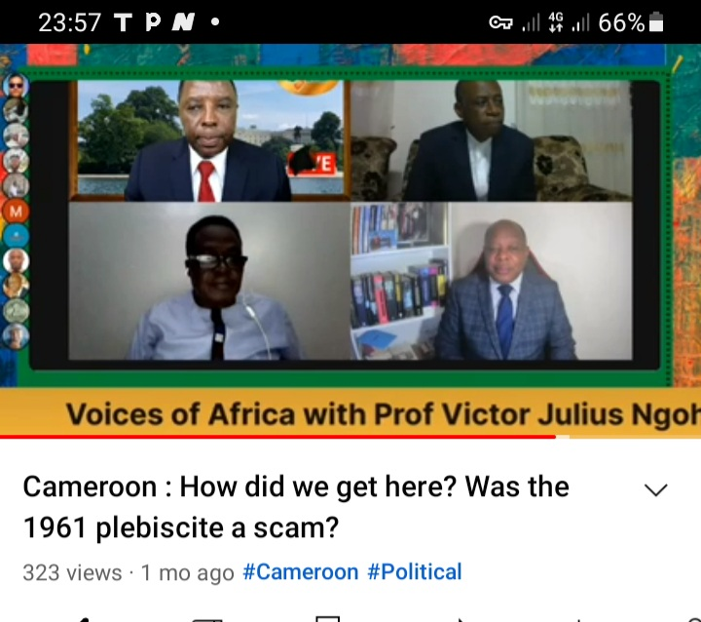

***ChatNite Africa debate with Professor Julius Ngoh, Barrister Alex Ndive Lysinge and Christopher Achobang tracing the history of The Cameroons and how we got a genocide. Facebook version can be viewed at*** [***https://fb.watch/i1LTql9nhE/***](https://fb.watch/i1LTql9nhE/) ***. the Youtube version is streaming at*** <https://www.youtube.com/live/mxna_V9W35Q?feature=share>

1. permission Letter

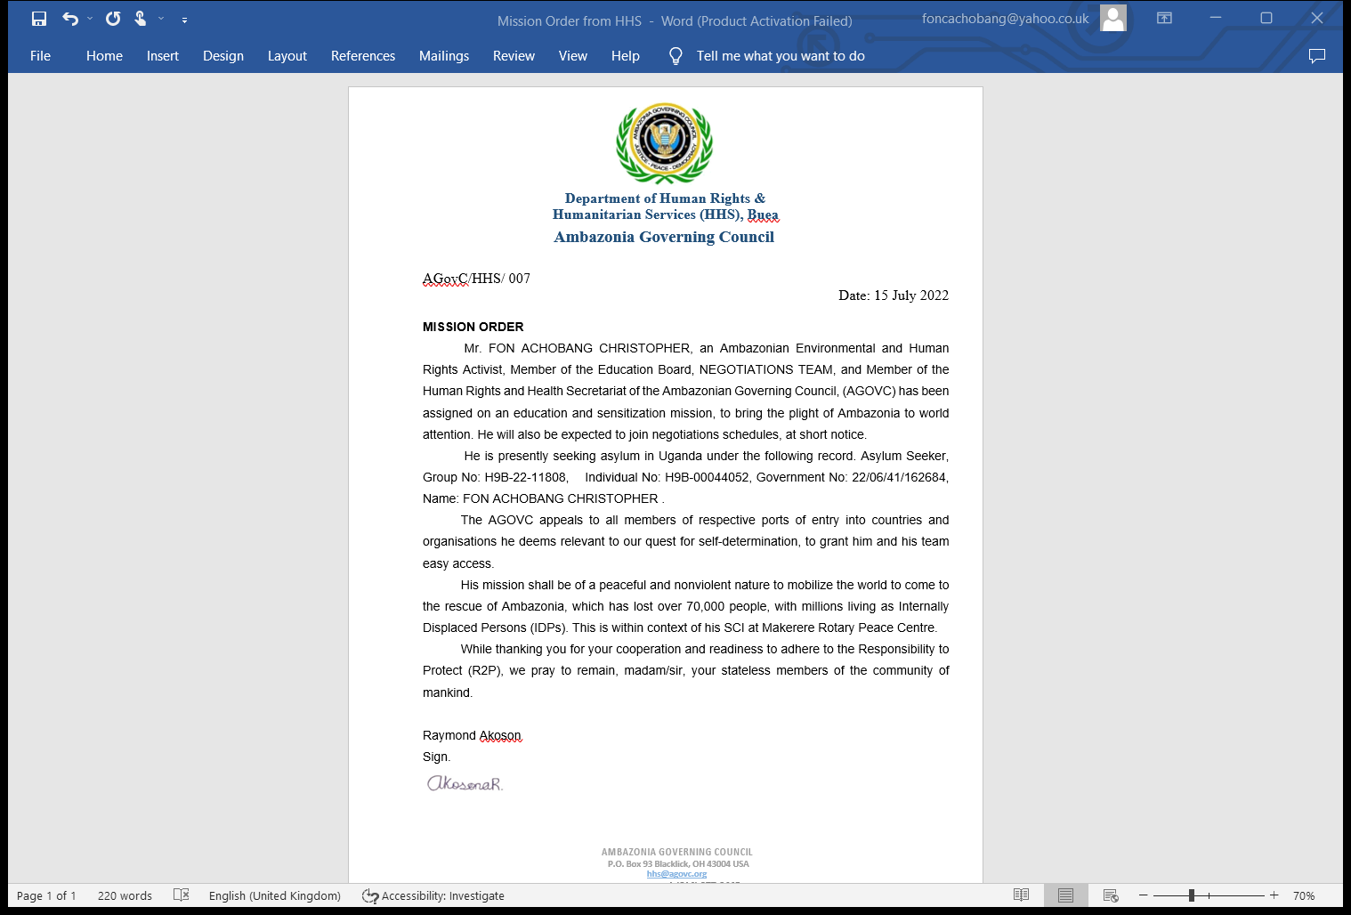

***Authorization from the Department of health and Humanitarian affairs to do education and sensitization on behalf of the Federal Republic of Ambazonia.***

1. Participant

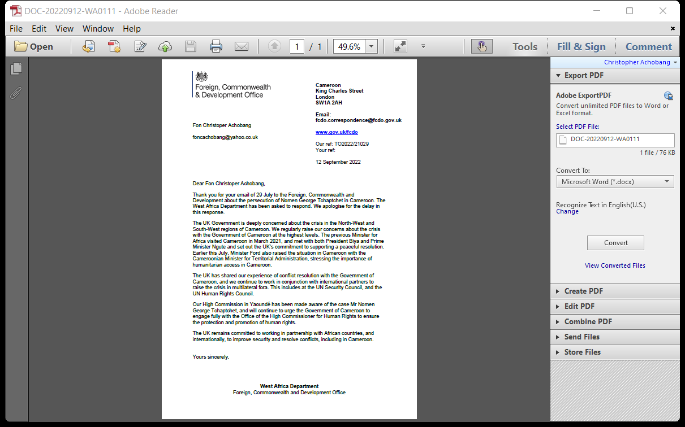

***West Africa Department of Foreign, Commonwealth and Development Office acknowledges receipt of petition meant for Queen of England, complaining of the persecution and violations of the rights of Nomen, like those of many other Ambazonians.***

1. Sample tweets

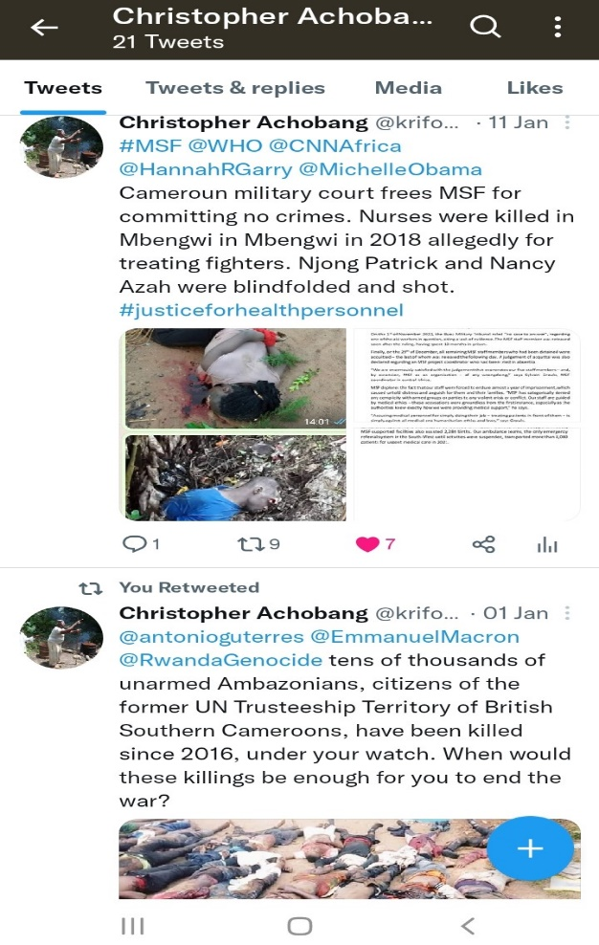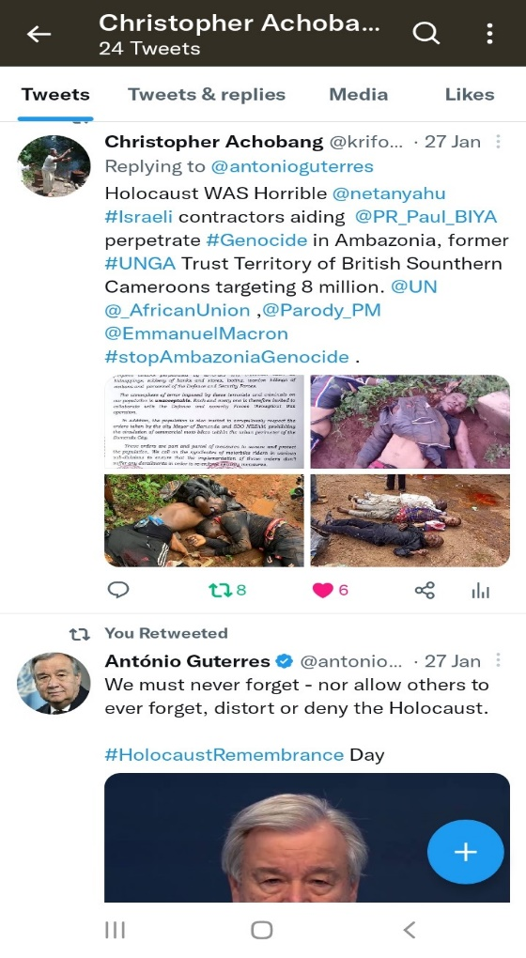

***Tweet replying to Antonio Guterres on anniversary of Holocaust on 27 January. Used tweet to condemn Holocaust and remind @UN, Israel through PM @netanyahu that his country sponsors and support @PR_Paul_Biya who is perpetrating genocide in Ambazonia. Tweet is also tagged to UK PM @Parody_PM, French President @Emmanuel Macron, The African Union @_AfricanUnion.***

* ***The second Tweet to the right reminds Doctors Without Borders and WHO that many medical personnel have been murdered in Ambazonia, Former British Southern Cameroons. This tweet happened when Cameroun Military court freed MSF staff who had been accused of supporting Ambazonian troops just like two nurses killed in Mbengwi in August 2018***.

1. 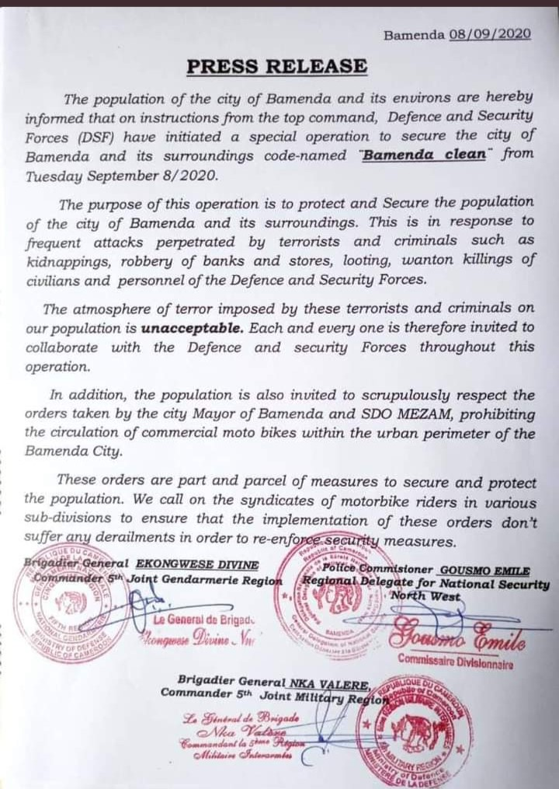Declaration of Genocide in Ambazonia

***After killing thousands in Ambazonia for three years, General Nka Valere, new military commander was appointed to the 5th Joint Military Region covering Bamenda. His first action with police and other military personnel was to declare GENOCIDE on 8th September 2020, under the code-name “Bamenda Clean”. It implied killing everyone suspected to be Ambazonian or having ties with Ambazonia. Tens of thousands were killed and disappeared in the region***.