**MAKERERE UNIVERSITY**

**ACCESS TO SOCIAL PROTECTION SERVICES BY PERSONS WITH DISABILITY IN GREATER ACCRA REGION, GHANA: THE LIVELIHOOD EMPOWERMENT AGAINST POVERTY PROGRAMME**

**NINGO PRAMPRAM DISTRICT, ACCRA, GHANA**

**BY**

**TIGENOAH, CLARA- VALENTINE**

**FEBRUARY 2022-FEBRUARY 2023**

Table of Contents

**ABSTRACT** iv

**LIST OF ABBREVIATIONS** v

**CHAPTER ONE** 1

**INTRODUCTION AND BACKGROUND** 1

**PROBLEM STATEMENT** 2

**GOALS AND OBJECTIVES** 3

***Goals of the Study*** 3

***Objectives of the Study*** 4

**CHALLENGES AND MITIGATION STRATEGIES** 4

**CHAPTER TWO** 6

**LITERATURE REVIEW** 6

***Types of Social Protection Programmes in Ghana*** 6

***Awareness of Social Protection interventions in Ghana*** 7

***Inclusion and Accessibility of PWDs in social protection*** 7

**THEORETICAL UNDERPINNINGS** 8

***The Culture of Poverty Theory*** 9

***The Entitlement Theory*** 9

**METHODS AND DESIGN** 12

***Study Area*** 12

***Sample and Sampling Technique*** 13

***Instrument*** 13

***Validation of the Instrument*** 14

***Ethical Consideration*** 14

**CHAPTER THREE** 15

**INTERVENTIONS AND ACTIVITIES** 15

***Focus Group Discussion Session*** 15

***Interview with Directors*** 16

***Workshop with stakeholders*** 16

***Data Analysis Procedures*** 17

**KEY FINDINGS** 18

***The awareness of Participants about Social Protection Interventions*** 18

***Access to LEAP Cash grants by PWDs*** 18

***LEAP Implementation Challenges*** 19

**CHAPTER FOUR** 21

**GENERAL CONCLUSION** 21

**RECOMMENDATIONS** 22

**IMPLICATIONS FOR POLICY** 22

**SUSTAINABILITY PLAN** 23

**REFERENCES** 25

**APPENDICES** 28

## ABSTRACT

*Whiles states are enjoined to ensure equitable access to social protection services for impoverished and vulnerable persons, there is little evidence of the participation of many persons with disability in mainstream social protection programmes. This study uses qualitative method to assess the awareness of persons with disability (PWDs) about social protection interventions in Ghana, mainly focusing on the Livelihood Empowerment Against Poverty (LEAP) Programme. It explores PWDs' coverage, access to the LEAP grants, and ease of access to payment centres. The study also explores the challenges of implementing the programme. Purposive sampling technique was used to engage 22 PWDs in the Ningo-Prampram district and three Directors in Greater Accra Region. The participants were engaged in focus group discussions and interview sessions to gather data for the study. The study found that most PWDs were aware of the LEAP programme and other social services linked to the programme. It was found that coverage of PWDs under the programme was low, whilst an appreciable number of PWDs received the disability common fund. In total, 23 per cent of PWDs had access to LEAP grants, whilst 64 per cent received the disability common fund and 13 per cent neither received LEAP grants nor the disability common fund.* *The major challenges of implementing the LEAP programme include irregular payments, meagre grants to beneficiaries and inadequate funding by the government. It is recommended that government should earmark more funds for LEAP programme implementation in order not to defeat its rationale.*

iv

## LIST OF ABBREVIATIONS

|  |  |
| --- | --- |
| **ACRONYM** | **MEANING** |
| CAGD | Controller and Accountant-General’s Department |
| CG | Capitation Grant |
| CFP | Community Focal Person |
| DCF | Disability Common Fund |
| DSW | Department of Social Welfare |
| DSWO | District Social Welfare Officer |
| GFDOs | Ghana Federation of Disability Organisations |
| GNSPS | Ghana National Social Protection Strategy |
| GoG | Government of Ghana |
| GPRS | Ghana Growth and Poverty Reduction Strategy |
| GSFP | Ghana School Feeding Programme |
| LEAP | LEAP Livelihood Empowerment Against Poverty |
| LMS | LEAP Management Secretariat |
| LOC | Local Organizing Committee |
| MoGCSP | Ministry of Gender, Children and Social Protection |
| NCPD | National Council for Persons with Disability |
| NHIS | National Health Insurance Scheme |
| PWD | Persons with Disability |
| SP | Social Protection |
| SWO | Social Welfare Officer |

v

# CHAPTER ONE

## INTRODUCTION AND BACKGROUND

Social protection programmes for persons with disability (PWDs) have become one of the key interventions employed by governments to help improve the living condition of the poor and build their capacity for inclusive growth. However, over the past decade, these programmes have encountered some challenges in many countries across the globe (Kidd & Athias, 2020).

Approximately 15 percent or 1 billion of the world’s population have some form of disability (World Bank, 2019), and they have a higher rate of poverty than persons without disabilities.

Available data indicates that just 27.8 percent of persons with severe disabilities receive a type of disability-targeted cash transfer. Whereas 97.9 percent of persons with disabilities in Eastern Europe and 9.4 percent in Asia and the Pacific are covered with social protection services, there is no reliable data from Africa on the coverage of social support services for PWDs. It has been argued that the disparities in the provision of social protection services for PWDs are due to barriers in the design or implementation of cash transfer programmes as many PWDs do not receive mainstream social protection benefits (Staab, 2020).

In Africa for example, the coverage gap of social protection (SP) programmes between persons with disabilities and those without disabilities is huge as only a tenth of all vulnerable people have access to social protection programmes (World Bank, 2019). Kabare (2018) observed that there has been an increasing interest in the inclusion of PWDs in social protection policies, strategies, and programmes in recent times but the implementation of these interventions is still skewed towards persons with vulnerabilities while many of those with disabilities are excluded due to circumstances that cannot be easily explained.

In Ghana, various disability-inclusive social protection programmes have been designed to alleviate poverty among persons with disabilities in various communities. Even though the programmes are directed towards reducing poverty among vulnerable people including PWDs, implementing these programmes is fraught with challenges. Some of the challenges are physical, communication, attitudinal and lack of sensitivity towards the plight of PWDs (Oduro & Amanfo, 2017). Asuman et al. (2020) concluded that the inclusion of PWDs in social protection programmes has encountered challenges because its implementation involves a complex mix of factors such as political will, appropriate legislation, economic resources, and implementation mechanisms at the local, regional, and national levels.

The persistent challenges in the implementation of social protection policies for PWDs have made them the most devastated group among the poorest and most socio-economically excluded persons in Ghana (Peprah et al., 2018). Currently, PWDs in Ghana are approximately 2.1 million according to the Ghana Population and Housing Census, 2021, even though this figure could be higher. This is because in some communities, disability is seen as a curse, and persons with disability are either hidden by their family members or guardians, or they hide themselves for fear of stigmatisation (Badu et al., 2018).

Besides, government officials tasked to handle issues of PWDs often shirk their responsibility leaving the burden on solely family members to bear (Asuman et al., 2020). However, improvements in social services and overcoming the challenges of PWDs require deliberate interventions that can reduce environmental and social barriers to address the needs of PWDs.

Social protection programmes have thus become important channels to promote the social inclusion of people with disabilities, especially those who need financial support for their households. Despite the existence of the Livelihood Empowerment Against Poverty (LEAP) programme, studies by Opoku et al. (2018) have shown that many PWDs still depend on family members and others for their daily needs. Therefore, this study aims to assess the awareness of PWDs about LEAP programme and other social services inherent in the programme, explore the accessibility of LEAP cash grants by PWDs, and challenges of implementing the LEAP programme.

## PROBLEM STATEMENT

The strengthening of social protection systems is a core objective of every government because PWDs are significantly more likely to live in poverty and face a wide range of social, economic, and cultural forms of marginalization (Banks et al., 2020). However, it has been argued that in Ghana, the provision of social protection interventions is universally implemented and they do not target specific vulnerable groups, such as persons with disabilities (Daidone et al., 2015).

This notion has been buttressed by Banks et al. (2020) who noted that many social protection interventions do not have a clearly defined social protection framework and do not concentrate on any particular group of vulnerable people. Another challenge is the difficulties of most PWDs in moving from their homes to accessing public social interventions (Cookson, 2018).

Most of the studies on social protection interventions focus on the impact on vulnerable persons. Few studies have touched on the accessibility of PWDs to social protection services. This study intends to fill this gap by assessing the awareness of PWDs about social protection interventions such as LEAP programme, its accessibility and a strategy for reducing poverty and vulnerability.

## GOALS AND OBJECTIVES

### Goals of the Study

The study’s primary goal is to assess the extent to which PWDs have access to LEAP grants as a social protection intervention in Ghana. Existing literature shows little information on how accessible social protection services are to PWDs including the LEAP programme. This study intends to investigate PWDs awareness of the LEAP programme and other social interventions inherent in the programme, their coverage and accessibility to the programme and challenges of implementation. The outcome of this study will have extended implications for providing adequate social protection services such as cash transfers to PWDs. This study will serve as a significant source of information for policy makers, practitioners and other stakeholders such as the Government, the Ministry of Gender, Children and Social Protection (MoGCSP) and the LEAP Management Secretariat (LMS), the National Council for Persons with Disability (NCDP) and the Ghana Federation of Disability Organisations (GFDOs), to improve implementation of the LEAP programme.

Furthermore, the study findings will aid the MoGCSP and LMS in identifying opportunities and benefits that are inclined to provide cash transfers to the poor and vulnerable, especially PWDs.

The outcome of this study is also intended to assist the government in making reforms to implementing LEAP and targeting PWDs to reduce poverty among them and enhance their socio-economic status.

### Objectives of the Study

The objectives of the study are:

1. To examine the level of awareness of PWDs about the LEAP programme and other social services inherent in the programme
2. To determine the extent to which PWDs have access to LEAP grants
3. To assess the challenges in the implementation of the LEAP programme.

## CHALLENGES AND MITIGATION STRATEGIES

The study was expected to cover PWDs in the Greater Accra Region for information, but due to the region’s vastness, the strategy adopted to overcome this challenge was to select one of the districts in Greater Accra, the Ningo Prampram District for focus group discussion with PWDs. This District was selected because the high number of PWDs living in the area and the willingness of officials of the Social Welfare Department to support the process.

The time and cost of travelling to the various offices of the Directors of the LMS, the NCPD and the GFDOs, within the Greater Accra was challenging. In addition, travelling to the Ningo Prampram District and meeting with the District Social Welfare Officer (DSWO) and Community Focal Person (CFP) to obtain their support in organising the PWDs in Ningo Prampram was involving. Also, a lot of cost was incurred meeting PWDs for the discussions. However, with support from family members, some funds and logistics was offered to enable me to carry out the study. Furthermore, with proper planning and clustering of PWDs who agreed to participate in the study at a central location helped to reduce the cost of transporting them to the place.

The late arrival of some PWDs for the focus group discussions prevented the discussions from commencing as scheduled. The strategy adopted to overcome this challenge was to wait for some time to get a substantial number before discussions started. Waiting for some time enabled us to engage the right PWDs who offered reliable information for the study.

# CHAPTER TWO

## LITERATURE REVIEW

### Types of Social Protection Programmes in Ghana

In Ghana, social protection interventions began with the introduction of social security and pension schemes mandated by the Social Security Act of 1965. The scheme was to provide financial support for workers who experienced such shocks as incapacitation due to hazardous working conditions, accidents due to work, and old age (Niyuni, 2016). This social security scheme is still running in addition to other social protection programmes.

From 2000-2005, the Government of Ghana (GoG) introduced the Ghana Growth and Poverty Reduction Strategy (GPRS I). The GPRS I was established to fast-track the process towards the reduction of poverty by half by 2015 as it formed part of the millennium development goals. Also, the National Health Insurance Scheme (NHIS) was initiated in 2003 to provide healthcare to the poor, including persons with disabilities (Peprah et al., 2017).

Subsequently, the Ghana National Social Protection Strategy (GNSPS) was launched to operate the Livelihood Empowerment Against Poverty (LEAP) programme, which started in 2008. This LEAP programme involves the free registration of vulnerable people, including PWDs, the aged, and the underage, for cash transfers and free healthcare under the National Health Insurance Scheme (NHIS). Other interventions include free school uniforms and exercise books for pupils in primary schools in deprived communities, the school feeding programme, and the capitation grant. The beneficiaries of these social protection programmes include persons with disability, but the proportion of PWDs who can access these services is not good enough (Oduro & Amanfo, 2017).

The LEAP programme has enrolled more than 90,700 beneficiary households in 144 districts in all 16 regions of the country, and payments are made according to the number of beneficiaries in a given household. Currently, a household with one eligible member receives GHC64.00, a household with two eligible members receives GH¢76, while households with three eligible beneficiaries get GH¢88. Those with four or more eligible beneficiaries receive GH¢106.00 (Ministry of Gender, Children and Social Protection, 2017). Out of the more than 90,700 beneficiaries of the LEAP, 23,814 were persons with some form of disability (Faces of

Inequality, 2020). This figure represents 26 per cent of all beneficiaries of LEAP in the country

(Mfoafo-M’Carthy et al., 2020).

### Awareness of Social Protection interventions in Ghana

The effective implementation of social protection programmes is the ability to create awareness to enable the inclusion of many targeted persons and help them access services easily. When a programme is able to create high awareness among the targeted groups, it ensures wider coverage and reduction of poverty among PWDs (Walsham et al., 2018). Research has also shown that many PWDs who live in remote areas may be unaware of available social protection schemes, and those who know about them find it difficult to travel to the service centres to access those facilities (Devandas et al., 2017).

The issue of awareness of social protection interventions has further been underscored by Jaha and Sika (2015) who observed that over 95 percent of beneficiaries felt the way they received information about LEAP payments was not the best, as 43 percent of households received information from a community leader and 14 percent received information from a Local Organizing Committee (LOC) member which unduly delayed.

### Inclusion and Accessibility of PWDs in social protection

Coverage of social protection programmes among disabled populations is consistently low across many developing countries (Marella et al., 2016). This has been supported by Mitra et al. (2017) who noted that social protection programmes do not reach many persons with disabilities.

Various reasons have been proffered for this. Whereas Kuper (2019) revealed that many PWDs are excluded from intervention schemes due to inclusion errors in some situations, Walsham et al. (2019) suggest that the barriers that prevent PWDs from accessing interventions are stigma, discrimination, and lack of sensitivity or awareness on the part of implementers in providing care to persons with disabilities. Similarly, Kidd (2017) argue that the problem of lack of access to social protection programmes by PWDs is the inability of most of them to move from one place to the other to access the help offered.

In Ghana, the coverage of social protection programmes for persons with disability has not reached the expected target levels over the years. Only 26 per cent of vulnerable people are enrolled on the LEAP programme. Asuman et al. (2020) called for the improvement of coveragesince many PWDs in communities need to access LEAP. At the national level in many countries, Ferre and Sharif (2015) observed that budgets are often insufficient to cover persons identified with disabilities.

Challenges of many cash transfer programmes include targeting PWDs, administrative challenges, and lack of clear guidelines or survey tools to determine eligibility criteria. In some situations, the implementers are less equipped to determine the status and severity of the disability situation of individuals.

Staab (2020) indicated that common challenges encountered by implementers of social protection programmes for persons with disabilities in any country include the lack of reliable data and understanding of the needs of vulnerable persons, leading to expensive and unreliable targeting. As a result, the benefits to beneficiaries often fall far below the cost of their basic needs or travel to receive the service (ILO, 2020).

Regarding the implementation of the LEAP programme in Ghana, Quayson (2018) identified that the amounts transferred were insufficient to meet the needs of beneficiaries, especially those with disabilities. Quayson further revealed inadequate administrative resources to implement large-scale cash transfer schemes. In addition, in some regions, cash transfers to beneficiaries had been inconsistent.

## THEORETICAL UNDERPINNINGS

This study is grounded on the culture of poverty and entitlement theories. These theories were selected because they explain the concept of poverty and the necessity of governments to provide assistance to ameliorate the conditions of vulnerable persons.

### The Culture of Poverty Theory

The culture of poverty theory was proposed by Lewis (1966). This theory maintains that passing poor concepts from generation to generation through a set of beliefs, values, and skills creates poverty situations for people. This theory upholds that individuals caught in poor conditions are not necessarily to blame because they appear to be victims of circumstances within their culture or subculture. This theory assumes that cultural values are socially generated and perpetuated and reflect the interactions of individuals and communities. In this context, the theory proposes that the culture of poverty is a subculture of poor people in poor regions or in social contexts where they develop a shared set of beliefs, values, and norms that promote such behaviours, separate from but embedded in the culture of the main society (Small et al., 2010).

This theory explains that the cultural traits embedded within individuals trigger behavioural patterns of poverty, thus preventing them from being socially movable and creative. This tendency keeps them in a vicious cycle of poverty since they fail to connect with wealthy people because of their cultural traits. This mentality makes them live in deplorable and poor conditions, and they never take steps to improve their lot (Bernabe-Ortiz et al., 2016).

The underlying argument of Hume and Shepherd (2003) is that government welfare schemes contribute to the poverty situations of people as they depend on welfare packages, making them maintain their poor status. They do not make any effort to get employment and earn their own money. However, many concepts fail to identify the efforts vulnerable people put in place to escape poverty. There are situations where vulnerable groups have faced cultural discrimination as a result of their disability which affects their efforts to get out of poverty. When PWDs find themselves in such discriminatory circumstances, government interventions and programmes such as LEAP could help them to get out of such deplorable conditions.

### The Entitlement Theory

The entitlement theory is grounded on the ideas of Barrientos et al. (2003). Barrientos et al. argued that poverty and vulnerability do not come about due to lack of privileges such as food in a country. However, it occurs when people lose their entitlements, such as the ways to acquire food and other needs. As a cash transfer programme for vulnerable persons, the LEAP programme helps to reduce their poverty and entitlements such as cash grants enable them to resist short, medium and long-term economic risks and shocks. In this regard, governments implement interventions such as LEAP to reduce poverty in communities.

Entitlement theorists also believe that personal and community well-being are closely linked to negative consequences and that the closure of economic activities such as a market, factory, or any other crisis can lead to personal and community problems. These problems may rob community members of their entitlements, making some migrate to other lucrative localities (Mosse, 2007). This shows that individuals do not cause the factors that create poverty. For instance, lack of employment opportunities in a community can lead to migration, closure of economic activities due to low patronage, and a decline in local tax revenues. These negative factors can lead to the deterioration of schools in the locality and poorly trained individuals. This situation can lead to the prevalence of health problems and inability to afford preventive medicine, a good diet and healthy living.

These conditions are the primary factors that make vulnerable people stay poor (Barrientos et al., 2003).

The entitlement theory is relevant to this study because it emphasizes that individuals have the right to life and are not to be deprived of their rights except under the principles of fundamental justice. From this perspective, governments initiate social protection programmes to alleviate the plight of the vulnerable so they can enjoy their entitlements or rights (Mosse, 2007). These interventions or policies enable governments to fulfil the right to safe and comfortable living of individuals in the state. As rights are considered entitlements, the LEAP programme is an entitlement that should be rendered to the poor in society to reduce their poverty levels and provide opportunities for underprivileged individuals.

The 1992 Constitution of Ghana enjoins the government to provide for poor and vulnerable groups to give them their entitlement. The LEAP cash transfer programme initiated by the Government of Ghana is meant to reduce abject poverty and protect people's entitlements.

**CHANGE THEORY AND ITS RELEVANCE TO THE STUDY**

The change theory was espoused by Lewin (1951). Lewin proposed that an individual's behaviour in response to change is a function of group interactions and the forces that affect the group structure. These forces jeopardise the individual's behaviour and capacity to change. Lewin (1951) argues that change is the foundation for individual and group development, yet most people prefer the status quo or the existing conditions and try to prevent the change process.

The three stages of change espoused by Lewin (1951) include unfreezing, actual change, and refreezing. The unfreezing stage deals with managing individuals' perceptions and aims at preparing the affected individuals to embrace a change. In this regard, the implementers of the change process need to improve the preparedness of the individuals for change. Effective communication is crucial in getting individuals to adopt the change at this stage. To achieve an effective change process, Lewin indicated the need to conduct a needs analysis through a survey to understand the conditions of the people. For instance, under the LEAP programme, poverty level is objectively determined using a Proxy Means Test (PMT) score calculated from data collected on potential beneficiaries by the PMT questionnaires. The programme involves targeting potential beneficiaries, enrolment of qualified beneficiaries on the LEAP register and payment of beneficiaries on bimonthly basis.

The second stage is where the change process is executed. This stage requires implementers of the change process to ensure a continuous flow of information to obtain the support of the people. This support can be achieved through community sensitisation and empowerment activities that motivate people to achieve change. There is continuous engagement and sensitization of LEAP beneficiaries by the DSWOs, CFP, and LMS staff during community meetings, payment weeks and during monitoring. Particularly, the Communications and Case Management Units of the LMS supports the continuous education and resolution of cases of beneficiaries.

The third stage is the refreezing stage, where the people stabilise or accept change and remain there. At this stage, implementers of the change process will have to enhance change through reinforced activities which will be accepted as the culture of the day, so they do not revert to previous behaviours. Change can be sustained when the implementers identify and reward early adopters of change, regularly collect feedback, and offer support to the people. The relevance of the change theory to this study is that disability tends to make people vulnerable in many ways. Disability renders people physically, emotionally, and financially deficient. This condition makes some PWDs adopt certain lifestyles and accept the status quo. The condition prevents them from finding ways of changing their situation, as this theory espouses. Also, implementers of social protection programmes who try to bring a change in the lives of PWDs may face resistance from community or family members who may act as barriers to the development of PWDs.

When implementers of the LEAP programme use effective communication and training to create awareness, they can reach out to many PWDs to sensitize them. According to the change theory, any social intervention's effectiveness is embedded in conducting a needs analysis survey. To make social protection interventions effective such as LEAP programme, there is the need for a continuous flow of information, sensitisations, discussion and empowerment programmes to improve the conditions of vulnerable persons, especially PWDs, as suggested by the change theory. Therefore, it is expedient that the LEAP Management Secretariat and other major stakeholders collaborate to sustain and improve the conditions of the vulnerable.

## METHODS AND DESIGN

The study adopted the qualitative research design. This approach was used to evaluate the extent to which persons with disability are aware of and accessing existing social protection programmes with a focus on the LEAP programme, including barriers to implementation. The purpose of adopting this design was to understand the experiences of PWDs as beneficiaries of the LEAP programme. This qualitative research was conducted in the Ningo-Prampram district in Greater Accra Region to measure awareness and coverage of the programme among PWDs and explore implementation challenges.

### Study Area

The study area was the Ningo-Prampram district in the Greater Accra Region of Ghana. According to the Ghana Statistical Service (2021), there are approximately 2.1 million persons with disability in Ghana, and about 23 per cent of PWDs live in the Greater Accra Region.

However, this figure might not be the true reflection of PWDs, as disability is considered a curse in some communities and persons with these conditions are either hidden by their family members or guardians, or PWDs hide themselves to avoid denigration by society (Badu et al., 2018).

Several considerations informed the choice of the Greater Accra Region. The first consideration is familiarity with the region and the system of social work in the region. Being a native of Ghana and having worked in Greater Accra for many years, there is a fair understanding of the environment and social protection interventions implemented in the area. Also, funding was an important consideration. As the study has no external sources for funding, a choice of study area like the Ningo-Prampram District needed to be selected. The reason for the selection of the study area was due to its nearness to my home district so as to facilitate the effective use of personal resources and most of all due to the high number of PWDs living in the area.

### Sample and Sampling Technique

The sample for this study comprised 25 individuals. These included three Directors from the LMS, the NCPD, both under the Ministry of Gender, Children and Social Protection, and the GFDOs. The remaining 22 participants were PWDs from the Ningo-Prampram district. The selection of this sample size of 25 was based on the willingness of the PWDs and officials available to participate in the study.

Purposive sampling technique was used for the selection of the respondents. This technique was used instead of any other sampling technique because the research concerned PWDs and stakeholders involved in the welfare of PWDs and social protection delivery. By virtue of this, PWDs had to be purposively selected. In addition, specific Directors had to be purposively sampled as they are responsible for the welfare of PWDs and implementation of the LEAP programme.

### Instrument

The main instrument that was used for the collection of primary data was a semi-structured interview guide. The semi-structured interview guide was used because it provided an opportunity to probe further and gain insights into the questions. The interview guide had four sections. The first section was about the personal information of the participants of the study. The second section covered the level of awareness of PWDs about LEAP and other social protection services inherent in LEAP. The third section examined the extent to which PWDs had access to the LEAP programme, and the fourth section covered the challenges in implementing the LEAP programme.

### Validation of the Instrument

In order to establish the reliability and validity of the data collection instrument, the draft interview guide was submitted to Dr. Mbabazi (Supervisor), who read through it and made suggestions. The final copy was subjected to a pre-test with two heads of institutions and 5 PWDs in the Eastern Region of Ghana. The Eastern Region was selected for the pre-test because it is outside the study area and has similar characteristics to Greater Accra. The consistency of the responses and the ability to gather information to satisfy all the study objectives made the instrument reliable and valid.

### Ethical Consideration

During the data collection session, care was taken to educate the participants about the reasons for the study and how the outcomes could help improve the implementation of the LEAP programme for vulnerable persons in Ghana. The participants were informed that the information they would provide would be used for this study and not for any other purpose. They were also assured of the confidentiality of their responses such that their scripts would be kept in a locker and no other person could access them. The anonymity of the participants was also assured as they were asked not to disclose their full names. The privacy and dignity of participants were respected, and those who did not want to participate in the study were left out. Only those who agreed to contribute were included in the study.

# CHAPTER THREE

## INTERVENTIONS AND ACTIVITIES

### Focus Group Discussion Session

Through the support of the District Social Welfare Officer (DSWO) at the Ningo-Prampram district and the Community Focal Person (CFP) for the district, some PWDs in the area were invited for a group discussion. The discussion were held at the community center of the district, which serves as a payment center for LEAP beneficiaries. Ningo-Prampram was selected for the study because of the high number of PWDs living there. Through the assistance of the CFP, some community members were organized to clean and prepare the community center for the programme.

The discussion was scheduled to start at 9.00 am, but due to the late arrival of some participants, it started around 9.30 am. The programme started with a prayer from one of the participants. Then, there was formal introduction of the participants and the Researcher, followed by a welcome address by the District Social Welfare Officer. The purpose of the study was discussed with the participants. Ground rules for the discussions were outlined. They were told to put their phones on silent mode so as not to distract other participants during the discussions.

There were 22 PWDs with ages ranging between 30 to 55 years. The participants were mature individuals who could understand the issues of the study and give appropriate responses. The types of disabilities of the participants include visual impairment and physical incapacities. It was observed that five (5) participants received the bi-monthly LEAP grants and the Disability Common Fund (DCF), and three (3) neither received LEAP grants nor the DCF. The remaining 14 received the DCF, which is expected every quarter of the year.

The first part of the discussion focused on PWDs' awareness of various social protection interventions, including the LEAP programme and other social services linked to it. The second part of the discussion dwelt on the accessibility of the LEAP grants by PWDs. This aspect underscores their inclusion and movement to payment centres to receive the grant if they are included. The last section discusses the challenges of the LEAP programme from the perspective of PWDs. These areas were discussed extensively because they formed the objectives of the study. The discussions ended well with the participants. Informal conversations ensued among participants as they were provided snacks at the end of the proceedings at 12.00 pm. The participants departed for their homes before the investigator also departed.

### Interview with Directors

The office of the Directors of LMS, NCDP and GFDOs were visited to introduce the research to them and request to hold interview sessions with them. They accepted to participate, and letters were then sent to them introducing the research in detail and its purpose. Interview sessions were then scheduled with them. However, these interviews were not done as scheduled because the directors kept rescheduling the meetings. But eventually, the interviews were accordingly conducted.

The interviews with the Directors focused extensively on the challenges in implementing the LEAP programme and measures for improvement. All three directors acknowledged challenges facing the LEAP programme such as inadequate and or lack of funding for the programme, delays in the release of funds culminating in delayed payments to beneficiaries, and meagre grants to beneficiaries which cannot cater for their very basic needs. Specifically, the director at the NCDP lamented the challenge of lack of sign language interpreters during LEAP payments to help persons with special needs.

The directors confirmed the need to adequately fund the programme and increase the grants of beneficiaries to enable them to cater for their needs due changing economic times and hardships. Regarding awareness of complementary social protection services, the directors mentioned the national health insurance scheme as key in all the social protection services provided.

### Workshop with stakeholders

A one-day workshop was held with stakeholders to unearth and discuss the issues of awareness, access and coverage of PWDs on the LEAP programme. The workshop also focused on implementation challenges, improving the programme, and expanding coverage for PWDs.

The discussants agreed that there was a general awareness of social protection services in Ghana; however, this varied from one service to the other. For instance, they said the public is aware of

Ghana’s LEAP programme and national health insurance scheme. However, regarding access and coverage of the LEAP programme by the vulnerable, especially persons with disability, participants lamented that coverage was very low and many PWDs have not been enrolled on the LEAP programme.

The discussants mentioned that the major challenges of implementing the LEAP programme include inadequate funding, irregular and meagre LEAP cash grants to beneficiaries, unavailability of resources for officials to monitor beneficiaries, difficulties of beneficiaries in accessing complementary services, lack of sign language interpreters for persons with special needs, delayed payment by service providers, and long distances to payment centers.

The discussants said the major challenge of the programme is funding, and Government should find a way to overcome this challenge because inadequate funding hinges on delayed or irregular payment to beneficiaries and expanding coverage. However, all other issues could be tackled with sufficient funding for running the programme.

### Data Analysis Procedures

The responses from the PWDs during the focus group discussions, one-on-one interviews with the Directors and stakeholders’ workshop were processed and analysed using deductive and inductive analysis techniques. The use of an inductive technique allows one to generate meanings from the data set collected to identify patterns or concepts that emerge from the collected data. In this study, the Directors, PWDs and stakeholders were engaged in interview sessions and group discussions to collect data to understand the issues surrounding implementing the LEAP programme. Key themes and words that cut across the responses and those related to the research objectives were sorted and analysed.

## KEY FINDINGS

### The awareness of Participants about Social Protection Interventions

It was observed that all the participants were aware of social protection interventions in Ghana and those tailored towards PWDs. Also, participants were aware of the LEAP programme and other complementary social services inherent in the programme. Participants mentioned social protection interventions such as the DCF, LEAP, NHIS, the Ghana School Feeding Programme (GSFP) and Capitation Grant (CG) meant for their children. The participants said they learned about these interventions through SWOs, the National Commission for Civic Education (NCCE), and the GFDOs.

Regarding the payment of LEAP grants, participants said they received information about the payment dates from the CFP and SWOs through word of mouth or phone calls.

### Access to LEAP Cash grants by PWDs

Out of the 22 participants, only 5 had access to LEAP grants and the DCF, while 14 enjoyed the DCF only. Three (3) participants had no access to any social protection intervention. However, they said they were making arrangements to be processed for the disability common fund. Regarding movement and/or travel to receive the LEAP grants, 4 participants out of 5 LEAP beneficiaries indicated that the payment center was within their community and they had no issues accessing it. Only one participant said she had to board a vehicle before accessing the grant because her residence was far from the payment center.

There was a probe as to whether or not all PWDs should be on the LEAP programme. The response from participants were that LEAP was designed based on a certain criteria and the criterion for enrolment determines who qualifies to be on the programme. In addition, they do not believe all PWDs needed to be enrolled on the LEAP programme because the living conditions of some PWDs were better, and in some cases, some PWDs are more prosperous than abled-bodied persons. They, however, had issues with the selection process as most PWDs who lived in poor conditions were left out during the enrolment.

With only 5 out of the 22 participants accessing the LEAP programme in this survey, it shows that coverage was low regarding PWDs. This was confirmed by the participants, who said many vulnerable PWDs in communities needed financial assistance but were not enrolled on the LEAP programme.

### LEAP Implementation Challenges

From the participants' perspective, the major challenges of implementing the LEAP programme include delays in the payment of grants, meagre cash grants, and additional costs of transport to access grants. Participants said the payment delays impacted them as they always expected to receive funds to cushion them. However, participants acknowledged that they sometimes received combined payments when payments were delayed. All the participants stated that the cash grants were too small and insufficient to cater for their basic needs. More so, those who had to travel to payment centers to receive their grant said transport costs exhausted some of their grants. It was observed that there is lack of information from the programme implementers on the periodic registration and selection of beneficiaries. The lack of information has kept many vulnerable PWDs out of the programme.

It was observed that each Director viewed the implementation challenges to the work they do as stakeholders of PWDs. The Directors interviewed include the LMS, NCDP and GFDOs. All three directors confirmed the challenge of delays in the payment of grants.

The Director of LMS outlined challenges in implementation, including delay in the release of funds from the Government through the Ministry of Finance (MoF) and Controller and Accountants Generals Department (CAGD) to the Ministry of Gender, Children and Social Protection (MoGCSP). Other administrative challenges include delays in the processing and approval of funds within CAGD and MoGCSP. However, the most significant implementation challenge is the programme's funding. The Director acknowledged that these delays affected the consumption patterns of the vulnerable as they depended on this programme for a living.

The Director at the NCPD indicated that apart from delays in payment of the grants, the grants were inadequate and could not cater for the needs of PWDs as living standards had risen over the years, with no commensurate increase. Furthermore, the Director stressed that the distance covered by some beneficiaries to access grants and the transport cost was challenging for PWDs.

Finally, regarding the issue of caregivers of PWDs, he wondered whether the grant was put to the specific use of PWDs.

The Director at GFDOs observed that the programme's selection process for the enrolment of beneficiaries was unsatisfactory, the criteria were discriminatory, and cash points were not accessible to PWDs. More importantly, there were no sign language interpreters at payment centres to cater to persons with difficulty hearing and speaking.

# CHAPTER FOUR

## GENERAL CONCLUSION

The study aimed to examine access to social protection interventions by PWDs with a particular focus on the LEAP programme. The study found that all participants were aware of some social protection interventions in Ghana. This outcome answers the study's first objective, which was to examine the level of awareness by PWDs of social protection services, particularly the LEAP programme and its complementary social services. This outcome made the study conclude that there was effective awareness creation by the LMS and the Department of Social Welfare. The NCCE also played a role by creating awareness of social protection services.

The study found that out of 22 PWDs who participated in the discussion, only 5 had access to LEAP cash grants, 14 were on the disability common fund, and 3 were not on any programme. However, an appreciable number seem to be enrolled on the Disability Common Fund. Also, the study found that some PWDs lived closer to the LEAP payment centers, whilst others stayed far away and had to travel to access the grant during payments. These outcomes satisfied the second objective which was to determine the extent to which PWDs had access to the LEAP grants. From these analysis, it can be concluded that the enrolment of PWDs in the LEAP programme is low and unsatisfactory.

The study also found that the implementation of the LEAP programme is fraught with many challenges, as espoused by the survey participants (PWDs and Directors). These included lack of funding, delays with bi-monthly payments to beneficiaries, and meagre grant amounts that cannot care for their essential needs. These findings answer the third objective of the study, which was to assess the challenges in implementing the LEAP programme.

The study, therefore, concludes that the challenges to the effective implementation of the programme are inadequate funding by Government and delays in the payment of the meagre cash grants to beneficiaries.

## RECOMMENDATIONS

Considering the significant findings of the study, it is recommended that key stakeholders such as the MoGCSP, LMS, NCDP, DSW, the NCCE and the GFDOs should build synergy and intensify awareness of social protection interventions, especially about the LEAP programme. This will ensure PWDs' awareness of existing social services that they can participate in order to reduce their vulnerabilities.

It is also recommended that more LEAP payment centres should be created in communities to enable PWDs to access the grant easily and without incurring additional costs such as transport. When payment centres are established closer to the homes of PWDs, they will not have to incur transport costs, which reduces the grant's value.

Also, key stakeholders in the LEAP programme's delivery chain, thus the Government of Ghana (GoG), the MoF, the CAGD, the MoGCSP, and the LMS, are encouraged to improve on payment of LEAP grants at scheduled times and without prolonged delays. This will help reduce the financial difficulties of PWDs who will not have to wait for longer period to receive the grant.

Also, donor partners are encouraged to increase support for the LEAP programme and mainly devote funds for PWDs to be enrolled to combat their vulnerable situation. Furthermore, sign language interpreters should be deployed to help with interpretation during LEAP payments, as some PWDs may need support.

In addition, the Government should review the grant amount since the grant's value has depreciated in these dire economic times. An increase in the grant amount will help beneficiaries afford some basic needs easily and improve their living conditions.

## IMPLICATIONS FOR POLICY

The significant outcomes of this study show that various challenges were encountered by both the beneficiaries and implementers of the LEAP programme. Challenges encountered by implementers were inadequate funds for programme implementation, delays in the release of funds from the Government, and administrative delays. The implication is that when these challenges are left to linger, they derail the programme's positive impact and rationale as a social protection intervention. By this, Policy makers, Government and relevant Ministries, Departments and Agencies should work collaboratively towards the provision and allocation of adequate and timely funding to facilitate prompt payment of grants to beneficiaries.

In addition, meagre grant amounts to beneficiaries will reduce the impact of the intervention on the lives of beneficiaries, particularly PWDs, and the poverty levels in the country will remain high.

## SUSTAINABILITY PLAN

To sustain the benefits and positive impacts of social protection interventions such as the LEAP programme, there is the need for all key stakeholders in the implementation chain to work collaboratively and undertake innovative measures to improve the delivery of the programme. An improvement plan needs to be drawn up and agreed upon by the critical stakeholders in the delivery chain and followed. This plan will help monitor actions to be undertaken by the various stakeholders. Therefore, a schedule and follow-up plan will be developed to monitor the key ministry (MoGCSP) responsible for implementing the LEAP programme to take the necessary steps to lobby the Government and other stakeholders to provide funding on a timely basis to prevent delays in payment of beneficiaries.

In addition, follow-up visits and meetings will be held with stakeholders who participated in this research to deliberate on the synergy between institutions to enhance the implementation of the LEAP programme. These institutions include the MoGCSP, LMS NCPD, GFDOs, and DSW in the Ningo-Prampram district. These follow-ups will enhance coherence in the implementation, targeting and selecting vulnerable persons with a focus on PWDs, and the programme delivery.

An advocacy campaign will be planned to focus on PWDs' enrolment in the LEAP programme to ensure that their lives will be improved. This initiative involves bringing together civil society organisations that work on disability issues and key government institutions promoting the welfare of the poor and PWDs to advance the campaign for social services for the vulnerable.

There will be follow-up visits to Ningo Prampram district to monitor and evaluate the provision of social protection services to PWDs, particularly the LEAP programme. Essentially, any challenges, improvements and lessons learnt will be communicated to the MoGCSP and LMS to ensure a sustained positive impact on the lives of beneficiaries of the programme.

# REFERENCES

Asuman, D., Ackah, C. G., & Agyire-Tettey, F. (2020). Disability and household welfare in Ghana: Costs and correlates. *Journal of Family & Economic Issues*, 2020, 1–7.

Badu, E., Gyamfi, N., Opoku, M. P., Mprah, W. K., Edusei, A. K. (2018). Enablers and barriers in accessing sexual and reproductive health services among visually impaired women in the Ashanti and Brong Ahafo regions of Ghana. *Reproductive Health Matters*, 26, 51–60.

Banks, L. M., Hameed, S., Kawsar, U. S., et al. (2020). No one left behind? Comparing poverty and deprivation between people with and without disabilities in the Maldives.

*Sustainability* 12(5): 2066.

Barrientos, A., Gorman, M., & Heslop, A. (2003). Old age poverty in developing countries:

Contributions and contributions and dependence in later life. *Word Development*, 3 (3); 555-570

Bernabe-Ortiz, A., Diez-Canseco, F., Vasquez, A., et al. (2016) Inclusion of persons with disabilities in systems of social protection: A population-based survey and case–control study in Peru. *BMJ Open,* 6(8): e011300.

Cookson, T. P. (2018). *Unjust conditions: Women’s work and the hidden cost of cash transfer programmes*. Oakland, CA: University of California Press.

Daidone, S., Handa, S., Davis, B., Park, M., Osei, R. D., & Osei-Akoto, I. (2015). *Social networks and risk management in Ghana’s Livelihood Empowerment Against Poverty Programme.* Innocenti Working Paper No. 2015-06. Florence: UNICEF.

Devandas, A. C (2017). Social protection and persons with disabilities. *International Social Security Review,* 70(4): 45–65.

Faces of Inequality, (2020). National Report on the Situation of Women with Disabilities in

Ghana, 2020. Ghana Situation Report 2020. Accra. Ghana

Ferre, C.,& Sharif, I. A. (2015). *Bangladesh – Can conditional cash transfers improve nutrition?*

*From evidence to policy.* Washington, DC, World Bank.

Ghana Statistical Service, (2021). Ghana Population and Housing Census. Government of Ghana. Accra.

Hume, D., & Shepherd, K. (2003). Conceptualizing chronic poverty. *World Development*, 31(3), 403-424.

ILO, (2020). *World social protection report 2017–19: Universal social protection to achieve the Sustainable Development Goals*. Geneva, International Labour Office.

Jaha, I., & Sika, B, S. (2015). Challenges of the Livelihood Empowerment Against Poverty programmeme in the Upper West region of Ghana: the institutional perspective. *UDS International Journal of Development*, 2, 188-205.

Kabare, K. (2018*). Social protection and disability in Kenya*. Nairobi: Development Pathways.

Kidd, S. & Athias, D. (2020). *Hit and miss: An Assessment of targeting effectiveness in social protection with additional analysis.* Development Pathways Working Paper June 2020.

Kidd, S. (2017). Social exclusion and access to social protection schemes. *Journal of Development Effectiveness*, 9(2): 212–244.

Kuper, H. (2019). Access to social protection among people with disabilities: Mixed methods research from Tanahun, Nepal. *The European Journal of Development Research*, 1–28.

Lewin, K. (1951). Field theory in social science: selected theoretical papers. New York: Harper.

Lewis, O. (1966). The culture of poverty. *Society*, 35 (2); 7-9.

Marella, M., Devine, A., Armecin, G. F., et al. (2016). Rapid assessment of disability in the Philippines: Understanding prevalence, well-being, and access to the community for people with disabilities to inform the W-DARE project. *Population Health Metrics*, 14(1): 26.

Mfoafo-M’Carthy, M., Grischow, J. D., & Stocco, N. (2020). Cloak of invisibility: A literature review of physical disability in Ghana. *SAGE Open*, 2020, 10.

Ministry of Gender, Children and Social Protection, (2017). *Disability in Ghana*. Ministry of Gender, Children and Social Protection, Accra. Ghana.

Mitra, S., Palmer, M., Kim, H., Mont, D., & Groce, N. (2017). Extra costs of living with a disability: A review and agenda for future research. *Disability and Health*, 43(2), 97–112 Niyuni, W. (2016). *Linking social protection programmes in Ghana: The case of the LEAP Cash Transfer Programme.* Paper presented at the Symposium on Social Protection Systems – Tying the Knots, September 5–6.

Mosse, D. (2007). Power and the durability of poverty: A critical examination of the links between culture, marginality, and chronic poverty. *CPRC Working Paper 107*.

Manchester: Chronic Poverty Research Centre.

Oduro, R., & Amanfo, R. O. (2017). *Advancing out of poverty in Ghana: The role of the Livelihood Empowerment Against Poverty (LEAP) Programme*. No-poor Policy Briefs No. 35.

Opoku, M. P., Swabey, K., Pullen, D., et al. (2018). Poverty alleviation among persons with disabilities via United Nations’ sustainable development goals in Ghana: Voices of stakeholders with disabilities. *Sustainable Development*, 28(4): 41–59.

Peprah, P., Kyiyaga, E. M., Afful, H., Abalo, E. M. & Agyemang-Duah, W. (2017). Does the

Ghanaian Livelihood Empowerment Against Poverty Programme Lead to an Increase in Household Productive Livelihood Assets? Analysing the Ashanti Scenario. *Cogent Social Sciences,* 3: 1–12.

Quayson, T. (2018). *Assessing the impact of social protection on social inclusion: The case of the Livelihood Empowerment Against Poverty (LEAP) in the Ga South Municipality*.

Masters dissertation, Department of Public Administration, University of Ghana.

Small, M. L., Harding, D. J., Lamont, M. (2010). Reconsidering culture and poverty. *Annals of the American Academy of Political and Social Science*, 629 (1); 6-27.

Staab, S. (2020). *Social protection for women informal workers: Perspectives from Latin America.* In M. Chen and F. Carré (eds) The Informal Economy Revisited: Examining the Past, Envisioning the Future, pp. 215–20. London: Routledge.

Walsham, M., Kuper, H., Banks, L. M., & Blanchet, K. (2019). Social protection for people with disabilities in Africa and Asia: A review of programmes for low-and middle-income countries. *Oxford Development Studies*, 47(1), 97–112.

Walsham, M., Kuper, H., Banks, L. M., et al. (2018). Social protection for people with disabilities in Africa and Asia: A review of programmes for low-and middle-income countries. *Oxford Development Studies*, 47: 1–16.

World Bank. (2019). *World report on disability*. World Bank. New York.

# APPENDICES

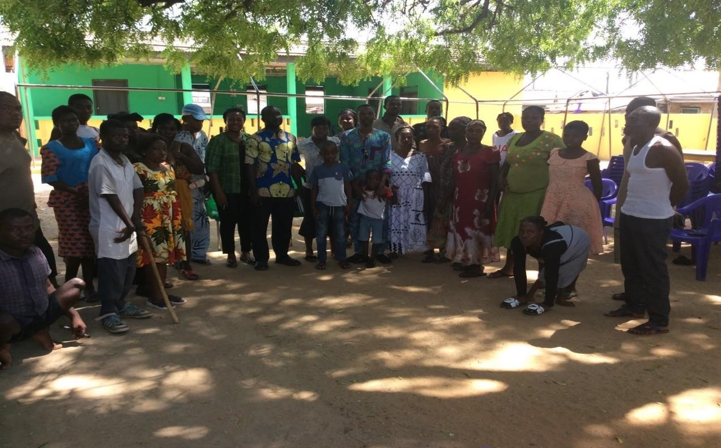

***Group Photo with PWDs in Ningo-Prampram District in Greater Accra Region***

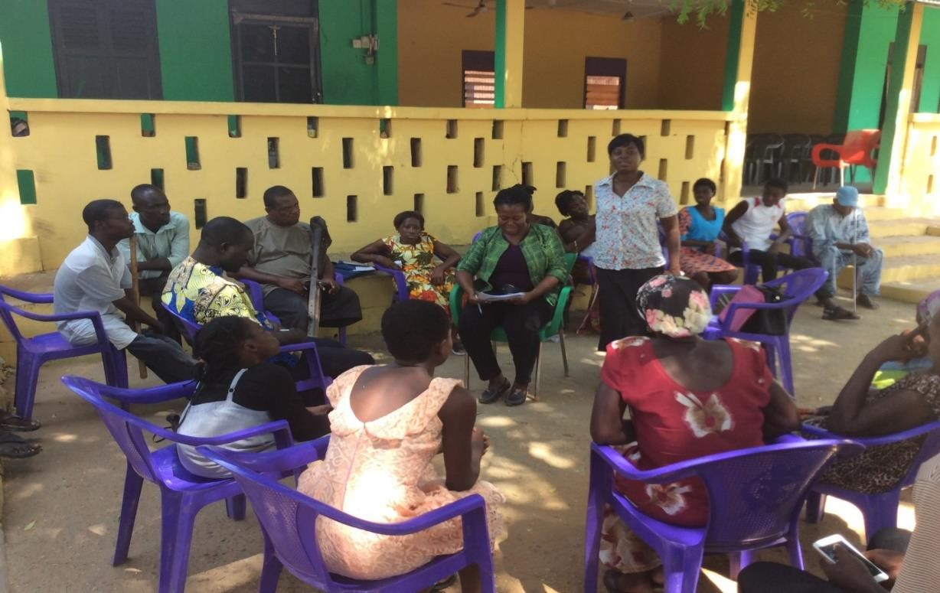

***Mrs Jemima Akweley Agyeman, Principal Social Development Officer of Ningo-Prampram District interpreting the interview questions to participants in the local language***

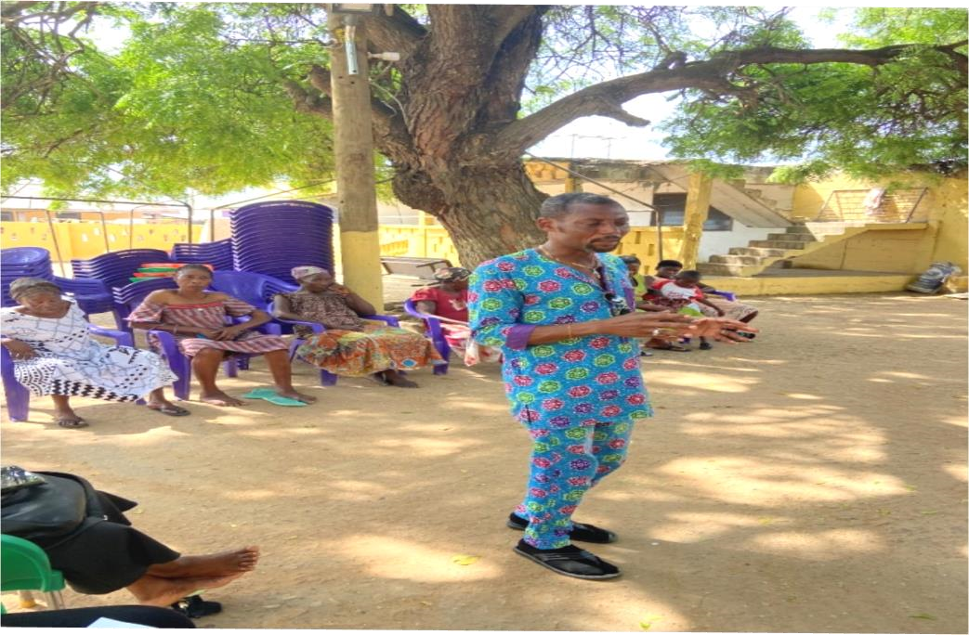

***Mr Richard Y. Quaye, the Community Focal Person for LEAP doing the interpretation during the session***

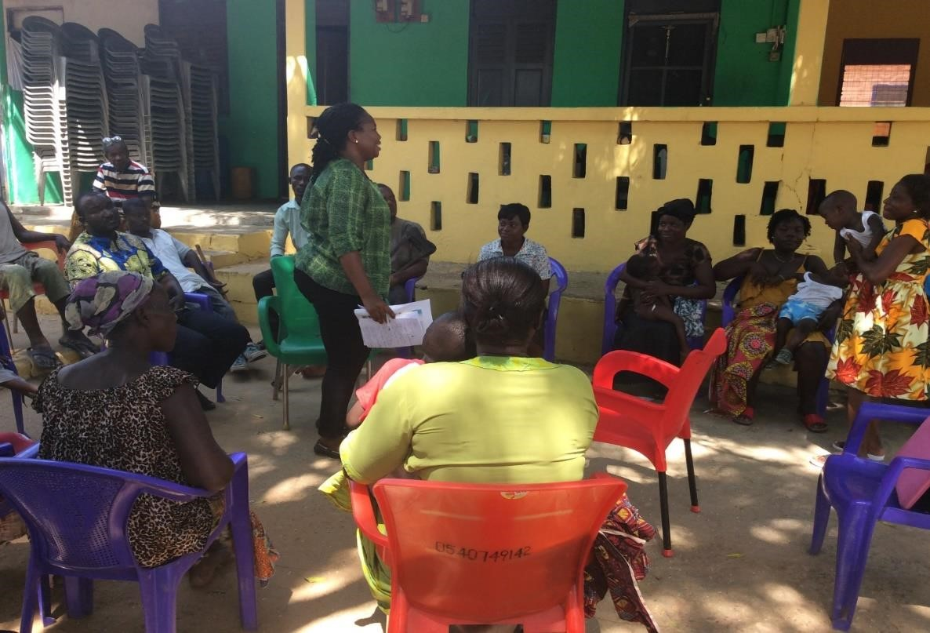

***Miss Tigenoah discussing an issue with participants***

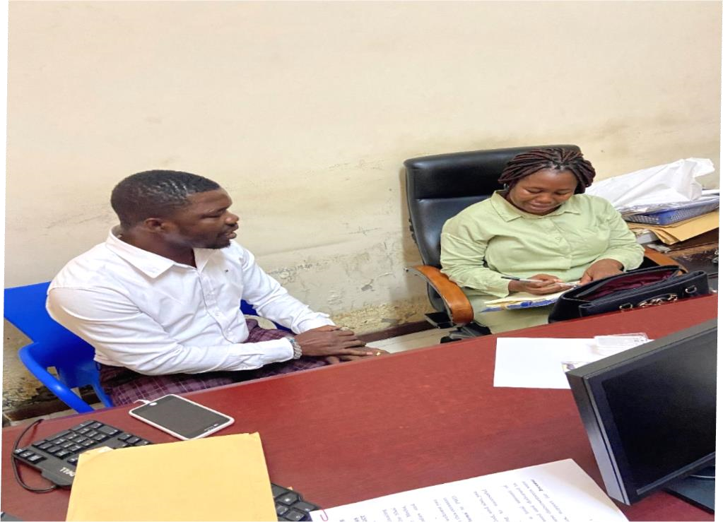

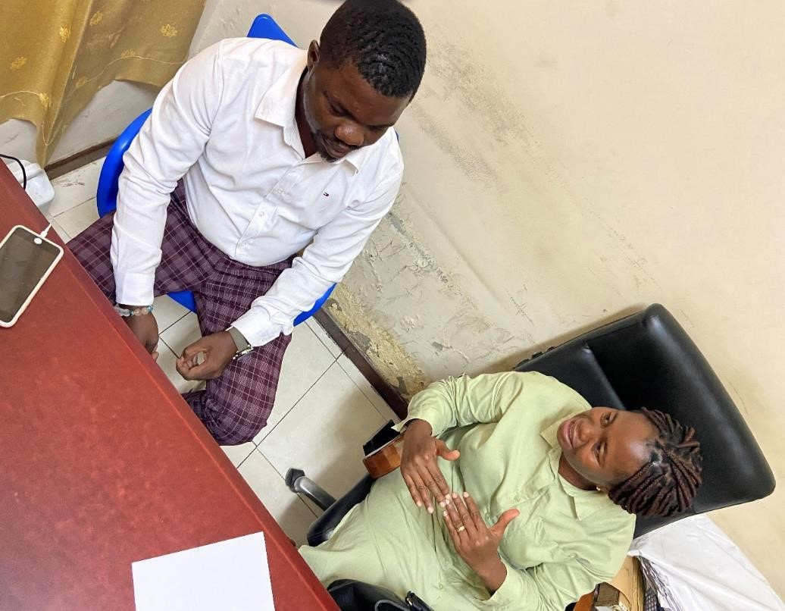

***Interview with Mr Joshua Addy, Director at the National Council for Persons with Disability***

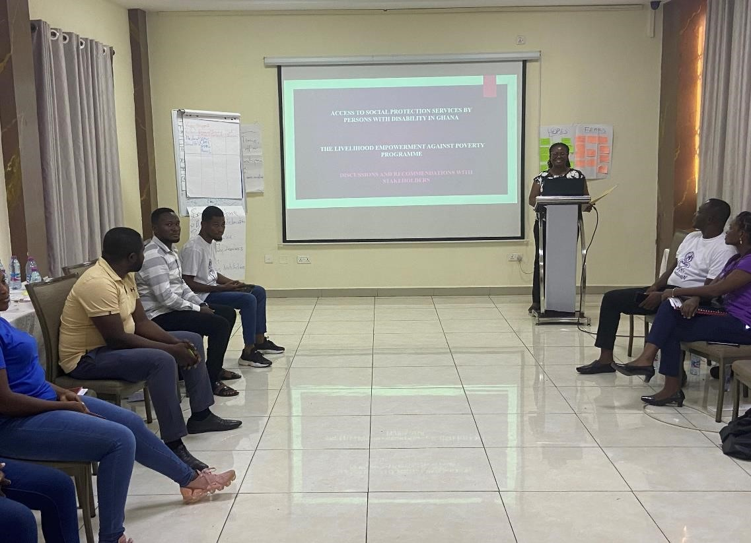

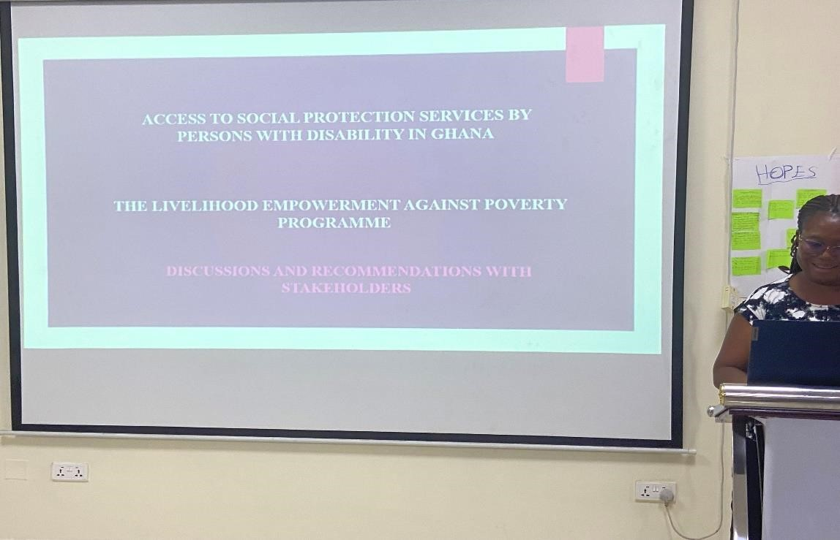

***Workshop with stakeholders***

