**Project Tittle**: Scaling up gender based violence prevention throughmale engagement

**Location**: Iceme Sub-county, Oyam District

**Start Date:** June 2022

**Completion Date:** August 2022

Implementer : Dinah Akallo

**Executive summary**

This report highlights the activities that were implemented for three months from June 2022-August 2022. The project aimed at improving Gender Based Violence ( GBV) prevention and response in rural communities of Lango Sub region specifically in Oyam district. The overall goal is to ensure that **Women and girls enjoy their socio-economic and cultural rights as provided in the constitution of the republic of Uganda** by first promoting Gender equitable social norms, attitudes, and practices at individual, household and community levels in Oyam district by October 2022.

Secondly, promoting equitable access and utilization of quality SGBV prevention and response services by all people.

The project was implemented in Iceme sub-county in Oyam District. The core focus of the project was on GBV prevention at the community level with an emphasis on gender transformative training and behavior change, awareness raising targeting mature males (preferably married)

The project further focused on strengthening awareness on linkages and referral pathway for specialized GBV services with the involvement of key actors. In particular, this project focused on: promoting behavior change and addressing social norms and values that may enable or condone GBV at community and household level; strengthening referral mechanisms and ensuring information on available services for GBV survivors is available and widely disseminated at community using media and other community methods.

The implementation of activities at community level was done with the help of a pool of community Resource Persons, elders, clergy , police and traditional leaders.

**CHAPTER ONE**

**Introduction and Background:**

Gender Based Violence (GBV) continues to be a concern in the region with African countries having some of the highest cases of different forms of GBV. According to the 2015 UN Women Beijing +20 report, Africa has a prevalence rate of 45.6% of physical and sexual intimate partner violence compared with an estimated rate of 35% of women worldwide who have experienced either physical and/or sexual intimate partner violence or sexual violence by a non-partner at some point in their lives

Gender Based Violence is one of the culturally and/or religiously tolerated violation of human rights and a form of gender injustice and discrimination that has over the years perpetuated gender inequality and inequity. GBV is serious as it has grave consequences on its victims including loss of life, physical injuries and disability, infections like HIV/AIDs, Sexual and Reproductive health disorders as well as psychological and negative behavioral outcomes. These consequences have serious negative effects on individual victims, their families, and community as a whole. As such, GBV if not adequately addressed leads to broader social and economic negative implications

The project that was implemented aimed at reversing this trend mainly by working with men who are said to be the perpetrators of Gender Based Violence.

**Problem Statement:**

Women constitute more than half of the population of Uganda. However, despite constitutional provisions which enshrines equal treatment for women and men in social, economic and political spheres, women continue to be victims of customs and cultures which have excluded them from decision-making and the right to inherit land and other assts. Women bear the brunt of gender-based violence, including sexual harassment which is practiced in places of work and institutions of learning and genital mutilation which is practiced by the Sabiny in the East and the Pokot in north-eastern Uganda

Despite solid evidence demonstrating the significance of women’s empowerment to realizing human rights, reducing poverty, promoting development, and addressing the world’s most urgent challenges, gender equality remains an unfulfilled promise. Although Uganda has a comprehensive legal and policy framework on Violence against Women and girls; GBV the prevalence rates continue to be high; according to UDHS 2016, at least 56% of women aged 15-49 years report having ever experienced GBV. This is because, there continues to exist gaps in implementation of legislation to protect women from violence and enable survivors to access services and justice. There is also limited knowledge about the different laws and policies among duty bearers and rights holders.

**Goals and Objectives:**

**Goal**

The Goal of the project is ‘Families in Iceme sub-county enjoy their social, economic and cultural rights by September 2022

**Objectives**

* To raise awareness on the ever-increasing cases of gender injustice
* To build and strengthen the capacity of men to respond and prevent cases of gender injustices

**Challenges and mitigation strategies:**

During the implementation of this project, a number of challenges were encountered. They included among others the following;

1. Due to the popular cultural norms and Values that perpetrate male supremacy and female dominance, some men were discouraged from participating in this project. By introducing the topic and engaging men during the identification process, some men feared to participate in this noble course because they did not want to be labelled ‘female’ or that they are not man enough. This nearly created anxiety among others.
2. Close to the above mentioned challenge is the fact that Patriarchy places men as dominant, leaders and aggressive. As a result engaging men if not well understood may mean that their power and dominance is being taken away from them. This is the reason some of them refused to participate.
3. Seasonal changes affected the project negatively. There was too much sun shine that resulted in famine in the communities. As such some community members were asking if the project was going to provide food aid as one of the measures of mitigating Violence in families. Their expectations were not met and as such some felt it was not important to be a part of the trainees. It took some bit of effort and explanation to make them understand the long term benefits of mind set change.
4. The Non-Governmental Organization (NGO) syndrome created by numerous NGOs in the rural areas was a challenge as people were expecting a lot of cash and other handouts. They could not imagine a project that is purely being implemented on voluntary basis.

**Mitigation.**

1. I work with a faith based institution and therefore had the advantage of working with and through the religious leaders. My participants were carefully picked by the religious leaders who knew them fairly well. They are men of good character whose conducts are being emulated by the community members, so working with them ensured that the communities understood what the programme is all about. Through them, the community members have understood the aims and objectives of the project and now more willing to participate.
2. The sensitization has cleared the mis-conception that the project was aimed at disempowering men but clarified that the project will work with men and women while placing men at the fore front of Gender Based Violence prevention.
3. Indeed the project was implemented at a time when there was a lot of heat. Communities had lost their first harvest to sunshine so apparently there is some bit of famine. As such, this raised a lot of expectations on the side of the participants who expected transport refund, food, facilitation to sensitize and monitor communities etc. However, working with the church was of advantage because communities and congregants know that church work is voluntary work.
4. To mitigate the effect of NGO syndrome, it was explained to the participant’s right from the beginning that participation is voluntary and that we are using the committed Christians who are already doing something. It was explained that the project will only build the capacity of those who were already doing something so that they can continue doing it rather professionally.

**CHAPTER TWO**

**Literature Review**

This chapter presents literature on male engagement. The chapter also presents conceptualization of male engagement and, the role of men in promoting Gender Equality and mitigating Gender Based Violence.

**Conceptualization of male engagement**

Also referred to as men's engagement is a programmatic approach that involves men and boys a) as clients and beneficiaries, b) as partners and c) as agents of change, in actively promoting gender equality, women's empowerment and the transformation of inequitable definitions of masculinity.

**The role of men in promoting Gender equity.**

The Government of Uganda is committed to addressing Gender Based Violence (GBV) which is a serious human rights, public health and a socio-economic concern in Uganda. This commitment is reflected in the existence of a policy on the Elimination of Gender Based Violence in Uganda and the Domestic Violence Act 2010 and its regulations 2011 which focus on the protection of rights holders and offering strategic guidance to duty bearers. The Ministry of Gender labour and Social Development has developed the National Male Involvement Strategy for the prevention and response to Gender Based Violence in Uganda aimed at engaging men and boys to become change agents in their communities and workplaces, promoting peace and security, mitigating conflicts, protecting the rights of women and girls, sensitizing their peers and ensuring victims/survivors receive appropriate services. (Ministry of Gender Labor and Social Deveopment , May 2017).

In the **learning Brief by the Irish joint consortium on Gender Based Violence**, ( (Irish Joint Consortium on Gender Based Violence , No date ) it indicates that Experience has demonstrated that women are significantly more likely to experience GBV than men. It has also shown that working with men, as partners, is critical to the prevention of and response to GBV. The challenge however is to find ways of working with men as well as women within a community context, and within all development programmes. Working with men to address GBV is important in order to change behavior, to get men’s assistance in strengthening community institutions that can address GBV, and to get men involved in promoting women’s equality and leadership.

The brief further continues that the reasons for engaging men are several: it reduces violence, women frequently ask for the programme to involve men as well as women; their participation helps to avoid a backlash against a violence against women programme from men; because men often hold more power and influence in a home or community, they can be more effective change agents; it supports the social reintegration of survivors who are often ostracized by their husbands/families e.g. in conflict situations where women have endured rape; and critically, if social change is to be sustained it is essential to engage the whole community (not only one half, namely women) including the most influential power brokers

During the discussions at the 3rd Men engage Global symposium (MenEngage Ubuntu summeries: Engaging men and boys in ending Gender Based Violence including violence against women and girls. , 2021)Gabrielle Jamela Hosein (senior lecturer at the Institute for Gender and Development Studies at the University of the West Indies in Trinidad and Tobago) said that as feminists, men and boys must be involved in other movements that fight injustice, such as climate and labor movements. ‘This needs to be one of the most important goals of the work with men and the Men Engage Alliance,’ this, she said, would support an accountability-centered approach to stopping men’s violence against women.

A report by(Working with men and boys to end Violence against women and girls , February 2015)indicates that it is now widely accepted that strategies to end violence against women and girls must include work with men and boys. For example the report notes the following; Training men to be positive role models for their peers especially in relation to promoting Womens Economic Eopowerment (WEE), sharing household responsibility more equitably, and speaking out against VAW also emerged as a promising approach to male engagement.

From a review of the literature, there are several types of programming or avenues to engage men and boys in the prevention of gender-based violence. All have the goal of changing social norms regarding men’s behaviors and attitudes towards masculinity and violence against women. The “2012 Shift: The Project to End Domestic Violence” report published by the Calgary Area United Way, identified seven areas of promise or entry points for engaging Canadian boys and men in violence prevention (Wells et al., 2013). The report discussed these entry points specifically in relation to domestic violence but many programs have used similar entry points to engage men to address GBV generally and not exclusively between intimate partners. The entry points are: 1 Engaging fathers 2 Men’s health 3 the role of sports and recreation 4 The role of the workplace 5 The role of peer relationships 6 Men as allies 7 Aboriginal healing ((Mens's Engagement in Gender Based Violence prevention: A critical review of evaluation approaches , 2014)

The potential benefits of men’s involvement include improved family health, better communication between couples, joint and informed decision-making within households, and better sexual and reproductive health,” says Dr Olive Sentumbwe, National Professional Officer for Family and Reproductive Health at WHO Uganda office, also noting that men are becoming more involved. Community Educator Ojandu agrees, having participated in his local Male Involvement Group."Men and women have the same rights and that we should always agree before we act. Sometimes children do not need to know that their parents are in disagreement, because it also affects their psychosocial health,” he says. Today, Ojandu organizes a community dialogue in which members discuss and advise each other on domestic problems. He and other community-level service providers note that reporting of gender-based violence has increased. “People are no longer ashamed to report their cases. They know they have the law on their side, and we always make sure they get the right treatment." **(** (Involving men in tackling Gender Based Violence in Uganda , May 2022)

**Theoretical Underpinnings**

The project was informed by Johan Galtung’s (1970s) theoretical approaches to Violence. He talked of structural violence which is Violence that is built within the system and manifests between what is and what should be e.g. leading to deprivation or repression from fulfilling needs, interests and aspirations

**How do we understand violence?**

[**Johan Galtung**](https://www.transcend.org/pctrcluj2004/TRANSCEND_manual.pdf)  explained violence in terms of its three dimensions; direct violence, structural violence, and cultural violence.He suggested that these dimensions of violence can be depicted as the three arms of a triangle.

## Direct Violence

Direct violence is what we see and experience. So, it may be physical violence such as physical assault, killing, etc. Along with, it can also be psychological violence or behavior that causes trauma, anxiety, or stress.

**Structural Violence**

Structural violence is built into the social structure. Galtung says societies are made up of systems. These systems include: laws and institutions established for enforcing them, economic systems such as the market, social inter-relationships, religious institutions and their workings, as well as in many cases, institutions of the army.

These systems interact with each other to create complex relationships of power. We can measure power in terms of access to resources, decision making, and opportunities. It is possible that the structures of a society are such that they result in the marginalization of certain groups, or they discriminate against them. This results in the infringement of their rights.

Such violence is not always intended; it is a product of the existing structures of a Society. Galtung also uses the term, ‘social injustice’ to explain structural violence. (Dutta, March 2020)

**Cultural Violence**

Cultural violence refers to the prevailing attitudes or beliefs used to legitimize violence of direct or structural nature. These include the prejudices or stereotypes existing in society, which have been internalized by individuals. The stereotypes find expression in the interactions people have with each other.

Johan takes example of violence against women, to explain these different dimensions of violence.

Domestic violence or other forms of violence that women and girls face in society is an example of direct violence. It is visible and we can easily identify the actors that cause such violence.

But, is domestic violence a personal problem between two individuals? In other words, would punishing husbands who beat their wives address the problem of domestic violence?

Yes and No.

Yes, punishing the husband may address the problem between that particular couple. However, such punishment is possible only if there is a law on domestic violence. Meaning, the legal structure of society recognizes domestic violence as a wrong and imposes sanction against it.

Even if there is a law on domestic violence, yet, the culture in many societies may condone it. The culture may accept wife beating and not consider it as a wrong. In such a case, even if there is a law on domestic violence, the police may be reluctant to file a complaint and may ask the wife to sort it out herself.

In another example, some cultures explain cases of sexual assault against women by comments such as “boys will be boys”, or “the woman asked for it by dressing in that way”. Such attitudes are a form of cultural violence, which the patriarchal structure of society supports. Patriarchy, as you know, is a social system that results in discrimination against women.

Coming back to the question, would punishing husbands who beat their wives address the problem of domestic violence?

No, not unless the structure and the culture of the society also undergoes a change. (Dutta, March 2020)

**Change theory and how it was applied**

The change theory involved understanding where we were and where we wanted to be. This is also stipulates the strategies that were used to get to the desired point.

The change objective of the project is to see that; Families in Iceme sub/county in Oyam District enjoy their social, economic and cultural rights by September 2022. To achieve this, the project will realize to two outcomes namely;

1. Socio-cultural norms, attitudes, and practices at individual, household and community levels change towards realization of Gender equality in Oyam district by the end of 2023.
   1. Increased awareness on gender equitable social norms, attitudes, and practice within the communities in Oyam district

**The Change theory is as such diagrammatically presented below**

|  |  |
| --- | --- |
| **Goal** | Families in Iceme sub/ county enjoy their social, economic and cultural rights |
| **🡹** | |
| **Outcomes** | Socio-cultural norms, attitudes, and practices at individual, household and community levels change towards realization of Gender equality in Oyam district by the end of 2023 |
| **🡹** | |
| Outputs | Increased awareness on gender equitable social norms, attitudes, and practice within the targeted sub-county |
| **🡹** | |
| Strategies | 1. Community mobilization/ sensitization and promotion of behavior change 2. Strengthen community-level response and referral mechanisms for GBV survivors. 3. Male engagement approach to Gender Equality and women empowerment |
| **🡹** | |
| Contextual issues | * Unequal gender power relations and related social norms that promote violence against women and children * High incidence of child and forced marriages (10.9%) and teenage pregnancy (10.7%) in Oyam district. |

**Methods and Design**

This chapter attempts to explain the different methods and strategies that were used to implement this project**.**

The most effective methodologies included conducting consultative meetings with relevant stake holders, conducting training workshops and working with organizations doing similar work (working worth male champions)

The project also encouraged the male champions to hold periodic self-assessment meetings to be able to continuously monitor their own effectiveness in assisting the communities.

**Chapter Three**

This chapter explains the activities that were under taken to achieve the desired objectives. They are as explained below;

**Consultative meetings with relevant stakeholders**

At the start of the project, the peace fellow moved to Iceme sub-county where consultative meetings were held independently with different stakeholders. The first visit was to the area Arch Deacon. The peace fellow introduced the whole concept to the Arch Deacon. This was to make him understand the project clearly, but also to rally his support for the project. It should be noted that one of the cardinal duties of religious leaders is prevention of Gender Based Violence, so this project comes to support his work. He welcomed the idea and also already had some of his parishioners in mind as part of the male Champions

Recognizing that the Community Development Office is vital in these area, a visit too was made there. The community Development officer also welcomed the idea and promised his support to the project. He was instrumental in identifying some of the men whom his office has also been working with. He also advised that to have the support of the police, there was need to also pay a courtesy call to them.

Meeting the officer in Charge of child and Family Protection Unit of Iceme was a very encouraging experience. The officer commended the project for using this approach because in this way, we are putting the perpetrators at the fore front. She said this was good idea. She also helped in identifying some of the men whom she recommended that we could work with because they have also been helping her in one way or the other.

By the time I finished with police, I had already enough men (only 10) already identified by the three stake holders visited. A courtesy call to the LC111 Chairman was to make him aware and also have his support where need be.

**Training of Male Champions**;

A training targeting male counterparts as agents of change in the community was conducted. The training targeted Religious, Cultural and Local leaders who were drawn from Omiri Parish, Aringo dyang village, Angweta parish, ongica village, Okwi Parish, BerAbwot A, Aloni Parish; Anyali Village, Eastern Parish: Aringo Laworo Village, Angweta Parish; Ager oket Village and Anomi Parish; Arech Village.

The purpose of the training was to create awareness and equip the identified male champions with relevant skills and knowledge on how to work with men and boys in the promotion of gender equality and women empowerment, and to share with participants the key practical approaches on how to work with fellow men to combat gender based violence (GBV) in the communities in which they stay. Men were also educated on the importance of their involvement in Gender based Violence prevention

As a result of this training, an action plan was developed which was meant to guide the next course of action for the male champions.

**Bench marking from other Organizations.**

To help the male’s champions do their work well, the peace fellow borrowed some ideas from Gulu Women Economic Development and Globalisation ( GWED G ) an organizations that has been using this approach to. Particularly the officer borrowed their reporting tool that was tailored to use by the male champions . The tool is as seen below

**Key findings / impact**

After one month from the time the champions were trained and commissioned to go and implement their work, a review meeting was held with them.

This meeting was to help us understand their achievements so far (the number of families and or individuals reached), challenges and or emerging issues and how we can improve the work. The following were the finding by the men;

Once men are put “in charge”, they move things. This they said that men always want to be recognized. Even in Gender Based Violence prevention, a number of them reached agreed that recognizing their effort as men would go a long way in preventing this vice. This is opposed to always demonizing them.

Some men complained that empowerment is making their women stubborn. That some of the workshops that women attend is poisoning the women and instead causing them to be less respectful. These has escalated violence in the homes because there is no man who can live with a woman who is disrespectful. This is made worse when the woman is having some finances.

The issue of thinking that all men are violent is misleading. It is as if all men are inhuman and are very heartless. There should be recognition for and solution to the violent women too.

Everyone talks as if women are too vulnerable to fight back. The truth is a lot has been miss conceived. Men are suffering in silence so the only way out is to be silent for those who can tolerate and for those who cannot, you will see a full-blown physical violence.

Some Gender Based Violence programmes are there to victimize men. Men get shy because from start to finish, say of a training, negative things about men are being discussed: It is as if women do not have the slightest capacity to harm men. This is wrong and misleading. It is also contributing to most girls remaining single mothers.

Recognizing male effort in GBV prevention is motivation to the ‘few good men”

Working with women in failed marriages sends a negative image, especially in Gender Based Violence prevention programmes. Some of them behave as if they are revenging on the men. They are not good examples to young girls who would wish to have families. Unfortunately some women are too naive to comprehend what works in their homes/ contexts. They treat all the information received from some training as gospel truth which if implemented, may result in Violence. Women should learn to be wise.

Women who mainly socialize the children are the ones who are promoting patriarchy- discussions during training.

**Conclusions.**

A fully fledged project on working with men to end Gender Based Violence would probably be the most ideal. This was revealed by the men and community members in Iceme. This assertion is also backed by the study which was conducted by Instituto Promundo, with support from the United Nations Trust Fund to End Violence against Women that implemented a multi-country project to engage men and boys in preventing violence against women and promote gender equality. This was conducted in five countries including India, Brazil, Chile and Rwanda. Findings from this study indicated that group education and campaign activities used in each site led to increased discussion by young and adult men about gender equality and decreased support for attitudes that encourage men’s use of intimate partner violence. It further found out that In Rwanda, the Rwandan Men’s Resource Center (RWAMREC) worked with three local coffee cooperatives to conduct gender-based violence prevention trainings. The trainings served a dual purpose: when men and women worked alongside each other through the cooperatives they were educated on how to prevent gender-based violence and promote healthy families while also increasing coffee production and related incomes. Following the trainings, there was a reported increase in the questioning of gender-based violence by men, as well as a decrease in the number of gender-based violence cases and more equitable division of labor. Results in Rwanda are informal and not backed up by a control group nor systematized pre- and post-test results.

**Recommendation**

As earlier mentioned and seen from the texts above, including the Literature review, working with men has become very vital and is crucial for any Gender Based Violence project to yield fruit. Women and or feminists can no longer stay away from men and expect positive change. Since it is mostly men who are cultural leaders and therefore the custodians of culture, working with them would help them appreciate the negative consequences of certain cultural norms and values that have perpetrated Gender Based Violence. We need men as change agents in the Gender Justice movement

Need to focus on sensitization women on responsible empowerment. Women should stop the double standard of only wanting what works for them

Involving men should also be of benefit to men. Silence about men’s issues will result in withdrawn men who do not want to get involved in anything because they feel neglected.

**Testimonies**

During the course of training the Gender Champions, two boy children appeared during lunch and begged for lunch. Much as they were given lunch, I was curious to find out who these destitute children were and where there relatives were.

I was told that the father of the boys was on the run after killing his brother. Their mother re-married but unfortunately passed on. No relative wants to stay with them now because they also imagine that they will be killers like their father.

On sharing this story with the participants picked interest. They said that in Lango culture, no one is home less so they collected some money, requested the police Child and Family protection Unit (CFPU) to take them back which she did though with difficulty. Some of the money was used to buy them clothing and shoes before they were taken back. Photos of the children before and after relocation and clothing them were shared.

Unfortunately we have not followed up to know how they were firing

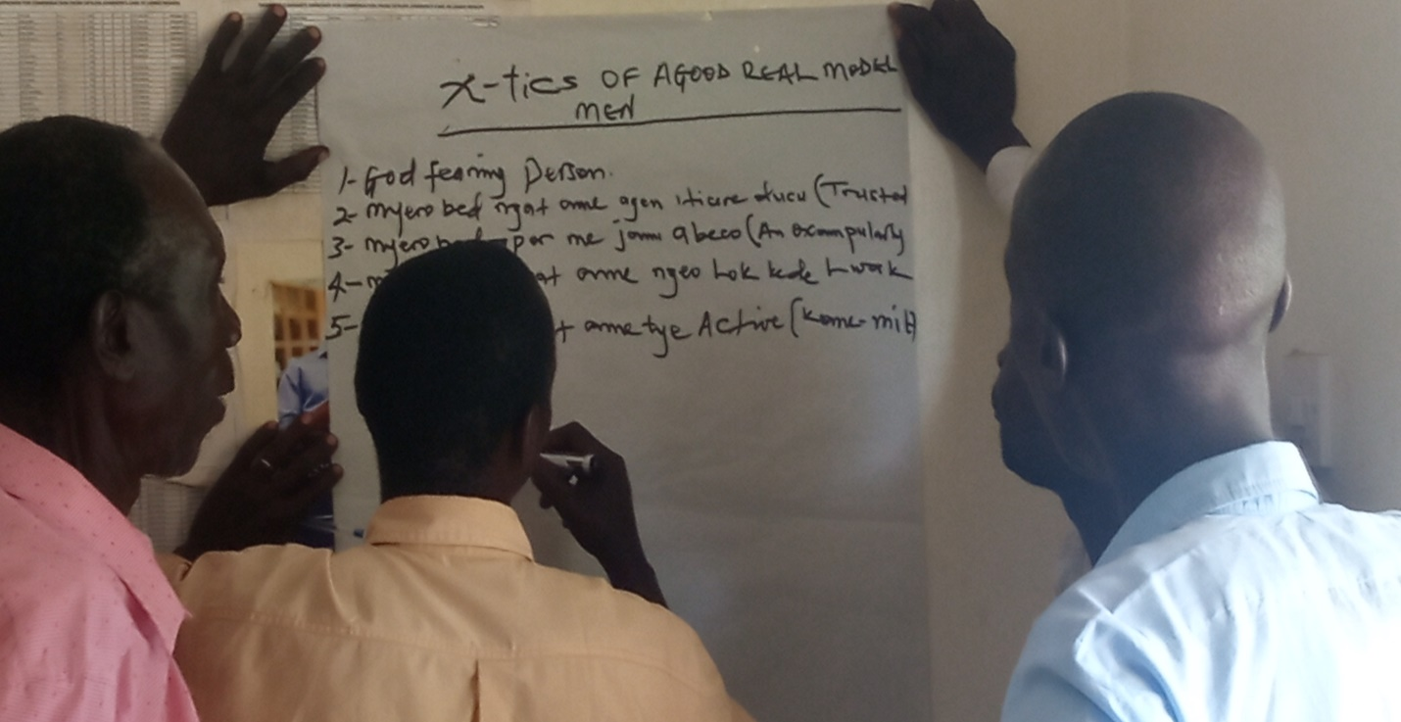

*The male champions in a group work discussing the characteristics of a model man*

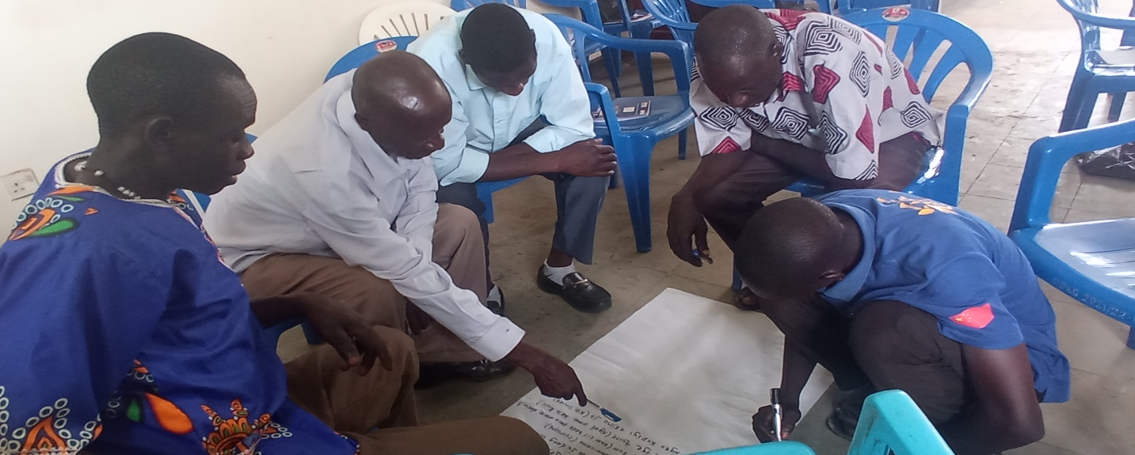*: Another set of model men in a group discussion.*

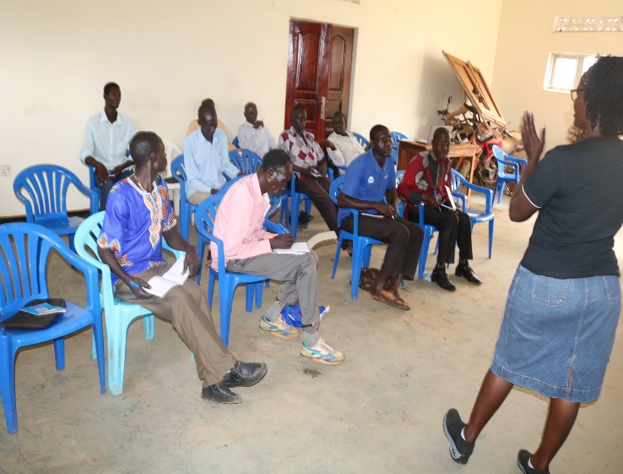

*Dinah Akallo (peace fellow) speaking to the men*

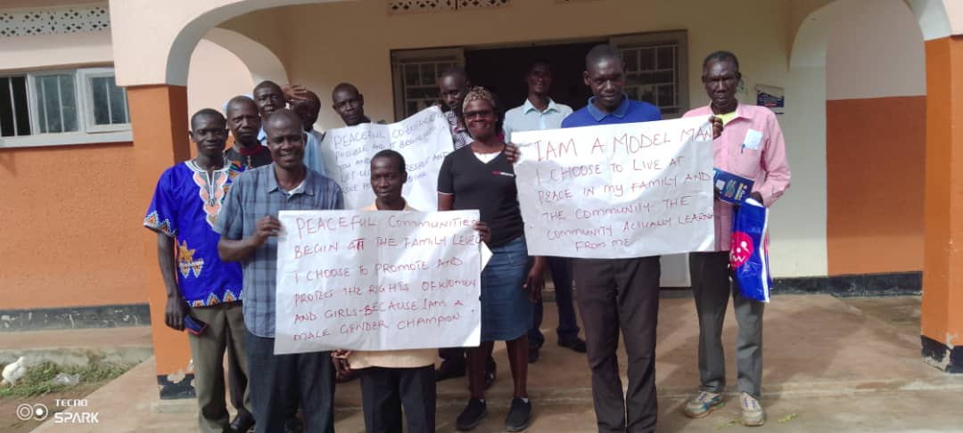 *Group photo with the model men after the training. The men held placards with messages on them.*

# References

Dutta, K. (March 2020). *Violence triangle of Johan Gultang in the context of conflict theory.*

(May 2022). *Involving men in tackling Gender Based Violence in Uganda .* Kampala .

(No date ). *Irish Joint Consortium on Gender Based Violence .*

(2021). *MenEngage Ubuntu summeries: Engaging men and boys in ending Gender Based Violence including violence against women and girls. .* Not indicated : Not indicated .

(2014). *Mens's Engagement in Gender Based Violence prevention: A critical review of evaluation approaches .* toronto. Ontario.

Ministry of Gender Labor and Social Deveopment . (May 2017). *National Male involement strategy for the prevention of Gender Based Violence .* Kampala: Uganda Publishing Coporation.

(February 2015). *Working with men and boys to end Violence against women and girls .*