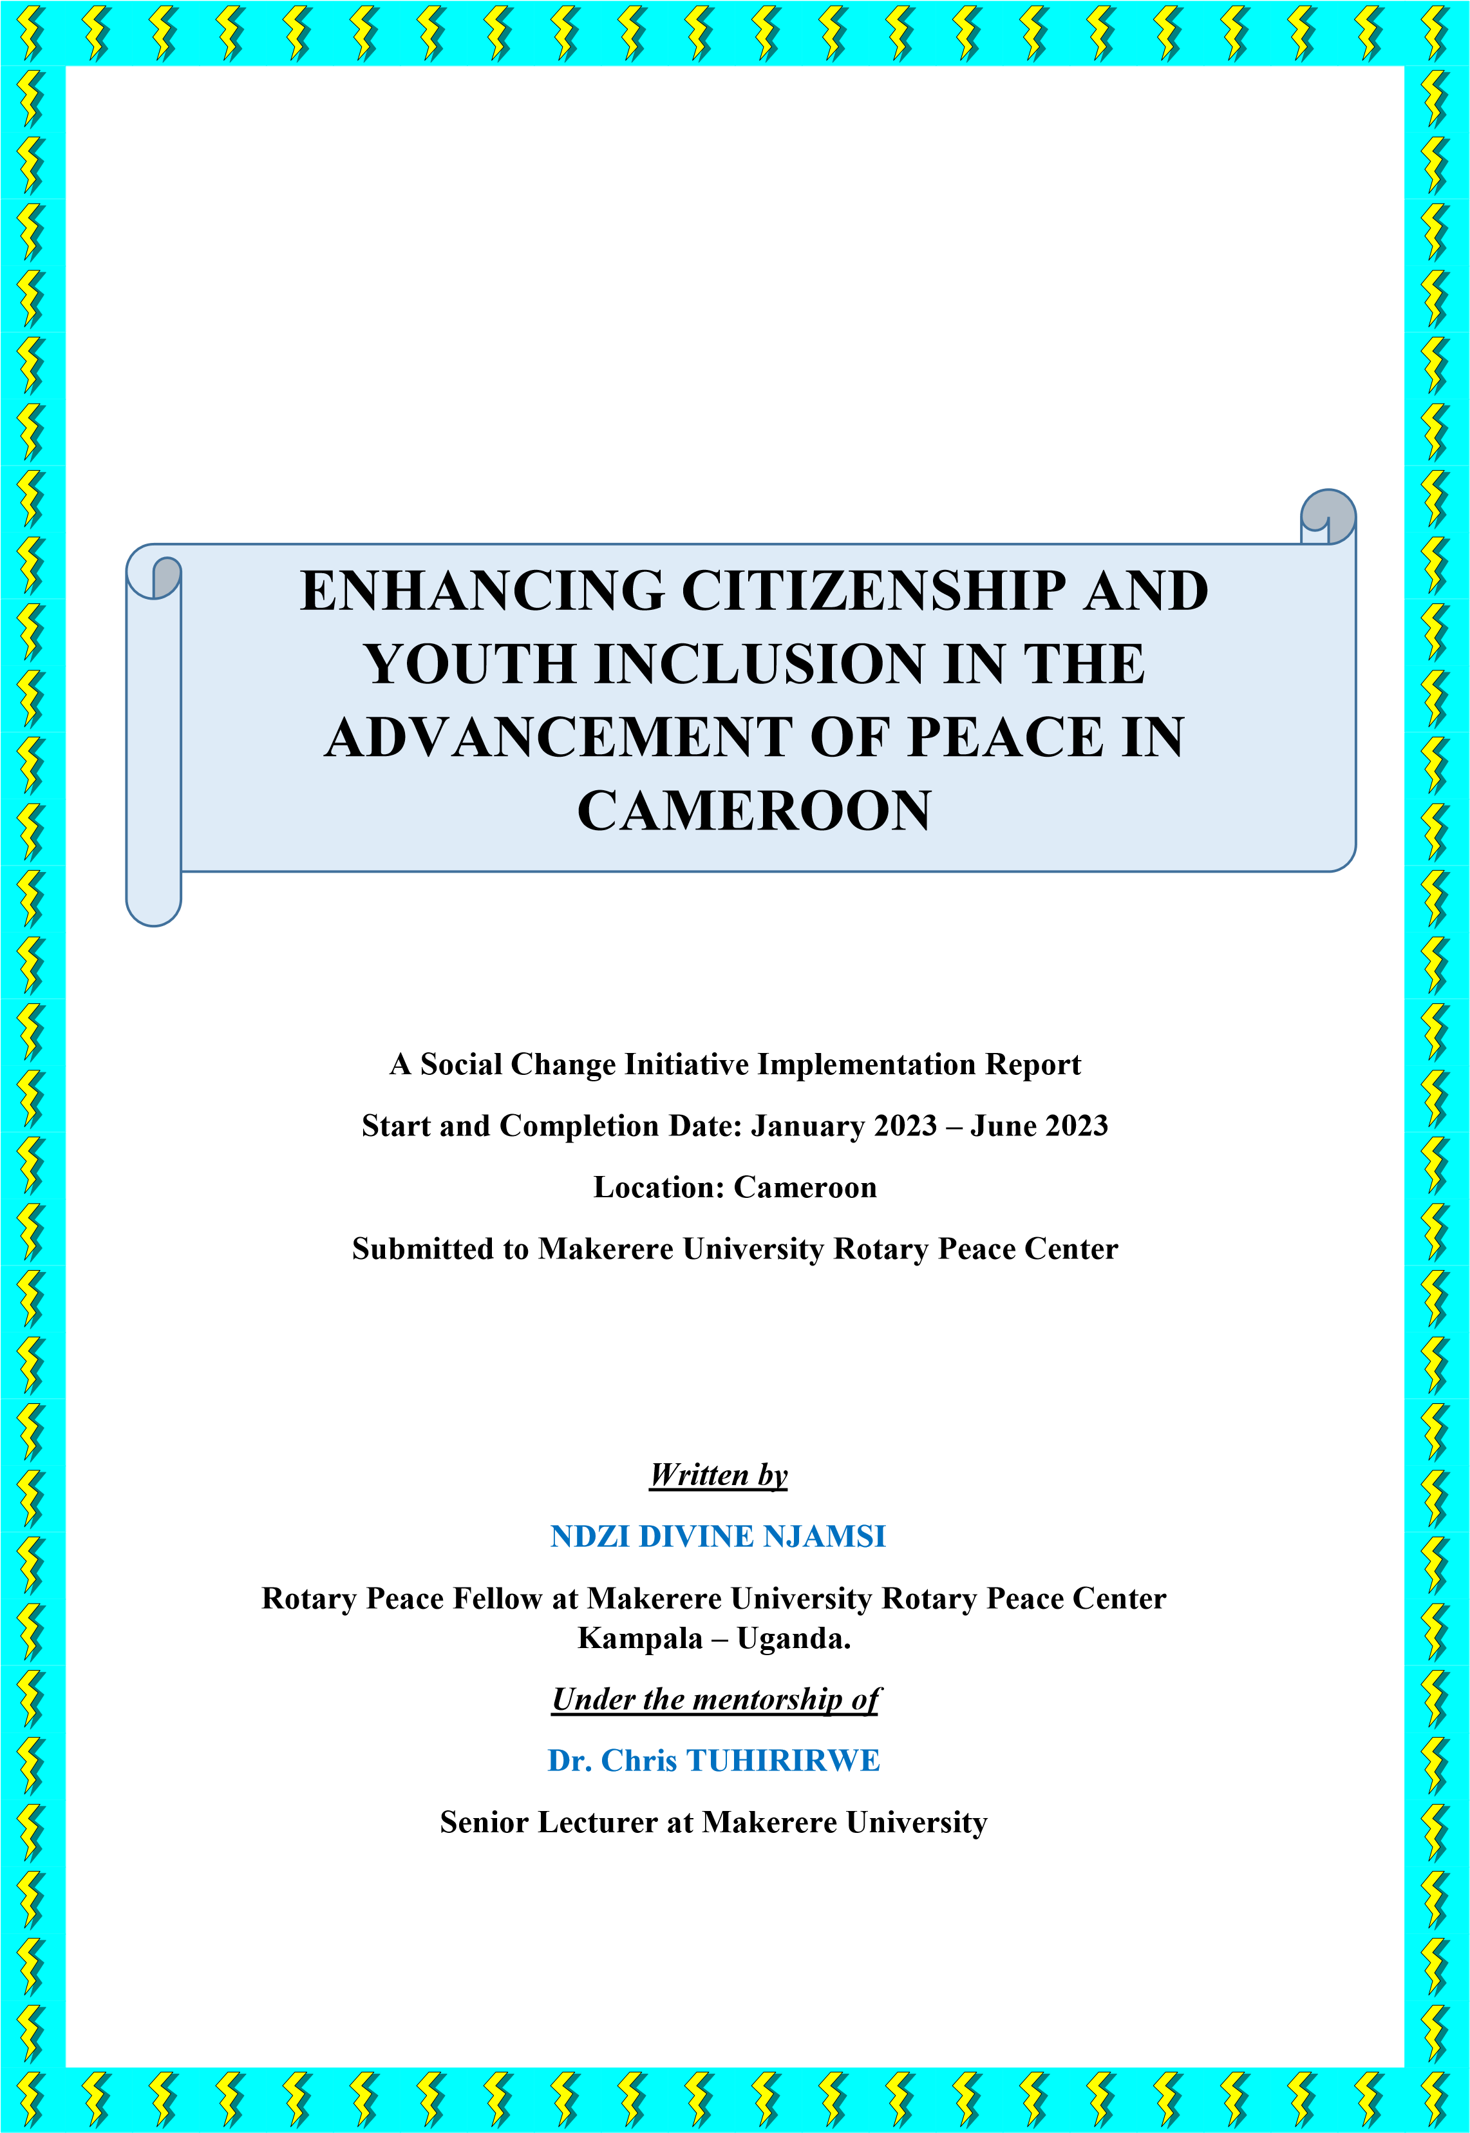

# TABLE OF CONTENT

**TABLE OF CONTENT** 1

**ABSTRACT** 3

**CHAPTER ONE** 4

**1.1 Introduction and Background** 4

**1.2 Problem Statement** 5

**1.3 Goals and Objectives** 6

**1.3.1 Goal** 6

**1.3.2 Objectives** 7

**1.4 Challenges and mitigation strategies** 7

**CHAPTER TWO** 8

**2.1: Literature Review** 8

**2.1.1 Theory of Peace by Galtung (2005)** 8

**2.1.2 Peacebuilding Theory by Sandole** 9

**2.1.3 Theory of Democracy** 9

**2.1.4 Conclusion** 11

**2.2 Theoretical Underpinnings** 11

**2.2.1 By Objectives** 11

**2.2.2 By the problem statement** 11

**2.2.3 Research Questions** 12

**2.2.4 Literature review relevant to theories** 12

**2.3 Change theory and how it was applied** 12

**2.4 Methods and Design** 13

**2.4.1 Choice of Approach** 13

**2.4.2 Choice and Selection of Respondents** 13

**2.4.3 Description of Respondents** 13

**2.4.4 The Interview and Analytical Process** 14

**CHAPTER THREE** 15

**3.1** **Interventions and Activities** 15

**3.1.1 Call for Applications** 15

**3.1.2 Other activities** 16

**3.2 Key findings / impact** 17

**CHAPTER FOUR** 20

**4.1 General Conclusion** 20

**4.2 Recommendations / implications for Policy** 21

**4.3 Sustainability Plan** 21

**REFERENCES** 23

**APPENDICES** 24

**APPENDIX I :** **FIRST PHASE OF THE TRAINING IN FEBRUARY 2023** 24

**APPENDIX II : SECOND PHASE OF THE REPAIR TRAINING, AFTER PARTICIPANTS IMPLEMENTED THEIR COMMUNITY ENGAGEMENT PROJECTS (JUNE 19 – 21, 2023), DAY 1 :** 26

**APPENDIX III: DAY 2: PHOTOS SHOWING MY PRESENTATION ON THE THEME “UNDERSTANDING THE EIGHT (8) PILLARS OF POSITIVE PEACE** 28

**APPENDIX IV : FIELD VISIT TO THE MINISTRY OF YOUTH AFFAIRS AND CIVIC EDUCATION, AND ITS DECENTRALIZED STRUCTURES** 30

**APPENDIX V : DAY 3 ; SHOWING A PANEL DISCUSSION ON THE THEME “WHY**

**YOUTH PARTICIPATION IN PEACEBUILDING MATTERS”** 31

**APPENDIX VI : SCANNED AUTHORIZATION LETTER FROM THE DIVISIONAL**

**OFFICER. NOTE THAT THE CONTENT OF THE LETTER IS IN FRENCH** 32

**APPENDIX VII : TRANSLATION OF THE AUTHORIZATION LETTER OF THE DIVISIONAL OFFICER ABOVE, FROM FRENCH TO ENGLISH** 33

# ABSTRACT

Cameroon has over the years transmogrified into a country where illiberal democratic practices are rife: our elected government rules through authoritarian practices, deprives citizens of human rights and ignores constitutional limits on power. The civic space is being limited through the aggressive spread of illiberal norms, rising social tensions, and strained relations with the international community. In the prevailing material circumstances, the aged and ailing cling steadfastly to power and young people tend become less and less interested in political matters. The Anglophone crisis on course has led to irrefutable instances of human rights violation including the pursuit of law and order policies at the expense of fundamental human rights (the February 14, 2020 killings in Ngarbuh in the North West), sexual violence, hostage taking, and the destruction of property. Roughly a million people have become internally displaced, over 3000 deaths have been officially recorded, approximately 60000 have moved west across the border into Nigeria as refugees (according to a recent report of the UNHCR) and 600000 children are out of school.

Currently, civic space in Cameroon faces big threats as the role of the civil society has become nuanced and mischaracterized in the strident political assertions of national sovereignty and territorial integrity, constant attempts to delegitimize civic actors branding them as foreign agents aiming to destabilize the country. The discussion about the specific role of Civil Society in Cameroon or more generally in the case of protection of witnesses or victims of torture in the Anglophone crisis for example, have become shaped by assertions and counter-assertions about the limits of civil society. However, in many cases, a victim of torture will be highly wary of State-provided victim and witness protection measures, given that this requires him or her to trust the same State that is responsible for violating his rights to be the one providing him or her with protection. In Cameroon many victims of the Anglophone crisis are fearful of approaching remedial State institution for being the very source of violations. There is a clear need for dialogue and greater rapprochement between the State and Civil Society in Cameroon.

This social change initiative was inspired from the ongoing socio-political instability in the North West and South West Regions of Cameroon (the Anglophone Regions) and the Boko Haram Terrorist activities in the Northern Regions of Cameroon. With the rise of hate speech in online spaces of Cameroon, physical abuse of the other (from a different ethnic group) and open discrimination in administrative offices, including a shrinking civic space in Cameroon.

# CHAPTER ONE

## 1.1 Introduction and Background

The Anglophone crisis on course in Cameroon has led to irrefutable instances of human rights violation including the pursuit of law and order policies at the expense of fundamental human rights (the February 14, 2020 killings in Ngarbuh in the North West), sexual violence, hostage taking, and the destruction of property. Roughly, a million people have become internally displaced, over 3000 deaths have been officially recorded, approximately 60000 have moved west across the border into Nigeria as refugees (according to a recent report of the UNHCR) and 600000 children are out of school. The COVID-19 Pandemic has further compounded the economic odds of many families in the Anglophone regions who now face not only the stark consequences of war but also the risk of sickness.

A Major National Dialogue organized as a result of the Anglophone crisis held between September 30 and October 4, 2019, prompting the release of several political prisoners and granting of a Special Status to the Anglophone Regions of Cameroon. Nevertheless, the practical mechanisms to implement the recommendations of the Major National Dialogue have not been deployed. So, fighting continues in the Anglophone regions as the roughly 500 and 1,000 active fighters (Amba boys) on ground - according to the monitoring group, Armed Conflict Location and Event Data (ACLED) - have refused to lay down their weapons. Many Anglophones are dissatisfied with the outcomes of the Major National Dialogue and same feelings have been shared even within the international community. A new entry point for continued dialogue has been provided by the Swiss government. The Swiss-led process aiming to bring the parties together for a negotiated dialogue faces current delicate conundrums, as the government has shown little interest in participating in other dialogue opportunities.

In February 2020, joint Legislative and Municipal elections held, but were marred by the raging conflict in the North West and South West Region that led to the rerun of elections in the regions; low turnout (less than 40%) due to calls for elections boycott by some opposition groups; and feelings of general disenchantment among the populace amidst strong perceptions that not much was going to change through the elections. Currently, there is great polarization in society and deepening ethnic divides in the country with a rise in hate speech and fake news which further fuels tension causing excessive human rights violations and criminal acts. There is fear and distrust of government remedies as it is generally perceived as the source of human rights violations, a lack of information flow compromises any long term humanitarian efforts to ensure access to justice for victims of gross human rights abuse, and a wholesale rollback of democratic norms and a campaign of reprisals against peaceful dissent, fuels political apathy, and eclipses reform-minded voices.

Worst still, the administration of Cameroon is beginning to shift its rhetoric towards civil society. With the recent March 10, 2020 pronouncements of the Minister of Territorial Administration, the closing space for civil society is no longer just an emergent trend of uncertain gravity. Civil society organizations and activists in an ever-increasing number now have to contend with systematic efforts to reduce their resource base, weaken their operational effectiveness, and destroy their public legitimacy. Formal and informal restrictions on freedoms of association and assembly and the public vilification of civic actors have already become the new political reality. This represents a fundamental rupture in the spread of liberal civil society norms over the past several decades. Of course, human rights activists and citizen groups working to challenge State power have always faced an uphill struggle. Their work unsettles deeply entrenched vested interests, causing political and economic elites to lash out against them. In authoritarian contexts like that of Cameroon, state-society relations have become tenuous, with government now turning towards keeping tight control over foreign aid flows and dissidents risking violent state repression. There is a need for dialogue between the State and Civil Society and clear measures effected to protect the status and standing of civil society in Cameroon.

All the above-mentioned situations have led to the feelings of non-belonging by Cameroonian citizens, as many have lost interest in national issues such as elections, community development and participation in peace processes. In addition, young people have become very apathetic as they keep advancing reasons such as corruption, nepotism, dictatorship as justification for their nonparticipation in the advancement and restoration of peace, especially, in the North West and South West regions that have been suffering the effects of the Anglophone crisis for since November 2016.

## 1.2 Problem Statement

Apart from the ongoing Anglophone crisis and the activities of the Boko Haram terrorist group in the Northern Regions of Cameroon that poses a problem to peaceful coexistence and harmonious living, the civic space in Cameroon is also subject to the authoritarian rule of the country through the Ministry of Territorial Administration. Some civil society organizations and activists now have to contend with systematic efforts to reduce their resource base, weaken their operational effectiveness, and destroy their public legitimacy. Formal and informal restrictions on freedoms of association and assembly and the public vilification of civic actors have already become the new political reality. This represents a fundamental rupture in the spread of liberal civil society norms over the past several decades. Of course, human rights activists and citizen groups working to challenge State power have always faced an uphill struggle. Their work unsettles deeply entrenched vested interests, causing political and economic elites to lash out against them. In authoritarian contexts like Cameroon, statesociety relations have become tenuous, with government now turning towards keeping tight control over foreign aid flows and dissidents risking violent State repression.

Young people still continue to face discrimination in several ways. As voters the legislation only allows them to vote at 20 instead of 18 as is in other African countries. As candidates they are even more subjected to difficult conditions to participate. Despite making up more than half of the population, young people (ages 18-35) often find themselves marginalized from mainstream politics and decision making. While they are often involved in informal, politically relevant processes, such as activism or civic engagement, they are not formally represented in national political institutions such as parliaments or municipalities. They struggle to gain the respect of public officials and are seen as lacking the skills and experience to engage in political activity and lead positive change in their communities. This exclusion, combined with limited educational and economic opportunities, growing unemployment rates, stagnant growth, and wide scale corruption have contributed to increasing rates of emigration and frustration with the status quo. Young voices in Cameroon are demanding progressive social and political inclusion, greater levels of participation, and a change in the configuration of politics. There is an emerging generation of young thought leaders and political change agents who not only need a favorable environment and appropriate laws but also the skills and resources to effectively engage in politics, evolve a new paradigm and consolidate peace and democracy in Africa.

## 1.3 Goals and Objectives

### 1.3.1 Goal

The goal of this social change initiative was to deepen the role of young people to foster active citizenship and peacebuilding in Cameroon through peaceful methods.

This project is important because we are panting for peace in Cameroon that has not been since the escalation of the Anglophone crisis in November 2016. Apart from nurturing youths for future leadership, it is also important to equip them with peacebuilding skills so that they become transformative leaders when they get to top leadership positions

### 1.3.2 Objectives

The specific objectives of this social change initiative were:

* To foster the inclusion of youths in the peace advancement process in Cameroon;
* To contribute towards enhancing active citizenship in Cameroon;

## 1.4 Challenges and mitigation strategies

First, the major challenge to the successful execution of this social change initiative (s.c.i) was finance. Considering the fact that Peace Fellows were not entitled to a seed grant by Rotary International, it made the execution of this s.c.i very difficult. In order to mitigate this financial challenge, I had to organize a fundraising by writing appeal letters to strategic people that I know and some well-wishers. Although the Rotary Club of Yaounde Mfoundi (my host club) did not support due to financial constraints, members of the club financially supported the s.c.i individually and gave some donations in terms of the didactic materials that will be needed. My personal inter-relation with people greatly helped me in the successful implementation of this s.c.i.

Secondly, in order to avoid the program (3days) from being banned by the Divisional Officer of the district where the s.c.i was organized, I submitted an authorization letter to the divisional officer in order to request for the clearance of public manifestation and luckily, this authorization was granted.

# CHAPTER TWO

## 2.1: Literature Review

This chapter explains in details the theories, concepts and objectives mentioned in the background. Although the concepts peace, peacebuilding, democracy, governance and elections have been widely published by several authors, I did a deeper reading of the above concepts in order to successfully implement this social change initiative.

### 2.1.1 Theory of Peace by Galtung (2005)

This theory was propounded by Johan Vincent Galtung, a Norwegian sociologist who is the principal founder of the discipline of peace and conflict studies. According to Galtung, peace should be built after the problems caused by structural violence are eliminated, so positive peace should be targeted, not negative peace (Galtung, 1976, pp. 297-298) [1]

In this theory of peace, he made mention of two concepts being negative peace which implies the absence of physical violence, and positive peace which is the presence of harmony with the elimination of structures that inhibit human potential and performance. His concept on positive peace has become a major approach in Peace and Conflict Studies (PCS) for removing conflict, solving it, or transforming it, and for understanding the different relations between peace thinking and social reality.2

It is worth noting that Johan Galtung was influenced in his philosophy of peace by the pacifism of Gandhi. The iconic Indian leader and political ethicist, famously concerned with understanding and implementing non-violent forms of civil resistance, coined the term satyagrha. Satyagrha refers to a universal value of truth and peacefulness — where strength comes through enacting non-violent and peace-affirming practices.

The lay theories of peace according to Leshem and Halperin (2020)[2] are based on the relative strengths of three meanings or interpretations of peace, which are not necessarily mutually exclusive, corresponding to “the end of war” (negative peace), “harmonious relationship” (positive peace), and “justice” (structural peace). Although lay theories lack the rigor of scientific theories and not very popular in PCS, people rely on them to understand, interpret, and predict their social world and “what counts as one’s lay theory of peace is the balance between the three, namely, which interpretations dominate, and which are more applied the lay theory of peace.

In many ways, Galtungs’ theory of Positive Peace neatly summarizes the philosophies of both Gandhi and Boulding. Stressing the importance of attitudes — like satyagrha — and institutions in actively improving the social, economic and political factors that promote peace.[3]

### 2.1.2 Peacebuilding Theory by Sandole

According to Sandole (2010)5 peacebuilding is a dynamic approach and framework for strengthening positive peace through some third-party interactions with different actors performing different tasks at the same time or at different points in time. Proactive peacebuilding would require third-party interveners to attempt and implement an intervention before a conflict occurs to “prevent the house from catching on fire” (Sandole, 2010, p. 13). Comprehensive peacebuilding is often undertaken for regional and global governance to deal with deep rooted causes of conflict from prevention through resolution to transformation. This contemporary theory is effectively operative at all levels of conflict analysis and intervention in order to de-escalate the situation and restore normalcy for sustainable peace. It provides a conceptual and operational framework for reconciliation, distributive and restorative justice particularly in situations of recovery from mass violence, armed conflict, or violations of human rights.

### 2.1.3 Theory of Democracy[4]

In his 1863 Gettysburg Address, Abraham Lincoln defined democracy as "government of the people, by the people, for the people." These words have come to mean different things to different people and have sparked debate all over the world. Four theories of democracy have taken shape over time, each addressing the questions of who holds power and influences public policy.

#### 2.1.3.1 Traditional Theory of Democracy

This promotes majority rule without violating minority rights, maintaining the willingness to compromise, and recognizing the worth and dignity of all people. Under the Traditional Theory, everyone has the right to participate in government. This participation can occur either by direct or representative vote. In a direct vote, the people approve public policy themselves. This situation works well on a small scale, as in a town meeting. In a representative vote, a group of elected officials acts on behalf of their constituents. This type of vote is used at the state and national levels to determine public policy. For voting to be effective at any level, people need access to information, so they can make informed decisions.

#### 2.3.1.2 Pluralist Theory of Democracy

Holds that people with common interests form organized groups to promote their causes and influence the political agenda. This theory maintains that no single group, industry, or government agency dominates politics. It also asserts that a healthy competition exists in the development of the policy agenda and in the selection of the policy makers. Examples of special interest groups that represent the needs and agendas of the public include the National Education Association (NEA), the American Civil Liberties Union (ACLU), and the American Association of Retired Persons (AARP). The cohesion of the people results in compromise so that opposing views are represented in the eventual public policy.

#### 2.3.1.3 Elite Theory of Democracy

Maintains that the majority of political power and influence is held by a small number of individuals, groups, and industries. People who support this theory argue that government policies disproportionately favor the elite over everyone else. For example, the oil industry and many others have been known to funnel millions of dollars into political campaigns for the candidates who support lenient pollution standards. President Eisenhower in his farewell address warned against the possible problems created by the "military-industrial complex," which is symbolic of the elitism in government.

**2.3.1.4 Hyperpluralism**.

Similar to the Pluralist Theory, Hyperpluralism suggests that people who share interests form groups to advance their causes. Like the Elite Theory, it suggests that some groups wield too much power and influence on the government. For example, when a group does not like a policy passed by Congress, it can take its cause to court. Several important court decisions have been reached in civil rights and environmental cases thanks to the efforts of strong special interest groups. However, hyperpluralists argue that taking cases to court can undermine the political system by pitting the judicial process against the legislative process. Ultimately, the result of Hyperpluralism would be the total gridlock of government; that is, too many groups vying for power but lacking the cohesion necessary to force compromise. The factionalism that Madison and Hamilton warned about in *Federalist Papers* #10 and #51 come into play in this scenario.

Although quite different, all four theories of democracy share a common idea: people, either as individuals or groups, can make a difference in government. Involvement is the key to effecting change and making sure the government responds to its citizens.

### 2.1.4 Conclusion

Theories are critical and important to an understanding, analysis, explanation, prediction and prescription of conflicts by providing researchers and practitioners with necessary insights into the root causes, nature and effects, and initiatives for their prevention, management and resolution for peaceful and harmonious coexistence. While a unified theory of PCS may be desirable, it may be difficult to develop as the causes, levels, manifestations, and management intervention strategies in conflict situations are so varied with different actors and factors. It gives a connection between the objectives of study and the methodology for data collection, analysis, and findings.

## 2.2 Theoretical Underpinnings

### 2.2.1 By Objectives

The objectives of this social change initiative were all geared towards increasing youth participation in peacebuilding and civic engagement. This is because I have the vision to raise transformational leaders. People who will value humanity rather than power and fame when they get to top leadership positions. As such, it is important to prepare them now for the postPaul Biya era so that Cameroon should not be governed by a group of power mongers again. Further, we are panting for peace in Cameroon that has not been since the escalation of the Anglophone crisis in November 2016. Apart from nurturing youths for future leadership, it is also important to equip them with peacebuilding skills so that they become transformative leaders when they get to top leadership positions

### 2.2.2 By the problem statement

As referred in the problem statement above, this s.c.i was inspired from the ongoing sociopolitical instability in the North West and South West Regions of Cameroon (the Anglophone Regions) and the Boko Haram Terrorist activities in the Northern Regions of Cameroon. With the rise of hate speech in online spaces of Cameroon, physical abuse of the other (from a different ethnic group) and open discrimination in administrative offices, including a shrinking civic space in Cameroon.

### 2.2.3 Research Questions

* How can youth inclusion be fostered in the peace advancement process in Cameroon?
* How can we enhance active citizenship in Cameroon?

### 2.2.4 Literature review relevant to theories

This is indicated in Chapter 2.1 above where we explained theories related to the work. As a reminder, some of these theories are the theory of Peace by Galtung, the Peacebuilding theory by Sandole and the Theory of Democracy.

## 2.3 Change theory and how it was applied

**Step 1 :** The problem that i wanted to address in this social change initiative was that of the restriction of youth participation in civic and political life and also the current peace problem in the anglophone regions of Cameroon. In this problem, i am supporting youth participation Citizenship and youth inclusion in the advancement of peace in Cameroon. This is because youth are the target of political manipulation in the country due to their political apathy. Also, the political apathy of youth in Cameroon have been one of the major causes of violence in the political space of the country. The root causes of this problem in Cameroon are connected to social discrimination, nepotism, corruption, bad governance and the shrinking of civic spaces due to its harsh laws on civil society by the State.

**Step 2 :** The desired impact of this social change initiative is to see young people in Cameroon run for political positions. This is because the best way to positively transform the country is to fully participate in politics as young people.

**Step 3 :** Increased youth participation as candidates for the 2025 Presidential Elections in Cameroon (outcome)

40 youth leaders from the 10 Regions of Cameroon have acquired skills in peacebuilding and applying the eight pillars of positive peace in their professional, academic and personal lives (output)

## 2.4 Methods and Design

In this section, we shall examine the methodological aspects of the social change initiative

### 2.4.1 Choice of Approach

The main objective of this research project was to examine the reasons or motives behind young people’s political apathy in Cameroon and lack of citizen engagement. This furthers our understanding of why they don’t mobilize to register in the electoral lists and stay away from anything that has to do with youth political participation, and allows us to analyze the meaning that non-involvement has for them. Methodologically, a qualitative approach was chosen, as it was felt that the goal of this social change initiative would be best achieved through qualitative data collection methods such as detailed personal interviews and by relying on the principles of grounded theory.

### 2.4.2 Choice and Selection of Respondents

The criteria used to select the groups or organizations in which young people are actively involved were narrowed down to those that can have an influential effect on the modes, practices, and meaning of political involvement for young people. These criteria are: (1) the gender make-up of the group: mixed groups versus those whose membership is restricted only to women; (2) the age composition of the group: multi-generational groups versus those whose membership is restricted only to young people; and (3) the degree of institutionalization exhibited by the group.

The criteria used in respondent selection are gender, age, and reasons for non-involvement or non-participation. Respondents had to be young people between the ages of 18 (age of majority) and 35. This age bracket (18–35) is the one that includes young adults who are involved with major youth groups or with youth group committees. Respondents also had to be involved in the group’s activities. Our final respondent sample is composed of 35 young people. Ten are active in civil society organizations, ten are active in the trade union of taxidrivers, 7 are active in the trade union of hawkers and 7 active in the trade union of *BodaBoda* riders. These groups are open to both men and women, and are also highly institutionalized.

### 2.4.3 Description of Respondents

The youths interviewed for this study are all between 18 and 35 years old, with an average age of 22. Their annual income varies between zero to FCFA119400 (being UGX737,093) although the average annual income of respondents active in civil society organizations is FCFA59,700 per month (being UGX368,547). The average annual income of respondents who are active in community groups and associations is around FCFA2,984,974 (being UGX18429615,00). Those with higher incomes all have full-time jobs, which helps explain these salaries differences. Their residential situations also vary—some respondents live with their spouses, while others live alone, with roommates, or with their parents. Almost all of them are working (taxi driver, Boda-Boda riders, or studying), although most are doing both at the same time. Some have only been active in their association for a short period of time, while others have been involved for several years. Besides collecting information on respondents’ socio-economic status, we also collected information on their parents. Almost all of our respondents have parents who work outside the home—only four have mothers who are home-makers. Their parents work in a variety of occupations, although their mothers often tend to work in traditionally female professions (nurses, teachers, secretaries).

### 2.4.4 The Interview and Analytical Process

Semi-structured interviews, lasting an hour and a half on average, were carried out on the following main topics: (1) the trajectory that their non-involvement has taken (motives, triggering mechanisms, origin of their lack of interest in politics and political participation, etc.); (2) their life history (family and academic trajectories); (3) the meaning that nonpolitical participation has for them (definitions, representations, and so on); and (4) social representations (perceptions of Cameroonian society, social issues, and so on). Interviews were all recorded and transcribed in full. A qualitative content analysis was then performed. This involved the following two main steps: (1) vertical analysis (interview content), which involved delimiting and coding the main topics and related sub-themes, extracting the organizational components of each narrative, grouping these elements into categories, and elaborating hypotheses; and (2) comparative analysis (cross-comparison of interviews), in which the content of the young people’s discourse was linked to independent variables (such as family origin, occupation, and so on) in order to verify these working hypotheses, find cases that might negate these working hypotheses, and refine the original thematic categories.

# CHAPTER THREE

## 3.1 Interventions and Activities

The following activities were executed during the implementation stage of this social change initiative.

### 3.1.1 Call for Applications

Firstly, there was a call for applications of the program titled Rebuilding Peace through Actions with Inclusive Reach with the content of the program as follows

***-Rebuilding Peace through Actions with Inclusive Reach – REPAIR***

*REPAIR is a youth peace and democracy initiative intending to deepen young people’s knowledge about peace and democracy while fostering a culture of active youth participation and leadership. Based on the need to promote young people’s active participation in democratic governance and political structures in Cameroon, the REPAIR series supports young activists and organizers as thought-leaders and allies in crafting solutions and new youth-focused approaches to democracy and its challenges in our society. The 2023 REPAIR series will host 40 youth leaders from the ten (10) regions of Cameroon for two (02) semesters, each lasting for three (03) days during which participants shall exchange and build knowledge, skills, and values needed in advancing peace and democracy work. The REPAIR series is knowledge based and activity-oriented, and this year focuses on fostering youth participation in peacebuilding processes, understanding of Cameroon’s Democratic process, Youth participation and Leadership. Each participant will have the opportunity to build his or her leadership and organizational skills by carrying out a step down (community engagement program) activity in their locality of residence or region of origin, as a means of strengthening knowledge of peace and democratic values among peers. The semesters will involve discussions on important questions of peace, civic engagement, youth participation and local governance within society and may lead to policy proposals on same issues to relevant stakeholders. Upon the successful completion of the REPAIR series, each participant will be awarded a Certificate as a Youth Envoy for Peace and Democracy (Yep).*

*Eligibility*

*Applicants (male or female) interested in the REPAIR series should:*

* *Be no older than 35 years of age,*
* *Demonstrate strong interest in democratic activism and in the advancement of peace in their respective communities or nationally.*
* *Preferably is a youth leader affiliated with a sector civil society organization. While we will consider applicants who are currently employed by a civil society organization or are graduates, we will request additional information to confirm that the individual is acting on their own in regards to their participation, and that their current employer is flexible with their independent role as a REPAIR attendee.*
* *To be eligible to attend the next semester and receive the Certificate, each attendee must (after the first semester) conduct a community engagement activity reaching at least 40 youths in their respective regions.*

*Please Note: The 2023 REPAIR series is open to applicants from Cameroon only. REPAIR is not an educational program offering academic courses leading toward a degree. It does not provide funds or any other type of financial aid to graduate students, nor is it designed to finance youth projects/organizations. The program cannot support those seeking to complete professional training programs, attend conferences, or pursue internships at other organizations.*

### 3.1.2 Other activities

Other activities that were realized in relation to the success of the s.c.i were

* *Evaluation of applications by the team and the selection of successful candidates, henceforth referred to as participants*
* *Search for a hotel to accommodate participants*
* *Sending out of emails to selected participants containing invitation letters and concept note*
* *Contacting facilitators for the training*
* *Implementation of the social change initiative*

Amongst the facilitators contacted, it is also important to note that I facilitated a training on the theme Understanding the eight (08) pillars of positive peace, same as I moderated a panel discussion in English and French.

-Also, during this second phase of the REPAIR training program, I initiated a field trip to the Ministry of Youth Affairs and Civic Education with the 40 participants from the 10 Regions of Cameroon. The goal of this field trip was to make participants understand how the Ministry functions in attending to challenges that the youths face in Cameroon and to know how they can collaborate with the Ministry in solving these challenges.

## 3.2 Key findings / impact

Our social change initiative helped us to understand why young people were not interested in peacebuilding, political participation and civic engagement. However, we were able to convince them on the importance of youth political participation such as the fact that it is only through participation that one can positively transform the system that has not been working.

The second key finding was the fact that participants were surprised to have such a magnificent program in Cameroon. In most cases, such programs are organized out of the country but in this case, participants welcomed the initiative of empowering and equipping them not only for community development and peacebuilding, but also for transformational leadership.

Thirdly, amongst the 40 participants, we had a junior parliamentarian from the West Region of Cameroon and a junior Senator from the South West Region of the country. This demonstrates the extent to which Cameroonian youths are bracing up to take political positions in future although they are restricted through the institutions (Constitution and Electoral code) as explained in the next lines. In Section 45[5] of the Electoral code of the Republic of Cameroon, the minimum voting age is 20 years whereas the age of maturity in Cameroon is 18 years. Paradoxically, the law authorizes them to choose a life partner at 18 for the men and at 16years for women (with parental consent), they have the right to own a national identity card at 18, drive at 18, drink alcohol at 18 and to the extent of serving in the military and police force at the age of 18 years to die for the country but they cannot vote at 18. It is true, the electoral code of Cameroon in Section 117 and the Constitution of the Republic of Cameroon in Article 6(5) both authorize a youth to be a candidate for the presidential election at the age of 35 years[6]. Ironically, every candidate running for the post of the president must pay a non-refundable caution fee of FCFA30,000,000 (being

UGX185,227,210) into the State’s treasury[7], not to talk of the clumsy administrative procedures[8]. By implication, young people are systematically restricted from the political space through the electoral register as the prevailing poverty and unemployment in Cameroon does not favor any youth aspiring for political office to raise such a heavy amount (except they are willing to compromise some of their political aspiration’s values to align with those of the ruling party*-the Cameroon People Democratic Movement-CPDM*, before they are able to obtain “financial support” from the “big fishes” of the ruling party), thereby acting as a distraction in the political scene so that the electorate does not vote out the ruling party.

We also found out that the minimum age for criminal responsibility in Cameroon is 14 years according to the penal code[9]. This is a complete contrast of the age of maturity, implying that at the age 14 years, a Cameroonian can be sent to jail in Cameroon meanwhile they have not yet attained the minimum voting age which is 20 years authorizing them to have a voter’s card. Cameroon has a punitive law against her youth population. Instead of implementing laws that will favor young Cameroonians to aspire for political office and develop the nation, the aged authoritarian Biya regime is systematically restricting youth from accessing the political space, worst of all with the shrinking civic space where authorizations to operate are withdrawn at will by the Minister of territorial administration should any civil society organization dares to expose the authoritarian rule of the regime.

Further, some of the participants pledged to create their own organizations through which they will continue to spread the knowledge and skills on peacebuilding in general and positive peace in particular. In the same light, we were able to inspire the participants whom took the commitments to apply for the Rotary Peace Fellowship at Makerere University so that they can also be trained as specialists in peacebuilding and conflict transformation. It will be important to note that from my participation in the Rotary Peace Fellowship, I came back in December and mentored some young Africans (Cameroon, Nigeria, Ghana, Zimbabwe, Uganda and Kenya) to apply for the program. As I submit this report, five (5) candidates out of the nine (9) who applied had their applications endorsed and fit for global competition. This demonstrates the extent to which the Rotary Peace Fellowship had positively impacted me and I am giving it back to my community through the social change initiative and mentoring of aspiring candidates for the Rotary Peace Fellowship.

Finally, the young people pledged to continue to spread the message of youth political participation in their respective communities of residence. In the months ahead, we will be organizing the program titled *“The Next Mandela Fellowship”* geared towards preparing young Cameroonians for the double elections in 2025 (Presidential and Parliamentarian Elections respectively). We must remain committed to the course and steadfast despite the prevailing and systematic restrictions from the Biya regime. The vision is to raise leaders whom will value humanity rather than power, fame and money when they get to top leadership positions.

# CHAPTER FOUR

## 4.1 General Conclusion

While young people in Cameroon and the Anglophone regions, have been involved in conversations, activism and actions seeking to define their voices within the political spectrum, they confront other forces that determine the extent and impact of their actions. The recent events encapsulating the struggles of the Cameroonian youth in finding their voices, speak to the continuous lack of understanding and acceptance of the relevance of youths’ role in advancing social justice and positive societal and political change. There seems to be a competing interest between the older and younger generations, with each adopting different strategies and tactics to undermine the other. There is therefore a need for inter dialogue based on mutual understanding and respect, and for emphasis on generating the potentials of young people, their role and place as the future generation of leaders. Meanwhile, there needs to be a profound reflection on the part of the youth about the objectives of their actions and the approaches that will lead to the intended results. As mentioned in the discussions, a portrayal of diverse forms of youth activism is important to provide new meaning to the notion of youth as a rebellious political category.

The inexistence of an inclusive political culture that includes youths, alongside the political apathy of youth represents the main challenge to a full and effective political participation of young people in Cameroon. Despite the challenges, youth in Cameroon must continue to engage in youth and community development activities, while making efforts to be heard politically. The average Cameroonian youth uses or has access to internet to keep up with current social trends, especially outside of Cameroon. Increasingly, young Cameroonians are using the internet and social media to be informed about what is happening within the social, economic and political spaces within their country. The interest is just starting to build, but unfortunately, they are also exposed to the prejudices of dealing with conflicting opinions on social media. Cameroonian youth are just beginning to find their voices and own the social media as a means of expression, but they should not expect the same result in Cameroon as was experienced in the 2023 Presidential Elections in Nigeria. The response of Cameroonian government to youth on social media reflects the society and the dominant cultures where youth is not associated with wisdom. The struggle therefore is first to break out of that stereotype and then use this new trend of social media to learn, to inform, and to express.

## 4.2 Recommendations / implications for Policy

As expressed above, Cameroonian youth see the elderly as old and obsolete while these same elders consider the youths as inexperienced and lack wisdom. As a policy recommendation, the government of Cameroon should engage the youths in an inter-generational dialogue. This inter-generational dialogue will build in young people a culture of meaningful political participation and discourse with their elected representatives. This will blend both the wisdom *(of the elders)* and strength *(of the youths)* to move the democracy and development of the country forward.

Youth participation in Cameroon can also be improved through a number of approaches, such as education and capacity building. Youth-friendly information and materials can be developed with young people themselves, through both traditional and inclusive technology mediums, such as internet. The State should increase access to political education and civic engagement programs for young people in schools and communities.

Enhance youth representation and participation in decision-making processes by promoting the inclusion of young people in political parties, government bodies, and advisory committees as well as create platforms and spaces for meaningful and inclusive youth participation in policy-making and governance, such as youth councils and forums, to ensure that young people's voices are heard and their perspectives are considered in the development and implementation of policies.

## 4.3 Sustainability Plan

Currently, I am engaged in training youths to be peacefully active in political participation and governance through its national flagship program entitled Rebuilding Peace through Actions with Inclusive Reach – REPAIR. With a legacy of impacting close to 1300 youths from the ten (10) Regions of Cameroon since the year 2015, this growing network of youths will continue to drive community initiatives as part of the program.

Also, in order to ensure the peaceful and active political participation of young people, the State of Cameroon should increase access to political education and civic engagement programs [1]. Enhance youth representation and participation in decision-making processes [2]. Create platforms for meaningful and inclusive youth participation in policy-making and governance [3]. Address administrative challenges faced by people with disabilities to reduce the participation gap [4][10]. Include people with disabilities in mainstream development policies and programs, while developing initiatives tailored to their specific needs [5].[11]

Finally, there is a need for political reform through the modification of the constitution and the electoral code.

# REFERENCES

Cameroon, R. o. (2008). *Constitution of the Republic of Cameroon.*

Cameroon, R. o. (2016). *Penal Code of Cameroon.*

Elections, D. G. (2018). *Electoral Code of Cameroon.*

Galtung, J. (1976). *Three Approaches to Peace: Peacekeeping, Peacemaking and Peacebuilding.*

Galtung, J. (2005). *Meeting basic needs: peace and development.* Washington, DC.: American Psychological Association.

*https://www.hippocampus.org/homework-help/American-*

*Government/Constitutional+Beginnings_Theories+of+Democracy.html.* (s.d.).

https://www.visionofhumanity.org/introducing-the-concept-of-peace/ accessed on June 29, 2. a.

(s.d.).

Leshem, O. A. (2020). *Lay theories of peace and their influence on policy preference during violent conflict.* United States of America: National Academy of Sciences .

Ndille, R. (2021). *‘Disability and Education in Cameroon: A Living Theory Perspective and Its Implications’.*

Sandole, D. J. (October 29, 2010). *Handbook of Conflict Analysis and Resolution.* Routledge.

Savers, S. (November 2022). *Cameroon Political Participation Study.*

# APPENDICES

## APPENDIX I : FIRST PHASE OF THE TRAINING IN FEBRUARY 2023

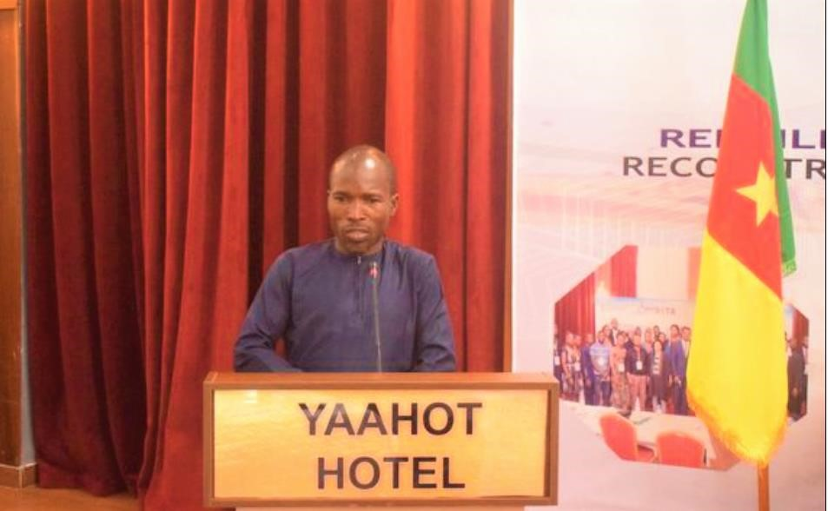

Picture 1: Opening ceremony of the first phase of the training 22 – 24 February 2023 by the representative of the Minister of Youth Affairs and Civic Education

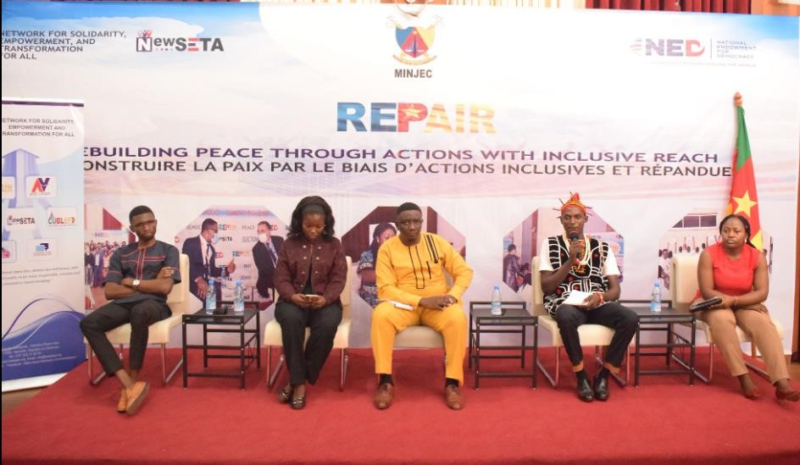

Picture 2 : Panel Discussion with some youths sharing their experiences on community engagements in fostering peacebuilding efforts

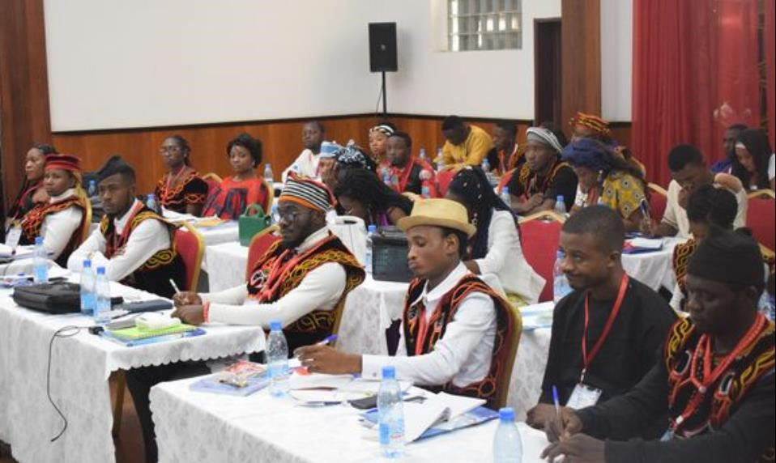

Picture 3: Photo of the 40 participants from the 10 Regions of Cameroon in their respective traditional regalia representing the cultural diversity of the country.

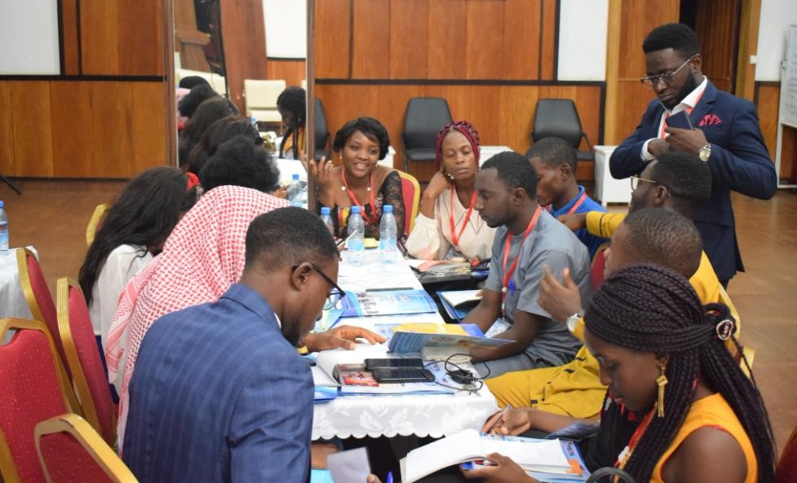

Picture 4: Break out session of the participants during the training.

## APPENDIX II : SECOND PHASE OF THE REPAIR TRAINING, AFTER PARTICIPANTS IMPLEMENTED THEIR COMMUNITY ENGAGEMENT PROJECTS (JUNE 19 – 21, 2023), DAY 1 :

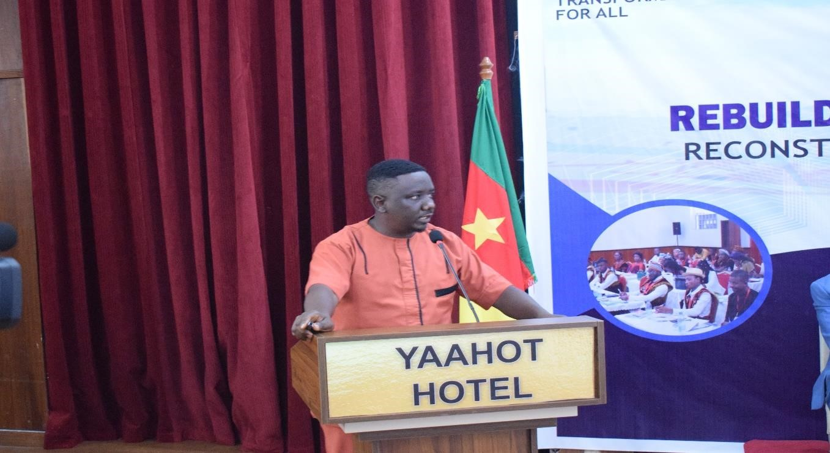

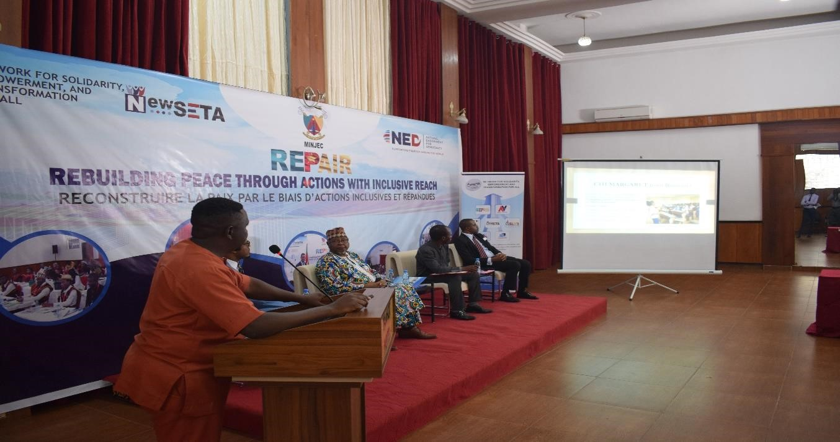

Pictures 1& 2: Ongoing projection of participants’ community engagement projects at the opening ceremony of the second phase of the training, in front of invitees and participants.

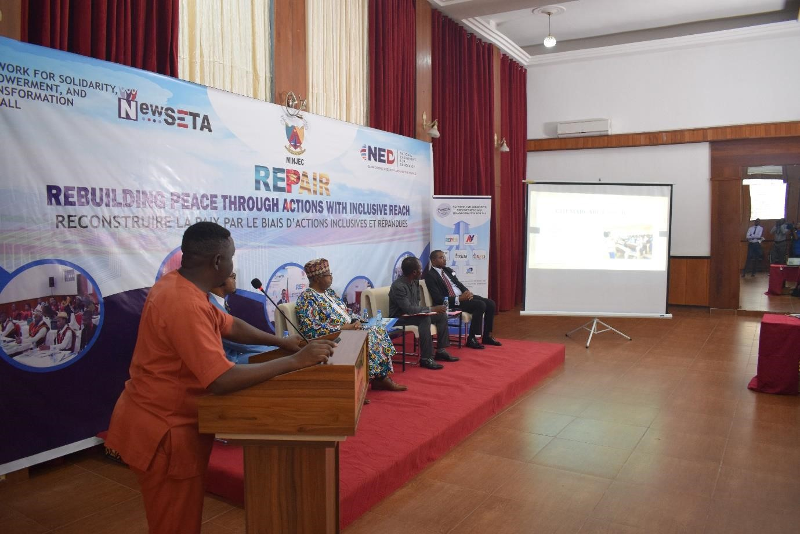

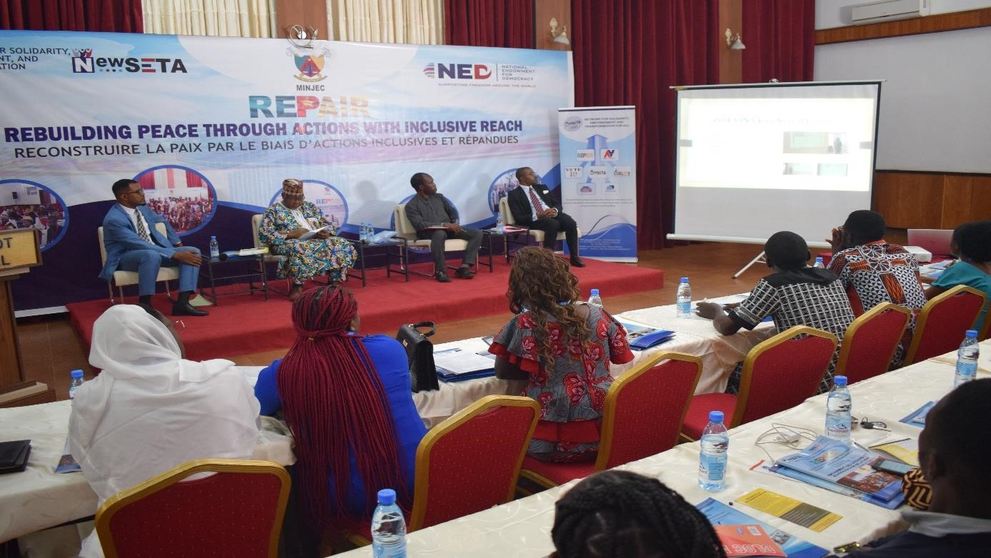

Pictures 3 & 4: Continuation of pictures of the opening ceremony.

## APPENDIX III: DAY 2: PHOTOS SHOWING MY PRESENTATION ON THE THEME “UNDERSTANDING THE EIGHT (8) PILLARS OF POSITIVE PEACE.

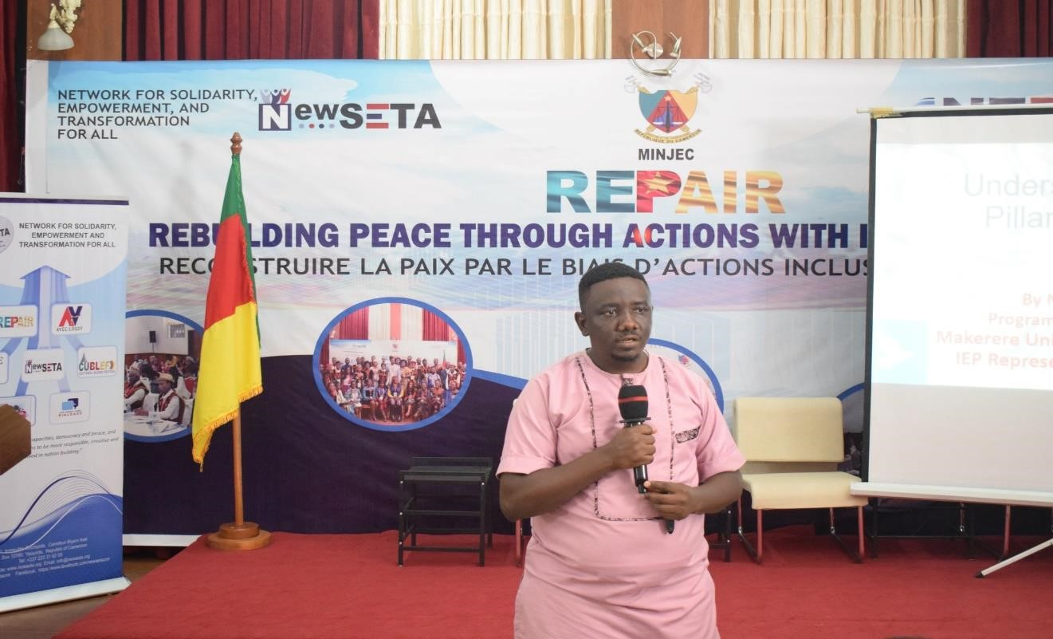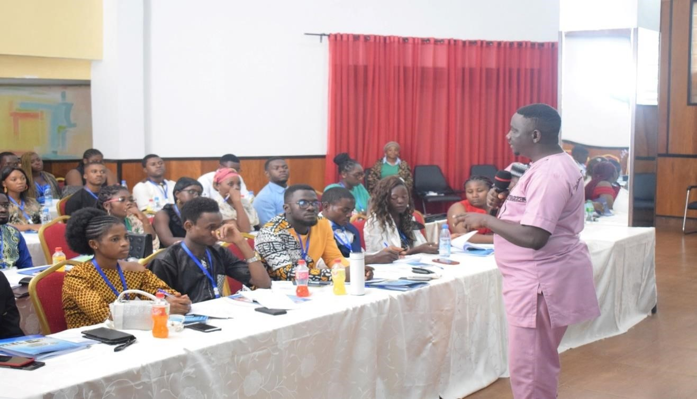

Pictures 1&2: My presentation on the theme “Understanding the eight pillars of Positive Peace”

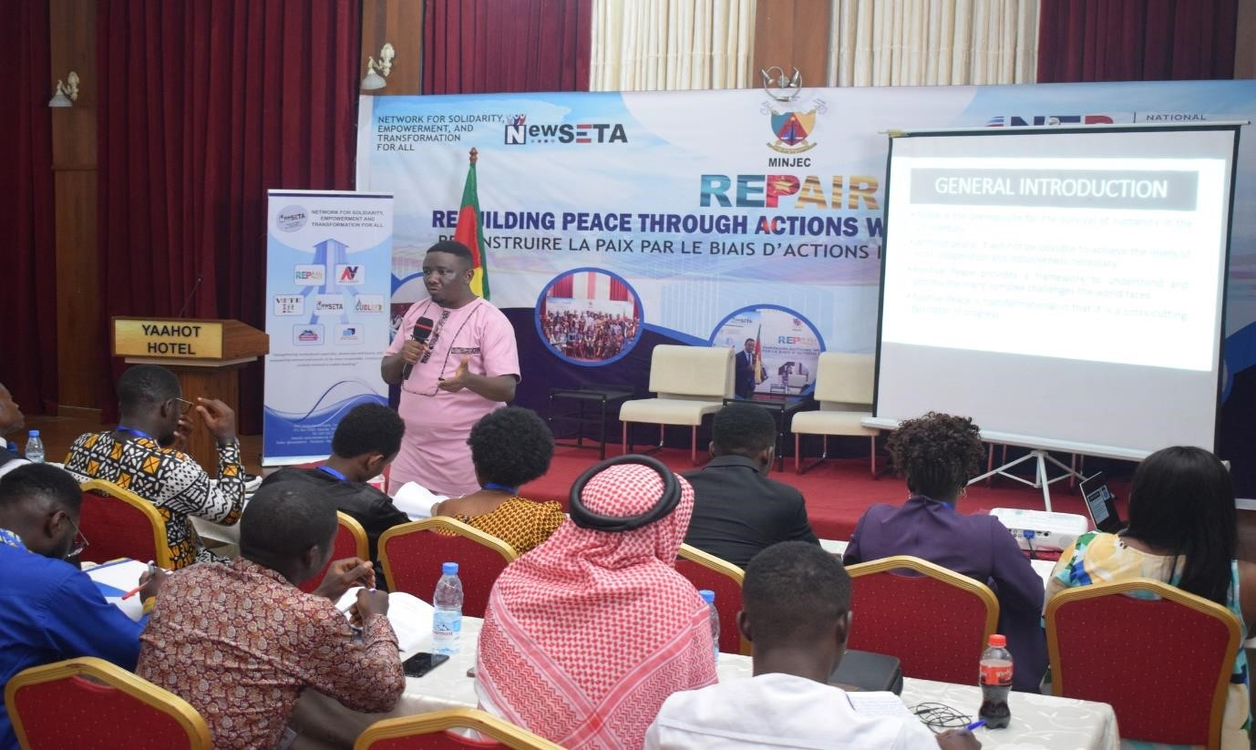

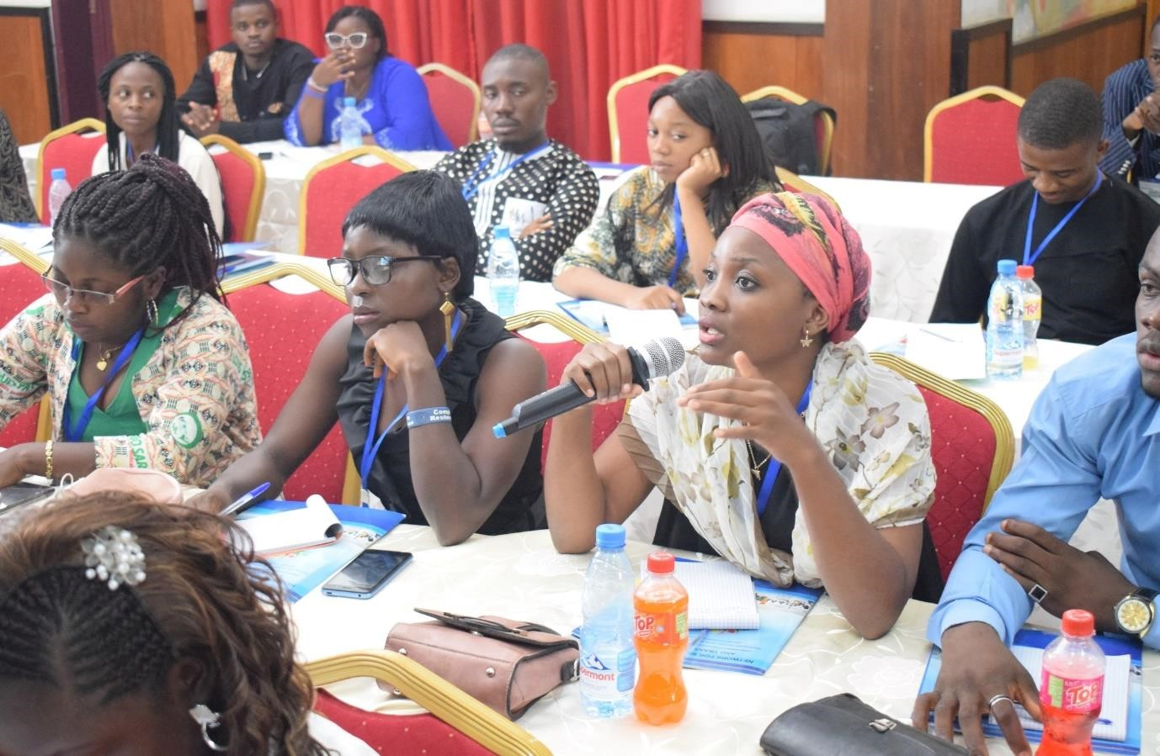

Pictures 3&4: Continuation of pictures of my presentation on positive peace – engagement of participants.

## APPENDIX IV : FIELD VISIT TO THE MINISTRY OF YOUTH AFFAIRS AND CIVIC EDUCATION, AND ITS DECENTRALIZED STRUCTURES.

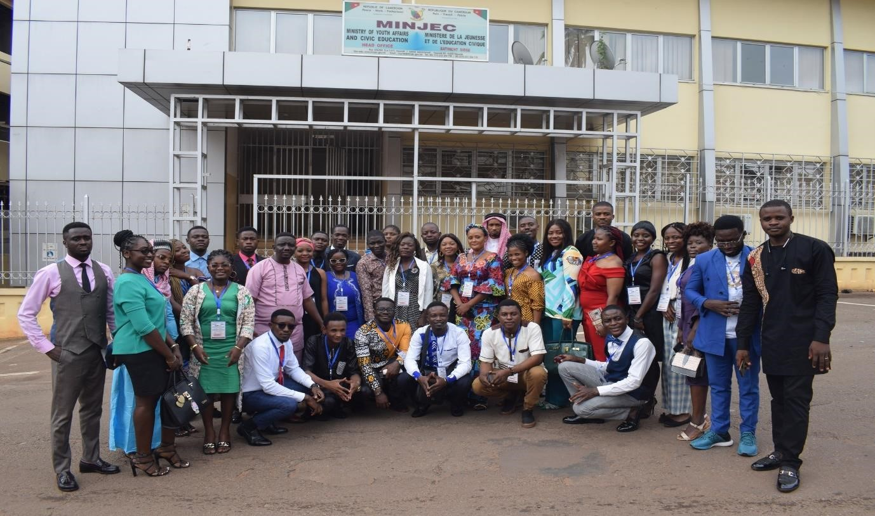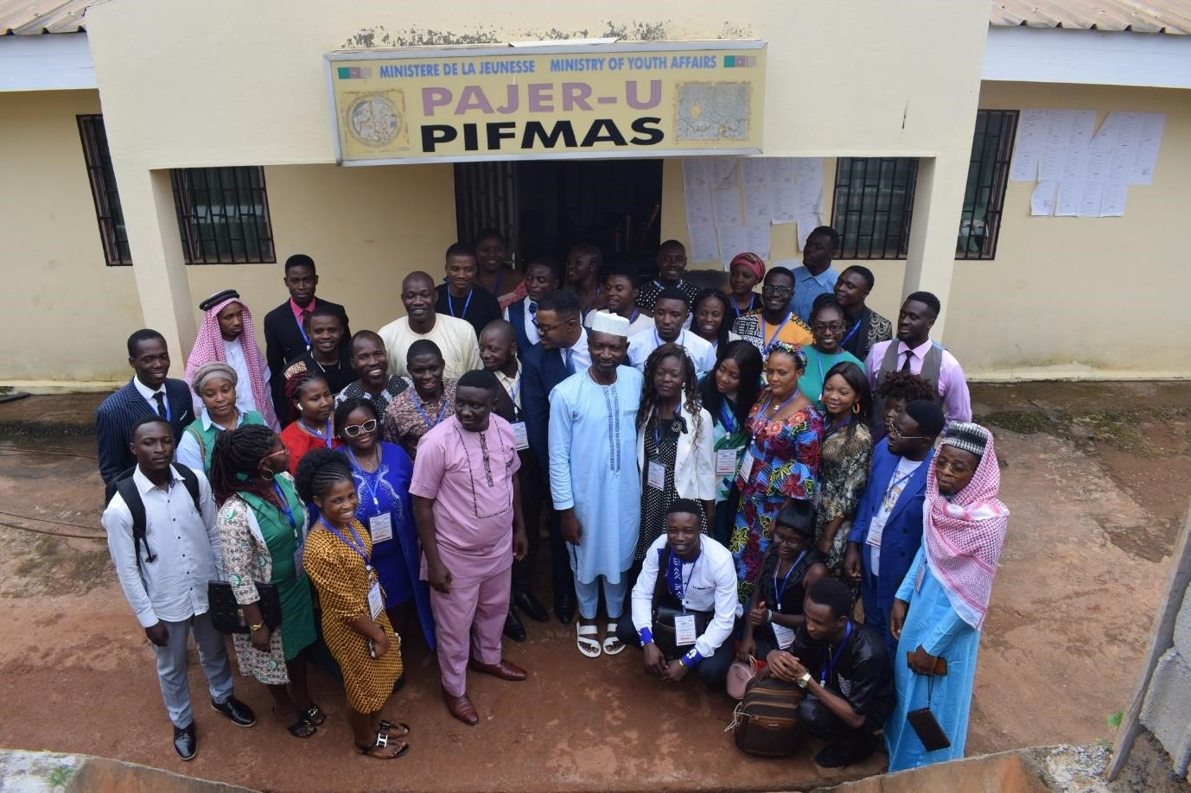

## APPENDIX V : DAY 3 ; SHOWING A PANEL DISCUSSION ON THE THEME

## “WHY YOUTH PARTICIPATION IN PEACEBUILDING MATTERS”

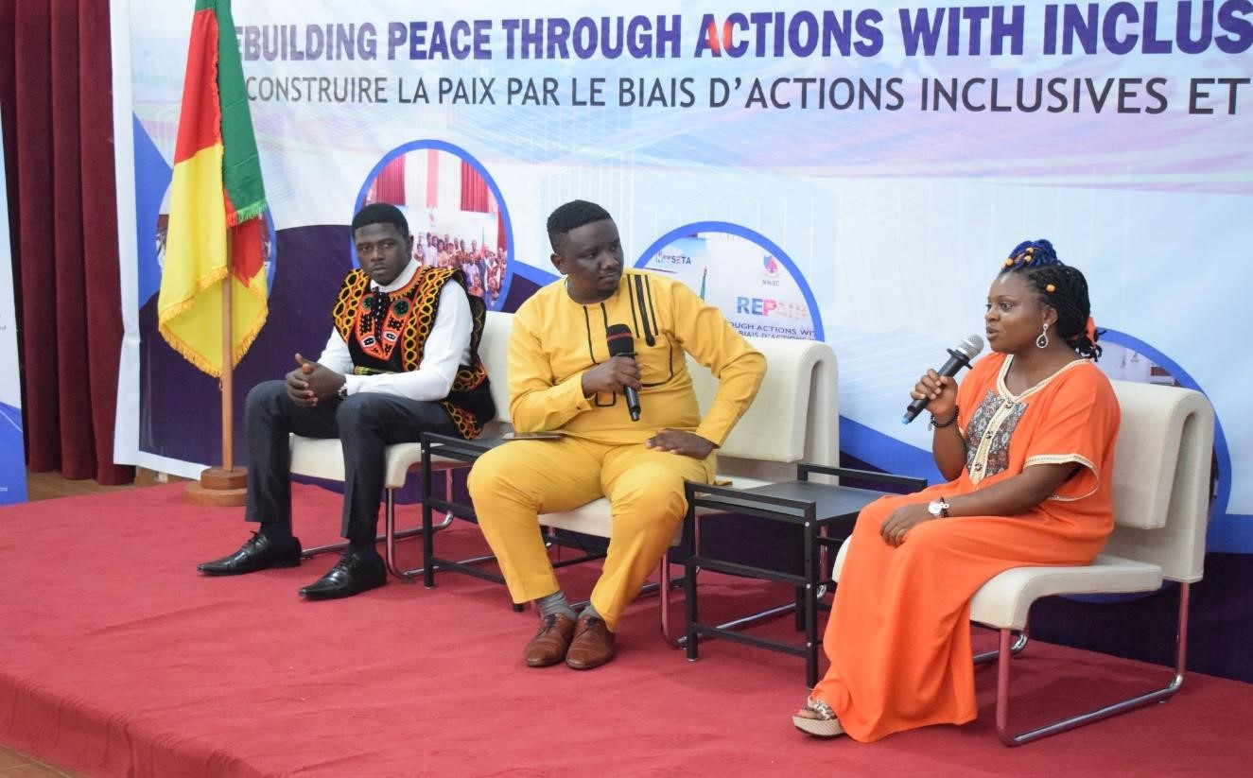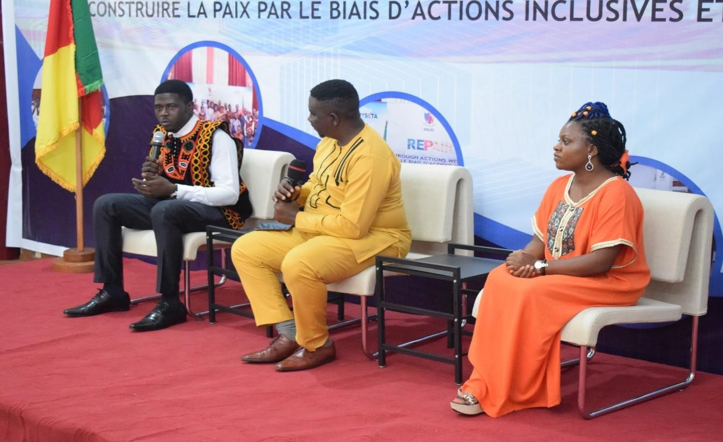

## APPENDIX VI : SCANNED AUTHORIZATION LETTER FROM THE DIVISIONAL

## OFFICER. NOTE THAT THE CONTENT OF THE LETTER IS IN FRENCH

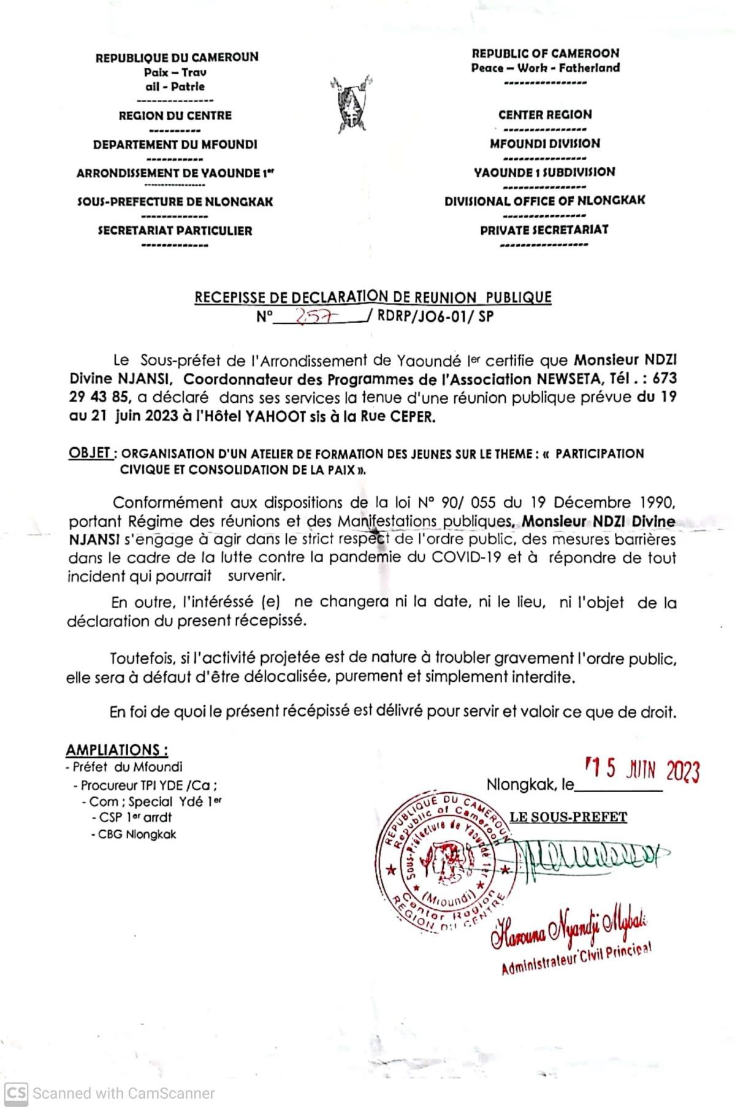

## APPENDIX VII : TRANSLATION OF THE AUTHORIZATION LETTER OF THE DIVISIONAL OFFICER ABOVE, FROM FRENCH TO ENGLISH.

**RECEIPT DECLARING A PUBLIC MANIFESTATION**

**No 257/RDRP/JO6-01/SP**

The Divisional Officer of the Yaounde 1 district certifies that **Mr NDZI DIVINE NJAMSI, Program Coordinator of the association NEWSETA, Tel : 673-29-43-85,** has declared in his services the holding of a public meeting scheduled for the **19 – 21st June 2023 at YAAHOT Hotel located at Rue Cepper.**

**PURPOSE : ORGANIZATION OF A YOUTH CAPACITY BUILDING WORKSHOP UNDER THE THEME « CIVIC ENGAGEMENT AND PEACEBUILDING »**

In accordance with the dispositions of the law no 90/055 of 19 December 1990, regulating the holdings of public gatherings, **Mr NDZI DIVINE NJAMSI** commits to act within the strict respect of public order, the measures put in place for the fight against the COVID-19 pandemic and will be held accountable for any unforseen incident that may occur.

Further, the beneficiary will not change the date, the venue nor the purpose of this receipt of declaration.

However, if the activity is projected to seriously disturb public order, its location shall not only be changed, it will also be cancelled.

In case of need, this present declaration receipt shall serve the purpose for which it was issued.

Signed on June 15, 2023

The Divisional Officer

Copies to :

Senior Divisional Officer of the Mfoundi Division

Prosecutor of the Yaounde High Court

Yaounde 1 Special Police Station

Yaounde 1 Police Station

Gendarmerie Brigade of Nlongkak

1. Galtung, J. (1976). *Three Approaches to Peace: Peacekeeping, Peacemaking and Peacebuilding* 2 Galtung, J. (2005). *Meeting basic needs: peace and development*; American Psychological Association, Washington, DC.
2. Leshem, O. A., & Halperin, E. (2020). *Lay theories of peace and their influence on policy preference during violent conflict,* National Academy of Sciences of the United States of America.
3. <https://www.visionofhumanity.org/introducing-the-concept-of-peace/>accessed on June 29, 2023 at 13:18. 5 Dennis J.D. Sandole et al; *Handbook of Conflict Analysis and Resolution,* Published October 29, 2010 by Routledge.
4. https://www.hippocampus.org/homework-help/American-

   Government/Constitutional+Beginnings_Theories+of+Democracy.html
5. Section 45 of the Electoral Code of Cameroon, 2018.
6. Constitution of the Republic of Cameroon and Section 117 of the Electoral Code of Cameroon, 2018.
7. Section 124 of the Electoral code of Cameroon, 2018.
8. Section 122 of the Electoral Code of Cameroon, 2018.
9. Section 80 (2) of the Penal Code of Cameroon
10. Ndille Raymond (2021) ‘Disability and Education in Cameroon: A Living Theory Perspective and Its Implications’.
11. Sight Savers : Cameroon Political Participation Study, November 2022.