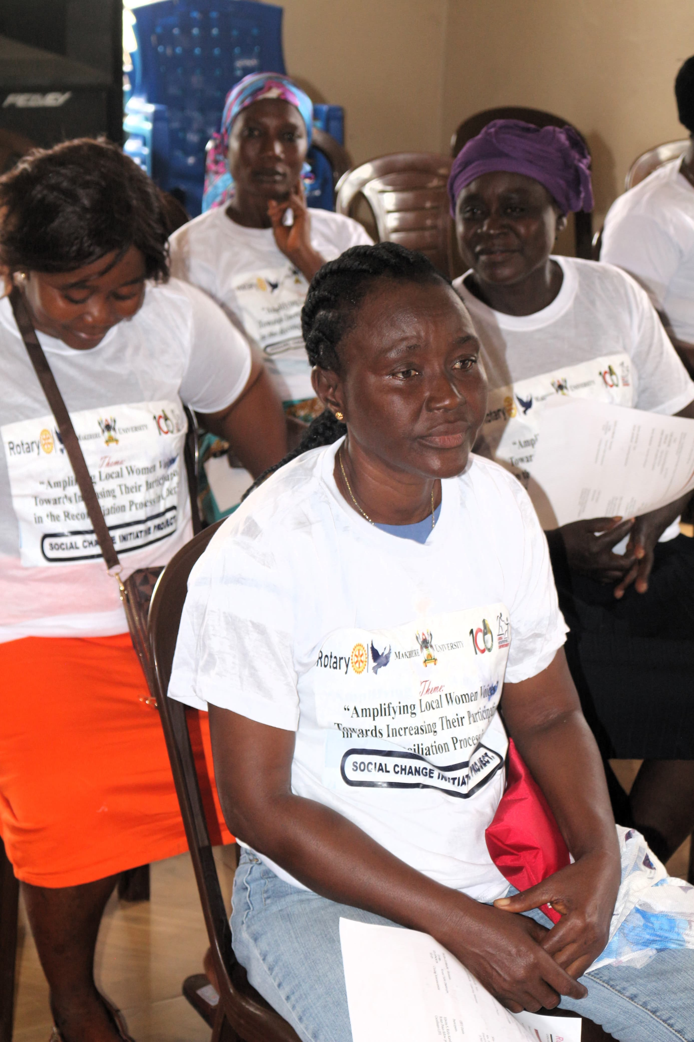

SOCIAL CHANGE INITIATIVE IMPLEMENTATION REPORT

TITLE: “AMPLIFING LOCAL WOMEN VOICE: TOWARD INCREASING THEIR” PARTICIPATION IN THE RECONCILIATION PROCESS IN LIBERIA
Location: Montserrado, Liberia
February 2024 - August 2024
Abstracts /Summary:

Since the end of its second civil war in 2003, Liberia has made great strides in building peace and establishing democracy. Yet, the country keeps grappling with its reconciliation process that remains flawed with regard to both pace and inclusion until today. The recent 2023 election was highly polarized and further divided the country, with the opposition party winning by just 20,000 votes. Low levels of women and youth engagement in the reconciliation process has put the sustainability and credibility of reconciliation at risk in Liberia. This is particularly true when considering women's marginalization. In spite of the key role, they played in terminating the civil war back in 2003, Liberian women have by and large failed to take an active role in the country's male-dominated reconciliation process. population and both identify and addresses the root causes of the country's violent past. Any attempt to strengthen reconciliation in Liberia must hence necessarily empower women to finally take a more active role in this process and raise their voice with regard to local issues that torpedo efforts to reconcile Liberia's population.
Against this background, I undertook a project which focused on strengthening women’s participation in Liberia's Liberia peace building plan. The project targets Montserrado County. Against this background, I undertook a project which focused on strengthening women’s participation in Liberia's Liberia peace building plan. The project targets Montserrado County.
CHAPTER ONE
Introduction and Background:
The Liberian conflict, which started in December 1989, brought brothers and sisters, formerly living together in peace, against one another. The wars left deep scars on the Liberian society, including severe gender-based violence, displacement, and the disintegration of social and political structures the conflict lasted for more than two decades and witness a number of brutal atrocities perpetrated by all sides.
During the civil conflict, Liberian women were subjected to countless numbers of sexual abuses and exploitation. The World Health Organization in its 2002 World Report on Sexual Violence estimated that between 61% and 77% of women and girls in Liberia were raped during the war. The main causes of the first conflict can be attributed to deprivation of needs, ethnicity, political marginalization, corruption and human rights violations.
Liberia's journey toward peace and stability has been arduous, marked by two devastating civil wars that profoundly impacted its society. As the nation transitions from conflict to peace, the reconciliation process remains a critical element in healing and rebuilding its fractured communities. Despite significant progress, the process of reconciliation has often been undermined by inadequate inclusivity, particularly concerning women
Although Liberians acknowledge that gains have been made in reconciliation and healing, the vast majority believe that reconciliation in Liberia is incomplete. Since the end of the civil
war, Liberians have successfully carried out four peaceful democratic elections, which restored a measure of confidence in the institutions of government and proved that differences can be
resolved through peaceful political competition at the polls. One of the main challenges is how to address the issue of reconciliation as a means of consolidating peace. The war trauma is still fresh, and the historical and systemic drivers that fuelled the war are still present. Reconciliation did not reach deeply and widely enough to rebuild the torn relationships within
and between ethno-regional groups The lack of genuine and inclusive reconciliation in Liberia has been cited as a source of future conflict.
Since the end of the conflict in 2003, the Government of Liberia has undertaken a number of efforts to trigger reconciliation and consolidate peace. A Truth and Reconciliation Commission (TRC) was set up in 2005 to promote reconciliation” by investigating gross human rights violations and violations of humanitarian law, sexual violations, and economic crimes The TRC presented its final report to the Government of Liberia but unfortunately, most of these recommendations have not been Acted upon.
In 2013, A Strategic Roadmap for National Healing, Peacebuilding, and Reconciliation was adopted by the Government of Liberia and its international partners. The Strategic Road Map laid out the alternative dispute resolution system known as the Palava Hut system, an elder-led, indigenous, and non-adversarial process widely used in rural Liberia to resolve disputes. However, its effectiveness is undermined by insufficient resources, lack of coordination, and a predominantly patriarchal structure. Women and youth are rarely represented and remain unable to voice their grievances or substantively participate in Palava Hut processes. The current system favors decisions made by a consensus of elders continuing to fuel a sense of marginalization and exclusion. Restoring damaged social relationships and addressing the legacy of the conflict is critical to peace and reconciliation, without which Liberia’s status as a fragile state will continue to loom large.

The UN Security Council Resolution 2333 (2016) actively encourages the Government of Liberia to “prioritize national reconciliation” in an effort to spur economic recovery and promote good governance, while simultaneously strengthening transparency and accountability, as well as ensuring the participation of women and youth in conflict prevention, conflict resolution and peacebuilding.

The lack of substantive engagement with key target groups, including women, in the consultation over the post-conflict reconciliation plan’s development has helped to hinder long-term sustainability thus far though. A grassroots peacebuilding approach that actively engages women and other marginalized segments of the Liberian population and builds bridges between citizens, local authorities, and national government to collaboratively identify the root causes of conflicts in Liberia as well as generate recommendations on how to mitigate them is thus the most promising way ahead to achieve the full implementation of Liberia's 2003 CPA and its 2017 Peacebuilding Plan. Amplifying women’s participation in Liberia's reconciliation process is not only a matter of justice but also a strategic necessity for ensuring lasting peace and social cohesion
Problem Statement:
Liberia's reconciliation process, crucial for healing the deep wounds inflicted by its prolonged civil conflicts, remains significantly flawed in terms of inclusivity, particularly regarding women’s participation. Despite women’s pivotal role in ending the civil wars and their active involvement in grassroots peacebuilding efforts, their representation in formal reconciliation mechanisms has been minimal. This exclusion undermines the effectiveness of reconciliation initiatives and perpetuates gender inequalities, impeding genuine social cohesion and national healing.
The 2003 Comprehensive Peace Agreement (CPA) and the subsequent 2017 Peacebuilding Plan (LPP) aimed to address these issues by promoting inclusive processes. However, both have fallen short in integrating women’s voices into their frameworks. Women in Liberia continue to face systemic barriers to participation, including cultural norms, lack of representation in decision-making bodies, and security concerns. These barriers not only limit women’s contributions to the reconciliation process but also fail to address the gender-specific impacts of conflict, such as sexual violence and economic marginalization.
Previous attempts to enhance women's role in Liberia's reconciliation process have remained largely unsuccessful. There is broad consensus that reconciliation will only succeed if the entire population feels represented by the process and can express their opinion about the issues that Liberia needs to address to sustain peace. This is particularly true in case of the women who denote for 50% of the population and have a rich knowledge on local threats that undermine reconciliation
Goals and Objectives:

The project helps to reenergize Liberia’s reconciliation process. It contributes to improving women’s participation in peace building activities. It is grassroots peacebuilding approach that actively engages women and other local stakeholders and builds bridges between women and local authorities, to collaboratively identify the obstacles to women’s participation in reconciliation and peacebuilding processes as well as generate recommendations on how to mitigate them. The project aims to promote an inclusive reconciliation process and support the Liberia Peacebuilding plan.

The project sought to promote an inclusive reconciliation process and support the Liberia peacebuilding plan.

The primary goal of this project is to enhance women’s capacity and agency within Liberia's political, civic, and mediation spaces, fostering a more conducive environment for their leadership and participation. This involves addressing and transforming perceptions and norms
that hinder women’s involvement in the reconciliation process. The overarching objectives are to ensure their inclusion, promote gender equality and empowerment, address women-specific issues, build sustainable peace, and strengthen democracy and governance.
1. Inclusion and Representation: The objective is to ensure that women’s voices, perspectives, and experiences are integral to the reconciliation process. Women constitute a significant portion of the population and possess unique insights into the conflict’s impact on their lives. Including their perspectives will ensure a more comprehensive and inclusive reconciliation effort, reflecting the diverse experiences and needs of the population.
2. Gender Equality and Empowerment: This aim focuses on promoting gender equality and empowering women in post-conflict Liberia. By challenging traditional gender roles and norms, the initiative seeks to encourage women’s active involvement in decision-making processes. Empowering women through their participation in reconciliation will contribute to their overall socio-political and economic advancement, fostering a more equitable society.
3. Addressing Women-Specific Issues: The goal here is to address the specific challenges faced by women during and after the conflict, such as gender-based violence, displacement, and economic marginalization. Women’s active participation in reconciliation will help ensure that these issues are highlighted and addressed, leading to more effective and targeted support for their needs in the reconstruction and reconciliation phases.
4. Building Sustainable Peace: This objective is to contribute to the establishment of lasting peace in Liberia. Research indicates that women’s involvement in peace processes enhances the likelihood of reaching durable agreements and reduces the risk of conflict relapse. By bringing diverse perspectives and approaches, women’s participation will support social cohesion, reconciliation, and long-term stability.
5. Strengthening Democracy and Governance: The aim is to fortify democratic processes and governance structures in Liberia. Women’s participation in the reconciliation process will promote democratic values such as inclusivity, transparency, and accountability. This will help create a more representative and participatory democracy, where women have equal opportunities to influence decision-making and policy formulation.
Challenges and mitigation strategies:
Challenges
1. Cultural and Social Barriers: Deep-rooted patriarchal norms and cultural practices in Liberia often limit women’s public and political roles. Traditional views on gender roles can undermine efforts to include women in the reconciliation process, reinforcing their marginalization and reducing their influence.
2. Limited Representation and Resources: Women’s underrepresentation in formal reconciliation bodies and decision-making platforms is a significant barrier. Additionally, the lack of resources and support mechanisms can constrain women’s ability to participate effectively and sustain their involvement.
3. Security Concerns: In post-conflict settings, security issues disproportionately affect women, making it difficult for them to engage in reconciliation activities. The threat of violence and instability can deter women from participating or undermine their contributions.
4. Lack of funds
5. Sustainability
Mitigation Strategies:
1. Addressing Cultural and Social Barriers:

Some men believe that women should not bother about politics and reconciliation and actively sought to undermine women's participation in the reconciliation and peacebuilding processes accordingly and tied to prevent some community's female members' participation in the meetings

To address this, we publicly announced beforehand the various activities, including a description of the purpose of these events. Secondly, men were invited to attend an introductory session on the reconciliation process and why women's participation is crucial to achieve sustainable peace in Liberia on- Engaging community leaders and influencers can help shift cultural perceptions and support women’s roles in reconciliation.
2. Enhancing Representation and Resources:
- Policy Interventions: Advocate for policies that ensure women’s representation in formal reconciliation bodies and decision-making processes. Establishing quotas or mandates for women’s participation can help address their underrepresentation.
- Capacity Building: Provide training and capacity-building programs to empower women with the skills and knowledge needed for effective participation. This includes leadership training, negotiation skills, and conflict resolution techniques.
4. Funding Constraint:
Two critical challenges that faced the project was the lack of funds. To alleviate this challenge, we worked with the Liberia Initiative for Empowerment (LIFE)
5. Sustainability
This challenge was addressed through our engagement with targeted local actors. We worked carefully with local CSO and CBO partners to develop local Women Network for Peace and Security. By addressing these challenges with targeted strategies, we were able to implement the project.
CHAPTER 2
Literature Review:
Introduction:
Liberia, a West African nation, has experienced profound political and social turmoil due to prolonged civil conflicts. The reconciliation process, crucial for healing and rebuilding the nation, has historically marginalized women. However, the inclusion of women is essential for a more comprehensive and effective reconciliation. This literature review explores the significance of amplifying women's participation in Liberia's reconciliation process, examining existing research, theoretical frameworks, and practical implications.
Historical Context and Theoretical Framework:
Liberia's civil wars, spanning from 1989 to 2003, left deep scars on its society. The wars disproportionately affected women, who faced sexual violence, displacement, and loss of livelihoods. The aftermath of such conflicts necessitates a reconciliation process that acknowledges and addresses the specific needs and contributions of women.
The theoretical framework for this review is grounded in feminist theory and conflict resolution theories. Feminist theory emphasizes the importance of including women’s voices in all aspects of societal reconstruction, arguing that women's experiences and perspectives are crucial for a just and equitable peace. Conflict resolution theories support this by highlighting that inclusive processes lead to more sustainable and effective peace outcomes (Rehn & Johnson-Sirleaf, 2002; Enloe, 2014).
Importance of Women’s Participation
1. Inclusive Peacebuilding:
Research shows that women's participation in peacebuilding and reconciliation enhances the overall effectiveness of these processes. According to the UN Women’s report (2015), women bring unique perspectives and solutions to conflict resolution, often focusing on social justice, community healing, and long-term stability. In Liberia, women’s involvement has been pivotal in peacebuilding efforts, exemplified by the roles played by the Women of Liberia Mass Action for Peace during the civil war (Johnson-Sirleaf, 2007).
The importance of women's participation in the peace-building process cannot be overstated. Evidence shows that women's involvement in peace processes globally contributes to more sustainable and inclusive outcomes. According to a UN Women study, peace agreements are 35% more likely to last at least 15 years if women are involved in their creation.
2. Enhanced Social Cohesion:
Women’s inclusion in reconciliation processes contributes to social cohesion. Studies indicate that women often act as mediators and facilitators of dialogue, bridging gaps between different community groups (Kravetz, 2013). In Liberia, women's participation in local peace committees and reconciliation meetings has been shown to foster better intergroup relations and promote collective healing (Gbowee, 2011).
3. Addressing Gender-Specific Issues
The reconciliation process must address gender-specific issues such as sexual violence, displacement, and economic marginalization. Women are often disproportionately affected by these issues, and their inclusion in decision-making ensures that these concerns are adequately addressed (UN Women, 2014). Research by the International Crisis Group (2013) highlights that gender-sensitive approaches in reconciliation processes lead to more equitable outcomes and support women’s empowerment.
Challenges to Women’s Participation:
Despite the recognized benefits, women’s participation in Liberia’s reconciliation process faces several challenges:
1. Cultural and Social Barriers
Deep-seated cultural norms and social practices often limit women’s roles in public and political spheres. In Liberia, traditional gender roles and patriarchal structures hinder women from fully participating in reconciliation processes (Moran, 2015). This cultural resistance requires concerted efforts to challenge and change entrenched norms.
2. Limited Representation and Resources
Women’s representation in formal peace and reconciliation bodies remains limited. The lack of adequate resources and support mechanisms further constrains their ability to participate effectively. Studies by the Women’s Rights International (2016) indicate that without sufficient resources, women’s contributions are often marginalized or overlooked.
3. Security Concerns
In post-conflict environments, security concerns can disproportionately affect women, making it difficult for them to engage in reconciliation activities. The ongoing threat of violence and instability can deter women from participating or undermine their contributions (Dolan, 2014).
Strategies to Amplify Women’s Participation
1. Policy and Institutional Support:
To enhance women’s participation, it is crucial to develop policies that support their involvement. This includes creating frameworks that ensure women’s representation in reconciliation bodies and decision-making processes. The implementation of quotas and gender-sensitive policies can help address the underrepresentation of women (UNSCR 1325, 2000).
2. Capacity Building and Training:
Investing in capacity building and training for women is essential for their effective participation. Programs that enhance women’s skills in negotiation, leadership, and conflict resolution can empower them to take active roles in reconciliation (O’Reilly, 2013). Providing education and training opportunities can help overcome some of the barriers faced by women.
3. Community Engagement and Advocacy:
Engaging communities in supporting women’s roles in reconciliation processes is vital. Advocacy efforts that challenge traditional gender norms and promote women’s contributions can foster a more inclusive environment. Grassroots organizations and local leaders play a key role in these advocacy efforts (Gbowee, 2011).
Theoretical Underpinnings:
1. Feminist Theory
Feminist theory provides a crucial framework for understanding and addressing the issues related to women’s participation in reconciliation processes. It emphasizes the importance of including women’s perspectives and experiences in all aspects of societal reconstruction. This theory critiques traditional power structures and norms that perpetuate gender inequality and exclusion. In the context of Liberia’s reconciliation process, feminist theory advocates for structural changes that ensure women’s voices are integrated into decision-making and policy formulation. By challenging patriarchal norms and promoting gender equity, feminist theory supports the creation of inclusive platforms where women can contribute effectively to peacebuilding and reconciliation (Tong, 2009).
2. Conflict Resolution Theory
Conflict resolution theory, particularly its focus on inclusive and participatory approaches, is instrumental in addressing the challenges of women’s participation in reconciliation processes. This theory underscores the importance of involving all stakeholders, including marginalized groups, in conflict resolution to achieve sustainable outcomes. Theories such as the "Integrated Approach" to peacebuilding emphasize that the inclusion of diverse perspectives, including those of women, leads to more comprehensive and effective solutions to conflicts. In Liberia, applying conflict resolution theory involves ensuring that women are not only represented but actively engaged in designing and implementing reconciliation strategies (Miller & Miedema, 2020).
3. Human Rights Framework
The human rights framework highlights the fundamental rights of women to participate in political and public life, including in reconciliation processes. This framework asserts that gender equality and women’s empowerment are central to achieving justice and peace. International instruments such as the Convention on the Elimination of All Forms of Discrimination Against Women (CEDAW) and United Nations Security Council Resolution 1325 on Women, Peace, and Security provide normative guidelines for promoting women’s participation. These frameworks advocate for legal and policy reforms to eliminate barriers and ensure that women’s rights are upheld throughout the reconciliation process (UN Women, 2014).
4. Social Capital Theory
Social capital theory, which focuses on the value of social networks and relationships in facilitating collective action, is relevant for enhancing women’s participation in reconciliation. This theory posits that strong social networks and connections can empower individuals and groups, including women, to engage more effectively in public processes. In Liberia, building social capital involves creating networks of support and collaboration among women and between women and other community stakeholders. Strengthening these networks can help

women overcome barriers to participation and amplify their voices in reconciliation efforts (Putnam, 2000).
5. Transformative Justice Theory
Transformative justice theory emphasizes addressing the root causes of conflict and inequality to achieve lasting peace and social justice. Unlike traditional justice models that focus solely on punitive measures, transformative justice seeks to transform underlying structures and relationships that perpetuate violence and inequality. In Liberia’s reconciliation process, this theory supports the inclusion of women as agents of change who can address both the symptoms and root causes of conflict. By involving women in the design and implementation of reconciliation measures, transformative justice theory aims to create more equitable and sustainable outcomes (Zehr, 2002).
These theoretical frameworks—feminist theory, conflict resolution theory, human rights framework, social capital theory, and transformative justice theory—provide a comprehensive basis for addressing the challenges of amplifying women’s participation in Liberia’s reconciliation process. They collectively advocate for inclusive, equitable, and effective approaches to ensure that women’s voices and contributions are integral to achieving lasting peace and stability in Liberia.
THEORY OF CHANGE
The Liberia Strategic Roadmap for National Healing, Peace-building and Reconciliation defines reconciliation in Liberia as 'a multidimensional process of overcoming social, political, and religious cleavages; mending and transforming relationships; healing the physical and psychological wounds from the civil war, as well as confronting and addressing historical wrongs including the structural root causes of conflicts in Liberia’. It outlines responsibilities for key government actors, working closely work with civil society, to deliver on a programmatic framework for its implementation around three themes: accounting for the past; managing the present; and planning for the future

Although Liberians acknowledge that gains have been made in reconciliation and healing, the vast majority believe that reconciliation in Liberia is incomplete. Since the end of the civil war, Liberians have successfully carried out four peaceful democratic elections, which restored a measure of confidence in the institutions of government and proved that differences can be resolved through peaceful political competition at the polls. One of the main challenges is how to address the issue of reconciliation as a means of consolidating peace. The war trauma is still fresh, and the historical and systemic drivers that fuelled the war are still present. Reconciliation did not reach deeply and widely enough to rebuild the torn relationships within

and between ethno-regional groups. The lack of genuine and inclusive reconciliation in Liberia has been cited as a source of future conflict.

Abject poverty, ethnic divides, tribalism and increasing dissatisfaction with the central government nurture grievances and dissatisfaction which have the potential to escalate rapidly. With the 2023 presidential elections been closely contested, the risk of intra- and inter-community violence is increasing over the upcoming months. An inclusive reconciliation process that identifies and tackles the root causes of Liberia's violent past is therefore regarded as the key to make the country and its population more resilient to all sorts of different crises which are currently looming.

Our project sought to support local women to develop strategies and good practices to overcome the previously identified barriers to their participation in the reconciliation process. It was underpinned by the theory of change that if key women actors are providing with the necessary capacity building trainings, they will better understand and appreciate their mutual values, and thus be better able to work towards their common goals, resulting in a more inclusive reconciliation process that takes into account the needs and interests of women.

The project change of theory approach is based on a people-to-people strategy, bringing together local women from diverse to discuss and overcome their differences and identify joint interests, in order to move forward together. It sought to equip women leaders with skills to leverage the positive relationships with local communities to promote collaboration and achieve tangible results.
METHOD AND DESIGN
The project supports the UN-Security Council Resolution 1325 on Women, Peace and Security The project was implemented in collaboration with the Liberia Initiative for Empowerment (LIFE). LIFE is a women-led, not for profit organization that facilitates the empowerment of women, girls and children through skills training, advocacy and sustainable livelihood initiatives. LIFE’s roles included to impartially facilitate and manage the project; and to assess risks, challenges and respond, adjust the project activities and partnership in a timely and conflict sensitive manner.

Dialogues were the major platform that was utilized to accomplish the proposed objectives, bring diverse stakeholders together and lay the foundation for a sustainable and widely shared reconciliation agenda. This approach shifts the interactions between groups with differing opinions, providing the necessary tools to create win-win scenarios and avoid zero-sum thinking. Through this approach, the project broke down barriers to communication, and create opportunities for collaboration at multiple levels. It created and reinforces impartial venues to convene women leaders and actors across dividing lines in a safe space for effective problem-solving.
The project team worked to the project integrate the ‘Do No Harm’ principles at all levels. First, it carefully mapped all actors that have a stake in the project, through a participatory and inclusive lens. Then, the team developed a roadmap to engage key stakeholders in the activities and to encourage them to collaborate, taking special consideration of barriers to participation,

security risks, and potential harmful consequences of any activity. The project was guided by the integration of conflict sensitivity at all stages of the program management cycle: 1) an inclusive and participatory design process; 2) a conflict sensitive planning and quality programming; 3) integrating reflective practices and managing risks; and 4) learning and accountability to program participants, partners, donors and the peace-building community.
Throughout each activity, we took careful consideration of the target location, timing, and visibility.

CHAPTER THREE

INTERVENTION AND ACTIVITIES:
The project was implemented in a total of 5 communities across Montserrado County and consisted of two interventions within each participating community. Each activity was monitored to ensure that the realization of the project objectives. Before the official commencement of the project, the project team undertook a number of strategic engagements with key stakeholders, including UN women, the Peace Building Office (PBO) –, Ministry of Internal Affairs, Office of the Peace Ambassador, the Superintendent of Montserrado County and the Women's NGO Secretariat of Liberia (WONGOSOL)
These institutions are crucial to reconciliation and women participation the consultations provided the platform to get their buy in into the project. – WONGOSOL has accompanied and shaped Liberia's reconciliation process since 2003. It played an active role in the LTRC and has sought to fight discrimination against women at all levels of society. Their knowledge about women organizations in Liberia helped the Project Team to identify communities where reconciliation is particularly male-dominated, PBO is the government body who developed the 2013 Strategic Roadmap for Healing, Peacebuilding and Reconciliation in Liberia. It is thus a core actor in Liberia's reconciliation process. The project team will discuss with the PBO about the final outcome in order to maximize the latter's impact.
The project team identified three local professional facilitators from the local CSOs with excellent communication and negotiation skills, and excellent knowledge of the local dynamics to facilitate the training and dialogues/

MONITORING AND EVALUATION
The project team was committed to maximizing programmatic success through integrated monitoring systems, reflective learning, and participatory methods that build on and contribute to lessons learned and best practices. At the start of the project, the team established an M&E system that provided its team with a framework for contextual monitoring with special attention to assumptions, program activity and results tracking, testing the theories of change hypotheses, and measuring program impact. The Project Team worked to ensure that program staff and partners are regularly informed on how conflict dynamics are evolving and project activity impact.

Each of the activities will have its own quality controls: pre and post-test questionnaires to measure knowledge change for each of activities; rapid feedback tools for dialogue initiatives; and self-evaluation forms for CSO leaders etc. The key actors’ participation will be disaggregated by gender and ethnic group, given that representativeness is key criterion for promoting inclusivity.

ACTIVITIES

To ensure the success of the project, the following activities were implemented.

- CAPACITY BUILDING TRAINING WORKSHOPS

As part of the project, one capacity building training workshop were organized in each community. Each workshop covered two days and explored the participant to topics relating to skills in consensus-building, conflict resolution, gender, leadership, human rights, Citizen Participation, peace building, Inclusive governance and non-adversarial advocacy. The workshops were designed to build the capacities of local women to serve as catalysts for peace building and reconciliation in their communities. It provided them with the tools necessary to engender peace, security and reconciliation at both local and national levels. Each workshop was attended by 20 participants.

b. Women Peace and Security Dialogue

Each dialogue covered one day and was attended by 20 women selected from the participants of the workshops. The dialogues were organized to foster intra-community dialogue among target communities' female population to develop strategies and formulate recommendations about how to address the barriers identified during the workshops. During these meetings, women were given the opportunity to openly discuss what they themselves could do within their communities to make a larger contribution to the reconciliation process and what kind of external support they would need to overcome the barriers that have prevented them from doing so in the past.
C. Women – Local Stakeholders Town Hall Meeting.

The project team conducted one woman–Local Stakeholders Town hall Meeting in each community. Each town hall meeting covered one day and was Attended by 25 participants (15 women and 10 stakeholders, including local community’s leaders, traditional leaders, religious leaders, youth civil society, persons with disabilities, obtained from the capacity building workshops to advocate for their inclusion in peace and reconciliation programs. During these meetings, women were given the opportunity to openly discuss what they themselves could do within their communities to make a larger contribution to the reconciliation process and what kind of external support they would need to overcome the barriers that have prevented them from doing so in the past. At the same time, participating women had the chance to express their opinion about what the government should do to address women's marginalization in reconciliation.
Townhall meeting participants were also encouraged to create local mechanisms/ platforms that allow them to regularly gather within their community and discuss as well as report barriers to their representation as well as threats to reconciliation, including possible activities to counter them.
Local stakeholders will also be given the chance to express themselves about how they can help women to participate in peace building and reconciliation processes. At the end of the

Women led town hall meetings, one female participant were identified to serve as Ambassador for Peace, Security and Reconciliation
These Ambassadors will be responsible to. laisse with Office of the Superintendent, locals and national leaders to advice or advocate for actions that enhance women participation in local peace and security initiatives

KEY FINDINGS
The role of women in peace building and reconciliation processes cannot be overemphasized. Globally, various organizations are engaged in activities to break down barriers that have affected the active participation of women in peace and security issues.
During each workshop, a special section was devoted to identify obstacles to women participation in peace security and reconciliation processes. These platforms allowed the participants to compile a list with the most pressing obstacles identified by women for each community. During the dialogue and town hall meetings, women and stakeholders were given the opportunity to strategize and formulate recommendation on the way forward in addressing the various obstacles. Some of the major factors identified by majority of participants who attended the various workshop included

Cultural Issues and Patriarchy.

Traditionally, Liberia is a male dominated society and most men in Liberia are of the opinion that women should not bother about politics, security and reconciliation and have worked to undermine women's participation in the reconciliation and peacebuilding processes.

CHAPTER FOUR
General Conclusion:
In conclusion, amplifying women's participation in Liberia's reconciliation process is crucial for achieving a sustainable and inclusive peace. The project implemented to address this issue has demonstrated the importance of empowering women leaders and organizations, building their capacity, and fostering collaboration among various stakeholders. The key findings and impact of the project highlight the significance of women's involvement in peacebuilding and reconciliation efforts, as their perspectives and experiences are vital for addressing the root causes of conflict and promoting social cohesion.
Moving forward, it is essential to continue supporting initiatives that promote gender equality and women's empowerment in Liberia, as well as in other post-conflict settings. This includes implementing policies and programs that ensure women's equal representation in decision-making processes, investing in capacity-building efforts for women leaders and organizations, and fostering partnerships and collaboration among various stakeholders. By prioritizing women's participation in reconciliation processes, we can work towards creating more just, peaceful, and prosperous societies for all.

RECOMMENDATIONS:

Increased awareness program for men to understand it is important to involve women in peacebuilding and reconciliation initiatives.
Here are few are few recommendations:
1. Inclusive Policy Frameworks: Develop and implement policies that specifically promote women's involvement in peace and reconciliation efforts. This includes ensuring women's voices are included in decision-making processes at all levels.
2. Capacity Building: Provide training and resources to empower women leaders and activists. This can include skills development in negotiation, conflict resolution, and leadership.
3. Community Engagement: Facilitate community dialogues that include women's perspectives. Creating safe spaces for women to express their views and experiences can enhance their participation.
4. Support Networks: Establish and strengthen networks and coalitions of women’s organizations. This can help in sharing resources, strategies, and best practices for advocating for women’s rights and participation.
5. Media Representation: Encourage media outlets to highlight and brand their work contributions to peace and reconciliation efforts. Positive representation can change societal perceptions and inspire more women to engage.
6. Funding and Resources: Allocate specific funding for initiatives aimed at increasing women's participation in reconciliation processes. Financial support can help sustain women's organizations and programs.
7. Mentorship Programs: Create mentorship opportunities where experienced women leaders can guide and support local and younger women in leadership roles.
8. Monitoring and Accountability: Establish mechanisms to monitor women's participation in peace processes and hold stakeholders accountable for their commitments to gender inclusion.
9. Integrating Gender Perspectives: Ensure that gender perspectives are integrated into all aspects of the reconciliation process, including conflict assessments and peacebuilding strategies.
10. International Support: Engage international organizations and agencies to provide support, resources, and advocacy for women's participation in Liberia's reconciliation efforts.

Sustainability Plan:
Reconciliation processes are vital for healing communities after conflicts, and the participation of women is essential for achieving lasting peace. Women often have unique perspectives and solutions that can contribute to more inclusive and effective reconciliation. This sustainability plan aims to amplify local women’s voices, ensuring their active participation in reconciliation efforts through structured initiatives and community engagement.
Vision and Goals:
Vision: Empower local women to play a central role in reconciliation processes, ensuring their voices are integral to shaping community dialogue and decision-making.
Goals:
1. Increase the representation of women in local governance and reconciliation forums.
2. Enhance awareness and understanding of reconciliation principles among women in the community.
3. Create sustainable networks of support among women to facilitate their active participation in peacebuilding initiatives.
Stakeholder Engagement
Identifying Key Stakeholders:
To ensure the success of this initiative, it is crucial to identify and engage with various stakeholders, including:
- Local women’s organizations and community groups
- Local government and reconciliation committees
- NGOs dedicated to gender equality and peacebuilding
- Educational institutions that can provide training and resources
Building Partnerships:
Establish formal partnerships with these stakeholders to create a collaborative network. This network will facilitate resource sharing, joint training sessions, and collective advocacy efforts. Regular meetings will be scheduled to discuss progress, challenges, and opportunities for collaboration.
Capacity Building
Training Programs:
Develop comprehensive training programs that equip women with essential skills needed for effective participation in reconciliation processes. These programs should include:
- Leadership Development: Workshops focused on leadership skills, public speaking, and negotiation techniques.
- Conflict Resolution: Training on conflict management and mediation strategies to empower women to engage in dialogue effectively.
- Legal Literacy: Inform women about their rights and available resources related to peacebuilding and governance.
Mentorship Programs:
Establish mentorship initiatives that connect emerging women leaders with experienced mentors. This can include pairing young women with seasoned activists or local leaders to provide guidance, support, and encouragement.
Awareness Campaigns
Community Outreach:
Organize awareness campaigns to highlight the importance of women’s participation in reconciliation. These campaigns can include:
- Community Forums: Host open forums where community members can discuss the role of women in reconciliation, share personal stories, and propose solutions.
- Workshops and Seminars: Facilitate educational events that inform participants about reconciliation processes and the critical role of women in these efforts.
Storytelling Platforms:
Create platforms for women to share their experiences related to conflict and reconciliation. This could be through:
- Digital Storytelling: Utilize social media to promote stories of women who have successfully contributed to reconciliation efforts.
- Public Narratives: Organize events where women can narrate their journeys and the challenges they faced, fostering empathy and understanding in the community.
Resource Mobilization
Funding Strategies:
To sustain initiatives, it is essential to develop a robust funding strategy that includes:
- Grant Applications: Identify potential funding sources, such as international development organizations, governmental grants, and private foundations focused on gender and peace initiatives.
- Crowdfunding Campaigns: Engage the community in fundraising efforts through crowdfunding platforms that support local women’s initiatives.
In-kind Contributions:
Encourage local businesses and community members to provide in-kind support, such as venues for meetings, materials for training sessions, and volunteering their time and expertise.
Monitoring and Evaluation
Setting Indicators:
Develop a set of clear indicators to measure the impact of initiatives, such as:
- The number of women participating in reconciliation meetings.
- The number of training sessions conducted and the participants trained.
- The level of community awareness regarding women’s roles in reconciliation.
Feedback Mechanisms:
Implement regular feedback mechanisms, such as surveys and focus group discussions, to gather input from participants. This will help assess the effectiveness of the programs and identify areas for improvement.
Policy Advocacy
Engaging Policymakers:
Advocate for policies that promote the inclusion of women in peacebuilding and reconciliation processes. This can be achieved through:
- Lobbying: Engage with local government officials to stress the importance of women’s participation in decision-making.
- Policy Briefs: Develop and distribute policy briefs outlining the benefits of including women in reconciliation efforts.
Documentation and Reporting:
Regularly document progress and outcomes of initiatives, creating reports that can be shared with stakeholders. This transparency will foster trust and support for the ongoing efforts.
Sustainability Strategies
Local Ownership:
Encourage community ownership of initiatives by involving local women in every stage, from planning to implementation and evaluation. This sense of ownership will increase the likelihood of continued engagement and support.
Continuity Plans:
Develop plans for ongoing training and support beyond the initial funding period. This can include establishing local women’s councils that continue to advocate for women’s rights and representation in reconciliation processes.
Communication Strategy
Digital Presence:
Utilize social media and online platforms to amplify women’s voices and share successes. Create a dedicated website or social media pages to highlight initiatives, share stories, and provide resources.
Media Engagement:
Work with local media to cover women-led initiatives and spotlight their contributions to reconciliation. This can help shift public perceptions and raise awareness of the importance of women’s involvement.
By implementing this sustainability plan, local women’s voices can be effectively amplified, contributing significantly to reconciliation processes. Through stakeholder engagement, capacity building, awareness campaigns, and continuous advocacy, we can create an inclusive environment that values women’s contributions to peace and reconciliation. This approach not only empowers women but also strengthens the overall reconciliation efforts, leading to a more harmonious and equitable society.

APPENDICES:
https://eu.docworkspace.com/d/sIEmHx8ToAY6suLgG?s

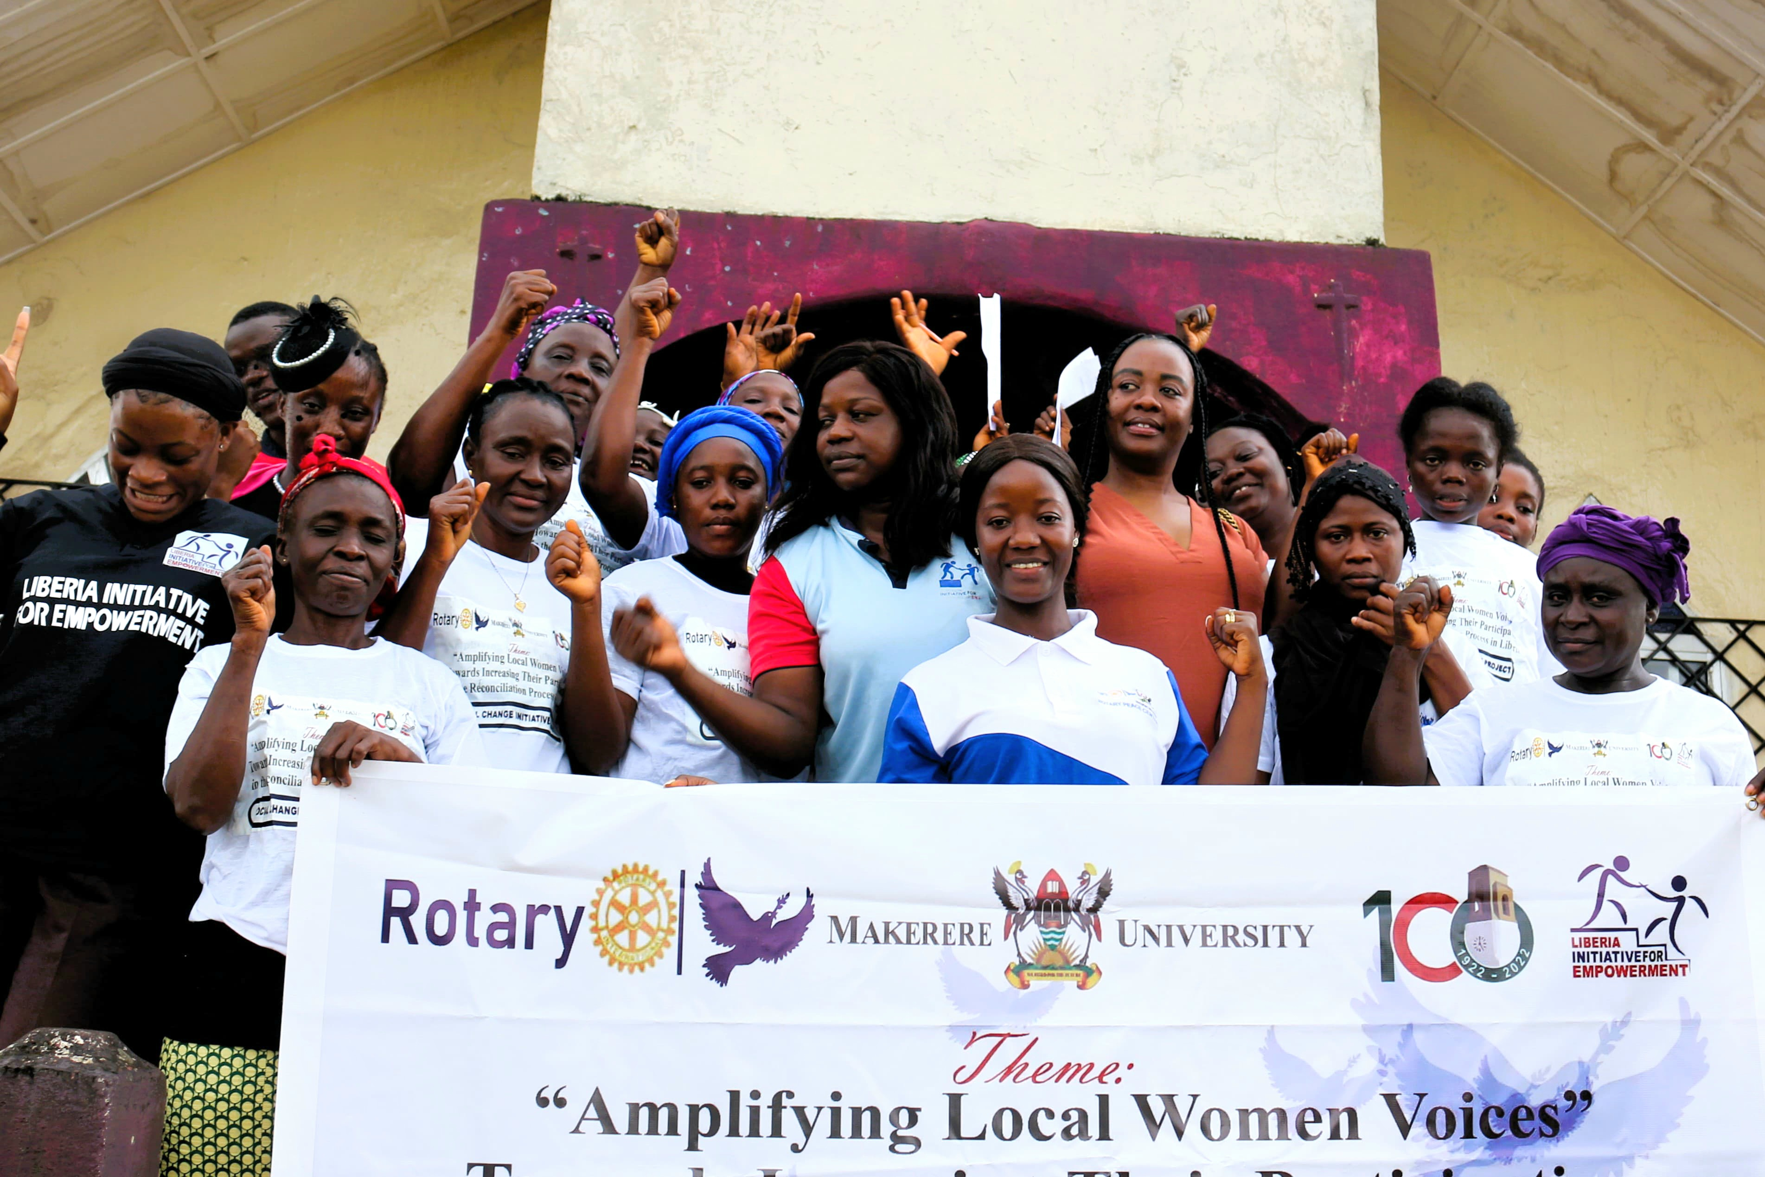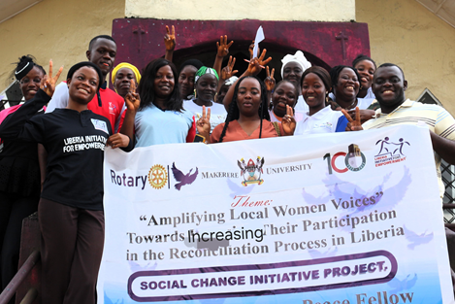
Group photos of participants and collaborating organization taken after the launch:

Participants attentively seated during the SCI launch
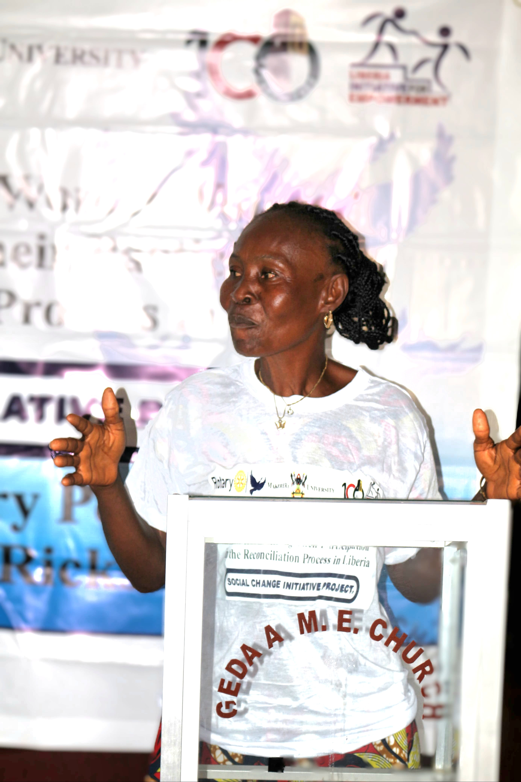
Mrs. Zinnah Walker making, head of “Women of Progress” a local women led organization, making a remark at the program:

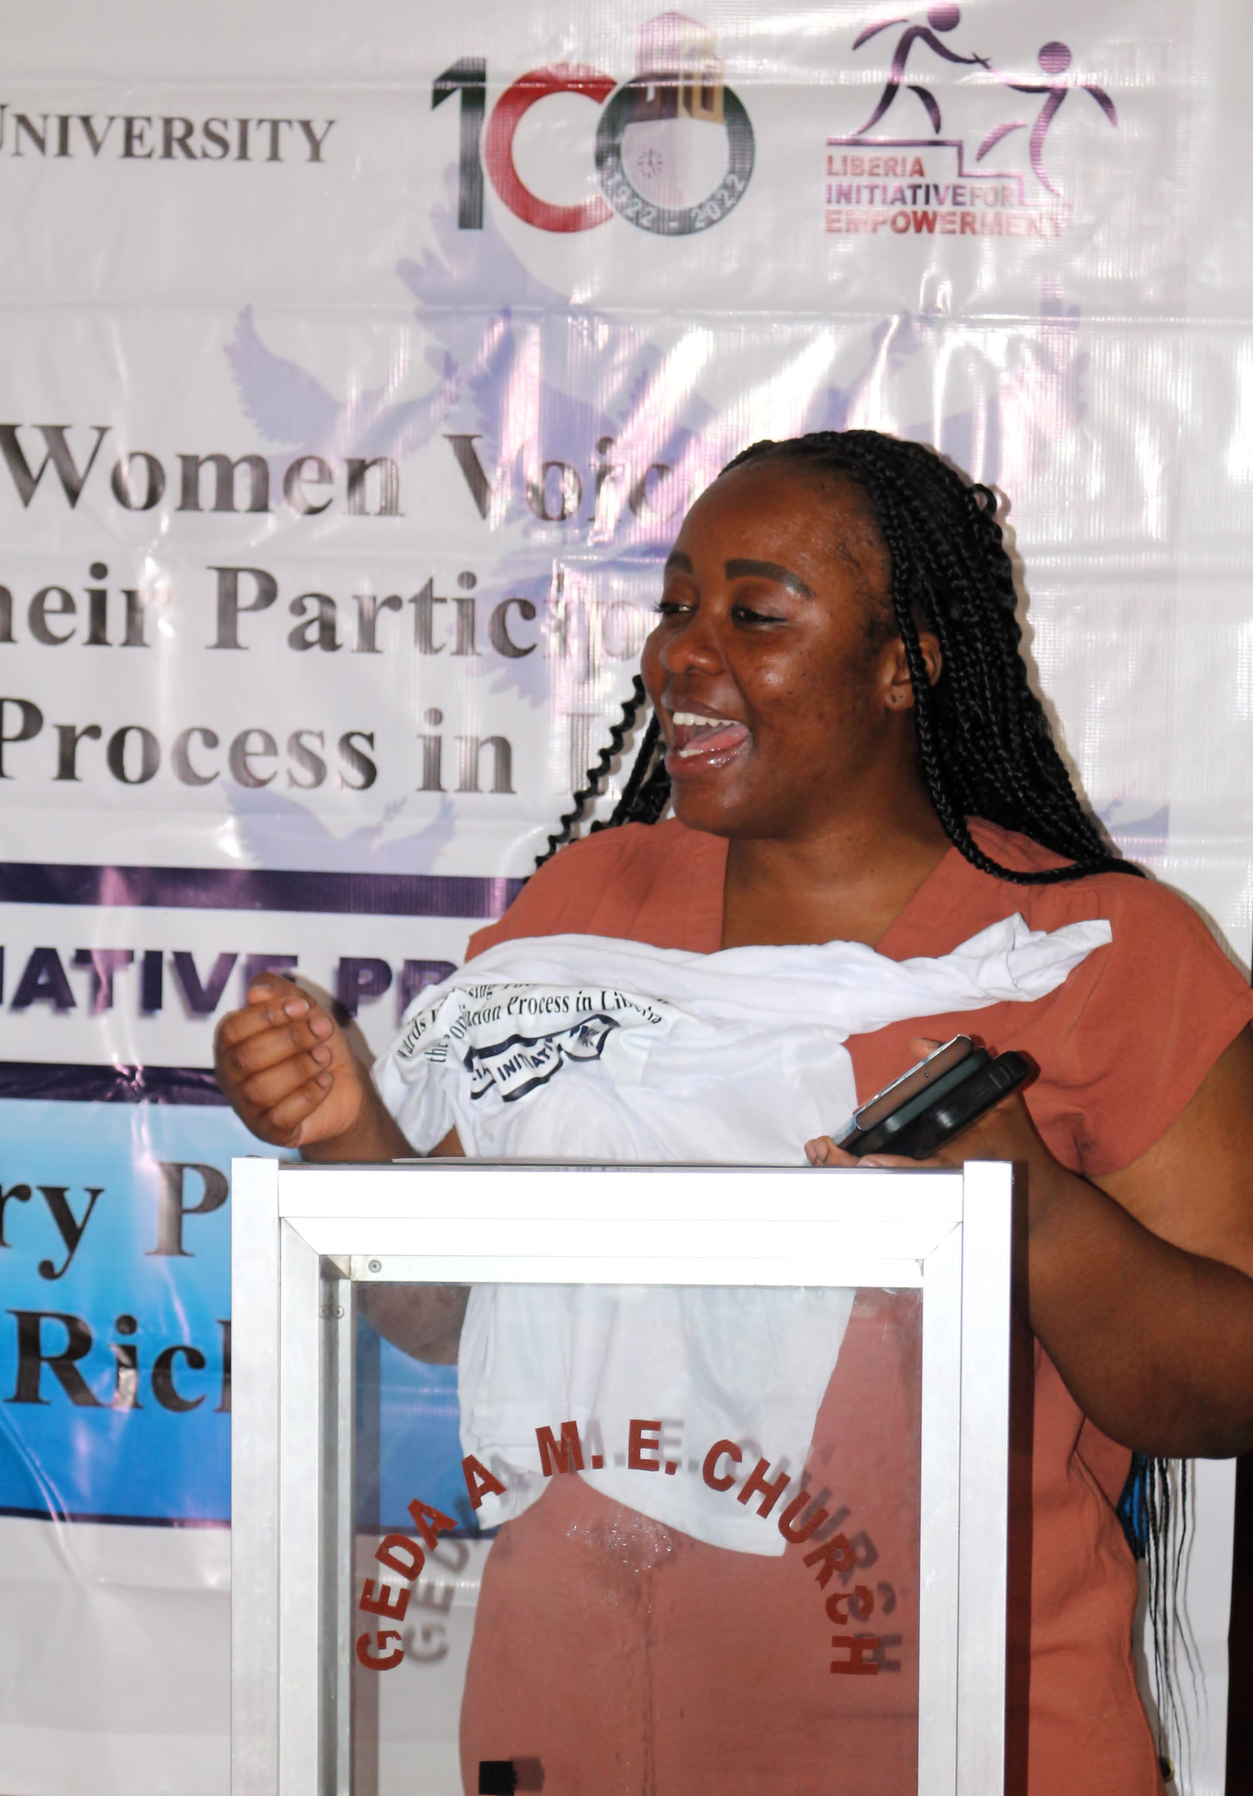
Madam Jodie Reid Seton, Executive Director of Liberia Initiative for Empowerment served as key note speaker. She applauded Miss. Ricks for always pushing and also encouraged the participants to continue to support each other. She concluded by saying, lets work with the men to ensure a safe and violence free community.
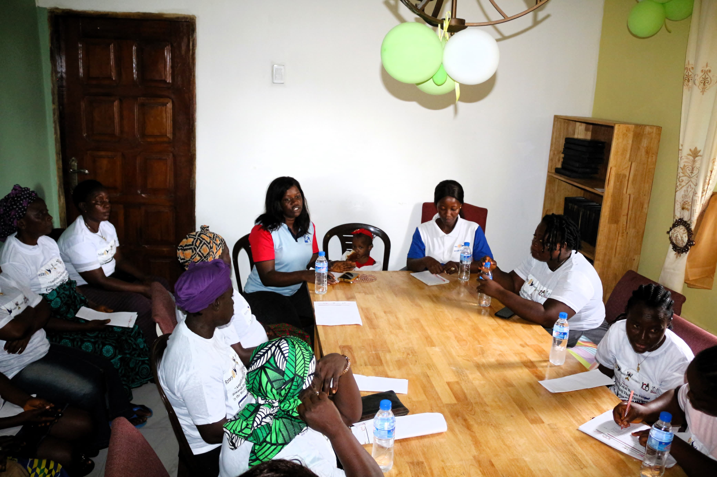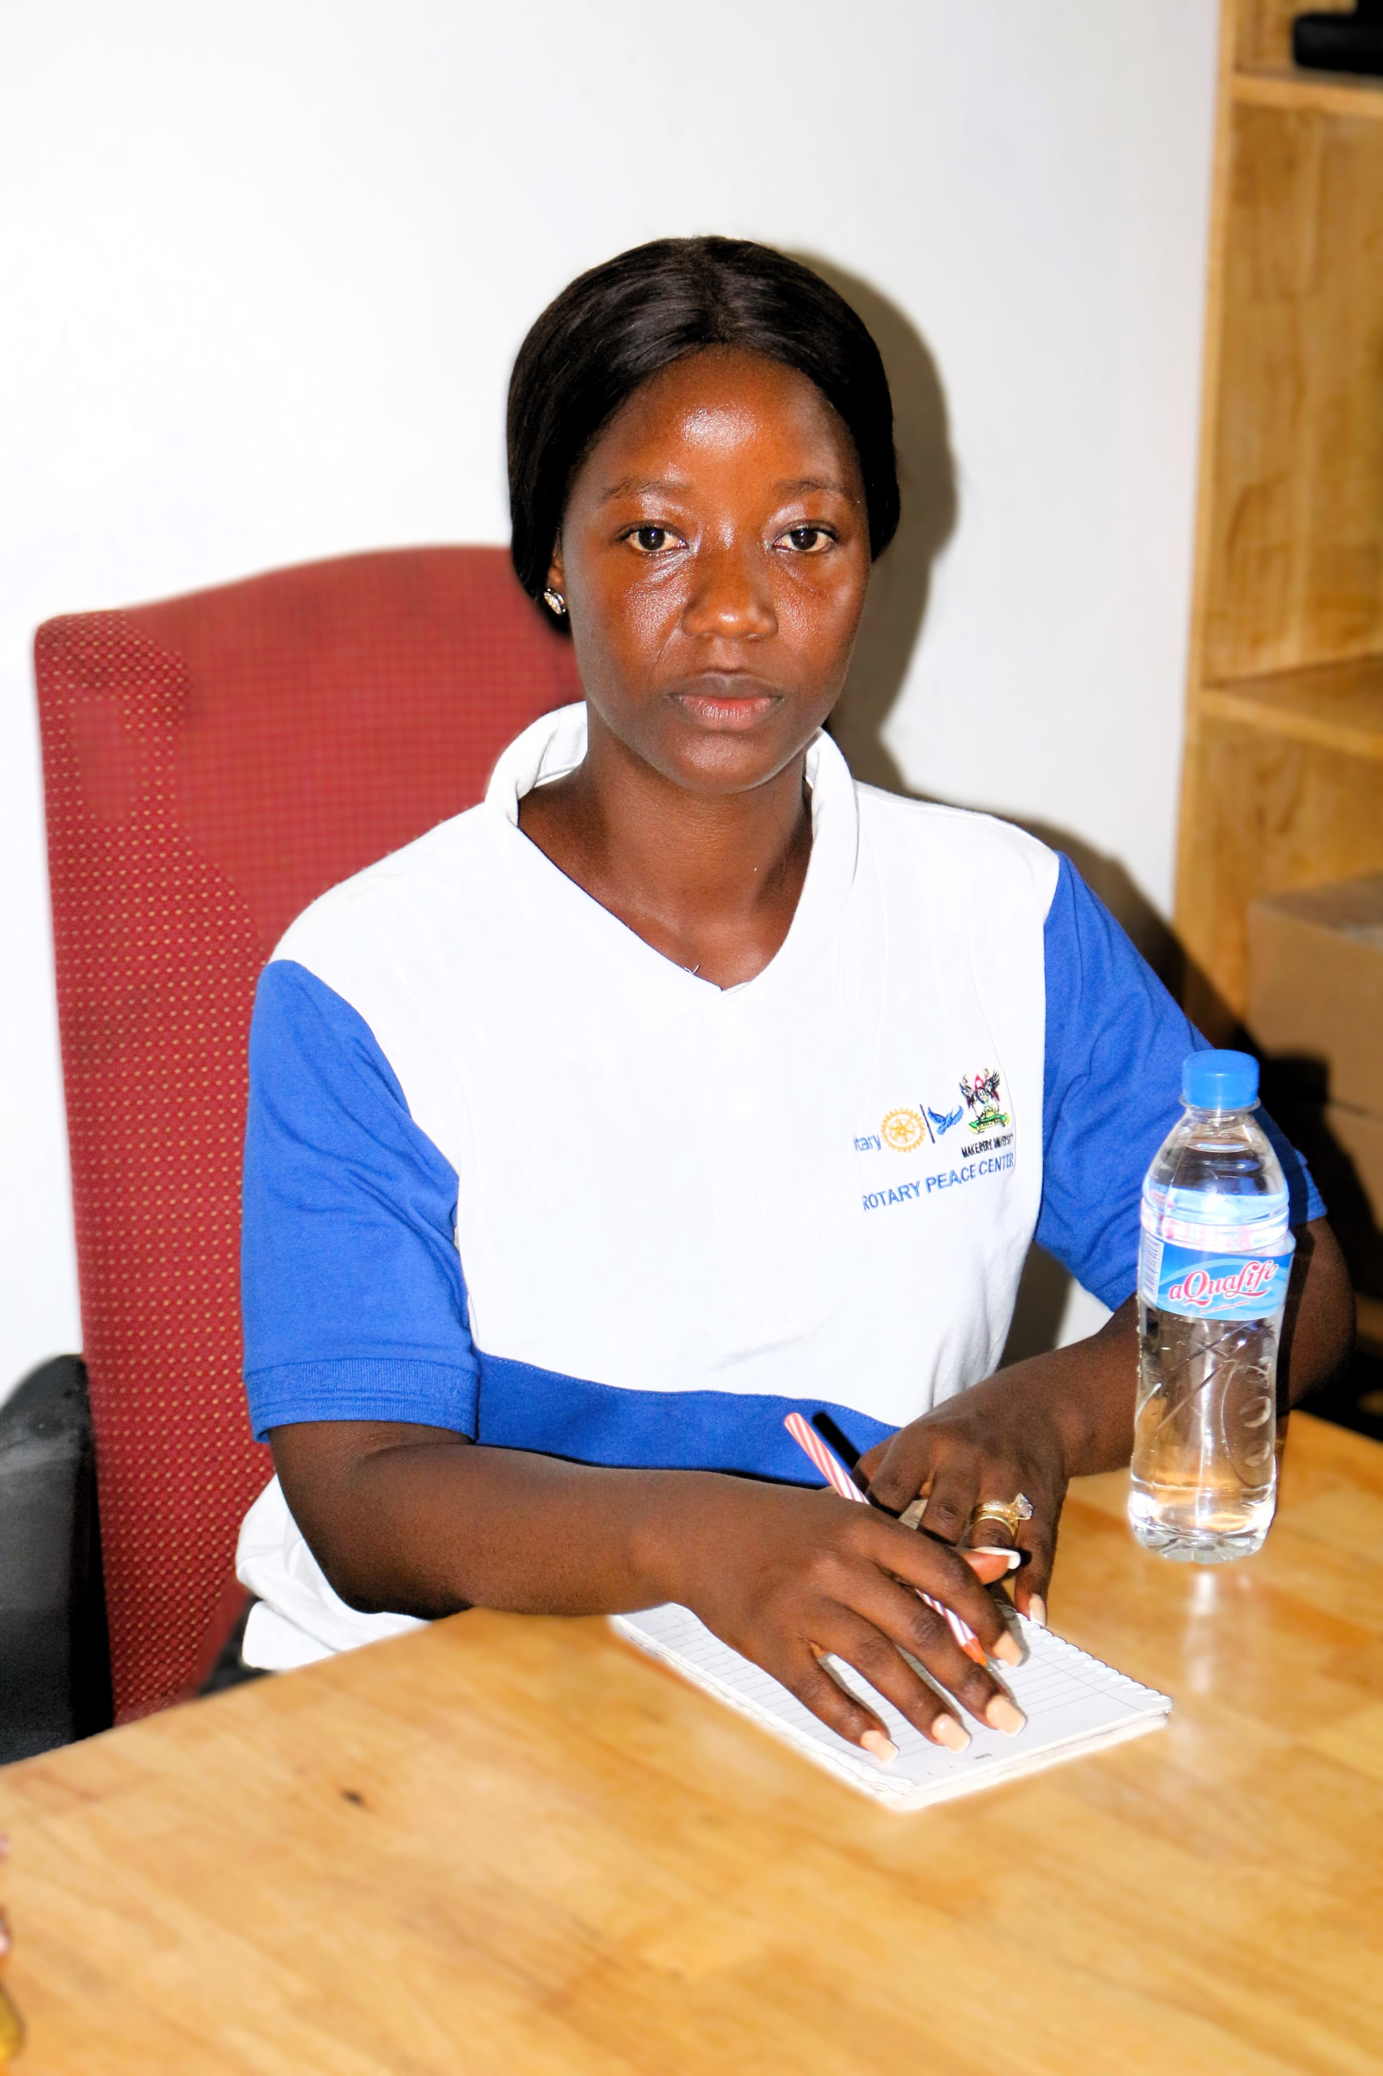Source: Geda Hall, Brewerville City
Round table discussion on the barriers faced by women peacebuilders in Liberia.

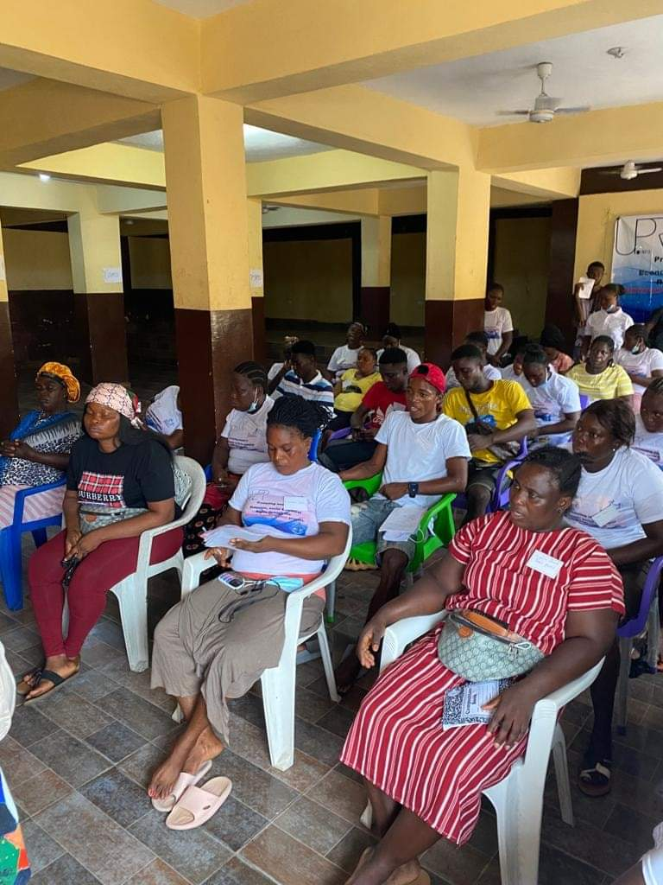
Source: West Point Town Hall, Monrovia, Liberia
One day capacity-building training on Women peace and security and their involvement in grassroots peacebuilding approach.

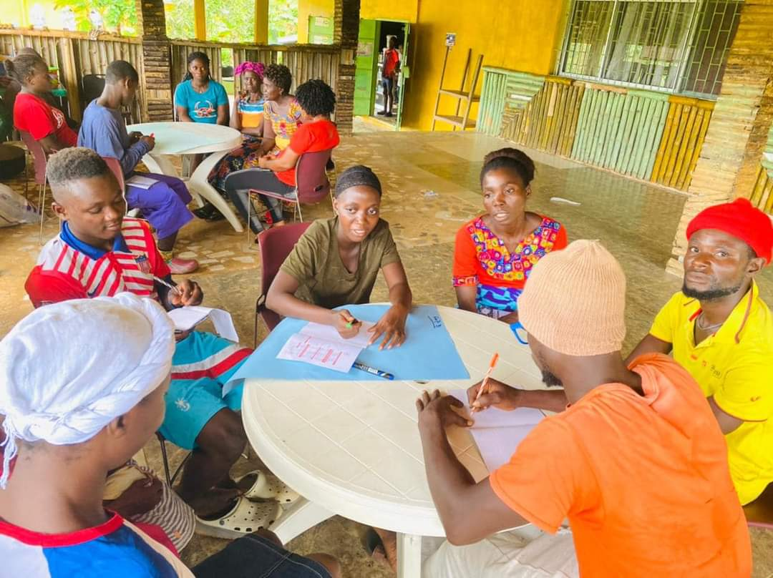

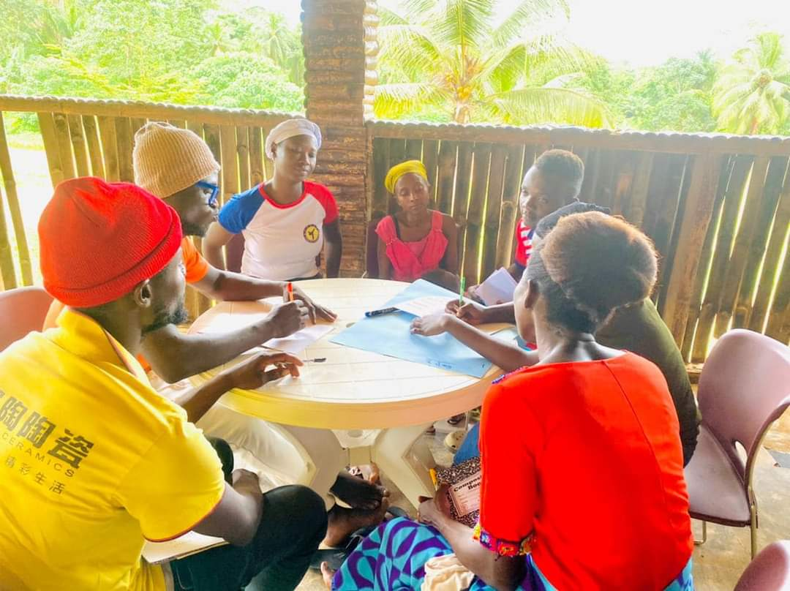
Source: Arthington community, Liberia.
Group Discussion on self awareness and engagement efforts to promote reconciliation process.

References:
https://eu.docworkspace.com/d/sIEmHx8ToAY6suLgG?sa=601.1123
state-of-peace-reconciliation-liberia_0.pdf (crs.org)

Reconciliation and Peace Consolidation | UNMIL (unmissions.org)
state-of-peace-reconciliation-liberia_0.pdf (crs.org)
Survey report conducted by the Center for Security Studies and Development, 2024
UN Women 2024

Sexual Violence in Liberia: End the Silent Epidemic | United Nations Development Programme (undp.org)
Survey report conducted by the Center for Security Studies and Development, 2024
state-of-peace-reconciliation-liberia_0.pdf (crs.org)
ibid
Truth Commission: Liberia | United States Institute of Peace (usip.org)
gol-2013.pdf (kofiannaninstitutelr.org)
Jaye,T. ,Bloh, O., Ethnographic Study on National Forums to Assess the traditional Palava Hut System in Liberia, UNMIL, National Independent Human Right Commission, November 2015
Survey report conducted by the Center for Security Studies and Development, 2024
UN Women, 2024
Reconciliation and Peace Consolidation | UNMIL (unmissions.org)
state-of-peace-reconciliation-liberia_0.pdf (crs.org)

