

**SOCIAL CHANGE INITIATIVE**

**PROJECT TITLE: CLIMATE RESILIENCE**

**AND EMPOWERING LIVELIHOODS FOR WOMEN AND YOUTH**

**PROJECT LOCATION, SOMALIA GAROWE BURTINLE**

**GPS- 7°48'7.92" N 48°23'56.83" E**

**START AND COMPLETION DATE: JULY 2022 TO JULY 2023**

**ELDAD NYAMU 2023**

# Abstract / summary: (250 words)

For almost 30 years, Somalia has been tackling a combination of civil war, famine, desertification, and environmental degradation, piracy, political fragmentation, and terrorism even as the population struggles to rebuild and move forward. Although the conflict has many underlying causes, one factor that remains poorly understood is climate change. In a country where, alongside war, 6 million people currently face starvation, understanding the role of climate change and its impact on patterns of drought and developing innovative responses is more pressing than ever.[1] This project looked at how we can mitigate climate change with Somali women and youth as they are the much affected by Climate change. In spite of their vulnerabilities and the many challenges, it is clear to see that the critical role women and youth can play as powerful change agents to address climate at an alarming skill is minimized. As key actors in sustaining families, building community resilience and responding to climate-related disasters, women tend to make decisions for the utilizations of core resources in the interests of our families, our communities and our children. Women comprise over 40% of the agricultural labor force worldwide and play a major role in agriculture and livestock. Somali female population counted 50.19% in 2016, according to the World Bank report.[2] Somali women are victims of climate change impacts and gender-based violence.

Furthermore, their scenarios are unreported or underreported.

# CHAPTER ONE Introduction and Background: (800words)

Somalia is highly susceptible to the effects of climate change and extreme weather. Without anticipatory preventive approaches, these factors are likely to exacerbate existing vulnerabilities and reduce the people’s livelihood options, which in turn may have negative impacts for stability and security in Somalia. More frequent and intense droughts and floods undermine food security and worsen livelihood conditions in Somalia, adversely affecting marginalized groups, fueling grievances, increasing competition over scarce resources and exacerbating existing community tensions and vulnerabilities. This has complex and interlinked implications for the peace and security situation in Somalia.[3]

The seasons and livelihoods in Somalia revolve around rainfall. The main rainy season (called *gu*) is from April to June and a second rainy season (called *deyr*) is from October to November. All other months are dry. Somalia is one of the most vulnerable countries in the world for the impacts on climate change because of the climate conditions by nature arid and semi-arid harsh environment. Nearly 70% of Somalia’s population depends on agricultural and pastoralist livelihoods. Livestock accounts for around 40% of GDP and more than 50% of export earnings for Somalia. That means nearly 8 million Somalis are dependent on livestock production to survive. Livestock production and animal husbandry require reliable supplies of water and pasture land. However, farmers and pastoralists in Somalia are becoming increasingly sensitive to the intense droughts and loss of grazing land caused by climate change.[2]

1. NUPI. (2021, February 3). Climate, Peace and Security Fact Sheet: Somalia. Retrieved from <https://www.nupi.no/en/news/climate-peace-and-security-fact-sheet-somalia>
2. Fahima Abdi. (2021, May 11). Impact of climate change on Somali women pastoralists (nomadic): unreported climate victims, Somalia rural women. Retrieved fro[m https://www.linkedin.com/pulse/impact-climate-change-somali-womenpastoralists-nomadic-fahima-abdi](https://www.linkedin.com/pulse/impact-climate-change-somali-women-pastoralists-nomadic-fahima-abdi)

Pastoralists are grappling with frequent and severe droughts, affecting their herds and their livelihoods. For example, the recent recurrent and the most severe droughts in living memory in Somalia is from (2011, 2015-16, and 2017) which leftover 75% of Somalia livestock killed and thousands of people particularly child and women die because of famine and endemic diseases. Climate change and resource scarcity are exacerbated by a lack of government interventions such as strategic adaptation plans, policies on land-use, and disaster risk management at the national level. In addition, Pastoral households are still less likely to diversify or change their livelihoods.[3]

Despite contributing to just 0.08 per cent of global emissions, Somalia is ranked among the most climate vulnerable countries in the world (LSE 2021). It occupies a spot in the top ten percent of most vulnerable countries (Ministry of Foreign Affairs 2018). Somalia ranks 179th on the NDGain Index, scoring 27.7 (low) and behind only Chad. In terms of vulnerability, Somalia scores last (181st with 0.675) (ND-GAIN 2021). The country faces a number of climatic risks, including but not limited to prolonged droughts and flash floods, erratic rainfall, rising temperatures, cyclones, sandstorms and dust storms.[4]

The climate risks that Somalia faces are cascading and add to the overall vulnerability of the country. One example of the compounding of these risks is seen in 2019 where delayed onset of regional rains left Somalia in drought. The prolonged drought period was followed by intense rainfall which consequently led to flooding and displacement of over 370,000 people. Infrastructure such as roads were destroyed and water sources contaminated (Soderberg *et al.* 2020). To add to this, Somalia is experiencing and predicted to continue experiencing temperature increases, which add to the risks by creating the conditions necessary for unprecedented numbers of locust swarms. Somalia declared a national emergency in February of 2020 when desert locusts caused catastrophic damage to crops and livelihoods (Soderberg *et al.* 2020).[6]

Somalia comprises 80 percent arid and semi-arid areas, which have reduced capacity to weather climate shocks due to their low water retention levels. This in turn amplifies the effects of climaterelated extreme events such as droughts and flash floods (Eklow and Krampe 2019).[5]

Climate change is projected to exacerbate water access issues already strained by geographical and geo-political stressors. Additional impacts to the country’s hydrological health are felt through increases in (charcoal-driven) deforestation, desertification, and land degradation – all of which are amplified by the effects of climate change, in a reinforcing and accelerating cycle (Eklow and Krampe 2019).[7]

Water scarcity is already a prevailing issue which is projected to escalate as river volumes drop (Eklow and Krampe 2019). Agricultural production, a key livelihood staple, is largely concentrated in the floodplains of the two main rivers, the Juba and Shabelle - both of which now sometimes dry up (Eklow and Krampe 2019).[7]

It is important to note that with the longest coastline in Africa (at 3333km in length), and over half the population clustered on its shores, Somalia is also vulnerable to rising sea levels, tsunamis, and an increase in Tropical Cyclones (State Minister for Environment 2015). For example, in November 2020, Cyclone Gati became the strongest cyclone ever to make landfall in Somalia, displacing thousands and inundating the coastline with more than a year’s precipitation in just two days (NASA 2020).[7]

Finally, it would be remiss not to point out Somalia’s (largely untapped) hydroelectric and other renewable energy potential, including geothermal, solar, and wind. The Government of Somalia outlined the ways in which the civil war interrupted this development by halting construction on the Baardheere Dam and derailing upkeep from the already constructed Fanoole Dam on the Middle Jubba. Once again, climate change also comes into play, with the severe El Nino season in 1998 shifting the trajectory of the river away from the Fanoole Dam (State Minister for Environment 2015).[7]

**Problem Statement:**

The degree to which people are affected by climate change impacts is partly a function of their social status, gender, poverty, power, and access to and control over resources. Despite the international community’s increasing acknowledgment of the differential experiences and skills women and men bring to the development and environmental sustainability efforts, pastoral women still have lesser economic, political, and legal clout and are hence less able to cope with and are more exposed to the adverse effects of the changing climate.[6]

Drawing on pastoral women’s experiences, knowledge, and skills and supporting their empowerment will make climate change responses more effective. However, the impacts of gender inequalities and women’s recurrent socio-economic disadvantages continue to be ignored and remain a critical challenge to adaptation efforts. As the world continues to grapple with what a post-Kyoto climate regime should look like, it is crucial that mitigation and adaptation efforts integrate gender issues at all levels. This will minimize risks to women and children and ensure greater success of efforts to address climate change.[8]

Women in developing countries especially pastoralist women are particularly vulnerable to climate change because they are highly dependent on local natural resources for their livelihood. Pastoral Women charged with securing water, food, and fuel for cooking and heating face the greatest challenges. Thus they experience unequal access to resources and decision-making processes, with limited mobility in rural areas. It is thus important to identify gender-sensitive strategies that respond to these crises for women.[8]

Goals and Objectives: (400 words)

The social initiative looked at reducing pre-existing and emerging climate change impacts and effects through climate-adaptive approaches to combat climate change related issues such us famine, environmental degradation, floods, and desertification.

Challenges and mitigation strategies: (400 words)

Physical risks

* Risk: Type of disability affecting women and girls’ prohibits their accessibility and participation.
* Mitigation: Conducted early identification of beneficiary disability through Washington Group of Questions, provide necessary accessibility materials and support to ensure equal and full participation for all.

Environmental risks

* Risk: Further COVID-19 outbreaks.
* Mitigation: development of COVID-19 project contingency plan, including provision of equipment and internet to local communities to ensure access to media interventions
* Risk: Floods or droughts limits delivery of project activities.
* Mitigation: The project developed a contingency plan against climate related impacts, including floods and droughts with twin goals of project continuation and support for the community through sinking of community dams and mobilizing more support to sink more dams as a way of floods control and water preservation to support livelihoods and the rehabilitation of degraded landscapes and ecosystems.

Political risks

* Risk: Change in government policy, legislation or regulation surrounding the women’s rights, gender and social inclusion sector, which makes it difficult to attain all desired results.
* Mitigation: Regular meetings and dialogues with relevant ministries to keep up-to-date with possible changes in regulation through consortia existing relationships with ministries. Co-implementing partners leverage evidence-based advocacy, sharing best practices and learning at national level.

Economic risks

* Risk: Delayed transfer -We had certain delays with the transfers which kept bouncing back hence our schedule was affected and the social change initiative had to start several months late down the line
* Risk: High inflation, exchange rate variations and market fluctuations impact budget.
* Mitigation; We reduced the entitlements and scope

Social and safeguarding risks

* Risk: Participating staff or volunteers who may be perpetrators of abuse have unsupervised access to women, girls and most marginalized groups.
* Mitigation staff trained and supported to apply each organization’s child protection and safeguarding policy, PSEA, including code of conduct, incident reporting mechanism, signs and symptoms of abuse. Beneficiaries informed about the project-specific culturally relevant and child sensitive incident reporting mechanism.
* Risk: Girls/women do not feel safe taking part or parents and husbands do not allow them to take part.
* Mitigation: Application of proven and effective community entry strategies engaging all key stakeholders to identify and encourage participation; engaging the entire family reduces disapproval.

**CHAPTER TWO**

# Literature Review and Theoretical Underpinnings

In the pages that follow I attempt to give a brief and historical background to discourses of climate change and women. What is climate change? Does it affect women more than men and why? Can there be formal and informal definitions and perceptions of climate change in certain contexts? I believe this background information provides an important theoretical framework for this discussion because only then can we begin to understand the climate change as a literary and social construct. Secondly, I attempt to provide a general overview of climate change effects on women and men in order to be able to situate and contextualize the works with which this study is concerned within this particular genre (women). Stories of women from various countries of how they are affected by climate change types of climate change induced disasters and effects stories will be discussed in an attempt to closely explore what exactly the climate change effects on women story entails.

Gender divisions of labour often result in the over-representation of women in agriculture and the informal sector, which is vulnerable to climate change and climate variability.[7] Lack of access to clean and safe water, safe sanitation, health, and energy sources, often put extra burdens on women’s shoulders, adding to their reproductive and care-giving tasks (Enarson, 2000). When a slow or sudden onset disaster strikes, this adds to the double burden of productive and reproductive labour (Patt et al, 2007). [8]

Going beyond market-centric assessment and approaches, the continuum of learning and development discourse must acknowledge the sphere of non-market activities and find ways to address those giving due emphasis on differential needs and priorities of women and men in a given society.[10]

Although there have been attempts to establish the fact that hazard and disaster responses are generally gender-blind, which often disregard special needs and abilities of women in various stages of disaster, impacts of disasters are not so gender-blind. In many societies, vulnerability to climate change and extreme weather events differs for women and men. It is important to find out the causes of vulnerability to disaster and how it discussed in the community and addressed in the disaster response programmes and action plans, including gender concerns as one of key elements that determine vulnerability. All three dimensions of vulnerability i.e. susceptibility to hazard, possibility of suffering damage, and recovery capacity (Watts & Bohle 1993; Adger 2006), are affected by gender patterns of access and control over resources, gender roles and responsibilities, and norms (Enarson & Morrow 1998).[10]

In many cases women are more vulnerable than men to climate change and variability, especially in times of disasters through their socially constructed roles and responsibilities (Dankelman, 2010), and because they lack adequate power and assets (Mitchell et al, 2007). As climate-induced disasters unfold, the interplay of traditional gender relations often exacerbates existing inequalities, leaving women even more vulnerable to subsequent disasters (Hoffman, 1998) and hardships. The capacity of societies to endure disasters is determined by the internal strengths and weaknesses of the society – the level of social, economic and cultural vulnerability. The ability to cope differs depending on its social conditions: poor and rich, women and men, young and old, indigenous, etc. (Rashid, 2002). Gender cuts across these various groups and sheds important light on the development of specific strategies to cope with disasters (Salvano Briceno, 2002). Though there is an absence of systematic gender-sensitive statistics, it is observed that higher vulnerability and marginalization results affected more women than men. In addition, women’s active agency and crucial role in helping families pull through this period are usually ignored (Rahman, Tahmina, 1996). Images of a woman giving birth in a tree, a child looking for his parents, or a woman selling off her only jewelry assets to manage post flood household necessity, demonstrate that gender issues are seldom just a woman’s issue but more often, a family affair, a community concern, and a social issue. Usually, the psychosocial and emotional effects of the damage such disasters are overlooked in favor of focusing on the economic aspects of the damage (Hussein Maliha and Husain, Tariq 2000). Women’s social, economic and political position in societies differs, making them more or less vulnerable to these situations. It is well understood that gender relations structure people’s ability to anticipate, prepare for, survive, cope with, and recover from disasters (Salvano Briceno, 2002). In the context of Bangladesh, a large part of women’s vulnerability is caused by gender norms, expectations, and social roles. Women are disadvantaged because of their subordinate position in the family arising out of patriarchy and traditionally embedded cultural values. Therefore, women are doubly disadvantaged during a disaster time and in climate change context as they have limited, and more risky, mobility concerns due to cultural norms of honor and shame, and purdah and most are extremely dependent on male members of the household (Rashid, 2002).[9]

# Women in the backdrop of climate change in Bangladesh

Patriarchy controls women’s spheres of influence in Bangladesh; yet gender relations have been undergoing a process of considerable transformation over the last three decades as part of broader economic transition and social change (Halim, 2001). In Bangladesh, women’s experience and interests are strongly differentiated by their class position, with poor women more marginalized (Neelormi, 2010). However, available statistics on health, nutrition, education, employment, and political participation reveal continuing struggles to achieve equality (Neelormi, 2010). Despite many of the affirmative policies and steps to facilitate stronger gender parity in the economic and social sphere, Bangladeshi women lag far behind their male counterparts under the prevailing economic and social circumstances. Significant disparities in employment and wage rates persist which; combined with considerable gaps in asset ownership, seriously limit women’s economic opportunities, as well as restricting their social sphere. Literature indicates that women are disproportionately vulnerable to climate change/ variability (Neelormi, 2010; CCC, 2008; BCCSAP, 2009) in Bangladesh.[10]

# Differential and disproportionate vulnerabilities of women under climate change/ variability in Bangladesh

Water logging-induced prolonged exposure to filthy water causes severe skin diseases and gynecological problems for women

This phenomenon disrupts land-based productive systems, which in turn aggravates women’s malnutrition in affected areas

Collection of fuel and potable water becomes extremely hazardous;

Women cannot send their children to school during prolonged water logging and young girls are forced into child marriage;

Men often leave their families back home in search of employment, leaving household responsibilities to women, thereby adding to their vulnerability;

Young girls with skin ailments are ill-treated in arranged marriages, often required to pay an increased amount of dowry.

The design of shelters being gender-insensitive, women do not feel like going there, increasing their risk;

Women anticipate ‘sexual harassment’ on route to remotely-placed shelters, which forces them to stay at their respective shanty dwellings and increases risk of drowning;

Managing menstruation, pregnancy, and breast-feeding is gender-insensitive in shelter centres;

With increasing population, there is increasing competition for refuge space in shelters, which deters females;

When floods hit, children and women often remain within marooned dwellings (as long as possible) and are subject to snake-related deaths;

Unemployed women are compelled to migrate elsewhere, and face acute conditions of physical and social insecurity;

Poor women find it extremely difficult to ensure food and drinking water security when they struggle to live in flooded conditions;

During floods women’s privacy concerns are challenged. Sanitation activities decrease especially for pregnant women. In the absence of freshwater, adolescent girls cannot maintain hygienic reproductive.[11]

# Differential and disproportionate vulnerabilities of women under climate change/ variability in Somalia

Somali women play a significant role in Somali society; the division of labor is clearly defined and heavily weighted towards women. Traditionally, the nomadic woman milks the animals, processes the milk, feeds the family, and cares for and watches the livestock. She also collects firewood, cooks, feeds the children, cleans the house, and washes the clothes and the utensils. In addition to that, women have the responsibility of “building and dismantling the nomadic aqal (home)” as they move from place to place in search of grass and water for their livestock. [12]

The men were to “move, arrange additional transport from other families” and look after the camels the recent year's many women are involved in small income generation activities such as running small shops, selling tea, Qat, etc but also a few are engaged in livestock trade and charcoal business as wholesalers while men produce it as illustrated above. Climate change and the resulting loss of livestock, water, and vegetation has changed this traditional workload. [11]

# The rise in gender-based violence

The climate crisis has also been associated with increased sexual and gender-based violence, as it impairs existing social structures and exposes women to increased vulnerabilities. Growing evidence has shown that social, political and economic tensions generally escalate after a climate disaster, leading to an increase in gender-based violence. In the post-disaster assessment following Cyclone Nargis in Myanmar, survey respondents noted increased alcohol consumption by men and a 30 percent rise in domestic violence rates. Reports from the United Nations Population Fund show that intimate partner violence rose after the drought in East Africa, tropical storms in Latin America and similar weather events in the Arab States region. Research by the United Nations Development Program shows the climate crisis is likely to escalate social, economic and political conflicts, which may exacerbate gender-based violence.

Additionally, women and girls report a higher level of sexual assault or violence when living in camps or emergency shelters after a climate disaster, where there is limited privacy. Based on a survey collected in Bangladesh, 93 percent of the respondents reported the disaster shelters as not “women-friendly”.[13]

Anecdotal evidence has shown how climate change could lead to a rise in the rate of child marriage in developing regions, where poor families rely on dowries as a source of income to reduce financial burdens. For example, during extreme droughts, young girls in Ethiopia and South Sudan have been sold into marriage in exchange for cattle. [12]

There is also evidence of an increased risk of human trafficking following natural disasters. A study from the UN International Organization for Migration discovered that the sudden onset of climate disasters is likely to cause displacement, which provides traffickers with opportunities to exploit vulnerable people. Recent research from International Institute for Environment and Development and Anti-Slavery International found that young women from Northern Ghana who migrated to major cities like Accra after local droughts faced increased risk of trafficking, sexual exploitation and debt bondage. [12]

As climate change adds economic pressure on families and leads to the loss of households and livelihoods, the overall social instability increases the risk of child marriage, gender-based violence and human trafficking. [12]

# Policy recommendations for reducing the gendered impacts of climate change

While climate change can have an unbalanced impact on women, it offers opportunities to rewrite the rules of society during times of great change. The key question is how to incorporate gender issues into policy frameworks, reconsider women’s roles and capacities and involve women as agents of change. [12]

The first step might be to collect more inclusive quantitative and qualitative data to accurately reflect the needs of underserved women communities to inform innovative policies. It is critical to ensure sampling methods don’t have inherent gender biases and disaggregate data to reflect divergent experiences of women by age, income, disability status and other factors. Specific policies such as unconditional business grants or capital injection can also be considered to increase women’s access to economic resources in the long run. Locally, village-level governance should also be reformed to be more gender-inclusive to further promote equal electoral participation and distribution of work. Additionally, improving transport infrastructure and reducing transportation costs would help enhance women’s mobility. [14]

The UN Women Watch has offered systematic approaches to respond to climate change and address women’s needs: mitigation and adaptation, technology transfer and financing. Mitigation and adaptation involve a process of minimizing greenhouse gas emissions from human activities and building resilience in key sectors, such as agriculture. These efforts should effectively address the gendered effect of climate change in crucial areas like water, food security, health, human rights and agriculture.[12]

Additionally, more innovative technologies and financing activities can be applied to support sustainable practices at the household and community level. The United Nations Framework

Convention on Climate Change confirmed that women’s active participation in funding organizations, allocation of resources process and gender-sensitive investment could lead to improved outcomes of climate-related programs. Technological developments should also consider women’s specific needs and roles and make sure products are user-friendly, affordable and effective.[12]

Currently, women are underrepresented in the decision-making process for environmental governance even though, in many cases, they are leading the initiatives for environmental conservation. For example, in the Sundarbans in India, as the rising sea levels have eroded the embankments and placed hundreds of local villagers at risk, local women have banded together to plant mangrove trees as protective barriers. [12]

In Nicaragua, women started the Gloria Quintanilla peasant cooperative to replace the chemicalintensive methods of growing coffee with agroecological practices to produce traditional crops like bananas, plantains and maize. The initiative helped ensure self-sufficiency and also used the profits to fund community education and technical training for women. [12]

In all, women’s perspectives and efforts to address climate change need to be recognized and incorporated into national and local policies to ensure equal rights and equal participation. [12]

# Theory of Change and how it was applied

The theory of change; **If** women and youth are empowered with the skills, resources, and knowledge to thrive in a changing climate, contributing to both their own well-being and the resilience of their communities **then,** there will be enhanced community climate resilience, reduced vulnerability to climate-related shocks, improved economic stability for women and youth, increased representation and leadership of women and youth in climate adaptation efforts, addressing the link between climate change and violent extremism, with the aim to promote resilience, peace, stability where women and youth can work towards building sustainable and inclusive communities that are better equipped to adapt to the impacts of climate change, while also addressing the root causes of violent extremism and promoting peace.

1. BU. The Gendered Impacts of Climate Change. Retrieved from [https://www.bu.edu/eci/2022/05/17/thegendered-impacts-of-climate-](https://www.bu.edu/eci/2022/05/17/the-gendered-impacts-of-climate-change/#:~:text=Additionally%2C%20women%20and%20girls%20report,not%20%E2%80%9Cwomen%2Dfriendly%E2%80%9D)

[change/#:~:text=Additionally%2C%20women%20and%20girls%20report,not%20%E2%80%9Cwomen%2Dfrie ndly%E2%80%9D.](https://www.bu.edu/eci/2022/05/17/the-gendered-impacts-of-climate-change/#:~:text=Additionally%2C%20women%20and%20girls%20report,not%20%E2%80%9Cwomen%2Dfriendly%E2%80%9D)

1. Harwell, M. R. (2011). Research design: Qualitative, quantitative, and mixed methods: Pursuing ideas as the keystone of exemplary inquir. In C. Conrad, & R. C. Serlin (Eds.), The Sage handbook for research in education:

Pursuing ideas as the keystone of exemplary inquir (Second Edition ed.). Sage.

**Methods and Design:**

1.10 Methodology of the study

This section focuses on the sources of data and data collection techniques, sampling procedures adopted and tools for data presentation and analysis.

* + 1. Research Design

Harwel argues that research design is an illustration of how an investigation should take place. It shows how data is to be collected, instruments for data collection as well as how the analysis is to be conducted [15]

Research is the search for new knowledge. During research, a given approach has to be adopted based on what is to be investigated. Descriptive research design is adopted in this case because it responds to questions such as who, what, where and how.[13]

* + 1. Research paradigm

This study used mixed method research design. This approach aimed at building scientific knowledge about phenomenon. Mugenda argues that quantitative and qualitative methods are distinguished on the basis of the views about reality, source and impact of the relationship between the inquirer and the object and views about knowledge and truth.[16]

The assumption of the quantitative methods helps the researcher to predict, describe, control and explain a phenomenon of interest. This therefore makes the study to be clear on the phenomenon to be investigated. It also enhances prediction by estimating a phenomenon, hence correlation research. It enables control and manipulation of some parts of a variable in order to exert control over the other. Therefore, it gives accurate observation over a particular phenomenon.[14]

* + 1. Study Target population

This study targeted beneficiaries in Burtinle district of Garowe Puntland state of Somalia, famers, pastoralists, climate change department within the ministry of agriculture environment and climate change Puntland, targeting critical officers in implementation of environmental and climate change issues, CSOs, NGOs, political leaders, intellectuals, and the religious leaders.

* + 1. Sampling technique

This study employed purposive sampling technique so as to allow the selection of cases that are essential in responding to the research questions. Purposive sampling is important for studying certain domain with well-informed experts. Purposive Sampling is very essential in this study because it is easily employed with both qualitative and quantitative research techniques.

* + 1. Data collection technique

The study employed primary and secondary method of data collection. Primary data was obtained through questionnaires, interviews and observation. The questionnaires and interview instrument for data collection was preferred as it helps the respondents to be objective and more precise while answering the research questions. The study also used observation as a technique for getting data by observing structures placed to enhancing democratic governance and development. Structured questionnaires will be used to elicit information from the target populations. On the other hand, the secondary information was obtained through document for instance books, academic journals, internet as well as the newspapers. This helps the researcher to refer and compare data findings in the past and the present.

* + 1. Analysis and presentation of data

Data analysis is a process that comes after administering the research tools which can be field data or from the library. It involves the process of inspecting, cleaning, transforming and modeling data with the goal of discovering the useful information and suggesting conclusions and recommendations. This involves organizing the data, uncovering underlying structures, extracting important variables, detecting any anomalies and finding possible explanations of the findings hence more of content analysis method. Presentation is in form of pie-charts, graphs, frequencies tables and even narrations.

* + 1. Ethical considerations

The researcher considered good code of conduct in carrying this study by enhancing originality of the study. The participants were enlightened on their rights on whether to participate or refuse to get involved in the study, their safety was assured. Their participation is not mandatory hence consent is sought from the respondents.

* + 1. Scope and Limitations

This research suffered inadequate time for more research on the topic. Climate change is a wide area of study that requires more time. However the researcher utilized and maximized on available time as far as dedicating more hours at night to research on the topic. Finally, the Finance to carry out this research was limited the budget was only 10,000 USD.

# CHAPTER 3

**Interventions and Activities:**

Four interrelated pathways illustrate the relationship between climate change, peace and security: (1) livelihood deterioration, (2) migration and mobility, (3) military and armed actors, and (4) political and economic exploitation.[17]

* Climate-related displacement and migration are likely to increase, particularly for those whose livelihoods are influenced by droughts and floods; that can fuel tensions at the community and national levels and disrupt ongoing conflict resolution initiatives.
* Internally displaced persons (IDPs) are particularly vulnerable to identity-related conflicts and armed group recruitment.
* Armed groups like Al Shabaab can take advantage of climate impacts by positioning themselves as service and relief providers following droughts and floods.
* Droughts and floods can link local resource conflicts to broader insecurity, as elites may exploit the impacts to advance their influence over communities and resources.

For farmers and herders, rainfall patterns influence a complex series of movements in search of grazing land between the seasons. Seasonal variability and unpredicted shifts can have cascading effects on herders, farmers, markets, families and entire communities. FGS concluded that extreme weather events are associated with loss of livelihoods and increased poverty. This has been further highlighted in the January 2020 FGS–AU–UN Joint Threat Assessment of Somalia. Somali community leaders told the authors of the 2013 NAPA report that droughts fuel herder–farmer conflicts because settled communities and livestock herders must compete for fewer resources. This intervention will help build community anticipatory preventive responses to climate-related security risks, including environmental peace building, and how it can help to strengthen the resilience of IDPs and local communities – especially women and youth – and contribute to climate-proofing governance, basic service provision and peace and security efforts.[18]

The aim of the project is to establish climate smart villages to improve the adaptability and resilience of farmers in the relatively food insecure and vulnerable regions and to use this evidence in supporting designs of large-scale climate adaptation programs, to find and promote synergies among activities that improve production systems, enhance livelihoods, support the conservation of biodiversity and sustain ecosystem services with the ultimate goal is to ensure sustainability. A mix of locally relevant climate-smart technologies and practices identified based on evident knowledge and complemented with weather information services from Somali water and land information management(SWALIM) will be implemented in the CSVs. This demands the increased integration of activities to reach a range of different objectives related to poverty alleviation, agricultural production and food security, adoption of climate-smart agro-pastoral systems for improved and sustained fodder availability and livestock nutrition. In addressing multiple objectives in an integrated manner, the emphasis is placed on adaptive management and stakeholder involvement for smallholder farmers within Buntinle district scaling up to other parts of Somalia. Through this project, a portfolio of CSA technologies and practices that deliver multiple benefits, such as reducing emissions and improving adaptation while securing livelihoods and food and nutrition, were be adopted.[19]

Activities:

Conducted community needs assessments

Developed gender-inclusive climate resilience and livelihood empowerment programs

Provided training in climate-smart agriculture and sustainable livelihoods

Organized community awareness campaigns on climate change

Established community-based climate monitoring and early warning systems

Promoted women and youth participation in decision-making processes

**Key findings / Impact:**

It is important to rain support and sensitize women and youth farmers on the effectiveness of Climate-smart villages (CSV) options (practices, technologies, services, programs, and policies) not only to enhance productivity and raise incomes, but also to build climate resilience, increase adaptive capacity, and wherever possible, reduce GHG emissions; promote sustainability, scalability, and replicability. Promote and strengthen collaboration with agricultural extension officers, local authorities through training and provision of critical research inputs. Mapping vulnerability of gender-differentiated groups disaggregated data according to age and sex is necessary to be able to assess the specific situation or needs of men and women of different age groups and has made an effort to obtain information specific to men, women, girls and boys to minimize the possibility of overlooking specific needs related to age and sex to set a baseline to track changes in living conditions induced by the project activities. Periodically evaluating with the participation of all actors, (during and at the end of each cropping campaign), the results achieved on physical, economic and social aspects. Capitalization of knowledge and documentation of best practices.

# Impact

Women have improved income, improve HH nutrition and they are much empowered both socially and economically by the project, Increased vegetable production for food, seeds and income targeting 200 women/HH, Trained, supported and sensitized 200 women farmers on the effectiveness of Climate-smart villages (CSV) options (practices, technologies, services, programs, and policies) not only to enhance productivity and raise incomes, but also to build climate resilience, increase adaptive capacity, and wherever possible, reduce GHG emissions; promote sustainability, scalability, and replicability, Identified CSA options for the rehabilitation of degraded landscapes and ecosystems and the enhancement of farmers resilience through training of 200 women and encouragement to plant more trees, 150KG assorted vegetable and horticultural seeds distributed to 200 targeted women, 200 women trained on CSA approaches, Reduced food dependency, Employment opportunities for 200 women created, Average increase of 5$ daily per beneficiary attributed to marketing of horticultural produce, 20 ha of horticultural land established

**CHAPTER FOUR**

# General Conclusion

The project was implemented in a participatory approach, consultation was done with the staff, vulnerable women and communities affected before the activities were initiated and community owned. Local mobilization of available resources were instituted to ensure support of the activity. Open forums for affected women and networking helped us to develop a joint efforts to address food security issues and the involvement of women in combating the effects of climate change and mitigate conflict.

The Social change initiative promoted collaborated with other key players sharing the same objectives e.g. UN-FAO, Ministry of agriculture, WFP, NGOs, and CBOs supporting food security, peace building and climate change adaptations.

**Recommendations / Implications** **for Policy:**

Conduct an in-depth and evidence-based analysis of pastoral women’s and men’s roles in sectors impacted by, and their strategies for coping with, climate change

Improved understanding of women’s and men’s knowledge, roles, and abilities will provide a solid basis for policy and programs developed to address and combat climate change impacts.

Integrate gender perspectives throughout climate change programming in order to effectively address both women’s and men’s needs and priorities, ensure the full and meaningful participation of women and achieve gender-equitable outcomes.

Climate change actions need to be based on consultation with pastoral women, build and incorporate their skills and knowledge, and provide opportunities for improving health, education, and livelihoods. Also, Increasing women’s participation would result in more environmental and productivity gains and would create mutual benefits and greater returns across the Sustainable Development Goals. Likewise, overall women’s increased involvement in adaptation and mitigation efforts would enhance the efficacy and sustainability of such efforts. Gender considerations and women’s issues, needs, and contributions should be integrated across the planning and execution cycle of climate change policies and projects.

Collect more inclusive quantitative and qualitative data to accurately reflect the needs of underserved women communities to inform innovative policies. It is critical to ensure sampling methods don’t have inherent gender biases and disaggregate data to reflect divergent experiences of women by age, income, disability status and other factors. Specific policies such as unconditional business grants or capital injection can also be considered to increase women’s access to economic resources in the long run. Locally, village-level governance should also be reformed to be more gender-inclusive to further promote equal electoral participation and distribution of work. Additionally, improving transport infrastructure and reducing transportation costs would help enhance women’s mobility.

**Sustainability plan:**

During the project implementation period we strengthened the village relief committee to prepare a community-based management and maintenance plan, which will enable community mobilization, in order to maintain check dams, terraces and community gardens fencing on a biannual basis and or as needs may arise.

The hand tools provided during the soil and water conservation and water sources rehabilitation activities will be used by the community to maintain structures such as, check dams, terracing, fencing etc.

The participatory community-based planning used in identifying problems, analyses them and prepare an action plan will definitely enhance women’s and youth sense of ownership of the project, which is crucial to its maintenance and future sustainability. By working with local CSOs, each implementing partner enacts widespread and sustainable change. Evidence attributes CSOs’ valuable role in reaching diverse community actors beyond the lifecycle of projects, continuing the trajectory of social and community behavior change to combating climate change.

The involvement of local and national media further enhances sustainability of project outcomes through the multiplier effect delivered by media-based norms and value change to prevent environmental degradation through human activity like charcoal burning, environmental pollution e.t.c. Media engagements such as radio talk shows, social media and use of billboards, banners and flyers will further enhance visibility and in turn social and community behavior change.

# APPENDICES

Pictorials Max **5pgs** with descriptions – Attached Final project narrative report to the donor

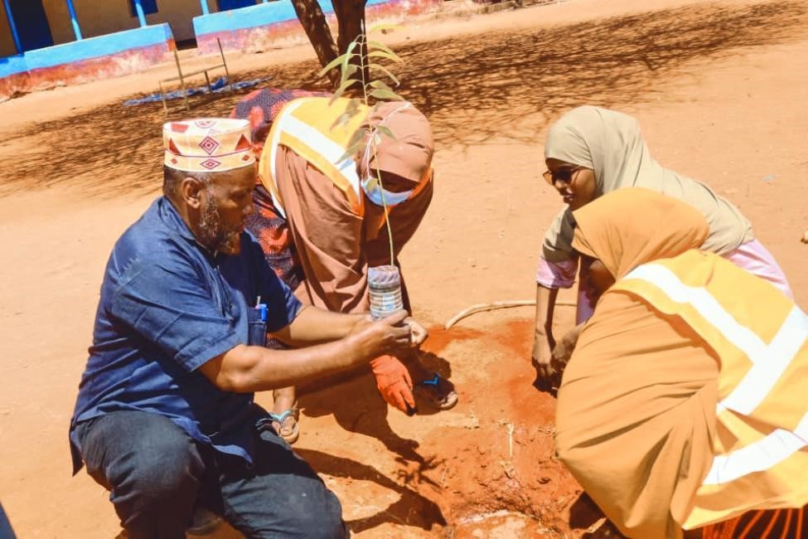

Women planting trees in a school together with a teacher

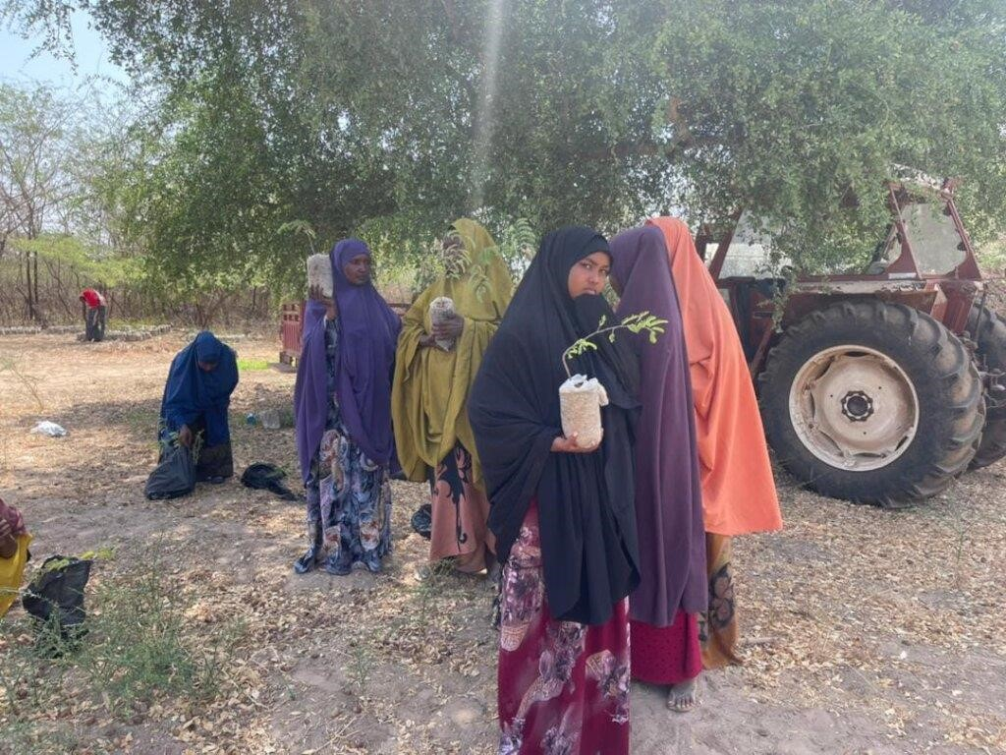

Tree Seedlings community distribution

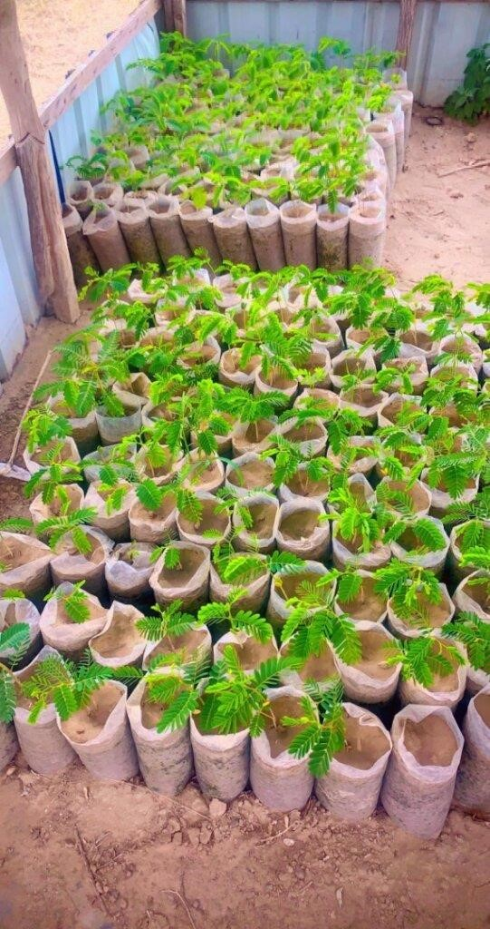

Home tree nursery

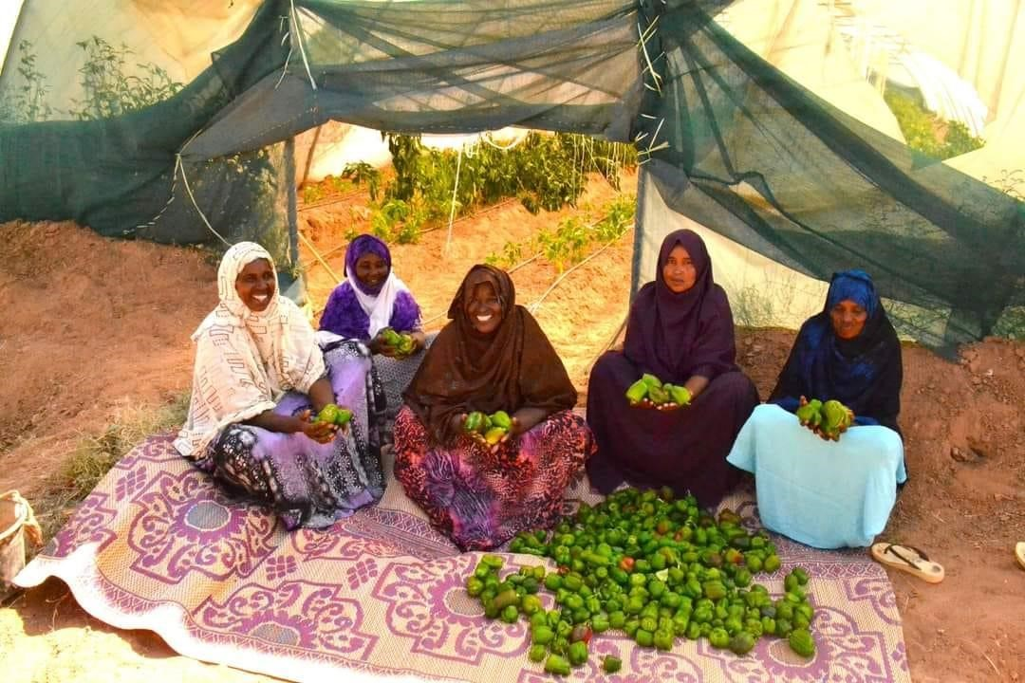

Vegetable and horticulture production for food and income through climate smart agriculture **ANNEX**

Annex 1: Memorandum of understanding/ Contract page 1

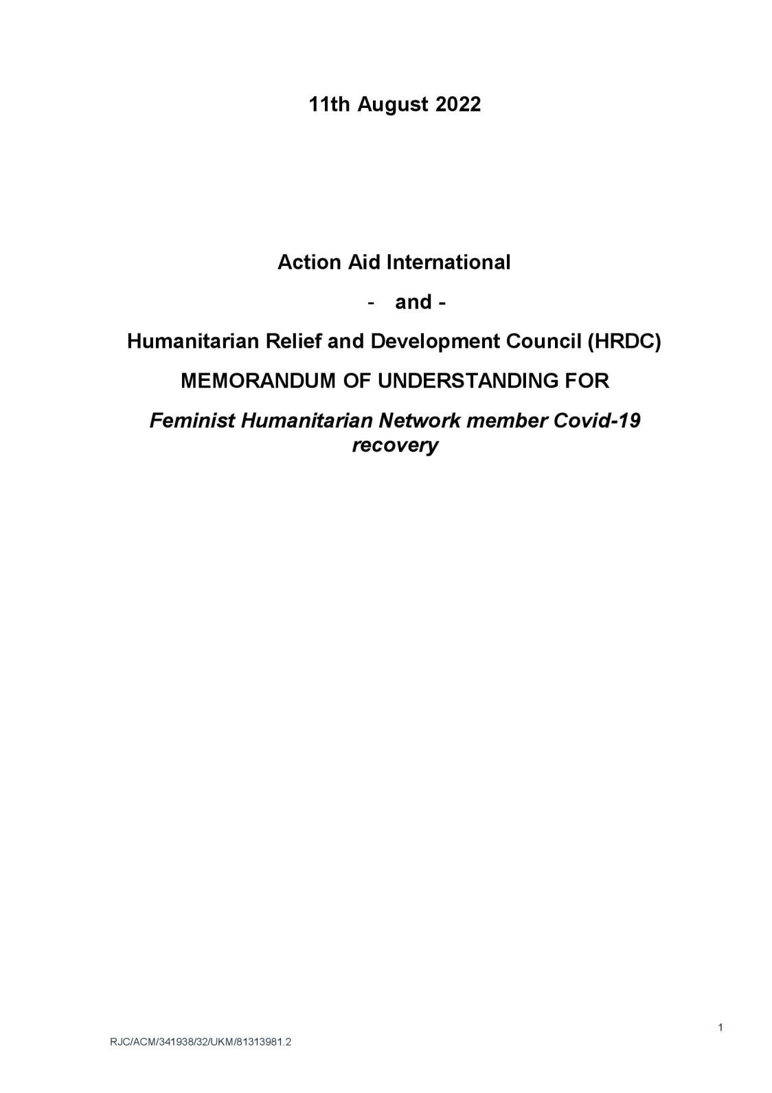

Annex 2: page 2

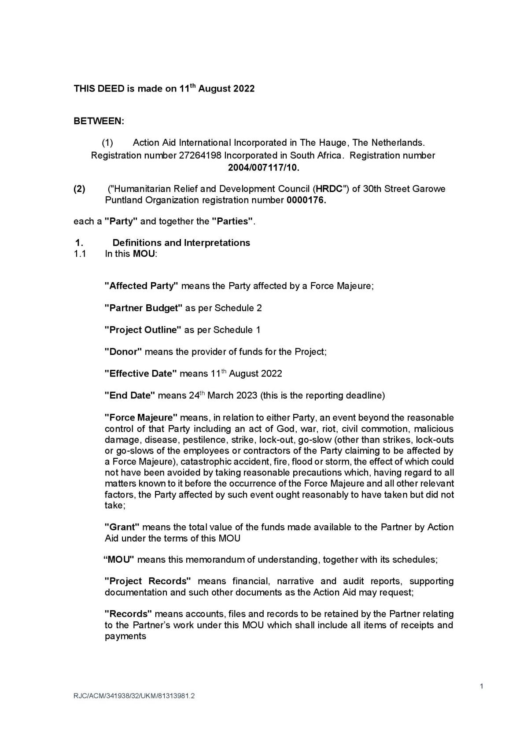

Annex 3: page 3

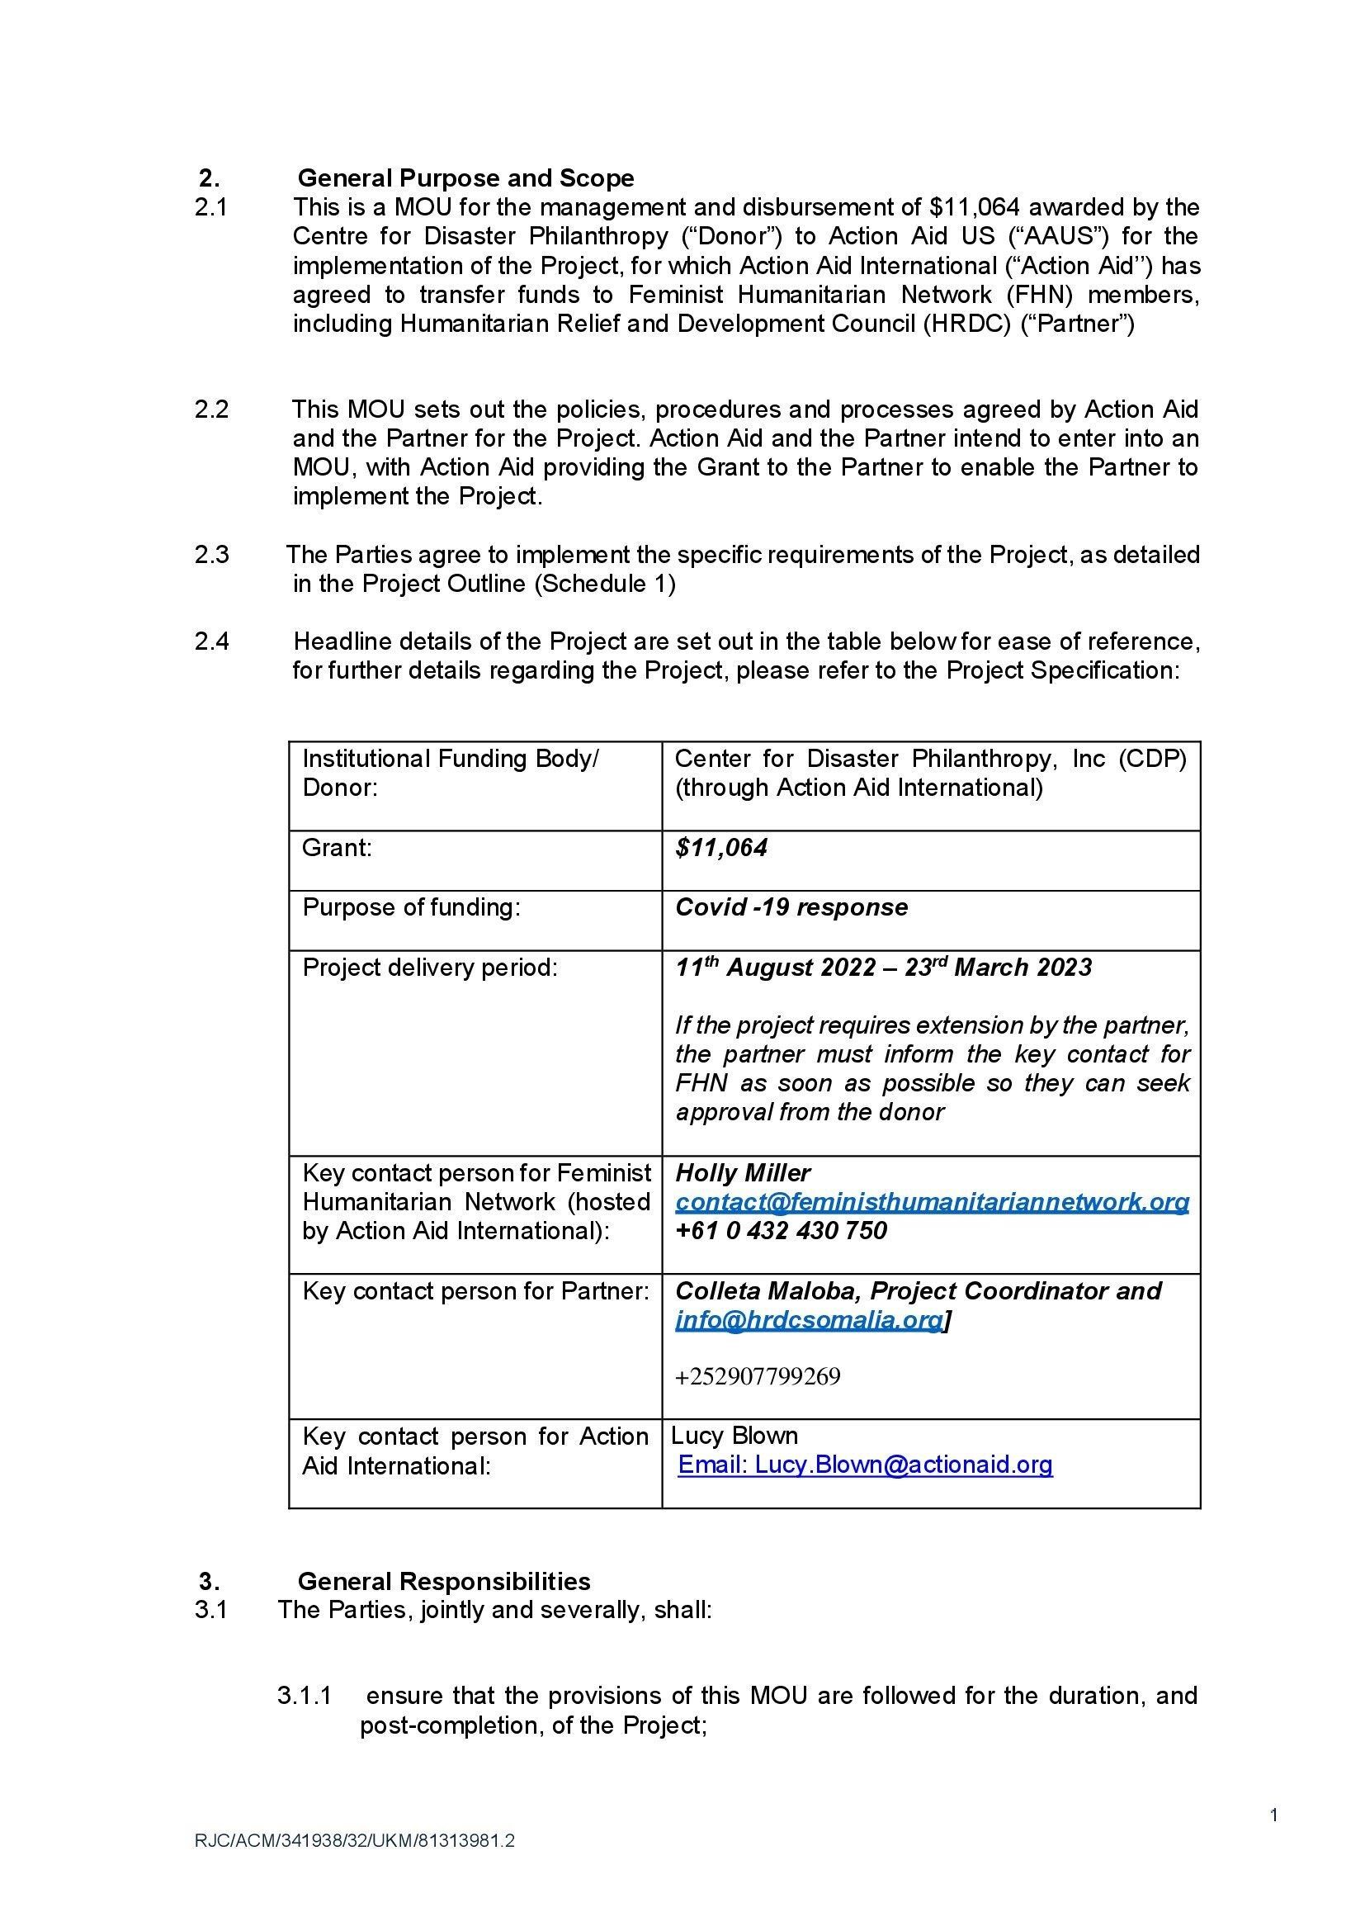

Annex 4: page 13

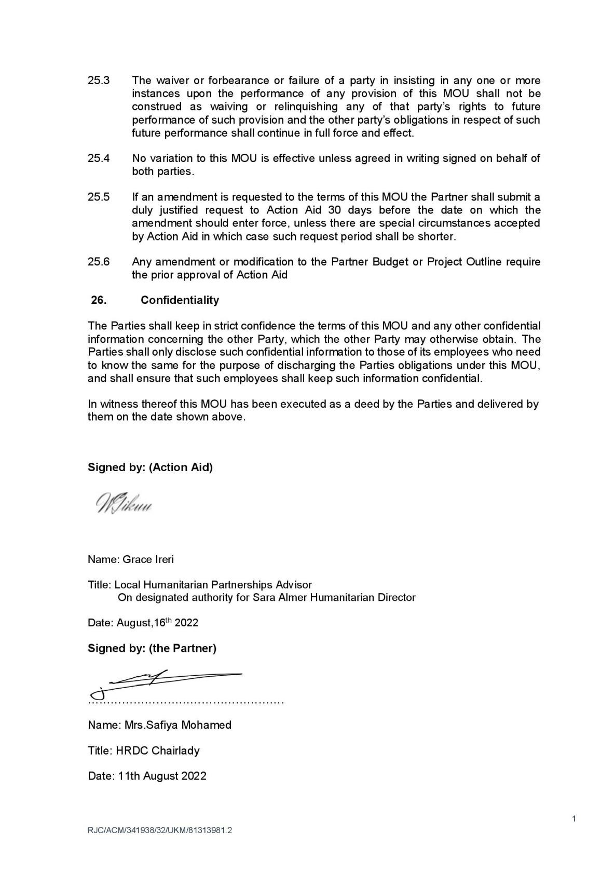

Annex 5: Bank transaction copy

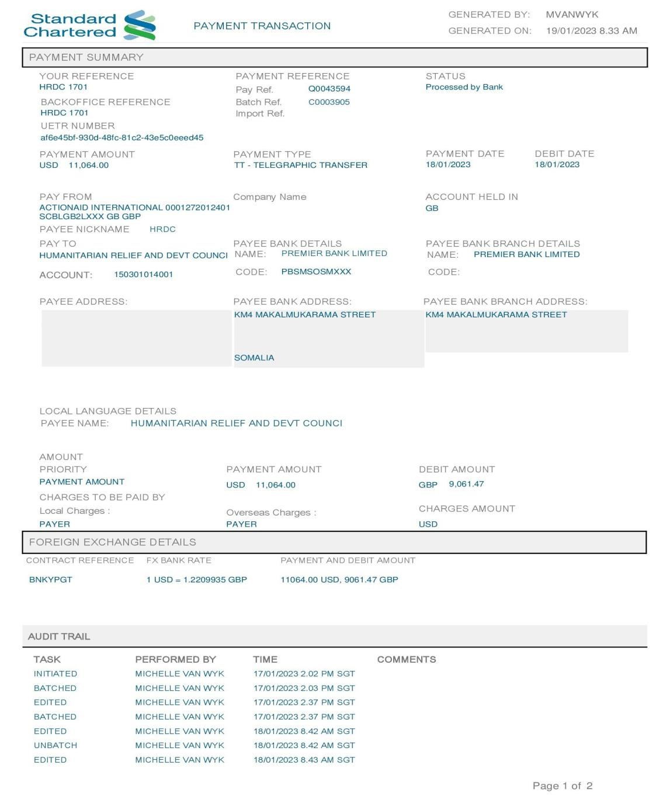



1. Giovanna Kuele and Ana Cristina Miola. (2017, November 7). Somalia: The Role of Climate Change in Recurring

   Violence. Retrieved fro[m https://reliefweb.int/report/somalia/somalia-role-climate-change-recurring-violence](https://reliefweb.int/report/somalia/somalia-role-climate-change-recurring-violence) 
2. Fahima Abdi. (2021, May 11). Impact of climate change on Somali women pastoralists (nomadic): unreported climate victims, Somalia rural women. Retrieved fro[m https://www.linkedin.com/pulse/impact-climate-change-somali-womenpastoralists-nomadic-fahima-abdi](https://www.linkedin.com/pulse/impact-climate-change-somali-women-pastoralists-nomadic-fahima-abdi) 
3. Fahima Abdi. (2021, May 11). Impact of climate change on Somali women pastoralists (nomadic): unreported climate victims, Somalia rural women. Retrieved fro[m https://www.linkedin.com/pulse/impact-climate-change-somali-womenpastoralists-nomadic-fahima-abdi](https://www.linkedin.com/pulse/impact-climate-change-somali-women-pastoralists-nomadic-fahima-abdi) 
4. Red Cross Red Crescent Climate Centre. Climate fact sheet Somalia. Retrieved fro[m https://www.climatecentre.org/wpcontent/uploads/RCCC-ICRC-Country-profiles-Somalia.pdf](https://www.climatecentre.org/wp-content/uploads/RCCC-ICRC-Country-profiles-Somalia.pdf) 
5. Red Cross Red Crescent Climate Centre. Climate fact sheet Somalia. Retrieved from [https://www.climatecentre.org/wpcontent/uploads/RCCC-ICRC-Country-profiles-Somalia.pdf](https://www.climatecentre.org/wp-content/uploads/RCCC-ICRC-Country-profiles-Somalia.pdf)

  
6. UNDP. Overview of linkages between gender and climate change. Retrieved from <https://www.undp.org/sites/g/files/zskgke326/files/publications/PB1-AP-Overview-Gender-and-climate-change.pdf>

  
7. heinrich Böll Foundation. Gender and Climate change: Botswana Case Study. Retrieved from <https://www.boell.de/sites/default/files/assets/boell.de/images/download_de/ecology/Botswana(1).pdf>
8. UN Women. Climate resilient and empowering livelihoods for women. Retrieved from

   [https://asiapacific.unwomen.org/sites/default/files/Field%20Office%20ESEAsia/Docs/Publications/2016/01/CLI](https://asiapacific.unwomen.org/sites/default/files/Field%20Office%20ESEAsia/Docs/Publications/2016/01/CLIMATE%20RESILIENT%20AND%20EMPOWERING%20LIVELIHOODS%20FOR%20WOMEN.pdf)

   [MATE%20RESILIENT%20AND%20EMPOWERING%20LIVELIHOODS%20FOR%20WOMEN.pdf](https://asiapacific.unwomen.org/sites/default/files/Field%20Office%20ESEAsia/Docs/Publications/2016/01/CLIMATE%20RESILIENT%20AND%20EMPOWERING%20LIVELIHOODS%20FOR%20WOMEN.pdf) 
9. UN Women. Climate resilient and empowering livelihoods for women. Retrieved from

   [https://asiapacific.unwomen.org/sites/default/files/Field%20Office%20ESEAsia/Docs/Publications/2016/01/CLI](https://asiapacific.unwomen.org/sites/default/files/Field%20Office%20ESEAsia/Docs/Publications/2016/01/CLIMATE%20RESILIENT%20AND%20EMPOWERING%20LIVELIHOODS%20FOR%20WOMEN.pdf)

   [MATE%20RESILIENT%20AND%20EMPOWERING%20LIVELIHOODS%20FOR%20WOMEN.pdf](https://asiapacific.unwomen.org/sites/default/files/Field%20Office%20ESEAsia/Docs/Publications/2016/01/CLIMATE%20RESILIENT%20AND%20EMPOWERING%20LIVELIHOODS%20FOR%20WOMEN.pdf) 
10. UN Women. Climate resilient and empowering livelihoods for women. Retrieved from

    [https://asiapacific.unwomen.org/sites/default/files/Field%20Office%20ESEAsia/Docs/Publications/2016/01/CLI](https://asiapacific.unwomen.org/sites/default/files/Field%20Office%20ESEAsia/Docs/Publications/2016/01/CLIMATE%20RESILIENT%20AND%20EMPOWERING%20LIVELIHOODS%20FOR%20WOMEN.pdf)

    [MATE%20RESILIENT%20AND%20EMPOWERING%20LIVELIHOODS%20FOR%20WOMEN.pdf](https://asiapacific.unwomen.org/sites/default/files/Field%20Office%20ESEAsia/Docs/Publications/2016/01/CLIMATE%20RESILIENT%20AND%20EMPOWERING%20LIVELIHOODS%20FOR%20WOMEN.pdf) 
11. UN Women. Climate resilient and empowering livelihoods for women. Retrieved from

    [https://asiapacific.unwomen.org/sites/default/files/Field%20Office%20ESEAsia/Docs/Publications/2016/01/CLI](https://asiapacific.unwomen.org/sites/default/files/Field%20Office%20ESEAsia/Docs/Publications/2016/01/CLIMATE%20RESILIENT%20AND%20EMPOWERING%20LIVELIHOODS%20FOR%20WOMEN.pdf)

    [MATE%20RESILIENT%20AND%20EMPOWERING%20LIVELIHOODS%20FOR%20WOMEN.pdf](https://asiapacific.unwomen.org/sites/default/files/Field%20Office%20ESEAsia/Docs/Publications/2016/01/CLIMATE%20RESILIENT%20AND%20EMPOWERING%20LIVELIHOODS%20FOR%20WOMEN.pdf) 
12. Fahima Abdi. (2021, May 11). Impact of climate change on Somali women pastoralists (nomadic): unreported climate victims, Somalia rural women. Retrieved fro[m https://www.linkedin.com/pulse/impact-climate-change-somali-womenpastoralists-nomadic-fahima-abdi](https://www.linkedin.com/pulse/impact-climate-change-somali-women-pastoralists-nomadic-fahima-abdi) 
13. BU. The Gendered Impacts of Climate Change. Retrieved from [https://www.bu.edu/eci/2022/05/17/thegendered-impacts-of-climate-](https://www.bu.edu/eci/2022/05/17/the-gendered-impacts-of-climate-change/#:~:text=Additionally%2C%20women%20and%20girls%20report,not%20%E2%80%9Cwomen%2Dfriendly%E2%80%9D)

    [change/#:~:text=Additionally%2C%20women%20and%20girls%20report,not%20%E2%80%9Cwomen%2Dfrie ndly%E2%80%9D.](https://www.bu.edu/eci/2022/05/17/the-gendered-impacts-of-climate-change/#:~:text=Additionally%2C%20women%20and%20girls%20report,not%20%E2%80%9Cwomen%2Dfriendly%E2%80%9D)

   
14. BU. The Gendered Impacts of Climate Change. Retrieved from [https://www.bu.edu/eci/2022/05/17/thegendered-impacts-of-climatechange/#:~:text=Additionally%2C%20women%20and%20girls%20report,not%20%E2%80%9Cwomen%2Dfrie ndly%E2%80%9D.](https://www.bu.edu/eci/2022/05/17/the-gendered-impacts-of-climate-change/#:~:text=Additionally%2C%20women%20and%20girls%20report,not%20%E2%80%9Cwomen%2Dfriendly%E2%80%9D)
15. Harwell, M. R. (2011). Research design: Qualitative, quantitative, and mixed methods: Pursuing ideas as the keystone of exemplary inquir. In C. Conrad, & R. C. Serlin (Eds.), The Sage handbook for research in education:

    Pursuing ideas as the keystone of exemplary inquir (Second Edition ed.). Sage.
16. Mugenda, O.M. & Mugenda, A.G. (2003). Research methods: quantitative and qualitative approaches.Nairobi: Acts Press.

   
17. NUPI. (2021, February 3). Climate, Peace and Security Fact Sheet: Somalia. Retrieved from <https://www.nupi.no/en/news/climate-peace-and-security-fact-sheet-somalia>
18. NUPI. (2021, February 3). Climate, Peace and Security Fact Sheet: Somalia. Retrieved from <https://www.nupi.no/en/news/climate-peace-and-security-fact-sheet-somalia>
19. Making Prosperity. sustainable and healthy food for all. Retrieved from [https://makingprosperity.com/solutions- details/sustainable-and-healthy-food-for-all-50](https://makingprosperity.com/solutions-%20details/sustainable-and-healthy-food-for-all-50) 