FINAL REPORT OF SOCIAL CHANGE INITIATIVE:

SOCIO-ECONOMIC INTERVENTION FOR VULNERABLE
GRASSROOTS WOMEN

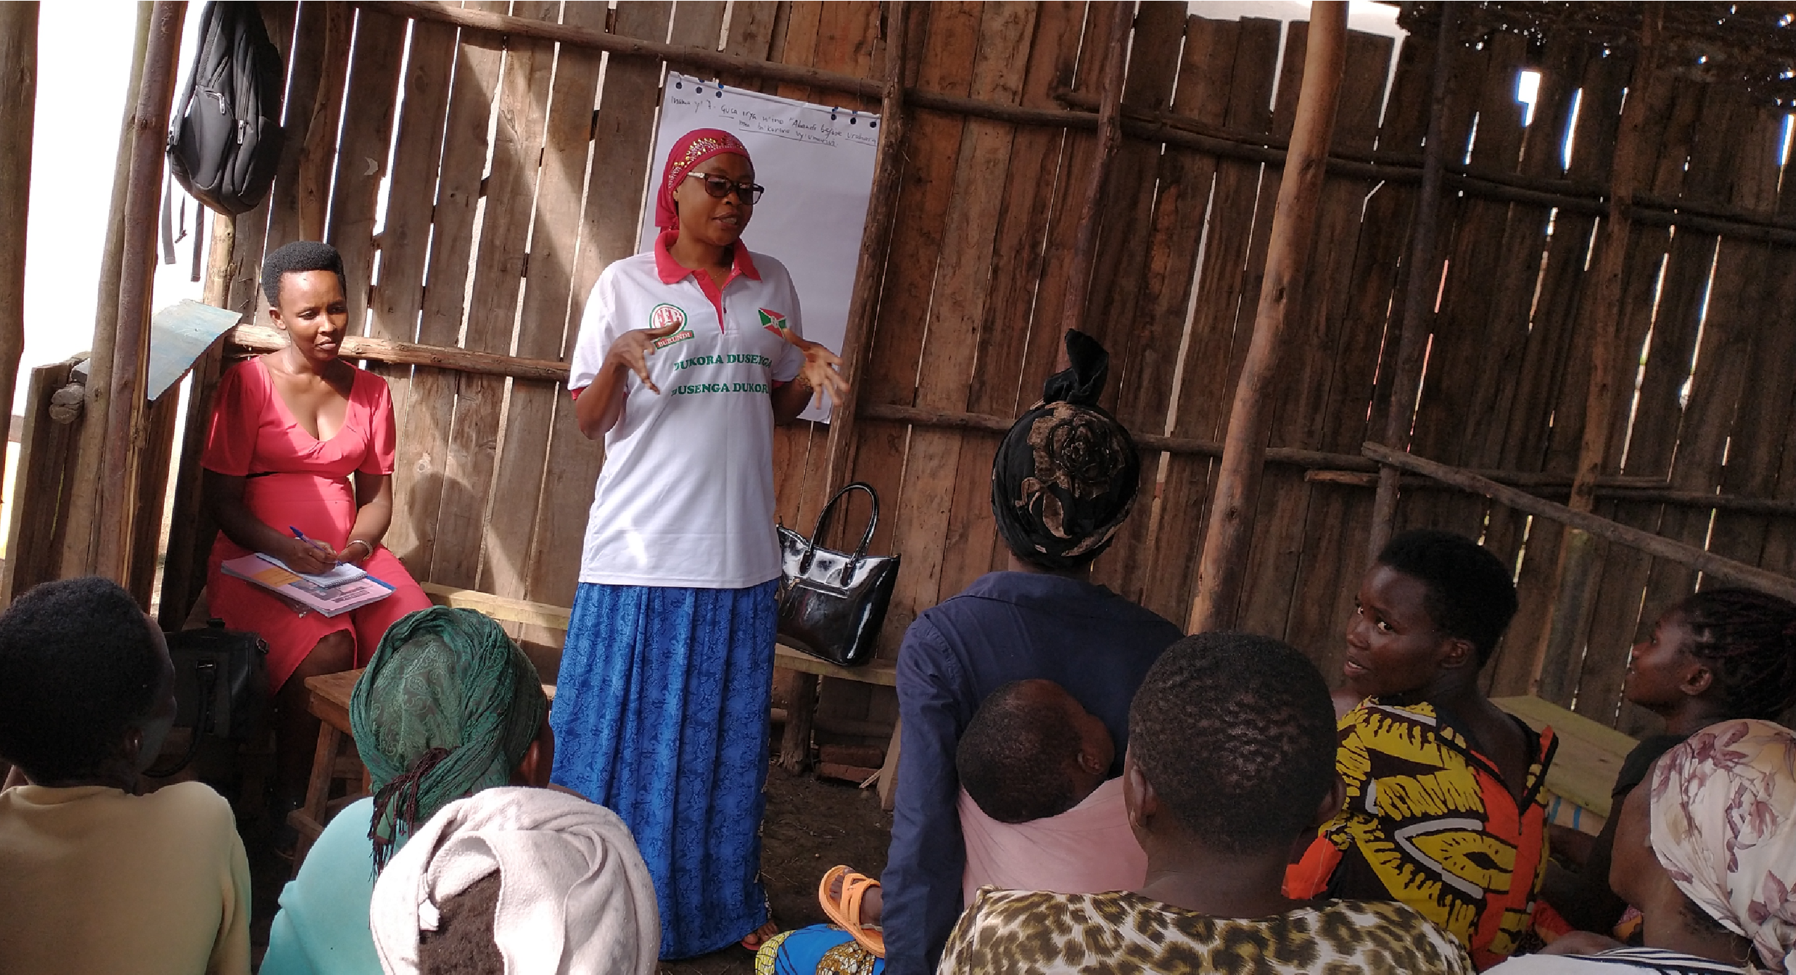

Implementation period:
June - December 2021

1. About SEMERERA

Semerera was founded in 2013 by human rights advocates and community organizers who dreamed of a free and inclusive Burundian society for all. The Kirundi name of the organization, "Semerera," ("Speak Out" in English), refers to the founders’ desire to equip women from local communities to take the lead in standing up against all forms of injustice, increase their participation in decision-making and peacebuilding processes, and contribute to the socioeconomic development of their families.

2. About the Project
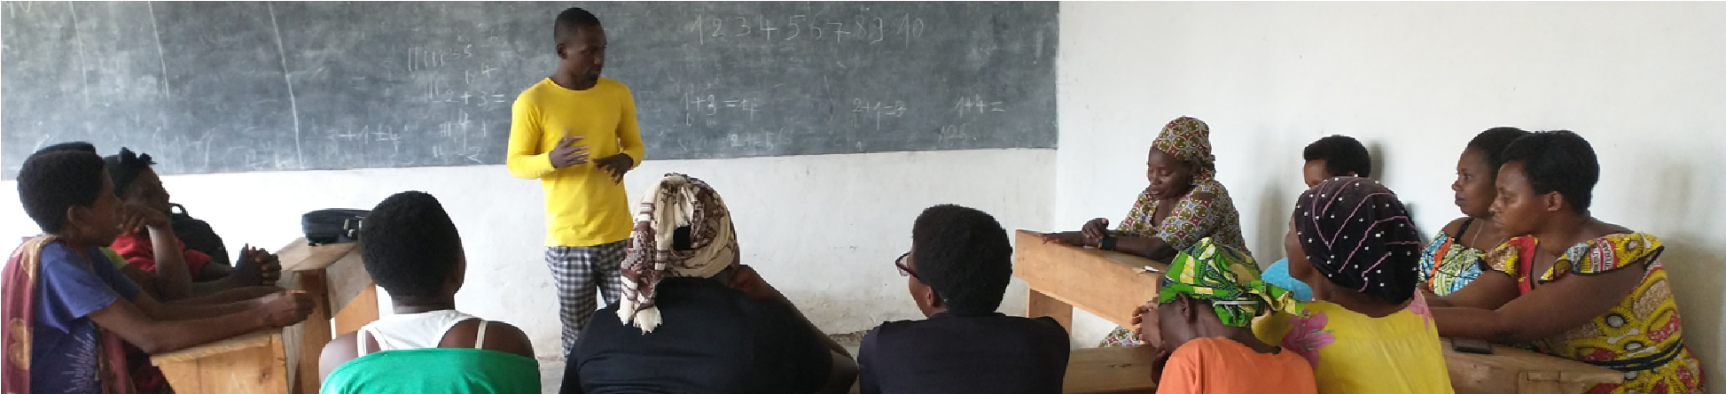

In 2021, SEMERERA received a grant from the National Endowment for Democracy to implement a project to equip women from 10 local communities with the necessary knowledge and skills to independently advocate all forms of injustice against women, girls, and children. Among the objectives of the project were to give the women the necessary skills and link them up with new opportunities to improve their livelihoods and enable them to independently carry out strategic advocacy activities for the promotion and protection of the rights of women, girls, and children in their communities.

To that end, SEMERERA adapted Spark Microgrants’ Facilitated Communal Action Process (FCAP) approach that combines capacity building and financial support to empower local communities. A few elements were added including:

- partner with small women’s groups (30-40 members per group)
- a 12-month process: 3 months for the planning phase, 3 for implementation, and 6 for postimplementation (followup).
- regular networking opportunities between the women's groups themselves and between the groups with other stakeholders (local and international NGOs, government institutions, branches of ministries, etc).
- involvement of media to amplify women’s voice.

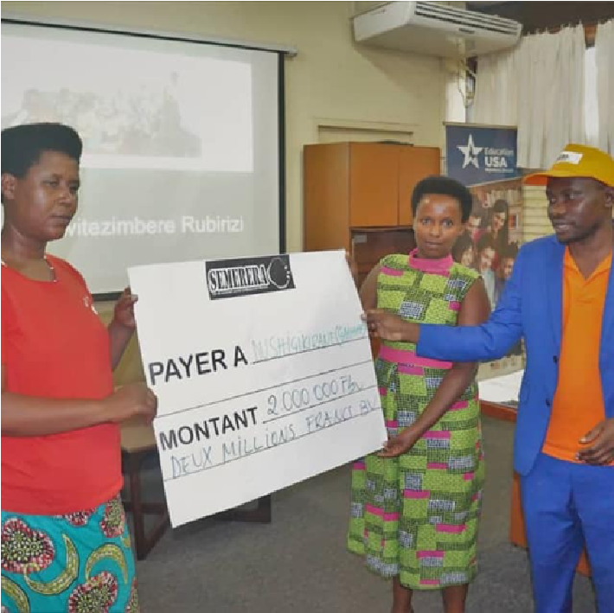
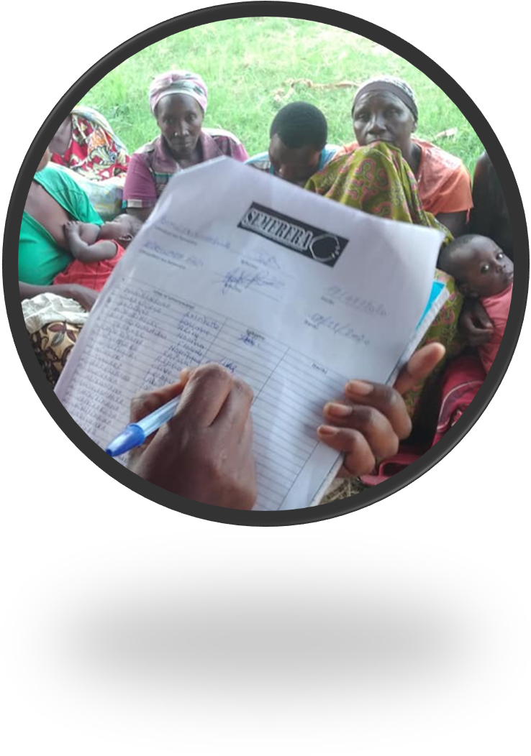
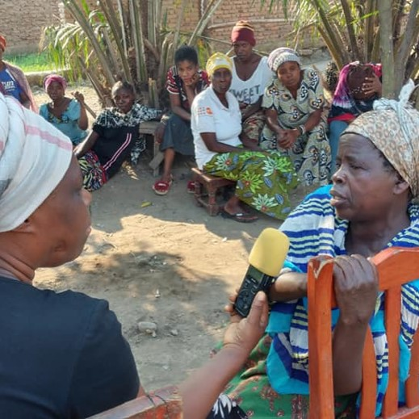

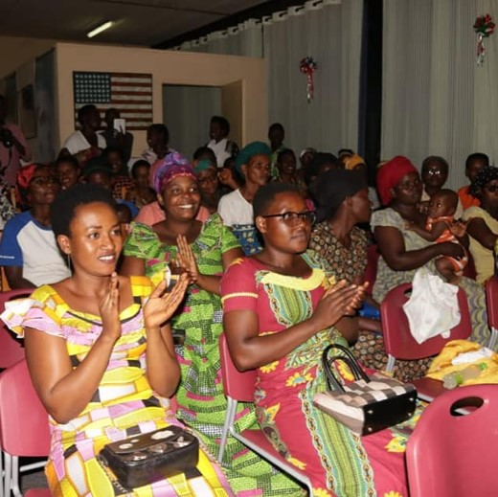
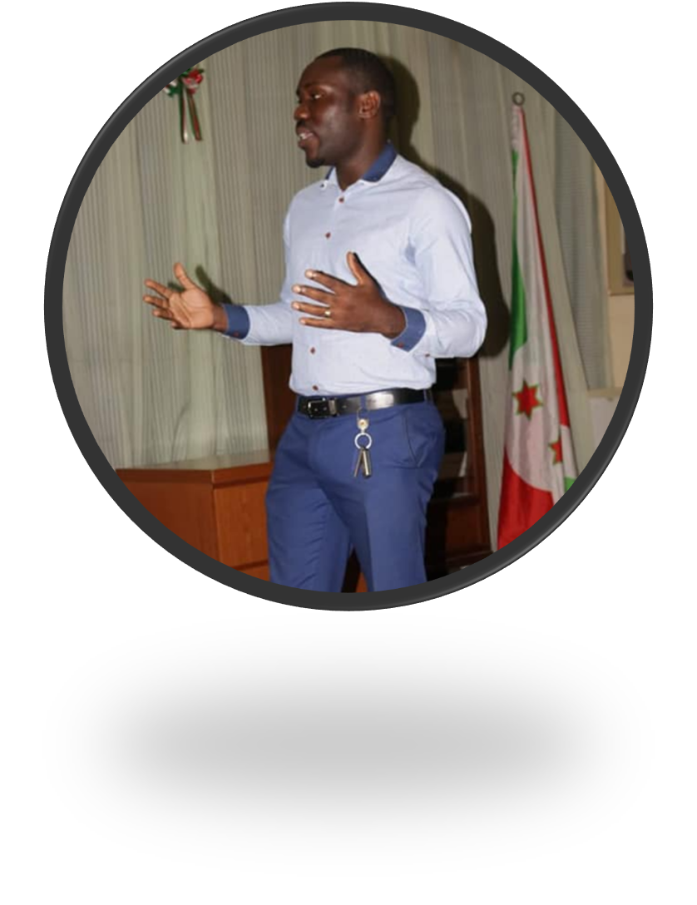
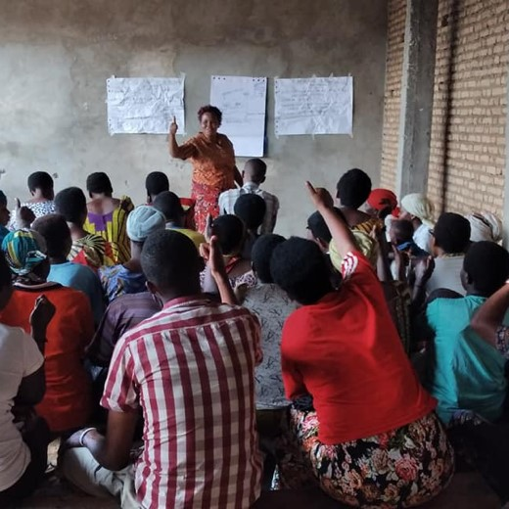
3.
Project Highlights

14
networkin
g/
advocacy
17

NGOs
involved

51

media
coverage
s

178

weekly
meetings

10

small
grants

10

groups

(408
women)

4. Project Updates/Outcomes

- Amplification of women’s voice through the media:
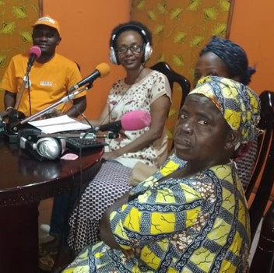
After attending the public advocacy and networking events, several media wanted to know more about the women’s groups and their activities. RTNB (Burundi
National Radio-Television), Radio-Television Isanganiro (the biggest private radio-television in Burundi), Radio Colombe FM (a youth and women's radio supported by UNFPA (UNFPA)), Jimbere Magazine, Le Renouveau were among the media groups that gave the women more opportunities to talk about their personal stories and about the overall situation of women’s rights in their communities. In total, the 10 women’s groups were featured 51 times in the media (interviews, articles, reportages, invitations to debates and
other programs)

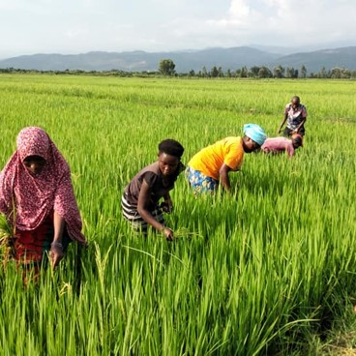
- 10 communal income-generating activities

Each of the 10 women’s groups received a grant of $1000 (Bif 2,000,000) to start their own income generating activities. Among the main projects implemented farming (rice, potatoes, maize). Six months after the beginning of implementation, each of the 10 groups had made a benefit of up to three times their capital.

- Increased access to loans for individual members

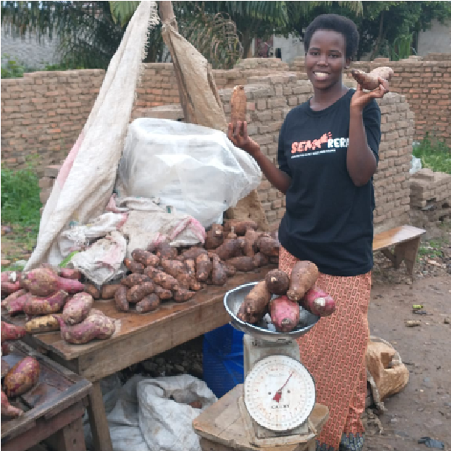
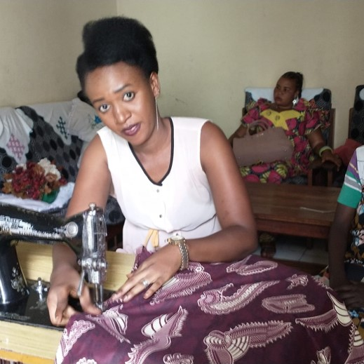
Six months after the beginning of the implementation of the communal projects, 89% of all individual members of the 10 groups were able to get individual loans for individual incomegenerating activities across. In groups that used to do savings and loans activities before partnering with us, a
monthly loan to an individual member increased on average from Bif 5,000 to Bif 50,000 while the number of people who could get a monthly loan went from 4
to 15. The proportion of those who were able to pay their loans back on time with a 5% interest rate across the groups was 98%. Food-selling, tailoring, craft-making are among the individual activities implemented by the women with the loans from their groups.
- An attractive initiative:

17 local and international NGOs (including CARE INTERNATIONAL, SPARK
MICROGRANTS, SACODE, US EMBASSY in Burundi), local officials and representatives from the Burundian ministry in charge of gender and women’s rights participated in the 14 networking and advocacy events organized on groups. Besides appreciating the events, some of them promised to support the women’s groups in their work and work together to improve their connditions. The Embassy of the United States of America in Burundi for instance kept its promise by sending a delegation to visit the Gatumba (western side of Bujumbura) women’s community group. The goal was to learn more about the community’s work and explore ways to collaborate with them in the future. The embassy agreed to fund the extension of the project to five more women’s groups from Gatumba in 2022.

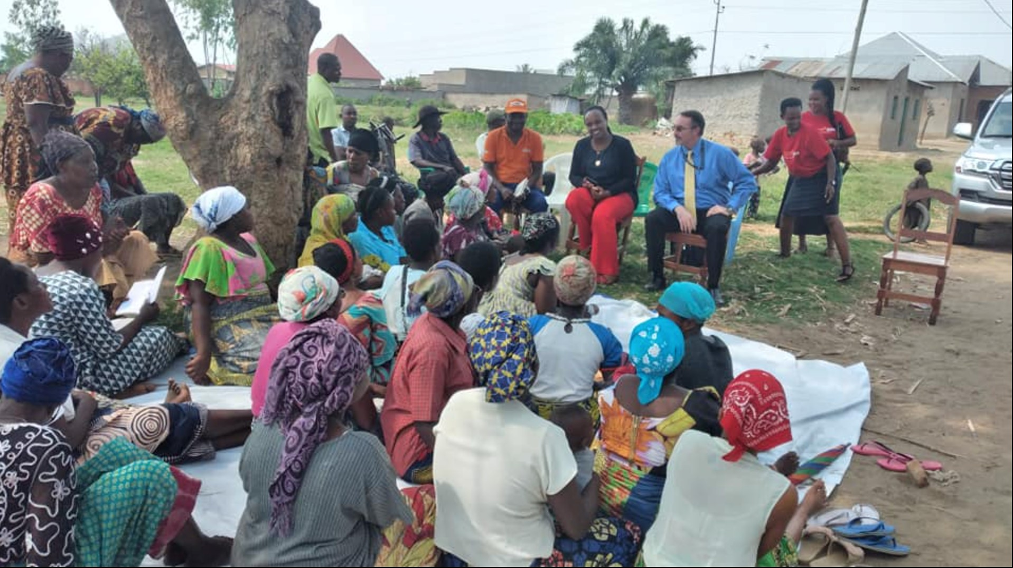
A delegation of the US Embassy in Burundi visited our women’s groups in Gatumba to explore ways of scaling up the project

5. Key Important Learnings from the project

- Small groups might be more efficient and well-preforming than larger groups:

Working with small groups of women from the same community has more advantages including flexibility, increased participation, and involvement in groups activities. In all the ten groups we worked with, members were from the same sub-village which reduced the distance to attend meetings. We preferred to work with small groups of 25-40 women per group. The average attendance was around 98% per meeting and the ratio between attendance and participation was always 100%. Because of their reduced number, participants had more opportunities for quality participation beyond mere opinion and short interventions. During all meetings, deeper group discussions, engagements, debates, multi-time interventions and presentations by individual members could be witnessed. And when the implementation period of their project came, all had almost something to contribute to time, and skills. This increased members accountability and contributed to the quality and impact of their work.

- Women’s grassroots groups are important bulwark against injustices in local communities
Throughout the implementation of the project, the 10 women’s groups we worked with were able to:
- identify and report numerous cases of abuses against women, girls, and children; they reported 116 situations of abuses (domestic violence, sexual abuses, negligence, trafficking, etc.) against women, girls, and children.
- collaborate with local leaders, law enforcement agents, and women’s rights organizations (including SEMERERA) for the prosecution of abusers: for instance 13 mature men responsible of the pregnancies of young school girls were prosecuted thanks to the support, involvement and collaboration of the women’s groups.
- initiate the organization of 46 advocacy community meetings to discuss the overall situation of the rights of women, girls, and children.
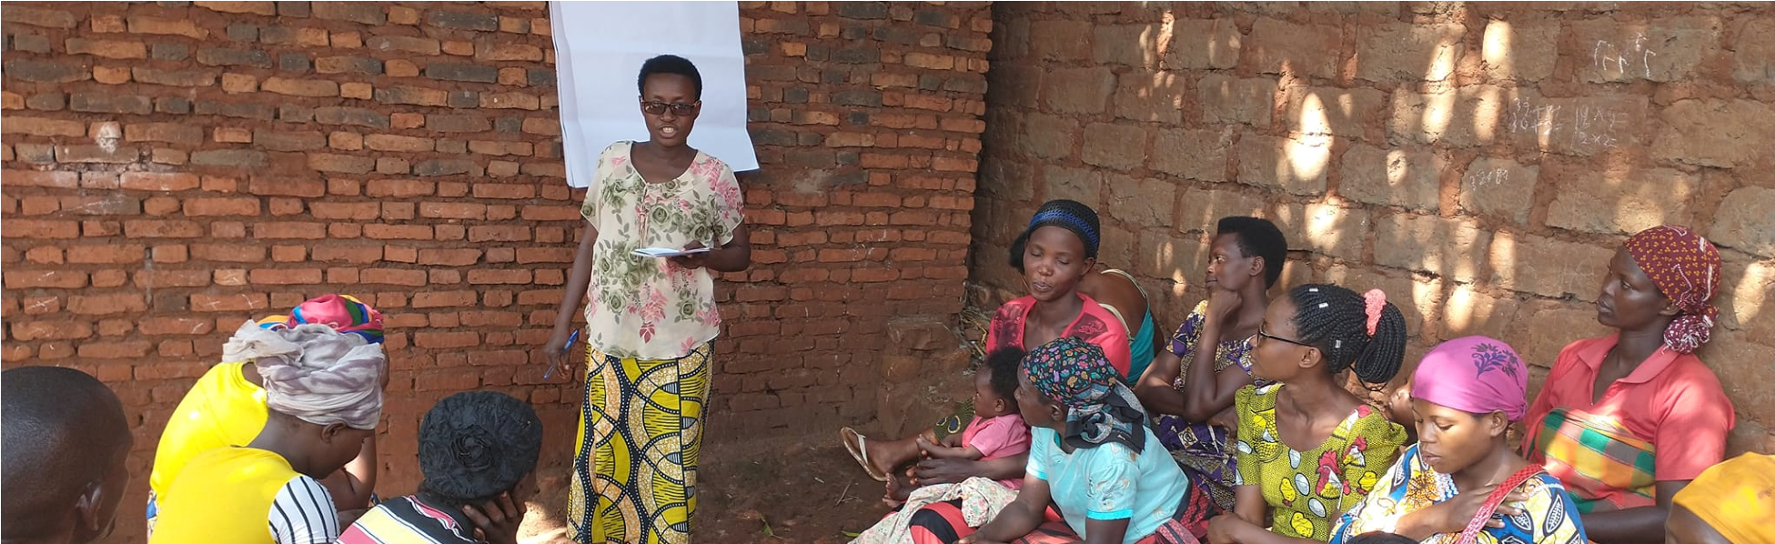
The above shows that grassroots women can play an important role as leading agents of change in their respective areas to develop a more democratic and egalitarian society. They have a huge potential to serve in the promotion and protection of their own rights as well as the rights of other vulnerable groups, such as girls, children, and people with disabilities. In addition to their savings and loan activities, they could easily become important local advocacy groups and serve as the eyes and ears of other stakeholders around the promotion of human rights (human rights NGOs, civil society organizations, etc.). In fact, these stakeholders don’t always have the necessary means and personnel to be present everywhere, at every time. Even when they have funded projects, these are limited in time and resources. Their intervention and protection will mostly cease with the end of the projects, and the beneficiary groups are likely to find themselves in the vulnerability situation they were in before the intervention.
That’s why it is highly important to meticulously identify sustainable ways to ensure vulnerable groups like women and girls are not always dependent on external support and intervention when it comes to the protection and promotion of their human rights. Prioritizing their involvement and implication in the fight against harmful social and cultural norms against them is therefore paramount. Among the main ways to achieve that is by equipping them with the necessary tools and skills to be able to independently stand up against injustices. These include the following actions:
- increasing their knowledge of their human rights.
- developing women's skills in dealing with cases of human rights abuses (what to do when they witness or have knowledge of them, how and to whom report serious violations of their rights, etc.).
- linking them to stakeholders in the area of women’s rights around where they live: this gives them ideas on when and where to report, seek support, etc.
- Where possible, provide them with the necessary tools to efficiently play their role.

