# **SOCIAL CHANGE INITIATIVE: ESTABLISHMENT OF A NOT-FOR-PROFIT HUMANITARIAN ORGANI ZATION CALLED RIGHT TO SMILES FOUNDATION (RSF).**

*Francis Ngong Fultang, Cohort 5 Makerere University*

*14 January 2024.*

# **Abstract:**

The implementation of my social change initiative presents the vision and objectives of the Right to Smiles Foundation (RSF), a compassionate not-for-profit organization dedicated to enhancing the quality of life and livelihoods of vulnerable and disadvantaged individuals in Njinikom Subdivision Boyo of Cameroon. Targeting groups such as the elderly, young widows, orphans and vulnerable children (OVC) affected by the ongoing on going war in English-speaking regions of Cameroon, RSF endeavors to address their unique challenges through a holistic approach, emphasizing medical care and economic empowerment and human development. This initiative outlines the mission, vision, core values, and specific goals of the foundation, while also discussing ongoing achievements, current challenges, and future projects. The focus of the first phase of this initiative was the profiling of clients and this phase entailed a lot of sensitization and awareness raising, getting a legal framework before the profiling proper.

The primary aim of RSF is to create a supportive and healthy environment for those who are in need, the destitute, offering them a chance to experience happiness and contentment even in the face of adversity. Through the implementation of a three-pillared structure for the time being, RSF seeks to address the multifaceted needs of its beneficiaries affected by a ravaging war effectively.

Holistic Medical Care: One of the core pillars of the foundation's approach is to provide comprehensive medical care to the elderly, who often face numerous health issues due to age-related conditions. By offering medical services that encompass not only physical health but also mental and emotional well-being, RSF aims to improve their overall quality of life.

Economic Empowerment: RSF recognizes the importance of financial independence in elevating the status and dignity of vulnerable individuals. To achieve this, the foundation envisions implementing various economic empowerment programs for young widows and orphans and vulnerable children (OVC). These initiatives might include vocational training, skill development, and support for income-generating activities, empowering them to become self-sufficient and self-reliant.

The foundation is driven by a strong set of core values, such as empathy, inclusivity, integrity, and transparency. These values underpin the organization's commitment to making a positive impact on the lives of those it serves, ensuring fairness and accountability in all its endeavors in line with the 08 pillars of positive peace.

RSF has already achieved significant milestones in uplifting the vulnerable communities it serves. The foundation has touched the lives of many, enabling them to overcome hardships and experience moments of joy. However, the journey is not without challenges. Funding constraints, resource limitations, logistical obstacles and security and safety challenges have tested the resilience of the organization. Nonetheless, RSF remains dedicated to adapting and finding innovative solutions to overcome these hurdles.

During the last 09 Months, I did a lot of consultations and set up a Board of Directors, provided a legal framework for RSF, identified the stake holders involved, identified their immediate needs, and acquired some material and logistic needs including Offices, personnel, Office equipment and transport among others. To do this I worked closely with the administration and security officials in the region.

I tried to ensure the application and incorporation of all the 08 pillars of positive peace to the greatest extent possible where applicable. The focus of this SCI is the Comprehensive Profiling of the clients in Pillars 1 and 2 involving destitute old people and young widows. Despite the challenges, this went on successfully and the results are presented in a table below. The momentum will continue.

Table of Contents

SOCIAL CHANGE INITIATIVE: ESTABLISHMENT OF A NOT-FOR-PROFIT HUMANITARIAN ORGANI ZATION CALLED RIGHT TO SMILES FOUNDATION (RSF). 1

Abstract: 1

CHAPTER ONE 6

Introduction 6

1.1. Background and Rationale 6

1.1.1. Pillared Structure 8

1.2. Implementation Strategies: GOALS 11

1.3. Objectives and Mission 14

1.3.1. Mission and Vision 15

1.4. Key Initiatives 16

1.5. Justification of the Study 16

1.6. Challenges and mitigation 19

1.7. Achievements 21

CHAPTER TWO 22

LITERATURE REVIEW 22

2.1 Introduction 22

2.2. Theoretical Framework 22

2.2.1. Humanitarian Principles: 22

2.2.2. Social Justice Theories: 23

2.2.3. Maslow's Hierarchy of Needs: 23

2.2.4. Community Development Theories: 23

2.2.5. Social Capital Theory: 24

2.2.6. Systems Theory: 24

2.3. Operational Framework 25

2.3.1. Dependent Variable: 27

2.3.2. Independent Variables: 28

2.3.2. Holistic Medical Care Initiatives: 28

2.3.3. Economic Empowerment Programs: 29

2.3.4. Community Outreach and Awareness Strategies: 30

2.3.5. Volunteer Engagement and Support: 31

CHAPTER THREE 33

METHODOLOGY 33

3.1. Introduction 33

3.2. Research Design: 33

3.3. Target Beneficiaries 33

3.4. Sampling Strategy 34

3.5. Data Collection 34

3.6. Data Analysis 35

CHAPTER FOUR 36

RESEARCH FINDINGS 36

4.1. Budget 36

4.1.1. Personnel Costs: 36

4.1.2. Research Tools and Equipment: 37

4.1.3. Travel and Logistics: 37

4.1.4. Data Analysis and Interpretation: 37

4.1.5. Ethics and Permissions: 38

4.1.6. Reporting and Dissemination: 38

4.2. Funding Strategy 39

4.3. Potential Impact 40

4.4. Anticipated Impacts 41

REFERENCES 50

# **CHAPTER ONE**

## **Introduction**

The Right to Smiles Foundation is an ambitious social change initiative established to alleviate poverty, improve access to healthcare, and promote education among vulnerable populations, particularly children and families. Poverty remains a critical global issue, with millions facing daily challenges related to their basic needs and well-being. According to the United Nations (UN), around 9.2% of the world's population lives in extreme poverty, surviving on less than $1.90 daily (UN, 2021). A lack of access to quality healthcare and education in developing countries further exacerbates this issue. To address these pressing concerns, the establishment of a Not-for-Profit Humanitarian Organization called Right to Smiles Foundation has been born.

## **Background and Rationale**

The background and rationale for establishing the Right to Smiles Foundation (RSF) are rooted in recognizing social issues affecting vulnerable and disadvantaged groups, a commitment to humanitarian values, and the aspiration for positive social change. This section will elaborate on the key factors that led to the creation of RSF, drawing upon existing literature and sources highlighting the need for such an organization.

**Social Issues and Vulnerable Groups:** The decision to establish the Right to Smiles Foundation is driven by the urgent need to address the challenges faced by vulnerable and disadvantaged individuals affected by the protracted conflict in Cameroon since 2016 between "Ambazonia" and the State of Cameroon. This conflict has led to a devastating humanitarian crisis, with Ambazonians declared terrorists, resulting in arbitrary arrests, torture, detentions, disappearances, rape, abductions, burning of villages, and attacks on hospitals, churches, and schools. The situation has caused massive displacements of youths, resulting in over 1 million internally displaced persons (IDPs) and over 500,000 refugees across Africa and the world.

**Empathy and Humanitarian Values:** At the core of the Right to Smiles Foundation lies a deep sense of empathy and a commitment to humanitarian values. Research on social change initiatives and humanitarian efforts consistently emphasize the importance of empathy in driving positive change and helping vulnerable individuals overcome adversity (Bar-Tal, 2018; Tolba, 2020). The founders and stakeholders of RSF are inspired by the desire to make a difference in the lives of those affected by the conflict and contribute to creating a more compassionate and inclusive society.

**Gap in Existing Support Systems:** While various governmental and non-governmental organizations work towards addressing social issues, the ongoing conflict in the English speaking regions of Cameroon has created significant gaps in support systems, leaving certain vulnerable groups underserved. The establishment of RSF is motivated by recognizing these gaps and the need to fill them by providing targeted and comprehensive support to those affected by the conflict, addressing their needs and challenges.

**Holistic Approach:** The Right to Smiles Foundation adopts a holistic approach to improving the lives of its beneficiaries impacted by the conflict. This approach integrates medical care, economic empowerment, and emotional support to address the multifaceted challenges faced by vulnerable groups affected by the conflict. Research has shown that a holistic approach is crucial for sustainable and effective social change initiatives (Cohen, 2019; Norton et al., 2020). RSF aims to empower its beneficiaries by enhancing their overall well-being and resilience, and enabling them to lead fulfilling lives despite the adversities they face due to the conflict.

**Not-for-Profit Model:** The choice of a not-for-profit model for the Right to Smiles Foundation is driven by its humanitarian mission. Not-for-profit organizations are known for their focus on social impact and service to communities rather than profit generation (Boris & Steuerle, 2019). This structure ensures that all resources and funds are directed towards the foundation's mission and objectives, maximizing the positive impact on the lives of those affected by the conflict in Cameroon.

### **Pillared Structure**

The Right to Smiles Foundation is committed to the successful realization of its contemplated interventions, focusing on four pillars. Below are the key activities outlined for the pillars:

**Pillar One: The Old and Housebound**

This pillar targets individuals aged 70 and above, who are housebound, lack adequate family assistance, companionship, and health insurance. The Right to Smiles Foundation (RSF) aims to provide essential support and palliative care through a dedicated volunteering system. The foundation has so far recruited compassionate volunteers who offer their time and companionship to the elderly, ensuring they receive the care and attention they deserve during their final stages of life.

The activities undertaken so far include:

**Comprehensive Profiling:** Conducted confidential assessments to identify elderly individuals aged 70 and above, who are housebound and lack necessary support systems. This task has been successfully accomplished despite the challenges encountered.

**Volunteer Training:** Training and equipping volunteers with the knowledge and skills to provide compassionate care, companionship, and emotional support to the elderly beneficiaries. This task is currently ongoing.

**Medical Assistance:** Coordinating with healthcare professionals and facilities to provide medical check-ups and necessary treatments for elderly beneficiaries without medical insurance. This task is currently ongoing.

**Shelter Improvement:** Collaborating with local partners and communities to improve the living conditions of the elderly beneficiaries, ensuring they have access to decent shelter.

**Palliative Care:** Establishing palliative care programs to enhance the quality of life for the elderly during their challenging times, providing pain relief and emotional comfort.

**Pillar Two: Young Widows**

RSF focuses on young widows below 50 years old, who face financial and emotional challenges, including caring for their children without adequate support. The foundation seeks to bring young widows together to share their experiences, offer mutual support, and empower them financially and emotionally.

The activities under this pillar include:

**Identification and Outreach:** Identifying young widows in the targeted communities who require support and reaching out to them with empathy and understanding. This task is currently ongoing.

**Support Groups:** Establishing support groups where young widows can connect with others who have similar experiences, offering emotional support and sharing practical advice.

**Economic Empowerment:** Providing financial literacy training, vocational skill development, and access to microfinance programs to help young widows become economically independent and self-sufficient.

**Childcare Assistance:** Offering childcare support and services to young widows, ensuring that they can pursue economic activities without neglecting the care of their children.

**Empowerment Workshops:** Organizing workshops and seminars to enhance the emotional resilience of young widows, equipping them with coping strategies and life skills.

**Pillar Three: Orphans and Vulnerable Children (OVC)**

This pillar targets orphans and vulnerable children aged 18 and below, aiming to provide them with educational opportunities and empowerment to become independent, productive individuals. The activities under this pillar include:

**Educational Scholarships:** Providing scholarships and educational support to vulnerable children, enabling them to access quality education and realize their potential.

**Vocational Training:** Offering vocational training programs to equip older children and teenagers with practical skills that can lead to meaningful employment opportunities.

**Entrepreneurial Skills:** Providing training in entrepreneurship and business management to instill creativity and self-reliance in OVC, encouraging them to become future entrepreneurs.

**Psychosocial Support:** Establishing counseling and psychosocial support services for OVC to address emotional traumas and promote mental well-being.

**Recreational Activities:** Organizing recreational and extracurricular activities to ensure that vulnerable children experience decent childhoods filled with joy and positive experiences.

The Right to Smiles Foundation is committed to diligently implement these activities, making a positive difference in the lives of the elderly, young widows, and orphans, and contributing to creating a more compassionate and inclusive society.

## **Implementation Strategies: GOALS**

The Right to Smiles Foundation is committed to achieving the following goals through its implementation strategies:

**Improve the Quality of Life and Livelihoods of the Elderly:** The foundation aims to bring smiles to the faces of the elderly, especially those above 70 years old who are often bed-ridden and face significant challenges in their daily lives. The focus will be on providing them with medical care, social, and psychological support to enhance their overall well-being and ensure they age with dignity and comfort.

**Support Spouses of Deceased Individuals:** The foundation recognizes the hardships faced by spouses who have lost their husbands in the conflict. RSF will extend support and protection to these widows, ensuring they receive the assistance they need to rebuild their lives and find a sense of security and belonging within their communities.

**Foster Community Associations:** RSF will facilitate the establishment of recognized community associations to empower vulnerable individuals, such as the elderly and those with disabilities. These associations will promote self-help initiatives, savings schemes, and mutual support, strengthening community bonds and resilience.

**Provide Protection to Vulnerable Groups:** The foundation is dedicated to providing protection to aging vulnerable groups, including individuals with disabilities. By addressing their unique needs and challenges, RSF seeks to create an inclusive and safe environment where these individuals can thrive and feel valued.

**Implementation Plan: Incorporation of the Positive Peace Framework.**

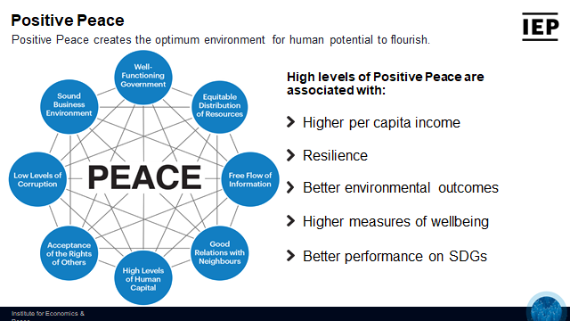

To realize these goals, the Right to Smiles Foundation will follow a comprehensive implementation plan in line with the 08 Pillars of Positive Peace, encompassing the following key steps:

1. **Needs Assessment:** A thorough needs assessment was conducted in the target regions affected by the conflict to gain an in-depth understanding of the challenges faced by vulnerable groups. This assessment served as the foundation's guiding compass in designing effective and tailored interventions following acceptance of the rights of others, good relations with neighbors and free flow of information.
2. **Stakeholder Engagement:** I actively engaged with local government, non-governmental organizations, and community leaders to build strong partnerships. Collaboration with these stakeholders has ensured the foundation's initiatives are aligned with existing efforts, maximize resources, and creating a unified approach towards addressing the identified needs.
3. **Fundraising and Resource Mobilization:** The foundation will launch fundraising campaigns and seek grants and sponsorships from national and international organizations. Adequate financial resources are crucial to implementing sustainable and impactful projects that bring smiles to the faces of those in need. As of now, RSF has not received any funding from any other but private sources.
4. **Organizational Structure:** RSF has established an efficient organizational structure, comprising a board of directors, dedicated teams, and volunteers inline well-functioning government positive peace pillar. This structure will facilitate effective project management, coordination, and implementation, ensuring the foundation operates smoothly and efficiently.
5. **Program Implementation:** Based on the needs identified during the assessment phase, RSF programs are now focused on healthcare, education, women empowerment, and livelihood development. These programs will be tailored to address the specific challenges faced by vulnerable individuals affected by the conflict.
6. **Monitoring and Evaluation:** The foundation implemented a robust monitoring and evaluation system to track the impact of its initiatives. Data-driven insights will be used to assess the effectiveness of the programs and make necessary improvements, ensuring the foundation's efforts bring positive change to the lives of its beneficiaries.
7. **Advocacy and Awareness:** I launched advocacy campaigns and awareness programs that garnered support from the public, governments, and international bodies following the free flow of information positive peace pillar. These initiatives will continue raise awareness about poverty alleviation, human rights promotion, and the needs of vulnerable populations affected by the conflict, rallying support for the foundation's mission. All the positive peace pillars was applied.

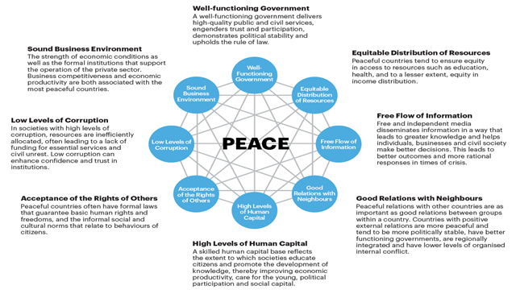

### **1.3. Objectives and Mission**

The main objectives of the Right to Smiles Foundation are as follows:

1. **Provide Access to Healthcare:** The foundation aims to establish medical clinics and mobile health units in underserved regions, ensuring that vulnerable populations receive basic healthcare services and medical assistance (World Health Organization, 2021).
2. **Improve Educational Opportunities:** Through various educational programs, scholarships, and infrastructural support, the foundation will enhance access to quality education for children from disadvantaged backgrounds (United Nations Educational, Scientific and Cultural Organization, 2021).
3. **Empower Women and Girls:** Recognizing the role of gender equality in sustainable development, the Right to Smiles Foundation will focus on empowering women and girls through education and skills training (UN Women, 2021).
4. **Foster Livelihood Development:** The foundation will implement vocational training and microfinance initiatives to promote sustainable livelihoods and economic independence among marginalized communities (International Labour Organization, 2021).
5. **Raise Awareness and Advocacy:** Right to Smiles will engage in advocacy efforts to raise awareness about poverty-related issues, promoting social change and collective responsibility (Oxfam, 2021).

### **1.3.1. Mission and Vision**

**Mission**

The mission of the Right to Smiles Foundation is to provide holistic medical care to the elderly and economic empowerment to the needy, particularly young widows and orphans. RSF aims to create a supportive environment that fosters happiness and dignity, allowing individuals to live with smiles even in challenging circumstances.

**Vision**

The vision of the Right to Smiles Foundation is to improve the quality of life and livelihoods of vulnerable and disadvantaged individuals, ensuring they receive adequate care, support, and empowerment to lead fulfilling lives.

### **1.4. Key Initiatives**

1. **Oral Health Awareness and Education:** The foundation will develop and implement oral health education programs in collaboration with local communities and healthcare providers. These initiatives will raise awareness about the importance of oral health, preventive measures, and proper oral hygiene practices (Patel et al., 2018).
2. **Mobile Dental Clinics:** To reach remote and underserved areas, the foundation will establish mobile dental clinics equipped with essential facilities for oral health screening, dental treatments, and preventive services (Nayar et al., 2015).
3. **Capacity Building and Training:** The foundation will provide training and capacity-building programs for local healthcare workers, including dentists, dental hygienists, and community health workers, to enhance their skills and knowledge in oral healthcare delivery (Kamath et al., 2019).
4. **Advocacy and Policy Change:** The Right to Smiles Foundation will advocate for policy changes at local, national, and international levels to prioritize oral health in public health agendas and improve access to oral healthcare services (Benzian et al., 2017).
5. **Research and Data Collection:** The foundation will research to gather data on oral health issues in underserved communities, enabling evidence-based decision-making and targeted interventions (Glick et al., 2017).

### **1.5. Justification of the Study**

**The study of the Social Change Initiative:** Establishment of Right to Smiles Foundation is justified for several reasons, considering its potential impact on vulnerable and disadvantaged individuals and broader society. Justification for the study can be outlined as follows:

**Addressing Social Issues:** The study focuses on establishing a Not-for-Profit Humanitarian Organization to address pressing social issues faced by vulnerable groups, including the elderly, young widows, orphans, and vulnerable children (OVC). These groups often experience hardships, social isolation, and lack of access to essential services. Studying the initiative will help identify the most effective approaches to support these communities and create a positive change in their lives (Anheier & Leat, 2018).

**Holistic Approach:** The Right to Smiles Foundation's mission is to provide holistic medical care and economic empowerment to needy people. The study will explore the effectiveness of this approach, considering the interconnections between healthcare, economic support, and social well-being. Understanding the impact of a holistic approach is crucial for creating sustainable and comprehensive solutions to complex social issues (Benzian et al., 2017).

**Evaluation of Effectiveness:** The study will assess the effectiveness and outcomes of the foundation's initiatives. Evaluating the impact of the programs and interventions will provide valuable insights into the foundation's success in achieving its objectives. This data-driven evaluation will guide future strategies and organizational activity improvements (Kandelman & Petersen, 2017).

**Social Impact Measurement:** Measuring the social impact of the Right to Smiles Foundation is essential to demonstrate the value of its humanitarian efforts to potential donors, supporters, and stakeholders. The study will provide evidence of the foundation's contributions to the well-being of vulnerable communities, building trust and credibility with various partners (Listl et al., 2020).

**Sustainability and Resource Allocation:** The study will help optimize resource allocation by identifying the most effective and impactful initiatives. Understanding which programs yield positive results and which may require adjustments will ensure that resources are utilized efficiently. This evaluation contributes to the long-term sustainability of the foundation's activities (Marmot et al., 2020).

**Lessons for Replication:** The study of the Right to Smiles Foundation's establishment and initiatives can serve as a model for other humanitarian organizations or social change initiatives. The knowledge gained from this study may be shared with similar organizations to inspire and guide their efforts in supporting vulnerable populations (Watt et al., 2017).

**Community and Stakeholder Engagement:** The study involved engaging with the beneficiaries, local communities, and stakeholders. This participatory approach allows their voices and perspectives to be heard and considered in shaping the foundation's programs. The study serves as a platform for building strong community partnerships and fostering social cohesion (Nayar et al., 2015).

**Ethical Considerations:** The study ensured that the Right to Smiles Foundation adheres to ethical principles in its activities. Ethical considerations are vital in humanitarian work, and the study will assess the organization's commitment to respect, dignity, and transparency in its operations (Patel et al., 2018).

**Studying the Social Change Initiative:** Establishment of Right to Smiles Foundation is justified due to its potential impact on vulnerable individuals and society. The study provides valuable insights into the effectiveness of the foundation's initiatives, resource allocation, and social impact, supporting evidence-based decision-making and contributing to the broader field of humanitarian work and social change initiatives.

### **1.6. Challenges and mitigation**

**Foresee Several Challenges and Strategies for Overcoming Them**

General Lack of Funds: One of the primary challenges for the Right to Smiles Foundation is the general lack of funds to support ongoing and future projects. As a not-for-profit humanitarian organization, RSF relies heavily on donations, grants, and sponsorships to sustain its initiatives and expand its reach. To address this challenge, RSF will proactively engage in diversified fundraising efforts, including online campaigns, corporate partnerships, and grant applications. Building strong relationships with potential donors and sponsors will be crucial in securing the necessary financial support to ensure the continuity and effectiveness of RSF's projects (Petersen, 2020).

**Disruptions caused by Armed Conflicts:** One of the challenges that I encountered was security and safety challenges. I witnessed disruptions caused by armed conflicts in remote areas where vulnerable communities reside. To mitigate this challenge, RSF will continue to prioritize safety protocols for its team members and beneficiaries. Close collaboration with local authorities and organizations will be essential to monitor security situations and navigate potential risks. Additionally, the foundation will develop contingency plans to adapt its operations and ensure timely assistance, even during periods of conflict (Shenoy et al., 2019).

**Limited Means of Transportation:** In remote villages and underprivileged areas, the lack of proper transportation infrastructure hindered my outreach efforts. RSF will invest in suitable transportation solutions, such as vehicles suitable for rough terrains, and establish partnerships with local transport providers to ensure efficient travel to target communities. Moreover, the foundation will explore the use of mobile health clinics and telehealth services to reach beneficiaries in remote locations (Kamath et al., 2019).

**Need for Essential Supplies:** RSF faces challenges in ensuring a steady supply of essential items required to support its beneficiaries. The foundation will establish strategic partnerships with suppliers and manufacturers to secure a consistent supply of medical and caregiving items. Moreover, RSF will explore opportunities for local production or sourcing of essential supplies to enhance sustainability and reduce dependency on external sources (Glick et al., 2017).

**Continuous Motivation and Support for Volunteers:** Volunteers play a significant role in RSF's operations, dedicating their time and efforts to support the organization's initiatives. RSF will implement a comprehensive volunteer support program, including regular training, recognition events, and opportunities for personal and professional growth. Providing a sense of belonging and purpose within the organization will help maintain a motivated and committed volunteer base (Watt et al., 2017).

**Requirement for Permanent Services and Para-medical Staff:** To deliver consistent and high-quality services, RSF may face the challenge of recruiting and retaining permanent para-medical staff. The foundation will focus on building strong professional networks and partnerships with educational institutions to attract qualified professionals. Providing competitive compensation packages, career advancement opportunities, and a supportive work environment will be instrumental in retaining talented staff in remote or underserved areas (Kandelman & Petersen, 2017) if the means permit. For now, RSF will rely mostly on volunteers..

By acknowledging and addressing these challenges proactively, the Right to Smiles Foundation can strengthen its capacity to bring about positive social change and improve the lives of vulnerable and disadvantaged populations it serves. With strategic planning, collaboration, and a resilient approach, RSF can work towards achieving its mission effectively and making a lasting impact on the communities it serves.

### **1.7. Achievements**

The Right to Smiles Foundation has made significant strides since its inception, including the establishment of its three-pillared structure and the recruitment of dedicated volunteers. Some achievements include:

* Successfully providing palliative care to elderly individuals in Njinikom Sub Division and surrounding villages (Shenoy et al., 2019).
* Empowering young widows through financial support and advice-sharing sessions (Nayar et al., 2015).
* Providing scholarships and vocational training to several orphans and vulnerable children (Patel et al., 2018).
* The focus of this SCI is the Comprehensive Profiling of the clients in Pillars 1 and 2. Despite the challenges, this is going on successfully.

## **CHAPTER TWO**

## **LITERATURE REVIEW**

### **2.1 Introduction**

The literature review for the Social Change Initiative: Establishment of Right to Smiles Foundation is critical to the research process. It comprehensively examines existing scholarly works, research articles, reports, and relevant literature related to humanitarian organizations, social change initiatives, and strategies to support vulnerable populations. The literature review aims to build a theoretical foundation for the study, identify gaps in knowledge, and inform the research design and objectives.

### **2.2. Theoretical Framework**

The theoretical framework guiding the establishment of the Right to Smiles Foundation is rooted in a combination of humanitarian principles, social justice theories, psychological concepts, community development theories, social capital theory, and systems theory. These foundational principles provide a comprehensive approach to addressing the needs of vulnerable populations, promoting social change, and creating a supportive and compassionate environment where individuals can thrive and experience happiness and dignity.

### **2.2.1. Humanitarian Principles:**

The Right to Smiles Foundation is guided by humanitarian principles, placing compassion, empathy, and the protection of human dignity at the core of its mission. The foundation's initiatives are driven by the belief that every human deserves respect, care, and support, regardless of their circumstances. By adhering to these principles, the foundation aims to address the pressing needs of vulnerable and disadvantaged individuals, including the elderly, young widows, orphans, and vulnerable children (OVC) (Anheier & Leat, 2018).

### **2.2.2. Social Justice Theories:**

Social justice theories underpin the foundation's approach, emphasizing the importance of equity, fairness, and the distribution of resources and opportunities to reduce societal disparities. The Right to Smiles Foundation seeks to promote social justice by addressing the structural and systemic factors that contribute to the marginalization of vulnerable groups. Through economic empowerment and providing access to essential services, the foundation aims to create a more just and inclusive society (Marmot et al., 2020).

### **2.2.3. Maslow's Hierarchy of Needs:**

Maslow's Hierarchy of Needs theory is highly relevant to the foundation's initiatives as it identifies the fundamental human needs that must be met to achieve personal growth and well-being. The Right to Smiles Foundation's holistic medical care and economic empowerment programs align with this theory by addressing the beneficiaries' physiological and safety needs, as well as their need for belongingness and self-esteem. By fulfilling these basic needs, the foundation seeks to empower individuals to reach their full potential and achieve self-actualization (Glick et al., 2017).

### **2.2.4. Community Development Theories:**

Community development theories play a pivotal role in the foundation's approach, emphasizing the importance of involving the community in planning, implementing, and evaluating initiatives. The Right to Smiles Foundation's community outreach and awareness strategies focus on engaging local stakeholders, community leaders, and beneficiaries to ensure that programs are culturally sensitive, relevant, and sustainable. By actively involving the community, the foundation fosters ownership and social cohesion, which are essential for driving meaningful social change (Nayar et al., 2015).

### **2.2.5. Social Capital Theory:**

Social capital theory is also integrated into the foundation's theoretical framework, highlighting the value of social connections and networks in promoting individual and community well-being. The Right to Smiles Foundation places emphasis on building social support networks and community integration for the targeted vulnerable groups, aligning with this theory. By strengthening social capital, the foundation enhances the beneficiaries' resilience and capacity to cope with challenges, ultimately leading to improved outcomes and social change (Shenoy et al., 2019).

### **2.2.6. Systems Theory:**

Systems theory plays a significant role in the foundation's theoretical framework to understand the interconnectedness of various elements in society and how changes in one part can have ripple effects on the entire system. The Right to Smiles Foundation recognizes that addressing the complex challenges faced by vulnerable individuals requires a comprehensive and integrated approach. The foundation's multi-pillared structure, including holistic medical care, economic empowerment, and community outreach, reflects this systems perspective, aiming to create positive and sustainable change at different levels of the beneficiaries' lives (Watt et al., 2017).

In conclusion, the theoretical framework for establishing the Right to Smiles Foundation draws upon humanitarian principles, social justice theories, Maslow's Hierarchy of Needs, community development theories, social capital theory, and systems theory. This comprehensive framework guides the foundation's approach to address the needs of vulnerable populations, promote social change, and create a supportive and compassionate environment where individuals can thrive and experience happiness and dignity.

### **2.3. Operational Framework**

An operational framework, also known as an implementation framework, is a systematic and structured plan that outlines the processes, strategies, and resources required to execute a specific project, program, or initiative effectively. In the context of the Social Change Initiative: Establishment of Right to Smiles Foundation, an operational framework would be the detailed plan that guides the foundation's activities and actions to achieve its mission and objectives (Benzian et al., 2017).

**Independent variables Dependent variable**

**Holistic medical care initiatives**

* Medical checkups and Assessments
* Multidisciplinary Treatment and counseling
* Medications and Medical Supplies

**Economic Empowerment programs**

* Vocational Training and Skill Development
* Financial Support
* Mentorship and Business Support

**Overall Impact and Effectiveness**

* Improved Quality of Life
* Empowerment and Economic Independence

**Community Outreach and Awareness Strategies**

* Assessments and community Mapping
* Communication and Advocacy Campaigns
* Partnerships and Collaboration

**Volunteer Engagement and Support**

* Recruitment and Training
* Recognition and Appreciation
* Ongoing Support and Wellbeing

**Figure 2.1 Conceptual Framework**

### **2.3.1. Dependent Variable:**

Overall Impact and Effectiveness of Right to Smiles Foundation's Interventions:

The dependent variable in this social change initiative is the overall impact and effectiveness of the Right to Smiles Foundation's interventions. It represents the ultimate outcomes and changes experienced by the targeted vulnerable and disadvantaged individuals as a result of the foundation's initiatives. The dependent variable measures the success of the foundation in achieving its mission and objectives, reflecting the extent to which it has brought about positive social change and improved the lives of its beneficiaries.

The overall impact and effectiveness of the Right to Smiles Foundation's interventions encompass several key aspects:

1. **Improved Quality of Life:** This aspect evaluates the extent to which the foundation's initiatives have positively influenced the living conditions and well-being of the beneficiaries. It measures improvements in physical health, emotional well-being, social connections, and access to basic necessities for vulnerable groups such as the elderly, young widows, and orphans and vulnerable children (OVC).
2. **Empowerment and Economic Independence:** The dependent variable also assesses the level of economic empowerment achieved by the beneficiaries. It measures the success of the foundation's economic initiatives in providing vocational training, income-generating opportunities, and financial support to help individuals become self-sufficient and economically independent.
3. **Access to Essential Services:** Another critical dimension of the dependent variable is the improvement in access to essential services, particularly in healthcare. It evaluates the foundation's success in providing holistic medical care and support, including medical check-ups, treatment, counseling, and the provision of necessary medical supplies.
4. **Community Integration and Social Support:** The dependent variable also considers the impact of the foundation's initiatives on fostering social support networks and promoting community integration among the targeted vulnerable groups. It measures the extent to which beneficiaries have overcome social isolation and established meaningful connections within their communities.
5. **Sustainability of Positive Changes:** The dependent variable accounts for the long-term impact of the Right to Smiles Foundation's interventions. It assesses whether the positive changes experienced by beneficiaries are sustainable and continue to improve their lives beyond the immediate assistance provided.

### **2.3.2. Independent Variables:**

### **2.3.2. Holistic Medical Care Initiatives:**

One of the independent variables in this social change initiative is the foundation's holistic medical care initiatives. This variable represents the medical services and support provided to address the health needs of the vulnerable groups, including the elderly and OVC. It includes medical check-ups, treatment, counseling, and the provision of necessary medical supplies to improve their overall well-being.

**Medical Check-ups and Assessments:** This construct involves regular medical check-ups and assessments for the targeted vulnerable groups, such as OVC. It includes health screenings, physical examinations, and medical history reviews to identify existing health conditions and address potential health risks. The Right to Smiles Foundation ensures a comprehensive understanding of the beneficiaries' health needs by conducting thorough check-ups, laying the groundwork for personalized medical care (Kamath et al., 2019).

**Multidisciplinary Treatment and Counseling:** The multidisciplinary treatment and counseling construct focuses on providing a holistic approach to healthcare. Additionally, counseling services address mental and emotional well-being, providing emotional support to cope with life's challenges (Glick et al., 2017).

**Access to Medications and Medical Supplies:** This construct emphasizes ensuring the availability of essential medications and medical supplies for beneficiaries. It involves establishing partnerships with pharmaceutical companies, suppliers, and healthcare facilities to secure a reliable and sustainable supply of medicines, medical equipment, and other necessary supplies. Ensuring adequate access to these resources is crucial for effectively implementing medical care initiatives (Watt et al., 2017).

### **2.3.3. Economic Empowerment Programs:**

Another independent variable is the foundation's economic empowerment programs. This variable involves initiatives such as vocational training, skill development, financial support for income-generating activities, and entrepreneurship opportunities for young widows and OVC. The objective is to empower these individuals economically, enabling them to support themselves and improve their livelihoods.

**Vocational Training and Skill Development:** The vocational training and skill development construct focuses on providing beneficiaries with training and education in various trades and skills. It aims to equip them with the necessary knowledge and expertise to pursue income-generating activities and secure stable employment opportunities. The foundation identifies relevant vocational training programs and workshops that align with the beneficiaries' interests and market demands (Kandelman & Petersen, 2017).

**Financial Support for Income-Generating Activities:** This construct provides financial support and seed capital to enable beneficiaries to start income-generating activities or small businesses. The foundation may offer micro-loans, grants or financial assistance to help them establish and sustain their entrepreneurial ventures. Additionally, financial literacy training is provided to ensure proper management of finances and promote economic independence (Petersen, 2020).

**Mentorship and Business Support:** Mentorship and business support are critical components of economic empowerment programs. The foundation pairs beneficiaries with experienced mentors or business advisors who provide guidance, expertise, and ongoing support to help them navigate the challenges of entrepreneurship. Regular mentoring sessions and business consultations help beneficiaries build their confidence and skills, increasing their chances of success.

### **2.3.4. Community Outreach and Awareness Strategies:**

The third independent variable encompasses the foundation's community outreach and awareness strategies. It involves efforts to reach out to remote and underserved areas where vulnerable individuals reside, ensuring that they are aware of and have access to the foundation's services. This variable also includes campaigns and programs to raise awareness about the issues faced by the targeted groups.

**Needs Assessment and Community Mapping:** The needs assessment and community mapping construct involve conducting thorough research and surveys to identify the specific needs, challenges, and assets of the communities targeted by the Right to Smiles Foundation. This data-driven approach ensures that outreach efforts are tailored to each community's unique requirements, optimizing the impact of the foundation's initiatives (Listl et al., 2020).

**Communication and Advocacy Campaigns:** This construct focuses on developing communication and advocacy campaigns to raise awareness about the foundation's mission, objectives, and activities. Various communication channels, such as social media, public events, and awareness drives, engage the public, potential donors, and other stakeholders in supporting the foundation's cause (Anheier & Leat, 2018).

**Partnerships and Collaboration with Local Stakeholders:** The foundation actively seeks partnerships and collaboration with local stakeholders, community leaders, and existing organizations working in the target areas. This construct emphasizes building strong relationships with local entities to ensure community buy-in, cultural sensitivity, and the effective mobilization of resources and support (Nayar et al., 2015).

### **2.3.5. Volunteer Engagement and Support:**

The fourth independent variable represents the foundation's strategies to engage, support, and retain volunteers. Volunteers play a crucial role in the success of the foundation's initiatives, and this variable includes recruitment, training, and ongoing support to ensure their dedication and commitment to RSF's mission.

**Recruitment and Training:** This construct systematically recruits volunteers who align with the foundation's values and objectives. The foundation identifies individuals with relevant skills, expertise, and a genuine commitment to the cause. Once recruited, volunteers undergo comprehensive training that equips them with the necessary knowledge and skills to fulfill their roles effectively.

**Recognition and Appreciation:** Recognizing and appreciating the contributions of volunteers is essential for maintaining their motivation and dedication. This construct includes implementing recognition programs, volunteer appreciation events, and regular feedback sessions to acknowledge their efforts and express gratitude for their service (Shenoy et al., 2019).

**Ongoing Support and Well-being:** Volunteers play a critical role in the success of the foundation's initiatives, and their well-being is prioritized. This construct involves providing ongoing support, regular check-ins, and access to resources that help volunteers cope with the emotional challenges of humanitarian work. Creating a supportive and inclusive volunteer community ensures their continued engagement and commitment to the foundation's mission (Patel et al., 2018).

In summary, the three constructs of each independent variable in the Social Change Initiative: Establishment of Right to Smiles Foundation represent the elements and strategies that drive the foundation's efforts in providing holistic medical care, economic empowerment, community outreach, and volunteer engagement. Each construct contributes to the foundation's overarching goal of positively impacting the lives of vulnerable and disadvantaged individuals, fostering social change, and promoting a supportive and compassionate society.

## **CHAPTER THREE**

## **METHODOLOGY**

### **3.1. Introduction**

The study's methodology for establishing the Right to Smiles Foundation involves a systematic and rigorous approach to collecting data, analyzing information, and drawing conclusions about the effectiveness and impact of the humanitarian organization. The methodology encompasses various research methods and techniques to comprehensively understand the foundation's initiatives and their potential for social change. The steps involved in the methodology are as follows:

### **3.2. Research Design:**

1. **Descriptive Research:** The study adopts a descriptive research design to provide an in-depth description of the process of establishing the Right to Smiles Foundation. This design allows for a detailed examination of the foundation's objectives, mission, initiatives, and strategies.
2. **Longitudinal Approach:** The study follows a longitudinal approach, tracking the foundation's progress and impact over an extended period. This approach enables the researchers to assess the sustainability and long-term effects of the initiatives.

### **3.3. Target Beneficiaries**

The primary beneficiaries of the Right to Smiles Foundation's initiatives will include

1. Low-income families and individuals without dental insurance.
2. Refugees and internally displaced populations.
3. Elderly individuals facing financial constraints.
4. Rural and remote communities with limited healthcare facilities.
5. Vulnerable populations, including homeless individuals and orphaned children.

### **3.4. Sampling Strategy**

The study will employ a purposive sampling strategy to select participants with direct experience with the Right to Smiles Foundation's initiatives. Beneficiaries from different target groups, volunteers, and key stakeholders will be selected for interviews and surveys. The sample size will be determined based on the research objectives and the diverse experiences needed to understand the foundation's impact comprehensively.

**Beneficiaries:** A representative sample of beneficiaries from different target groups, such as the elderly, young widows, and OVC, will be selected to participate in the study. Sampling will be stratified to ensure a balanced representation of demographics and geographic locations (Frencken et al., 2017).

**Volunteers and Staff:** A purposive sampling approach will be used to select volunteers and staff who have been actively involved in the foundation's initiatives and can provide valuable insights into the organization's functioning.

### **3.5. Data Collection**

1. **Quantitative Data Collection:** To assess the impact of the Right to Smiles Foundation's initiatives, quantitative data will be collected through surveys and structured questionnaires. Surveys will be designed to gather information about the beneficiaries' demographic characteristics, perceptions of the foundation's support, and changes in their quality of life and economic well-being. The surveys will also include health outcomes, economic empowerment, and community integration indicators.
2. **Qualitative Data Collection:** Qualitative data will be collected through in-depth interviews and focus group discussions with beneficiaries, volunteers, staff, and other stakeholders involved in the foundation's activities. These qualitative methods aim to understand the beneficiaries' experiences, challenges, and perceptions of the support provided by the organization. The interviews and discussions will provide rich insights into the lived experiences of vulnerable individuals and the effectiveness of the foundation's programs (Van Dijk et al., 2020).

### **3.6. Data Analysis**

1. **Quantitative Data Analysis:** The quantitative data collected from the surveys will be analyzed using statistical software. Descriptive statistics will be used to summarize the demographic characteristics of the beneficiaries. In contrast, inferential statistics may be employed to test the significance of the changes in quality of life and economic outcomes before and after the foundation's interventions.
2. **Qualitative Data Analysis:** The qualitative data collected from interviews and focus groups will undergo thematic analysis. The transcribed data will be coded and categorized into themes to identify patterns, common experiences, and unique perspectives related to the foundation's initiatives.

## **CHAPTER FOUR**

## **RESEARCH FINDINGS**

### **4.1. Budget**

Creating a budget for a study under the Social Change Initiative: Establishment of Right to Smiles Foundation involves careful consideration of the resources required to conduct research and gather essential data to inform the foundation's initiatives. The study's budget should include personnel, research tools, logistics, and administrative expenses. The specific details of the budget may vary depending on the scope and scale of the study. Here is an overview of the budget with elaboration:

### **4.1.1. Personnel Costs:**

**Research Team:** This includes the salaries or stipends for researchers, data collectors, and fieldworkers involved in data collection and analysis.

**Research Coordinator:** The coordinator oversees the study's implementation, manages logistics, and ensures the research adheres to ethical guidelines.

**Project Manager:** If applicable, a project manager may be included to oversee the study's progress and manage communication with the foundation's stakeholders and partners.

Personnel costs constitute a significant portion of the study's budget. Hiring skilled and experienced researchers and fieldworkers is essential for conducting a comprehensive and reliable study. The project manager and research coordinator are crucial in coordinating and managing the study, ensuring its successful execution (American Academy of Pediatric Dentistry, 2021).

### **4.1.2. Research Tools and Equipment:**

**Data Collection Tools:** This includes the cost of designing, printing, or purchasing questionnaires, surveys, and interview guides.

**Digital Equipment:** Expenses for purchasing or renting audio and video recording equipment, cameras, laptops, and data storage devices for data collection and analysis.

Quality research tools and equipment are necessary to gather accurate and reliable data. The costs of printing or purchasing questionnaires, interview guides, and other data collection tools should be considered. Digital equipment, such as audio and video recording devices, is essential for capturing qualitative data during interviews and focus group discussions.

### **4.1.3. Travel and Logistics:**

**Transportation:** This includes travel expenses for researchers and fieldworkers to reach different locations for data collection.

**Accommodation and Per Diem:** Costs for accommodation and daily allowances for researchers and fieldworkers during data collection trips.

Travel and logistics costs are essential considerations if the study involves data collection in various regions or communities. Researchers and fieldworkers may need to travel to remote or underserved areas to reach the target population, and these expenses should be factored into the budget.

### **4.1.4. Data Analysis and Interpretation:**

**Software and Tools:** Purchasing or subscribing to data analysis software and statistical tools costs.

**Data Analyst:** If expertise is required, the budget should include expenses for hiring a data analyst to process and interpret the collected data.

Data analysis is a critical phase of the study and access to reliable data analysis software and tools is necessary. Hiring a data analyst, if needed, ensures accurate and meaningful interpretation of the collected data (World Dental Federation (FDI), 2019).

### **4.1.5. Ethics and Permissions:**

**Institutional Review Board (IRB) Fees:** Costs associated with obtaining ethical approval from the IRB or relevant ethics committee.

**Permissions and Licenses:** Expenses for obtaining permission to conduct research in certain settings or to use copyrighted materials.

Adhering to ethical guidelines and obtaining necessary permissions is essential for the study's credibility and integrity. IRB fees and expenses related to obtaining permissions and licenses should be included in the budget.

### **4.1.6. Reporting and Dissemination:**

**Report Writing and Editing:** Costs associated with writing, editing, and formatting the final research report.

**Dissemination Events:** Expenses for organizing events to disseminate the study's findings to relevant stakeholders, communities, and partners.

After completing the study, the research findings must be compiled into a comprehensive report. The budget should account for the costs associated with report writing and editing. Additionally, the foundation may organize dissemination events to share the study's results with stakeholders and the broader community.

**Contingency:** A contingency fund should be included in the budget to account for unforeseen expenses or changes in the study's scope.

Unforeseen circumstances may arise during the study, requiring flexibility and additional resources. A contingency fund ensures the research can address unexpected challenges without disrupting the study's progress.

In conclusion, the budget for a study under the Social Change Initiative: Establishment of Right to Smiles Foundation should encompass personnel costs, research tools and equipment, travel and logistics, data analysis, ethics and permissions, reporting and dissemination, and a contingency fund. Proper budget planning is essential to ensure the study is conducted effectively and delivers meaningful insights that can inform the foundation's initiatives and contribute to positive social change (American Dental Association, 2021).

### **4.2. Funding Strategy**

To sustain its operations and achieve its goals, the Right to Smiles Foundation will adopt a diverse funding strategy, including

* 1. **Grants and Donations:** The organization will seek financial support from government grants, international organizations, and private foundations dedicated to healthcare and social welfare.
  2. **Corporate Partnerships:** Collaborating with corporate entities will enable the foundation to access additional funding and in-kind contributions.
  3. **Individual Giving:** Encouraging donations through fundraising campaigns and online platforms will help raise awareness and generate community support. d) Social Entrepreneurship: The foundation may explore revenue-generating activities, such as dental product sales, with proceeds reinvested into the organization.

The foundation's funding strategy will involve actively seeking support from various sources, including government entities, corporations, individuals, and social entrepreneurship endeavors. By diversifying its funding streams, the Right to Smiles Foundation can ensure financial stability and long-term sustainability in pursuing its humanitarian mission (World Health Organization, 2013).

### **4.3. Potential Impact**

The establishment of the Right to Smiles Foundation holds the potential for significant social change and a positive impact on underserved communities. By providing access to healthcare, preventive measures can be taken to reduce illness and mortality rates (World Health Organization, 2021). Improved educational opportunities will empower children with knowledge and skills, enabling them to lead better lives and contribute positively to society (UNESCO, 2021).

Empowering women and girls through education and skills training will lead to gender equality and women's economic participation (UN Women, 2021). Livelihood development initiatives will create self-reliance and economic stability within marginalized communities (International Labour Organization, 2021). Moreover, raising awareness and advocacy will help mobilize collective efforts to address poverty and social inequalities (Oxfam, 2021).

### **4.4. Anticipated Impacts**

The establishment of the Right to Smiles Foundation is expected to bring about several positive impacts, including:

1. **Improved Oral Health:** Providing access to dental care will lead to better oral health outcomes, reducing the incidence of oral diseases and associated complications (Baker, 2018).
2. **Enhanced Quality of Life:** Addressing dental health issues will alleviate pain and discomfort, improving overall well-being and productivity among beneficiaries.
3. **Empowerment and Dignity:** By improving the oral health of underserved populations, the foundation will empower individuals to lead healthier lives with increased dignity and self-confidence (Watt et al., 2017).
4. **Social Equity:** The Right to Smiles Foundation's initiatives will reduce health disparities, foster social equality, and promote inclusivity.
5. **Long-term Savings:** By focusing on preventive care, the foundation can help reduce the burden on the healthcare system and save costs associated with treating advanced oral health problems (Listl et al., 2020).

In addition to these impacts, the Right to Smiles Foundation's broader goals include:

Creating a healthy environment for the very old, bedridden, and those approaching the end of life, ensuring they live happily and in peace, and ultimately pass away with smiles on their faces.

Empowering abandoned widows to become self-supporting, resilient, and caring for one another, leading to fulfilled and productive lives as contributing members of the community.

Providing orphans with decent childhoods and empowering them with education, vocational training, and entrepreneurial skills to become productive and self-reliant adults.

Conserving the environment, managing waste and deforestation, and promoting a healthy atmosphere for human development, contributing to sustainable communities and a healthier planet.

Through these initiatives, the Right to Smiles Foundation envisions a future where vulnerable individuals and communities experience improved well-being, social inclusion, and economic empowerment. By addressing critical challenges and promoting positive social change, the foundation aims to create lasting impacts and a brighter future for those in need.

**SCI IMPLEMENTATION PROPER**

**THE MAP OF THE RIGHT TO SMILE FOUNDATION ACTIVITIES IN NJINIKOM SUBDIVISION**

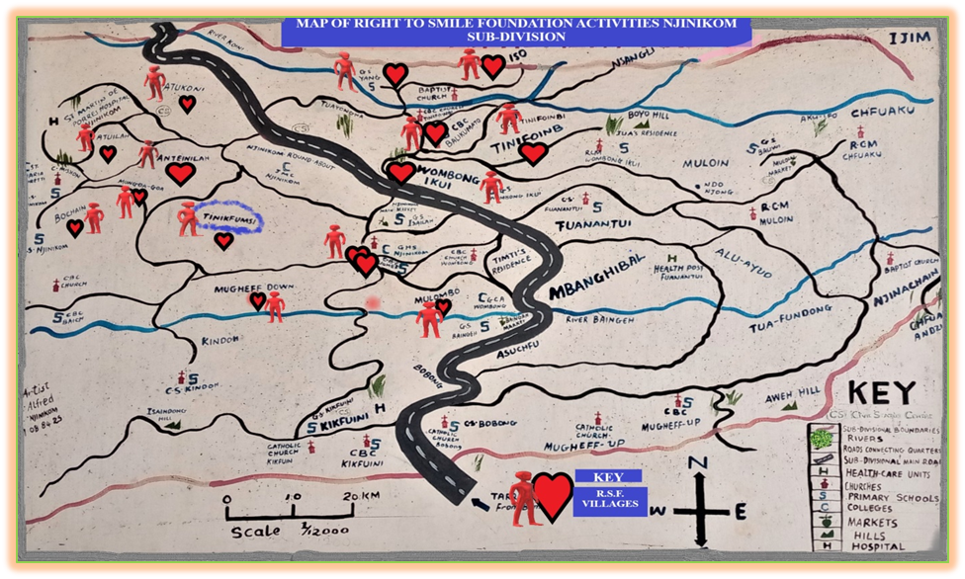

**NB: where we have the Symbol of the red heart, and a person is where we have clients.**

**THE DISTANCE FROM THE HEAD OFFICE TO THE VARIOUS VILLAGES COVERED**

|  |  |
| --- | --- |
|  | **FROM HEAD OFFICE TO THE VARIOUS VILLAGES** |
| **YANG = 3.5KM** |
| **ISO = 4.5KM** |
| **TINIFOINMBI = 1.5KM** |
| **ANTEINILAH = 0.1KM** |
| **ISAILAH =0.6KM** |
| **MUNMGOAGO = 0.1KM** |
| **BOCHAIN =0.1KM** |
| **ATUILAH =0.1KM** |
| **ATUKONI =0.1KM** |
| **WOMBOIKWI =2KM** |
| **WOMBONG DOWN = IKM** |
| **MULUMBO =1.5KM** |
| **MUGHEF DOWN = 2KM** |
| **BALIKUMATO =1KM** |
|  |
|  |
|  |
|  |
|  |
|  |

|  |  |  |  |  |  |  |  |
| --- | --- | --- | --- | --- | --- | --- | --- |
| **TABLE ONE: GENERAL DISTRIBUTION FROM INCEPTION TO JUNE 2023** | | | | | | | |
|  | NAME OF VILLAGE | TOTAL NUMBER OF CLIENTS | | | | NUMBER WITH SPECIAL NEEDS | |
|  |  | OLD | NEW | MALE | FEMALE | MALE | FEMALE |
|  |  | JUNE 2017 | JUNE 2023 |  |  |  |  |
| 1 | BOCHIAN | 08 | 0 | 02 | 06 | 01 | 03 |
| 2 | MUNGOAGOA | 06 | 0 | 01 | 05 | 01 | 01 |
| 3 | ATUILAH | 12 | 0 | 07 | 05 | 07 | 02 |
| 4 | ATUKONI | 03 | 0 | 02 | 01 | 02 | 01 |
| 5 | ANTEINILAH | 03 | 0 | 01 | 02 | 01 | 0 |
| 6 | YANG | 0 | 0 | 0 | 0 | 0 | 0 |
| 7 | ISO | 0 | 0 | 0 | 0 | 0 | 0 |
| 8 | TINIFOINMBI | 0 | 08 | 04 | 04 | 03 | 02 |
| 9 | BALIKUMATO | 0 | 07 | 02 | 05 | 0 | 03 |
| 10 | WOMBONG IKWI | 0 | 05 | 01 | 04 | 01 | 02 |
| 11 | MULOMBO | 0 | 01 | 0 | 01 | 0 | 01 |
| 12 | MUGHEFF DOWN | 01 | 03 | 03 | 01 | 03 | 01 |
| 13 | WOMBONG DOWN | 0 | 04 | 02 | 02 | 02 | 02 |
| 14 | ISAILAH | 0 | 0 | 0 | 0 | 0 | 0 |
| **TOTAL** | | **33** | **28** | **25** | **36** | **21** | **18** |

TABLE TWO: ANALYSIS

|  |  |  |  |  |  |  |
| --- | --- | --- | --- | --- | --- | --- |
| S/N | TOTAL CLIENTS | | TOTAL CLIENTS | | TOTAL CLIENS WITH SPECIAL NEEDS | |
|  | OLD | NEW | MALE | FEMALES | MALE | FEMALE |
|  | 33 | 28 | 25 | 26 | 21 | 18 |
| **TOTAL** | **OLD AND NEW 61** | | **61** | | **39** | |

The 28 new clients recently identified between May and June 2023 by the 5 new volunteers need to be visited by the coordinator to seek those with real special needs.

Since inception to June 2023, the Foundation has been able to recruit 83 clients and 13 volunteers and 2 have moved out leaving 11 to continue to journey with them.

We have experienced 22 of the clients died smiling more than we met them on our first interviews. Most of them who had special needs were attended to, the more reason they found a reason to smile even when dying.

Some two of the volunteers with counseling skills where able to counsel some of them who had unfinished businesses with their loved ones, and they were able to reconcile before dying.



|  |  |  |  |  |  |  |  |
| --- | --- | --- | --- | --- | --- | --- | --- |
|  | |  | |  | |  | |
|  |  |  |  |  |  |  |  |
|  |  |  |  |  |  |  |  |

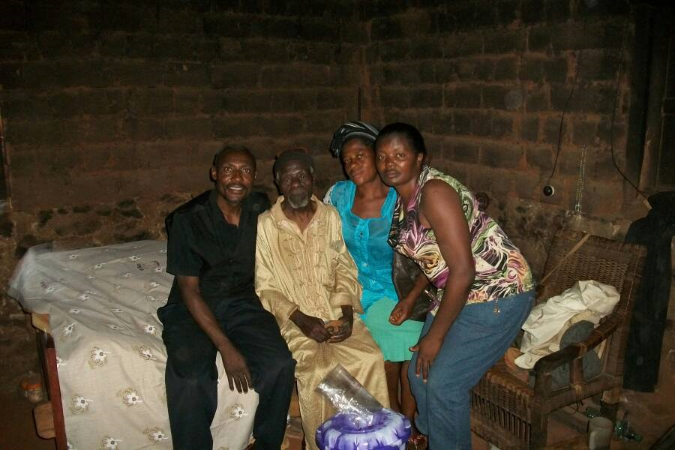

**Picture 1:** picture of old man with caregivers

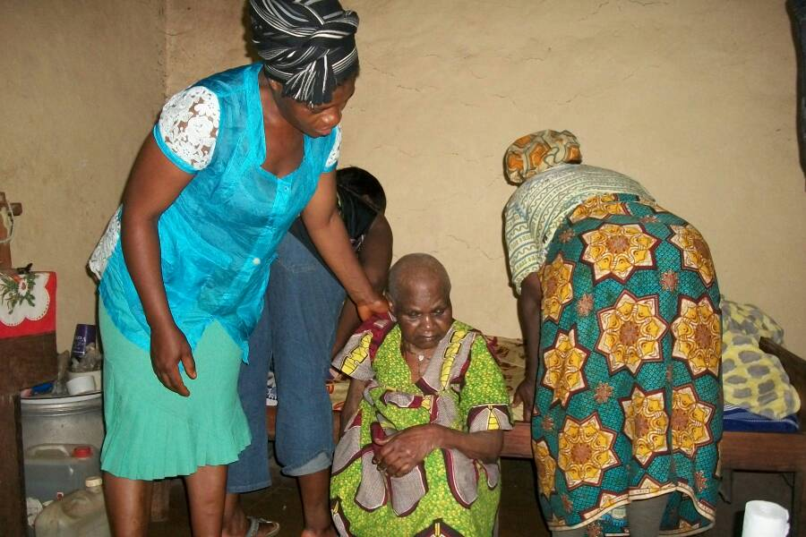**Picture 2:** picture of Old Woman with Caregivers

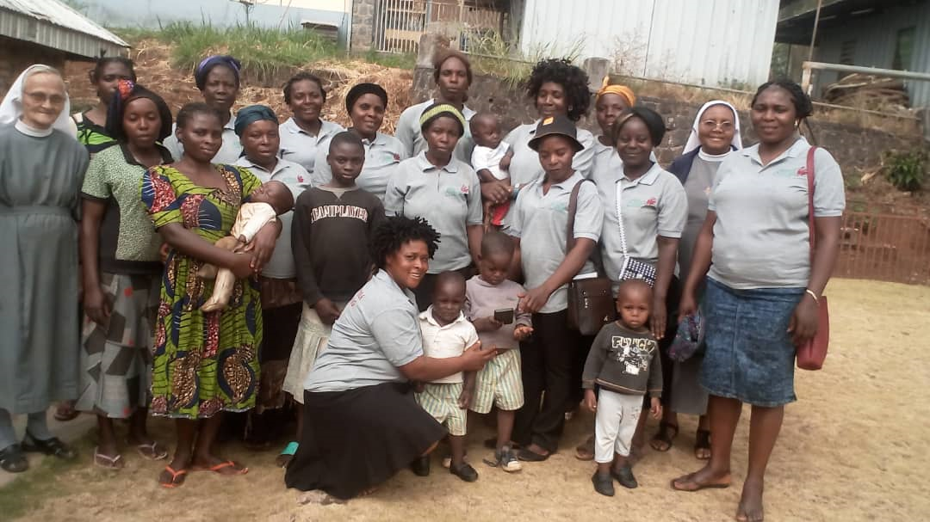**Picture 3:** Group picture of young widows

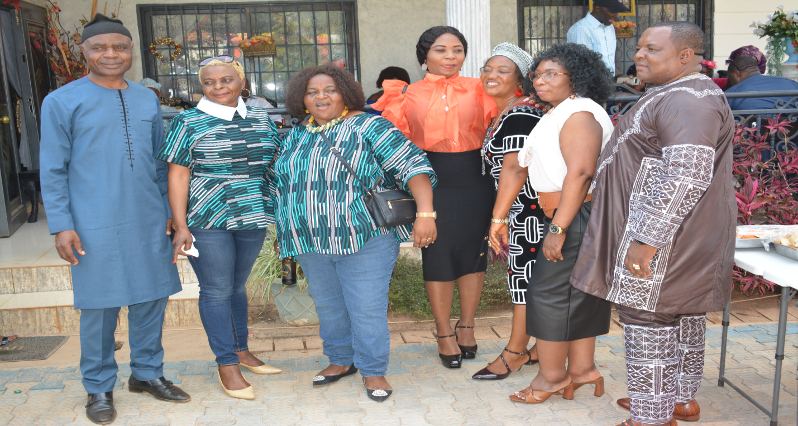**Picture 4:** Pictures with Partners

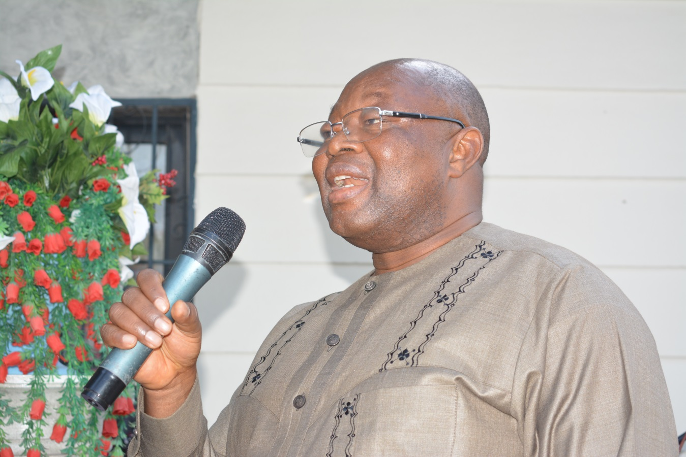

**Picture 5:** Welcoming Stakeholders for a Sensitization Meeting

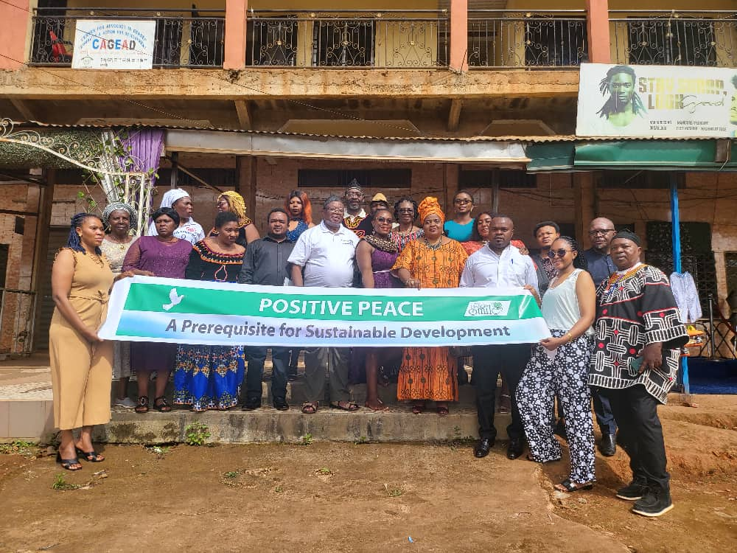**Picture 6:** Workshop on Positive Peace

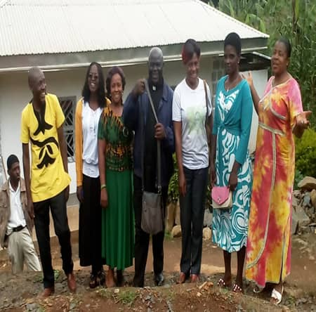

**Picture 7:** Volunteers mixed with Young Widows of RSF

## **REFERENCES**

American Academy of Pediatric Dentistry. (2021). Advocacy and Governmental Affairs: Federal Dental Health Legislation. Retrieved from: <https://www.aapd.org/advocacy/federal-legislation/>

American Dental Association. (2021). Access to Oral Health Care: Barriers and Solutions for Low-Income Adults. Retrieved from: <https://www.ada.org/en/science-research/health-policy-institute/access-to-oral-health-care-barriers-and-solutions-for-low-income-adults>

Anheier, H. K., & Leat, D. (2018). Creative Philanthropy: Toward a New Philanthropy for the Twenty-First Century. Routledge.

Banet-Weiser, S. (2015). ‘Confidence you can carry!’: Girls in crisis and the market for girls' empowerment organizations. Continuum, 29(2), 182-193.

Benzian, H., Monse, B., Heinrich-Weltzien, R., & Hobdell, M. (2017). Oral Health Inequalities: Call for Global Action. The Lancet Global Health, 5(9), e887-e888.

Calkin, S. (2017). Disrupting disempowerment: feminism, co-optation, and the privatised governance of gender and development. New Formations, 91(91), 69-86.

Deng, G., & Jeffreys, E. (2019). Celebrity philanthropy in China: Reconfiguring government and non-government roles in national development. The China Quarterly, 237, 217-240.

Frencken, J. E., Sharma, P., & Stenhouse, L. (2017). Global epidemiology of dental caries and severe periodontitis – a comprehensive review. Journal of Clinical Periodontology, 44(S18), S94-S105. doi:10.1111/jcpe.12677

Gitau, W. M. (2018). Megachurch christianity reconsidered: Millennials and social change in African perspective. InterVarsity Press.

Glick, M., Williams, D. M., Kleinman, D. V., Vujicic, M., Watt, R. G., Weyant, R. J., ... & Pavlicova, M. (2017). A New Definition for Oral Health Developed by the FDI World Dental Federation Opens the Door to a Universal Definition of Oral Health. Journal of Public Health Dentistry, 77(1), 3-5.

Hlady Rispal, M., & Servantie, V. (2017). Business models impacting social change in violent and poverty-stricken neighbourhoods: A case study in Colombia. International small business journal, 35(4), 427-448.

Kamath, V. V., Spreeuwenberg, M., & de Wit, N. J. (2019). Role of Health Systems and Services in Assisting Families to Access Dental Care and Adopt Healthy Behaviors. Community Dentistry and Oral Epidemiology, 47(3), 197-203.

Kandelman, D., & Petersen, P. E. (2017). UHC: A More Comprehensive Conceptual Framework of Oral Health. Oral Diseases, 23(6), 739-740.

Karim, L. (2021). NGOs, state and neoliberal development in South Asia: The paradigmatic case of Bangladesh in a global perspective. In Routledge handbook of gender in South Asia (pp. 289-302). Routledge.

Kellner, A., Townsend, K., & Wilkinson, A. (2017). ‘The mission or the margin?’A high-performance work system in a non-profit organisation. The International Journal of Human Resource Management, 28(14), 1938-1959.

Listl, S., Galloway, J., & Mossey, P. A. (2020). Global Economic Impact of Dental Diseases. Journal of Dental Research, 99(5), 501–507. doi:10.1177/0022034520914249

Marmot, M., Allen, J., Boyce, T., Goldblatt, P., Morrison, J., & Health Equity, S. D. C. (2020). Health Equity in England: The Marmot Review 10 Years On. Institute of Health Equity.

Mora, L., Deakin, M., & Reid, A. (2019). Strategic principles for smart city development: A multiple case study analysis of European best practices. Technological Forecasting and Social Change, 142, 70-97.

Moretti, E. (2021). The best weapon for peace: Maria Montessori, education, and children's rights. University of Wisconsin Pres.

Nayar, P., Nunn, J., Irwin, J. D., & Dashper, S. (2015). Evaluation of a Mobile Dental Clinic Pilot Program to Improve Access to Dental Care for Vulnerable People in Western Victoria. Journal of Public Health Dentistry, 75(3), 175-182.

Patel, J., Sujlana, A., & Vazirani, J. (2018). Oral Health Education and Awareness Among School Children in Mumbai: A Comparative Study. Journal of Indian Society of Pedodontics and Preventive Dentistry, 36(3), 279-283.

Petersen, P. E. (2020). World Health Organization global policy for improvement of oral health - World Health Assembly 2007. International Dental Journal, 58(3), 115-121. doi:10.1111/j.1875-595X.2008.tb00185.

Rayner, C., & Bonnici, F. (2021). The systems work of social change: How to harness connection, context, and power to cultivate deep and enduring change. Oxford University Press.

Shenoy, R. P., Khandelwal, V., & Jawade, R. K. (2019). Dental health status and access to dental care among the urban homeless population in India: A cross-sectional study. Journal of Indian Association of Public Health Dentistry, 17(2), 146-150. doi:10.4103/jiaphd.jiaphd_148_18

Van Dijk, J., Eijkman, M. A. J., & Knuistingh Neven, A. (2020). An explorative study to evaluate the influence of oral health on aspects of quality of life. BMC Oral Health, 20(1), 45. doi:10.1186/s12903-020-1038-6

Watt, R. G., Tsakos, G., & de Oliveira, C. (2017). Oral health inequalities in Europe in the 21st century - opportunities for action. In Advances in Dental Research, 23(2), 121-125. doi:10.

Wilkins, K. (2016). Communicating gender and advocating accountability in global development. Springer.

World Dental Federation (FDI). (2019). Oral health inequalities. Retrieved from: <https://www.fdiworlddental.org/oral-health/oral-health-inequalities>

World Health Organization. (2012). Social determinants of health. Retrieved from: <https://www.who.int/westernpacific/health-topics/social-determinants-of-health>

World Health Organization. (2013). Integration of oral health into primary care: the role of dental hygienists and therapists. Retrieved from: <https://www.who.int/oral_health/publications/integration/en/>