

# **College of Humanities and Social science Department of Peace Studies and Religion Program**

**Postgraduate Diploma in Peace Building and Conflict Transformation Social change initiative:**

Improving Social Media usage among Amhara Region Youths for Sustainable Peace

By:

Gizealew Alazie Dagnaw (Rotary Peace Fellow)

Mentors: Professor. Helen Nambalirwa Nkabala & Rev. Simon Masiga

Ethiopia,2022

# Contents

List of Tables ................................................................................................................................................. 3

List of Figures ................................................................................................................................................ 4

List of acronyms ............................................................................................................................................ 5

Executive Summary ....................................................................................................................................... 6

CHAPTER ONE ............................................................................................................................................ 1

Introduction .................................................................................................................................................... 1

*Problem statement ......................................................................................................................................... 2*

*Objective of the project .................................................................................................................................. 3*

The specific objectives:- ................................................................................................................................ 3

Challenges and Mitigation Strategies ......................................................................................................... 4

CHAPTER TWO ........................................................................................................................................... 6

Literature Review........................................................................................................................................... 6

*What role does social media play in peacebuilding? .................................................................................... 6*

*How to promote peace on social media ......................................................................................................... 7*

*Theoretical underpinnings ............................................................................................................................. 7*

Change Theory and how it applied ................................................................................................................ 8

Method and design ......................................................................................................................................... 8

*Need Assessment .......................................................................................................................................... 10*

Development Context ............................................................................................................................... 10

Problem Analysis ..................................................................................................................................... 11

Figure 2: Problem analysis using problem tree............................................................................................ 11

CHAPTER THREE ..................................................................................................................................... 12

Interventions and Activities .......................................................................................................................... 12

Key findings ................................................................................................................................................. 13

*The training is conducted............................................................................................................................ 13*

*Impacts and Application of Social Media among Young People ................................................................ 16*

CHAPTER FOUR ........................................................................................................................................ 17

Conclusion ................................................................................................................................................... 17

Recommendation ......................................................................................................................................... 17

References .................................................................................................................................................... 18

## List of Tables

Table 1: logical framework approach ..........................................................................................................9

Table 2: Stakeholder interest and impact .................................................................................................. 12

Table 3: Survey after Training ................................................................................................................... 13

## List of Figures

Figure 1: Change theory model .................................................................................................................................. 8

Figure 2: Problem analysis using problem tree ......................................................................................... 11

**List of acronyms**

* ANRS: Amhara National Regional State
* ICT: Information Communication Technology
* LFA: Logical Framework Approach
* M&E: Monitoring and Evaluation
* TV: Television

## Executive Summary

***Background:*** *Social Media is emerging as a major topic of discussion because it has a great impact on people, especially the youth. Before creating and or sharing news and messages using one of the tools of social media and public relations, such as a news release or media advisory, Facebook, Twitter, YouTube and broadcast media it is important for everyone to assess the types of media outlets they are using and the types of audience they are targeting. Unless both the formal media user and the social media bloggers become responsible for their actions, the political altercations on social media can cause mayhem and halt the progress of this growing democratic system and tackle the preexisted culture of living together peacefully.*

***Justification:*** *Communication media plays a great role in the current dramatic socio-political change in Ethiopia., The misuse of social media and its- consequences is trying to disturb the mutual life and culture of the society and may lead with negative outcomes. Most social media users use social media to make influence to propagate conflict instead of peace. Currently in Ethiopia social media user violet the normative theory of media,. This project was conducted to fill this gap by providing awareness of media literacy in general and social media usage skill training in particular.*

***Goal and purpose of the project:*** *Improving social media usage in the Amhara Region in particular and Central, West, and North Gondar Zones Youths’ Associations and recreation centers in subparticular*

***Approach:*** *Logical Framework Approach (LFA) has been used to* for designing, monitoring, and evaluating of this project*.*

***Key Finding:*** *The impacts of social media among youths depend on how it is applied. On the one hand, there exists a correlation between social media use among the young generation and its impacts on the national peace-building process to realize sustainable peace in Ethiopia and create healthy relationships between ethnic groups.*

***Work plan****: the project will run from May 2022 to December 2022*

**CHAPTER ONE**

## Introduction and Background

Social Media is emerging as a major topic of discussion since it has a great impact on people, mainly the youth. In the recent time, serious discussions and debates about the employment of new information and communication technologies (ICTs) and social media (e.g., Facebook, Twitter, blogs, etc.) escalated and commanded the attention of people across sectors of society in the different countries (Mulisa &

Getahun, 2018).

Social media allows an organization or individual to communicate directly news and messages to members, subscribers, the public, and even other media outlets. While there are several social media tools, four of the most common include Facebook, YouTube, Twitter, and blogs[2]. Before creating and or sharing news and messages using one of the tools of social media and public relations, such as a news release or media advisory, everyone must determine the types of media outlets they are using and the types of audience they are targeting. Similarly, the truthfulness of the content and the purpose of sharing should be put into consideration. Unless both the formal media user and the social media bloggers become responsible for their actions, the political altercations, mayhem social media can cause may hinder the progress of the growing democratic system and affect the preexisted culture of living together peacefully. New media tools have made a significant and enduring difference to the way people organize for social and political activism, created economic opportunities for those in the developing and developed world, facilitated disaster response, linked networks across national divides, and shared previously inaccessible information and knowledge such as alternative ways of understanding issues of conflict (Himelfarb & Chabalowski, n.d.).

Social media tools in particular have allowed people to be producers of content and to participate in dialogue that spans the globe in real-time. Conversely, some studies show that in recent times, social and broadcast media are playing a negative role in society and are not obeying the normative theory of media. The normative theory of media is concerned with what the media ought to be doing in society rather than what they do and the dominant ideas about the obligations of mass media will be consistent with other values and arrangements in a given society. Social media users also have limitations on the need to

consider the consequences of their activities and their responsibility to be honest, fair, and accurate; to check their facts; not to distort information; to question the motives of their sources, and to avoid creating stereotypes. Therefore, the important point which should aware that the digital natives is how to harness the power and potential of social media to manage conflict and build peace and enhance global development. The idea of peace-building through social media brings to mind the concept of customization of messages to meet particular needs or solve specific problems (Siddiqui, 2016). Modern industrial society has witnessed a plethora of customized messages from targeted mass mailing to neighborhood newspapers and from phone-in radio shows to cable television selection. Although the trend to customize media messages has existed for a considerable amount of time, the interactive nature of the internet and other new media has revolutionized the concept of customization by allowing users to receive information that is tailored to each single or group of users’ interests and preferences. Amara Region is one of the nine [ethnic divisions o](https://en.wikipedia.org/wiki/Regions_of_Ethiopia)f [Ethiopia w](https://en.wikipedia.org/wiki/Ethiopia)ith the capital city of [Bahir Dar.](https://en.wikipedia.org/wiki/Bahir_Dar) Ethiopia's largest inland body of water, [Lake Tana, w](https://en.wikipedia.org/wiki/Lake_Tana)hich is the source of the [Blue Nile](https://en.wikipedia.org/wiki/Blue_Nile) river is located within

Amara. The region also contains the Simien Mountains [National Park,](https://en.wikipedia.org/wiki/Semien_Mountains_National_Park) which is the highest point in Ethiopia.

Amara is bordered by the state of [Sudan t](https://en.wikipedia.org/wiki/Sudan)o the west and northwest, and in other directions by other regions of Ethiopia: [Tigray t](https://en.wikipedia.org/wiki/Tigray_Region)o the north, [Afar t](https://en.wikipedia.org/wiki/Afar_Region)o the east, BenishangulGumuz to the west and southwest, and [Oromia t](https://en.wikipedia.org/wiki/Oromia_Region)o the south(Adamu, 2020).

### Problem statement

The influence of social media is indubitable it reaches anyone with an Internet connection, no matter their geographic location or socioeconomic status (Asegidew et al., n.d.). This means information that was previously out of reach for isolated and less well-off communities is now accessible by more people than ever before. The use of social media as a formidable force for social engineering and political electioneering has continued to grow (Abraha, 2017). The technology is participatory, interactive, and cost-effective. This has made it the medium of the moment as far as political communication and participation are concerned. In the last two years, activists use social media in mobilizing the people to protest against the government, for the rise of inter-ethnic conflicts. Even if social media brought many positive outcomes and prospects, challenges in the uses of social media are observed. Media is a tool, a powerful tool that by the very nature of its existence, inevitably engages in the process of social change either

negatively or positively. Unfortunately, journalists, public relations and communication workers, and media practitioners are too often trained to do their job without being responsible for the kind of social outcome their performance produces. Communication media plays a great role in the current dramatic socio-political change in the sky of Ethiopia, the misuse of social media and its- consequences affects those living together in various ways and with a negative outcome. Not only social media but broadcast media also violet the normative theory of media, which is the media theory that refers to the complex social-political-philosophical principles which organize ideas about the relationship between media and society. Almost all district and city administrations of the country have youth centers and recreation centers and they have their own social media pages, especially Facebook pages are very common without clearly stated media usage policy and with the insufficient skill of media literacy. Theoretically, social media tools can facilitate better communication between parties in conflict and help resolve it before an outbreak of violence (Price et al., 2009). As the current situation of the country shows that, the problem of poor and illegal media usage is a social killer and if solutions will not made, the problem may lead to civil war and country disintegration. According to the information gained from preliminary observation and need assessment the main reasons for poor and irresponsible use of social media are lack of policy support and regulation, unable to manage social media accounts, Hate speech, Fake News, Violating social norms and values, Fake named pages and Lack of information filtering .Youths are the primary victim of this problem. Due to that the project was conducted to fill the gap by providing awareness of media literacy in general and social media usage skill training in particular (Overview of the Ethiopian Media Landscape 2018, n.d.).

### Objective of the project

The general objective of this project is to improve social media usage among Amhara region youths for sustainable peace

## The specific objectives: -

* To Train on ethics of digital communication
* To familiarize with how social media influence the community
* To be aware of the role of social media in peacebuilding and development
* To be aware of the impact of misuse of social media on the socio-political development of the society
* To give training on how to secure the privacy of social media accounts and pages
* To be aware of how and why social media messages are created and distributed

**Challenges and Mitigation Strategies**

Social media is both, good and bad. When we use wisely it has changed our lives in many ways since its inception. When we use carelessly, Facebook, YouTube, and Twitter have turned out to be means of disseminating unfounded stories, wrong information, prejudice, and falsehood. For over a century, the people of Ethiopia have lived together building a peaceful, harmonious and prosperous society with cultural amalgam and diverse beliefs. They espoused peaceful coexistence and cherished respect for each other until the evolution of social media began rocking down their tranquility and calm a decade ago. Social media has global presence and it presents many challenges to companies and their followers. Companies can smartly and strategically use social media and mitigate its challenges by considering the following aspects (Siddiqui, 2016):

**No formal rules and regulations**: Countries have made their rules and regulations to regulate social media in their respective countries. Hence, a social media activity that is illegal in one country may not have serious consequences in many other countries. Hence, companies have to be careful about the lack of global rules and regulations for social media though it has a global audience and followers. Companies have to be conscious of rules and regulations in the countries where they intend to do marketing etc. using social media platforms.

**Disinformation**: It was found that there is designed disinformation spread by competitors of various companies. Companies that are not on social media face more disinformation about them than companies that are active on social media. This disinformation is deliberately designed to malign companies and their products and services.

Companies can counter disinformation campaigns by having authentic social media profiles where people can find authentic company information. Many times, companies highlight disinformation being spread about them on their profiles. This cautioned their followers about wrong information, rumors, etc. being spread on the Internet.

**Return on Investment**: Many companies intend to track the benefits of being active on social media platforms. They do not find very prominent tools and strategies to track the financial benefits of being active on social media. They may understand that social media is a strong medium today. People will talk about them irrespective of their presence on social media or not. They also need to understand that being active on social media has tangible and intangible benefits. Hence, they should make strategies to get tangible and intangible benefits on social media.

## CHAPTER TWO

**Literature Review**

Social media is a very powerful medium today. It has extensive reach across the world. Companies intend to buy Instagram followers to enhance their presence on popular social media platforms to explore the opportunities available on social media. Companies generally prefer to be active on a few popular social media platforms like Facebook, Twitter, Instagram, LinkedIn, YouTube, (Himelfarb & Chabalowski, n.d.). Companies prefer popular social media platforms as they have a maximum number of followers. Companies have to make detailed strategies for individual social media platform social media has long been used as a power tool in the field of peacebuilding with even the United Nations (UN) making use of several social media platforms including Facebook, Twitter, and Instagram to not only highlight their work in the field but also to help convey their pertinent messages to the world. In 2018 there were an estimated 3.196 billion social media users in the world according to the annual Global Digital Report compiled by *We Are Social* and *Hootsuite*. When used correctly, social media can be used with great success in terms of peace promotion (Okolie-Osemene, n.d.). ***What role does social media play in peacebuilding?***

Thanks to the creation of various social media platforms such as Facebook, Twitter, Instagram, and LinkedIn, individuals from across the globe have been allowed to interact with people both inside and outside of their communities. Social media can facilitate peace by encouraging valuable dialogue between people from different ethnic, religious, and political backgrounds. This dialogue can, in turn, alter attitudes, change perceptions, and encourage increased tolerance & mutual understanding between ethnic groups who would otherwise never have had the opportunity to engage with one another. Now a day information is power and insight can impact public discourse. This way, perceptions can be changed by access to media. Different types of media are utilized globally to distribute knowledge and idealistically, free mass media is a tool of and signpost for democracy. Freedom of expression is not only the core of healthy media but also a fundamental human right and vital for a democratic structure. It stands for freedom of speech, the right to information, and the representation of different opinions in a heterogeneous society. In any culture of prevention, effective and democratic media are an essential part and indispensable for societies trying to make a transition toward peace and democracy(Graciyal & Viswam, 2018).

### How to promote peace on social media

As a social media user, you have the power to influence a lot of people with what you post. One of the biggest evils of current-day social media, and the one that incites the most hatred, is the spreading of fake news. On Twitter alone, nearly 9 million potentially automated or menacing accounts are identified every week. By choosing your content wisely and steering clear of any potential social-media danger zones you can effectually convey your message of promoting Peace Education to the world(*Free Speech and the Regulation of Social Media Content*, 2019).

### Theoretical underpinnings

The use of social media is gaining traction as a method, context, and space in peacebuilding and conflict transformation arenas. In the past decade, social media apps and services have greatly evolved and expanded, redefining societal understandings of knowledge, communication, and social connections. Particularly, popular social media such as Facebook, Twitter, Instagram, and Snapchat are integral to the daily experiences of many young people, including students, employees activists, and different civic servants and politicians. The medium of social media is creating a shift in peoples understanding of knowledge ,authority, communication, interaction, and power ,creating an intriguing terrain for the query of development of critical consciousness.

## Change Theory and how it applied

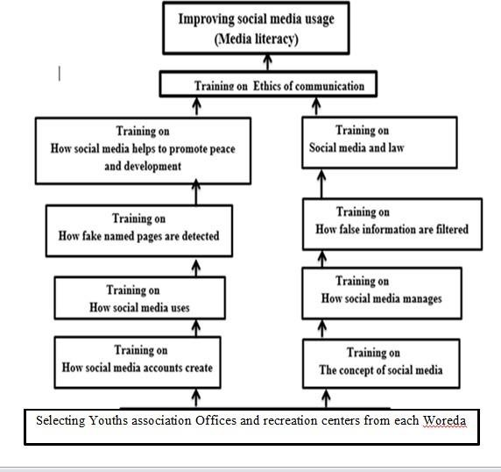

Figure 1: Change theory model

## Method and design

There are different approaches of project design but The Logical Framework Approach (LFA) is a methodology mainly used for designing, monitoring, and evaluating of projects, so (LFA) is the method used to this project because of it is recommended to achieve high quality project standards. As the result, uses the logical framework approach to show the logical relationships among components of the projects using logical frame matrix.

Table 1: logical framework approach

|  |  |  |  |
| --- | --- | --- | --- |
| **Narrative Summary** | **Objectively verified indicators (OVI)** | **Means/sources of verification(MV)** | **Important assumptions** |
| Overall goal: Looking Socially healthy and stable Amhara region | Reduced Social media crisis Improving peace and sustainable development | Governmental  Reports  Pre-test and Post- test on the novice Outcome evaluation | Government commitment to deliver Continuous training Policy support for social media usage |
| Project purpose: improving Social media usage on Amhara Region in general and North, central and West Gondar Zones in particular. | Reducing Hate speech on Social media  Reducing fake News on  Social media  Promoting peace and development through social media | Governmental  Reports  Pre-test and Post-test on the subject trainee  Community opinion | Design a “social media for peace and development” campaign |
| Component objectives: deliver training on the Ethics of digital communicating ion how social media  influence the community how fake named accounts and pages are detected how false information is filtered  The role of social media for peacebuilding and development | Successfully run the training | Ask questions to the trainee Take comments  At the end of each training component | Training hall with internet connection  Continuous follow-up of the Communication Bureau to the training up to the end |
| Outputs:  Social media used for peacebuilding | Almost all communication professionals will aware of the importance of social media for peacebuilding | Project report Survey | Extending the project and working with different local associations (youths,  females, professional…) |
| Social media used for  community development | Almost all communication professionals will aware of the importance of social media for community development | Project report Survey |
| Activities: Preparing training manuals and questions  Plan training place  Plan training time  Conduct pre-test  Conduct training  Conduct Pot-test | Documented training manual and questions documented plans for effective communication Analyzed and presented the evaluation results | Documents at hand collected questions Surveys Comments from higher Officials of the region | Co-operation with respective  Governmental Offices  Training hall with internet connection  Continuous follow-up of the Communication Bureau to the training up to the end |

### Needs Assessment

After the general observation of the problem of social media usage, the peace fellow moved to Amhara National Regional State (ANRS) Communication Bureau, and Peace and Security Bureau collect some important information. According to the information gained from the preliminary observation, there is a high need for training for social media communities at the regional level. However, due to limited time and budget, the project narrows the project site to North, Central, and West Gondar Zones youth associations and recreation centers.

## Development Context

Recently social media plays a negative role in peacebuilding and social development that may cause conflict and social crisis among the different ethnicities of the country as well as within similar communities. Due to the complex nature of social media, the consequences are also difficult to manage unless the users are responsible for why, how, and for whom they use social media. To overcome this problem the university should work on the government and public agendas(Harith & Ahmad , 2021). We assume that almost all youth living in the cities, Youth associations, and Youth recreation centers have their own Facebook accounts and pages. And so they should be sensitized on how, why, and for what purpose they use Social media. The government offices especially the regional peace and security Bureau, city and zonal peace and security, youth Association departments, and district peace and security, and youth association offices are the most interested primary stakeholders to work with the project owner who is a peace fellow of at Rotary International Makerere University peace center, Uganda.

## Problem Analysis

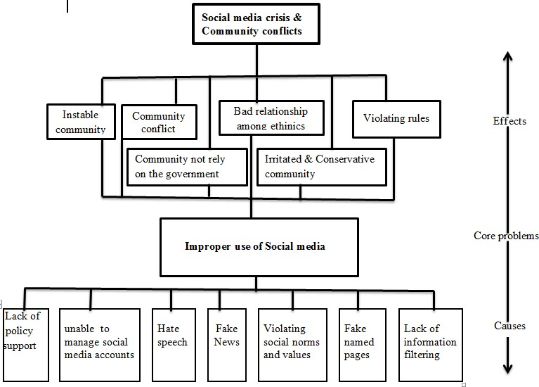

**Figure 2: Problem analysis using problem tree CHAPTER THREE**

## Interventions and Activities

The peace fellow identified the potential stakeholders in the course of different project stages.

Because it is important to identify and manage stakeholders' interests, potential risks and misunderstanding mechanisms, to identify key people to informed about the project during the execution phase, negative stakeholders as well as their adverse effects on the project. Since the project proposes based on stakeholders’ interest and their interest has approved by request supportive letter. Therefore, the project owner identified all relevant stakeholders, their roles, interests, impact on the projects, and type of their participation using the stakeholder table, and stakeholder participation table.

Table 2: Stakeholder interest and impact

|  |  |  |  |  |
| --- | --- | --- | --- | --- |
| **Stakeholders** | | **Interests** | **Potential project impact** | **Relative Priorities of interests** |
| Primary | Makerere University Rotary Peace Center, Uganda | Improving service | Positive | Serving the community |
| ANRS Peace and security  Bureau, Departments, and Offices | Improving service | Positive | Getting peace and a stable community |
| Youths’ affair bureau,  Departments and Offices | Improving service | Positive | Getting youths with positive influence on communities peacebuilding and development |
| Youths Associations and recreation centers | Improving service | Positive | Getting training |
| Secondary | The Community | Getting service | Positive | Getting peace and sustainable development |
| Information centers | Getting right information | Positive | Creating socially health society |

## Key findings

### Trainings conducted

October 2022, Gondar, Ethiopia - successfully conducted five days training on “Improving Social

Media usage among Amhara Region Youths for Sustainable Peace” held on 28 September – 02 October 2022 in Gondar, Ethiopia. Improving the usage of social media sites has become one of the most popular social behaviors among young people, thanks to the ubiquity and many different opportunities that they provide. Recent statistics suggest that more than two/thirds of internet users and approximately onethird of the people living in the world are social media site users. Similarly, recent trends show that social media usage among youths has increased dramatically. Social media has been evolving and many factors have contributed to its changing nature. These factors are interlinked and interconnected by actors, space, and enabling infrastructure or environment. It has become instantaneous and unpredictable affecting many societies and at the same time reaching a wide audience because of technology. Now a day cyberspace is an environment without boundaries, a privileged place where terrorists find resources, make propaganda activities, recruit and mobilize sympathizers, disseminate information, provide training, and secure communication. Social media is an essential element of peacebuilding whereby youth networks fully utilize it to their advantage. Peacemakers use popular online platforms such as Twitter, Facebook, and YouTube and Blogs with direct and straightforward language that attracts young individuals through the use of images and videos with high emotional impact to generate positive peace. In addition, messaging is amplified through easy dissemination of content through the use of emails, texts, and mobile applications by sympathizers and media outlets. It is with this background in mind that this training was conducted to equipping trainees with advanced knowledge and practical skills on the use of Social Media Platforms to effectively craft and utilize to promote positive peace. A total of 54 youths from zones, woredas ,and city administration are active users social media in their day-to-day activities and are selected by a near government official and the local community . During the training the participants raise different genuine ideas with regard to impacts of social media for creating socially healthy community among those user capacity development, clear policy on social media usage, give immediate true information on the government side in order to close the door of false information and also recommendation are given for the next trainer . The training participate delegated districts as follows .

|  |  |  |  |
| --- | --- | --- | --- |
| Central zone | Gondar | West Gondar Zone | North Gondar Zone |
| 18 |  | 18 | 18 |

The sample photo during the training is looks like as follows.

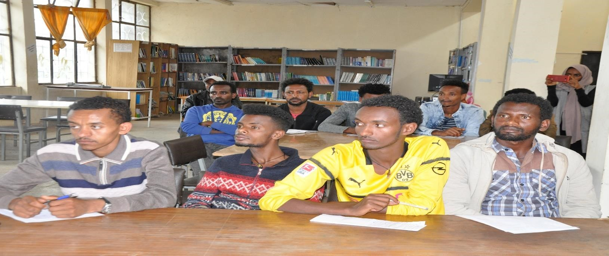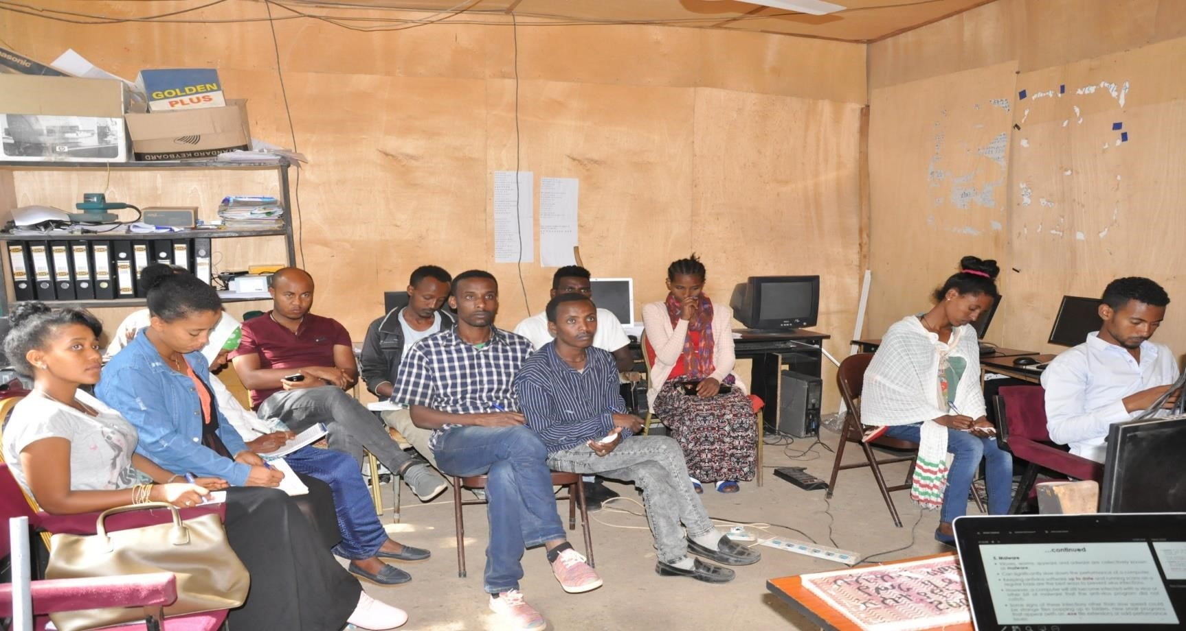

After the training, a survey has conducted on the need and importance of the training. The result of the survey has presented in the following table. Questions related to the training (N=54, October 2022) Table 3: survey after the training

|  |  |  |  |  |
| --- | --- | --- | --- | --- |
| **Variables** | **Response**  **Options** | | **Response f&%** | |
| **F** | **%** |
| How do you perceive the training? | Very Good | | 48 | 88.89% |
| Good | | 6 | 11.11% |
| Not that much | | 0 | % |
| Do you think that the training is the important and hot issue? | Yes | | 54 | 100% |
| No | | 0 | 0% |
| Do you think that the training has value to solve community problems? | Yes | | 54 | 100% |
| No | | 0 | 0% |
| Could you recommend another target audience for this training? If you say yes, who are they? | Yes | Public relation | 26 | 52% |
| Leaders | 10 | 20% |
| Broadcast workers | 14 | 28% |
| No | | 4 | 7.41% |
| Do you think that the training should address all over the region? | Yes | | 54 | 100% |
| No | | 0 | 0% |
| What type of problem do you think with Social media usage? | Technical problem | | 24 | 44.44% |
| Personal problem | | 20 | 37.04% |
| Political problem | | 10 | 18.52% |

In the table above, the respondents said that the training is an important and hot issue and so it should cover the entire region of Amhara and in the country Ethiopia because young people of today are growing up on the “diet” of social media. Social media have become an inextricable part of their lives. Generally, the training is very important for Ethiopia about current situation to generate positive energy for building sustainable peace about socially health community and also among the 50 (92.59%) of the respondents who were recommended the training for other audiences; 26(52%) recommend for public relation professionals, 14 (28%) recommended for broadcast workers and 10 (20%) recommended for leaders.

### Impact and Application of Social Media among Young People

The impacts of social media among youths depend on how it is applied. On the one hand, there exists a correlation between social media use among the young generation and their impacts on the national peace building process. The younger generation grow up acquiring “digital literacy” thus living in a digital world in which adults are only. Today’s new generations are socializing in a hybrid virtual space, learning in innovative ways, creating a new language, and practicing multicultural values to realize positive peace in Ethiopia. Among other benefits of social media use by younger generations, the main characteristics of the next generation’s culture are independence, emotional and intellectual openness, social inclusion, free expression and strong views, innovation, pre-occupation with maturity, pleasure by the investigation, immediacy, and sensitivity to corporate interest.

The negative impacts of social media among youths are starting to surface, making procrastination easier and sleeping harder. Teens are putting off their school work and spending more time on either Facebook, Twitter, YouTube, Blogs, etc. Certain frequencies being emitted from their cell phones and other devices also pose a great health risk to them. Some useless blogs and vlogs continue to influence young people so extremely that they become violent and can take some inappropriate actions. Abduction, murder, and robbery can be easily carried out by sharing details on social media. There are many registered cases in police stations where adults target young children and lure them into meeting them. There is no point in fighting social media all the time because it could cause power battles and endless conflict between parents and their children. Parents can only help their children by setting limits and boundaries that could help keep the children healthy and safe. There is a high level of moral decadence in our society today due to cultural imperialism supported by social media. The social media campaign is creating deeper division in society, social and political groups, ethnic communities, racial entities, and cultural groups.

***Key Challenges***

During the training there are many problems among those financial problem &training computers are the major problem.

## CHAPTER FOUR

**Conclusion**

Truthfully in Ethiopia, the majority of youths have access to the various social networking sites of their choice. They use social media sites more for maintaining their existing relationships, as a task management tool, and for informational and educational purposes. Others also use it for meeting new people, socializing, and for entertainment. Some too have used these media for their self-actualization, but others have used them for self-destruction. The impact of social media is dependent on what they are used for. The training provides its contribution on the use of social media for positive purpose with regard to positive peace in order to realize sustainable peace in Ethiopia in the near future by promoting good relationship between different ethnic groups with the use of different social media sites.

## Recommendation

Currently, social media are affecting mostly the new generation both positively and negatively, corrective and preventive measures should be taken towards reducing its negative impacts on youths. Therefore, young people should be allowed to explore the potentialities of these media as we cannot think of a world without these sites today improving social media usage is not an alternative rather it is mandatory in 21 century, to be genuine youths are the backbone of national building, especially in Ethiopia it is very essential due the current situation of ethnic conflict most probably guide by social media so use social media for positive peacebuilding is today’s activity.

Active citizenship in a digital society requires passive consumers of technology and social media to become critical thinkers and active creators, capable of problem-solving through digital means. It is clear, therefore, that additional efforts are needed to increase the (social) media literacy levels of the population in general and that of young people and vulnerable groups in particular.

## References

Abraha, H. H. (2017). Examining approaches to internet regulation in Ethiopia. *Information and Communications Technology Law*, *26*(3), 293–311. https://doi.org/10.1080/13600834.2017.1374057

Adamu, M. A. (2020). Role of social media in Ethiopia’s recent political transition. *Journal of Media and Communication Studies*, *12*(2), 13–22. https://doi.org/10.5897/jmcs2020.0695

Asegidew, M., Nigatu, B., & Moges, A. (n.d.). *Ethnic-Politics-Driven Social Media Hate Speech in Ethiopia Interregnum: A Triangulation of Prevalence, Perceptions, and Regulations*.

*Free Speech and the Regulation of Social Media Content*. (2019). https://crsreports.congress.gov

Graciyal, D. G., & Viswam, D. (2018). Social Media and Peace Building in Indian Politics. *Research Journal of Humanities and Social Sciences*, *9*(1), 135. https://doi.org/10.5958/2321- 5828.2018.00024.4

Himelfarb, S., & Chabalowski, M. (n.d.). *Media, Conflict Prevention and Peacebuilding: Mapping the Edges USIPeace Briefing October 2008 For more information: info@usip.org*.

Mulisa, F., & Getahun, D. A. (2018). Perceived Benefits and Risks of Social Media: Ethiopian Secondary School

Students’ Perspectives. *Journal of Technology in Behavioral Science*, *3*(4), 294–300. https://doi.org/10.1007/s41347-018-0062-6

Okolie-Osemene, J. (n.d.). *TOWARDS UTILIZING NEW DIGITAL MEDIA TECHNOLOGIES FOR THE PROMOTION OF PEACE EDUCATION IN NIGERIA*.

*Overview of the Ethiopian Media Landscape 2018*. (n.d.).

Price, M. E., al Marashi, I., & Stremlau, N. A. (2009). *Media in the Peace-Building Process: Ethiopia and Iraq*. <http://repository.upenn.edu/ascpapers/149>

Siddiqui, S. (2016). Social Media its Impact with Positive and Negative Aspects. In *International Journal of Computer Applications Technology and Research* (Vol. 5, Issue 2). [www.ijcat.com](http://www.ijcat.com/)

*Harith F& Ahmad ,, D. A. (2021). The Negative Role of Social Media During the COVID-19 Outbreak. International Journal of Sustainable Development and Planning 16(2):219-228*

*DOI:10.18280/ijsdp.160202*