

**Implementation of the Social Change Initiative**

**Project Report**

**Project Title: Increasing the meaningful participation of Youth in decision making for positive Peace in Uganda.**

**Submitted by**

**Gorett Komurembe Rwabunumi**

**Location: Ntungamo sub county, Ntungamo District**

**Start and Completion Date: 25th April - 19th August 2022**

**Submitted to: Makerere University Kampala**

**September 2022**

# **LIST OF ACRONYMS**

**CBO: Community Based Organization**

**CDO: Community Development Officer**

**CEDAW: Convention on Elimination of all Forms of Discrimination Against**

**Women**

**CSO: Civil Society Organization**

**EU: European Union**

**SDGs: Sustainable Development Goals**

**LC: Local Council**

**UBOS: Uganda Bureau of Statistics**

**UN: United Nations**

**UNCRC: United Nations Convention on the Rights of the Child**

**UN-IANYD: [United Nations Inter-Agency Network on Youth Development](https://www.un.org/development/desa/youth/what-we-do/un-inter-agency-network-on-youth-development/ianyd-members.html)**

**UNICEF: United Nations Children’s Fund**

**UNOY; United Network of Young**

**UNSCR: United Nations Security Council Resolution**

**USAID: United States Agency for International Development**

**USIP: United States Institute for Peace**

**Contents**

**LIST OF ACRONYMS** 2

**ABSTRACT** 4

**1.0 CHAPTER ONE: INTRODUCTION AND BACKGROUND** 5

**1.2 Problem Statement** 6

**1.3 Goals and Objectives** 7

**1.4 Challenges and mitigation strategies** 7

**2.0 CHAPTER TWO: LITERATURE REVIEW** 9

**2.1 Youth participation in peacebuilding** 9

**2.2 Youth and peacebuilding** 11

**2.3 Youth and violent extremism** 13

**3.0 Theoretical Underpinnings** 17

**3.2 Change theory and how it was applied** 18

**3.3 Application of the theory of change** 18

**3.4 Methods and Design** 19

**4.0 CHAPTER THREE: INTERVENTIONS AND ACTIVITIES** 21

**4.1 Youth consultation** 21

**4.2 Development of training content** 21

**4.3: Positive Peace workshop for 30 youth** 21

**4.4: Online monthly check-in calls to trained youth** 23

**4.5: Community dialogues on positive peace** 23

**4.6: Social media to promote discussions on positive peace** 23

**5.0 KEY FINDINGS / IMPACT** 25

**6.0** **CHAPTER FOUR: GENERAL CONCLUSION** 28

**6.1** **RECOMMENDATIONS / IMPLICATIONS FOR POLICY** 29

**6.2 SUSTAINABILITY PLAN** 30

**7.0 APPENDIX 1: PICTORIALS** 31

**REFERENCES** 33

# **ABSTRACT**

This is a report from the implementation of the social change initiative on youth participation in peacebuilding processes in Uganda. Youth being 78% of Uganda’s population (UBOS 2017), it’s critical to involve them in decision making and peacebuilding processes at all levels. Despite government initiatives to empower the youth in terms programmes including the youth livelihood program, Emyoga and the recently launched Parish Development Model, the youth continue to face challenges in their quest to meaningfully participating in the decision making and peacebuilding processes including political participation. Such challenges include the lack of critical resources (economic and civic) to draw on, the lack of information regarding opportunities for participation, lack practical skills to create their own jobs, the lack of awareness of human rights and the legal and policy frameworks that promote youth participation in Uganda, apathy brought on by the belief that their voice would not make a difference, but also the general public attitude that youth are difficult, that they only cause trouble and are violent. Female youth are excluded further due to social-cultural barriers in addition to the knowledge and capacity gaps (World Youth Report 2018). The normalized culture of intolerance, exclusion and violence presents Uganda youth with no other means of resolving conflicts other than engaging in violent protests whereby they get hurt and some get killed.

The social change initiative aimed at addressing the knowledge and skills gaps among 30 youths from Ntungamo sub county, Ntungamo District to enable them to appreciate peacebuilding and use of non-violent conflict means of conflict resolution. Ntungamo district has been a hotspot for violence peaking during and after election time with the youth at the centre. Youth involvement in election violence not only in Ntungamo district but Uganda as a whole has been occasioned with tragic outcomes and continue to pose a threat to peace and security of the nation. Failure to recognize the potential of the youth as active political actors and decision makers, implies exclusion and encourages violent extremism.

**Key words:** Youth, participation, peacebuilding, inclusion, exclusion, marginalization, violent extremism

# **1.0 CHAPTER ONE: INTRODUCTION AND BACKGROUND**

Over the past decade, the involvement of some young people particularly young men, but also increasingly young women in violence and extremist groups has led some to paint youth generally as a threat to global security and stability. Moreover, a growing body of evidence suggests that young women and men can and do play active roles as agents of positive and constructive change. The recently adopted Security Council Resolution 2250 (2015) on Youth, Peace and Security marks the formal recognition of the positive role young women and men for the maintenance of peace and security. Additionally, in September 2015, Member States of the United Nations adopted the 2030 Agenda for Sustainable Development, setting out a global vision and plan for ending poverty and hunger, realizing human rights, and strengthening world peace, while ensuring that no one is left behind. While considerable progress has been made, such progress has been uneven. Inequality has not only persisted, but in many instances widened, with substantial numbers of people, especially the youth, excluded from full participation in economic, political and social life.

Uganda has one of the fastest growing and youngest population in the world with 78% under the age of 30 (UBOS 2018), representing significant development potential. While this can be a good basis for economic growth, it also poses an immense challenge to the country in the form of widespread youth unemployment, which threatens the social economic stability and development of the Uganda.

Even with their numerical strength, the youth in Uganda particularly face challenges in meaningfully participating in the decision making and peacebuilding processes. Such challenges include the lack of critical resources (economic and civic) to draw on, the lack of information regarding opportunities for participation, lack practical skills to create their own jobs and earn a living, the lack of awareness of human rights and the legal and policy provisions of youth participation in Uganda, apathy brought on by the belief that their voice would not make a difference, but also the general public attitude that youth are difficult, that they only cause trouble and are violent. Female youth are excluded further due to social-cultural barriers in addition to the knowledge and capacity gaps including sexual harassment (by candidates and agents) during elections, lack of family support, and lack of exposure and low levels of education (World Youth Report 2018).

The normalized culture of intolerance, exclusion and violence presents Uganda youth with no other means of resolving conflicts other than engaging in violent protests whereby they get hurt and some get killed.

## **1.2 Problem Statement**

Uganda is one of the countries with the youngest population in the World. As of 2021, Uganda was second to Niger, among countries in the world with the youngest population with a median age of 15.8 (Lars. K 2022).  Moreover, the latest population census 2014 places 81.3% of the total population under the age of 35 years, and 20.6% of the population between 15 and 24 years. In terms of electoral input, the youth contributed nearly half of the registered voters with approximately 6.4 million youth (18-30 years). However, the importance of youth participation in Uganda’s political processes remains a major contest. Although many countries in Africa are moving towards more open and free political societies but a large segment of the population remains marginalized and excluded from effectively participating in the democratic processes including peacebuilding. Yet, the consolidation of any democracy requires that citizens (of all category) engage and participate in politics (Helix .O (2017).

Notwithstanding the existence of good institutional and organizational structures for effective youth participation, Uganda youth lack the critical resources (economic and civic) to draw on, knowledge and information in order to meaningfully participate in peacebuilding processes. This has subsequently made them vulnerable to manipulation by elites in the country. While in 2005 the new democratic dispensation ushered in hope and promise of change, it pears that little has been achieved (Bangura. I 2018). A trend analysis of youth participation shows that youth are marginalized, called ‘leaders of tomorrow’, and lack civic leadership, and conflict non-violence skills. This coupled with commercialization of Ugandan politics and high unemployment rates of 64% unemployed youth (ACODE 2014) makes youth vulnerable to manipulation and recruitment into militias (UBOS 2012). Therefore the need to strengthen the capacity of youth with knowledge and skills in leadership and peacebuilding processes to meaningfully participate in decision making and peacebuilding processes is paramount.

## **1.3 Goals and Objectives**

**Overall Goal**

The overall goal of the project is to promote inclusive and peaceful communities where youth are active agents of positive peace.

**Objectives**

1. Establish barriers to youth participation in decision making and peacebuilding processes
2. Assess the factors that drive youth into violent extremism
3. Strengthen the capacity of 30 youth with knowledge and skills to meaningfully participate in peacebuilding processes.

## **1.4 Challenges and mitigation strategies**

|  |  |
| --- | --- |
| **Challenges** | **Mitigation strategies** |
| Lack of funds to effectively execute the project. This affected the delivery of the content that was prepared. | Reduced on the number of the training days from 3-2 days. |
| Due to clout that Rotary Foundation has, majority of people that would have contributed to the project were convinced that Rotary injected in money and probably I was using the project to make myself rich. “Are you sure Rotary did not fund this”, asked one of the Rotarians who came across the project flyer. | Explanation to the potential sponsors that the implementation of projects was not funded by Rotary Foundation helped a lot. |
| High expectations from the target project beneficiaries including the district and sub county leaders. A part from transport refund that was expected, the beneficiaries thought that I had secured a huge grant to implement the project in the whole of Ntungamo district. | Thorough explanation to the youth and district and sub county leaders that the project was part of the Rotary Peace fellowship helped. |
| Sexual harassment from some men who came across the project flyer. “Come for my little contribution”. Can we meet over dinner and I give you your contribution” yet on the flyer, there was a telephone number that people could use to send through their contributions. | Approached Centenary Bank that contributed 1 million shillings that was a big boost. |
| Overwhelming requests from youth from Ntungamo and beyond who wanted to be part of the training. Because the flyer had my telephone contact, I received overwhelming phone calls from youth requesting to be part of the training. The requests still stand up today. | The 3 youth-led CBOs established at community level (Butare and Kahunga parishes) will continue to mobilize youth for peacebuilding activities. |
| Lack of smart phones for youth to participate in online discussions | Community dialogues helped to reach to wider audience with information on youth participation. These we conducted by trained youth |

# **2.0 CHAPTER TWO: LITERATURE REVIEW**

This chapter reviews some of the existing literature on youth participation in peacebuilding processes. It aims to provide insights into youth participation in decision making, youth and peacebuilding, and youth and violent extremism.

## **2.1 Youth participation in peacebuilding**

Uganda has one of the fastest growing and youngest population in the world with 78% under the age of 30, representing significant development potential (UBOS 2017). The national youth policy (2016) defines youth as all young persons, female and male, aged 15 to 29 years. While this can be a good basis for economic growth, it also poses an immense challenge to the country in the form of widespread youth unemployment, which threatens the social economic stability and development of the Uganda.  Whereas member States of the United Nations adopted the 2030 Agenda in September 2015 and the United Nations Security Council Resolution (UNSCR) 2250 on Youth Peace and Security as frames to guide states on matters pertaining youth participation in decision making, and their inclusion in policy and programmes, the implementation of these frameworks rains weak and inclusion of youth continues to receive little attention and support.

The MGLSD (2016) notes that effective youth participation is about creating opportunities for the youth to be actively involved in designing, shaping, and influencing policy development and implementation processes. The Government of Uganda has put in place legal and institutional frameworks to ensure participation and involvement of the youth in decision making and national development. In addition, the Constitution of the Republic of Uganda, 1995 provides for representation of the youth in the national parliament. The National Youth Council Act, Cap 319 established the Youth Council structures from village to national level to provide channels through which youth engage in development process. The Local Government Act of 1997 also provides for representation of the youth in all Local Government Council structures. Civil society organizations and other non-state actors provide alternative spaces for youth participation.

Sustainably entrenching youth as an integral part of the peacebuilding agenda entails a redefinition of their role and importance as agents of peace. Indeed, the conception of youth and of the role they stand to play in peacebuilding is limited to a few rigid scenarios. These tend to revolve around the premise of the ‘youth bulge’, or the idea that disproportionately large youth cohorts relative to the population bear a strong correlation with the occurrence of violence (USAID, 2005, 3). A recent UNOY report underscores this idea, arguing that the perception of youth in relation to violence and conflict is often a dichotomous one, with them being depicted either as ‘causal or recipient agents’, rather than positive agents for peace (UNOY, 2013a, 1). A trend in the recent literature is to caution against such reductionist representations and call for a move towards nurturing the positive dividends that youth stands to contribute to peace processes. USAID’s report, ‘Youth and Conflict’, situates itself within this current, arguing that ‘when youth are shielded from social and economic stresses, and can participate in decisions that affect their lives, they are more likely to pursue peaceful change’ (2005, 5). The successful implication of youth in peacebuilding processes requires a comprehensive approach going beyond immediate conflict dynamics in order to address socio-economic concerns. This is in line with the recommendations issued by the UN-led Subgroup on Youth Participation in Peacebuilding. Specifically, it argues that successful policy must firmly rest on the adoption of multiple approaches, drawing from human rights, economic, socio-political and sociocultural components (Subgroup on Youth Participation, 2014). The fact that this wide-ranging framework closely overlaps with the development agenda validates the relevance of calls issued for youth and peacebuilding to occupy a prime position on the post-2015 agenda.

A specific tool being highlighted as a means of securing active and positive youth involvement in peacebuilding is education. The Youth and Conflict report finds that ‘an important way to avoid future conflict is to draw on the energy and capacities of youth as the leaders of tomorrow’s societies’ (USAID, 2005). In its 2011 Education and Peacebuilding Report, UNICEF argues that education acts as a significant vehicle of social cohesion. It must therefore be supported at every stage of a given conflict, and most critically so in post-conflict settings (2011). Indeed, a survey of selected case studies shows that education stands to have a transformative effect in post-conflict societies in the long run by yielding changes in social attitudes and values which may in turn redefine conflict (UNICEF, 2011).

Alpaslan Ozerdem (2020) suggests that what needs to be done is that youth should be conceptualized and studied as agents of positive peace in terms of addressing not only the challenges of physical violence, but also the challenges of structural and cultural violence, and the broader social change processes to transform violent, oppressive and hierarchical structures, as well as behaviour, relationships and attitudes into more participatory and inclusive ones. This is because without recognizing youths as political actors, their trajectories in peacebuilding would likely be ignored, wasted and at best, under-utilized.

Conciliation Resources report (2018), suggested that it is important to provide youths with training opportunities to take an active part in peacebuilding. With their youthful energy and capabilities, and ability of adaptation to new technological trends, for example, youths could act as mediators, community mobilisers, humanitarian workers and peace brokers. Like any particular conflict affected population group, the mobilization of youths’ capacities requires a targeted and long-term approach.

## **2.2 Youth and peacebuilding**

The term peacebuilding originated from Johan Galtung’s pioneering work ‘Three Approaches to Peace: Peacekeeping, Peacemaking and Peacebuilding’ (1975). In his article he argued for the creation of peacebuilding structures to promote sustainable peace. Galtung argues that peace has a structure different from, perhaps over and above, peacekeeping and ad hoc peacemaking. The mechanisms that peace is based on should be built into the structure and be present as a reservoir for the system itself to draw up. More specifically, structures must be found that remove causes of wars and offer alternatives to war in situations where wars might occur (Galtung J. 1976). In this context Galtung also introduced the distinction between negative peace and positive peace. While negative peace is characterized by the absence of violence, positive peace means the absence of structural and cultural violence. Due to this Galtung (1975) defined peace in a more positive and wider way. In addition, Galtung established a tripartite classification among the concepts of peacekeeping, peacemaking, and peacebuilding with corresponding defined roles. Whereas peacemaking describes the negotiation procedures between different stakeholders aiming for truce, peace agreement, or peace resolution towards specific conflicts, peacekeeping comprises third-party intervention to reduce direct violence, or maintain the absence of it. Lastly, peacebuilding emphasizes the psychological, social, and economic environment at grassroots level (Galtung 1975). Peacebuilding is directed to create positive peace, structures of peace on the basis of equity, justice and collaboration, hence addressing root causes or potential causes of violence.

Lederach (1997) is in agreement with Galtung (1975) that peacebuilding intends to set up societal peace so future conflicts become less likely but broadens peacebuilding and notes that peacebuilding encompasses, generates, and sustains the full array of processes, approaches, and stages needed to transform conflict toward more sustainable, peaceful relationships. The term thus involves a wide range of activities that both precede and follow formal peace accords. Symbolically, peace is seen not merely as a stage in time or a condition. It is a dynamic social construct (Lederach 1997). For the purpose of this report, this definition of peacebuilding by Lederach was selected, because it focuses on it as a fluent social construct depending on the activities and actors shaping them. Lederach’s comprehensive approach is based on broad social participation and tries to cope with the multi-layered and contextualized nature of human experiences.

Lederach (1997) argues that there is not a singular conception of youth. Rather, youth has to be understood in all the variety of young people’s experiences and identities contextualized across their social, economic and political environments. On the contrary, youth are often sketched in a binary understanding, as violent perpetrators or victims of conflicts (McEvoy-Levy 2006; Sommers 2006; Del Felice & Wisler 2007; Drummond-Mundal & Cave 2007; International Youth Foundation 2011). Such a reduction overshadows the diversified positions of youth in wartime and post-war scenarios, the altering situations with context-specific reasons, and lastly their contributions to peacebuilding (McEvoyLevy 2006; Del Felice & Wisler 2007). Perhaps the most important requirement of peacebuilding programmes is that they are grounded in young people’s realities” (Drummond-Mundal & Cave 2007, p.72). Based on this, McEvoy-Levy (2006) emphasizes the significance of elaborately examining how youth senses about and around issues of conflict, post-conflict and the peaceful future. Hence, youth voices should be included in peace-related issues, and in particular in programmes and policies focusing on youth peacebuilding actions.

Numerous published studies seek to amplify those youth perspectives through qualitative research (Denov & Maclure 2006; Uvin 2007; MacKenzie 2009; Pruitt 2013). These studies provide insight into youth realities, give them opportunities to be heard by letting them speak, and lay the basis for further youth involvement into programming. Peacebuilding programmes have to ensure that especially vulnerable groups are included and enabled to voice themselves within shaping community development (Gervais et al. 2009). This is specifically the case in Uganda society, historically rooted in patriarchal structures and leadership by the eldest, neglecting youth and women (Vorhölter 2014; Baines & Gauvin 2014). However, Becker (2012) 12 specifies that giving space to young people is needed but not enough, programmes stressing youth participation have to go beyond offering framed opportunities; they have to enable youth shaping them. Moreover, it should be ensured that programmes embrace the variety of youth and cope with the diversity of youth identities within the post-conflict society; in particularly it should “not assume that elite youth leaders from civil society represent them” (UN-IANYD).

The UN Guiding Principles on Young People’s Participation in Peacebuilding (UN-IANYD 2014) recommend that tactics and programmes should “involve hard-to-reach young people and those who belong to groups often disproportionately affected by conflict, such as disabled young people and young people from minority or indigenous groups”. Otherwise as illustrated by Palestinian youth, marginalized youth may perceive themselves as separated from the society and evolve deviant norms and values, thus including various youth realities in measures and programmes to support peacebuilding should be an imperative to construct peaceful societies (Stewart 2011).

Hilker and Fraser (2009), view especially the danger of the reproduction of gender inequalities, in case youth are interpreted solely as young males who retrieve a source for violence. In addition, Hilker and Fraser (2009), and Sommers (2006) point out that the social status and social rights of female youth within their communities is often strongly connected to motherhood; in contrast, fatherhood of male youth does not necessarily alter the social status.

Furthermore, international significance was given to youth and in particular youth participation in issues of peace and security at the Global Forum on Youth, Peace and Security in August 2015, culminating in the adoption of the Amman Youth 13 Declaration on Youth, Peace and Security (2015). The first article of the declaration sketches most of the previous discussion:

## **2.3 Youth and violent extremism**

Over the past decade, the involvement of some young people particularly young men, but also increasingly young women in violence and extremist groups has led some to paint youth generally as a threat to global security and stability. Report by Inter-Agency for Peace and Development (2016) shows that youth who participate actively in violence are a minority, while the majority of youth despite the injustices, deprivations and abuse they can confront daily, particularly in conflict contexts are not violent and do not participate in violence. In fact, young women and men can and do play active roles as agents of positive and constructive change.

Violent extremism is rising across the globe as indicated by the growing number of attacks due to developmental and external factors. [Alava et al., 2017](https://econtent.hogrefe.com/doi/full/10.1027/1016-9040/a000415#c2) argues that violent extremism is defined as the use of violent means to achieve political goals and is currently a central preoccupation for governments and state actors trying to fight political violence and terrorism around the world. Violent extremism has no borders, religion or ethnicity; yet, areas of poverty, unequal access to resources and opportunities, and political instability are breeding grounds for many of the push factors guiding youth to address the myriad of problems young women and men face across the globe. The United States Institute of Peace (USIP) notes that extremism is the result of a complex overlap of concurring and mutually reinforcing factors, unique to each context and, to a certain extent, each individual.

Scholars commonly argue that engagement in violent extremism specifically for youth individuals – is a process that begins with a “sensitivity” phase, which could be a motivational trigger due to exposure to a threatening event interacting with individual characteristics ([Bélanger et al., 2019](https://econtent.hogrefe.com/doi/10.1027/1016-9040/a000415#c18); [Doosje et al., 2016](https://econtent.hogrefe.com/doi/10.1027/1016-9040/a000415#c33)). In agreement with other scholars, Özerdem and Podder provide a succinct definition of violent extremism: "the process of developing extremist ideologies and beliefs”.

Additionally, the social-economic changes that have affected societies in the past three decades have generated threats pertaining to economic, social-affiliative and existential domains. Hitherto, the literature on youth responses to these threats provides evidence for their impact on violent extremism ([Bélanger et al., 2019](https://econtent.hogrefe.com/doi/10.1027/1016-9040/a000415#c18); [Lösel et al., 2018](https://econtent.hogrefe.com/doi/10.1027/1016-9040/a000415#c97)).

Kruglanski et al incorporates psychology into the understanding of extremism by arguing that it should be thought of as a range that denotes "the extent of imbalance between the focal goal served by the extreme behavior and other common ends that people have" (2016, p. 71). Because of biological and social-psychological factors linked with maturation, young individuals (children and adolescents up to 18 years of age) have been found to be particularly sensitive to propaganda efforts of violent organizations’ recruiters ([Heinke & Persson, 2016](https://econtent.hogrefe.com/doi/10.1027/1016-9040/a000415#c61)).

Developmental factors underlie youth sensitivity to peer influence /rejection, and it seems that stress regulation skills after ostracism keep maturing from adolescence to adulthood ([Sebastian et al., 2010](https://econtent.hogrefe.com/doi/full/10.1027/1016-9040/a000415#c134)). One can understand that they may be especially prone to extreme compensatory behavior to resolve to a sense of justice. Sommers, M. (2019) argues that youth humiliation and exclusion often are significant and local community leaders frequently support the marginalization of youth. Sommers continues to say that youth humiliation often connects to the widespread inability to gain social acceptance as adults and instead endure reputations as “failed” men and women.

The range of ways that youth can be excluded is breathtaking. Analysis for one study, for example, revealed five “major structural factors that appear to underlie youth exclusion and these include; Unemployment and underemployment and lack of livelihood opportunities, insufficient, unequal, and inappropriate education and skills, poor governance and weak political participation, gender inequalities and socialization.

While violent extremism requires interventions to protect the security of people and assets, prevention of violent extremism needs to look beyond strict security concerns to development related causes of and solutions to the phenomenon. Experiences in both development and peacebuilding show that an increase in the levels of inclusion and tolerance in communities can lead to both better governance of diversity and to societies better inoculated against violent extremism. Tolerance for diversity and intercultural understanding are also at the heart of the new 2030 Sustainable Development Agenda, and particularly Sustainable Development Goal (SDG) 16, on building peaceful, just and inclusive societies.

Most prominently advanced in this regard is the notion of citizenship and human rights. Davies .L (2016) argues for a comprehensive human rights education that influences both content and action of teaching, arguing that the values of human rights “foster an inclusive culture”.  Similarly, Miller argues that the human rights agenda offers the possibility of a shared values base from which to build moral development (Joyce 2013). It is suggested that human rights education and the “values of citizenship and diversity” provide a values framework that equips young people to speak against extremism[1]. Nevertheless, some issues in the threat regulation have remained unaddressed so far. The main predictor of engagement into violent extremism remains young age (Ayetekin, 2019).This is detectable in the cases of radical Islamist organisations.

The (2015) Resolution 2250 of the UN Security Council on youth, peace and security recognizes the rise of radicalization and violent extremism, and stresses the importance of addressing conditions and factors leading to their impact on youth. The Secretary-General’s Plan of Action to prevent Violent Extremism recommends youth participation, leadership and empowerment as core to the UN’s strategy and responses.

# **3.0 Theoretical Underpinnings**

**Social demographic factors**

Age, sex, Education

Theoretical education system

School drop out

Lack of experience and qualifications

Poverty

Lack of practical skills

Youth are violent

Impatient

Have high expectations

Like fighting

Threats to peace

Trouble makers

Passive

Leaders of tomorrow

Do not settle

Negative perceptions about youth

Youth Exclusion

**Other factors**

Discriminatory policies

The project was guided by the assumption that hands-on practical skills and knowledge are critical in enabling individuals get included in social economic and political development. The theoretical nature of education in Uganda, school drop outs, poverty and the demand for experience for one to be absorbed anywhere are among the contributing factors for youth exclusion form decision making and peacebuilding processes.

Regarding negative perceptions about youth, the project assumes that there different perceptions in different societies that fuel exclusion of youth and limits their participation from decision making and peacebuilding processes. The project assumed that societies hold negative perceptions including youth being violent, impatient, and troublesome, threats among hence the local resistance in some societies to treat them as agents of change.

The study also assumes that other factors such as discriminatory policies including the Local Government Act (1997) and National Youth Policy (2016) that provide for only two representatives for youth in councils and 5 representatives in the national parliament leads to marginalization of youth issues and subsequent exclusion. Therefore these factors were explored to evaluate how they relate to the subject of study.

## **3.2 Change theory and how it was applied**

If youth are equipped with the relevant knowledge, attitudes and skills, have the information about the existing opportunities, then, they will be able to engage as active citizens and create positive change at all levels in their community and society.

## **3.3 Application of the theory of change**

The project equipped 32 youth (14 female and 18 male) with knowledge and skills on leadership, conflict prevention and resolution, human rights using positive peace framework. This enabled the youth to be innovative and proactive and established 3 youth led associations to continue mobilizing youth for positive peace at community level.

The project engaged the youth using social media platforms to discuss critical issues affecting the youth and find local solutions.

Two youth groups established have started Village Saving and Loans Associations to reduce on their vulnerable by availing quick loans to each to start up small businesses.

## **3.4 Methods and Design**

The project utilized the following methods

**Training**

Training was used as an approach to increase knowledge and skills of youth in conflict prevention and resolution was used. Training content was developed and participatory training methods including role plays and groups discussions were used to enable participants learn and engage during the training.

**Human rights-based approach:** The project applied the human rights based approach as rooted in the United Nations Convention on the Rights of the Child (UNCRC), the Convention on the Elimination of All Forms of Discrimination against Women (CEDAW) and the World Programme of Action on Youth (UN-IANYD 2014). All of those three human rights conventions are grounded in principles of the international human rights system; i.e. legitimacy, accountability and transparency, participation, empowerment, equality, as well as non-discrimination and particularly in attention to vulnerable groups. The youth were consulted especially on the barriers that inhit their meaningful participation and factors that drive youth to violent extremism. This guided the project design and implementation.

**Focus Group Discussions and key informant interviews**

Focus group discussions with youth from 3 target parishes of Butare, Kahunga and Ntungamo Municipality (12 youth) were held before the training was conducted to understanding and appreciate challenges that affect the youth and those that lead them to violent extremism. Key interment interviews with the Local Council 2 chairperson, community development officer, women councilor, and with the district youth councilor were held. These discussions provided insights and guided the project implementation.

**Awareness raising**

Awareness raising methodology especially using the social media and Information, Education and Communication materials was employed during design and implementation of the project reaching a total of 1,205,000 people with messages on the important role youth play in peacebuilding.

**Community dialogues**

Communities were mobilized to participate in community dialogues reaching 81 youth (36 female 45 male) in the target parishes.

**Movement building:** Three youth led groups have been established in 2 target parishes of Kahunga and Butare that are spearheading youth mobilization for peace through savings and sports activities.

# **4.0 CHAPTER THREE: INTERVENTIONS AND ACTIVITIES**

The following interventions were implemented to contribute to achievement of the objectives;

## **4.1 Youth consultation**

Consultations with 30 youth from Ntungamo sub county (Butare, Kahunga and Ntungamo municipality) 10 youth per parish were consulted to understand and appreciate the challenges that inhibit youth from meaningfully participating in decision making and peacebuilding processes. During the same consultation, the factors that drive youth into violent extremism were discussed. The findings from the consultations informed the training content for youth training. Focus group discussions and interviews with local leaders helped to obtain the information to inform the project.

## **4.2 Development of training content**

The training content was developed focusing on different modules that included understanding gender and development, peace leadership, human rights, conflict prevention and resolution, legal frameworks that promote youth participation in leadership and peacebuilding, effective communication, Understanding Peace, Conflict and Violence: Role of young people in countering violence and conflict. Training content guided the entire training process and it was shared with trained youth by email after the training.

## **4.3: Positive Peace workshop for 30 youth**

A 2-day positive peace workshop was successfully held from 28th -29th April 2022 at Ntungamo sub county headquarters, Ntungamo district. The purpose of the training was to;

1. Enhance youths’ knowledge and skills in leadership, conflict prevention, and resolution skills for meaningful participation in decision making and peacebuilding processes.
2. Increase youths’ understanding and appreciation of the existing opportunities to meaningfully participate in decision-making and peacebuilding processes.
3. Increase youths’ understanding and appreciation of Youth Peace and Security agenda and other normative frameworks that promote the role of youth in peacebuilding and sustainable development.

A total of 32 youth (14 Female and 18 Male) completed the training and developed action plans showing how they were to apply the acquired knowledge and skills. The 32 youth were awarded with certificates of completion of the training.

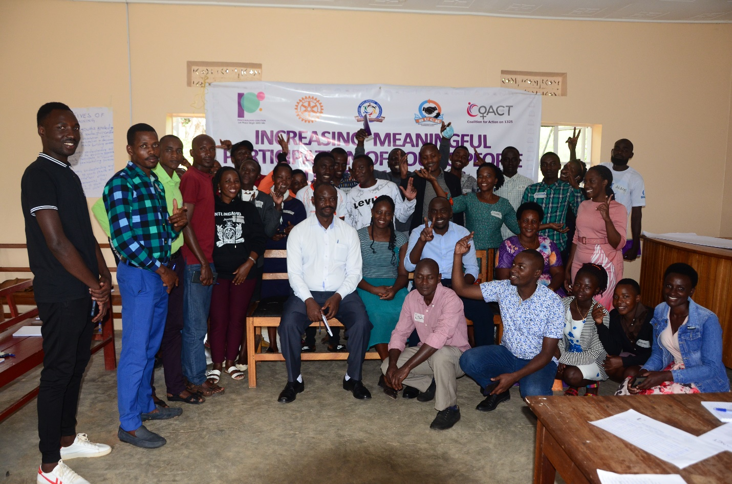

**L-R seated was the LC3 Chairperson Ntungamo sub county, Community Development Officer (CDO) and District Youth Chairperson Ntungamo district**

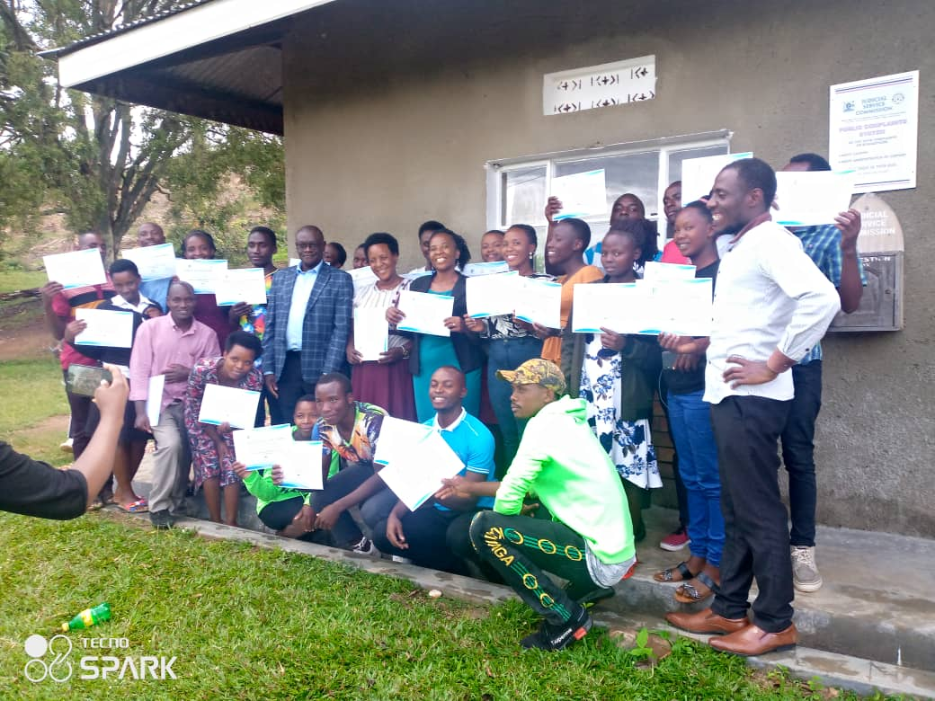

**Participants after receiving their certificates after the training**

## **4.4: Online monthly check-in calls to trained youth**

Monthly check-in calls were held in addition to whatsApp group that was created during the training. These enabled the trained youth to stay connected with each other, work together to register their community based organisations at district level as Youth-lead peacebuilding CBOs to continue mobilizing youth for positive peace.

## **4.5: Community dialogues on positive peace**

Four (4) community-level dialogues in 2 parishes of Butare, Kahunga, Ntungamo sub county, Ntungamo district were successfully conducted and reached a total of 98 young people (50 Female and 48 Male). The dialogues provide a platform for the youth to share information, ideas, and challenges and agree on strategic actions needed to increase youth participation across the spectrum. The community dialogues also provided a platform for young people to share issues that affect them and discuss strategies together with district and sub county level leaders to create more opportunities for youth to thrive.

## **4.6: Social media to promote discussions on positive peace**

Social media (Facebook and Twitter) was utilised to stimulate discussion on youth participation in peacebuilding processes. Although 40% of the trained youth had smartphones, 60% did not have such phones to follow or contribute to discussions on social media platforms. This limited their participation. Hash tag #Youth4Peace was created for utilisation on Twitter and the social media platform. Below are snapshots

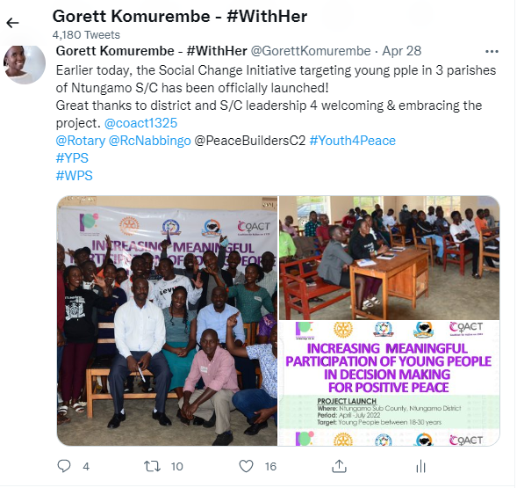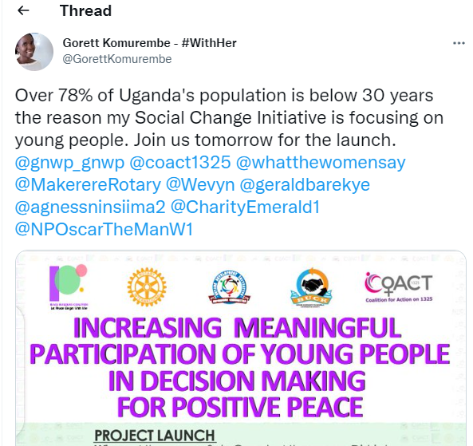

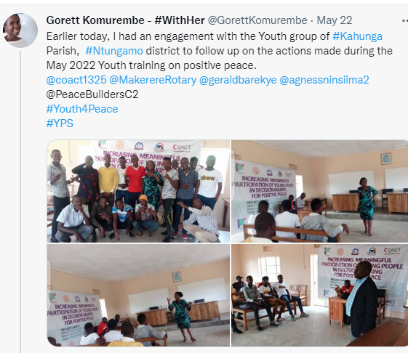

# **5.0 KEY FINDINGS / IMPACT**

The findings show that there are a number of barriers that inhibit youth participation in decision making and peacebuilding processes including commercialization of politics (including high cost of campaigns), lack of information regarding available elective positions at different levels, low self-esteem and lack of leadership skills. For female youth in addition to the already mentioned barriers, they mentioned other additional barriers that limit their participation in decision making. These included; sexual harassment (by candidates and agents) during elections, negative socio-cultural norms and beliefs, lack of family support, lack of exposure and low levels of education.

In addition, the study found that there is lack of information on the existing opportunities for young people to meaningfully engage in decision making and peacebuilding process. Youth think that because of their status as young people, sometimes leaders deny them information or by proxy, the information does not reach them on time. This limits their level of involvement and they sometimes lose out on good opportunities.

The study revealed limited knowledge or no induction on legislation among the youth. This makes it difficult for youth to engage, advocate for their rights, and meaningfully participate in leadership and decision-making. “As young people, you find us being technically challenged by the technical people during meetings since we do not know much, Says a Youth from Kahunga parish.

The study revealed limited knowledge or no induction on legislation among the youth. This makes it difficult for youth to engage, advocate for their rights, and meaningfully participate in leadership and decision-making. “As young people, you find us being technically challenged by the technical people during meetings since we do not know much, Says a Youth from Kahunga parish.

Further, youth expressed distrust about national politics and government programmes citing marginalization and manipulation of youth; corruption and vote buying and bribery and financial impropriety in government programmes. Some youth described having been used during the 2021 general elections with their issues and concerns subsequently dismissed. They stated that youth’s desperation makes them easy targets for manipulation by politicians while others use them to destabilize communities. Youth blame the failure of government programmes to their exclusion from design and planning.

The study found that there is negative attitude among most youth with the desire to gain quickly in the shortest time possible and not paying attention to the process of learning, acquiring knowledge and skills before they can take off. This leaves them out and creates bias and mistrust among the older generation. This confirms the public perceptions about youth being impatient.

The findings also revealed that high levels of unemployment among youth makes them demoralized and demotivated to aspire for higher things after education. Unemployment is massively driving youth into alcohol and drug abuse with its negative consequences especially suicidal tendencies, sexual abuse, death and increasing crime rate in the communities.

**Verbatim quotes from the field during the training**

“My parents sold land to pay for my education at university. I graduated in January 2021 and since then I have not found a job. My parents of course expect me to start working as soon as possible but this is not forthcoming. I feel so frustrated and ready to grab any opportunity that presents itself”

“As youth, we are in a situation of survival for the fittest. We have limited resources, we are very many and so we have to fight to our very best to take some of these opportunities that come”

“You know the saying that education is the key, government changed the padlocks longtime ago. You complete the education cycle but you are worse than the person who never went to school”.

“The youth are not empowered and are disorganized” – a statement often used to tactically isolate youth from participating in decision making and peacebuilding processes.

Majority youth spoke of their high energy, resilience, and a strong desire to receive education, find work, and contribute to peace and development in their communities. Development efforts should acknowledge their significant potential and seek to create substantive roles for youth to engage in peacebuilding and civic activities, allowing them to build confidence, leadership skills, and empowerment*.*

The findings also reveal that skills training has potential to help youth to build resilience following adversity in their earlier life. Therefore vocational skills training should be geared towards helping young people to develop a positive attitude, life skills and adjustments. One of the participants during the training noted that while more efforts are being targeted towards training, life after the training should not be a minor concern. Many young people have ended up cohabiting with violent partners or in many other informal employment as bar attendants or food vendors.

The study revealed low representation of youth in the sub county and district councils. Only two positions are provided for youth (Male and Female representatives) at district and sub county level while at national level, only 5 positions are reserved for youth. The need to amend the existing laws to increase youth participation is paramount.

The findings reveal that female youth still suffer from the social discriminatory norms, beliefs and practices that hinder their effective participation in peacebuilding processes. The youth coordinators per target parish mentioned how hard it was to get female youth on the programme. Some parents stopped their daughters from participating in project just because they are girls despite having delivered invitation letters to their parents and made numerous phone calls. These norms affect people’s perception of themselves and others and directly affect individuals’ choices, freedoms, and capabilities.

# **6.0** **CHAPTER FOUR: GENERAL CONCLUSION**

1. It is important to emphasize that young people’s inclusion and participation in peacebuilding processes equally matters. Utilizing a multilayered and integrated engagement approach should therefore be the main strategy for realizing youth inclusion and participation in peace processes.
2. Skilling of youth including vocational training is one element of a holistic approach that helps open prospects for young people to live productive lives. Vocational training can contribute to more employment and more income opportunities thereby contributing to addressing the root causes of radicalization.
3. Shifting the mindset towards young people as agents of change will support the realization of a broad socio-political culture of inclusion. Available evidence suggests that young women and men can and do play active and valuable roles as agents of positive and constructive change.
4. Some youth engage in violent extremism because they are looking for survival and have no stake in the economy. Engaging them in productive work that enable them earn a living will create sustainable peace.
5. The potential of social media as a tool for peace was also highlighted. Youth noted its capacity to transcend conflict lines and to build positive communities. However, young people also recounted their experiences in which social media had been used as a tool for hate, abuse, discrimination and incitement to violence. Much attention is thus needed to channel social media’s positive potential and to mitigate its risks: youth should be at the forefront of these efforts.
6. While violent extremism requires interventions to protect the security of people and assets, prevention of violent extremism needs to look beyond strict security concerns to development related causes of and solutions to the phenomenon. Experiences in both development and peacebuilding show that an increase in the levels of inclusion and tolerance in communities can lead to both better governance of diversity and to societies better inoculated against violent extremism.

# **RECOMMENDATIONS / IMPLICATIONS FOR POLICY**

1. Government and CSOs should facilitate youth’s capacity building relevant to their individual and contextual needs to ensure they can design, initiate, and complete successful peacebuilding initiatives and confidently participate in peace processes.
2. The government should amend the Local Government Act, which currently only has 2 provisions for youth representatives per district as a mechanism to increase youth participation in democratic and peacebuilding processes.
3. Promote use of the ICTs to target and sensitize the youth on peacebuilding including WhatsApp, Facebook and twitter, tiktok.
4. MGLSD should develop and implement a National Action Plan on Youth Peace and Security and provide funding for it. This will increase youth participation in peacebuilding processes.
5. Local Governments and CSOs should organize massive youth community mobilization and sensitizations with sustained momentum before, during and after elections using popular media and other enablers like football, netball and popular artists. This will address issues of exclusion.
6. Utilize community gatekeepers including religious and cultural leaders to sensitize the youth on peacebuilding and non-violence approaches.
7. Government and development partners should ensure a sustained provision of funds, technical resources, and guidance to support youth-led peace initiatives. This should include fighting corruption and punishing those that embezzle youth funds.
8. Support the establishment of intergenerational platforms to discuss challenges related to youth inclusion in peacebuilding. These would provide permanent platforms for intergenerational participation in the policymaking process and should be composed of elders, political leaders, policymakers, and youth representatives from all backgrounds

## **6.2 SUSTAINABILITY PLAN**

1. Working within already existing government structures specifically the office of the district and sub county community development department, youth structures and Local council leaders will continue to provide the necessary support to the trained youth during their community engagement and youth mobilization.
2. The three (3) youth-led associations that were established in Kahunga and Butare Parishes will continue to engage and mobilize youth for peace.

# **7.0 APPENDIX 1: PICTORIALS**

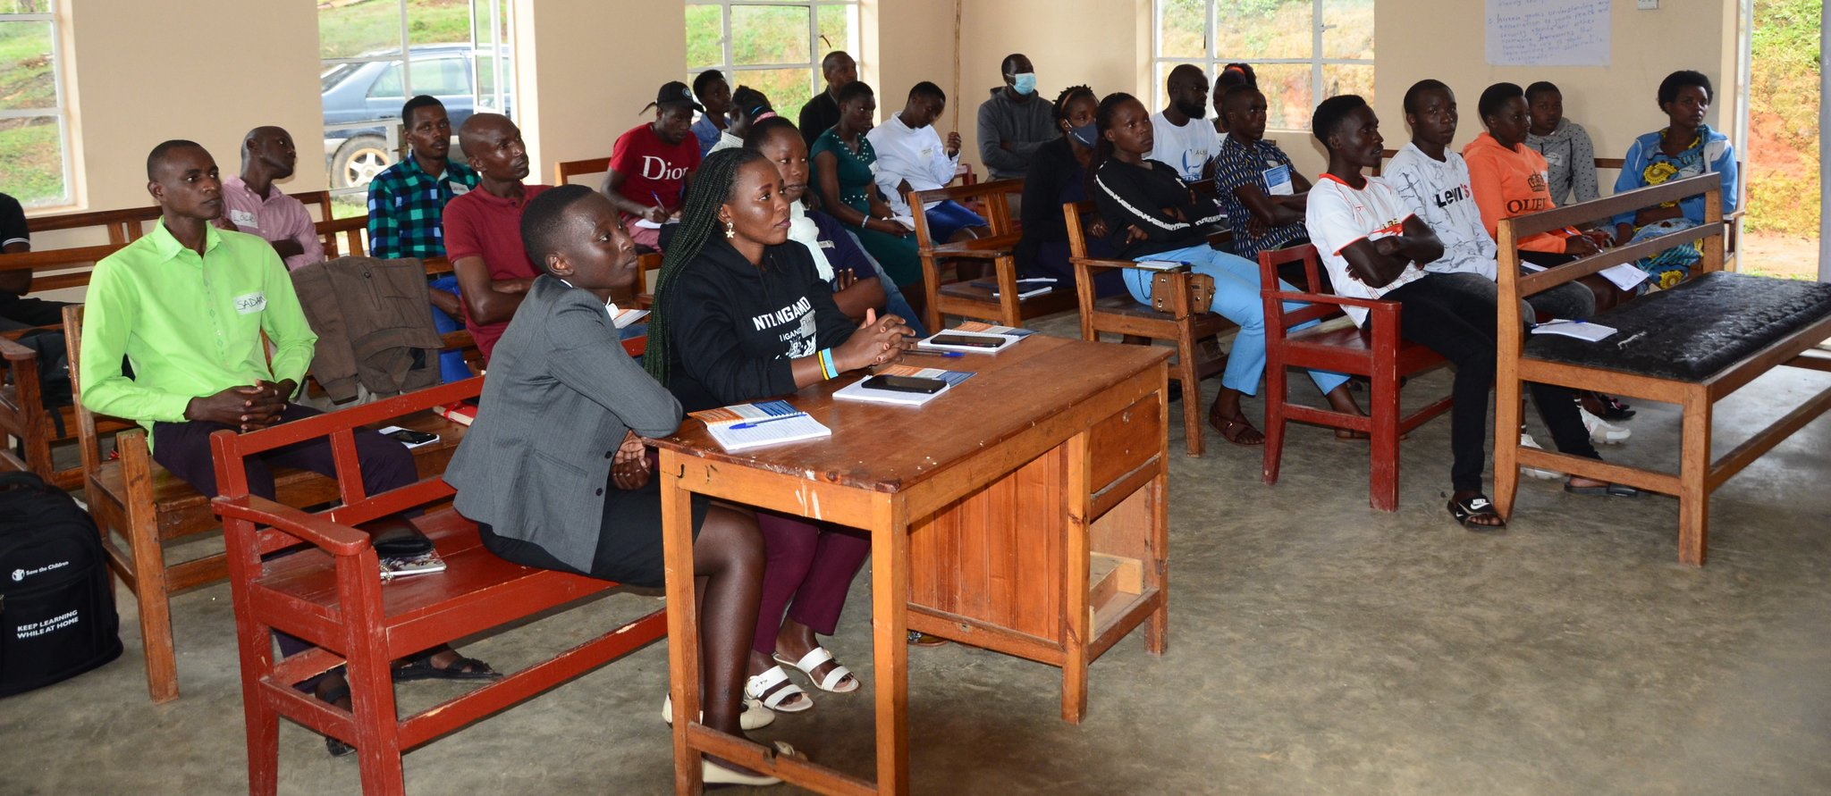

**Youth very attentive during the training**

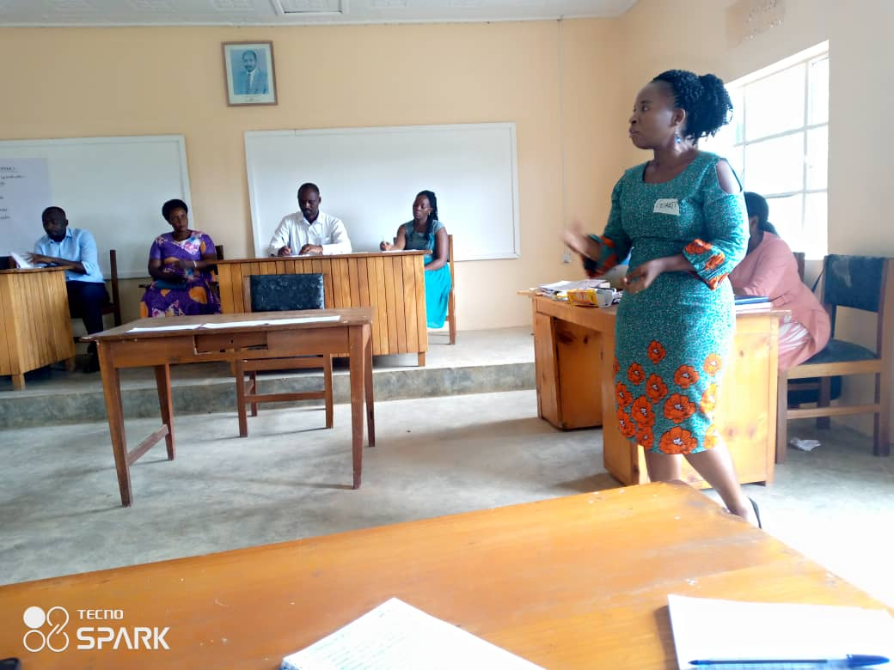

**Gorett Komurembe giving a brief about the youth peacebuilding project**

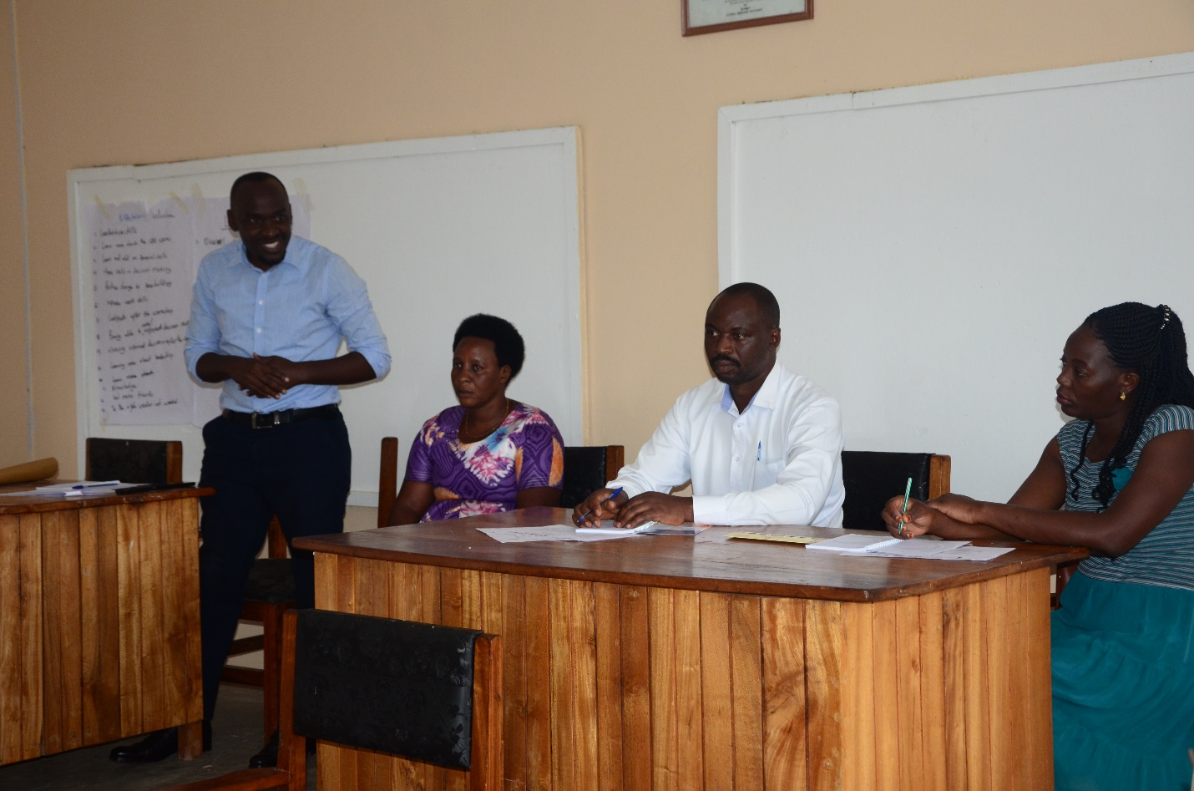

**District youth chairperson giving opening remarks at the training. Next to him was the woman council, LC3 Chairperson and CDO**

# **REFERENCES**

1. Alpaslan, O (2020). The Role of Youth in Peacebuilding: Challenges and Opportunities. <https://gdc.unicef.org/resource/role-youth-peacebuilding-challenges-and-opportunities>. Accessed on 26th August 2022
2. Ayetekin, (2019). Youth Extremism as a Response to Global Threats. <https://econtent.hogrefe.com/doi/10.1027/1016-9040/a000415>. Accessed on 15th August 2022
3. Babriel o, etal (2018) [Human Security and Citizenship in Finnish Religious Education: Rethinking Security within the Human Rights Horizon.](https://philpapers.org/rec/ADEHSA) *Human Rights Review* 19 (4):447-469.
4. Bélanger et al (2019). Radicalization Leading to Violence: A Test of the 3N Model
5. Bélanger, J. J., Moyano, M., Muhammad, H., Richardson, L., Lafrenière, M. A. K., McCaffery, P., & Nociti, N. (2019). Radicalization leading to violence: A test of the 3N model. *Frontiers in Psychiatry*, *10*.
6. Blakemore, S. J. (2018). Avoiding social risk in adolescence. *Current Directions in Psychological Science*, *27*, 116–122.
7. Christer M, etal (2018). Vi[olent Extremism, National Security and Prevention. Institutional Discourses and Their Implications for Schooling.](https://philpapers.org/rec/MATVEN) *British Journal of Educational Studies* 66 (1):109-125.
8. Cirhigiri, C. C. (2019, June). Youth and peacebuilding: Key insights and lessons from a global online consultation. Peace Direct. Retrieved February 14, 2020, from <https://www.peaceinsight.org/blog/2019/07/youth-and-peacebuilding/>
9. Conciliation Resources report (2018). Youth aspirations for peace and security
10. Davies .L (2016). Security, Extremism and Education. [*British Journal of Educational Studies*](https://philpapers.org/asearch.pl?pub=3348) 64 (1):1-19
11. Doosje et al. (2016). Terrorism, radicalization and de-radicalization
12. Galtung. J (1976). Approach to Peace Studies, Volume 5, Issue 1.
13. Ghosh. R (2022). Rethinking education to counter violent extremism. A critical review of policy and practice. <https://www.tandfonline.com/doi/abs/10.1080/17449642.2021.2023998>. Accessed on 15th August 2022.
14. Heinke, D. H., & Persson, M. (2016). Youth specific factors in radicalization. *Defence against Terrorism Review*, *8*, 53–66.
15. Helix .O (2017). Political Parties and Youth Political Participation in Uganda
16. Joyce .M (2013). Resilience, Violent Extremism and Religious Education, *British Journal of Religious Education* 35, no. 2.
17. Lederach J.P. (1997). Building Peace: Sustainable Reconciliation in Divided Societies, United States Institute of Peace Press, Washington, DC
18. Maciejewski, D. F., Keijsers, L., van Lier, P. A., Branje, S. J., Meeus, W. H., & Koot, H. M. (2019). Most fare well – But some do not: Distinct profiles of mood variability development and their association with adjustment during adolescence. *Developmental psychology*, *55*,
19. McCormick, C. M., & Mathews, I. Z. (2010). Adolescent development, hypothalamic-pituitary-adrenal function, and programming of adult learning and memory. *Progress in Neuro-Psychopharmacology and Biological Psychiatry*, *34*, 756–765.
20. [Michalinos Z (](https://philpapers.org/s/Michalinos%20Zembylas)2020).  [Affect/Emotion and Securitising Education: Re-Orienting the Methodological and Theoretical Framework for the Study of Securitisation in Education.](https://philpapers.org/rec/ZEMAAS) - *British Journal of Educational Studies* 68 (4):487-506.
21. Ministry of Gender, Labour and Social Development September (2016). Uganda National Youth Policy: Unlocking youth potential for sustainable wealth creation and development.
22. Sommers, M. (2019) Youth and the field of countering Violent extremism, Washington, DC: Promundo-US.
23. Strange, S. (2015). *States and markets*, Bloomsbury Publishing.
24. Uganda Bureau of Statistics 2012: Uganda National Household and Health Survey. Kampala Uganda; UBOS.
25. UN-IANYD, (2014). The UN Guiding Principles on Young People’s Participation in Peacebuilding
26. United Nations Children’s Fund (2011); Annual report
27. UNOY (2015). A Space for Peace: Inclusion of Youth and Peacebuilding in the Post-2015 Development Agenda A report of the United Network of Young Peacebuilders.
28. USAID (2011). Youth mapping report volume 1: a cross sectoral situation analysis on youth in Uganda.<https://www.youthpolicy.org/national/Uganda_2011_Youth_Mapping_Volume_1.pdf>. Accessed on 7th September 2022
29. World Youth Report (2018): Youth and the 2030 Agenda for Sustainable Development. United Nations New York, New York 10017 United States of America.

1. Ghosh et al., “Can Education Counter Violent Religious Extremism?”