**Restoring Hope. Rebuilding Futures.**

Mengo-Kisenyi Settlement, Kampala, Uganda

6 – 15 July 2022

Jennifer Montgomery

# ABSTRACT

Barriers to social and economic equality are high for women and girls in poor and conflictaffected areas. Many women resort to selling sex as a means of survival and to provide for their families. This activity often brings unwanted sexual violence which can cause lasting damage and moral injury. This can impede personal growth and achievement and cause problematic reliving of the traumatic experiences. When trauma becomes an identity, individuals get stuck and are unable to see a positive future. Art making can restore victims’ capacity to access their emotions and begin their individual healing process. The integration of creative arts-based methods with traditional qualitive research strategies can offer a more intimate look at challenges experienced by marginalized populations and create a safe and supportive environment conducive to new ways of thinking and behavioral change. This paper explores the social and economic drivers of Gender Based Violence among women living in an urban settlement in Uganda and uses mindfulness and creative expression to connect and empower women to create sustainable change in their lives and communities.

# CHAPTER ONE

## Introduction and Background

In November of 2021, Makerere Peace fellows, Cohort 2, conducted a field visit to MengoKisenyi informal settlement hosted by Mengo Youth Development and Education Link (MYDEL), a non-governmental organization based in Kampala, Uganda. The organization serves beneficiaries in the Mengo-Kisenyi community with a mission to empower through education, sensitization, and skills development to contribute to sustainable poverty reduction among marginalized communities.

Mengo-Kisenyi is an informal settlement in Kampala Central Municipality with approximately 200,000 residents. Some of the population comes from rural areas of Uganda seeking employment in the capital city. Others arrive as internally displaced people from war affected areas in northern Uganda. Mengo-Kisenyi also accommodates many refugees from neighboring countries such as the Democratic Republic of Congo, Rwanda, Somalia and Ethiopia who were forced to flee from poverty, famine, ethnic conflicts and war (MYDEL, n.d.).

One of the places we visited in the settlement was the brothel, where women and girls have sex for money with men. After our tour, we gathered at a nearby hotel to engage in a community dialogue with representatives from the community about specific challenges. A group of women representing the commercial sex “workers” spoke about their desperation for money for food and school fees for their children. They were without skills or training for a livelihood and were doing what they had to do to survive. As I listened to them speak, I grew frustrated with the lack of safeguarding of this vulnerable group of women in such an insecure environment. The women shared that even when they are not “working” in the brothel, they are repeatedly victimized by Gender Based Violence (GBV) in the community. After our discussion, several of the women approached me and asked if I could help them find relief. They were tired, run down and without hope from this terrible situation. Many had resorted to using drugs to numb the pain and desperation they faced each day. As a professional working in the anti-human trafficking field in the United States, I was immediately drawn to these women’s stories and chose Mengo-Kisenyi for my Social Change Initiative project site.

According to Vital Voices Global (2022), an international non-profit organization focused on female economic empowerment, Gender Based Violence (GBV) is violence that is directed at an individual based on their biological sex or gender identity. It includes physical, sexual, verbal, emotional and psychological abuse, threats, coercion and economic or educational deprivation. GBV remains pervasive around the world and is recognized as a violation of human rights. It limits, and in many cases prevents, individuals from achieving their full leadership potential in all areas of society, with devastating impacts that reverberate in communities and countries across the world.

My initiative is an intervention with women in poverty that addresses conflict by focusing on transforming hardships such as sexual violence into opportunities for self-awareness, selfcompassion and creative expression to equip individuals for self-sufficiency, leadership and community peacebuilding. The framework of the initiative is guided by a “Strengths

Perspective,” which emphasizes the human capacity for resilience and resourcefulness and recognizes the need for individuals and communities to form and achieve their own goals and aspirations. While it is important to acknowledge difficulties that people experience, this approach reframes obstacles as challenges, opportunities and motivators for change.

I chose to include art as the vehicle for change because of the significant role it has played in my life healing trauma from sexual violence. Art is a recognizable part of culture in our world but has been underutilized in the peacebuilding process. Creativity has the power to reject the past, to change the present and to seek new potential. Art can restore victims’ capacity to access their emotions and begin their individual healing process. Through the power of art, we can build creative approaches to peacebuilding and contribute to a safer, more equitable and just world.

My initiative aligns closely with Rotary’s mission to advance world understanding, goodwill and peace, specifically the focus on education and literacy, conflict prevention and building resilience. I share deeply the vision of peace as a living, dynamic expression of human development and not as an abstract concept. By equipping individuals with self-awareness, connection and a voice, we give life to the possibility of peace and reconciliation on both a personal and collective scale and make a significant contribution to sustainable and positive peace.

## Problem Statement

Barriers to social and economic equality are high for women and girls in poor and conflictaffected areas. Many women resort to selling sex as a means of survival and provide for their families. In Mengo-Kisenyi, women are repeatedly victimized by sexual violence from community members and others outside the community. Safety is elusive and there is no organized effort to safeguard this vulnerable population within the already insecure environment.

When trauma becomes an identity, individuals get stuck and are unable to see a positive future.

Historically, human beings experience suffering through the trauma of violence, violation or war. As Brooks (2018) suggests, wherever there is trauma, there has been betrayal, an abuse of authority, a moral injury. Sexual assault can be a form of moral injury which can occur when someone acts or is a witness to behaviors that are in opposition to a person’s values and moral beliefs. Often people who have suffered a trauma, whether it is sexual assault or war or displacement, find that their identity formation has been interrupted and fragmented. Time doesn’t flow from one day to the next but instead circles backward to the bad event. When people are disconnected from themselves due to traumatic experiences, they also struggle to connect effectively with others. An important part of re-establishing this connection is to focus on self-care strategies and establishing physical and emotional safety and identity formation through creative expression.

## Goals and Objectives

The goals and objectives of my Social Change Initiative are:

* To identify the social and economic factors responsible for GBV in Mengo-Kisenyi settlement.
* To establish a meaningful connection between the women and themselves and others through mindfulness and creative expression.
* To engage women in problem solving through discussion of challenges and solutions to problems the women currently face in their community.

My research questions are:

1. What are the social and economic factors responsible for GBV in Mengo-Kisenyi?
2. Can mindfulness and creative expression serve as a bridge to connection, isolation and hope for the future?
3. Can women in marginalized communities be empowered to advocate for themselves and solve their own problems?

One of the limitations of this study is that the initiative does not examine in depth the cause and effect of a myriad of other contributing factors to struggle and hardship for women in informal settlements such as HIV/AIDS, sanitation and hygiene issues, girls’ lack of access to education and other social issues relating to the wide gender gap in Uganda. While these issues certainly exist and affect the target population for this study, they were not the specific focus of this intervention.

Due to the limited timeframe and resources allotted for this initiative, my strategy was to collect key data that could be helpful to my overall understanding of the challenges faced by the women and contribute to future interventions with this population, both in Mengo-Kisenyi and perhaps the larger informal settlement context.

The goal of any conflict intervention should be a sustainable peace. Peace begins within and that is why I chose to address the individual nature of trauma and its potential effect on community for my initiative. The inevitable result of mitigating personal stress and healing from trauma is creating individuals who are more willing and able to connect with others and be the glue in groups to create community cohesion and conditions that foster peace.

## Challenges and mitigation strategies

Establishment of trust between the facilitator and participants was critical to success of my initiative. One of the things that helped mitigate this was that many of the women remembered meeting me when our peace fellow cohort toured the settlement in November of 2021. Additionally, I chose to reinforce trust by disclosing a bit about my own history of sexual violence and personal experience of being a single parent of multiple children which created solidarity with the participants.

Another significant challenge was the women’s limited ability to understand or speak English. I used my small vocabulary of both Lugandan and Swahili words to communicate appreciation or thanks when appropriate. I also used a female translator from MYDEL for much of the instructions and interpretation. Despite this challenge, I was still able to relate to the women because I was giving them something that went beyond language and that came instead from my heart. This had a powerful impact and taught me an important lesson - the further away we get from our own conditioned cultural beliefs and experiences, the greater the opportunity to see our own light. When we are willing to step out of our comfort zone and be vulnerable, we create a strong sense of hope and purpose, for ourselves and those around us.

In addition to the language barrier, low levels of literacy, the chaotic nature of the women’s lives, childcare duties and other contextual life challenges also impacted the intervention. During the two-week program, one of the women gave birth, another woman’s mother died and was buried immediately in accordance with Muslin tradition. Both women came back to the program and were committed to completing it despite these major life events. This demonstrated a high level of engagement with the program, discipline and motivation which is a good indicator that the women would do well with vocational skills training in the future.

Successful execution of the initiative demanded openness to a mindset change by the women. The solution to their problems was not just about getting more money. We addressed this issue through group dialogue, creating alliances and a culture of safety and trust. Ultimately, they were able to see themselves as more than what happened to them and found hope that they can be and do better with the right mindset, skills and approach.

# CHAPTER TWO

## Literature Review

People living in sub-Saharan Africa are disproportionately exposed to trauma and may be at increased risk for post-traumatic stress disorder (PTSD). Researchers have documented a wide range of atrocities and high rates trauma in sub-Sahara Africa and the trauma appears to be intertwined with a wide range of contextual factors (Smigelsky, 2014).

Trauma from sexual Gender Based Violence is often particularly complex. Sexual assault is a sexual act committed against someone without that person’s freely given consent (Menon, 2018). Intimate Partner Violence (IPV) is defined as physical, sexual or psychological harm by a current or former partner or spouse. Human trafficking is defined in the United Nations Trafficking in Persons Protocol as the recruitment, transportation, transfer, harbouring or receipt of people through force, fraud or deception, with the aim of exploiting them for profit. The parallels among sexual assault, IPV and human trafficking victims are myriad, including demographics, tactics used by perpetrators and physical and mental health sequela (Menon, 2018).

Creating interventions for cross-cultural contexts is important and must be done using the most sensitive care possible. Harris (2007) moved beyond adapting traditional Western therapy to conceptualizing creative therapeutic processes that combine the essence of Western trauma treatment with the rituals of the culture of Sierra Leone. The capacity of dance/movement therapy to promote emotional expression through the body resonates with the culture of Sierra Leone, in which unity of mind and body is strong (Smigelsky, 2014).

Creative activity alone does not necessarily lead to positive resolution, but the goal of creative arts therapy is to facilitate expression that helps explore feelings and experiences without reinforcing traumatic memories (Malchiodi, 2015). Creative therapy can also help generate narratives that can be ordered or altered through cognitive reframing techniques (Steele, 2012), to help reduce long term sequelae of posttraumatic stress.

The positive impact of creative art therapy can be understood from different theoretical perspectives. From a psychobiological perspective, conceptualizations of traumatic stress as a physiological response of the autonomic nervous system (Levine, 2018) support a somatic approach to intervention including sensory and bodily expression and integration (van Westrhenen, 2017).

According to Smigelsky (2014), the impact of trauma is measured in both the presence of symptoms and the absence of regular daily functioning. Therefore, it is appropriate for interventions to move beyond the reduction of symptoms toward improved functioning. Improving the capacity for the women to function well in their challenging situations was one of the goals of my initiative. In addition to therapeutic interventions, attention to the activities of mundane life is necessary. Social relationships are deeply woven into the fabric of life for many communities in sub-Saharan Africa, and the case for social support as a protective factor against posttraumatic stress is strong.

Understanding the roots of violence is also important to connect the focus of my initiative to the larger field of peacebuilding. Staub (2003) correctly points out that cultural and societal conditions that frustrate basic psychological needs make violence more likely, whereas conditions that help fulfill these needs in constructive ways contribute to the development of peaceful relations and fully human lives. How do we build cultures of peace? How do people transcend the situations they are living in to find larger meaning and peace within? To answer these questions, we must first look at the basic human needs of security, a positive identity and a sense of effectiveness. For those living in poverty, Staub (2003) asserts there is an omnipresent feeling of injustice and struggle. Among marginalized groups such as “commercial sex workers” or women who have been victims of sexual GBV, negative images or stereotypes can incite harmful action, discrimination and further violence by others. Additionally, as Staub (2003) points out, devaluation, threat and frustration can break down the ability of members of a group to connect and support each other. This was apparent within the group of women in this intervention. My goal was to purposefully affirm the humanity of the members of this devalued group to help create a sense of solidarity and support for each other.

Healing can be defined as the process or act of curing or restoring to health or wholeness the body, the mind and the spirit (Haggard, 1983). It requires people to engage with their painful experiences and struggles, have their suffering and pain acknowledged, receive empathy and experience loving and supportive connections with others. My initiative weaves these outcomes throughout the activities of the four-day curriculum.

To engage in making art, Gude (2010) says one must begin by surrendering to the process of making. This requires a commitment to actively engage with materials while staying loose and experimental. One of the biggest challenges to this surrender is to step outside the comforting constraints of conformity. In his classic book, On Becoming a Person, Carl Rogers (1995) summarizes circumstances that promote personal growth and self-actualization. He describes two major conditions that are essential for creativity – psychological safety and psychological freedom. My goal with the women was to create an environment that promoted free artistic exploration while accepting each person with unconditional worth, without external evaluation and with empathy. What is important is not the uniqueness of the artistic product, but rather the deeply felt connection between self, process and product as Gude (2010) correctly points out.

Art education supports each person in telling his or her own story (Gude, 2010). As Hillman

(1975) says, the structure of self is not formed only by what happened, or by one’s experiences but also by how one has understood and interpreted the experience both at the time of the initial experience and upon later reflection. This is how people shape and re-shape themselves which offers a window of hope for those stuck in an untenable situation. Ultimately, heightened selfawareness is extended to heightened awareness of others. Through art and theory, we form new patterns of perception that enable us to see the world with fresh insight (Gude, 2010).

## Theoretical Underpinnings

According to Collins (1992), researchers bring frames of reference, goals and biases to the research project. Each type of inquiry is influenced by the researcher’s own view of the world. As a survivor of sexual GBV, I have certain values and experiences that influence the questions I asked on my surveys and the activities I chose for the initiative. These experiences, expectations and values are comparative in nature. Collins (1992) suggests the researcher and the research should not function as exclusive end products but as a continuous ebb and flow of information. Using qualitative inquiry allows data emerging from interactions to have a history and a future thus becoming dynamic in essence.

My perspective for the intervention was an integrated approach that included a meaningful connection between the researcher and the research. This incorporated experimentation and exploration which allowed me to trust my own perceptions of what would be helpful for the program participants. This was exciting because it created a theoretical link between what I knew from my own experiences and processes as an artist and what I perceived in other people’s experiences and challenges. We can use our visual perception to create art forms which often give new insight and outlook into how to use our own perceptiveness to create more integrated lives. Ultimately, it was my goal for the program participants to see for themselves that the whole is often greater than the sum of its parts.

Curriculum design was based on initial conversations with the women last fall, research-based best practices in the field, the data collected on the pre-survey and my own lived experience using creative expression and mindfulness to heal trauma. As a researcher, it was important to keep some social and intellectual distance to preserve objectivity.

In designing my intervention, I took deliberate care to focus on the collectivist culture of Africa, commonly referred to as “Ubuntu,” which focuses on membership of a group where people act to fulfill goals that serve not only their own interests but also their family or an entire community.

According to Desmond Tutu, Ubuntu is, “…the essence of being human. It speaks about humaneness, gentleness, hospitality and putting yourself out on behalf of others, being vulnerable. It embraces compassion and toughness. It recognizes that my humanity is bound up in yours, for we can only be human together.” This was the lens through which I approached and conducted my social change initiative.

Community is critical in fulfilling needs for connection and identity. The collectivist approach contrasts with more individualistic cultures such as in the United States and Western Europe where the focus is often on personal autonomy. In this type of environment, individuals make decisions for themselves and act to fulfill individual goals often at the expense of the larger group.

The two theoretical approaches I used to achieve my project goals were mindfulness and creative expression. On the most basic level, mindfulness is the experience of being fully present and focused on whatever it is that you are doing without self-judgment. This includes being aware of yourself, your emotions, your bodily sensations, or your surroundings in the present moment. Individuals have an innate ability to be “mindful,” but don’t always find it easy to access or experience. The term “mindfulness” is sometimes confused as a type of secular prayer but it is actually something entirely different. Mindfulness exercises, which focus on breathing and calming the nervous system, can be useful in guiding people to find their more centered, mindful selves. This can lead to peace of mind and better decision making. Mindfulness at its best can be used along with prayer for those who practice religious beliefs.

Creative expression is a useful medium for people to process thoughts and feelings about their experiences and their lives. An inherent part of our humanity is the desire to make things and express our needs and wants. Art is a form of communication that emerges from our own personal creative experiential processes. Art-making, like other forms of creative expression, can increase self-awareness and can be a powerful tool for reflection, making people more in touch with themselves. The way we perceive things visually is directly related to how we think and feel. This correlation becomes obvious when we choose to represent our perceptions using art materials. In sharing what we produce through art-making with others, it becomes a way to allow ourselves to be better seen and understood and feel more connected (First Aid Arts, n.d.). According to Lederach (2005), the emergent, unstable, and open-ended character of art has the potential to produce new and creative means of intervention that might enable the necessary

‘discursive space’ and ‘moral imagination’ required for peacebuilding and, possibly, reconciliation.

Arts-based research is defined by McNiff (2008) as ‘the systematic use of the artistic process, the actual making of artistic expression in all the different forms of the arts, as a primary way of understanding and examining experience by both researchers and the people they involve in their studies. This approach can ‘unlock the potential of the often-vulnerable populations’ who might struggle to engage with more traditional research approaches.

When you do something creative, “being in the moment” allows you to be more in-touch with yourself. Sharing what you make with others allows you to tell your story and feel more connected to people around you. Being creative stimulates thoughts, moods and feelings that change our brain and our bodies and can have a positive impact on our health. Through creative expression we can learn to give up falseness and grow into our authentic selves. During the workshops, we also used music and dance as a form of creative expression and release which provided an effective way to bond as a group.

## Theory of Change

My theory of change for this initiative centered on the idea that if we access the women’s trauma, emotional challenges, “unsafety” and isolation, through purposefully building community and sanctuary together, new ways of viewing their situations will open up and they will be receptive to learning self-care skills to build confidence, resilience and leadership capacity.

Some of my assumptions were based on the idea that if we can build on these initial actions, future success will occur with vocational skills training and business ownership, parenting and managing life’s challenges. Through my intervention, change will come by first reconnecting to the self that is lost through complex trauma from sexual exploitation, commodification and objectification. Once the connection is re-established, individuals will connect more easily with others, have feelings of safety and accomplishment and separate from their trauma. This allows them to see their needs beyond just “more money” and help themselves through imagination of a brighter future and finding solutions to accomplish this. By engaging participants in creative problem solving, the intervention becomes sustainable and has a better chance for success.

Desired outcomes of this intervention include participants accessing and completing vocational skills training and creating sustainable livelihoods that buffer them from sexual violence and don’t rely on engaging in commercial sex. The following outcomes are part of the longer-term strategy for my initiative:

* Restored sense of physical and emotional safety for at-risk women living in MengoKisenyi.
* Renewal, restoration, connection to self and others through expressive arts.
* Reduced isolation for at-risk women engaging in commercial sex.
* Reintegration of women and girls back into themselves and their communities to restore peace.
* Increased community awareness about the impact of sexual violence on at-risk women, their children and family members (generational trauma).
* Affected communities are engaged in the dynamic process of dialogue and reconciliation. ▪ Reduced number of sexual violence incidents perpetrated by men inside of MengoKisenyi.

My situational analysis included utilization of the onion method of conflict analysis because with this population there were many dynamics to be considered. Only those on the surface were visible until I peeled some of the layers to see what existed at the core, which was much more complex. I also reviewed existing research with similar populations and had extensive conversations with stakeholders at MYDEL to gather key information about my target population and strategize on how we could reach our intended goals and outcomes. During these conversations, I learned that this particular group of women was among the most challenging to serve in the Mengo-Kisenyi community.

Analyzing assumptions was important to fully understand the cause-and-effect factors relating to the conflicts being addressed by the intervention. My operational assumptions about the informal settlement context and potential drivers of GBV were motivating factors behind my research questions and curriculum design post data collection and analysis. Determining the areas of highest risk-reward proved most critical to success of the intervention. This required courage to ask difficult questions and rely on others with more direct knowledge and experience with the target population to guide me and offer support and suggestions when change was needed.

The monitoring of assumptions was an ongoing challenge. I intentionally adjusted and readjusted group activities and the agenda during the workshops based on feedback from the program participants and volunteer staff. One assumption I made at the beginning of the workshop was that the women wanted to be fed a hot meal for lunch instead of receiving the monetary equivalent for transport or to buy food for their children. After receiving feedback from them directly, I adjusted my approach. During the implementation of my initiative through trial and error I learned a lot which is innately part of any change endeavour. The theory of change used for my intervention was meant to inform the development of future monitoring and evaluation for the follow up projects anticipated.

## Methods and Design

For project design, I used a variety of conflict analysis tools to create an effective and sustainable intervention. In addition to the Onion Method, I used the Strengths, Weaknesses, Opportunities and Threats (SWOT) approach which allowed me to adequately assess internal and external factors as well as current and future potential for change. I also used the Problem and

Opportunity Analysis as a tool to find the logical entry points with both my target population of at-risk women and the Mengo-Kisenyi community at large.

My role in executing the intervention was as a catalyst for change. Based on my resource analysis, the best approach for my initiative was to partner with an already existing NGO doing work with the community and collaborate on sustainable solutions for this challenging population. This required several brainstorming sessions before and after the workshops each day and a flexible, open approach. Staff from MYDEL were vital to the success of my initiative during the programming portion and as part of a longer-term sustainability plan.

The research variables for the intervention included the women themselves and unplanned travel delays. Several women had life events occur during the two weeks of my program that presented challenges which are outlined in another section of this report. Additionally, my travel complications also affected the schedule of activities planned for the intervention.

I began conceptualizing my initiative in November 2021 by using watercolors to paint what represented my vision for the project: A world where people are emancipated from past traumatic experiences due to conflict-related sexual violence to find their authentic selves and live up to their God given potential.

Staff from MYDEL identified a group of at-risk women in Mengo-Kisenyi which included single mothers, those victimized by sexual violence and others who are struggling to survive. A presurvey (Survey 1) based on my research questions was created for the group to gain some background data to inform my curriculum for the on-site resilience building workshops. The curriculum used guided self-discovery and expressive arts to enable individuals to tell their personal stories to build self-awareness, confidence and resiliency for the purposes of leadership and peacebuilding on an individual and community level.

Qualitative data collection methods were utilized which focus on data that is non-numeric and helps unpack how decisions are made to provide detailed insight about the women’s situations.

Qualitative research methods usually collect data at the site, where the participants are experiencing issues or problems which gave me a better look at what is really happening.

Multiple forms of data were collected, such as interviews, observations, and surveys, rather than relying on a single data source. This type of research method helped me understand the complex issues the women are facing by breaking the data down into meaningful inferences that are easily readable and understood. Since qualitative research is a more communicative method, participants were able to build trust with me and the volunteers who assisted in data collection through the surveys and the information obtained was raw and unadulterated.

Due to the sensitive nature of my research which involved personal stories and feelings, I as the researcher needed to go beyond knowledge of research skills to include knowledge of self as well as knowledge of others. This approach underscores Collins (1992) assessment that when you use participatory arts-based research, the participants are actually co-researchers in the research process.

Key in-depth verbal interviews were conducted with two of the program participants using a

MYDEL female volunteer as a translator. Additional details about the women’s lives, circumstances and challenges were obtained.

During my two weeks in the community, MYDEL requested that I provide professional training for their staff so they can better understand and work with the group of at-risk women. This training was provided at the MYDEL Vocational Training Center for six identified key staff.

A public exhibition of the women’s artwork in the communities where the women live and work was done to spark conversation, understanding and awareness of the issues and challenges the women face to help remove the stigma associated with commercial sex. A human rights-based approach was used for the intervention which focused on education and empowerment.

# CHAPTER THREE

## Interventions and Activities

The intervention consisted of a pre-on-site survey (Survey 1) given to 63 women in the at-risk group identified my MYDEL one month prior to the on-site program for data collection on the women’s backgrounds, level of education and experience with violence and stress. Collection of this data informed my curriculum development for the workshops.

Four days of on-site workshops were commenced with program participants at Bukandula Hotel in Mengo Parish Central Division. Initially, 94 women showed up for the first day of the workshop, but the number reduced to 70 by the end of the on-site program. Having so many women desiring to join without adequate resources to include them all was disheartening. Additionally, there were circumstantial issues that prevented some of the women from completing the program as planned.

The objectives of the in-person workshops were:

* To talk about sexual violence and other related challenges and why connection is so important.
* To learn about how creative expression—and color in particular—can help us express who we are and use our voice to advocate for ourselves.
* To experience how using creative expression and color can make us feel more connected to ourselves and each other.

•To spend time together in a safe and supportive environment to learn and find solutions to challenges.

The following group activities were undertaken during the four-day program:

*Getting to Know Each Other*: I gave brief background information about myself, my life experiences and resulting professional work to create solidarity and a safe space. Women were given the microphone to share their own testimonies with the group. Many moving stories were heard.

*Color Introduction and Breathing Exercise*: Using research-based information on color theory (First Aid Arts, n.d.), the women were introduced to the meaning of colors and how they can be used to express feelings without words. Focused breathing techniques were taught to calm the body and reduce stress. These self-care strategies were practiced each day before our activities began to teach the women how to do this on their own.

*Body Map Activity*: Worksheets (Therapist Aid, n.d.) were handed out and the women were instructed to use colors to paint how their bodies felt. This activity required calm and focus to tune into their individual bodies and give themselves much needed attention and care. One program participant reported that this activity uncovered pain in the legs that was not noticed previously. Medical attention was sought, and Malaria was discovered and the individual received treatment immediately.

*Team Building, Creative Expression and Art Making*: The women were organized into six skilling groups. A particular emphasis was placed on creative problem solving and thinking beyond just a money mindset. These groups received their own set of watercolors, brushes and a large sheet of paper to paint a group representation of how they would like to be regarded by others in the Mengo-Kisenyi community. The groups each painted for one hour and then a group leader presented a verbal description of what they painted and its meaning. Several of the groups painted scenes representing the items needed for their businesses and the Ugandan flag indicating pride of country. We took group photos with the artwork. The women were very proud of their creations.

Several other strategies were used throughout the workshops:

Music and dance were incorporated into each day of the workshops for body awareness, movement, stress relief, social cohesion and creative expression. We took turns dancing in groups and cheering each other on to provide support and appreciation.

Teaching the women about their rights and sexual harassment was part of providing education and empowerment. This was a collaborative effort with a female volunteer from MYDEL to lead a discussion on this topic which included what it meant to feel safe, what is coercion, how to say “no” to unwanted sexual aggression.

The “telephone game” was used to reinforce an element of play, group safety and support. The message passed around the group circle was, “Madame Jennifer cares about us.”

To empower the women to act for change and promote group cohesion, on the last day of the workshop, elections were held among the larger group of women for the following positions: Chairperson, Vice Chairperson, Publicity, Welfare and Secretary. This effort was an effective wrap up and provided self-governance for easy follow up and created continuity. I encouraged the groups to meet weekly or monthly to talk and paint together. I also gave each group a set of watercolors, brushes and small sketchbooks for this purpose.

Two in depth interviews with selected program participants were conducted to get detailed information about challenges and needs which are included in the appendices. These interviews were videotaped with permission and transcribed for data collection purposes.

On the last day of the program, a public exhibition of the group artwork was carried out in Mengo Kisenyi settlement. The goal of this activity was to foster a broader awareness of the issue of GBV and the stigma surrounding it. While hanging some of the artwork, a male resident got impatient and was verbally angry and then physically aggressive with other men in the area. A fight broke out and chaos ensued. This required an abrupt change of plans and male MYDEL staff had to complete the hanging of the artwork in other selected areas of the settlement.

There were two other related activities involved with my initiative:

## **MYDEL Vocational Skills Training Center**

The project team toured the MYDEL Vocational Skills Training Center in Masanafu Kinonya

Lubaga Division and learned about training programs available such as hairdressing, tailoring and computer literacy. During the tour, I provided professional training for staff on working with people with trauma so they could have tools to use with their beneficiaries. From this dialogue, I was able to learn more about impediments to reporting GBV and sexual crimes in Uganda and the challenges for victims which included lack of financial resources and transportation. Some of the younger women who volunteer and intern with MYDEL told me that hearing my training made them realize that they also have trauma from childhood abuse and need to deal with it if they are trying to help others. The data collected throughout the tour, training and dialogue will inform future interventions with this population.

## **Visit to Ugandan Supreme Court**

Supreme Court Justice Mike Chibita invited me to come to the Court and speak with his law students from Pepperdine and Regent University in the United States about my Social Change Initiative in Uganda and professional work on Gender Based Violence and anti-human trafficking efforts in the United States.

### Key Findings

Survey 1 was given to 63 women in the target group for background data collection one month prior to the on-site program to inform my initiative curriculum. The age range of the women was under 18 years old to 46 years old and above. Most of the women were Ugandan and had some primary and secondary school education. One respondent indicated a university education and two indicated no education. All but one of the respondents indicated they had children and nearly all indicated they would like to learn a new skill.

Some of the key findings related to my intervention were as follows:

|  |  |
| --- | --- |
| **Survey Question** | **Percentage of**  **Responses** |
| Do you feel overwhelmed? | 86%, yes |
| Do you go to bed hungry at night? | 81%, yes |
| Have you been a victim of rape (sexual violence) or been a victim of any type of violence? | 75%, yes |
| Have you exchanged sex for money, food or other? | 85%, yes |
| Do you have a safe place to sleep at night? | 65%, no |

The following findings were gathered during the on-site workshops with the women through group and individual sharing and Survey 2 feedback and support the Survey 1 results:

## **Food Insecurity**

One of the key data points was a high percentage of women indicated that they go to bed hungry at night which suggests a significant vulnerability and potential driver of GBV and sexual coercion. Many of the women who identified this factor also admitted to having traded sex for food or money to buy food for themselves or their children.

## **Social Isolation**

Key take aways from the mindfulness and creative expression activities were recorded during the on-site portion and in the follow up post-program Survey 2, which was distributed two weeks after the on-site workshops. Social isolation was a recurring theme in the comments from program participants: “I learned to relax,” “I learned self-control,” “I feel like I am part of a group now,” “I’m not the only one with problems,” “to be together is power, “I feel more loving and wish the best for the other women,” and “I feel motivated again.”

One of the goals of the program was to empower the women to identify, discuss and come of up with their own solutions to challenges they face in the community. This provides engagement and ownership in contrast to expectation that others will solve their problems. This was accomplished through active listening, dialogue, leadership training and creating a safe environment for all voices to be heard. For each of the six skilling groups, the following challenges and solutions were identified by the women:

|  |  |  |
| --- | --- | --- |
| **Group** | **Challenges** | **Solutions** |
| Soap Making | No place to sleep. Idleness. No money for food for children. Nowhere to put children/no money for school fees. | Jobs |
| Salon/Hairdressing | Unsafe lodges to sleep in, rape. Children raped. Need something to do. No money for rent. | Skills training, jobs and money to support selves and children. |
| Catering/Baking | Idleness and no money for food or rent. Can’t pay school fees, no food. | Catering skills training. |
| Art, Music, Drama | Can’t pay rent or school fees without selling themselves to men. | Need business capital and safe housing for sleep. |
| Tailoring | Can’t protect selves without men’s help. No money for sewing machines. | Business capital and materials needed. |
| Business | Hard to protect selves from bad groups of people in settlement, drug users, hatefilled people, alcohol. | Jobs, stay away from bad groups, stay home more. Partner with other women and buy each other’s goods and services. |

## **No Skills/Joblessness**

Another key finding identified by the women was that being idle, with no job or purpose, creates significant vulnerability to GBV and sexual coercion. These women do not want to be idle. They want to learn and become skilled so that they can start their own businesses and become productive and contributing members of their community while supporting themselves and their children financially, without having to rely on men. None of the women in this group indicated they enjoy commercial sex. It is merely a means to an end for survival for their families. Many of the women’s children were conceived due to rape and sexual violence.

## **Unsafe Place to Sleep at Night**

Several of the women said that they sleep outside at night unprotected from the weather, Malaria and sexually aggressive men because they do not have money for rent. Others have chosen to sleep at lodges in the settlement where men and women sleep together in unmonitored areas. In one of my key interviews, a women told a very sad story of being so tired that she went to sleep in one of the lodges during the day and woke up to a man violently raping her. She is now pregnant as a result and has nowhere to sleep safely and a lot of fear about going to sleep every night.

## **Lack of Transportation**

Finding safe and affordable transportation for women and their young children is a large barrier to educational opportunities and safety. The women must walk everywhere because they do not have money for transport out of the Mengo-Kisenyi settlement. During one of my key interviews, I learned that lack of safe and affordable transportation was a main reason why the women have not been able to participate in vocational skills training and other types of learning opportunities in the past.

# CHAPTER FOUR

## General Conclusion

Complex trauma was evident during my intervention with at-risk women in Mengo-Kisenyi settlement and supported through key findings from my research. This data reinforces Ng’s (2020) study which points out that trauma in sub-Saharan Africa is a complex problem affecting individuals and communities in complicated ways. One of the most meaningful outcomes of this initiative is the potential to prevent future conflict. By enabling individuals to transform their hardships, build resilience and become leaders and peacebuilders in their own communities, we can create real and lasting change.

Success is defined by engaged individuals who have experienced a transformation of suffering into empowerment, resilience and peace. Based on the data collection and hearing directly from the participants about their experience with my program, I believe success has been achieved due to increased hope, motivation for learning and solidarity and cohesion with the other women in the program. Although not all the longer-term desired outcomes of this intervention have been realized, the initiative collected important data to inform additional interventions and sensitized program participants to new ways of framing challenges and built resilience which are all important steps to lasting positive change.

An additional outcome of this initiative is the safeguarding of those who have suffered due to the pandemic from being marginalized and dehumanized in their communities. Giving this group of women a space through expressive arts to unveil the challenges they are facing post-pandemic and ongoing marginalization is an opportunity to sensitize them to various peacebuilding strategies that they can use to address those challenges, deconstruct stereotypes around commercial sex “work” and fight against any injustice or social exclusion that may occur in their communities as a result. I believe it is through identifying substantial transformation in each person’s life that success can truly be measured. We can create lasting social change one powerful, purposeful story at a time.

## Recommendations and Implications for Policy

One of the most important things I learned through this fellowship opportunity is how to build trust with others from a cultural perspective. During my Social Change Initiative, this required cultural sensitivity and awareness, active listening skills and an open and flexible approach.

Effective solutions to the complex problems the women face require a holistic approach. To motivate behavioral change, we must be willing to meet people where they are in their journey. Delivering an individualized solution requires case management strategies utilizing a trauma informed approach and focusing on meeting the immediate needs of victims of sexual violence such as food, shelter, clothing and identification (Laser et al, 2019). This approach is based on

Maslow’s Hierarchy of Needs which focuses on five areas of human need; psychological, safety, social, self-esteem and self-actualization. For the women in this intervention, this includes food for themselves and their children, a safe place to sleep at night, love and belonging as part of the larger program group and the six skilling groups, increased self-esteem from having the ability to be better seen and heard and the larger hope of self-actualization through future vocational skills training and livelihoods. According to Maslow, meeting each need is not an all-or-nothing phenomenon. Consequently, people don’t need to entirely satisfy one need for another need in the hierarchy to emerge. This is a lifelong journey that advances and retreats based on complicated and individualized contextual factors.

This multi-faceted perspective helps to broaden and deepen the current approaches to conceptualizing trauma, evaluating its cost, and intervening on behalf of those impacted by trauma from sexual violence. Rather than being overwhelmed by the complexities of these women’s circumstances, the greatest resources for addressing trauma in marginalized communities in sub-Saharan Africa are the people and communities themselves. Beneficiaries of resilience building programs should play a key role in determining needs and desired outcomes of interventions. Merging the best of Western psychological theory and practice with the best of sub-Saharan African indigenous knowledge and experience will yield more effective approaches to understanding and addressing the cost of trauma on future generations. My intervention incorporated the concept of Ubuntu with other stress mitigation strategies such as mindfulness and creative expression to enable agency, voice and empowerment with at-risk and marginalized women.

Through my theory of change, a framework exists for a coherent narrative about how the intervention makes contributions for improving the lives of an often overlooked and undervalued population. This is useful for communicating about the intervention to potential funding partners, participants and policymakers and provides a consistent point of reference for those involved in implementing and managing the follow up projects into the future.

## Sustainability Plan

Throughout my initiative, I had the opportunity to collect critical data to inform follow up projects with the program participants. Due to the limited timeframe for our initiatives, the scope was focused on stress and trauma mitigation and building resilience through creative expression to collect key data to inform future interventions. To ensure meaningful follow up, I have partnered with another Cohort 2 fellow and two women Rotarians in Kampala to create an International Nongovernmental Organization to carry on this work indefinitely. Magenta Girls Initiative (MGI) is a registered nonprofit in the United States and exists to mobilize community support for educating girls and economic empowerment for at-risk women in Uganda.

As a result of my intervention identifying key social and economic indicators of Gender Based Violence within Mengo-Kisenyi settlement, I have received interest and support from MYDEL, the Kampala Capital City Authority, the Mayor of Kampala, the Ministry of Gender, Labour and Social Development in Uganda, the Rotary Club of Kasangati and several Rotary clubs in multiple regions of the United States to continue this vital work.

Through MGI, I have partnered with MYDEL on a Rotary Global Grant proposal providing a holistic approach to safeguarding at-risk women and their children from GBV in Mengo-Kisenyi settlement in Central Kampala through education, training, psychosocial support and community awareness and prevention activities. The goal of the follow-up proposal is to use data gathered from my Social Change Initiative research to design a program to break the generational cycle of poverty and violence by empowering at-risk women through training and education to work outside of commercial and coercive sex to support themselves and their children in a safe and sustainable way.

The objectives of the proposal are to:

1. Sensitize the community of Mengo-Kisenyi settlement and surrounding areas about the harm of Gender Based Violence (GBV) through public awareness and community training.
2. Create a crisis center in the project area to assist and support women victimized by Gender Based Violence (GBV).
3. Train 70 identified at-risk women through vocational skills training and life/financial literacy skills to create income generating opportunities.
4. Address the critical issue of food insecurity by training the women on urban farming and kitchen gardening to promote self-sufficiency.

My Social Change Initiative, the follow up Global Grant proposal and the work of our new

International NGO, Magenta Girls Initiative, address the United Nations Sustainable Development Goals 2030 in the following ways:

1. – *No Poverty*. The goal of the programs is to lift women and girls out of poverty and empower them to be self-sufficient and productive members of their community.

1. – *Zero Hunger* is addressed through the urban farming training in the follow up Rotary Global Grant proposal. Food security was identified through my research as a pervasive issue facing atrisk women in the target population.

1. - *Good Health and Well-Being*. These initiatives address positive mental health and self-care activities that have been proven to increase overall health and well-being.

1. – *Quality Education*. The vocational skills training for the women and scholarship for the children of the program participants provide quality education for the women and their children.

1. – *Gender Equity*. Women face serious challenges in marginalized communities. This intervention focused on empowerment and reducing the stigma associated with sexual violence.

8 – *Decent Work and Economic Growth*. The overall goal of this project and follow up programs is to enable the women through better health and access to education and training to find decent work through livelihood building.

1. – *Reducing Inequality*. Women and girls in Uganda are educated at a far lower rate than men and boys. This intervention and subsequent follow up projects seek to promote education and skilling of at-risk women which will increase access to sustainable livelihoods.

1. - *Sustainable Communities*. Learning self-care and urban farming techniques will address the issue of food insecurity in a cost effective and sustainable way and allow the women to provide for their families.

1. – *Peace and Justice, Strong Institutions*. Victims of GBV need strong institutions to support their well-being and livelihood in marginalized communities. By creating a crisis center in the settlement, we empower the women to speak up and report injustice for appropriate follow up and referral.

1. – *Partnerships*. Partnership was a key part of my initiative and has created a strong relationship with MYDEL for future projects. Rotary has also been a significant partner and will continue to be so through the Global Grant project. The work of MGI is based upon collaborative partnerships with other organizations to provide support for vulnerable girls and women in marginalized communities.

Continued monitoring and evaluation of the changing contexts within the target population and settlement community will be necessary to be responsive and effect long term, sustainable change.

# BIBLIOGRAPHY

Brooks, D. (2018, November 19). Fighting the spiritual void. *The New York Times*. Nov. 20, 2018, Section A, Page 23. Opinion.

Collins, E. C. (1992). Qualitative research as art: Toward a holistic process. *Theory into practice*, *31*(2), 181-186.

First Aid Arts. (n.d.). *Toolkit*. Retrieved June 17, 2022, from [https://www.firstaidarts.org/toolkitsupport](https://www.firstaidarts.org/toolkit-support)

Gude, O. (2010). Playing, creativity, possibility. *Art Education*, *63*(2), 31-37.

Haggard, P. (1983). Healing and health care of the whole person. *Journal of religion and health*, *22*(3), 234-240.

Harris, D. A. (2007). Pathways to embodied empathy and reconciliation after atrocity: Former boy soldiers in a dance/movement therapy group in Sierra Leone. *Intervention*, *5*(3), 203-231.

Hillman, D., Lehnhoff, J., Hillman, J., & Valkenaar, M. C. (1975). An emotion-attribution approach to moral behavior: Interfacing cognitive and avoidance theories of moral development. *Psychological Review*, *82*(4), 299.

Laser, J.A., Hounmenou, C., Peach, D. (2019). Moving toward self-actualization: A traumainformed and needs-focused approach to the mental health needs of survivors of commercial sexual exploitation of children. *International Journal of Social Work*, 6 (2): 27.

Lederach, J. P. (2005). *The moral imagination: The art and soul of building peace*. Oxford University Press.

Levine, P. A., Blakeslee, A., & Sylvae, J. (2018). Reintegrating fragmentation of the primitive self: Discussion of “somatic experiencing”. *Psychoanalytic Dialogues*, *28*(5), 620-628.

Malchiodi, C. A., & Crenshaw, D. A. (Eds.). (2015). *Creative arts and play therapy for attachment problems*. Guilford Publications.

McNiff, S. (2008). Art-based research. *Handbook of the arts in qualitative research: Perspectives, methodologies, examples, and issues*, 29-40.

Menon, B., Stoklosa, H., Van Dommelen, K., Awerbuch, A., Caddell, L., Roberts, K., & Potter, J. (2020). Informing human trafficking clinical care through two systematic reviews on sexual assault and intimate partner violence. *Trauma, Violence, & Abuse*, *21*(5), 932-945.

Mengo Youth Development and Education Link. (n.d.). Retrieved June 5, 2022, from <https://www.mydelink.org/about-us/>

Ng, L.C., Stevenson, A., Kalapurakkel, S.S., Hanlon, C., Seedat, S., Harerimana, B. C., Koenen, K.C. (2020). National and regional prevalence of posttraumatic stress disorder in sub-Saharan Africa: A systemic review and meta-analysis. Research review found on website: [https://www.mhinnovation.net/resources/national-and-regional-prevalence-ptsd-sub-saharanafrica.](https://www.mhinnovation.net/resources/national-and-regional-prevalence-ptsd-sub-saharan-africa)

Rogers, C. R. (1995). *On becoming a person: A therapist's view of psychotherapy*. Houghton Mifflin Harcourt.

Smigelsky, Melissa & Aten, Jamie & Gerberich, Stacy & Sanders, Mark & Post, Rachael &

Hook, Kimberly & Ku, Angie & Boan, David & Monroe, Phil. (2014). Trauma in sub-Saharan Africa: review of cost, estimation methods, and interventions. *International Journal of Emergency Mental Health*. 16. 354-65.

Staub, E. (2003). Notes on cultures of violence, cultures of caring and peace, and the fulfillment of basic human needs. *Political psychology*, *24*(1), 1-21.

Steele, W., & Malchiodi, C. A. (2012). *Trauma-informed practices with children and adolescents*. Routledge.

Therapist Aid. (n.d.). *Body map worksheet*. Retrieved June 15, 2022, from <https://www.therapistaid.com/therapy-worksheets/art/none>

United Nations Office of Drugs and Crime. (n.d.).  [https://www.unodc.org/unodc/en/humantrafficking/human-trafficking.html](https://www.unodc.org/unodc/en/human-trafficking/human-trafficking.html)

van Westrhenen, N., Fritz, E., Oosthuizen, H., Lemont, S., Vermeer, A., & Kleber, R. J. (2017). Creative arts in psychotherapy treatment protocol for children after trauma. *The Arts in Psychotherapy*, *54*, 128-135.

Vital Voices Global. (n.d.). Retrieved August 22, 2022, from<https://www.vitalvoices.org/>

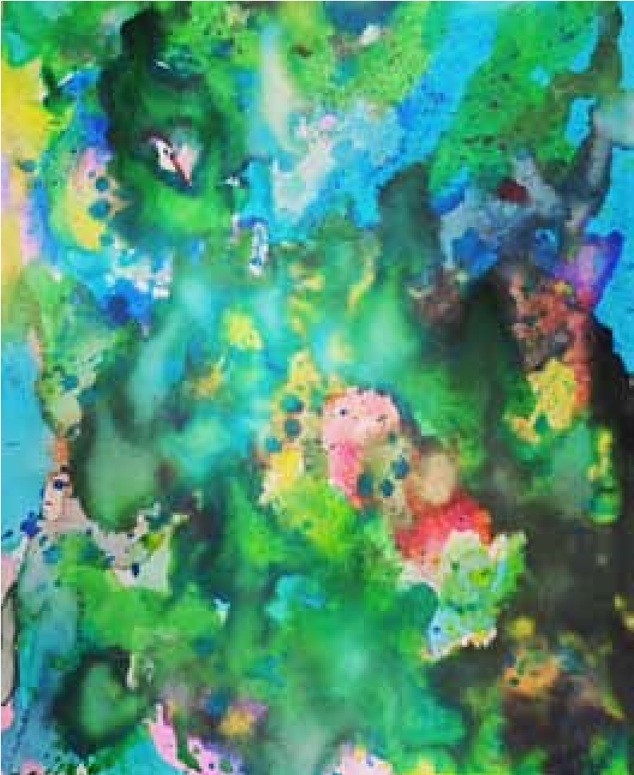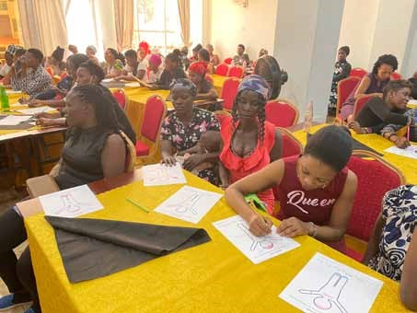

November 2021 original watercolor

for SCI Vision. Body Map Activity.

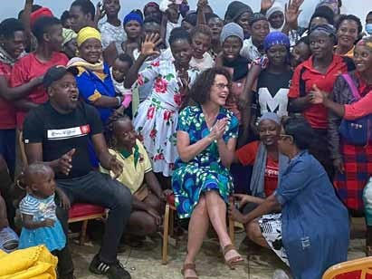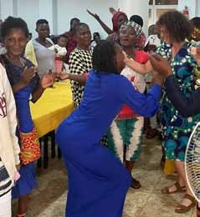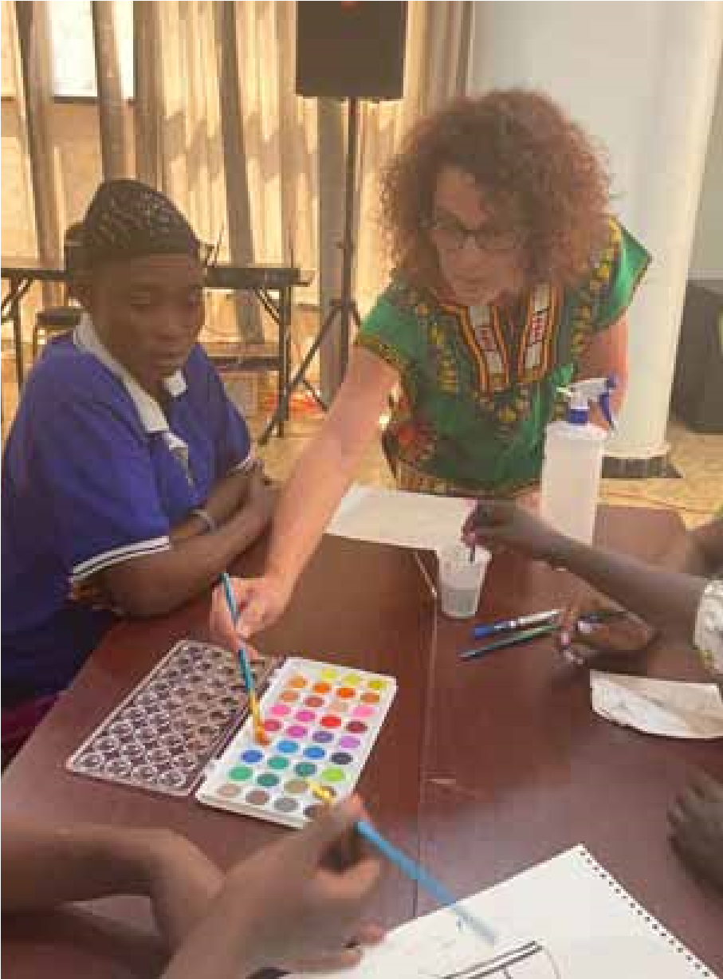 Group photo during the workshop.

Painting with the women for group artwork.

***Restoring Hope. Rebuilding Futures.***

***July 2022***

Using our bodies to dance and sing.

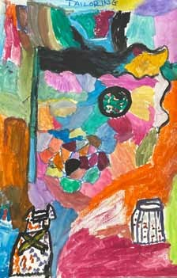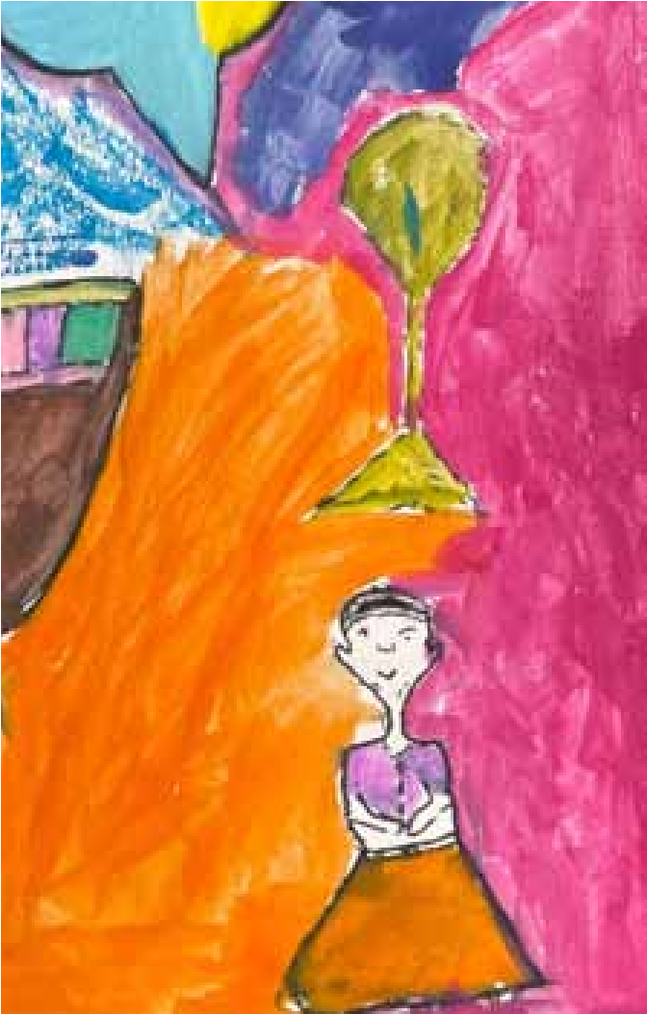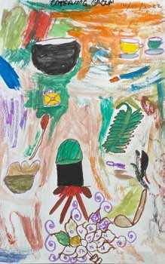***Final group artwork***

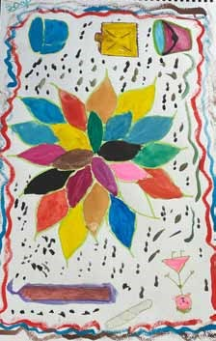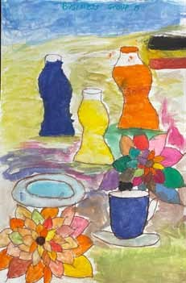

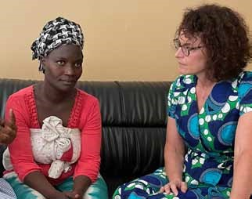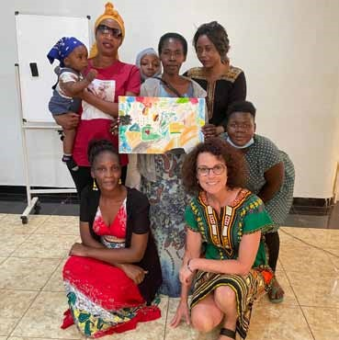 Listening to a woman’s testimony.

A group with their artwork.

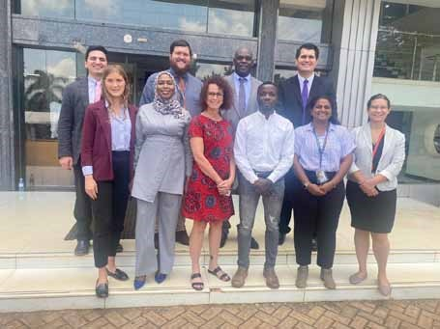 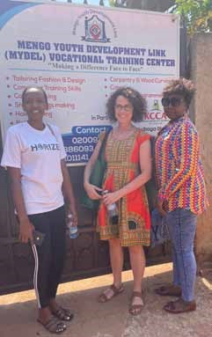 Ugandan Supreme Court with Justice Mike Chibita and interns

Tour of the MYDEL Vocational from the U.S.

Skills Training Center.

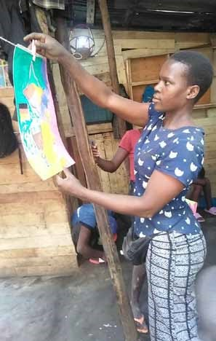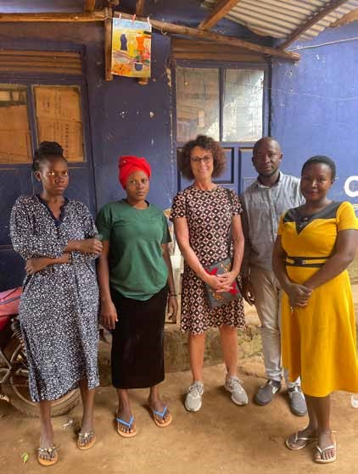 Woman hanging her artwork in the slum.

Artwork hanging outside the brothel. 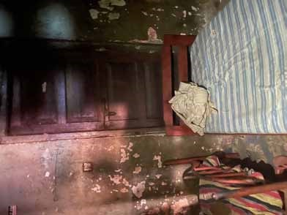

Bedroom inside the brothel.

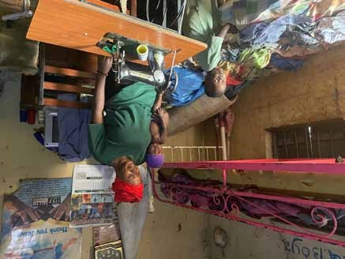

A woman from the workshop and her children in her home in the slum.

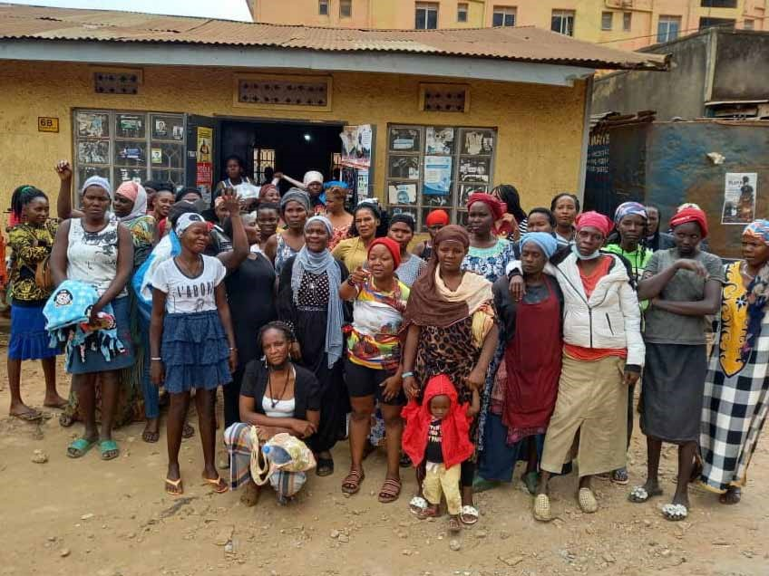

Group photo of the women from my SCI project in the slum.

## **SCI – Participant Profiles**

*Pseudonyms used to protect privacy

Violet

Violet was raped by a man in Jinja last year who is HIV positive. She went to the hospital and got tested and is now also HIV positive. She is suffering. She has three children, all boys, aged 10, 5 and under 1 year old. Each pregnancy occurred because of rape. The older two boys are HIV positive but the baby has not yet tested positive. She is unable to take her HIV medication because she needs to take it with food but often has nothing to eat. If she gets money for food, she feeds her children first. She is not employed but does odd jobs including hair braiding and makes only 10-15,000 UGX each time. That is not enough for food for her three children and herself. If she eats, she takes the medicine. If not, she doesn’t because medicine without food makes her too weak and have very bad dreams. Her biggest challenge is finding a place to sleep safely at night for her family. Her current rent is 380,000 UGX for three months. She will get kicked out of her home if she can’t pay. The electricity is also 20,000 UGX. She has no money for transport and is stuck in the slum. She is supposed to take her of her mother also which is very difficult. She is originally from Mbale. During the program, she felt good being able to share her problems with me and the group. It gave her hope for a better future.

Alice

Alice has no family because when she was saved, her family was Muslim, and they chased her out when she became a Christian. Someone agreed to take her in for security purposes. She felt like she was part of the religious life then and went to live at Prayer Mountain in Wakiso. She slept safely there. She felt like the spirit was telling her to go back to the slum to spread the Word of the Lord. Sometimes she would have no money for transport back to Prayer Mountain so she would sleep in the slum. She had to sleep in the Lodge in Kisenyi, where there are small bunks and it was not safe. Men and women sleep there together. When she finished preaching she would go to the small bed in the lodge and sleep. One day, a man came in and strangled her and raped her during the day. She went to the hospital immediately to get medication to protect her from getting HIV/AIDS. In the slum, even if you report sexual violence, no one cares. She tried to talk to the chairperson of the area but said he didn’t care. She had no support. She was hurting. When someone sees she is a preacher, they believe in her. She felt shame and could not tell people what had happened. When she found out she was pregnant, it was devastating. She says that she has faith in God but cannot continue like this. She is reliving the trauma all the time. During the workshops she cried every day. So far, she is negative for HIV. She has one other child but said the father was a witch doctor and wanted to use her for bad things. She ran away from him and stayed with her child. Once he caught her, he took her child away from her. She wants to get out of the situation she is in. She wants to learn hairdressing to take care of herself and her baby. She needs to be able to pay rent at a safe place. She feels weak now because of the pregnancy. She has hope of staying strong since she is not HIV positive. She has not slept well in the five years she says but says it was easy to sleep when she stayed at Prayer Mountain. Prayer Mountain won’t accept her now because she is pregnant. She will try to go back there after the birth.

Questionnaire (1) Pre-Survey

INTRODUCTION

I am a fellow at the Rotary Peace Center at Makerere University studying Peace and Conflict Transformation. My research project includes two surveys, group dialogue and art making. I am kindly requesting your participation in responding to these questions. No names or identifying information is needed. The responses collected are for academic purposes only and will be treated with strict confidentiality.

Thank you for your participation in my research - Jennifer Montgomery

Section A. BACKGROUND

Age: Under 18____ 18 - 26____ 27 - 34____ 35 - 45____ 46+____ Unknown____

Level of Education: Primary____ Secondary____ College____

Livelihood: Employed____ Casual Labor____ Unemployed____ Student____

Relationship Status: Single____ Married____ Divorced_____ Complicated_____

Do you have children? Yes____ No____

What is your nationality? Ugandan____ Other____ Refugee____

Do you have a spiritual practice or belong to a religion? Yes____ No____

Section B. RESEARCH QUESTIONS

*Material*

Are you in charge of your own money? Always____ Sometimes____ Never____

Do you go to bed hungry at night? Yes____ No____

Have you exchanged sex for money____, food____, other____?

Do you have a safe place to sleep at night? Yes____ No____

Are you interested in learning a new skill? Yes____ No____

1

If you have a problem, do you have someone to talk to? Yes____ No____

Do you have hope for a better future? Yes____ No____

*Social*

How often do you take alcohol or other drugs (Khat, etc)? Never____ Once a day____ Once a week____ Occasionally____

Have you ever: sketched/painted a picture____ sang in a choir/group/school____ written a story or poem____?

Do you feel like to sing/paint/draw a picture? Yes____ No____ Unsure____

Do you feel like bad things will happen to you? Yes____ No____ Unsure____

Do you have 2 or more significant or meaningful relationships with family or friends? Yes____

No____

Do you feel like you can make changes in your own life? Yes____ No____ Unsure____

Do you have a hero, or someone you admire? Yes____ No____

If you ask someone to do something or stop doing something, do they usually agree? Yes____

No____

*Symbolic*

Do you feel overwhelmed? Never____ Sometimes____ Frequently____

Do you feel trapped and unable to make your own decisions? Yes____ No____ Unsure____

Has anyone ever said that you are worthless or not important? Yes____ No____

Are you good at something? Yes____ No____ Unsure____

Have you been a victim of rape or been forced to have sex with someone? Yes____ No____

Have you been a victim of any type of violence? Yes____ No____

2

Questionnaire (2) Post-Survey

## **INTRODUCTION**

I am a fellow at the Rotary Peace Center at Makerere University studying Peace and Conflict Transformation. My project includes two surveys, group dialogue and art making. I am kindly requesting your participation in responding to these questions. No names or identifying information is needed. The responses collected are for academic purposes only and will be treated with strict confidentiality.

Thank you for your participation in my research program - Jennifer Montgomery

*Material*

**Did you learn a specific skill that will help you navigate your life? Yes____ No____**

*Social*

**Did you meet at least one other person you can contact or speak to if you need help? Yes____ No____**

*Symbolic*

## **Do you have hope for a better future? Yes____ No____**

*Other*

**Is there anything else you would like to share about your experience with my 3-day program?**

