**SOCIAL CHANGE INITIATIVE IMPLEMENTATION REPORT**

**JOHN RUBARAMIRA**

**STUDENT NUMBER: 2200700032**

**COHORT 3 ROTARY PEACE FELLOW**

Title: **BATWA RIGHTS ADVOCACY**

Location: **South Western Uganda**

Start and Completion Date: **October 2022 - open**

**Abstract / summary:**

### This report covers the Social Change Initiative aimed at advocacy for the rights of Batwa of South West Uganda. The initiative targets supporting Bwindi Mgahinga Conservation Trust (BMCT), established in 1994 under the Uganda Trustees Laws, to mobilize more financial resources for Batwa Projects.

### BMCT mission is to foster conservation of biodiversity of Mgahinga Gorilla National Park (MGNP) and Bwindi Impenetrable National Park (BINP) through investments in community development projects, grants for research and ecological monitoring, funding park management, protection and programmes that create greater conservation awareness.

### The Social Change Initiative is also in line with BMCT vision which is to conserve the bio-diversity and ecosystem health of MGNP and BINP protected areas in harmony with the development needs of the surrounding communities of which Batwa are the most vulnerable.

Resource mobilization strategies (mobilization of local governments and other partners in the region for joint strategic planning, project proposal writing and project implementation) are key means of advocating for Batwa rights to health, education, land etc.

Meetings have been held with BMCT staff, fundraising plan prepared including other advocacy plans. One funding proposal was developed and submitted to WHO and Government of Norway. The process is on-going, will involve Rotary and is expected to raise enough resources for Batwa.

BMCT remains the key stakeholder that will drive the initiative to realize long term and sustainable impact.

**CHAPTER ONE**

**1.1 Introduction and Background:**

The Batwa of South Western Uganda are an indigenous group of forest peoples who were evicted from Mgahinga and Bwindi forests in 1991 when the forests were gazetted National parks. (Atuhaire, 2022). As a result, the Batwa live along the boundaries of Ichuya forest reserve, Mgahinga Gorilla National Park and Bwindi Impenetrable National Parks. Their eviction from these forests meant that they abandoned their hunter-gatherer life to a sedentary lifestyle. In the forests they survived on honey, fruits, game meat, and medicinal plants to cure their ailments.

Batwa are the former hunter-gatherers, and a big number are landless, despised & a marginalized group in Kabale, Rubanda, Kanungu and Kisoro Districts of south western Uganda, which makes them often targets of discrimination from their neighbors (Bakiga and Bafumbira). Government interventions and public service providers often do not treat the Batwa as a disadvantaged group and therefore end up generalizing in their service delivery. This is often re-enforced by the fact that the Batwa used to live in the forests, depended entirely on herbal medicine as part of their health care and therefore the concept of accessing medical services is generally new to them. The health indicators on Batwa in southwestern Uganda show that Batwa are among the poorest in Ugandabut despite their poorer health they are less likely to use the health care facilities like other groups (Balenger S et al, 2005).

To date, there are 3,730 (1787 males & 1,943 females) Batwa in the Bwindi Mgahinga Conservation Area (BMCA), with a population growth rate of 5.1% for the last five (5) years. About 68.3% of the Batwa in the BMCA are below 25 years and 52.1% are female. Majority of the Batwa population (56.3%) are in Kisoro District (BMCT Batwa population survey/Census 2020).

Batwa were expelled from their ancestral forests (Echuya, Mgahinga and Bwindi) when these were gazetted as forest reserve and National Park, respectively in the early 1994. Most Batwa are landless and live as unwelcomed squatters on other people’s land. An unpublished report by Dr Scott Kellerman 2007, a community health practitioner in south west Uganda estimates Batwa maternal mortality rate of 1 in 16 and children below-five mortality estimated at 38% for Batwa in general and as high as 59% for landless Batwa. Those without land often live as squatters on other people’s land getting little or no payment for working in their landlord’s fields.

The Batwa were never compensated for their loss of land and livelihoods.

Over the last 27 years, BMCT procured 406 acres of land (Kanungu (173.28 acres), Kabale/Rubanda (93.85 acres) and Kisoro (138.87 acres), resettled 303 Batwa households and provided them with start-up kits (seeds, household items and other inputs) in Rubanda, Kisoro and Kanungu Districts. The BMCT’s strategy is based on the belief that providing displaced Batwa with assets is an important way to foster their sense of self-esteem, since it is by owning productive assets such as land, a house and livestock that the Batwa will be more valued in the eyes of the local communities.

**1.2 Problem Statement**:

Batwa eviction from forests meant that they abandoned their hunter-gatherer life to a sedentary lifestyle. In the forests they survived on honey, fruits, game meat and medicinal plants to cure their ailments.

Batwa livelihood strategies tend to be temporary because they are landless. Most landless Batwa are squatters on land of non-Batwa who often dislike them and make any long-term strategies for improving their life situation very difficult.

In a number of Batwa settlements, some humanitarian agencies are supporting Batwa to address their livelihood needs through agriculture, tourism, scholastic materials, limited food supplies and medical facilities. Despite all these efforts, the situation of most Batwa remains sad, many have even resorted to begging as a livelihood option. Government and the humanitarian agencies, however, have not addressed the social and structural issues that continue to make Batwa communities marginalized and discriminated against.

Most often Batwa squatters are not allowed to build permanent structures such as proper housing or water and sanitation facilities. Since most health interventions for the communities by government and by civil society have consistently been targeting settled families through outreach programmes, the landless and mobile Batwa are even more marginalized in accessing socio-economic services.

Previous research conducted in western Uganda reveal that accessibility and acceptability of Social services in general affects utilization of health facilities.

However, research done specifically on barriers to antenatal care access by Batwa (Rubaramira, 2010) revealed that Batwa depend a lot on forest medicinal plants and less on government health services. They also depend on other forest products for their livelihoods. This presents a conflict with government policies regarding conservation of forests. Thus, the SCI supports government and civil society organization (especially BMCT) in developing a resource mobilization advocacy strategy and plan that will target sensitization of Batwa and host communities and implementation of projects that address Batwa livelihood issues and provide alternatives to dependence on forest products.

**1.3 Goals and Objectives:**

The overall goal is the advocacy for Batwa rights (health, education, etc), respect and protection by duty bearers through engagement of Local Governments and Conservationists to provide the needed capacity and empowerment of Batwa for improved livelihoods. The target beneficiaries will be the Batwa of Kabale, Rubanda, Kanungu and Kisoro Districts. The social change initiative targets mobilisation of stakeholders and local governments to fundraise and generate financial resources for Batwa development projects (as per current priorities – Health, Education, Agriculture and Housing). It is envisaged that there will be a vibrant, educated and empowered community capable of accessing health services, promoting and maintaining good hygiene, sanitation and peacefully coexisting with host communities and the protected areas.

**1.4 Challenges and mitigation strategies**:

Uganda is one of the countries with the poorest medical and social services in the world with access to health care limited to 49% of the population living within 5km of health units, rural communities being the majority. Furthermore, the state of minorities (groups such as Batwa) access to health and social services is predictably appalling and in many cases members of the minorities rely on their traditional knowledge of traditional herbs (Baker, W.G, 2001). However, there has been improvement in physical access, quality of care, and removal of major financial barrier for the poor that have led to rise in utilization of social services (HSSPI 2001-2004/2005)

In spite of the above, Batwa are often targets of discrimination from their neighbors (the Bakiga and Bafumbira). Government interventions and public service providers often do not treat the Batwa as a disadvantaged group and therefore end up generalizing in their service delivery. This is often re-enforced by the fact that the Batwa used to live in the forests, depended entirely on forest products for their survival and therefore the concept of accessing social services is generally new to them.

The health of Batwa in South Western Uganda is among the poorest in Uganda (Ballenger S. Coppenger E. Fried S. and Kanchev K. 2005) but despite their poorer health they are less likely to use the health care facilities than other groups due to lack of resources and inferiority complex, stigmatization among others.

Thus mobilization of resources and implementing projects that address their priority needs will be vital in ensuring their survival and sustainability of forest resources.

**CHAPTER TWO**

**2.1 Batwa Community and Social Demographics:**

The Batwa of Uganda are mainly in South Western Uganda in the District of Bundibugyo, Kabale, Rubanda, Kisoro and Kanungu. They are the former forest dwellers and hunter-gatherers who lived and practiced a traditional, cultural and economical way of life in the mountainous forest areas of the great lakes region of central Africa. As these are gazetted as no-go area, they were forced to abandon their traditional life style.

In 1996, Kabann and Wily study identified 573 Batwa in Kabale, 901 in Kisoro and 297 in Rukungiri.

However, united organization for Batwa Development in Uganda (OUBDU) carried out a survey in 2007 and found Batwa population had increased to 2,987 in 3 districts as follows: Kabale 774 people, 646 in Kanungu and 1,567 in Kisoro.

To date, there are 3,730 (1787 males & 1,943 females) Batwa in Kanungu, Kabale, Rubanda and Kisoro Districts (BMCT survey, 2020).

On average the Batwa households are mainly monogamous, fertility rate are around 4 children per woman compared to 6.9 children among their neighbors, the Bakiga (Kabann and Willy, 1996).

A study conducted on indigenous people’s poor utilization of health services indicates that they lack knowledge about hygiene, nutrition and places to seek treatment and that will keep them away from health services even when they are available and free (Ashford., Lori S., Gwatkin., Davidson R., Yazbeck, et al. 2006).

The indigenous people’s perception of illness and symptoms can vary from those of the rest of the population in different ways. Supernatural forces are often believed to influence the health of people and they sometimes have divergent views of how to prevent illness than other groups (Macfarlane, Joan E., Alpers, Michael P, 2009).

GEF Impact Evaluation (2007) – case study on impacts of creation and implementation of National parks and support to Batwa on their livelihoods, well-being and use of forest products identified that Batwa continue to rely on forest resources especially medicinal plants for their health12. Uganda wild life Authority and other organizations have a role to mobilize resources to buy land for Batwa for settlement and Batwa access to and utilization of forest products such as medicinal plants (harvested at sustainable level).

Education of Batwa children was found to be as low as 7.7% (they had 2 in primary seven and 1 in senior one3, access to health services was low (120 individuals were immunized, 104 had access to ANC services and 8 individuals tested for HIV (UOBDU- Batwa population survey. (2007).

Kabann and Wily’ (1996) note that *“the Batwa can rarely afford health care, preferring to seek help from their own herbalists who continue to involve parents and other close family willing to offer assistance on credit”.*

Loss of access to the forest resources not only created a negative impact on the practices of Batwa herbalists, but also affected their access to wild food resources. The pregnant mothers and their children are probably more subject to malnutrition and more susceptible to common diseases.

On the subject of health, education and community-building, it is reported that Batwa do not feel welcome in clinics and, indeed; (Kabann and Wily, 1996) quotes one health worker as finding the idea of visiting Batwa households laughable. “*They just want everything free, how could I help a Mutwa?”*

**2.2 Batwa Health, Socio-economic and cultural issues:**

Batwa played a very important role during the colonial era in the early 20th century. They were black smiths, porters, labourers and performers and served at courts of local chiefs. The Batwa were regarded as forest experts in terms of identifying medicinal herbs and provision of meat to farmers (Lewis, J, 2000).

In 1930s, the colonialists gazetted Batwa forest habitats Bwindi and Echuya as forest reserves making the latter as a no-go area for the Batwa. The decision to gazette these forests into reserves meant that Batwa had lost their trade of meat, honey and medicinal plants to their neighbors the Bakiga and Bafumbira. The Batwa were no longer useful to the other group, they had lost their forest based economy, their health care system and the contempt for them increased and social barriers solidified (Lewis, Jerome, 2000).

In Uganda access to health care is only limited to the population living near health facilities. Rural communities are the most severely affected given that most health facilities are located in towns and health professionals live in urban hospitals (W.G. Baker, 2001).

Strategic health policy formulation in health care systems is supposed to be based on information that promotes health seeking behavior. The factors that determine health seeking behavior may be physical, socio-economic, cultural and political. Therefore, the utilization of health care services, public or private, formal or non-formal depends on a number of factors (W.G. Baker, 2001). These may include: socio-demographic, socio-economic status, level of education, political conditions and cultural beliefs, lack of physical accessibility, financial accessibility, gender, disease pattern and health care system itself.

The Batwa housing conditions are similarly in a very bad state. Majority of them live in very poor housing conditions of makeshift houses made of sticks and grass which leak when it rains. The leaking houses are often overcrowded by many extended family members and to the Batwa this is considered to be normal, which demonstrates their desperate state (ACODE. 2005 pg9)

Batwa are often left out of health programme and projects, and one study indicated that Batwa childhood mortality was more than double that of the general population (Kabann and Willy, 1996).

Batwa women are more prone to ill-health that their men due to childbearing role. Also, women and girls are at risk of acquiring HIV/AIDS and STDs from the beliefs of other ethnic groups. *The latter believe that when they have sex with Batwa women the backache heals (*Jackson, Dorothy, 2006).

Lack of access to traditional herbs and medicine also contributes to Batwa’s poor health.

**2.3 Minority rights to social services:**

The constitution of the Republic of Uganda, 1995, provides for minorities to have a right to participate in decision making processes and that their views and interests are taken into account in making national plans and programmes. While disaggregated data for these groups is not routinely collected, thereby masking gross inequalities between different poor communities, there is quantitative evidence to draw upon. Surveys in Bolivia, Brazil, Guatemala and Peru indicate that Afro-descendants and indigenous peoples’ monthly mean earnings are half those of white people (Minority Rights Group International. (Briefing, 2003).

In Uganda, only 5 out of every 10 Batwa children in Kisoro will reach their first birthday, compared with a national average of 82 per cent of children surviving their first year.

In India, 50 per cent of Dalits live below the poverty line, compared to 30 per cent of the overall population (Monica A., Magadi, Madise, Janet. Rodrigues et al. 2000).

The Batwa of Kabale District is an ethnic minority with strong historical relations to the tropical forests of south-western Uganda. Despite their traditional attachment to the rain forests, they have been pushed out and left landless, scoring very poorly on health and development indicators (CARE (REPA) Programme, Uganda, 2008).

The government of Uganda has good and enabling environment such as gender equality, reproductive health, and decentralization of health services among other programmes supported by the private sector. There is a lot of investment to increase the number of health facilities, improve quality of health care and increase number of professional health workers, equipment, drugs and other supplies.

A study conducted in Ghana (Sekyere East District) rural settings indicate that despite free ANC services; there is low patronage and inconsistency in use of ANC by pregnant women. The study determined social, geographical (associated with age, marital status and area of residence) and economic (significant in terms of employment status) barriers to ANC. Women were found to be highly dependent on either their husbands or relatives for taking health decisions particularly Antenatal care (Adu-Mensah, Mabel. 2008).

Economic factors can affect and determine whether the poor people in the communities can have access to health care. Health care costs can even make the poor fall deeper into poverty (Ashford., Lori S., Gwatkin., Davidson R., Yazbeck, et al. 2006).

* 1. **Batwa indigenous knowledge on medicinal plants**:

Traditional medical practitioners and TBAs play an important role in rural communities’ health in Africa. A study conducted on people, park and plant use around Bwindi Impenetrable National Park in South Western Uganda where Batwa were part of respondents, shows that TBAs use medicinal plants for symbolism and magical purposes (as protective charms against bad omens, to ensure safe journeys, love affairs and court cases). The medicinal herbs assist women during pregnancy and at birth. They use the herbs for preventing premature Labour, inducing Labour, removal of placenta, treating swollen breast/improving lactation and for de-worming (A.B. Cunningham., 1996). The same study found out that most Batwa and other local communities depended a lot on *Rytigynia kigeziensis (Nyakibazi), Physaris peruviana, Ricinus peruviana, pennisetum purpureum and Eucalyptus spp* for the prevention of the above ailments.

**Change theory and how it was applied:**

The Social Change Initiative seeks to Advocacy for rights of Batwa, including guaranteeing respect and protection by Duty bearers.

The initiative considers engagement of Local Governments, private sector and Conservationists will lead to Batwa involvement in forest management

The engagement will also lead to Batwa access to forest products through forest user committees; access to Social Services and projects.

Batwa participation in decision making processes (as part of forest/park management) will lead to peaceful coexistence among all communities around parks and sustainable forests.

**Methods and Design:**

The Social Change Initiative is an on-going process that uses positive peace framework approach to analyse and advocate for Batwa Rights.

Initial meetings have begun with BMCT to lay strategies for engagement with other stakeholders. Workshops and meetings Involving District Local Governments and other partners will be conducted to ensure an all-inclusive Batwa response plan is developed and implemented.

Resource mobilization has already started with BMCT and is hoped to generate resources that will support Batwa rights advocacy initiative.

**CHAPTER THREE**

**3.1 Interventions and Activities:**

In October 2022, an online meeting was held with BMCT and it was agreed to kick start the proposal writing targeting securing funding from Government of Norway.

A proposal was developed and submitted to World Health Organization (WHO) Uganda as partner lead in resource mobilization.

On 24/4/23 a meeting held with BMCT Trust Administrator and Programme Manager

Objective of the meeting was tolay strategies for implementation of the social change initiative that targets Batwa communities under BMCT operational area.

The meeting with BMCT had the following commitments:

* Development of a concept for Batwa – John/Sikora and PM in consultation with TA – ***By end of May 2023***
* Development of partnerships and capacity building of BMCT staff in resource mobilization – John to link BMCT with Rotary International and its affiliates for an expert in resource mobilisation – ***By end of 2023***
* PM to provide John with current information on Batwa for ease of development of draft fundraising plan to be shared with TA - ***Immediate***
* John to follow up the Proposal that was submitted to WHO (in 2022) for funding Batwa program – ***May 2023***
* Explore possibility of submitting same proposal directly to Government of NORWAY and other donors – ***June/July 2023***

**3.2 Key findings / impact:**

According to BMCT Annual Report 2022, Batwa children have benefitted from Education grants. In 2016, BMCT Launched a Batwa sponsorship scheme where children were holistically supported with all scholastic requirements. BMCT implemented a Batwa scholarship scheme where 127 (57 males and 63 females) pupils in primary schools, 11(8 males & 3 females) students in a vocational institute, 3(2 males & 1 female) students in secondary school). Batwa have 1 female graduate who is currently employed at BMCT as the Batwa Coordinator.

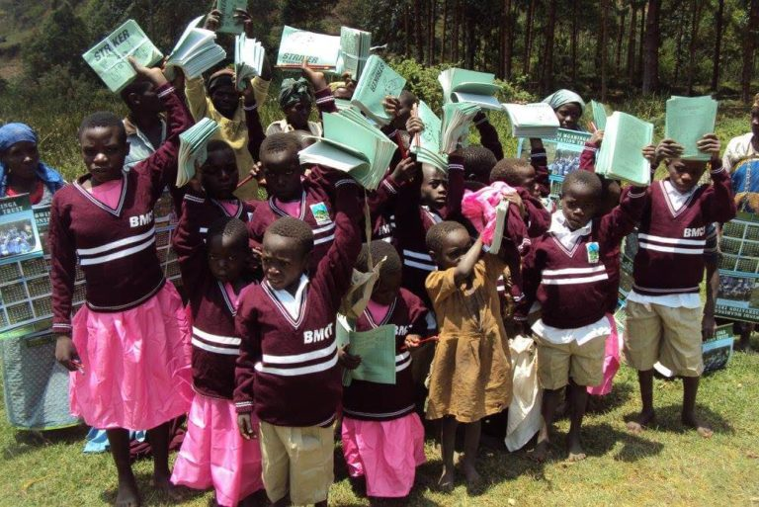

On housing, Batwa have benefitted from Housing Grant. This intervention is aimed at improving Batwa housing conditions. A total of nine (9) Batwa permanent houses were constructed and handed over to beneficiaries in Kihembe Batwa settlement, Kanungu district and eight (8) and under construction at Kanyamahenene Batwa settlement, Kisoro district.

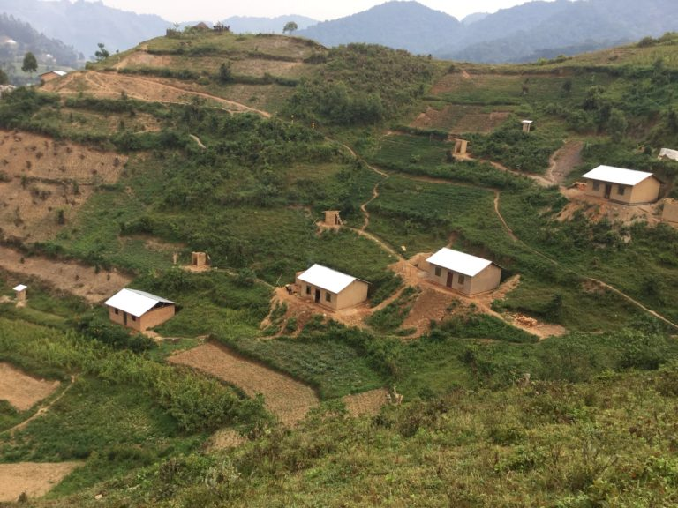

Batwa model village has been constructed and handed over to Batwa of Kihembe in Kanungu Distrct.

The above achievements will be the baseline for evalaution of the SCI. Once funding is secured from BMCT partners and donors, resources will be committed to ensure more Batwa benefit from land acquisition, education, health, agriculture, housing and advocacy for Batwa rights.

**CHAPTER FOUR**

**4.1 General Conclusion**:

This Social Change Initiative that aims to achieve Batwa Rights guaranteed, respected and protected, is in line with BMCT strategic plan.

Other key stakeholders targeted are District Local Governments, National Forest Authority, Research institutions (NARO, ITFC), Uganda wildlife Authority, Conservationist/NGOs (NU, ADRA, and AICM, ROTARY), and private sector, Faith Based Organisations, BATWA and Host Communities and Donors

The Social Change Initiative is an on-going initiative that will create awareness on rights of Batwa and involvement of Batwa in management of forest/parks.

BMCT is the lead organization in the successful implementation with the support of all the 4 District Local Governments (Kabale, Rubanda, Kanungu and Kisoro).

There is little achievement at time of writing this report due to the fact that the initiative is expected to yield results in the medium and long term. This will be after mobilization of stakeholders and resources for Batwa project interventions.

**4.2 Recommendations / implications for Policy:**

Given the fact that this Social Change Initiative is an on-going short, medium to long term venture, I would like to recommend the following:

1. That a fundraising plan be adopted by all stakeholders
2. That funds raised be used to support more land acquisition, education, health, agriculture and housing construction projects for Batwa i.e. building on current BMCT achievements.
3. That the revenue sharing programme of UWA (especially revenue from Bwindi and Mgahinga National Parks) part of it should be committed to specifically support Batwa land acquisition and housing Projects. This will facilitate quicker resettlement of landless Batwa.
4. Given that government evicted Batwa from the forests, local government should set aside a budget for Batwa resettlement as part of compensation. This should be reflected in District annual plans.
5. The fundraising drive should aim at developing a *Batwa sustainable Fund* that BMCT should manage

**4.3 Sustainability plan:**

The Social Change Initiative sustainability plan lies in the involvement of BMCT (with Batwa component and a fund in perpetuity), government (primary duty bearer), Batwa and host communities around the protected areas.

**REFERENCES**

1. Uganda Demographic Health Survey. (UDHS 2006).
2. Roadmap for accelerating the reduction of Maternal and Neonatal Mortality and Morbidity in Uganda. (2007-2015).
3. United Organization for Batwa Development in Uganda (UOBDU). Batwa population survey. (2007)
4. Christopher KIDD. *Developing discourse and the Batwa of South Western Uganda*: representing the ‘other’ presenting ‘self’ (2008).
5. Lewis, Jerome (2000): *The Batwa Pygmies of the Great Lakes Region.* Minority Rights Group
6. Richard N., Stella N., and Pascal: The use of formal and informal services for antenatal care and malaria treatment in rural Uganda. Health policy and planning. (1998, 13(1): 94-102).
7. W.G. Baker*: The marginalization of minorities in Uganda*. An MRG International report (2001).
8. Ballenger S., Coppenger E., Fried S., and Kanchev K., (2005): *Between Forest and Farm: Identifying Appropriate Development Options for the Batwa of South-western Uganda*. First Peoples Worldwide/George Washington University report
9. Monica A., Janet N., and Robert N. Frequency and timing of antenatal care in Kenya: explaining the variation between women of different communities. Social science & Medicine volume 51, issue 4, 15 august 2000, pages 551-561
10. Uganda population and housing census. (1991, 2002)
11. Kabann and Willy: Report on a study of the Abayanda Pygmies of South Western Uganda. (1996)
12. Namara, Agrippinah (2007): *Case Study: Impacts of Creation and Implementation of National Parks and of Support to Batwa on their Livelihoods, Well-Being and Use of Forest Products Impact* Evaluation Information Document No. 10. GEF Impact Evaluation
13. Jackson, Dorothy (2006): *The Health Situation of Women and Children in Central African Pygmy Peoples.* Forest Peoples Programme.
14. Monica A., Magadi, Madise, Janet., Rodrigues et al. (2000): Frequency and timing of antenatal care in Kenya: explaining the variations between women of different communities. *Social Science and Medicine*, 51, (4), 551-561.
15. Minority Rights Group International. (Briefing 2003).
16. CARE (REPA) Programme, Uganda. Combating Child Mortality among Batwa (CCMB) project. Rights, Equity and Protected Area Project Document, June 2008.
17. Health Issues in Uganda: Uganda Demographic Health Survey 2000/2001

1. Uganda Ministry of Health sector strategic investment plan.(HSSPI 2001-2004/2005)
2. Adu-Mensah, Mabel. (2008). Perceived barriers to Antenatal care by attendants in the Sekyere East District Ghana
3. Penninah Z. (May 2001). *The impact of (forest) nature conservation on indigenous peoples*: the Batwa of south-western Uganda - A case study of the Mgahinga and Bwindi Impenetrable Forest Conservation Trust.
4. ACODE, Living on the margins: The deprivation of community-based property rights of the Batwa Pygmies of South Western Uganda (2005), p.9
5. Ashford., Lori S., Gwatkin., Davidson R., Yazbeck, et al. (2006): [*Designing Health and Population Programs to Reach the Poor*](http://www.prb.org/pdf06/DesigningPrograms.pdf)*.* Population Reference Bureau.
6. Macfarlane., Joan E., Alpers, Michael P (2009): *Treatment-seeking behavior among the Nasioi people of Bougainville: choosing between traditional and western medicine*, Ethnicity & Health, 14: 2, 147 — 168
7. A.B. Cunningham., (1996): People, Park and Plant Use. Recommendations for multiple-use zones and development alternatives around Bwindi Impenetrable National Park, Uganda.
8. BMCT Annual Report 2021-2022
9. Rubaramira, John, MPHL Thesis Report 2010

**APPENDICES:**

1. **Timeframe for planned activities:**

|  |  |  |  |
| --- | --- | --- | --- |
| **#** | **Activity** | **When** | **Person(s) responsible and support** |
|  | Development of a concept for Batwa | By end of June 2023 | John/Sikora and PM in consultation with TA |
|  | Development of partnerships and capacity building for BMCT staff in resource mobilization. | May – Dec 2023 | John, PM, TA |
|  | Link BMCT with Rotary International and its affiliates for an expert in resource mobilisation | 2023 | John |
|  | Provide to John with current information on Batwa | 1st Week of May 2023 | PM |
|  | Draft Batwa fundraising plan to be shared with TA and presented to stakeholders for input | By end of May 2023 | John, PM, Sikora |
|  | Finalise Fundraising Plan | June 2023 | TA + BMCT Team |
|  | Follow up of the Proposal that was submitted to WHO (in 2022) for funding Batwa program | 1st week of May 2023 | John |
|  | Explore possibility of submitting the proposal (in 5 above) directly to Government of NORWAY and other donors | May 2023 | John and PM/Team |
|  | Develop at least 3 fundable Batwa project proposals | May – July 2023 | John/Sikora and PM in consultation with TA and other BMCT staff |
|  | Implementation of Batwa funded activities | September 2023 | BMCT |

1. Planning meeting with BMCT Senior Staff

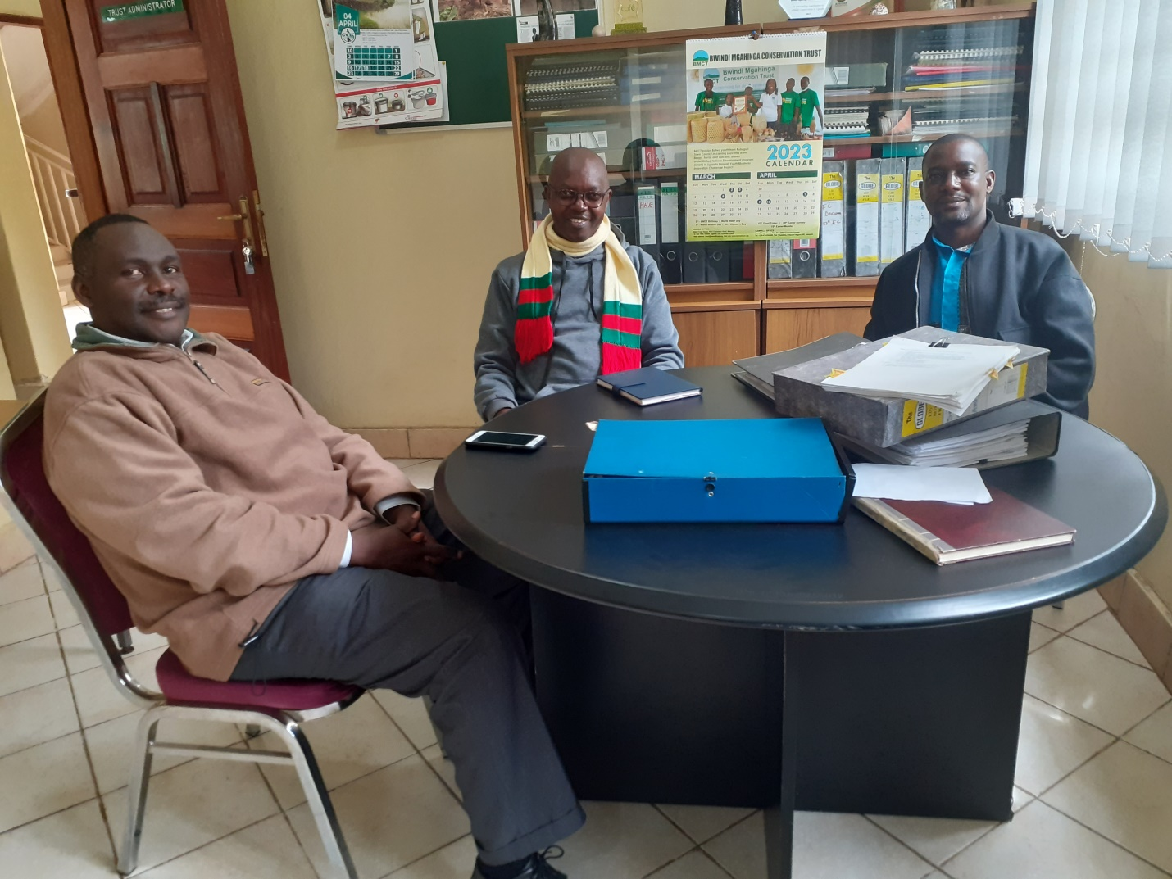

Left to Right: Wilberforce (BMCT Trust Administrator), John Rubaramira and BMCT Programme Manager – Planning meeting on 24th April 2023.