

Education Through Sport (Edu-Sport). Pemba City, Cabo Delgado – Mozambique. Start date: October 1st, 2022 - Completion date: October 30th, 2024.

Abstract

While acting as a positive pathway for young people, *Educate through Sport* (Edu-Sport) was designed to promote social cohesion, through sports, among community members in five neighborhoods namely: Paquitequite, Ingonane, Natite, Gingone, Eduardo Mondlane and Muxara out of thirteen in Pemba city, the capital of Cabo Delgado, a province brutally affected, since October 2017, by Islamic State in Mozambique. Most projects implemented in the neighborhoods were only concentrating on responding emergency needs for both Internally Displaced Persons and host communities. Edu-Sport employed covert, and participation observation method to understand youth movements and occupation. The findings pointed to the correlation between lack of sports infrastructure and the grievances against the government for its incapacity to provide sports infrastructure, exacerbated by lack of platforms to promote dialogue and discussions. Most young people were lingering at the beach throughout the day, and they formed smaller groups and played football through randomly created teams. While games were played, others gathered to cheer their selected teams. While teams played against each other accompanied by the cheering, it was difficult to tell that, in all the gatherings, there were diversified tribes and that others were Internally Displaced Persons. Thus, hypothetically, Edu-sport was designed, funded by the United States Government through its Embassy in Mozambique as a way to provide positive pathway for young people while at the same time creating space for social cohesion. The concept was designed by Josue Tambara while the implementation remained under the responsibility of a Pemba (local) based organization called *New Vision the Bay.*

*Keywords:* Internally Displaced Persons, Edu-Sport, Islamic State Mozambique, Cabo Delgado, Social Cohesion

1. CHAPTER ONE

INTRODUCTION

The present report aims at sharing an overview of the *Edu-Sport* program from Pemba city, capital of an insurgency affected province of Cabo Delgado in Mozambique. Edu-Sport was designed to promote social cohesion, through sports, among community members in five neighborhoods Paquitequite, Ingonane, Natite, Gingone, Eduardo Mondlane and Muxara out of thirteen in Pemba city, the capital of Cabo Delgado, a province brutally affected, since October 2017, by Islamic State in Mozambique.

Edu-Sport stands for Educate through Sports and it was designed to run from October 2022 to October 2024 through a partnership between two entities: Josue Tambara – a Rotary Peace Fellow from Makerere University who designed the Edu-Sport concept as his Social Change Initiative leading to the obtention of a postgraduate diploma in Peace Building and Conflict Transformation in 2022/23 Academic year and New Vision the Bay – an organization registered under the laws of the government of Mozambique which operates in Pemba city, engaging young people through sports, in Cabo Delgado province. Based on the agreement, the two entities decided to apply for funding under the call for proposals which was published by the United States Embassy in Mozambique under the title: *Countering Violent Extremism Through Sports Diplomacy*, funding number: *PAS-MAP-FY22*. For reference, you can access the submitted and awarded proposal on the following link: <https://drive.google.com/file/d/1f2c2vdBMCbEwFtndkBye10Q29h4igJfc/view?usp=share_link>

Edu-Sport as a hypothesis, would help to provide space for young people to develop skills in sports as well as promote social cohesion among neighborhoods. Specifically, to achieve the purpose, Edu-Sport planned to engage into the following outputs: a). creation of 4 basketball and 2 football clubs in Paquitequite, Ingonane, Natite, Gingone, Eduardo Mondlane and Muxara neighborhoods; b). Realization of football and basketball games to agglutinate community members and c). provision of positive pathways for young people from the mentioned neighborhoods.

Edu-Sport was designed to be implemented from October 2022 to October 2024. The rationale for the current report is to share about the importance of sports in peace building and encourage its application.

Structurally, this report is organized in the following manner: *Chapter One*: i). Introduction; ii). Problem Statement; iii). Goals and Objectives; iv). Challenges and Mitigation; *Chapter Two*: i). Literature Review; ii). Theoretical Underpinnings; iii). Change Theory and How it was applied and iv). Methods and Design; *Chapter Three:* i). Interventions and Activities; ii). Key Findings; *Chapter Four:* i). General Conclusion; ii). Recommendations/Implications for Policy; iii). Sustainability Plan and Appendices.

This work is a contribution to Peace Building and Conflict Transformation, therefore, what has been accounted in this report should not be considered as a mandate. It is important to note that there is no single approach to counter violent extremism as extremist groups and organizations continue adapting. Henceforth, stakeholders engaged in countering violent extremism will require both wider range of interventions as well as being more contingent in nature to address the challenge.

PROBLEM STATEMENT

The problem of lack of funding to promote sports activities contributes negatively to the creation of spaces that can promote social cohesion in Pemba city. As a result, many young people have more time to linger around without doing anything thereby putting themselves in a situation prone to ISM recruitment. Based on this New Vision the Bay intended to use its expertise in sports and youth programs to promote social community cohesion and leadership skills to combat violent extremism, young people in Pemba neighborhoods, are using sports and associated activities to build resilience, cultivate youth empowerment, unite their communities, stimulate community government relations, get psychosocial support, and foster peace. Edu-Sport was used to find response on *whether* *lack of promoting sports activities contributed negatively to peace building* and that the lack of positive pathway activities for young people exacerbates the grievances that youth have against the government in Pemba. Many young people have more time to linger around, consequently, susceptible to ISM recruitment.

GOALS AND OBJECTIVES

**Outcome objective:**

To promote social cohesion through sports among community members in the neighborhoods of Paquitequite, Ingonane, Natite, Gingone, Eduardo Mondlane and Muxara in Pemba city.

**Output Objectives:**

1. To create 4 basketball and 2 football clubs in Paquitequete, Ingonane, Natite, Gingone and Muxara neighborhoods.
2. To agglutinate community members through football and basketball games.
3. To create positive pathway for young people from neighborhoods of Paquitequite, Ingonane, Natite, Gingone and Muxara.

CHALLENGES AND MITIGATION STRATEGIES

**Risks**

Risk is the possibility of something bad happening. Risk involves uncertainty about the effects/implications of an activity with respect to something that humans value, often focusing on negative, undesirable consequences.

**Strategy**

According to Hubbard, G., (2004). *Strategic Management: Thinking, Analysis and Action*, strategy is defined as:

Those decisions which have high medium-term to long-term impact on the activities of the organization, including the implementation of those decisions, to create value for customers and key stakeholders and to outperform competitors.

After completing the on-campus training program, Josue Tambara’s plan for the Social Change Initiative was to design and implement a Sports for Peace project but when he faced challenges and the most burning ones are indicated below:

1. Entities do not open to support initiatives where there are less gains.
2. Lack of ample time to persuade entities for funding (fundraising)
3. Organizations were not willing to support an individual but would be more willing to engage an organization legally registered

To circumvent the above challenges, Josue decided to legally register an organization. He used personal funds to pay for the registration expenses. He called the organization – *Mudança Social* (Social Change) and had planned to use this to implement his Social Change Initiative. Despite all the effort, he could not raise enough funds. The registered organization lacked a history to handle funds. The only amount of money he managed to raise was US$400 sent from Mr. Dennis Bergquist, former Rotary President of Kino Rotary Club in Tucson, Arizona in the United States of America. Converted to the local currency, the $400 was equivalent to 25,200.00Mts. He needed $7,000.00 (441,000Mts) to fully fund his initiative and what he received represented 0.057%.

He then decided to change his strategy. Instead of designing a project concept, fundraise and implementing the initiative, the best option was to look for existing legally registered community-based organizations in need of support to design project concepts. With such organization, he would sign a collaboration agreement in which his duties would merely be to design the project concept, submit to possible donors and the implementation responsibility would be under the organization.

Josue used his knowledge based on his experience working on the USAID OTI Mozambique Community Resilience Program (MCRP) where he worked as the Program Development Officer with the only duty of designing project concepts for local organizations which were funded (small grants) by MCRP.

Luckily, the United States Government was calling for proposals for the Sports Diplomacy initiatives to be implemented in Pemba city in Cabo Delgado province. He was contacted by New Vision the Bay which requested him to work as a consultant in designing the proposal which would be submitted to the United States Embassy in Mozambique. He accepted to design the concept but not to work as consultant. Instead, he would perform the task as a charity because it would be considered as part of his contribution towards peace building and therefore, his Social Change Initiative. The agreement/Memorandum of Understanding between Josue Tambara and New Vision is attached.

The table below is risk matrix for Edu-sport, designed by Josue Tambara and implemented by New Vision the Bay:

Table 1: Edu-Sport Risk Matrix

|  |  |  |  |
| --- | --- | --- | --- |
| **Item No.** | **Description** | **Risk** | **Mitigation Strategy** |
| 1 | Accepting payment on Edu-Sport while being employed on another USAID funded project. This would make Edu-Sport not being considered for funding by the US Government or obligate Josue Tambara to renounce his employment on the Local Governance Strengthening program | **High** | Sign an agreement with New Vision the Bay to clearly indicate that Josue Tambara is contributing as a volunteer and as part of his Social Change Initiative |
| 2 | Designing a project concept which would be implemented in districts affected by the conflict (red-zone districts) | **high** | Get information from funders about the exact region of their interest |
| 3 | Designing a project concept for only the capital city of the province | **low** | Find out if New Vision the Bay has good records working with youth in Pemba city |
| 4 | Incapacity of New Vision the Bay to implement the project because of lack of knowledge about the communities in Pemba city | **low** | Find out if New Vision the Bay has good records working with youth in Pemba city |
| 5 | New Vision the Bay’s poorly qualified personnel to execute the project concept | **low** | Get list of personnel from New Vision the Bay and make calls to find out about their experiences |

1. CHAPTER TWO
   1. Literature Review

## Violence

## ‘‘Psychological or physical force exerted for the purpose of threatening, injuring, damaging, or abusing people or property. In international relations, violent conﬂict typically refers to a clash of political interests between organized groups characterized by a sustained and large-scale use of force.

## According to Galtung, J., (1993). *Violence Typology.* There are three types of violence knowingly:

## Direct Violence - Is exercised directly by an actor. This violence is visible and of a physical or psychological nature. There is a perpetrator and a victim. Direct violence is what is normally understood as violence (torture, murder, physical or psychological abuse, humiliation, discrimination, bullying, …)

## Structural Violence - This type of violence is similar to social injustice and the structures that promote this social injustice. It is a rather invisible force that is formed by the structures that prevent the satisfaction of basic needs. It usually expresses itself indirectly and has no directly visible cause. According to Galtung, it always occurs when people are influenced in such a way that they cannot realize themselves in the way that would actually be potentially possible (apartheid, racial segregation laws, legal provisions for the submission of the civilian population, in the form of unjust social conditions, unequal access to Education, degrading living conditions, poverty, …)

## Cultural / Symbolic violence - Aspects of a social culture that legitimizes the use of direct or structural violence. The cultural and symbolic violence often shows itself in attitudes and prejudices (racism, sexism, fascism, Islamophobia, …).

## The invisible level refers to a situation of structural and cultural violence, in which no one appears who could be held responsible. The structural violence is built into the system and manifests itself in unequal power relations and consequently in unequal life chances. All three types of violence are interdependent. To prevent one, one must also deal with the other two and address them.

## Fig. 1: John Galtung Illustration of Violence

**Direct Violence**

**Visible**

**Invisible**

**Cultural Violence**

**Structural Violence**

Source: Galtung, J., (1993). *Violence Typology*

* + 1. Whole-of-government Approach

Snodderly defines *whole-of-government approach* as being:

An approach that integrates the collaborative efforts of the departments and agencies of a government to achieve unity of effort toward a shared goal. Also known as interagency approach. The terms unity of effort and unity of purpose are sometimes used to describe cooperation among all actors, government and otherwise.

Brought to this report because during our work, we engaged with a diversified number of government departments working in separate buildings but all, with a shared goal – provision of public services for social well-being

* + 1. Sociology of Sport

The most popular sport in the world is football seconded by Basketball. Football is easy to understand, easy to set up, and does not require a lot of materials. Because of this, it quickly grew to become the most popular sport worldwide, being played by more than 250,000,000 professional players, but a lot more casual player. It is also one of the most watched sports in the world.

* + 1. Sport History

According to Edwards, D., (2012). *Maximizing Positive Social Impacts: Strategies for Sustaining and Leveraging the Benefits of Intercommunity Sport Events in Divided Societies.* Using sport for peacebuilding purposes is not something new. However, only recently this field of research started to gain considerable attention. Much of the research undertaken in the area of contribution of sport to society focuses on economic impacts, as these are considered the central point for evaluating sports performance. During the last decade the research focus was also shifted into investigating the social, cultural, development and peacebuilding impacts of sport.

Serra, P., (2015). *Sociology of sport*, gives the following definition:

The sociology of sport, also referred to as sport sociology, is the study of the relationship between sport and society. It examines how culture and values influence sport, how sport influences culture and values, and the relationship between sport and the major social spheres of life such as the media, politics, the economy, religion, race, gender, and youth.

* + 1. Sport legislation

1. United Nations
2. The sociology of sport, also referred to as
3. sport sociology, is the study of the relationship
4. between sport and society. It examines how
5. culture and values inuence sport, how sport
6. inuences culture and values, and the relation-
7. ship between sport and the major social spheres
8. of life such as the media, politics, the economy,
9. religion, race, gender and youth**Sport Legislature**

In the November 2018 United Nation’s, A/73/L.36 Resolution, sport was recognized as *an enabler of sustainable development*. In this resolution, the UN furthermore encourages Member States, with the support of the United Nations system, within existing resources, and other relevant stakeholders, to explore ways and means to integrate sport in various development objectives (….) and decided to include in the provisional agenda of its seventy-fifth session the item entitled “Sport for development and peace”.

1. In Mozambique

In alignment with the UN’s recognition of sport as an enabler of sustainable development, the Constitution of the Republic of Mozambique in article 93 follows suit by stating:

Access to Sport practicing is a human right considering that sport is an element of human socialization, and its practice is guaranteed by the State through creation and implementation of public policies with the purpose of proportionating well-being and improve the quality of human life…’’

Based on the above international and national recognition of the importance of sport, Edu-sport found relevance of the purpose and was able to fully engage powers at all levels, forms, and spaces. Gaventa, J., (2006). *Finding the spaces for change: A power analysis*.

Reynard, S., (2020). *Peace Review: A Journal of Social Justice* stresses that:

Arguably the most easy-to-grasp contribution of sport in society is its unquestionable ability to bring people together and to unite a community or nation behind a common cause. This might have something to do with the popularization of certain sport events that contribute to peace, such as the uniting of black and white South Africans during the 1995 Rugby World Cup and the dialogue between American and Chinese athletes during the so-called Ping-Pong Diplomacy in the 1970s. It might also have to do, however, with the fact that sport contributes to peace….

In the same article, Reynard alerts about the fallacy of fully considering sport as a peace contributor:

And yet, sport does not always contribute to peace. Indeed, for every example of sport contributing to peace, one could easily find twice the number of examples of sport contributing to conflict. So, the relationship between sport and peace is in fact complex, and it is a topic worth exploring to not repeat the same mistakes (….) there are factors in society that can prevent us from participating in sport.

He continues arguing that:

Beyond public health barriers (Covid-19), many regions of the world have other obstacles to overcome inaccessible sport, and social exclusion of migrants, internally displaced persons, and minority groups. These barriers must be overcome for sport to have a chance at contributing to lasting peace.

And to concur with the thought of sport being an element for human socialization, Allport, G.W., (1979). *The Nature of Prejudice*. *Perseus Books alludes*:

We say that an individual who is on friendly terms with all sorts of people is a tolerant person. He makes no distinction of race, color, or creed. He not only endures but, in general, approves his fellow men. (….) Tolerance, we conclude, is seldom, if ever, the product of a single cause, but rather the result of several forces pressing in the same direction The greater the number of forces that press in this one direction (temperament, family atmosphere, specific parental teaching, diversified experience, school, and community influences), the more tolerant the developed personality will be…

Gschwend, A., & Selvaranju, U., (2007). *Psycho-social sport programmes to overcome trauma in post-disaster interventions* compliments by stating that:

Sudden onset disasters require immediate emergency response and sport is increasingly being used as a method of trauma relief among populations affected by such large-scale disasters. While the use of sport programmes as an emergency intervention in post-disaster situations is relatively new, and there is little empirical evidence which can confirm the effectiveness of the use of sport for trauma-relief, a number of different actors are pioneering this approach.

Rookwood, J., (2008). *Soccer for Peace and Social Development, Peace Review: A Journal of Social Justice,* Supports the importance of sport in promoting peace: ‘‘Sport, and soccer has the capacity to facilitate social development and promote peace in a variety of politically and socially tense environments…’’

* 1. Theoretical Underpinnings

Edu-Sport, a hypothesis is trying to answer the question on *whether* *lack of promoting sports activities contributed negatively to peace building.*

According to article: *The role of sport in peacebuilding* retrieved from [sportanddev.org](https://www.sportanddev.org/en/learn-more/peacebuilding/role-sport-peacebuilding): At the grassroots or community level, sport can be seen to provide a useful way of creating an environment in which **people can come together** to:

* work towards the same goal, show respect for others and share space and equipment.

All these aspects are crucial to peace-building processes and are exemplified in findings from a Peace Players International programme.

The programme ‘bridging divides’ in South Africa uses basketball to bring children and communities together. An assessment of the programme shows that the majority of participants expressed fewer racial stereotypes and less racism compared to children who were not part of the programme. Many participants were in favor of racial integration and further inter-racial socialization than other children.

* + 1. **Sport and national identity**

The United Nations Report on the International Year of Sport and Physical Education (2005) highlights the benefits that sport can bring in building national identity, especially at the level of elite sport. Sport can provide a positive image of the nation to the international community. Studies on specific cases have shown that sport, especially football, can positively contribute to strengthening national pride and forming a cohesive national identity.

According to Nagy, A., Tobak, J., (2015). *The role of sport Infrastructure: Use, Preferences and Needs:*

*...*if we want the population to live in a healthier way and do more sports only education and motivation are not enough, it is very important to provide the appropriate infrastructural background as well. People can have a wide range of choice provided by the local sports establishments and companies and the possibilities resulting from sport infrastructure investments. The effects of sport infrastructure investments and developments are many folded and long-term, but it is worth approaching their benefits from different points of view.

Researching this topic can contribute to better understanding of the society from the points of view of health care, economy, and sociology and while trying to answer our question on *whether* *lack of promoting sports activities contributed negatively to peace building,* we conducted research using Covert and Participation Observation Method in five out of thirteen neighborhoods of Pemba city.

* 1. Theory of Change (TOC)

**IF** basketball and football clubs are created in Paquitequite, Ingonane, Natite, Gingone, Eduardo Mondlane and Muxara neighborhoods and serve as a positive pathway for young people as they play against each other while agglutinating community members **THEN** social cohesion among community members will be promoted through sports **BECAUSE:**

**Assumptions:**

1. Youth from the neighborhoods of Paquitequite, Ingonane, Natite, Gingone, Eduardo Mondlane and Muxara have less opportunities for sports activities
2. Pemba youth lack positive pathways
3. ISM taps into youth’s excess unoccupied time for radicalization
4. There is less opportunities to gather community members and rejoice together
   * 1. Application of the Theory of Change

To understand how the TOC was applied, refer to the log frame, below:

|  |  |  |  |  |
| --- | --- | --- | --- | --- |
|  | **Narrative Summary** | **Objective Verifiable Indicators** | **Means of Verification** | **Assumptions** |
| **Goal/Objective** | To promote social cohesion through sports among community members in the neighborhoods of Paquitequite, Ingonane, Natite, Gingone, Eduardo Mondlane and Muxara in Pemba city. | Sports activities taking place and youth sports clubs and community members engaged and young people occupied with positive pathways | # Of Sports activities being developed.  # Of games at neighborhood level | Youth from the neighborhoods of Paquitequite, Ingonane, Natite, Gingone, Eduardo Mondlane and Muxara have less opportunities for sports activities.  Pemba youth lack positive pathways .  ISM taps into youth’s excess unoccupied time for radicalization.  There is less opportunities to gather community members and rejoice together |
| **Purpose of Project** | 1. To create 4 basketball and 3 football clubs in Paquitequite, Ingonane, Natite, Gingone and Muxara neighborhoods. | * Meetings with community Stakeholders * Creation of sports modality clubs | * # of meetings * Authorization letters * List of players * Legal association names for each club * Leadership training sessions * # of clubs created per sports modality (basketball and football) | Sports clubs are not legally registered and have no governing structure |
| 1. To agglutinate community members through football and basketball games | * Training Sessions * Edu-sport tournament | * # of training sessions conducted * # of tournament games played * List of teams registered for the tournament | Pemba city lacks tournament games to bring people together and rejoice as they cheer for their teams |
| 1. To create positive pathway for young people from neighborhoods of Paquitequite, Ingonane, Natite, Gingone and Muxara. | * Creation basket and football clubs * Realization of sports tournament games * Realization of Leadership training sessions | * List and names of created clubs * Leadership training curriculum * # of training sessions | Sports activities will likely serve as a positive pathway for Pemba youth |
| **Output/Results** | 1. Buy in from community members | Permit letters from leaders | * Signed permit letters from government authorities * Letters of consent from CSOs and other organizations |  |
| 1. Space for sports activities | Teams with spaces to practice sports activities within the neighborhood | * Official letters issued by government | Spaces created for sports should maintain as public space |
| 1. Sustainability and management | Democratically elected body to manage clubs and funds gained from game fees | * A statute to govern the neighborhood Sports board clearly indicating the governing board and how it will be elected and how will funds raised from the sports infrastructure be managed | The neighborhood sports governing board is inexistence |
| 1. Sports games taking place and youth using their free time for positive activities and developing careers through sports | Sports clubs fully engaging youth involved into provincial tournaments | * # of sports clubs according to modality * List of first players * # of conducted games |  |
| **Activities** | 1. Meetings with community Stakeholders | * 1. Meeting with Pemba provincial and local authorities      1. Getting authorization for the project implementation      2. Mobilization of youth in the selected neighborhood | * Permit documents obtained from the government authorities |  |
| 1. Creation of sports modality clubs | 2.1. Registration of clubs’ governing body (registering an association for the club)  2.2. Leadership training to the club governing body (governance and positive peace)  2.3. Registration of first players for each club  2.4. Procurement of training equipment (jerseys, nets…) | * # of registered associations with regulating statutes * List of training participants * List of players per club * Receipts to prove payment of equipment |  |
| 1. Training | * 1. Teams’ training (basketball and football)      1. Rules and regulations – basketball and football      2. Psychosocial support (partner engagement)      3. Positive Peace (apathy, sympathy, empathy, compassion) (bystander effect)      4. Sports training sessions | * # of training sessions * Training curricula * List of training participants |  |
| 1. Edu-sport tournament | 4.1. Registration of tournament Teams (basketball and football).  4.2. Launch of the tournament  4.3. Realization of tournament games up to semi finals | * # of teams registered for the tournament * Event to launch tournament * # of tournament games played |  |
| 1. Edu-Sport Tournament Final game | Realization of Edu-Sport tournament final game | * Final tournament | In pemba city there are less trophies for clubs to play against for |
| 1. Final Project Report |  |  |  |

Edu-sport: <https://drive.google.com/file/d/1f2c2vdBMCbEwFtndkBye10Q29h4igJfc/view?usp=share_link>

* 1. Implementation method and design
     1. Research Method

According to Dudovskiy, J. (2022). *The Ultimate Guide to Writing a Dissertation in Business Studies: A Step-by-Step Assistance* defines this data collection method as:

A way of collecting data through observing. It is classified as a participatory study because the researcher must immerse herself in the setting where her respondents are, while taking notes and/or recording. Observation data collection method may involve watching, listening, reading, touching, and recording behavior and characteristics of phenomena. Observation as a data collection method can be structured or unstructured. In structured or systematic observation, data collection is conducted using specific variables and according to a pre-defined schedule. Unstructured observation, on the other hand, is conducted in an open and free manner in a sense that there would be no pre-determined variables or objectives.

* + - 1. Covert Observation Method

In the first days of project proposal writing preparation, we employed a *covert* *observation.* The observer is concealed, and sample group members are not aware that they are being observed.

1. Advantages

The advantage of using this method is:

* Effective because sample group members are likely to behave naturally with positive implications on the authenticity of research findings.

1. Disadvantage

Despite providing us with important information:

* Lack of engagement with observed sample members
* Difficulties in data validation.

In our case, although we were aware of these drawbacks, we still employed this method because, during our preparation, Cabo Delgado was heavily affected by the insurgency and Pemba city was receiving many IDPs. Any data collection and information sharing were considered a threat by the government. Therefore, seeking government and sample groups’ authorization without any guarantee that the project would be funded, could be like water off the duck’s back. Thus, we tried to avoid conflict and used the collected data mainly for the project proposal design.

* + - * 1. Covert Observation Application

Using this method in 5 neighborhoods, 5 people (Helena, Olimpio, Buanadade, Chafim and Honecker) who are professional trainers of football and basketball were identified from the 5 neighborhoods.

Table 1: Covert Observer distribution

|  |  |  |  |
| --- | --- | --- | --- |
| ***No*** | ***Name*** | ***Neighborhood origin*** | ***Allocated Neighborhood*** |
| 1 | Buanadade | Paquitequete | Gingone |
| 2 | Chafim | Natite | Eduardo Mondlane |
| 3 | Helena | Muxara | Natite |
| 4 | Honecker | Eduardo Mondlane | Muxara |
| 5 | Olimpio | Gingone | Paquitequete |

The observers indicated in the table above, were given a specific task as covert observers. Their main duty was to go into a neighborhood allocated to them, different from where they originally resided to observe youth movements from 7am to 6pm every day for a period of 3 weeks.

**Subjectivity of Observation as data collection method -** Important to note that allocating a covert observer to a different neighborhood was decided as a way of dealing with the problem of subjectivity in Observation Method during research. Youth movements were observed 3 times in a day (morning, afternoon, and early night hours).

The observation was mainly to see what are the most activities that they perform in different moments and period of the day.

1. Covert Observation Method budget

The author had received a sum of $400 from Kino Rotary Club in Tucson, Arizona with the aim of contributing to Josue Tambara’s Social Change Initiative which required $7,000.00 to be fully funded and executed, he used the $400 to cover food and transport allowance for the covert observers. Converted to local currency with an exchange rate of $1: 63.00Mts, the amounted yielded 25,200.00Mts enough to cover costs for the observers. The main costs associated to their work were:

1. Transportation 3 times per day
2. Food (lunch and water)
3. Communication (airtime)

Thus, 5,040.00Mts equivalent to $80, was allocated to each observer.

1. Covert Observation Method materials

A non-structured questionnaire with list of items to be observed was handed to each observer whose main task was to tick with an X on what was happening. (see annexed materials)

1. Sample selection

Pemba city has a total of 13 neighborhoods. The 5 selected neighborhoods represented 38% of the universe. A biased element was introduced in the sample due to the availability of IDPs in the selected neighborhoods.

There were more IDPs living with host families in the selected neighborhoods. We wish data for IDP distribution in the neighborhoods was clear to be shared but unfortunately, the only existing that refers only to the number of IDPs living in Pemba (not segregated by neighborhood).

The Map below shows the 13 neighborhoods of Pemba city with the 5 selected for Edu-Sport project being the red-ones being the highly populated.

1. *Cariacó*
2. *Cimento*
3. *Chuiba*
4. *Eduardo Mondlane*
5. *Gingone*
6. *Ingonane*
7. *Josina Machel*
8. *Mahate*
9. *Maringanha*
10. *Metula*
11. *Muxara*
12. *Natite*
13. *Paquitequete*

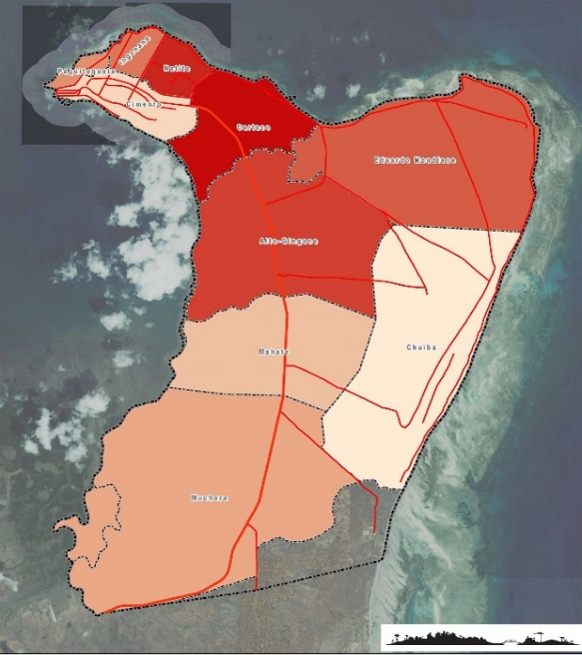

Adapted by Josue Tambara from: <https://gotopemba.com/infra-estruturas-sociais-2/>

Thus, based on the above facts and figures provided by OIM DTM, we chose to involve young people from the selected neighborhoods. Even though the employed covert observation method provided us with relevant information as summarized in table 2 below, we decided to test another tool to provide us with more evidence for our purpose.

Table 2. Summary of covert observation from 5 neighborhoods

|  |  |  |  |
| --- | --- | --- | --- |
| Neighborhood | Morning | Afternoon | Early Night Hours |
|  |  |  |  |
| Paquitequete | Boys and girls in the ocean for fishing activities | Boys and girls gathering at the only football ground to watch and play. Some boys and girls playing basketball at an improvised court. | Boys and girls helping parents to remove fish from fishing nets, boys and girls still playing at the football pitch, boys and girls still swimming |
| Ingonane | Boys and girls in the ocean for fishing activities | Boys and girls playing football and other games in the open streets. Some groups gathering at the only obsolete basketball court | Boys and girls helping parents to remove fish from fishing nets, boys and girls still playing at the football pitch, boys and girls still swimming |
| Natite | Boys and girls selling in the local market | Boys and girls playing at the beach | Large groups of boys and girls moving towards the neighborhood from the beach |
| Muxara | Boys and girls in the ocean for fishing activities | Boys and girls moving into smaller groups to the beach to swim, linger around and play football against other neighborhoods’ teams | Large groups of boys and girls moving towards the neighborhood from the beach |
| Eduardo Mondlane | Boys and girls playing beach soccer, boys and girls involved in fishing activities. Some boys and girls playing at the Pemba newly constructed stadium which was falling due to lack of maintenance | Boys and girls playing football, basketball, and handball at the obsolete stadium while others play beach soccer. Some other groups just linger around after swimming in the ocean waters | Large groups of boys and girls moving towards the neighborhood from the beach and the obsolete stadium |

Source:Adapted by Josue Tambara Covert Observation (1 – 22 September 2022)

Participant Observation Method

Participant observation is a qualitative research methodology in which the researcher studies a group not only through observation, but also by participating in its activities. In qualitative observation methodology, the researcher immerses himself in the daily activities of the participants in order to record the behavior in as many scenarios as possible. Thanks to the immersion in the study place, the researchers can observe the daily life of the people: their exchanges with each other, their formal and informal conversations, habits, etc.

It offers researchers the opportunity to collect honest and intimate information about people. However, this information is filtered through the perspective of researchers who, by using this method, run the risk of losing their objectivity and altering with their presence the behavior of the groups they study.

## Importance of participant observation

Participant observation is a method that helps you see and understand what people are doing and compare it with what they say. In this way, you help researchers know if the people with whom you are conducting a study act differently from what they are described. It also allows the researcher to better understand what is happening in a given group and its cultural environment, giving greater credibility to their interpretations of the observation. In addition, it allows the researcher to collect qualitative data through various types of interviews and quantitative data through surveys and different quantitative observation techniques.

## Characteristics of participant observation

According to Guest, G., et al (2012). *Collecting qualitative data: A field manual for applied research,* participant observation has historically been associated with a form of field research in which the researcher resides for long periods of time in a small community.

Today, this methodology is used in a wide variety of settings and for widely varying periods of time, from a single interaction to many years. In the case of Edu-Sport proposal preparation, we inverted the covert observation method allowing observers to go back to their respective neighborhoods of origin and be part of young people’s daily life. This created base to validate the following characteristics of the method:

* The long-term nature of the interaction between the observer and the participants as part of the fieldwork process.
* A wide range of relationship dynamics that it studies, such as differences in status between the two parties, differences in power and educational differences, as well as degrees of formality. Differences in power can have their origin in gender, social class, health, and other aspects.
* The variety of settings, from close interpersonal interactions to observing public gatherings and actual participation in social events.
* In this case, research took place in settings familiar to the observer, opening space for no sensitive communication due to familiarity of social codes…

Fig 4 below, illustrates further on the participant observation continuums.

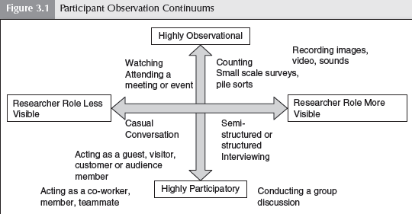

Source: Image c/o [*Chapter 3: Participation Observation*](http://www.sagepub.com/upm-data/48454_ch_3.pdf) Guest, G., Namey, E. E., & Mitchell, M. L. (2012). *Collecting qualitative data: A field manual for applied research.*

1. CHAPTER THREE
   1. Interventions and Activities

Activities were designed as milestones and each milestone was tied to its deliverable as indicated below:

**Activity 1. Meetings with community Stakeholders (October 2022 – March 2023)**

* 1. Meeting with Pemba provincial and local authorities
     1. Getting authorization for the project implementation
     2. Mobilization of youth in the selected neighborhood

**Activity 2. Creation of sports modality clubs (April 2023 – July 2023)**

2.1. Registration of clubs’ governing body (registering an association for the club)

2.2. Leadership training to the club governing body (governance and positive peace)

2.3. Registration of first players for each club

2.4. Procurement of training equipment (jerseys, nets…)

**Activity 3. Training (August 2023 – January 2024)**

* 1. Teams’ training (basketball and football)
     1. Rules and regulations – basketball and football
     2. Psychosocial support (partner engagement)
     3. Positive Peace (apathy, sympathy, empathy, compassion) (bystander effect)
     4. Sports training sessions

**Activity 4. Edu-sport tournament (February 2024 – July 2024)**

4.1. Registration of tournament Teams (basketball and football).

4.2. Launch of the tournament

4.3. Realization of tournament games up to semi finals

**Activity 5. Edu-Sport Tournament Final game (September 7th, 2024)**

5.1. Realization of a Final Edu-sport tournament

5.2. Prizing (prizes to come from New Vision’s sources not from this project’s funds)

**Activity 6. Final Project Report (October 30th, 2024)**

**PROPOSED PROGRAM SCHEDULE AND TIMELINE**

|  |  |  |  |  |  |  |  |  |  |  |  |  |  |  |  |  |  |  |  |  |  |  |  |  |  |  |  |
| --- | --- | --- | --- | --- | --- | --- | --- | --- | --- | --- | --- | --- | --- | --- | --- | --- | --- | --- | --- | --- | --- | --- | --- | --- | --- | --- | --- |
|  | ***Period of Project Execution*** | | | | | | | | | | | | | | | | | | | | | | | | | | |
|  | *2022* | | | *2023* | | | | | | | | | | | | | *2024* | | | | | | | | | | |
| **Activity** | ***Oct*** | ***Nov*** | ***Dec*** | ***Jan*** | ***Feb*** | ***Mar*** | ***Apr*** | ***May*** | ***Jun*** | ***Jul*** | ***Aug*** | ***Sep*** | ***Oct*** | ***Nov*** | ***Dec*** | ***Jan*** | | ***Feb*** | ***Mar*** | ***Apr*** | ***May*** | ***Jun*** | ***Jul*** | ***Aug*** | ***Sep*** | ***Oct*** |
| *Activity 1* |  |  |  |  |  |  |  |  |  |  |  |  |  |  |  |  | |  |  |  |  |  |  |  |  |  |
| *Activity 2* |  |  |  |  |  |  |  |  |  |  |  |  |  |  |  |  | |  |  |  |  |  |  |  |  |  |
| *Activity 3* |  |  |  |  |  |  |  |  |  |  |  |  |  |  |  |  | |  |  |  |  |  |  |  |  |  |
| *Activity 4* |  |  |  |  |  |  |  |  |  |  |  |  |  |  |  |  | |  |  |  |  |  |  |  |  |  |
| *Activity 5* |  |  |  |  |  |  |  |  |  |  |  |  |  |  |  |  | |  |  |  |  |  |  |  |  |  |
| *Activity 6* |  |  |  |  |  |  |  |  |  |  |  |  |  |  |  |  | |  |  |  |  |  |  |  |  |  |

* 1. Key Findings
     1. Youth grievances against the government

In Cabo Delgado province, although the insurgency is said to have many narratives, youth are being recruited by the fighters. Some of the recruited youths are joining due to government’s incapacity to address community youth’s needs. Specifically, these needs entail:

1. Income generation opportunities
2. Quality public service delivery (health, education, and WASH[1]) leading to:

* Lack of sport infrastructure
* Asymmetrical distribution of resources (Cabo Delgado province is rich in natural resources including oil and gas reserves. The recent gas discoveries and its opportunities have seen many highly qualified youth flocking from other regions to take employment opportunities from poorly qualified locals who see nothing but to join the insurgency).
  + 1. Sports as a unifier

Through the conducted meetings that brought both government and community members on the same platform to discuss Ed-Sport, we observed that sports have a crucial key in the contribution towards positive peace if funding for its realization is considered. Youth are eager to engage into sports activities but there is lack of attention from decision-makers.

A sport has constantly served as a most powerful vehicle for a societal transition. All the credits are given to the recognition and embracement of mixed experiences that can greatly contribute to building character, teamwork, community, and determination. A sport provides you with the opportunities to confront adversity with reliance and confidence. There are several skills learned from sports that can easily be applicable in our daily lives.

A sport pushes us to leave our comfort zones and gives us the challenge to confront fears and anxiety. Sports indeed help us to develop a successful mindset towards the challenges we face.

1. CHAPTER FOUR
   1. Recommendations

The report’s recommendation are not anything different from what has already been endorsed by the *2022 Secretary General Report, Sport: Catalyst For a Better, Stronger Recovery* which alludes that Sport should be maximized so that it can serve as a catalyst for:

1. Social inclusion, empowerment, and anti-discrimination

Sport can be catalytic when it is shaped to improve people’s opportunities, confidence, and sense of belonging in the short run, while laying the ground to change mindsets and build inclusive societies. Women’s and girls’ participation in sport, for example, can boost confidence and self-esteem while challenging gender stereotypes and influencing the behavior of men and boys.

1. Addressing Poverty and Inequalities

Sport-based programmes can help to develop and improve the soft skills of disadvantaged individuals to enable them to gain and retain suitable employment. Development of the sports industry, itself, can also be a powerful way to generate employment and contribute to economic growth in poor communities. Sports-based approaches can generate a “virtuous cycle”, building networks of local entrepreneurs, while increasing an area’s attractiveness to tourism. A growing sports industry, for example, could provide productive employment opportunities for young people in Africa, helping to catalyze inclusive and sustainable economic growth.

1. Improving mental and physical health

The impact of sport and physical activity can have immediate impacts on people’s well-being, while serving as a catalyst to lower the cost of health care and reap the benefits of a more productive, active population.

1. Confronting the Climate Crisis

No sector can “build back better”, without addressing the pressing climate crisis. Sport can play a catalytic role by using its universal platform to raise awareness, influence behavior, and generate action to combat climate change. By lowering its own carbon footprint and proactively adopting sustainability standards, the highly visible sports industry can lead by example, with a ripple effect, in other sectors.

1. Enabling sport as a low-cost, high-impact tool
2. Financing

The paradox of sport means that those with access to the largest pool of players (grassroots sports) have the fewest resources. Community-level actors implementing sport for development and peace are often dependent on public and corporate funding. Many lack the personnel to monitor and scale up good practices and meet donor requirements.

1. Partnerships

Given the community-level nature of most sport for development and peace initiatives, SDG impacts and lessons learned are often not aggregated or applied to improve programming or scale up what works. The report recommends that governments, supported by the UN and other entities, “adopt measures to strengthen national and local government collaboration with grassroots entities implementing sport for development and peace, including to build enabling partnerships, strengthen local capacities to monitor impacts, and scale up what works in a sustainable manner.

CONCLUSION

As Nelson Mandela stated, ‘‘Peace is not just the absence of conflict; peace is the creation of an

environment where all can flourish regardless of race, color, creed, religion, gender, class, caste,

or any other social markers of difference.’’ And, since peacebuilding is not about stopping conflict,

and it goes beyond stopping direct violence to working on the more systemic issues of structural

and cultural violence, sport as a tool has the power to engage people to transform their capacities to manage conflict without violence; to transform relationships between people across identity divides; and to transform the systems dynamics of seemingly intractable violence.

On the basis of the partial findings of the project, it is fair to say that infrastructural developments, stakeholder engagement and funding are necessary to provide sports facilities. The social importance of sport as a product is significant.

In case of Edu-Sport, the sustainability plan lies in the creation of sports clubs with an elected governing body which will run the day-to-day operations of each club.

REFERENCES

Hubbard, G., (2004). *Strategic Management: Thinking, Analysis and Action*

Galtung, J., (1993). *Violence Typology*

Edwards, D., (2012). *Maximizing Positive Social Impacts: Strategies for Sustaining and Leveraging the Benefits of Intercommunity Sport Events in Divided Societies*

Serra, P., (2015). *Sociology of sport*

Gaventa, J., (2006). *Finding the spaces for change: A power analysis*

Reynard, S., (2020). *Peace Review: A Journal of Social Justice*

Allport, G.W., (1979). *The Nature of Prejudice*. *Perseus Books*

Gschwend, A., & Selvaranju, U., (2007). *Psycho-social sport programmes to overcome trauma in post-disaster interventions*

Rookwood, J., (2008). *Soccer for Peace and Social Development, Peace Review: A Journal of Social Justice*

Nagy, A., Tobak, J., (2015). *The role of sport Infrastructure: Use, Preferences and Needs*

Dudovskiy, J. (2022). *The Ultimate Guide to Writing a Dissertation in Business Studies: A Step-by-Step Assistance*

**APPENDICES**

1. Edu-Sport Award File by the United States Government

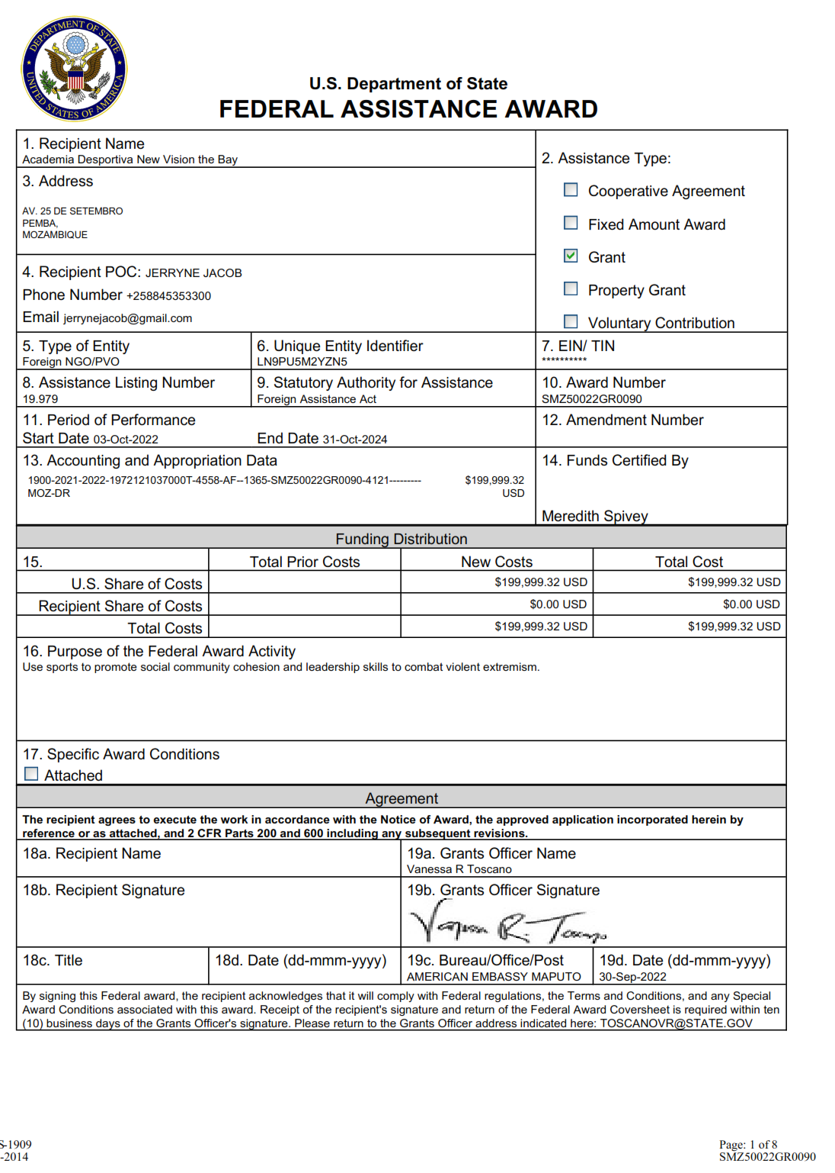

1. New Vision the Bay’s submitted proposal clearly showing the support from Josue Tambara – a Rotary Peace Fellow from Makerere University.

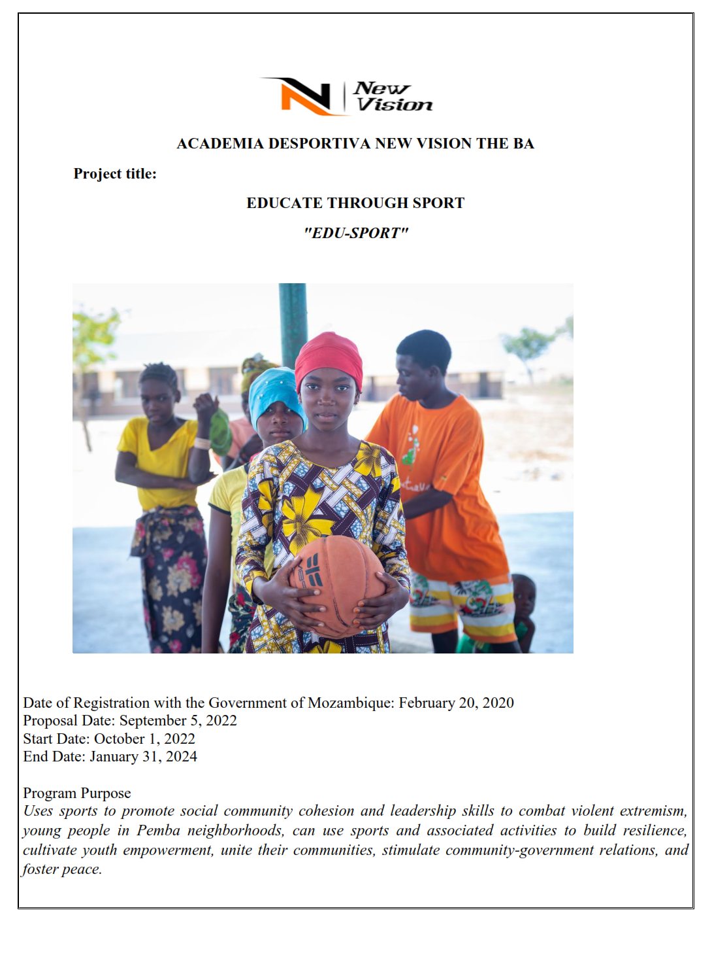

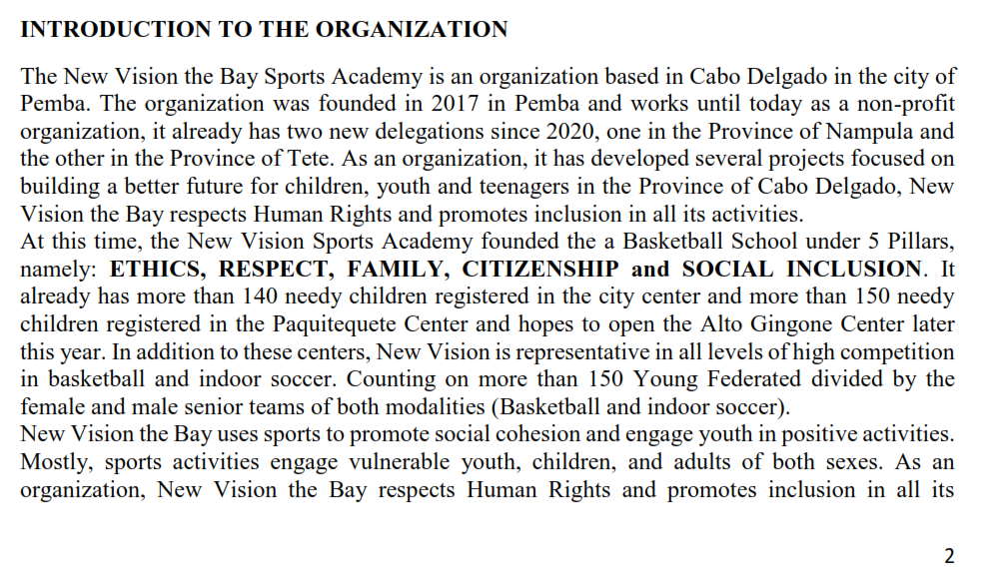

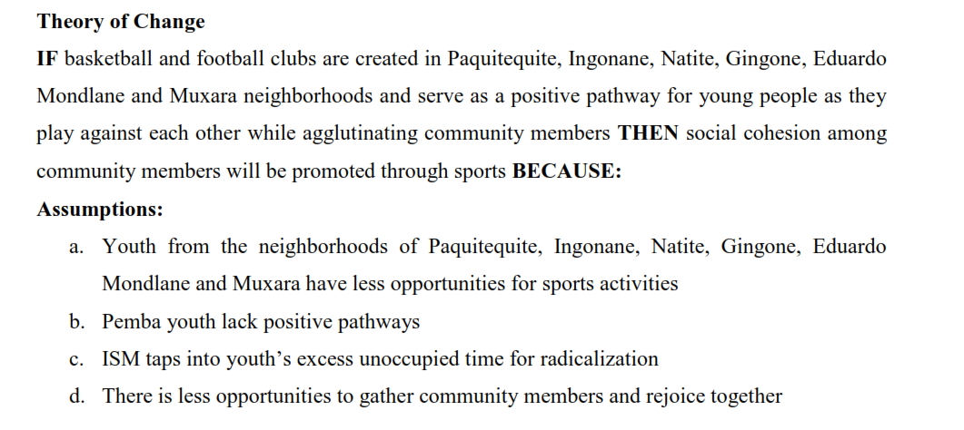

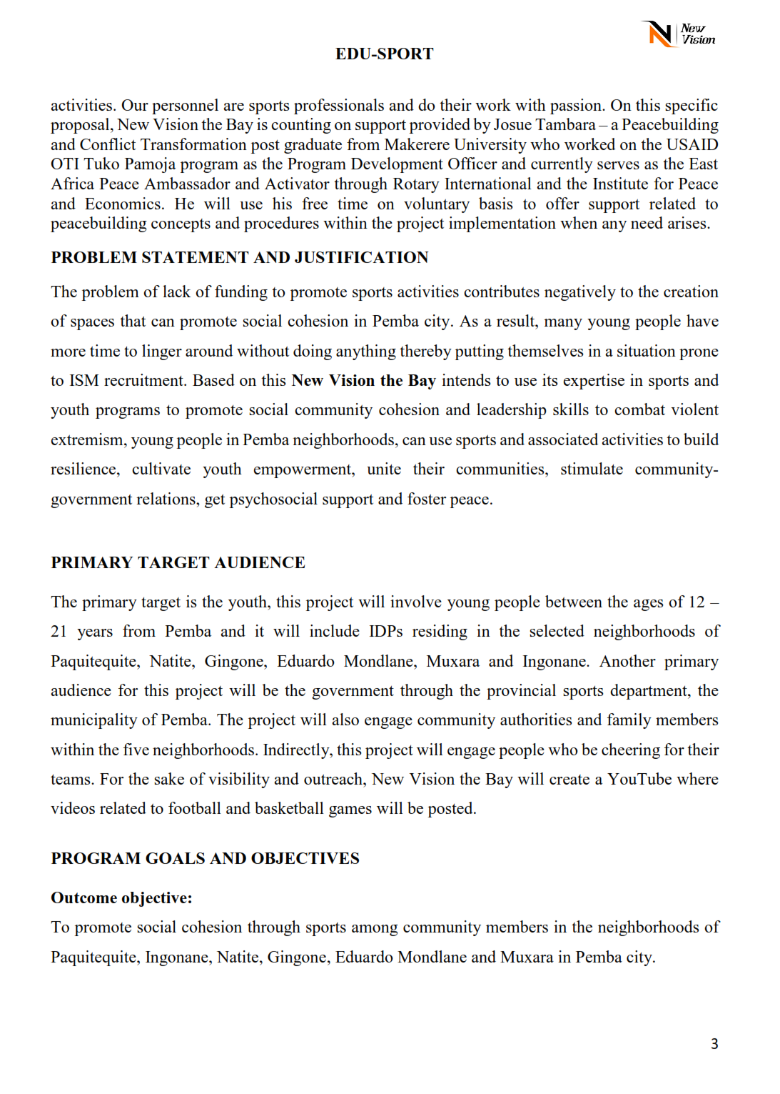

1. Memorandum of Understanding – Josue Tambara and New Vision the Bay

Josue Tambara, a Rotary Peace Fellow designed the Edu-Sport project concept as his Social Change Initiative to support a local organization which works in Pemba engaging local youth through practice of sports in the football and basketball modalities. The idea to design the concept for New Vision the Bay was to guarantee sustainability considering that this organization already works in Pemba and other districts of Cabo Delgado province. Most of the people working in this organization speak the local language different from Josue.

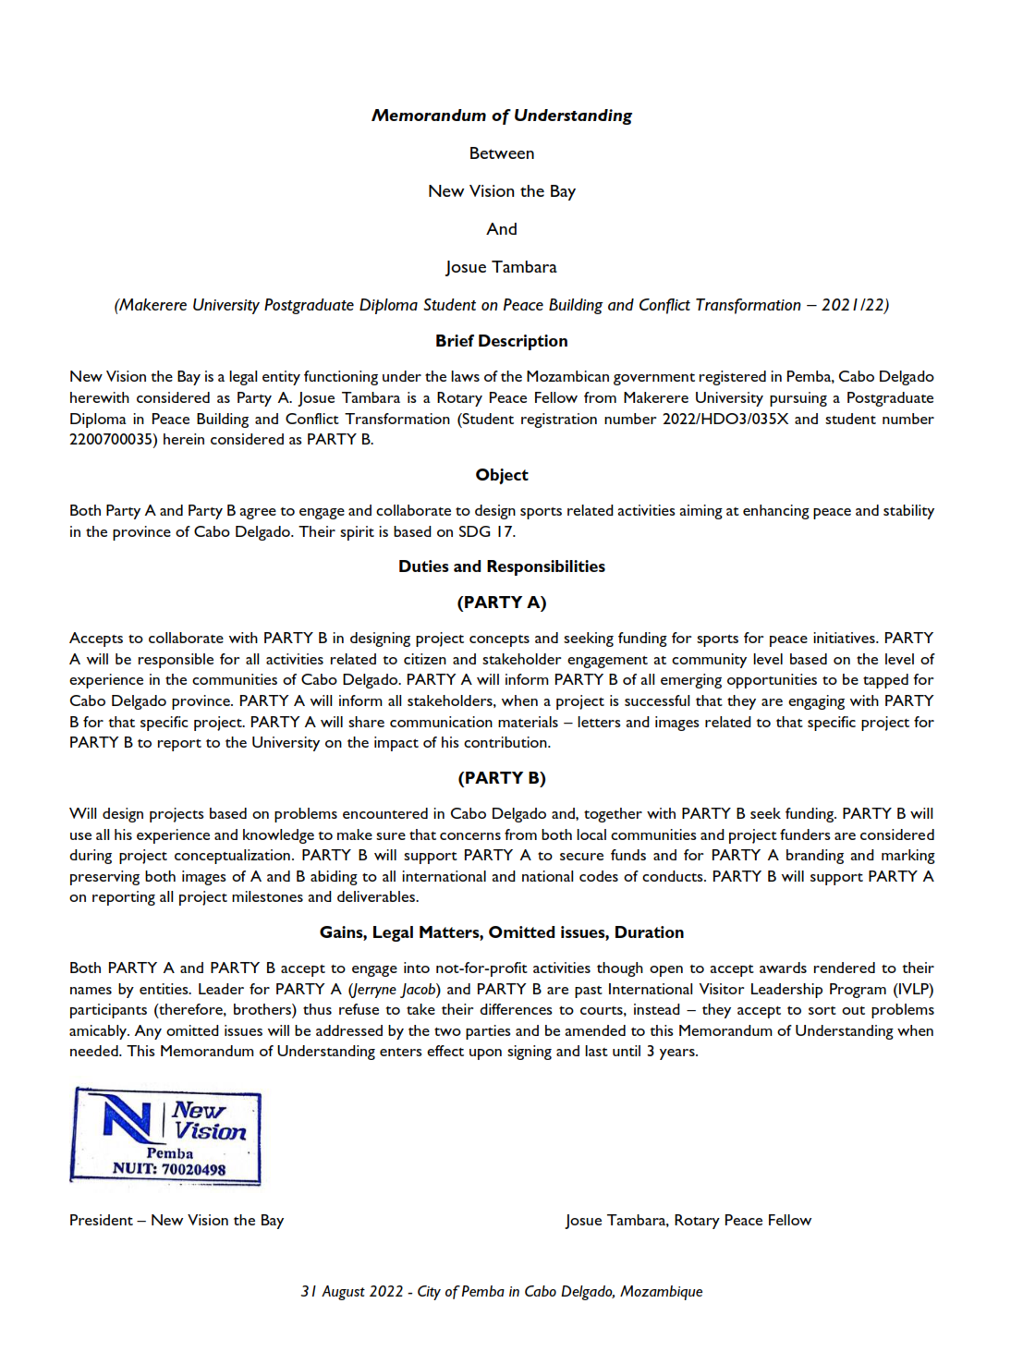

1. Email from the United States Government communicating about the Award (the word me in the email recipients represents Josue Tambara who was using address: [yoswajat@gmail.com](mailto:yoswajat@gmail.com)

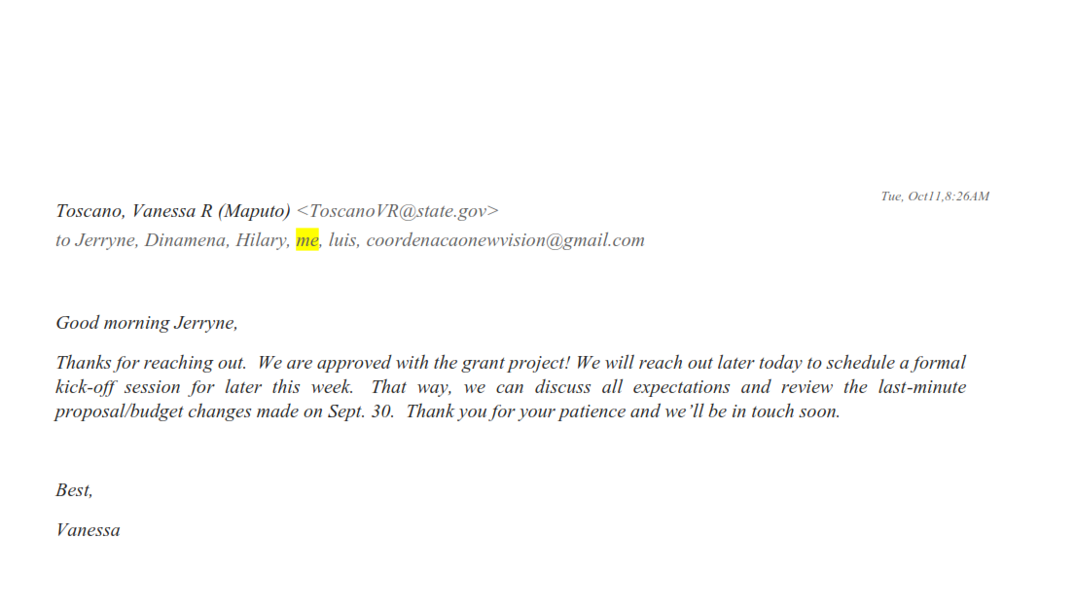

1. Pictures

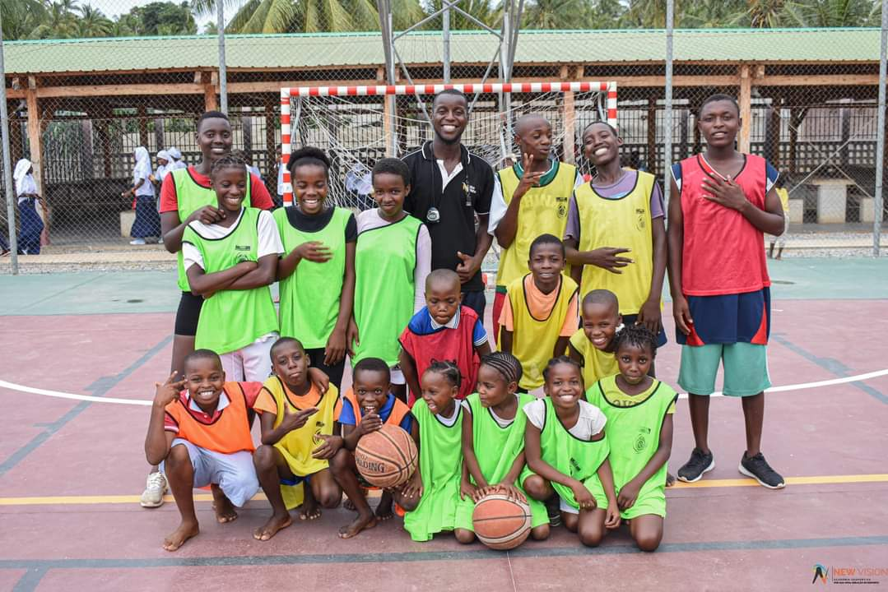

Girls learning how to throw and score

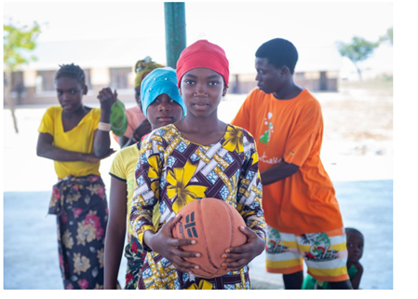

1. Water Hygiene and Sanitation