**Title:** Visual Artistic Expression for Social Cohesion between Urban Refugee Youths and Host Communities

**Location: Country-** Kenya

**County –** Nairobi

**Constituency -** Embakasi East (Urban)

**Start Date:** 1st August 2023

**Completion Date:** 23rd January 2024

**Abstract**

This social change initiative aimed to address social division and exclusion between urban refugee youths and host communities in the Embakasi constituency, Nairobi, Kenya. The project involved 15 youths, comprising 9 host community members and 6 urban refugee youths. The primary objective was to bridge cultural differences and cultivate a shared sense of identity and community through the creation of a collaborative art space. Activities included forming art groups with both refugees and host community members, producing joint artworks representing shared experiences and fostering intercultural dialogue, and organizing art exhibitions and community events for reflection and discussion. Additionally, the SCI's impact was achieved through five well-organized physical and six virtual dissemination events, each serving as a platform to showcase the outcomes of the initiative to diverse audiences. This dissemination strategy aimed to enable diverse audiences to understand the experiences of refugees and underscore the importance of their inclusion in our society. Community mediation skills, such as dialogue, active listening, impartiality, negotiation, and collaborative problem-solving, were integral to the initiative's success of this SCI.

**CHAPTER ONE**

**INTRODUCTION AND BACKGROUND**

Kenya hosts over 600,000 refugees and asylum seekers who have fled war, conflict, and persecution, with the majority residing in refugee camps such as Dadaab and Kakuma. However, approximately 95,000 refugees have settled in Nairobi and other urban areas, facing challenges related to the encampment policy that restricts refugees to remote rural areas (Karanja, 2010). Despite this policy, refugees often migrate to urban centers, seeking employment opportunities and improved access to education for their children. Notably, the urban refugee population in Nairobi is diverse, with Somali and Ethiopian refugees concentrated in Eastleigh and other nationalities, including Sudanese and Congolese, settled in areas like Embakasi, Kawangware, Kasarani, and Umoja (DRS, 2023).

Within this urban context, refugees and host communities experience high unemployment rates, living under the internationally recognized poverty line of USD 1.98 per person per day. Challenges to full integration into Kenya's labor market persist due to political, policy, and economic barriers (UNHCR, 2023). The scarcity of resources, exacerbated by the encampment policy, contributes to tension and conflict between refugees and host communities. Limited access to essential resources such as jobs, intensifies perceptions among host communities that refugees pose threats to their livelihoods (Yarnell., & Thomas2014).

Following the Kenyan government's announcement in December 2013, urging refugees and asylum-seekers to relocate to Dadaab and Kakuma camps, marked significant challenges for urban refugees. In the aftermath of this directive, Nairobi experienced a surge in attacks targeting refugees and Kenyans of ethnic Somali origin, creating an alarming environment of hostility and discrimination (Jesuit, 2013). Disturbingly, instances of harassment and abuse had not only been attributed to criminal gangs but had also involved law enforcement officials, responsible for ensuring the safety and security of all individuals within the country.

Moreover, in my own experience living with refugees in Nairobi, I observed that the challenges faced by refugees in host communities are often rooted in a lack of understanding among the local population regarding the experiences of refugees fleeing their countries, especially in Kenyan communities that have not directly experienced war or conflict leading to mass displacement. In many instances, misconceptions and stereotypes contribute to the difficulties faced by refugees attempting to integrate into their host communities. Recognizing the importance of addressing these misconceptions and fostering inclusivity, understanding, and mutual respect, this social change initiative aims to create a platform where refugees can share their experiences directly with the host community.

The initiative sought to dismantle stereotypes and promote awareness about the unique challenges refugees face, encouraging a more empathetic understanding among host communities. By providing a space for dialogue and sharing personal narratives, the initiative aspired to foster a sense of shared humanity, dispel misconceptions, and promote harmonious coexistence between urban refugees and their host communities. The ultimate goal is to bridge cultural differences, reduce social division, and cultivate a community where both refugees and host community members feel a sense of belonging and shared identity.

**Statement of the Problem**

The increased challenges faced by urban refugees in Nairobi stem from a profound lack of awareness and understanding among the local population regarding the experiences of refugees fleeing their countries, especially in Kenyan communities that have not directly experienced war or conflict leading to mass displacement. In many instances, misconceptions and stereotypes contribute to the difficulties faced by refugees attempting to integrate into their host communities. There is an urgent need to address these misconceptions, promote inclusivity, and foster mutual respect to create a harmonious coexistence between urban refugees and host communities.

Top of Form

Bottom of Form**Objectives of the SCI**

This SCI was guided by the following goal and objective:

**Goal:** Promote Social Cohesion and Inclusivity between Urban Refugees and Host Communities in Nairobi.

**Objectives:**

* Create a platform for dialogue and exchange of experiences between urban refugees and host community members through collaborative visual artistic expressions.
* Utilize visual art as a powerful medium to challenge stereotypes and dispel misconceptions about refugees, fostering a more nuanced understanding within host communities.
* Establish an environment that encourages open communication, understanding, and empathy between urban refugees and host communities, using visual art as a bridge for shared experiences.
* Form collaborative art groups consisting of both refugees and host community members to collectively create artworks that reflect shared experiences and promote intercultural dialogue.
* Organize art exhibitions and community events to showcase the joint artworks, providing a platform for discussion, reflection, and community engagement.

**Challenges and Mitigation Strategies**

1. The lack of suitable workshop space posed a challenge to conducting art activities. I successfully mitigated this challenge by securing a rental space generously provided by a community-based organization situated in the informal settlements. This alternative venue facilitated the smooth implementation of Project
2. A reluctance among refugees to participate due to security concerns. To mitigate this challenge I clearly communicated the purpose of my SCI and demonstrated a genuine commitment to their well-being and safety.
3. Hesitancy from host community youths, who were engaged in their small income-generating enterprises, posed challenges for the SCI. To tackle this, I implemented a solution by offering small tokens as a form of compensation for their time, thus encouraging active participation and addressing their apprehensions.
4. Limited funding and resources hindered the effective implementation of the project. To mitigate this challenge, I funded the project with personal resources, supplemented by a supportive contribution of $100 from Snaida, a colleague and fellow in Cohort Five.

**CHAPTER TWO**

**General Overview of Urban Refugee Realities**

Kenya has been hosting a large population of refugees, primarily from war-torn Somalia, South Sudan, Ethiopia, the Democratic Republic of Congo, and other conflict-ridden regions, offering sanctuary for those escaping violence and food insecurity (DRS, 2013). For over three decades, a significant number of refugees have chosen to reside in urban areas, with Nairobi being a prominent choice. Unlike traditional camps, urban settings provide refugees with opportunities for self-sufficiency rather than relying solely on aid provisions (Yarnell., & Thomas, 2014).

Refugees encounter various challenges upon arrival in a new country, such as language barriers, cultural unfamiliarity, prejudice, and social exclusion. However, these experiences vary widely, as refugees come from diverse backgrounds and professions, challenging the stereotype of a unified refugee story. Refugees can be teachers, doctors, and college students, each with unique names and lives preceding their refugee status (Kirk, 2019). Despite this diversity, common myths persist, and misconceptions about refugees abound, emphasizing the need for more accurate and individualized narratives to dispel these prevailing myths.

Commonly, refugees are mistakenly portrayed as "economic migrants" seeking opportunities in more developed countries, perpetuating a misconception. Studies indicate that low-skilled foreign workers and low-skilled domestic workers often complement rather than compete with each other. For instance, in Lebanon, the influx of over a million Syrian refugees since 2010 has contributed to rapid, unsustainable urbanization in an already fragile context (World Vision, 2020). This situation has heightened vulnerabilities, strained basic urban services, and intensified social conflicts, demonstrating the interconnectedness of urban communities and the need for nuanced approaches (REACH. (2014). Tensions between refugee and host communities and the challenges faced by local administrations in managing these complexities are noteworthy.

**Misconceptions and Social Complexities in Host Communities**

In recent years, prevailing misconceptions have significantly influenced global perspectives on refugees, hindering a nuanced understanding of their experiences. These misconceptions contribute to difficulties in fostering peaceful coexistence between host communities and refugees, often fueling xenophobic attitudes (Aster, 2022). One major fallacy suggests that refugees resist integration, when, in reality, the challenges they encounter are frequently exacerbated by societal prejudices. Another persistent misconception is that refugees are aloof and disinterested in societal integration, resulting in a disconnect between host communities and refugees (Concern, 2022). Contrarily, refugees are often enthusiastic about engaging in social activities, and breaking down stereotypes through meaningful conversations can facilitate integration. Recognizing the importance of acceptance and empathy from receiving communities is crucial, acknowledging that refugees, like everyone else, aspire to establish social connections and seize opportunities for personal enrichment (Doctors of the World, 2023).

Refugees are frequently underestimated, and the assumption that they are underqualified is unfounded. Studies indicate that refugees, especially those with tertiary education, are often qualified for their jobs. Challenges arise in the workplace due to employers not recognizing foreign qualifications, contributing to hurdles in career advancement (Concern, 2022). Refugee students often face obstacles in accessing quality education, delaying their opportunities in the labor market. The misconception that refugees are underqualified overlooks their diverse skills, talents, and potential contributions to host societies. Contrary to the misconception that refugees are an economic burden or take jobs away from citizens, evidence suggests otherwise. In various countries, refugees contribute significantly to economies, paying taxes and often starting their businesses. The UNHCR estimates that 70% of refugees live in countries limiting their right to work, often driven by concerns for the local economy (Aster, 2022). The reality, as seen in the US and the UK, is that refugee communities can positively impact economies, debunking the myth of refugees as a drain on resources and opportunities.

**Art as a Tool for Breaking down Social Barriers**

Art has long served as a powerful medium for transcending social barriers and fostering understanding among diverse communities. Through its ability to communicate across cultural and linguistic divides, art becomes a universal language that encourages dialogue and connection (IUPUI, 2019). In the context of this social change initiative leveraging art as a tool holds the potential to bridge gaps in perception and dispel stereotypes. By providing a creative platform for individuals from different backgrounds to express themselves, share their stories, and engage in collaborative projects, art becomes a catalyst for breaking down preconceived notions and fostering a sense of shared humanity (UNHCR, 2015).

The transformative impact of art on social cohesion lies in its ability to humanize individuals who may be marginalized or misunderstood. Visual artistic expression, in particular, enables participants to convey complex emotions, experiences, and aspirations that may be challenging to articulate verbally (Bhushan, 2023). In the urban refugee experience, where misconceptions and stereotypes often prevail, art serves as a medium for refugees to reclaim their narratives and for host communities to gain insights into the rich tapestry of diverse lives within their midst. The process of creating art together can lead to mutual respect, empathy, and a deeper appreciation for the shared humanity that transcends socio-cultural differences (UNHCR, 2015).

Beyond breaking down social barriers, art also has the potential to contribute to community resilience and empowerment. When individuals engage in artistic expression collectively, it fosters a sense of belonging and ownership within the community (IUPUI, 2019). Artistic projects become a testament to the strength and resilience of communities facing adversity. In the case of urban refugees, whose journeys are marked by challenges and uncertainties, participating in artistic endeavors offers a way to celebrate their strengths, aspirations, and contributions (UNHCR, 2015). Ultimately, by harnessing art as a tool for breaking down social barriers, this social change initiative aims to cultivate a more inclusive and empathetic community where the transformative power of creativity becomes a driving force for positive change.Top of Form

**Theoretical Framework: Social Identity Theory and Visual Artistic Expression**

The theoretical framework underpinning this SCI is grounded in Social Identity Theory (SIT). Developed by Henri Tajfel and John Turner, SIT posits that individuals categorize themselves and others into social groups based on shared characteristics, fostering a sense of belonging and identity within these groups.

In the context of visual artistic expression, SIT suggests that collaborative art projects between host communities and urban refugees can contribute to the creation of a shared social identity. Through the process of co-creating artworks, participants can emphasize commonalities, shared experiences, and collective goals, thereby mitigating intergroup boundaries and fostering a sense of unity.

Visual art serves as a powerful medium for articulating and representing shared narratives, emotions, and aspirations, allowing participants to communicate beyond linguistic and cultural differences. By engaging in the artistic process together, individuals from different backgrounds can develop a collective identity that transcends traditional divisions, promoting mutual understanding and social cohesion.

Additionally, the theoretical framework draws on the transformative potential of participatory art practices, as it aligns with SIT's emphasis on the importance of positive intergroup interactions in reducing prejudice and promoting social harmony. By embracing a shared creative endeavor, participants in collaborative art projects have the opportunity to challenge stereotypes, break down barriers, and build a sense of community that extends beyond cultural, ethnic, or refugee-host distinctions.

Top of Form

**Theory of Change**

The theory of Change (ToC) for this SCI is grounded on the assumption that if implemented, visual artistic expression initiatives for social cohesion between refugees and host communities then it can bring them together, fostering communication, understanding, and empathy between Urban Refugees and Host Communities. This SCI was implemented with a clear understanding of the challenges faced by urban refugees in integrating into the host community. Recognizing the impactful role of art in fostering communication, understanding, and empathy, the initiative focused on creating a collaborative art space that actively involved urban refugees and host communities.

To efficiently conduct these activities, the initiative required various resources, including human involvement, suitable spaces, art materials, and technology for documentation. Workshops and training sessions were organized, providing participants with opportunities to engage in collaborative art projects, attend cultural understanding sessions, and showcase their work through art exhibitions and community events. These activities aimed at breaking down cultural barriers, promoting dialogue, and enhancing mutual understanding between the two groups.

The tangible results produced through these activities included the number of participants involved, the creation of collaborative art pieces, and an increase in cross-cultural awareness within the community. These outputs were critical in measuring the initiative's success and impact in the short term. The initial outcomes observed involved improved attitudes towards cultural diversity and the development of enhanced artistic skills among the participants.

Moving into the mid-term phase, the initiative aimed to witness changes in social behaviors, increased community cohesion, and improved integration of urban refugees. The initiative was successful in fostering a sense of shared identity and community through artistic expression. Participants not only developed artistic skills but also built meaningful connections and relationships, contributing to a more inclusive and cohesive society.

The long-term vision for the initiative extends beyond its immediate intervention. It aspires to establish sustainable social practices that promote inclusivity, create positive shifts in societal attitudes towards refugees, and contribute to the formation of a harmonious and integrated community. To achieve these enduring outcomes, ongoing evaluation, adaptation of strategies, and collaboration with local organizations, community leaders, and policy advocacy remain crucial. Continuous support and funding are essential resources needed to sustain the initiative's positive impact and foster lasting social change.

**A visual presentation structure of the Theory of Change**

Long-term Outcomes

|  |
| --- |
|  |

Midterm outcomes

|  |
| --- |
|  |

Short-term outcome

|  |
| --- |
|  |

Interventions

|  |
| --- |
|  |

Assumptions

|  |
| --- |
|  |

Participants

Sustainable social practices that promote inclusivity, create positive shifts in societal attitudes towards refugees, and contribute to the formation of a harmonious and integrated community.

Increased community cohesion, and improved integration of urban refugees.

Improved attitudes towards cultural diversity and the development of enhanced artistic skills among the participants.

* Visual art workshop and training
* Collaborative art projects
* Public art dissemination

Visual art is a powerful tool to bring people together, fostering communication, understanding, and empathy between Urban Refugees and Host Communities.

Urban Refugees

Host Community

**CHAPTER THREE**

**Interventions and Activities**

The following were the implementation activities for this SCI:

**Visual art workshops:** The implementation phase of the Social Change Initiative commenced with the organization of two impactful visual art workshops. These workshops served as a crucial platform to bring together urban refugee youths and members of the host communities. Led by experienced facilitators well-versed in visual art, these workshops were well-designed to guide participants through a series of engaging activities. The primary objective at this stage was to familiarize participants with the overarching goals of the project and underscore the significance of their active involvement in the SCI.

During these preparatory workshops, participants were provided with a unique space to express themselves creatively through various visual art forms. The activities were curated to encourage participants to share their perspectives, experiences, and aspirations. This initial engagement not only laid the foundation for collaborative art projects but also played a pivotal role in fostering a sense of shared identity among the diverse group of participants. Importantly, it was an opportunity to gather opinions from both urban refugee youths and members of the host communities, ensuring that the SCI was attuned to the needs, aspirations, and cultural nuances of all involved parties. These workshops served as the cornerstone for building a supportive and inclusive environment, setting the stage for the subsequent phases of the initiative.

1. Top of Form

**Collaborative art projects:** Following the preparatory training workshops, the collaborative art projects officially commenced three days later, marking a significant milestone in the SCI's implementation. A total of six urban refugee youths and nine members of the host communities actively participated, coming together to work on shared art pieces. The collaborative art projects were meticulously organized, emphasizing teamwork and creating an inclusive environment where each individual had the opportunity to share their unique experiences through the medium of art.

This phase of the initiative unfolded over two months, allowing sufficient time for the creation of meaningful and impactful art pieces. The timeline for the art projects was mindful of breaks, with one-week intervals strategically incorporated to provide time for sourcing materials and securing funds essential for the smooth continuation of the SCI. The collaborative nature of these art projects not only resulted in the creation of eight unique pieces but also provided a rich learning experience for all participants. Through the process of painting and drawing, the diverse group of individuals engaged in a dynamic exchange of ideas and perspectives, contributing to a deeper understanding of each other's backgrounds and fostering a sense of unity within the group. The art pieces, serving as tangible representations of shared experiences, became powerful tools for promoting dialogue and breaking down cultural barriers within the community.

**Dissemination of SCI outcomes**

A crucial aspect of the SCI's impact was achieved through five carefully organized physical dissemination events, each serving as a platform to showcase the outcomes of the initiative to diverse audiences. Two of these events were conducted in collaboration with different organizations that invited me to share the success stories and art pieces created during the collaborative projects. These physical events, held in accessible community spaces, facilitated direct engagement with the local community, fostering a sense of connection and understanding.

In addition to physical events, the initiative embraced the digital realm by organizing six virtual dissemination events, three of which were hosted in collaboration with the Bosch Alumni Network. One notable virtual event was titled "Virtual Continental Tour on Migrations and Refugees: Building from Crisis to Sustainable Development –The 2030 Agenda: Migration, Refugee Population as Key Driver to Sustainable Development." This event provided a unique opportunity to disseminate the SCI's outcomes to a broader audience, including participants from different regions, fostering cross-cultural dialogue and expanding the initiative's reach. The virtual dissemination events, characterized by interactive discussions and presentations, effectively leveraged technology to connect with diverse stakeholders, including those who may not have been able to attend physical events. Overall, the combination of physical and virtual dissemination efforts significantly contributed to amplifying the initiative's impact, promoting community engagement, and initiating conversations on the importance of visual artistic expression for social cohesion.

**Community dialogues:** I organized and facilitated two community dialogues between the two groups where urban refugees were given a platform to openly share their personal experiences, challenges, and aspirations with members of the host community. The dialogues aimed to break down stereotypes, dispel misconceptions, and humanize the stories of refugees, fostering a sense of empathy and shared humanity. The community dialogues were structured to encourage open and respectful communication, creating a space for genuine dialogue between urban refugees and host community members. This process allowed for an exchange of perspectives, creating an opportunity for both groups to learn from each other. The sharing of experiences aimed to build bridges of understanding, acknowledging the commonalities and shared challenges that transcend cultural differences.

**Key Findings and Impact of the Social Change Initiative**

The implementation of the SCI's activities demonstrated tangible results in fostering collaboration, understanding, and shared identity. The impact extended beyond the immediate participants, contributing to community-wide appreciation and awareness of the role visual artistic expression can play in promoting social cohesion.

The preparatory visual art workshops served as a foundational step, fostering a sense of shared identity and providing a platform for creative expression. Participants, comprising urban refugee youths and members of host communities, actively engaged in expressing their perspectives, needs, and cultural nuances. The workshops facilitated collaboration and ensured the SCI was aligned with the aspirations of both groups, fostering an inclusive environment.

The collaborative art projects resulted in the creation of eight unique pieces, representing shared experiences and promoting dialogue. Through the two-month collaborative process, participants from diverse backgrounds engaged in meaningful exchanges, contributing to a deeper understanding of each other. The art pieces became powerful tools for breaking down cultural barriers and fostering unity within the community.

Physical and virtual dissemination events, including collaborations with external organizations, successfully showcased the initiative's outcomes. The combination of physical and virtual dissemination efforts significantly amplified the initiative's impact, reaching diverse audiences and initiating conversations on the importance of visual artistic expression for social cohesion.

Two community dialogues provided a platform for urban refugees to share personal experiences, dispel stereotypes, and foster empathy. The dialogues facilitated genuine communication between urban refugees and the host community, building bridges of understanding.

**CHAPTER FOURTop of Form**

**Top of Form**

**Conclusion**

This SCI has been instrumental in bringing about positive changes in perceptions, relationships, and community dynamics. By harnessing the power of visual artistic expression, the initiative has successfully contributed to building bridges of understanding, fostering empathy, and creating a more cohesive and inclusive community. The lasting impact of the initiative is a testament to the transformative potential of art in promoting social change and harmony. The SCI not only provided a platform for creative expression and alignment with the aspirations of both urban refugee youths and host community members but facilitated collaboration and also nurtured a strong sense of shared identity within the diverse group. The impact extended beyond the participants, contributing to community-wide appreciation and awareness of the transformative role visual artistic expression can play in promoting social cohesion. The community dialogues provided a platform for urban refugees to share personal experiences, dispel stereotypes, and foster empathy. The impact of these dialogues was evident in improved relationships, understanding, and shared responsibility within the community, addressing social division and contributing to a more inclusive environment.

**Recommendations/Implications for Policy**

The recommendations provided below aim to contribute to the development of a supportive policy environment that recognizes, values, and sustains the role of visual artistic expression in fostering social cohesion:

* Advocate for the formal recognition of visual artistic expression as a valuable tool for promoting social cohesion within local and national policies. Work towards the inclusion of art-based initiatives in community-building strategies and frameworks.
* Integrate art-based activities and programs into formal and informal education settings. This could involve curriculum adjustments, extracurricular activities, or partnerships with educational institutions to emphasize the importance of the arts in fostering understanding and unity.
* Involve community members in policy development, including refugees and host communities, in the development and evaluation of social cohesion strategies. This ensures that policies are reflective of the actual needs and aspirations of the communities they aim to serve.
* Integration of artistic initiatives in social services policies, particularly those related to mental health and well-being. Position art as a therapeutic and community-building tool that can contribute to the overall social and emotional health of individuals.

**Sustainability Plan**

This SCI aims to evolve from a project into a lasting and integral part of the community, promoting social cohesion through visual artistic expression for years to come. The sustainability plans include:

1. Community-Led Initiatives: Empower community members, including both refugees and hosts, to take leadership roles in organizing and sustaining art-based activities. Facilitate the formation of community-led art groups that can continue engaging in collaborative projects independently.
2. Partnerships with Local Institutions: I plan to develop partnerships with local schools, community centers, and cultural institutions to integrate art-based initiatives into their regular programs. This collaboration can ensure a continuous platform for artistic expression and social cohesion activities.
3. Digital Platforms and Archives: I aim to create a digital platform or archive to document and showcase the outcomes of the SCI. This online presence can serve as a repository of artistic expressions, project impact, and community stories, ensuring the initiative's legacy is accessible and visible.
4. Grant Applications and Fundraising: I have developed a sustainable funding strategy which includes regularly applying for grants, both locally and internationally as well as partnerships with foundations, NGOs, and corporate sponsors interested in supporting initiatives promoting social cohesion through the arts.

**Appendices**

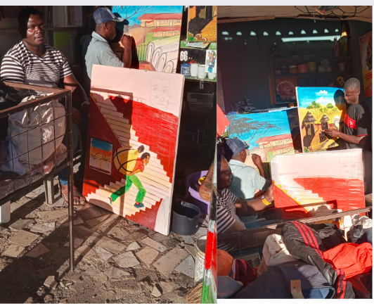

This picture captures the early stages of our art project, where we began painting and drawing with a small group of participants. While we couldn't gather everyone in one sitting, they all contributed ideas based on their experiences. The artwork was brought to life by those with strong painting skills, reflecting the collaborative effort and creativity within the group.

**Top of Form**

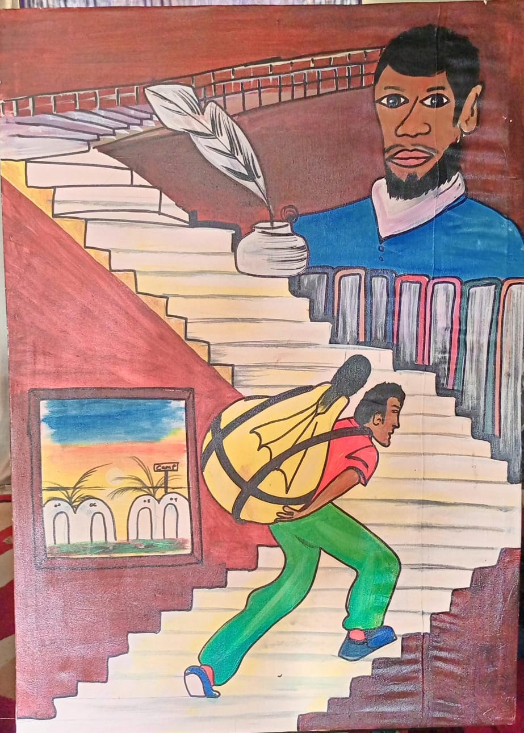

This picture illustrates the myriad challenges encountered by refugees as they integrate into the host community. Many of them venture outside the camp into the city, facing a significant protection gap. The image vividly portrays the difficulties they encounter while navigating the social and economic landscapes of the urban environment.

At the top of the image, a man gazes downward as someone ascends winding stairs, burdened with a heavy, bright bulb. The man at the summit symbolizes authority overseeing the refugees, while the individual climbing the stairs represents refugees navigating myriad challenges in the host community. The bright bulb embodies hope and love, signifying their aspiration to live in peace and harmony in their new environment.

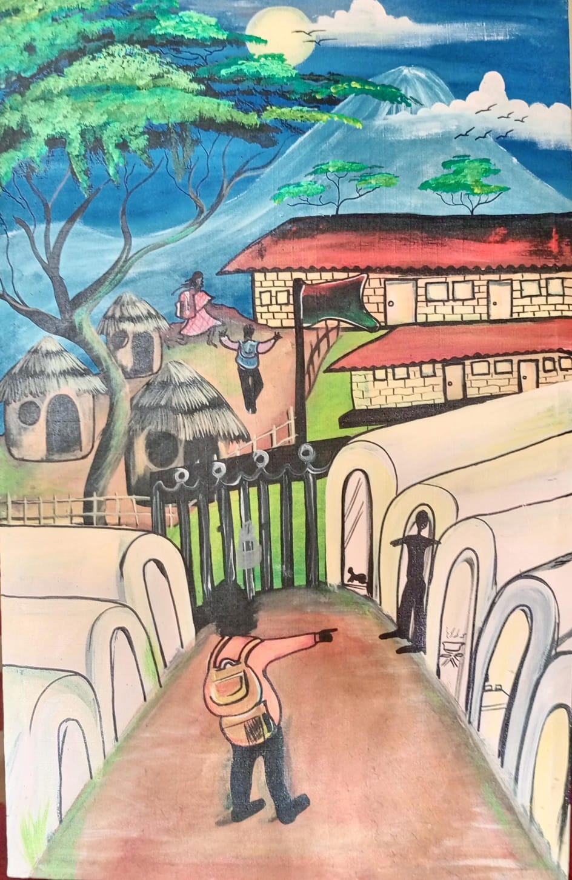

This image depicts the experiences of refugee children in school, illustrating the numerous challenges they encounter in accessing education in urban settings. The child standing symbolizes a refugee child in the camp setting, while the gate represents the barriers they face in accessing education. The grass-thatched house symbolizes typical African homes. This visual expression captures the challenges they encounter at the camp, emphasizing that in urban settings, they face even greater obstacles to education.

**Dissemination of SCI Output**

The images below depict the dissemination of the SCI output to various audiences. This dissemination took place through various platforms, both physical and virtual. The purpose was to enlighten communities about who refugees are, their rights, and why we should embrace them in our communities, support them, and live in peace with them. This initiative extends beyond Nairobi to other cities where urban refugees are hosted.

**Top of Form**

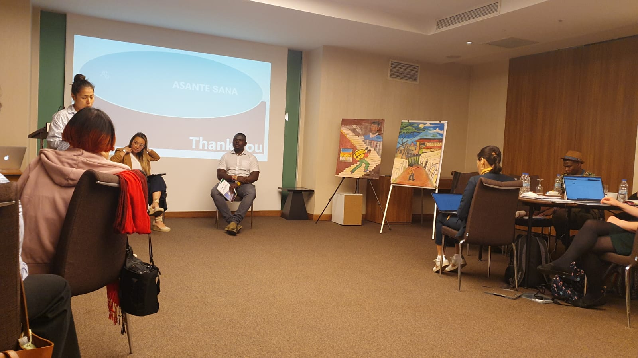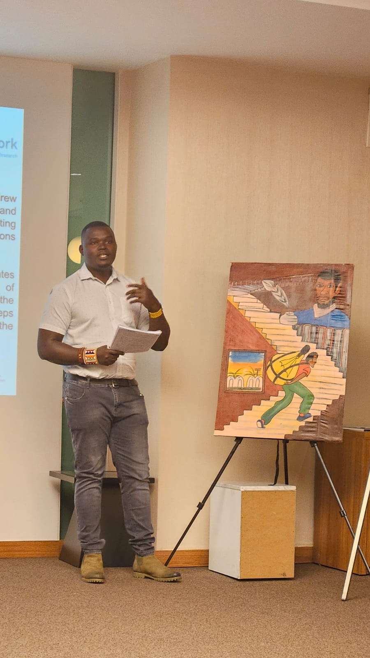

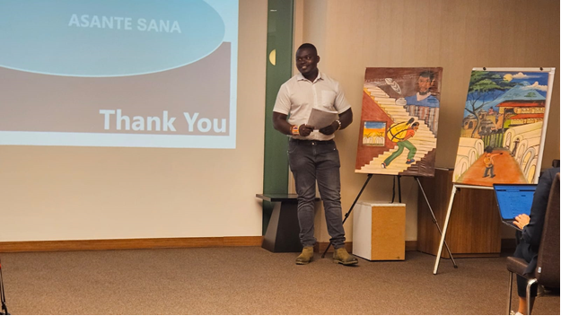

Participant Testimony 1:

*"Engaging in visual artistic expression alongside fellow refugees and members of the host community has allowed us to communicate without words. Through our art, we discovered shared emotions, experiences, and dreams, fostering a sense of unity and understanding that goes beyond language barriers. This experience has opened my eyes to the common humanity we all share."*

Participant Testimony 2:

*"Being part of collaborative art projects has given me a platform to express my identity and culture. Through the process, I've learned so much about the traditions and stories of the host community. It's amazing how art becomes a bridge that connects us, breaking down stereotypes and building empathy. Art has the power to unite us in our shared journey toward peace."*

Participant Testimony 3:

*"Art has become a tool for building relationships and breaking down social barriers. Our collaborative artworks have become symbols of unity, telling stories of resilience and hope. Through this creative process, we've developed a deep understanding of each other's struggles and triumphs. Art has not only transformed our surroundings but has also transformed us, fostering a genuine sense of peace and solidarity."*

**ReferenceTop of Form**

Aster, T. (2022, June 22). World Refugee Day: Common Misconceptions About Refugees. Blog Speak Social. <https://blog.speak.social/world-refugee-day-common-misconceptions-about-refugees/>

Bhushan, T. (2023). *The Impact of Art on Society: Role of Art in Shaping Culture, Challenging Societal Norms, and Sparking Social Change.* The Daily Guardian. Retrieved from <https://thedailyguardian.com/the-impact-of-art-on-society-role-of-art-in-shaping-culture-challenging-societal-norms-and-sparking-social-change/>

Concern. (2022, June 6). Refugee Myths, Busted - and 6 Refugee Facts You Should Know. Story New. Concern World. <https://www.concern.net/news/refugee-myths-facts>

Doctors of the World. (2023). Misconceptions and Myths Regarding Refugees. Press Release. <https://doctorsoftheworld.org/blog/myths-and-misconceptions-around-refugees/>

DRS. (2023). Registered refugees and asylum-seekers: Kenya statistic package. Retrieved from <https://refugee.go.ke/wp-content/uploads/2023/09/Kenya-Statistics-Package-31-August-2023.pdf>

Jesuit Refugee Service. (2013). Civil society group urges the government to end abuse of refugees. Press Release. Retrieved from <https://reliefweb.int/report/kenya/civil-society-group-urges-government-end-abuse-refugees>

IUPUI. (2019). *Art: The Language that Breaks Barriers.* Published by IUPUI. Retrieved from <https://blog.engage.iupui.edu/2019/07/29/art-the-language-that-breaks-barriers/>

Karanja, 2010. The Educational Pursuits and Obstacles for Urban Refugee Students in Kenya

Kirk (2019). Matching Refugee to Host Country Location Based on Preferences and Outcomes. IPL working paper series, No. 19-03 (2019)

REACH. (2014).*Understanding Social Cohesion and Resilience in Jordanian Host Communities* (Assessment Report). Retrieved from <https://reliefweb.int/sites/reliefweb.int/files/resources/REACH_Social-Cohesion-Resilience-in-Jordanian-Host-Communities_FINAL.pdf>.

UNHCR. (2015). *7 art initiatives that are transforming the lives of refugees.* Paris. Retrieved from <https://www.unhcr.org/innovation/7-art-initiatives-that-are-transforming-the-lives-of-refugees/>

World Vision International. (2020). Social Cohesion Report: Social Cohesion between Syrian Refugees and Urban Host Communities in Lebanon and Jordan. <https://www.wvi.org/sites/default/files/World%20Vision%20International%20DM2020%20Social%20Cohesion%20Report.pdf>

Yarnell, M., & Thomas, A. (2014). Between a Rock and a Hard Place: Somali Refugees in Kenya. Refugee International. <https://www.refugeesinternational.org/reports-briefs/between-a-rock-and-a-hard-place-somali-refugees-in-kenya/>

Top of Form