**Action for Positive Peace**

By: Luther N. Mafalleh

University of Liberia, Monrovia, Liberia

Start Date: June 15, 2022

Completion Date: November 30, 2022

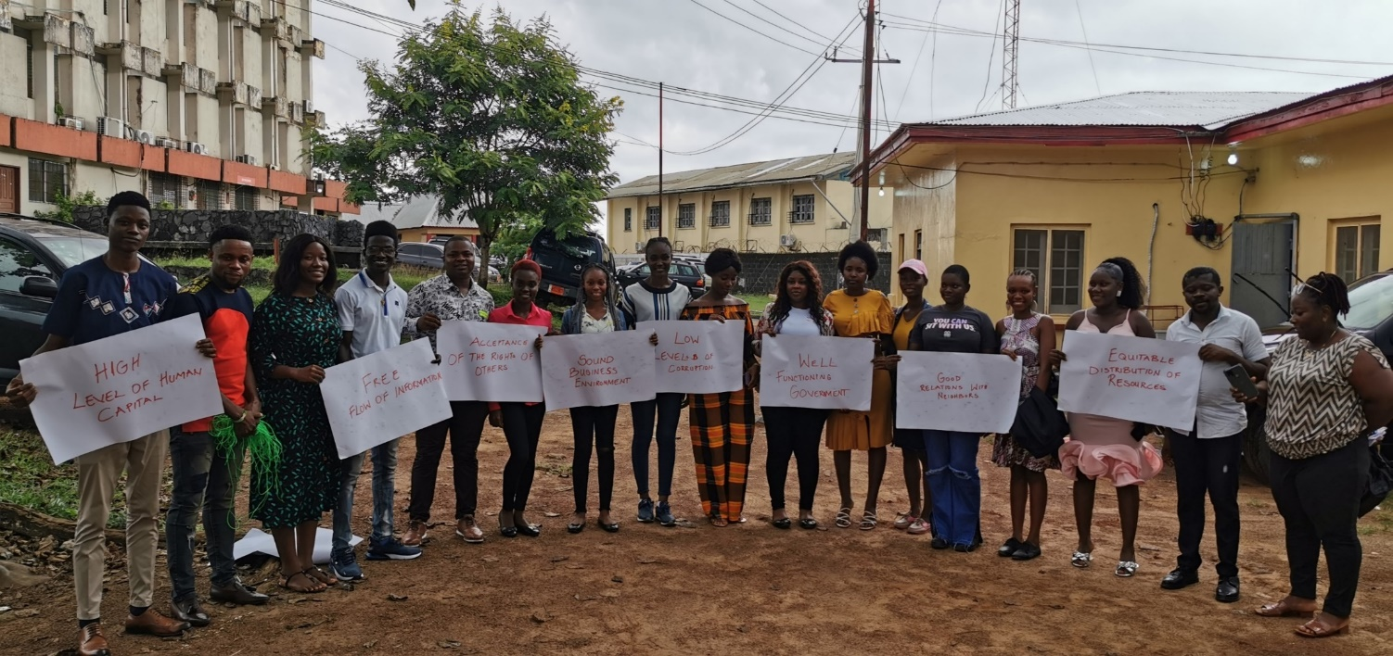

Excited participants at the end of the workshop

**Table of Contents**

**Abstract** 3

CHAPTER ONE 4

Introduction and Background 4

Problem Statement 5

Goals and Objectives 5

Challenges and mitigation strategies 6

CHAPTER TWO 7

Literature Review 7

Theoretical Underpinnings 8

Change theory and how it was applied 11

Methods and Design 12

CHAPTER THRTE 14

Interventions and Activities 14

Initiation Meetings 14

Recruitment of participants 14

Positive Peace Workshop 14

Key findings 16

CHAPTER TOUR 18

General Conclusion 18

Recommendations 18

Sustainability plan 19

References 20

APPENDICES 22

# **Abstract**

Galtung (1964) introduced the terms ‘positive peace’ and ‘negative peace’. Since then, many other scholars, philosophers and or organizations have expanded the concepts.

Institute for Economics & Peace (2022) asserts that Positive Peace provides a theory of social change, explaining how societies transform and evolve and affirms that Positive Peace describes an optimal environment under which human potential can flourish. In confirmation, Finley, L. (2003) theorizes a way to teach for a more peaceful future by centering our curricula on the notion of selflessness.

The Peace Fellow selflessly embarked on the Actions for Positive Project to build student leaders capacity to take actions that promote and nurture positive peace on the University of Liberia. This capacity building and awareness actions will create the optimal environment for students’ and faculties’ potential to flourish.

During the implementation of phase one of the project, there were key lessons learnt. Firstly, Positive Peace capacity building for student leaders are very necessary in order to improve Positive Peace on campus. The pre assessment of the Actions for Positive Peace workshop showed that 71% of participants did not know what positive peace is before the workshop. Lastly, student leaders’ campus based peace initiatives are needed on campus to create peaceful learning environment. The post assessment of the workshop showed that 65% of student leaders lack confidence to undertake a peace building initiative prior to the workshop.

# **CHAPTER ONE**

## **Introduction and Background**

Liberia has struggled to build peace over the last few years despite the signing of the Comprehensive Peace Agreement in 2003 that brought to an end the brutal war that existed in the country. Even after the agreement, the country's peace is still fragile. Conflicts driving factors include widespread corruption, high centralized power, derogation of the government institutions, uneven distribution of resources, and many land conflicts. Many efforts have been commissioned by various world organizations such as the United Nations to contribute to sustainable peace and social cohesion in the country. The groups engaged more are the young people in rural areas who are believed to be the crucial target in work for peace. My social change initiative focused more on young people in the urban setting.

When working with youth, (Ginifer 2003) validates that youth sometimes express anger and frustration over their marginalized position and limited participation in decision-making processes, that is, traditional practices that limit their engagement in community life or employment opportunities. In the same direction, World Bank (2013) indicates that Liberia and Sierra Leonean youth, both male and female, are most often cited as perpetrators of violence.

In furtherance, Dollard et al. (1939) proposes, “The occurrence of aggressive behavior always presupposes the existence of frustration and, contrariwise, that the existence of frustration always leads to some form of aggression”. Unlike the use of the word in everyday language, the understanding here is that frustration is not an emotional experience, it rather “an interference with the occurrence of an instigated goal-response”, (p. 1 & p. 7).

On the African Continent, Fomunyam (2017) suggests that students in Africa have inherited the culture of violence exhibited during the struggle against colonialism. While colonialism is “over”, the culture of violence used to fight it has not disappeared. Rather, it is increasingly manifesting itself across the African continent.

A LISGIS 2008 National Census puts Liberia’s youth population at more than 60 percent. Taking this largely youth population into account, addressing youth issues through peace education is paramount in promoting stability, preventing violence and building positive peace in Liberia. A good place to start is the University of Liberia because it has a long history of student violence.

## **Problem Statement**

From my participant observation perspective, proactive and constructive information gathering and dissemination, as well as dynamic and continues dialogue are missing between students and faculty or administration at the University. When the student leaders want to be heard on crucial matters pertaining to the University, they habitually stage violent protests that disrupt normal activities on the campuses of the University, wound students, and destroy properties.

Fomunyam (2017) theorizes that student protest in Africa and elsewhere in the world is not a new phenomenon and that on the African continent, widespread student activism arose in the early 1940s as African nationalism took different directions in the struggle for independence and took effective root after independence. From my observation this proposition seamlessly fits the University of Liberia scenario where agitated students refer to themselves as ‘militants’ and their most popular chants during protest are “Amanda” to which the rest of the group members respond “awaitu”.

Fomunyam (2017) citing Karmo (2016) notes that students at the University of Liberia gathered at the entrance of the Capitol Building to protest against a proposal to increase tuition fees from $175LD (approximately US$2) to US$4.00. The students petitioned lawmakers to intervene and asked them to increase the University’s funding to US$29 million in order to enable it to meet its growth and development agenda. They destroyed public property and fought with the police. These type of violent protests are frequently happens at the University of Liberia. Once in 2007,

As an alumnus of the University of Liberia, I know that such violent protests happen at least every other semester since my enrollment in 2006. I remembered gang of students rushing into my social science 201 class and splashing cold water on us so that we could leave classes because they were unhappy about the closure of registration process.

## Goals and Objectives

The goal of the project was to contribute to the reduction of the recurrence of violent protest at the University of Liberia.

The specific project objectives were to inspire and empower inspired student leaders to stand united against violent protest and division and act as champions for campus harmony and sensitize student leaders about the pillars of positive peace and how they can localize and practice them during their campaigns and advocacies for better learning conditions at the University.

## Challenges and mitigation strategies

Like many human activities, the Actions for Positive Peace initiative was successfully implemented but without challenges. The following are challenges encountered during the implementation of the project and how they were mitigated:

**University Bureaucracy:** the bureaucratic nature of leadership at the University of Liberia made it difficult to meet with top decision makers. I visited the offices of dean of student activities four times without ever seen him and his staff could not give out his mobile phone number without his permission. I overcame this by using my good relationship with staff that I know from the past.

**Prolong Closure of School**: Just before the commencement of the student leaders organized another protest action demanding the authorities to renovate the premises. Renovation works lasted for more than 3 months. Waiting and speaking to my contacts on campus to keep me abreast with all that was happening at the school were my mitigation strategies.

**Recruitment of student leaders**: When I held my first discussion with a small group of student leaders, their primary concern voiced was whether I was going to pay sitting fees for participants. Knowing that this was not part of the plans, many of them became reluctant to sign up for the training. To mitigate this challenge, I held another meeting with the Kofi Annan Institute and they suggested that I do a call for voluntary participant of student leaders’ announcement and share it with the various student leaders of political parties and associations. Thirty student leaders signed up voluntarily and eighteen showed up for the training after the making several follow calls prior to and on the day of the workshop.

**Failure to procure external financial support**: I tried to engage into crowd funding by my initial engagements with people I have earmarked as funders did not yield any fruitful results. It said that ‘one needs to put wood on the fire before getting heat from it’. Realizing that my project has a huge potential for scale up, I saved the needed funds to implement it as a way of reminding myself that I am putting wood on the fire. I was able to save the necessary money to execute the first phase of my project.

# **CHAPTER TWO**

## **Literature Review**

Galtung (1964) introduced the terms ‘positive peace’ and ‘negative peace’. Since then, many other scholars, philosophers and or organizations have expanded the concepts.

Gardner et al (2019) theorizes that when an initially goal-directed behavior becomes habitual, action initiation transfers from conscious motivational processes to context-cued impulse-driven mechanisms. Regulation of action becomes detached from motivational or volitional control. Upon encountering the associated context, the urge to enact the habitual behavior is spontaneously triggered and alternative behavioral responses become less cognitively accessible. Students at the University of Liberia highly fits into this theory in that the University context and their collective and sometimes manipulated motivations always lead them to organizing violent protests.

Powell Jr (1968) outlies three areas of special sensitivity for peace strategies on at educational institutions, namely: (i) participation in decision making; (ii) the role of faculties; and (iii) academic freedom. Each of these poses difficult questions to which there are no easy or unequivocal answers. The demand for student participation in decision making ranges all the way from membership on boards of trustees to selection of presidents and faculty and determination of curriculum. He adds that no responsible college administrator or board of trustees can accede to this type of demand. The student body is necessarily transitory, changing from year to year. Nor does the wisdom of student leaders always match their own conviction of infallibility. For these obvious reasons, the role and responsibility of students can never equate that of faculty, administration or trustees. Yet student views are entitled to be voiced and seriously considered; appropriate channels must be devised to accomplish this; and a far greater effort made to make these channels meaningful. The wise administrator will work these out, with faculty and student participation, in advance of campus trouble. All of this must have substance, and reflect a genuine desire to reach accommodation with responsible student views. Powell concludes that it must ever be remembered that no such program - however reasonable - will mollify the radicals. Their objective is revolution; not reform.

Fomunyam (2017) suggests that students in Africa have inherited the culture of violence exhibited during the struggle against colonialism. While colonialism is “over”, the culture of violence used to fight it has not disappeared. Rather, it is increasingly manifesting itself across the African continent.

In furtherance, Dollard et al. (1939) proposes, “The occurrence of aggressive behavior always presupposes the existence of frustration and, contrariwise, that the existence of frustration always leads to some form of aggression”. Unlike the use of the word in everyday language, the understanding here is that frustration is not an emotional experience, it rather “an interference with the occurrence of an instigated goal-response”, (p. 1 & p. 7).

Confirming how violence is related to human behavior, Fomunyam (2017 references Smith et al. (2012), Bell et al. (2009) and Hatemi and McDermott (2012a) and argues that behavioral genetics has scientifically proven that political ideologies, and political or attitudinal orientation are inherited. He further notes that, while no specific gene for a preference or ideological orientation exists, biological systems built by genes play an important role in mediating political attitudes. Genetically speaking, political attitudes (which deal with the will to act in a particular way as well as the desire to make certain choices) are inherited. The culture of violence is one such ideological trait inherited by African students and they are demonstrating that this is the case. This, he concludes, is not peculiar to North, West or Central Africa, but also occurs in South and East Africa.

Contrasting the routine response to violent behaviors, Schultz, W. (2006) argues that punishers have opposite valence to rewards, induce withdrawal behavior, and act as negative reinforcers by increasing the behavior that results in decreasing the aversive outcome. Avoidance can be passive when subjects increasingly refrain from doing something that is associated with a punisher (don’t do it); active avoidance involves increasing an instrumental response that is likely to reduce the impact of a punisher (get away from it). Punishers induce negative emotional states of anger, fear, and panic.

# **Theoretical Underpinnings**

Galtung (1964) introduced the terms ‘positive peace’ and ‘negative peace’. Since then, many other scholars, philosophers and or organizations have expanded the concepts.

Finley, L. (2003) theorizes a way to teach for a more peaceful future by centering our curricula on the notion of selflessness. He describes this selflessness as a value that crosses national barriers and religious beliefs, and thus can be found in the stories and parables of virtually every civilization. The educational and academic curricula of Liberia far not initiated peace education at schools levels.

Similarly, Finley, L. L. (2004) articulates that educators at all levels generally agree that students should be taught about peace but fewer seem to consider teaching for peace in the same light. Yet peace education entails more than just content. It also includes how we craft our learning environments and the teaching methods we use. The same is true for a post war country like Liberia. From elementary to tertiary levels of education, most teachers, if not all, lack basic peace education.

Lehnert (2010) claims that to make peace is a long and complicated process and we tend to forget this, as peace is still considered as an agreement between two or more parties, decided upon and signed by the elites and implemented by the people. Thus, overthrowing these pre-conceived ideas about peace is a critical prerequisite for the elaboration of constructive processes centered around positivity and a human grasp of the realities on the ground. One way to achieve such positivity is to build the capacity of the student leaders who are the constituents of every non peaceful situations on the University of Liberia campuses.

Salomon, G. (2003) alludes to (Bar-Tal, 2002) and argues that peace education often takes place in contexts of animosity, fear and belligerence that cultivate a mentality of siege and threat which makes peace education an elusive matter. He insinuates that a belligerent atmosphere can easily drown any peace education attempt and that the success of peace education would require the support of politicians, the media, the education system, parents and the public in general.

Moreover, Salomon, G. (2003) outlines that a society’s collective narrative, the story it tells about itself, about its adversary and about the conflict, is a major threat to peace education. He delineates three components – shared historical memories, shared sense of identity, and sets of shared beliefs – function alone and in combination as very demanding challenges to peace education. He assumes that the h**istory** is the most important source of a group’s narrative, that is, the way the group constructs and construes its past and thus, it’s present. This interplays with collective believe held by its members. It needs to be said, and said again, that these beliefs, the ones relevant to coping with a painful and often threatening conflict, are by necessity identical to the conflicting parties. However, this does not mean that the conflict affects both sides in the same way. The final component, he says, is **built-in inequalities**, the fact that in most conflicts the adversary sides are hardly ever equal in terms of their socio-economic, political, educational or demographic status.

Institute for Economics & Peace (2022) hypothesizes that Positive Peace is a transformational concept because it shifts the focus away from the negative by describing the necessary conditions for peace and how it helps a society to flourish. Due to its systemic nature, improvements in Positive Peace not only strengthen peace, but are also associated with many other desirable outcomes for society, such as higher GDP growth, better measures of wellbeing, higher levels of resilience and more harmonious societies. Importantly, it provides a theory of social change, explaining how societies transform and evolve. It affirms that Positive Peace describes an optimal environment under which human potential can flourish.

I have embarked on the Actions for Positive Project to build student leaders capacity to take actions that promote and nurture positive peace on the University of Liberia. This capacity building and awareness actions will create the optimal environment for students’ and faculties’ potential to flourish.

Harber, C., & Sakade, N. (2009) declare that peace education is understood generally to aim to offer opportunities to develop the skills, knowledge and values required for the practice of conflict resolution, communication and co-operation in relation to issues of peace, war, violence, conflict and injustice. Peace education can be implemented in societies in conflict, post-conflict societies and stable societies in order to achieve peaceful problem-solving.

Harber, C., & Sakade, N. (2009) further references (Fountain 1999, 1) in quoting UNICEF’s definition of peace education as:

…the process of promoting the knowledge, skills, attitudes and values needed to bring about behaviour changes that will enable children, youths and adults to prevent conflict and violence, both overt and structural; to resolve conflict peacefully; and to create the conditions conducive to peace, whether at an intra-personal, interpersonal, inter-group, national or international level.

The Actions for Positive Peace Project set out to contribute to the process of promoting the knowledge, skills, attitudes and values needed to bring about behavior change that will enable student leaders to prevent violence, in all its forms, on their campus.

## **Change theory and how it was applied**

In summary, the theory of my social change initiative states that **IF** student leaders capacity are built in positive peace and conflict management and they are willing to dialogue and work for peaceful learning environment at the University of Liberia (UL), **THEN** the occurrence of violent student protests will reduce and there will be serenity on campus, execution of academic calendars will go as planned and students will complete their courses within the normal academic timeframe.

The Action for Positive Peace project built the capacity of its beneficiaries to manage conflicts and prevent violence by facilitating positive peace training for them and encourage them to become positive peace ambassadors on their campuses and contributing to reduction of the occurrences of violent protests. To achieve this, I conducted a positive peace workshop for student leaders of various students’ political parties and associations of the University of Liberia.

The training provided the space for student leaders to receive training in the Institute for Economics & Peace, IEP, (2022) positive pillars. Below is a brief description of the eight pillars of positive peace that were facilitated at the workshop:

Well-functioning government: a well-functioning government delivers high-quality public and civil services, engenders trust and participation, demonstrates political stability and upholds the rule of law;

Good Relations with neighbors: peaceful relations with other countries are as important as good relations between groups within a country. Countries with positive external relations are more peaceful and tend to be more politically stable, have better functioning governments, are regionally integrated and have lower levels of organized internal conflict;

Equitable distribution of resources: Peaceful countries tend to ensure equity in access to resources such as education, health, and to a lesser extent, equity in income distribution;

Free flow of information: Free and independent media disseminates information in a way that leads to greater knowledge and helps individuals, businesses and civil society make better decisions. This leads to better outcomes and more rational responses in times of crisis;

High levels of human capital: A skilled human capital base reflects the extent to which societies educate citizens and promote the development of knowledge, thereby improving economic productivity, care for the young, political participation and social capital;

Acceptance of the rights of others Peaceful countries often have formal laws that guarantee basic human rights and freedoms, and the informal social and cultural norms that relate to behaviors of citizens;

Low levels of human corruption: In societies with high levels of corruption, resources are inefficiently allocated, often leading to a lack of funding for essential services and civil unrest. Low corruption can enhance confidence and trust in institutions; and

Sound business environment: The strength of economic conditions as well as the formal institutions that support the operation of the private sector. Business competitiveness and economic productivity are both associated with the most peaceful countries.

The state of positive peace in the world and the global peace indexes, with focus on Liberia, were presented to the participants and they were grouped into smaller working groups to brainstorm and find peaceful solutions to simulated real life situations.

There were pre and post assessments administered to all the participants of the workshop that signed in on time.

All the activities at the workshop was interspersed with fun games and exercises that that energized the leaners and reinforced the learning points.

## **Methods and Design**

The aim of this Project was to build the Positive Peace Capacity of Student leaders at the University. For this purpose a qualitative and quantitative a mixed research method was chosen.

The Institute for Economics and Peace’s Positive Peace Education design strategy was chosen during designing stage of the Actions for Positive Peace Project. The Peace Fellow believed that it would help the Project achieve the intended goals. The process comprise of six steps as summarized:

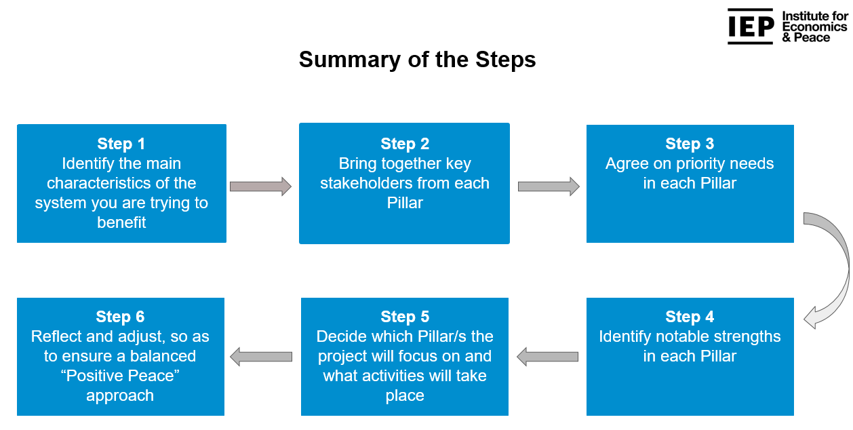

**IEP’s developing a Positive Peace project steps**

The project use the peace education in school methods proposed by Cremin, H., & Bevington, T. (2017), which delineates peace education in school methods that define some terms that are central to the discussion of peace-building. They assert that the terms are in more regular usage in schools than in peace education, but often refer to the same notions and in combination, they provide a fairly solid grounding for peace education in schools. The terms are defined as follow:

**Inclusion** is the process whereby a school makes it possible, acceptable and desirable for every child and young person in the population to receive a quality education in the same place, regardless of ability, need or identity such as gender, sexuality or ethnicity. Unlike segregation or integration, the focus shifts from the need of the individual to fit in, to the need of the school to provide an environment that allows all young people to flourish.

**Wellbeing** implies a state of inner peace, where there is dynamic balance in interpersonal relationships and in the various aspects of intra-personal life (including body, mind, heart and spirit). In a school context, this means that individuals experience warm, challenging and inspiring relationships; and that they have feelings of curiosity, belonging, awe and wonder

**Citizenship** education enables young people to recognize the personal, social and political contributions of others and to make an active and informed contribution themselves.

# **CHAPTER THRTE**

## **Interventions and Activities**

The Actions for Positive Peace worked with student leaders at the University of Liberia, Liberians oldest and largest higher education institution. Several activities were executed in order to achieve the project goal and objectives.

## **Initiation Meetings**

The peace fellow held seven initiation meetings with university authorities. One achievement of this activity is the securing of a partnership with the Kofi Anan Institute for Conflict Transformation, the peace education department of the University of Liberia. This partnership opened the way to the conduct of the positive peace workshop for the students without any further approval hindrances from any university authority.

## **Recruitment of participants**

I held discussions with different groups of student leaders ascertain their reaction to such training. Many of them were reluctant to sign up for the training. I held mitigation meeting with the Kofi Annan Institute and afterwards did a call for voluntary participant student leaders’ announcement and shared it with the various student leaders of political parties and associations. Thirty student leaders signed up voluntarily and eighteen showed up for the training after the making several follow calls prior to and on the day of the workshop.

## **Positive Peace Workshop**

The workshop was conducted on November 30, 2022 for 18 participants. The delivery agenda for the workshop was broken up into sections guided by the 8 Pillars of Positive Peace: *Well-functioning Government, Equitable distribution of Resources. Free flow of information, Good relations with neighbours, High levels of human capital, Acceptance of the rights of others, Low levels of corruption and Sound business environment.*

After introductions, participants were asked to reflect on their own definitions of peace and systems (groups) they have influence on or have ever tried to impact change upon. Followed by a warm up activity called the dot game where participants’ selected different colors form their colour clan with the exception of one rule….no talking. Based on the groups from the dot game participants were asked to stay in their colour clan (red, blue, green and yellow) to play the Pillar Island activity. This activity involved the groups being divided up into clans who were all facing resource and climate crisis.

Participants pointed out issues of domination and power/governance in the initial negotiation stage which in their view hampered effective communication and negotiation outcomes. The issue of resources identified as both a divider and connector, the latter became especially evident in the context of water scarcity due to external factors such as climate change that threatened the whole of the island community.

During the workshop, adult Learning Principle, as suggested by Brundage, D. H., & MacKeracher, D. (1980), was used to facilitate the activities. Each training session followed the experiential learning cycle, which provided a space for workshop participants to share their experiences and uncover new information, develop key learning points and make the connection between the training and their working environment.

This method allowed participants to effectively communicate their experiences about a particular topic or session introduced, build on existing knowledge, acquire new information and skills and draw their own conclusions from the learning activities with respect to the application of the new knowledge and skills. The workshop trainers provided guidance to ensure active participation of all trainees in the learning process. The facilitation process adopted a combination of experiential learning and participatory training methods and techniques which included: Short Presentation, Recapping, Brainstorming, video presentations, pair and large group discussions, role-plays, games, energizers, songs, etc. These methods were employed to tap into the wealth of experience of participants. The pair group discussions encouraged peer learning, while structured exercises were used to engender participation, explain key concepts and challenge participants to pursue more undetrstanding and knowledge. All these methods were complemented by practical sessions.

From the onset of the training, Participants expectations were gathered immediately after self-introductions. The process created the space for participants’ expectations to be expressed and begin to be addressed from the beginning of each training session.

Overall, these activities and interventions secured Partnership with the Kofi Anan Institute for Conflict Transformation, trained 18 student leaders on the 8 pillars of positive peace, increase in Confidence to undertake a peace building initiative by 65%, and 5 students are now planning personal peace trainings.

Below are the summary of the eight pillars of Positive that were taught at the workshop:

## **Key findings**

The project use the quantitative research method to capture valuable insights about the participants. From the administered pre and post assessments, the following are key findings:

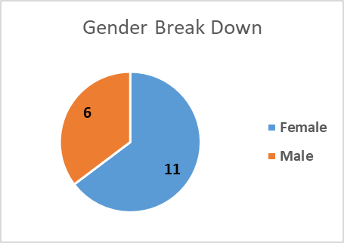

Figure 1: Gender break down of participants

* More female student leaders showed up at Positive Peace workshop on voluntary basis. This in my view indicates that more female student leaders at the University of Liberia are interested in available peace education opportunities as oppose to their male counterparts.
* 65% of participants were uncertain about their confidence level to organize and initiate peace project in their community. Lehnert (2010) asserts that when people lack confidence in their capacity of peace education, they are more likely to revert to violence as a means of resolving conflicts. At the end of the training all participants responded that they were confident to organize their own peace activities in their communities,

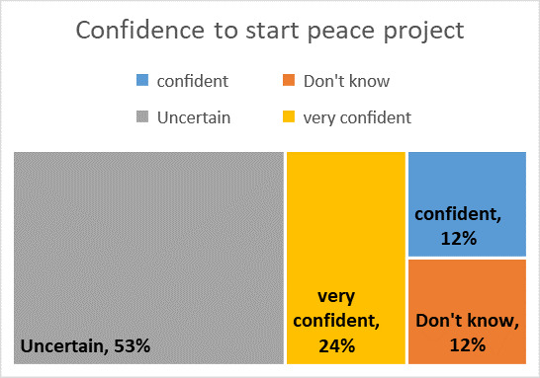

Figure 2: Participants peace confidence level prior to the workshop

* 71% of participants did not know what positive peace is before the workshop. This finding further corroborates the two other previous findings as mentioned above. As discussed in the theoretical underpinnings, this gap can be bridged if we adhered to Finley, L. L. (2004) articulation that educators at all levels generally agree that students should be taught about peace. At the end of the workshop, all participants wrote that they were now familiar with the topic of Positive Peace.

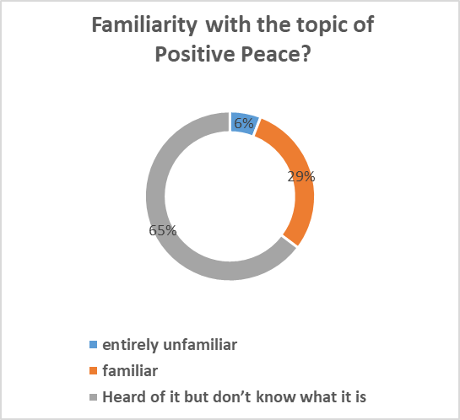

Figure 3: Participants prior familiarity with the term ‘Positive Peace’

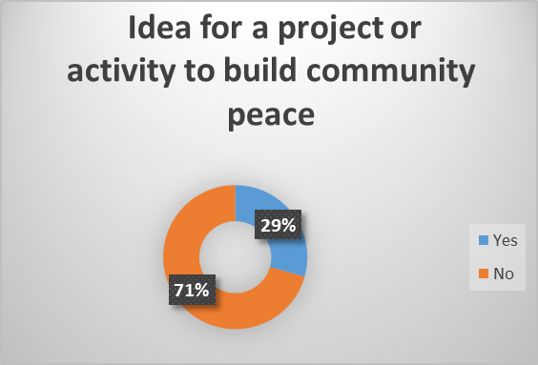

Figure 4: ideas about peace project before the workshop

* 71% of participants did not have peace project or activity ideas to build peace in their community. By the end of the workshop, 94% of participants reported that they now have ideas about building peace in their community.

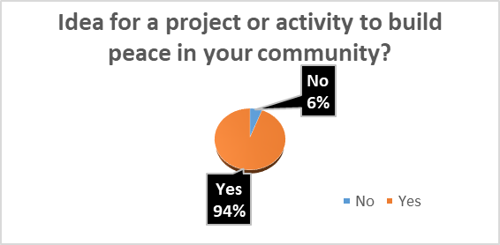

Figure 5: participants’ ideas about peace projects after the workshop

# **CHAPTER TOUR**

## **General Conclusion**

Throughout the course of implementation of the project, most of my participatory observations have been validated. Fomunyam (2017) theorizes that student protest in Africa and elsewhere in the world is not a new phenomenon and that on the African continent, widespread student activism arose in the early 1940s as African nationalism took different directions in the struggle for independence and took effective root after independence. From my observation as former student of the institution, this proposition seamlessly fits the University of Liberia scenario where agitated students refer to themselves as ‘militants’ and their most popular chants during protest are “Amanda” to which the rest of the group members respond “awaitu” and when they speak about the history of such chants, they term them as liberation chants.

The Actions for Positive Project was necessary and there remains the need for building the peace capacity of all student leaders at the University of Liberia. The project succeeded in building the Positive Peace capacity of 18 Student leaders.

From the interactions with student leaders, the Peace Fellow concludes that until the capacity of students are built and they are encouraged to initiate peace projects that promote serenity on campus, the morale of the University will continue to decline amongst the student population of Liberia.

## **Recommendations**

Although the activities and interventions of the Actions for Positive Peace Project secured Partnership with the Kofi Anan Institute for Conflict Transformation, trained 18 student leaders on the 8 pillars of positive peace, increase in Confidence to undertake a peace building initiative by 65%, and 5 students are now planning personal peace trainings, it will take sustain actions in order to achieve serenity on the University of Liberia Campuses.

The following recommendations need implemented in order to achieve an atmosphere of Positive Peace at the University of Liberia:

* Administrators and faculty should encourage Positive Peace capacity building for student leaders and staff in order to improve Positive Peace on campus.
* Administrators and faculty needs to support student leaders’ campus based peace initiatives to create peaceful learning environment.
* Student leaders need to be courageous, opened minded and willing to let go of their militant ideas of conflict mitigation and begin to practice Positive Peace in resolving conflicts they encounter on a daily basis.
* Administrators, faculty and partner organizations should recognize and reward the Positive Peace Initiatives of student leaders.

If these recommendations are implemented, the University of Liberia will become place of uninterrupted learning center and there will be serenity on campus and students will be encouraged to enroll and completed their prescribed courses.

## Sustainability plan

The sustainability plan of the Actions for Positive Peace has outlined the following outcomes:

Outcome 1: Students, faculty and administration have peaceful relationships;

Outcome 2: Increased joint interaction, planning and university development; and

Outcome 3: University staff and students have stronger peaceful coexistence.

For Peace Fellow will implement the following interventions in order to achieve the outcomes:

* Continuous engagement with trained student leaders
* Organization of annual positive peace awards to recognize and reward the positive peace efforts of student leaders. These events will create means of awarding peaceful initiatives of student leaders who will take proactive actions to promote peace and mitigate conflicts. Students and staff whose activities and works promote positive peace on campus are awarded “Positive Peace Award” annually.
* Expand the project to other Universities. The Peace Fellow will establish a network of Positive Peace ambassadors at each Liberian University to initiate and implement Positive Peace Projects on their campuses and support the implementation of Actions for Positive Peace activities at their respective academic institutions.

# **References**

Institute for Economics & Peace. Positive Peace Report (2022). Analyzing the factors that build, predict and sustain peace, Sydney, January 2022. Available from: http://visionofhumanity.org/resources (accessed 4 December 2022)

Gardner, B., & Rebar, A. L. (2019). Habit formation and behavior change. In *Oxford research encyclopedia of psychology*.

Marien, H., Custers, R., & Aarts, H. (2018). Understanding the formation of human habits: an analysis of mechanisms of habitual behaviour. *The psychology of habit: Theory, mechanisms, change, and contexts*, 51-69.

Cremin, H., & Bevington, T. (2017). *Positive Peace in Schools: Tackling conflict and creating a culture of peace in the classroom*. Routledge.

Lehnert, D. & Bendra-Lehnert, L. (2010). ‘Media for Peace – a Holistic Framework for Action.

Finley, L. (2003). How can I teach peace when the book only covers war. *Online Journal of Peace and Conflict Resolution*, *5*(1), 150-165.

Finley, L. L. (2004). Teaching for peace in higher education: Overcoming the challenges to addressing structure and methods. *OJPCR: The Online Journal of Peace Education and Conflict Resolution*, *6*(1), 272-281.

Harber, C., & Sakade, N. (2009). Schooling for violence and peace: How does peace education differ from ‘normal’schooling?. *Journal of Peace Education*, *6*(2), 171-187.

Brundage, D. H., & MacKeracher, D. (1980). Adult learning principles and their application to program planning.

Schultz, W. (2006). Behavioral theories and the neurophysiology of reward. *Annu. Rev. Psychol.*, *57*, 87-115.

Powell Jr, L. F. (1968). A Strategy for Campus Peace.

Salomon, G. (2003). Does peace education make a difference in the context of an intractable conflict? Retrieved from https://hdl.handle.net/1887/4571

Galtung, J. (1964). An Editorial. Journal of Peace Research, 1(1), 1-4.

The World Bank. (2019, November 8). *Striving to Achieve Sustainable Inclusive Growth in Liberia: Rebuilding Vital Infrastructure While Strengthening Human Capital*. Retrieved from The World Bank: <https://www.worldbank.org/en/results/2019/11/08/striving-to-achieve-sustainable-inclusive-growth-in-liberia-rebuilding-vital-infrastructure-while-strengthening-human-capital>

# **APPENDICES**

1. Pictorials

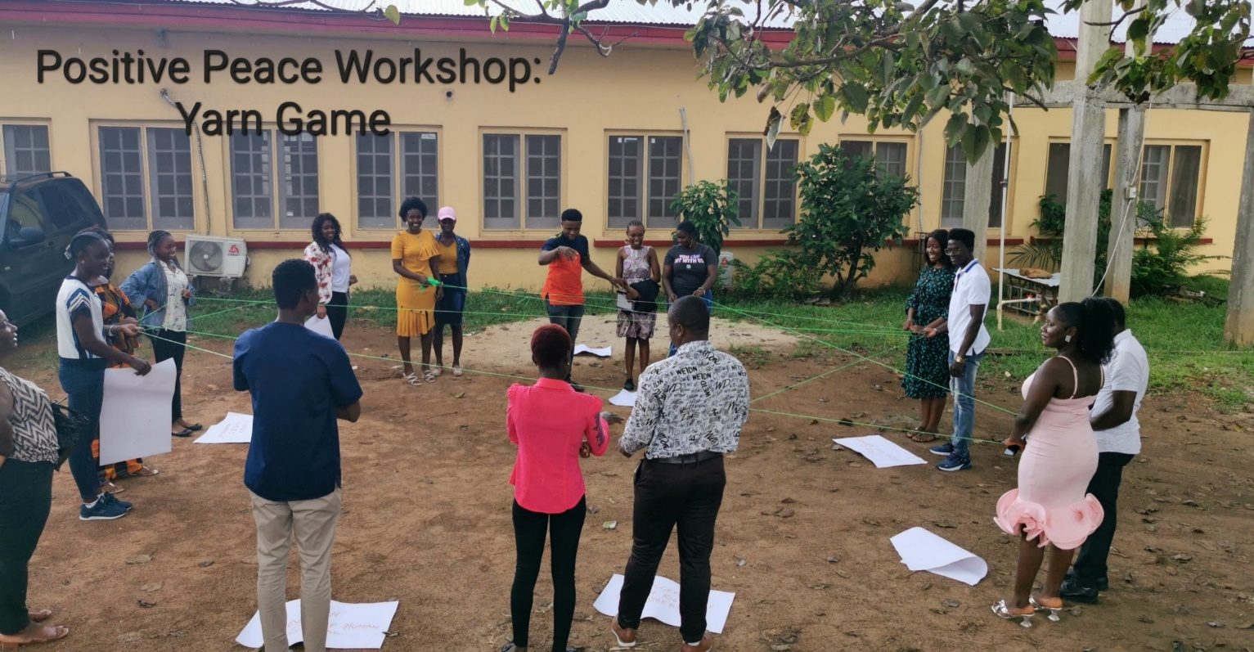

Workshop participants during a positive peace exercise

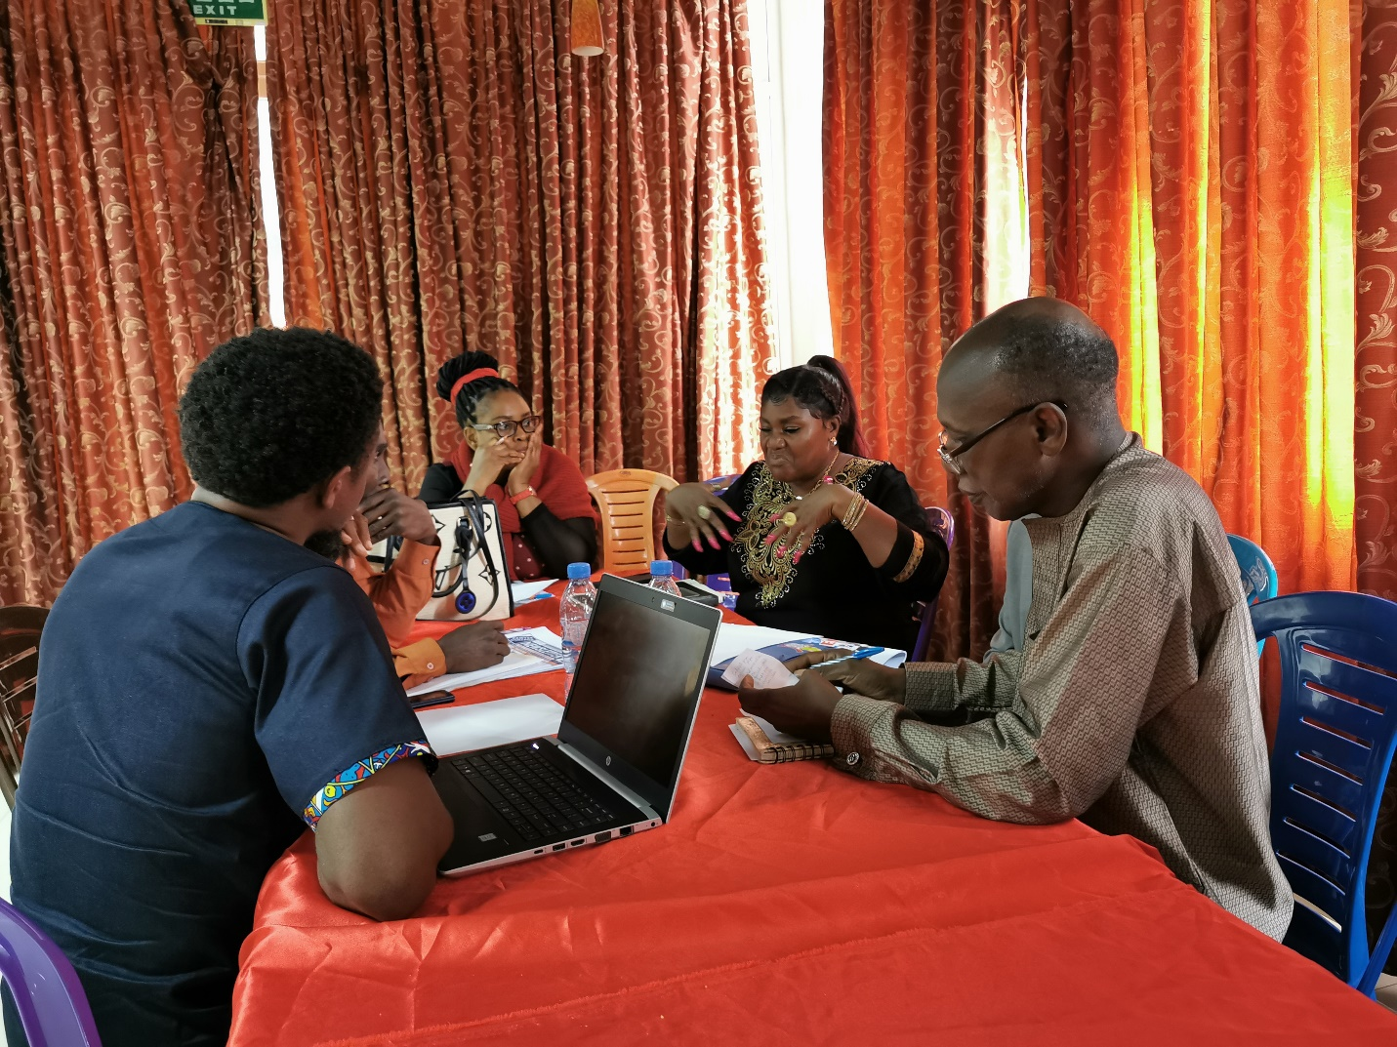

Peace Fellow at planning meeting with University Faculty staff