project report  Transforming the Lives of Young Prisoners for Rehabilitation and Community Reintegration in Northern Malawi | MASIDAHASTINGS ZIBA, Northern Malawi, ROTARY PEACE FELLOWSHIP, 2023 COHORT 5

PROJECT TITLE: TRANSFORMING THE LIVES OF YOUNG PRISONERS FOR REHABILITATION AND COMMUNITY REINTEGRATION IN NORTHERN MALAWI

LOCATION: MZUZU PRISON, NORTHERN MALAWI
START AND COMPLETION DATE: 1ST APRIL 2023-31ST DECEMBER 2023
SUMMARY
Vocational training and education within prison facilities are integral components of a comprehensive approach to inmate rehabilitation. It is significant to provide educational opportunities and vocational training to incarcerated individuals since it has a bearing on reducing recidivism (re-offending), fostering personal development, and preparing inmates for successful reintegration into society. My Social Change Initiative has contributed to this phenomenon of creating peaceful societies in Northern Malawi in the long run through formal and informal education support, Restorative Justice and Peace Workshop, Peace Club Outreach Sessions and following up and linking Ex-prisoners to see how they are integrating with their communities. All in all, the project has contributed to youth employment, prison and community co-existence, positive Peace in Northern Malawi.

CHAPTER ONE
1.0 INTRODUCTION AND BACKGROUND
Understanding offending Before embarking on a discussion of rehabilitation, it is useful to revisit some of the debates surrounding the ‘causes’ of crime and the risk of individuals engaging in criminal activity. The exact causes of crime have concerned criminologists for many decades. In a marked departure from previous attempts to identify significant variables, or risk factors, that when present can irrefutably increase the likelihood of individuals committing crime, criminologists are increasingly referring to correlates, rather than causes of crime. The use of correlates recognises that there may not be any single, or group, of factors that cause crime, but rather that there are perhaps diverse factors that interact on each other in a variety of ways to increase the likelihood of offending amongst certain individuals.

There remain, however, various schools of thought, all of which recognise the potential of certain common variables that may predispose an individual to consciously make the decision to engage in deviant behaviour. The most fundamental factors identified by criminologists are biographical variables. These generally include basic demographic characteristics such as age, gender, family environment, education and socio-economic status. Age and gender are perhaps constantly identified as the two most important biographical factors, with analysts the world over arguing that young men are the most likely to commit crime. This can clearly be identified in Malawi, where the vast majority of offenders currently incarcerated within Malawi prisons are males between the ages of 16 to 30 years old. Through the Rotary Peace Fellowship Program, Masida Hastings Ziba, a Rotary Peace Fellow in Cohort 5 Partnered with Mzuzu Prison to implement a Social Change activity. The project description is found in the next chapters.
1.2 PROBLEM STATEMENT
Crime prevalence has been on the increase in Malawi in the recent years. It has been observed that a good number of persons apprehended and committed to prisons are ex-offenders who were once or more served sentences for similar or others offences. This happens against the background of reformation and rehabilitation programs which are rolled out by MPS with an aim of curbing deviant lifestyles in prisoners.
Questions are being raised as to why offenders are being reconvicted yet the prison is offering reformation and rehabilitation programs. It has also been observed that the greatest challenge for offenders lies in the period immediately after release when they attempt to reintegrate into the community and re-establish their lives. Inevitably, when people are released from prison, the circumstances and memories of the crime they committed still prevail. The broken bonds and wounds they caused still exist. They are often burdened with the stigma of their incarceration, and thus often find it even more difficult to settle in their communities. Many ex-offenders opt to flee their communities and find peace elsewhere because of hostility in their communities.

Malawi Prison Service prepare inmates for re-integration as well as to sanitize communities where inmates will go after expiry of their sentences. The other roles of Mzuzu Prison are: To Civic Educate these youths about dangers of engaging in criminal acts which attracts custodial sentence, Promote Restorative Justice for ex-Prisoners, Civic educate communities that people who are to be released from prison needs to find a society that is free from criminal acts if the country is to end recidivism which also contributes to overcrowding in prisons, to cement the relationship between prison and community members, to play leading role by bringing in other stakeholders that can help the community on matters of good citizenship and To engage community members and stakeholders to find a lasting solution to conflicts. (Malawi Prison Service Website, 2023).
1.3 GOALS AND OBJECTIVES
1.3.1 Goal: To enhance rehabilitation and transformation of the lives of underprivileged youths in Mzuzu City.
- Objective 1: Increase access to formal education to female prisoners in Mzuzu Prison by December 2023.
- Objective 2: To increase access to informal and vocational skills development of prisoners at Mzuzu Prison by December 2023.
- Objective 3: To promote social re-integration of ex-prisoners in the Northern Region of Malawi by December 2023.

  - CHALLENGES AND MITIGATION STRATEGIES
1.4.1 Funding
Masida Hastings Ziba started the project with no funding to implement the project. Despite of coming from a civil society landscape where donors and partners could come in, it was Mzuzu Prison that was ready to offer technical support. In the course of negotiating with partners some partners came in and supported some activities with the little they could. These were Think Malawi that supported the project with 3,000 Euros for initial activities that have been implemented. The funding was not enough with the total budget pegged at 15,000 USD. Luckily enough after conducting several resource mobilization meetings as part of the project, more support has been pledged by another international organization called “Funducion Arnhold dela Camara” through materials and direct support to the activities to continue the Peace Building Activities at Mzuzu Prison and Beyond.

    - Logistical Challenges
The implementation of the project was delayed because of bureaucratic factors like seeking permission from Prison Headquarters and the intermingling of both peace building activities and normal prison custodial routine. The routine only allowed few prisoners to take part at any activity outside their pre-arrange routine activities. We struggled to identify beneficiaries except those studying at the school and those in a prison Peace club. Despite this challenge, the rotary Peace Fellow igniting the change was well connected with Prison Authorities such that some considerations were made and all key activities were done leading to 126 prisoners benefiting from the project by the end of December, 2023.
    - Technical challenges
The concept of Peace Building and conflict transformation is new in Malawi and few senior officers were trained in the field. Despite the Prison Headquarters endorsing a National Restorative Justice and Peace Building Program, it was not yet embraced and implemented at local prison stations like Mzuzu Prison. As a remedy, the Prison Authorities in conjuction with Masida Hastings Ziba, conducted awreness and educational session prior to implementation of the project at MzuzuPrison.

CHAPTER TWO
2.0 LITERATURE REVIEW
Key Words: Recidivism, Peace Building, Conflict Transformation, Restorative Justice, community Re-integration, Vocational Training, employment.
Recidivism, which refers to the relapse of an offender into criminal behaviour or habitual reoffending is a result of a number of factors. In our case, Malawi Prisons Service partly plays a role not by design but due to limited resources to address rehabilitation needs of every prisoner. Regardless of a number of rehabilitation programmes that the Prisons department offers to inmates, some inmates do not benefit from such programmes due to lack of resources (Kajawo, 2023).

For instance, Mzuzu Prison offers vocational trainings like Motor Vehicle Mechanics, Carpentry and Joinery, Electrical installation, plumbing, Welding and fabrication, Tailoring and Fashion designing and others do not accommodate all prisoners who express interest to undergo such trainings due to inadequate teaching and learning materials which are very expensive to purchase. These are the programmes that empower prisoners to financially sustain themselves after the expiry of their sentences hence avoiding other crimes that stem from idleness and lack of stable income to earn a living. It is in that vein that the Prisons department takes a share of the blame for contributing to recidivism, though as I alluded to earlier on, it is not by design or lack of administrative will or vision for a correctional approach in the management of offenders, but rather it is due to a shrunk financial envelope and other resources to take on board all prisoners who express interest to undergo such vocational trainings that will in the long run not only transform them into the reliable and productive citizens of the land , but also financially empower them.
It is on that premise that apart from government’s funding to prisons, stakeholders like STRADE and Rotary Peace Fellow lik Masida Hastings Ziba need to partner with Malawi Prisons Service in the provision of quality and meaningful vocational trainings to prisoners.
It should also be mentioned that community’s negative perception to ex-inmates also deter a successful reintegration of ex-inmates which in the long run contributes to recidivism. Most of the times ex-inmates are welcomed back with the same hostility and enmity they had left behind at the time of their arrest and subsequent conviction. Others are blatantly told that they are not welcome in such communities regardless of the fact they have already paid for their crimes through incarceration. They are declared “persona-non-grata”. Such an attitude towards ex-inmates by the community leaves them with no option but to find another safer home than forcing themselves to live with the unforgiving community. Unfortunately, they go to places where they have no settlement, land to cultivate or people to support them. Consequently, they easily come into conflict with law as they illegally try to make a living. Some inmates do not even attempt to go straight to their homes after expiry of their sentences for fear of reprisals from the victims they had offended. It should not be contested to deduce that an inmate who unsuccessfully reintegrates into his or her community has higher chances of committing another crime, not by design, but out of desperation to make the ends meet.(Kajawo 2023)
Samson Kajawo 2023) in his artilcle in Journal of Prison education and re-entry argued that there is a disparity between correctional education policies and the actual reality. Due to the inadequacy of resources and the negativity of the prison environment, the facilities failed to provide quality, appealing and motivating education to the already educationally disenchanted incarcerated young people, resulting in low enrolment rates. It was, therefore, concluded that education was still a pipe dream at young prisoners’ centres in Malawi.
According to United Nations Office of Drug and crime, Restorative justice refers to a way of responding to crime, or to other types of wrongdoing, injustice or conflict, that focuses primarily on repairing the damage caused by the wrongful action and restoring, insofar as possible, the well-being of all those involved. It reflects a more relational theory of justice because it emphasizes the restoration of respect, equality, and dignity to the relationships affected by wrongdoing. Restorative justice is called 'restorative' because it employs restorative processes, that is, processes that restore agency, ownership and decision-making power to those directly affected by the harmful event - victims, offenders, their supporters and the wider community. Rather than deferring all responsibility to the state or to legal professionals, it aims to engage the immediate participants in resolving the harm.
In an attempt to address the problem of unsuccessful reintegration of offenders into their respective communities, the Malawi Prisons Service in 2022 partnered with Mennonite Central Committee and introduced a project called “Restorative Justice and Peace Building”. The programme aims at facilitating a reconciliation between the Offender (inmate) and the victim. The reconciliation is voluntary on both sides as they voluntarily agree to meet for Victim-Offender Reconciliation Conference at the facility where the offender is serving his or her sentence. The main stakeholders of this reconciliation are the Offender, the Victim and the Community which is represented by either the village chief or village elders. Since the launch of the project which will soon graduate into a programme, the Prisons Department has registered 152 resolved and successful reconciliations where the victims and the community have committed to welcome the offender once he or she goes back to join them in their communities upon the expiry of his or her sentence. A follow up on some cases have confirmed that the ex-inmates were really successfully reintegrated hence reducing the chances of recidivism that are orchestrated by unsuccessful reintegration. On this note, Malawi Prisons Service has demonstrated extra-ordinary commitment to ensure successful reintegration of offenders which can positively impact on the efforts to reduce recidivism.
Being a Rotary Peace Fellow, I don’t entirely point a finger at Malawi Prisons Service on recidivism, but rather look at a broader picture and other several factors that come into play as far as recidivism is concerned. Prisons’ department needs support of several stakeholders in its correctional programmes. The community should also play a role for the successful reintegration of inmates into their society by giving them another chance to be productive citizens of the land. There are so many issues that contribute to recidivism which are far much beyond the interventions of Malawi Prisons Service, such as poverty due to lack of unemployment and economic opportunity, depression and an unchanging lifestyle and social circle upon release. My theory of change is described below:

2.1 CHANGE THEORY AND HOW IT WAS APPLIED
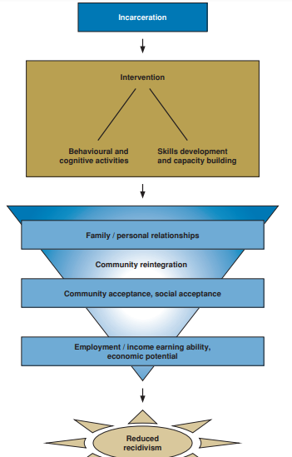
Increased access to formal and informal education will lead to more employment opportunities for Prisoners and ease their reintegration into their communities hence more productive youth that contribute to Malawi development.
However, this is not straight forward occurrence as there are other factors like Behaviour change through trainings. The social Change Initiative has attempted this by conducting Peace club sessions within Mzuzu Prison. Another factor is skills development. The social Change Initiative supported Mzuzu Prison Vocational workshops and formal schools with materials for skills development.
To foster easy re-integration of inmates after their release, the SCI supported Restorative Justice and Peace Building activities both at Mzuzu Prison and surrounding Communities.
2.2 METHODS AND' DESIGN
The project used Participatory approach in implementation of social change activities. A participatory approach is one in which everyone who has a stake in the intervention has a voice, either in person or by representation. Staff of Mzuzu Prison provided technical support, prisoners were the main beneficiary of the project, community officials like Block leaders, Religious leaders and Counselors were also involved and people from other government like Police, Human rights commission all took certain roles directly or indirectly.

CHAPTER THREE
- INTERVENTIONS AND ACTIVITIES
3.1 CONDUCT A NEEDS ASSESSMENT
A needs Assessment was conducted to guide the implementation of activities at Mzuzu Prison. The Table below shows some of the common factors influencing criminal activities among those incarcerated. Mzuzu Prison had over 1500 Prisoners at the time we conducted the needs assessment. We collected information from 150 inmates to understand the factors leading to their imprisonment.
Table 1: risk Factors for Criminal behavior
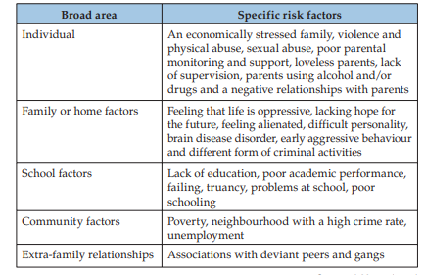
The following categories of variables: individual, family or home, school/ educational, community, and extra-familial relationships. A strong correlation is often made between poverty and crime. From the above table, it can be argued that many of the social factors identified as risks are themselves found most commonly amongst poor families. While by no means exclusive to lower income families, drug and alcohol abuse, a lack of education, truancy and unemployment.
3.2RESOURCE MOBILZATION MEETINGS
Resource mobilization is when a business or organization secures new or additional resources to meet needs. This process can also include strategies that maximize the efficiency of existing resources.
The Rotary Peace Fellow for this Project was privileged to lead an Organisation through which resource mobilization was done. The organization is called “Stimulus for Transformative Development” (STRADE). The Peace fellow capitalized on already existing partnerships with local and international partners who provided technical and financial support. This project would not have been possible without technical support from Mzuzu Prison and governments Departments in Mzuzu City. The Project Received financial support from two international organisations namely: Funducion Arnhold dela Camara, a Spanish charity foundation who supported the proect with 5,000 Euros and Think Malawi which supported the project with 3000 GBP, a UK Charitable organization. The funding is still available and will enable the project to continue beyond the Peace Fellowship Programme.
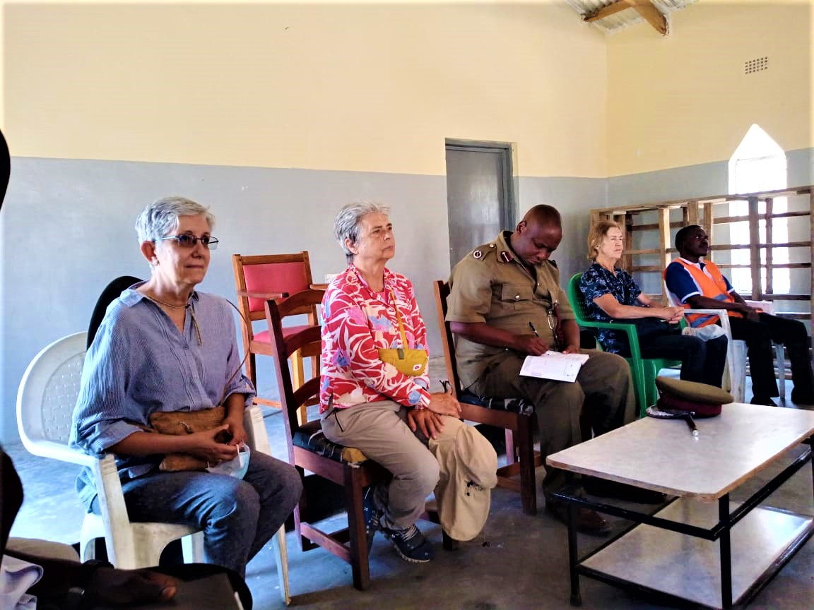
Stakeholders at a Resource mobilization meeting with Stakeholders from government and Civil society.
3.3 0FORMAL AND VOCATIONAL EDUCATION SUPPORT
3.1 Distribution of Learning and Teaching Materials
STRADE promised the inmates to stay vigilant and focus on their education. In his remarks, The Executive Director of STRADE, Mr Masida Hastings Ziba told the whole gathering that the organization has partnered with Think Malawi to implement a project for one year until they close their last Semester. Various items were donated which included; Note Taking Books, ball point pens, cartons of chalk and cartons of pencils.

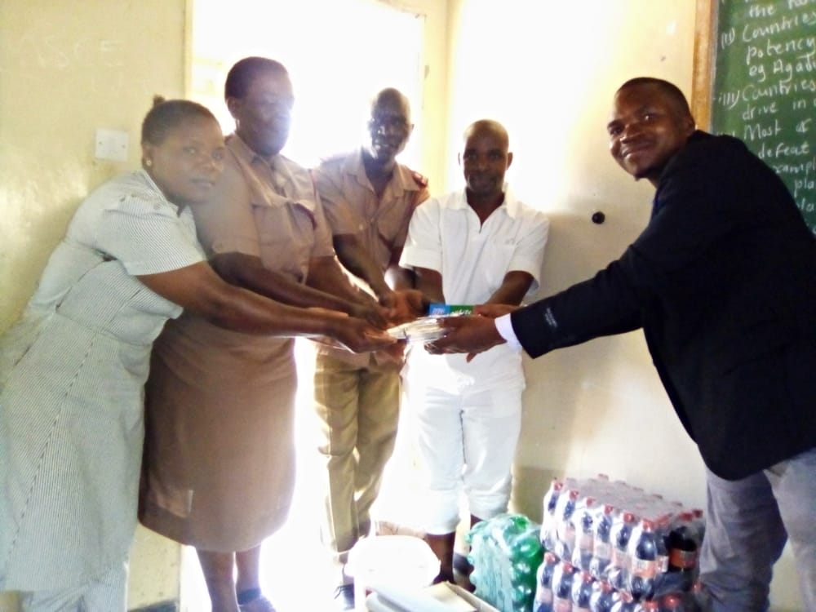
Symbolic handover of learning and teaching materials plus the refreshments by STRADE Executive Director, Mr Masida Hastings Ziba.
3.2 Procurement of Sewing machines to Mzuzu Prison Girls Secondary School
With support from Think Malawi, STRADE donated sewing machines to the Prison vocation skills department to equip inmates especially Women with skills to earn their living once they are released from prison. The sewing machines are meant to be a long term of the school to the project.
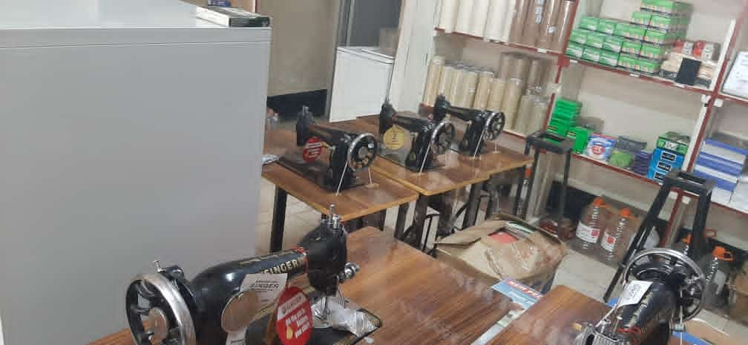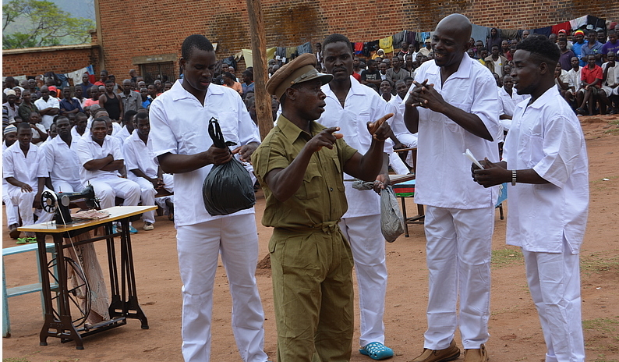

Apart from the Sewing machines, other materials donated included school uniform fabric, teaching and learning materials. This was made to address some of the challenges which inmates who are pursuing studies at the prison are facing. “We made an assessment last year and noted that there were some inmates who had intentions to continue with school but they lacked essential learning materials to do so. 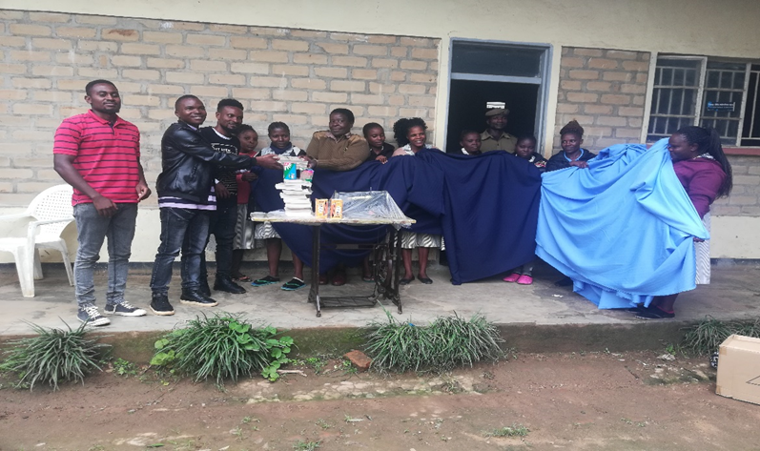
Symbolic Presentation of Sewing machine and Uniform Fabric for Girls at Mzuzu Prison.
3.3 Soap Making Training Using Locally Available Materials
STRADE organized an activity that was aimed at giving accesses to the inmates on how they can make soap given the materials ,this is due the complaint that they have been raising on how it becomes difficult for them to get their laundry clean since the prison cannot afford to give them these washing materials especially on regular basis which deteriorates their livelihood status, one other fact is that some of them will have to get out of prison eventually ,it is therefore a something they can go out with to their societies to implement and capitalize. On this particular day we managed to train 150 female inmates and other interested members of staff. The training has been done in two phases that in June, 2023 and July 2023.
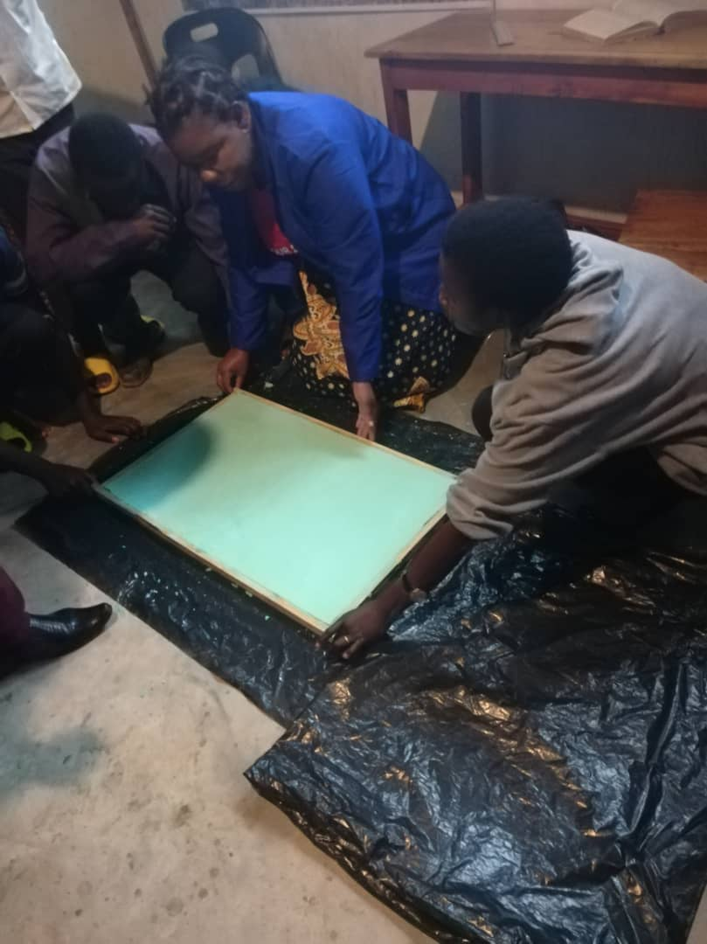
Inmates showing their trained skills to the by making their first bar soaps.
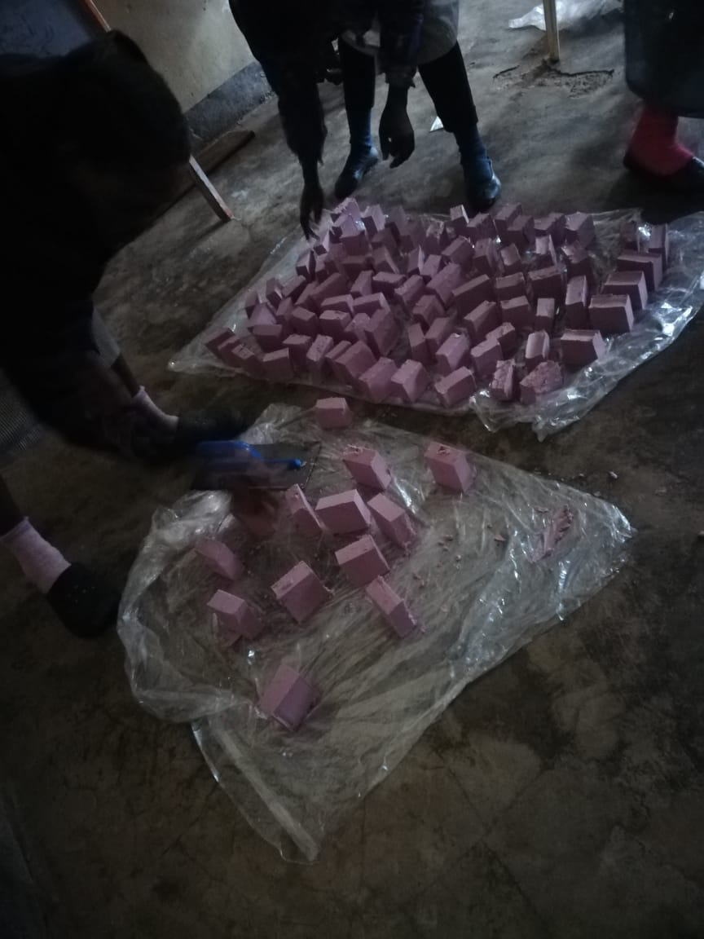
Pieces of Soap made by prisoners after the training.
3.4 Agricultural training Activities
The economy of Malawi is predominantly agriculture based. Agriculture accounts for 30% of GDP and generates over 80% of national export earnings. The agriculture sector employs 64% of the country’s workforce and contributes to food and nutrition security. Through support from think Malawi, the agriculture sector of Mzuzu Prison was supported to facilitate a training in modern agriculture such as Green House Farming, organic farming and permaculture and crop production.

Graduate of agriculture training in prison
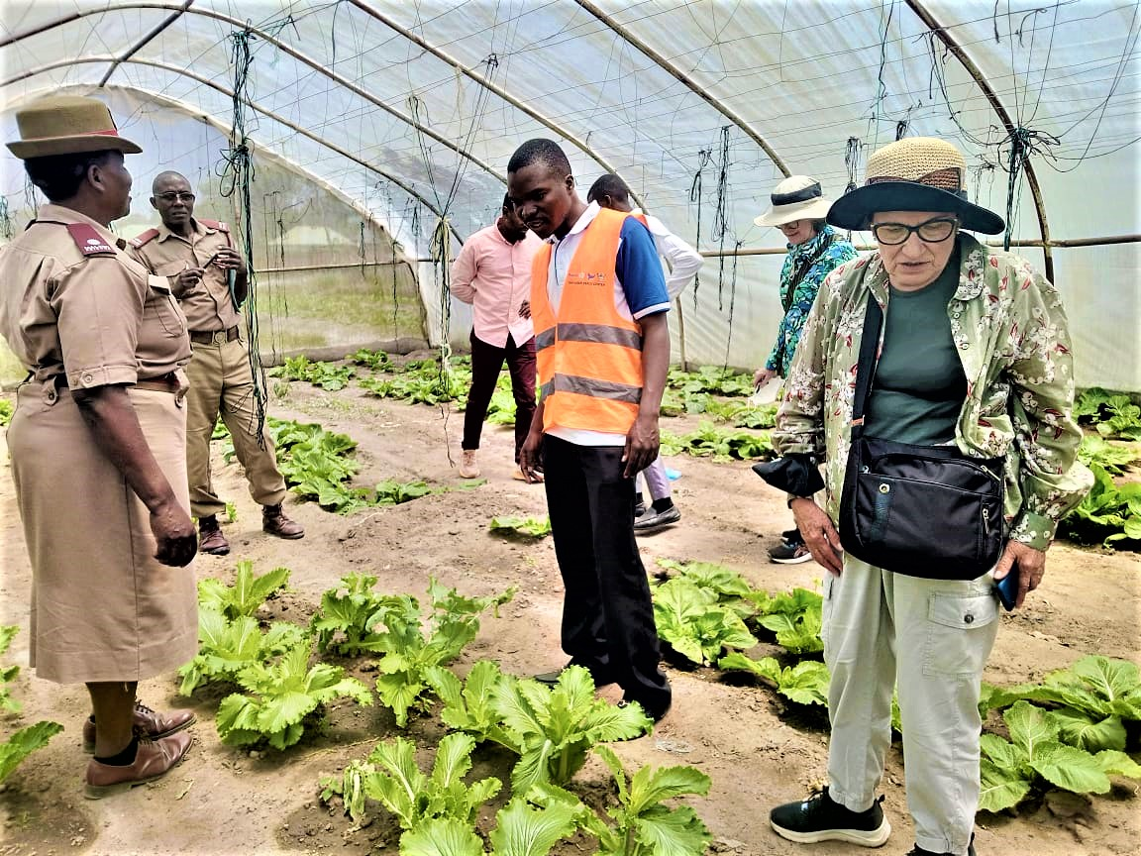
Inspecting prison demonstration Greenhouse Garden
  - PEACE BUILDING AND COMMUNITY REINTEGRATION ACTIVITIES
In an attempt to address the problem of unsuccessful reintegration of offenders into their respective communities, the Malawi Prisons Service in 2022 partnered with Mennonite Central Committee and introduced a project called “Restorative Justice and Peace Building”.
Thanks to a long-term effort across Mennonite Central Committee (MCC) offices in Ontario and Zambia, a restorative justice curriculum has been introduced at more than 100 correctional facilities in Zambia and Malawi.
The nature of the criminal justice system in Zambia was largely punitive—punishment for those who had broken the law without much thought for how to help restore both the victims of crime and the perpetrators. But having encountered the peacebuilding work of MCC, representatives of the ZCS saw there could be a better way built with the concepts of restorative justice. Such an approach addresses the needs of those who have been victimized, the community impacted by the crime and the offender.
In the context of Mzuzu prison where the social change Initiative took place, it has a peace club that has been operating since 2022. Stakeholders including STRADE were invited for a brief meeting with prison authorities in January 2024.
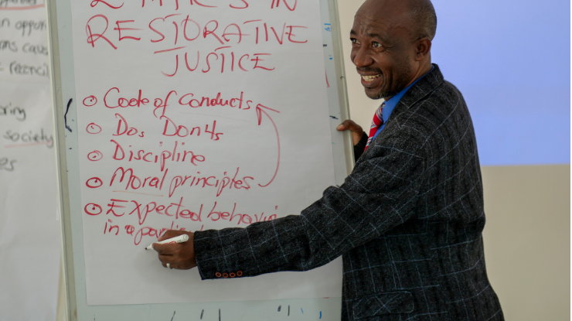
Picture courtesy of Menonite Central Committee: Captured by Malawi Prison Staff who attended the training session.

3.6 LINKAGES AND COMMUNITY REINTERGRATION
In a view to sensitize the community on the importance of accepting those released from prison, I facilitated a sensetisation rally to educate the surrounding communities in Mzuzu on Positive Peace and community Reintegration.
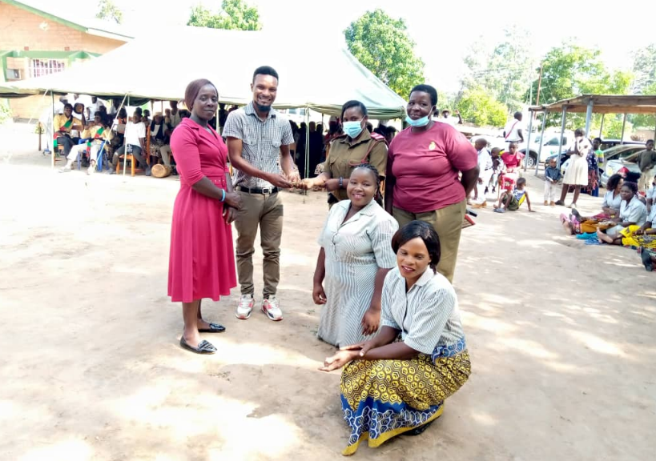
Awareness Meeting on Community-Prisoner Integration in Mzuzu City.

3.7 IMPACT : MONITORING AND EVALUATION
PROJECT TARGETS AND ACHIEVEMENT
INDICATORS (Understood as the measurement to track progress of your SCI different results. The indicators should be SMART-Specific, Measurable,Attainable, Relevant and Timed. Please use the same measurement unit consistently for baselines and targets (%, number, etc) | BASELINE (Understood as the starting point of the indicator) | TARGET (Understood as the end point of the indicator) | ACHIEVEMENT
1. Number of underprivileged youth that do re-offend after serving prison sentences in Mzuzu Prison; | Re-offending is at 20 people out of 100 Released thus 20% | The number of re-offenders reduced to 10 % | 5 Inimates re-offended. Its ongoing until the end of 2024 calendar year
2. Percentage rate of ex-offenders into formal and informal employment opportunities | Only 30% are able to employ ex-offenders | The employment rate of ex-offenders increased to 50% | Ongoing Measurement. Needs more research and resources for data collection
3. Literacy rated of inmates after 1 to 2 years of formal and informal education enrollment | The current literacy level among prisoners at Mzuzu Prison is 30% (b) basic and vocational skills level of prisoners is at 40% | The target was 150 Prisoners to benefit from the initiative | 126 Prisoners have undergone formal and informal education. This is 84 % achievement
4.Skills development level of inmates enrolled formal and informal education opportunities; | No ex-Prisoner is comnnected to mentors/advisors | No ex-Prisoner is connected to mentors/advisors | 3 (two men and 1 woman) are in Public Universities after their release from Prison .
5.Number of inmates retaining or gaining employment after serving their sentences | 40% of e-xprisoners are accepted by their families/Communities | 40% of e-prisoners are accepted by their families/Communities | On going. 60 in mates were released in this reporting period. Over 20 Prisoners were released and accepted by their families after restorative justice intervention. This is just 33% follow up.

4.0 CHAPTER FOUR
GENERAL CONCLUSION
STRADE has implemented all the main activities of the project from May 2023 to December 2023. These are Girls education awareness Campaign, Procurement and donation of learning and writing materials, Procurement and donation of 5 sewing machines and Procurement, donation of uniform fabrics for female inmates at Mzuzu Prison Girls Secondary School, Training in Soup Manufacturing and conducting of remedial or extra classes for those in government examinable classes. Monitoring and evaluation of key project indicators will continue. Masida Hastings Ziba in partnership with Mzuzu Prison, will continue implementing the project beyond the timeframe of the project. The following activities have been prepared awaiting future funding from well-wishers and international funding partners.
Currently, prison authorities are putting their focus into growing this project into reaching their vast catchment area and beyond. Some of the extra activities that will be implemented if resources will be available include the following:
- Community Restorative Justice Meetings with victims in the Northern Region
- Community follow-up to Ex-offenders and establish Peace Clubs in Northern Region
- Community Sensitization Meetings on Restorative Justice in Northern Region
- Training for Stakeholders and Prison Staff on Stakeholders on Peace building.
- Annual Evaluation Meetings on the Programme.

7.0 KEY PROJECT PHOTOS
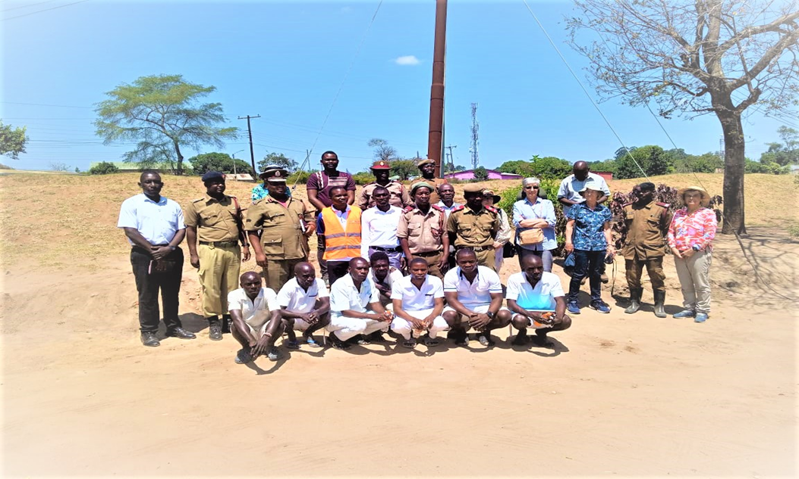
Key Project funding, implementing and Strategic Partners at after a fundraising meeting in Mzuzu City. In the Prison Premises.
Project Partners admiring the vegetables in a Prison Green House Garden. This is will be reapplied in their communities after serving their sentences.
Supporting the Prison with Training Materials by Masida Hastings Ziba and STRADE members.
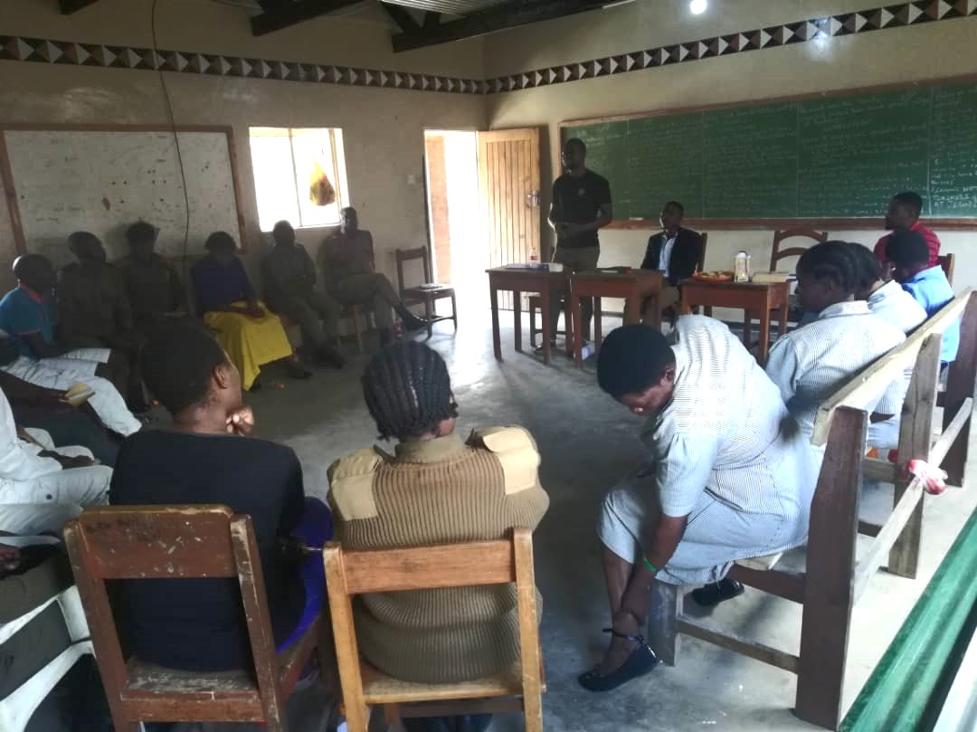
Peace Club Session being conducted at Mzuzu Prison. This was formed after many new prisoners were finding problems to go back to their families and start new life. They were re-offending few months after release. It was also a way of Teaching a Peace club curriculum that the prison is currently implementing.

REFERENCES
KajawoS.(2023)file:///C:/Users/WHITEHATS%20ICT%20WORLD/Downloads/Exploring_the_perspectives_of_young_offenders_and_.pdf
Malawi Government (2016) National Agriculture Policy, September 2016.
Malawi Government, Malawi Prison Services: https://www.mps.gov.mw/
Maree, A. (2003) Criminogenic Risk Factors for Youth Offenders in Bezuidenhout, C. and Joubert, S. (2003) Child and Youth Misbehaviour in South Africa: A Holistic View, Van Schalk Publishers: Pretoria.
Mennonite Central committee (2022) https://mcc.org/our-stories/witnessing-seeds-peace-blossom
United Office of Drug and Crime: UNODC (2023): https://www.unodc.org/e4j/zh/crime-prevention-criminal-justice/module-8/key-issues/1--concept--values-and-origin-of-restorative-justice.html#:~:text=Restorative%20justice%20refers%20to%20a,being%20of%20all%20those%20involved, accessed on 2nd November 2023.

Maree, A. (2003) Criminogenic Risk Factors for Youth Offenders in Bezuidenhout, C. and Joubert, S. (2003) Child and Youth Misbehaviour in South Africa: A Holistic View, Van Schalk Publishers: Pretoria.
https://files.eric.ed.gov/fulltext/EJ1387738.pdf
https://www.unodc.org/e4j/zh/crime-prevention-criminal-justice/module-8/key-issues/1--concept--values-and-origin-of-restorative-justice.html#:~:text=Restorative%20justice%20refers%20to%20a,being%20of%20all%20those%20involved.
National Agriculture Policy, September 2016
https://mcc.org/our-stories/witnessing-seeds-peace-blossom

