**REPORT OF THE SOCIAL CHANGE INITIATIVE (SCI) AND PROJECT IMPLEMENTATION ON GENDER BASED VIOLENCE AND THE IMPACT OF CLIMATE CHANGE IN WARU COMMUNITY, FEDERAL CAPITAL TERRITORY (FCT), ABUJA, NIGERIA**

**BY**

**OGUIKE MIRIAM ADAEZE UJU, PEACE FELLOW, COHORT 4, ROTARY PEACE CENTER, MAKERERE UNIVERSITY, KAMPALA, UGANDA**

**Location:** Traditional Palace of Waru Community, FCT, Abuja, Nigeria

**Start:** February 20th, 2023

**Completion/Implementation:** August 10th, 2023

***Abstract***

*The project examined Gender Based Violence (GBV) and the Impact of Climate Change in Waru Community, Federal Capital Territory, Abuja, Nigeria. It ascertained the socio-economic and cultural lives of the participants that causes gender based violence, and established the community perceptions of climate change and violence that are gender based. The methodology included desktop review, team meetings, advocacy visit to key stakeholders, baseline study and focus group discussion. There were twenty eight participants (15 females) and (13 males) who were mostly indigenes of the community. The focus group discussion engaged the females and males separately inorder to achieve the goal of the project. It was found that climate change has impact on the people and their socio-economic activities. It also causes gender based violence and other social and economic issues in both males and females in Waru community. It was recommended that more sensitization should be carried out across the country inorder to enlighten people about climate change and gender based violence to prevent conflict and promote peaceful co-existence.*

**CHAPTER ONE**

**Introduction and Background**

The local communities in Nigeria depend on Agricultural activities for food and survival. Nigeria is vulnerable to environmental and climate change. There has been a gradual rise in temperature between 1901 and 2005. Mean air temperature of 26.3℃ between 1901 and 1970 and an increase to 27.8℃ from 1971 to 2005-apparently greater than the global average of 0.74℃. Rainfall since 2012 till date has been noted to be largely erratic (Bello et al, 2012). The country has often faced challenges of herders/farmers conflict, flood, drought, extreme weather condition, deforestation, displacement and population bulge as result of climate change. The socio-economic effect of climate change such as unemployment, lack of income, trauma, insecurity, low human capital development, unavailability of farmland, food insecurity, forced migration, etc has led to the gender based violence that occurs in Waru community. There are increased cases of rape, sexual abuse, drug and substance abuse, school dropout, teenage girl pregnancy, trafficking, child and forced marriage, Sexual Exploitation and Abuse (SEA) etc. Gender Based Violence (GBV) is an umbrella term for any harmful act that is perpetrated against a person’s will that is based on socially ascribed (i.e. gender) differences between male and female. It includes acts that inflict physical, sexual or mental harm or suffering, threats of such acts, coercion, and other deprivations of liberty. These acts can occur in public or in private. GBV is specifically targeted against a person because of his or her gender. It includes, but not limited to, physical, sexual, and psychological harm (including intimidation, suffering, coercion, and/or deprivation of liberty within the family or within the general community). According to UNHCR, Gender-Based Violence (GBV) refers to harmful acts directed at an individual based on their gender. The European Institute of Gender Equality (EIGE, 2019) noted that both women and men experience gender-based violence but the majority of victims are women and girls because of their vulnerability. Gender based violence could be emotional or psychological, and it is against human rights globally though most cases are not reported or under-reported in most developing countries. The EIGE also noted that GBV is deep rooted in gender inequality and continues to be one of the most notable human rights violations within all societies. Climate change is one of the most debated issues in the global discourse. It has attracted attention of scholars, policy makers, the general public, and the international community. At the center of this debate are issues of societies’ preparedness to respond or adapt to the challenges of climate change, and to address their vulnerabilities. One of the outcomes of the 1992 United Nations Conference on Environment and Development (UNCED) was the Framework for Convention on Climatic Change (FCCC) signed by 154 countries, many of whom now have a national plan to address the problem of climatic change. However, many of the countries with sophisticated resilience structures are still overwhelmed by the effect of climate change. Homer (1991) stated that “this issue is not unconnected with, for the most part, the shift in scientific community’s perception of global environmental problems. To begin with, the previously held notion that the environmental system, in particular the earth’s climate is resilient to human abuse has been upturned, and replaced with a new belief in earth’s multiple local equilibria that are highly unstable”. Also, the fact that a slight alter in climate system may result in complex environmental and social effects, which could potentially trigger conflict has been established. This paradigm shift in perception of the global climate finds overwhelming evidence in the violent conflicts across Nigeria and other natural disasters that threaten the global peace and development. The Rotary Peace Fellowship has afforded the fellow the opportunity to carry out a baseline study to identify the gap in knowledge and how climate change could trigger socio-economic and cultural issues and will result to gender based violence in Waru community. It created the awareness on the practices and behaviours that lead to GBV.

**Problem Statement**

There is increase in the socio-economic effect of climate change such as: unemployment, lack of income, trauma, insecurity, low human capital development, unavailability of farmland, food insecurity, forced migration, etc. There have been reported cases of gender based violence in Waru community in Abuja. The community has a very under-equipped and under-resourced primary health centre and there is no senior secondary school. Young people who desire for formal education in the community trek long distance to attend a secondary school at a far community in Apo. The lack of a senior secondary school indicates that there isn’t a formal and organized system to reach young people with accurate sexual and reproductive health information. This appears to be one of the reasons for the high rates of teenage pregnancies and dropouts from schools. All these could be the reasons why the Gender Based Violence (GBV) has increased from 5% to 19% for emotional violence, physical violence and sexual abuse in Waru community, in the Federal Capital Territory (FCT) Abuja, Nigeria. Also, from 2015 and till date, Nigeria is yet to enact a gender sensitive and specific legislation at the national level. There is little or low sensitization across the country on climate change, the socio-economic and cultural factors that exacerbate gender based violence; hence engaging participants at the community level for more knowledge and possible policy recommendations around the menace.

**Goals**

To **generate findings on the nature and level of community participation in peacebuilding and conflict management processes in Waru; the level of access that the victims of gender based violence have to reporting the cases and prevention of the impact of climate change; and the formal and informal mechanisms in place or required for the effective implementation of scoping workshop, sensitization and empowerment programme to prevent GBV in the target community**.

**Objectives**

The broad objective is to know about gender based violence and the impact of climate change in Waru community, Federal Capital Territory, Abuja, Nigeria.

The specific objectives include:

1. To examine the social, economic and cultural lives of the participants
2. To ascertain the root causes of gender based violence in Waru community
3. To establish community perceptions of climate change- culture, man-made.
4. To examine the effect of climate change in Waru community- socio-economic factors – unemployment, drug abuse, rape, sexual abuse, poverty, displacement, force migration, structural issues, etc on Waru community
5. To ascertain the community strategies for conflict management and resolution
6. To create awareness on GBV

**Challenges**

The cultural structure of Waru community requires the women to be submissive and get permission from the men folk for any engagement, including women activities. The fellow initially wanted to carry out gender-based project for the female in the community. However, the advocacy visit of the team to the District Head who is also the Traditional Head suggested that the men should also be part of any event that would engage the women. This is to ensure that the men protect the women, and that the women remain submissive. Some of the challenges encountered include:

* Cultural limitation
* Redesigning of the project due to the insistence of the male gender to be part of the discussions
* Paucity of fund that affected the engagement of media and publicity.
* Advocacy visit, baseline study and focus group discussion took place the same day. This made it very tasking and intense, because most participants were farmers and might not be available for any engagement within the period. Besides, funding such activities is very demanding.
* Initial distrust and perception by the males that awareness of gender based violence could empower the females for liberation.

**Mitigation strategies**

The following steps were taken to mitigate the challenges during the project implementation:

* The project implementation team carried out an advocacy visit to the District/Traditional Head inorder to understand the entry point and to clarify the desktop and other secondary data for a fruitful engagement.
* The team involved some opinion leaders and youth for inclusivity.
* The peace fellow owned the project and sponsored the implementation; this is due to the zeal to impact the society and promote positive peace.
* The stakeholders created an atmosphere of mutual trust for successful outcome.

**CHAPTER TWO**

**Literature Review**

**Conceptual Framework**

**Gender**

**This is** the economic, social, political, and cultural attributes and opportunities associated with being women and men. Gender is a sociocultural expression of particular characteristics and roles that are associated with certain groups of people with reference to their sex and sexuality. Some of the perspectives of gender include:

* Gender Analysis
* Gender Equality
* Gender Mainstreaming

**Gender Analysis:** It involves collecting and analyzing sex-disaggregated data and other qualitative and quantitative information. It explores assumptions about issues such as the distribution of resources and the impact of culture and tradition; as well as the potential direct or indirect benefit of a development initiative on women and men.

**Gender Equality** is the condition that affords women and men equal enjoyment of human rights, opportunities, and resources irrespective of social status. Gender equality is under-discussed in many countries due to culture and socio-political marginalization. Within the EU space, the principles of equal treatment developed from a rather isolated legal provision in the 1960s, to a currently significant and meaningful *Acquis Communautaire* in the area of equality.

**Gender Mainstreaming** is the process of incorporating a gender perspective into policies, programs, project activities, and administrative functions, as well as into the institutional culture of an organization. This was the key element of the 1995 Beijing Platform for Action adopted at the Fourth World Conference on Women. The UN Economic and Social Council defines it as a strategy for making women’s as well as men’s concerns and experiences an integral dimension of the design, implementation, monitoring and evaluation of the policies and programmes in all political, economic and societal spheres so that women and men benefit equally and inequality is not perpetuated.

**Gender-Based Violence (GBV):** This is an umbrella term for any harmful act that is perpetrated against a person’s will that is based on socially ascribed (i.e. gender) differences between male and female. The European Institute of Gender Equality (EIGE, 2019) noted that GBV is deep rooted in gender inequality and continues to be one of the most notable human rights violations within all societies. Most GBV cases are not reported or under-reported in most developing countries. Osah et al (2021) postulated that in Nigeria, there are Provisions of Chapter IV of the 1999 Constitution as amended on Fundamentals of Human Rights. However, no specific national law that addresses gender based violence. There are only states laws on sexual abuse such as rape.

**Types Gender Based Violence:**

**Domestic Violence:** It is the intentional and persistent abuse of anyone in the home in a way that causes: pain, distress, injury or death, and traditional practices that is harmful to someone within a household that violates their basic human rights.

**Sexual Abuse/Rape:** This is the physical intrusion of sexual nature, whether by force or under unequal or coercive conditions. The issue of marital rape has become a concern during discussion around GBV. This is a situation where partners in marriage forcefully have a sexual intercourse with his/her partner without an amicable understanding. The partner “incharge” threatens or blackmails the other with a condition where they are helpless.

**Emotional Abuse:** Emotional abuse is a pattern of behavior in which the perpetrator insults, humiliates, ignores or isolates, and generally instills fear in an individual in order to control them.  Emotional abuse is often a part of other kinds of abuse, which means it can be difficult to spot the signs or tell the difference. It can occur in marriage or relationship. Women experience emotional abuse from their male partners who engage in extra-marital affairs, infidelity and polygamy. Men also go through emotional abuse from their wives due to inability to provide for the family and other economic challenges. It is important to note that every type of gender based violence could lead to mental health issues.

**Factors that Cause Gender Based Violence (GBV)**

**Cultural:** Patriarchal views in some societies such as Africa legitimize violence to ensure the dominance and superiority of men. Culture has made the understanding of the family sphere as private and mostly under male authority.

**Legal:** Being a victim of gender- based violence is seen in many societies as shameful and weak; with many women still being considered guilty of attracting violence against themselves through their behavior, dressing and lifestyles. The practices of law enforcement in many cases favour the perpetrators; which help to account for low levels of trust in public authorities; and for the reason that most of these crimes go unreported, and perpetrators go unpunished.

**Economical:** The lack of economic resources creates patterns of violence and poverty that become indefinite making it difficult for the victims to free themselves. When unemployment and poverty affect men, they can become violent and will try to assert their masculinity over women through violence means.

**Political:** The topic of gender-based violence is in some cases considered unimportant; with domestic violence also being given insufficient resources and attention to help effect changes in policy or to adopt measures to combat gender-based violence and support equality. Some political leaders feel that enactment of laws on gender based violence would be a threat to the status quo. For instance, a legislator that engages in child marriage would insist that his culture or religion allows such practice.

**Climate change**

The Intergovernmental Panel on Climate Change (IPCC) defines climate change as any change in climate over time, whether due to natural variability or as a result of human activity” (IPCC, 2007, p. 21). Evans (2012, pp. 3-8) notes that in addition to its geophysical impacts such as temperature increases, climate change will impact social and environmental systems through hazards such as excessive heat and the melting of glaciers, which will result in secondary impacts including desertification, coastal flooding, land degradation, reduced crop yield, low water availability and food insecurity, among others. Climate change represents potentially the most serious of a range of environmental drivers of conflict and gender based violence.

**Theoretical Framework**

This work focuses on gender based violence and climate change as sociological phenomena. Both concepts can be explained with the following theories:

**Feminist Theory:** This theory is used to explain gender based violence in this context. In the 1970s, [feminist theory](https://en.wikipedia.org/wiki/Feminist_theory) embraced the concept of a distinction between biological sex and the [social construct of gender](https://en.wikipedia.org/wiki/Social_construction_of_gender_difference). Most contemporary social scientists, behavioral scientists and biologists, many legal systems and government bodies, and inter-governmental agencies such as the World Health Organization ([WHO](https://en.wikipedia.org/wiki/WHO)), make a distinction between gender and sex. The modern academic word for gender in the context of social roles of men and women, dates back to at least 1945 and was popularized and developed by the feminist movement from the 1970s onwards which theorizes that human nature is essentially [epicene](https://en.wikipedia.org/wiki/Epicenity) and social distinctions based on sex are arbitrarily constructed. In this context, matters pertaining to this theoretical process of [social construction](https://en.wikipedia.org/wiki/Social_construction_of_gender) were labeled matters of *gender*. Biologist and feminist academic [Anne Fausto-Sterling](https://en.wikipedia.org/wiki/Anne_Fausto-Sterling) (1993) rejects the discourse of [biological](https://en.wikipedia.org/wiki/Biological_determinism) versus [social determinism](https://en.wikipedia.org/wiki/Social_determinism) and advocates a deeper analysis of how interactions between the biological being and the social environment influence individuals' capacities. Another feminist who is also a philosopher, [Simone de Beauvoir](https://en.wikipedia.org/wiki/Simone_de_Beauvoir) applied [existentialism](https://en.wikipedia.org/wiki/Existentialism) to women's experience of life: "One is not born a woman; one becomes one” In context, this is a philosophical statement. However, it may be analyzed in terms of biology- a girl must pass [puberty](https://en.wikipedia.org/wiki/Puberty) to become a woman—and sociology, in social contexts is learned rather than instinctive. Within [feminist theory](https://en.wikipedia.org/wiki/Feminist_theory), terminology for gender issues developed over the 1970s. In the 1974 edition of *Masculine/Feminine or Human*, the author Chafetz Janet Saltzman uses "innate gender" and "learned sex roles", but in the 1978 edition, the use of *sex* and *gender* is reversed. By 1980, most feminist writings had agreed on using *gender* only for socio-culturally adapted [traits](https://en.wikipedia.org/wiki/Trait_theory). Political scientist [Mary Hawkesworth](https://en.wikipedia.org/wiki/Mary_Hawkesworth) (2019) addresses gender and feminist theory, stating that since the 1970s the concept of gender has transformed and been used in significantly different ways within feminist scholarship. She notes that a transition occurred when several feminist scholars, such as [Sandra Harding](https://en.wikipedia.org/wiki/Sandra_Harding) and [Joan Scott](https://en.wikipedia.org/wiki/Joan_Wallach_Scott), began to conceive of gender "as an analytic category within which humans think about and organize their social activity". Feminist scholars in [Political Science](https://en.wikipedia.org/wiki/Political_Science) began employing gender as an analytical category, which highlighted "social and political relations neglected by mainstream accounts". However, Hawkesworth states "feminist political science has not become a dominant paradigm within the discipline". Thus it is evident that culture can play a part in assigning gender according biological making. They also point out that in addition to social relational contexts, cultural beliefs plays a role in the gender system. Social theorists have sought to determine the specific nature of gender in relation to biological sex and sexuality, with the result being that culturally established gender and sex have become interchangeable identifications that signify the allocation of a specific 'biological' sex within a categorical gender. The second wave feminist view that gender is socially constructed and hegemonic in all societies remains current in some literary theoretical circles, [Kira Hall](https://en.wikipedia.org/wiki/Kira_Hall) and [Mary Bucholtz](https://en.wikipedia.org/wiki/Mary_Bucholtz) (2006) explained this in their perspective as how gender, language and sex are related. The feminist theory therefore argues that gender is not the same as sex. Gender is a political and social construct. The cultural perspective of gender assigns roles based on biological makeup and sex. However, the feminist theory has postulated that a person cannot be forced to accept a role contrary to what he or she accepts. There could be cases of inter-sex or other biological makeup in-between a male or female. This confusion has let to gender based violence where someone is first human and must exercise basic rights. There should be equal participation of all in every aspect of life.

**Climate Change Theory:** One of the common theories of climate change is Anthropogenic (man-made) Global Warming (AGW) theory. It is used to explain climate change as a phenomenon that affects human existence and the environment. It holds that man-made greenhouse gases, primarily carbon dioxide (CO₂), are the predominant caused by the global warming that occurred during the past 50 years. Bast (2010) in his book “Seven Theories of Climate Change”, illustrates the AGW. He said that the theory contends that human emissions of greenhouse gases, principally carbon dioxide (CO₂) causes a catastrophic rise in global temperatures. The energy from the sun travels through space and reaches Earth. Earth’s atmosphere is mostly transparent to the incoming sunlight, allowing it to reach the planet’s surface where some of it is absorbed and some is re-absorbed back as heat out into the atmosphere resulting in Earth’s atmosphere becoming warmer than it otherwise ought to be. In recent time, human activities such as of burning wood and fossil fuels and cutting down or burning forests have increased the concentration of CO₂ in the atmosphere by approximately 50 percent. Earth’s climate also responds to several other types of external influences, such as variation in solar radiation and in the planet’s orbit. Proponents of the AGW theory believe man-made CO₂ is responsible for floods, droughts, severe weather, crop failures, species extinctions, spread of diseases, ocean coral bleaching, famines, food insecurity and other effects of climate change. According to the AGW theorists all these disasters will become more frequent and more severe as temperatures continue to rise. Nothing less than large and rapid reductions in human emissions will save the planet from these catastrophic events.

**Change theory and the application**

The Theory of Change (ToC) is a set of beliefs about how change happens and, as such, it explains why and how certain actions will produce the desired changes in a given context, at a given time (Mafumbo, 2022). A ToC can also be considered a testable hypothesis, where a particular action (X) would produce an expected result (Y). In the context of the SCI, the activities such as advocacy, focus group discussion and inclusivity were able to create awareness and active participation of the females and males in Waru community, regardless of the cultural limitations. The input such as experience sharing, success stories and recommendations were movement towards a desired goal and other planned activities in the future such as scoping workshop, sensitization and empowerment programme to prevent GBV in the target community. Example, it was established that if there are adequate policies/laws on climate change according to environment, sensitization on human rights, gender equality, THEN gender based violence will be prevented or reduced. The following illustrate the application of the Theory of Change during the implementation of the SCI.

1. Since there is existing data from desktop review, though very skeletal, but how do we collect primary data?
2. If we visit the key stakeholders and people in the community, can we examine the social, economic and cultural lives of the participants; ascertain the root causes of gender based violence; establish the peacebuilding mechanisms in the community.
3. With the application of the theory of change, what will be the inputs, outputs and outcomes such as:

* Community awareness and participation
* Social and cultural exchange
* Increased knowledge and understanding of climate change and GBV, etc
* Break the silence on GBV
* Increased the understanding of conflict and other gender related issues.
* Visible positive reactions and interactions among men, women, youth, boys and girls in the community.
* Consciousness of practices and character that cause GBV.

**Table below Illustrates the Application of Theory of Change for the SCI**

|  |  |  |  |  |
| --- | --- | --- | --- | --- |
| → Input → | → Output → | → → → Outcomes → → → → → → | | |
| -Identifying the key stakeholders  -Applying community-based approach to ascertain social, economic and cultural lives of the participants; the root causes of gender based violence; assess the peacebuilding mechanisms in the community. | -Community awareness and participation  -Social and cultural exchange  -Increased knowledge and understanding of GBV.  -Consciousness of practices and character that cause GBV. | Short Term | Medium Term | Long Term |
| Break the silence on GBV  -Increased the understanding of gender related issues  Active participation at the Base line data collection and FGD | Improved relationships and interactions among men, women, youth, boys and girls in the community.  -Consciousness of practices and character that cause GBV. | Sustainable and positive peace that will create self-reliance and growth  Low cases of GBV, peaceful and timely resolution of suspected cases of emerging GBV |

**Using the Eight Pillars of Positive Peace for the Theory of Change**

Positive peace is the attitudes, institutions and structures that create and sustain peaceful societies. Using the positive peace indicators by (Galtung 1971) the project will achieve (long term) the following:

* Better understanding, respect, healthy relationship among the people in Waru community.
* Effective community leadership and structure
* Improved communication and flow of information
* Tolerance and peaceful co-existence
* Human rights protection
* Empowerment for human capital development
* Human security
* Transparency in conflict management

**Methods and Design**

**Study Area**

Waru Community is located in the suburbs of Abuja, about 26km from the Abuja City Centre. It is home to 3,000 people. The community is made of indigenous people (Gbagi) and settlers due to its nearness to the Abuja capital city. It is led by a district head who doubles as the community chief. It has a camp for the Internally Displaced Persons (IDP) who are victims of Boko Haram insurgency, banditry, floods and other socio-economic issues. There have been reported case gender based violence in Waru community in Abuja. Waru has a very under-equipped and under-resourced primary health centre and there is no senior secondary school. Young people who desire for formal education in the community trek long distance to attend a secondary school at a far community in Apo. The lack of a senior secondary school indicates that there isn’t a formal and organized system to reach young people with accurate sexual and reproductive health information. This appears to be one of the reasons for the high rates of teenage pregnancies and dropouts from schools.

**Project Population**

The participants included 28 indigenes of the community- females (53.6%) and males (4.4%) who were married and single and mostly farmers. The first stage was advocacy to the Traditional Head with his Secretary and Chief of Clan. Second stage involved all participants during the baseline survey of gender based violence and climate change issues. The third stage was the focus group discussion which disaggregated the females and the males for discussions.

**Method of Data Collection**

Primary and secondary data were used for the SCI. The secondary data was obtained from secondary sources such as publications, academic journals, conference proceedings, etc. Primary data was sourced through the various activities and intervention in the community.

.

**Project Design**

* **Planning:** This included the preparing for the social change initiative project proposal. background knowledge, rationale, gap identified, objectives, statement of the problem, method to be applied, cost benefits, activities, challenges, expected outcomes, etc. (February – March, 2023)
* **Desktop Review:** This required following up on reported cases of GBV across Nigeria, and the increasing conflict and insecurity globally. Explored literatures and materials on the root causes of gender based violence and climate change, cultural, socio-economic factors such as unemployment, drug abuse, poverty, displacement, force migration, structural issues, etc. With a background knowledge of the herders/farmers conflict in Waru community and successful peace agreement facilitated by the Peace Fellow and team of Peace and Security Forum stakeholders coordinated at the Institute for Peace and Conflict Resolution, Abuja in collaboration with key stakeholders and decision makers from the government and security agencies, Development Partners, NGOs, Traditional and Religious leaders, Women and Youth groups, Media, Academia, among others in 2017. The SCI was an opportunity to reach out to the community that is one of the host communities of the FCT, yet lack development. There is overwhelming influx of the internally displaced persons that have triggered conflict and GBV in community and the environs. (March – May, 2023)
* **Implementation Team:** The Peace Fellow involved two peace and conflict resolution and gender experts from the Institute for Peace and Conflict Resolution (IPCR) and an NGO (Real Future Africa) located at Waru Community. (June, 2023)
* Meetings with the team and discussions on how to commence project implementation (July, 2023)
* Project Implementation (August, 2023)
* Ethical considerations of “Do No Harm”
* Advocacy to the Traditional/Head of Waru community
* Baseline study of gender based violence and the impact of climate change in the community
* Focus Group Discussion among the female (15 participants) and male (13 participants).
* Experience sharing and success stories
* De-brief by the implementation team
* Report writing

# CHAPTER THREE

**Interventions and Activities (10th August, 2023) included:**

* Advocacy to the District Head
* Commencement and Arrival / Registration by all Participants
* National Anthem and Prayer
* Introduction of Guests and Dignitaries
* Welcome Remarks
* Goodwill messages
* Climate Change and Environmental Issues in Nigeria. The Impact in Waru Community
* Gender Based Violence and Impact of Climate Change in Waru Community
* Focus Group Discussion (Separate males and females)
* Recommendations
* Refreshment/Closing Remarks and Departure

**Welcome Remarks**

The District Head of Waru Community, His Royal Highness, Ibrahim A. Sarki, welcomed all participants to the event. He gave an overview of the community, stating that Waru is a peace-loving community and the indigenes are receptive and accommodating. HRH commended the efforts of the government and other stakeholders in the areas of security and health care by building a Police station and Health Centre for the community. However, Waru faces many challenges regardless of being a host to the FCT, migrants and other residents. He has granted media interviews and it seems establishing of schools in the community is still far-fetched. The children walk long distance to school, because none exists in Waru. There is bad road, lack of basic infrastructures, poor housing and no development. He called on the organizers of the project to advocate on behalf of the community, because government is almost displacing the indigenes due to allocation of the land to the FCT residents without any provision for suitable homes and economic activities for the people, since their occupation is majorly farming. HRH thanked the Peace Fellow for such initiative as the impact of climate change and gender based violence occurs in the community, and because of culture and stigmatization, it is under-reported and hidden, while the victims die in silence. He wished the participants fruitful deliberations.

**Goodwill Messages**

**The Village Head:** The village Head of Waru community, Chief Markus G. Danjuma highlighted that some NGOs had visited; however, the community still expect interventions in infrastructural human development. They experience climate change that affects the soil texture. The farm yields are poor, and the men no longer harvest cash crops for commercial purposes.

**Women Leader:** The leader of the women group, Liyatu Yohana said she was happy when informed about the programme. She mobilized the women as directed by the village head. The women want peace. They want their men to take care of their homes. But on the contrary, women are overwhelmed with family challenges. They would use the avenue to share their experiences.

**Youth Leader:** Ezra Angulu, the leader of the community youth forum said youth are facing unemployment, substance abuse, lack of funds for business, invading and destruction of farms by herdsmen and their cattle. The youth want to have a voice and be part of leadership, rather than coming to mobilize them and buy their votes during elections, and later be left to their fates.

**President Real Future Africa NGO:** Amb. Fidelis I. Inyon has carried out interventions around education in Waru community. Because of absence of schools, he helps to organize the youth to enroll in satellite studies, where they can be tutored in the community, and taken to centres to write exams to qualify for higher institutions. However, this has been challenging because there is no funding, and the people are poor and cannot afford the cost of such services. There is also language barrier, because the people mainly speak their local language – Gbagi. He thanked the Peace Fellow for creating the awareness on gender based violence in the community. There should be quick interventions to prevent further occurrences.

**Climate Change and Environmental Issues in Nigeria: The Impact in Waru Community**

The representative and senior staff of the Institute for Peace and Conflict Resolution (IPCR) Ndako Salihu Haruna spoke about how climate change causes conflict, insecurity and other socio-economic issues. He encouraged the people to always uphold any peacebuilding programme in the community. There should be early warning and reporting system to alert of any conflict and abuse. IPCR is a government agency that promotes peace in the country and collaborates with various stakeholders for peacebuilding activities across the country.

**Gender Based Violence and Impact of Climate Change in Waru Community**

The Rotary Peace Fellow,Miriam Oguike, who was the brain behind the project, thanked all participants for coming. The SCI is part of the requirements to assess the impact of Rotary Peace Fellowship to communities. She was glad that the people were ready to understand the concepts of gender based violence and climate change because the two phenomena are affecting the quality of lives. Miriam told them that climate change is not a cultural issue but natural and man-made occurrence. The ability to mitigate, apply resilience and coping mechanisms on the impact is important. Do not block the water ways to cause flood, keep your environment clean to avoid diseases that might be passed through water, reduce fossil fuel, burning of bush, cutting down of trees and deforestation. Climate change causes conflict and gender based violence. When there is flood, people cannot go to farm, there is hunger. The cattle will invade available farms to eat up the crops. And there will be herders and farmers conflict that could lead to loss of lives and property. Climate induced conflict causes displacement, loss of livelihood, trauma, sexual abuse, substance abuse, food insecurity, sexual abuse and exploitation, etc. The man could face emotional abuse from the wife as a result of his inability to provide for the family. The wife may be maritally raped if she refuses the husband assess to her body as a result of being overwhelmed from struggling for family welfare. A young girl can be sexually exploited because of displacement or homelessness caused by climate change. Miriam encouraged them to participate actively for successful outcome.

**Issues Identified from Baseline Study**

* Flooding
* Deforestation
* Herders/Farmers Conflict
* Lack of social amenities
* The community is not in the master plan
* The farmland has become hideout for hoodlums and crime gangs
* No more forest guards
* No government support
* No forest reserve in FCT to generate employment
* Plant and crop diseases affect yields
* The soil is getting weak due to climate change
* Poor hygiene
* Lack of water and sanitation
* Insecurity
* Land grabbing by the government and powerful people
* Lack of education and skills
* School dropout and out of school children
* Displacement
* Food insecurity
* Drug and substance abuse
* Environmental Issues
* Commercial sex
* Lack of representation at the mainstream politics and government
* Gender dynamics and irresponsible parents

**Harmonized Focus Group Discussion (Females and Males)**

1. Men and women experience gender based violence
2. There is lack of awareness and sensitization about GBV
3. The palace of the District Head is where victims of GBV, conflicts and other issues are reported and addressed.
4. Some serious GBV cases have been reported to the security agency and gone to court and in prison for three years.
5. Victims of GBV are brought to the palace. But not sure if there are further help or actions for psychosocial healing.
6. Switch in gender roles where the women are the head of households while the men are unemployed or on the street engaging in drugs and substance abuse.

**Key findings / impact**

1. The community host IDPs who are also unemployed and poor: Waru community has a camp for the Internally Displaced Persons (IDP) who are victims of Boko Haram insurgency, banditry, floods and other socio-economic issues**.** IDPs are mostly unemployed; hence cases of GBV are prevalent. There are no schools (primary and secondary) in the community. The IDPs also lack education and skills to advance their lives. Though there is a very under-equipped and under-resourced primary health centre. Young people who desire for formal education in the community trek long distance to attend a secondary school at a far community in Apo area. The lack of a senior secondary school indicates that there isn’t a formal and organized system to reach young people with accurate sexual and reproductive health information such as GBV. This appears to be one of the reasons for the high rates of teenage pregnancies and dropouts from schools.
2. The residents of Waru community are multi-religious. They practice Islam, Christianity, African Tradition, etc. They all live peacefully without religious conflict.
3. There are land grabbers and the community has not agreed on the relocation offer by the government: There has been disagreement and the government has abandoned more engagements with the community due to lack of commitment for the relocation plans. Land racketeers have made such transactions risky; hence the government insists and allocates land to powerful elites to grab in Waru.
4. The indigenes depend on only farming for livelihood and mostly lack business ideas and skills: The people in the community are yet to be sensitized on the need to develop business potentials and skills acquisition. Depending on farming alone has limited their means of livelihood. The land is getting weak as a result of climate change impact. The herders and farmers conflict leads to violence and destructions that causes poverty and food insecurity.

1. Practice of polygamy is increasing: The African culture does not discourage polygamy, however, the Waru people have engaged in such practice more in recent time, regardless of reports of poverty. This act subjects the women to emotional trauma and they become overwhelmed with family issues and struggles, while the men keep more wives and abuse drugs and alcohol, without providing for the family. Here also, women are seen competing among themselves for relevance to the irresponsible man.

1. There is no master plan for Waru community. The Federal Capital Development Administration (FCDA) do not have any structured plan for the community. Decisions are taken randomly without involving the stakeholders from the community. The land is allocated, and the new owner invades the space, which leads to violence, litigations and loss of property.
2. Tree-felling and deforestation has caused climate change issues. This is unauthorized and the owners of the land are not informed. There are n forest guards to prevent such invasion. The powerful grabbers invade the few forests available and cut down economic trees that also protect the environment, therefore causing harsh weather from sunrise and Sahara. The felling of trees also causes flooding that washes away crops and farmland.
3. There is no previous intervention with economic and financial management component inorder to sensitize the Waru community and residents on building resilience, financial discipline and sustainable livelihood.
4. The women and youth are neglected during development projects and decision making. The culture of the land relegates the women to the background that their voice is not heard. The women leader is also subject to the decisions by the men. And that does not allow them to take roles in politics and governance.
5. Gender inequality is one of the causes of GBV. The women are not in leadership positions and the girls do not go to school. Culturally, the women do not own their bodies. There is increasing cases of child and early marriages because of poverty and lack of sensitization.

# CHAPTER FOUR

**General Conclusion**

The debate around climate change is one of the most contested environmental issues in recent time. It is also a complex human problem with societal implications on several domains of life, through extreme weather conditions such as flood, drought and desertification, fossil fuel and gas emission, etc. These events frequently result in social, economic and environmental consequences, impacting more significantly on the most vulnerable populations. Gender is a differentiating variable within social vulnerability, addressed in Sustainable Development Goal (SDG) 5. Both men and women experience the impact of climate change. However the experiences of both in the impact are different, considering cultural norms and practices, access to security and protection resources. In Waru community, both genders experience conditions of vulnerability such as poverty, hunger, unemployment, lack of education, emotional abuse which trigger situations of gender based violence. The data and fact-finding from the Social Change Initiative in the community cannot be over-emphasized. Though climate change impact varies in different context, but the vulnerability of men and women are almost similar. Abase on the study, a cross-cutting gender approach aligned with mitigation and resilience-building programmes is necessary, as well as the adoption of sustainable policies and practices to promote the understanding of climate change. It is essential that policymakers consider the knowledge and experience of both men and women and their peculiarity in participations and decision-making; hence empower them and encourage an inter-sectional approach to achieve more effective interventions to GBV prevention and climate change mitigation.

**Recommendations / implications for Policy**

1. Organize a scoping workshop to sensitize the community members on GBV and its prevention. And climate change mitigation.
2. Speak out campaign on GBV. Through the media, NGO, CSO, etc
3. Continuous advocacy to critical stakeholders for GBV prevention and peaceful co-existence.
4. Establish a structure and platform for awareness and prevention of GBV through agencies of peace and conflict resolution, Ministry of Youth, Ministry of Women Affairs, and other relevant stakeholders.
5. Creating social media platforms such as facebook, twitter, WhatsApp, etc for more reach to the youth and the general public.
6. There should be empowerment programmes and vocational centers to train the women and youth on skills and self-reliance to avoid GBV caused by drug abuse, school dropout, idleness and poverty.
7. The policy on forestry should be reviewed. If none exist in the FCT, the authority incharge must enact such law to protect the forests and trees inorder to protect the environment.
8. Government should establish schools and vocational in the community to encourage children and girl-child education, so as to catch them young against forced marriage, commercial sex and GBV.
9. The government should provide social amenities and construct good access roads for the community to aid their movement and transportation.
10. The herdsmen should be sensitized on the need to avoid the destruction of farm and crops to prevent violent conflict and food insecurity in the community.
11. Agricultural practices and pesticides for protection of crops should be provided for farmers in Waru. And the soil should be preserve by going more green and avoiding of bush burning.
12. There should be sanitation and opening of drainage to allow water and rain pour to stop flood and climate issues.
13. There should be political will by the government to structure the master plan of Waru community and the entire FCT, rather than allow illegal grabbing of indigenous land.
14. There should be suitable homes for displaced persons. Women and girls should be prioritized to prevent sexual exploitation of the females during conflict and climate change impact.
15. The youth and women should be encouraged to participate in politics and governance to help attract development into the community.

**Sustainability plan**

(800words)

* Establish a communication link for follow-up between the key community stakeholders and the implementation team.
* Continuous advocacy to critical stakeholders for peaceful co-existence to prevent GBV.
* Communication, community outreach, dialogues with local and traditional leaders on GBV prevention and reporting of GBV cases and improving the help seeking behaviour for survivors.

# APPENDICE

**Picture 1: Grid of Abuja City (Left) and Waru Community (Right)**

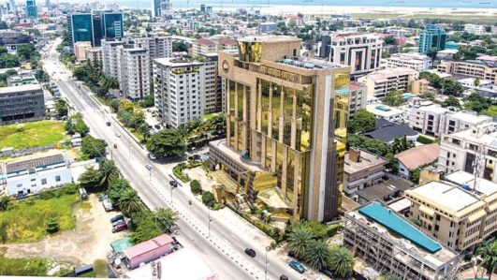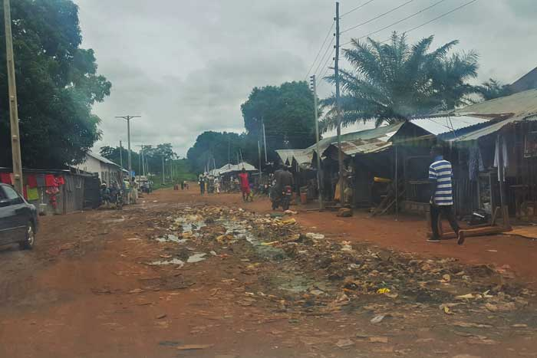

**Picture 2:** Image of farmland in Waru community affected by climate change, which has forced women out of farm and exacerbates food insecurity and gender based violence.

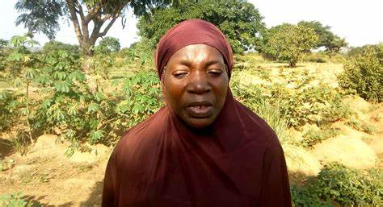

**Picture 3:** Rotary Peace Fellow presenting a gift to the District Head of Waru Community during the Advocacy visit before the SCI Implementation

# 

**Picture 4:** Banner capturing the Theme of the SCI with Logos of the Rotary International, Rotary Peace Center, Makerere University Kampala, Institute for Peace and Conflict Resolution (IPCR) Abuja, Nigeria, Institute for Economic and Peace (IEP) and Positive Peace Activators, which are agencies that the Peace Fellow represented in the project.

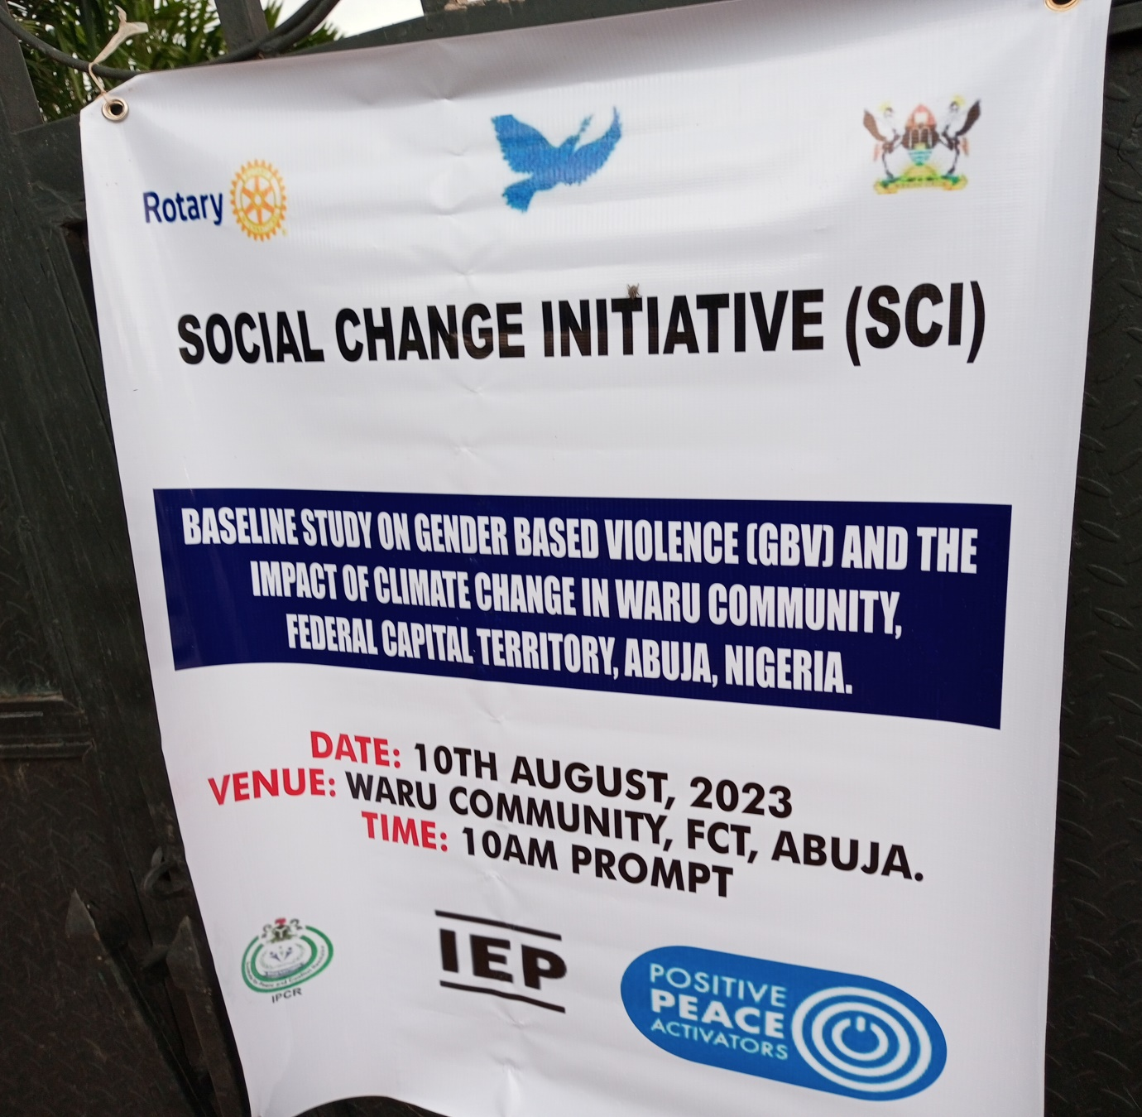

**Picture 5:** Participants at the SCI Implementation

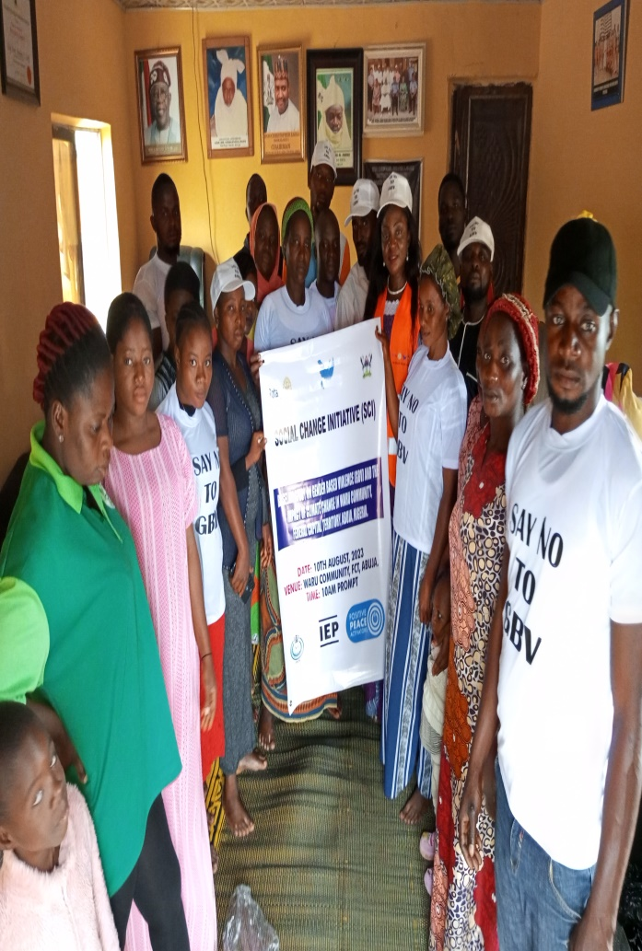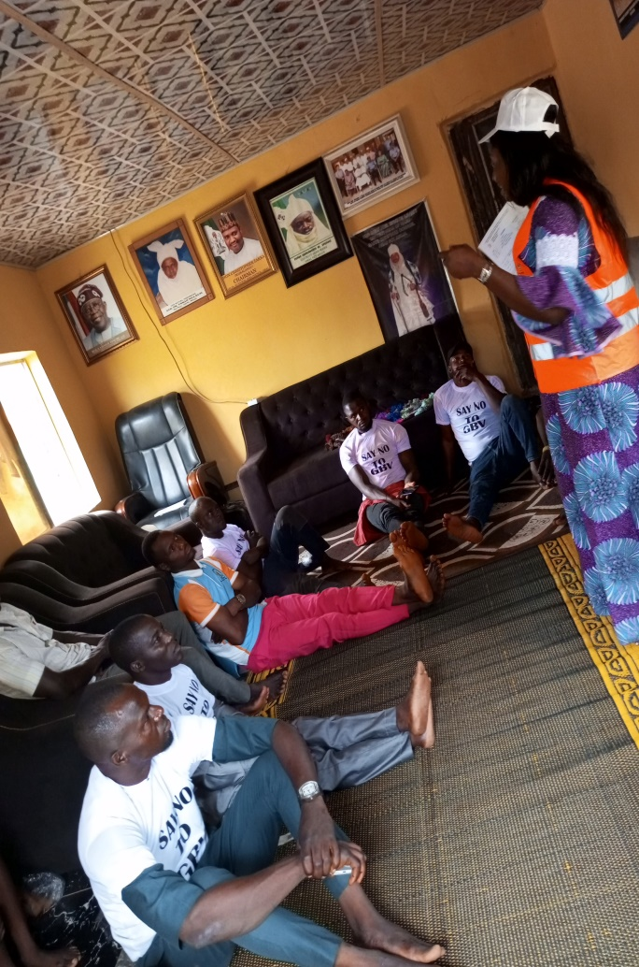

**Participant Testimonies**

1. According to a female participant, Juliet Josiah *“ My husband started becoming less concerned about me and the children. No food, no money with our children. I decided to be doing small business. I go to buy crops and fruits from another village, when I sell, my husband wants me to buy food and everything for the family. I used to help, but it is too much. My husband is not doing anything. He drinks alcohol. I am happy for this programme, I now understand that no money and food because of bad soil and cattle eating our crops, it can cause GBV. I will try and make peace so that me and my husband can find another thing to help us”.*
2. Ezra Angulu said he thought it was a cause when his crops where not yielding increase. Being a cultural and traditional man, may be the gods are not happy. And what could be the solution, because the farm produce was not enough for sell and feeding his family. During the SCI baseline study and focus group discussion, he shared his experience. With the knowledge about climate change, he now understands that it is not a cultural or spiritual issue, rather natural and man-made. The burning of bush, flooding and deforestation affects the soil strength and yields.

**References**

Al Gore, An Inconvenient Truth, The Planetary Emergency of Global Warming and What We Can Do About It (Rodale Books, 2006). Intergovernmental Panel on Climate Change, Climate Change 2007: The Physical Science Basis (Cambridge University Press, 2007). <http://www.ipcc.ch/>

Bast. J.L (2010). *Seven Theories of Climate Change.* Science & Public Policy Institute (SPPI). Reprint Series.

Bello O. B. et al. (2012*). Evidence of Climate Change Impacts on Agriculture and Food Security in Nigeria.* International Journal of Agriculture and Forestry*. Vol.* 2, No. 2. Pp 49-55

Bucholtz, Mary and Kira Hall (2006) *Gender, Sexuality and Language*. In Keith Brown(ed.). Encyclopedia of Language and Linguistics, Vol.2. Pg 756 - 758Oxford, UK.

# Caridade S.M, Vidal D.G and Dinis M.A (2021). *Climate Change and Gender-Based Violence: Outcomes, Challenges and Future Perspectives*. [World Sustainability Series](https://link.springer.com/bookseries/13384) Book Series (WSUSE)

Galtung, J (2011). Peace, Positive and Negative.

[https://onlinelibrary.wiley.com/doi/full/10.1002/9780470672532.wbepp189](https://www.bing.com/ck/a?!&&p=9097a4273359882dJmltdHM9MTY5Mzc4NTYwMCZpZ3VpZD0yZjgxYTQ2Zi1jOWNlLTZkMTgtMGUzNS1iNmIyYzhkMzZjZGEmaW5zaWQ9NTIyOA&ptn=3&hsh=3&fclid=2f81a46f-c9ce-6d18-0e35-b6b2c8d36cda&psq=Galtung+1971+on+positive+peace&u=a1aHR0cHM6Ly9vbmxpbmVsaWJyYXJ5LndpbGV5LmNvbS9kb2kvZnVsbC8xMC4xMDAyLzk3ODA0NzA2NzI1MzIud2JlcHAxODk&ntb=1" \t "_blank)

IPCC (Intergovernmental Panel on Climate Change). 2007. *Climate Change 2007: The Physical Science Basis.* Contribution of Working Group I to the Fourth Assessment Report of the Intergovernmental Panel on Climate Change. Cambridge University Press, Port Chester, New York

Hawkesworth, M (2019*) Gender and Political Theory: Feminist Reckonings.* Vol 31, Issue 2. Pp231 ISBN: 978-1-5095-2581-2 (pbk). Polity Press.

Homer-Dixon, T. (1991). *On the Threshold: Environmental Changes as Causes of Acute Conflict.* International Security, 16(2): 76-116.