**SOCIAL CHANGE INITIATIVE IMPLEMENTATION REPORT FORMAT FOR ROTARY PEACE FELLOWS**

**Peace Fellow details: Mohamed Tibin – Sudan ,** [**mohamedkhalifa222@gmail.com**](mailto:mohamedkhalifa222@gmail.com)

# SECTIONS

Title: (20 words)

Role of Youth in Social Peace and Response to Climate Change in North Kordofan State, Under ***Theme “Yes I Can”***

Location: (5 words)

Elobeid, Y-Peer Organization Office, North Kordofan State, Sudan

Start and Completion Date: (10 words)

July 12th 2023 to 20th August 2023

Abstract / Summary: (250 words)

The initiative stems from multiple assumptions, including that youth are the ones leading conflicts and wars in their societies of all kinds; youth vitality, activity, and ability to act must be transformed into positive energy to become agents of social peace rather than fuel for wars. In order for the initiative to achieve this, it focused on the general goal / overall is: Strengthening the role of youth in building social peace and responding positively to the effects of climate change by building the capacities of three youth-led organizations in the state of North Kordofan. The main problem will address it through different sets of activities.The central issue that the project initiative seeks to achieve on the ground is ***Young people*** are the ones who ***participate in internal conflicts and wars of all kinds***, which makes them vulnerable to many risks. Therefore, the initiative would like to work to change the role of young people to be able to make ***social peace and be agents*** and positive response to climate change, and that this will apply through local ***youth-led organizations***. The project design includes a number of activities that will help achieve the core objective of the initiative. The most prominent activities that will be implemented will be soft, that is, the project will focus on training and capacity building for young people who run organizations to be more able to create an impact and positive change in their communities and among their peers of young people.

The most prominent activities that were implemented through the components of the initiative were the training of 15 young people who are members of youth-led organizations through two training packages, the first package on ***Peace Building and Climate Change Essentials***, and the second package was on ***Skills of Community Mobilization, Advocacy, Proposal Writing and Report Writing.*** Among the activities implemented was an awareness campaign about the importance of **facing climate change** and the title of the campaign was: ***The importance of youth participation in combating the effects of climate change in North Kordofan State*. Purpose of the event was:** To strengthen the role of youth and youth-led organizations in positive participation in combating the effects of climate change in North Kordofan State. The implementation of the activities was preceded by conducting a baseline survey in order to determine the status of the beneficiaries of the project before implementation and to help measure the impact in the future.

# CHAPTER ONE

Introduction and Background: (800words)

Sudan suffered for a long period from civil wars and internal conflicts since or before it gained its independence from the colonial United Kingdom, where the mother witnessed the emergence of the first armed movement demanding political rights for southern Sudan. In addition, Sudan also has a long experience in tribal and ethnic conflicts, which are almost chronic and intractable at times, as well as the historical and traditional conflict between farmers and herders.   
In the year 2003, another conflict broke out in western Sudan, specifically in the Darfur region, leaving a number of nearly 300,000 dead and 2 million people among the displaced and refugees.

In general, this means that Sudan is still suffering from the repercussions of conflicts of all kinds, and the most prominent of these repercussions is the participation of an estimated part of Sudanese youth in the conflict in all its forms. This bitter reality experienced by the Sudanese people of political instability, developmental faltering and other negative effects all together led me to formulate this societal initiative for change to address this dire situation and stir the static pool

Young people are the ones who possess physical energy and vigor, in addition to enthusiasm. All these characteristics make youth potential soldiers. We know that war begins in the minds, and peace must build in those minds. This is what this initiative seeks to achieve through a general goal and functional goals, in addition to a series of intervention activities with the aim of making a positive impact among young people, making them agents of peace and supporters of environmental peace. The initiative project focuses on targeting a number of ***youth-led organizations*** and ***a group of young people*** who have a moral and personal commitment to lead social peace and respond to the effects of climate change in North Kordofan States. The project will build the capacity of three youth-led organizations in the states of North Kordofan. These organizations will be able to design and implement future projects to support social peace and respond to climate change using the positive peace methodology, and on the other hand, build the capacity of 15 young people of both sexes (Female + Male). This type of intervention considered a strategic intervention, and if it is destined to succeed that means, it will lead to raising the awareness of a large number of young people; in the project areas. Target groups will know the importance of the role of young people in creating and promoting social peace on the one hand, and on the other hand, addressing the issues and repercussions of climate change in their communities. The activities proposed for implementation, which in turn will lead to the achievement of the general goal and the interim functional goals, centered on training, afforestation, and raising community awareness of the importance of social peace and responding to climate change. The project will use the methodology of ***positive peace*** and ***social marketing***, and these methodologies will effectively help in achieving the goal of positive social change in the locations of intervention (social peace and response to climate change).

Problem Statement: (250 words)

The central issue that the project initiative seeks to achieve on the ground is ***Young people*** are the ones who ***participate in internal conflicts and wars of all kinds***, which makes them vulnerable to many risks. Therefore, the initiative would like to work to change the role of young people to be able to make ***social peace and be agents*** and positive response to climate change, and that this will apply through local ***youth-led organizations***. Youth-led organizations can lead interventions addressing youth peers, and these organizations adopt effective methodologies such as positive peace and social marketing, and adopt addressing ***youth at risk*** issues; youth to be drivers of social peace and supporters of environmental conservation by playing a positive role in responding to climate change.

Goals and Objectives: (400 words)

**Overall Goal:**

* Strengthening the role of youth in building social peace and responding positively to the effects of climate change by building the capacities of youth-led organizations in North Kordofan state.

**Functional Objectives:**

* To Strength the capacities of 30 young members(direct 15 and indirect 15) of youth-led organizations of both sexes to be able to drive social peace and advocate for environmental issues (responding to climate change).
* To promote the understanding of the youth who lead local organizations in the project areas with positive peace and social marketing methodologies in order to use them in the desired social change.
* To mobilize young people towards effective response to climate change to be champions of change to confront and reduce the effects of climate change in their communities.

Challenges and mitigation strategies: (400 words)

Through the working view of the initiative of this project, the possibility of occurrence or emergence of ***challenges*** is highly expected, and the most prominent expected challenges can summarize in the following points:

1. The poor security situation in Sudan as a result of the war that broke out on the fifteenth of last April 2023 between the Sudanese Armed Forces and the Rapid Support Forces, which led to the transformation of a number of Sudanese states into a battlefield, including the states of North Darfur and North Kordofan, which are the states in which the initiative activities are planned to be implemented.
2. Inappropriate design of project activities to address the central issue of the project (problem statement).
3. The time factor for the implementation of activities on the ground may face multiple and surprising variables.
4. The biggest challenge for the project proposal is the lack of funding for implementation phase.
5. Negative societal resistance to the principle of positive change for many considerations.

The ***strategies*** required to meet the five challenges identified above are as follows:

* The strategy that I followed to reduce the impact of this risk on the initiative project was to modify the location of implementation, as I canceled implementation in North Darfur state for security reasons, and was content with implementation only in North Kordofan state, where I now reside, despite it being a war zone. However, the planned activities were implemented in light of very complex security conditions.
* Ensure using a number of methodologies that help to identify and implement activities will be more capable of addressing the required positive changes.
* Review the implementation schedule from time to time to avoid any delay and make time more flexible.
* The challenge of financing the project is very complex, and the reduction strategy will be based on searching for the largest number of donors available, and in the event of failure, it will rely on the available self-resources and deal with them logically. I contacted the German Friedrich Ebert Organization, which is concerned with youth affairs in Sudan, in order to provide financial support for the implementation of the project. I reached positive understandings with the organization, but the outbreak of war in Sudan forced the organization to freeze its activities and close its doors in Sudan. In conclusion, I financed all project activities from my own sources until the implementation was completed successfully.
* Society's resistance to change usually expected, and the strategy for dealing with this challenge must be multi-dimensional, for example, explaining the project and its objectives clearly, in addition to preparing a deep and effective analysis of the stakeholders in particular, the expected supporters, and the influential people in society.

# CHAPTER TWO

Literature Review (1000 words)

A number of various information sources were used, including specialized reports and references, in addition to specialized training materials, and the following is a presentation of the collection titles of literature used in the project:

A number of various information sources were used, including specialized reports and references, in addition to specialized training materials, and the following is a presentation of the collection of literature used in the project:

1. ***Positive Peace Report 2022***

This report is prepared by the Institute for Economics & Peace (IEP) is an independent, non-partisan, non-profit think tank dedicated to shifting the world’s focus to peace as a positive, achievable, and tangible measure of human well-being and progress. IEP achieves its goals by developing new conceptual frameworks to define peacefulness; providing metrics for measuring peace; and uncovering the relationships between business, peace and prosperity as well as promoting a better understanding of the cultural, economic and political factors that create peace.

Positive Peace is a transformational concept because it shifts the focus away from the negative by describing the necessary conditions for peace and society to flourish. Due to its systemic nature, improvements in Positive Peace not only strengthen peace, but are also associated with many other desirable outcomes for society, such as higher GDP growth, better measures of wellbeing, higher levels of resilience and more harmonious societies. Importantly, it provides a theory of social change, explaining how societies transform and evolve. Positive Peace describes an optimal environment under which human potential can flourish. This report deals with the state of peace in the world according to the eight pillars and its relationship to economic achievement. This concept is transient to the traditional understanding of peace

1. ***Pillars of Peace***

The Pillars of Peace which have been developed by IEP from the analysis presented in this paper consist of the following elements:

• Well-functioning government

• Sound business environment

• Equitable distribution of resources

• Acceptance of the rights of others

• Good relations with neighbors

• Free flow of information

• High levels of education

• Low levels of corruption

These eight factors were found to be associated with peaceful environments and can be seen as both interdependent and positively reinforcing of each other. This means the relative strength of any one ‘pillar’ has the potential to either positively or negatively influence peace.

1. ***Youth, Peace and Security (A programming Handbook)***

Youth, Peace and Security: A Programming Handbook, developed by the United Nations with the generous support of the Folke Bernadotte Academy – the Swedish Agency for Peace, Security and Development – seeks to contribute to the operational readiness and capacity of United Nations practitioners to implement the youth, peace and security (YPS) agenda. For the United Nations, the development of the handbook was led by the United Nations Population Fund, the United Nations Development Programme and the Peacebuilding Support Office in the Department of Political and Peacebuilding Affairs, in consultation with a task force including various United Nations entities represented at global, regional and country levels, as well as Folke Bernadotte Academy partners. The handbook is intended to be used by country, regional and global teams in the United Nations system, but it can also provide insights and guidance to field practitioners beyond the United Nations, including other international or regional organizations, national counterparts, youth-led and youth focused organizations, movements and networks, and peacebuilding organizations.

1. ***Youth Peace Building Training Manual***

This training manual is a step-by-step guide for facilitators to equip refugee youth and host community youth with key skills in peacebuilding and conflict resolution. This training manual will provide facilitators with:

1. A deeper understanding of key skills and concepts to effectively manage and peacefully transform conflict.

2. A step-by-step guide to support them in sharing these skills and concepts with youth. This training manual will provide youth trainees with:

1. Essential skills in leadership, communication, peacebuilding and conflict management.

2. Opportunities to practice and apply their skills.

3. An opportunity to learn from their peers and form a network of young changemakers with shared values

The manual was developed by the UNHCR Regional Bureau for the East, Horn of Africa and Great Lakes under the auspices of the Regional Youth Peacebuilding Programme, with the support of the Bridgeway Group, consultant and field staff who tested the tool across Kenya, Sudan and Uganda. Design and layout by Talking Story. Made possible by the support of the Dutch Ministry of Foreign Affairs/Prospects

1. ***At the Frontier: Young People and Climate Change***

This is the fourth edition of the Youth Supplement to UNFPA’s State of the World Population Report. This Youth Supplement addresses climate change and young people, through the lens of what impact climate change is predicted to have, and what that will mean for young people’s lives, livelihoods, health, rights and development. The Youth Supplement explores these issues because the young people of today will be standing in the frontline in the coming decades, meeting the challenges posed by climate change.

1. ***Youth in action on climate change: inspirations from around the world***

Climate change creates elevated levels of uncertainty about our future and amid this uncertainty, one thing is certain. We will leave the Earth to our children, young people and future generations. Young people are increasingly aware of the challenges and opportunities that the necessary transition to low carbon growth entails, and many are joining the global dialogue on solutions, getting involved and acting. As young people work across the globe to determine their future by acting on climate change, their actions inspire us all. This new generation has an increasingly strong social and environmental awareness, the energy and knowledge to lead our societies towards a low carbon and climate resilient future. This publication was prepared with the financial support from the European Union and the Swedish International Development Cooperation Agency. Thanks go to the many youth leaders and youth organizations, who have contributed to this endeavor, as well as the members of the United Nations Joint Framework Initiative on Children, Youth and Climate Change.

1. ***Climate change and human health***
2. ***As study on the roles and contributions of youth to peace and security in Africa***
3. ***Climate Change Information Kit***
4. ***Climate Change 2022 (Impacts, Adaptation and Vulnerability)***

Theoretical Underpinnings (1000words)

The project has used a number of theories that will help in achieving the general objective of the project in addition to the specific complementary objectives. The most prominent theories or methodologies that will contribute to achieving what was mentioned above, we find the following:

1. Participatory Learning
2. Peer Education
3. Social Marketing

***1.Participatory Learning***

These are methods which provide opportunity for the learners to get actively involved in their own learning. With this method, the pupils explore, interact with the learning materials, share views and ideas, learn in groups, investigate, make decisions, observe, and solve practical problems. These methods are experiential as pupils learn by doing activities. Participatory methods are also called active learning or learner-centered learning, because these methods take account of learners needs; abilities, interest, age, background, and experiences, including special needs. adult educators know very well that there is no one method and material for making adult learning sessions successful and effective. Your understanding of various methods and materials for using in different contexts of adult learning lead you to a more varied and interesting way of holding the attention of adult learners. Participatory Learning and Action originated in the southern hemisphere in the 1970s, as a method of consultation and engagement with rural communities in developing countries, Particularly in Africa. It was developed on the principle that poor and exploited people can and should be enabled to analyze their own reality, and to examine their own problems, set their own goals, and monitor their own achievements. In essence it was based on empowerment, i.e. the commitment to helping people take more control over their lives. The project will use this theory to make the training activities effective in transferring knowledge and exchanging experiences among the youth themselves

**2.*Peer Education***

Peer education is a popular concept that implies an approach, a communication channel, a methodology, a philosophy, and a strategy. In the olden days of kings and queens (in England), peers were nobleman, aristocrats, lords, titled men and patricians. The English term “peer” refers to "one that is of equal standing with another; one belonging to the same societal group especially based on age, grade or status". In modern times, the term has come to mean fellow, equal, like, co-equal or match according to the dictionary of synonyms (Oxford Thesaurus). Recently the term is used in reference to education and training. Peer education is now viewed as an effective behavioral change strategy, and it draws on several well-known behavioral theories – Social Learning Theory, Theory of Reasoned Action and Diffusion of Innovation Theory. In the initiative project, this theory will be used to communicate strategic messages from peer youth to each other for the effectiveness of the methodology.

***3.Social Marketing***

“Social Marketing is the process of influencing human behavior on a large scale, using marketing principles for the purpose of societal benefit rather than commercial profit.” (Pamela Mae, 2001), another definition says that: “The design, implementation and control of programs aimed at increasing the acceptability of a social idea, or practice in one or more groups of target adopters.” (Kotler and Zaltman, 1971). IN 1952, G. D. Wiebe raised the question "\Why can't you sell brotherhood like you sell soap?"1 This statement implies that sellers of commodities such as soap are generally effective, while "sellers" of social causes are generally ineffective. At the end we find that social marketing is a process that applies marketing principles, tools and techniques to create, communicate and deliver value in order to influence target audience behaviors that benefit society (public health, environment and social change …etc.). The reason that led me to use this theory or methodology is that it is effective in communicating the values ​​of societal change in innovative and unconventional ways, in addition to its remarkable impact.

Change theory and how it was applied: (700 words)

The theory of change that the project seeks to create within the scope of its work based on a number of pillars that integrated with each other in order to enhance opportunities for positive change. In general, the pillars of the project’s theory of change summarized in four essential pillars, which are as follows:

***The first pillar:*** building the capacities of youth-led organizations in the field of peace building and response to climate change. A number of carefully selected training activities will be carried out that are compatible with the desired change. These activities will consider the shortcomings and gaps in the capabilities of the beneficiary group (youth who lead local organizations). The activities will focus on helping young people to be drivers and agents of positive change in their communities.

***The second pillar:*** the adoption of youth organizations benefiting from the project’s services, new methodologies to spread the values ​​of social peace, and on the other hand, to create a collective positive understanding of the effects of climate change, and the approaches are **positive peace** and **social marketing.**

***The third pillar:*** creating a platform for positive networking of youth-led organizations with other organizations with high professional experience. The project will encourage youth-led organizations to network with national and international organizations with expertise in the fields of peacebuilding and response to climate change, in order to gain experience from these organizations and deepen the learning cycle between generations.

***The fourth pillar:*** creating a common understanding of the values ​​of positive peace and the importance of confronting the effects of climate change using accompaniment methodologies, it helps to address all generations and age groups.

The aforementioned four pillars will contribute together to achieving the values ​​of the desired change theory that the project is working to achieve on the ground.

All four pillars will play a fundamental and pioneering role in making the theory of the desired change a reality that will cumulatively change the reality experienced by societies to a new one based on the principles and values ​​of positive peace as well as echo peace.

Methods and Design: (800 words)

The general methodology that the project followed during the implementation phase a composite methodology, that is, more than one methodology that will work in an integrated manner with the aim of achieving the overall objective of the project in addition to the products that will lead to positive change based on the results.

***The first method: Participatory Learning***

Participatory learning methods based on experiential learning that lets young people feel, think and act out of their comfort zone in order to challenge stereotypes and become actively involved in pursuing their personal growth whilst developing key life skills and other sides of the life. According to the Council of Europe, participatory learning has the following features:

• Participatory and learner-centered

• Holistic and process-oriented

• Close to real-life concerns, experiential and oriented to learning by doing, using intercultural connections and creating empathy

• Voluntary and (ideally) open-access

• Aims above all to convey and practice the values and skills of democratic life

• Balanced interaction between values, knowledge and skills dimensions of learning

• Linking individual and group learning, creating connections at local, regional, national and international level

• Symmetrical teaching/learning power relations.

Participatory methods include games, role-plays, experimentation, discussion, inquiry based, problem solving, projects, rhymes, storytelling, debate, and case studies. This approach will help me to deliver an interactive training workshop.

***The second method: Positive Peace***

Positive Peace as a term first introduced in the 1960s by Norwegian sociologist Johan Galtung and historically understood qualitatively based on idealistic or moral concepts of a peaceful society. The distinguishing feature of IEP’s work on Positive Peace is that it is empirically derived and therefore conceptually different from Galtung’s version. Positive Peace defined as the attitudes, institutions and structures that create and sustain peaceful societies. Positive peace is a concept or approach that interprets peace in a comprehensive and non-traditional way, which leads to a deep understanding of peace that goes beyond violence and conflict to a flexible concept that accommodates the root causes of conflict and violence while providing a protective environment from future conflicts. Positive peace as a relatively recent approach will help the beneficiaries of the project to form an advanced and deeper understanding with regard to the promotion of social peace in the societies in which they live.

***The third pillar: Social Marketing***

“Social Marketing is the process of influencing human behavior on a large scale, using marketing principles for the purpose of societal benefit rather than commercial profit.” (Pamela Mae, 2001) another concept explained it as “The design, implementation and control of programs aimed at increasing the acceptability of a social idea, or practice in one or more groups of target adopters.” (Kotler and Zaltman, 1971). This approach using in planning the process of social change in particular related to behaviors and trends and be effective in responding to climate changes in society.

***The fourth pillar: Peer Education***

Peer education is the process whereby well-trained and motivated young people undertake informal or organized educational activities with their peers (those similar to themselves in age, background, or interests). These activities, occurring over an extended time, that aimed at developing young people’s knowledge, attitudes, beliefs, and skills and at enabling them to be responsible for and to protect their own health. Peer education can take place in small groups or through individual contact and in a variety of settings: schools, universities, clubs, churches, workplaces, street settings, shelters, or wherever young people gather. The project will harness this approach to enhance the positive role of youth in teaching the values ​​of social peace among their peers, and on the other hand, it will strengthen the response to climate change.

# CHAPTER THREE

Interventions and Activities: (1200 words)

The period of implementation of the project activities extended for approximately a month and a half. During the implementation period of the initiative's components, we find that the most important activities and interventions that have been implemented are placed in the following context:

* ***3 coordination meetings*** were held with the directors of three youth-led organizations in North Kordofan State for the purpose of enlightening them about the initiative, its components, and the prospects for joint cooperation with these organizations.
* Implementation of a baseline survey in North Kordofan, in which 53 young men of both sexes participated, the purpose of it to measure the initial information possessed by young people about social peace and climate changes, and compare the result with another survey that might be in the future.
* The initiative implemented a five-day integrated training program for 15 members of youth-led organizations in North Kordofan State, as follows:

***First: Training Package #1:***

The first package was named “***Peace Building and Climate Change Essentials workshop***” and its time period was two days 5th – 6th August 2023. 15 young people actually participated in the first package, and the main purpose of the package is: The main purpose of the training package, in general, is to provide the 15 youth beneficiaries, representing three youth-led organizations in North Kordofan state, with initial knowledge and skills on building social peace, its importance and ways to enhance it, and on the other hand, identifying the basic concepts of climate change and its indicators as well as its effects on communities.

* Explain the basic concepts related to social peace and climate change.
* Understanding the relationship between social peace and climate change.
* Distinguish between the number of conflict analysis tools and determine the use of each of them.
* Explain the concept of positive peace and then define the positive peace pillars.

***The table # 1: shows the result of the final evaluation of training package #1***

|  |  |  |  |  |  |  |  |
| --- | --- | --- | --- | --- | --- | --- | --- |
|  |  | Excellent | V.Good | Good | Medium | Adequate | Poor |
| Total number and % of participants that felt purpose and objectives of the training have maintained: | Number | 7 | 6 | 0 | 0 | 0 | 0 |
| % | 53.8 | 46.1 | 0 | 0 | 0 | 0 |
| Total number and % of participants that rated the relevance of the training content to their work and/or life: | Number | 6 | 3 | 4 |  |  |  |
| % | 46.1 | 23 | 30.7 | 0 | 0 | 0 |
| Total number and % of participants that felt their knowledge and skills have improved: | Number | 4 | 5 | 4 |  |  |  |
| % | 30.7 | 38.4 | 30.7 | 0 | 0 | 0 |
| Total number and % of participants that rated the training styles\ techniques as useful: | Number | 1 | 7 | 2 | 3 |  |  |
| % | 7.6 | 53.8 | 15.3 | 23 | 0 | 0 |
| Total number and % of participants that rated the effectiveness of the facilitation(facilitator) as: | Number | 6 | 5 | 2 | 0 | 0 | 0 |
| % | 46.1 | 38.4 | 15.3 | 0 | 0 | 0 |
| Total number and % of participants that rated the interaction and general level of participation as: | Number | 6 | 6 | 1 | 0 | 0 | 0 |
| % | 46.1 | 46.1 | 7.6 | 0 | 0 | 0 |
| Total number and % of participants rated the Administrative arrangement of training workshop (coordination, services and etc) | Number | 3 | 2 | 4 | 1 | 0 | 3 |
| % | 23 | 15.3 | 30.7 | 7.6 | 0 | 23 |

According to the results of the final evaluation of the training workshop, and when the trainees were asked about what are the most important essential learning points that they got out of the workshop and have the ability to apply them practically in the near future, they answered the following:

* Effective use of conflict analysis tools
* The concept of environmental peace and the concepts of climate change, its causes and indicators.
* The concept of social peace and other related concepts.
* Pillars of social peace and how to sustain it
* The role of youth in facing the effects of climate change
* The pillars of positive peace and its comparison with traditional peace

***Rabaa Aladwia Abdelrazeg Abdo*** *says that*: “One of the essential points that emerged from this training workshop is the concept of positive peace. The importance of the point for me lies in the fact that positive peace is a relatively new concept and more comprehensive than the traditional concept of peace that we know before”. Rabaa adds “I will collect more information about positive peace for more understanding, and I will certainly convey the concept to other youth who did not attend the workshop”.

***Second: Training Package #2:***

Training Package #2 is titled: Skills of Community Mobilization, Advocacy, Proposal writing and Report writing Workshop that conducted on 12th \ 13th \ 14th August 2023 in Youth Peer Education Network Training Hall – Elobeid, North Kordofan State. The second package of the training program aims to provide the 15 young participants, representing 3 youth-led organizations, with initial skills and necessary knowledge in three basic fields: community mobilization, advocacy, proposal writing, and report writing. As for the technical objectives that the training workshop sought to achieve over the course of the three training days, they can be summarized in general as follows:

* The ability of the trainees to explain the basic concepts of the training package easily and efficiently and their ability to transfer them to others from their young peers.
* A deep understanding of the steps required to prepare an effective and successful advocacy plan on the ground.
* Determining the importance of community mobilization and highlighting its role in activating community participation and promoting accountability values.
* Differentiating between the component parts of the proposal, and on the other hand, realizing and understanding the problem analysis tools.
* Participants gained the ability to mention the constituent parts of the report and then answer the question of what are the characteristics of a good report?

***The table # 2: shows the result of the final evaluation of training package #2***

|  |  |  |  |  |  |  |  |
| --- | --- | --- | --- | --- | --- | --- | --- |
|  |  | Excellent | V.Good | Good | Medium | Adequate | Poor |
| Total number and % of participants that felt purpose and objectives of the training have maintained: | Number | 9 | 4 | 1 | 0 | 0 | 0 |
| % | 64.2 | 28.5 | 7.1 | 0 | 0 | 0 |
| Total number and % of participants that rated the relevance of the training content to their work and/or life: | Number | 11 | 3 | 0 | 0 | 0 | 0 |
| % | 78.5 | 21.4 | 0 | 0 | 0 | 0 |
| Total number and % of participants that felt their knowledge and skills have improved: | Number | 4 | 9 | 1 | 0 | 0 | 0 |
| % | 28.5 | 64.2 | 7.1 | 0 | 0 | 0 |
| Total number and % of participants that rated the training styles\ techniques as useful: | Number | 2 | 9 | 0 | 3 | 0 | 0 |
| % | 14.2 | 64.2 | 0 | 21.4 | 0 | 0 |
| Total number and % of participants that rated the effectiveness of the facilitation(facilitator) as: | Number | 7 | 5 | 2 | 0 | 0 | 0 |
| % | 50 | 35.7 | 14.2 | 0 | 0 | 0 |
| Total number and % of participants that rated the interaction and general level of participation as: | Number | 5 | 7 | 2 | 0 | 0 | 0 |
| % | 35.7 | 50 | 14.2 | 0 | 0 | 0 |
| Total number and % of participants rated the Administrative arrangement of training workshop (coordination, services and etc) | Number | 0 | 1 | 7 | 2 | 0 | 4 |
| % | 0 | 7.1 | 50 | 14.2 | 0 | 28.5 |

According to the results of the final evaluation of the training workshop, and when the trainees were asked about what are the most important essential learning points that they got out of the workshop and have the ability to apply them practically in the near future, they answered the following: The pivotal learning points that the participants listed as content that was understood, assimilated and digested, and then they have the desire and ability together to transfer it to others from their peers or to practice it in a practical way in the context of their work in the humanitarian field. We summarize them as follows:

* Knowing the drafting of reports and its administrative importance, types and reasons for their use.
* The importance of writing an effective proposal in serving the goals of communities.
* How to set up a successful and effective advocacy campaign.
* Learn about community mobilization and mobilization tools and the specifications of a good community mobilizer.
* The standard way to arrange the parts of the report.
* Specifications of a good and convincing proposal for the donor.
* Basic concepts associated with community mobilization and advocacy.

***Mojahid Ahmed Abbas Ahmed*** *says that:* “Today I learned how to write an effective financing proposal and the importance of this knowledge to me because it develops my skills in preparing proposals and helps me to advance in the field of project management, and I will work to apply what I learned directly in the organization to which I belong ".

**Third: Awareness Campaign on the Importance of Facing Climate Change**

On August 20, an awareness campaign was conducted on the effects of climate change in the state of North Kordofan, where the number of attendees was ***approximately 20 youth both sexes***. The campaign activities were implemented by two trainees using peer education and participatory learning methodologies, noting that the attendance was diverse. The title of the campaign is as follows: **The importance of youth participation in combating the effects of climate change in North Kordofan State,** the purpose of the campaign isto strengthen the role of youth and youth-led organizations in positive participation in combating the effects of climate change in North Kordofan State. Among the most important findings of the campaign are what will be mentioned later:

* The participants in the discussion session unanimously agreed that climate change is of great importance, and it turned out that they have a good knowledge of the concept, causes and effects.
* Participants mentioned the indications of the impact of North Kordofan state on climate change, for example, they referred to the unjust cutting of trees, the noticeable rise in temperatures, and desertification in the northern part of the state, in addition to other important indicators.
* Participants stressed that the urgent issues that need urgent advocacy in North Kordofan state are the desert encroachment and the removal of vegetation cover (the illegal cutting of trees), in addition to unregulated mining and its environmental impact.
* The youth participating in the campaign put forward specific proposals aimed at promoting the role of youth in facing the effects of climate change in North Kordofan state, through raising awareness, training, capacity building and sharing information with peer youth.

Key findings / impact: (800words)

After the completion of the two training packages with remarkable success, it was found that the participants in the workshop who were members of youth-led organizations in North Kordofan state ***possessed the minimum level of knowledge and skills that make their role effective in the programmatic interventions of their organizations*** with regard to peace building and responding to climate change ; On the other hand, the youth participants in the training ***signed a document of moral commitment to be agents of peace and to respond to climate change*** in the societies in which they reside, and this is considered one of the most positive training outcomes. Later, the final outputs and impact indicators of the training program will be mentioned according to each training package separately.

***First: Training Package #1***

* Providing the participants in the training workshop with a minimum level of basic skills in the field of peacebuilding and responding to climate change.
* Improving the ability of youth participants in the training workshop to understand the close relationship between climate change, conflicts and wars.
* The participants showed the moral commitment to adopting the concept of positive peace as an effective means to achieve the values ​​of social peace.
* The commitment of each participant in the workshop to transfer the knowledge and skills acquired during the workshop to their young peers.
* Adopting a deep understanding of the importance of the values ​​of social peace and the seriousness of the effects of climate change on Sudan in general and the state of North Kordofan in particular.

***Second: Training Package #2***

* The beneficiaries of the training (15 young people they represent 3 local youth-led organizations in North Kordofan State, ) are able to understand and know the mobilization of community and the positive advocacy of issues that have importance and priority to community members.
* Through the results of the final evaluation of the second training package, it appears that the participants in the training have initial knowledge about proposals writing in a standard manner, which improves their ability to write proposals or contribute effectively to writing in the organizations to which they belong.
* Participants are able to plan, implement and evaluate community mobilization and advocacy campaigns for real issues of concern to the communities in which they live.
* The youth group that received the training showed an appreciative understanding of the importance of reports writing in the life cycle of management and on the other hand as an effective means of communication. Now they have the ability to define the types of reports and their functions as well as the steps required to write a modal and standard report.

# CHAPTER FOUR

General Conclusion (300words)

The initiative project is an attempt to transform the negative capabilities of young people within the scope of the project into positive energy that supports social peace and an effective response to climate change. The problem or central issue addressing that: Young ***people*** are the ones who ***participate in internal conflicts and wars of all kinds***, which makes them vulnerable to many risks. Therefore, the initiative would like to work to change the role of young people to be able to make ***social peace and be agents*** and positive response to climate change, and that this will apply through local ***youth-led organizations***. The findings of this project is to create a group of young people with a personal and moral commitment to be agents for building social peace in their societies, and on the other hand, ambassadors and champions of change with regard to responding to climate change. The training program for the initiative project, which represented the main focus of the implemented activities, worked on providing the direct beneficiaries, who are 15 young people who are members of 3 youth-led organizations in the state, with the basic knowledge and skills required as inputs to build the capacities of the beneficiary group in the areas of: peacebuilding and response to climate change , the technical skills required for community mobilization issues, advocacy and preparing a effective proposal as well as how to write standard reports.

Finally, this simple intervention that was made by my social change initiative it clear resulted that the youth in the North Kordofan state are in desperate need of an integrated program for capacity building and training so that they have the capabilities that make them agents for building social peace and advocating for climate change issues.

Recommendations / implications for Policy: (500 words)

This initiative was implemented in North Kordofan state of and focused significantly on activating the role of youth and youth-led organizations in peace building and responding to climate change.

This initiative is likely to bring about a youth movement that will in turn raise community awareness of the importance of social peace and the need to pay attention to the effects of climate change in North Kordofan state. The policies adopted in the state of North Kordofan, which work to reduce the illegal cutting of trees and the management of natural resources, need real advocacy in order to activate the use of the laws that actually exist because they are related to local conflicts, especially the historical conflict between farmers and herders. The initiative's recommendations are summarized as follows:

* Activating and strengthening the role of youth in local organizations to support the values ​​of social peace and confront climate change in their local communities through training, capacity building and improving the capabilities of youth-led organizations at the local level.
* Linking youth organizations with funding sources at the local and national levels to sustain the efforts of these organizations to work effectively.
* Encouraging the establishment of partnerships, networking and alliances between youth-led organizations for the purpose of obtaining financing, exchanging experiences and joint learning.
* Implementation of advanced training programs in the same fields that were implemented within the activities of the initiative in order to increase areas of deep understanding of training topics.

Sustainability plan: (800words)

The sustainability plan that I propose is based on three main pillars: community, financing, and organization. These pillars must be integrated in order for the plan to be effective and to be able to accomplish what has been planned.

***Community Sustainability:*** Youth organizations will work on continuous communication with the local communities with which they work in order to raise awareness of the importance of sustaining any positive impact resulting from the initiative's interventions in its second phase, which will be carried out by members of youth-led organizations who have benefited from the training programs. The ultimate goal is to ensure community support and adoption of the initiative's positive impact in the future.

***Financial Sustainability:*** Funding is considered one of the most important pillars of the future sustainability of the impact of the project. In this direction, youth-led organizations must be linked with donors at the local and national levels. On the other hand, the principle of partnership, networking and alliances in implementing projects jointly, which helps to provide funding in the future, should be activated.

***Organizational Sustainability:*** Organizational sustainability is based on the fact that these youth-led organizations in North Kordofan state are viable for a longer period of time and that they have the elements and ingredients that make them exist for a number of years in the near future. Organizational sustainability will focus on institutional development, which should be an important element for survival and aid in the existence of organizations for a long time. Governance and organizational institutionalization will be among the most prominent elements of this sustainability, as well as the smooth rotation of the sessions of the Board of Directors.

# APPENDICES

**APPENDICES # 1 Pictorials**

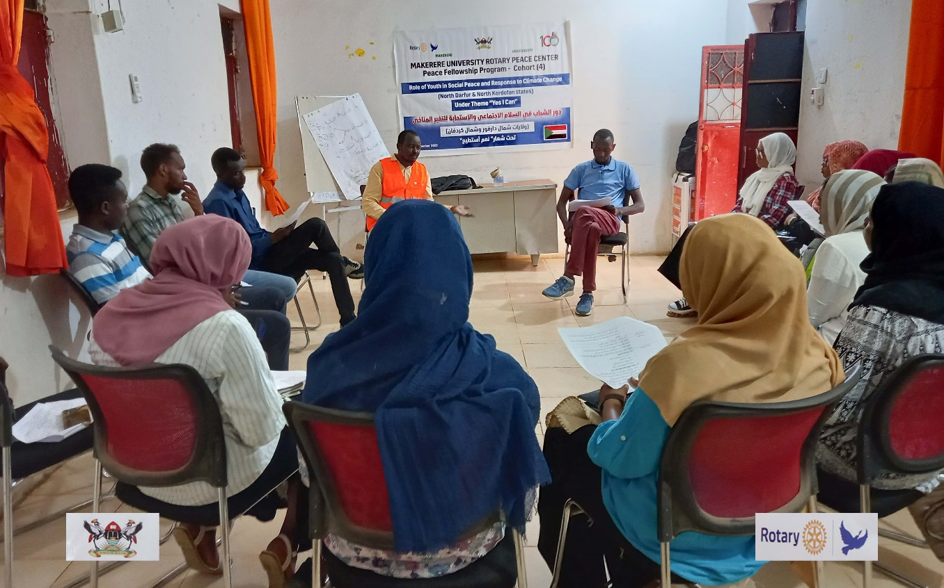

***Figure 1 Orientation Session to kick off the training program***

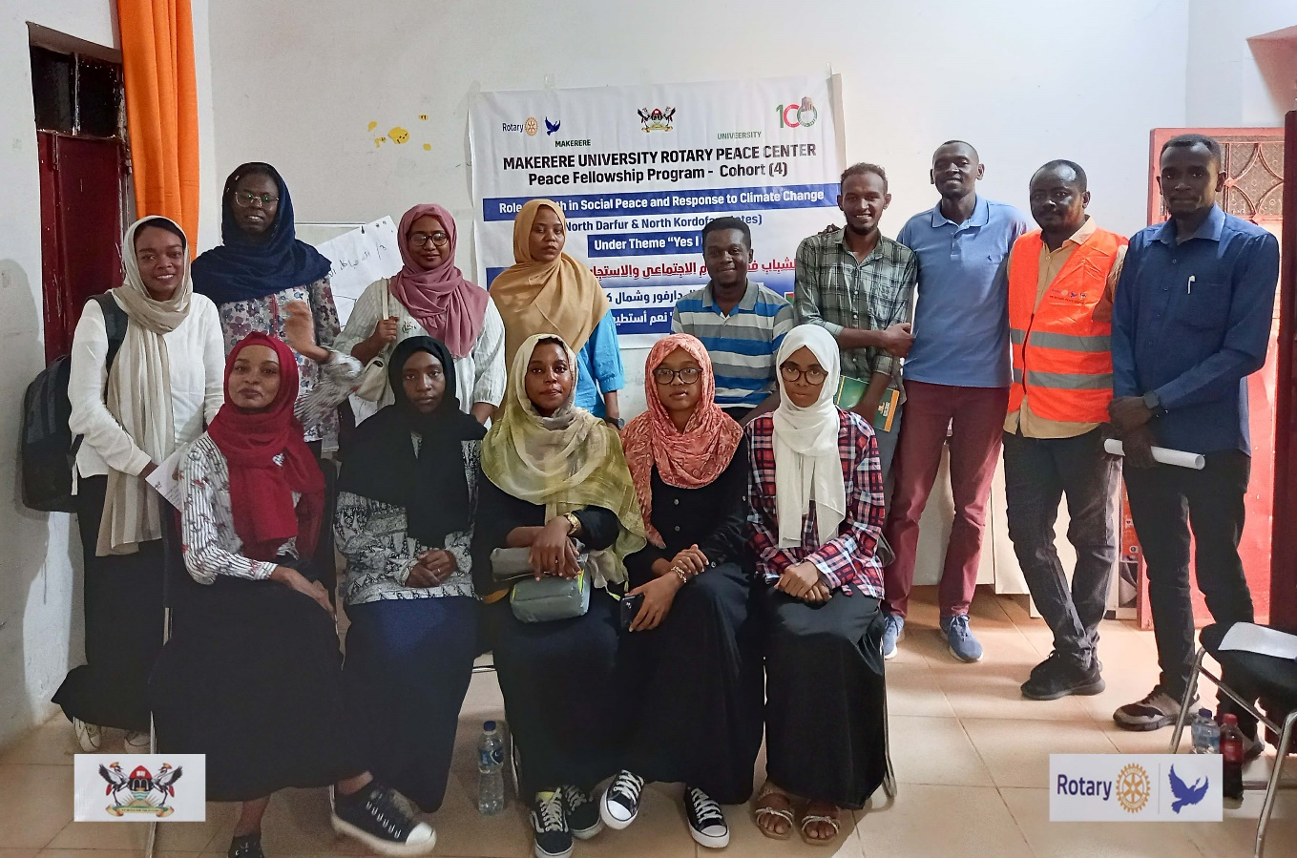

***Figure 2 Target group that benefited from training program***

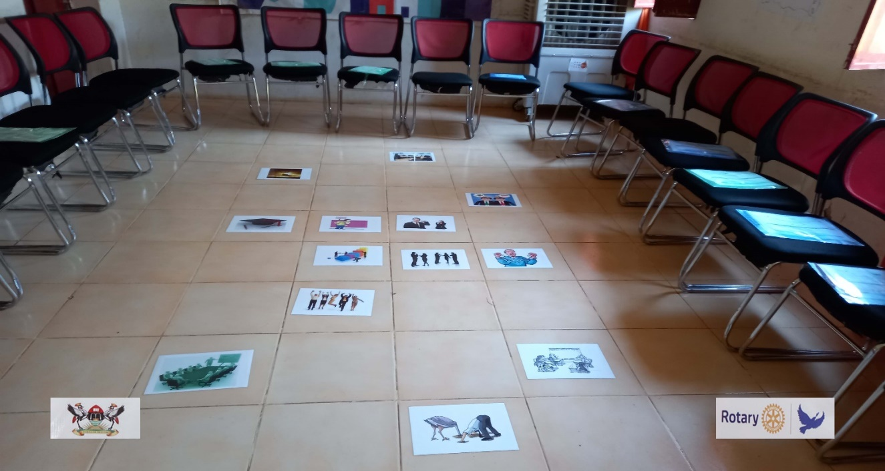

**Figure 3 Hosting Training Hall Layout - Y-Peer Office - Elobeid**

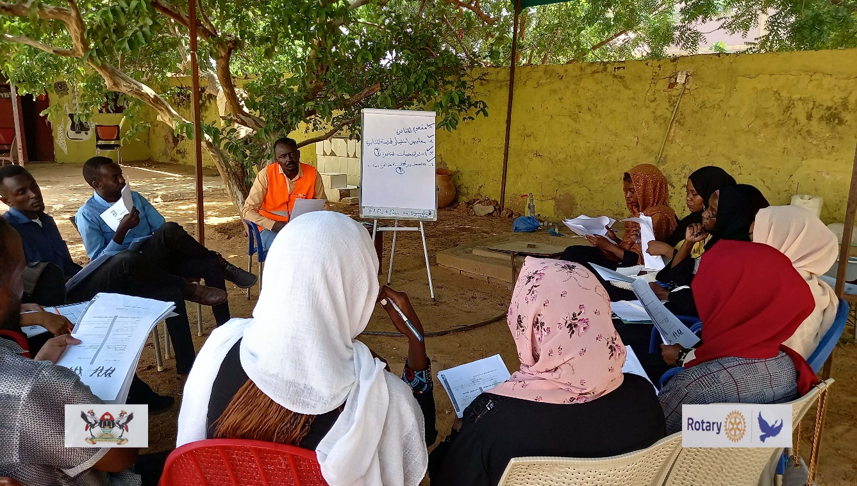

***Figure 4 Training session conducted in open air – Second Training Package***

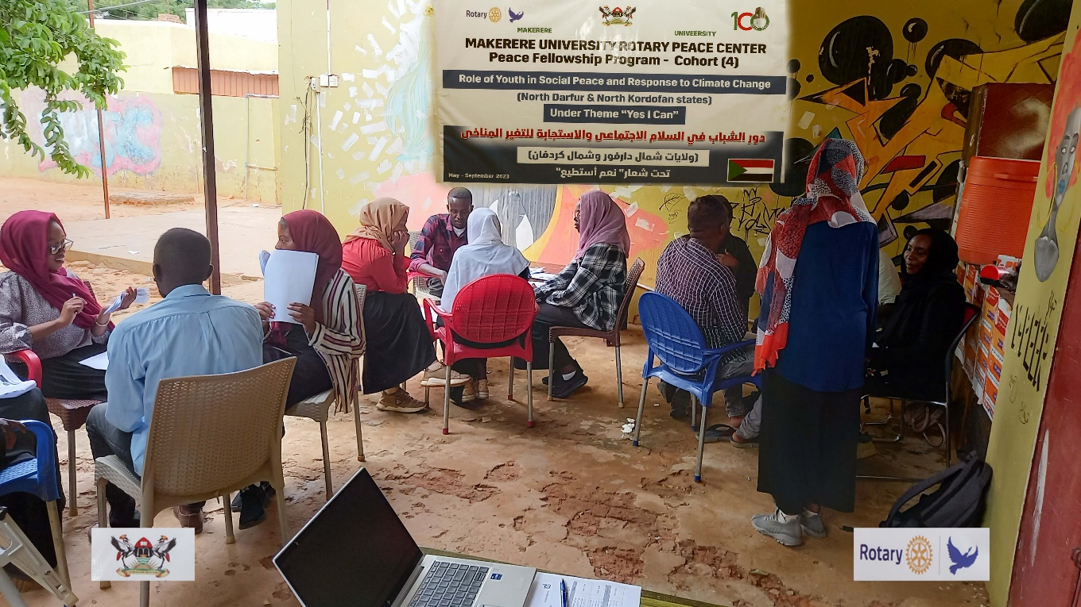

***Figure 5 Group working during the training event , Component of the proposal***

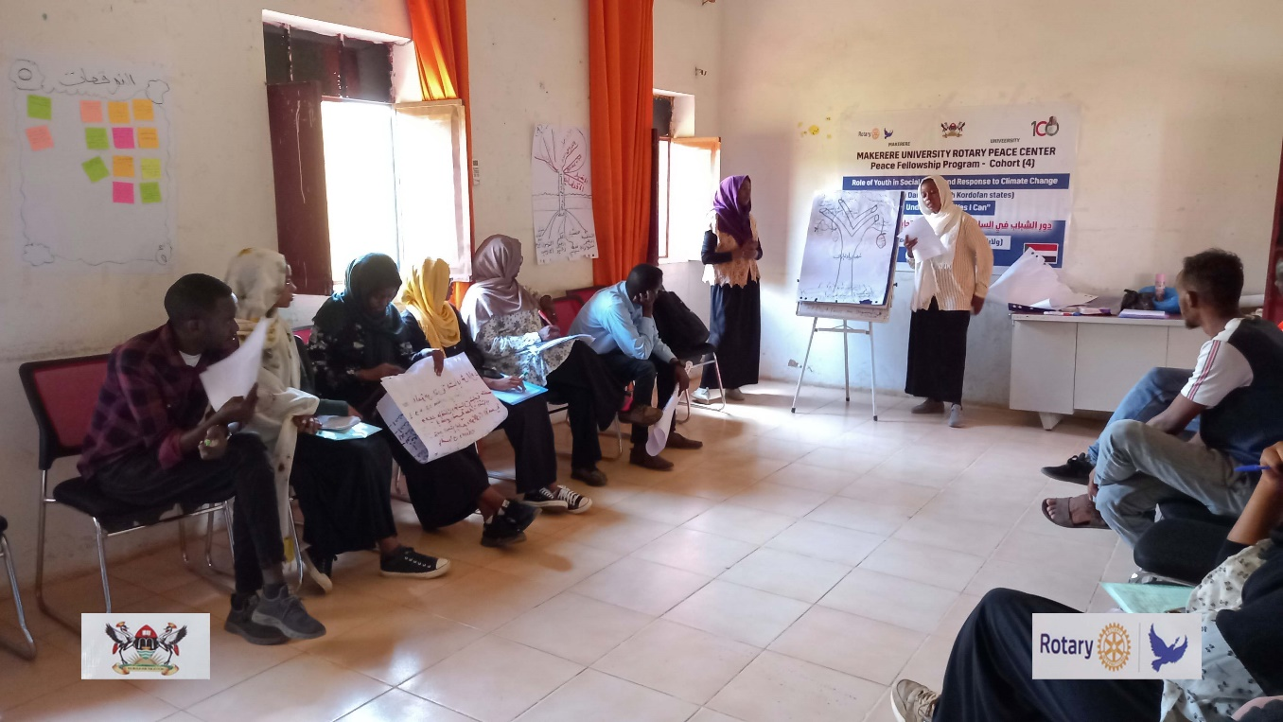

***Figure 6 group work presentation , one of participant groups present conflict analysis tools***

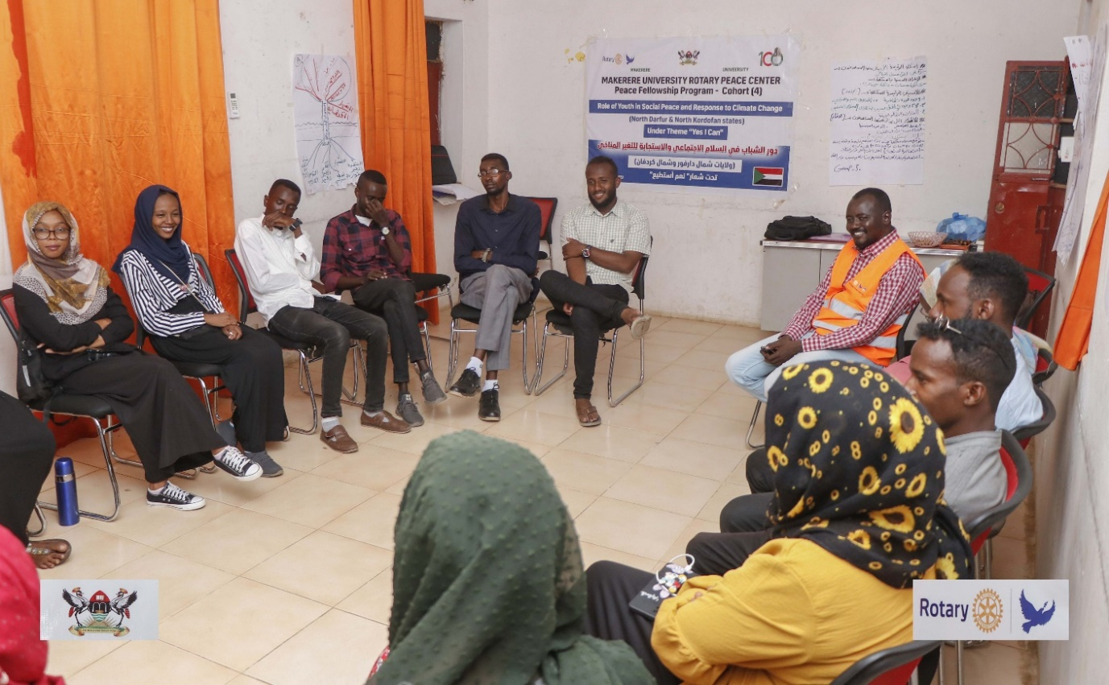

**Figure 7 Awareness Campaign on the Importance of Facing Climate Change in North Kordofan State.**

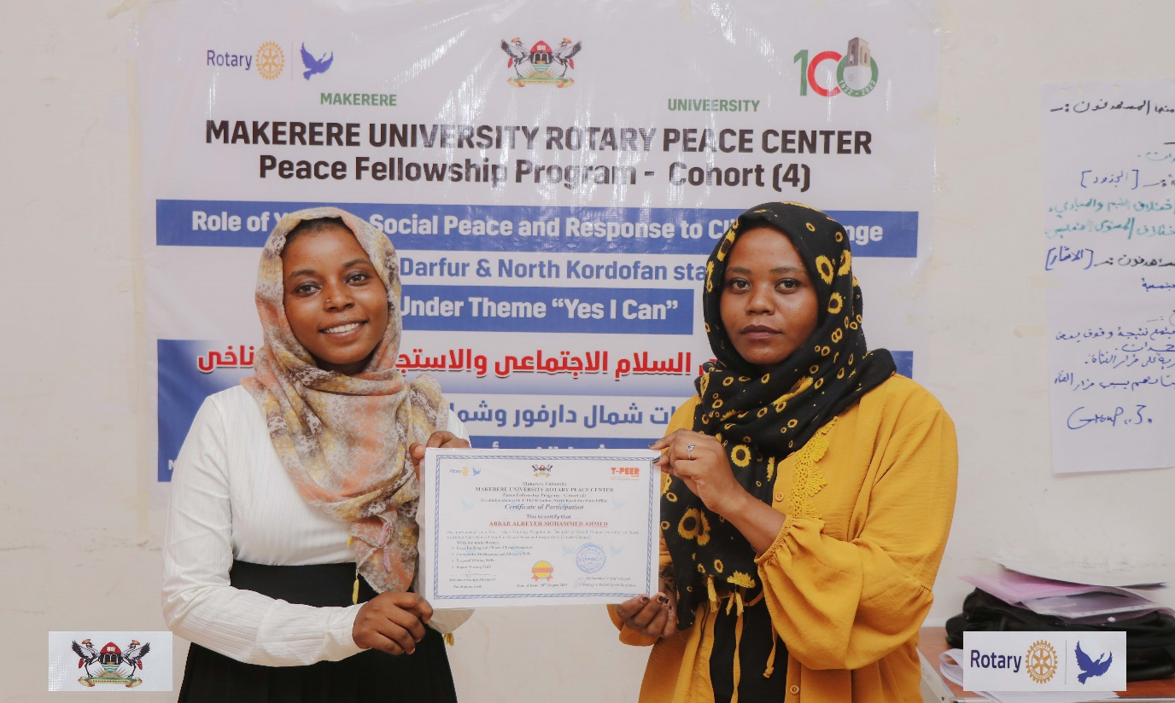

**Figure 8 Participants received certificate of participation in 5 days training**

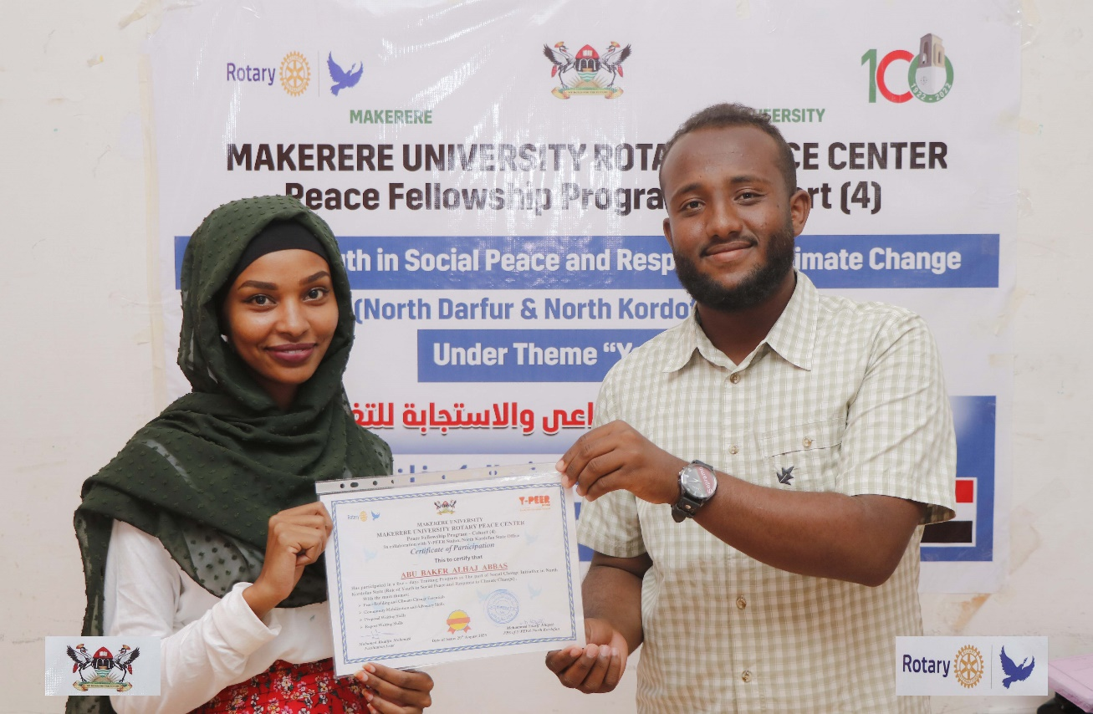

**Figure 9 Certification Ceremony in the final day of the project - Elobeid 20 August 2023**

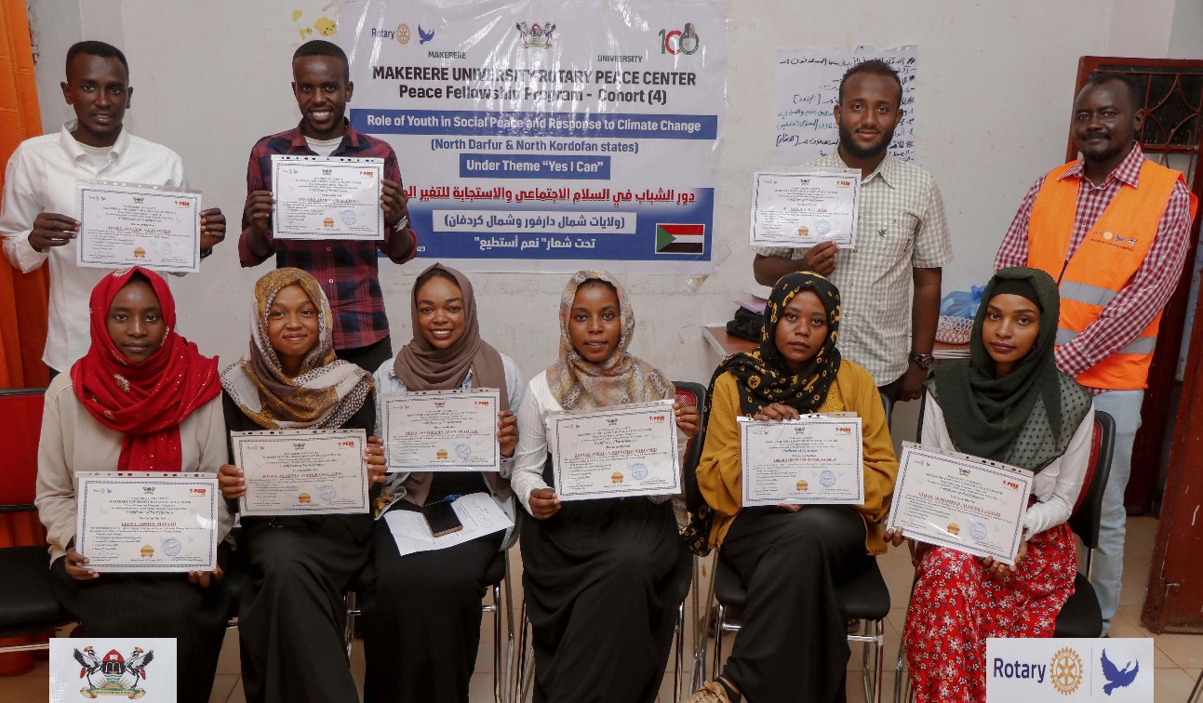

**Figure 10 Certification Group Photo**

**APPENDICES # 2 training program agendas ( separate attached)**

**APPENDICES # 3 training program attendance sheets ( separate attached)**

**APPENDICES # 4 Nomination Letter ( separate attached)**

**APPENDICES # 5** **Moral Commitment for Peace and climate change response ( separate attached)**

Pictorials Max **5pgs** with descriptions

Clearances/ Permission letters

Participant Testimonies

Any other relevant Document

# NOTE

Spacing: 1.5

Format: New Times Roman

Margins: Normal

Reference Style: APA Version 7.