**MAKERERE UNIVERSITY**

**MARKET ACCESS ROLL OUT: LINKING SMALLHOLDER FARMERS TO SUSTAINABLE MARKETS**

**BY**

**MUSAKA MULANGA CHIKOBOLA**

**A SOCIAL CHANGE INITIATIVE REPORT SUBMITTED TO THE**

**DIRECTORATE OF RESEARCH AND GRADUATE TRAINING FOR THE**

**AWARD OF THE POST GRADUATE DIPLOMA IN PEACE BUILDING AND CONFLICT TRANSFORMATION OF MAKERERE UNIVERSITY**

**AUGUST, 2023**

**SOCIAL CHANGE INITIATIVE DETAILS**

|  |  |  |
| --- | --- | --- |
| **Title:** |  | **Market Access Roll Out: Linking Smallholder Farmers to Sustainable Markets** |
| **Implementing:** |  | **Rotary Peace Fellow 2022** |
| **Contact Address:** |  | **Department of Agribusiness and Marketing**  **Ministry of Agriculture**  **P. O. Box 410018**  **Kasama, Zambia 10101** |
| **Contact Person:** |  | **Musaka Mulanga Chikobola** |
|  |  | **Mobile: +260977314409** |
|  |  | **Email: ask9@yahoo.com** |
| **Location of SCI:** |  | **Senga Hill District, Northern Province, Zambia** |
| **SCI Beneficiaries:** |  | **202 Smallholder farmers** |
| **Duration of SCI:** |  | **One (1) year.** |
| **Date of Commencement:** | | **September 2022** |
| **Date of Completion:** | | **August 2023** |

**Community Contribution: Nil**

**Fund Request: Nil**

**Total Funds: Nil**

# ACKNOWLEDGEMENTS

First, I would like to thank Rotary International for funding my studies during my year at Makerere University. Their generosity made me want to help others.

I wish to thank my supervisor Dr. Sarah Bimbona for her support and guidance during the preparation of the proposal and in writing the Social Change Initiative (SCI) report. A special thanks goes to Prof. Helen Nambalirwa-Nkabala (Director), Dr. Samson Barigye (Academic Coordinator) and Dr. Dickson Kanakulya (Research and Grants Coordinator) from Rotary Peace Centre, Makerere University for their advice and suggestions in developing the project proposal and writing the SCI report.

I would like to thank all my colleagues in Makerere’s postgraduate Peacebuilding and Conflict Transformation - Cohort 4 for their valuable comments, contributions, and critiques throughout the SCI project process. Gratitude goes to officers from the Ministry of Agriculture (MoA) of the Zambian Government and the collaborating partners that helped to make the SCI project successful. In fact, their efforts and contributions to my work cannot be exhausted. Their support made the task of completing the postgraduate diploma much easier. They have been a source of help anytime, anywhere.

Finally, I would like to thank the Rotary Peace Center at Makerere University for their contribution to my professional career. I am very grateful to God for the inspiration and courage to do all this academic work. This SCI report would not have been written if the Lord had not graciously kept me alive.

**TABLE OF CONTENTS**

ACKNOWLEDGEMENTS ii

LIST OF TABLES v

LIST OF FIGURES vi

LIST OF ABBREVIATIONS AND ACRONYMS vii

ABSTRACT viii

CHAPTER ONE 1

INTRODUCTION AND BACKGROUND 1

1.1 Background 1

1.2 Statement of the Problem 3

1.3 Goals and Objectives 4

1.3.1 Specific objectives 4

1.4 Challenges and Mitigation Strategies 4

1.5 Structure of the Social Change Initiative Report 5

CHAPTER TWO 6

EMPIRICAL LITERATURE REVIEW 6

2.1 Introduction 6

2.2 Literature on Market Access and Aggregation Models 6

2.2.1 Market access challenges 6

2.2.2 Market access and smallholder aggregation models 7

2.2.3 Benefits of smallholder commodity aggregation marketing 9

2.3 Theoretical Underpinning (Conceptual Framework) 10

2.4 Change Theory and How It Was Applied 12

1.3.2 Benefits of legume production 12

1.3.3 Current bean marketing approach 12

1.3.4 Commodity aggregation and virtual market 13

2.5 Methods and Social Change Initiative Project Design 14

2.5.1 The project area 14

2.5.2 Target crop for market access interventions 15

2.5.3 Social change initiative beneficiaries 17

2.5.4 Collaborating partners 17

CHAPTER THREE 18

SOCIAL CHANGE IMPLEMENTATION STRATEGY 18

4.1 Introduction 18

4.2 Interventions and Activities Implemented 18

4.3 Key Findings and Impacts of the Social Change Initiative 24

4.4 Implementation Challenges and Actions Taken 26

CHAPTER FOUR 27

CONCLUSION AND RECOMMENDATIONS 27

6.1 Introduction 27

6.2 Summary and Conclusion 27

6.3 Recommendations and Policy Implications 27

6.4 Sustainability Plan for Commercial Bean Production and Marketing 29

REFERENCES 31

APPENDICES 37

# LIST OF TABLES

**Table 2.1** Bean production and productivity in Northern Province ..................................16

**Table 4.1** Project implementation challenges and actions ................................................26

**Table 5.1** Social Change Initiative work plan ...................................................................40

# LIST OF FIGURES

**Figure 2.1** The Northern Province of Zambia ...................................................................15

**Figure 4.1** Training of marketing officers in market access .............................................19

**Figure 4.2** Training of field officers in market-oriented agriculture .................................20

**Figure 4.3** Beneficiary farmers receiving new bean seed variety .....................................21

**Figure 4.4** Training in commodity aggregation and handling ..........................................22

**Figure 4.5** Bean commodity aggregation and purchase ....................................................23

# LIST OF ABBREVIATIONS AND ACRONYMS

|  |  |
| --- | --- |
| ESAPP | Enhanced Smallholder Agribusiness Promotion Programme |
| FAO | Food and Agriculture Organization of the United Nations |
| FISP | Farmer Input Support Programme |
| GRZ | Government of the Republic of Zambia |
| IAPRI | Indaba Agricultural Policy Research Institute |
| IFAD | International Fund for Agricultural Development |
| MAL | Ministry of Agriculture and Livestock |
| MFNP | Ministry of Finance and National Planning |
| MoA | Ministry of Agriculture |
| NGO | Non-Governmental Organization |
| SCI | Social Change Initiative |
| SIFAZ | Sustainable Intensification of Smallholder Farming Systems in Zambia |
| SME | Small and Medium Enterprise |
| UN | United Nations |
| WFP | World Food Programme |
| ZSA | Zambia Statistics Agency |
|  |  |

# ABSTRACT

Zambia is famous for its friendly and peaceful people, outstanding natural beauty, fertile soil, and immense mineral wealth. However, the agricultural sector has not shown much growth in terms of production and productivity in Zambia. One of the central problems of production is the low yield per unit area. While agricultural production and productivity are affected by many and varied constraints, one of the most important is the limited market access and linkages affecting small farmers. This Social Change Initiative (SCI) attempts to answer this question by providing interventions to improve on market access for beans among smallholder farmers with implications for maintaining food security and sustaining peace. The focus was on effective market access strategies for smallholder farmers.

Market access is essential if agriculture is to become the main engine of pro-poor growth. The inability to solve the problem of market access has contributed to increasing poverty in rural areas and farmers have been left without a source of income due to the untapped potential of their production. Therefore, innovative interventions are needed to connect smallholder farmers to markets that lend themselves well to the development of long-term strategies to reduce poverty and hunger in rural areas. The specific interventions done by the SCI to improve market access are as follows: support investments in market access and capacity building of farmers and officers; encourage digital innovation and information flow; and promote partnership links between farmers and value chain actors.

Specific recommendations from the project are that there is need to; promote digital innovations that improve market access; train farmers to produce more, but of good quality, and use good post-harvest practices; establish formal partnerships with value chain actors in bean value chains; aggregators involved in bulk marketing should offer premium prices for good quality beans, which in turn would encourage other farmers to engage in commodity aggregation and collective marketing. Smallholder farmers who have attained at least primary level education should be targeted as well as encourage youth and women participation. To improve market access, it is also vital to strengthen farmer organizations to conduct market research. These interventions are also important in contributing to reduce hunger, improve food security and maintain peace in the country.

# CHAPTER ONE

# INTRODUCTION AND BACKGROUND

## 1.1 Background

Agriculture remains the primary source of food, employment and income for many people living in developing countries. About 75% of the world’s poor live in rural areas and agriculture is their main source of income. Although small farms account for only 12% of the world’s arable land, they house the majority of the poor and food insecure, employ over 2 billion people and produce 80% of food in Asia and Africa (Food and Agriculture Organization of the United Nations [FAO], 2015; Lowder *et al*., 2016). Farmers are the key to realizing food security and prosperity. However, most of the billions of people around the world who live on less than $2 a day are smallholder farmers who make a living from agriculture, yet many of them struggle to grow, raise or sell enough food to meet their needs. This means that for the estimated 1.5 to 2 billion people living in smallholder households, agriculture remains the best opportunity to escape out of poverty (Ferris *et al*., 2014). Therefore, the growth and development of smallholder agriculture is important for poverty alleviation, food security and social and economic development in both underdeveloped and developing countries (Mellor, 2017; Pingali *et al*., 2019).

Agricultural growth is often the most effective and equitable strategy for reducing poverty and increasing food security because it contributes significantly to peace by increasing income and employment, thereby reducing social frustrations that lead to violent conflict (FAO, 2014). Research shows that income growth from agriculture is up to four times more effective in reducing poverty than growth in other sectors (World Bank, 2007; Deblock and Haji, 2008). Conflict and insecurity are the main causes of hunger and food crises, while food security is closely linked to peace and stability. In the field of peacebuilding, there is growing interest in the market development approach to both promote economic growth and support peacebuilding. In fact, the lack of economic growth, and therefore economic opportunity, is often a major cause of conflict. The 2030 Agenda for Sustainable Development identify peace as an important condition for development and as an outcome of development itself. The first two Sustainable Development Goals (SDGs) focus on eradicating poverty and hunger, achieving food security and making agriculture sustainable.

In Zambia, agriculture is an important engine for economic growth and poverty reduction. The sector employs 60% of the population, including 1.5 million smallholder farmers who produce 80% of Zambia’s national food supply. Agriculture is also one of the priority economic sectors that will help Zambia achieve middle-income country status by 2030 (Ministry of Agriculture [MoA] and Ministry of Fisheries and Livestock [MFL], 2016; Ministry of Finance and National Planning [MFNP], 2022). More than 70% of the population is dependent on agriculture for livelihood. In addition, agriculture accounts for

29% of Zambia’s non-traditional exports (all exports except copper and cobalt) and 7% of total national export earnings. This means therefore that the agricultural sector can create additional employment opportunities, especially for women and young people, through downstream industries.

The vision of the agricultural sector in Zambia is an efficient, competitive, sustainable and export-oriented agricultural sector that will ensure food security and increased incomes by 2030. However, despite some growth in the agricultural sector, productivity and farm incomes are very low. Poverty remains stagnant in rural areas due to various constraints affecting the sector. Statistics from the 2015 Living Conditions Survey (LCMS) show that more than 50% of the Zambian population live below the poverty line (Zambia Statistics Agency [ZSA], 2015). While agriculture faces many and varied constraints, one of the most important is the limited market access and links affecting smallholder farmers. Others are over-reliance on rain-fed agriculture, exposure to climate-related risks; limited access to quality inputs, finance, information, advisory services and crop protection products at the right time, close to farmers and at a reasonable price (Mulenga *et al*., 2020; MFNP, 2022).

The above challenges have caused the agricultural sector’s growth to slow to an average of 1.8% per year, well below the 6% minimum growth rate target set by the Comprehensive Africa Development Programme (CAADP). The sector’s share of Zambia’s gross domestic product (GDP) also remained low at 3.2% from 2017 to 2021 (Mulenga *et al*., 2020). This low agricultural performance has resulted in the sector’s low contribution to socioeconomic development, resulting in high rates of poverty and malnutrition. For example, the average headcount of multidimensional poverty in 2020 has been estimated at 44% and 59% at the national level and in rural areas, respectively. National statistics showed a high prevalence of stunting at 35% (ZSA *et al*., 2019). These figures show that Zambia is still falling short of the Malabo Declaration commitment to improve the nutritional status of the continent, which includes reducing stunting to 10% in all African countries.

## 1.2 Statement of the Problem

The Government of the Republic of Zambia (GRZ) implements the Farmer Input Support Programme (FISP) to increase productivity and income of smallholder farmers (MoA, 2022a). This provides certified seeds and fertilizers for resource-poor farmers and leads to increase in production and productivity in support of food security. However, government support is only aimed at maize production, marketing, storage and distribution (Indaba Agricultural Policy Research Institute [IAPRI], 2015), leaving farmers with limited access to formal markets for other crops. The farmers are often forced to sell other crops to local middlemen below market prices. Despite their efforts yielding bumper harvests, market access is difficult, resulting in 30% post-harvest grain losses, thus preventing them from increasing yields. Productivity gains can mean little without improved access to markets.

Initiatives to help farmers increase their yields require an approach that includes better access to markets to help them expand their farm businesses, increase their income and improve their position in the value chain in the face of growing global concerns about food security and peace. Beans are not widely promoted at the government level and lack of value adding efforts such as processing is likely to pose a challenge to production (Birachi, 2012). This Social Change Initiative (SCI) will connect smallholder farmers with a market for their beans, not supported for marketing by GRZ, using the commodity aggregation model. The model links smallholders and big bulk buyers, emphasizing product quality and post-harvest management to reduce losses. In addition, the digitization of agricultural services offers opportunities to address some market access challenges. Therefore, the Virtual Farmers Market (VFM), a digital platform will be promoted to provide agribusiness services and solutions to improve input and output market linkages and access.

## 1.3 Goals and Objectives

It is not always easy to connect smallholders to markets, nor to ensure their produce meets market standards. This SCI addresses smallholder farmers’ market access challenges such as the bulk storage of sufficient quantities of good-quality commodities for buyers through commodity aggregation to provide formal, predictable, and sustainable markets. The focus is on successful market access strategies targeting smallholder farmers using appropriate solutions and interventions. A lack of marketing linkages or failure to access regional and international markets is a major challenge for agricultural enterprises in Zambia. However, reliable market access can boost productivity, increase incomes and strengthen food security. This in turn encourages farmers to invest in their own businesses.

### 1.3.1 Specific objectives

The specific objectives are as follows:

1. Train officers and farmer organizations in commodity aggregation.
2. Promote the VFM digital platform that fosters reliable market access linkages between input suppliers, aggregators and smallholder farmers.

## 1.4 Challenges and Mitigation Strategies

In the recent past, many improved varieties of beans have been released through research, and some have been promoted and tested in the Senga Hill district. However, production and productivity in the area remain low at an average of 0.56 tons/ha, while the potential is 1.5 tons/ha. Reasons that have contributed to low productivity include limited access to certified seeds and fertilizers due to limited financial capacity. Many smallholder bean growers in Zambia fail to buy seed and hire production tools to expand production or reduce production costs because of low incomes from their enterprises and lack of access to affordable credit. In addition, there is lack of mechanization in order to increase area under cultivation as most of our farmers relay on use of hand hoes for cultivation. On the marketing side, the farmers get very little income from selling beans as most of them are involved in distress sales due to limited income sources, leading to food insecurity in most years. In addition, farmers are fragmented, so they sell their crops individually and to individual traders, reducing their bargaining power and resulting in low prices.

The United Nations (UN) estimates that Africa’s population will double to 2.4 billion between 2015 and 2050, further increasing demand for food (United Nations [UN], 2015). This shows that Africa’s food production deficit requires new ideas and urgent attention from scientists and policymakers. Most poverty reduction strategies in Zambia focus on improving income generation. Considering the benefits of beans as a source of income for rural Zambians, this SCI focused on the Northern Province. Despite relatively high bean production, the province has one of the highest poverty rates and remains one of the poorest in the country with a poverty incidence of 79.7% (ZSA, 2015). Connecting farmers to markets can help increase income and provide jobs. The will in turn contribute to improved rural livelihoods, poverty alleviation, positive peace and economic development. The smallholder farmers in the agricultural sector form the SCI primary target group.

The justification for the SCI is based on: (i) the need to accelerate smallholder agriculture growth to reduce poverty through improved marketing and higher productivity; (ii) the need to contribute to the GRZ Vision 2030 policy framework that supports the development of an efficient, sustainable and competitive agricultural sector to ensure food security and income generation at household and national levels; (iii); and the opportunity to focus on smallholder productivity and diversification (away from maize).This SCI addresses market access challenges by linking smallholder farmers to markets. This will help improve farmers’ incomes and thereby reduce poverty in Zambia, particularly in the project area.

## 1.5 Structure of the Social Change Initiative Report

The rest of the report is structured as follows: The second chapter gives an overview of selected literature on market access and aggregation models. The chapter also describes the theoretical underpinnings, the change theory and how it was applied, and the methods and design for the SCI. The third chapter discusses the interventions, activities, key findings and impacts of the SCI. The fourth chapter focuses on the conclusions, recommendations, and policy implications of the project. The chapter concludes with the sustainability plan.

# CHAPTER TWO

# EMPIRICAL LITERATURE REVIEW

## 2.1 Introduction

This chapter gives an overview of the literature on market access and aggregation models. The chapter also describes the conceptual framework and theory of change; how they were applied and the methods and design of the SCI.

## 2.2 Literature on Market Access and Aggregation Models

### 2.2.1 Market access challenges

Marketing is about identifying customers, establishing their needs and how to satisfy them. Smallholder agriculture, a major global economic activity, is the main source of income and employment for 70% of the world’s rural poor. Smallholder farmers contribute to food security, equitable income distribution and links to economic growth (Poole, 2017). However, small farmers face limitations when it comes to physical market access and access to market information. Farmers engaged in traditional food plants are usually dependent on informal markets because of the weak or absence of links with markets. These farmers can greatly improve their income by increasing the percentage of market sales. Nonetheless, their participation rate in the market remains low because of limited access to reliable market information and information about potential business partners; and higher transaction costs as most farmers are situated in remote areas with poor transport and market infrastructure (Chiuri *et al*., 2013; Magesa *et al*., 2014; Poole, 2017). The smallholders are also usually exposed to higher risks and transaction costs because of their small production surpluses. Their choice of products to be marketed mainly depends on marketing information, pricing and market proximity (Magesa *et al*., 2014). One disadvantage for smallholder farmers is that they lack marketing knowledge, resulting in most crops being marketed at their farm gate or on the local market with reduced costs. Limited access to secure markets is thus a significant issue facing smallholders for their products and inputs (Baloyi, 2010; Ferris *et al*., 2014).

Smallholder farmers should be supported to improve their incomes and diversify their livelihoods through access to sustainable market services. Markets and better access to markets are key to attracting agriculture and economic growth. Improved market access is important in enhancing participation in the markets and participation level (Fan and Brzeska, 2016). Market participation has enabled smallholder farmers to diversify their products and transfer surpluses to neighboring markets (Baloyi, 2010). In addition to better product prices and market information, farmer groups serve as important catalysts for innovation uptake by promoting an efficient flow of information. Johnson and Berdegue (2004) found that working together can help farmers negotiate better prices for inputs and outputs. Farmers can negotiate better market prices for inputs and outputs, thereby improving their agricultural income (Ferris *et al*., 2014; Arouna, 2018). In their study on the role of agricultural cooperatives among smallholder banana producers in Kenya, Fischer and Qaim (2012) found that members of farmer groups who sold their produce together fetched a higher price, and had a higher income than non-members who sold individually**.** This shows that collective action has a positive effect on market participation, and in turn, market participation improves household food security.

However, market access is not the only variable affecting household food security. Market access factors that can influence value chain actors in the product chains include distance to markets, sources of product supply, value addition, storage, and market information (Omiti *et al*., 2009; Chiuri *et al*., 2013). Other factors are household characteristics which may include transaction costs, farm characteristics and agroecological risks. Household characteristics include age of household head, level of education, household size, and dummies for household off-farm activities. Age represents the family head’s farming experience and then it can improve productivity, which can allow farmers to generate a large market surplus. The level of education is an indicator of human capital and therefore a high level of education would improve agricultural productivity.

### 2.2.2 Market access and smallholder aggregation models

The importance of smallholder aggregation, where farmers collectively access inputs for production and sell their produce in formal markets, is because most of the farms in the world are small and marginal. About 475 million or 84% of the estimated 570 million farms worldwide have less than two hectares (FAO, 2014; Gomez *et al*., 2020). Aggregation models are institutions in which producers collectively manage resources or access credit, input, information, and product markets and reduce transaction costs (Abraham *et al*., 2022). This allows smallholders to overcome their size-related disadvantages and commercialize their operations. These collectives are, in principle, bottom-up movements emerging within the community of smallholder farmers. Collectives are often externally funded and set up with support from non-governmental organizations (NGOs) and parastatal organizations. The motivation for aggregation can also be top-down under institutions such as contract farming and out-grower schemes. Under these initiatives, buyers intentionally select the farmers who are most likely to meet contract requirements, thereby excluding some participants (Barrett *et al*., 2012; Bellemare and Bloem, 2018; Barrett and Carter, 2020).

However, apart from contract farming and out-grower schemes, bottom-up aggregation models are neither new to agriculture nor unique to smallholder farming systems. Cooperatives as models of aggregation have contributed to the development of agriculture in many European countries since the 19th century. In the 21st century, cooperatives account for 50% of agricultural input supply and 40% of sales in the European Union (Tortia *et al*., 2013; Bijman and Iliopoulos, 2014). In the past two decades there has been a renewed interest in aggregation models and smallholder commercialization. Population growth, globalization and economic liberalization in many developing countries have led to income growth, urbanization and a shift in food preferences towards higher quality and more varied diets (Pingali, 2007; Ortega and Tschirley, 2017; Minocha *et al*., 2019; Pingali *et al*., 2019).

The new farmer aggregation models differ from cooperatives. They seek to address the unique market and production challenges that have arisen from changing consumer demands that cooperatives could not adapt to due to low market orientation and excessive state control (Abraham *et al*., 2022). It is important to promote these models more broadly in smallholder farming systems to address smallholder market disadvantages and improve the livelihoods of millions of farmers in developing countries. Most of the aggregation models today specialize in higher value agricultural products and cash crops. Furthermore, different aggregation models have the potential to address the specific challenges that smallholders face in accessing input and product markets in different contexts. Therefore, moving away from a single cookie-cutter model to diverse arrangements of aggregations is crucial to increase smallholder participation and the viability of aggregation models (Abraham *et al*., 2022).

### 2.2.3 Benefits of smallholder commodity aggregation marketing

The aggregation model was identified as an ideal channel for marketing commodities. The farmer-level buyer is called the aggregator. Aggregators act as a link between scattered smallholder farmers, each with small quantities of produce, and bulk buyers looking for large quantities of commodities to purchase. While it would be difficult for smallholder farmers to secure large, more profitable markets, it is equally difficult for large buyers to find large quantities in one place (MoA, 2022b). Through bulking commodities, farmers attain economies of scale that attract buyers. Farmers also learn about basic marketing and create links with traders, processors and agro-dealers on a more regular basis. This will improve market access, market acceptance, profitability and demand for local smallholder producers.

The aggregation model benefits smallholders, aggregators, key government departments, implementing partners, buyers and other private sector actors such as input suppliers and financial institutions with accurate crop harvest forecasts for marketable surplus; building capacity of aggregators to purchase good quality commodities from smallholder farmers; easy access to reliable, predictable and sustainable markets; enhancing adoption of postharvest handling and loss management technologies; improves understanding of the quality standards required by the market; reduced transaction costs for doing business; promoting good business ethics and compliance to contractual obligations by aggregators; provide smallholder farmers with better access to markets and financial and aggregation services and; reduces transportation costs for the smallholder farmers and buyers (Chiuri *et al*., 2013; Abraham *et al*., 2022; MoA, 2022b). Strengthening farmer organizations and linking them to active bean aggregators can alleviate some of the market related problems.

## 2.3 Theoretical Underpinning (Conceptual Framework)

The liberalization of agricultural markets in Zambia has led to the rise of several alternative market channels for smallholder farmers to sell their agricultural produce including beans. Beans are evolving into a profitable cash crop in response to increased demand by consumers. In the last 10 years there has been an upward trend in area planted with beans. This is attributed to availability of organizations that are promoting beans in these areas coupled with new varieties and improved seeds being made available. The seed buy back system by some organizations has also widely contributed to more areas being put under beans. In addition, there is increasing use of new varieties and application of fertilizers. (Birachi, 2012). Better incomes have also been demonstrated to accrue from beans. However, bean smallholder farmers in Zambia face many challenges; one of them is the lack of group marketing, where they bring all their products together and negotiate for higher prices as united actor, thus taking advantage of economies of scale.

The availability of market is major factor that may affect the observed upward trends in area planted. Market access through an aggregation model would ensure that smallholder farmers participate and benefit more from the existing and potential markets in which they operate. Therefore, good market access can enable the farmers to produce more for themselves and the market and turn to cultivating more cash crops. Sustained access to predictable and profitable markets would increase farmers earning capacities, give them financial empowerment and an incentive to invest more in their farming. Finding ways to link smallholder farmers to markets is key to reducing poverty and hunger in rural areas and improving food security. There is great potential to be competitive and to improve both markets and market access by creating smallholder farmer producer marketing groups and buyer purchasing groups that are linked within a platform to share in and draw up a winwin strategy that has a positive impact on all livelihoods (Chiuri *et al*., 2013).

In simple terms, aggregation is bringing together products from multiple producers in an area at one or more collection centres to generate the quantities needed to cost-effectively sell to bulk buyers. By bulking (or aggregating) commodities locally for commercial buyers, aggregators help improve market access to smallholder farmers who would otherwise find it difficult to sell their small quantities, often of unspecified quality, in profitable markets. Aggregation also helps reduce transaction costs for both farmers, who can now sell to a good local market, and off-takers (commercial buyers), who can now find (or access) large quantities of a commodity of good quality in one place. It is argued that commodity aggregation also helps smallholders obtain necessary market information, secure access to new technologies and tap into high-value markets, offering them a competitive advantage over large farmers and agribusinesses (MoA, 2022b; Ssajakambwe *et al*., 2019).

Despite the values that farmers get through commodity aggregation marketing, farmers who were participating in collective marketing in a study by Ssajakambwe *et al*. (2019) advanced some of the challenges they were faced with among the groups through which they come to market collectively. Reasons like lack of trust, stringent requirements, late payments, lack of groups, lack of information, high costs, lack of interest, low or almost the same prices and time consuming were found to be responsible for continued reluctance of farmers to participate in collective marketing. There is fear by some farmers that the produce must be sorted and graded with part of the produce that does not meet the standards getting rejected at the aggregation point. There is also need for the members of the group to carry out most of the postharvest activities at the farm to reduce on the activities carried out at the collection center. On the other hand, better prices, reliable markets, availability of training and extension, availability of credit and availability of input loans were motivation to farmer’s participation in collective marketing. Collective marketing agencies should aim at building central collection and storage points in each participating subcounty or any other strategic point as nearer as possible to the farmers (Ssajakambwe *et al*., 2019). In addition, Ton *et al*. (2010) emphasized the need for regular group meetings to fine tune internal management and transaction modalities with members and nonmembers of the group to build trust and sustainability of the group. Trust is necessary for cost-efficient trade.

Aggregators buy commodities from smallholder farmers through bulking facilities called aggregation centres. Aggregation centres provide a predictable and sustainable market for smallholder farmers that sell to or through them. Aggregation helps achieve economies of scale along the value chain. Bulk buyers do not have to travel long distances to fill up their trucks, hence saving on transport and associated logistical costs (MoA, 2022b). A handful of existing farmers organizations have successfully served as vehicles for linking farmers to markets and for rural transformation (Muganga Kizito and Kato, 2018). It is difficult to achieve the desired production targets under these constraints.

## 2.4 Change Theory and How It Was Applied

### 1.3.2 Benefits of legume production

The production and consumption of grain legumes has shown to have many environmental, economic and nutritional benefits. Legumes naturally fix nitrogen in the soil, reducing the need for inorganic fertilizers and improving the environmental sustainability of cropping systems. In addition, residual soil nitrogen improves soil fertility and crop productivity in the long term (Bationo *et al*., 2011; Thierfelder *et al*., 2012). Legumes have many potential economic and nutritional benefits for smallholder farmers. For example, farmers can store these crops for long periods without loss of nutritional value, which grants them the choice to consume or sell the legumes between harvests (FAO, 2016). Legume leaves (e.g., common beans leaves) can be consumed during the growing season, offering smallholders some insurance against food insecurity (Barrett 1990; Chivenge *et al*., 2015; Ojiewo *et al*., 2015). Due to their high protein, mineral and fiber content, legumes are a valuable complement to a primarily carbohydrate-based diet (Tharanathan and Mahadevamma, 2003; Ojiewo *et al*., 2015). The increase in crop productivity caused by the presence of legumes on farms should, in turn, to increase the availability of food for both sale and home consumption, thus potentially influencing both the production and income pathways.

### 1.3.3 Current bean marketing approach

Marketable surplus for mixed beans is moved mainly by small scale commodity traders from rural areas to main markets (Birachi, 2012). In Northern and Luapula provinces, the market for beans is fragmented and mainly informal with traders moving from door to door in search of the commodity and in some cases designating makeshift buying points. NGOs like WFP have also played a key role in the bean market in the two provinces. It provides a ready market to the farmers in selected districts as it procures to meet its requirements for emergency assistance in other countries (Birachi, 2012).

In order to remove some of the marketing constraints faced by individual farmers and minimize costs, it is necessary to bulk produce and sell at designated points called Bulking Centers. Bulking is putting things together into one bigger unit that can be accessed at one place at any given point in time and makes marketing easier. Despite the various development actors supporting some cooperatives in Luapula and Northern provinces by constructing bulking centres and feeder roads, the centers have been under-utilized for bean collective marketing (Simfukwe, 2019). Most farmers prefer to market individually despite recording huge quantities of marketable surpluses of beans. However, promoting collective marketing has been recognized to play a major role in farming throughout the world and has many advantages such as reducing transaction costs, ensures higher output prices and lower input prices (Fischer and Qaim, 2012; Abdul-Rahaman and Abdulai, 2020; Ssajakambwe *et al*., 2019). It also increases production and improves quality required in modern markets and enhances the use of post-harvest techniques as well as help strengthen the social coherence and trust. To avoid or resolve disagreement and conflict, a bulking arrangement needs a governance structure (Ton *et al*., 2010; Nangobi and Mugonola, 2018; Ssajakambwe *et al*., 2019).

### 1.3.4 Commodity aggregation and virtual market

The aggregation model to be implemented incorporates physical and virtual commodity bulking for smallholder farmers, through the commodity aggregation hub model and Maano VFM platform. The model facilitates agribusiness services to smallholders supporting them in price discovery and market information systems and hence reducing their transaction costs, reduce price risks and better commodity marketing in a timely manner. Specifically, the strategy embeds both quantitative and qualitative aspects. The quantitative aspect includes price, efficiency and volumes whereas qualitative aspect includes sorting, grading, packaging and customer satisfaction. The Maano VFM, an online agriculture trading platform aims to support small holder farmers by facilitating farmer trade - discussions and negotiations on an application using android/iOS, web and USSD channels. Maano also enables farmers to register and pay for insurance and access elearning services. The strategy further offers services to the smallholder farmers in input supply, training as part of farmer capacity building, access to post harvest and storage training and associated equipment and access to trade finance and credit, all of which could become part of their off-farm income approach as start-up Small and Medium Enterprises (SMEs). Commodity aggregation would contribute to alleviate the constraints of market access for farmers (Birachi, 2012).

## 2.5 Methods and Social Change Initiative Project Design

### 2.5.1 The project area

The SCI was done in the Northern province, one of Zambia’s 10 provinces, which is divided into 12 districts. The population of the province is 1,618,412 which is 8.40% of the total population of Zambia. The Northern province is largely rural, with 77.7% of the population living in rural households and over 405,900 farmers. The province’s economy depends on agriculture with the potential for smallholder-led agricultural growth, with 75- 80% of the population engaged in farming (ZSA, 2022). In addition to maize, smallholder farmers in the province grow millet, cassava, soybeans, mixed beans, groundnuts, cowpeas and rice. Farmers, generally youths, lack marketing skills, information and know-how and have little ability to understand market dynamics. Reliable, tailored agriculture advice and local market and pricing data are also hard to come by. As a result, smallholder farmers get a fraction of the yields because they continue to farm small plots of land the size of a football field. For many women and young farmers who cannot borrow money from banks, what they produce and sell is their only source of income.

Agricultural commercialization involves the transition from subsistence farming to more market-oriented production which is measured as a ratio of percentage value of marketed output to total farm production (Omiti *et al*., 2009). Changing the thinking of farmers that farming is a way of life to farming as a business is necessary if increased productivity and household incomes are to be achieved. The change in thinking is expected to improve food security and quality of life at household level. For farmers to move from a lower level of farming (small-scale) to a higher level (smallholder and commercial) they need to have both technological and business skills. They need to have a clear dream of every step they take towards meeting their aims. For example, a farmer needs to know the challenges facing the enterprise chosen from the production and marketing points of view in order to make the right decisions. Figure 2.1 shows a map of the Northern Province of Zambia.

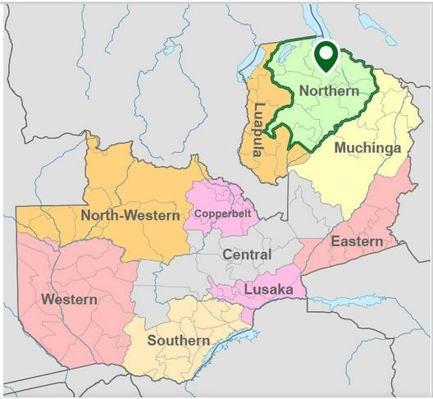

**Figure 2.1** The Northern Province of Zambia

Source: https://zambia.opendataforafrica.org/ (16/06/2023).

### 2.5.2 Target crop for market access interventions

The GRZ continues to support market access and related infrastructure improvements to increase smallholder farmer production, productivity and income-earning capacity through access to profitable and sustainable markets. The crop chosen for market access is beans. This crop has the potential to increase incomes and help reduce poverty for smallholder farmers. In Zambia, mixed bean is one of the six most widely grown crops, besides maize, groundnuts, sweet potatoes, cassava and rice. The bulk of the crop is produced in the Northern Province, accounting for 62% of the total production mostly grown during the rainy season. Major users of beans include schools, hospitals and prisons.

**Table 2.1** Bean production and productivity in Northern Province

|  |  |  |  |
| --- | --- | --- | --- |
| **Crop/Season** | **Hectares planted (ha)** | **Production (tons)** | **Yield (tons/ha)** |
| **Mixed beans**  **2020-2021** | 59,127.00 | 33,027.00 | 0.56 |
| **2021-2022** | 60,250.00 | 33,921.00 | 0.56 |
| **2022-2023** | 82,847.00 | 54,674.00 | 0.77 |

Source: 2023 Crop Forecast Survey data, MoA, Northern Province.

Mixed bean production increased from 33,027.00 tons in 2020/2021 to 54,674.00 tons in 2022/2023, an increase of 66.67%, and productivity increased from 0.56 tons/ha to 0.77tons/ha. However, the area under cultivation in Northern province is relatively low compared to the 3 provinces which performed better (Eastern, Southern and Central). Nationally, the province ranked first in bean production. The major contributors to the beans production in the province were Mbala, Senga Hill, Kasama and Lunte districts. The key uses of beans are home consumption and sales of surplus in the markets. Open markets constitute the main bean markets.

Some beans are sold while fresh as pods in different markets. This proportion is mostly unknown but it is likely to be in the range of 5% to 10% of the total production. Most beans are however sold as dry beans (over 90%). In Zambia processing activities are limited by cost of canning materials (for canned beans). Industrial processing is estimated at 5% though prospects are quite high. Major export outlets for Zambian beans are Congo DRC, Angola, Botswana, South Africa and Zimbabwe. Taking the marketable portion of beans together, it is observed that there is growing demand for beans and currently demand exceeds supply. The challenge is that production is casually approached and varieties are not widely distributed among the farmers (Birachi, 2012).

### 2.5.3 Social change initiative beneficiaries

The group trained in the aggregation model is the Senga Hill District Mutende Cooperative, which has a total of 202 members, i.e., 89 men and 113 women, including 73 youths. The group was officially registered as a cooperative in March 2020. The primary business is to improve bean production and productivity by providing agricultural inputs, mechanization, crop aggregation sites and marketing services to members. This is intended to improve the standard of living of the members. Currently, the group is managed by a board of 13 members, the day-to-day operations are overseen by the management, which consists of 4 members and is headed by the chairperson of the cooperative. The members of the group come from four clusters, namely Mutende, Kalukanya, Chipanda and Songolo, who undertook training in commodity aggregation.

The members of the cooperative have been involved in production of different varieties of beans, but most of the production was at the subsistence level. Having gone through a full cycle of training on commodity aggregation, the group intends to put the acquired skills and knowledge into practice. For the above reasons, the cooperative wants to increase its bean production by mechanizing some aspects of its production and by marketing the beans in an organized way through aggregation or bulking. To better achieve the market potential, it would be necessary to double the current marketed bean volumes.

### 2.5.4 Collaborating partners

The SCI activities were implemented in cooperation with other institutions and government departments. Partners included the Ministry of Agriculture (MoA), Good Nature Agro, World Food Programme (WFP), Food and Agriculture Organization (FAO), International Fund for Agricultural Development (IFAD), Japan International Cooperation Agency (JICA) and Zambia Agricultural Research Institute (ZARI). These organizations work to improve market access for farmers. A multi-channel dissemination approach for equipping and enhancing business skills are likely to ameliorate the challenges in market access.

# CHAPTER THREE

# SOCIAL CHANGE IMPLEMENTATION STRATEGY

## 4.1 Introduction

The chapter describes interventions and activities as well as important findings and impacts of the Social Change Initiative.

## 4.2 Interventions and Activities Implemented

**i. Training of marketing officers in market access**

The Ministry of Agriculture (MoA) is committed to helping smallholder farmers increase their income and improve their livelihoods as they are critical to building sustainable food systems, promoting food security and achieving zero hunger. The objective is to strengthen and sustain smallholder farmers’ ability to do business, while supporting governments’ capacity to design policies with their interests in mind. The Trainer of Trainers (ToT) workshop targeted 24 MoA officers from the Department of Agribusiness and Marketing, in particular District Marketing Development Officers (DMDOs) and Assistant District Marketing Development Officers (ADMDOs). The Provincial Agricultural Coordinator (PACO) officially opened and closed the meeting. The aim of the meeting was the training of master trainers in the following areas: market systems approach; aggregator profiling (identification and selection) and; commodity aggregation toolkit for market participants.

All 24 participants from the 12 districts (Mungwi, Mbala, Senga Hill, Nsama, Mporokoso, Lunte, Chilubi, Kaputa, Mpulungu and Kasama) attended and received training, representing a 100% participation rate in Northern Province. Demonstrations of the Virtual Farmer’s Market (VFM) were carried out. This is an app-based e-commerce platform where farmers’ surplus and buyers’ demand for crops are advertised and traded. VFM offers small farmers and buyers a transparent, open and trusted space to negotiate fair prices and offers. The workshop was held for two days from 20th to 21st September 2022 and was sponsored by the World Food Programme (WFP).



**Figure 4.1** Training of marketing officers in market access **ii. Training of field officers in market-oriented agriculture**

The Smallholder Horticulture Empowerment and Promotion (SHEP) project, a marketoriented agriculture approach is implemented in nine (9) districts in the Northern Province, including Senga-Hill. The SHEP training program from 25th to 27th January 2023 was for field officers who would train farmers and provided an opportunity to gain knowledge and information, and encouraged farmers not to “grow AND sell” but “grow TO sell.” The training included product quality (know the product quality required in the market and produce quality products), bulking (minimize costs through cooperative shipping/increase marketing and negotiation power), etc. The training aimed to improve farmers’ business knowledge and skills in order to improve their income, sell their products and improve farmers’ market access. Farmers develop their own business plans, using the knowledge and information they receive training, and then decide to put it into practice. The trainings were sponsored by the Japan International Cooperation Agency (JICA).

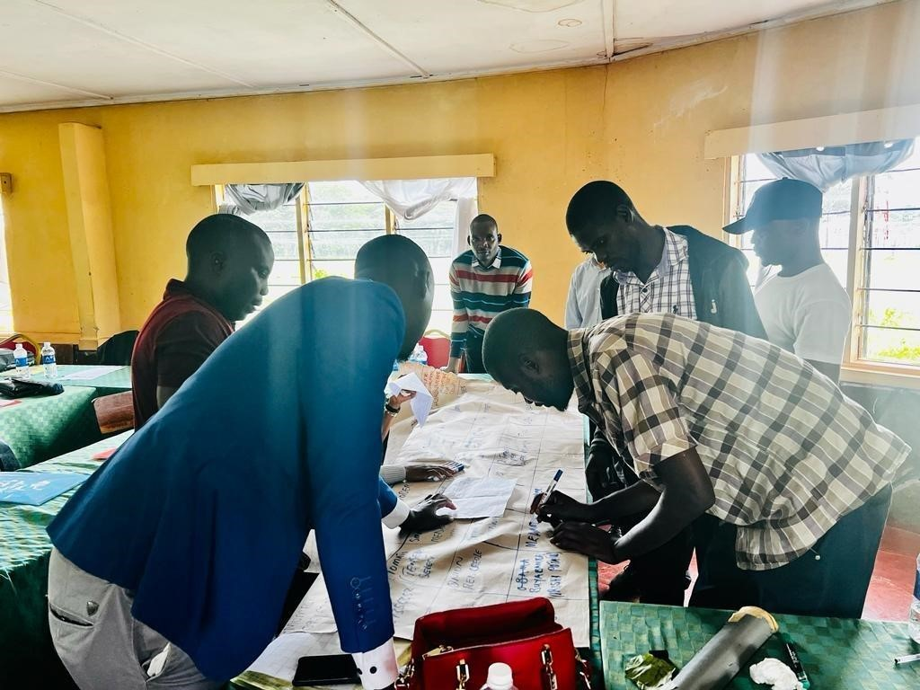

**Figure 4.2** Training of field officers in market-oriented agriculture **iii. Linking farmers to input suppliers**

A Meeting was held on 11th January 2023 with the beneficiaries on introduction of new bean varieties with officers from Zambia Agricultural Research Institute (ZARI). The Cooperative also had a contract with Good Nature Agro to supply sugar beans. Good Nature Agro produces and sources high-quality legume seed from small-scale farmers. The Agro arranged for the inputs that were distributed to farmers through an e-voucer system using and online digital platform. The bean distributed was the early maturing Sugar Beans variety called Lungwe Bungwe. The variety is good for canning and a yield of 1.5ton/ha and 75-80 days to maturity. Good nature Agro had an officer on the ground to provide technical support to farmers and worked with MoA extension staff to make sure there was consistency in the technical advice given to farmers. It is necessary that more smallholder farmers be linked to input markets in order for them to benefit from the opportunities.

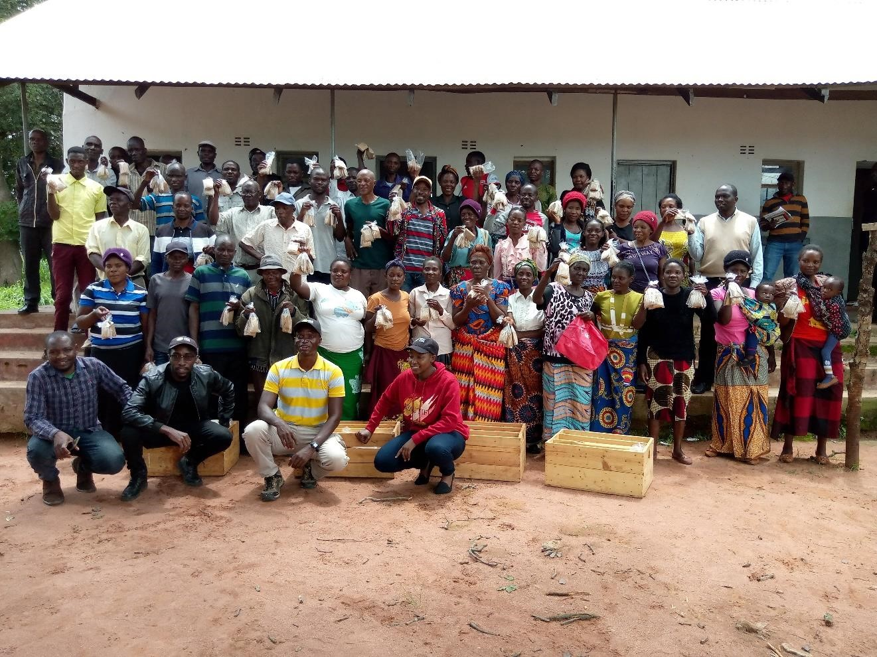

**Figure 4.3** Beneficiary farmers receiving new bean seed variety **iv. Training of farmers in commodity aggregation and handling**

The farmers were trained in commodity aggregation and handling. This was aimed at developing clear linkages for commodity marketing and off taking as well as clear demonstration of quantity, quality standards and timelines for delivery. Other topics covered included Private Sector engagements and Financial Contract Management where cooperative business models for aggregation and their importance was discussed. The trainings were done in collaboration with the FAO implemented Sustainable Intensification of Smallholder Farming Systems in Zambia (SIFAZ) project and Good Nature Agro. As part of the linking of smallholder farmers to markets the two organisations are involved in promoting market linkages between farmers and value chain actors to establish economically sustainable farming as a business.

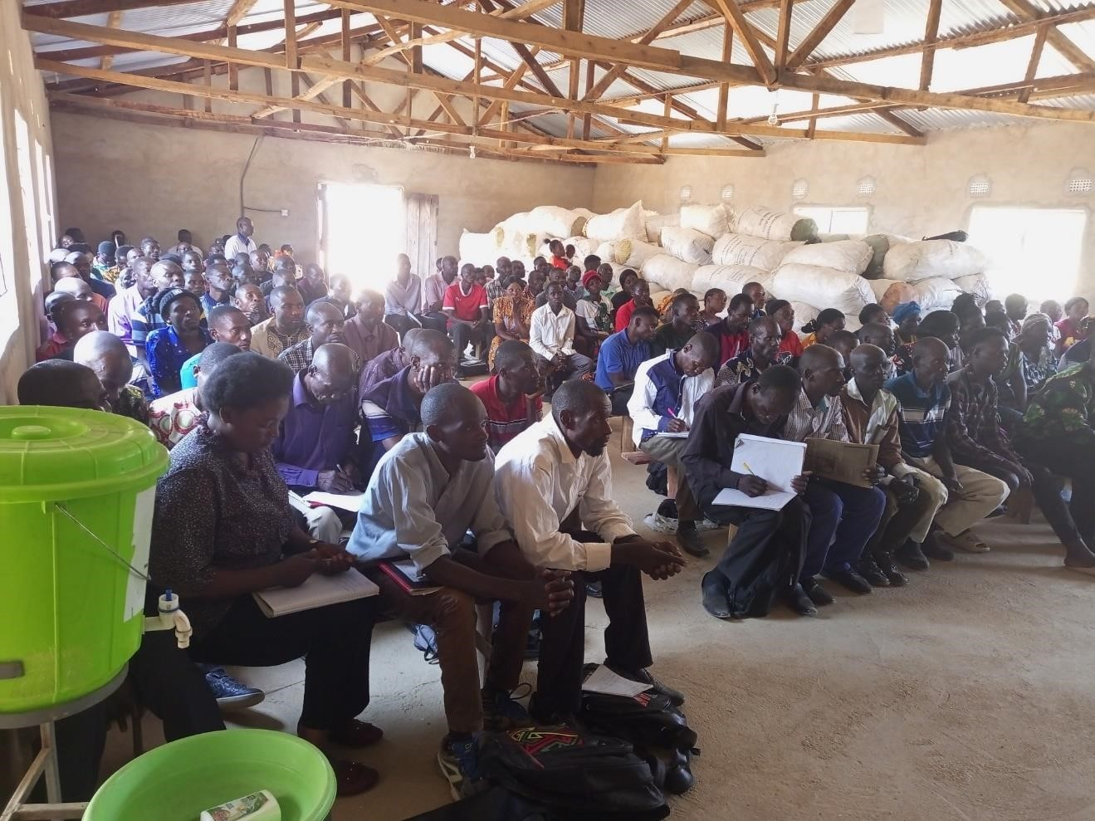

**Figure 4.4** Training in commodity aggregation and handling

**v. Linking farmers to offtakers (buyers)**

A meeting was held on 20th April 2023 with Good Nature Agro to buy back beans from the farmers who were linked to input supply by the e-voucer digital platform. The meeting agenda was Good Nature Argo’s intention to buy back Lungwe Bungwe bean variety from senga hill and other districts in Northern Province. The objectives of the meeting were to estimate the number of farmers and the expected yield from the farmers bean produce; confirm availability of storage and security and status of roads; and agree on the dates for the quality trainings were to be done before the buying starts so that farmers should hear the requirements, price and the steps to be followed at the buying points. This was meant to provide required market information to the farmers before the bean purchase could start. The price agreed was K15/kg compared to K13/kg market price. Good Nature Agro works with agro-processors, outgrower networks and traders looking for specific quantities and consistent supplies of premium legumes and help farmers link to these markets.

**vi. Digital innovation to enhance markets access**

The inputs were distributed to farmers through an e-voucer system using an online digital platform. The mobile phone sms platform was used to inform farmers about some of the requirements with tailored extension services, and market connections. The farmers were advised to have numbers registered to their names on the SIFAZ electronic farmer register. The message below was successfully shared with the farmers via bulk SMS using a digital platform on Thursday, June 15, 2023: “Good Nature Agro is buying Lungwebungu beans at K15.50/Kg from farmers. You must aggregate and sell through your Co-operative.

Contact your Camp Officer or your Co-operative Chairperson for more information.” **vii. Bean bulking and purchase from farmers**

The farmers bulked the beans and Good Nature Agro purchased beans from the farmers. Apart from Mutende cooperative members other farmers were also allowed to sell their beans to Good Nature Agro but through the cooperatives. The Lungwebungu beans was bought at K15.50/Kg from the farmers and the bulking centre was at the shed that was built by IFAD through the Enhanced Smallholder Agribusiness Promotion Programme (ESAPP) project. The payment method agreed was to do a bank transfer through the cooperative bank account and the cooperative pays the individual members.

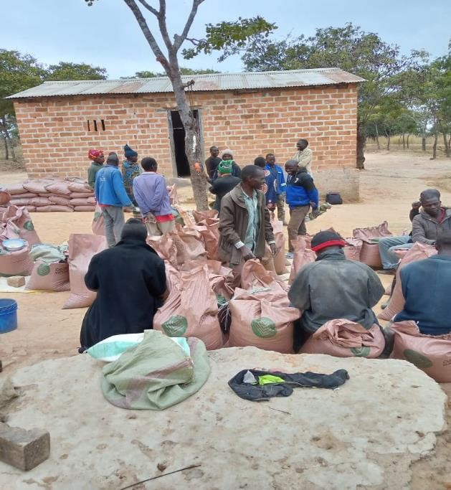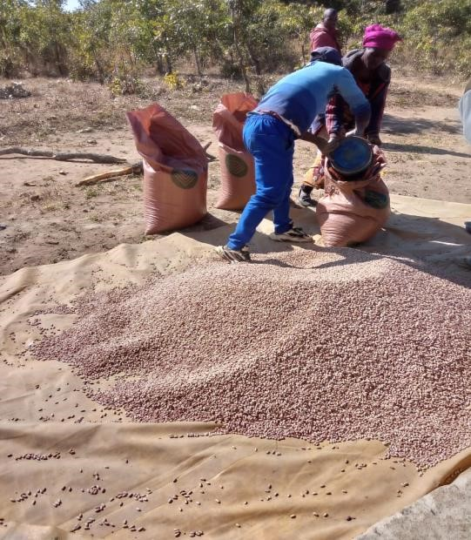

**Figure 4.5** Bean commodity aggregation and purchase

## 4.3 Key Findings and Impacts of the Social Change Initiative

The 202 smallholder farmers benefited through the following findings and impacts:

1. The cooperative capacity building trainings helped the farmers to effectively bargain higher prices hence generate high income compared to fellow farmers that would opt to market individually. Well sorted and graded commodity attract a better price than a poor. The farmers were also able to reduce transport costs by selling at the bulking centre close to their homesteads. Empirical literature shows that longer distances are associated increased transaction costs (Simon *et al*., 2015).
2. Farmers increased their knowledge in post-harvest management that enhance resilience to shocks. The capacity building trainings also helped farmers to improve the quality of beans marketed as required in modern markets and enhanced the use of post-harvest techniques. It is thus important to train farmers to produce more, but of good quality, and to use good post-harvest practices.
3. The farmers had access to input and output markets and agribusinesses services that increased their incomes by reducing transaction costs. Access to information on available markets and prices for the commodity is important because it enables farmers to make informed decisions. Mukundi *et al*., (2013) found that farmer organization as the source of information was positively associated with market participation. To avoid being exploited, farmers should always seek market information from reliable sources such as fellow farmers, extension agents, Zambia National Farmers Union and listening to radio farm programs.
4. The project led to improved marketing structures and practices amongst smallholder farmers. The mobile phones enhanced communication and information sharing. The finding is consistent with Mango *et al*. (2017) and Abdul-Rahaman and Abdulai (2020) who found that ownership of a mobile phone can improve collective marketing rates among the rural populace. This is because farmers who own mobile phones increase the odds of participation in collective marketing.
5. There was an increase in marketable surpluses by smallholder producers as a result of increased access to certified inputs (Seed, Fertilizer, Chemicals) from Good

Nature Agro. The use of certified seed in bean production positively influenced participation in commodity aggregation marketing. Certified seed varieties are high yielding and therefore guarantee high marketable surplus from the farmers. The findings are consistent with Chilundika (2011) who found that use of production technology such as hybrid seed or fertilizer positively influenced the probability of entering the market among bean producers in Zambia.

1. The farmers were able to plan and produce according to market demands. After the trainings in market-oriented agriculture, the farmers can do accurate crop harvest forecasts for marketable surplus and conduct market surveys on their own in local markets, supermarkets, schools, restaurants, lodges, etc. This shows that access to market information is strongly associated with high level of participation in marketing using the aggregation model as farmer groups are cheaper sources of information. The results affirm the findings of Mukundi *et* *al*. (2013) and Omit *et al*. (2009) that in a situation where farmers bulk agricultural products targeted for a particular market, they require timely information accessed at low cost.
2. There was an increase in productivity and the area cultivated under beans as shown by the 2023 crop forecast survey data for Northern Province**.** Farmers are expanding on their production land due to readily available markets for bean output. The more marketable surplus a farmer produces the higher the quantity that will be sold through commodity aggregation. The findings concur with Nangobi and Mugonola, (2018) that higher output increases the likelihood of market participation because it enables households to have sufficient marketable surplus.
3. The market access project also led to increased skills in diversified agricultural production**.** Unlike growing a mono-crop of maize, farmers can enjoy the following benefits from growing beans: increased family nutrition; increased soil and land health, especially in soil nitrogen levels; increased incomes from higher value crops; and guaranteed market through a contract with Good Nature Agro.

The key lesson to be learned from this SCI is that restoring market access can be an important way in which food interventions can help conflict-affected populations. Local collective organizations such as cooperatives are important institutions in areas where the provision of public goods is limited and where state institutions are weak (or non-existent).

They drive important development outcomes, including nutrition and food security.

## 4.4 Implementation Challenges and Actions Taken

The challenges encountered during the SCI project implementation and some of the actions taken are given in the table below.

**Table 4.1** Project implementation challenges and actions

|  |  |
| --- | --- |
| **Challenge** | **Action Taken/Proposed** |
| i. The Maano Virtual Farmers Market (VFM) digital platform was not used. | Instead, the SIFAZ project digital platform was used to distribute inputs and disseminate marketing information. |
| ii. Less women and youths attended the trainings. Female representation was about 30%. | Field officers to encourage women and youths to actively participate in trainings and meetings. |
| iii. Visiting the project area often to monitor the activities was a challenge due to limited resources. | Working in collaboration with the DMDO and field officers to make sure the activities were implemented according to plan. |
| iv. There was no funding to support the activities that were planned. | Worked with the collaborating partners to support the funding of the activities (FAO, JICA, WFP). |
| v. The vulnerability-focused criteria pose a challenge to the achievement of the project’s economic objectives, as most beneficiaries in the subsistence level category focus more on handouts than on sustainable economic activities. | The model of employing independent business management team of experts to manage business on behalf of the farmers assures sustainability if there is effective monitoring and technical support from service providers. |

Source: SCI project data, Senga Hill

# CHAPTER FOUR

# CONCLUSION AND RECOMMENDATIONS

## 6.1 Introduction

This chapter begins with a summary of the Social Change Initiative and the conclusions.

Based on the findings, recommendations and implications are made for stakeholders.

## 6.2 Summary and Conclusion

The failure to address the problem of market access has contributed to increasing poverty in rural areas and deprived farmers of a source of income because their productive potential is not being realized. Poor access to inputs (improved and certified seed, fertilizers and chemicals) and markets negatively affects growers. Most production takes place in areas which are often not easy to access because of poor state of roads and long distances from urban centers. Therefore, innovative interventions are needed to link smallholder farmers to well-functioning markets by designing long-term strategies to reduce poverty and hunger in rural areas. Commercialization of agricultural produce through cooperatives that undertake collective marketing through commodity aggregation can decrease transactions costs for smallholder farmers and improve their incomes.

In order to increase the participation of smallholder farmers in collective marketing through the aggregation model, it is necessary to focus on measures that improve access to market information, the promotion and introduction of hybrid bean varieties to increase production and the construction of storage facilities in rural areas away from main markets. The 2030 Agenda sees the eradication of poverty and hunger, achieving food security and making agriculture sustainable as critical to achieve the additional goal of creating peaceful and inclusive societies. There can be no sustainable development without peace, and no peace without sustainable development.

## 6.3 Recommendations and Policy Implications

Combining efforts to restore and maintain resilient livelihoods with peacebuilding and conflict-resolution efforts is critical to sustainable development and food security.

Likewise, investing in food security can strengthen conflict prevention efforts and achieve sustained peace. It is therefore in the interest of policymakers and stakeholders to implement the following measures to improve stallholder farmers’ market access, and food security and maintain sustainable peace, particularly in the study area:

i. Investing in resilience and food security helps fight hunger and build peace. Therefore, there is a need to support investment in market access and capacity at local, national, regional and global levels to reduce poverty and build sustainable food and agricultural systems. Supporting agribusiness and marketing can create employment opportunities for youths and contribute effectively to peacebuilding and post-conflict recovery. ii. Promotion of digital innovations to improve market access. There is need to promote the use of digital platforms by farmers to acquire market information for their target crops to overcome the challenge of long distance to the market, e.g., Maano, Limalinks, Agri-Predict. The government can also utilize the Zambia Integrated Agricultural Management Information System (ZIAMIS) web-based database to send e-Extension messages and other agricultural marketing information messages to farmers. At current levels of communication development, the flow of information between buyers and sellers (farmers) can be based on the use of mobile phones.

iii. The commodity aggregation model for smallholder farmers should be promoted via the commodity aggregation centers and VFM digital platform. The model helps to connect smallholders and bulk buyers emphasizing product quality and post-harvest management to reduce losses. It is also important to train farmers to produce more, but of good quality, and to use good post-harvest practices. The ministry of agriculture and stakeholders to support the implementation of planned specialized trainings in areas such as post-harvest handling of produce, value addition, entrepreneurship, tractor hire services business, to further sharpen the farmers’ business and marketing skills. iv. The cooperative should engage and collaborate with reliable agro-suppliers early enough to ensure timely supply of agro-inputs to their members. The cooperative should also create more linkages and establish formal partnerships with other stakeholders in bean value chains.

1. Collective marketing should be promoted among youth cooperatives members that have attained primary education. High literacy levels will allow youth farmers utilize market information which will lower transactions costs and make participation and intensity of participation worthwhile. Female farmers should also be targeted and encouraged to increase the quantities sold through groups.
2. There is continued need for farmer trainings on Good Agricultural practices to raise the productivity for most crops including beans. Smallholder farmers who have at least completed primary school education should be targeted and encourage the participation of youth and women. The approach to train farmers using both theoretical and practical demonstration of production best practices proved effective in increasing the knowledge and skills of smallholder farmers.
3. The prices offered at the commodity aggregation point significantly influenced the share of collectively traded beans and the decision in favor of collectively traded beans. It is recommended that aggregators involved in bulk marketing offer premium prices for good quality beans, which in turn would encourage other farmers to engage in bulking (aggregation) and collective marketing.

## 6.4 Sustainability Plan for Commercial Bean Production and Marketing

In Zambia a larger portion of legumes are produced by smallholder farmers although there is significant participation of commercial farmers particularly in the Soya Beans value chain. However, this does not negatively impact the potential for Soya Beans to catalyze the commercialization of smallholder farmers. This sustainability plan component will aim at increasing both production and productivity of beans by the cooperative members, it will include acquisition of seed, chemicals and fertilizer. This support is aimed at increasing production and productivity through timely access to quality inputs under out grower schemes, mechanization for production activities, and market infrastructure such as bulking facilities. The inputs will be provided under commercial arrangements whereby the smallholder producers are expected to pay back the cost of inputs and mechanized services through part of their harvest.

The proposed operation model is that 202 farmers will each be given inputs to cultivate 1 hectare of beans each (60Kg seed, 6 bags of fertilizer, 1Kg seed guard, a fungicide, insecticide and a pesticide. The expected production from each farmer cultivating 1 hectare will be 18x50kg bags. After harvest, each member will be expected to pay back 20% of their produce to the co-operative. Moreover, the beneficiary members will be mandated to sale at least 50% of their produce through the co-operative bulking centre using the aggregation model. All the members of the group are being trained in production and marketing of beans through commodity aggregation. Increased production and productivity will in the long run contribute to increased and sustainable household income and food security and sustainable peace.

Marketing is a challenge in a liberalized economy especially when markets are far from production areas, accessibility is poor and the commodities being marketed are bulky and individual farmer production levels are low. The SMEs or service providers are expected to provide inputs, including mechanized services i.e., tillage, planting, and harvesting, to economically active smallholder farmers. They are also expected to provide offtake markets through increased capacity to process or aggregate the farmers produce. These partnerships with SMEs are the bedrock of sustainability as the project intends to not only grow the capacity of the smallholder farmers but that of the partner organizations to reach and serve farmers better. This will form the basis for sustaining agribusiness partnerships that are mutually beneficial to all the players involved and increase value chain efficiency.

The sustainability interventions should include capacity building, provision of mechanized services, inputs under our grower schemes, market facilities such as bulking centres, among others. Training and mentoring of the bean producers would ensure that the technologies are well understood and can be better accepted. The farmer capacity building also proposed as a possible solution to low adoption of new technologies: involve farmers in research as well; undertake collaborative researcher with other partners (NGOs); promote new varieties and technologies; examine market tastes locally and internationally (access to the right market information is the key to developing market linkages); and provide bean seeds timely. Further, orienting farmers to practical agribusiness mentorship before providing them with financial support proved to be a more viable model for smallholder farmer business development model and promises sustainability. Interventions at various links of the bean value chain have the potential to create income for the smallholder farmers.

# REFERENCES

Abdul-Rahaman, A., and Abdulai, A. (2020). Farmer Groups, Collective Marketing and Smallholder Farm Performance in Rural Ghana. *Journal of Agribusiness in Developing and Emerging Economies*, 10(5), 511-527.

Abraham, M., Chiu, L. V., Joshi, E., Ilahi, M.A., and Pingali, P. (2022). Aggregation models and small farm commercialization - A scoping review of the global literature. *Food Policy, 110,* 102299.

Arouna, A. (2018). Assessing the impact of collective marketing of paddy rice in innovation platforms by smallholder producers in Benin. In *Rice Crop-Current Developments*. London, UK: IntechOpen.

Baloyi, J.K. (2010). *An analysis of constraints facing smallholder farmers in the Agribusiness value chain: A case study of farmers in the Limpopo Province.* Doctoral dissertation, University of Pretoria, South Africa.

Barrett, C.B., and Carter, M.R. (2020). Finding our balance? Revisiting the randomization revolution in development economics ten years further on. *World Development*, 127, 104789.

Barrett, C.B., Bachke, M.E., Bellemare, M.F., Michelson, H.C., Narayanan, S., and Walker, T.F. (2012). Smallholder participation in contract farming: comparative evidence from five countries. *World Development*, 40(4), 715-730.

Barrett, R.P. (1990). Legume species as leaf vegetables. In J. Janick and J. E. Simon (Eds.), *Advances in New Crops* (pp. 391-396).

Bationo, A., Waswa, B., Okeyo, J. M., Maina, F., Kihara, J., and Mokwunye, U. (Eds.). (2011). *Fighting poverty in sub-Saharan Africa: the multiple roles of legumes in integrated soil fertility management*. Springer Science and Business Media.

Bellemare, M.F., and Bloem, J.R. (2018). Does contract farming improve welfare? A review. *World Development*, 112, 259-271.

Bijman, J., and Iliopoulos, C. (2014). Farmers’ Cooperatives in the EU: Policies, Strategies, and Organization. *Annals of Public and Cooperative Economics*, 85(4), 497-508.

Birachi, E. (2012). Value Chain Analysis of Beans in Eastern and Southern Africa: Building Partnerships for Impact Through Research on Sustainable Intensification of Farming Systems *(CIAT)*.

Chilundika, N. (2011). Market participation of bean smallholder farmers in Zambia: a gender-based approach. *Research report presented to the Department of Agricultural Economics and Extension Education, University of Zambia*.

Chiuri, W., Birachi, E., Buruchara, R., Adekunle, W., Fatunbi, O., Pali, P. N., ... and Nkonya, E. (2013). Market access for agro-enterprise diversity in the Lake Kivu Pilot Learning Site of the sub-Saharan Africa Challenge Programme. *African Journal of Agricultural and Resource Economics*, 8(311-2016-5591), 120-134.

Chivenge, P., Mabhaudhi, T., Modi, A. T., and Mafongoya, P. (2015). The potential role of neglected and underutilized crop species as future crops under water scare conditions in sub-Saharan Africa. *International Journal of Environmental Research and Public Health*, 12, 5685-5711.

Deblock, C., and Haji, R. (2008). Commission on Growth and Development, The Growth Report. Strategies for Sustained Growth and Inclusive Development, Washington, The International Bank for Reconstruction and Development/The World Bank, 2008. *CEIM: Montréal, mai*.

Fan, S., and Brzeska, J. (2016). Sustainable food security and nutrition: Demystifying conventional beliefs. *Global food security*, 11, 11-16.

FAO. (2014). *State of Food and Agriculture*. Rome, Italy. http://www.fao.org/3/a-i4040e. pdf.

FAO. (2015). *The state of food and agriculture 2015 in Brief: Social protection and agriculture:* Breaking the cycle of rural poverty. 1-13.

FAO. (2016). *2016 international year of pulses - Frequently asked questions*. Italy: Rome.

Ferris, S., Robbins, P., Best, R., Seville, D., Buxton, A., Shriver, J., and Wei, E. (2014). Linking smallholder farmers to markets and the implications for extension and advisory services. *MEAS Brief*, 4(10), 13-14.

Fischer, E., and Qaim, M. (2012). Linking smallholders to markets: determinants and impacts of farmer collective action in Kenya. *World Development*, 40(6), 12551268.

Gomez y Paloma, S., Riesgo, L., and Louhichi, K. (2020). *The role of smallholder farms in food and nutrition security* (p. 251). Springer Nature.

Indaba Agricultural Policy Research Institute (IAPRI). (2015). *Agriculture in Zambia, Past, Present and Future. IAPRI*: Lusaka, Zambia.

Johnson, N.L., and Berdegue, J.A. (2004). *Property rights, collective action and agribusiness* (No. 569-2016-39039).

Lowder, S. K., Skoet, J., and Raney, T. (2016). The number, size, and distribution of farms, smallholder farms, and family farms worldwide. *World Development*, 87, 16-29.

Magesa, M.M., Michael, K., and Ko, J. (2014). Access to agricultural market information by rural farmers in Tanzania. *International Journal of Information and Communication Technology Research,*264-273

Mango, N., Makate, C., Lundy, M., Siziba, S., Nyikahadzoi, K., and Fatunbi, A.O. (2017). Collective market Participation for Improved Income among Smallholder Farming households: A case of Balaka Innovation Platform in Malawi. *African Crop Science Journal*, 25(1), 97.

Mellor, J. W. (2017). *Agricultural development and economic transformation: promoting growth with poverty reduction*. Springer.

Ministry of Agriculture [MoA] and Ministry of Fisheries and Livestock [MFL]. (2016). *Second National Agricultural Policy (SNAP)*. Government of the Republic of Zambia: Lusaka, Zambia.

Ministry of Agriculture [MoA]. (2022a). *Farmer Input Support Programme Implementation Manual, 2022/2023 Agricultural Season*. Lusaka: Government of the Republic of Zambia.

Ministry of Agriculture [MoA]. (2022b). *Commodity Aggregation: A Toolkit for Market Actors.* Government of the Republic of Zambia: Lusaka, Zambia.

Ministry of Finance and National Planning [MFNP]. (2022). *Eighth National Development Plan (8NDP) 2022-2026*. Government of the Republic of Zambia: Lusaka, Zambia.

Minocha, S., Makkar, S., Swaminathan, S., Thomas, T., Webb, P., and Kurpad, A.V. (2019). Supply and demand of high-quality protein foods in India: trends and opportunities. *Global Food Security*, 23, 139-148.

Muganga Kizito, A., and Kato, E. (2018). Does linking farmers to markets work? Evidence from the World Food Programme’s Purchase for Progress satellite collection points initiative in Uganda. *African Journal of Agricultural and Resource Economics*, *13*(311-2018-3122), 169-181.

Mukundi, E., Mathenge, M., and Ngigi, M. (2013). Sweet Potato Marketing Among

Smallholder Farmers : The Role of Collective Action’, *4th International*

*Conference of the African Association of Agricultural Economists, September 2225, 2013, Hammamet, Tunisia*, p. 21.

Mulenga B.P., Kabisa M., Chapoto, A., and Muyobela T., (2020). *Zambia Agriculture Status Report 2020*. Indaba Agricultural Policy Research Institute, Lusaka, Zambia.

Nangobi, R., and Mugonola, B. (2018). Determinants of Collective Marketing and Marketable Surplus for Smallholder Sorghum Producers in Oyam District, Uganda. *Journal of Development and Agricultural Economics*, 10(7), 213–224.

Ojiewo, C., Keatinge, D. J. D. H., Hughes, J., Tenkouano, A., Nair, R., Varshney, R., Siambi, M., Monyo, E., Ganga-Rao, N. V. P. R., and Silim, S. (2015). The role of vegetables and legumes in assuring food, nutrition, and income security for vulnerable groups in sub-Saharan Africa. *World Medical and Health Policy*, 7, 187-210.

Omiti, J. M., Otieno, D. J., Nyanamba, T. O., and McCullough, E. B. (2009). Factors influencing the intensity of market participation by smallholder farmers: A case study of rural and peri-urban areas of Kenya. *African Journal of Agricultural and Resource Economics*, 3(311-2016-5509), 57-82.

Ortega, D.L., and Tschirley, D.L. (2017). Demand for food safety in emerging and developing countries: a research agenda for Asia and Sub-Saharan Africa. *Journal of Agribusiness in Developing and Emerging Economies*, 7(1), 21-34.

Pingali, P. (2007). Westernization of Asian diets and the transformation of food systems: Implications for research and policy. *Food policy*, 32(3), 281-298.

Pingali, P., Aiyar, A., Abraham, M., and Rahman, A. (2019). *Transforming food systems for a rising India* (p. 368). Springer Nature.

Poole, M. (2017). *The origins of economic democracy: Profit sharing and employee shareholding schemes*. Routledge.

Simfukwe, J. (2019). *Tatampapa Cooperative Extra Ordinary Meeting Report*. Senga Hill district, Northern Province, Zambia.

Simon, G. K., Margaret, N. and Bett, H. K. (2015). Determinants of Farmer Participation in Collective Marketing and Intensity of Participation in Indigenous Chicken

Markets in Western Kenya’, *IOSR Journal of Agriculture and Veterinary Science Ver. II*, 8(10), 2319–2372.

Ssajakambwe, F., Elepu, G., Walekhwa, P. N., and Mulebeke, R. (2019). Factors That Influence Participation in Markets through Collective Action among Smallholder Maize Farmers in Masindi district, Uganda. *African Journal of Marketing Management*, *11*(5), 45-51.

Tharanathan, R. N., and Mahadevamma, S. (2003). Grain legumes - A boon to human nutrition. *Trends in Food Science and Technology*, 14, 507-518.

Thierfelder, C., Cheesman, S., and Rusinamhodzi, L. (2012). A comparative analysis of conservation agriculture systems: Benefits and challenges of rotations and intercropping in Zimbabwe. *Field Crops Research*, 137, 237-250.

Tortia, E.C., Valentinov, V.L., and Iliopoulos, C. (2013). Agricultural cooperatives.

*Journal of Entrepreneurial and Organizational Diversity*, 2(1), 23-36.

Ton, G., Opeero, D. M., and Vellema, S. (2010). ‘How Do We Get it to the Mill?’ A Study on Bulking Arrangements that Enable Sourcing from Smallholders in the Ugandan Vegetable Oil Chain. *A study on bulking arrangements that enable sourcing from smallholders in the Ugandan vegetable oil chain (July 8, 2010). VC4PD Research Paper-July*.

United Nations [UN]. (2015). *World Population Prospects: The 2015 Revision, Key Findings and Advance Tables*. Working Paper No. ESA/P/WP.241. New York.

World Bank. (2007). *World development report 2008: Agriculture for development*. The World Bank, Washington, DC.

Zambia Statistics Agency [ZSA], Ministry of Health [MOH] and ICF. (2019). *Zambia Demographic and Health Survey 2018: Key Indicators*. Rockville, Maryland, USA: Central Statistical Office, Ministry of Health, and ICF.

Zambia Statistics Agency [ZSA]. (2015). 2015 *Living Conditions Monitoring Survey Report.* Government of the Republic of Zambia: Lusaka, Zambia.

Zambia Statistics Agency [ZSA]. (2022). 2022 *Census of Population and Housing Preliminary Report*. Government of the Republic of Zambia: Lusaka, Zambia.

# APPENDICES

1. ***Training of marketing officers in market access***

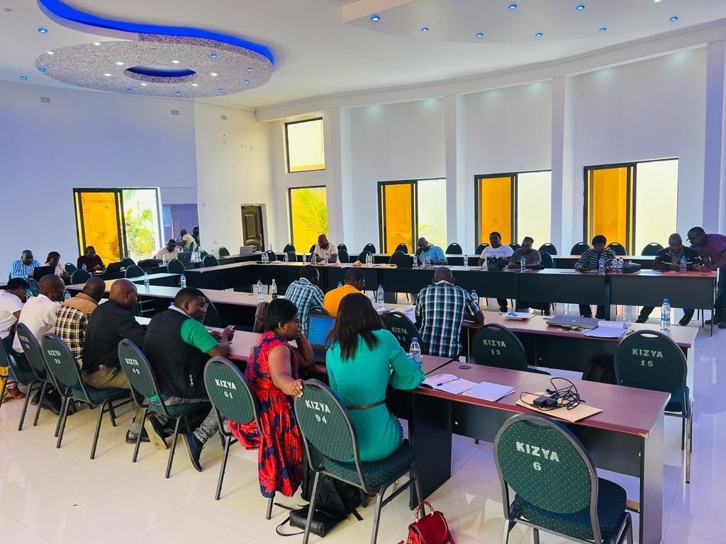

1. ***Training of farmers officers in market-oriented agriculture***

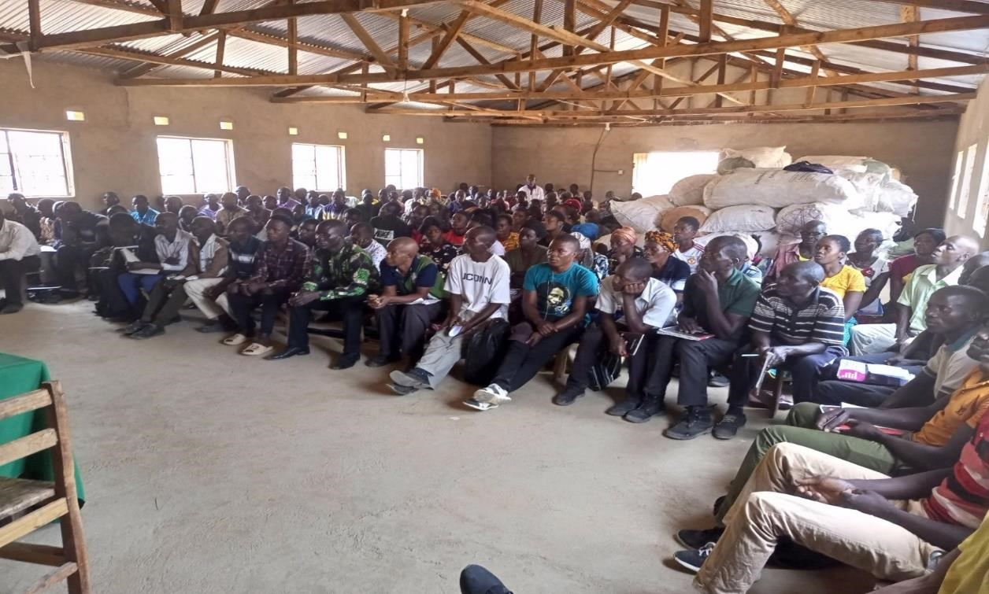

1. ***Commodity aggregation centre storage shed***

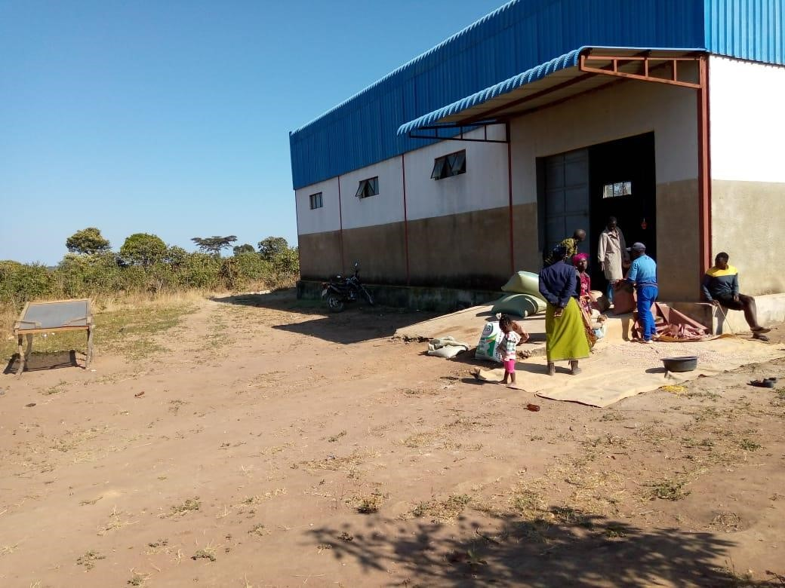

1. ***Beans bought by Good Nature Agro at the aggregation centre***

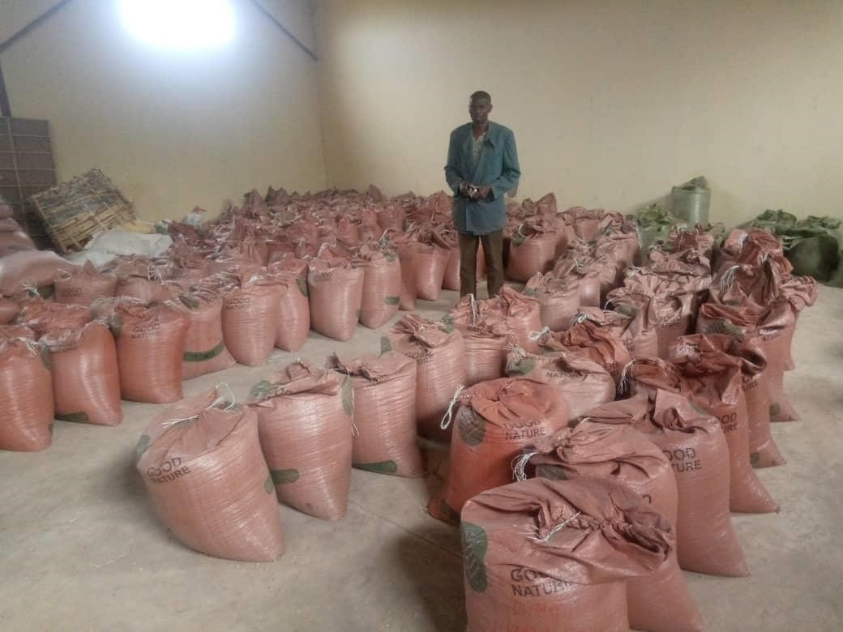

1. ***Relevant training manuals used***

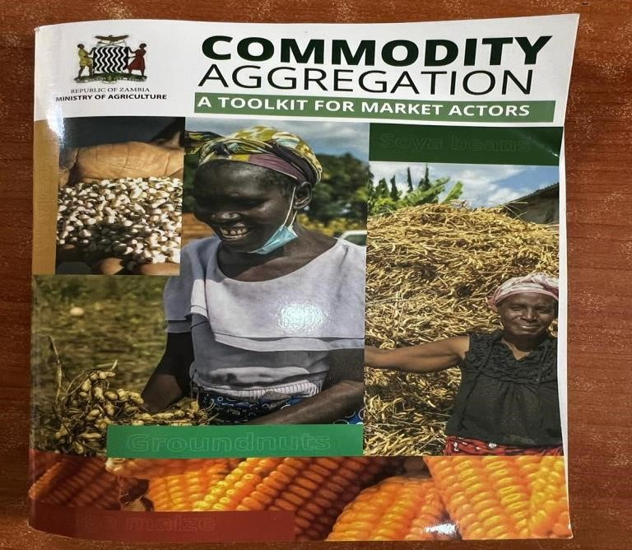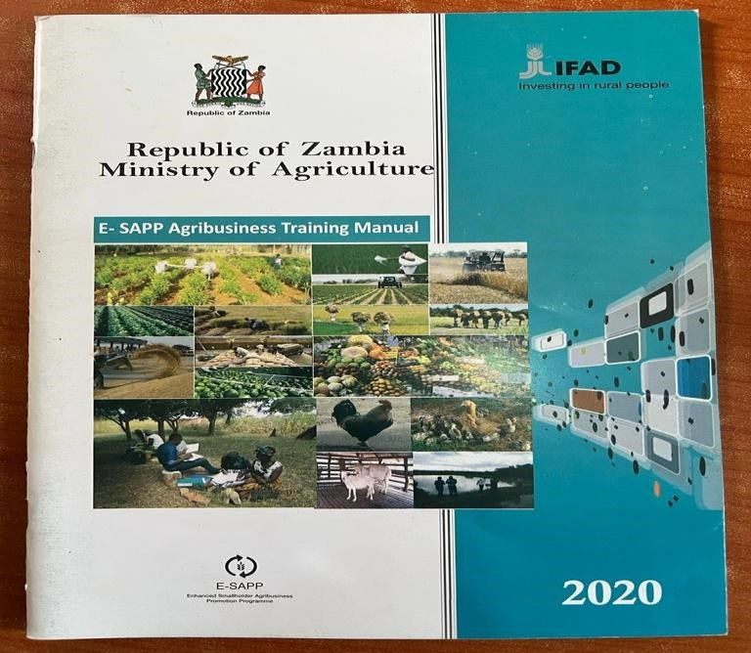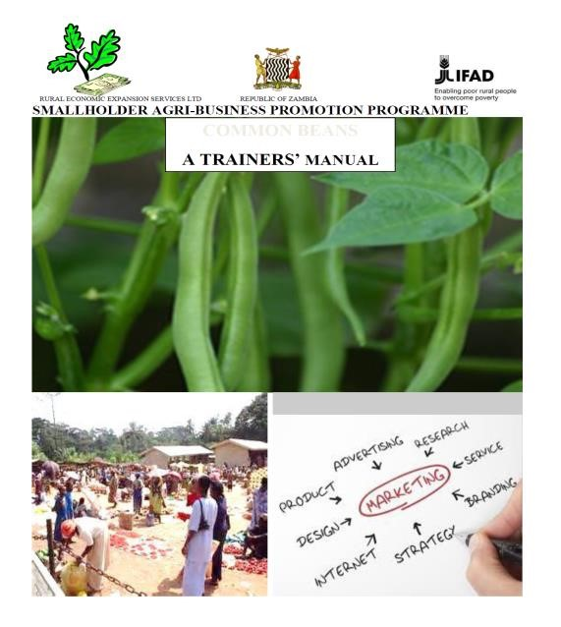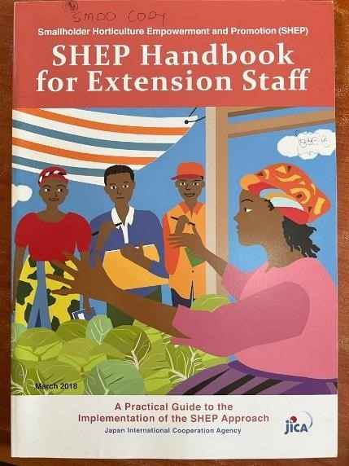

***vi. Participant testimony***

[an interview is yet to be arranged with one market access beneficiary farmer]

**Table 5.1** Social Change Initiative work plan

|  |  |  |  |  |  |  |  |  |  |  |  |  |  |  |
| --- | --- | --- | --- | --- | --- | --- | --- | --- | --- | --- | --- | --- | --- | --- |
| **SCI-2022-2023 Agricultural Season Work Planning for Market Access Roll Out Activities** | | | | | | | | | | |  |  |  |  |
| **Key Components of**  **Strategy for 2022-2023**  **Season** | **Target** | **Potential Partners** | **Implementation Timeline - September 2022 to August 2023** | | | | | | | | | |  |  |
| **Sep** | **Oct** | **Nov** | **Dec** | **Jan** | **Feb** | **Mar** | **Apr** | **May** | **Jun** | **Jul** | **Aug** |
| Training of marketing officers in market access | 24 officers | MoA, FAO |  |  |  |  |  |  |  |  |  |  |  |  |
| Training of field officers in market-oriented agriculture | 10 officers | MoA, JICA |  |  |  |  |  |  |  |  |  |  |  |  |
| Linking farmers to input suppliers (procurement and logistics). | 202 farmers | MoA; Good Nature Agro |  |  |  |  |  |  |  |  |  |  |  |  |
| Cooperative capacity building in commodity aggregation and handling. | 202 farmers | MoA; FAO;  Good Nature Agro |  |  |  |  |  |  |  |  |  |  |  |  |
| Linking farmers to output buyers, commodity bulking and purchase (sugar beans). | 202 farmers | MoA; Good Nature Agro |  |  |  |  |  |  |  |  |  |  |  |  |
| Submit project report on SCI completion and prepare for public dissemination of the interventions applied in the field. | 1 project report | Makerere  University;  Rotary  International;  Fellows |  |  |  |  |  |  |  |  |  |  |  |  |

*Note: No budget line was attached as the planned activities were done in collaboration government departments and partners.*

40