**Rebuilding Our Communities in Benue (ROC—Benue): Performing Arts for Peace (Gwer-West LGA, Benue State, Nigeria) June-December, 2023**

**By**

**Tersoo Matthew NANDE**

**Reg. No. 2022/HD03/0032X**

**Student No. 2200700032**

Supervisor

**Professor Sylvia Antonia Nakimera Nannyonga-Tamusuza**

**ABSTRACT**

This Social Change Initiative (SCI) aimed at deploying performing arts—dance and drama—in mobilizing Tse-Orbiam and Tse-Nyamti, two communities that were in conflict over land, for dialogue. In this experiential study, Advocacies, Dance, Drama and Dialogue were employed as data collection methods and it was presented using qualitative/descriptive analysis. Due to the difficulty in getting conflicting parties willingly agree to dialogue, the project trained over 30 pupils of NKST Primary School, Naka, who were from the two conflicting communities, in dance and drama. They performed before their warring parents and helped to convince them to dialogue. The study found out during the two dialogue sessions held with eight participants that the custom of registering land dispute cases with the traditional rulers using money, drinks and a goat, for hearing has commercialized justice, ensuring that the highest bidders always win. This has reduced the effectiveness of the traditional institution in matters pertaining to conflict, especially land disputes, and eroded public trust in the institution. Population explosion was also discovered to have greatly precipitated land disputes in Benue State as the younger generations are rising up to revoke tenancy agreements entered into between their forefathers in order to have access to more land. The study recommended that government should look into the activities of traditional rulers to ensure that they are serving their subjects rather than themselves. The Benue State government should prioritize introducing alternative means of income for the mostly subsistence farmers in order to reduce their dependency on land.

**Key Words:** Performing Arts, Drama, Dance, Dialogue, Land Dispute

**CHAPTER ONE**

**1.1 Introduction/Background**

“Performing Arts for Peace” is a project that seeks to address the land dispute between Tse-Orbiam and Tse-Nyamti, two Tiv waring communities in Gwer-West Local Government Area (LGA) of Benue State, Nigeria. This project, despite being a Social Change Initiative (SCI), as part of the Rotary Peace Fellowship at Makerere University, is intended to serve as a model for addressing land disputes in Benue State and Nigeria at large.

Land is an essential natural resource both for the survival and prosperity of humanity, and it is so valuable a resource that it belongs even to the dead, those living and those yet unborn (Takuh, 2016). This means that this important resource has become both a blessing and a curse, depending on place and time. According to Britannica.com, the Tiv who live on both sides of the river Benue, speak a language of the Niger-Congo family. They are subsistence farmers who specialize in crops like yams, corn, millet, and so on. They typically live in round huts, clustered around a reception hut known as *Ate*. Brothers live next to one another and until 1946 when the British appointed the first paramount ruler, they had no chiefs. Leadership was based on age, influence and affluence, and important decisions were made by heads of families; even to this day, elders hold more social power than the political chiefs. Robertson, (cited in Aluaigba, 2011, p,76), described the Tiv “(as) attractive and stout-hearted people, hardworking, and in those days, brave warriors. They resisted the invasion of the (Islamic jihadists) who pressed from the North, and were little affected by the Ibos and other Nigerian tribes of the south”.

Land dispute is a pervasive problem in Nigeria as farming is the main occupation of most of the population. As such, people place a lot of importance on land and much of the violent conflicts common among Nigerians usually stem from disagreements over land usage. According to a 5 years (2018-2022) report which was published by The PUNCH Newspaper:

No fewer than 676 persons have been killed in various communal and boundary disputes in Nigeria between January 2018 and August 2022. Also, no fewer than 444 houses were destroyed during the crises in the period under review. Findings indicated that most of the clashes resulted from unresolved age-long disputes, while a few others were fresh cases.  A breakdown, according to states, indicated that Ebonyi State recorded the highest communal clashes in the country with 131 deaths; Taraba State, 116; Benue had 92 incidents, Kogi 67, and Cross River 73, respectively. These were the five worst-hit states within the period (Adepegba, Omogbolagun, Odeniyi, Shaibu, Ukagwu, and Shaibu, 2022).

It is clear from the above statistics that land dispute is a leading cause of conflict in Benue State and by coincidence, the five states listed above all share boundaries. This means that the states with seemingly the highest concentration of peasant farmers in Nigeria also top in land disputes. The precarious situation within these locations can be blamed on population explosion, lack of alternative employment opportunities for the youths and weak/ineffective alternative conflict resolution mechanisms. As majority farmers, depletion of soil fertility, and population surges are responsible for the movement of people from place to place in search of greener pastures, leading to clashes over land usage.

In Benue State, the Tiv account for much of the land disputes numbered in the above statistics. In fact, Imobighe (2003) reports that despite several inter-ethnic conflicts between the Tiv and their neighbours, there are more inter-clan clashes among the Tiv than clashes between the Tiv and other ethnic groups. As a result, other ethnic groups have attributed a defamatory characterization of the Tiv as warlike, aggressive, and a rebellious people, though such portrayals have been refuted as stereotypes and misrepresentation of the Tiv (Ahire, 1999). It is important to note that intra-ethnic conflicts in Tivland used to be settled by the *kwav* (age-grades) and the *ityo* (collection of the most elderly persons in Tivland) using mediation; while inter-ethnic conflicts between Tiv and other ethnic groups were handled by the *jir tamen* (Tiv traditional council, comprising the Tor Tiv—the paramount ruler, and all clan heads in Tivland), with the *Swem* serving as the deity of truth (Aluaigba, 2011, p.75).

Nowadays, most elders have become alcoholics, thereby undermining the respect they used to command among their subjects. The introduction of Christianity in Tivland has also eroded much of the indigenous cultural practices, particularly the use of deities, in compelling social compliance among subjects. In the past, “the fear of *mbatsav* (traditional priests) …silently settle(d) almost all quarrels, political decisions and subdue(d) discontent and raging revolt” (Abeghe, 2005, p.8). This was because of the consequences that came from lying before the *Swem*, and all the parties involved in a dispute would speak the truth, and the Tor Tiv also ensured that his verdict was unbiased and impartial. Unfortunately, all those alternative dispute resolution mechanisms among the Tiv have become ineffective, leading to the need to try out other methods.

It was the quest for new methods of resolving land disputes in Benue State, particularly among the Tiv, that led to the development of the “Performing Arts for Peace” project. Music, dance and drama were used to mobilize people of Tse-Orbiam and Tse-Nyamti who were fighting over land and they were entertained by their own children who attended NKST Primary School, Naka, Benue State. Thereafter, the two conflicting parties, moved by the presentations, agreed to sit together for a dialogue—something that had been very difficult to achieve in the past.

**1.2 Statement of the Research Problem**

In a study conducted by Yamano and Deininger (2005) on the causes, impacts, and resolutions of land conflicts in Kenya, the study found that land use, particularly land sale, was the major cause of disputes among neighbors or relatives within a given community. Available data shows that in Nigeria, Benue State is the third most affected state when it comes to land disputes, and the Tiv account for much of that data. This project was designed to address the Tse-Orbiam and Tse-Nyamti conflict. As a Tiv person working with a non-profit organization in Benue State, carrying out community dialogues to address land disputes, I identified the difficulty in mobilizing participants for dialogues as a major challenge and decided to design this project to address it.

From the interviews conducted with key stakeholders from the two waring communities, Tse-Orbiam claimed that they had been oppressed by Tse-Nyamti for long, insisting that their oppressors asked them to remain on the other side of Chu River and not to cross over to farm. Tse-Orbiam further claimed that the conflict began in 2016, while Tse-Nyamti insisted that it was since 2009. The cause of the conflict according to Tse-Nyamti was that Tse-Orbiam people were leasing/selling out the said land to outsiders so they (Tse-Orbiam) were asked to stop because the land does not belong to them. One day, youths from Tse-Nyamti attacked Tse-Orbiam people on the farm, cut down all the economic trees that were on the land, extending up to On-Mbavaa, a neighbouring village. Tse-Orbiam people initially did not react but over the years, they have also been retaliating and the conflict has lingered, although no life has been lost so far.

Recently, all the major traditional rulers within the axis met to discuss the conflict and they resolved that though the two communities were in close proximity, they were from different clans (Kyaau and Gyarua) and should maintain the boundaries that demarcated those clans, accordingly. However, Tse-Orbiam people were not satisfied with the outcome of the resolutions by the traditional rulers so they took their case to court. The court ruled in favour of Tse-Orbiam but Tse-Nyamti are appealing the judgment.

**1.3 Goals and Objectives**

The goal of this project is to restore peaceful coexistence between Tse-Orbiam and Tse-Nyamti communities in Gwer-West Local Government Area of Benue State, Nigeria through the instrumentality of dance, drama and dialogue. The following are specific objectives:

* Use performing arts to mobilize Tse-Orbiam and Tse-Nyamti people to come together at NKST Primary school Naka for a live performance
* Use dialogue to bridge the divide between the two communities after watching the live performance by their own school children

**1.4 Challenges and Mitigation Strategies**

* Performing Arts for Peace was initially designed to address the Mbasombo and Mbaviur land dispute and the implementation began in earnest—conflict mapping, advocacies to key stakeholders, auditioning of students of Yonov Community College, Ikpayongo for drama and dance, and series of rehearsals—before the crisis resurfaced and the school was shut down. This put-paid to all the efforts that were put into the project thus, leaving the implementation team stranded.
* On the recommendation of a colleague, the project was moved from Ikpayongo, Gwer-East Local Government Area of Benue State to Naka, Gwer-West Local Government Area. This was due to the fact that schools were shut down in Ikpayongo indefinitely and the project was designed to be implemented in a school. In order to meet up with schools’ graduation date in early August 2023, NKST Primary School Naka was chosen for the connector project between Tse-Nyamti and Tse-Orbiam. The implementation had to start all over from the scratch—conflict mapping, advocacies to key stakeholders, auditioning of pupils for drama and dance, before the actual event was staged in an elaborate ceremony that had parents and community leaders in attendance.
* It was difficult to raise the required funds to implement the project. Letters were written to various individuals and groups, including Rotary Clubs, but nothing came of it.
* The researcher relied heavily on his personal finances in running much of the project. A seed grant of US$1000 was later secured through the Pollination Project, with an extra support of $200 from Rotarian RoAnna Savage, to augment the expenditure. Due to lack of proper funding, the project relied heavily on the sacrifice and expertise of colleagues and community volunteers for its success.
* It was difficult to get the people of Tse-Nyamti to agree to be part of the peace process. They were non-receptive to the idea of engaging with Tse-Orbiam in any peace process.
* The researcher employed the assistance of a community volunteer who identified some strategic stakeholders of whom the elders in Tse-Nyamti have so much respect, to persuade them to embrace the peace process. This proved to be the melting point in the intervention.

**CHAPTER TWO**

**2.1 Literature Review—Performing Arts for Peace**

The performing arts are a vital and necessary part of our culture and society and exist in many formal and informal settings. Live performances in large arenas, our favourite songs and recordings, television shows, community theater productions, and informal dance groups, all provide avenues for experiencing music, theater, dance, and musical theater. By definition, performing arts means theater, music, opera, and dance, from the traditional “high arts” to the popular arts, including live arts performed in all venues and non-live arts through all forms of mass media: CDs and other recordings, radio, video, television, and the internet (McCarthy, Brooks, Lowell, and Zakaras, 2001, p.5). The performing arts are an important part of our lives, our communication, and our self-expression. These arts forms are categorized as such because of how each embodies the idea of practice to performance: the process of experiencing, studying, watching, or performing a piece of music, script, or choreography (Wikipedia.com).

The high arts are traditional art forms such as ballet and symphonic music. The popular arts consist of art forms such as rock and roll music or musical theater that have attracted mass audiences in the commercial marketplace. The folk arts range from gospel music to cultural dance troupes and represent the traditional art and culture of the diverse ethnic communities around the world. Many live folk arts performances are produced by amateur (i.e., unpaid) artists and small non-profit performing groups in the volunteer sector (McCarthy et al, 2001). Amateur activity tends to take place outside official organizations or in non-arts organizations such as schools and churches, representing a very important part of performing arts (McCarthy et al, 2001). This is also true of the Tiv people of central Nigeria, where performing arts are embedded in their culture and tradition.

It is important to note that performing arts can sometimes be used as tools for promoting violence. As observed by Huesmann (2007), several factors can precipitate violent actions by various individuals or groups, but evidence shows a correlation between violence extremism and exposure to violence in media, digital media, and entertainment. For instance, “I Saw the Devil (2010)” is a Korean bloody movie about Kyung-Chul, the psychopath man who killed people just for his pleasure. Although the movie ended with a portrayal that revenge is bad, Lussier (2011) argued that the audiences admired the violent scenes in the movie and it was adjudged to be the best bloody revenge movie in 2010. This movie teaches revenge and can further deteriorate relations if watched by key actors in a conflict. Which is why Cantor (2000) advised that “government actions restricting violent media are not censorship but providing parents with the necessary information to protect their children” (p.367).

To promote peace through performing arts, Shamill Idriss (2020), CEO of Search for Common Ground, stated in a publication titled “In Media We Trust” that one way “we build peace is through media” (p.1). His organization designs content “to provoke discussions within communities in conflict and model new ways to overcome differences” (p.1). Depending on the type of conflict Search for Common Ground is trying to resolve, the mitigation approach could be community theater, television dramas, reality TV shows, radio programs, or call-in shows, which must be preceded by extensive community outreach and engagement. Idriss stated three ways that the change his organization helps to bring about becomes sustainable:

The first is institutionalization: when a government ministry, police department, media syndicate, or other important institution adopts new policies or procedures reflecting principles of peace. The second is commercialization: when a local market emerges to resource a peacebuilding approach so that its continuation need not rely on philanthropic support. The third is popularization: when we effect a change in social norms, or how a large portion of a population deals with differences; this is where social impact entertainment is particularly powerful (p.1).

People experience the performing arts in several different ways. Some people may be directly involved in a “hands-on” way by singing in a choir or acting in a stage play. Others attend a live performance, while others listen to a recording or watch a play on television. Individuals may be involved as producers (at an amateur or professional level), as consumers (by attending a live performance or listening or watching a recorded performance), and as supporters (by donating time or money to arts organizations) (Balfe and Peters, 2000, cited in McCarthy et al, 2001). In all this, the level of demand for the performing arts differs, often dramatically, depending upon the art form and how individuals choose to experience it. Indeed, consumption of the performing arts through the media is more prevalent than attendance at live performances, and many more people participate through their attendance by engaging in the arts in a hands-on manner (NEA, 1998a; Americans for the Arts, 1996, cited in McCarthy et al, 2001).

Artists are very central to performing arts, either as creators of works of art such as composers, playwrights, and choreographers—or performers such as musicians, conductors, actors, and directors. The attitudes and behaviours of the consumers of performing arts are largely formed by the portrayals of the various roles performed by artists in whatever art form. This is why it is important for artists to be deliberate about promoting peace in the characters they portray. Idriss (2020) also agrees that attitudes, behaviours, and even world views are developed from people’s emotional experiences, not their rational thinking. This point explains why extremist groups are able to easily recruit and mobilize young people whose brains have been awash with violent media content. It is important for creatives to leverage this emotional power by deliberately designing performing arts that resonate with the target audience. This can be better done by collaborating with people who are affected by the conflict situation which the performing arts are designed for.

Bertolt Brecht (1898-1956), cited in Iyang (2016), advocated the kind of performing arts that “propels the spectators into action, to bring the desired change in society, rather than that which plays on their emotions and finally leaves them to take things as they are” (p.150). In a nutshell, active and interactive forms of performing arts are most suited for resolving conflicts than passive ones. Community theatre is certainly an active and interactive social activity which is inextricably linked with the origins of society itself (Courtney, in Iyang, 2016). This is true because community theatre does not make use of “professional artists” but locals who in most cases, are directly impacted by the conflict. It gives a voice to the voiceless within the community wherein it is staged, and this agrees with Steve Barlow and Steve Skidmore’s definition of theatre as an “art form that provides individuals with practical opportunities to express themselves and develop aesthetic understanding” (Iyang, 2016, p.154).

Amoding and Felzmann (2023) opined that community theater helps communities to express their situation using role play in order not to directly point fingers at anyone, but rather to discuss resolutions peacefully. This approach takes advantage of cultural factors such as storytelling, songs, idioms, and social gatherings to communicate the message of peace. Thereby helping to break even stone hearted individuals who fuel conflicts and perpetrate violence. GIZ-ZFD (2013) believes that community theatre helps in developing trust, safety, and social cohesion which strengthens social and cultural capacities to resolve conflicts, and promote meaningful interaction and dialogue. The use of dance (*Swem*) and community theater in this project greatly facilitated the coming together of the warring communities for dialogue.

**2.2 Theoretical Framework**

The study adopted both Ted Gurr’s **Relative Deprivation theory** and the Institute of Economics and Peace’s **8 Pillars of Positive Peace Framework** to explain the conflict situation between Tse-Orbiam and Tse-Nyamti and the peace process initiated through the Performing Arts for Peace project.

**2.2.1** Relative deprivation theory is based on the concept of deprivation, which indicates difference between what one expects in life and what s/he eventually gets. Relative Deprivation was first coined by the American sociologist Samuel Stouffer but popularized by Ted Gurr. In his famous 1970 book, Why Men Rebel, Gurr explained relative deprivation to mean “actors’ perception of discrepancy between their value expectations and their value capabilities” where “Value expectations are the goods and conditions of life to which people believe they are rightfully entitled. Value capabilities are the goods and conditions they think they are capable of getting and keeping” (Gurr, 1970). The key argument here is that people rebel when there is a discrepancy between what they have and what they think they should have. Such perceived sense of deprivation causes frustration, leading to aggression. Relative deprivation is therefore seen as “wanting what one does not have, and feeling that one deserves whatever it is that one wants but does not have” (Townsend, 1979). The theory states that the discrepancy between what people think they deserve, and what they actually get is responsible for conflict. It is important to emphasize that the individual experience of discontent when being deprived of something to which one believes oneself is entitled to, is problematic when emphasis is placed on the perspective of the individual alone (Walker and Smith, 2002).

This theory speaks directly to the Tse-Nyamti versus Tse-Orbiam land dispute which is as a result of land sale. Tse-Nyamti feel deprived from the largesse being enjoyed by Tse-Orbiam as the latter sell/lease out the land in dispute. Although, Tse-Orbiam are enjoying the advantage of commercializing the said land due to their side’s proximity to Naka town, Tse-Nyamti are annoyed that their own side of the land is cut away from urbanization and therefore, cannot be able to sell it at good prices right now. In actuality, the conflict is based on the feeling of deprivation from the bounty accruing from land sale which one group feels towards the other, not that the aggrieved group lacks land with which to cultivate.

**2.2.2 Eight Pillars of Positive Peace Framework**

The Positive Peace Framework is empirically derived by the Institute of Economics and Peace (IEP) and it involves the use of a systems-based approach for understanding the creation and maintenance of peaceful societies. The Positive Peace Framework is made up of 8 pillars of Positive Peace (visionofhumanity.org).

**2.2.2.1 Well-Functioning Government**

It was quite difficult convincing Tse-Nyamti people to embrace the peace process initiated through the Performing Arts for Peace project. After series of preparatory meetings with key stakeholders from both Tse-Nyamti and Tse-Orbiam, it was still very difficult to get the former agree to sit together with the latter. This was because, Tse-Nyamti has both politico-economic and numerical advantage over Tse-Orbiam and their leaders were leveraging these advantages to maintain the status-quo. On realizing this, the highest ranked traditional ruler in Gwer-West local government area (LGA), the Acting Ter Nagi, was contacted through advocacy and he appealed to leaders of Tse-Nyamti to embrace the peace process and find a resolution to the protracted conflict. Head of education department at the local government also intervened in persuading them. At the end, the various leaderships prevailed on Tse-Nyamti and peace was achieved.

**2.2.2.2 Sound Business Environment**

Tse-Orbiam and Tse-Nyamti live on either side of river Chu. As a result of the land dispute between them, they no longer cross one another’s paths. This has made it difficult, especially for Tse-Nyamti people who must pass through Tse-Orbiam to get to Naka market, and this has affected income levels from the sale of farm products.

**2.2.2.3 Equitable Distribution of Resources**

The two conflicting communities both have vast land to meet their basic needs. However, Tse-Orbiam is resident on the side that is gradually urbanizing which makes the value of their land to rise thereby increasing demand for it.

**2.2.2.4 Acceptance of the Rights of Others**

It is difficult for Tse-Nyamti to accept the fact that Tse-Orbiam owns the land wherein they reside. They are angered by the fact that the latter is cashing out on the land while theirs is not yet in demand.

**2.2.2.5 Good Relations with Neighbours**

The fact that none of the two communities can cross over river Chu to the other community shows that relations are completely strained.

**2.2.2.6 Free Flow of Information**

The two communities were not in talking terms therefore information could not flow from one community to the other. Instead, misinformation, fake news and hate speech took center stage.

**2.2.2.7 High Levels of Human Capital**

Tse-Nyamti have influential people in government whereas Tse-Orbiam do not. This tilts the balance of power in favour of the former. Although majority of the youths from the two communities are either school leavers or school drop outs.

**2.2.2.8 Low Levels of Corruption**

The traditional rulers who are constitutionally vested with the responsibility of resolving land disputes operate a justice system that is highly skewed. They usually require a live goat, cartons of beer and NGN 20,000.00 to listen to a land case. The implication is that the party that meets the requirements is likely to get justice at the expense of the less privileged one.

**2.3 Change Theory and How it was Applied**

**IF** Tse-Nyamti and Tse-Orbiam will agree to come together at NKST Primary School Naka to watch live performance by their own children who attend school there, **THEN**, they will be more willing to dialogue and resolve their land dispute.

The above theory of change was applied in the implementation of the Performing Arts for Peace project as follows:

**2.3.1 Situation Analysis:** the researcher, through a community volunteer, conducted conflict mapping on the nature and character of the conflict after which key actors were identified. Chief Adum from Tse-Nyamti and Mr Vandikaan Chiem from Tse-Orbiam were interviewed respectively to gain more insight into the conflict—socio-politico environment/interests, conflict drivers/triggers, trends, opportunities, etc. The insight gained from the above determined the scope and scale of the intervention.

**2.3.2 Change Conceptualization:** The goal of the project was to restore peaceful coexistence between Tse-Orbiam and Tse-Nyamti communities in Gwer-West Local Government Area of Benue State, Nigeria through the instrumentality of dance, drama and dialogue. As a result, both Tse-Nyamti and Tse-Orbiam were brought together at NKST Primary School Naka where they watched live performance, Dance and Drama, by their own children in a ceremony. Thereafter, the two conflicting parties were summoned for a Dialogue, involving key actors, where they brainstormed and reached a mutual agreement to end hostilities over land.

**2.3.3 Change Inputs:** These include Preconditions and Pathways.

Preconditions: Volunteers were recruited in Naka, including 3 staff members at NKST Primary School, who worked tirelessly for the success of the live performance; and another community volunteer who co-facilitated the dialogue. The researcher relied heavily on his personal funding but later got a small grant of $1000 from The Pollination Project and an additional $200 from Rotarian RoAnna Savage from Oregon, USA which enabled the implementation.

Pathways: Through the efforts of the volunteers, the conflict was better understood through mapping, and the right students were selected and trained for both drama and dance which led to the impact that both presentations had on participants at the event. The right stakeholders were also selected as participants for the dialogue while the funds received also facilitated logistics for the project implementation.

**2.3.4 Implementation:**

|  |  |  |
| --- | --- | --- |
| **Activity** | **Outputs** | **Outcomes** |
| Conflict Mapping | - key stakeholders were identified  - Intervention was tailored based on the reality | **-**stakeholders willingly came 2gether  -intervention was a success |
| Dance/Drama Audition | -38 students were selected | - perfected skills through rehearsals |
| Dance/Drama Presentation | -performed live before their parents | -informed parents’ decision to willingly dialogue |
| Dialogue | -2 Reflective Structured Dialogues were held with 8 participants  -Facilitated by 2 facilitators | -the 2 community leaders finally agreed to hold an expanded stakeholders’ meeting  -conflicting parties agreed to withdraw case from court and settle out of it  -parties also agreed to demarcate the boundary to end hostilities |

**2.3.5 Monitoring, Accountability and Learning:** The inability to raise the required funds for the project led to scaling it down to fit the available budget. For instance, the number of high-level stakeholders initially captured in the design were dropped. This was also exacerbated by the fact that a lot of effort and resources had been expended in the Mbaviur-Mbasombo conflict before dropping it to take on the Tse-Orbiam-Tse-Nyamti conflict. Emphasis was now placed on community-level stakeholders who had direct bearing on the conflict.

**2.4 Methods and Design**

According to the University of Newcastle Library Guides (2023), research methods are the strategies, processes or techniques utilized in the collection of data or evidence for analysis in order to uncover new information or create better understanding of a topic. Research Design on the other hand, is the overall strategy that integrates the different components of a study in a coherent and logical way in order to effectively address the research problem. In this experiential study, the researcher employed Advocacies, Dance, Drama and Dialogue as the methods through which data was generated during the implementation of the Performing Arts for Peace project and was presented using qualitative/descriptive analysis.

In the initial project design, Yonov Community College, Ikpayongo was chosen to serve as the venue for connecting Mbasombo and Mbaviur communities. This was because the two communities were clans under Yonov district which established the school, and children from both communities attended the school. The idea was to first of all, connect these school children, then use them to speak to their parents through dance and drama. After changing the implementation location, NKST Primary School Naka, was adopted because it had pupils from both Tse-Orbiam and Tse-Nyamti who attended school there. Although, the school was not central to the two communities as YCC that informed the original design, it provided the same impetus for the implementation.

NKST Primary School Naka, was established in 1990 by the Nongo u Kristu u i Ser u sha Tar (the Universal Reformed Christian Church), a predominantly Tiv church. It is currently a government grant-aided school located on the outskirt of Naka town. The school has a student population of 309 and 20 teachers. It is the closest public school to both Tse-Orbiam and Tse-Nyamti, and children from these communities attend the school due to proximity and low cost.

**2.4.1 Advocacy:** Mind.org.uk defines advocacy as getting support from another person to help you express your views and wishes. The researcher visited four traditional rulers overseeing the respective conflicting communities, the area Education office to seek approval to stage the event at NKST Primary School, Naka; and finally, the approval of the host school.

**2.4.2 Dance:** Britannica.com defines dance as the movement of the body in a rhythmic way, usually to music and within a given space, for the purpose of expressing an idea or emotion, releasing energy, or simply taking delight in the movement itself. The Tiv dance popularly known as *Swem* was adopted for this project. Generally, *Swem* has two meanings among the Tiv. On one hand *Swem* is known as a place where the entire Tiv people originated, and on the other hand, it is a great fetish which is itself anti-*tsav* (witchcraft), and also kills *mbatsav* (witches/wizards) (Bohannan, 1958). According to Aluaigba (2011), Swem refers to a small pot with ashes inside and decorated with the *ayande* (a shrub with unique spiritual significance in Tiv traditional religion). Dzurgba, cited in Aluaigba, 2011, pp.76-77, “revealed the identity and location of *Swem* (location) in Akwayaland in south-west province or south-west state in south-west Cameroon”. Interestingly, the Tiv have also developed a dance routine which embodies the spirit of *Swem*, and it was deliberately adopted for this project to prick the moral conscience of conflicting parties who are Tiv.

**2.4.3 Drama:** According to writingexplained.org (2023), a drama is defined as a piece of literature of which the intended purpose is to be performed in front of an audience. The project deployed Community theatre—which refers to a production that is made entirely by a community with no outside help from professional theatre artists—to convey the message of peace. The drama was titled “Ka Nyi Se Er Ve Se Zua a Bem?” (What Shall We Do to Achieve Peace?) and was acted in Tiv language by the pupils of NKST Primary School, Naka with the guidance of their school teachers. The interview with the key stakeholders from both Tse-Orbiam and Tse-Nyamti informed the script which was vetted by Denis Teghtegh, a Professor of Theater Arts at the Benue State University, Makurdi. He also provided guidance on how to carry out community theater without compromising its principles.

At the end of the drama presentation, guests and spectators at the event, gave their feedback on the lessons they drew from it. Some conflict actors from both Tse-Orbiam and Tse-Nyamti also made their opinions known after watching the drama and this was the highlight of the event as it drew the two communities closer to holding their first dialogue.

**2.4.4 Dialogue:** Clarku.edu (2023) defines dialogue as a focused and intentional conversation, a space of civility and equality in which those who differ may listen and speak together. The project adopted the Reflective Structured Dialogue (RSD) approach which “equips people to interrupt dysfunctional dynamics and build relationships across differences in order to address challenges where they live, work, worship, and learn” (wikipedia.com, 2023). Four key actors from each of Tse-Nyamti and Tse-Orniam were chosen with the help of the respective traditional rulers who identified them, bringing the total number to eight participants at each of the two dialogues.

**CHAPTER THREE**

**3.1 Intervention and Activities**

On 28th July, 2023, 85 people gathered at the premises of NKST Primary School, Naka, Gwer-West Local Government Area of Benue State, Nigeria to witness performances from pupils of the school, as part of activities marking their end of session ceremony. 37 of the participants were farmers/community leaders drawn from the two warring communities of Tse-Orbiam and Tse-Nyamti; 10 of the participants were the school teachers; 2 participants came from the local government education authority office; while 4 were the conveners of the event; and 36 were the pupils who participated in both dance and drama. They were other spectators at the event who did not closely identify themselves to be recorded.

**3.1.1 Dance:** The pupils presented two set of dances: choreography to selected afrobeat songs and, the Swem dance. The choreography was the brainchild of the school teachers and was performed by 4 pupils to spice up the occasion and had no major significance to the Social Change Initiative. However, it helped in calming nerves and reducing tension among warring groups who were “forced” to sit under the same canopy and watch their children perform. The Swem dance, which had 19 females and 1 male dancers, mostly dressed in the black and white striped attire (Tiv official attire—anger), embodied the culture and tradition of the Tiv people. The dancers formed 6 groups, one had 4 females bearing firewood on their heads, representing rural women; the other group had 8 females, 2 leading the way—each bearing a smoking claypot, reminisce of the actual Swem, with 2 holding the overflow of the long robes worn by the 2 females in front, while the remaining 4 danced along; there were also 2 females, each holding a cow tail serenade the dance floor (these two are known as “tembe duen”—opening the floor or heralding the arrival, in this case, of the Swem); another 2, a male, cultivating the soil while the female planted; there was also a female, mimicking a man suffering from scrotal enlargement; while the other female mimicked a pregnant woman (see link for full video of dance presentation <https://drive.google.com/file/d/1Y7li_yhK5vutZt9TT6GzmI4YoQq6adbY/view?usp=drive_link>).

**3.1.2 Drama:** The drama, which was titled, “What Shall We Do to Achieve Peace?” had 26 actors who were all pupils of NKST Primary School, drawn from both Tse-Orbiam and Tse-Nyamti. 8 of the actors were females while 18 were males. The story centered around two friends, Iorvaa and Avalumun, who enjoyed a long-lasting friendship but after the death of Avalumun, his eldest son led his family into war with Iorvaa’s family over land. The conflict saw to the destruction of lives and property and a badly injured psyche of survivors. Iorvaa, the surviving patriarch, summoned a dialogue where everyone came together and openly discussed their history, where things went wrong and the losses suffered by each party. They concluded with the question, “What shall we do to achieve peace?” (see link for full video of the drama presentation <https://drive.google.com/file/d/1N8PksDhrQ2H3tHjeZtYK8Gu_DjeK71T-/view?usp=drive_link>) This drama was meant to speak to consciences of participants from both Tse-Orbiam and Tse-Nyamti, two communities that were facing a similar fate which informed the SCI. At the end of the performance, some of the stakeholders who were present expressed their thoughts concerning what they had just seen and the implications on the conflict which the intervention was intended to resolve.

**3.1.3 Dialogue:** Two dialogue sessions were held by two facilitators at two different venues due to the preference of the participants. The first dialogue took place at NKST Primary School, Naka on Tuesday, 15th August 2023 to discuss **“Land Dispute Between Tse-Orbiam and Tse-Nyamti”.**

During the preparatory sessions before the dialogue, the facilitators (Convener & Community Volunteer) interacted with Chief Adum, the traditional ruler in charge of Tse-Nyamti kindred and it was through him that key conflict actors from his community were selected as participants for the dialogue. While Mr. Vandikaan, community leader in Tse-Orbiam identified his kinsmen as participants. Tse-Orbiam people expressed fears of sitting together in a dialogue with their counterparts, Tse-Nyamti despite the impact of the drama by the pupils of NKST Primary School, Naka still fresh on their minds. They alleged that Nyamti people were violent, possessed weapons, use hard drugs and were cunning in their dealings. To allay their fears, a neutral location was suggested as venue for the dialogue and was accepted by all the selected participants. The dialogue took place at NKST Primary School, Naka.

Chief Adum, the traditional ruler, gave a background on the settlement patterns between the two Communities. He said that people of Tse-Orbiam settled along the river Chu one hundred years ago. The community was constantly affected by floods, so they had to relocate to the land across the river that belonged to Tse-Nyamti. Nyamti ceded the land to Orbiam and was advised to use the land solely for subsistence purposes. But at the demise of Orbiam, the patriarch, his descendants began to lease lands to persons other than their kin. And according to Chief Adum, this development annoyed his people to the point that they ordered their youths to cut down economic trees that Orbiam people planted on the land.

Demesugh Tyende from Tse-Orbiam also shared his experience of how he was attacked on the farm by Bam Francis from Tse-Nyamti with a pistol and a machete. He knelt down and begged for his life but was thoroughly beaten then allowed to go with injuries and was told that his life might end at any other time. Demesugh told both Chief Adum and Zaki Vandikaan that the conflict rested upon their shoulders and they were responsible for both peace and war. Whatever they decided was what would happen.

Chief Adum responded by saying that Demesugh's words pierced his heart so he advised that the dialogue should end so that the two leaders could be allowed to meet, together with other elders and find ways of resolving the issue amicably. The facilitators intervened at this point and advised participants to give their leaders the benefit of the doubt and see how they proceeded. Participants appreciated the facilitators for being neutral in facilitating the dialogue because they had thought that the facilitation would be biased. Their fears were allayed and they were able to successfully discuss openly from the heart. The two chiefs promised to report back to the facilitators the outcome of their caucus meeting as soon as possible.

The second dialogue in Naka took place at Chief Adum’s house, on Saturday, September 23, 2023 to discuss the same issue, **“Land Dispute Between Tse-Orbiam and Tse-Nyamti”.**

As usual, Chief Adum kicked off the discussion with a brief recap of the outcome of their caucus meeting following from the previous dialogue. He stated that their exclusive meeting was successful. They agreed to honour their children’s request for them to embrace peace which was shared during the drama presentation. They also agreed to let the past pass so that they can forge a common future together again. However, they could not agree on what to do with the court case and decided to reconvene for another dialogue to look at it collectively. He reminded participants that, after several back and forth at different courts, Tse-Nyamti are still appealing the recent judgement which favoured Tse-Orbiam.

Vandikaan Chiem from Tse-Orbiam said that after trying to no avail through the traditional rulers to secure their land, they resorted to the law court where the matter is still pending after securing back-to-back victories. Since then, both sides have never had the opportunity to dialogue as they only meet in court. His confusion now was that should this dialogue resolve the issue, how would they do with the court case?

Orjume Bem from Tse-Nyamti responded by saying that they had not wanted to pursue the matter in court even after they were summoned. However, Tse-Orbiam people were selling off the land to outsiders who are now claiming ownership of the land and that forced their hands to also seek the intervention of the courts.

Orkeghen Titus from Tse-Nyamti said that he was happy that for the first time since the beginning of the conflict, participants from both sides were suing for peace. However, he stressed that it was not the youths who reported the matter to court and that no youth had ever appeared in court, it was their elders. Therefore, he suggested that after the dialogue, their elders should be informed of their decision to embrace peace and settle the matter out of court so that it can be withdrawn from the court immediately. Participants unanimously agreed to communicate the outcome of their decision back to the facilitators as soon as possible. They would also insist on the demarcation of the disputed land.

**3.2 Key findings/Impact**

* Despite having the two conflicting parties at the drama presentation, it was still difficult to get Tse-Nyamti contingents to honour the invitation to dialogue. Their fear was premised on the fact that Tse-Orbiam had been favoured in the case at every level of adjudication. The dialogue conveners appealed to their conscience and explained to them why this particular process was aimed at a win-win situation rather than producing winners and losers. This means that conflicting parties need to fully understand any intervention for them to be able to trust the process.
* The custom of registering land dispute cases with the traditional rulers using money, drinks and a goat, has commercialized justice, ensuring that the highest bidders always win. Thereby reducing the effectiveness of the traditional institution in matters pertaining to conflict, especially land disputes, and eroding public trust in the institution.
* Population explosion has greatly precipitated land disputes in Benue State as the younger generations are rising up to revoke tenancy agreements entered into between their forefathers in order to have access to more land. This is also further exacerbated by urbanization which is greatly raising the value of land. And, recently, displacement of people due to the protracted farmers/herders’ conflict in Benue State has increased the demand for land which is closer to urban centers as people are weary of engaging in farming activities in the hinterland where attacks are common.
* Women participation in decision making over land dispute is still a far cry as it is mostly seen as a “men’s affair”. For instance, while selecting participants for the dialogue, the community leaders of both Tse-Orbiam and Tse-Nyamti argued against involving women. Insisting that their presence at the dialogue would only add to the number as their voices were not needed in discussing an “important” issue as land dispute.
* The youths are the foot-soldiers driving land disputes in Benue State but are often supported by the elders and community leaders who usually maintain a behind-the-scene posture. Although, due to rampant cases of drug abuse among the youths, certain land disputes are solely the prerogative of those youths driving them as the elders cannot reign them in. But in most cases, it is by the elders’ prompting that the youths escalate land conflicts.

**3.2.1 Impact**

The Performing Arts for Peace project was very impactful despite its short lifespan. For instance, the Head Teacher of NKST Primary School, Naka stated that it was the first time in their history that such an occasion was held at their premises. He was so happy that his pupils were given the opportunity and platform to express their talents in front of their parents. The three teachers who coordinated the performances were also full of excitement and expressed gratitude for the opportunity to have engaged in extracurricular activities. Parents who were present also expressed their gratitude for seeing their children perform at such an occasion. The head teacher added that the occasion will influence an upsurge in students’ enrolment for next session (September, 2024).

My colleagues at the office and the community volunteer who have been involved with peacebuilding activities also had the opportunity to approach conflict resolution from a different angle. They have remained grateful for the privilege to have been part of auditioning the pupils, supervising the first and final rehearsals for both dance and drama before the actual presentation. This experience has ignited a desire in them to also want to become Rotary Peace Fellows themselves. They intend to apply for the next cohort.

As for the actual conflict which the project sought to resolve, below is a summary of what the key actors from both Tse-Orbiam and Tse-Nyamti had to say, regarding the impact of the dialogues:

Zaki Adum from Tse-Nyamti said that after the dialogues, they convened an expanded dialogue involving the two communities after they saw the need for them to return back to being kinsmen again. They agreed to abide by the resolutions which were reached by their elders and traditional rulers earlier. The leaders had divided the disputed land and had given a portion to Tse- Nyamti something they were not comfortable with which escalated the conflict even to the law court. But after the dialogues, and the way it allowed them to have an open and honest discussion for the very first time without prejudice, they were able to see their backwardness which had been caused by the protracted conflict. This made them to willingly embrace peace.

As a result, Tse-Orbiam people had returned the portion of land which the elders had determined to be ceded to Tse- Nyamti which they refused. But now that they (Tse-Nyamti) have also agreed to stay away from their own land, Tse-Orbiam people have also given them that land for peace to reign. Even at the dialogue, both sides emphasized the agreement they reached and pledged their readiness to ensure that it is fully implemented. He stressed that by the grace of God, they would not allow other issues to creep up and disrupt the peace which took them so long to achieve. They have decided that to keep the bond intact, the two communities would be meeting frequently in joint meetings to iron out both pending and emerging issues. They have also decided that they would spread the word around their communities about the resolution reached so that every member of their communities would become aware that peace had returned between them. The people would also know that the land dispute had been resolved and portions of land ceded on both sides. This was necessary to prevent the conflict from resurfacing in the future.

Likewise, Zaki Vandekaan Chiem from Tse-Orbiam offered his perspective on the resolutions. It is noteworthy to mention that both men were interviewed together at the same spot. Vandekaan stressed that his counterpart did not lie about all that they had agreed upon as part of the peace process. However, he noted that there was a minor issue remaining which would perfect the peace process, but he believed that as they continued to meet frequently, they would be able to address it. He blamed the protracted conflict on the devil who came in between them to cause enmity and retrogression, but thanked the dialogue conveners for their timely intervention.

As for withdrawing the case from court, he stated that now that both sides had agreed to embrace peace, they hope to look into the court case and come up with the best way to ending it. Although he hoped that if none of them turned up at the court for their scheduled hearing, then the case would be struck out. However, he was reminded that for the peace process to be fully completed, it was necessary for them to deliberately decide on how to resolve the court case as well instead of letting it die out on its own. He agreed that with the commitment shown by both sides he was sure that even the court case would soon be withdrawn.

Both men took out time to praise the Reflective Structured Dialogue (RSD) approach which helped to resolve their longstanding dispute which had no amicable solution in sight. They also promised to refer other communities with similar problems to also apply the RSD method and receive the kind of help they had received. Zaki Vandekaan Chiem stressed that since their first dialogue, everyone was so touched by the openness of their discussion that their consciences had continued to speak to them silently. No wonder, all their subsequent meetings had been very orderly and none of the people who had been part of the dialogues had attempted to shout at anyone. That was something very unusual.

**CHAPTER FOUR**

**4.1 General Conclusion**

The Performing Arts for Peace project was a huge a success, beginning from the drama and dance presentations down to the two dialogue sessions. Although, getting stakeholders from Tse-Nyamti to buy-into the project was very difficult initially but it turned out to be a blessing in disguise as they now champion the sustainability of the peace process. It is noteworthy that the trick of getting children from the two conflicting parties of Tse-Orbiam and Tse-Nyamti to dance and act drama before their conflicting parents was a master stroke. This strategy ensured that sworn enemies who were hitherto not willing to see eye-to-eye finally succumbed to the power of their children’s innocent appeal and came together to address their protracted land dispute for peace to reign.

Although, I have been working in Benue State and am familiar with the conflict ecosystem there, the implementation of the Performing Arts for Peace project was a whole new experience. Usually, our interventions focused on the primary actors involved in the conflict. But this time, we had to begin at the school by engaging with the children. On the surface, it seems like children do not harbour grudges against one another, particularly when they attend the same school. But it turned out that parents constantly drum their ideas into the minds of their children, thereby, corrupting their innocence. By beginning our implementation at NKST Primary School, Naka, we were able to connect children from the two conflicting communities first before even reaching their parents. This proved to be very effective in breaking the resilience of their parents who had been refusing to meet and dialogue.

**4.2 Recommendations/Implications for Policy**

* Conflict resolution mechanisms aimed at resolving land disputes must be seen by all parties concerned as transparent and neutral in order for the peace process to be effective. For this reason, it is important for the newly established Benue State Peace Commission to build the capacity of local chiefs and community leaders in the areas of peacebuilding and conflict resolution in order to increase their effectiveness and reduce the bias in the existing system.
* Government must look into the activities of traditional rulers to ensure that they are serving their subjects rather than being served with money, drinks and goats. The Benue State chieftancy laws must clearly stipulate the procedure for intervening in communal conflicts by detailing the requirements for registering and hearing cases. This will go a long way in ensuring transparency and restoring the confidence of the people in the traditional institution.
* Population explosion is a global challenge which most countries are combating through birth control mechanisms. Although, the youthful population of Nigeria is a major advantage if properly managed, but as majority of them are without gainful employments and are daily being pushed hard by the security situation in the state, it is expedient that the Benue State government and other well-meaning organizations introduce alternative means of income for these mostly subsistence farmers in order to reduce their dependency on land.
* Women must be deliberately encouraged to become part of decision making on land dispute issues since they are mostly the worst hit by these crises. This could be done by involving them as part of early warning early response committees in their communities to build their confidence and understanding of security issues to eventually take on greater responsibilities.
* It is important to empower the youths with the skills and wherewithal to become economically viable so as not to be used by self-serving elders for destructive purposes. Obviously, population, urbanization and crises are fast shrinking the size of the available land for agriculture. The government, through the Benue State Youth Development Commission, must introduce a comprehensive youth empowerment programme to carter for the skilled, semi-skilled and the unskilled. This is necessary to stem the tide of youth restiveness and reduce the dependence on land which is a major catalyst for land disputes in the state. The Ministry of Agriculture, through its extension services, can also carry out mass farmer education on ways to enhance their productivity using reduced size of land—integrated farming approaches using small-holding farm technologies.

**4.3 Sustainability Plan**

Performing Ars for Peace is a people centered project which was well received by the beneficiaries and it is important to sustain such gains. The project was implemented in three locations, namely: NKST Primary School, Naka; Tse-Orbiam and Tse-Nyamti communities. However, after the peaceful resolution of the land dispute, both Tse-Orbiam and Tse-Nyamti now see themselves as one, which is key for the sustainability of the peace achieved. There are also structures and activities which have been designed to preoccupy the beneficiaries and enhance their continued peaceful coexistence. At NKST Primary School, a Performing Arts Club has been established, while a joint Early Warning Early Response (EWER) committee has been set up between Tse-Orbiam and Tse-Nyamti.

**4.3.1 Performing Arts Club:** The club is under the guidance of Mrs. Ann Mtom and assisted by Mr. Amaa Msuega, with about 40 students who participated in the performances during the event, constituting the pioneer members. It is expected that going forward, the club will actively encourage school pupils to express themselves through performing arts and also deploy same when/where necessary to mitigate disputes, particularly land conflicts which are prevalent in the land. The teachers are to ensure periodic recruitment of new students into the club’s membership to avoid the club dying off after the current members might have all graduated. As a way to ensure that the club remains up and running, the Head Teacher also promised to continue organizing graduation ceremonies, beginning from next year in order for it to become a culture at the school. This will provide ample opportunities for the club to be performing.

**4.3.2 Early Warning Early Response (EWER) Joint Committee:** The two communities agreed to form an EWER committee to be meeting fortnightly in order to identify early warning signs of conflict between/among them and respond early to nip it in the bud and avoid escalation. This committee includes traditional rulers, religious leaders, women and youth leaders from both sides. It is also hoped that the committee will engender the much-needed trust between the two communities after many years of conflict. The volunteer who assisted me in implementing this project is based in Naka town and as an experienced dialogue facilitator, he is the referral channel for this committee should things go out of their immediate control, he could be called upon to intervene.

**4.3.3 Collaboration and Synergy:** The EWER committee has been formally introduced to the management of NKST Primary School, Naka and the Education Secretary, Gwer-West Local Government Education Department. This partnership is meant to enlarge the peacebuilding space within the area and provide adequate checks for the new found peace between Tse-Orbiam and Tse-Nyamti in order to avoid relapse. Stakeholders from the two communities are encouraged to stop by the school or Education office anytime to catch up and stay in touch. And, should they require any further assistance regarding their peace process, they are also advised to reach out sooner than later.

**4.3.4 Technical Support:** I have the phone numbers of the major stakeholders at the school, in both communities, and at the local government education levels. My role is to stay in touch and provide any form of technical assistance that might be required both for the current peace process between Tse-Orbiam and Tse-Nyamti and in the future. We have built a relationship based on trust and I hope that this can go a long way in consolidating the gains of the Performing Arts for Peace project and even opening up new vistas within the area for more interventions.

**References**

Abegha, T. (2005). Tiv Riots and the Aftermaths. Makurdi: Oracle Business Limited.

Adepegba, A., Omogbolagun, T., Odeniyi, S., Shaibu, N., Ukagwu L., and Shaibu, G. (The Punch Online, 2022). Accessed on 6 July, 2023. Boundary Disputes Worsen Insecurity, 676 Killed in States. [https://punchng.com/boundary-disputes-worsen-insecurity-676-killed-in- states/](https://punchng.com/boundary-disputes-worsen-insecurity-676-killed-in-%09states/)

Ahire, P. (1993). The Tiv in Contemporary Nigeria. Zaria: Tiv Studies Project.

Aluaigba, M. (2011). Exploring the Tiv Traditional Methods of Conflict Resolution in North- Central Nigeria. African Conflict and Peacebuilding Review, Vol. 1, No. 2, Special Issue on West African Research Association Peace Initiative Conference in Dakar, pp. 74-103. <http://www.jstor.org/stable/10.2979/africonfpeacrevi.1.2.74>

Amoding, F. and Felzmann, K. (2023). An Inclusive Peacebuilding Approach in the Teso Sub- region of Uganda, accessed 10/8/2023. [https://documentingpeace.org/footprints-for-peace- through-community- theatre/](https://documentingpeace.org/footprints-for-peace-%09through-community-%09theatre/)

Bohannan, P. (1958). Extra.Processual Events in Tiv Political Institutions. American Anthropologist, 60, 1-12.

Cantor, J. (2000). Government Restrictions of Media Violence Does Not Threaten Free Speech. Accessed 11/9/2023. <https://www.wld.net/>

GIZ-ZFD, Shimgelina, “Merging Ethiopian Wise Counsel Mediation and Facilitative Mediation” (Addis Ababa, 2013): 51f, accessed 11/9/2023. https://www.ziviler- friedensdienst.org/sites/default/files/media/file/2022/zfd-merging-ethiopian-wise- counsel-mediation-and-facilitative-mediation-1949_77.pdf.

Gurr, T. (1970). *Why Men Rebel.* Princeton: Princeton University Press, 24

Huesmann, R. (2007). The Impact of Electronic Media Violence: Scientific Theory and Research. J Adolesc Health, 41(6 suppl 1): S6-S13.

Idriss, S. (2020). In Media We Trust. UCLA- School of Theater, Film, and Television, Skoll Center for Social Impact Entertainment. Accessed 10/8/2023. [https://thestateofsie.com/shamil- idriss-search-for- common-ground-sustainable-peace-media-discussion/](https://thestateofsie.com/shamil-%09idriss-search-for-%09common-ground-sustainable-peace-media-discussion/)

Imobighe, T. (2003). “Ethnicity and Ethnic Conflicts in Nigeria: An Overview.” In Civil Society and Ethnic Conflict Management in Nigeria, Imobighe (ed). Ibadan: African Strategic and Peace Research Group

Iyang, E. (2016). Community Theatre as Instrument for Community Sensitization and Mobilization. TYDSKRIF VIR LETTERKUNDE. 53(1). DOI: Accessed 10/8/2023 <http://dx.doi.org/10.4314/tvl.v53i1.10>

Lussier, G. (2011). I Saw the Devil: Revenge is a Dish Best Served Bloody. 11/9/2023. <https://www.slashfilm.com>

McCarthy, K., Brooks, A., Lowell, J. and Zakaras, L. (2001). The Performing Arts in a New Era. Accessed 11/9/2023. ResearchGate, <https://www.researchgate.net/publication/2385667>

Takuh, V. K. (2016). Application of Alternative Dispute Resolution Mechanism in Resolving Land Conflicts in Benue State, Niger state. Unpublished project work, Department of Estate Management and Valuation, Federal University of Technology Minna, Nigeria.

Townsend, P. (1979). *Poverty in the United Kingdom : A Survey of household resources and standards of living*, Penguin Books, [ISBN](https://en.wikipedia.org/wiki/ISBN_(identifier)) [0-520-039769](https://en.wikipedia.org/wiki/Special:BookSources/0-520-039769),[[1]](https://books.google.com/books?id=weGYy_-czvsC)

Walker, I. and Smith, H. (2002). “Fifty years of relative deprivation research,” in *Relative deprivation: Specification, development, and integration*, edited by I. Walker and H. Smith, Cambridge: Cambridge University Press, 2.

Yamano, T. & Deininger, K. (2005). Land conflicts in Kenga: causes, impacts, and resolutions. FASID discussion paper 2005-12-002.

**APPENDICES**

Pictorials

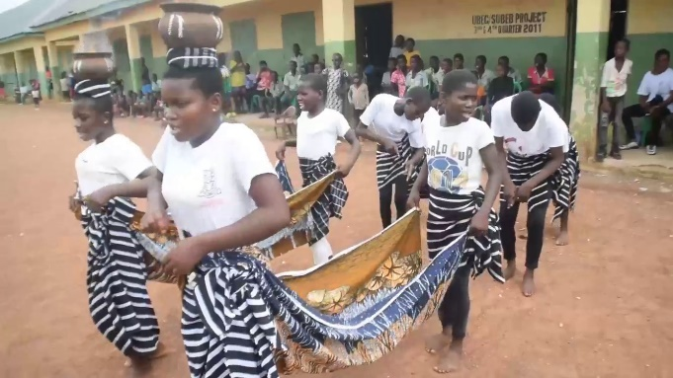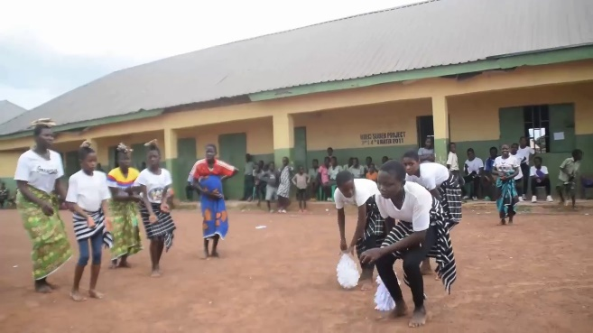

Pic. 1: Pupils dancing Swem Pic. 2: Swem dancers

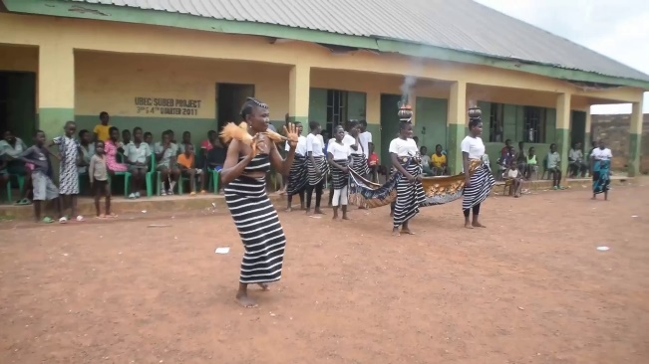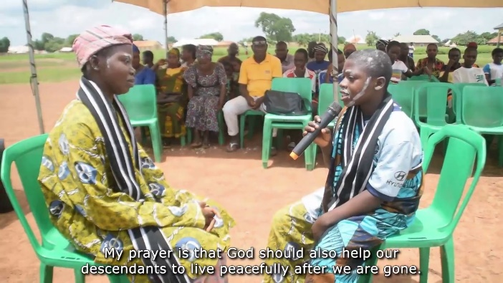

Pic. 3: Swem dancers Pic. 4: Drama scene

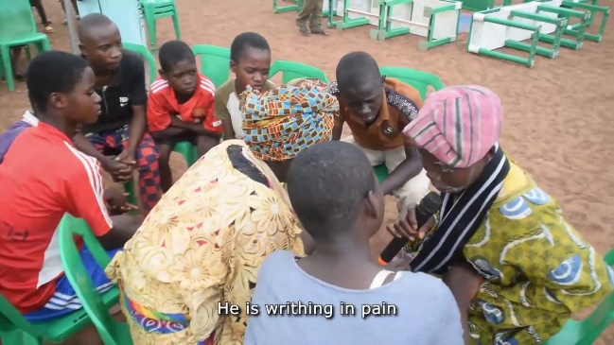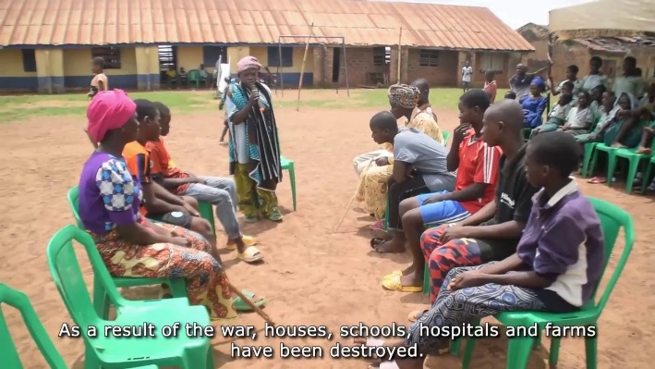

Pic. 5: Drama scene Pic. 6: Drama scene

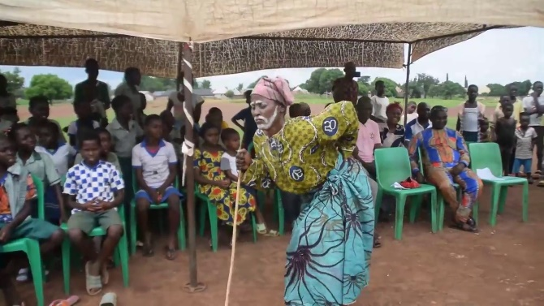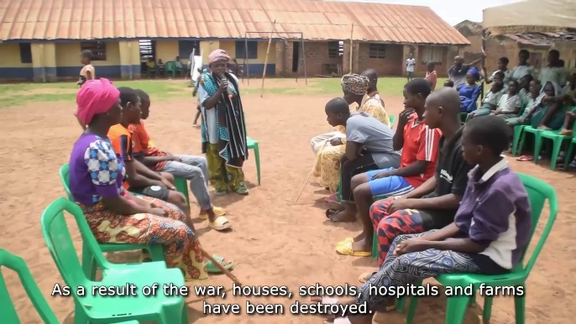

Pic. 7: Swem Dance Pic. 8: Drama scene

**Clearances/Permission letters**

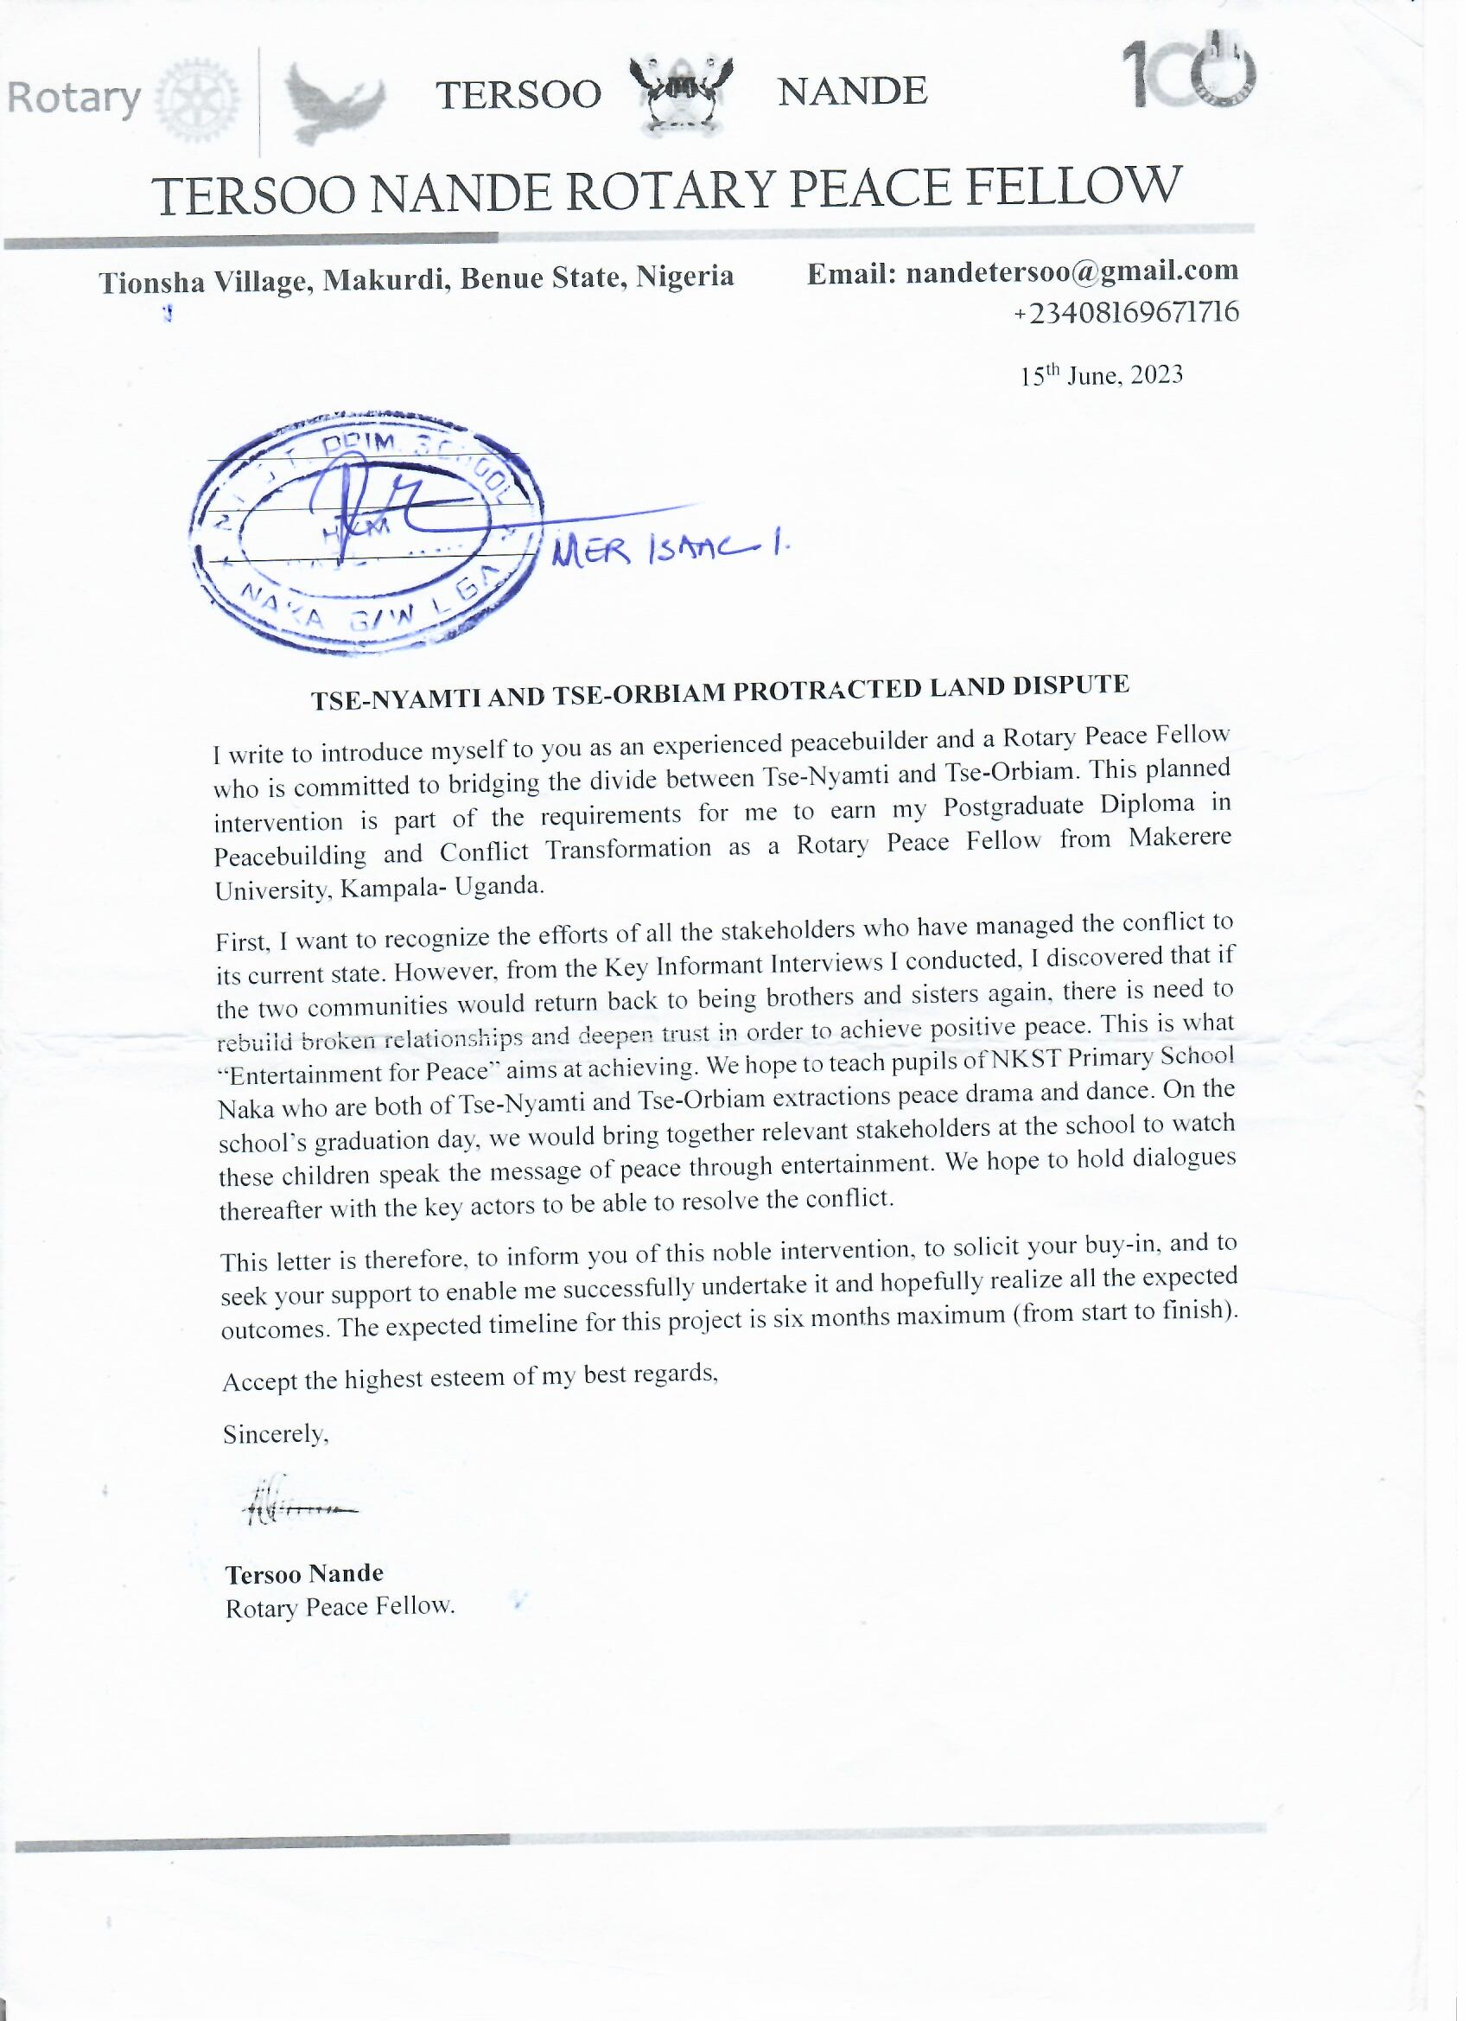

**Participant testimonies (at the end of drama presentation)**

* A participant from Tse-Orbiam, thanked the school for training the pupils well as demonstrated in the drama presentation. He stressed that as depicted in the drama, that was exactly what was happening in his community. That their own conflict involved Tse-Orbiam, Tse-Nyamti and On-Mbavaa. He was touched by the end of the drama where the children concluded that they would converge at the farm in order to resolve their dispute. If they had also done likewise, their conflict would not have lingered. Although, according to him, it was Tse-Nyamti people who refused to embrace peace and escalated the conflict. He concluded that if they could unite and find a common ground, their land dispute would end and peace would return.
* A youth from Tse-Nyamti stated that he learnt from the drama that elders and leaders were responsible for the peace and wellbeing of their communities. He stressed that in communities where leaders restrain their youths from wrong doing, such communities enjoy more peace and development. He promised to take word back to his elders/leaders to live up to their expectations as seen in the drama.
* An elder from Tse-Nyamti stated that the drama demonstrated that “ignorance is darker than night”. Because, he saw that even their grandparents who were without education were wiser and more hospitable than this present generation. He advised that elders/leaders should be providing guidance for the youths and should also seek advice from the youths, when need be, for peace to reign. Unfortunately, even the land which they are fighting over, once they die, they will be buried in it and that will be their end.
* A female participant said the drama showed them that conflict brings about backwardness and destruction of lives and property. In the drama, the elders agreed to visit the disputed land and demarcate the boundary. If they could listen to the voice of their elders/leaders, they will have less conflicts.

**Any other relevant document**

**Baseline Interviews with key stakeholders from the two conflicting communities**

Interview with Mr. Vandekaan Chiem from Tse-Orbiam

Tse-Nyamti have been oppressing Tse-Orbiam for long now, insisting that the latter should remain on the other side of Chu stream and not cross to the other side to farm. Although the relationship between the two groups used to be very cordial from their forefathers until this present generation when relations strained.

The conflict began in 2016 but was not serious until in 2017 when it blew out of control and has remained a nightmare to the two communities up till 2023. One day, people from Tse-Orbiam were on the farm cultivating yam when suddenly youths from Tse-Nyamti emerged from nowhere and ordered them to stop and leave the place immediately. When they demanded to know what their offence was, Tse-Nyamti youths maintained that Tse-Orbiam people should be farming and stopping by the Chu stream on the other side where they live and not extend to this side. Tse-Orbiam people reminded their neighbours that their forefathers were the ones who set the boundaries for the two communities and it has remained so. Why the sudden change? But the youths would not hear of their entreaties and started cutting down all the economic trees that were on the land, extending up to On-Mbavaa, a neighbouring village. Tse-Orbiam people initially thought it was only a bad joke but over the years, they have also been forced to retaliate and that has kept the conflict lingering.

In 2019, the conflict escalated to the point that Tse-Orbiam people who lived on the other side of the stream were forced to vacate and any crop planted was destroyed. No one was allowed to cross to the other side. This conflict intensified because Tse-Nyamti people felt they had the support of one of their sons who was a member of the Benue State House of Assembly. And because of the influence of the law maker, Tse-Nyamti people made life difficult for Tse-Orbiam people.

It looks likely that Tse-Nyamti people have the backing of a powerful person who is urging them on to forcefully collect Tse-Orbiam’s land. Tse-Nymati people are insisting that Tse-Orbiam people should openly admit that the land in question originally belonged to them but was only temporarily ceded to Tse-Orbiam. If this happens, the conflict will end but as long as the former keeps claiming that they own the land, the conflict will continue. Tse-Nyamti people added that they are angered by the fact that Tse-Orbiam people are leasing/selling out the land to others when they have no right to do so.

When the conflict affected On-Mbavaa, the matter was reported to traditional rulers at various levels within the LGA. They intervened by visiting the disputed land where they listened to stories about the conflict and advised Tse-Nyamti people to withdraw from the issue and let peace reign. And that old boundaries should be respected. However, Tse-Nyamti refused to heed to the advice.

Due to the conflict, both communities no longer see eye-to-eye, even the major path that cuts across the two villages for access to Naka town has been abandoned. No one uses the path again to avoid passing through either of the villages and being attacked.

The community leader of Tse-Orbiam stated that when he was elected, he reached out to Tse-Nyamti people for them to meet and resolve the conflict but they refused to honour his invitation, maintaining that they only want Tse-Orbiam to keep to the other side of the river and they will be peace.

Interview with Zaki Adum from Tse-Nyamti

He stated that the cause of the conflict was dispute over land which started since 2009. Tse-Orbiam people were leasing/selling out the land to outsiders so they were asked to desist from doing so because the side they were leasing/selling out did not belong to them. Tse-Orbiam people were advised to focus only on farming to meet their food needs not to make a profit from it. This was the major cause of the conflict.

Different traditional rulers have intervened in the matter and advised Tse-Orbiam people to stick to the other side of the stream. Even the late paramount ruler of Gwer-West LGA intervened and advised Tse-Orbiam to instead request for land from Tse-Nyamti if they needed more land. Zaki Adum was appointed by the paramount ruler to be overseeing the two communities and reporting events to him. One day, someone from Tse-Orbiam cut down a mahogany, when he discovered it, he cautioned that the man would have taken permission first. This generated a lot of conflict and they all went back to report to the paramount ruler who demanded to know whether the planks were removed from the land already and the Zaki Adum answered that it was still there. But when Zaki Adum went for a burial elsewhere after they had returned from the meeting with the paramount ruler, the offender brought a van and removed the planks without his knowledge.

Recently, all the major traditional rulers within the axis met to discuss the conflict and they resolved that though the two communities are in close proximity of each other, they are of different clans (Kyaau and Gyaruwa) and should maintain the boundaries that demarcate those clans accordingly. Documents were signed showing the demarcation and handed over to him (Zaki Adum) as the community leader within the area. Tse-Orbiam people were not satisfied with the outcome of the resolutions by the traditional rulers so they took their case to court.

The case at the court, the judge ruled that part of the land should be ceded to Tse-Orbiam people and that did not sit well with Tse-Nyamti people and this led to renewed hostilities and the judgement is now being appealed in Makurdi.

So far, Tse-Nyamti does not believe that they are external forces interfering in the case. They believe it is them against Tse-Orbiam except such powerful forces might be working secretly behind the scenes. Tse-Orbiam people are insisting that they must be allowed to own land on this side of the river for peace to reign. Meanwhile, some of their elders who are now dead but the witness they shared was documented, confessed that Tse-Orbiam people do not own any land beyond the river. Tse-Nyamti people feel that Tse-Orbiam people are just being troublesome because by right of settlement, it is their neighbours who are on the same side of the river with them that should be laying claim to some of the land and not those on the other side.

The only thing about the conflict is that no one has been killed but relationships are completely strained. He stated that their only challenge is the claim of ownership over the land by Tse-Orbiam people when their forefathers only had an understanding that allowed Tse-Orbiam to be farming only. Now they are leasing/selling it out. So, if they are willing to agree to abide by the gentleman agreement that had existed between their forefathers until the conflict ensued, peace will return.

**Endline interview with the same stakeholders from the two communities of implementation**

Zaki Adum fromTse-Nyamti

After the dialogues, they convened an expanded dialogue involving the two communities after they saw the need for them to return back to being kinsmen again. They agreed to abide by the resolutions which were reached by their elders and traditional rulers earlier. The leaders had divided the disputed land and had given a portion to Tse- Nyamti something we were not comfortable with which escalated the conflict even to the law court.

But after the dialogues, and the way it allowed them to have an open and honest discussion for the very first time without prejudice, they were able to see their backwardness which has been caused by the protracted conflict. This made them to willingly embrace peace.

As a result, Tse-Orbiam people had returned the portion of land which the elders had determined to be ceded to Tse- Nyamti which they refused. But now that they have also agreed to stay away from their own land, Tse-Orbiam people have also given them that land for peace to reign. Even at the dialogue, both sides emphasized the agreement they reached and pledged their readiness to ensure that it is fully implemented.

He stressed that by the grace of God, they would not allow other issues to creep in and disrupt the peace which took them so long to achieve. They have decided that to keep the bond intact, the two communities would be meeting frequently in joint meetings to iron out both pending and emerging issues. They have also decided that they would spread the word around their communities about the resolution reached so that every member of their communities would become aware that peace had returned between them. The people would also know that the land dispute had been resolved and portions of land ceded on both sides. This was necessary to prevent the conflict from resurfacing in the future.

Mr. Vandekaan Chiem from Tse-Orbiam

Both men were interviewed together at the same spot. He stressed that his counterpart did not lie about all that they had agreed upon as part of the peace process. However, he noted that there was a minor issue remaining which would perfect the peace process, but he believed that as they continued to meet frequently, they would be able to address it. He blamed the protracted conflict on the devil who came in between them to cause enmity and retrogression, but thanked the dialogue conveners for their timely intervention.

As for withdrawing the case from court, he stated that now that both sides had agreed to embrace peace, they hope to look into the court case and come up with the best way to ending it. Although he hoped that if none of them turned up at the court for their scheduled hearing, then the case would be struck out. However, he was reminded that for the peace process to be fully completed, it was necessary for them to deliberately decide on how to resolve the court case as well instead of letting it die out on its own. He agreed that with the commitment shown by both sides he was sure that even the court case would soon be withdrawn.

To ensure that everyone was carried along in the peace process, they summoned even youth leaders and women leaders during their last expanded meeting which produced the current resolutions. While they were having the meeting, any youth who wanted to speak ill of the process was immediately shut down, letting them know that the process had progressed beyond what they were thinking. He expressed confidence that the peace they had achieved would last them forever.

Zaki Adum also agreed with his counterpart that youths from both sides are on the same page. The two leaders joined together and prayed for the convener of the peace process and asked God to bless the work they do. They took out time to praise the RSD approach which helped to resolve their longstanding dispute which had no amicable solution in sight. They also promised to refer other communities with similar problems to also apply the RSD method and receive the kind of help they had received.

Mr. Vandekaan Chiem stressed that since their first dialogue, everyone was so touched by the openness of their discussion that their consciences had continued to speak to them silently. No wonder, all their subsequent meetings have been very orderly and none of the people who had been part of the dialogues had attempted to shout at anyone. That was something very unusual.

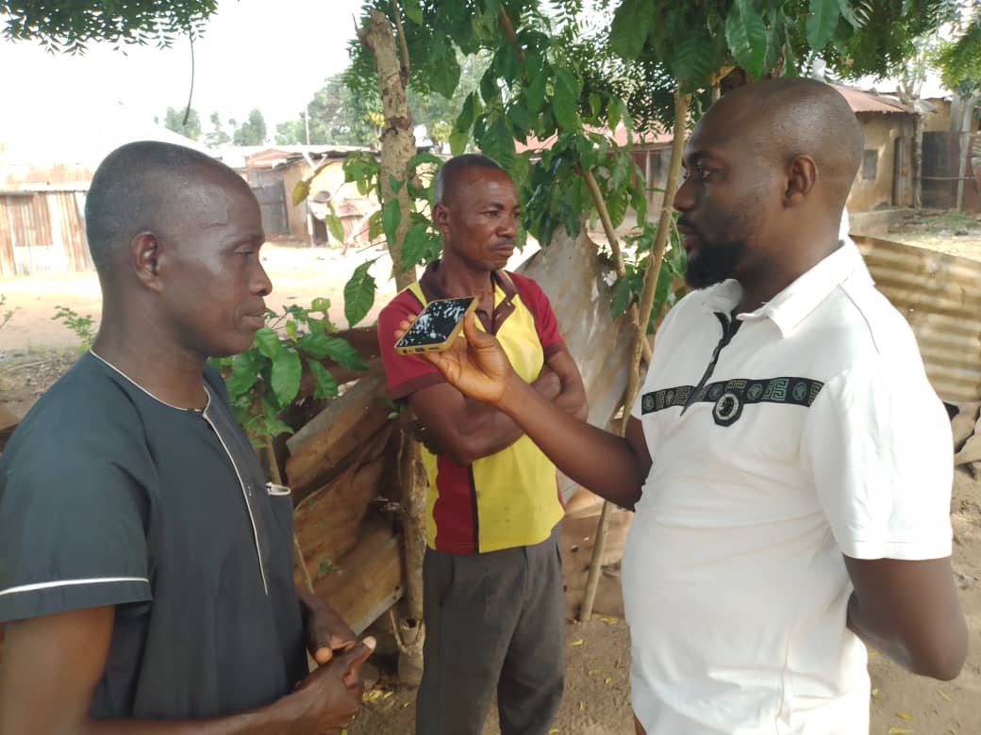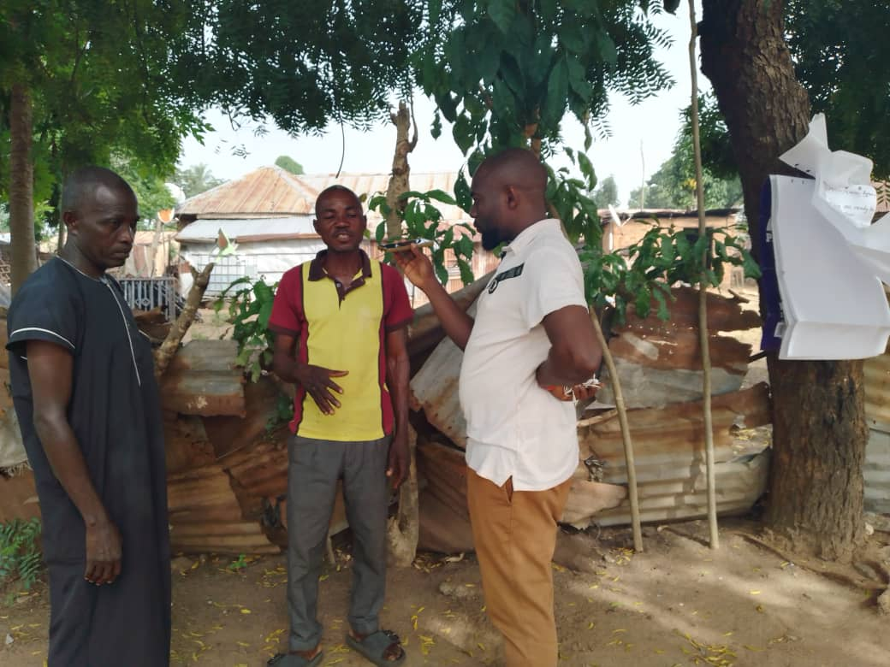

Tersoo Nande with both Zaki Adum and Mr. Vandekaan Achiem during the last interview

**Activities Report**

**PEFORMING ARTS FOR PEACE PROJECT**

**DIALOGUE SESSIONS BETWEEN TSE-ORBIAM AND TSE-NYAMTI TO ADDRESS THEIR LAND DISPUTE**

**By**

**TERSOO NANDE**

**1st Dialogue**

The first dialogue took place at NKST Primary School, Naka on Tuesday, 15th August 2023. The topic of the dialogue was, **“Land Dispute Between Tse-Orbiam and Tse-Nyamti”.**

* During the preparatory sessions before the dialogue, the facilitators (Convener & Community Volunteer) interacted with Chief Adum, the traditional ruler in charge of Tse-Nyamti kindred and it was through him that key conflict actors from his community were selected as participants for the dialogue.
* While Mr. Vandikaan, community leader in Tse-Orbiam identified his kinsmen as participants. Tse-Orbiam people expressed fears of sitting together in a dialogue with their counterparts, Tse-Nyamti despite the impact of the drama by the pupils of NKST Primary School, Naka still fresh on their minds. They alleged that Nyamti people were violent, possessed weapons, use hard drugs and were cunning in their dealings. To allay their fears, a neutral location was suggested as venue for the dialogue and was accepted by all the selected participants. The dialogue took place at NKST Primary School, Naka.
* Chief Adum, the traditional ruler, gave a background on the settlement patterns between the two Communities. He said that people of Tse-Orbiam settled along the river Chu one hundred years ago. The community was constantly affected by floods, so they had to relocate to the land across the river that belonged to Tse-Nyamti. Nyamti leased the land to Orbiam and was advised to use the land solely for subsistence purposes. But at the demise of Orbiam, the patriarch, his descendants began to lease lands to persons other than their kin. And according to Chief Adum, this development annoyed his people to the point that they ordered their youths to cut down economic trees that Orbiam people planted on the land.
* Vandikaan, who is the community leader of Tse-Orbiam, shared a personal experience of how his goats were grazing openly on the disputed land then youths from Tse-Nyamti caught them and butchered them and sold them at the market. He was furious and laid a complaint to the vigilante group. Unfortunately, the vigilante leader took sides with youths from Tse-Nyamti and justice was never served.
* He was not satisfied with the outcome and reported to the police. It was resolved that he should be compensated in monetary terms. However, that compensation was not enforced. Tension began to brew during the dialogue as some participants murmured about the worrisome level of attacks and seizures of farm equipment by militia from both communities as a result of the dispute.
* Demesugh Tyende from Tse-Orbiam also shared his experience of how he was attacked on the farm by Bam Francis from Tse-Nyamti with a pistol and a machete. He knelt down and begged for his life but was thoroughly beaten then allowed to go with injuries and was told that his life might end at any other time.
* Recently, someone died from Tse-Orbiam who lives on the disputed land, Tse-Nyamti people insisted that the man would not be buried on the land except the portion of land for his burial was bought. The stalemate led to the corpse being buried elsewhere.
* Vandekaan from Tse-Orbiam stated that he interceded during the burial saga by pleading with the youths from both communities to sheath their swords and allow peace to reign but they could not arrive at a compromise so they decided to do the burial elsewhere.
* Demesugh told both Chief Adum and Mr. Vandikaan that the conflict rested upon their shoulders and they were responsible for both peace and war. Whatever they decided was what would happen.
* Chief Adum responded by saying that Demesugh's words pierced his heart so he advised that the dialogue should end so that the two leaders could be allowed to meet, together with elders and find ways of resolving the issue amicably.
* Mandaki Terkula from Tse-Orbiam lamented that simply because he had contested for the same position as Chief Adum but lost. He has tried to reach out to the Chief several times in order to find solutions but because Mandaki does not have money to give him, his calls have not been honored. He expressed gratitude for Chief Adum's response that the issue would be looked into by the two chiefs and an expanded council of elders.
* The facilitators intervened at this point and advised participants to give their leaders the benefit of doubt and see how they proceeded. Participants appreciated the facilitators for being neutral in facilitating the dialogue because they had thought that the facilitation would be biased. Their fears were allayed and they were able to successfully discuss openly from the heart. The two chiefs promised to report back to the facilitators the outcome of their caucus meeting as soon as possible.

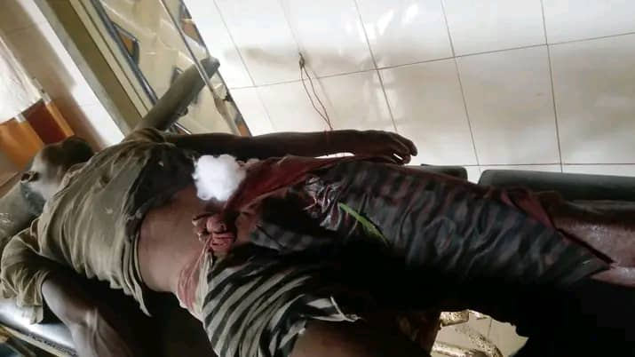

Demesugh Tyende at a primary health clinic in Naka receiving treatment for his machete wounds

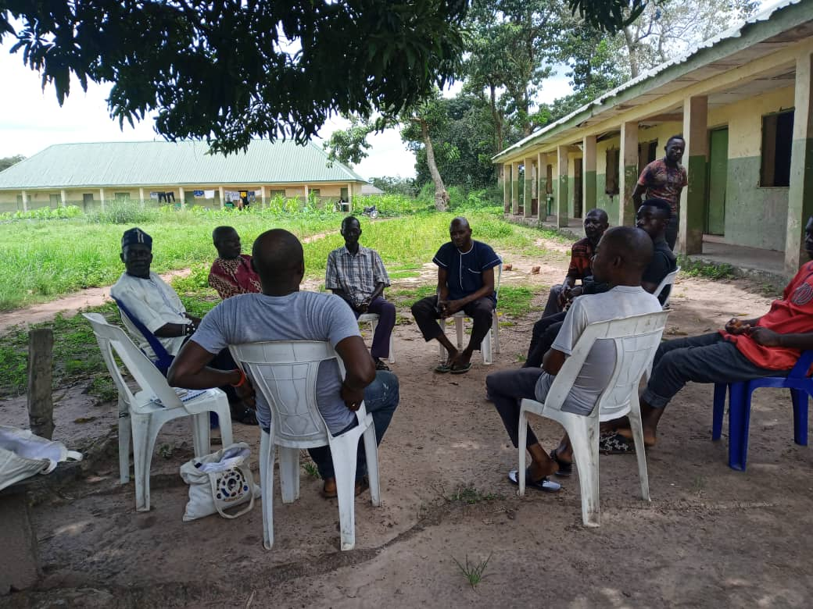

Participants from Tse-Orbiam and Tse-Nyamti during the first dialogue

**2nd Dialogue**

The second dialogue in Naka took place at Chief Adum Ahua’s house, on Saturday, September 23, 2023. The topic of the dialogue was, **“Land Dispute Between Tse-Orbiam and Tse-Nyamti”.**

* As usual, Chief Adum kicked off the discussion with a brief recap of the outcome of their caucus meeting following from the previous dialogue. He stated that their exclusive meeting was successful. They agreed to honour their children’s request for them to embrace peace which was shared during the drama presentation. They also agreed to let the past pass so that they can forge a common future together again. However, they could not agree on what to do with the court case and decided to reconvene for another dialogue to look at it collectively. He reminded participants that, after several back and forth at different courts, Tse-Nyamti are still appealing the recent judgement which favoured Tse-Orbiam.
* Vandikaan Achiem from Tse-Orbiam said that after trying to no avail through the traditional rulers to secure their land, they resorted to the law court where the matter is still pending after securing back-to-back victories. Since then, both sides have never had the opportunity to dialogue as they only meet in court. His confusion now is that should this dialogue resolves the issue, how will they do with the court case?
* Orjume Bem from Tse-Nyamti responded by saying that they did not want to pursue the matter in court even after they were summoned. However, Tse-Orbiam people were selling off the land to outsiders who are now claiming ownership of the land and that forced their hands to also seek the intervention of the courts.
* Tyohuna Jeremiah from Tse-Orbiam responded to Orjume by stating that the two communities have been fighting one another in the court and if they so decided that enough was enough, they could inform the court that they wished to withdraw the case and settle out of court.
* Orkeghen Titus from Tse-Nyamti said that he was happy that for the first time since the beginning of the conflict, participants from both sides were suing for peace. However, he stressed that it was not the youths who reported the matter to court and that no youth had ever appeared in court, it was their elders. Therefore, he suggested that after the dialogue, their elders should be informed of their decision to embrace peace and settle the matter out of court so that it can be withdrawn from the court immediately.
* Participants unanimously agreed to communicate the outcome of their decision back to the facilitators as soon as possible. They will also insist on the demarcation of the disputed land.

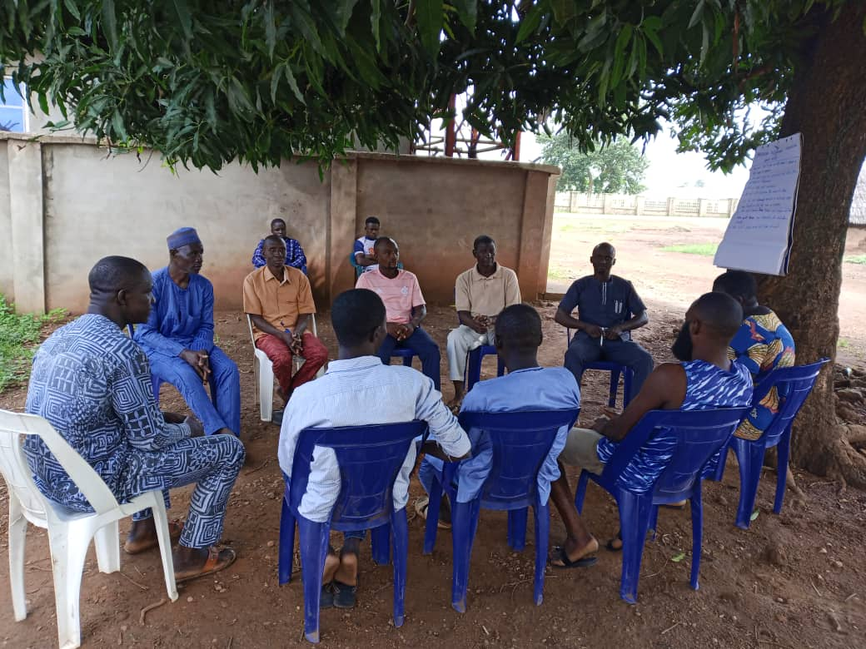

Participants from Tse-Orbiam and Tse-Nyamti during the second dialogue

**Conclusion**

The Performing Arts for Peace project was a huge a success, beginning from the drama and dance presentations down to the two dialogue sessions. It is noteworthy that the trick of getting children from the two conflicting parties of Tse-Orbiam and Tse-Nyamti to dance and act drama before their conflicting parents was a master stroke. This strategy ensured that sworn enemies who were hitherto not willing to see eye-to-eye finally succumbed to the power of their children’s innocent appeal and came together to address their lingering land dispute for peace to reign. Special thanks to The Pollination Project and Rotarian RoAnna Savage for providing the funding to enable the attainment of this monumental breakthrough solution and to my colleagues for their technical support.



(L-R) Matthew Buan, Ruth Odeh, & Tersoo Nande (Facilitators)

**WHAT SHALL WE DO TO ACHIEVE PEACE? (KA NYI SE ER VE SE ZUA A BEM?)**

**Scene 1**

Stage opens with Ortamen Iorvaa and Ortamen Avalumun sharing fond experiences of their long brotherhood and friendship, even as they take their snuff.

Ortamen Iorvaa: ‘My brother and friend’ referring Ortamen Avalumun, ‘God has been so merciful to us. He has blessed us with long life and we have both lived together peacefully. My prayer is that our descendants should continue to enjoy such peace after we are long gone’

Ortamen Avalumun: ‘Amen…I’m quite sure that we have lived up to 200 years’ (they both burst out laughing). ‘Imagine when we fought the Biafra war as young men up till now’.

Ortamen Iorvaa: ‘Of course, those were good old days.’ Turning to his friend, ‘my biggest fear is Agbodo, who has been our neighbour for many years but has refused to even eat our food’.

Ortamen Avalumun: ‘Truly, Agbodo is a point of concern. And to make matters worse, my son Ngyewe likes being friends with his son, Okpito. I hope their friendship will not cause trouble between our descendants in future’.

Ortamen Iorvaa: ‘I hope so too but I don’t think we are going to die anytime soon so let’s go and drink burukutu. Wan Nyityo is the best in brewing millet’

Ortamen Avalumun: ‘My brother, if we don’t give up drinking Wan Nyityo’s bkt we might live up to 300 years old and our children might not be happy. I think my son, Ngyewe, wants me to die so he can inherit my youngest wife, Mwuese’ (they both laugh heartily as they walked off the stage)

**Scene 2**

Stage opens at Ortamen Avalumun’s household where his eldest son, Ngyewe, is presiding over a family meeting:

Ngyewe: (clears his throat and begins his address) ‘I greet every one of you for agreeing to stay back for us to have this discussion after the successful burial of our patriarch, Ortamen Avalumun. Right now, we have become Tse-Avalumun, and as the head of this family I want to assure you that we will try to honour our father the best we can. But first of all, we need to address the fadama issue with On-MbaIorvaa, so that peace can reign’.

Mama Akpena: ‘My son, I’m happy that you want us to honour your late father who was my husband. But we shall not honour him by starting a fight with his friend’s family over fadama’.

Ngyewe: ‘But mama…you know very well how this fadama issue has been causing trouble between the two families except that our parents didn’t want to talk about it?’

Mama Akpena: ‘Yes. Therefore, let us respect the wisdom of your father and his friend who valued peace over war and let the issue be’.

Ngyewe: ‘It’s okay my people, now that mama has decided to toe the path of her husband, let’s leave the matter for now. You can all return back to your respective destinations safely’. (they all leave the stage, expressing their emotions differently)

**Scene 3**

Stage opens at Ortamen Iorvaa’s household where his son, Akawe, is reporting an issue to his aged mother:

Akawe: ‘Mama, are you aware that Ngyewe and Okpito have conspired to take over our fadama?’

Mama Ngiena: ‘I knew that those two were of no good together. Please, my son, stay away from them. I don’t want you to fight anyone over land please’.

Akawe: ‘But mama, if I do nothing, they will take over that land and that’s our only fadama. I don’t want to lose it’.

Mama Ngiena: ‘If they insist, let them have it but you will lack nothing, my son. I’m old, I will soon join your father, please allow me to die in peace.

Akawe: ‘It’s okay mama, I hear you.

**Scene 4**

Stage opens with youths from On-MbaIorvaa going to farm on their fadama. Akawe is their leader and they are determined not to lose the land to Tse-Avalumun. Shortly after they started cultivating, youths from Tse-Avalumun appeared and attacked the former and a brawl ensued. But at the end of the day, On-Mba-Iorvaa overpowered the latter leaving two people dead.

They all scamper away for their safety, and moved the corpses away from the stage.

**Scene 5**

Opens with Ngyewe and his boys discussing with Okpito to support him so that they can attack On-MbaIorvaa and completely annihilate them. Okpito agrees and they conclude on when and how to carry out the attack.

**Scene 6**

Stage opens with On-MbaIorvaa sleeping at night when suddenly, a combined team of Ngyewe and Okpito unleashed deadly attack on them, killing mostly women and children. Others ran away and survived. They returned after believing that the attackers must have gone and they start wailing and lamenting.

**Scene 7**

Someone addresses the audience, detailing the conflict between Tse-Orbiam and Tse-Nyamti and the repercussions which have led to displacement, lack of education for the children, enmity between the two kindreds, and so on. He ends with the question: what shall we do to achieve peace?