

**Social Change Initiative Report for the Project:**

**Regenerative farming for Refugee Communities (Re-**

**Farm) implemented in Nakivale Refugee Settlement**

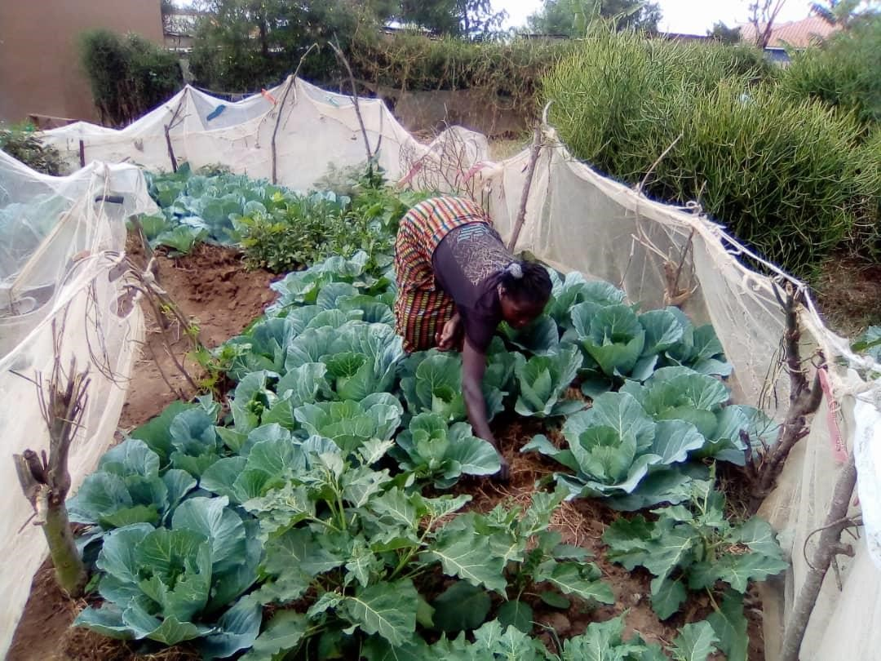

**Prepared by: Noah Ssempijja, Rotary Peace Fellow 2021**

**Makerere University Peace Center**

**2022**

**TABLE OF CONTENT**

ABSTRACT 2

CHAPTER ONE 3

Introduction and Background 3

Problem Statement 5

Goals of the Social Change Initiative 5

Challenges and mitigation strategies 6

CHAPTER TWO 8

Literature Review 8

Theoretical Underpinnings 10

Project’s theory of Change and its application 12

Methods and Designs 15

CHAPTER THREE 18

Interventions and Activities 18

Project deviations 23

Key findings / impact 24

Helping farmers adopt the knowledge and skills learnt 26

General Conclusion 29

Recommendations / implications for Policy 30

Sustainability plan 31

REFERENCES 33

ANNEX 35

Baseline Questionnaire 35

Regenerative Diary Questionnaire 36

Selected project pictures 37

# ABSTRACT

Key Component to the Makerere University Peace Fellowship program is for the fellows to implement a community Social Change Initiative (SCI). This report provides an account of the SCI implemented by the Peace Fellow in Nakivale Refugee Settlement. The Project entitled “Regenerative Farming for Refugee Communities” was implemented between February – August 2022. The project’s goal was to improve food security and resilience to climate change effects for refugee and host farmers in Nakivale refugee settlement. Initially, the project was designed to benefit 50 refugee and host community households, but due to funding from Regenerosity, the projected reached 122 refugee and host communities.

Key to the project’s implementation and success was the involvement of local stakeholders, locally based organizations and beneficiaries in the planning, implementation and monitoring of project activities. In total, up to 600 individuals (67% females and 33% males) directly benefited from the project’s activities through training, accessing food and incomes. The project adopted a regenerative diaries approach to assess its impact, and discovered that there 75% households had more than two meals attributed to the project, while up to 50 households earned between $2-$7 dollars weekly out of sale of food attributed to the project. Sustainability of this project is key, and as such, a local organization has integrated its activities in their operations, thus, households will continue benefiting from the project activities.

# CHAPTER ONE

## Introduction and Background

This Social Change Initiative report is prepared following the implementation of the Social Change Initiative Project entitled Regenerative Farming for Refugee Communities in Nakivale Refugee settlement. The report is presented to Makerere University; Rotary Peace Center as partial fulfillment for the award of the Post Graduate Diploma in Peace and Conflict Transformation under the Peace Fellowship Program. The report gives provide an overview of the Social Change Initiative (SCI) project that was implemented by the Peace Fellow, the underlying theoretical framework under of the SCI, the key interventions implemented and provides recommendations to inform policies regarding refugee livelihoods in Uganda. The SCI initiative was implemented between February and August 2022 in Nakivale refugee settlement. The SCI targeted female and youth refugee households in the settlement.

Uganda is home to over 1.5 million refugees that are settled in 14 refugee settlements across the country including within the capital – Kampala. The government of Uganda with support of development partners has developed the Refugee Host Population empowerment framework (ReHoPE)[1], the Social Transformative Agenda (STA)[2] and the Refugee Response Program (RRP). Whereas these initiatives are in place, the actual implementation of activities recommended therein has been very limited and yet the refugee crises continue to grow amidst the COVID-19 Pandemic. Empirical evidence from available literature points to the fact that if no action is put in place, the impact of refugees and the local communities on the integrity of the environment is likely to escalate with devastating effects on natural, economic and social capital in areas that host refugees.

Among the settlements that host refugees in Uganda is Nakivale. Nakivale is the oldest refugee settlement in Africa, and benefits from what is often lauded as the most progressive refugee policies in the world. Nakivale is home to over 140,000 refugees mainly from the Democratic Republic of Congo, Rwanda, Burundi, Somalia, and South Sudan. As one of the longest standing refugee settlements in the world, Nakivale feels a little more like a town than a refugee camp. Indeed, in a BBC media report published in 2016, Nakivale refugee settlement was termed as “The best place to be a refugee”. However, refugees in the settlement have been affected by food insecurity mainly due to cutting of World Food Program food rations cuts, poor harvest from the gardens as well as harsh climate change effects that do not favor sustainable food production[3]. This situation has been exacerbated by the outbreak of COVID-19 Pandemic which has further put the population on pressure.

On the other side, the host counterparts also face a number of food security problems. Approximately 84 percent of Ugandans live in rural communities and rely on agriculture for food and their livelihoods. This can make families vulnerable to weather cycles and natural disasters that can affect crop yields. In a research carried out by Uwezo in 2018, it was discovered that majority of Ugandans had faced food insecurity with seven people out of 10 noting that they had to skip a meal because of lack of food. Over 69 percent said that their households ran out of food, 67 per cent said they were hungry but had nothing to eat while 85 per cent were worried about running out of food in the coming three months.

## Problem Statement

Nakivale refugee settlement is located in South West Uganda, in Isingiro district. The settlement hosts over 140,000 refugees from the Democratic Republic of Congo, Rwanda, South Sudan, and the Horn of Africa. The 2020 [Nakivale Refugee Settlement Profile,](https://reliefweb.int/report/uganda/nakivale-settlement-profile-isingiro-district-uganda-july-2020) reported that refugees depend mainly on subsistence farming characterized by low production, poor productivity and limited access to wider value chains; with thousands of them struggling to get what to eat and earn an income. This is mainly caused by harsh climate change effects that make food production hard and lack of knowledge and skills on good agronomic practices that are climate smart.

This situation is exacerbated by WFP’s cutting of food rations for the refugees. In 2020, refugees’ food was cut by 70% with refugees getting cash for food worth UGX13,000 ($3.5) per month, just too little to buy a decent meal. As a result, refugees have resorted negative copying mechanisms such as skipping meals, sleeping on empty stomachs. For example, In Nakivale 94.7% of the households relied on less preferred, less expensive and non-nutritious food to survive[4]. Sadly, the children and women suffer the most! Due to lack of nutritious meals, children become malnourished which affects their growth and health. Other households participate in environmental degrading activities such as cutting trees, burning charcoal, use of chemicals in their gardens to increase food productivity among others that affect the biodiversity. Refugee and host community relations have also soured due to conflicts over the limited food and resources.

## Goals of the Social Change Initiative

The main goal of Re-Farm Project was to improve food security and resilience to climate change effects for refugee and host farmers in Nakivale refugee settlement. This would be achieved through empowering refugees and host community farmers with practical regenerative farming and climate change adaptation skills. The project participants would be empowered with the knowledge and skills to grow organic food using regenerative farming methods and techniques and at the same time improve the soils on which they work.

The project was designed to have achieved the following specific objectives by end of its implementation:

1. Improved incomes and nutrition for refugee and host farmers
2. Improved resilience and climate change adaptation for refugee and host farmers
3. Improved co-existence between refugees and host communities

The project had been designed to directly benefit over 50 refugee and host households especially those headed by women and youth, comprising of an average number of 4 members each household. However, with a 5000 USD grant funding from Regenerosity, the Fellow was able to increase the target households from 50 to 100. Indirectly, the project benefited over 1000 individuals in Nakivale Refugee Settlement.

## Challenges and mitigation strategies

1. There was an outbreak of cholera epidemic in some parts of the settlement including in areas where the SCI was being implemented. This caused the project activities in those specific areas to come to a halt; as 80 households were affected by the disease. Most of the farmers that had been mobilized from these areas could not attend the trainings. We worked with the local leaders to follow all the set procedures until the cases reduced. Activities in areas that had been affected were put on hold, and resumed after the government has declared them cholera free at the moment.

1. Farmers adopt at different pace. During our observations at the demo sites, we have noticed that there are fast, medium and slow adopters. This has been an interesting challenge to us the project team. So we have come up with schedule where by the slow and medium learners are able to gain experience from the fast learners through experience and knowledge sharing. This has encouraged farmer to farmer learnings and interactions during Demo visit. The slow and medium learners are inspired to commit more time to the project activities.

1. The project was constrained by the funds. In total, up to $10,000 USDs was needed to effectively implement the project activities and ensure sustainability of the activities. To engage, facilitate and sustain volunteers, to provide high quality seeds and monitor project activities all required funds. However, the fellow was lucky to receive funding of up to $5000 from Regenerosity that has facilitated implementation of the project activities. Also, local community structures and existing local organizations were leveraged during the implementation of the project in order to reduce on the cost of implementation. For example, the project worked with local refugee volunteers to mobilize groups and facilitate trainings.

1. In some areas, our activities collided with some of the refugee camp routine verification exercise. As a result, some farmers would not come for trainings as they had to go and get verified by the refugee camp activities. However, we always reschedule to meet them in their free time to compensate for the times they did not come for group learning meetings.

# CHAPTER TWO

## Literature Review

By end of 2020 the world had registered a record 82.4 million forcibly displaced people and over 26.4 million refugees[5]; half of whom are children under the age of 186. The reasons for fleeing have generally been attributed to conflict or persecution, climate change effects, and war. It is estimated that 1 in every 95 people on the earth flee their homes. According to UNHCR, as of mid-2021, 68% of the world’s refugees originated from just five countries. These include Syrian Arab Republic with 6.8 million people fleeing, Venezuela with 4.1 million, Afghanistan with 2.6 million, South Sudan with 2.2 million and

Myanmar with 1.1 million people fleeing for safety. Worth noting, the Least Developed

Countries host 85% of the world’s refugees, while the developed countries only host 15%.

Uganda, party to the 1951 Refugee Convention has a rich history of hosting refugees dating back in the 1940s during the Second World War. Over 7000 prisoners of war from Poland, Germany, Romania and Austria sought refuge in Uganda at Nyabyeya and Mpunge in the present day Masindi and Mukono districts respectively1. At the same time, the struggle for independence from a number of African states saw Uganda host thousands of refugees. in 1950s, thousands of Kenyans fled following the Mau-Mau anticolonial movement in Kenya and sought refuge in Uganda1. The political and ethnic conflicts in Rwanda between the Hutus and Tsutsi between 1950 – 1960s forced a number of Rwandan Tutsi to flee into Uganda. These were settled into Kyaka I refugee settlement, Oruchinga and Nakivale settlements 2. According to Pirouet, (1988), over 80,000 Sudanese refugees fled to Uganda after the army mutiny in Sudan. These were later repatriated following the 1972 Addis Ababa agreement 4. Between 1980s – to date, a number of events in the East African region has seen millions of people flee their countries for refuge. For example, the 1994 genocide in Uganda saw over 20,000 refugees enter Uganda – while as of December 2018, over 1 million South Sudan refugees fled to Uganda following the conflicts between the government and the opposition 4. To date, Uganda ranks third among the refugee hosting countries after Turkey and Colombia. The East African Country is home to over 1.5 million refugees; with over 944 thousand refugees fleeing from the neighboring country South Sudan. The Democratic Republic of Congo (DRC) and Burundi are the other two refugee origin countries – with the latter having over 52 thousand persons fleeing while the former with up to 450 thousand refugees by end of October 2021.

Refugees in Uganda are hosted across 14 settlements, with a handful of them staying with in urban centers across the country. As of May 2021, there were over 95000 refugees in the Kampala the capital city of Uganda; under the mandate of UNHCR and oversight of the Ugandan office of the Prime Minister (OPM) in charge of refugees. The refugee settlements are mainly located in the South West and West Nile part of the country. Majority of refugees are hosted in West Nile – with the largest refugee settlement - Bidi Bidi hosting over 242,819 refugees mainly from South Sudan[6].

In Uganda, refugees have freedom to movement within the country and can freely interact with the locals (host communities). Indeed, Uganda has been applauded for its progressive refugee policy that among other elements ensures that refugees have a piece of land for cultivation, can access employment opportunities, have access to education at the same level as nationals and have access to basic amenities with in the refugee settlement. The goal for this arrangement is to promote refugee self-reliance and achieve refugee and host peaceful co-existence. However, cases of tension, conflicts and radicalization have been registered on several occasions – thus undermining this rather well intentioned arrangement.

There have been reports to suggest that refugee and host community co-existence and livelihoods can be attained but mainly at the grassroots and individual level. There have been cases of refugees working with the host communities to address their livelihood challenges with in their communities. For example, in Nakivale refugee settlement, refugees and host community members have established join village savings and loan associations through which they can save and loan funds to each other for running their small enterprises 5. There are also registered cases of intermarriages between refugees and host communities 6,7 – and cultural adaptations and exchange through learning each other’s language, values, foods among others.

As such the livelihood agenda for refugees is an important aspect in the international refugee regime since the early 2000s. The increasing protracted refugee situations and failure to address these has meant that sustainable solutions needs to be implemented to enhance refugee protection and livelihoods in the host countries8. Indeed, this kind of approach is key as refugee situations become protracted after the emergency period, relief and support from the international community tends to reduce or sometimes cut off completely9; thus making it hard for UNHCR to provide for all the needs of refugees in protracted situations10.

Amidst these challenges, the UN refugee agency is increasingly promoting the ‘selfreliance’ of refugees, and encouraging the development of sustainable livelihoods9. The refugee livelihood and self-reliance approach promoted by UNHCR has been clearly defined in the Handbook for Self-Reliance (2005) and Livelihood Programming in UNHCR – Operational Guides (2012). These guidelines among other aspects provides guidance to the development organizations to support the financially constrained UNHCR to implement projects promoting livelihood and refugee self-reliance. The extent to which this approach has yielded results equivocal; however, refugee hosting states such as Uganda have incorporated this approach in their refugee hosting agendas.

## Theoretical Underpinnings

Implementation of this social initiative was influenced by the Sustainable Livelihoods

Framework(SLF). Originally influenced by the work of Robert Chambers in the mid1980s11, the SRL framework was integrated into British Department for International Development (DFID)’s program for development cooperation. The Sustainable Rural Development Approach points to two distinct by complementary elements of human development. These are “livelihoods” and “sustainable livelihoods”. Chambers and Conway12 illustrates that “a livelihood comprises of the assets, activities and capacities required to attain a living. To them, a livelihood is sustainable when individuals can cope with and recover from the stresses and shocks; and are able to maintain or enhance the capabilities and assets consistently while protecting the national resources base”.

The LSF is built around the vulnerability of the individuals who have passed through hard times and need to lead their own development to improve their livelihoods. The framework is characterized by elements of people centered, holistic and dynamic development approaches that built on people’s strength, creating micro and macro links to achieve sustainable development. Most importantly, the SLF serves as a tool to investigate the livelihoods of the vulnerable people and the factors that influence these livelihoods. It is however important to note that, the SLF model provides simplified information on livelihoods and does not address a wide range of livelihood components that can be explained through qualitative and participatory research and analysis at the local levels.

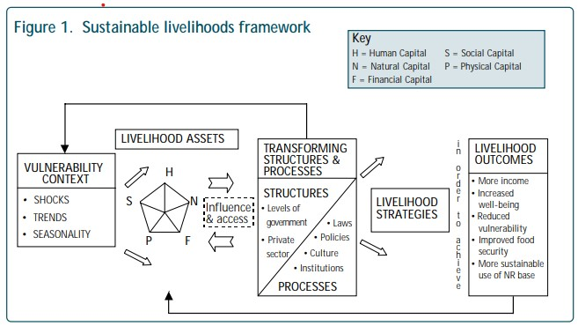

### Source: DFID

In the illustration above, the framework depicts the vulnerable context in which humans live. These are characterized by trends, shocks and seasonality that affect their livelihoods. For example, for the refugees that the SCI targeted, trends can include such events as forced migration, change of leaders in their home countries, high influx of refugees that affect service delivery; and the seasonality contexts such as employment issues, food prices and others that have impacts on the livelihoods of individuals. On the other side, the framework points to shocks can include conflicts, economic hardships, natural hazards among others.

Consistent with Chambers and Conway’s definition of the concept of sustainable livelihoods, it is evident that refugees undergo a lot of stress, shocks and life threating events before and during movement from their countries of origin. Worldwide, refugees are faced with traumatic events, loss of property, loss of relatives, cultural shocks and are generally in mental distress13–16.

At the same time, refugees need access to key resources (livelihood assets) to be able to build their resilience. For the case of Nakivale, Refugees need access to natural resources such as land for cultivation, access to road networks, peaceful living environment with the host communities as well as financial and physical support. These resources can be made possible through the influence of the local structures, policies and laws government refugees and the private sector. Initiatives such the Re-farm project implemented by the fellow complement these resources for the refugees thereby enhancing access to key knowledge and skills, improving food security and incomes which are all key result areas for the SLF.

## Project’s theory of Change and its application

Consistent with the Sustainable Livelihood Framework, the SCI was designed to respond to the shocks faced by refugees in order to attain food security and incomes. Specifically, the SCI responds to the problem that Refugee and host farmers struggle to utilize their small pieces of land to increase incomes and become food secure; due to poor farming methods, climate change effects and lack of knowledge and skills to implement regenerative farming practices. The overall impact of the SCI was to enhance good health, incomes and agrobiodiversity for refugees and the hos communities in Nakivale.

To achieve this, the project implemented a number of activities the included development and delivery of regenerative farming content, providing high quality seeds, delivering climate change awareness, tree planting and regenerative diaries to gather behavioral change information from the beneficiaries. Key stakeholders such as UNHCR, Office of the Prime Minister (OPM) in charge of refugees as well as local leaders were involved and consulted during the implementation of the project. On ground, the SCI collaborate with local community based organizations such as Youth Initiative for Community Empowerment (YICE), Wezentu group for mothers of Children with Disabilities and the Uganda Police were actively involved in the local project activities.

To ensure success of the project activities, tailored project management support, on-field farmer practical trainings and on farm support as well as application of the positive peace pillars (especially equitable distribution of resources) were enhanced. For example, out of the 100 households reached through the project, 33 were national households while 67 were refugee households representing 33% of host households reached; working with in the 70:30 refugee host reach guidelines for refugee’s development projects in Uganda.

The illustration below shows the project’s theory of change.

**Fugure 2: Project theory of Change.**

**Impact** Improved health, wealth and agrobiodiversity of refugee and host farmers in Uganda (SDG1, SDG2, SDG3 & SDG8)



**Outcomes Economic empowerment for refugees Peaceful co-existence between**

**and host communities refugees and host communities**

* Improved food security and nutrition for • Increased responsible use of natural refugee and host communitiesresources and environment
* Refugees earn incomes through sale of • Facilitated knowledge sharing between vegetables / surplus seeds refugees and host communities
* Created alternative sources of income • Enhanced use and sharing of indigenous through sale of fruits, volunteer fees etcseeds and farming tips

**Outputs** Improved incomes and Improved resilience and Improved co-existence

nutrition for refugee and host climate change adaptation between refugees and

farmers for target farmers host communities

|  |  |
| --- | --- |
| **Enablers** | * Local support including OPM & UNHCR buy-in and other INGOs in the settlement * Refugee and host communities strengthened to work together and learn from each other * Local project support team identified, hired and trained to support delivery of trainings * Accurate data collected and field support activities implemented to understand need and support adoption. |
|  |

**Activities** • Development and delivery of regenerative farming content

* Access to appropriate and high quality indigenous seeds for first growing food
* Climate change adaptation training and water harvesting and Irrigation support
* Fruit tree planting and environmental conservation training
* Tailored positive peace training for refugees and host communities
* Regenerative diaries (bi-weekly data) collected from a sample of beneficiaries

**Inputs** • Focused Project Management Support

* Specialized technical support
* Tailored practical farmer training and on farm support • Tailored application of positive peace pillars



|  |  |
| --- | --- |
| **Problem Statement** | Refugee and host farmers struggle to utilize their small pieces of land to increase incomes and become food secure; due to poor farming methods, climate change effects and lack of knowledge and skills to implement regenerative farming practices. |
|  |

## Methods and Designs

The social change initiative was designed and implemented following community based participatory methods that involved the local stakeholders and beneficiaries in the design, planning and implementation of the project activities. Consistent with examples of participatory refugee projects in Palestine 17, the SCI implemented methods that would enhance active contribution to the project from the local beneficiaries and at the same time create sustainability of the intervention. For example, right at the design of the project, local organizations, refugee groups and local volunteers were involved in the planning and redesigning of the project. During implementation, trainings were conducted in the locally spoken languages in the settlement (Swahili) by the local refugee volunteers. This promote ownership of the project, full participation from the local communities and enhanced learning and adoption of the knowledge and skills learnt.

In order to drive adoption and comprehension, all trainings and other project activities were practical and hands on. As a regenerative farming project, the activities were designed to be carried out from the field / gardens so that farmers can immediately apply the knowledge and skills learnt. For example, when training on how to establish a double dug or nursery bed, farmers would be showed practically how it is done, and they would try it there and then – and then would be asked to replicate the same on their gardens soon after the training. Group trainings of 10 – 20 members per group were encouraged, and these groups have both refugee and host community members working together. This enhanced knowledge sharing – where refugees would share their farming tips and experiences from the country of origin, while nationals would share tips and skills from Uganda. One fascinating example was when a refugee from Burundi shared that the pigs intestines can control termites from the demonstration garden we had established – an idea that was opposed by her other group members until the technology was tested, and indeed, the termites were controlled. Such and many experiences shared during the project made learning enjoyable while new regenerative tips and skills were acquired by the project beneficiaries.

After all the community organizing and participatory trainings, we helped farmers to adopt the skills learnt on their gardens through home visits and on garden support. The community volunteers visited farmers on their gardens to see the farming activities they are implementing and they would get on spot support and advise on how to improve their gardens. Key advises provided included tips on water harvesting, pest and disease management, organic fertilizer making and positive peace messages. The graph below summaries the project’s approach and methods used.

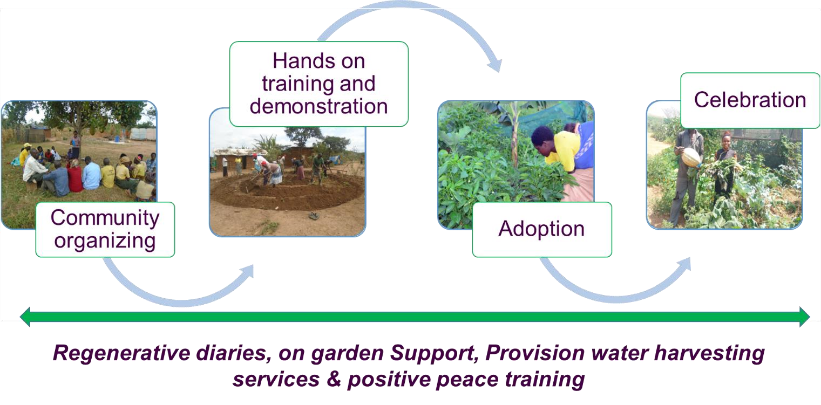

In order to assess progress and impact of the project, periodic assessment the project activities were carried out to ensure they are on track. Monitoring was carried out for every activity – and tools such as activity evaluation, reports and field activity reports were used. The project embedded regenerative diaries to facilitate evaluation of its impact. Regenerative diaries are a set of simple assessment questions that were administered for at least 20% of the target beneficiaries at the start of the project (baseline), and thereafter, 6 beneficiaries were interviewed bi-weekly. The bi-weekly diaries captured among other aspects, beneficiaries’ feedback about the project, any key tips they learnt in the two weeks, their social lives – the meals they had, incomes among others. In total 10 – 15 diaries questions were developed. These were administered biweekly by the project volunteer in the refugee settlement. The regenerative diaries were collected using mobile phone - on a free source application called Kobo Collect. The regenerative diaries formed a strong part of the evaluation of the project – and a snapshot of the findings has been presented in this report under the impact section.

# CHAPTER THREE

## Interventions and Activities

Over the last six months, the Fellow has implemented the SCI initiative activities in Nakivale Refugee Settlement. A number of activities and interventions were implemented during this period. These are described in the section below:

#### 1. Community entry, local leaders’ engagement, and review of implementation plans

At national level, the Fellow engaged the office of the Prime Minister in Charge of Refugees to obtain authorization to work with local refugee groups in Nakivale to implement the project. With this approval, a team of volunteers from within Nakivale refugee settlement was engaged to support on-ground implementation of activities including identification of farmers. In addition, the Nakivale settlement leadership was engaged to introduce the project and discuss the implementation plans with them. This activity involved conducting local leaders’ meetings, discussing the project activities, implementation plan and the role of local leaders. During these meetings, it was agreed that the local leaders would support the project team in identifying project beneficiaries and target communities.

*“With a key nutrition and environmental component, I advise your intervention should target households with vulnerable children and those in environmentally hit communities” noted – the Nakivale Refugee Settlement Commandant, Mr. Mugenyi David.*

While these target groups are what we had in mind, we learnt that engaging local leaders not only help promote a sense of ownership over the intervention but also helps in identifying the real beneficiaries that would benefit from the project. That is why, over 80% of our project beneficiaries have more than two children in their households. Following engagements with settlement leaders, the project team was introduced to the village leaders – who then, introduced us into the community. Working with in the right community channels facilitated the project’s acceptance from the community.

**2. Farmer identification and project awareness meetings.**

By working with the refugee settlement local leaders, the project team visited communities within the refugee settlement conducting community level meeting. During these meetings, the project was introduced to the community members, and criteria of those that would be beneficiaries was laid down. Among the key discussion points were; sharing information on the project goals, objectives and how it was to be implemented. At this point, community members were given chance to ask any questions they had. It was discovered that, the mostly asked question was whether the project would provide seeds, and how it was to follow-up on the farmers to ensure that they adopt what they learnt. During these meetings, farmers that were ready to enrol for the project were registered and an appointment for their profiling was made. This activity was conducted in 6 villages as guided by OPM, and it is from these villages that the farmers that are currently participating in the project were identified.

#### 3. Farmer profiling and baseline data collection

All the farmers that picked interest in joining the project and fit the laid down criteria were visited at their homes. The purpose of these visits was to engage them to understand more about the project, collecting information baseline information from them and discussing the grouping and the days they want to attend trainings. In total, 136 farmers were profiled from the 5 villages as summarized in the table below.

|  |  |  |
| --- | --- | --- |
| **Village** | **Number of beneficiaries** | **Group focus** |
| Misyera | 30 | Refugees and Host |
| Kashojwa B | 21 | Refugees |
| Nyarugugu B | 48 | Refugees |
| Kashaha | 14 | Refugees |
| Nyarugugu A | 23 | Host |

It is important to note that, 71% of the project beneficiaries are females, while 29% are males. In addition, 37% of the beneficiaries are nationals while 53% are refugees. with funding from Regenerosity, the project targets increased from 50 households to 100 households, but the project reached over 130 households. The maps below show the

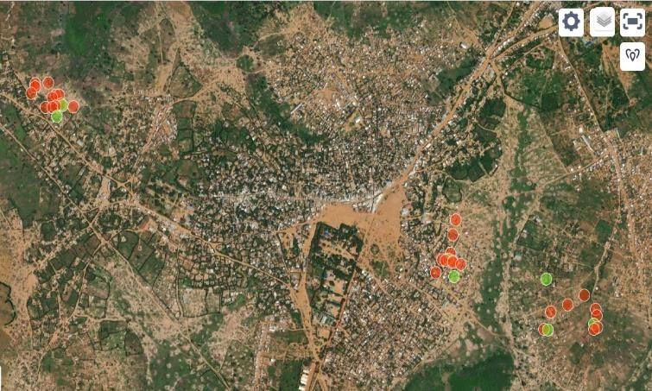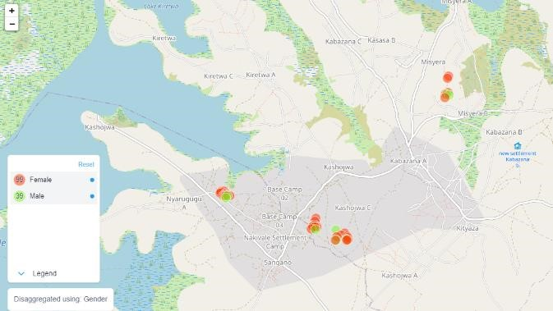

location and gender of our beneficiaries.

### Baseline data findings

Our baseline / profiling data indicated a few interesting findings. For example, we discovered that almost 50% of the enrolled beneficiaries had six or more members in the household, while up to 30% members had between four to five members in the household as indicated in the graph below.

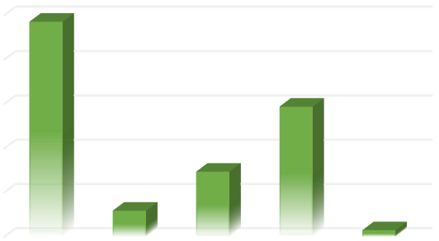

0

%

10

%

20

%

30

%

40

%

50

%

Six or

more

Two

Three

Four or

five

One

Number of household members

This points to the fact that the need for food security in these households can never be underestimated. We are happy to report that after just six months of the project, these households are able to produce enough vegetables and food for their households and have surplus that they share with their neighbours. This in return saves them between 40,000 UGX to 80,000 UGX (11 – 22 USD) per month on food.

The main source of the project beneficiaries profiled was food and cash donations form humanitarian organisations, with only 12% indicating they had a small business through which they earned their income. The average monthly income for beneficiaries is 80,000 UGX (22 USD) – and this would mainly be spent on buying food stuffs and other essential items at the household. With food available through the project interventions, these households will be saving half of their monthly income for other essentials such as education and health expenses.

Of the profiled farmers, 36% had tried to grow vegetables and food around their households but never yielded much. Of these, 13 farmers indicated they their vegetables were hit by pests and they did not know what to do about them, thus got frustrated and gave up on farming. All the farmers that had participated in farming had not practiced regenerative farming methods – this, was a new concept and the practices were new to all the farmers we work with. This points to the fact that, there is still need to reach out to as many farmers as possible, especially refugees who are using small patches of land for their farming activities – so they are introduced to regenerative farming practices.

The data from the baseline / profiling will be used to track success of the project, together with data from the regenerative diaries that started in March. This data was collected by the project volunteer in charge of monitoring, using an online data collection tool called KoboCollect application.

**4. Farmer group formation and introduction to group dynamics training.**

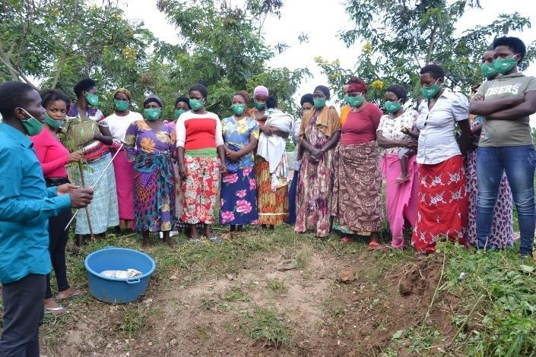Our previous work with smallholder farmers has taught us that, farmers work effectively in small groups and they are able to help each other learn, motivate each other and create meaningful social capital that is key for their development. For this intervention, all our profiled farmers were tasked to create small groups of 10 members each. Currently, we have 11 farmer groups formed (9 for refugees and 2 for the host community) – and these have been introduced to group dynamics training. The training is aimed at helping them understand the importance of working in groups, prepare them to resolve conflicts in their small groups and

guide them to identify leaders that would facilitate group activities. The group dynamics training takes three days for each group and farmers are tasked with identifying their leaders at the end of the training. ***The image above shows the project volunteers orienting farmers on group dynamics****.*

**Introducing regenerative farming and setting-up of demonstration gardens.**

With the baseline findings that regenerative farming is a new concept to the farmers we are working with, the fellow developed a simple training guide to introduce the farmers to the principles and practices of regenerative farming – using the permaculture methodology. Within their small groups, farmers set suitable days and time during which they attend a 2-hours practica l training session. Because we have learnt that adults learn better while doing, we designed our training activities around the demonstration gardens – commonly known as learning sites. Regenerative training activity is a phased on-going activity – and a number of topics are handled every training session. Each group meets twice in a week for the training – although some groups have asked to meet three times.

Key topics for training include: understanding the regenerative farming principles, understanding the environment and soil, introducing regenerative garden establishment, identifying good quality seeds, setting up regenerative nursery beds, integrated pest management and control, garden management, organic fertilizer production and making of manures, water harvesting, vegetable harvesting and handling among others. In order to illustrate our trainings, in the subsequent page we share photos of our training sessions on the different topics.

To ensure that farmers are able to immediately put the knowledge learnt into practice, we engage them in establishing demonstration sites. We ask willing farmers to provide a piece of land where the demonstration site would be established for each of the small group of 10 that attend the trainings. As the training session go on, farmers practice the knowledge and skills learnt at the site, after which they would go in their homes and set up the same gardens. Currently, we have 11 demonstration sites established, with one demonstration site established on the land of the Uganda Police – in the Refugee settlement – following a request from the office of the prime minister in charge of refugees. Interestingly, the demonstration site at the police post, has enabled a number of non- project beneficiaries to learn regenerative methods – with many reaching out to our field team for support and guidance as they set up their gardens. In total, 5 non- profiled project beneficiaries have set up small gardens following the learnings from the police demonstration. Food from the police demonstration is served to the police officers, and local communities around the police.

Other key activities that were carried out during this period included, training of farmers on making liquid and organic manures, setting up of organic manure sites on the gardens, participating in settlement level meetings and presenting our work there, registering the project on the Rotary Accelerator program.

## Project deviations

At the development phase, the project had anticipated embedding positive peace trainings and awareness sessions. However, these could not be implemented during this phase of the project. The reason for this deviation was mainly due to time and financial constraints. The process of training beneficiaries on regenerative farming took between 2-3 months including the practical sessions. Farmers would only attend the training once in a week, and trainings were not consistently conducted due to the outbreak of Cholera in the settlement. At the same time, the Fellow did not have enough funds to prepare materials for positive peace training and support beneficiary attendance.

However, by engaging refugees and host community beneficiaries to attend the trainings together, sharing farming experiences and working on garden practical activities together, the relationship between refugees and the host community was enhanced throughout the project period. Indeed, some refugee households reported to have shared their food with their neighbor host households that were not targeted in the project. Our regenerative diaries indicated that there was a generally great relationship between refugees and the host community – and that both groups enjoyed working together in groups.

## Key findings / impact

The concept of regenerative farming is new to the refugee communities. During the training, we observed that the farmers enrolled in the project were all surprised about the simple farming technics that they had to apply on their gardens. a lot of excitement was observed during the setting up of the demonstration gardens where farmer groups came together to learn and implement the knowledge and skills learnt. Indeed, refugee farmers expressed their views as to how the farming technics were new and unique from what they had learnt from their countries of origin. This had both advantages and disadvantages. The advantages were that farmers would pay a lot of attention to the content being trained on to them, and they would want to try every farming tip introduced to them. The disadvantage was that the project had to invest more time to change the mindset of the farmers to adopt regenerative farming practices.

Overall, the SCI contributed tremendous results for refugee and host households in Nakivale refugee settlement. The figure below provides a summary of its contribution – as described in the subsequent text.

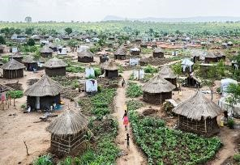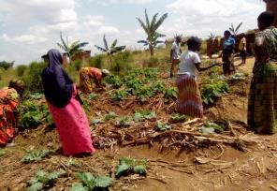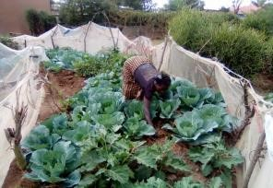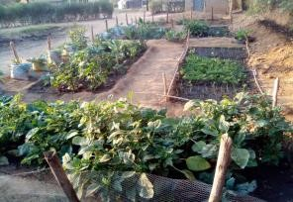

85 extra HHs making 5 villages / small 79% HHs reached 5 regenerative garden total 135 HHs reached communities reached having at least 2 meals demos established from the planned 50. per day

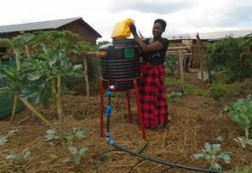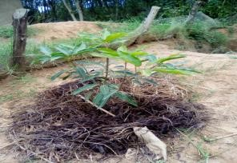

|  |  |  |  |
| --- | --- | --- | --- |
| 4 Mobile Drip Irrigation kits and water harvesting  set up | 50 fruit trees planted; distributed among farmers | 54 farmers earn between $2 - $7 monthly by sell of food | 2 new partnerships signed to support scaling of project |

### SCI project Impact through Regenerative Diaries – a Case Study of Sarah

The SCI initiative adopted the regenerative diaries as its monitoring tool. The regenerative diaries are a series of repetitive questions asked bi-weekly to the project beneficiaries to assess their behavioral change and benefits from the project. A total of 8 beneficiaries were identified and engaged in the diaries. The diaries ask meals they have, their incomes and general living conditions. This information helped to inform the project if farmers learnt new skills, or improved their livelihoods as a result of our interventions. Below is a case study of diary responses from Sarah; one of our farmers enrolled in the SCI.

Sarah is a refugee from DRC, and she has been in Uganda since 2014. Sarah is a single mother of three children and she lives in Nakivale refugee settlement. She is one of the refugees that participated in the SCI activities in Nakivale.

### Beneficiary: Sarah, Baseline Diary one Diary two Diary three Diary four 31, Refugee

|  |  |  |  |  |  |
| --- | --- | --- | --- | --- | --- |
| How do you feel today? | *Neutral* | *Neutral* | *Neutral* | *Good* | *Good* |
| Average daily meals in last two weeks | *1* | *1* | *2* | *3* | *3* |
| Amount earned from sale of food | *0* | *0* | *5000* | *13500* | *22400* |
| Number of neighbors given food | *0* | *0* | *2* | *5* | *9* |
| Household  challenges in last 2 weeks | *Child sick* | *No challenge* | *Child has no fees* | *No challenge* | *No challenge* |
| Garden Challenges in last 2 weeks | *Lack of water / poor yields* | *Too much*  *rains* | *Too much weeds* | *Pests and diseases* | *No challenge* |
| New good farming  skill learnt in last 2 weeks | *None* | *Using manures in the garden* | *Tree planting*  *skill* | *Mulching and water harvesting* | *Controlling pests organically* |

From the table above, it is visible that Sarah’s general feeling on diary days improved from neutral at the start of the project, to good in the third month of the project. She also increased her earning from 0 at baseline up to 22,400 UGX out of sale of farm inputs; and was able to share food from her garden with up to 9 neighbors – thereby enhancing her relationship with the neighbors as well as expanding the impact of the project. Over the three months she was on the project, Sarah learnt new skills such as using manures in the garden, tree planting, mulching and organic control of pests. Sarah’s case represents the over 100 refugee and host farmers that the project reached. They increased they food they grow, but also learnt practical organic farming skills that they continue to apply on their gardens.

# Helping farmers adopt the knowledge and skills learnt

Key to the SCI’s goal was ensuring that farmers adopt the knowledge and skills learnt during the training sessions on their own gardens, and can sustain these throughout their farming lives. Therefore, through local volunteers, we carried out home visits to each of the enrolled farmers to help them establish their own gardens, and guide them on how to manage their gardens. As such, out of the 136 profiled farmers, we have helped 126 farmers establish their gardens and they have started harvesting their food. During the home visits, we are able to talk to farmers one on one about the challenges they face on their gardens, offer them practical support and guidance as well as gather any stories they have. We have learnt that, visiting farmers motivate them to even work more – and sustaining their gardens. The images below were captured during our farmer home visits.

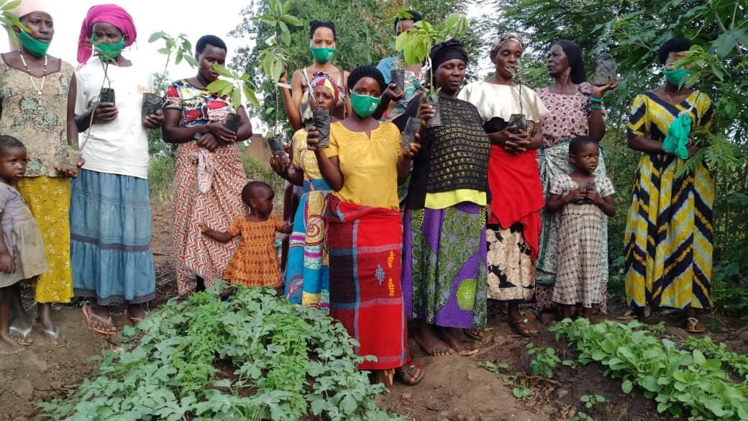In addition, farmers are provided with basic materials such as seeds, water harvesting kits to enable them practice the knowledge learnt. For example, in order to promote tree planting, we distributed 120 fruit trees (60 mangoes, 60 HassOvacados,

10 pawpaws and10 oranges).

*The image above shows farmers after getting their fruit trees at a nursery bed.*

### Changing refugee farmers’ attitudes about regenerative farming

During the project, we discovered that we had to work on farmers’ attitudes towards regenerative farming practices. for example, some number refugee farmers that were enrolled in the project believed mulching breeds termites and that it was bad for the soil. While others, believed that with organic farmer, the food produced would be of low quantities and quality – and therefore they preferred applying chemicals in their gardens. Through a series of trainings and practical activities, farmers were able to understand that regenerative farming improves food productivity and that the practices were cheap and effective.

In order to enhance continued mind-set, change and adoption of regenerative farming techniques acquired, farmers have been organized in to small groups and leaders to these groups have been identified. The leaders are responsible for communicating directly with the project regarding any support and more trainings needed. They also motivate their



***In my home country, we used to***

***believe***

***mulching breeds termites***

***that eat crops. YICE’s training***

***has helped me understand it***

***instead keeps the water in the***

***soil and crops become healthy.***

***Liz, 25***

***refugees***

***from Burundi***

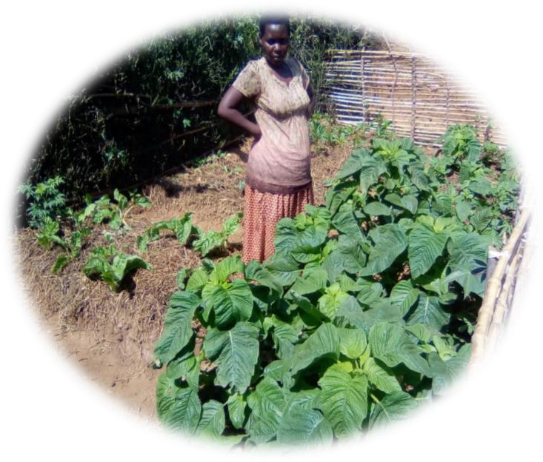

group members to adopt the skills learnt and take care of their gardens.

***A few selected project images***

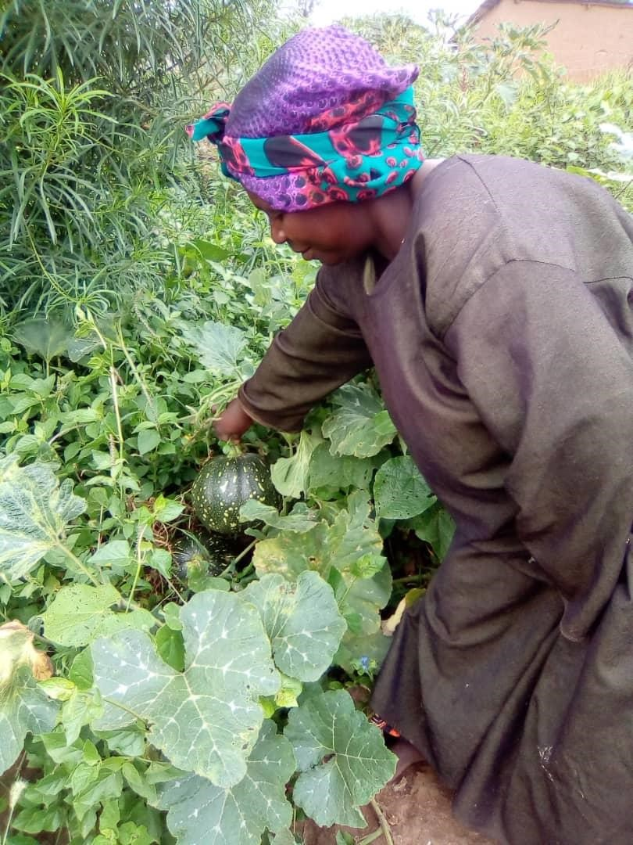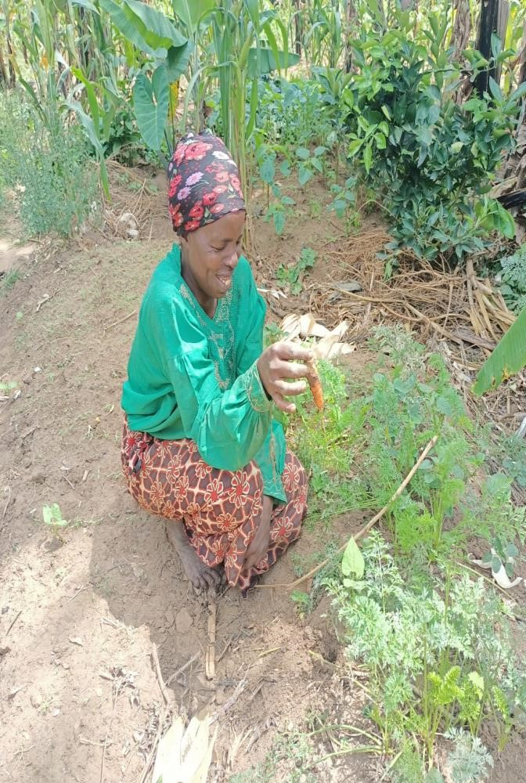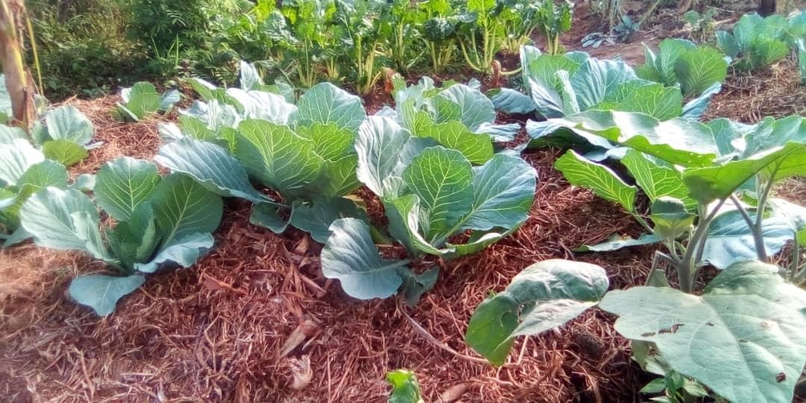

***On top, ready regenerated vegetable garden, L&R: refugee farmers happy abou***

***t their food in the garden***

**CHAPTER FOUR**

## General Conclusion

Generally, the implementation of the social change initiative was a success. The social change initiative was designed to improve food security and resilience to climate change effects for refugee and host farmers in Nakivale refugee settlement. Through the project results achieve, this goal was realized. But, most importantly the fellow had an opportunity to interact with displaced persons in Nakivale refugee settlement and introduce the new concept of regenerative farming to the refugee households.

By collaborating with OPM, UNHCR and other community based organizations working in the refugee settlement as well as the refugee groups, the fellow increased his understanding of the refugee situation; and was able to relate the theories learnt in class to the real community situations. For example, during the implementation of SCI, the concept of positive peace was critically being analyzed by the fellow through community interactions with the local structures and the impact the project had in promoting peaceful co-existence between refugees and the host community. The experience was that, positive peace can be measured beyond its well-articulated eight pillars to include more aspects such as environmental well-being (conservation) and food security among others.

It should be noted that food security for refugee communities is key to attaining peaceful communities. During community interactions, there were reports that due to lack of food, refugees and host communities experienced sporadic conflicts with some members of the refugee community being accused of stealing food from the host community. Projects such as the Re-Farm that promote food security among the refugee communities are key to enhancing peaceful co-existence between refugees and the host.

## Recommendations / implications for Policy

Uganda is not about to stop hosting refugees, as the country admits new refugee arrivals every month. It is therefore important that sustainable solutions to the refugee problem are developed and implemented in order to enhance protection, care and support for the refugees. Key to these solutions is the implementation of programs that promote self-reliance for refugees, promotes peaceful co-existence between refugees and the host communities and are sustainable in nature that their impact would offer long term solutions to the problems faced by refugees. Consistent with this understanding, the following policy implications are key to enhancing the refugee system in Uganda.

Programs and projects targeting refugees should be designed in an inclusive manner, covering a wide range of needs and involving the refugees and the host communities altogether. While the government’s refugee program policy of 70:30 refugee / host beneficiary ration is an exciting one, the policy ought to be implemented for all programs – and such programs should be all inclusive. Inclusive programming involving both refugees and the host enhances opportunities for togetherness between refugees and the host, and promotes peaceful co-existence. such programs should also prioritize the needs of women and youths and ensure that they are involved at all levels including their designing.

The visible effects of climate change on refugee and host community farmers requires immediate environmental and climate change interventions in the refugee settlement. Walking through the settlement, you would barely find trees (because they have been cut by refugees for survival), the soils and grass are all always dry and the people generally lack the knowledge and skills to restore the green in the settlement. That is why, INGOs, the government of Uganda and UNHCR must implement activities geared towards restoring the trees and soils in the settlement; that would enhance environmental conservation and climate change resilience for the refugees. Specifically, climate change awareness, tree planting, regenerative farming and other projects are recommended.

Despite the protracted nature of refugees in Nakivale, it is evident that the dependency mindset still exists among the refugee population. Inclusive Self-reliance programs including those that promote mindset change must be implemented. For example, with a big number of refugees having access to farm land, WFP would invest more resources in educating the refugee population about producing their own food than providing food rations to them. In addition, programs such as those that promote skills development, art and craft and technology development should be prioritized to improve refugees’ skills, access to employment and income opportunities. Such programs, would address the dependency challenges, strengthen refugee host relations and promote sustainable development in the refugee hosting communities.

There are continued complexity in the understanding of refugee regime and approaches both at national and international levels. This is attributed to knowledge gap that exists at both levels, and therefore calls for continued research and sharing of knowledge on refugees and the host communities. Specifically, the nexus between positive peace, conflict and displacement needs to be fully researched and understood. At the same time, the best practices in implementing refugee response and self-reliance programs should be well examined and lessons shared with all stakeholders; for learning purposes.

## Sustainability plan

The exciting news is that the project will continue impacting the refugee community in Nakivale Refugee Settlement. The fellow has designed and implemented a number of strategies to achieve project sustainability. Key components in this strategic plan are, the involvement of local community organization as implementers, involvement of local community members, fundraising strategies and organization of beneficiaries into small groups to ensure togetherness and continued learning and sharing of experiences – as elaborated on below.

The SCI project was implemented through a local community based organization called YICE Uganda. Following approval from the OPM, the fellow engaged a local organization in Nakivale to support implementation of the project activities. As such, Regenerative farming was introduced to the organization’s work, and the project activities were implemented under the supervision of the organization and OPM. The fellow built the capacity of the organization staff to support project activity implementation and carried out on-going monitoring and evaluation of project activities. After successfully implementing the project activities, the organization has accepted to integrate the project’s activities into its own programing. This implies, that YICE will continue running the project activities and at the same time, fundraise for its scale.

With the success of the pilot project, there has been interest from prospective supporters to help provide more funding to the project activities to continue. For example, two months after start of implementation, the fellow received $5000 in funding from Regenerosity and now expected support from the Rotary Peace Project Accelerator program. Indeed, in October, the fellow with make a virtual Project Pitch before the Rotary Supporters in Basel – and anticipate to raise funds for this project. Other fundraising efforts include engaging WFP for another pilot in Rwamwanja, working with Hunger Fighters to scale regenerative activities in Nakivale and a proposal to aBi trust development fund in Uganda to scale the activities. Any success from these options will ensure that the SCI activities will continue and even impact more refugee households.

In addition, at the design of the project, the fellow involved all community members in the plan and empowered key leaders to train others to of the project activities. The fellow empowered the community to plan for the project activities which enables them to continue conducting trainings even when the project has ended. For example, the project volunteers were hired from within the refugee community and these were trained in delivering regenerative farming trainings, monitoring project activities and working with other stakeholders to continue implementing the project activities.

We intend to have created social connections and groups that would continue scaling the project activities. For example, beneficiaries are being mobilized into groups to implement Village Savings and Loan Associations (VSLA) activities. VSLA activities always keep the groups active and intact. Through VSLAs the groups are able to put their funds together and loan to each other or implement key income generating activities. As a strategy, we intend to use the VSLAs to keep the groups active as well as continue reaching out to them during their savings days. This eases mobilization and promotes group efficiency.

# REFERENCES

1. Gingyera-Pinycwa AGG. *Uganda and the Problem of Refugees*. Makerere University Press; 1998.
2. Mulumba D, Olema WM. Policy analysis report: Mapping migration in Uganda. Published online 2009.
3. Pirouet L. Refugees in and from Uganda in the post-independence period. *Uganda Now Between Decay Dev James Currey London*. Published online 1988.
4. Frank A. Uganda and the refugee problem: Challenges and opportunities. *African J Polit Sci Int Relations*. 2019;13(5):62-72.
5. Ssempijja N. Locally-Led Initiatives in the Nakivale Refugee Settlement: A Pathway to Local Integration for Refugees in Uganda? - Refugee Law Initiative Blog. Published 2020. Accessed December 14, 2021.

https://rli.blogs.sas.ac.uk/2021/08/25/locally-led-initiatives-in-the-nakivalerefugee-settlement-a-pathway-to-local-integration-for-refugees-in-uganda/

1. Idris I. Integrated approaches to refugee management in Uganda. *Help Rep , Bright UK Inst Dev Stud*. 2020;716.

https://opendocs.ids.ac.uk/opendocs/handle/20.500.12413/14991

1. Vemuru V, Araya YY, Gossa ET, et al. *An Assessment of Uganda’s Progressive Approach to Refugee Management*. The World Bank; 2016.
2. Omata N, Kaplan JD. *Refugee Livelihoods in Kampala, Nakivale and Kyangwali Refugee Settlements: Patterns of Engagement with the Private Sector*. Refugee Studies Centre, Oxford Department of International Development …; 2013.
3. Jacobsen K. *The Economic Life of Refugees*. Kumarian Press; 2005.
4. Jamal A. *Minimum Standards and Essential Needs in a Protracted Refugee Situation: A Review of the UNHCR Programme in Kakuma, Kenya*. UNHCR Geneva; 2000.
5. Kollmair,M., Gamper, S.F. & J. THE SUSTAINABLE LIVELIHOODS APPROACH Input Paper for the Integrated Training Course of NCCR North-South Aeschiried. Published online 2002.
6. Chambers R, Conway G. *Sustainable Rural Livelihoods: Practical Concepts for the 21st Century*. Institute of Development Studies (UK); 1992.
7. Carswell K, Blackburn P, Barker C. The relationship between trauma, post-

migration problems and the psychological well-being of refugees and asylum seekers. *Int J Soc Psychiatry*. 2011;57(2):107-119.

1. Ward C, Bochner S, Furnham A. *The Psychology of Culture Shock*. Routledge; 2020.
2. Kadigo MM, Diallo NO, Maystadt JFPC. How to Cope with a Refugee Shock? Evidence from Uganda. Published online 2022.
3. McQuaid JH, Silva MA, McKenzie KC. Surviving violent, traumatic loss after severe political persecution: lessons from the evaluation of a Venezuelan asylum seeker. *BMJ Case Reports CP*. 2021;14(3):e239025.
4. Rempel T. UNRWA and the Palestine refugees: a genealogy of “participatory” development. *Refug Surv Q*. 2009;28(2-3):412-437.

# ANNEX

## Baseline Questionnaire

|  |  |
| --- | --- |
| **type** | **name** |
| phonenumber | phonenumber |
| text | name |
| select_one fo6fc40 | sex |
| integer | age |
| text | village |
| integer | How_many_people_are_in_your_household |
| select_multiple od3is68 | _9_what_is_your_source_of_income_ |
| text | Specify_other_sources_of_incom |
| select_one fn49a33 | on_average_how_much_did_you_earn_in_the_last_three_months_ |
| select_one wz5jo47 | what_is_your_current_leadership_role_in_the_community_ |
| select_one uh9fn24 | are_you_aware_of_the_dangers_of_poor_hygiene_ |
| select_one pq4yx39 | Have_you_ever_harves_ater_for_your_garden |
| select_one im3fp99 | Have_you_ever_hard_a_on_Water_harvesting |
| select_one qs5no59 | Have_ever_had_any_permaculture |
| text | If_yes_when_and_by_who |
| select_multiple ks4ua41 | How_do_you_think_Irr_evant_to_your_garden |
| select_one mv5ha31 | Do_you_belong_to_any_Savings_g |
| select_multiple gh3he91 | If_Yes_How_do_you_benefit_from_it |
| select_multiple yc53u20 | If_No_why_are_you_n_t_in_a_savings_group |
| select_one ln2sv74 | Are_you_happy_to_giv_h_a_vegetable_garden |
| select_one kh7wd69 | Would_you_buy_an_irr_on_Instalment_basis |
| calculate | __version__ |

## Regenerative Diary Questionnaire

|  |  |
| --- | --- |
| **type** | **name** |
| start | start |
| end | end |
| select_one fs3oa87 | Consent_Hi_friend_you_Do_you_accept |
| select_one xq5hm83 | Name_of_Respondent |
| select_one cv1jf42 | Respondent_type |
| select_one tx62a58 | How_do_you_feel_today |
| select_multiple fx5hg04 | What_made_you_happy_or_unhappy |
| text | Specify_other_reason_e_not_happy_or_happy |
| text | Mention_any_major_ch_r_the_last_two_weeks |
| select_one tp24o63 | On_average_many_mea_n_the_last_two_weeks |
| select_one gv3ki44 | How_often_does_your_etables_during_meals |
| select_multiple st0qq30 | What_challenges_have_n_the_last_two_weeks |
| select_multiple uk1nu72 | How_have_you_control_n_the_last_two_weeks |
| select_one un7ni81 | How_has_been_your_re_r_the_last_two_weeks |
| select_one br3pb98 | How_has_been_your_re_r_the_last_two_weeks_001 |
| text | Why_that_kind_of_relationship |
| integer | How_much_money_did_y_n_the_last_two_weeks |
| integer | How_many_neighbors_d_n_the_last_two_weeks |
| integer | If_you_were_to_sell_ould_you_have_earned |
| text | What_new_regenerativ_n_the_last_two_weeks |
| text | Share_any_comment_a_sage_you_have_for_us |
| image | Take_a_picture_of_th_d_you_at_their_homes |
| image | If_the_respondent_ac_sting_mulching_etc |
| text | Any_observation_from_you_add_them_here |
| geopoint | Capture_location |
| calculate | __version__ |

## Selected project pictures

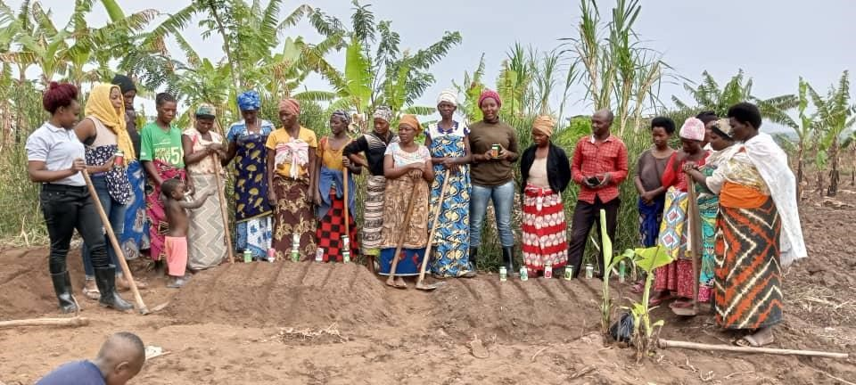

#### Beneficiaries undergoing a practical training as a group in field

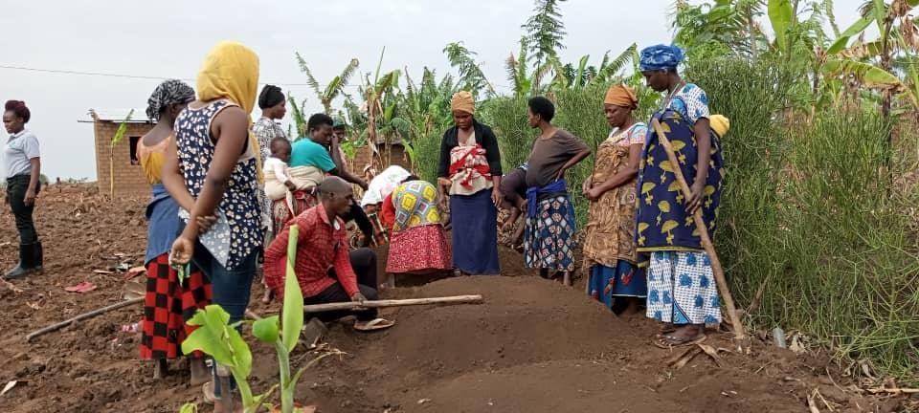

#### Beneficiaries putting into practice the knowledge learnt

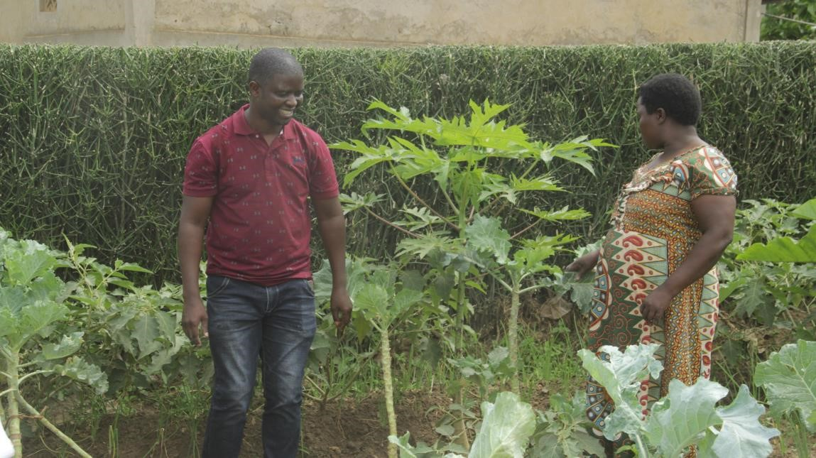

#### The peace fellow offering on garden support to the beneficiaries

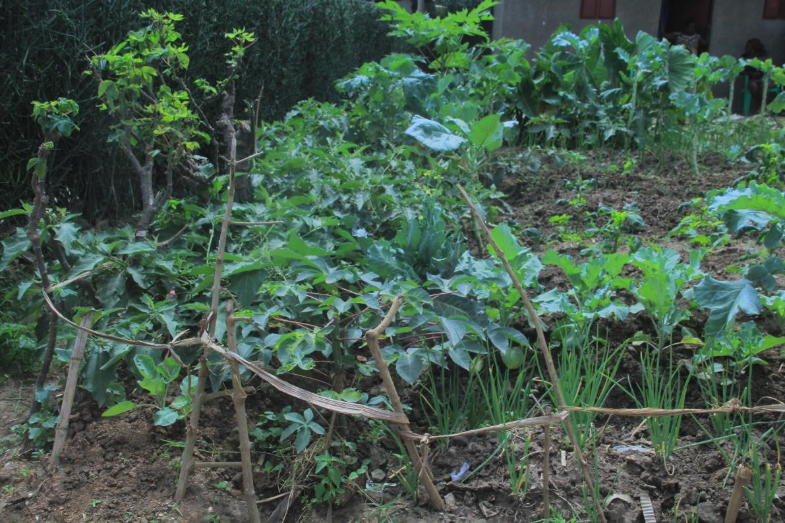

**Some of the gardens ready for harvesting – designed following regenerative farming designs.**

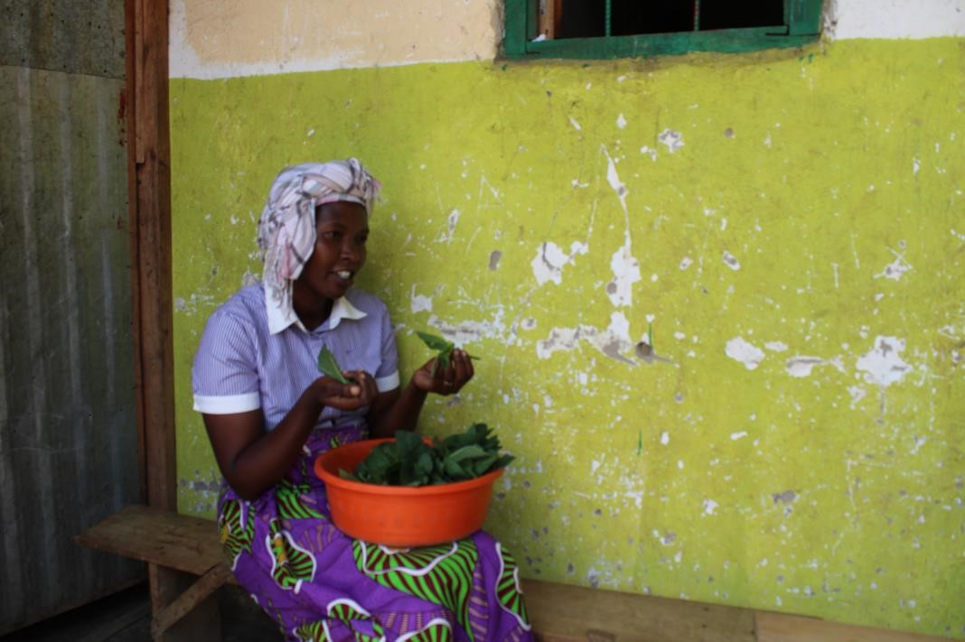

#### A beneficiary preparing her vegetables for cooking

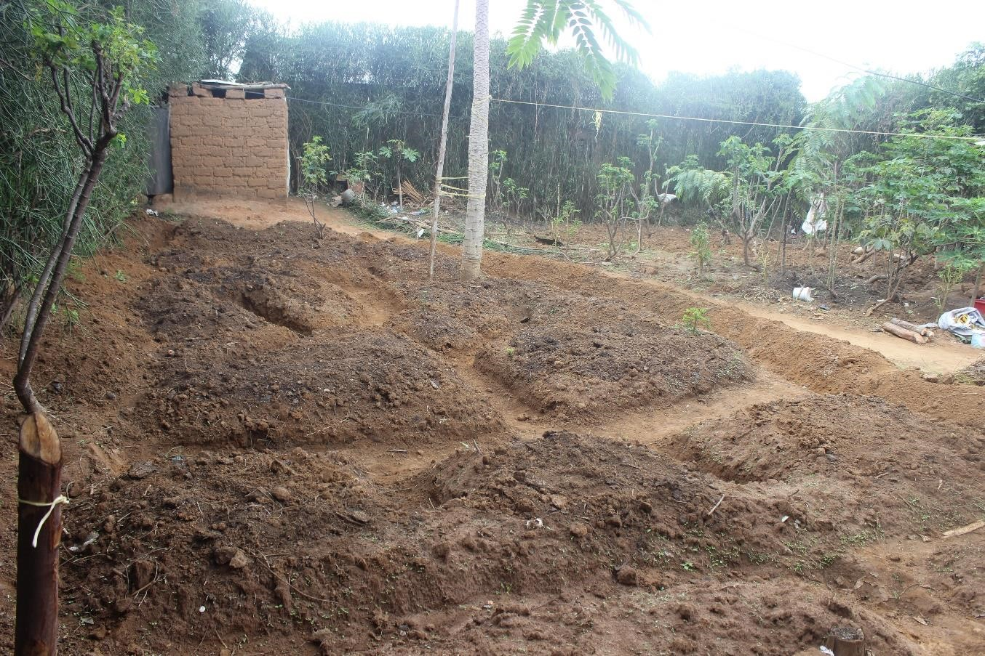

#### A regenerative garden designed before planting

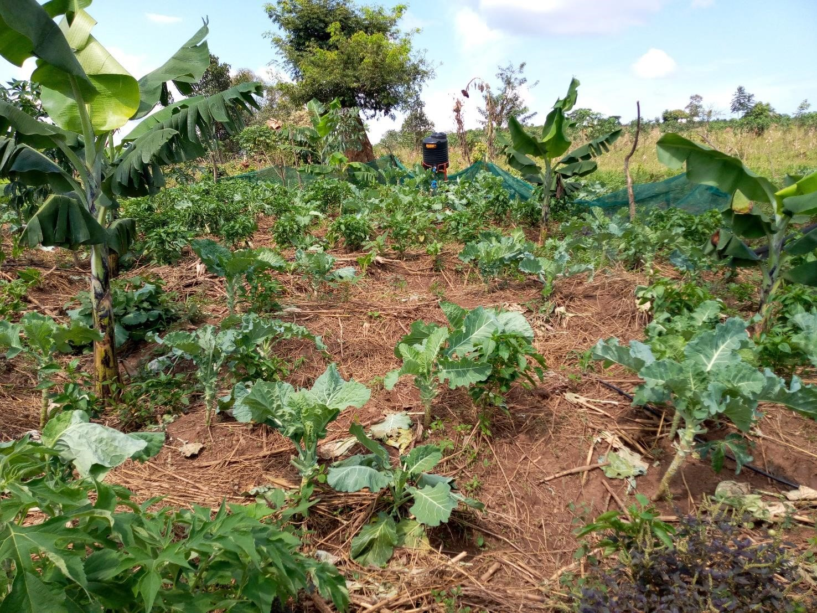

#### One of the gardens set up by farmers

1. A self-reliance and resilience strategic framework targeting refugees and host communities in Uganda’s refugee hosting districts. The program recognizes the need for creative durable solutions … has a special focus on self-reliance and resilience of refugees and host communities alike.

  
2. Overall goal is to achieve self-reliance and local settlement of refugees and promote social development in refugees and host communities as a durable solution to the refugee problem while protecting local and national interests. Pillars 1, 2 and 5 specifically focus on land, sustainable livelihoods and environment protection respectively

  
3. <https://reliefweb.int/report/uganda/nakivale-refugee-camp-faces-food-shortage>
4. Food Security and Nutrition Assessment in Refugee Settlements Final Report, [https://reliefweb.int/sites/reliefweb.int/files/resources/Refugee%20FSNA_Report_Final_Dec%202020_Aug%2 02021.pdf](https://reliefweb.int/sites/reliefweb.int/files/resources/Refugee%20FSNA_Report_Final_Dec%202020_Aug%202021.pdf) 
5. <https://www.unhcr.org/refugee-statistics/>[6 https://www.refugeecouncil.org.au/how-manyrefugees/#:~:text=UNHCR%20most%20recently%20estimated%20that,and%20over%2026.4%20million%20refugee s.](https://www.refugeecouncil.org.au/how-many-refugees/#:~:text=UNHCR%20most%20recently%20estimated%20that,and%20over%2026.4%20million%20refugees)
6. <https://data2.unhcr.org/en/documents/details/89499>