**SOCIAL CHANGE INITIATIVE IMPLEMENTATION REPORT**

**Title: Get to The Youths First: Harnessing the Potentials of Students to Mitigate Cattle Rustling in Karamoja**

**OKELLO PETER CROMWELL**

**REG NO: 202/HD03/025U**

**STUDENT NO: 22007000025**

**Project Location: Moroto District, Karamoja, Uganda**

**May 2023 - August 2023**

Table of Contents

Acknowledgement 2

Abstract 3

CHAPTER ONE 4

**Introduction and Background** 5

**Problem Statement** 6

**Goals and Objectives** 7

**Challenges and mitigation strategies** 7

CHAPTER TWO 9

**Literature Review** 9

**Background and Causes of Cattle Rustling** 9

**How to Mitigate Cattle Rustling.** 11

**Theoretical Underpinnings** 11

**Change Theory and how it was applied** 14

**Methods and Design** 16

CHAPTER THREE 19

**Interventions and Activities** 19

**Key findings / Impact** 21

CHAPTER FOUR 24

**General Conclusion** 24

**Recommendations / Implications for Policy** 25

**Sustainability Plan** 27

APPENDICES 30

Pictures with descriptions 30

Clearances/ Permission letters 35

Participant Testimonies 36

Reference 37

# Acknowledgement

I would like to acknowledge and give my singular gratitude to my Mentor, Dr Luwerekeza Bernard for his unflinching support that made this work possible. His guidance and advice during the design and implementation of this project have been immeasurable. The Resident District Commissioner of Moroto district Mr. Wopuwa George Williams and the Deputy Division Commander of the Uganda People’s Defence Forces 3rd Division in Moroto, Maj Gen Felix Busozoori for their generous support they gave me in ensuring that his project was a success story. I am equally grateful to the ASTU commander for sending his team who did commendable job in engaging with the students of Moroto High School during the peacebuilding dialogue. The media fraternity comprising the Uganda Broadcasting Corporation, Ateker radio, New Vision and Urban Television for their role in ensuring that peace Ambassadors’ voices reached the target audience.

I appreciate the partnership I received from the Uganda Human Right Commission’s Regional Office in Moroto. Their generosity in sharing knowledge and experience ensured the success of my project.

To the head teacher, staff and students of Moroto High School and Moroto Parents’ School, I am eternally grateful for your cooperation that ensured that my project in your schools was received and given the necessary support.

Finally, and most importantly, I thank God for granting me sound health and energy to accomplish my project. May His Name for ever be Glorified!

# Abstract

The project was aimed at building and strengthening the capacity of local students and education institutions to contribute to sustainable peace in the Karamoja subregion where cattle rustling has been prevalent for over fifty years. Students in the Karamoja region have lately been implicated in the practice of cattle rustling leading to some of them getting killed when they go for rustling mission to neighboring communities. If students who are supposed to be the agents of positive change in their communities are involved in criminal activities like cattle rustling, it makes it difficult for their out of school peers to abandon the practice.

The major aspect of the project involved identifying students from Moroto High school as a sample and holding inception meetings with them on the issues of cattle rustling in the Karamoja region. These inceptions meetings were followed by a series of trainings with students on the issues surrounding rustling. Subsequently, three radio talk shows and a public dialogue were held involving the students, the military officers and the Anti Stock Theft Unit of the Uganda Police about the role of students in addressing cattle rustling.

Community members including former cattle rustlers, made phone calls to the radio appreciating the role of students. 1200 students were commissioned as Peace Ambassadors charged with the responsibility of transforming their communities with peace message. The project established a working relationship between the security persons and the students in peace building work in Karamoja.

The Peace Ambassadors committed themselves to dissuading fellow youths /out of school peers from engaging in cattle rustling and instead consider embracing alternative productive livelihood activities.

# CHAPTER ONE

## **Introduction and Background**

Karamoja is located in the North Eastern region of Uganda with a land size of 27,000 Square Kilometers and a population of 1.2 million people, 70% of them living in rural areas (UBOS,2019). Karamoja literacy is at only 25%. Comprising of political divisions known as districts (Abim, Amudat, Kotido, Kaabong, Karenga, Moroto, Nakapiripirit, Napak, and Nabilatuk), the Karimojong are mainly pastoralists who keep cattle, goats, sheep, camels, and donkeys. Crop production is practiced in the greenbelts including the entire Abim district.

The main form of conflict in Karamoja is Cattle Rustling and, it is one of the biggest impediments to the region’s development. The conflict has its roots in the interclan clashes buttressed by cattle rustling; an organized crime involving male youths armed with AK-47 guns mobilizing themselves and attacking kraals in their neighboring communities. In the present-day Karamoja, learning to live in peace is the greatest development challenge that requires immediate attention. In the process of the raids, there is the exchange of fire which lead to many youths getting killed, most of whom leave behind orphans and widows. Every year, hundreds of youths in Karamoja die due to rustling-related activities. The latest wave of cattle rustling now involves some students who join in the raids during school holidays. To find the money to meet the cost of education, some students risk their lives going for raids and some of them have been killed in the process. The knowledge of the potential of education in liberating one from poverty forever is the cardinal reason for the youths taking risks to rustle. As a result of the youth getting into the process of cattle rustling, the number of orphans and widows in Karamoja has gone high. These orphans and widows now live in poverty and destitution without a father/husband to fend for them. Therefore, policymakers should rethink the need for affirmative action for Karamoja children and youth in accessing education at all levels if Karamoja is to be empowered and incorporated into Uganda’s economy. Uganda's vision for 2040 cannot be realized in full if part of its national community like Karamoja is excluded.

Donor community contributes the largest share of their tax payers’ money towards the development of Karamoja but without a peaceful environment in Karamoja, their efforts will not yield the desired results. This is why the project on building the capacity of students was designed to empower them to contribute to creating a peaceful environment for people to take part in live changing activities as opposed to them engaging in the risky practice of cattle rustling.

## **Problem Statement**

Cattle rustling is the major reason why peace has eluded Karamoja for many generations. So many lives have been lost and many families as well as property destroyed leading to the general underdevelopment of the region. In the past, cattle rustling was practiced by the uneducated youth but today, even students are actively involved in cattle rustling allegedly to raise money for paying their school fees. There have been cases of students killed during the act of rustling and were only discovered to be students through their school identification cards. Students engagement in rustling is compounded by the high degree of negligence from their leaders and government. For so long, the attempt to address cattle rustling were targeting political leaders, elders and the women with very little consideration to involve young people who are front liners in cattle rustling. The project sought to fill this gap so that students/youths can have their voices heard about the question of cattle rustling. Negative peer influence has also been noted as a contributing factor in youth/ student’s involvement in cattle rustling. This has been so because there existed a gap that could have been filled by positive influence. The students needed to have been deliberately raised by responsible adults to become positive inspiration to their peers both within the school settings and outside the school.

Moreover, other factors such as poverty, high cost of bride price, parental negligence, political marginalization, and the porous international borders including improved technology, high cost of education have among others, continued to influence the rising cases of cattle rustling in the Karamoja subregion. Addressing these development challenges could immensely mitigate and eventually lead to the elimination of cattle rustling in Karamoja.

## **Goals and Objectives**

The ultimate goal and objectives of the project was to harness the potentials of Student in mitigating Cattle Rustling in Karamoja sub-region and, this involved getting to the youth first as the key stakeholders in cattle rustling in the region.

The specific objectives included:

1: To empower local capacities to be at the forefront of peacebuilding and reconciliation initiatives.

2. To strengthen knowledge sharing and advocacy campaigns in schools and the affected communities to help in strengthening the peace-building efforts in Karamoja.

3. Sensitize and raise awareness of the local communities in Karamoja on the dangers of cattle rustling dialogues, and social events.

4. Increase the number of students and teachers engaging in peace-building initiatives

5. Raise the number of community Members accessing the information on peace and conflict resolution.

## **Challenges and mitigation strategies**

The project was faced by numerous challenges including limited funding to execute the implementation of my related activities and, as a result, the project scope had to be reduced to two secondary schools only (Moroto High School and Moroto Parents Secondary School) in Moroto District. I also decided to lessen the number of stakeholders to support me in the project since it was not possible to raise money for their facilitation. I had to consider working with school heads of clubs and student leaders to support in the mobilization of students for the activities as they did not require considerable funding to facilitate their work.

One of the challenges I encountered included insecurity which delayed the start of the project. The project was initially meant to be implemented in Northern Karamoja but the volatile security situations there compelled me to relocate to Moroto district which was relatively more peaceful. The deteriorating security situation limited my project with schools as it was risky to take students to the communities.

Mobilization of students to participate in my project activities sometimes registered poor response in one of the secondary schools since the school had their programmes and with other partners affluent with money that took away the attention of the students from my project. It was upon this background that I considered fixing programmes on days that were not liable to interruptions by other activities.

The cost of the radio talk-show was very high, requiring a huge sum of money to pay for airtime. In addition, some of the local radios did not accept to offer free airtime as part of their contributions to community development. Based on the good working relationship with key stakeholders like the army, the police and the media, I was able to receive from Uganda Broadcasting Corporation (UBC) an offer of free air time that was allocated for the work of the Resident District Commissioner for Moroto District including a free Airtime from *Ateker* Radio. These free airtimes offered by stakeholders were able to host two Radio talk shows with students are guest speakers. The Urban Television and the new Vision, one of the leading government newspapers in Uganda covered the event and reported on it on8 August 2023.

It was hard work with these schools all alone since they required multi-stakeholder approach to peace building.

Managing the implementation of the Social Change Initiative involving the engagement of students in the fight against cattle rustling was challenging and required the collaboration with other partners. To make my work more impactful, I had to create a partnership with the Uganda Human Rights Commission in Moroto which is also involved in their Human Rights and Peace project across the schools in Karamoja. Other partners that reinforce my energy were the Uganda People’s Defence Forces, the Uganda Police and their Anti-stock theft Unit, the media and the Office of the Resident District Commissioner in Moroto. The support offered by each of these partners were limited to technical support and other non-financial resources to enhance project implementation.

# CHAPTER TWO

## **Literature Review**

There are a significant amount of literature concerning cattle rustling, and related issues in Karamoja and other pastoral communities with similar contexts. This literature review, therefore, presents relevant information about the background and causes of cattle rustling, the effects of cattle rustling on the peace and development in Karamoja and how to mitigate cattle rustling as well as the role of youth in the fight against cattle rustling.

## **Background and Causes of Cattle Rustling**

Cattle rustling refers to the stealing of cattle (Okoli&Okpaleke, 2014) and according to (Blench, 2004), it is a means of primitive accumulation of cow-herd in the contexts of subsistence and commercial pastoralism. The persistence of cattle rustling in Karamoja and across other east African pastoral communities has resulted into the destabilization of communities and undermining of their normal livelihood strategies, thus contributing to increased poverty (Kaimba, Njehia&Guliye, 2011). Therefore, Increasing the level of development in pastoral areas and formulation of appropriate policies will help in controlling the rustling menace.

In Karamoja, cattle rustling is conducted for restocking, retaliation, and theft for sale on markets (Agade,2010). There is overwhelming evidence that points to male youths as the primary actors in the conflict (cattle rustling) and that they are engaged in cattle rustling because of hunger, greed for livestock, youth idleness, need for school fees, greed for money and the conflict between the Jie and the Turkana and resulting spillover effects (Arasioand Stites, 2022)

According to Oluka (2010), cattle rustling in Karamoja is still in practice because of government neglect of the region, the presence of illicit modern weapons in Karamoja, persistent insecurity in Karamoja region coupled with unreliable and semi-arid conditions in the Karamoja region and others. A research report by Omara (2023), suggest that youth are main perpetrators of cattle rustling because of the large number of cattle required for marrying a wife and the same report blames the escalating cases of cattle rustling on the Anti Stock Unit (ASTU) who are no longer aggressive in their role of combating cattle rustling.

Cattle rustling is still the main cause and form of conflict in Karamoja and in other pastoral communities across the Horn of Africa (Anyango et al, 2017). It arises from the availability of illicit guns, commercialization of cattle raids, incitement by politicians, high levels of poverty, traditional values attached to cattle and war, the culture of revenge, high level of illiteracy and the cost of bride price when marrying women (Cheserek, Odenyo, and Omondi, 2012, pp.173-179, Kinyua, Yakub, Kamau, and Bett, 2011).

Cattle rustling impacts negatively on social service delivery, infrastructural development and it also influences poverty levels. Communities affected by cattle rustling have low school attendance, lack of peace, and other social services and destruction of infrastructure due to insecurity (Lolchuraki, 2013; Mwangi, 2013).

Moreover, poverty also presents one of the biggest obstacles to peacebuilding in Karamoja as it is with other pastoral communities in Uganda (UBOS, 2014; Ssewanyana, 2010 Krätli, 2001). The high level of poverty among the Karamojong pastoral community calls for innovative approach to address it to improve education access for the Karamojong children.

Student who experience poverty are less likely to access quality education as compared with their counterparts from affluent families (Kiernan, and Mensah, 2011) and for that reason they will end up in criminal activities like cattle rustling. Studies also show that poverty levels are much more widespread and severe among pastoralists as compared with their agro-pastoralist counterparts (Teka, Woldu, and Fre, 2019) as witnessed in countries such as Kenya, Sudan, and Uganda, Ethiopia and Somalia and elsewhere. Where poverty is widespread, pastoralists' young people are hindered from accessing school but are instead engaged in child labour in an attempt to earn a living (Jensen and Nielsen, 1997).

## **How to Mitigate Cattle Rustling.**

Datzberger (2017) advises that non-formal school play a critical role in peacebuilding although it is unexploited. Her research cites the role played by the Alternative Basic Education for Karamoja (ABEK) which despite its persistent implementation challenges, has proved to be appropriate to the security and conflict conditions in Karamoja and is also relevant for overcoming structural and indirect forms of violence.

Bush& Saltarelli(2000) also emphasize the role of education in promoting peace. Their work encourages peacefulness, policy makers to consider promoting education for peace programmes to contribute to the development of local peacebuilding capacities. This is aimed at ensuring sustainability as it is developed by both state and non-state actors. In this case therefore, using education as a tool for peacebuilding in Karamoja is encouraged by researchers but it recommended to design them basing on the context.

Moreover, following allegation and evidence that police and army sometimes apply aggressive and violent means to deal with cattle rustling, Marigat (2023) propose a positive community- policy relationship to guarantee community acceptance and cooperation with the police force. One way of doing this is through community policy and dialogue that allows honest discussions on strategies to mitigate cattle rustling.

## **Theoretical Underpinnings**

This project is based on the Historical Social Development Approach to cattle rustling which pins the rustling in Karamoja to a historic trajectory that has continued to evolve and shape the practice of cattle rustling overtime.

Cattle rustling in Karamoja just as it is with other pastoral communities has been serving as a long-held practice to distribute animal wealth most especially after the experience of drought, epidemic and or raids. Cattle rustling in Karamoja has for generations served important social, political, and economic functions within the pastoral system, including specific functions such as initiations of young men and dowry for marriage. There is overwhelming historical evidence that cattle rustling has been an adaptive response to the political atmosphere arising from repressive governments.

Prior to colonialism and before the spread of firearms, young men used bows and arrows including spears as weapon to aid in cattle raiding and the elders provided advisory support to them. The coming of the firearms into Karamoja in the 19 centuries from Ethiopia, Khartoum and Zanzibar complicated cattle raids since they were more effective and deadly weapons.

Attempts by the colonial government to put Karamoja under direct rule was impossible because of the Karimojong nomadic lifestyle and this made it hard to control the flow of firearms into and out of Karamoja. The increase of guns in Karamoja compelled the colonial government to declare military rule in the region but still failed because Karamoja was ungovernable under the British appointed chiefs and this made the region to be declared a closed region where one only had to enter upon receiving a permit. The closure of Karamoja followed by the creation of police posts near mobile kraal in the region but there always intermittent reoccurrence of raids of erratic severity. To address the problem of insecurity caused by illegal guns, colonial and post independent governments launched disbarment programmes in 1945, 1953, 1954, and 1960 followed by resumption two decades after independence in the years 1984,1987, 2001, 2006 and 2023. This narrative displays the historical underpinning of cattle rustling.

There have always been attempts to address the problem of cattle rustling and interethnic conflict in Karamoja from colonial period to the present day but they have not been successful. It could be argued the failures are attributed by wrong approach such as ignoring the involvement of the young men who are the main actors in cattle rustling.

Historical narratives also suggest that famine in Karamoja couple political instability and intertribal hostilities along with the armory attack of the Moroto army barrack in 1979 increased cattle rustling and because the state was focused on fighting the insurgent in Luwero, little focus was given to the internal conflict in Karamoja. A period after the 1986 saw another closure of Karamoja borders with her neighboring regions and this resulted into aggravated internal cattle raids leading to loss of both lives and cattle.

The period between 2010 and 2019 was observed to be the period of relative peace in Karamoja considering that there were general positive impacts characterized by access to natural resources, a healthy inter-group relation, herd movement, private sector expansion including uninterrupted cross border movements. Along the way, there emerged what is now called ‘commercialized raiding’ where cattle are not now raided for the traditional purpose such as marriage and prestige but for sale. The young men in the commercial raids operated without being detected by their communities and their form of raiding did not win the blessing of the elders as it was with traditional raiding. It is in this under commercial raiding where cattle rustled by students to meet their school fees are classified hence the reason this project target student to engage them in mitigating cattle raids.

Other historical factors that have given vent to cattle rustling include natural resource scarcity. The continuous rise in human and animal population is responsible for resource-based conflict as people and animals compete for the limited resources. Moreover, the Karimojong always in dry season are nomadic and as result they conflict with their neighboring communities over the resources such as; grazing land, water and crops damaged by animals including that the pastoralists steal their hosts’ animals as they return to Karamoja.

Other historical factors that led to the practice of cattle rustling include climate change which have left the people vulnerable to drought, struggle over grazing land and famine which have made young men to steal animals to recover from the loss caused by bad weather. Also, it is worth noting that conflict over mineral access, rights, and wealth are associated to disarmament programme which some people argue was a deliberate move by the government to disarm the Karimojong so as to make it easy for them to exploit their minerals without strong resistance. It is further argued that the State after disarming the Karimojong instead of focusing their attention on providing social service, decided to build roads, extend electricity lines as a means of making it easy to exploit the minerals in Karamoja even as so many Karimojong children are flocking city streets are beggars.

The conflict in Karamoja can be ascribed to historical marginalization following the trends it has taken from the colonial time to the present-day and that it has long been involving the young with blessings from their elders. It is upon this background that the project took a historical approach to deal with cattle rustling.

## **Change Theory and how it was applied**

The project was based on the assumption that if we get to the youth first as primary perpetrators of cattle rustling and harness their potentials to mitigate it, then they will be in a position to contribute to mitigating cattle rustling in Karamoja.

The project was planned focusing on the methods of implementation on the assumption that the chosen methods and strategies would lead to the realization of the desired results. There were inception meetings relating to cattle rustling and through these meetings, awareness about cattle rustling was created and the students were informed about their role in controlling the vice.

The literature review that were conducted about cattle rustling and the conflict in Karamoja and other related issues was based on the assumption that it would provide data required to inform the next course of action. There was numerous literature that were consulted before and during the project implementation phase and the gaps in literature were the basis upon which information about the areas that required intervention were determined. One of the sources of literature that were visited included newspapers, acidic articles, Ugandan Government policy documents and relevant websites rich with the required data.

To ensure the team alignment and kick off the project well, inception meetings were conducted with key stakeholders and issues pertaining to peacebuilding including project goals were discussed resulting into the acceptance of the project. The inception meetings brought the team together and created a shared understanding of the project background including agreeing on how to work together effectively. It further generated learning and built capacity of the Peace Ambassadors setting them ready to contribute to sharing knowledge about peacebuilding with other students and youth in their communities.

Information that was shared during the meetings enriched the knowledge of the target participants setting them ready to contribute to combating cattle rustling. The leaders including the military officers and the Anti-Stock Theft Unit (ASTU) of the Uganda police shared their experience and insights from their expertise in security which equipped the students with tools required to act as role model and to influence police change in their communities. In the same vain, students too shared their experiences that the leaders appreciated and would use in supporting their work in promoting peace and pacifying the entire Karamoja region.

The sets of interactive radio talk shows that were held paved way for peace Ambassadors to engage the public in matters concerning cattle rustling and the need for peacebuilding in Karamoja. The radio talk shows were designed to share thoughts with communities and to influence them to abandon cattle rustling and embrace peace instead. It was observed from the stimulated phone calls that listeners made to the radio that they have appreciate peace message and were willing to abandon cattle rustling. Therefore, the real value and power of talk shows were noticed in provoking interaction as information and viewpoints were exchanged and expanded and perceptions changed. This was especially valuable since the talk was all about conflict and it ended up as a joint problem-solving session.

The project also used dialogue as a means of engaging with stakeholders on the matters relating to rustling. As anticipated, it guaranteed sharing of various opinion and perspective on cattle rustling and peace building. Peace dialogue was also designed to ensure inclusivity by engaging students who have been typically left out of the center of peace building and policy making. The peace dialogue between students, the military officers and police not only increased mutual understanding between them but it also provided means and opportunities for young people to be heard and for their rights, needs and priorities to be taken into account in peacebuilding in Karamoja. There was careful and systematic preparation that entailed building trust and putting in place basic conditions including ensuring that participants were prepared to openly listen and respect other viewpoints and to share their thoughts without fear of retribution.

## **Methods and Design**

To familiarize myself with the current state of knowledge on the topic, topic related literature about cattle rustling and peace building with particular focus on Karamoja were identified and also used as basis for designing this project. There are several publications about the history of cattle rustling, how it is practiced and its implication on the development of Karamoja and its neighboring communities. The sources of literature that were visited included newspapers, academic journals and articles, government policy documents and books.

Through literature review, I was not only able to develop my theoretical framework and methodology but it also became easy to identify gaps in knowledge and unresolved problems that my research sought to address. Literature revealed that there was a gap in the involvement of students in the fight against cattle rustling which impact on the development of Karamoja has been grave.

Inception meetings were held with different stakeholders including the school authorities, the media, the Resident District Commissioner, the military officers in the division and the Uganda Human Rights Commission. The purpose of inception and consultative meetings were to introduce the project to the key stakeholders with the intention of attracting their support, strengthening their relationship with the issue for project success. The meetings were focused on ensuring that all the relevant voices were included in peacebuilding. All the key stakeholders were impressed by the project and appreciated the intention of engaging young people in the fight against cattle rustling which has become a big security threat in the region. Meetings brought in the unique perspectives, ensured inclusion and paved way for subsequent engagements with students’ communities and the targeted cattle rustling in the community.

The project was also made successful by using school debate to exchange opinions on issues that relate closely to peace in Karamoja. To attract students’ participation in peace building, particularly in controlling cattle rustling, it was found out that that their voices and opinion needed to be harnessed and, that was used to enhance their listening skills, critical thinking, language mastery, a value of tolerance and democracy, and to advance their advocacy for policy change. It should be noted that it is not easy to organize educational debate because they require a substantial amount of resources as well as thorough organization to guarantee its success. At Moroto Parents Secondary School, students had a debate on the early marriage and cattle rustling and, this ignited their thoughts on what role the youth play in reducing cattle rustling which also leads to early marriage as most girls drop out of school. Generally, as students were engaged in verbal exchange of opinions, analysis and discussion, some

knowledge and truth were constructed and developed by those involved. As this was an inter-class competition, those participants who won were awarded prizes as a means of motivating them to always participate and make critical debate part of their school and out of school lives.

Using radios to reach out to the community was one of the methods that attracted a mass of participants in the project. Well purposed radio talk shows were designed and used as a method for community outreach by the peace Ambassadors. The topics were ‘the role of youth in controlling cattle rustling. This was relevant to the audience and substantially full of vigor. The programme was orderly so listeners could follow the conversation.

Peace Ambassadors shared with the radio listeners in the public, fresh ideas, based on cattle rustling and the challenge of peace building in the region and the students peace Ambassadors expressed hope for the future during their discussion. The radio talk shows allowed for the listeners to make phone calls and asked questions and made compliments on the issues under discussion. The radio talk show at its best, attracted the audience to listen but also stimulated the audience to discuss what they were hearing on the radio.

Community dialogue was designed for reaching out to students’ community with the message of peacebuilding in Karamoja. Facilitated by the Peace Fellow in partnership with the Uganda Human Rights Commission, it was designed as a conversation between students, the army, and the Anti-Stock Theft Unit (ASTU) of the Uganda police. It allowed students and other participants to speak openly and listen respectfully and attentively. It was facilitated in such as a fashion that it excepted attack and defense and avoided offensive attributions based on assumptions about others.

The dialogue sessions focused on building and strengthening the culture of dialogue for conflict mitigation and peacebuilding in Karamoja to ensure lasting peace that has eluded them for so many decades. This method helped to share experience of the tensions that have existed in the region for many years. This was also aimed at helping in the advancement of a shared social narrative in relations to the causes and the nature of conﬂicts in Karamoja. This process enabled the target community of students to hear various views from one another and together through mutual understanding proposed best approaches for preventing student’s future participation in cattle rustling.

# CHAPTER THREE

## **Interventions and Activities**

There were project interventions designed to contribute directly to the achievement of the specific objectives. They assisted the project connect activities directly and concretely to the objectives. These interventions and activities allowed me to work towards my project’s stated objectives and were well designed interventions focusing on strategic activities and areas which allowed me to reach the stated goals.

Consultative meeting with the school patron supported me to identify and train 15 leading Peace Ambassadors Club members in Moroto High School for five days, once in a week. The training focused on Ambassadors’ role in peace building in the conflict affected Karamoja region, how to identify and deal with challenges in peace building among others. As peace Ambassadors their roles in peace building were identified and agreed upon as: acting as role model in their respective communities, sharing about the role of youth in peacebuilding through working as agents of positive change, inspiring other young people in their schools’ community.

I also held meetings with key stakeholders including the Resident District Commissioner, Regional Police Commander, the Commander of the Ani-Stock Theft Unit of the Uganda Police, the staff of the Uganda Human Rights Commission, the Whitaker Peace Non-Governmental Organization and the media (Uganda broadcasting Corporation, New Vision newspaper, Ateker radio, Urban TV and other media organizations) including the students themselves. The meeting focused on sharing with them about the project and to seek their support and active participation in my social change initiatives in the schools.

The first meeting was with the Resident District Commissioner who is the president’s representative in Moroto District. Upon sharing the project concept with the RDC, he was impressed and committed to supporting my social Change Initiatives in the schools. Also, considering that the RDC is the security head of the district, his permission for me to carry out my social change initiatives were paramount to project success. The RDC endorsed my project and, this made it easier for the other lower cadres in the district such as the head teachers and the police officers to give me access to the schools where the project was conducted. The meeting with the RDC resulted into having access to the government radio which Station Manager gave us space to hold talk show on the role of students in peace building in Karamoja. A similar project inception meeting with the Uganda Peoples Defense Force (UPDF), deputy division commander along with some of his junior staff earned their support and their active participation in the project. The UPDF leaders in the division graced the school dialogue with students and teachers on the theme; Get to the Youth First: Harnessing the potentials of students to mitigate cattle rustling in Karamoja.

Project Communication and Visibility was enhanced by advertising about it on local radios including the Uganda Broadcasting Corporation Radio based in Moroto to broaden publicity for public awareness. Broad banners with suitable messages about forth coming events were printed bearing logo of the Peace Centre, and rotary international and used during the events. Journalists were contacted to ensure that they cover the events and report about them. The activities were reported on new vision newspaper, the Urban Television and Ateker radio.

Inter-class peace debate on cattle rustling was conducted in Moroto Parents Secondary school. This debating session generated various opinions on the conflict in Karamoja and how it has influenced child marriage and poverty. Key participants in the debate included; students, teachers, and Officer from the Uganda Human Rights Commission.

Peace Ambassadors' dialogue took place in Moroto High School and it attracted all students, 1200 of whom were commissioned Military Officer, Lt Col Fred Wemba as additional Peace Ambassadors. During the dialogue, there were discussions about the root causes of the conflict, the risks involved in cattle rustling, the impact of the conflict, and how to address them. During this sessions, Peace Ambassadors, the military officers and the Uganda police represented by the Anti Stock Theft Unit (STU) engaged with the overall school population on peacebuilding- discussing causes of cattle rustling, its dangers, and what should be done to stop the vice.

Two Peace Ambassadors' Radio talk shows on peacebuilding in Karamoja were conducted and, these radio talk shows attracted interaction with the community through telephone calls to the radio where the listeners asked questions and made comments. One of the callers acknowledged that students have been disenfranchised for long and their involvement in peacebuilding is important in peacebuilding.

One Twitter space dialogues on cattle rustling and peacebuilding in Karamoja and this attracted hundreds of participants. This meeting mainly targeted the elites in Karamoja including some media personalities, opinion leaders and researchers hailing from Karamoja. The participants agreed on working together with government and other stakeholders to promote peace in the Karamoja region.

## **Key findings / Impact**

This field project helped me to discover so many things related to the conflict in Karamoja. Firstly, Karamoja is the poorest region of Uganda with a poverty rate of 66% and literacy rate of only 25 %. These two factors combined, render the youth vulnerable to manipulation hence their resort to cattle rustlings as means of meeting their livelihoods. Youths who are economically empowered and have some education that equip them with information and jobs are not engaged in cattle rustling. Considering the impact of poverty and low level of educational attainment among the pastoralist youths, it is therefore, important to consider investing in education and economic development as a means of controlling cattle rustling.

Interacting with students during the inception meetings and training sessions revealed that some of them were actively involved in cattle rustling. Their reason for participating in rustling is attributed to factors such as poverty, peer influence and the high cost of education. Students also allege that they lack guidance and inspiration from their leaders and the Karamoja elites and because they feel abandoned, they then embark on participating in cattle rustling. It was found out that most of the initiatives to mitigate cattle rustling did not target students who are also the active participants in cattle rustling. This is partly why efforts to reduce cattle rustling have yielded minimal results. The first peaceful phase of disarmament launched by the president in 2001 registered some success because the students were initially involved in engaging their communities against violence and cattle rustling but because they were later disenfranchised and their participation reduced, cattle rustling resurfaced in full scale to date. The project sensitized students on their role in cattle in promoting peace and through the established peace clubs, they are now set ready to volunteer as positive change agents in their schools and communities. My engagement with the elites via a twitter space on the ways of addressing cattle in Karamoja/ Uganda drew their attention and challenged them to contribute their knowledge and skills to peace building, something that they agreed to do.

Moreover, the projects involvement of the army (the Uganda Peoples Defense Force-UPDF) and the Police in a dialogue and joint radio talk show reassured the students and the public and built their confidence in the country’s armed forces and their role in working with civilian population to usher in peace. The engagement of the army and the police with the students resulted in building a healthy relationship instead of the long-held narrative where civilians feared the military and the police. The public Relations department of the Uganda military and the police have committed themselves to sustaining community policing to ensure sustainable peace in Karamoja sub region.

There is limited local initiatives geared towards mitigating cattle rustling in Karamoja except the annual events such as Karamoja/Ateker cultural gala that takes place once a year and the use of radios and church institutions to deliver peace messages. Most of the existing local initiatives does not bear in their mind the aggressive engagement of the active actioners of cattle rustling. Some section of the community still considers the role of the national government and the Non-Governmental Organizations to deal with cattle rustling. The role of kraal leaders, the elders and the cattle rustlers themselves have not been widely made use of. The project’s direct engagement with students as the frontlines in cattle rustling address the gap and ensures that the youth play their active role in dealing with the vice.

The Karamojong community are still stack in their old culture of paying heavy bride price for marrying a woman. The average cost of marrying a woman in Karamoja ranges from 50 to 100 cows and since the cows are hard to find, some youths locally known as the *Kkarachuna* choose to go for cattle rustling or raiding to get what is required. In the process of cattle rustling, youth are killed and revenge ensued. It was during the meetings, radio talk shows and the dialogues when the students and the army officials raised the matter, calling upon the Karamoja elders, parents and kraal leaders to relax the marriage demand to make it affordable for the youth who are ready to get married in order to avoid embarking on cattle rustling. Telephone calls from the public reemphasized the need to reduce the bride price, a sign the community also embrace the idea as a means of combating cattle rustling.

One of the most significant findings of this work is that so many young people have been killed during the act of cattle rustling in the past three years. Most of the youth who were killed left behind orphans and widows who continue to suffer for lack of parental care and family support. Also, some families have lost all their cattle to rustling and this has left them destitute. It is majorly due to the loss of parents and animals to rustling that some children have abandoned Karamoja for begging mission in Kampala street including some of them fleeing to Nairobi. The project participants agreed that addressing cattle rustling will lead to economic stability, family restoration and eventual return of Karamojong street children to their homeland.

# CHAPTER FOUR

## **General Conclusion**

The main threat to the peace and development of Karamoja has remained cattle rustling that has been in practiced for decades but escalated after the Karimojong warriors acquired guns after the overthrow of the government of Iddi Amin in 1979.Poverty, illiteracy, peer influence, general marginalization of Karamoja including the ingrained culture that views cattle rustling as a normal economic practice of acquiring wealth are identified as the key factors responsible for the decades of conflict in Karamoja. With so many people killed and livestock lost, the Karamoja community has remained one of the poorest in the region with the lowest human development index in terms of educational attainment and healthiness.

Students’ recent involvement in cattle rustling is a testimony that if young people who are supposed to be agents of positive change are left unattended to, they will use their energies for negative activities such as cattle rustling and that will endanger the future of Karamoja and the country.

So many initiatives have been put in place in response to the crisis in Karamoja but very little attention were drawn to involving students/ youths directly as the primary perpetrators who have used their youthful energies to engage in cattle rustling. My project which focused on getting to the youth first in harnessing their potentials to mitigate cattle rustling in Karamoja has proved that engaging young people in peace building activities excites them and makes them utilize their potentials. Most importantly, evidence drawn from this project that ensured engagement of young people in interactions with the military officers, police officers, the media and other stakeholders suggest that they require mentorship and exposure to allow them utilize their potentials to contribute to peace building. The gap that has been existing in youth involvement in peace building programming and activities if filled up by tapping from the potentials of young people can make credible contributions to peace building.

Government, therefore, has the primary duty to design a comprehensive long tern development policy and programme for Karamoja to guarantee lasting peace.

## **Recommendations / Implications for Policy**

The Karamoja development challenges like cattle rustling requires a robust and comprehensive development programme to address them. Based on my interaction with the students, the community and the stakeholders such as the army, the police and the Uganda Human Rights Commission including the media, the following are the policy recommendations for the restoration of peace in Karamoja to guarantee sustainable development:

There is need to strengthen school-community relationship to allow space for parents and schools to share ideas about the conduct of their youths. The wave of cattle rustling now involving students implies that there is a weak link between schools and communities. The role of school Management committees and Parents Teachers’ Association is vital in managing the security crisis affecting Karamoja.

Furthermore, as a matter of policy, it is important for the government to consider promoting free and compulsory education for all the children and young people in Karamoja so that they stay in school instead of the street and the kraal where they are denied education and tempted to participate in criminal activities. Since the poverty level in Karamoja is very high, it means that parents cannot afford to send and keep their children in school unless the government designs a programmes that offers the Karamojong children and youth equitable access to quality education relevant to their development needs.

Moreover, the need to create and provide a reliable income generating activities targeting the Karimojong youths cannot be underestimated. When some young people are idle and lack productive engagement, they are tempted to divert their attention to criminal activity like cattle rustling which disturbs the peace of the region and the neighboring communities. Karamoja is endowed with numerous minerals and vast land and it is recommended that government urgently sets up industries such as a cement factory, irrigation scheme and others to engage its idle youth. There is overwhelming evidence that when youth are involved in income generating activities, they will not have the time to engage in cattle rustling.

There has always been the call to design the appropriate mechanism of addressing the problem caused by the porous borders where illicit arms into Karamoja from Kenya and South Sudan. Since these neighboring countries are all members of the East African Community, there is need to engage their respective government and the East African Legislative Assembly (EALA) on controlling guns in the hands of the civilian pastoralists to avoid the inflow of arms into Uganda. A joint East African peaceful disarmament programming would be the ideal approach to tackling the cattle rustling that has been aided by the availability of small firearms in the hands of the pastoralists. On the contrary, the East African government should consider strengthening cross border trade along those corridors where cattle rustling is practiced as an alternative means of empowering the pastoral communities along the borders.

Initiating, strengthening and sustaining community policing on matters related to peace building in Karamoja were some of the proposals put forward during the engagement with the project stakeholders. Because during the interactions with the students it was revealed that leaders were not reaching the community with messages on peace building and that most community members were clueless of the law against crimes such as cattle rustling, it was proposed community policing be put in place to create a space where leaders and engage with local people on the control of crime.

Other proposal lingers around the improvement of infrastructure such as roads, electricity supply line, water supply and among others to boost business. With improved infrastructure, it is assumed that the Karimojong will make use of them to create wealth as contrary to taking advantage of poor infrastructure to practice cattle rustling. It is suggested that creating water supply could limit the nomadic lifestyle of the pastoralist make them to have a sedentary lifestyle. Improved road network across the Karamoja region including along the international borders with Kenya and South Sudan would improve security surveillance and boost cross border trade that will eventually develop the region.

## **Sustainability Plan**

The continuation of the peace building project in Karamoja through student leaders can only be possible with a well-established sustainable plan. Ambassadors’ peace clubs have already been established in two secondary schools to continue the engagement of student leaders in peace building process. In the near future, I intend to roll out these clubs to all the secondary schools across the Karamoja subregion and actively engage them in peace building activities. Every school shall be guided to develop their long-term vision and stick towards achieving them.

There is plan underway to train teachers particularly the patrons of peace clubs to equip them with the knowledge and skills required to establish, and strengthen peace clubs in their respective schools. Already, the teachers in the two schools where the project were implemented have been equipped with the tools, they require to run the peace clubs. Materials such as policy documents on human rights, report on Karamoja conflict have been shared with them to update them about the events unfold on in the region.

Plans are underway to establish a memorandum of understanding with the key stakeholders such as District Education Offices and schools to keep the peace ambassadors’ clubs running and engage them actively in social activities such participation in events, community out reaches, and interaction with other peace building institutions.

The role of technology in commutation cannot be overstated and for that reason I intend to support the creation of social media platform for continuous engagement with students and elites on the issues of peacebuilding notwithstanding the fact that some students cannot access the social media due to lack of gadget such as smart phones, tablets and computers.

Although some peace clubs have been created and more are yet to be introduced in other schools within Karamoja, the project team will take on a community-based approach of empowering local communities and available community structures to take lead in the project in the future peace building initiatives. Such communities’ originations shall be linked to schools to ensure sustainable engagement and interactions with students both during school days and when students are back in their home during holidays. School governing bodies such as the Parents Teachers Association (PTA) and Boards of Governors or School Management Committee (SMC) shall be contacted to support these initiatives as means of strengthening community- school engagement and sustenance of these clubs to promote peace in Karamoja region.

There is a plan to link the Ambassadors clubs to potential supporters that are active in peacebuilding to keep them running after the end of the Social Change Initiatives. So far, the peace clubs are linked to the Uganda Huma Right Commission in Moroto, the Uganda Peoples Defense Forces, the Uganda police and the media groups operating in Karamoja. Each of these stakeholders have important roles they paly to support the peace clubs in making significant contributions to peace building in Karamoja. Developing strategies for local support and funding is underway so that the clubs do not have to depend heavily on external support for their operations.

Establishing the school based administrative structures for Peace Ambassadors’ Clubs so that they can continue to support the work of the peace clubs in peacebuilding in terms of monitoring, giving advisory support and mobilizing for resources to support the clubs is one of the ideal approaches set for sustainability. This is possible because schools already have their traditional structures of administration which can be used to make the peace clubs function normally and efficiently. To alley the fear of schools being overwhelmed because other existence of many clubs, their peace club activities shall be schedule for days and time that are convenient enough not to interrupt other school activities.

Together with my project partners, I have already cultivated in students and the teachers the volunteering mindset to avoid the project getting limited because of the absence of funding. When they appreciate and take peacebuilding work as their duty, they will not rely on any external body to induce them in doing their work. So far, students who were recruited and commissioned as peace ambassadors are aware that it is voluntary work and therefore, they only require intrinsic motivation and some professional and moral support to continue in peace building work in their communities

# APPENDICES

# Pictures with descriptions

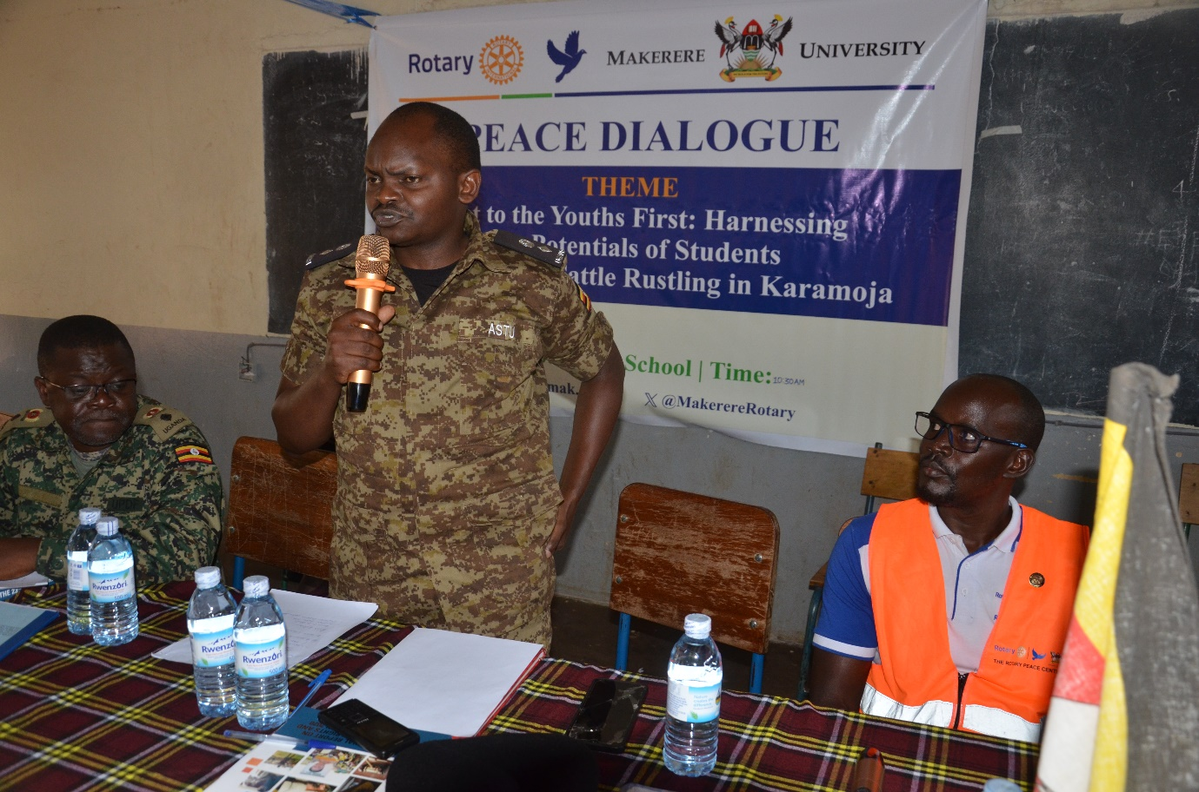

*Police Officer- ASTU (C) Making a point during the peace dialogue at Moroto High School as Lt col Fred Wemba (L) and Peace Fellow (R) looks on. 5th August 2023*

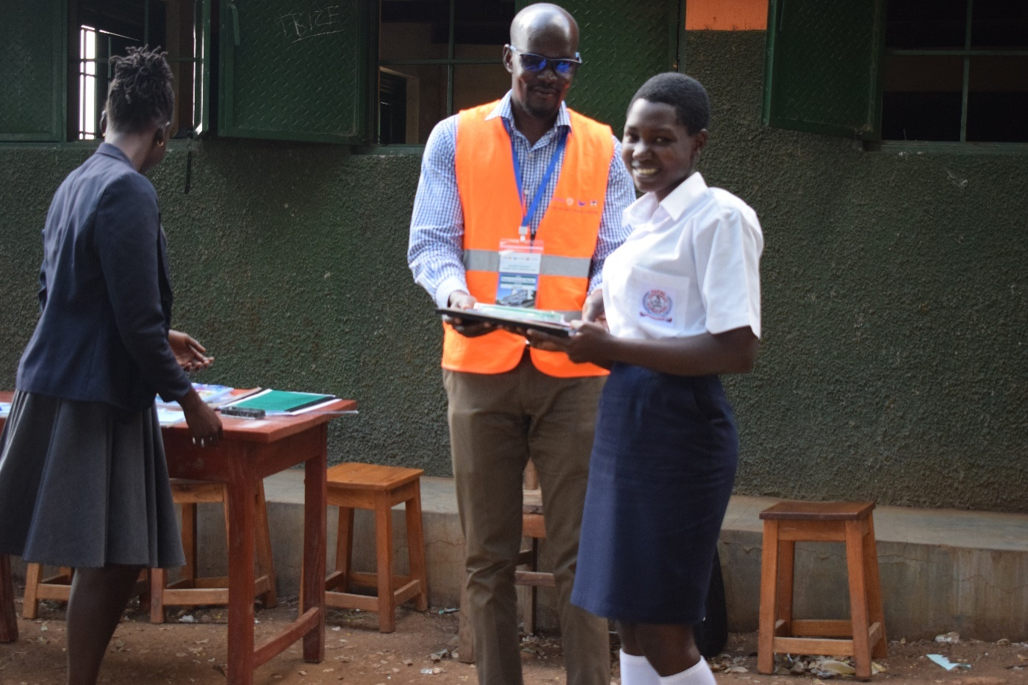

*Peace Fellow handing over a prize to a winning debater at Moroto Parents School on 12 July 2023*

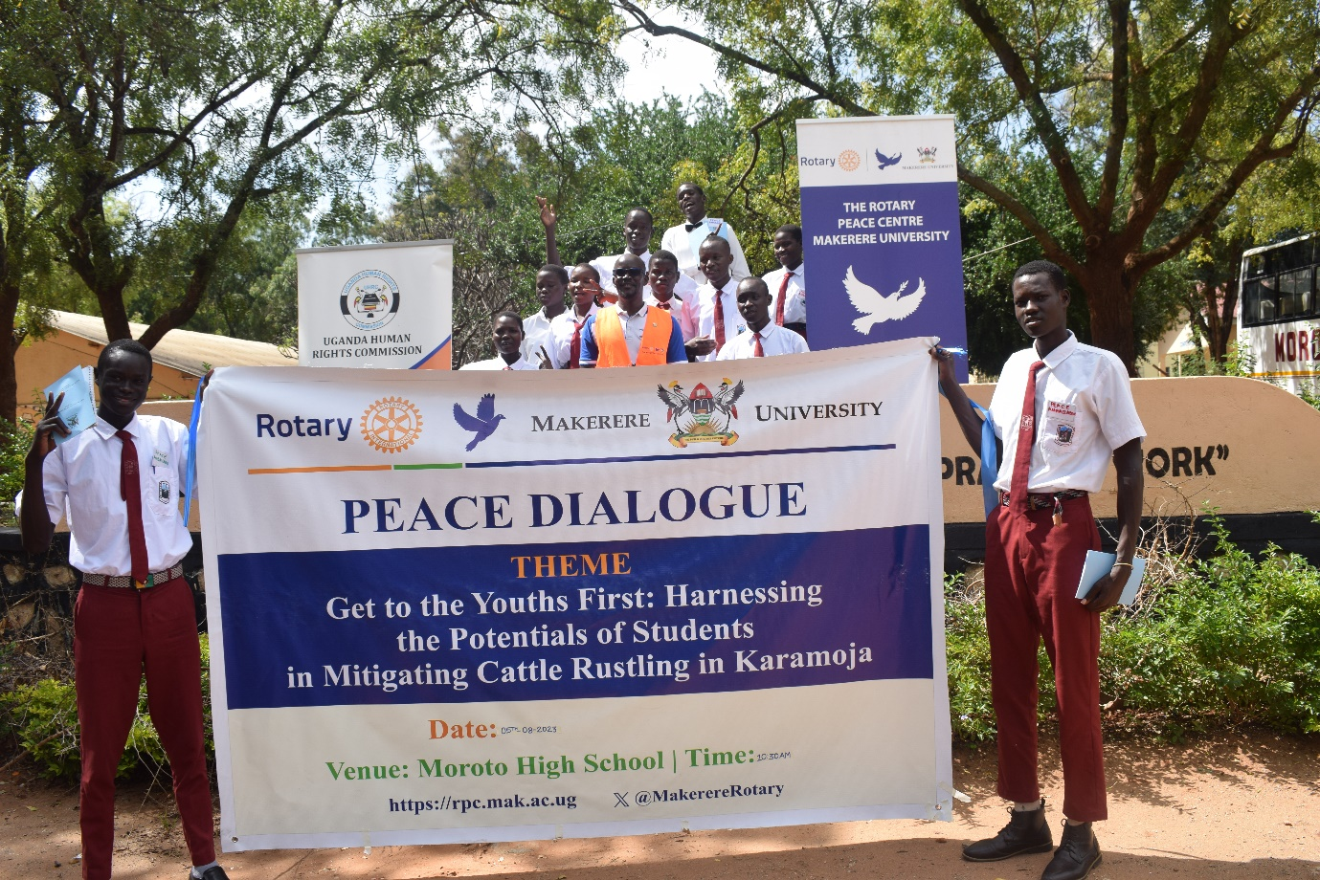

*Peace Fellow with some of the Peace Ambassadors at Moroto High School on 5 August 2023*

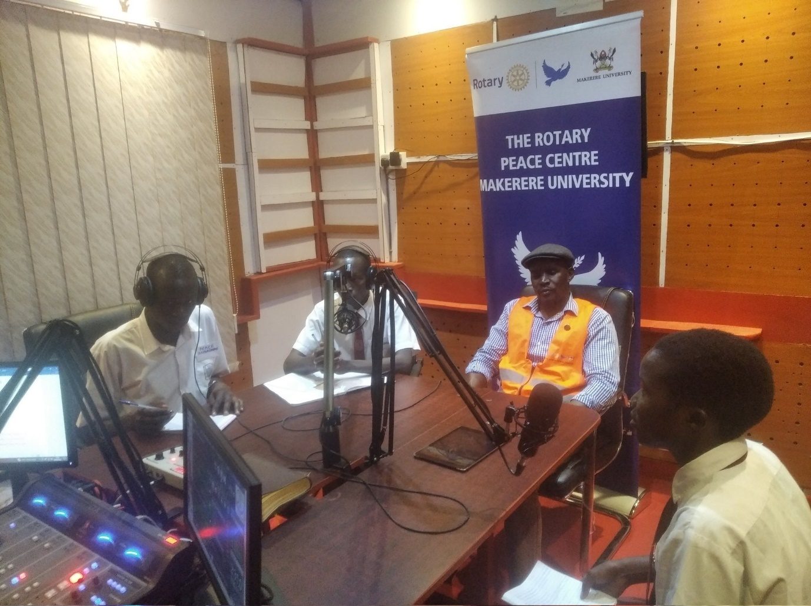

*Peace Ambassadors on a radio talk show at Ateker FM in Moroto on 10 August, 2023*

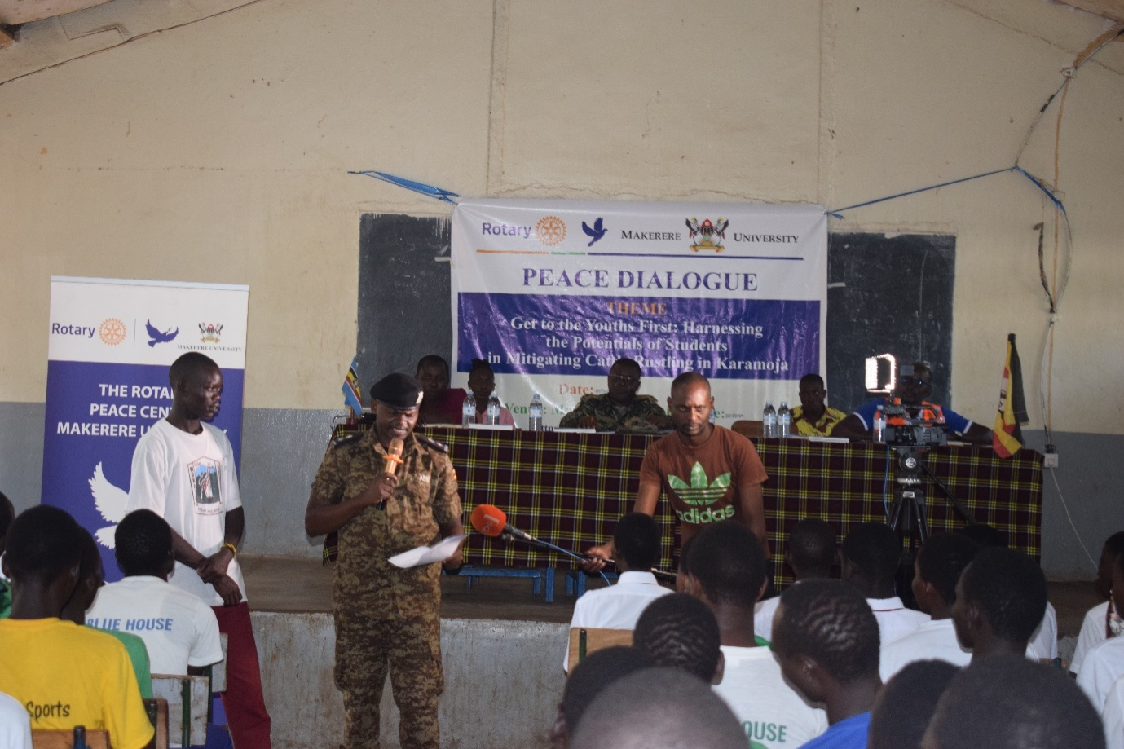

*ASTU- Police commander makes a point during peace dialogue at Moroto High School-on 5 August 2023*

# Clearances/ Permission letters

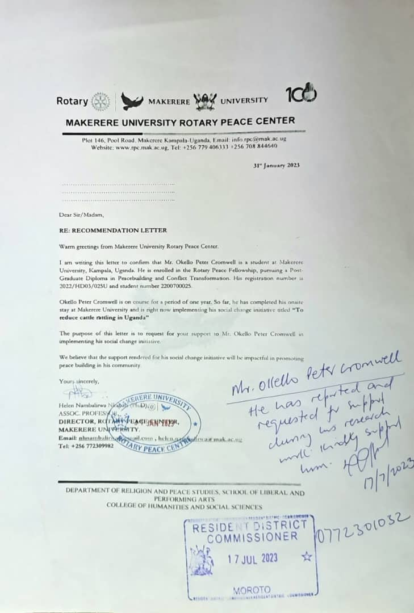

# Participant Testimonies

<https://www.youtube.com/watch?v=h5q9TDiS9Ak>

# Reference

Oluka, N. (2010). *Cattle rustling and human rights abuses in Teso Sub-Region: case of Bukedea District, 1986-2006* (Doctoral dissertation, Makerere University).

Omara, C. S. (2023). *The impact of policing strategies in combating cattle rustling in Karamoja sub region: A case of Anti-Stock Theft Unit (ASTU)* (Doctoral dissertation, Makerere University).

Arasio, R.L., and E. Stites. 2022. “The Return of Conflict in Karamoja, Uganda: Community Perspectives.” Karamoja Resilience Support Unit (KRSU), Feinstein International Center, Friedman School of Nutrition Science and Policy at Tufts University, Kampala, Uganda

Datzberger, S. (2017). Peacebuilding through non-formal education programmes: a case study from Karamoja, Uganda. *International Peacekeeping*, *24*(2), 326-349.

Bush, Kenneth D., and Diana Saltarelli. *The Two Faces of Education in Ethnic Conflict: Towards a Peacebuilding for Children*. Florence: Innocenti. UNICEF Office of Research 2000. [www.protectingeducation.org/sites/default/files/documents/unicef_the_two_faces_education_in_ethnic_conflict_peace_buil.pdf](http://www.protectingeducation.org/sites/default/files/documents/unicef_the_two_faces_education_in_ethnic_conflict_peace_buil.pdf) (accessed 3 Sept. 2015). [[Google Scholar]](http://scholar.google.com/scholar_lookup?hl=en&publication_year=2000&author=Kenneth+D.+Bush&author=Diana+Saltarelli&title=The+Two+Faces+of+Education+in+Ethnic+Conflict%3A+Towards+a+Peacebuilding+for+Children)

Marigat, S. K. (2023). Managing cattle rustling by enhancing police–community cooperation in the Karamoja Cluster: Lessons from Baringo, Kenya. *African Security Review*, 1-18.

Kaimba, G. K., Njehia, B. K., &Guliye, A. Y. (2011). Effects of cattle rustling and household characteristics on migration decisions and herd size amongst pastoralists in Baringo District, Kenya. *Pastoralism: Research, Policy and Practice*, *1*(1), 1-16.