**YOUTH FOR PEACE**

BY

AJAO, OLUSINA TUNDE

REG. NO: 2021/HD03/2026X

A SOCIAL CHANGE INITIATIVE (SCI) REPORT SUBMITTED IN PARTIAL FULFILLMENT OF THE REQUIREMENTS FOR THE AWARD OF THE POSTGRADUATE DIPLOMA IN CONFLICT TRANSFORMATION AND DEVELOPMENT OF MAKERERE UNIVERSITY

MARCH 2022

**DECLARATION**

I, AJAO OLUSINA TUNDE, do hereby declare that “*Understanding what makes Makerere Rotary Peace Fellows Successful in Life*” is entirely my original unaided work, except where acknowledged, and that it has not been submitted before to any other University or institution of higher learning for the award of any academic qualification.

Signed……… Date…31/03/2022

AJAO OLUSINA TUNDE,

ROTARY PEACE FELLOW

**APPROVAL**

This Social Change Initiative (SCI) report has been approved for submission to the College of Humanities and Social Sciences by the University Mentor and Supervisor after having thoroughly read through its contents.

…………………………… …………………………….

Dr. Venny Mbabazi Date

**Mentor and Supervisor**

………………………… ………………………….

Dr. Chris Tuhirirwe Date

**Mentor** **and Supervisor**

**Abstract**

More than 600 million youths live in fragile and conflict-affected contexts across the world. The implication of this is that several young people experience violence, miss out on education, face exploitation and even struggle to survive. Youths have predominantly occupied the scenes as victims of conflict, actors of conflicts, and agents of peace-building. Many of our young people seem to be highly unsatisfied with their lives. Such a high percentage of youths see the future as something black. Paradoxically, too often, young people are seen as a source of problems, yet their multiple roles in society and their potential to act as agents of change towards peace and development are vitally important. Despite the frequent occurrence of violence, participation in various peace educational programmes can yield positive attitudinal, perceptual and relational changes. Violent conflicts can be avoided or transformed via the constructive engagement of youth in peace-building activities. While young people are eager to have access to more capacity-building opportunities, their exclusion from peace processes prevents us from benefiting from their unique capabilities. This social change initiative aims to create awareness on conflict prevention and provide the necessary skills for peace-building among students and teachers. The youths are to be empowered through education and training and thus become agents of peace and development in society.

**CHAPTER ONE**

* 1. **Introduction and Background**

The alarming rate of occurrences of conflicts in the world over has become worrisome. Conflict is now become a persistent feature of universal phenomena. Violent conflicts remain a constant threat to human progress and sustainable development. The frequency of violent conflicts in Africa has become a major concern for all. Nigeria and many other African nations are facing conflicts characterized by genocidal attacks, bombing, maiming and killings of several persons, loss of business investments, and destruction of several properties. However, according to the UNICEF constitution, “Since war begins in the mind of man, it is in the mind of man that the foundation of peace must be constructed”. If we want peace, we must to work for justice. If we want justice, we must work peace. One thing cut across them all, if we justice and peace, we need to work for education. Peace education is also critical in peace-building. Therefore, the awareness and respect for human rights are essential for promoting peace.

[More than 400 million](https://www.youth4peace.info/system/files/2018-04/16.%20TP_Youth%20affected%20by%20violent%20conflict_IEP.pdf" \t "https://impakter.com/youth-role-peace-processes/_blank) young people, between the age of 15 and 29, live in fragile and conflict affected contexts across the world. The implication of this is that more than 400 million young people experience violence, face exploitation, miss out on education, and even struggle to survive. Despite such challenges, young people have shown that they are able to [play an active role](https://www.youth4peace.info/system/files/2019-07/Global%20Policy%20Paper%20Youth%20Participation%20in%20Peace%20Processes.pdf), particularly at grassroots and local levels, as peacemakers, mediators, and peace-builders. The potential for youth to contribute to peace-making and peace-building was recognised with the adoption of [Resolution 2250](https://www.un.org/press/en/2015/sc12149.doc.htm" \t "https://impakter.com/youth-role-peace-processes/_blank) by the United Nations Security Council in 2015. As one of the five pillars of the UN’s Youth, Peace and Security ([YPS](https://www.youth4peace.info/About_YPS_Agenda)) agenda, this included a commitment to ensuring the participation of young people in conflict prevention and resolution, violence prevention, and the promotion of social cohesion.

The youths are the resources of any nation. However, there is a wide gap between the enormous potentials of the youths and the development level in Africa and as well across the globe. Many countries in Africa are currently confronting different forms of violent conflicts. Several attempts have been made to find lasting solution, but these have yielded little or no result. It is even disheartened that the youths are one of the main actors of these conflicts. Whereas, the youths are meant to be a very valuable asset of any country, because they are the instruments of development of the society. However, many of our youths today are ignorant of their potentials, they are filed with erroneous perception and misconception of purposes. Many of them are ill-equipped and become unproductive. Therefore, the aim of this social change initiative is help to re-orientate, empower and engaged the youths as agents of peace and development in our societies. This initiative will promote peace.

* 1. **Problem Statement**

A critical look at sociological studies on youth carried out in different parts of the world reveal a bulk of surprisingly similar considerations. Young people as a category seem to be highly unsatisfied with their lives. They feel deprived of adequate education and employment opportunities. They barely identify, if at all, with the political thinking and behaviour of their parents. They feel let down and marginalized by society. In short, they are in crisis (UNDP, 2006). As a result of the several challenges confronting these young learners, most of them are prone to grievance, poor academic performance, low human capacity, violent conflicts, crimes, drug abuse, prostitution and human trafficking and other vices in the societies.

Also, it unfortunate that young people are often excluded because of a **perceived lack of experience and qualifications**. Their practical and lived experience in conflict areas and within their communities is not sufficiently taken into account. While young people are eager to have access to more capacity-building opportunities, their exclusion from peace processes prevents us from benefiting from their unique skills and capabilities, supporting their capacity development, and shaping peace processes based on youth’s lived experiences and grassroots-level insights. Thus, this social change initiative/ project is aimed at equipping the youths and raising them to become active actors in building positive peace and sustainable society.

* 1. **Goals and Objectives**

The aim of this social change initiative is help to re-orientate, empower and engage the youths as agents of peace and development in our societies. The specific objectives of this project is to:

1. bring about positive attitudinal change, progressive thinking and perception among the youth
2. Promote awareness of cost of violent conflicts and provide conflict prevention skills
3. enable the youths to be more actively engaged in peace building processes.
4. Increase human capital development of the youths.
   1. **Challenges and Mitigation Strategies**

There were some difficulties and limitations beyond the researcher’s control in the course of this practical project. The challenges include limited time to carry out the project; inadequate funding to execute some of the planned programs; and most importantly, the inability of the the Peace Fellow to access financial supports of the Rotary clubs as a result of the covid situation.

As a result of the covid situation, some adjustments were made in the initial planned social change Initiative. In fact, all the schools extended their holiday periods and resumed much later than the normal academic calender due to government restrictions. The Social Change Initiative duration was therefore re-adjusted to four months, instead of the initial plan of 6 months. Also, there was an adjustment as to the mode of delivery, as some of the proposed methods became not feasible. The Fellow therefore opted for training and mentor-ship methods. Also, the Peace Fellow completely depend on personal income to finance the project. This posed a lot of limitations to what could have been achieved if there were other financial supports and sponsorship. Notwithstanding, the project was generally a success and recorded lot of great accomplishments.

**CHAPTER TWO**

**2.1. Literature Review**

This section focuses on review of relevant literature on youth and violent conflict globally, and in Africa in particular. The meaning of youth, and the way society regards youth, vary across time and space, as well as within societies. Young people stand out as a truly unique societal group in the inclusion agenda: youth is a transitional phase of life and an identity that all people will belong to during their lives. As such, youth represent ‘a microcosm of wider society’ with diverse identities, ideologies and views falling under the large umbrella (UNFPA & PBSO, 2018). In particular, youth has an important gender dimension: boys and girls might experience being young in a considerably different way (UNPD, 2006). The literature that touches on youth and violent conflict focuses on analyzing the reasons why young people engage in fighting. It is often remarked that war would not be possible without youth – as combatants of any war, in any part of the world, are made up primarily by young people. Why is this the case? Do young people, by the mere fact of being young and energetic, tend towards violence? Therefore, is a large proportion of young people in society perse a warning sign for trouble? Do young people fight for their own causes, or are they mobilized into war by others? Do young people fight to change the circumstances of their particular grievances – and if so, what are these grievances? (UNPD, 2006)

The UN World Population Prospects statistics [estimate](https://esa.un.org/unpd/wpp/publications/files/key_findings_wpp_2015.pdf" \t "https://gdc.unicef.org/resource/_blank) that there are 1.3 billion youths between 15-24 years old in the world and nearly one billion live in developing countries where conflict is more likely to have taken place. A cursory look at sociological studies on youth carried out in different parts of the world reveal a bulk of surprisingly similar considerations. Young people as a category seem to be highly unsatisfied with their lives. Many of the youths often feel deprived of adequate education and employment opportunities. They barely identify, if at all, with the political thinking and behaviour of their parents. They feel let down and marginalized by society. In short, they are in crisis. Too often, young people are seen as a source of problems, yet their multiple roles in society and their potential to act as agents of change towards peace and development are as well vitally important.

This scarcity of opportunities affects youth at all levels of education. Emphasis, by governments and international actors alike, is normally placed on primary education. Indeed, a lack of basic literacy and numeracy skills prevents young people from entering the labour market and therefore from establishing themselves as fully independent adults, as well as from developing the capacity to resist political manipulation. However, the emphasis on primary education should not diminish the focus on higher education opportunities (or lack thereof ) when discussing youth. Just as MacFarquhar (2005) puts it,

‘‘there is such a high percentage of young people who see the future as something totally black…. If you open even a small window for them to see the sky, it will be a tremendous force for change. But they have to be able to see the sky.’’

Closely connected to the issue of education is another major concern in young people’s lives: getting a job with a living wage. As education is largely failing to provide students with an avenue towards a better future, young people increasingly regard education as irrelevant or useless. This feeling is poignantly summarized in the words of a young combatant from Congo Brazzaville: ‘‘Education does not lead to employment, so why bother? The State no longer recruits – you have a Ph.D. and you are a taxi man’’ (Munoz, M. 2000). The problem is not only linked to the availability, quality and relevance of education, but also more broadly to the economic and social constraints in which most developing countries find themselves. In many parts of the world, insufficient opportunities exist for young people to earn a living. According to estimates of the International Labour Organization (ILO), 66 million young people are unemployed, and a much higher number are under-employed. Worldwide, the unemployment rate for young people (aged 15 to 24) is up to three times higher than for adults (Brett/Sprecht, 2004).

**2.2. Theoretical Underpinnings**

The human needs theory as formulated by Burton (1990) is a good theoretical framework that provides an insight into the situation of youth and conflict in the society. The Needs theory reveals that deep-rooted conflicts are caused by the denial of one or more basic human needs, such as security, identity, good education, employment and recognition. Burton explains that in analyzing conflicts one must distinguish among interests, values and needs. In an attempt to manage or resolve conflicts, it should be understood that only interests are negotiable in the short term; while values can only change over the long run in an atmosphere of security and nondiscrimination. The theorist however asserts that ‘‘human needs’’ cannot be negotiated away under any circumstances (Burton, 1990). Furthermore, Rosati et al (1990) argued that all human beings have basic needs which they seek to fulfill and failure caused by other individuals or groups to meet these needs could lead to conflict. Education, empowerment through skills acquisition and recognition are some of the important needs of the youths. For the young people to actualize their dreams and aspirations in life, the basic needs must be provided by the society in which they exist. Thus, violent conflicts among the youths usually involve demand for the needs and aspirations that have not be met. The fundamental argument underlying this clarification is the fact that conflict is inevitable in every healthy human society, although it depends on the nature, intensity, dimension and goals involved. This theory is so far very critical to our analysis and understanding of the conflicting forces in the society and the basis for which youth empowerment, peace education and peace-building activities should be employed for harmonious coexistence and sustainable society.

**2.3. Change Theory and how it was applied**

A theory of change is a purposeful model of how an initiative—such as a policy, a strategy, a program, or a project—contributes through a chain of early and intermediate outcomes to the intended result (Serrat, 2017). Theory of Change is basically a comprehensive description and illustration of how and why a desired change is expected to happen in a specific context. It is focused especially on mapping out or “filling in” what has been described as the “missing gap” between what a program or change initiative does (its activities or interventions) and how these lead to desired goals being accomplished. Social change as the process whereby individuals and communities adjust or abandon customs and associated leading ideas, values, and purposes to act differently in response to random (unique) or systemic factors—is no simple matter. It is driven by a composite array of cultural, demographic, economic, environment, political, religious, scientific, and technological forces, singly but more often than not in co-evolutionary combination, and almost always in the face of vested interests that favor the status quo (Serrat, 2017). The theory of change helps navigate the complexity of social change. It does this by first identifying the desired long-term goals and then works back from these to identify all the conditions (outcomes) that must be in place (and how these related to one another causally) for the goals to occur. These are all mapped out in an Outcomes Framework.

The Outcomes Framework then provides the basis for identifying what type of activity or intervention will lead to the outcomes identified as preconditions for achieving the long-term goal. Through this approach, the precise link between activities and the achievement of the long-term goals are more fully understood. This leads to better planning, in that activities are linked to a detailed understanding of how change actually happens. It also leads to better evaluation, as it is possible to measure progress towards the achievement of longer-term goals that goes beyond the identification of program outputs.

As mentioned in the description of the theory of change above, the Rotary Peace Fellow first identified the gap or the need in the society that requires an urgent and specific attention.The need to stop or prevent violent conflicts in our communities is indeed of a paramount attention, if we must have a peaceful and sustainable society. Youths - as victims of conflict, drivers of conflict and agents of peace-building - are identified to have important roles to play in achieving the goal of building peace.

Young learners from a Public school at the Federal Capital Territory of Nigeria were selected for the social change initiative project. The students of the school are of different sociocultural backgrounds. Some of them are housemaids, many are living with guardians, and several are from dysfunctional families or very poor parents. The situations of these students often portray the clear pictures of hard condition, neglect, abuse, struggling to survive and discrimination. As a result of the several challenges confronting these young learners, most of them are prone to grievance, poor academic performance, low human capacity, violent conflicts, crimes, drug abuse, prostitution and human trafficking and other vices in the societies.

The change theory was applied through peace-building and human capital development training among the selected young learners. The duration for the project was four months and it was able to achieve the following outcomes:

1. Positive attitudinal change, progressive thinking/perception.
2. Awareness of conflict prevention, which enable the youths to be more actively engaged in peace building processes.
3. Increase human capital development among the youths.

**2.4. Methods and Design**

1. Field project was carried out;
2. Consult with the community to actually know their needs (need assessment):
3. Engage with the relevant authorities (Ministry of Education etc.)
4. Make use of inclusive participation; engage the Management and teachers, PTA members and the students’ forums,
5. Involve all the relevant stakeholders and Rotary Clubs for supports

**CHAPTER THREE**

**3.1 Intervention and Activities**

**3.1.1. Youth, Conflict Prevention and Development; Youth for Peace**

This is an initiative where the youths are empowered through education and training, and then engaged for the purpose of conflict prevention, peace-building and development in the society. According to Johan Galtung (1976), peace-building involves addressing and removing the root causes of violence – the structural and the cultural violence – that feeds into and enables direct violence. Preventing conflict is the avoidance of actions or in-actions that are inimical to development, lead to loss of lives, or and destruction of properties. Peace is the foundation of development. Therefore, the project is aimed at empowering the youths and raising them to become active actors in building positive peace and sustainable society.

**3.1.2. Report of the Social Change Initiative**

Young learners from three Public schools at the Federal Capital Territory of Nigeria are targeted. The students of these schools comprised of children from different sociocultural backgrounds. Some of them are housemaids, many are living with guardians, and several are from dysfunctional families or very poor parents. The situation of these sets of students often portrays the clear pictures of hard condition, neglect, abuse, struggling to survive and discrimination.

The first step taken for the execution of this Social Change Initiative was the prior consultation with the school community for need assessment and to ascertain the relevance of the project to the students. There were series of visits to the school and discussions with the School Principal and other school management members to acquaint them with the planned project. Later, I also sought and obtained permission from the regulatory authority, FCT Secondary Education Board, to carry out the Social Change Initiative in the selected school, Government Secondary School, Mabuchi.

However, due to the covid situations, there were some adjustments in the initial planned social change Initiative. In fact, all the schools extended their holiday period and resumed much later than the normal academic calender as a result of the government restrictions. The Social Change Initiative duration was therefore re-adjusted to four months, instead of the initial plan of 6 months. Also, there was an adjustment as to the mode of delivery, as some of the highlighted methods became not feasible due to lack of funding and the covid restriction. The Fellow, therefore, opted for training and mentor-ship method.

The Social Change Initiative commenced on 10th September 2021, and 1pm to 2pm of every Thursday was allocated by the school for the project. I also got two of the teaching staff of the school to work with. On the first day over 120 students indicated interest and registered for the training. The students were extremely excited about the program, as it addressed many of their desires and needs. The demography of the students cut across from the senior secondary school class 1 to class 3. The age range was between 12 to 18 years old.

We have had a total number of nine interactive sessions so far. The mode of delivery were interactive and participatory learning methods. Most of the students were actively engaged in the training process. There was a pre -training survey to understand the level of knowledge of the participants in the concept of conflict, peace-building and human capital development. The responses were very surprising as only few of the participants have very little knowledge of those concepts, while the majority of them have no ideal. However, the facilitator used the first day for introduction and discussed some of the contents and expectations of the training. The students were really fascinated by the program because it was quite different from the normal academic curriculum and yet has a great impact.

Subsequently, other sessions took place and each one was dedicated to different activities. Some of the activities include: (1) Introduction to Conflict and Conflict Analysis training, (2) discussion on the root causes of conflict, violent conflicts and examples from Nigerian context, Manifestation of violent Conflicts, (3) Possible solutions from the participants, (4) peace-building process, (5) Gender awareness training, (6) Inspirational/motivational sessions, (7) Interactive/question and answer session. The average number of participants for each of the session was 82. I and the two members of the staff facilitated most of the sessions and a total number of 160 students have been trained so far.

The programme has started yielding the result already as there has been a positive change in the attitudinal behaviour of the students. Many of the students are more responsible and well behave. The level of their zeal for learning and their academic performances have also greatly increased. In fact, some of the student have started exploring their creative abilities in more positive forms. However, due to the end of the term examination, I could not carry out the last two scheduled session as planned. These were later shifted took place after the school resumption in January 2022. The last session was a close up session, and Peace Ambassadors Club was be established for the school and handed over to the school management and staff to coordinate.

**3.2. Key Findings**

1. Key findings, from this Social Change Initiative, revealed that peace work with young people affected by violent conflict is essential and achievable and must be youth-driven and youth-informed. A diverse set of project results show progress in many areas, which can be expanded. Mainstreaming and targeted approaches to supporting youth that account for age, gender and other differences are critical to meeting the needs and aspirations of the youths. There should be a comprehensive framework for action that accounts for the diverse circumstances of youth and ensures all sectors of responses are integrated across phases of conflict and recovery.
2. The project also revealed the challenges that remain in bridging gaps between policy and practice. Also, the challenges of appropriate coordination between humanitarian and development actors and getting adequate funding for work with youth. These and other barriers continue to undermine youth survival, capacities and roles, and thereby the short-term and long term well-being of their entire societies.
3. The rationales for work with young people go beyond the need to prevent their involvement in armed conflict or to support their roles as peace builders. They include the need to support a diverse range of other roles young people play in their societies.
4. The project also revealed that additional cooperation is needed between humanitarian and development actors to ensure holistic attention to youth across all sectors of programming.
5. Finally, the findings of the study revealed that violent conflicts can be avoided or transformed via constructive engagements. Proper orientations, awareness and enlightenment through the different forms of education are the essential ingredients for peace building process.
6. Another important finding is that peace and security are essential for sustainable development and good governance. Good governance in turn heightens peace and security. It is therefore of utmost imperative that well-articulated and thought out master plan, engineered towards curbing incessant violent crises, be fashioned to meet the challenges of confrontations between the various conflicting parties in our societies.

**CHAPTER FOUR**

**4.1. General Conclusion**

We live in a hyper-connected, highly inter-dependent world, where knowledge is the most important currency. It of upmost imperative to address the deficit of appropriate knowledge and low level of human capital development for any society to enjoy any form of peacefulness or development. That makes education and capacity building of the young people more important than ever before. Youth all over the world have greater roles to play in peace-building process. Therefore, the barriers inhibiting the inclusion of young people in peace process must be critically identified and thoroughly addressed by all relevant stakeholders. ‘Youth’ should not become a box to be ticked in peace processes. Nor should youth be seen merely as representatives of ‘youth issues’. Too often, young people are seen as a source of problems, yet their multiple roles in society and their potential to act as agents of change towards peace and development are vitally important. Therefore, attention must be paid to what youth voices express, how they envisage the objectives of the transition to peace, which relationships they aim to transform, and what solutions and resources they offer. What youth can do for peace is important, but meaningful inclusion requires reflecting also on what peace can mean and do for youth.

**4.2. Recommendations / Implications for Policy**

1. Set up and support platforms for youth to represent their voices and experiences and to partner with each other to work towards peace together.
2. Create safe online and face-to-face spaces for youth to work together, learn from each other, and receive support and training from peers and more senior experts. This should include access to mental health support to help them deal with any trauma they may have.
3. Develop youth organisations to support youth-led and youth-owned peace initiatives as well as representation of young people in decision-making processes at all levels.
4. Ensure a sustained provision of funds, technical resources, and guidance to support youth-led peace initiatives of different types.
5. Facilitate youth’s capacity building relevant to their individual and contextual needs to ensure they can design, initiate, and complete successful peace initiatives and confidently participate in peace-building processes.
6. Incorporate diverse backgrounds and needs of young people in research, policy, and programming to ensure that support is targeted to address and redress relevant issues. Additionally, develop a research agenda around the role of youth in peace processes where youth’s agency and voices are placed at the centre.
7. Address the different forms of disadvantage, exclusion, and marginalization of young people face, including poverty, unsafe environments, poor healthcare and education, among others.
8. Establishment of Peace radio programmes prepared by local youths, focusing on youth issues, with particular reference to the current conflict, human rights and social affairs.

**4.3. Sustainability Plan**

Executing projects that make positive impact in the lives of the people is a laudable accomplishment; however, making such projects to be sustainable is of upmost imperative for development. The sustainability plan for the Social Change Initiative ‘‘Youths for Peace’’ are the following;

1. Establishment of Peace Club in the selected school; this will ensure continuation of the training and retraining by the students themselves under the guardian of Matrons and Patrons - who are staff of the school
2. Appointing two of the school staff as the matron and the patron of the peace club.
3. Creation of network contact with the students and the staff of Nigeria:
4. Connect the school and the Peace Club of school with a Rotary Club for adoption

**References**

Brett/Sprecht (2004), Young Soldiers: Why They Choose to Fight, Lynne Reinner: Boulder CO.

Burton, J. (1990). Conflict: Resolution and Prevention. New York: St. Martin’s Press.

Galtung, J. (1990). Cultural Violence. *Journal of Peace Research*, 27(3), 291-305.

MacFarquhar, N. (2005), ‘Unexpected whiff of freedom proves bracing for the Mideast’, *New York Times*, 6 March.

Rosati, J.A., Carroll D.J., Coate, R.A. (1990) A Critical Assessment of the Power of Human Needs in World Society. In: Burton J., Dukes F. (eds) Conflict: Readings in Management and Resolution. Palgrave Macmillan, London.

Serrrat O. (2017). Theories of Change. In: Knowledge Solutions, Springer, Singapore. http://doi.org

UNDP (2006). Youth and Violent Conflict: Society and Development in Crisis.

**APPENDIX 1: Pictures**

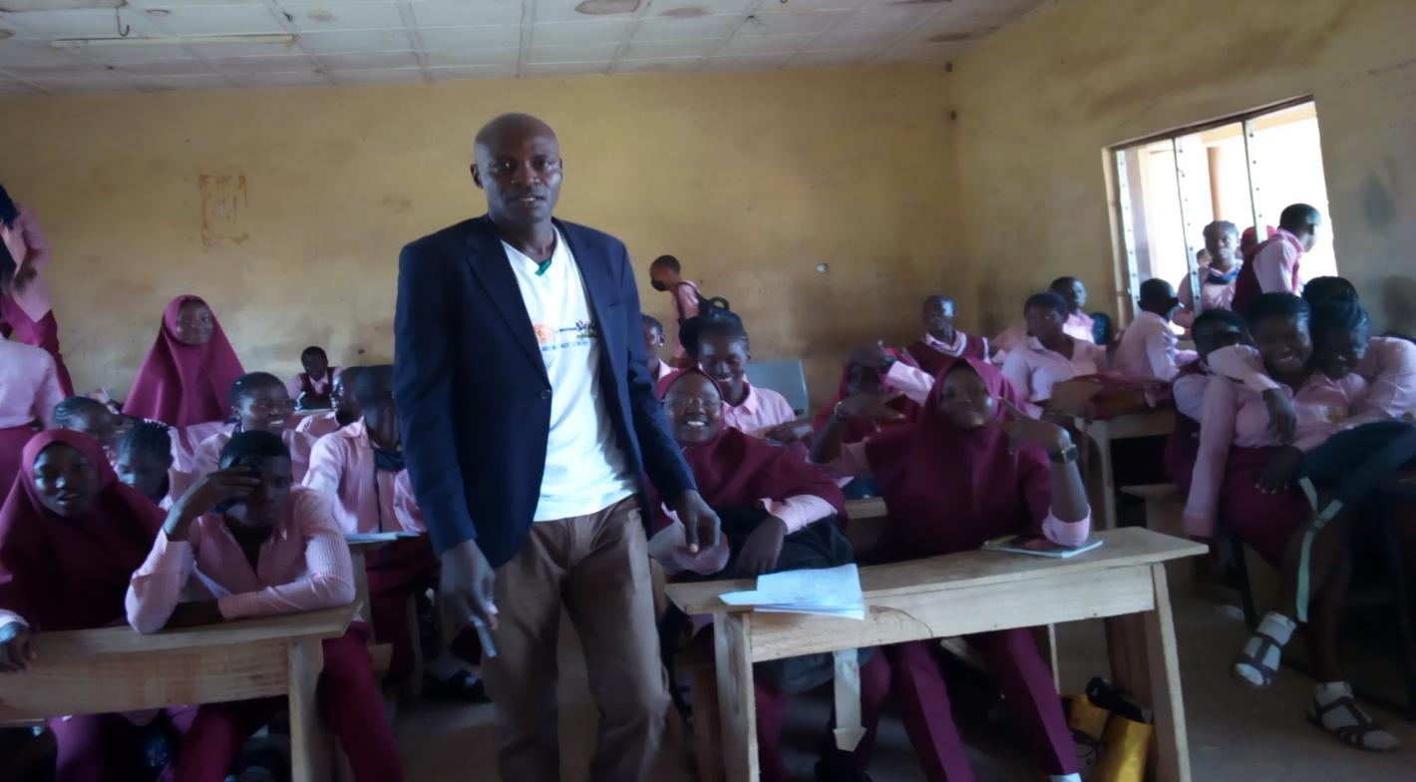

Peace Fellow during a training section at the Government Secondary School at the FCT - Abuja

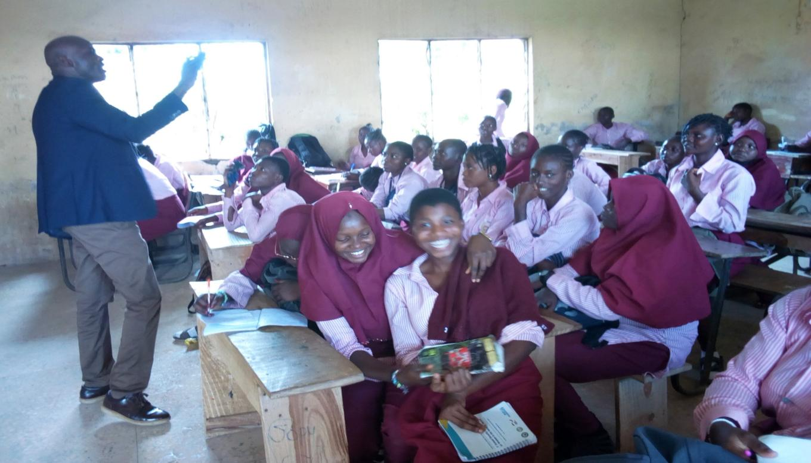

Peace Fellow during a training section at the Government Secondary School at the FCT - Abuja

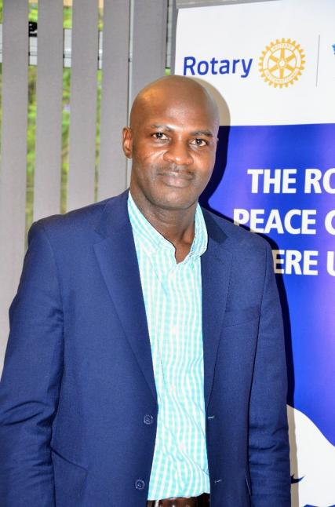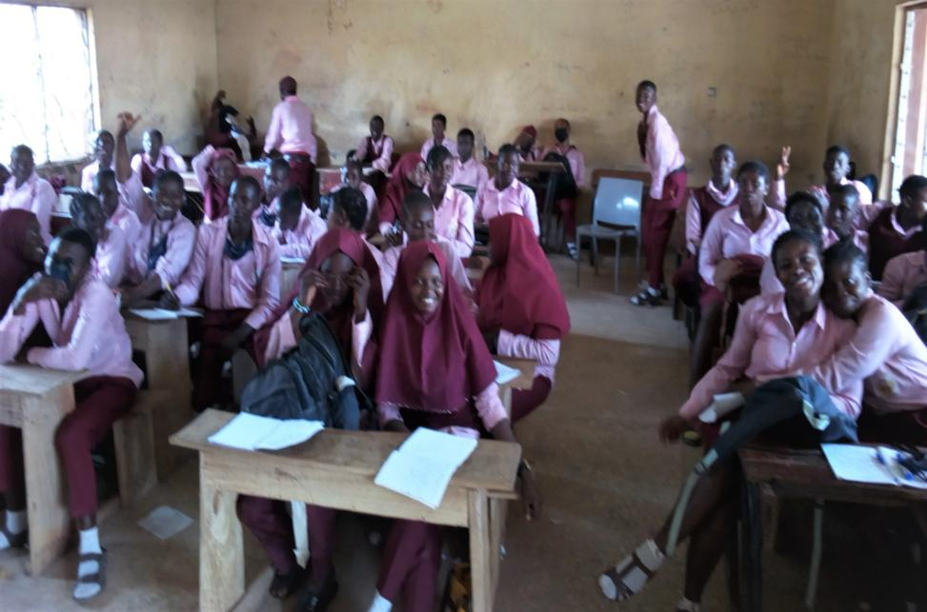

Rotary Peace Fellow Senior Secondary School 2: some of the students of the school during a session

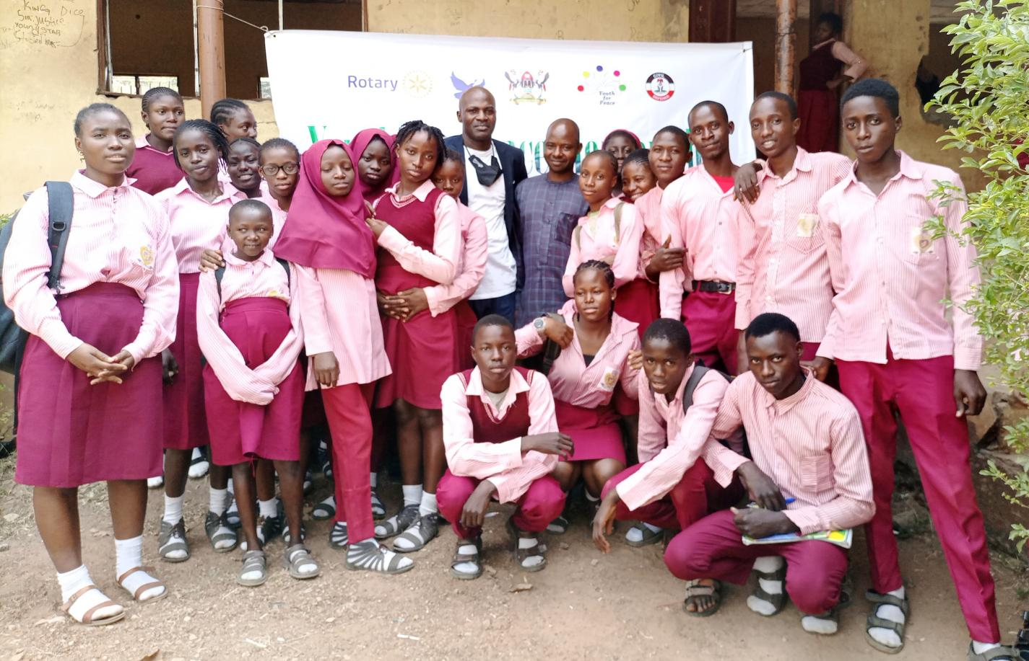

Cross section of the Fellow and trainees

**APPENDIX 2: Banner for the SCI Project**

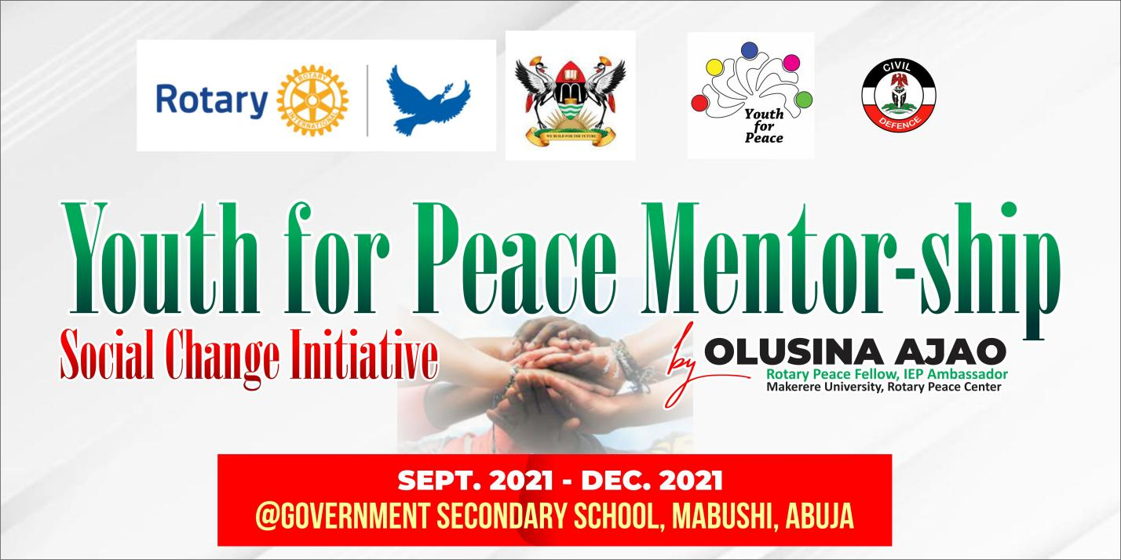

Banner for the social Change Initiative Project

**APPENDIX 3: Testimonies/Letter of Appreciation**

