**PROMOTING WOMEN’S INVOLVEMENT IN PEACE AND SECURITY PROCESSES USING INTERGENERATIONAL APPROACH IN OSUN AND OGUN STATE, SOUTH WEST NIGERIA.**

**A SOCIAL CHANGE INITIATIVE IMPLEMENTED IN THE DEPARTMENT OF RELIGION AND PEACE STUDIES, SCHOOL OF LIBERA AND PERFORMING ARTS COLLEGE OF HUMANITIES AND SOCIAL STUDIES AND SUBMITTED TO THE POSTGRADUATE COLLEGE, MAKERERE UNIVERSITY KAMPALA, UGANDA. IN PARTIAL FULFILMENT OF THE REQUIREMENT FOR THE AWARD OF DEGREE OF POSTGRADUATE DIPLOMA IN PEACE AND CONFLICT TRANSFORMATION.**

**BY**

**OLUWATOYIN JOEL**

**SUPERVISOR: CHARLOTTE K. MAFUMBO**

**Locations: Osun and Ogun State, SouthWest Nigeria**

**START DATE: JUNE 2023**

**COMPLETION DATE: November 2023**

Table of Contents

# **Acknowledgements ……………………………………………………………………………..4**

**Chapter One ………………………………………………………………………………………………6**

**1.0 Introduction…………………………………………………………………………………………..6**

**1.1 Background of the study**…………………………………………………………………………………………………………………6

**1.2 Problem Statement**………………………………………………………………………………………………………………………….7

**1.3Goals of the Social Change Initiative**…………………………………………………………………………………………………8

**1.4 Specific Objectives**………………………………………………………………………………………………………………………….9

**1.5 Challenges of the SCI or the study process………………………………………………………….**9

**Chapter Two**

**Literature Review** 11

**2.1Empirical Review** 11

**2.2 Summary of Literature Reviewed** 14

**2.3 Theoretical Framework** 15

**2.3.1 Change Theory** 15

**2.3.2 Peace Education Theory** 17

**2.4 Summary of Theoretical Framework** 18

**2.5 Methods and Design** 209

**2.6 Implementation Methods and Design** 20

**2.7 Alignment of the SCI with UNSCR 1325 and 2250………………………………………21**

**CHAPTER THREE**

**INTERGENERATIONAL TRAINING IN WOMEN’S ROLE IN UNSCR 1325** 25

**3.1 INTERVENTION AND ACTIVITIES** 25

**3.2 Key Findings and Impact of Training** 27

Summary 30

**CHAPTER FOUR** 31

**CONCLUSION AND RECOMMENDATION** 31

**4.1 General Conclusion** 31

**4.2Recommendation** 32

**4.3 Sustainability Plan** 33

***Government Involvement and Policy Development:*** 33

***International Agencies and Partnerships:*** 34

***Community Engagement and Empowerment:*** 34

***Outcome Measurement and Adaptation:*** 35

***Resource Allocation and Financial Sustainability:*** 35

***Networking and Collaborations:*** 35

***References*** 37

List of Appendices 40

**Appendix Two: Training on UNSCR 1325** 41

**Appendix Three: Post Training Images** 42

**Appendix Four: Simulation Exercise** 43

**Appendix Five: Research Ethical Approvals** 44

# **Acknowledgements**

My special appreciation goes to the Almighty God by whose great love and grace I successfully completed this programme in Makerere University. I like to express my sincere gratitude to Rotary International, all Rotary Donors especially Sir Emeka Ofor for financing this program. I am appreciative to the Entire Rotary Club of Oshogbo Central District 9125, Rtn Taofiq Ayinla Awodele President and past President Rtn Engr. Femi Adewole Okunola of Oshogbo club for their Recommendation during the application process. Also, my appreciation goes to CSP Sunday Afolayan and Rtd CSP Sikiru Olayinka for their supports and recommendations during the application period. I want to specially appreciate the endorsement team headed by Rtn Ayoola Oyedokun past district governor district 9125 thank you all for the endorsement.

I appreciate the entire Makerere Rotary Peace Center staff most especially Prof, Helen Program Director and Ms Seera Communication Officer for their guidance and supports since the inception of this program, my research supervisor Dr. Charlotte Mafumbo for her guidance, time and efforts devoted to make this work a success. Also, my appreciation goes to all lecturers both online and on-site facilitators for their contributions, support and encouragement, and all non-academic staff members of Makerere University Kampala, Uganda for their inputs and support.

I appreciate the Osun State Governor His Excellency Sen. Ademola Nurudeen Jackson Adeleke for his financial assistance for the implementation of this project; also, I like to appreciate Mr. Okanlawon Adesina Permanent Secretary General Service at the office of the governor of Osun State and ASP Ahmed Bio Abdulrahma for their support during the financial assistance processes.

I also like to appreciate the efforts of my co-facilitators Dr. Tope Olaifa,Mrs. Lola Wey. Comrade Ibrahim Olayinka and ACP Babatunde Sodimu for their supports and for aligning themselves to this project.

Special appreciations to all the participants, Ogun State Women Police Officers and Oba Ile & Oba Oke women for their time and commitment to the success of this project. To all my volunteers Hon. Ojetola, Joy Joel and Engr. Lajubu Olugbenga I say a very big thank you. To all Cohorts 5 Makerere Rotary Peace Fellows thank you so much.

I appreciate my beloved husband Joel Leke Moses and my children; Joy, Mercy and Grace for their love, support and understanding. To others who in one way or the other contributed to the success of this programme. I thank them all for their prayers and support. God bless.

**Abstracts**

The study critically evaluated how programmes (such as training and workshop on security and peace-making) closed knowledge gaps and empowered women in these important fields through an intergenerational approach. These were with the view to promote and increase women’s participation in peace and security procedures. The study embraced the Community-based Initiative approach, which comprises assessing the design, content, and delivery of workshops, training sessions (on UNSCR 1325 (2000) and UNSCR 2250 (2015)), and other activities that support women’s participation in security and peace via symbolic representation. Likewise, the study examined how these programmes affected participants’ comprehension of and participation in peace-related activities via qualitative approach.

The findings revealed a significant knowledge gap among participants regarding international treaties and resolutions such as UNSCR 1325 (2000) and 2250 (2015). However, the interventions effectively served as an eye-opener, enhancing participants ‘awareness, and understanding of these policies. Notably, the planting of the ‘Peace Tree’ emerged as a symbol of renewed commitment to community harmony and collaboration, underscoring the intertwined nature of community safety and development. The study recommends a paradigm shift towards more inclusive peace processes, emphasizing the need for policies that actively involve women in all stages. It highlights the importance of integrating education and training programs on international treaties into law enforcement and public administration curricula and developing dynamic, gender-sensitive policies. In conclusion, the study posits that these interventions have laid the groundwork for more inclusive, informed, and effective participation in peace processes, potentially transforming peace and security dynamics globally.

# **Chapter One**

# **1.0 Introduction**

A woman plays a critical role in maintaining peace and security. The adoption of the United Nations Security Council Resolution 1325 (2000) on women, Peace and Security and United Nations Security Council Resolution 2250 (2015) on Youth, Peace and Security both aimed at ensuring that women and youth involvement in peace and security is paramount for a sustainable peace. Many years since its inception, implementation of these resolutions also known as frameworks remains varied across the World. In Nigeria especially in Osun State that presently women neither hold any elected position nor affirmative action positions at Federal electoral positions and State House of Assembly including the Security Sector like Osun State Police Command as an Example from the rank of Assistant Commissioner to the rank of Commissioner of Police which totaled 14 with just only one female who is the deputy commissioner of police serious gender inequality, women’s representation is extremely low especially at the managerial and decision making positions in the State. Furthermore, Osun State Police Command has been neglected in peace operations especially the women. Oba Ile and Oba Oke community in Olorunda local Government area in Osun State is known for violent both inter communal conflicts is common among these communities over trivial issues that can be settled amicably among families, within community and among the communities mostly leads to wanton destructions of properties and loss of lives. It is against this background that this social change initiative was conducted to sensitize and enhance women and youth capacity for participation in peace and security processes.

# **1.1 Background to the study**

Promoting women in peace and security processes using intergenerational approaches is a framework of the United Nations Security Council of Resolution 1325 (2000) and Resolution 2250 (2015) to maintain international peace through involvement of women and youth. Because women and youth are adversely affected by armed conflict and are targeted by combatants and other elements as a weapon of warfare through sexual violence, exploitation, early Marriage etc.

Furthermore, the adoption of Resolution 1325 (2000) and Resolution 2250 (2015) was aimed at promoting women involvement in peace processes and promoting their inclusive in all peace process because both generations form the majority of the population. The Government of Nigeria has so far developed two National Action Plans on Women Peace and Security starting with the first in 2013 till 2016 and the second NAP in 2017.  ‍

While Resolution 2250 (2015) on Youth Peace and Security was domesticated by the Federal Government of Nigeria through its own National Action Plan on Youth Peace and Security NAPsYPS in 2021 which make Nigeria to be the first in Africa country to domesticate this international framework with five pillars namely, Participation, Protection, Prevention, Partnership and Disengagement and Reintegration.

‍ The importance of Women and Youth cannot be underestimated in peace and security processes and their meaningful representation at all peace processes especially at decision making level is paramount to be able to address their needs, concerns, and fears through a collaborative effort to find lasting solution and reduce the effects of conflict related issues on them.

According to scholars Maxwell & D. Maxwell 1989 and Linda 1992 they argued thatwomen have problem solving strategies to resolve conflicts because they tend to discuss issues in more depth and can openly express their feeling unlike men. Female mediators have been found to be more comprehensive in their approach (Peacekeeping and International Conflict Resolution pg 220-221)

Female mediators get to the root causes of the problem in order to find long lasting solution to issues of conflict and addressed it whereby leading to sustainable peace because no woman will wish to lose a child or husband to conflict, they always respond to issue with motherly mind to find lasting solution. Both older and younger generations need to collaborate to address problem facing women and girls and how to build a sustainable peace through intergenerational approaches. There is strong evidence suggesting that women’s participation in peace and security processes contributes to longer and sustainable peace. Yet, despite this, women and youth remain largely invisible in peace and security processes.

# **1.2 Problem Statement**

Despite the existence of these frameworks UNSCR 1325 and 2250 there are few attempts to implement and promote women and youth participation in peace and security processes. This has posed a great challenge, especially in Nigeria, where women play fewer roles in all spheres of managerial roles than men. Since the creation of Osun State in (1991) in the western part of Nigeria women's inclusion is very low even though women are the victims of crimes and effects of violent in Osun State like Rape, Sexual Abuse, Domestic Violence, Assault, Murder and so on.

Because of beliefs and cultural practices women are believed and seen as weaker being hence not to be involved in jobs they usually are hard like politics, peace, security activities and others societies have neglected the capacity and strength of women forgetting that a man does all things with mind and strength and not with what really makes them a man. Women and youth are the strongest being but societies neglect the strength in them especially in African.

Many women and youth are not aware, familiar with these frameworks hence they are not equipped to participate or involved in peace and security activities/processes in their localities, and you can only give out what you have. Despite all these frameworks, there is little effort to promote Women and Youth involvement in peace and security processes. Hence, this Social Change Initiative to draw the attention of the selected women and youth on the importance of their participation in peace and security processes.

# **Goals of the Social Change Initiative**

The overall goal of the Social Change Initiative (SCI) was to identify ways in which women’s participation in peace and security at decision making processes can be increased. More specifically the SCI was set out to:

* Increase the number of women police officers in peace operations and in decision making.
* Strengthen older and younger women capacity to participate in peace and security processes and to provide a better opportunity for both to learn and collaborate with one another and
* Provide lasting solution to identified problems for a sustainable peace through various processes of peace building and programs.

Finally, to train men, women and youth on the importance of women participation in peace and security processes for world sustainable peace.

**1.4 Specific Objectives**

* To increase women police officers’ participation in decision making process in peace and security operations
* To enhance capacity of women police officers’ and community members in preventing violence against women and youth
* To strengthen the ability of Oba women and youth in early warning signs and conflict prevention responses
* To enhance capacity of Oba Ile and Oba Oke women and youth for peaceful co-existence and for better skills for conflict management.

# **1.5 Challenges of the SCI or the study process**

1. Difficulty in meeting with community leaders of both communities to seek for their approval.
2. Difficulty in meeting with Osun State Commissioner of Police for approval and the seminar training approval was declined.

3. Difficulty in identifying willing senior women police officers in peace and security operations and those that will align with the SCI.

4. Funding/ Availability of resources

5. Women police officers and the selected women in the community being unwilling to change/ or be mentored

6. Willingness of the Government to adjust its recruitment policy to allow more women in peace and security.

# **Mitigation Strategies**

1. The Oba Ile and Oba Oke kings were contacted through one of the political stakeholders in the two communities letter delivered and the project was explained to both and was well accepted because the two kings believed that is what they really need now because conflicts has deprived them of a lot of opportunities, and they believed the training seminar will help them to retrace their ways.
2. The approval for the training seminal was declined in Osun State Police Command, However, the Ogun State Police Command gave the Fellow full approval and support, and the training was conducted in Ogun State against the initial proposed State.
3. The senior women Police officers available are not willing to collaborate with the project, however, a male senior Police officer, a female consultant and senior researcher on peace and security partnered with the fellow in the training seminar.
4. A letter of request for funding / Support was sent to the office of Governor of Osun State His Excellency Sen. Ademola Nurudeen Jackson Adeleke and in his Gracious face approved a sum of # 1,500,000 ($2000) for the Social Change Initiative.

# **Chapter Two**

# **Literature Review**

# **Empirical Review**

Are women simply victims during conflict and after the conflict peacemaking? This issue is the result of decades of research into women's engagement and inadequate representation in peacemaking. According to Olitan, (2023) women's insufficient participation in peacemaking has been attributed to a variety of issues, including most African cultures' patriarchal culture, the women-as-victims-only narrative, and a lack of disclosure of unofficial accomplishments made by women through their engagement in peacemaking efforts. Importantly, the women-as-victims narrative, which appears in multiple-research, is frequently identified as the reason why women do not participate in post-conflict rebuilding, prompting the initial inquiry. To address this inquiry studies approached it via different direction for instance, Blanton, et al., 2023; Scheyer and Kumskova, 2023; Salzinger and Desmidt, 2023 had indicated several impacts of peacekeeping mission on women’s empowerment, addressing gender disparity in in peacemaking. This fueled the current study notion of making use of seminar and training in action so as to address Tishkov, andKharichkin, (2023) and El-Amraoui and von Hlatky, (2023) recommendation of promotion of women participation in peacemaking while also trying to curbs impact identified by studies (like Blanton, et al., 2023; Scheyer &Kumskova, 2023; Salzinger& Desmidt, 2023). This impact entails gender disparity (Salzinger& Desmidt, 2023; Scheyer &Kumskova, 2023); sexual exploitation and abuse (Blanton, et al., 2023). To further buttress this aforementioned, Olaitan, (2023) while examining the feminist rethinking representativeness of African women in peacemaking stressed the notion of theoretical practices, thus fueled the need to breach the gap between theoretical analysis and application, hence the need for action-based research.

Tishkov, andKharichkin, (2023) were interested in gender perspectives in UN police peacekeeping through historical structure-function lens. With El-Amraoui and von Hlatky, (2023) further buttress Tishkov, andKharichkin, (2023) through examining gendered war and sustainable development goal 16. They both believed that women are no longer considered solely as casualties, but as proactive facilitators of security and peacemaking. The examination goes beyond women's participation in peacekeeping to encompass social issues like assault on women and girls, its prevention and the professional abilities of peacekeeping personnel. Concerns have been expressed, however, concerning the possible masculinization of female peacekeeping as their numbers expand in the armed forces and law enforcement. This further fueled the rationale for current study to explore strategies to promote women's participation in peacemaking, security and decision-making procedures. The specific goals include increasing the role of female police officers in decision-making, increasing the capacity of female law enforcement officers and members of the community in preventing violence, enabling Oba women in early warning and preventing conflicts, and fostering peaceful coexistence and conflict resolution skills among Oba Ile and Oke women and youth. Imperatively, methodology differs while Tishkov, andKharichkin, (2023) and El-Amraoui and von Hlatky, (2023) methodology appeared to be qualitative in nature this study will be adopting quantitative, qualitative, and intervention-based design. The rationale for this is to explore approaches in promoting and the promotion women participation in peacemaking. Likewise, to collect varied perspectives, experiences, and ideas in order to gain a more nuanced understanding of the challenges and possibilities connected with women's participation in decision-making in security and peacekeeping contexts.

In the quest of providing answer to the inquiry, Singh et al., (2023) used Sierra Leone and Rwanda as examples of countries whose histories have been scarred by civil war. Singh et al., (2023) does a comparative analysis to assess the possibility that female representation could affect the way security and peacekeeping resolution 1325 is implemented. Singh et al., (2023) done through contrasting the implementation of the resolution in Rwanda and Sierra Leone. Singh et al., (2023) discusses how UN Security Council Resolution 1325 was implemented in Sierra Leone and Rwanda. Singh et al., (2023) also examines how politics influence and proportionality affect resolution effectiveness. Singh et al., (2023) findings were investigated using the implementation theoretical viewpoint of analysis of public policies. Singh et al., (2023) imply a there is a correlation between excellent deployment and a significant number of female legislators. The findings of Singh et al.'s (2023) study give compelling justification for increasing the capacity of female law enforcement personnel and people in the community to avoid assaults on women and youth. Specific measures would be designed to promote a more inclusive and successful implementation of UN Security Council Resolution 1325 in situations following a conflict by utilizing the knowledge acquired from the comparative evaluation and comprehending the connection between female representation and effective implementation. Thus, the current study's rationale focuses on Ogun State Women Police Officers and Oba women and youth leaders in peacebuilding.

However, studies (like Mounir & Tamam, 2023; Stayreyska, et al., 2023; Yaftali, 2023; Biare, 2023; Jallow, 2023; Mawby, et al., 2023; Niyonkuru & Barrett, 2021) provide insight into intergeneration peacebuilding participation among women via specific country as a case study. Intergenerational and case study approaches play pivotal roles in understanding and enhancing women's participation in peacebuilding efforts. These methodologies offer nuanced insights into the complex dynamics of women's involvement in post-conflict societies, shedding light on both the broader trends over time and the specific experiences of individuals within particular contexts. The intergenerational approach examines the involvement of women across different age groups over time. This perspective is crucial for understanding the long-term impact of women's contributions to peacebuilding. It helps identify patterns, challenges, and successes that may emerge across generations, offering insights into the evolving nature of women's roles in sustaining peace. Intergenerational research facilitates the transfer of knowledge and experiences between older and younger generations of women. This knowledge exchange is invaluable for preserving the lessons learned from past peacebuilding efforts and adapting strategies to current contexts. It fosters a sense of continuity and empowerment among women, ensuring that the wisdom gained over time is not lost. By examining the experiences of women from different generations, researchers can identify persistent challenges that may hinder women's effective participation in peacebuilding. This understanding is crucial for developing targeted interventions that address the root causes of barriers faced by women across different age cohorts. By examining both successful and challenging cases of women's participation in peacebuilding, researchers can draw lessons from both successes and failures. Understanding what works and what doesn't in specific contexts provides valuable knowledge for refining and optimizing strategies to enhance women's engagement in peacebuilding initiatives. Case studies (like Mounir & Tamam, 2023; Stayreyska, et al., 2023; Yaftali, 2023; Biare, 2023; Jallow, 2023; Mawby, et al., 2023; Niyonkuru & Barrett, 2021) offer tangible examples that policymakers and practitioners can relate to. The detailed analysis of specific cases provides actionable insights that can inform the development of policies and interventions aimed at promoting and sustaining women's participation in peacebuilding efforts. The intergenerational and case study approaches are highly relevant for advancing our understanding of women's participation in peacebuilding. Together, they offer a holistic perspective that considers the evolving nature of women's roles over time and the intricate details of their experiences within specific contexts. This comprehensive understanding is essential for developing effective, context-specific strategies that empower women as key contributors to sustainable peace.

# **2.2 Summary of Literature Reviewed**

The inquiry into women's roles in conflict and peacemaking, spurred by decades of research, challenges the prevalent notion of women solely as victims during and after conflicts. Olitan (2023) highlights impediments to women's participation in peacemaking, such as patriarchal cultural norms and the pervasive women-as-victims narrative. The study underscores the need to unveil unofficial accomplishments by women in peacemaking, addressing a gap in acknowledging their agency. In response to this, subsequent studies (Blanton et al., 2023; Scheyer and Kumskova, 2023; Salzinger and Desmidt, 2023) examine the impact of peacekeeping missions on women's empowerment, aiming to rectify gender disparities. Tishkov and Kharichkin (2023) and El-Amraoui and von Hlatky (2023) advocate for promoting women's participation in peacemaking, addressing the negative impacts identified in earlier studies. Singh et al.'s (2023) comparative analysis of Sierra Leone and Rwanda provides a nuanced understanding of the correlation between female representation and effective peacekeeping. The study emphasizes the need for action-based research, bridging the gap between theoretical analysis and practical application. Acknowledging the global scope, Malheiro et al. (2023) explore the implementation of women, peace, and security in the European context, identifying institutional limitations. The comprehensive exploration of diverse methodologies (quantitative, qualitative, and intervention-based) is vital to understanding and promoting women's participation in peacemaking. Intergenerational and case study approaches, as seen in studies like Mounir and Tamam (2023), Yaftali (2023), and others, provide nuanced insights into the evolving dynamics of women's roles in peacebuilding. These approaches illuminate persistent challenges and offer tangible examples that inform policy and intervention strategies.

The examination of women's leadership by Rudolf (2022) and Johnson (2013) emphasizes collaborative, inclusive, and transformative leadership styles in conflict prevention. It delves into the challenges faced by women leaders and explores strategies to overcome biases, fostering international collaboration and emphasizing the importance of diverse representation. The article by Achilleos-Sarll (2023) expands the discussion, highlighting the racial–colonial logics deeply woven into the Women, Peace, and Security (WPS) agenda. The UK's case serves as an illustrative example, showcasing how race is central to the institutionalization of the WPS agenda. In contrast, Kaweesi's (2023) study brings attention to the need for region-specific considerations, emphasizing African-based solutions to security challenges. The paradox of African solutions being dependent on the international world adds complexity to the understanding of women's participation in peacebuilding. In summary, these studies collectively reveal three distinct patterns: first, disparities in women's participation in peacebuilding, as expressed by Olitan (2023); second, the negative consequences associated with under-representation, highlighted by Blanton et al. (2023) and others; and third, the implementation of international policies influencing women's roles in peace and security, as demonstrated by Singh et al. (2023) and Malheiro et al. (2023). These patterns underscore the theoretical, policy formation, and practical dimensions of the discourse on women's involvement in peacebuilding, with the call for more action-based research to bridge the gap between theory and application.

# **2.3 Theoretical Framework**

# **2.3.1 Change Theory**

Discussing change theory in the context of promoting women's involvement in peace and security through an intergenerational approach involves understanding how societal and systemic changes can be initiated and sustained over time, particularly in the realm of gender inclusion and peacebuilding.

**Change Theory Foundations**: At its core, change theory in social contexts often revolves around the idea of understanding and altering the underlying structures, beliefs, and practices that govern societies (Burke, 2023). Kurt Lewin's three-stage model of change (unfreezing, change, refreezing) is a useful framework. It begins by challenging the status quo (unfreezing), implementing new ways of thinking and doing (change), and then solidifying these new practices into the culture (refreezing) (Harris, 2023).

**Applying Change Theory to Women's Involvement in Peace and Security**:

1. **Unfreezing – Acknowledging Gender Disparities**: The first step involves recognizing and critically examining the existing gender disparities in peace and security roles. This includes acknowledging historical underrepresentation of women and the societal norms that contribute to this. It's about challenging existing beliefs and creating awareness of the need for inclusive peacebuilding processes (Harris, 2023).
2. **Change – Introducing Intergenerational Approaches**: The actual change incorporates strategies to involve women of different ages and backgrounds in peace and security. This can be done through mentorship programs where experienced women leaders guide and support younger women, workshops that bring together women from various generations to share experiences and learn from each other, and policy changes that mandate the inclusion of women across different age groups in peace negotiations and security apparatus (Burke, 2023).
3. **Refreezing – Establishing New Norms**: To ensure sustainability, these new practices of intergenerational inclusion need to be deeply embedded into the systems. This might involve revising institutional policies, creating platforms for continual intergenerational dialogue, and ensuring that the success stories of women in peace and security roles are highlighted and normalized in media and education systems.

**Challenges and Opportunities**:

* **Challenges**: Resistance to change, especially in traditionally male-dominated fields like security, can be a major obstacle. Additionally, bridging generational gaps and ensuring effective communication and collaboration across different age groups can be challenging.
* **Opportunities**: An intergenerational approach offers the richness of diverse experiences and perspectives. Older generations can provide historical context and wisdom, while younger generations can bring new ideas and approaches, particularly in leveraging technology and modern communication strategies for peacebuilding.

**Impact Assessment**: It’s crucial to continuously monitor and evaluate the impact of these initiatives. Are more women getting involved in peace and security roles? Is there a noticeable shift in societal attitudes towards women in these roles? Are the voices of women from diverse age groups being heard and valued in peace processes?

In conclusion, applying change theory to promote women's involvement in peace and security through an intergenerational approach is about challenging existing norms, implementing inclusive practices, and ensuring these changes are deeply integrated into societal structures. It's a dynamic process that requires continuous effort, evaluation, and adaptation to evolving circumstances and needs.

# **2.3.2 Peace Education Theory**

The armistice Education Theory provides a helpful structure for encouraging women's participation in stability and safety via a generational approach because of its emphasis on teaching individuals and neighborhoods about peace, solving disputes, compassion, and non-violence. In the context regarding gender inclusiveness and peacebuilding, this idea emphasizes the significance of altering attitudes and behaviors to promote a culture of peace (Tjersland&Facci, 2023). The emphasis changes to developing educational programmes and initiatives that stress the importance of women in peacemaking and security roles when adopting peaceful education Model to encourage female participation in peace and security. These educational initiatives can be customized to highlight the distinct viewpoints and experiences of women from various generations, promoting a greater awareness and respect of their contributions to society at large.

One of the main components of this strategy is the creation of curriculum and workshops that actively include participants in conversations and activities that dispel age- and gender-related obstacles, in addition to educating about the significance of women's responsibilities in peace and security. These educational environments can function as forums for experience exchange, highlighting the contributions of women who have been instrumental in bringing about peace. When voices from several generations are included in the storytelling, it can be particularly effective in weaving together an assortment of perspectives ranging from past peace movements to present-day struggles and victories. Encouraging mentoring and communication amongst women of different generations is another crucial component (Patel & Kester, 2023). While older women might pick up fresh perspectives and concepts from younger peers, younger women can also benefit from the life lessons and knowledge of previous generations. Along with enhancing the educational process, this interaction helps women of all ages feel more united and supportive of one another, which strengthens their voice when it comes to issues of peace and security.

Incorporating practical skills training, such as negotiation, leadership, and conflict resolution techniques, into these educational programs further empowers women to take active roles in peace and security. By equipping them with the necessary skills and knowledge, these programs help to break down the barriers that often prevent women from participating in these fields. Moreover, Peace Education Theory applied in this context goes beyond formal educational settings. It involves community-based awareness campaigns and media engagement to change societal perceptions about the roles of women in peace and security (Ndwandwe & Adigun, 2023). By raising public awareness and advocating for policy changes that support the inclusion of women in peacebuilding and security roles, a more conducive environment for their participation can be created. Ultimately, the integration of Peace Education Theory in promoting women's involvement in peace and security through an intergenerational approach is about nurturing a culture that values and supports the contributions of women of all ages. It’s a comprehensive approach that involves education, empowerment, and societal change, aiming to create a more inclusive and effective peace and security landscape.

# **2.4 Summary of Theoretical Framework**

Integrating Change Theory with Peace Education Theory forms an effective framework for bolstering the role of women in peace and security, adopting an intergenerational perspective. The essence of Change Theory, particularly informed by Kurt Lewin's model, is the systematic transformation process. It begins with the recognition and challenge of the prevailing gender disparities in peace and security (unfreezing), advances through the introduction and application of intergenerational strategies (change), and culminates in the integration of these new practices into the societal fabric (refreezing). This pathway is not static but rather a dynamic continuum, necessitating persistent vigilance and adaptability. It faces hurdles, notably the resistance to change and the complexity of bridging generational divides. Yet, it also unlocks substantial opportunities by amalgamating the rich experiences and viewpoints of various generations, thereby enriching peacebuilding processes.

Complementing this, Peace Education Theory focuses on the transformative power of education in reshaping attitudes and behaviors towards women's roles in peace and security. This theory shifts the narrative towards creating educational initiatives that underscore the significance of women's contributions to peace and security, tailored to resonate across different generational experiences. By devising educational content that promotes dialogue and dismantles age and gender-based stereotypes, and by facilitating intergenerational mentorship and communication, this strategy fortifies the sense of unity among women. Including practical training in negotiation, leadership, and conflict resolution within these educational frameworks further empowers women to take on active roles in peace and security contexts. Extending beyond the confines of traditional education, this approach engages in community awareness campaigns and media outreach to transform societal perceptions and foster policy reforms that support the inclusion of women in peacebuilding roles.

The synergy of these theories presents a holistic strategy for encouraging women's participation in peace and security. By addressing the need for societal evolution, equipping women with the necessary tools for empowerment and education, and underscoring the value of inclusivity and diversity in peace efforts, they ensure a nurturing environment that respects and values contributions from women of all ages. This integrative approach is pivotal in cultivating a more inclusive and efficacious peace and security landscape, where the involvement of women is not just welcomed but is seen as essential for the creation of sustainable and lasting peace.

# **2.5 Methods and Design**

The populations for this Social Change Initiative comprised the Ogun State Women Police Officers and Oba (Ile&Oke) Women and Youths in Osun State. The reason for choosing Ogun State Police Command was that the approval to conduct the Training Seminar in Osun State Police Command was declined and a senior officer from Ogun State Police Command heard about the initiative and picked interest in it and facilitated the approval from Ogun State Commissioner of Police and the location for the women police officer training seminar was change to Ogun State Police Command meanwhile changing of location did not affect the SCI because the goals was to empower women police officer with the requisite knowledge to participate in peace operations. Also, Oba Ile and Oba Oke in Olorunda local government of Osun State are neighboring community that constantly witnesses violent conflicts within and among themselves, the communities are so intertwined that only the indigenes can identify their boundaries line because there’s no clear demarcation both in physical structure or other factors yet this communities fight each other’s even intra conflict within themselves and inter conflict so common among these communities. Thus, this study adopted a community-based initiative.

The women police officerswere selected by Ogun State Police Command within the range of 1-7yrs in service, 15- 20yrs and 25- 32yrs in service as requested by the peace fellow. The selected women police officers were selected from the rank of Chief Superintendent of Police to the rank Constables and the Oba women and youths were selected by the communities’ leaders within 18yrs- 30yrs and 31yrs – 50yrs.Sixteen participants from both communities making 32 participants altogether making 62 beneficiaries.

# **2.6 Implementation Methods and Design**

Two approaches were used for this SCI. Participatory training and simulations as well as a mini survey of their expectations for each training. This allowed trainees have an input in the implementation processes. The selected 62 participants (women police officers, Oba women and Youths) were assembled in a different selected center and conducted a training seminar. The Women Police Officers were trained on the topic “Promoting Women’s Police Officers Involvement in Peace and Security Operations” lectured by experts in peace and security on the following sub-topics:

* Introducing UNSCR 1325 (2000) and UNSCR 2250 (2015)
* What does Peace mean to you
* Conflict Analysis and Management
* The importance of women involvement in peace and security operations
* How to balance family and career
* Leadership Skills

While the Oba women and youths training seminar focused on the title “Promoting women’s involvement in Peace and Security processes” lectured by experts in peace and security on the following sub-topics:

* Introducing UNSCR 1325 (2000) and UNSCR 2250 (2015)
* What does Peace mean to you
* Conflict Analysis and Management
* The importance of women involvement in peace and security processes
* How to balance family and career
* Leadership Skills
* Positive Peace Workshop

Planting a Symbolic Peace Tree training seminar started with the used of baseline questions and training seminar through participatory and experience sharing methods after which a WhatsApp group was created for continuous learning. All the 62 participants were empowered with the requisite knowledge to participate in peace and security operations and processes

A letter of introduction was taken to the two Kings (Oba Ile and Oba Oke) through the project liaison officer Hon. Ojetola who is a stakeholder to both communities and a volunteer to the project because of his interest in the project and most importantly because of the recent happenings in two communities. The two Kings granted their approval without hesitation. Also, a letter of introduction was sent to Ogun State Police Command Abeokuta through The Assistant Commissioner of Police in charge of Administration ACP Babatunde Sodimu who also served as a volunteer to this project because of his interest in promoting women police officer involvement in peace operations.

**2.7 Alignment of the SCI with the UNSCR1325 and 2250 pillars**.

**Participation:** The participants were empowered with the requisite knowledge, information and encouragement needed to participate in any peace and security activities in their communities. They were encouraged to get involved in community development activities especially in peace and security activities as that are the only way they can prevent conflict and violent related incidents in their community and means in which their voice can be heard. While the women police officers were encourage to visit www.npfdpk.org.ng for peacekeeping operations information on how to be deployed and documentations.

**Protection:** The beneficiaries were charged with the responsibilities and obligations to protect one another and their communities; it is only when they protect themselves they will protect others. The protection of their family and community is their primary responsibility as a youth and a mother and the participants were encouraged not to relent in protecting each other’s and this can only be achieved when they promote activities that promote peaceful co-existence. The women police officers were reminder with the responsibility to protect which is their primary duty as security personnel and millions of women and girls are in the mission area waiting for this service from them.

**Prevention:** The stakeholders and the community leaders that collaborated with the SCI were advised to support social cohesion and implement violence prevention activities. The participants were trained on how to identify and report conflict early warning signs and the SCI led to formation of Oba Women Peace Ambassador and their activities is mainly for prevention of conflict and promoting peace among others.

**Partnership**: The beneficiaries were encouraged to partner and support one another and this was properly explained with Rotary Positive Peace Workshop.

**Disengagement and Reintegration:** The Oba women were advised and encouraged to searched inward and around their communities and assist any youth or man that has /is involving in any criminal acts or supporting violent activities by educating them and support them to reintegrate them back to the community and channel their energy to activities that can promote peace and develop their communities.

# **CHAPTER THREE**

# **INTERGENERATIONAL TRAINING IN WOMEN’S ROLE IN UNSCR 1325& 2250**

# **3.1 INTERVENTION AND ACTIVITIES**

On the 24th day of August 2023 thirty (30) women police officers were selected across Ogun State Police Command from the rank of Chief Superintendent of Police to the Rank of Constable of Police assembled at the State Music Hall for the training Seminar. The registration started by 0830hrs to 0900hrs. The training Seminar started with the introduction of the Rotary Peace Fellow and her team, the program and the Rotary International Programs. Followed by the proper opening of the program by the Commissioner of Police Opening remarks CP Abiodun M. Alamutu PSc, ably represented by Assistant Commissioner of Police Babatunde Sodimu Ogun State Assistant Commissioner of Police in-charge of Administration. Training seminar started properly with a baseline question on the previous knowledge of the participants on United Nations Security Council Resolution 1325 (2000) and United Nations Security Council Resolution 2250 (2015) 90% of the participants have not heard about these international treaties before while 10% of the participant have heard about it before but no deep knowledge about it. The United Nations Security Council Resolution 1325 (2000) and United Nations Security Council Resolution 2250 (2015) were properly spelt out with the pillars and their importance. After which another very important topic was take” What does Peace mean to you” with subtopics on the pillars of Positive Peace, the importance of peaceful co-existence with much emphasis on the factors promoting peaceful co-existence.

Furthermore, the training Seminar continued with a topic on “Conflict Analysis and Management” with subtopics on how to analyze a conflict, what to note when analyzing a conflict and how to manage a conflict not to escalate the effects the topic was well spelt out by ACP Babatunde Sodimu. Thereafter the seminar continued with a lectured on the topic “The importance of women in peace and security operations with subtopics on women’s roles in peace operations and likely outcome of women participations in peace operations with some examples and finally “Women in leadership” with subtopics on the skills and challenges mitigating against women’s participation in peace and security operation the two topics was taken by Dr Olaifa Tope a senior lecturer at the University of Agriculture Abeokuta and a consultant to UNWomen on women, Peace and Security and other International Organization. The training seminar ended with a group discussion; end line questions and a vote of thanks from CSP Idowu Faleke one of the participants.

Also, the second face of the training seminar was conducted on 6thday September 2023, 16 Women and Youth were selected by Oba-Ile community leaders within the age bracket of 18yrs-60yrs and assembled at Oba Ile town hall at about 0900hrs for the training program titled “ Promoting Women’s Involvement in Peace and Security Processes using Intergenerational Approach” The Rotary Peace Fellow and her team paid courtesy visit to the palace of Oloba Ile of Oba Ile and were warmly received by Baba Kekere of Oba Ile Land Chief Rasheed Oyedokun and he declared the program open with his opening remarks on behalf of the king who is unavoidably absent, followed by the introduction of the participants and the team. The training seminar started with the following questions “Why are men dominating us in all sectors, briefly explain what you know about women in peace and security and their knowledge about international treaties that empowered women to participate in peace and security processes. The following topics were properly lectured by experts

* Introduction of UNSCR 1325 (2000) and UNSCR 2250 (2015) with the pillars
* What does Peace mean to you (with subtopics on the Pillars of Positive Peace, Importance of peaceful Co-existence and factors promoting peaceful co-existence)
* Conflict Analysis and Management (with subtopics on how to analyze a conflict, what to note when analyzing a conflict and how to manage)
* The importance of women and youth in peace and security processes
* Women in leadership.
* The program ended with a questions and answer session and a vote of thanks from Mrs Grace Modupe Ojo.

And on the 7th day of September 2023, 16 Women and Youth were selected by Oba-Oke community leaders within the age bracket of 20yrs-45yrs and assembled at Oba Oke town hall at about 0900hrs for the training program titled “ Promoting Women’s Involvement in Peace and Security Processes using Intergenerational Approach” The Rotary Peace Fellow and her team paid courtesy visit to the palace of Oloba Oke of Oba Oke land and were warmly received by the King His Royal Majesty Oba Adam Iyiola Yusuf Oloba of Oba Oke and sent a representative to declared the program open with opening remarks on his behalf, followed by the introduction of the participants and the team. The training seminar started with the following questions “Why are men dominating us in all sectors, briefly explain what you know about women in peace and security and your knowledge about international treaties that empowered women to participate in peace and security processes. The following topics were properly lectured by experts.

* Introduction of UNSCR 1325 (2000) and UNSCR 2250 (2015) with the pillars
* What does Peace mean to you (with subtopics on the Pillars of Positive Peace, Importance of peaceful Co-existence and factors promoting peaceful co-existence)
* Conflict Analysis and Management (with subtopics on how to analyze conflict, what to note when analyzing conflict and how to manage)
* The importance of women and youth in peace and security processes
* Women in leadership.
* The program ended with questions and answer session and a vote of thanks from Hon. Mrs Rukayat Ogundele.

The Team and all the participants (32) both Oba Ile and Oba Oke assembled at St Peter Primary School with the presence of the Community Stakeholders and the king’s representative to proceed to an agreed spot for planting of “A Symbolic Peace Tree” The Avocado tree was planted in a spot where both communities agreed to be there boundaries and accessible to both villages to eat the fruits when producing and it was tagged Peace Tree planted and watered by women from both communities. After the planting of the Peace Tree, we moved back to the field for a Positive Peace Workshop with an explanation on how each pillar is so important so also our neighbors the two days’ workshop ended with the formation of Oba Women Peace Ambassador and they agreed to be meeting every last Saturday of every month with the aim of discussing the peace and security situations of both communities and how to intervene in matters that can degenerate to conflict-violent.

# **3.2Key Findings and Impact of Training**

1. 90% of the Women Police Officers that attended the training seminar are not familiar with the international instruments that support and empowered them to participate in peacekeeping operations. The participants are not familiar with the United Nations Security Council Resolution 1325 (2000) even though the resolution is domesticated in Nigeria since 2013 with the National Action Plan on Women, Peace and Security 2013 and second NAPWPS 2017 yet the sensitization and publicity is low and not practical; The training seminar was an eye opener to majority of the participants as some of the participant are just hearing about the resolution for the first time and understanding the policy with the pillars and how the pillars are relevant to the discharge of their duties as police officers.
2. Majority are not aware of the necessary skills needed to participate in peace operations, It was revealed that the selected women police officers are not familiar with the additional skills needed for peacekeeping operations; After the training seminar some of the attendees have enrolled on online courses to enhance their knowledge, while some have enrolled in driving school and two of the participants have applied and obtained their international passports.
3. Family constraints is the major challenges of most participant in participating in peacekeeping operations, Family Constraints has been identified as the major challenges hindering some of the women police officers in moving their career forward; The Rotary Peace Fellow and the facilitator use their own case as a case study with different stories as relate to their progress and how they are according their success credits to their husbands for more and future support. Dedicating your success to your family this makes them to see your pursuit as theirs
4. I don’t care altitude to seek further knowledge about what and how they can participate in peacekeeping operations rather believed on hearsays, Fake and Misinformation has discouraged some of the participants based on what people are saying about peacekeeping; The participants are advised to seek information’s from people that have the experienced and the Convener used her experience from peacekeeping toenlightened the beneficiaries
5. The Oba Communities Women and Youth see peace and security activities as majorly men’s duties and responsibilities, Over the time people sees Peace and security activities majorly as men’s duties and Oba women are not left out and that’s why women are mostly affected by the effects of conflicts; The training Seminar exposed the women to how conflicts has affected them in the time passed and if has a women they participated in peace processes by preventing their children and husbands in participating in violent activities the things damaged or lost will not be gone, they understood that they can actually involve in peace and security activities right from their homes and that is what led to Oba Women Peace Ambassador for promoting of peaceful co-existence and prevention of conflicts in the two community
6. None of the community women is familiar with any resolution that empowered them to participate in peace and security processes, The participants are not familiar with the United Nations Security Council Resolution 1325 (2000) and 2250 (2015) even though these resolutions is domesticated in Nigeria since 2013 with the National Action Plan on Women, Peace and Security 2013 and second NAPWPS 2017 and National Action Plan on Youth Peace and Security NAPYPS 2021 yet the sensitization and publicity is low and not to the rural communities where most conflict spring up; The training seminar was an eye opener to all of the participants as none of the participant is aware of the resolution before just hearing about it for the first time and understanding the policy with the pillars and how they can implement those policy in their localities.
7. The two communities Oba-Ile and Oba-Oke are intertwined that visitors cannot identify the boundaries yet they fight over trivial issues and cannot cooperate or tolerate each other, Oba Ile and Oba Oke are so intertwined and very difficult to identify boundaries, the training seminar was able to addressed this with the Positive Peace Workshop and with an African Philosophy Ubuntu “I am because You are”
8. The Women also believed that they are only for domestic activities alone, Women are not to be seen with elders or mingling in community affairs; having understand their importance and power that they possess the women decided to start involving in community affairs and that is why the women planted peace tree in the presence of their chiefs to create awareness that they are ready to get involve because they both need to work together to move their communities forward
9. Superiority complex is holding both communities down, I am the first to sojourned my forefathers owns the land you are a stranger and this statement has mostlytriggered a lot of conflicts in these communities, The training seminar exposed the participants to understand the concepts of Humility be human and if our forefathers allow peace to reign for continuity why do we want to erased our generation.
10. The progress of one community is a threat to the other the Peace Fellow found out that the two communities are stagnant because they both see any developmental project in the other community as a threat to the other not for the benefit of both communities and because of this many developmental projects are taken to another place; The women were sensitized on the importance of both communities supporting each other only then both can progress.

# **Summary**

This training aimed at ensuring that the women identify and appreciate their roles in peace and security procedures in accordance with UNSCR 1325 and to participate fully in any activities that can promote peace and prevent conflict by supporting one another for community’s development and societal growth

# **CHAPTER FOUR**

# **CONCLUSION AND RECOMMENDATION**

# **4.1 General Conclusion**

The intervention programmes, workshops, and other events held in the studied States in Nigeria, have provided a great deal of light on the underutilized potential and vital role that women play in maintaining peace and security. These programs—which range from educating female police officers to involving women and youth in the community—have been crucial in identifying and closing the significant knowledge gap about international treaties such as UNSCR 1325 (2000) and 2250 (2015). Despite these resolutions being domesticated in Nigeria, the majority of participants were remarkably ignorant of them, which highlights a larger problem of inadequate sensitization and practical implementation in peacebuilding and security processes.

The intervention has exposed the insufficient use of women's skills in peace operations, questioned historical cultural norms that confine women to household duties, and addressed the obstacles of misinformation and family obligations that prevent women from taking on more roles in peacekeeping. It is also interesting how attitudes have changed, notably in the Oba communities. Equal opportunities for women and inclusive peacebuilding have advanced significantly with the recognition of women's vital roles in community affairs and at home, replacing the outdated belief that peace and security are primarily male realms.

The 'Peace Tree' represents a renewed dedication to harmony and collaboration, surpassing customary divisions within the community. It represents the understanding that the safety and development of one community are closely correlated with the welfare of another. This project has not only helped people recognized how interrelated communities are, but it has also planted the seeds for a cooperative future in which peace and progress are shared goals rather than causes for conflict. In conclusion, this intervention had laid the groundwork for more inclusive, informed, and effective participation in peace processes, fostering a culture of peace that is sustained by both knowledge and action. This initiative serves as a model that, if replicated and scaled, has the potential to significantly transform peace and security dynamics, not just in Nigeria but in other similar contexts globally.

* **4.2Recommendation****:** The SCI has great Implication for Policies and their implementations if women, girls and youth have to play a greater role in UNSCR 1325 and 2250. The SCI set out four objectives to increase women police officers’ participation in decision making process in peace and security operations, to enhance capacity of women police officers’ and community members in preventing violence against women and youth, to strengthen the ability of Oba women and youth in early warning signs and conflict prevention responses and to enhance capacity of Oba Ile and Oba Oke women and youth for peaceful coexistence and for better skills for conflict management. In this section, recommendations are made in relations to the objectives and explain the actors and their roles**.**

The insights presented in this part highlight the need for a thorough and multidimensional strategy encompassing a range of stakeholders to improve women's involvement in security and peacemaking dramatically. The necessity for governments is crystal clear: countrywide awareness and training campaigns must be stepped up immediately. It takes more than spreading awareness of critical international conventions like UNSCR 1325 and 2250 to accomplish this endeavour. It is about ensuring that the National Action Plan on women, peacemaking, and justice is appropriately implemented in metropolitan areas (rural and urban) rather than simply a paper document. Furthermore, governments must not limit themselves to conventional policy frameworks. To assist women in overcoming the various family responsibilities and cultural conventions that restrict their ability to participate in peacekeeping missions, they ought to create encouraging policies and commit significant funding. A comprehensive strategy should address the multiple obstacles women in these sectors encounter.

Additionally, international organizations are essential. They are important collaborators in enacting change, not merely financiers or outside supporters. relatively in areas where knowledge of these issues is relatively poor, these agencies should think about offering substantial financing and thorough technical support for training programmes that explicitly aim at strengthening women's responsibilities in peace and security. But money on its own is insufficient. It is imperative to have comprehensive processes for overseeing and assessing the efficacy of those empowerment initiatives. A continual feedback loop is used in this approach to incorporate lessons learnt into current and upcoming initiatives. Additionally, these organizations ought to take the initiative in carrying out comprehensive studies on the obstacles that prevent women from taking part in peace processes in various cultural contexts. Advocacy initiatives can then be informed by this study, resulting in more inclusive policies that take into account the subtle differences across various communities.

There is a critical need for grassroots efforts at the community level. This involves putting up extensive education campaigns to inform men and women alike of the vital roles that women play in maintaining peace and security. These initiatives ought to actively promote and encourage women to take on leadership roles in their communities, rather than only raising awareness. By successfully challenging and altering conventional conventions, this strategy can reshape community dynamics in favour of greater gender equity and balance. It's also critical to support community-based peacebuilding efforts that involve both men and women. By fostering a climate of harmony and collaboration, these programmes can create the foundation for long-term communal growth.

In terms of policy implications, a paradigm shift towards inclusivity in peace processes is essential. Policies need to be reformed to actively include women at all stages of these processes. This includes the integration of education and training programs on relevant international treaties into the curricula of law enforcement and public administration institutions. The development and implementation of gender-sensitive policies that address the specific needs and challenges of women in peacekeeping and security roles is also crucial. These policies should be dynamic, evolving with the changing social and global landscapes.

# **4.3 Sustainability Plan**

Creating a sustainability plan for the initiative aimed at enhancing women's roles in peace and security requires a multifaceted approach that ensures the continuity and evolution of the efforts put forth. This plan will encompass strategies for government, international agencies, community involvement, and policy development, focusing on long-term impact and adaptability.

## ***Government Involvement and Policy Development:***

The government plays a crucial role in the sustainability of this initiative. First and foremost, it should institutionalize the training and awareness programs regarding UNSCR 1325 and 2250. This can be achieved by integrating these topics into the curriculum of law enforcement and public administration institutions. Furthermore, the government should commit to the continuous review and update of the National Action Plan on Women, Peace, and Security, ensuring it stays relevant and effective in addressing current challenges and societal changes.

Additionally, the government needs to establish a dedicated fund to support women's participation in peace and security. This fund could cover training costs, provide scholarships for further education in related fields, and support women-led peace initiatives in communities. Regular audits and public reports on the fund’s utilization will ensure transparency and accountability. The government should also focus on policy development that encourages gender diversity in all peace and security roles. Policies must be crafted to address specific barriers women face, such as family constraints, and should include provisions for flexible working arrangements, parental leave, and childcare support for women in these roles.

## ***International Agencies and Partnerships:***

International agencies should form long-term partnerships with local governments and NGOs to support and monitor the progress of initiatives promoting women in peace and security. These partnerships can provide technical assistance, funding, and global best practices to local entities. International agencies can also play a significant role in advocacy, using their platforms to raise awareness about the importance of women's roles in peace and security at global forums. Further, international agencies can sponsor research initiatives to continuously evaluate the effectiveness of various strategies in different cultural contexts. This research will provide valuable insights for refining and adapting approaches to women's involvement in peace and security.

## ***Community Engagement and Empowerment:***

Sustainable change is deeply rooted in community engagement. Continuous sensitization and education programs must be conducted at the community level to shift societal perceptions about gender roles. These programs should not only target adults but also engage children and youth, ensuring that the next generation grows up with more egalitarian views on gender roles.

Communities should be encouraged to form local peace committees that include both women and men. These committees can serve as platforms for dialogue, conflict resolution, and the planning of community-based peace initiatives. By involving women in these committees, communities not only benefit from their unique perspectives but also demonstrate their commitment to gender inclusivity. Women's empowerment must also extend to economic aspects. Supporting women's economic independence through skill development, microfinance programs, and access to markets can significantly enhance their status and influence in both their households and communities.

## ***Outcome Measurement and Adaptation:***

To ensure the initiative's effectiveness and sustainability, a robust system for measuring outcomes is vital. This system should track various indicators such as the number of women in peacekeeping roles, the impact of peace initiatives on community stability, and changes in societal attitudes towards women in leadership. Regular feedback mechanisms should be established to gather insights from participants and beneficiaries. This feedback will be crucial in adapting the initiative to meet evolving needs and overcome new challenges.

## ***Resource Allocation and Financial Sustainability:***

Ensuring the financial sustainability of the initiative is crucial. This involves diversifying funding sources to include government funding, international aid, private sector partnerships, and community contributions. The initiative could also explore innovative funding mechanisms such as social impact bonds or crowdfunding campaigns. Regular financial audits and transparent reporting will help in maintaining donor confidence and ensuring efficient use of resources. Additionally, building capacity within local organizations to manage and mobilize resources effectively is essential.

## ***Networking and Collaborations:***

Creating networks and collaborative platforms where women in peace and security can share experiences, challenges, and strategies is vital for sustainability. These networks can extend beyond national borders, fostering global solidarity and exchange of ideas among women in similar roles worldwide. Collaborations between different stakeholders - government, international agencies, NGOs, and communities - should be strengthened. These collaborations can facilitate resource sharing, joint training programs, and coordinated efforts in advocacy and policy development.

The sustainability of an initiative enhancing women's roles in peace and security lies in a collaborative, multifaceted approach that involves continuous learning, adaptation, and commitment from all stakeholders. By focusing on long-term policy development, community engagement, outcome measurement, financial sustainability, and global collaborations, the initiative can create lasting change and significantly contribute to more peaceful and equitable societies. This sustainable approach will not only empower women but also pave the way for a future where peace and security are shaped by diverse and inclusive perspectives.

## ***References***

Achilleos-Sarll, C. (2023). The (Dis-) Appearance of Race in the United Kingdom’s Institutionalization and Implementation of the Women, Peace and Security Agenda. *International Studies Quarterly*, *67*(1), sqad006.

Biare, Y. (2023). Intergenerational Peacebuilding Among Women (Case Study: Morocco).

Blanton, S. L., Peksen, D., & Blanton, R. G. (2023). The Impact of Peacekeeping Missions on Women’s Empowerment. *Political Research Quarterly*, 10659129231181594.

Burke, W. W. (2023). *Organization change: Theory and practice*. Sage publications.

El-Amraoui, A. F., & von Hlatky, S. (2023). 7 Gendered War, Gendered Peace. *Sustainable Development Goal 16 and the Global Governance of Violence: Critical Reflections on the Uncertain Future of Peace*.

Harriss, J. (2023). *Rural development: Theories of peasant economy and agrarian change*. Taylor & Francis.

Hirose, M., & Creswell, J. W. (2023). Applying core quality criteria of mixed methods research to an empirical study. *Journal of Mixed Methods Research*, *17*(1), 12-28.

Jallow, R. I. (2023). Intergenerational Peacebuilding Among Women (Case Study: Botswana).

Jauhola, M. (2016). Decolonizing branded peacebuilding: abjected women talk back to the Finnish Women, Peace and Security agenda. *International Affairs*, *92*(2), 333-351.

Johnson, C. A. (2013, April). Peace and security: Women’s leadership in conflict prevention and resolution in the Sahel Region. In *Commissioned Paper for High-Level Conference on Women’s Leadership in the Sahel Countries, Brussels* (Vol. 9).

Kaweesi, E. S. (2023). The paradox of critical security and the African solutions to African problems. *European Journal of International Security*, *8*(4), 450-470.

Linda Stamato (1992), “Voice, Place, and Process: Research on Gender, Negotiation, and Conflict Resolution”, Mediation Quarterly, Vol.9, No.4, Summer, pp. 375-386. 3) V.D. Wall, Jr. and M.L.

Malheiro, L., Bessa, F., Reis, J., Saraiva, L., Menezes, S., Machado, P., ... & Silva, D. (2023). The implementation of the Women, Peace and Security (WPS) agenda in the European Gendarmerie Forces. *International Journal of Police Science & Management*, 14613557231199329. .

Maxwell and D. Maxwell (1989), “Male and Female Mediation Styles and Their Effectiveness”. Paper presented at the National Conference of Peacemaking and Conflict Resolution, Montreal, February 28-March 5.

Mawby, B., Gabigogo, N. M., & Barrett, C. (2023). The Uganda NextGen Framework: Guidelines for Intergenerational Peacebuilding.

Molina-Azorin, J. (2023). Mixed methods prevalence studies, publishing strategies and reporting in business and management fields. *Handbook of Mixed Methods Research in Business and Management*, 110-122. 1)

Mounir, N., & Tamam, H. (2023). Intergenerational Peacebuilding Among Women (Case Study: Egypt).

National Action Plan for the Implementation of UNSCR 1325 and related Resolutions on Women Peace and Security in Nigeria 2013-2017 and 2017-2020

Ndwandwe, N. D., & Adigun, O. T. (2023). “Let there be Peace”: An Exploratory Study of Peace Education as a Strategy to Combating School-Based Violence in South African Secondary Schools. *Journal of school violence*, *22*(4), 556-568.

Nigeria National Action Plan on Youth Peace and Security .An adoption of (UNSCR2250) 2021-2024.

Niyonkuru, P., & Barrett, H. (2021). Gender and intergenerational challenges to Women’s economic empowerment initiatives in Rwanda. *World Development Perspectives*, *23*, 100340.

Olaitan, Z. (2023). Feminist Rethinking of the Representation of African Women in Peacebuilding: A Theoretical Analysis. *African Journal of Gender, Society & Development*, *12*(1), 185.

Patel, J., & Kester, K. (2023). Reflective research in peace education. *Innovation in education and peace praxis-developing post critical peaces, Routledge*.

Rudolf, M. (2022). For Us, Women are Sacred: Gender and conflict in the Casamance. *Cadernos de EstudosAfricanos*, (42).

Salzinger, M., & Desmidt, S. (2023). *Gender equality in EU external action: The gender action plan and the women, peace and security agenda*. ECDPM Briefing Note 162. Maastricht: ECDPM.

Scheyer, V., &Kumskova, M. (2023). 19. Feminist peace and security governance and the UN Security Council. *Handbook of Feminist Governance*, 238.

Singh, T., Sharma, P., & Bag, A. (2023). Women, Peace, and Protection “Myth”: Analyzing the United Nations Security Policies for Women in Conflict. In *Handbook of Research on Exploring Gender Equity, Diversity, and Inclusion Through an Intersectional Lens* (pp. 282-310). IGI Global.

Skjelsbæk, I., & Bæk, S. (2023). The Women, Peace and Security norms as seen by Norwegian male officers. *Nordic Journal of Working Life Studies*.

Stavrevska, E. B., Biare, Y., Jallow, R. I., Mounir, N., Yaftali, Z., Yoon, H., ... & Tamam, H. (2023). Intergenerational Peacebuilding Among Women: Leveraging the Power of Collaboration.

Tishkov, S. A., &Kharichkin, I. K. (2023). Gender Perspective in UN Police Peacekeeping. *Vestnik RUDN. International Relations*, *23*(1), 7-19.

Tjersland, H., &Facci, P. D. (Eds.). (2024). *Transrational Perspectives in Peace Education*. Taylor & Francis.

United Nation Security Council Resolution 1325 (2000). Convention on Women Peace and Security adopted by the Security Council at its 4213th meeting on 31stOctober, 2000.

United Nations Security Council Resolution 2250 (2015). Convention on Youth Peace and Security adopted by the Security Council at its 7573rdmeting on 09thDecember, 2015.

Yaftali, Z. (2023). Intergenerational Peacebuilding Among Women (Case Study: Afghanistan).

Yoon, H. (2023). Intergenerational Peacebuilding Among Women (Case Study: Eastern Afghanistan).

# List of Appendices

**Appendix One: Intervention Promotion Phase**

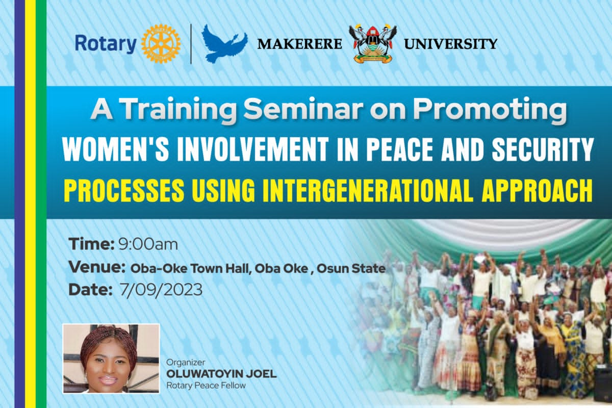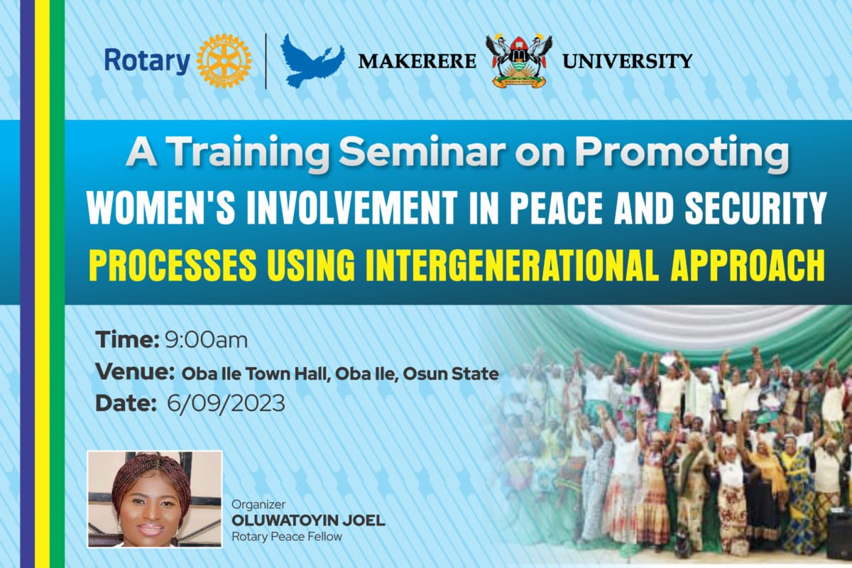**Intervention Promotion Phase**

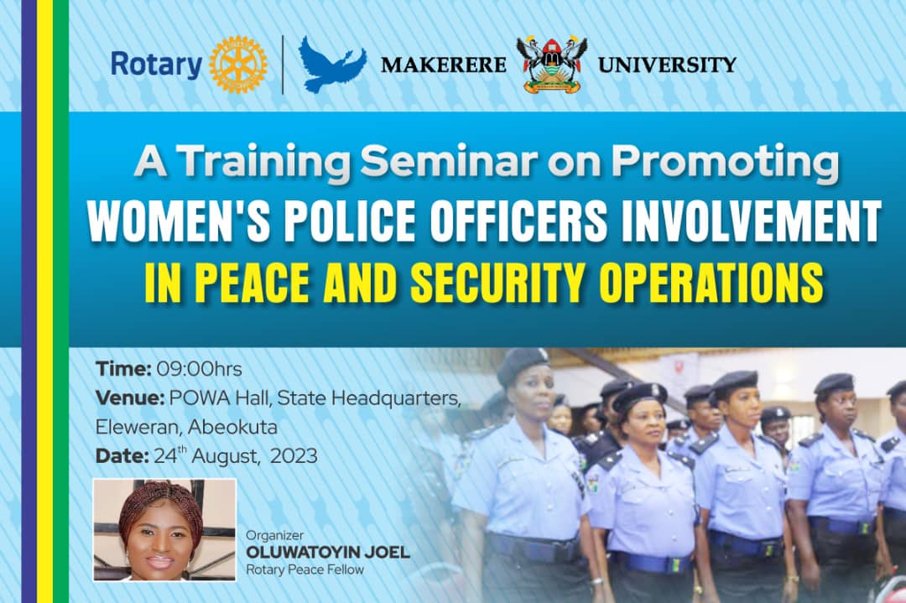The images depict the promotion of seminars to enhance women's roles in peace and security, reflecting a strategic collaboration between Makerere University and Rotary. The first seminar, organized for women police officers by Rotary Peace Fellow Oluwatoyin Joel, took place at POWA Hall in Abeokuta on August 24, 2023. It aims to equip female law enforcement personnel with crucial skills for peace operations. Subsequent seminars on September 6th and 7th at Oba Oke and Oba Ile Town Halls in Osun State extend this initiative to community women, advocating for their active involvement in peace processes. These seminars, also orchestrated by Joel, employed an intergenerational approach to foster communal peace and security. Collectively, these visuals convey a vibrant campaign for capacity building and communal harmony, inviting diverse women to partake in fostering a safer society. The narrative weaves together law enforcement and community engagement, underscoring the shared responsibility of sustaining peace. This concerted effort exemplifies a commitment to empowering women, ensuring their influential presence in the domain of peace and security operations.

# **Appendix Two: Training on UNSCR 1325**

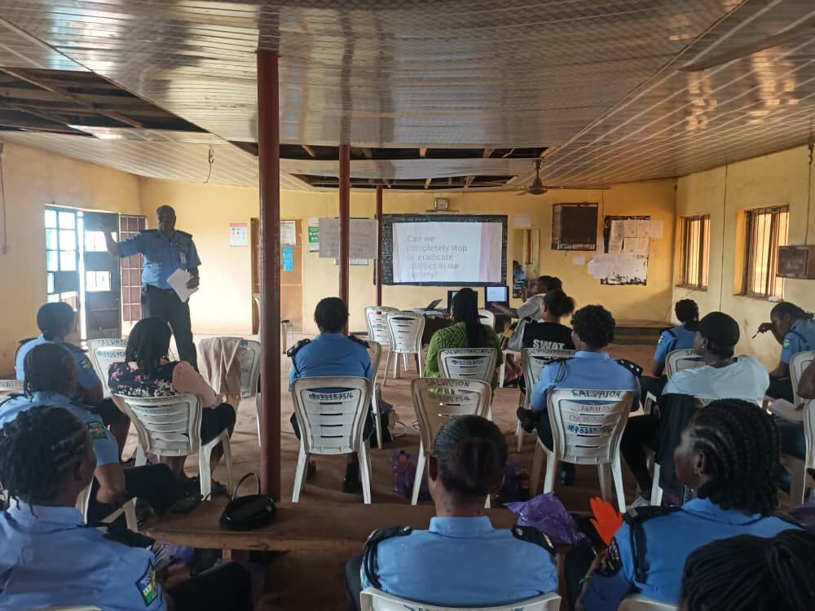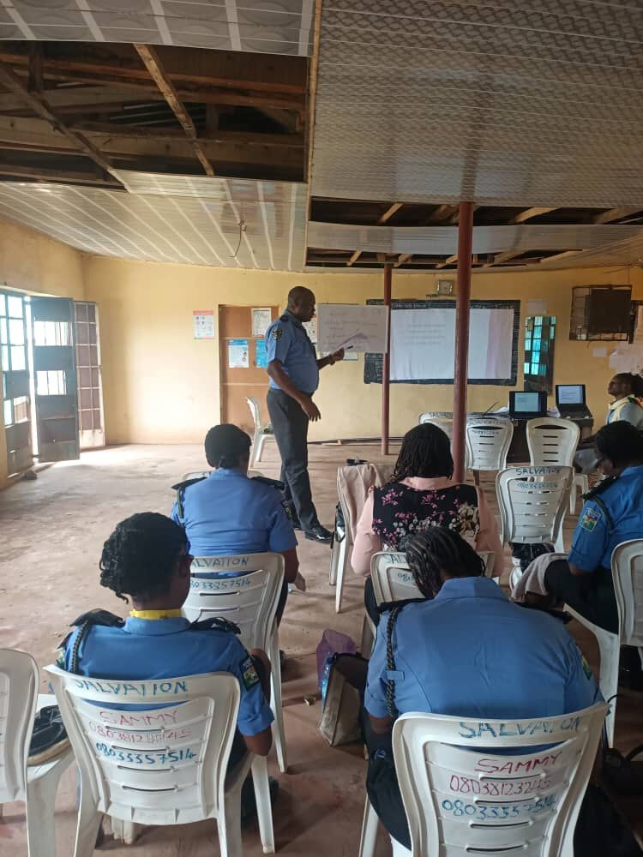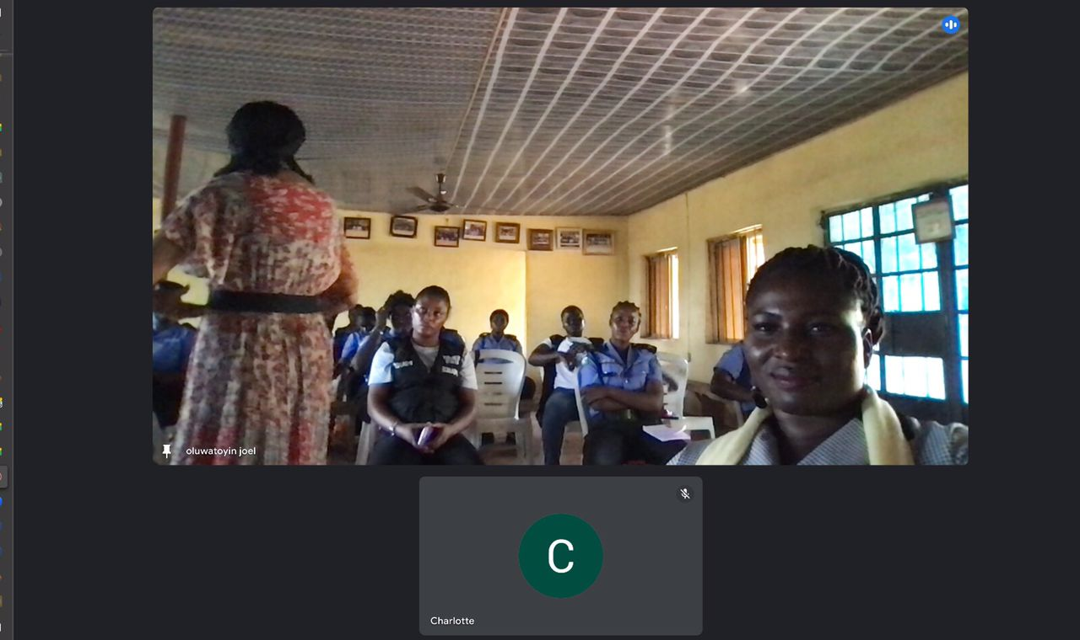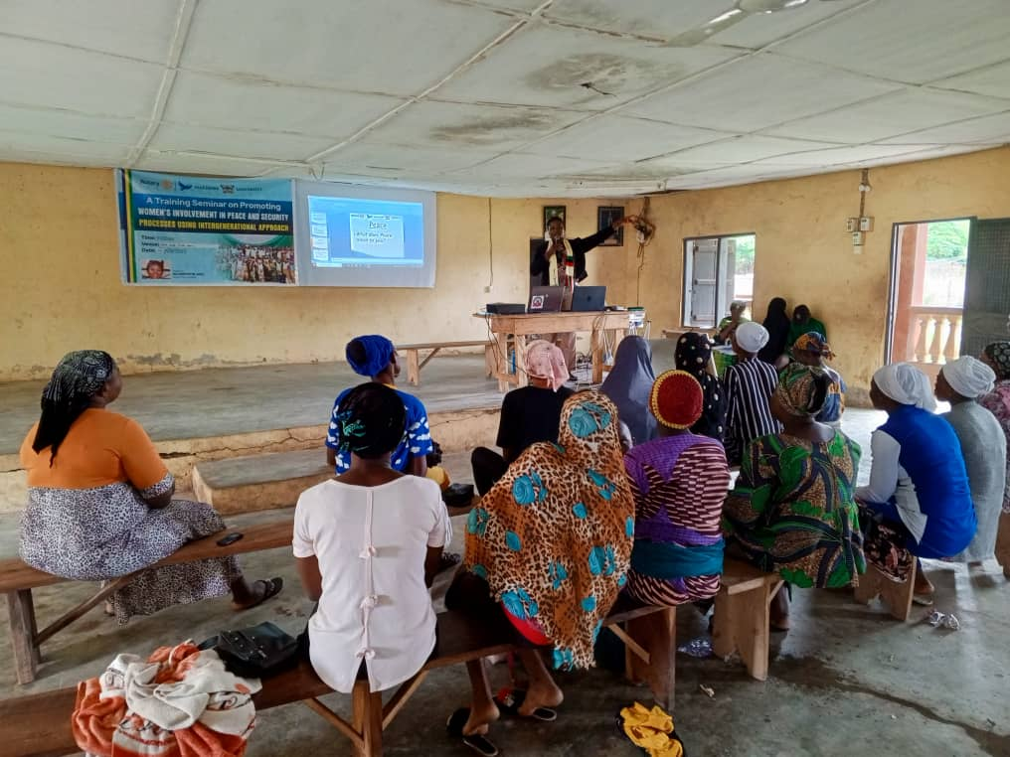**Training/Introduction to UNSCR 1325 (2000) and UNSCR 2250 (2015)**

The training sessions captured in the images provide an introduction to the United Nations Security Council Resolutions 1325 (2000) and 2250 (2015). Participants, consisting of women police officers and community members, attentively engage with facilitators who elucidate the resolutions' significance for women's involvement in peace and security. The presentations aim to raise awareness and understanding, empowering the attendees with knowledge to effectuate these international frameworks in their respective roles. These images illustrate a pivotal educational moment, highlighting the commitment to integrate women comprehensively into peacekeeping and security efforts.

# **Appendix Three: Post Training Images**

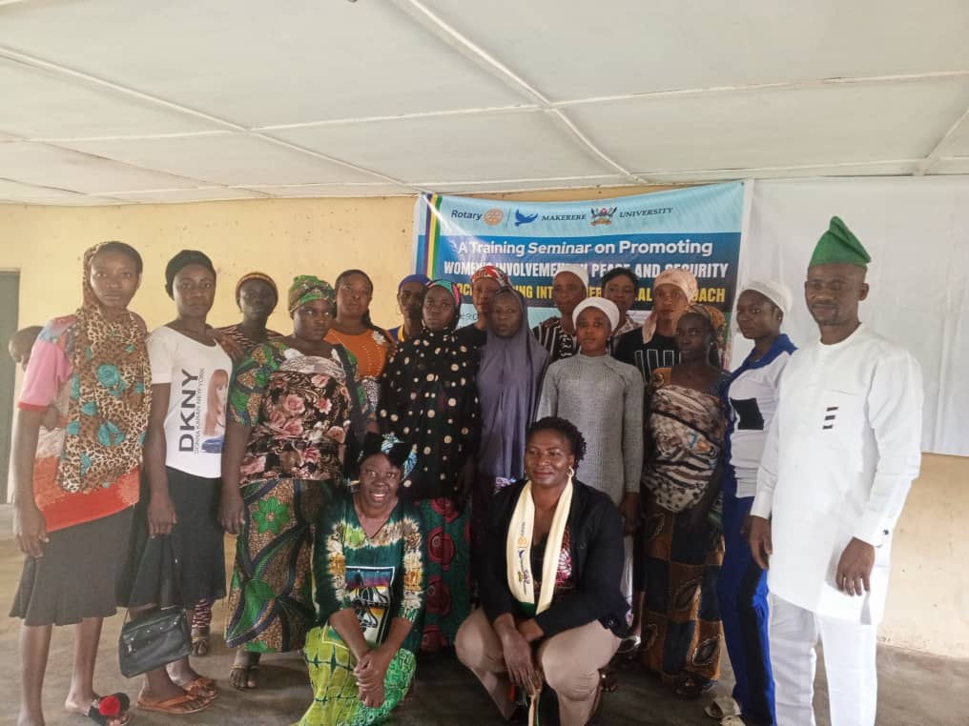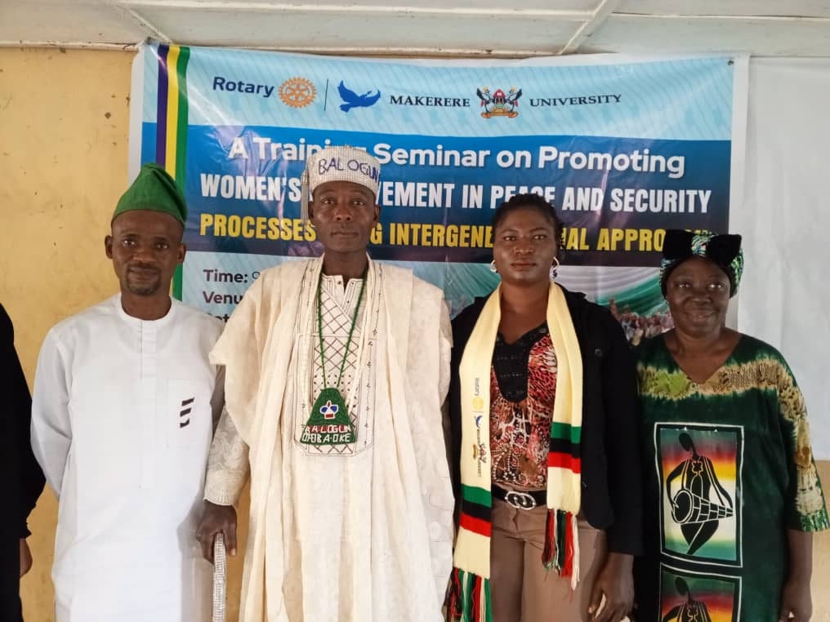**Post Training Images**

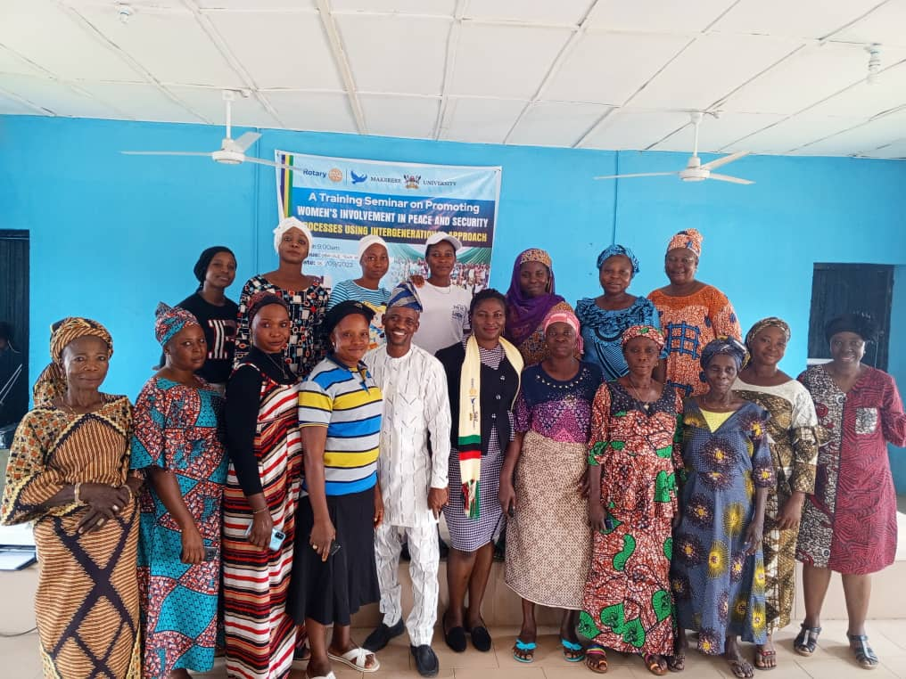

In the post-training photographs, it can be observed a vibrant assembly of community leaders and participants gathered, embodying the successful completion of a seminar aimed at fostering women's involvement in peace and security. The smiles and confident postures reflect the empowerment and unity that the training aimed to instill. Standing before the backdrop of the seminar's banner, the group symbolizes the collective commitment to implementing the teachings of UNSCR 1325 and 2250 within their communities. These images capture more than a moment; they represent a milestone in the journey towards inclusive peace and security processes, highlighting the crucial role of community engagement and leadership.

# **Appendix Four: Simulation Exercise**

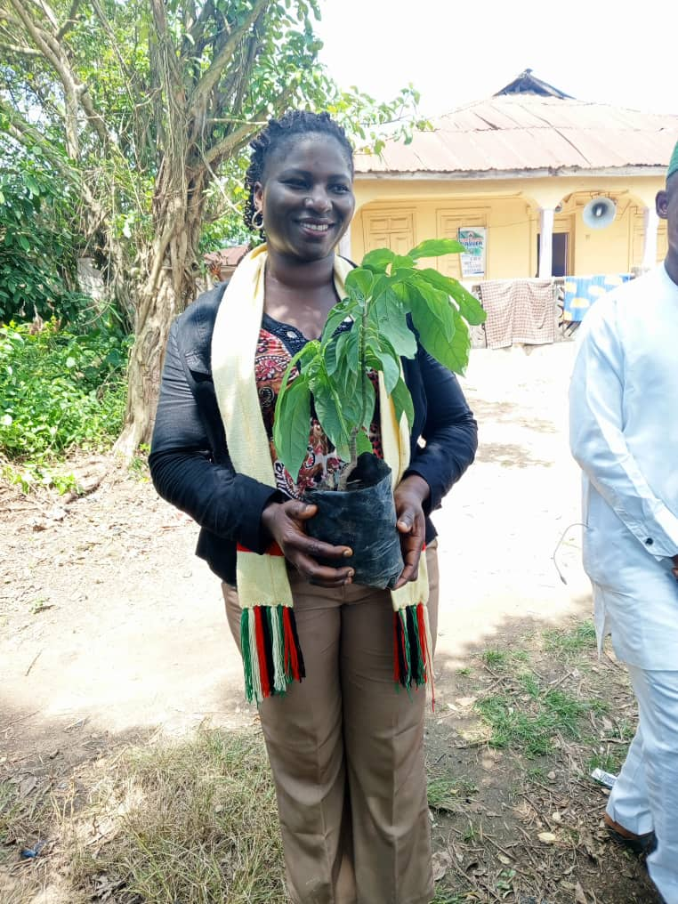**Symbolic Representation: Planting of Peace Tree**

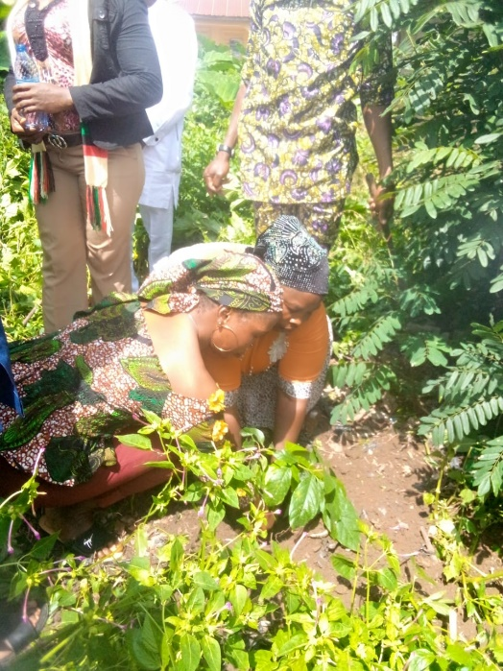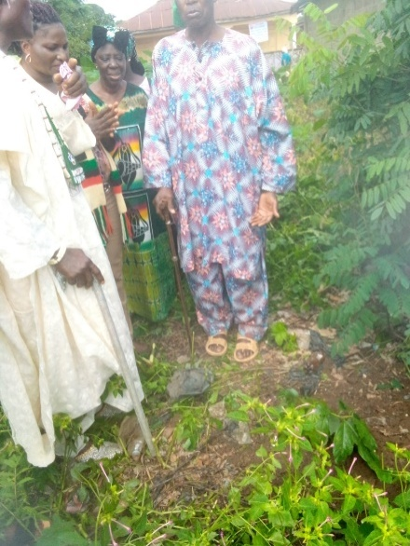

In a powerful culmination of the intervention, community leaders and participants gather for a deeply symbolic act of unity and commitment to peace: the planting of a tree. This moment, bridging human touch and the earth's soil, is a testament to the seminar's message on the enduring role of women in peace and security. As the community head leads a prayer, anchoring the roots of the sapling, they are sowing more than a plant—they are nurturing the seeds of social change. Each participant, standing witness to this rite, reaffirms their pledge to the principles of UNSCR 1325 and 2250. The tree stands as a living monument to their collective promise, a daily reminder that from the smallest seeds grow the mightiest of changes, deeply rooted in the community's commitment to a future of shared peace and prosperity. The planting of a tree in these images represents a profound act of hope and commitment. Community leaders and participants, gathered in a solemn ritual, lay their hands upon the earth to nurture new life. As the head of the community leads them in prayer, they are united in a pledge to peace and prosperity. The tree, once planted, will grow as a living emblem of their resolve to foster a harmonious future. This act is more than symbolic; it's a tangible step towards environmental stewardship and a daily reminder of the community's collective duty to safeguard and cherish women in their shared world.

# **Appendix Five: Research Ethical Approvals**

**Research Ethical Approvals**

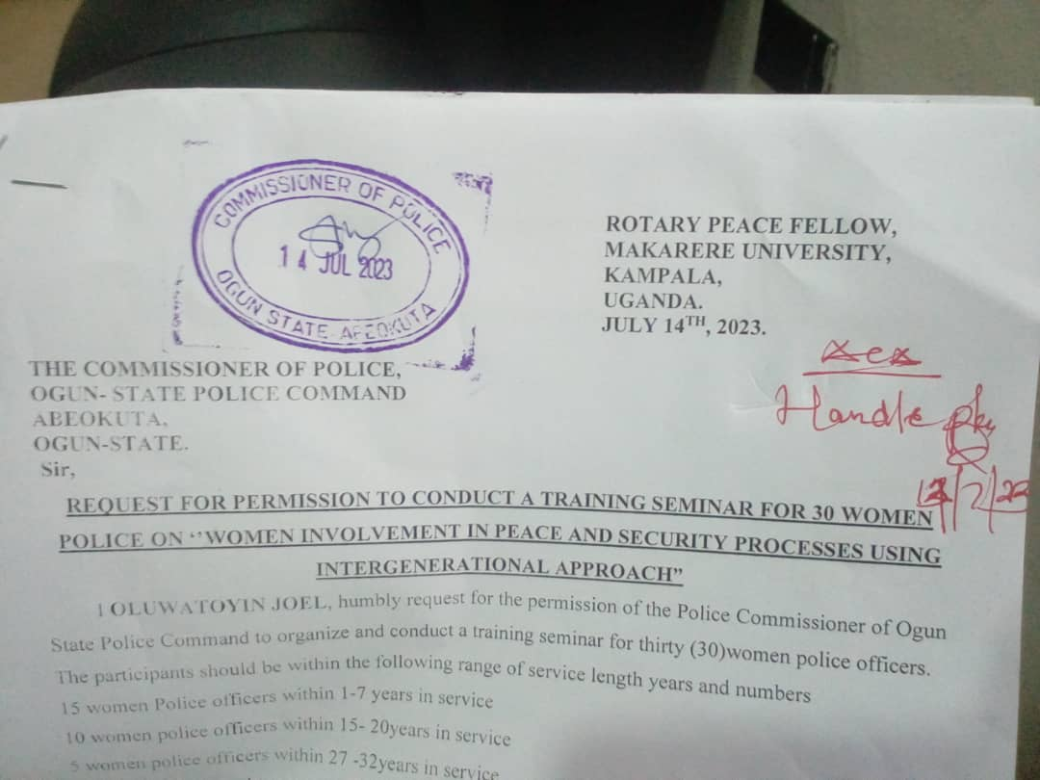

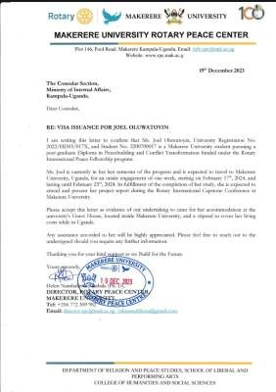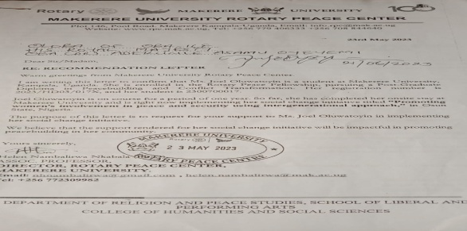

The picture above are ethical approval for this research. The below are permiscsion letters forwarded for seeking approval below:

