**SOCIAL CHANGE INITIATIVE**

***JANUARY 2022 - JUNE 2022***



THE USE OF



CRAFT

TRADE



TO



ECONOMICALLY



E

MPOWER



WOMEN IN THE NIGER

-



DELTA



DR. IFEYINWA PHILIPPA ODIAKA

POST-GRADUATE DIPLOMA, PEACE BUILDING AND CONFLICT TRANSFORMATION

TABLE OF CONTENTS

Background Information………………………………………………………………………………….3

Problem Statement…………………………………………………………………..............................4

Research Question…………………………………………………………….……………..6

Aim……………………………………………………………………………………………...6 Specific Objectives………………………………………………………………….………...6

Theoretical Framework…………………………………………………………………………………...6

Incorporation Of Positive Peace Principles………………………………………………………........8

Implementation…………………………………………………………………………………………...11

Engagement With The Community Leaders………...…………………………………....11

Beneficiary Sensitization, Identification and Training ……………….............................12

Monitoring and Evaluation…………………………………………...................................13

Beneficiary Registration………………………………………..........................................13

Results and Discussion…………………………………………………………………........................16

Ethical Consideration………………………………………………………………………....................19

Limitations, Recommendations and Sustainability Plan…………………………………..................19

Conclusion…………………………………………………………………………………………………20

References…………………………………………………………………………………………………21

# BACKGROUND

The largest delta in Africa, the ***Niger Delta*,** is the [delta](https://en.wikipedia.org/wiki/River_delta) of the [Niger River](https://en.wikipedia.org/wiki/Niger_River) sitting directly on the [Gulf of Guinea](https://en.wikipedia.org/wiki/Gulf_of_Guinea) on the [Atlantic Ocean](https://en.wikipedia.org/wiki/Atlantic_Ocean) in [Nigeria.](https://en.wikipedia.org/wiki/Nigeria) It covers approximately 75,000 square kilometers and is a very densely populated region at 265 people per kilometer-squared (one of the highest in the world). It is home to around 30 million people, accounting for more than 23% of Nigeria's total population. The years of slavery and subsequent colonial conquest in the Niger Delta brought with them massive migrations and intermingling of ethnic groups, intermarriage and resettlement of whole communities, creating a fascinating collage of more than 40 ethnic groups, speaking about 250 different dialects. With the abolition of slavery in the first decades of the nineteenth century, this region became a major producer of [palm oil,](https://en.wikipedia.org/wiki/Palm_oil) and was known as the ***Oil Rivers***; an agrarian region with fertile agricultural land, forests, rivers, creeks, and coastal waters teeming with fish and sundry water creatures as well as a rich culture and heritage. The Niger Delta also sits on top of major hydrocarbon reserves. Oil was discovered in the region in 1956 by Royal Dutch Shell, and the industry which has developed around it has become central to Nigeria’s economy. Oil mined in the area accounts for 95 percent of the country's foreign exchange earnings, about one-fourth of Gross Domestic Product, and the bulk of Nigeria's proven oil reserves, currently estimated at twenty billion barrels, and well over 80% of government’s annual revenue (Ikoro and Ukonu, 2016, p. 2490). Needless to say, the Niger Delta is the goose that lays Nigeria's golden egg.

Sadly, existing Nigerian policies solely recognize the Oil and Gas (O&G) industry as its economic driver. Through The Petroleum Act in 1969, all oil revenue was transferred to the Federal Military Government, which in turn was expected to disburse the money to the various states on the basis of need. This decree however transformed Nigeria from a genuine federation to a de facto unitary state, that by the 21st century, the Niger-Delta (oil-rich) region, made up of 10 of the 36 states of the Federation, witnessed a dramatic overturn from an agrarian to an oil-producing society, ushering in abject poverty in its wake. Why did things go wrong? Existing studies, theoretical reviews and reports have made fruitful attempts to answer this question as seen in the studies by Tobor and Muzorewa (2016), Ikoro and Ukonu (2016), Ukpong and Obok (2018), to mention but a few. These have documented evidence that the discovery of crude oil in this region birthed an era of greed, bribery and corruption; all culminating in a vicious circle of recalcitrant poverty socio-economic instability, decline in biodiversity, seismic operations, and community conflict, militancy and civil unrest. Escalating armed and violent conflict between gangs and towards government and oil company security forces increased the levels of militancy, underdevelopment, widespread oil pollution, a lack of livelihood options, kidnapping of foreign oil workers for ransom and a largely unresponsive government in the region. The militancy had a negative toll on oil price to above $100 per barrel for the first time in world history and also the untimely deaths of some prominent advocates for non-violent resistance to environmental injustice such as Ken Saro-Wiwa. In 2009, the Presidential Amnesty Program was set up and approximately 26,000 militants have agreed to a ceasefire. Presently, there is relative political stability but this is fragile as the original conditions giving rise to the militancy are yet to be fully addressed.

Historically, virtually every household in the Abuedo Community of Delta State (the community under study) enjoyed centuries of wealth and prosperity, attributed to their industriousness in agriculture; a community with independent and highly respected women. Nonetheless, there still remains paucity of data on what this affected community perceives as the way forward. With the ultimate goal of mitigating strife, restoring cultural identity and creating lasting peace, this initiative will facilitate human capital development in this community by diversifying the local economy through non-oil alternative trades such as craft trade and tourism. Some notable handcrafts in the region are knitting and dyeing fabric making; bead and jewelry making; traditional makeup art; grass and cane weaving; pottery, calabash decoration and sculpture; and carvings of wood, iron, ivory, bronze, ceramics, and brass. As concluded in the study by Olusakin (2006) on ‘Peace in the Niger Delta’, one of the major ways to bring about peace in Nigeria is by exploring the non-oil resources. Therefore, this initiative aims to offer one of the affected communities a platform to proffer a pragmatic solution to this menace bedeviling them.

# STATEMENT OF THE PROBLEM

The Niger Delta has been thrust into the global limelight due to resource extraction and conflict. A state of ‘resource curse’ or ‘paradox of plenty’ has ensued. The abundance of natural resource wealth from the region’s oil and gas reserves, coupled with weak governance enable the industry to operate below international standards where those in positions of power benefit disproportionately from oil money. Therefore, despite its huge revenues, oil exploration has been exploitative to community inhabitants, resulting in destruction of arable lands and water bodies through oil spillage, immense economic burden and loss of human livelihoods, bereavement, and severe local health consequences. According to Nigerian federal government figures, a clean-up of the 7,000 oil spills between 1970 and 2000 in the region, including full restoration of swamps, creeks, fishing grounds and [mangroves,](https://en.wikipedia.org/wiki/Niger_Delta_mangroves) could take 25 years. The escalation of violence in the Niger Delta has also led to huge losses that estimating the exact human and economic costs of the perennial conflict is extremely difficult. The Transparency International 2007 corruption perceptions index stated that, over the decades in Africa, around $20 to $40 billion has been illegally and corruptly appropriated from some of the oil-rich countries, by politicians and businessmen, and stashed abroad as assets. Since December 2005, attacks on oil facilities, illegal bunkering and oil worker kidnappings by militant groups, have caused a humongous loss in export earnings ranging from 70,000 to 300,000 barrels per day; an official estimate of about $3.5 billion annually (Ukpong and Obok, 2018). On the other hand, the economic burden of militarization of the entire region as well as the amnesty program for the militants has also left the country with external debts. The government reportedly made payments of more than $1,000 for each rifle and $10,000 for each machine gun handed over to the government.

Needless to say that overdependence on the oil and gas industry and mismanagement of funds have provided few alternative livelihood options for affected communities, following which the people have resorted to illegal trades, violence and discrimination for survival, with the brunt of the repercussions on the most vulnerable in the society- the women and children. Recent research estimates that children are twice as likely to die in their first month of life if their mother lived near an oil spill before conception. Women are at increased risk of health issues of infertility, early menopause, and some forms of cancer on account of air and water pollution. The women also face gender-based discriminatory practices and economic crisis as their traditional means of livelihood (farming and fishing) have been destroyed, and as such are under-represented in the strategic heights of political, economic and educational institutions. So far, little attention have been paid to the consequences of the Niger Delta conflict dynamic on women livelihoods and the active roles women can play in conflict resolution in the region.

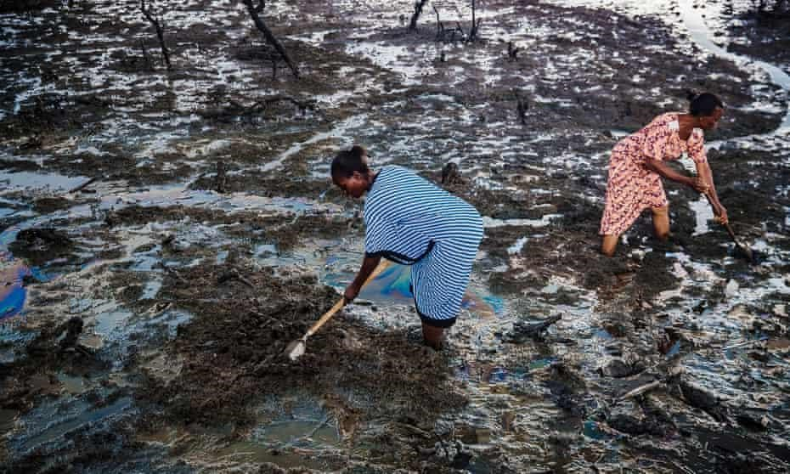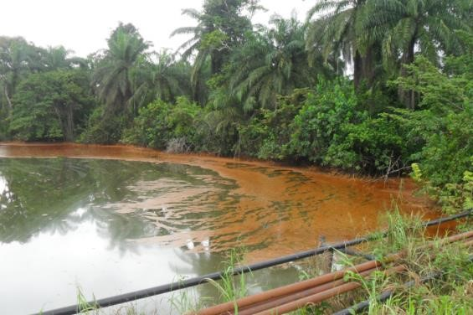

**Oil contamination of water bodies and arable farmlan**

**ds**

Figure 1: Widespread environmental destruction from crude oil spills in the Niger Delta

Data source: Gender and Economic Empowerment of Women [https://www.oecd.org/dac/genderdevelopment/39518651.pdf](https://www.oecd.org/dac/gender-development/39518651.pdf)

***2.1. Research Question*:**

What proportion of young female adults in Abuedo community have the belief, willingness, and capability of utilizing the craft trade for income generation?

***2.2. Aim*:**

To restore cultural identity and promote positive peace and development in the Niger-Delta region by economically empowering the women through the craft trade.

***2.3. Specific Objectives*:**

1. To estimate the proportion of young female adults in the community with the perception that the craft trade can be used for income generation
2. To provide technical support through the sensitization and training of young female adults on handcrafting for commercial purposes
3. To disseminate the project output and recommendations to stakeholders with the intent to creating an inclusive society for the community inhabitants in order to mitigate conflict and promote peace and development.

# THEORETICAL FRAMEWORK

A **Theory of Change** explains how a given intervention is expected to lead to specific development change, drawing on a causal analysis based on available evidence as illustrated in the chart below.

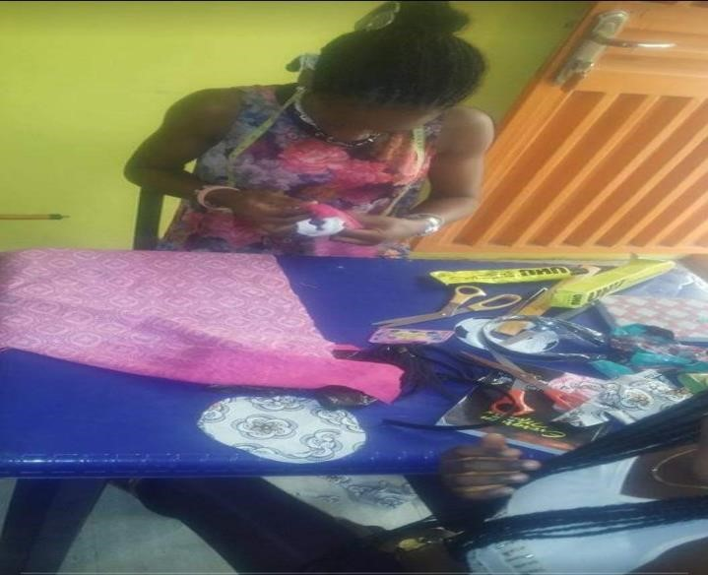

**Figure**

**2**

**. Focused beneficiaries during a handcraft**

**session**

**Figure 3**

**. Theory of Change**



**IMPACT**



•

Financial independence and

improved access of women and their children to key

institutions such as health, educational and financial institutions

•

Increased involvement of women in decision making in their households

•

Improved representation of women in strategic heights of political,

economic and

educational institutions (inclusive society).

•

Restored cultural identity of the women

•

Regional peace and development.



**OUTCOME**



**OUTPUT**



**ENABLERS**



**ACTIVITIES**



**INPUT**



**PROBLEM**

**STATEMENT**



•

Improved human capital development through

economic empowerment of women

•

Improved skill set of the beneficiaries in handcrafting.



•

Increased number of beneficiaries skilled in handcrafting

•

Increased number of women registered as craft vendors at the tourist centers

.



•

Consent to craft trade by

community leaders and other key stakeholders

•

Interest and commitment of the beneficiaries to craft trade

•

Functional tourist centers/ High turnover of tourists

•

Capability of the beneficiaries to meet up with product demands.



•

Conducted pre

-

and post

-

train

ing surveys of the beneficiaries

•

Facilitated sensitization campaigns and training sessions on handcrafting for the

beneficiaries

•

Facilitated linkage of trained beneficiaries to the tourist centers for registration as craft



•

Provided technical

support by sensitizing and training beneficiaries on handcrafting

•

Strategized linkage of trained beneficiaries to the tourist centers for registration as

craft vendors



•

A significant number of young female adults face economic crisis because their

convent

ional means of livelihood (mainly farming and fishing) have been lost to oil

exploration processes.

# INCORPORATION OF POSITIVE PEACE PRINCIPLES

This initiative cuts across all the seven (7) focus areas of intervention of the Rotary International namely: Growing local economies, Saving mothers and children, Fighting disease, Supporting education, Protecting the environment, Providing clean water, sanitation and hygiene, and Promoting positive peace. With promoting positive peace as the ultimate goal, the prospect for sustainable peace and development in the Niger Delta region requires a critical policy reorientation. This initiative embodies all eight (8) pillars of positive peace with the aim at livelihood transformation and inclusive societies that build on the effectiveness of the

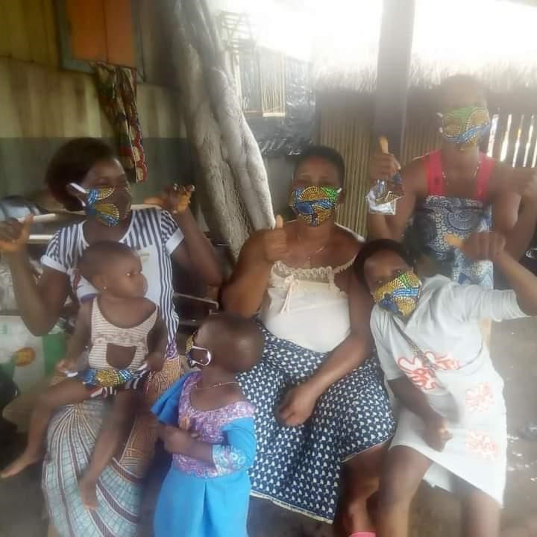

**Figure 4.**

**Satisfied beneficiaries with their children after a**

**handcraft training session**

country’s capabilities to build and maintain peace. The initiative improves the Index of economic freedom of the communities, by creating a **sound business environment** for the young female adults, who in turn become motivated and mobilized for public participation and for political, social and economic empowerment. With increased self-empowerment and income rate, there is greater access to education and professional training, culminating in **high levels of human capital** through improved youth development index and global innovation index. The booming economy breeds the culture of eradication of multiple sources of oppression based on social identities such as gender, ethnicity or race by bridging the poverty gap, encouraging social mobility and regional integration, lowering the gender-inequality index and raising the Inequality-adjusted life expectancy. All these engender the **equitable distribution of resources, good relations with neighbors** and **acceptance of the rights of others.** Improved income sources comes with a step up in mobile phone subscription rate for **free flow of information.** A unified society runs on accountability in development efforts sustained by good governance by a **well-functioning government** that thrives on values, ethics and **low levels of corruption**; propelling the oil industry to deliberately reverse the injustices to these communities to enforce justice, stability, high levels of resilience and development.

Regarding the African view on peacebuilding, the African indigenous peacebuilding tradition operates on the premise that all humans are interdependent because we belong, participate and share in our society. This is the basis for the concept of social solidarity. In practice, promoting social solidarity means confronting corruption and promoting power-sharing, inclusive governance and the equitable distribution of resources with the principles of empathy for others, sharing common resources and working cooperatively to resolve common problems. Africa is not a monolithic continent, but with multiplicity of ethnic, cultural and linguistic groups, hence this project creates a platform for participating communities to re-inform themselves with a cultural logic that emphasizes sharing and equitable resource distribution, reviving progressive cultural attitudes and values that can foster a climate for peace to flourish. This initiative highlights the significant role of indigenous approaches in the reconstruction of the Niger-Delta region through sensitization and training programs based on African cultural values of handcrafting and togetherness and at the same time, promoting societal inclusiveness, gender equality, and Pan-regional solidarity.

The role of culture in reconstruction and peace in Africa can never be overemphasized. Therefore, progressive cultural principles which promote the well-being of the individual and society can provide valuable insights into how Africa can be peacefully reconstructed by using its own indigenous value systems which emphasize promoting social solidarity



**Figure 5.**

**A royal visit by the Late Princess Diana to**

**indigenous women of Niger**

**-**

**Delta during a handcraft**

**training**

**session**

**in**

**1990**

https://twitter.com/princessdibooks/status/842879744605609

985

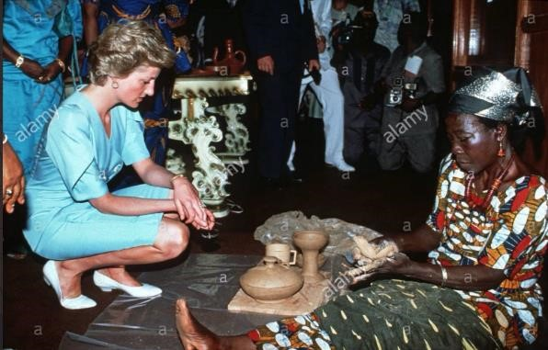

alongside international recognition.

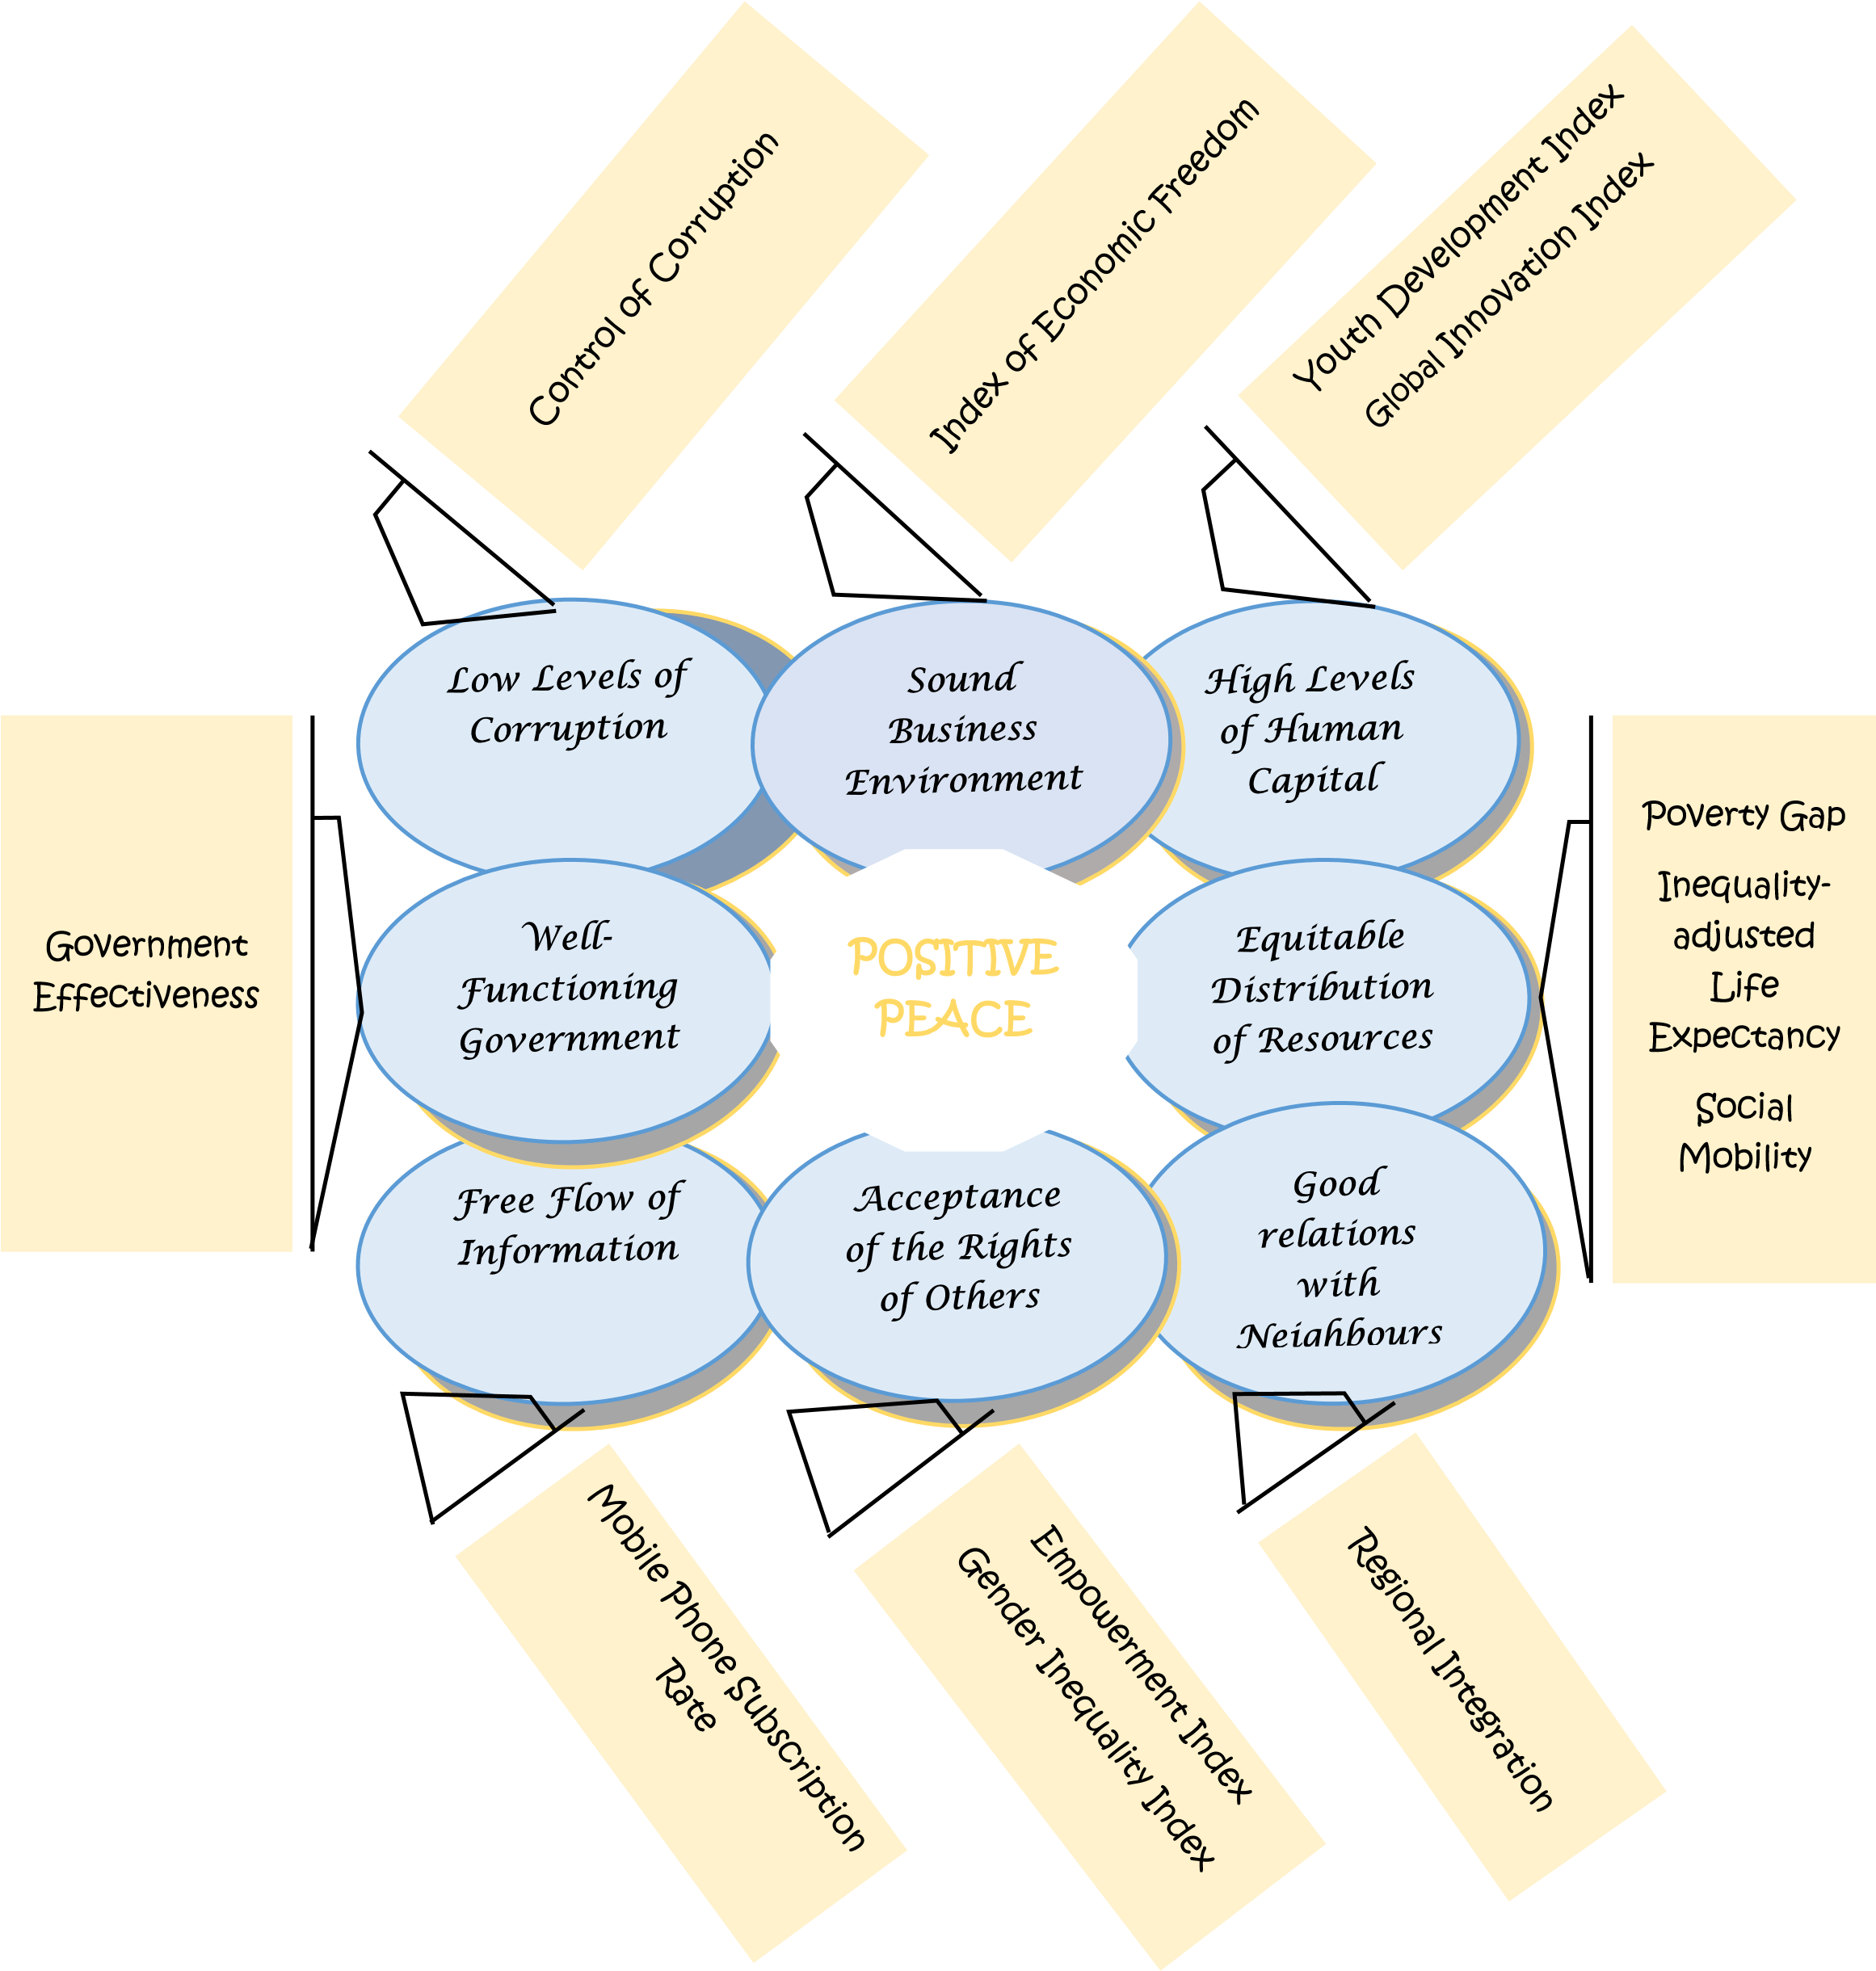

**Figure 6. The 8 Pillars of Positive Peace**

# IMPLEMENTATION

With the very recent relative stability in the Niger-Delta region owing to the interventions of some national and international actors, the government seeks to drive inclusive and sustainable development across all the local communities in the region by creating an integrated boost in the tourism industry. The Niger Delta is biodiverse, with its mangroves providing carbon sequestration capacity and with abundant [flora](https://en.wikipedia.org/wiki/Flora) and [fauna](https://en.wikipedia.org/wiki/Fauna) supporting a wide variety of plant and animal life, as well as the agriculture and fishing on which many in the region relied on for their livelihoods. The Mangrove forestsareestimated to cover approximately 1,900 to 3,300 square meter of land that provide essential habitat for rare and endangered species like the Niger Delta Red Colobus, the white throated Guenon monkey, relict populations of chimpanzee, elephant and [pygmy hippopotamus.](https://en.wikipedia.org/wiki/Pygmy_hippopotamus) Other centers of attraction in the region are the beaches with their spectacular white sands, caves, waterfalls and museums, valleys, and historical monumental sites such as the Mungo Park house and Nana’s Palace. Utilization of these coastal attractions for tourism could generate resources for both protection of the destination and empowerment of host communities, thereby allaying the fears of insecurity among households. Tourism is an industry of peace and has been the driving force in protecting and preserving natural and cultural heritage for future generations. As the region is now developing into a tranquil country getaway, the initiative aims to generate massive sensitization on tourism promotional activities to create awareness about the huge tourism investment opportunities that abound in the Niger Delta.

The steps in implementation were as follows:

***5.1. Engagement with the Community Leaders:***

The study kick started with a courtesy stakeholder meeting held in January 2022 at the mechanic workshop of the Assistant Youth Leader of Abuedo Community in Aniocha-South Local Government Area of Delta State. It had in attendance 6 community leaders (2 ladies and 4 gentlemen) across all age grades-

* 2 representatives from the traditional ruler’s house- the immediate past late village chief’s widow and the village messenger
* 2 representatives from the community youth association- the assistant youth leader (whose mechanic workshop was used as the meeting venue) and a tourist center manager • A representative sent by the community women leader • A market square guard.

The meeting was basically to notify them of the initiative’s aim to utilize the platform of improved tourism to strategize a human development agenda that proposes the participatory development and empowerment of young female adults in the community within a peaceful, equitable and legal socioeconomic framework, by the generation of revenue through the sale of handcrafts at the tourist centers. They unanimously agreed that the initiative is highly feasible since handcrafting requires a low level of capital investment; promised to render support whenever needed; and proposed that other communities within the region be incorporated into the initiative as resources permit. The meeting lasted for approximately 2 hours and ended with a vote of thanks from the leaders for giving the people a sense of belonging, tools for prosperity and the power of information dissemination; the boon of tourism development in the Niger Delta region.

* 1. ***Beneficiary Sensitization, Identification and Training:***

Sensitization campaign on craft trade was held for the young female adults between the ages of 18 and 40 years who are indigenes of and reside in the community. This campaign aimed to create awareness on the rapidly growing interest in tourism and to enable them see opportunities for socioeconomic development and cross-cultural interaction through this platform. The young female adults enrolled as beneficiaries were those who indicated interest in participating in the training and were allowed to volunteer for either the role of a trainer or trainee. However, all those enrolled as trainers were mandated to be skilled in a handcraft prior to the training as they can only impact known knowledge. Of the 63 beneficiaries, 16 were trainers while 47 were trainees. Ethical issues relating to their participation in the training including their rights to confidentiality were elucidated and an informed consent to participation was obtained from each beneficiary. Each trainer was then assigned to coach 3 trainees with similar interest in a particular handcraft, forming 16 teams of 4 beneficiaries each on average. The setting of the training sessions was informal and there was no limit to the number of sessions held by each team. The need for flexibility of the training sessions was to enhance learning at the beneficiaries’ convenience, to minimize attrition bias and improve validity. To obtain the required quantitative data, a survey of beneficiaries was conducted pre-training and post-training with a questionnaire drafted in the Pidgin-English language (the universal language spoken in the region) for better understanding and ease of communication of the beneficiaries.

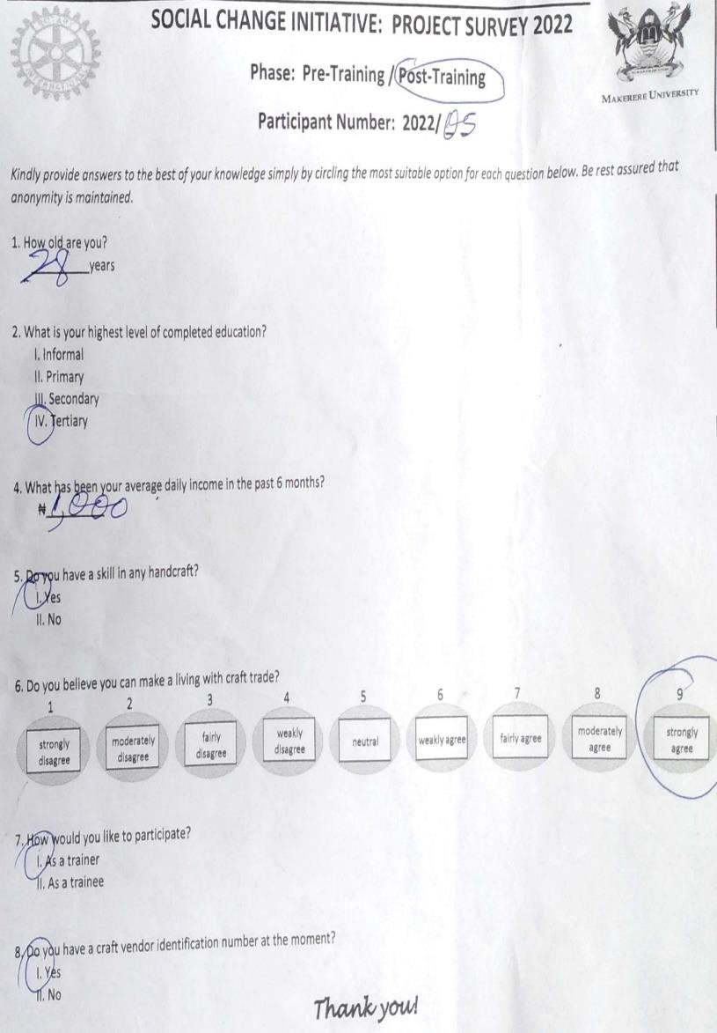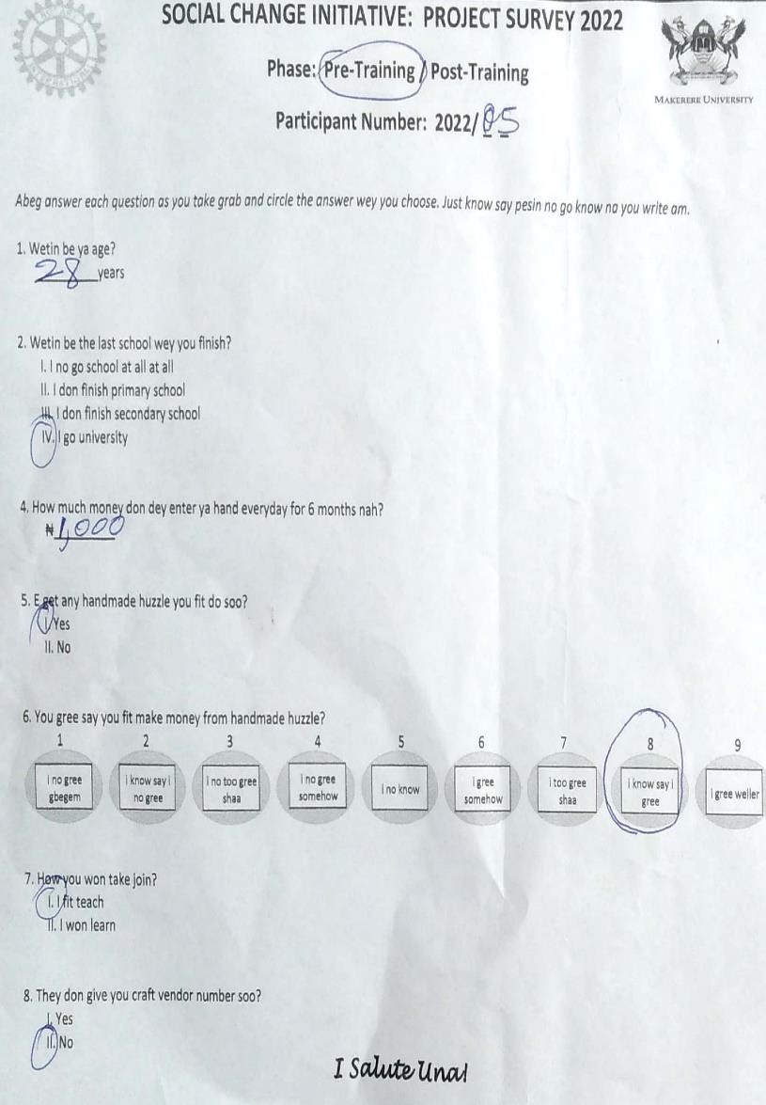

**Figure 7. Samples of the pre- and post-training questionnaires written in the Pidgin-English and corresponding British English languages respectively**

* 1. ***Monitoring and Evaluation:***

As training sessions were ongoing, periodic assessment of progress was instigated simultaneously. 3 indigenes not enrolled as beneficiaries were appointed by the women leader to act as assistants by conducting random check-ins during training sessions, providing guidance to the beneficiaries as needed, and ensuring correct and complete data collection.

* 1. ***Beneficiary Registration:***

Beneficiaries who have successfully completed the training and met other requirements of the center management were officially registered as craft vendors at the tourist centers. So far, 11 beneficiaries (3 trainers and 8 trainees) have been assigned a unique identification number and fully registered as craft vendors.

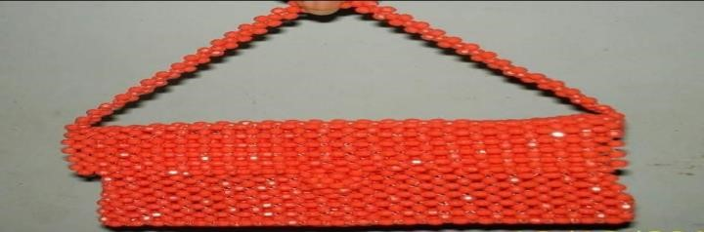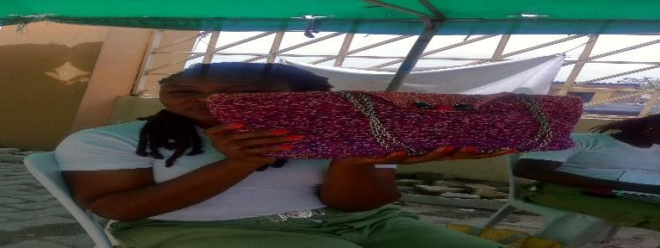

**Figure 8. Satisfied beneficiaries displaying**

**their handcrafts**

The Gantt chart below clearly illustrates the 6-month implementation of the initiative with corresponding activities and timelines.

## Table 1. Gantt chart Illustrating Key Implementation Activities and Timelines

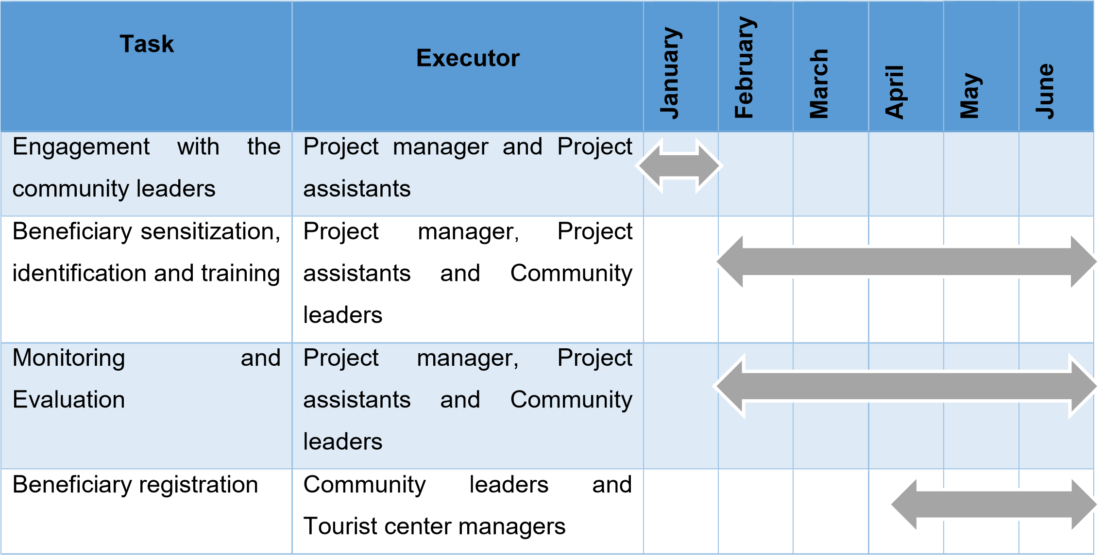

The Logical Framework below provides an overview of the initiative’s goal, activities and anticipated outcome for better specification of the phases of implementation.

**Table 2. Logical Framework**

|  |  |  |  |
| --- | --- | --- | --- |
| **Project Summary Indicators Means Of Risks/ Assumptions**  **Verification** | | | |
| **Goal**  Financial  independence and improved access to basic amenities by women and children | 25% of women have a stable income    25% of women are recorded to access health, educational, financial and other  institutions at will | End of project reports and surveys | Availability of structures for positive peace |
| **Outcome**  1**)**Improved economic empowerment of women from the craft  trade | 25% of women earn a living through the craft trade | Business reports from the tourist centers on registered vendors | Functional tourist centers/  High turnover of tourists    Capability of the beneficiaries to meet up with product demands |
| 2)Improved skill set of the beneficiaries in handcrafting | 50% of the beneficiaries are skilled in  handcrafting | Field activity reports | Dedication of  beneficiaries to the cause    Availability and accessibility of raw materials for the  handcrafts |
| 3)Increased involvement of women in decision making in their households | 25% of women have access to basic  amenities | Demographic records from the Primary  Healthcare Centers | Level of implementation of gender policies by the local, state and regional government |
| 4) Improved representation of women in strategic heights of political, | 25% of women occupy strategic leadership  positions in all spheres | Regional government reports | Level of implementation of gender policies by the local, state and regional government |
| economic and educational institutions (inclusive society). |  |  |  |
| **Output**  1)Increased number of beneficiaries skilled in handcrafts | 50% of beneficiaries can produce handcrafts independently | Field activity reports    Post-project evaluation survey | Availability and willingness of the skilled indigenes to impact knowledge |
| 2)Increased number of young female adults registered as craft vendors at the tourist centers | 25% of the skilled beneficiaries are registered as craft vendors at the tourist centers | Vendor registry at the tourist centers | Functional tourist centers/  High turnover of tourists |
| **Activities** 1)Facilitated sensitization  campaigns on craft trade for young female adults | 25% of young female adults were informed of the growing tourism in the region and the need to rekindle the craft trade growing tourism in the region and the need to rekindle the craft trade | Turn-out of young female adults to the sensitization session | Consent to the trade by community leaders |
| 2) Facilitated training for beneficiaries in handcrafting | 25% of young women and girls completed  trainings in handcrafting | Training attendance  lists    Training evaluation surveys | Consent to the trade by community leaders    Commitment of the  beneficiaries to the trade |

# RESULTS AND DISCUSSION

The table below summarizes the data obtained at the end of the initiative:

**Table 3. Perception and Training of Young Female Adults on the Use of Craft Trade for Income**

## Generation in Delta State- Nigeria 2022

|  |  |  |  |  |  |  |  |
| --- | --- | --- | --- | --- | --- | --- | --- |
| **Variables** | **All**  **Beneficiaries** | **Pre-training Perception** | | | | **Training** | |
| **Column1** | **Column2** | **Disagree** | | **Neutral Agree** | | **Trainer Trainee** | |
|  | **n=63** | **n=12** | | **n=12 n=39** | | **n= 16 n= 47** | |
| **Age in years** |  |  | |  | |  |  |
| Mean ± SD | 26.9 ± 5.3 | 23.9 ± 3.5 | | 24.1 ± 28.7 ±  4.4 5.4 | | 31.4 ± 4.8 | 25.3 ± 4.6 |
| Minimum - Maximum |  |  | |  | | 24 - 39 | 18 - 37 |
|  |  |  | |  | |  |  |
| **Baseline daily income in**  **USD** |  |  | |  | |  |  |
| Median (IQR) | 2.5 (1.2, 3.6) | 1.7 (1.2, 1.9) | | 1.8 (0.7, 3.6) | 2.9 (1.7, 3.6) | 3.9 (2.9, 5.3) | 1.9  (1.2, 2.9) |
| Minimum - Maximum |  |  | |  |  | 1.2 - 6.0 | 0.5 - 4.8 |
|  |  |  | |  |  |  |  |
| **Educational level, n (%)** |  |  | |  |  |  |  |
| Informal | 11 (17.5) | 3 (25.0) | | 1 (8.3) | 7 (17.9) | 1 (6.3) | 10 (21.3) |
| Primary | 12 (19.0) | 3 (25.0) | | 0 (00.0) | 9 (23.1) | 4 (25.0) | 8 (17.0) |
| Secondary | 28 (44.4) | 5 (41.7) | | 7 (58.3) | 16 (41.0) | 7 (43.8) | 21 (44.7) |
| Tertiary | 12 (19.0) | 1 (8.3) | | 4 (33.3) | 7 (17.9) | 4 (25.0) | 8 (17.0) |
|  |  |  | |  |  |  |  |
| **Prior skill, n (%)** |  |  | |  | |  |  |
| Yes | 21 (33.3) | 0 (0.0) | 2 (16.7) 19 (48.7) | | |  |  |
| No | 42 (66.7) | 12 (100.0) | 10 (83.3) 20 (51.3) | | |  |  |
|  |  |  |  | | |  |  |
| **Beneficiary role, n (%)** |  |  |  | | |  |  |
| Trainer | 16 (25.4) | 0 (0.0) | 1 (8.3) 15 (38.5) | | |  |  |
| Trainee | 47 (74.6) | 12 (100.0) | 11 (91.7) 24 (61.5) | | |  |  |
|  |  |  |  | | |  |  |
| **Post-training perception, n (%)** |  |  |  | | |  |  |
| Disagree | 0 (0.0) | 0 (0.0) 0 (0.0) 0 (0.0) | | | |  |  |
| Neutral | 5 (7.9) | 1 (8.3)  3 (7.7) | | | |  |  |
| Agree | 58 (92.1) | 11 (91.7) 36 (92.3) | | | |  |  |
|  |  |  | | | |  |  |
| **Fully registered as craft vendor, n (%)** |  |  | | | |  |  |
| Yes | 11 (17.5) |  | | | | 3 (18.8) | 8 (17.0) |
| No | 52 (82.5) |  | | | | 13 (81.3) | 39 (83.0) |
|  | | | | | | | |
| *Abbreviations:* | | | | | | | |
| *SD = Standard Deviation Conversion rate: 1USD Ω 415Naira* | | | | | | | |
| *IQR = Interquartile Range There were no missing data* | | | | | | | |
| *n = Number/ Frequency of occurrence* | | | | | | | |
| *USD = United States Dollars* | | | | | | | |

The project had a total of 63 beneficiaries between the ages of 18 and 39 years, of which 40 (63.4%) had at least a secondary school education and 21 (33.3%) had prior handcraft skill. The baseline median daily income was 2.5 USD with an IQR of 1.2, 3.6. Admittedly, this daily income which is significantly above poverty line of 1 USD is unexpected for a rural, conflict-infested setting. For this reason, knowing the occupation of the beneficiaries would have been of interest but due to the sensitive clime of the project setting, this socio-demographic was excluded from the survey for alleged reasons that the community inhabitants make a living through illegal trades such as oil pipeline vandalism and bunkering. The beneficiaries, being females, are speculated not to be the culprits but to indirectly benefit from the illegal trade as mothers, sisters, wives, girlfriends, and acquaintances to the vandals.

The data obtained on the pre-training perception was promising. Of the 63 beneficiaries, 39 (61.9%) agreed whereas an equal number of 12 each (19.0%) disagreed or at least had a neutral perception regarding the use of craft trade for income generation. The beneficiaries that believed in the craft trade were also found, on the average, to have at least a handcraft skill (48.7%) and earned the most (baseline median daily income of 2.9 USD). Nonetheless, there is no data to confirm if the beneficiaries in this category actually practice this trade and possibly earn money from it.

For the sensitization and training, 16 beneficiaries with prior handcraft skill enrolled as trainers while the rest enrolled as trainees. Each trainer was paired with 3 trainees. The trainees were between the ages of 18 and 37 years and had a baseline median daily income of 0.5 to 4.8 USD; 9 of whose earnings were below poverty line. So far, only 11 (17.5%) beneficiaries who have successfully completed the training, have fully registered as craft vendors at the tourist centres.

It is worthy of note that these results cannot be used to draw conclusive inferences and conduct predictive analyses due to the limited data available, hence the introduction of the monitoring dashboard to facilitate periodic data updates subsequently.



**Figure 9. A sample of the monitoring dashboard**

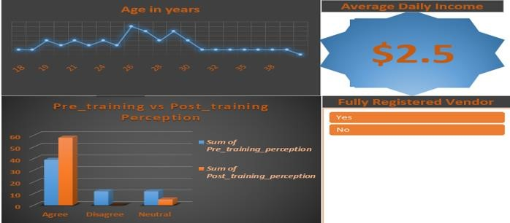

# ETHICAL CONSIDERATION

The beneficiaries and the community leaders were notified of the existing ethical issues which included their rights to participation, minimal risks, informed consent, anonymity, confidentiality, and to opt out at will. Valid consent, which was informed, voluntary and competent, was obtained from each beneficiary prior to the training and all sensitive data were excluded from the survey such as beneficiary name, address and occupation. All forms of communication were in the local languages- mainly the Pidgin-English and the Igbo languages, and delivered within a culturally acceptable and situational context.

# LIMITATIONS, RECOMMENDATIONS AND SUSTAINABILITY PLAN

One of the notable limitations of the initiative is that it was conducted in only one of the many communities within the Niger-Delta region and beneficiary selection was by convenience (selection bias) where only indigenes with similar interests were most likely enrolled in the training. This negatively affects the generalizability of the findings as it might not portray a true representation of the perception of the entire population on craft trade. The choice of this setup was largely due to limited resources for project expansion majorly manpower, time and finance. Reassuringly, since the raw materials for the handcrafts are in abundance in the community and need not be gotten through money exchange, it would seem reasonable to gradually scale up the project and grow the craft trade to circumvent any form of disproportion in the demand-and-supply ratio of the market. Additionally, the six-month duration of the initiative was insufficient to conduct some predictive analyses on the observed differences in the data. This downturns the project validity. Hence, a monitoring dashboard was designed to aid periodic data updates.

As a major drawback, the political dynamics at the tourist centers tend to discredit skilled indigenes residing in the community as only a limited number are registered as craft vendors at these tourist centers. It would be helpful if the community leaders and other stakeholders broker a deal with the government to revise the existing Memorandum of Understanding (MoU) for tourism to give more credence and opportunity to skilled indigenes residing in the communities housing the tourist centers. This improves sustainability of the trade as the market becomes readily available and highly accessible. Helpfully, some beneficiaries have noted their preference for telemarketing through the social media platform to avoid overreliance and overcrowding of craft vendors at the tourist centers.

# CONCLUSION

By revealing a positive relationship between the craft trade and economic empowerment, this initiative highlights the collective belief of the young female adults that economic status can be the boon and bane of cultural identity and regional peace and stability. Positive Peace is a facilitator to development. Therefore, this initiative is an integrated bottom-up participatory strategy that judiciously utilizes available resources (highly efficacious) to achieve the maximum impact (highly effective) of protecting the environment, securing the quality of life of the people and showcasing the active roles women can play in conflict resolution. Undoubtedly, all these create a sure path to peace in the Niger-Delta region and ultimately restore the identity of the Niger-Delta woman- ***confident***, ***self-sufficient***, ***bold*** *and* ***beautiful*.**



# REFERENCES

Africa Partnership Forum Support Unit (2007) *Gender and Economic Empowerment of Women,* fig.1 [Online]. Available at: https://www.oecd.org/dac/gender-development/39518651.pdf (Accessed: 11 January 2022).

Ikoro, E.I. and Ukonu, I.O. (2016) ‘Analysis of conflict resolution methods adopted in managing conflicts in Niger Delta region of Nigeria’, *International Journal of Economics and Business Management*, Vol.

2(6), pp. 2489-2511.

Olusakin, A.M. (2006) ‘Peace in the Niger Delta: Economic development and the politics of dependence on oil’, *International Journal on World Peace*, Vol. 23 (2), pp.3-34.

Princessdibooks (2017) [Twitter] 18 March, fig 5. Available at: https://twitter.com/princessdibooks/status/842879744605609985 (Accessed: 24 June 2022).

Tobor, J.O. and Muzorewa, W. (2016) ‘A comparative analysis of the Niger Delta crisis in Nigeria and the land reform process in Zimbabwe’, *European Journal of Research and Reflection in Educational Sciences*, Vol. 4, pp. 2056- 2285.

Ukpong, I.G. and Obok, E. (2018) ‘Implications of crude oil extraction on agriculture and livelihood in oil producing rural communities in Nigeria’, *Review of Agricultural and Applied Economics*, Vol. 2 [Online]. Available at: https://ageconsearch.umn.edu/record/281199/?ln=en (Accessed: 30 September 2021).