APRIL 19, 2022

The Voice of Peace for South Sudan (VPSS)

A COMMUNITY RADIO PROJECT FOR EDUCATION, DIALOGUE, AND

PEACEBUILDING IN AUSTRALIA AND IN SOUTH SUDAN

PETER PAL

M: +61432189368 E: paluguns@gmail.com

Table of Contents

Abstract 2

CHAPTER ONE 2

Background 2

Problem Statement 4

Goals 5

Objectives 6

Challenges and mitigation strategies 7

CHAPTER TWO 9

Change theory and how it was applied 9

Methodology 11

Actual implementation plan 13

CHAPTER THREE 16

Interventions and activities 16

Project stakeholders’ structure 16

Performance management 19

Risk management approach 20

Monitoring and evaluation 20

CHAPTER FOUR 22

General Conclusion 22

APPENDIX 22

Reference 43

# Abstract

In recent years, “social media platforms have been used to bring citizens together to protest violence, coordinate relief efforts, empower citizens, provide information to reduce tensions, and to build bridges of understanding across boundaries” (Baytiyeh, H., 2019, p. 76). This assertion speaks to the notion of this project where it aims to promote peace among the South Sudanese communities using a media platform for reconciliation. This report discusses the life cycle and transition of the community radio project, where it exposed appropriate project management systems which were used at the initial phase of the project. The report also consults relevant literature to inform the design and delivery of the community radio project. The information contained in the report do not present a complete picture of the project outcomes but provide preliminary information regarding where the project is at. This report is structured in chapters and subheadings where it discusses why this community radio project is needed, the problem statement which explains the gaps, used appropriate approaches for public consultation, the interventions and change theory approaches that could enhance stakeholders’ collaboration toward achieving the project goal. The report concludes with the summary, reflecting on the livelihood of the project, discussing what is being achieved, highlighting the challenges and interventions taken by the stakeholders to meet the requirements of the project, while recommending the project log frame and the status report attached to guide the delivery of this project.

# CHAPTER ONE

# Background

Vega Casanova, J., et al., (2021) highlight that “the construction of a culture of peace implies promoting transformative processes where communities can become an active part of the transforming process from a culture of violence to a culture of peace” (p. 465). This community radio project, The Voice of Peace for South Sudan (VPSS), was intended to be delivered in South Sudan to improve the relations of the divided communities, promote peace, and reconcile the grievances caused by the 2013 conflict. The Republic of South Sudan is a landlocked country that gained her independence in 2011. It has borders with six countries and its population was estimated as 12,778,250 in 2019. It is a home of more than 63 ethnic groups with different lifestyles, languages, and cultures, with predominantly Christians and traditional spiritual beliefs. The obvious barriers facing the communities in South Sudan since the war erupted in 2013 range from socio-economic and ethnic political violence, cattle raiding, land grabbing, and child abduction. Such volatile situations undermine positive engagement between the communities in South Sudan, despite the signing of the peace agreement in 2018. The identified factors represent the culture we want to change in South Sudan, using media to educate, reconcile South Sudanese communities and transform the mindset of war to embrace a culture of peace.

In “post-conflict situations, Baytiyeh, H. (2019), discussed that, social media can provide a more personalized resource and foster a sense of community; it has the potential to advance peacebuilding, support social cohesion, change perceptions and behaviors, and may reduce the risk of recurring conflicts” (p. 76). To be proactive in mitigating the reoccurring conflicts in South Sudan, therefore, we observed that a community radio platform will pave the way to understanding and breaking myths, regarding different cultures and diversity. This view speaks to Gustafsson, J.

(2016)’s assertion that “community media are often perceived to be vital avenues for peace initiatives, due to their close connection with the community [….], the participatory elements and their cultural sensitivity [….], and their ability to foster diversity, intercultural dialogue and tolerance [….]” (p. 116). This is true! Radio is a powerful electronic mass media having the capacity to reach the remotest areas even where there is no electricity with relevant information, education, and a persuasive message of peace. Given that approximately 80% of the populations in South Sudan are illiterate, the radio can be a very useful tool to engage the communities at the grassroot level, delivering messages of peace and dialogue through music, words and sentences that can easily be understood by people who can’t read or write in their own language in South Sudan. Gustafsson, J. (2016) further observed that “community radio stations [are important infrastructures to be use for] civic education and raising awareness about people’s rights, but their obligations are also characterized by the ownership of the people, access by the people, people’s participation and their non-commercial and non-state dependence” (p. 115). The Voice of Peace for South Sudan radio will operate as a non-governmental entity, a community media platform run, owned, and controlled by the community to educate the community about peacebuilding, health, community-based development, cross-cultural competences, human rights, and good governance.

The radio will be dedicated to broadcast programs of varied interests to different ethnic and religious groups focusing on sharing knowledge, promoting a culture of peace through providing non-violent communication approaches, disseminating information of peace and reconciliation on the standpoints of each group. Furthermore, the radio will promote the established international charters of human rights, especially the United Nations (UN) security council resolution 1325, Sustainable Development Goals (SDG), democratic principles and the positive peace frameworks. Other radio programs will also be produced, including programs that address community resilience building, gender disparity, social inequality, education and training, health and nutrition, population and reproductive health, water sanitation, dissemination of information and knowledge, campaign for creating awareness on fair election process, youth empowerment, and good governance. It is important that, through civic education, the community would understand these concepts and approaches so as to make an informed decision about their life and to achieve a sustainable peace. Baytiyeh, H. (2019) argued that “post-conflict recovery is not just physical; it is also a social and psychological process. The disruption of social ties and relations between diverse communities can deepen the rooted division and threaten the cohesiveness and welfare of the society” (p. 75). I believe through this media platform, the community relationship in Australia and in South Sudanese will be transformed and united.

# Problem Statement

Since the conflict broke out in 2013 in South Sudan, there emerged a severe communication breakdown between the diaspora South Sudanese communities in Australia. It was apparent that tribal hatred was the “underlying cause of the transformation from political rivalry to violent conflict and the way in which other causes are attached to the ethnicity factor” (Nyadera, I. N., 2018, p. 60). Such situation manifested frustration, fragmented the community, causing devastation, vulnerability, and undermined community cohesion in South Sudan and abroad. In fact, several peace agreements were signed by the aggrieved parties, hoping to de-escalate the conflict and serve life, but lacked courage to implement them except the Revitalized Agreement on the Resolution of the Conflict in the Republic of South Sudan (R-ARCSS) currently on trial.

In search for an amicable solution to the ongoing conflict in South Sudan, the diaspora South Sudanese community held meetings, seminars, and conferences to assess the causes of the conflicts in South Sudan and how to stop it from affecting diaspora community. These deliberations identify specific contributing factors to the problems happening in South Sudan including cultural and language barriers and the absence of well functional government. In fact, Johnson, D. H. (2014) examined that “the issues of governance highlighted by this conflict are not just internal to the SPLM, and there is potential for opening up a space for other voices to be heard and other groups to become involved in resolving the underlying issues that led to conflict” (p. 309).

To cease and mitigate such senseless conflict from spilling over onto the diaspora South Sudanese community, the community leaders were encouraged to organize peacebuilding initiatives and reflect on the following “four media initiatives that Gustafsson, J. (2016) identified as effective tools to promote peace and reconciliation: (1) activities that improve the general media environment to facilitate peace building – for example, by tackling hate speech and hate media; (2) local media projects that are used in order to disseminate information and educational material connected to peace-building activities; (3) media that proactively work for reconciliation by aiming to foster a culture of mutual understanding and peaceful coexistence, and; and (4) activities that train journalists and support the development of inclusive communication policies” (p. 116). Such peacebuilding initiatives will encourage collaboration and to promote the R-ARCSS through the established community radio platform. Since South Sudan is yet to attain positive peace, thus, this community radio will play an enormous role to empower the community, disseminate information that concerns peace and embrace themselves. Baytiyeh, H. (2019) supported this view that “social media can facilitate a resilient people-centered approach to conflict prevention and enables people around the globe to share firsthand witness reports of violence, social unrest, human rights infringements, election fraud, and political instability, empowering them to become agents of change within their own communities” (p. 76). The need for peace in South Sudan is urgent, and this platform will help the community realize the desired peace.

# Goals

The principal purpose for which the VPSS is established is to promote radio, including without limitation by:

1. creating, maintaining and managing a radio communication platform by and for the Victorian South Sudanese community to engage and dialogue; and
2. broadcasting radio programming of relevance to the Victorian South Sudanese community, including news, commentary, and discussion; and
3. developing radio programs of cultural, educational and social significance to the Victorian South Sudanese community.

# Objectives

To achieve the principal purpose set out in Rule **Error! Reference source not found.**, the VPSS may, among other things:

1. conduct public programs including education programs, social and community programs and research programs;
2. broadcast and develop radio programs which:
   * promote peace, community building and resilience, human rights, good governance, human rights, leadership, development, and social capital, among the diaspora South Sudanese community in Australia as well as in South Sudan;
   * encourage women and youth involvement in peace building and conflict transformation processes;
   * advocate for the unity of South Sudanese toward achieving national consciousness; o promote, showcase, and publish positive histories that represent South Sudan’s diverse cultural heritage;
   * promote cosmopolitan approaches to address cultural barriers undermining communities’ integration and interaction; and
   * provide listeners with educational resources pertaining health, employment, environment, social discourses from various channels and educate the community about their impacts in various languages.
3. disseminate information relating to education and community programs and to produce, edit, publish, issue, sell, circulate and preserve such papers, periodicals, books, circulars and other literary matters as are conducive to these objects;
4. establish and maintain relationships and close communications with corporations, entities, associations, foundations, institutions, organizations and groups including Federal, State

and Local Government instrumentalities, authorities and professionals that may have related interests to the Association and utilize their resources and facilities to provide and achieve the purposes of the VPSS;

1. seek and co-ordinate funding from Federal, State and Local Government, the private sector and other sources in the form of grants, gifts, donations and bequests committed to the purposes of the VPSS;
2. encourage and promote and generally to create greater community awareness in the knowledge and understanding of the purposes of the VPSS;
3. provide or attract funds for the facilitation of any of the purposes of the VPSS; and
4. do all such other things as are incidental or conducive to the attainment of the purposes and aims of the VPSS.

The purposes of the Association will be pursued principally in Australia.

# Challenges and mitigation strategies

The situation in South Sudan presented an enormous challenge to conduct project activity in the Greater Upper Nile Region, South Sudan. It was obvious that “the government lost monopoly over coercive power and was unable to administer justice, provide basic services to the citizens and guarantee their security” (Nyadera, I. N., 2018, p. 62). The absence of such central power to manage the community and provide protection to citizens jeopardized people’s participation in the community consultations in Pagak, South Sudan. As a result, our team in South Sudan had to engage with the community through local authorities who provided security and logistical needs to ensure people’s participation in the program. We learnt that these local authorities represent the security and political structures in those areas, they are tasked to check and scrutinize the legitimacy of any project intended to be delivered in their community. In our case, we initiate contact with the community before obtaining appropriate project registration papers. This was because the register office in Juba delayed the registration process of our project for months, until we gave up, even though we provided the register office with all relevant information required to complete the registration. Nevertheless, we consulted the county commissioner and explained our situation where we asked for permission to engage with the community. In fact, the commissioner realized the significance and benefit of this radio project to his community. As a result, he allocated land where the radio station will be built. Having secured the support of the local authority, we then continue with our efforts to consult with the community sharing information about the benefits that this community radio will bring to their community to achieve peace.

In diaspora though, the situation was different to the experience in South Sudan. Covid-19 pandemic was the major challenge undermining community engagement abroad. But we consulted the community leaders and faith leaders to advise on appropriate approaches to attract community’s participation into the design and delivery of the radio project. The challenge was that face-to-face engagement was not possible because of COVID-19 situation. Therefore, project activities were conducted remotely through zoom and other online platforms because people were observing covid-19 lockdown measures in Melbourne, Australia. Initially, people were hesitant to engage through an online platform to conduct project’s business. However, after some time, the teleconferencing and other online platforms turned out to be convenient for many people to engage through and to mobilize resources. Unfortunately, we have decided to establish this community radio project in Australia because we have not secured adequate funding that would enable us to deliver the project in South Sudan. Such a change was made in support and in consultation with relevant partners including Jewish Australian Internet Radio (J-AIR) in Australia, who promised to collaborate and mentor our staff to be able to establish and manage a productive community radio project to engage South Sudanese with peacebuilding activities that will influence change in

South Sudan. We have formed the organization’s steering committee, completed the drafting of the organization’s framework, and now we are at the last stage to incorporate the new entity, The Voice of Peace for South Sudan (VPSS) in Australia. We will continue to operate that way until we implement this community radio in Australia and in South Sudan. See appendix 2 and 3 below to see the project’s outlook.

# CHAPTER TWO

# Change theory and how it was applied

A theory of change specifies, up front, how activities will lead to interim and longer-term outcomes and identifies the contextual conditions that may affect them (Connell, J. P., & Kubisch, A. C., 1998). It is a practical tool of influence used to pursue a collective action and to galvanize support from various stakeholders to manage and deliver a project. This approach can enhance stakeholders’ ability to articulate the “intended outcomes, the activities it expects to implement to achieve those outcomes, and the contextual factors that may have an effect on implementation of activities and their potential to bring about desired outcomes” (Connell, J. P., & Kubisch, A. C., 1998, p.2). This approach explained comprehensively the project outlook and the expectations which the stakeholders must consider prior to the design and development of the project’s working paper. To achieve the articulated milestones, the stakeholders involved in the project development display credibility and competence in project management. Connell, J. P., & Kubisch, A. C.,

(1998), advised that “the inability of many stakeholders to make linkages between early activities and longer-term outcomes raises significant problems for evaluation design” (p.6). Considering such barriers in the consultation process would ensure that stakeholders involved in the project development display credibility and competence in project management. This is because the resources mobilization and community education are a long-term endeavor which can only be attained through effective engagement with the community, corporate and government sector, encouraging wider participation to impact change.

Stakeholder as a term can be ambiguous sometimes pertaining who is to be considered a stakeholder and their expected role in the project implementation. While Ginige, K., et al, (2018) sees the stakeholder in the context of societal challenges and explained that stakeholder “is anyone who has an influence on changing the status of a particular societal challenge in a country or anyone who can potentially be harmed or have their rights affected by societal challenges” (p. 1198). Among the obvious “challenge posed by the theory of change approach” as identified by Connell, J. P., & Kubisch, A. C. (1998) include “theorizing about these issues, [and further argued that] for the theory of change to remain responsive to emerging opportunities and challenges to the balance the needs” (p. 6). Such intervention provides stakeholders the opportunity to evaluate the impact, limitations, and sustainability of the project. In our situation, we applied the theory of change and adopted the Power Mapping concept to consolidate a comprehensive taskforce equipped to generate knowledge, resources and deliver the project. We recognized that power mapping, as Schiffer, E., (2007) discussed “analyze the power of different actors in a given governance field” (p. 7). The diagram below illustrated and further explained the process through which the stakeholders will manage and deliver this project.

### Figure 1: Stakeholders Power Mapping

Decision makers

**Impact of the**

**project**

**Status of the**

**organisation**

**Project**

**management**

**team/**

**VPSS**

**Engagement**

**platform**

*Project management team/VPSS* – this section explains the relation between the project team and potential stakeholder. In this section, the project team will undertake background research about the purposes and priority policies of the organization such as: peacebuilding, human rights, and democracy. Then, prepare appropriate resources information which reflect their area of service delivery before meeting with the person representing that organization for consultation. We learn that organizations like to support initiatives that promote the policy for publication.

*Engagement platform* – this section is where we engage with the public, initiate discussions on issues concerning the project variations with the community and publish information that would enhance public knowledge about the activities of the project. Importantly, this platform is where we publicly appreciate organizations that supported the project activity, invite representatives of such organizations, and acknowledge their contribution toward the project at the present of the community, highlight the limitations, the impact of the project, and articulate whether further support would be required. Prepare a report which explains clearly and provide them a copy together with the appreciated letter as an acknowledgement of their contribution toward the project implementation. If the project achieved its desired goal, it is likely that a commitment will be made by a representative of the organization to support the second round of the project.

*Impact and sustainability of the project* – this section is where the project management would convene a meeting with stakeholders to evaluate their collective success, reflecting and reviewing the interventions and approaches they applied to deliver the project. This collective success is not just about delivering the project, but also the impact that the project made to the benefited community. This approach provides stakeholders the opportunity to expand their network and invite potential partners who could play a vital role in mobilizing resources to deliver future activity.

*The status of the organization* – It is important to remember that the stakeholder organization, whether it is a government or non-governmental organization, is always mindful of their status and would wish to be seen as the lead agent in services delivered so as to remain in power. They always want to partner with an agency with a good track record in managing projects and resources transparently. To attract their support, the project team needs to integrate the project activities to the organization’s action plan. We applied this approach during our consultation with the stakeholders, and learned that, if you portrayed a positive image of their organization, they would support your project.

# Methodology

In the process leading to the design of this project, we applied exploratory research method to investigate the experience of the community. Exploratory research, as Ditsa, G. (2004) explained, “is generally conducted to develop initial rough understanding of some phenomenon” (p. 764). In fact, before this project came to light, subsequent community consultations were held with different demographics at different settings purposely to get them involved, understand their experiences, and the challenges facing their communities. In the consultation process, we adopted community development approaches (collaboration, cooperation, and empowerment) to ensure people’s participation, and that all demographics irrespective of age or gender participated in the discussion and shared their experiences. According to Gustafsson, J. (2016), “participation is therefore a central aspect of community media, as it has the potential to create a sense of belonging to the community, allowing the communication process itself to become an agent for social change and democratization” (Gustafsson, J., 2016, p. 116). Taking into consideration the culture specific approach, we engaged with the key informants such as local leaders and religious leaders who have helped to facilitated and organized meetings with other groups. Such collaboration enhanced our capacity to convene an effective session where participants discussed and shared knowledge about the situation of their communities and proposed alternative solutions to the problems facing their communities. Furthermore, the findings from the consultations were shared with the key informant at a focus group session where participants collectively agreed on the merit of the transcript and endorsed the proposed idea of establishing a community radio to help the communities and other stakeholders to communicate and reconcile the communities’ differences.

While in the process to deliver the project, a consultation was initiated to identify participants who will host the radio. The criteria used for screening includes being competent in English, Arabic, and local language to be able to perform and serve the purpose of the radio. The participants were to be mentored by an experienced broadcaster who was previously involved in the radio broadcasting, transferring knowledge and skills before they independently operate the radio. Such an approach we anticipated, will enhance communities’ interaction through broadcasting events and history that focus on building bridges and resilience of the community through recreational, music and religious events we aim to facilitate. It was recognized that the impact and the benefit of the radio project will be measure by how the communities access its contents from diversify sources such as by air, internet and social media platforms to foster harmony and dialogues between the communities; promotes appropriate peacebuilding approaches, human rights, and values commonly shared by South Sudanese communities to realized and sustain their unity.

“To ensure that we maintain the community’s participation in championing peace locally in South Sudan, we must establish a broadcasting platform where members communicate peace in various languages” (participant).

# Actual implementation plan

The project implementation plan below was used as the tools and benchmark for cultivating ideas at the phase one (feasibility study, design, and preparation of the project) of this project, using the Specific, Measurable, Achievable, Relevant and Time Bound (SMART) framework to oversee the inception and transition of the project. It is a work in progress, and we will continue to draw from the activities stipulated in the log frame template on page to develop a comprehensive plan activity for this project.

### Figure 2: Preliminary implementation plan template

|  |  |  |  |  |  |  |  |  |
| --- | --- | --- | --- | --- | --- | --- | --- | --- |
| Specific  (deliverable) | Measurable | | Achievable | | Realistic | | Time Bound | |
| Phase 1 | | | | |  | |  | |
| Feasibility  study: design and preparation | Consult with the  community and identify key project stakeholders.    Assess the livelihood of the community. | | Engage with relevant people in the community.    Accessed and secured suitable sites to construct the radio station.    Enough data collected. | | The community welcomed and supported the radio project initiative.    Logistical need provided. | | Ongoing consultation  in South  Sudan as well as in Australia | |
|  | | | Identify suitable locations  where the radio can be built. | |  | |  | |  | |  |
| Phase 2 | | |  | |  | |  | |  | |
| Refinement and  iteration | | | Evaluate, summarize, and iterate feedback.  Draft project training material.  Identified project  budget and implementing partners | | Project operational plan designed.  Developed training material.  Identified and recruited trainees for the course.  Facilitators confirmed.  Secured partners | | Trainees and  facilitators confirmed.  Accessed the  training materials.  Effective logistical needs provided.  Training space secured.  Resource mobilization mechanisms identified. | | 3 weeks from  7th – 26th  March 2022 in South Sudan as well as in Australia. | |
|  | | |  | |  | |  | |  | | |

**Figure 3: Expected milestones every three months/work plan**

The project milestones highlighted below were delivered from May - December 2021 in South Sudan and abroad. They were drawn from phase one deliverables to educate the public about the project’s purpose. Due to covid-19 and political situation in South Sudan, we had to alter and narrow our plan to focus highly on resources mobilization, establish the radio in Australia that will deliver the desired outcomes and model this later in South Sudan. Please refer to appendix 3 on page 31for the updated plan activities.

|  |  |  |  |
| --- | --- | --- | --- |
| Deliverable | Stage 1 | Stage 2 | Stage 3 |
| Consult with the community and partners | 21st May 2021  Elder, community and faith group leaders: one on one. | 15th June 2021&  15th July 2021  General meeting.  Raise awareness  about project | 15th August 2021  Project coordinator planning meeting. |
| Organise seminar to educate public about the important of the radio to promote peace | 1st September 2021  The first seminar will be held through Zoom while raising funds at the same time. | 1st October 2021  The role of the media in peace building. | 30th October 2021  Project coordinator’s meeting. |
| Mobilise resources  through fundraising | 1st November 2021  Second fundraising activity through  GoFundMe | 30th November  2021  Evaluation meeting |
| Review the procure equipment and logistic requirements | 15th December  2021 | 30th December 2021  Follow up meeting by | 15th January 2022 |
|  | Management and  partners meeting | project managing  team and partners | Evaluate actioned items and moving forward meeting |

# CHAPTER THREE

# Interventions and activities

Best, A., et al., (2013) explained interventions as “deliberate and planned action to accomplish, accelerate and/or influence the achievement of project results” (p. 331). In fact, interventions may constitute a set of measures developed to guarantee an effective management and monitoring of the project. This view represents the approach we adopted before we embarked on delivering the project where we identify project stakeholders, constitute structure, and develop appropriate measures for evaluating the key performance indicators to ensure the achievement of the expected outcomes. We consider these interventions as relevant tools for communication and to enable stakeholders to communicate, monitor, and evaluate their work performances. They consist of various measures and indicators as outlined in the activity’s tables below.

# Project stakeholders’ structure

The project structure provides opportunity for equal participation of the stakeholders through sharing of knowledge and responsibility to deliver results. Unlike the members of a functional structure, Alsène, É. (1999), discussed that, “project structure members do not generally have problems with priorities in the tasks to be accomplished (they are assigned to the projects for a certain amount of time), with neutrality with respect to the various interests at stake (they work outside existing hierarchical lines throughout the project duration), and with expertise in regard to the management of projects (the project team is often multidisciplinary)” (p. 368). In this project, we created three bodies to manage and facilitate the implementation of the project. The diagram below identified the stakeholders’ structure and explained further their roles and responsibilities in the table.

**Figure 4: Project structures’ chart**

External

Stakeholders

Project management

Project

Consultative

committee

**Figure 5: Stakeholder’s roles and responsibilities**

The table below outlined the role and responsibility of the project stakeholders:

|  |  |  |
| --- | --- | --- |
| Project stakeholders | Description | Roles and responsibilities |
| External stakeholders | The external stakeholder committee will work collaboratively with project management committee to deliver the radio project successfully. This approach provides both the project management team and project partners the opportunity to monitor the project, share knowledge, and engage with members effectively through networking. Diaspora and | **Mentor and support**  Facilitate connections with other development agencies to help VPSS leadership and members to access development opportunities and sustain the radio.  **Capacity building**  Enhance the capacity of the VPSS team through connection and provide professional development training to achieve excellence in managing and delivering the project. |

|  |  |  |
| --- | --- | --- |
|  | local South Sudanese community’s organizations involved in this radio project will continue to benefit from participating in capacity building, peacebuilding and developmental activities being deliver by this project. | **Cultural orientation**  Help to develop an acceptable cultural resource that will be used to educate the community about democratic principles and how to build a resilient community. |
| Project  management committee | The project management committee consists of 5 members whose role is to facilitate and implement the radio project. | The committee’s task will include:   * Developing practical contingency plans to engage people of good will to raise funds for the purpose of the project. * Managing the resources and the transactions made for the procurements of the project activities. * Report to the project partners on the progress of the project. * Collaborating closely with partners to deliver the project and meet its requirements and purpose. * Organize training to enhance   staffs’ capacity to batter engage and maintain a constructive relation with the communities and with other stakeholders. |
| Project consultative committee | The scope of the consultative committee is composed of 11 members representing South Sudanese associations committed to work together to deliver this project. | The role of the consultative committee will range from:   * Monitoring and evaluating the performances of the management committee. * Act as the body that regulates the performance/commitment of the management and project partners. * Report to the management committee on any issue that arises or that may require a collective support/response of the community. * Communicate any relevant suggestion to the management committee for further consideration |

# Performance management

The performance management evaluation template below explained the assessment approaches through which the project stakeholders will monitor project activities. The table outlines practical procedures to identified project’s limitations. This approach details the productivity and efficiency of the team toward meeting the requirements of the project.

**Figure 6: Performance management evaluation template**

|  |  |
| --- | --- |
| **Performance objectives** | **Standards identification** |
| The performance objectives constitute a set of procedures that will guide or to be undertaken by the stakeholders to implement the project, considering the following: | The standards identification embodies a set of inquiry, which critically assesses the effectiveness of the frameworks which the |
| 1. Used resources effectively. 2. Displayed an appropriate record and reporting mechanism. 3. Able to identify the impact and the transition of the project and suggest alternatives. 4. Identified limitations that might have occurred in the process of delivering the project and rectifying them. 5. Promoted the project to the community and potential providers. 6. Use other applicable approaches. | stakeholder developed for monitoring, evaluate the project, and check whether:   1. The records of the project reflective to or not the criteria of the project. 2. The project has been delivered within its given time frame and purpose. 3. There is a need for extra support, both physical and human resources. 4. There is a need for capacity building, both personal and organizational development. 5. The management team is engaging well with the community and service providers. 6. Other relevant approaches that serve such a purpose. |

# Risk management approach

The stakeholders adopted a risk register approach for this project; this is by identifying and list risks and enter them into a risk register template to inform the assessment planning. Please *refer to appendix 1:* Risk assessment and analysis template on page 22 for detail information.

# Monitoring and evaluation

Monitoring and evaluation of a project provides a comprehensive forward-looking approach of the project cycle by reflecting on many routines’ activities undertaken, including monthly meetings to be convened by the stakeholder to verify the progress or shortfalls of the project transition. Such measures will be considered by the project team to monitor the transition of the project. The table 4 below discusses the control mechanism (what to be monitor or evaluated) why, and how often the evaluation should occur or be carried out by who? will be applied in relation to the project and the frequency with which each phase will be implemented.

**Figure 7: Project monitoring and evaluation template**

|  |  |  |
| --- | --- | --- |
| Control | Purpose | Frequency |
| Project Status  Report | Management committee to submit a report on project status & progress to the project stakeholders. | Monthly, unless otherwise agreed by committees. |
| Exception Report | Management committee to submit a report to the partners and consultative committee when the project is in danger of exceeding the planning tolerances. | As required. |
| End-Stage Report | Management committee to submit a report summarizing events & achievements of every progressive stage. | At the end of each project stage. |
| Scope | Management committee to submit a report to the Project  Consultative Committee and partners for approval | As required |
| Issue Log, Risk  Register | Tool for registering & mitigating concerns relating to the project delivery. | Updated as required |

# CHAPTER FOUR

# General Conclusion

This report provided explanations and insights about the context of the project; discussed and indicated the need to establish a community radio in South Sudan to promote peace. It is unfortunate to experience that the political environment in South Sudan and the uncertainty about the capacity and commitment of the stakeholders to generate resources to cover the project’s activities were the major obstacles to the project. However, I contend the stakeholders’ engagement tools and concepts adopted in the development of this project will encourage collaboration between partner organizations in their effort to deliver the project and produce results. Thus, the project team must focus their effort and reflect on the project’s log frame matrix to keep the project vision intact. The question to be mindful of included: how will this project be delivered in an uncertain environment in South Sudan? How will the stakeholders mobilize resources to implement this project? What alternative strategies and interventions are there to address project constraints?

# APPENDIX

**Appendix 1: Risk assessment and analysis template**

|  |  |  |  |  |  |  |
| --- | --- | --- | --- | --- | --- | --- |
| **Risk** | **What is the harm that the risk could cause?** | **What is the likelihood that the risk would occur?** | **What is the level of risk?** | **What are the**  **controls**  **currently in place?** | **Date complete**  **d** | **Date of review** |
| Data breach | Loss of records and breach | Low | High | All project records are kept secure on  OneDrive and in a safer space using Cloud storage and | Actioned | Ongoing |

|  |  |  |  |  |  |  |
| --- | --- | --- | --- | --- | --- | --- |
|  |  |  |  | information back up |  |  |
| Data breach | Confidentiality and privacy breach | High | Medium | Key documents such as logo, letterhead, seal and intellectual properties, and other credentials are kept with management. Finance templates and details of partners are kept secure. Disciplin ed misconduct. | Actioned | Ongoing |
| Misman agement of fund. | Use finance for a purpose other than the project. Limitation of resources and be unable to hire the required project logistical needs.  Hire limited professional staffs to deliver the project. | Low | Medium | Maintain an  accurate recording of all activities, financial transactions (i.e. petty cash and bank statements) and reflect on performance approaches of the project. Disciplined and Prosecute actor | Actioned | Ongoing |

|  |  |  |  |  |  |  |  |
| --- | --- | --- | --- | --- | --- | --- | --- |
|  |  | |  |  | involved in  finance embezzlement or neglect. Train competent staff about financial management. |  |  |
| Social, political and environ mental unrest. | the time.  in the field. | Failure to deliver project on  Pose risk to staff | High | Low | Develop practical precautionary strategies to follow the political climate.  Communicate with community, authority and other actor in the field assessing and mitigate the risk. Develop flexible and alternative plans to carry on with project safely. | Actioned | Ongoing |
| Conflict of interest | Create and bias. | mistrust unintended | Low | High | Declare conflict of interest in writing. Educate staff to  communicate  and operate transparently. | Actioned | Ongoing |

**Appendix 2: Project Log Frame Matrix**

|  |  |  |  |  |
| --- | --- | --- | --- | --- |
| **Project description** | | **Objectively verifiable indicators of**  **achievement** | **Sources and mean**  **of verification** | **Assumption** |
| **Goal** | Harmonized and integrate the community. | No major ethnic conflict happening between the communities in the region.  Promote relevant concept of peace to enable leader manage community’s relationship.  Community members participate in socioeconomic development programs. | Leaders took initiative to manage communities’ situation and engage the community through the radio platform.  Dialogue between the communities is happening, movement between the community is resumed, the community realized peace and normalcy returned.  Members from different communities attend peace seminar without problem. | Their unity prevailed. |

|  |  |  |  |  |
| --- | --- | --- | --- | --- |
| **Purpose** | Establish the  Voice of Peace for South Sudan community  radio to foster peace and  dialogue among South Sudanese communities. | Establish the radio  Mobilized partners and sponsors to help deliver this program.  Recruit and train competent hosts in relevant South  Sudanese languages to promote the activities and the objective of this project in their own dialect.  Engage the community and partners in  peacebuilding advocacy. | Operationalized the radio in diaspora and in South Sudan.  Members used radio for peace, promote development initiative and to report security challenges in the community  Members used radio to promote health, education, youth, and women activity.  Host peace journalism seminar. | Impact the community positively. |
| **Output** | Discourage political violence that manifest intracommunal conflict in South Sudan. | Organize community dialogues to stabilize community’s relations.  Educate the community about ways to stop rampage killing and human abduction.  Host community dialogue to resolve resources competition, land grabbing and | Leaders use the radio to communicate peace in their communities.  The community can facilitate the return of the abducted children to their biological parent or community.  Community understands boundaries, | Culture of peace was restored, and law and order were respected. |

|  |  |  |  |  |
| --- | --- | --- | --- | --- |
|  |  | children abduction issues. | responsibilities, and humanity they share to coexist mutually. |  |
| **Activity** | Free flow of information | Create a website where members can access information about peace and community dialogue.  Create podcast to engage diaspora community in peacebuilding through partnering with existing community radio.  Establish hotline number to receive and share peace messages.  Create social media platforms to promote social cohesion among South Sudanese.  Create forum for faith group, youth, and women to dialogue and reflect on their role in pursuing peace. | The community used radio to communicate with people in South Sudan to encourage culture of peace and unity.  The community used radio to display art and music that represent their cultural heritage and promote peace in various languages.  The community use social media to share message of peace with the wider community.  Both diaspora community and the community in South Sudan use podcast to share knowledge and cultures to attain | Maintain this open space for  community’s dialogue. |

|  |  |  |  |  |
| --- | --- | --- | --- | --- |
|  |  |  | peace in South  Sudan.  Organize community retreat anduse radio to promote such activities and engage the community. |  |
| Good  relationship with neighbours | Authorities work together to ensure positive relations between the communities.  Organize conflict management seminar.  Initiate Youth concert and recreational tournament for peace.  Mitigate community’s conflict using  cosmopolitan approach. | Community organizes civic education session, with authority supporting the  grassroots peacebuilding initiatives  Organize reconciliation and dialogue seminars where member participate.  Host youth for peace concert.  The community use radio to promote restorative justice and human rights principles to mitigate conflict. | Foster  mutual and  respectful relationship between the communities  . |

|  |  |  |  |  |
| --- | --- | --- | --- | --- |
|  |  |  |  |  |
| Acceptance of the rights of other | Discourage ethnic and gender-based violence.  Encourage peace between the communities.  Promote unity and culture of peace among the South Sudanese communities in  Australia.  Promote human rights norms encouraging the obvious traditional human rights approaches. | The traditional structures that provide psychosocial therapy to affected people established and accessible.  Community learned alternative ways to address their grievances and  dissatisfaction through dialogue.  Encouraged youth and women involvement in  peacebuilding programs.  Community members understand what constitute of human rights abuses, using the radio to educate the community. | Promote and practice human rights principles. |

|  |  |  |  |  |
| --- | --- | --- | --- | --- |
|  | Sound business environment | Promote social, economic development activities between the communities.  Authority to provide adequate protection to the traders and farmers.  Promote micro-finance initiative to improve local agriculture development and production. | Traders use radio to promote business and advertise job.  Traders and farmers delivered goods, products, and services to the communities without interruption.  The community engage in business and accessed financial support from government and humanitarian agencies. | Improved the livelihood of the  community |
| Well functional government | Promote integrated peacebuilding principles to enable the  R-ARCSS  implementation process.  Promote the principles of good governance by educating the community about the role of the government. | The communities are engaged and work toward realizing a total peace in South Sudan.  The community understand the roles and responsibilities of the government.  Community understands the | Political stability  returned in South Sudan. |
|  |  | Promote liberal democratic principles.  Promote positive peace frameworks. | electoral system and voting processes.  Community understands health, education, and social justice services.  The community understand the concept of culture of peace, the kind of organization needed to deliver services to the community and sustain peace. |  |

**Appendix 3: Project milestone, 2022**

|  |  |  |  |  |  |  |  |  |  |  |  |
| --- | --- | --- | --- | --- | --- | --- | --- | --- | --- | --- | --- |
| **Task** | **Responsible person** | **Status** | **Year 2022** | | | | | | | | |
| Month | | | Month | | | Month | | |
| **Phase 1** |  |  | **W** | **W** | **W** | **W** | **W** | **W** | **W** | **W** | **W** |
| Consult with J-AIR management team | Management committee | ✓ | 2  nd    Dec | 13  th    Jan |  |  |  |  |  |  |  |
| Consult and organise members of the board | Management committee | ✓ |  | 17  th    Jan |  |  |  |  |  |  |  |

|  |  |  |  |  |  |  |  |  |  |  |  |  |
| --- | --- | --- | --- | --- | --- | --- | --- | --- | --- | --- | --- | --- |
| Organise organisation’s concept proposal | Management committee |  | ✓ | 1  2  th    Jan |  |  | 15  th    Feb |  |  |  |  |  |
| Consulted with J-AIR station manager and offered support and to access the station | Peter/Robert |  | ✓ | 18  th    Jan 22 |  |  |  |  |  |  |  |  |
| Seek legal advice and formulate organisation’s legal framework | Peter/David |  | ✓ | 28  th Jan  22 |  |  |  | 16  th    March 22 |  |  |  |  |
|  |  |  |  |  |  |  |  |  |  |  |  |  |
| **Phase 2** |  |  |  |  |  |  |  |  |  |  |  |  |
| Incorporate the organisation. | Peter | ? |  |  |  |  |  |  |  |  |  |  |
| Organise logo and letter head for the organisation | Secretary |  |  |  |  |  |  |  |  |  |  |  |
| Explore funding opportunity and apply. | Board | ? |  |  |  |  |  |  |  |  |  |  |
| Organise website/social media sites | Peter/Board | ? |  |  |  |  |  |  |  |  |  |  |
| Identify radio host personnel | Board | ? |  |  |  |  |  |  |  |  |  |  |
| Organise partnership papers | Secretary | ? |  |  |  |  |  |  |  |  |  |  |
| Acquire fund raising license | Peter | ? |  |  |  |  |  |  |  |  |  |  |
|  |  |  |  |  |  |  |  |  |  |  |  |  |
| **Phase 3** |  |  |  |  |  |  |  |  |  |  |  |  |
| Organise inauguration | Board | ? |  |  |  |  |  |  |  |  |  |  |
| Organise training for participants | Secretary | ? | |  |  |  |  |  |  |  |  |  |
| Develop program contents | Board | ? | |  |  |  |  |  |  |  |  |  |
|  |  |  | |  |  |  |  |  |  |  |  |  |

**Appendix 4: Project status report**

13th Nov 2021

By RPF Peter Pal

Email: paluguns@gmail.com

Mobile: +61432189368

### Summary

This project progress report summarizes the activities which the project team conducted in the past two weeks in Pagak, South Sudan. It contains information about ongoing consultation with the project coordinators and partners from different locations around three key milestones namely: Feasibility study, Resources mobilization and Stakeholders engagement. It discusses the outlook of the project and stages in which certain activity will be executed. It also articulated the limitations which the project coordinators anticipated could undermine the implementation of the project. At last, displayed pictures taken from the community consultation in Pagak, South Sudan.

|  |  |  |  |  |  |  |
| --- | --- | --- | --- | --- | --- | --- |
| **Activity** | **Description** | **Responsible team** | **Status** | **Year 2021 - 2022** | | |
|  |  |  |  | Stage 1 |  |  |
| Feasibility study | The project registration in South Sudan –  The project coordinators held a follow up meeting on 15th Oct 2021 regarding the registration of the project in South Sudan. It was reported that the registration required extra cost of 500 USD | The project team in South Sudan in consultation with the diaspora team | In progress. The project team in Australia are in the process to mobilize the required funding for registration completion in South Sudan. The project team in South Sudan will continue to implement this at their end.  *The next follow up meeting is scheduled for 17th December 2021.* | |  |  |

|  |  |  |  |  |  |
| --- | --- | --- | --- | --- | --- |
|  | Securing the construction site in South Sudan –  On 16th Oct 2021, I was updated about a community consultation meeting being held by the project team in South Sudan in support of the local county leadership where members discussed the needs and benefits of the radio. | The project team in South Sudan. | This task is done. The commissioner allocated a land where the radio station will be constructed in Pagak  Upper Nile State, South Sudan.    *Next step is to secure funds for construction in March 2023 onward.* |  |  |
| Resource mobilization | Fundraising Session –  On 25th Oct 2021 we held an online fundraising session where we raised an amount of $200  Australian dollars. | The project team in  Australia. | This is a recurring activity to be convened monthly at different settings and will need the public and potential partner’s participation in future fundraising.  Next fundraising is  22nd Nov and 20th Dec 2021. |  |  |

|  |  |  |  |  |  |
| --- | --- | --- | --- | --- | --- |
| Stakeholder engagement | Local rotary club support toward the project – In the past two months, I have had the opportunity to present information about this project to numerous sessions being organized by different rotary clubs in  Melbourne who  expressed interest to support this project. However, my sponsor club requested a copy of my proposal before us discussing supporting the project. | The project team in Australia | At the moment, I am preparing relevant project documents to be provided to the club as requested. After the receipt of these papers, a meeting will be convened with the club management to discuss alternative options to mobilize resources that will enable the project to be implemented.  The club invited me as guest speaker at the meeting to be held by the 24th Nov 2021. |  |  |

|  |  |  |  |  |  |
| --- | --- | --- | --- | --- | --- |
|  | UNMISS, DFAT and other NGOs – UNMISS and other humanitarian actors based in South Sudan indicated interest to support this project. Once the required project documents are obtained, they will indicate how they would participate in the implementation of the project. | Both the project team in South Sudan and Australia. | Ongoing engagement with these potential stakeholders still intact. I updated UNMISS offices about the progress of the registration in October 2021 and will feed them back by the first week of January 2022. This situation applies to other NGOs and DFAT with special interest to support peace in South Sudan. |  |  |
| South Sudanese partners in UK, Canada and US –  We held a constructive session with the SS community  representatives in the UK and North America on 1st Nov 2021. They pledged their support to the project. I provided them with | Diaspora leaders in the  UK, North  America, and Australia. | A monthly meeting will be held to update each other on the progress of the planned activity. Resource mobilization was the agreed focus area by the committee. |  |  |

|  |  |  |  |  |  |  |
| --- | --- | --- | --- | --- | --- | --- |
|  |  |  |  |  | Stage  2 |  |
| Train the radio hosts | Recruitment of the trainees – We consulted the community in Australia and in South Sudan to identify participants who will undertake the training and learn how to host the radio, develop contents and engage with the community effectively to promote peace. | The project team in South  Sudan and in Australia. | The recruitment of the trainees is yet to be finalized until the end of December 2021. While this is happening, the project team will endeavors to develop training templates, find trainers and suitable locations where the training will be convened, taking into consideration the logistical needs.  We expect the training to kick off by February 2022, either in South Sudan or in the neighboring country. | | |  |
|  |  |  |  |  |  | Stage  3 |

|  |  |  |  |  |  |  |  |
| --- | --- | --- | --- | --- | --- | --- | --- |
| Building the radio station | Inception of the building construction –  Before commencing the construction, the project team will assess the available resources, hire someone to survey the suitability of the construction site and provide a comprehensive itemized budget breakdown before starting to build the station. This approach will inform the committee's action either to go ahead with the design and budget or not. | The project team in South  Sudan and in Australia. | This task is yet to commence but I will start consulting with the project team in South Sudan to identify a good building company’s base in South Sudan or on the Ethiopia site to build the radio station when we secure funding. I would like the construction of the building to start as soon as possible and finish in May  2022. Then followed by the installation of the radio equipment and operationalized as soon as possible. The implementation of this task will be dictated by adequate resources available. From now onward, I will take practical measures to mobilize partners and ensure this project is delivered as scheduled. | | | | |
| Radio equipment | Delivering radio equipment –  I managed to secure a professional engineer whose works involved installation of community radio stations. He provided a comprehensive budget breakdown covering all costs including the logistics, setting up and maintenance. | The project team in Australia and the team in  South Sudan. | We have found a Radioactive company capable of setting up community radio and providing training. The radio equipment are yet to be deliver. Once we secured funds, I will inform the hired company to deliver the equipment to the construction site where the radio station will be established in South Sudan. I will remain in touch with this company till the job is done. | | | |
|  |  |  |  |  |  |  |

Limitation

The following items represent the obvious limitations I am facing:

1. Limited access to financial resources constrained my ability to deliver and meet the requirements of the project.
2. The political environment in South Sudan remains uncertain and could jeopardize the livelihood of the project partners to execute their works in the field, especially once delivering the logistical needs to construct the radio station. However, we are hopeful that the security situation will improve so the project team will implement the project.
3. Relevant sponsors and partners are yet to be secured to help deliver this project. I am in consultation with a range of actors who are yet to commit anything to support this project. However, the positive news is that the context of the project appealed to them. For this project to be delivered effectively, impact change and sustained; it needs a long-term sponsor.

However, lack of adequate financial resources is the measure of concern. I am hopeful that the humanitarian, peacebuilding, and developmental organizations willing to help South Sudan realize peace will collaborate with us to deliver this project.

Pictures taken during the community consultation meeting in Pagak South Sudan on 16th October 2021

Picture 1: Community briefing about the radio project by project team.

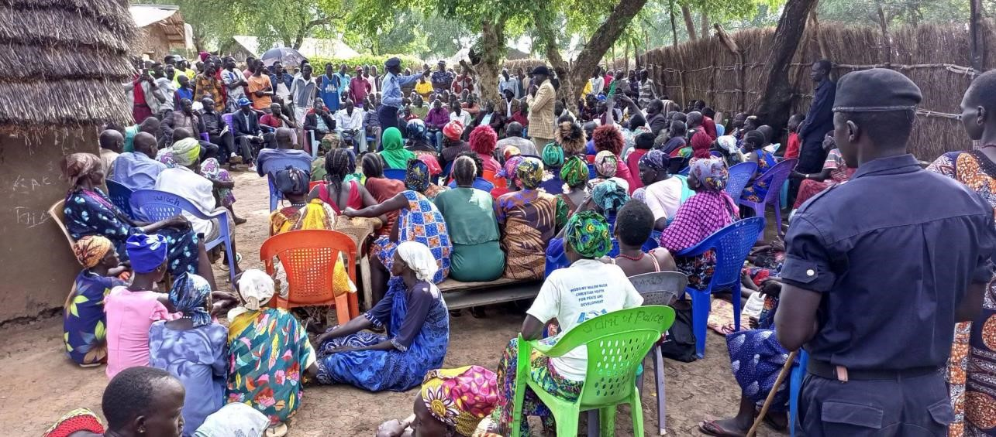

Picture 2: Commissioner and project team with members

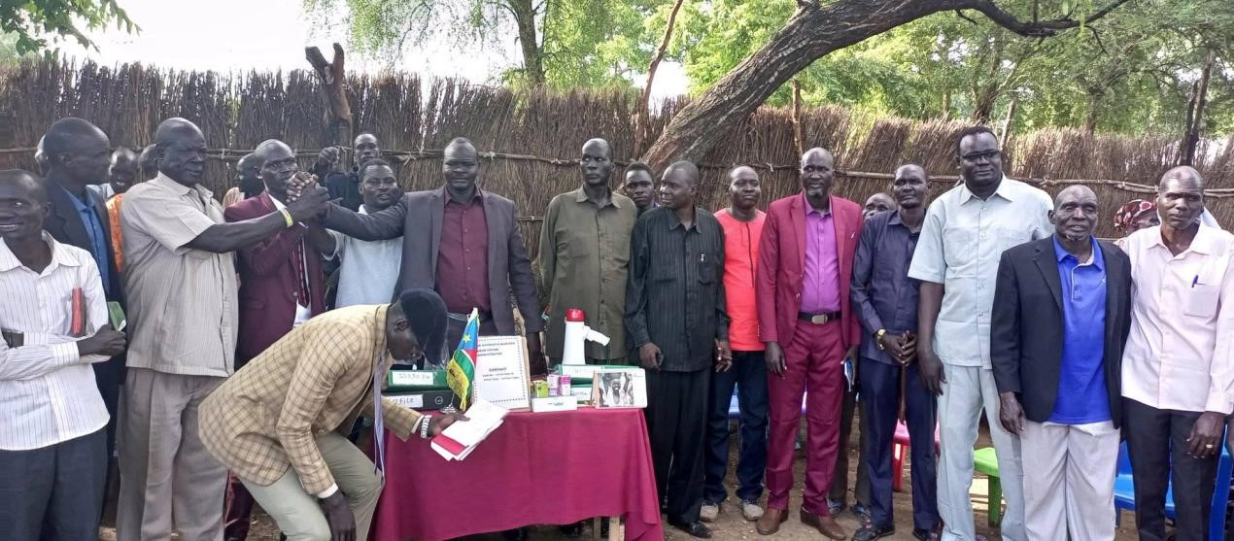

Picture 3: commissioner and project team with youth

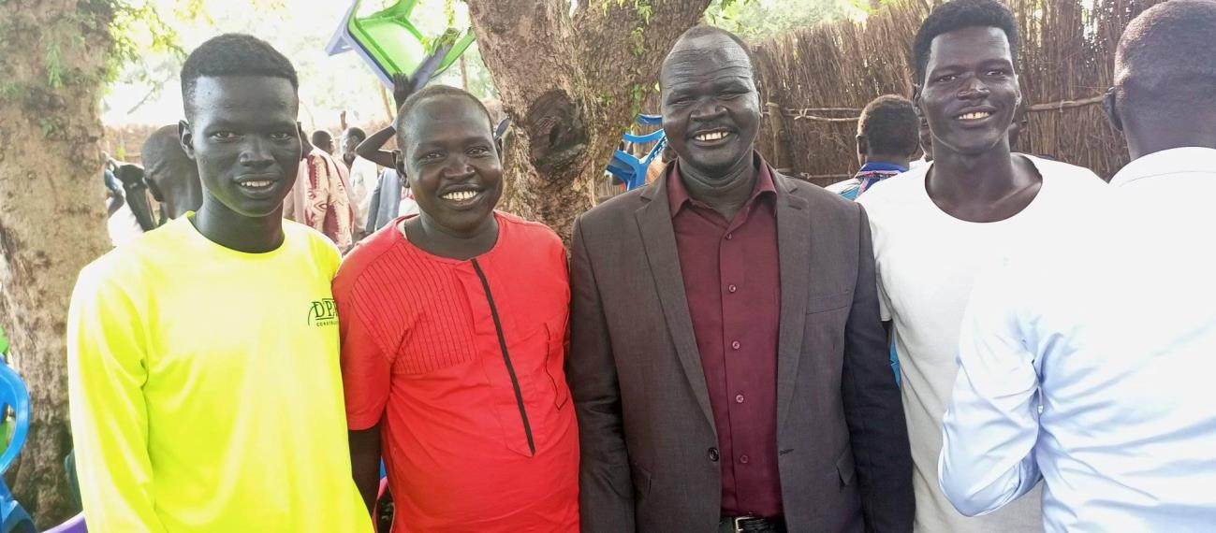

Picture 4: commissioner, and project team with women representatives

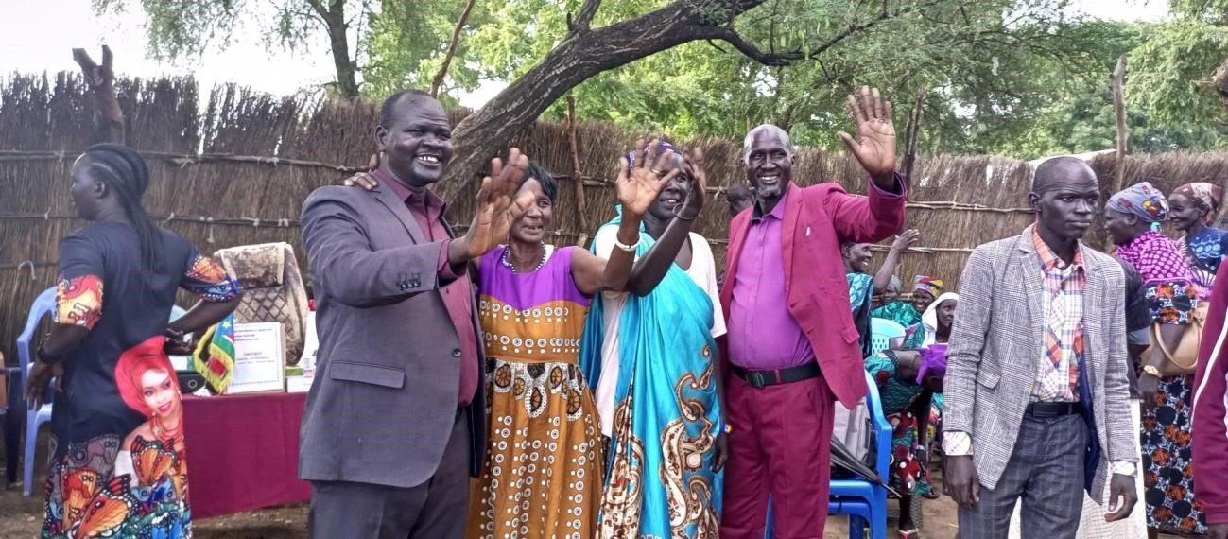

# Reference

1. Baytiyeh, H., 2019. Social media’s role in peacebuilding and post-conflict recovery. *Peace Review*, *31*(1), pp.74-82.
2. Connell, J. P., & Kubisch, A. C. (1998). Applying a theory of change approach to the evaluation of comprehensive community initiatives: progress, prospects, and problems. *New approaches to evaluating community initiatives*, *2*(15-44), 1-16.
3. Ginige, K., Amaratunga, D., & Haigh, R. (2018). Mapping stakeholders associated with societal challenges: A Methodological Framework. *Procedia engineering*, *212*, 11951202.
4. Schirch, L. (2013). Conflict Assessment and Peacebuilding Planning: A Strategic, Participatory, Systems-Based Handbook on Human Security. *Center for Justice & Peacebuilding Eastern Mennonite University. Retrieved from https://styluspub. presswarehouse. com/resrcs/chapters/1565495799_1stChap. pdf (accessed: 17.01. 2018)*.
5. Gustafsson, J. (2016). Community radio and peace-building in Kenya. *Journal of Alternative & Community Media*, *1*(1), 114-127.
6. Schiffer, E. (2007). *The power mapping tool: a method for the empirical research of power relations* (No. 589-2016-39854).
7. Best, A., Smit, J., & de Faber, L. (2013). Interventions and their relation to organizational culture and project management. *Procedia-Social and Behavioral Sciences*, *74*, 329-338.
8. Alsène, É. (1999). Internal changes and project management structures within enterprises. *International Journal of Project Management*, *17*(6), 367-376.
9. Nyadera, I. N. (2018). South Sudan conflict from 2013 to 2018: Rethinking the causes, situation and solutions. *African Journal on Conflict Resolution*, *18*(2), 59-86.
10. Vega Casanova, J., Pérez Quintero, C., & Tapias Hernández, C. A. (2021). Community radio for peacebuilding in the Colombian post-conflict: transformations, tensions and challenges for content production and local participation. *Social Identities*, *27*(4), 461-478. 11. Johnson, D. H. (2014). Briefing: the crisis in South Sudan. *African Affairs*, *113*(451), 300309.

12. Ditsa, G. (2004). A Research design and a Methodological Approach to an Explanatory User Behavior testing: Lessons learnt. *Innovations through information technology*, *1*, 1-730.