**Social Change Report for Rawlings Magede**

**Student ID:2300700024**

**Program:GPBT**

Women Peace Building & Conflict Mitigation Project

Table of Contents

**Abstract3**

Summary…………………………………………………………………………………………3

**Chapter 1**3

Introduction and Background……………………………………………………………………………………3

Problem Statement…………………………………………………………………………………………………………5

Goals and Objectives……………………………………………………………………………………………………….6

Challenges and mitigation strategies…………………………………………………………………………………..6

**Chapter 2**7

Literature Review……………………………………………………………………………………….7

Theoretical underpinnings…………………………………………………………………………………9

Change theory and how it was applied……………………………………………………………………………….11

Methods and Design…………………………………………………………………………………………11

**Chapter 3**12

Interventions and Activities…………………………………………………………………………………………12

Key Findings and Impact…………………………………………………………………………………………13

**Chapter 4**…………………………………………………………………………………………………14

General conclusion…………………………………………………………………………………….14

Recommendations and implications for Policy…………………………………………………………………15

Sustainability Plan………………………………………………………………………………………………16

**Title: Women Peace Building and Conflict Mitigation (WPCM)**

Location: Zaka District, Masvingo Province, Zimbabwe

Start and Completion date: May 2023-December 2023

**Abstract**

The WPCM project seeks to empower grassroot women with mediation skills through engagement with various stakeholders including duty bearers. The women are drawn from Zaka district in Zimbabwe. The district has the highest number of women survivors of either political violence or Gender Based Violence according to statistics produced by the Zimbabwe Gender Commission. This Commission is one of the five independent commissions Supporting democracy established under Chapter 12 of the Zimbabwean constitution and has a mandate of recommending prosecution for criminal violations of rights relating to gender.

**Summary**

As part of my Social Change Initiate for a Rotary Peace Fellowship program, I embarked on a embark on a project; the Women Peace building and Conflict Mitigation (WPCM). The initiative focused on grassroots women and women survivors of conflict and gender-based violence to promote socially cohesive communities and give women a leading role in conflict mediation and peace building. The initiative capacitated rural women with skills on understanding the broader spectrum of peace building and the ability to identify and analyze conflicts in local communities. The initiative was anchored on United Nations Resolution 1325.This landmark resolution reaffirms the important role of women in the prevention and resolution of conflicts, peace negotiations, peacebuilding, peacekeeping, humanitarian response and in post-conflict reconstruction and stresses the importance of their equal participation and full involvement in all efforts for the maintenance and promotion of peace and security.

**CHAPTER ONE**

**Introduction and Background:**

Debates around women’s roles in conflict as victims and perpetrators of violence have attracted much attention from local to the international levels. During conflicts, men and women suffer but the impact is greater on women. Women struggle to ensure peace for themselves and their families in addition to fending for the families (Rehn and Sirleaf, 2002). This has led to several high-profile international mandates and platforms emphasizing the importance of integrating women in peacebuilding. The Convention on the Elimination of All Forms of Discrimination against Women (CEDAW) 1979 and the Beijing Platform for Action (1995) recommend equal access and full participation of women in power structures and their full involvement in all spheres of life including peacebuilding efforts for the prevention and resolution of conflict. These are essential for the maintenance and promotion of global peace and security (Agosin 2001). Supporting these arguments is the United Nations Security Council Resolution 1325 of 2000 which calls for equal representation of women in peace and security negotiations and policy making.

These documents constitute a foundation for awareness and action and are an assertion of public responsibility for the achievement of women’s equality in political, economic, social and cultural arenas, complementing and extending the preceding in various societies. However, attempts to integrate more women in peacebuilding processes face the challenges of persistent gendered power inequality which has deep roots in traditions and culture (Chege 2012). The gendered power relations in most cases prevent women from participating in decision-making processes from local to national and even international levels (Björkdahl 2012; O'Rourke 2014). Attempts to overcome the challenges have been superficial in many nations like Zimbabwe. These challenges are partly linked to lack of a clear National Action Plan (NAP) to effectively implement and oversight mechanisms. Inadequate government support and lack of awareness by women of their rights continue to pose major challenges especially for those who reside in rural areas. Further, most approaches tend to marginalize women issues and in worse scenarios, gender analysis is less likely to be adopted. Most of the nations use women as an "add-on tool or a problem-solving tool", and as such, women issues remain everyone's business and no one's responsibility (Westendorf 2013; O'Rourke 2014).

A crucial point to note is that women play an incredible role in peace work, but their role is least acknowledged. Women right from the family, engage in various roles to better the community by ending violence but they still face a backlash in real peace processes as is the case in Zimbabwe (Moore and Talarico 2015). In Zimbabwe, patriarchy serves as a social construct and remains a key obstacle to women anticipation in peace arena. This practice bestows power to the dominant and in this case man, while relegating the less powerful (women). The patriarchal barrier in this country has always relegated women to the periphery since time immemorial. Patriarchy excludes women from the rights and responsibilities of citizenship. This means real exclusion from public life and the gendered construction of public-private dichotomy (Björkdahl 2012). Excluding women from public life should be noted, is excluding them from participating in matters affecting their lives and negating the contribution of half the population the opportunity to positively realize sustainable peace. Peacebuilding is a public arena which limits women influence on the construction of peace even though their presence can help facilitate behavior and attitude change – a path towards peace.

Since the United Nations Security Council adopted Resolution 1325 (2000), on Women, Peace and Security, there have been increasing international efforts to promote the inclusion of women in formal peace processes. A great deal has been achieved, yet some challenges remain that hinder women’s meaningful participation in peace building. Masvingo Province is a cultural and traditional province neatly intertwined by religious and cultural beliefs that relegate women to second class citizens who do not have convening authority to conduct meetings where they bring together various players. Added to this, the way traditional courts are structured in most rural communities makes it difficult for most women to access. At these courts, only men are afforded more opportunities to raise issues. The same can be said of local level Village meetings. Considering this, there is need for advocacy work that includes engaging various stakeholders on the need for change of practice.

**Problem Statement**

Women are often the most impacted by political violence, bearing the brunt of conflict and paying a higher price of the devastation – from increased gender discrimination and violence to the waning of gender-sensitive structures and programming. Still, they remain largely excluded from participating in peace processes, despite overwhelming evidence showing that women’s involvement in peace building and mediation leads to lasting, positive peace. In Zimbabwe rural communities, climate change has triggered numerous conflicts around administration of food aid coming from multilateral donors and the Department of Social Welfare. In some instances, due to failure by communities to deal with the effects of climate change, aid becomes a viable option and often leads conflicts. Against such a context, it becomes imperative to empower women with copying mechanisms to deal with conflicts and allow them to participate through my social change initiative. Women who participate in peace processes often tend to represent broader and more diverse constituencies, ensuring a range of views and concerns are represented and peace processes are fully democratized. The intervention is anchored on United Nations Resolution 1325,a landmark resolution that affirms the important role of women in the prevention and resolution of conflicts, peace negotiations,peacebuilding,peacekeeping and stresses the importance of their equal participation and full involvement in all efforts for the maintenance and promotion of peace and security.Consequently,the intervention is also informed by the Beijing Platform for Action (1995). Article 23 of the Beijing Platform for Action acknowledges that the achievement and maintenance of peace and security are a precondition for economic and social progress and women are increasingly establishing themselves as central actors in a variety of capacities in the movement of humanity and peace. For their realization, their full participation in decision making, conflict prevention and resolution and all other peace initiatives is essential. Further to this, the Convention on the Elimination of All forms of Discrimination against Women (CEDAW) compels state parties to take in all fields, in particular in the political, socio-economic and cultural fields ,all appropriate measures including legislation to ensure the full development and advancement of women ,for the purpose of guaranteeing them the exercise and enjoyment of human rights and fundamental freedoms on the basis of equality with men.

The Women Peace building and Conflict Mitigation (WPCM) Project fostered social cohesion and build peace in local communities. Over the years women have proved to be effective peace builders though various roles that they occupy in communities. In light of this, the project will train and capacitate 20 Women Mediators who will work in wards in Masvingo Province. They will utilize various platforms in communities such as dialogues, food aid distribution meetings and village meetings to spread message of peace and where possible mediate in conflicts. At the end of each training session, Women Mediators will conduct robust conflict mapping and analysis exercise within their communities. In the process, they will identify entry points and key stakeholders that can be engaged to address conflicts identified.

**Goals and Objectives**

The overall goal of the project is to build sustainable peace in communities by deepening women’s conflict mediation skills. The objectives of the project were to equip women with conflict mediation skills and to mediate in emerging conflicts within their communities.

**Challenges and mitigation strategies**

One challenge relates to what women can bring to the table, i.e., the aspect of self-efficacy. For example, in my experience with working with women peace builders, they have voiced the need to acquire substantive knowledge and skills that would be useful to promote meaningful participation in local peace building efforts. Solutions to this include offering opportunities for training but also exert what influence they can to level the playing field.

The other challenge is about women exerting their influence. To do so, Women Peace building and Conflict Mitigation (WPCM) Project will among other things, effectively push for the inclusion of a gendered perspective in peace processes which requires an inclusive and locally shaped agenda. This will increase women’s ability to collectively exert influence and contribute to the ending of conflicts in local communities. Since the United Nations Security Council adopted Resolution 1325 (2000), on Women, Peace and Security, there have been increasing international efforts to promote the inclusion of women in formal peace processes.

A great deal has been achieved, yet some challenges remain that hinder women’s meaningful participation in peace building. Masvingo Province is a cultural and traditional province neatly intertwined by religious and cultural beliefs that relegate women to second class citizens who do not have convening authority to conduct meetings where they bring together various players. Added to this, the way traditional courts are structured in most rural communities makes it difficult for most women to access. At these courts, only men are afforded more opportunities to raise issues. The same can be said of local level Village meetings. In light of this, I will lobby and conduct advocacy work on the need to restructure traditional courts so that they are gender sensitive and include women.

**CHAPTER TWO**

**Literature Review**

This section examines literature related to women’s participation in peacebuilding. It discusses theories that inform the need for promoting women’s participation in peacebuilding and looks at some of the challenges women face in building peace in their communities. In particular, it explores peacebuilding from a gender perspective; factors that deny women’s participation in peacebuilding and why women should be involved in peacebuilding processes. The literature review identifies the gap in literature since most of the previous studies done by other researchers in Zimbabwe focused on the impact of chimurenga [war of liberation] on women and not much has been done about women’s participation in peacebuilding especially in the rural Zimbabwean communities.

The women’s International League for Peace and Freedom [WILPF], along with various other women’s organizations, took a leading role in the activities surrounding the UN’s International Decade for Women from 1975-1985. General themes were formulated under equality, development and peace which were aimed at developing a concerted effort by the UN and associated NGOs to advance women’s legal equality, political participation, and involvement at all levels of economic development and decision-making processes. It was in the arena of economic development that the negative consequences of gender inequality and gender-biased cultural practices became so evident. From that time onwards, issues of advancing the roles and participation of women in the UN system and setting standards to increase their participation in the politics and economies of the member states achieved wider public attention. An important development was earmarked by the adoption of the UNSCR 1325 in 2000 which emphasized on women, peace and security. This resolution gave much consideration to women in the field of peace knowledge and security (Reardon and Jenkins 2015). It was a defining moment for women as hope was instilled in their lives. However, a major challenge has remained since women continue to be targeted during and after conflicts. What then could be the problem? Why are we not emancipating women from conflicts and have their voices heard on peace tables? These are questions that warrant further research. Adoption of the UNSCR 1325 is a good move to answer the raised questions. It is also surprising that even those countries that are signatories to the UNSCR 1325 lack a clear National Action Plan (NAP) to comprehensively implement the resolution. In addition, we recognize the efforts of adopting a gendered language into the resolution. An important question to raise would be that does this solve the issue? Gender has not been fully mainstreamed into key areas and aspects of peace operations – a reason why women voices are still behind the bars. Furthermore, UNSCR 1325 emphasizes on women participation in the peace processes but what kind of participation remain an answered question (Westendorf 2013). There is need for substantive and not descriptive representation of women if their needs are to be addressed. Adding women makes gender a usual business and allows them to be used as an ‘add-on tool' or a problemsolving mechanism as Mazurana, Raven-Roberts and Parpart (2005) points out. It is from this background, therefore, where the discussion from this research was generated and illustrated now with special emphasis being employed on enhancing women participation in peacebuilding and leadership processes within rural communities in Zimbabwe.

Throughout recorded history, in most human societies, some form of patriarchy has prevailed, reinforced by traditions and cultural values derived from systems of male dominance. It has been so commonly and continually practiced as to appear natural rather than a human-constructed social order that is both changing and changeable. In its present forms, patriarchy has become more of an ideology and belief system in the minds of many women and men. This ideology asserts the superiority of all males to all females and arranges this fundamental inequality in what Pratto, Stewart and Zeineddine (2013) refer to as a hierarchal order. This hierarchical order continues to privilege men at the expense of females and manifests in all spheres of life. Based on this hierarchy, power is vested in the hands of the dominant group and in this case man – a reason why women always play the role of second-class human beings. Although greater advances have been made to increasingly incorporate greater voices of women in peacebuilding (Ramnarain 2014), a gap still exists as women at the grassroots level continue to be marginalized. Women perform greater roles in restoring the community, but the patriarchal natures of the societies continue to relegate their work. An important point to note is that women constitute majority of the population and therefore, negating them an opportunity to actively participate in building peace is denial of sustainable peace to the whole nation. Patriarchy has been cited as the ultimate cause of all abuses of women human rights including inadequate participation in peacebuilding processes (Anderlini 2007). Zimbabwe is a patriarchal nation and therefore, patriarchal attitudes are deeply entrenched in the society. This determines the existing gendered power relationships between men and women in relation to important aspects of life. Westendorf (2013) further posits that the walls of patriarchy are deeply entrenched right from the global levels, and this poses a challenge since such walls cannot be easily destroyed. Bearing this in mind, this research challenged the patriarchal paradigm by formulating statues which can be used in enhancing women participation in peacebuilding and leadership processes in Zimbabwe. Feminists’ contributions were used and integrated into this research. Giddens (1990) uphold the view that women contribute important skills, perspectives, and insights into conflict resolution and peace building activities. Their insights stipulate that any peace process that ignores the needs and roles of women is unnatural and therefore inherently unstable. Further, Björkdahl (2012) adds that absence of women in peacebuilding creates a gap despite the international empowerment strategies. Their transformational power and potentials help to keep families together and call for an end to conflicts. Exclusion of women from peacebuilding processes – decision making, war making to peacemaking has far-reaching consequences for the nation as a whole. This is evident from a nation like Zimbabwe where the contributions of women to building peace remain behind the bars – a possible explanation as to why the nation still lags behind. It is from this background that the thrust of this research was formulated with the idea of enhancing women participation in peacebuilding and leadership processes within rural communities in Zimbabwe.

**Theoretical Underpinnings**

Feminism is a worldview that aims at creating a socially just world particularly for women and other oppressed groups in the society (Hesse-Biber 2010). This worldview perceives patriarchy as a major obstacle in realizing the full potential of human being. They question the existing cultural values and norms that define men and women based on biology and gender in society, thus allowing for an alternative outlook to live. Feminism strongly believes in education and advocacy as the major empowerment tools for women advancement. Further, they distinguish the diversities and accomplishments of women in relation to men (Kirst-Ashman 2007). This worldview was adopted in this paper because of its strong belief that men and women potentials are limited by gender (Abbott, Wallace & Tailor, 2005). Therefore, much emphasis is laid on equal participation of women at all levels of society including peacebuilding. An important point to note is that women are not a homogeneous group and therefore, making generalizations mean missing out on an important aspect. There are different strands of feminism but this study adopted liberal feminism in its quest to examine the situation of women and peacebuilding in Zimbabwe.

Liberal feminism focuses on equality. They view women submission as deeply rooted in customary and legal practices that deny them an opportunity to explore the public world (Leburu and Phetlho-Thekisho 2015). Women occupy the private sphere and are denied access to the world of knowledge – public realm where power and authority are exercised (Björkdahl 2012). Peacebuilding is a political contention for power relation which results in gender manipulation (Björkdahl 2012) and exclusion to ensure submissiveness to the dominant and powerful group. The view that women are physically and intellectually weaker is an argument with no basis except the social-cultural justifications. The fact that one is born human does not confer superiority to one sex over the other and therefore; liberalists notes that men and women have the same rational capacities and capabilities for the fact that they were born human beings. Equality in this respect should not be confused to mean uniformity. However, equality is about women being provided with the same opportunities as men to enable them realize their full potential and contribute positively to peacebuilding initiatives (Abbott et al., 2005; Pierre and Martin 1995). Furthermore, liberal feminism places a high premium on rationality, autonomy, and choice. Reason is a crucial aspect of moral and political autonomy. Therefore, women’s exclusion from the public sphere inhibits their full capacity to develop and exercise their rationality (McLaren, 2002). This partly explains why peace has remained a dream in many African nations including Zimbabwe. Full participation and inclusion of women in peace processes promote women rights and legal equality for women which is mandatory under the international framework (Anderlini 2007). When men and women work together, there are high chances of addressing affirmative as well as political issues without discrimination. Further, women by nature are good nurturers and therefore, they bring new perspectives and knowledge to peace processes which facilitate conflict prevention and focus on peacebuilding (Anderlini 2007). This promotes feelings of freedom, justice and peace in any nation. Moreover, Liberalists believe that biological differences should not be the determining factor for humanity but their capacity to reason (Leburu and Phetlho-Thekisho 2015). Therefore, the inclusion of women into peacebuilding initiatives should not be based on the differences but their ability to reason. Consequently, liberal feminism contends that relations between the two should not be gendered. The gendered power differences in public spheres should not be crucial in determining the levels of participation, access to resources, and opportunities (Abbott et al., 2005), but experiences and capabilities of women with respect to the human right should be of critical importance. Payne (2005) points out that liberalists efforts for equality between men and women should go beyond caring responsibilities to include workplaces, which until recently had been dominated by men across the world, especially in Zimbabwe. Anderlini (2007) adds that usual business will not change unless some force is used to allow active and substantial participation of women in peace processes. This is possible through eradicating the main source of inequality and injustices based on sex and gender roles. This will allow for the transformation of the society and the existing gendered power hierarchies to provide equity and equal access to political, social, and economic power (Björkdahl 2012). In Zimbabwe, the adoption of the international frameworks like the Beijing platform for women, the Millennium Development Goals (2000) currently sustainable Development Goals of 2015, the UNSCR 1325/2000 have seen an improvement in the status of women where they can now participate in politics including peacebuilding. However, it is not clear whether women participation is a genuine one or whether women are being used as a problem-solving tool or it is what Westendorf (2013) refers to as “add women and stir”. Even though Zimbabwe government supports gender equality, efforts to achieve women’s equal participation are yet to bear many fruits in lives of women especially in rural areas as evident from interview findings. Given this, there is need for Zimbabwe government to adopt a clear National Action Plan (NAP) as regards implementation of UNSCR 1325 to aid in comprehensively coordinating policy coherence and consistence and ownership to allow for a re-think on the concept of gender (Westendorf 2013). The conclusion is that equality on paper between men and women should be accompanied by structural changes and a commitment by all to ensuring the implementation of what is legally constituted on paper. It also follows that gender should be made an integral part of peacebuilding processes. This will facilitate gender to be everyone business and everyone responsibility.

**Change theory and how it was applied**

IF Rural Women are trained in Peace Building and Conflict Mediation THEN they can mediate in conflicts and promote social cohesion .The project took women through a breakdown of complex terms such as conflict mediation and peace building. The training involved practical sessions and role plays on the various dynamics of conflicts and the various strategies that can be employed to mediate conflicts. The project also trained women in conflict analysis and mapping. Conflict mapping facilitates the identification of openings for intervention and entry points for action. Mapping can also help in making an informed decision about whether the intervention should continue. It also helps in evaluating what has already been done in the conflict. Conflict maps can thus be used either early in the process to just understand and analyze the conflict or later to identify possible entry points for intervention or to build strategies. In local communities’ duty bearers mediate in conflicts amongst community members. As part of capacitating duty bearers, the project also trained a total of 12 duty bearers including Traditional leaders and Councillors. This activity is meant to complement women’s key role in conflict mediation within their communities. The project also trained 20 women in early warning and early response to allow for early detection of conflicts in their communities. The early warning and early response training also established a local referral system where women can access various key services and easily make referrals to key institutions such as the Victim Friendly Unit (VFU) and the Zimbabwe Gender Commission (ZGC)

**Methods and Design**

The project had four main activities namely, Conflict Mediation Trainings, Conflict Analysis and Conflict Mapping and Training of Duty Bearers in Mediation and Conflict Mapping. The training was conducted in the target district. A pretest was administered before the training to measure the level of knowledge of participants. Results of the pretests indicated that only 20% of participants had an idea of what conflict mediation entails. At the end of the trainings post tests were administered and results indicated that 95% of participants had gained knowledge on conflict mediation. The overall goal of the project is to build sustainable peace in communities by deepening women’s conflict mediation skills. The outcomes of this project was to empower women with conflict mediation skills and mediate in emerging conflicts within their communities.

**CHAPTER THREE**

**Interventions and Activities**

The project had four main activities namely;

1. Conflict Mediation Trainings x 1
2. Conflict Analysis and Conflict Mapping x1
3. Training of Duty Bearers in Mediation and Conflict Mapping x1
4. Early Warning and Early response training for Women x 1

The 20 women were trained in conflict mediation training where a series of exercises designed to deepen understanding of conflict were adopted. The training took participants through the basic understanding of conflict, examining different responses to conflict and thinking about various responses to various conflicts. The training also focused on searching for the deeper roots that often feed and sustain conflicts, including basic needs, resources and different values. Participants explored the various outcomes that can occur when conflicts are handled in different ways. The training also took participants through the various levels of conflict that include Intra-personal conflict, Inter-personal conflict, Group conflict, Intra-state conflict and Inter-national conflict.

Under the project, participants were trained in conflict analysis and conflict mapping. This process took participants in understanding the root causes of conflicts. There are many ways to resolve or prevent conflicts as individuals or as communities. Conflicts can be handled by avoiding, competing, accommodating, compromise or collaboration. These approaches can be used depending on existing situations. Each of the approaches, therefore, has advantages and disadvantages. Understanding Conflicts, we can understand conflicts by analyzing them. The analysis involves identifying the existing conflicts, causes of the conflicts and what makes the conflicts continue. It is important to observe the people involved in the conflict, the relationships between the victims and the perpetrator. Understanding these conflict dynamics helps us to identify better or best methods to deal with the conflicts. We should ask many questions about the existing or potential conflicts for us to be able to prevent them and to minimize their impact. To best analyze conflicts within our communities in a simple way, participants made use of a conflict tree. A Conflict Tree is a visual tool used to better understand identified conflicts in terms of their causes and effects. It is a useful tool for stimulating group discussions about conflict, reaching agreement on the core problem, understanding the links among causes and effects, and identifying conflict issues that could and should be addressed.

Under the project a total of twelve duty bearers were also trained in conflict mediation, analysis, and mapping. Duty bearers such as Traditional leaders have a constitutional mandate to resolve disputes and conflicts in communities as enunciated in Section 282 of the Zimbabwean constitution. The training sought to improve their conflict mediation and mediation skills. Lastly, women were also trained in Early Warning and Early response to allow them to identify and detect emerging conflicts before they fully blow into physical violence. Early warning and early response systems entail incorporated engagement between local actors and government officials. More specifically, traditional leaders and religious organizations need to be better informed and involved in these systems, as they are often keenly aware of threats on the ground. Their support is also vital in helping governments and international organizations implement an adequate response.

**Key findings and impact**

The key argument of the findings was that women in rural communities are playing crucial roles in peacebuilding processes especially at the grassroots level through different activities such as providing basic needs for the community, child care, psychological healing, advocating and lobbying for human rights and genders issues. Although the endless efforts to build peace, their participation is not yet fully recognized due to patriarchal nature of society which has its roots in the traditions and culture of the society. Patriarchy results in unequal power asymmetries which create a conducive environment for unequal relationships between men and women in any society. Inadequate support from the government and community, as well as sexual violence that occurs during and after armed conflicts is also one of the challenges that women are faced with. The main argument is that majority of women have been excluded in participating in peacebuilding processes in the Zimbabwean rural communities. Women’s contribution in peacebuilding is not defined or generally accepted. With the UNSCR 1325 in place, Zimbabwe is yet to adopt effective measures to enhance women participation in peacebuilding processes. From the participants' responses, it is worthwhile to conclude that the National Action Plan (NAP) either remains superficial or it is yet to be drawn since; there are no clearly defined processes and measures that allows for the active participation of women in all the spheres and levels of society including peacebuilding. Women represent the majority of the population anywhere and especially in the rural areas, therefore; their contribution in peacebuilding would unlock ways of achieving sustainable peace and development. Women especially the elderly, actively involve themselves in the mediation and conflict resolution each time conflicts arise in their communities. However, even with their contribution not being noticed, women never cease to work for peace in the community. In this project women’s contribution to peacebuilding shows that they can perform even the work that is specifically given to men through socialization. The findings support the Feminists approach of equal participation which states that all the stakeholders should work together to address affirmative as well as political issues if real peace is to be achieved (Abbott, Wallace & Tailor, 2005). Therefore, women should be involved at all levels of the hierarchy for peacebuilding to be successful in the Zimbabwean rural communities. Participants pointed out the cultural factors and the patriarchal system as the major challenges for their active participation in peacebuilding. Under this system, women are viewed as inferior to men. Their work is confined to the private sphere where they engage in such activities like cooking and taking care of children. On the contrary, men are allowed to explore the public sphere where all the decision-making within the family and in socio-economic and political activities take place. The theory of liberal feminism states that patriarchal systems deny women an opportunity to participate in socio-economic and political affairs. Women have been socialized to believe that they are inferior to men - a view that they have internalized and continue to tolerate and accommodate (Damba, Lunga and Musarurwa 2013). This explains why women in the rural areas are being left out from peacebuilding processes.

The 20 women have already started engaging key stakeholders in Zaka and are rallying communities around collaborative neutral platforms that are being attended by diverse people. They have also started working hand in glove with duty bearers who include Traditional leaders and Councilors as part of collaborative approaches to conflict prevention and mediation.

**CHAPTER FOUR**

**General Conclusion**

Rural women continue to defy patriarchal and religious barriers to build peace in Zaka district. Some of the testimonials from women peace builders who were trained under this project point to the fact that women remain key stakeholders in any given conflict. An example is how the 20 women worked collaboratively during the 2023 harmonized elections in Zimbabwe and utilized their nutrition garden to act as a space for the community to campaign against political violence. According to election reports produced by various human rights organizations in Zimbabwe, there was a drop in cases of intimidation and violence in Zaka as compared to previous years. This is attributable to the effort by various stakeholders including the 20 women trained under this project to rally the community towards peaceful elections.

**Recommendations and implications for Policy**

To strengthen women’s participation in peacebuilding, there is a need for the government together with civil society to come up with different programs that will capacitate women participation in peacebuilding processes. The government should put emphasis on the policies that support women's involvement in peacebuilding for them to be effective. In addition, there is a need to change the mind-sets of the community through education and training and making sure that women’s rights are respected during and after conflicts. The project recommends the following;

**Transforming mind-sets:** People tend to value their cultures, and this has remained in their mind-sets and the practice is passed on from generation to generations. In order for people to change the way they view women in rural areas, there is a need to transform their mind-sets through intensive training and education. If people are still having the perceptions of considering women as inferior to men and confining them to the private sphere, women’s participation in peacebuilding will always remain minimal, despite the major role which they have to play in peacebuilding processes. Therefore, there is a need for transformative peacebuilding changes.

**Training and education**: The project also showed the critical importance of civil society organizations in promoting gender-sensitive peacebuilding. Civil society organizations in rural communities need to remain independent and free from political influence. They need to continue lobbying and advocating for women's participation in peacebuilding and leadership processes through training and education. There is a need to train and educate both women and men that women have the right to participate in all levels of the society especially peacebuilding and leadership processes. Education will instil integration which helps rural communities to have a different perception of how they view women as equal partners.

**Formulation of gender sensitive policies:** The project findings also highlighted the importance of relevant gender sensitive policies. This means that the government and civil society organizations should come up with policies that protect and promote women’s rights during and after armed conflict. This will empower women to be involved in politics and choose what they would want to work for in the political arena. As the research findings have shown, as long as women are still facing sexual violence in the community, they will fear to participate in peace building processes. Therefore, the issue of women’s security in peacebuilding work becomes significant and paramount. This will be made a reality when the UNSCR 1325 is effectively implemented and closely monitored.

**National Action Plan (NAP):** Resolutions alone cannot achieve behavioural change, change in state-level policy and implementation system is important. Therefore, there is the need for the government to adopt and/or strengthen the National Action Plan on the implementation of the UNSCR 1325 of 2000. This will allow for comprehensive coordination of policy coherence and consistency, raise awareness and instil a sense of ownership, accountability and monitoring and evaluation of the resolutions implemented to allow the rethinking of the whole concept of gender.

**Need for gender mainstreaming:** Gender mainstreaming means moving from the known to the unknown to unravel the ‘hidden’ in the society. A clear understanding of gender as a concept is very crucial. This will help the society to understand the need for supporting women explore the public space. Also, setting up gender focal points, ministries, and departments of gender within various structures and organizations of society is key. This facilitates an understanding of why the 2/3 representation at all levels is important. Setting up gender focal points may not in itself realize the goal, but making gender everyone’s business and everyone’s responsibility will help to unravel the goal of sustainable peace.

**Need to embrace the principle of good governance**: Embracing good governance is the guiding principle and lays the foundation for sustainable peace. This will ensure respect for human dignity, rights, and the rule of law to strengthen democratization and promote transparency, and accountability by public administration. In addition, recognizing the role of women in peacebuilding and reconstruction processes and not to look at women as “homemakers” is necessary to challenge the deeply rooted masculine norm of culture in the society.

**Sustainability plan**

As part of sustainability of the project, I will continue to engage women through regular phone calls and virtual engagements using WhatsApp groups to track progress on the number of conflicts that women will mediate. The women will also conduct various mentorship programmes for young girls in rural areas and train them in conflict mapping and analysis. This mentorship programme will also extend to churches and schools. To date, the women have approached 2 secondary schools in their ward, and they have been granted clearance to speak to young girls. Added to this, a women organization, Shamwari Yemwanasikana (friends of the girl child) have also promised to incorporate the women into other mentorship programmes taking place in the ward. This arrangement ensures that there is continuous engagement with duty bearers and other stakeholders in the district.

**References**

Abbott, P. Wallace, C. & Tyler, M. (2005). An introduction to Sociology: feminist perspectives. Canada: Routledge Publishers.

Agosin .M. ed. (2001) Women Gender and Human Rights: A Global Perspective. USA: Rutgers University Press.

Anderlini, S. N. (2007). Women Building Peace: What they do, why it matters. Lynne Rienner Publications.

Björkdahl, A. (2012). A Gender-Just Peace? Exploring the Post-Dayton Peace Process in Bosnia. Peace & Change, 37 (2): 286-317.

Bouta, T. Frerks, G. and Bannon. L. (2005) Gender, Conflict, and Development. Washington, D. C: The World Bank.

Byrne. B. (1996) Towards a Gendered Understanding of Conflict. TDs Bulletin, Vol. 27, No 3.

Cohen, C. and Manion. L. (1994) Research Methods in Education.4th Ed. London.

Crowl. K.T. (1993) Fundamentals of educational Research. College of Staten Island,

Hesse-Biber, S.N. 2010. Mixed methods research: Merging theory with practice. Guilford Press.

Pierre. M. M, Martin. Y. P, (1995) Feminist Organizations. Harvest of the New Women’s Movement. Temple University press of Philadelphia.

Galtung. J. (1975) Peace Research Educational Essay in Peace Research Volume1. Copenhagen.

Galtung. J. (1996) Peace by peaceful means: peace and conflict, development and civilization. International Peace Research Institute.

Galtung. J. et al. (2002) Searching for Peace. The Road to Transcend. London: Pluto

Giddens. A. (1990) The consequences of modernity. Palo Alto, CA: Stanford Press.

Kirst-Ashman, K.K. (2007). Understanding generalist practice. Belmont: Thomson Brooks/Cole Publishers.

Leburu, G. and Phetlho-Thekisho, N. 2015. Reviewing gender-based violence against women and HIV/AIDS as intersecting issues. Social Work, 51 (3): 399-420.

Payne, M. 2005. Modern social work theory. New York: Palgrave Macmillan Publishers.

Rukuni. M (2010) Leading Afrika. Penguin Books. South Africa

Rukuni . M (2013) The Wisdom to Lead: Afrikan Pathways to Progressive Leadership in the World. WALA. Harare

**Pictorial Evidence**

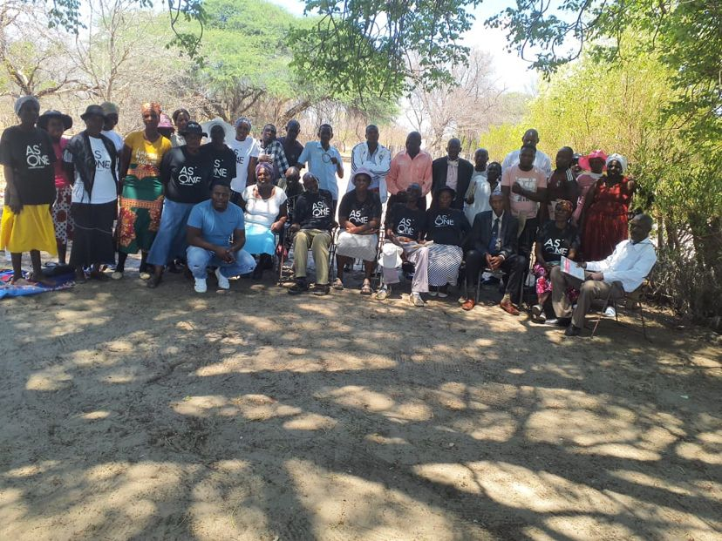

Figure 1 the 20 Trained women in conflict mediation posing for a photo with some duty bearers

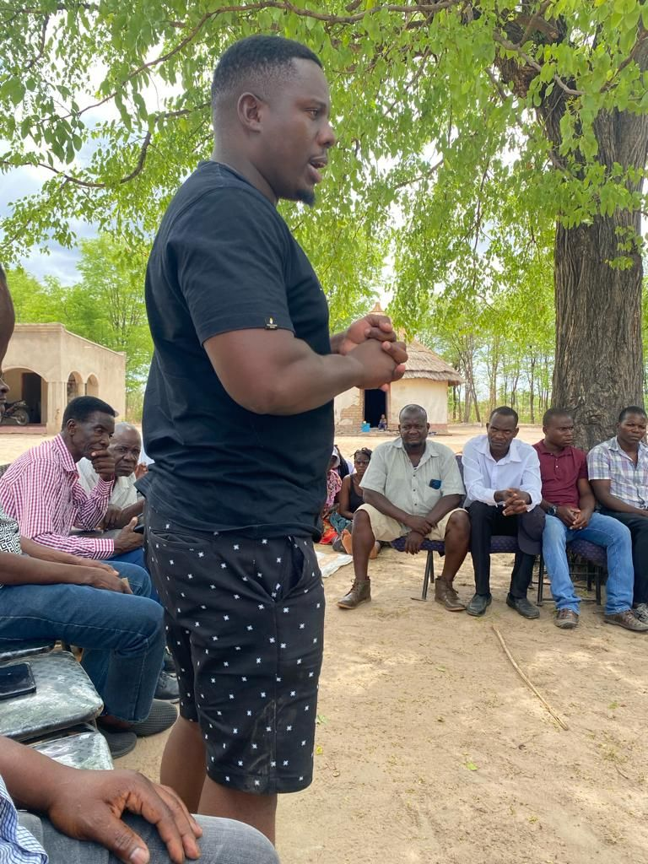

Figure 2 Training of Duty Bearers in Mediation and Conflict Mapping

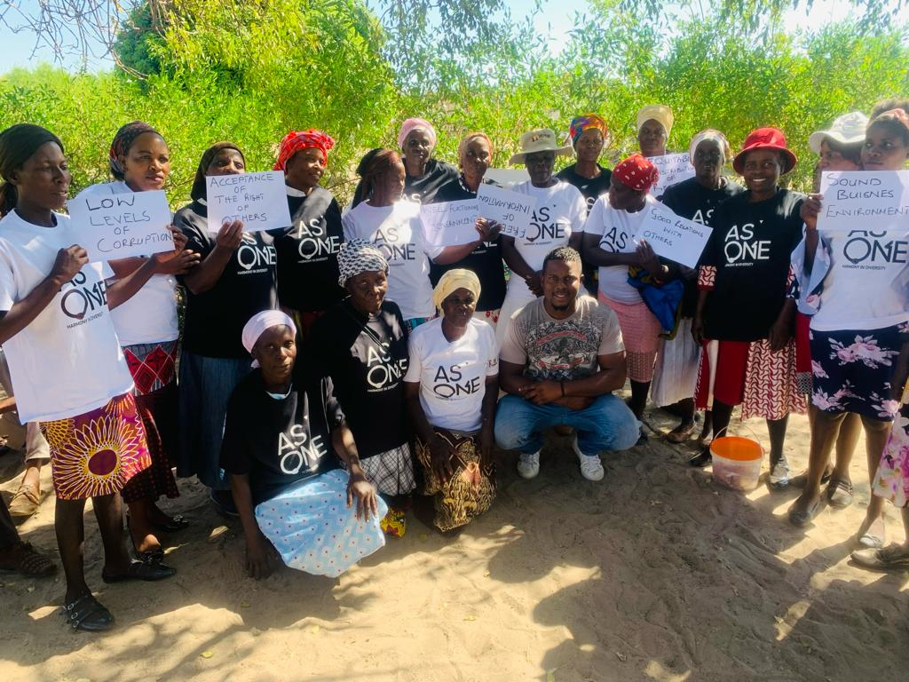

Figure 3 WPCM members pose for a photo after a training in Early warning and early response