The Plight of South Sudanese Refugees in Uganda Confronting Gender Based Violence in Bidi Bidi
Rebecca N. Mukiibi
Bidi Bidi Refugee Settlement, Yumbe District, Uganda
August 2022 - March 2023

ABSTRACT
Refugees like everyone else have an enormous drive to sustain themselves, generate their own income and create dignified livelihoods for themselves and community. Unfortunately, even in countries like Uganda with open door policies, there are still limited opportunities, services, and resources to fully assist refugees and displaced populations tap into their true potentials. Based on academic analysis, field work and independent research, this report investigates and focuses on the inescapable daily threats confronting refugee women and youth in Bidibidi refugee settlement, particularly around the problem of gender based violence. The report presents the underlying social and economic challenges that have confronted refugees in Bidi Bidi since the settlement was established, and why gender based violence, sexual exploitation and abuse are not only prevalent but a continuous disruption to peace building efforts and sustainable development in the region. Equally important, this paper delves into my collaboration with Sina Loketa a community based refugee organization and our efforts to not only spread awareness on these prevailing issues, but also implement a Rotary Peace Fellowship Social Change Initiative centered on short and long-term interventions on promoting Positive Peace and Prevention of Sexual Exploitation and Abuse (PSEA) in Bidi Bidi.

CHAPTER ONE
Migration is an expression of the human aspiration for dignity, safety and a better future. It is part of the social fabric, part of our very make-ups as a human family. - Ban Ki-moon
In 2022, the global refugee crisis reached historical highs with more than 32.5 million registered refugees and 4.9 million asylum-seekers pleading for refuge and security outside their countries of origin. Distinctly, millions have fled Afghanistan, Syria, El Salvador, Myanmar, South Sudan, the Central African Republic, and Ukraine just to name a few of these countries as a result of: ongoing conflicts; sudden economic collapses; droughts; natural disasters; and unbearable weather conditions. While refugee experiences are not a new phenomenon, these accounts remain a significant part of todays top social and humanitarian challenges influencing globalization, and the dynamics of international relations and migration.
Seeking and getting asylum are just two strenuous aspects endured by refugees. On the other hand, refugee pre-migration experiences linked with additional challenges of integrating and settling into a new or unfamiliar country can significantly affect the wellbeing of families and vulnerable populations, particularly women and children. In many cases, refugees are forced to flee unexpectedly, with little to no personal possessions, and sometimes with or without their families. The trek to safety is generally long, haphazard and treacherous. On top of this, refugee experiences in the host country are often riddled with added forms of insecurities, for instance, challenges of learning or understanding a new language, adapting and adjusting to different cultural norms, difficulties continuing with education and finding reliable work to confidently support themselves and their families.
Given the complex and often myriad conditions and interests of refugees, this paper focuses solely on illustrating the plight of South Sudanese refugees in Uganda in connection to my implementation of a Rotary Peace Fellowship Social Change Initiative (SCI) in Bidi Bidi Refugee Settlement. This report outlines the findings of my SCI fieldwork, research and collaboration with a local organization in Bidi Bidi and is designed to examine the conflicts & social economic dynamics in the camp, the issue of gender based violence and to identify culturally appropriate strategies and models for intervention. In other words, the report is not only an evaluation of refugee experiences, their inescapable relationship with host country nationals, but also a summary of the underlying drivers and consequences of gender based violence in the settlement. In the literature review section, I also analyze current discourses on refugee experiences, policies and interventions assumed to protect and preserve the wellbeing of vulnerable populations. Finally, I conclude with some personal recommendations based on my personal observations and experiences from the project thus far.
Background

Uganda
Today, Uganda a small landlocked East African country with a population of 45 million people, ranks as the third-largest refugee-hosting country in the world and largest refugeehosting country in Africa. In mid-December 2022, Uganda become home to more than 1.52 million registered refugees and asylum-seekers fleeing conflicts from mostly neighboring countries in the East and Horn of Africa and the Great Lakes region, such as South Sudan, the Democratic Republic of Congo, Somalia, Burundi, Eritrea and several others. Uganda’s notable high refugee rate is often credited to the fact that it has established one of the most progressive models of refugee protection, management, and resettlement in the world often referred to as “open door policies” for refugees. These policies are principally written in Uganda’s Refugee Act of 2006 as well as the 2010 Refugee Regulations which provide a strong legal and regulatory framework for refugee rights in Uganda. It is worth noting however, that the practice of receiving and aiding refugees is not recent or new for Uganda, but an active mission the country has historically been engaged in since World War II. Notably, as a protectorate of the British Empire and in response to the global conflict at the time, in 1942 Uganda welcomed 7,000 Polish refugees, mainly women and children fleeing persecution by the Soviets and Nazi Germany. These early refugees were placed in two settlement camps Nyabyeya, in Masindi District and Koja (Mpunge) in Mukono District. These refugee camps had extensive facilities like primary, secondary, and vocational schools, churches, hospitals, orphanages, recreational centers, and even cemeteries, which were managed my the refugees themselves. In his 1993 book on this topic, Lwanga-Lunyiigo illustrates that these services were provided because “the policy of the government was to make the camps self-sufficient as quickly as possible. To this end the refugees were encouraged to cultivate their own food and to make their own clothing.” Presently however, the notion of self-sufficiency is still something most refugees still grapple with especially within the confines of refugee settlements. Even though refugees in Uganda legally have more rights than some refugees in other countries, a majority are still struggling to make ends meet due to limited services, productive opportunities, poor infrastructures and living conditions.

South Sudan
When Uganda experienced an influx of refugees from South Sudan in 2016, the Ugandan government was prompted to establish a new refugee settlement alongside the South Sudanese border in Yumbe District called Bidi Bidi. This particular rush of refugees were driven by ongoing civil conflicts in South Sudan and were distressed from hunger, floods, and intercommunal tensions. For context, it is important to realize, that four years prior to this heavy flow of refugees that were placed in Bidi Bidi, what is now the republic of South Sudan had endured more than fifty-five years of armed struggle and had gained independence on July 9th, 2011 following a secession from Sudan. The Sudan People’s Liberation Army/Movement (SPLA/M) assumed control over the new South Sudanese country and its government under the leadership of Salva Kiir Mayardit one of the movements most prominent figures. What appeared as a promising democratic and peaceful step forward for the new sovereign state, the South Sudanese people and the region, on the contrary ensued more unchecked violence defined by a military aristocracy under Kiir and SPLA/M. The president’s regime was composed of warlord-style rebel leaders elevated to the top of a ruling class characterized by ethnicity and motivated by resource capture schemes. In December 2013, the South Sudanese Civil War erupted between Kiir’s presidential guards after he ousted Vice President Riek Machar based on accusations of violence and an attempted coup through the Sudan People’s Liberation Movement-in-Opposition. The political clash between Kiir and Machar, ignited the catastrophic five-year civil war between South Sudan’s two largest ethnic groups the Dinka and Nuer. President Kiir a Dinka and Machar a Nuer. Although several peace deals were presented to end the hostilities, the tribal tensions between the two major ethnic groups continued to engulf the rest of South Sudan effecting all the other tribes across the young nation. The fighting made millions of innocent people and communities vulnerable and eventually forced many to flee as refugees to neighboring countries like Uganda and contributing to the formation of the South Sudanese refugee community in Bidibidi, the focus of this report.

Bidi Bidi Settlement
Bidi Bidi also written as Bidibidi, is geographically located in the northern West Nile region of Uganda. The region is home to the Aringa people a Central Sudanic ethic group who are the indigenous people, and landowners of the area. Therefore, in this report, I generally refer to the Aringa population and community in Bidi Bidi as “the host community,” “host community members.” Prior to becoming a refugee settlement, the majority of the Aringa host community members resided in rural villages of their own, however, the region had minimal development and considered bush. With the arrival of the refugees, in about a year or in 2017, Bidibidi quickly grew into what is often referred to as a city of more than 270,000 people. Based on recent UNHCR data, the population of Bidibidi has since declined to 192,223 refugees as of January
2023. The population decline is primarily due to several large numbers of refugees returning back to South Sudan over the years, as well as the Ugandan government’s decision to stop settling new refugees in the area primarily because the government does not want the refugee population to surpasses that of the nationals as has been reported recently in a similar cases with the Adjumani refugee settlement. It is believed that if the refugee population surpasses that of the nationals, there are high chances this might instigate non-peaceful coexistence in the communities and increase food scarcity among other problems provoking refugee to hostcommunity tensions.
Although Bidibidi is often referred to as a city due to its large demographic population size and geographic area, the settlement in itself does not physically fit the common attributes given to urban or dense metropolitan areas like Kampala the capital city of Uganda. Bidibidi is made up of five regions named numerically Zone One through Zone Five which consist of several villages each. Although the Ugandan government is gradually expanding electricity polls in the area, the camp and local villages are still situated on arid terrains which remains mostly underdeveloped with unpaved roads and limited transport systems. Apart from several water wells, there are still no advanced critical infrastructural systems or central businesses in the settlement except: several small sparsely placed village centers in each zone, with makeshift shops selling some basic goods, mobile money kiosks, a few local markets and restaurants. In the five years of settlement, the majority of the refugees have moved out of UNHCR plastic tarp tents and have now constructed and live in traditional African thatched roof, mud huts assembled into family compounds with small to medium kitchen gardens.

Problem Statement
The majority of the details in this section of the report are derived from formal interviews and casual conversations I had with various individuals and families I met and got to know very well in Bidibidi about their personal and lived experiences as refugees. Based on my time in Bidibidi and interactions I had with both refugees, host community members, teachers and NGO workers, I recognize that there are several overarching challenges & socio-economic dynamics that are impacting the community at large. For instance, youth unemployment rate is very high and the majority of households are suffering from food insecurity because the food distributions has been disproportionately reduced, while on the other hand cash assistance payments are not enough to help meet people’s basic needs. There is constant land and resource disputes between the refugees and the host community, for example over water and firewood. In addition there is high levels of malaria due to poor housing conditions. Furthermore and perhaps more troubling is the staggering Gender Based Violence (GBV) and overall deterioration of people’s mental and physical health due to all the traumas of these situations. According to multiple sources in the camp, most of these situations for instance the problem of GBV were exasperated with the outbreak of the COVID-19 pandemic but continue to seriously impact the community to this day.

Goals and Objectives
The initial goal for this initiative was to help support refugee youth and women build positive connections through productive collaboration by helping local refugee organizations develop more income generating activities in their communities. However since visiting zone one and two in Bidibidi, and witnessing first hand that gender based violence and abuse are a prevailing problems the project focus shifted into helping local leaders and youth find and establish local solutions to increase Prevention of Sexual of Exploitation and Abuse in the settlement.
Like any other community, gender based violence in Bidi Bidi manifests in many forms such as physical abuse, sexual assault, mental and economic harm inflicted on a person due to socially ascribed power imbalances. In the refugee camp however since the majority of the population are women and children they often become victims of violence, abuse, rape and various types of exploitation. During my conversation with Mama Joyce a local women’s leader in the community, it was brought to my attention that due to gender norms women and young children, especially girls are prescribed to domestic work like fetching firewood and water for household use which puts them in dangerous situations and makes them more vulnerable to gender based violence. Since there is a shortage of firewood in the settlement and the few available water taps located in each zone are prone to being faulty or frequently run out of water having to accommodate so many people causes many young girls to travel long distances and to wait in long lines to get what they need. By the time they retrieve the firewood or water it might be dark or far off in isolated areas which makes them susceptible and defenseless to attacks and perpetrators of sexual exploitation and abuse. In other cases of abuse, the perpetrators are not complete strangers but individuals that victims know, trust, or even live with. For example, in Bidibidi, there are countless stories of unaccompanied minors or refugee children without parents or legal guardians. In these situations unaccompanied minors often join up with other households which often leaves them accessible to sexual violence and abuse not only in the refugee settlement but on the pre-migration you from South Sudan to Uganda.
Since these issues mostly impact women and youth, the target populations for the project mostly includes: youth and single mothers, however participation of men and local leaders is also essential. Listed below are some of the primary goals and objectives outlined for the project:
- Our first and main goal is to run a series of PSEA, positive peace workshops alongside awareness campaigns to sensitize the entire community on these problems and drivers of GBV, for instance strong patriarchal mindsets that often compromise the conditions and wellbeing of women and girls.
  - One of the objectives is to at least help participants gain the self confidence in their knowledge of PSEA and Positive Peace so they can become youth ambassadors that can speak up for peace and against SEA and other harmful behaviors.
  - The second objective is to help participants learn how to apply the positive peace approaches as a tool for positive change and sustainable development in their communities.
- However, to do this successfully, we also need to target and engage groups that are most inclined to commit these offenses for instance young, idle, unemployed youth and men as our second goal, to help them to find productive activities and training programs.
- At the same time, encourage local authorities and partners organizations to help inform community leaders and elders to help prioritize these problems on a local level. Settlements like Bidibidi need grassroots protection systems and through their influence community leaders and elders can help enforce policies that not only hold perpetrators accountable but also help victims find safe and meaningful support systems in reporting cases and receiving additional resources.
- The final goal is to build the resilience of children and women that might be victims of PSEA by integrating short-term responses with long-term objectives through diverse intervention methods. This means engaging the community through a variety of activities including: diverse empowerment workshops and skills capacity trainings.

Challenges and Mitigation Strategies
Without reliable and full time employment in the settlement, the majority of refugees in Bidibidi are struggling to meet their basic needs, and therefore depend heavily on humanitarian aid and support from organizations like: CARE International, International Rescue Committee (IRC), PLAN International, the World Food Program (WFP), World Vision, and UNHCR just to list a few. However, due to the COVID-19 outbreak, recent conflict in countries like Ukraine, and overall global food insecurity, humanitarian support and key interventions for instance around GBV keep declining for those who need it most in refugee camps like Bidibidi. For example, in terms of food insecurity, households that used to receive 12 kilograms of food items consisting of rice, beans, or maize flour have had their rations reduced to only 4 kilograms a month. Cooking oil which is often included in the distribution has also been reduced making it difficult to cook proper meals. The cutbacks in food distribution and other vital services is causing serious anxieties for many households, forcing many refugees to sell portions of what little they receive during food distributions for cash and pushing others into committing desperate acts of petty food theft and crimes from neighbors. Despite of being aware of these circumstances in the settlement, the Office of Prime Minister (OPM) the WFP and other aid organizations continue to call out for additional aid to ensure refugee assistance, however there has been little to no improvement to address these needs in places like Bidibidi.
Since unemployment is already a problem in Uganda even for the host country nationals, refugees are finding it intensely challenging navigating and accessing job opportunities especially inside the refugee camps. For refugee children and women, low income opportunities and food insecurity can also equate to them either partaking or being coerced into unreasonable measures like trading sex for food, money and other resources which they might need to survive.
This too is another form of GBV. Since most of the opportunities that were previously available to refugees settlements have either been disrupted or cut short in Bidi Bidi, to mitigate some of these problems is to empower local organizations like Sina Loketa to conduct outreach and interventions that will can help refugees become more self-sufficient rather than dependent on aid organizations. Without the right interventions, tools and knowledge to either protect themselves or sustain themselves properly the ramifications for refugees particularly in settlement settings are too high and should be avoided at all costs. For example, when it comes to GBV or sexual exploitation and abuse, the consequences often include: forced early marriage, teenage pregnancies, short and long-term physical and mental health like depression, victimblaming, getting ostracized from families and the community, isolation, substance abuse, and even attempted suicide which are life-threatening or have long-term adverse effects.
CHAPTER TWO

Literature Review
For most countries, immigration policies and refugee response have become imperative, everyday, contentious points of discourse in both the public and political spheres. In fact, as conflicts, disasters, religious and ethnic persecutions escalate globally, more segments of society including scholars, politicians, journalist & even everyday citizens are not only interested but are increasingly coming together to exchange and share their views on the matter. What seems most apparent is that there is a greater interest from people what implication refugees might have on the rest of society, as well as what the economic and political ramifications might be for countries taking them in.
Over the past few decades, several studies have been proposed to respond to concerns regarding the position of refugees in host countries, and one of these explanations points to the idea of protracted refugee situations. The United Nations High Commissioner for Refugees (UNHCR) defines protracted refugee situations as situations in which at least 25,000 refugees from the same country have been living in exile for more than five consecutive years. Refugees in these situations often find themselves trapped in a state of limbo: while it is not safe for them to return home, they also have not been granted permanent residence to stay in another country either (UNHCR-USA). According to Tulibaleka, Nakalema, and Tumwesigye, these protracted situations are actually a hinderance to refugees because the longer refugees stay in the host country without clear resettlement or repatriation options their desires and needs also change and as a result they undergo additional challenges especially when they are unable to meet those needs. In the case of refugees in Uganda, current data from UNHCR shows alongside previous studies confirm the presence of protracted refugee situations in Uganda as a critical factor that needs to be monitored and addressed. As a matter of fact, South Sudanese refugees in Bidibidi are a great example of the protracted situation seeing as 2023 marks almost seven years since thousands (more than 25,000 asylum seekers) arrived in Bidibidi and other settlements in Uganda, however there are no signs of them, the majority returning to their country of origin or getting resettled elsewhere. As a solution to this dilemma, a number of authors have recognized that integration into the local communities might be the best explanation to responding the protracted refugee situations (Dryden-Peterson and Hovil, 2004; Kaiser, 2006; Kaiser, 2010; Omata, 2012).
According to a 2010 UNHCR Global Report on Uganda, under the Refugees Act of 2006, Uganda’s asylum policies up hold key rights, including freedom of movement and expression. The Government favors a settlement approach, whereby land is provided to refugees in order to help them become self-reliant. With all these rights and freedoms being granted to refugees in Uganda, one might think that there is really no reason or explanation why refugees residing there should be facing any serious hardships. This too has been explored in prior studies by multiple scholars and it is reemphasized that the predicament of protracted situations actually compromises the idea of self-reliance regardless of the policy and its statement. To put it differently, once refugees are placed in settlements or camps they intrinsically lose the ability to become self-reliant since they become dependent on international assistance for security, food, water, shelter, medical treatment, education and other human needs (Crisp 2003; UNHCR 2001; Harrell-Bond 1998; Thomas and Schenkenberg van Mierop 2004). Previous studies by these same authors also indicate that:
there is, in fact, general consensus in academic and policy arenas that the longterm effects of protracted camp situations may actually threaten the success of the durable solutions required to close camps, and undermine people’s capacities to successfully meet post-refugee livelihood challenges (ibid.; UNHCR 2004; Jamal 2003). An emphasis on supporting the development of long-term refugees’ selfreliance is widely advocated, yet to date only pursued in a piece-meal fashion (ibid.). (pg. 107)
UNHCR defines self-reliance as the social and economic ability of an individual, a household or a community to meet essential needs (including protection, food, water, shelter, personal safety, health and education) in a sustainable manner and with dignity. One complication with the idea of self-reliance however is that it is difficult to measure it which perhaps makes it challenging to achieve amongst refugees despite increased public efforts by governments and humanitarian practitioners promoting it as the answer to refugee intervention. According to Seff, I., Leeson, K. & Stark on their article on measuring self-reliance through a new Self-Reliance Index (SRI), the humanitarian community’s shift towards self-reliance actually comes in part in response to more traditional emergency response frameworks’ failure to adapt to the needs and realities of current refugee and Internally Displaced People (IDP) populations. Since the inability to keep with needs and realities of refugees is a common observations by several scholars and researchers, it seems like an essential next phase for host countries like Uganda is to start reevaluating their refugee policies and whether or not they still align with current refugee trends, challenges and needs. Otherwise, if this point is neglected, regardless of whether the policies seem progressive or not on paper, as long as refugees keep expressing concerns and protracted refugee populations keep increasing there will be serious implications for the host countries and refugees. If better solutions were available for refugees to become more self-reliant, I strongly doubt they would pass up the opportunity. While emergency response models have been the primary standard to manage refugee populations, they have tarnished the image of refugees as vulnerable and made them more susceptible to humanitarian assistance and aid.

Theoretical Underpinnings
Considering the theoretical background of gender based violence and sexual exploitation and abuse amongst refugee populations in settlements in Uganda is an important part of examining various forms of literature. In the existing literature, there are several theories that are used to illustrate and clarify refugee experiences as well as to conceptualize the term gender based violence. In this report I will focus and cover just a few of these theories that I trust will contribute more to understanding social contexts the key topics. It is beyond the scope of this report to mention all the theories that conceptualize this part of literature.

Migration
To start, one approach that is most commonly utilized in the literature of refugees is migration. In their report on theories of migration, Xiana Bueno and Victoria Prieto-Rosas define migration theories as: an attempt to understand the reasoning behind and motivations for the decisions of individuals and households to move from one location to another – domestically or internationally – as well as the factors that explain the maintenance of migration flows over time. Different theories employ different concepts, assumptions, and frames of reference depending on their discipline of origin and the time in which they were formulated. Even though this definition seems loaded and it reminds up that the topic of migration is intriguing because there are countless other theories that have developed from it and guide us in understanding the causes of and motivations for individual and household migration decisions in addition to the primary reasons why these decisions were made. Another important point to consider about the theorization of migration, is that this particular concept goes as far back as the 20th century, and this is perhaps one of the main reasons so many other theories have derived from it.15 Buenos and Prieto-Rosas document that classical theories of migration have primarily focused on economic migrants and have subsequently included older migrants as long as they belong to the kinship network of economic migrants. One of these examples of migration theory is institutional theory which points out how nonprofit organizations mediate the migration process by capitalizing on the mismatch between a large number of potential migrants seeking to migrate to developed regions and the restrictions imposed by governments on legally admitting those migrants into their territories. This perspective is fundamental to highlighting vulnerable groups such as women, children and older populations that are presently the primary target groups for humanitarian organizations ensuring the defense of their human rights and improving their living conditions upon arrival and while in transit (Massey et al. 1993).

Dependency
The second term, is Dependency theory which is described by Theotonio Dos Santos, one of the founders of dependency theory, as “a situation in which the economy of certain countries

15 Bueno, X., & Prieto-Rosas, V. (2019). Migration Theories. Retrieved from https://ced.cat/wp-content/uploads/
2019/09/Bueno_and_Prieto_Rosas__Migration_Theories_Preprint__2019.pdf
is conditioned by the development and expansion of another economy to which the former is subjected” (Dos Santos 1970, p. 231). “Dependence” in the international system can be used as a measure for explaining global inequalities. In order to adequately examine the usefulness of the concept of dependency theory for explaining global inequalities, and dependency theorists often draw a connection between the role of the capitalist system and the underdevelopment of the periphery. “The relation of interdependence between two or more economies, and between these and world trade, assumes the form of dependence when some countries (the dominant ones) can expand and can be self-sustaining, while other countries (the dependent ones) can do this only as a reflection of that expansion, which can have either a positive or a negative effect on their immediate development.” (Dos Santos 1970, p. 231) . Each of these theories could be of use in explaining refugee experiences, situations, and the gender based violence that plagues most settlements in Uganda.

Change Theory
As stated throughout this report, there are countless challenges impacting the wellbeing of refugees in Bidibidi settlement. The research findings for instance point to both individual and communal conflicts that refugees grapple as well as overarching disruption of socio-economic dynamics in the community. These dynamics range anywhere from high unemployment of youth, food insecurity, water stress, tensions with host community population, mental health, and gender based violence. Although this report focuses most only GBV, most of these problems are very much interlinked and one of the main reasons the are repeatedly mentioned. Similarly as a multifaceted problem, gender based violence does not have just one single solution and therefore requires several interventions and approaches. All things considered, implementing this SCI is one example of the benefits of applying different methods and approaches to mitigate the problem on GBV in places like Bidibidi. Through this project, myself and the local organization in Bidibidi have been able to build a great network and an understanding of what is needed to achieve our goals and objectives in confronting GBV, spreading awareness and further preventing SEA.
As a part of these efforts I have developed a “Theory of Change on PSEA and Positive
Peace,” a visual diagram that demonstrates some approaches needed to address gender based violence in Bidibidi while also strengthening community cohesion. Inspired by the insights and knowledge I gained during my field visits, conversations with refugees and skilled experts on the topic of gender based violence and SEA, this theory of change articulates at least one way an effective response to this problem might look like. I outline the specific interventions taken in this SCI project and demonstrated how they intersect into impactful social change. I also anticipate that the visual diagram might at least be of help to other scholars or practitioners like Sina Loketa working on the same topic to monitor progress in their community or simply applied as a useful framework and tool to develop other theories of change that either respond to GBV or similar problems.
To achieve a vision without gender based violence or sexual exploitation and abuse in refugee settlements like Bidibidi, women, girls and in this case children need to have equal status and protection in society as men and boys so they can achieve their true potentials. This problem is not just a refugee problem or community problem but a development and human rights problem. Preventing sexual exploitation and abuse is one initial step towards ending gender based violence and allows victims the opportunity to seek and gain proper support networks and treatment so they can regain their self confidence, agency and power. In this case, our strategy for was to implement a number of activities to help mobilize different groups in the community, and help create awareness of the harmful impact of GBV and SEA. Although Sina Loketa does not directly provide services to victims, the organization is a central part of the community, a safe space and place for victims, allies, families, community elders, and humanitarian practitioners alike can coalesce and get resources for victims and other vulnerable groups in the community. Since GBV is a massive problem, it is important that all the different stakeholders can get together to work towards confronting the problem collectively. The outcomes from the Theory of Change reflect some of the changes I hope to see as a result of the different activities from the SCI. For example, we anticipate that the outcomes can reflect some changes attitudes and conditions of women, girls and youth, as well as the community types of protection services, polities and laws in the community. Since poverty and economic insecurity are additional drivers of gender based violence the diagram also highlights the need for skills training and income generating activities, which are necessary in increasing economic security and reduce their financial dependence on others and not fall prey to promiscuous alternatives.
To realize impact and change from this project, the Theory of Change diagram shows that women, girls, youth need to have equal access to coordinated GBV assistance & support. If the intervention activities are effective and the community is aware of these services, and quality protection and PSEA services are available, in both the short term results and long term impact this change can be achievable. Another point of impact that is hoped to come out of this project is development of a safer community environment for children and women which again is a result of better protection services as well as dissemination of key information across the settlement such as laws that can be applied to hold perpetrators accountable and also provide victims the opportunity to report incidents without fear of being persecuted. Additionally, for real impact, there needs to be an actual sense and feeling of empowerment amongst victims and other vulnerable groups in the community. The women in leadership and public speaking activities for example are intended to enable women and girls, especially teenage and single mothers to learn how to exercise their rights, use their voices and make decisions that are important to them, and find confidence in the community as leaders. For the young girls we would like to also see a decrease in teenage pregnancies while also seeing and increase in girls returning to school. In addition to this project along with the income generating programs would allow women and girls a chance to gain real training, skills and information and help them expand their networks in a positive way. Addressing gender based violence and supporting the needs of victims requires a lot of work, but it can be achievable over time. This theory of change model is not absolute because as the social dynamics and needs of the community evolve we hope to monitor and revise it where needed to meet our overall goals of ending gender based violence.

THEORY OF CHANGE
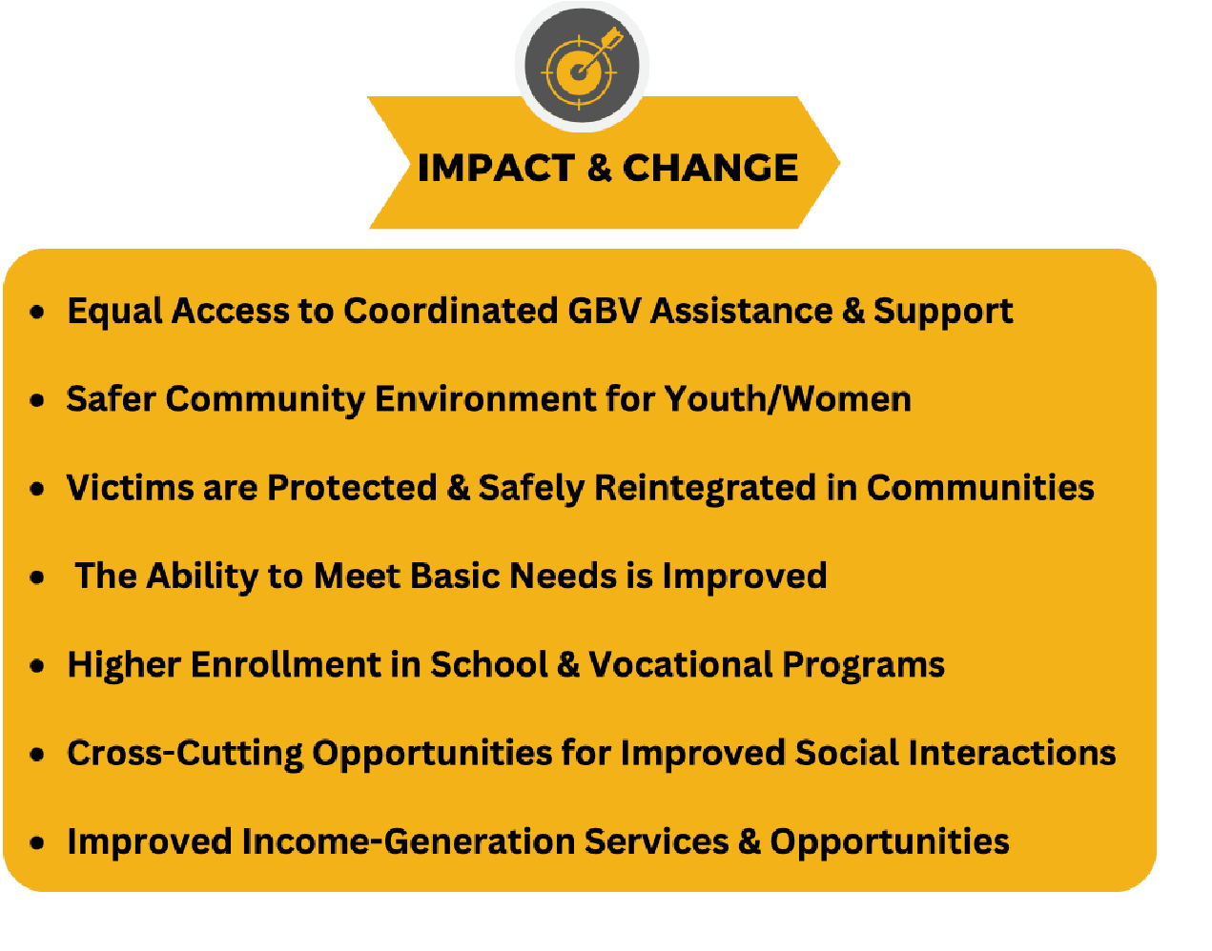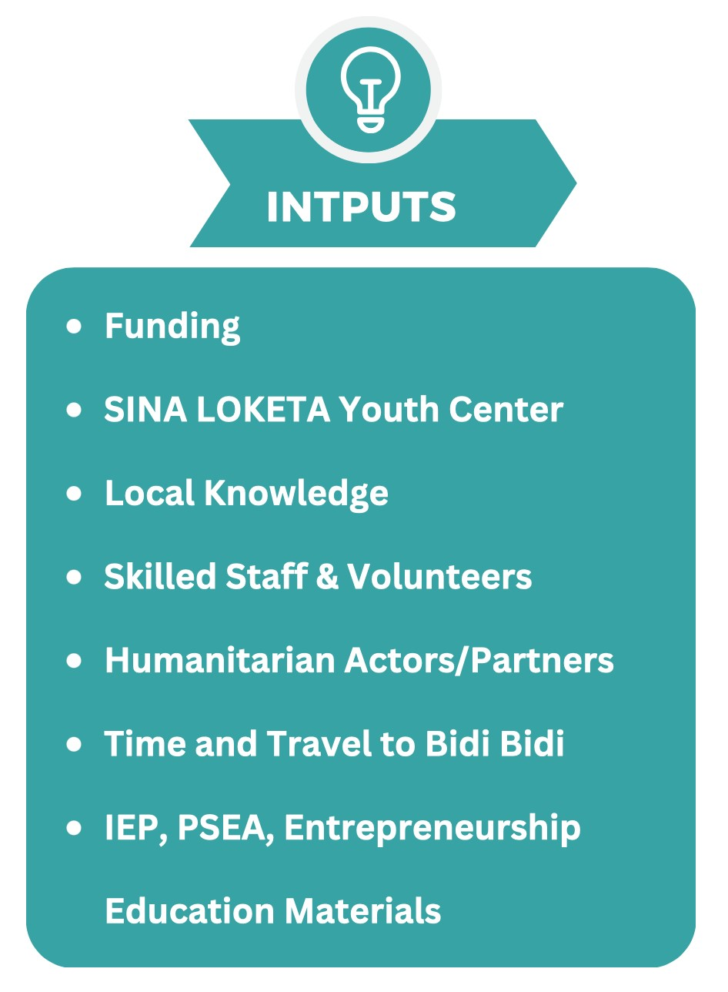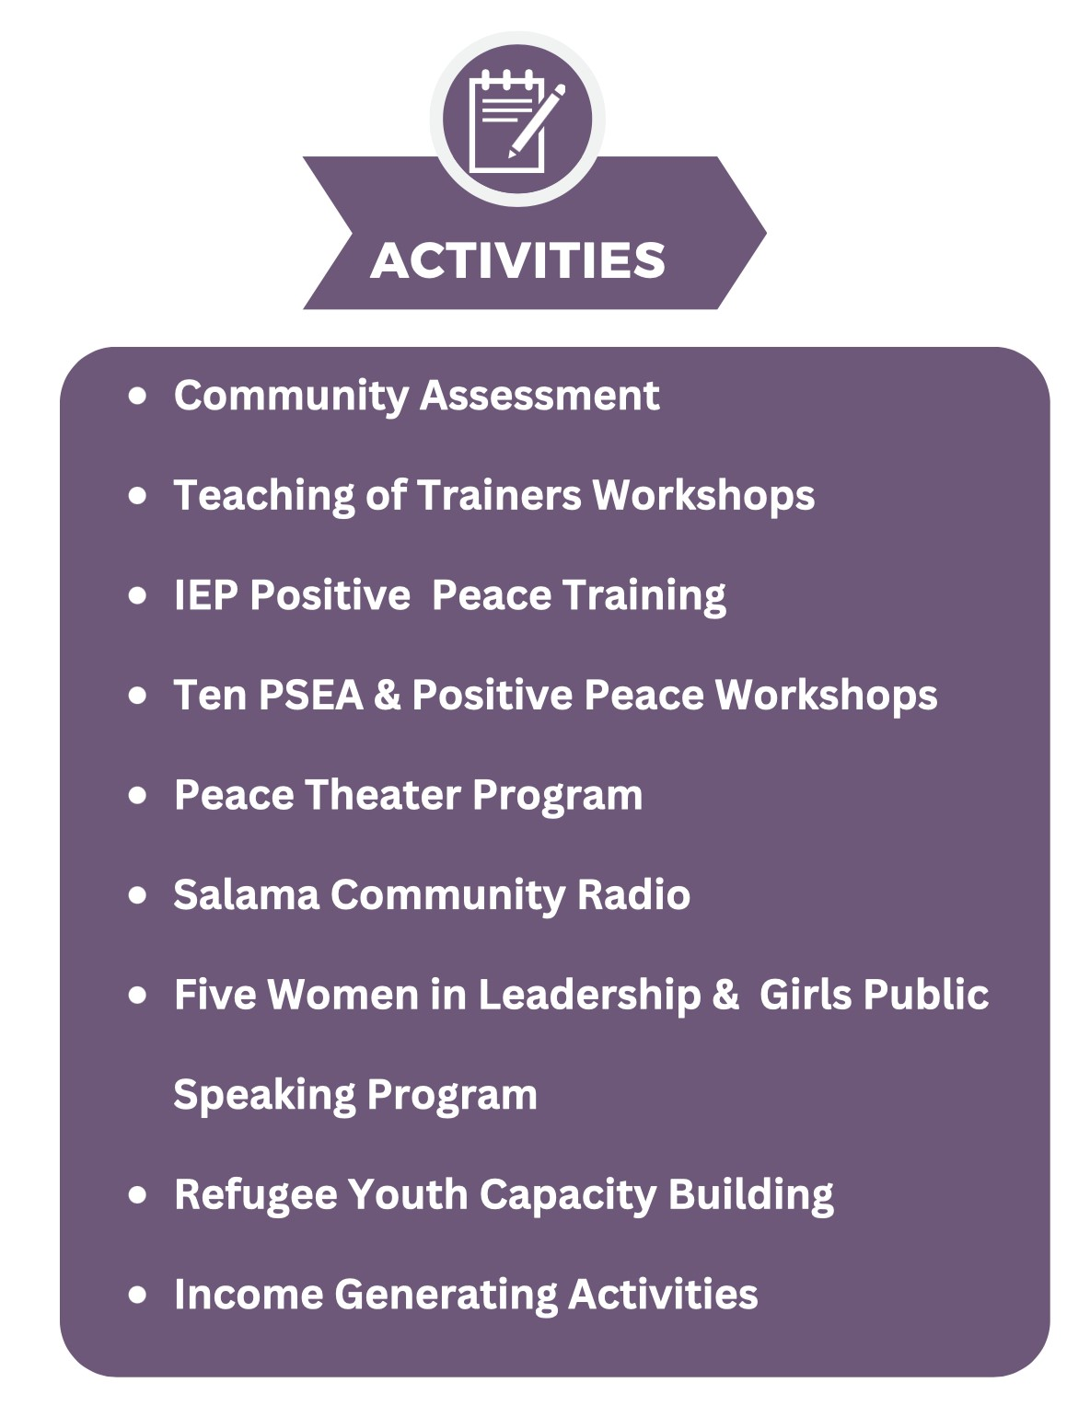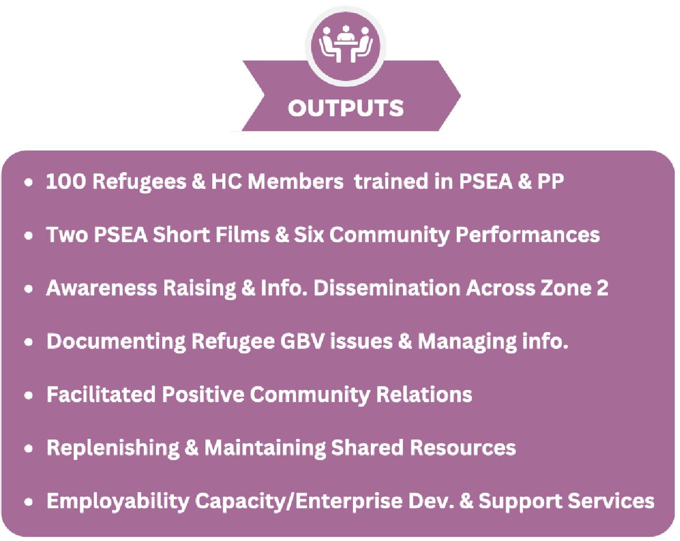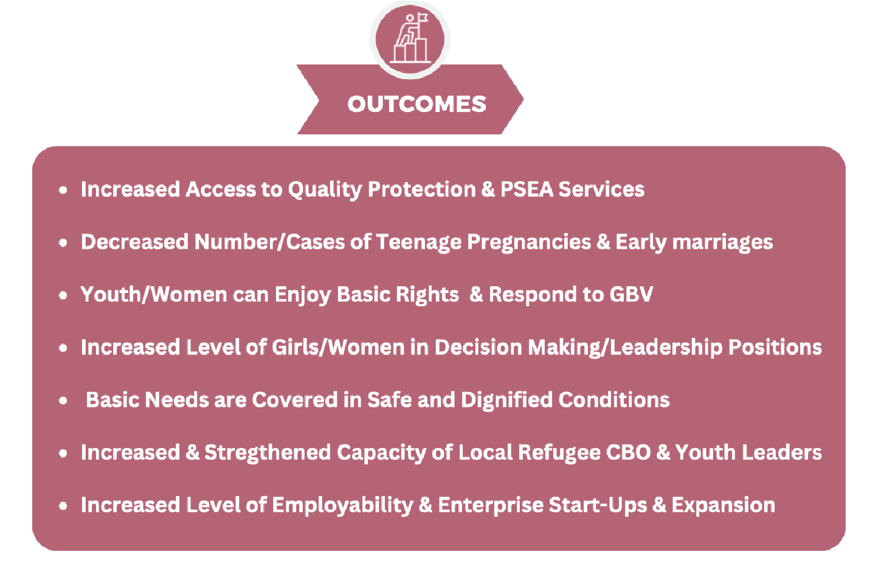

Methods and Design
In recognition of the fact that I am not from the Bidibidi community (a refugee or host community member) to carry out the Social Change Initiative project I partnered with Sina Loketa a refugee founded, youth-led non-profit organization in Bidibidi that already builds on creative capacities of young people to develop social capital through social entrepreneurship in Bidibidi. Sina Loketa was founded in 2018 about a year and a half after refugees were first settled into the camp when two of its founders Mawa Zacharia a South Sudanese refugee and Sylvain Himbana a Congolese refugee completed an extensive empowerment and social enterprise training program at Jangu International also known as SINA in Mpigi, Uganda. For the past four years Sina Loketa has developed into an influential local organization and space for refugee youth with a flourishing music program, information and communications technology (ICT) classes, entrepreneurship program, and a number of other community interventions for both the host community and the refugee population.
My research and SCI began with my acceptance of an invitation from one of the founders of Sina Loketa to investigate the situation of “sexual exploitation and abuse” in Bidibidi refugee camp. I had previously proposed a different SCI project to Makerere University and Rotary International for my fellowship, focused on economic empowerment of refugees and bridging the gaps between younger and older generations in the settlement but was pleased to receive advice from the Sina Loketa founders that research concerning gender based violence and introducing the concept of positive peace would be more valuable to the camp, the host community and local refugee organizations.
Initially, the plan was to carry out the project between five to six months starting in August, 2022 until January 2023. However, over time the project was extended beyond this period and estimated to end in Spring of 2023 to allocate more time for training, planning, and implementation of some of the activities. In April, 2022, I started coordinating with Sina Loketa to visit Bidibidi in the Fall of 2022 to see the organization, introduce myself and get acquainted with as many people as possible, and also get to know the community better through a community assessment. Afterwards, we decided that I return in October, 2022 to lead some workshops on positive peace and from their decide which activities were most suitable for our intervention on PSEA. We outlined several PSEA and positive peace activities and provided ourselves an extended timeframe from November, 2022 to April, 2023 in order to effectively and thoroughly facilitate workshops and project activities. This extension was a primary made by the Sina Loketa staff and based on their understanding of the community, holidays, and interactions with the local facilitators and trainers.
During the community mapping activity and focus group activity we made sure to separate participants by gender since women and men often have unique lived experiences, they might have different perspectives and provide different responses to the activities. For example, women often use different resources than men, and therefore they show the resources and features they think are important (such as water sources, firewood sources, and so on) and men will show those they think are important (such as grazing land, infrastructure, and so on). Ultimately, the results of the analysis will be shared between the PRA team, the community members, and other key stakeholders through visualization, public presentations and or discussions during meetings.. During most of the intervention workshop discussions, participants were divided into groups of about five, we gave them 20 minutes for the exercises and activities, about 10 minutes for preparation and and additional 10 minutes later to present and or discuss with the entire group. During these discussion and exercises we verbally and intentionally asked participants open-ended questions to increase participant engagement and to get more of their perspectives on the opportunities and challenges they see in their community or personal life.
On December 2 , 2022 we distributed a PSEA Survey to the PSEA and Positive Peace participants in person after the workshop to understand their general characteristics, understandings and opinions on SEA. The Survey consisted of sixteen questions measured on a 4-point Likert scale (Strongly Agree, Agree, Disagree, Strongly Disagree) and three response questions. The goal was to collect survey responses from all twenty-five participants attending the PSEA - PP workshops. Participants were given 10 minutes to fill in the survey and they were all fully completed.
To fund this project, I originally thought I would be able to apply for some grants to help cover the costs necessary for me to not only return to Uganda from the United States, but also finance the project activities. This was unfortunately not the case considering that most grant opportunities I came across earlier in my fellowship did not accept applicants applying individually for fellowship projects but rather enforced that grant proposals come directly from registered organizations. Nonetheless, this deterrence did not discourage me from moving forward with the SCI project. After my first visit to Bidibidi and once I established a feasible plan for the project and budget with the Sina lead staff, I organized an online fundraiser with a compelling short video of the project to help me raise some funding to cover the project costs and expenses. After the fundraising page was launched I shared the weblink on several social media platforms, directly to my personal networks, and with Rotary clubs and Rotarians I knew in the United States as well as in Uganda. In five months (October 2022 - February 2023) I raised 975.00 US dollars from fifteen individual contributions. In October 2022, Playing for Change Foundation a global nonprofit organization centered around music education and offers creative opportunities for marginalized and at-risk youth contributed 3000.00 US dollars towards the project after myself and the Sina Loketa staff submitted a project proposal for the PSEA project. Overall, while I was fortunate to gather some funding for the project, I self-funded a large amount out of pocket especially in the early stages of the project.
CHAPTER THREE
Interventions and Activities

Community Assessment
I chose to first visit Bidi Bidi for one week as a scoping exercise to meet the Sina Loketa staff and get a better understanding of the community, the context of the problem, and how most appropriately it could be addressed. I arrived in Bidibidi on August 5th 2022 with a team from Playing for Change Foundation one of the International Organizations that works with Sina Loketa as a funding partner and stayed for a full week engaging with the Sina Loketa, youth and other members of the community on a number of activities. Since I did not have too many days in the settlement, I decided to coordinate a community assessment which included facilitating a Participatory Rural Appraisal (PRA) comprised of several exercises: a community social mapping exercise, focus group discussions, transact walks in the villages, as well as through one on one interviews with refugees and host community members. The three main objectives for the assessment were: First, to help me develop a broad understanding of the various facets of social reality in Bidi Bidi, for example: get a better understanding of the social stratification, demographic, settlement patterns, and social infrastructure in the camp. Second, to provide a forum for discussion about the various aspects of social life for refugees and their host community. Three, learn more about the existing social institutions and the different views local people might have in regards to them.
On the fifth day of my field visit, I organized a community mapping exercise with the help of Sina Loketa. Thirty refugee youth, participated in the mapping exercise and focus group discussions initiated after the maps were presented to everyone. The aim of the community mapping exercise and focus groups was to: help me as well as the participants learn more about: Bidi Bidi settlement; the surrounding host community; existing opportunities, resources and challenges in the community; as well as to assess and measure existing programs. The PRA activities were designed to help spearhead discussion while also empowering the community members in Bidi Bidi to assume an active role in analyzing their own living conditions, problems and potentials in order to think of intervention that could result in positive change for the community. The community mapping exercise was successful in getting participants to identify and share how they: use community resources and the barriers they have in accessing them; compare perceptions of the importance of various community resources; and generate ideas for community improvement. Central to these activities was organizing a PRA team of refugee youth leaders that acted as lead facilitators during workshops. For instance, a facilitator from the youth group led the discussions about the maps, while another facilitator recorded the discussion and someone else kept time and was responsible materials.

Positive Peace Training
In October of 2022, I returned to Bidi Bidi for two more weeks and stayed with a refugee family while I facilitated five, four to five hour positive peace workshops For these workshops, I used the Institute for Economics and Peace learning materials to guide us in facilitating the training. I divided the lesson plans in two ways, focusing on introducing key concepts like positive and negative peace the first day and diving deeper into the other content on the second day, third and forth days. We engaged participants in several focus group discussions regarding the ideas of positive and negative peace, and also presented some examples of how the Global Peace Index and Positive Peace Index are applied in real life situations to demonstrate a country’s overall level of peacefulness. We used power-points, maps and graphs from the IEP learning materials to show where different countries were located during the GPI discussions and also provided fact-sheets to provide better contexts on the GPI analysis. The majority of the participants were new to this framework of peace but they were all very intrigued to learn more on how they can apply these concepts as a way to promote peace in Bidi Bidi. On the final day of the training, participants reviewed case studies of different countries where positive peace interventions had been adapted, and afterwards they too were asked and given time to present on some ways positive peace concepts could be utilized or applied to bolster sustainable peace in Bidi Bidi. This activity had thirty-seven participants from nine out of the eleven villages in Zone two that also represented different groups, including community elders, peace mediators, social entrepreneurs, host community members, ICT students and local women leaders. Once the activity was completed, EIP provided certificates to all the participants that attended at least four of the workshops and are now recognized as peace ambassadors in their community.

Gender Based Violence Interventions
With their knowledge and experience in positive peace, some of the participants from the positive peace training activity were asked to continue assisting with the SCI project in different capacities as peace ambassadors in order to spread the positive peace concept and PSEA to educate others in the community. Therefore, From November 2022 to April 2023, we are coordinating five activities as part of the SCI community intervention in Zone Two. These activities include:

Prevention of Sexual Exploitation and Abuse
On November 11, 2022, Sina Loketa launched the Prevention of Sexual Exploitation and Abuse (PSEA) and Positive Peace (PP) intervention Program. Similar to the community assessment, focus groups and Positive Peace trainings conducted in August and October, 2022 the PSEA & PP activities were carried out at the Sina Loketa Community Center in Zone Two, Village Three. For the first set of PSEA workshops, the program covered topics on teenage pregnancy and Gender Based Violence. The two facilitators worked with participants to discuss and review the various causes and effects of these issues and designed possible solutions that can be carried out in their community. Secondly, for the Positive Peace workshops, participants were introduced to the concept of Positive Peace and provided a brief overview of positive peace versus negative peace. Along with instructive sessions, the PSEA and PP workshops were facilitated through a learner-centered approach to engage beneficiaries in focus group discussions which provided and created valuable awareness for first time participants with little to no knowledge on these topics. The discussions helped participants understand the impacts of PSEA and how Positive Peace can be applied as a critical tool for community development. The Purpose of the trainings were to help educate refugee youth on the current prevailing problem of sexual exploitation and abuse in Bidi Bidi. Second, come up with solutions that can be applied on a community level to help prevent and limit cases of PSEA. The first two PSEA workshops were facilitated on November 24th and December 1st , 2022 and covered topics on sexual exploitation and abuse, STDs, teenage pregnancies, and GBV. The main beneficiaries of this activity were refugee youth ages thirteen to twenty years old. There were a total of twenty-five participants, ten boys and fifteen girls from the eleven villages located in Zone two of Bidi Bidi settlement. As an observation from the facilitators, at the end of the PSEA workshops participants were able to analyze the problems, root causes, effects of SEA and could also come up with some possible solutions of their own on how to confront this issue through a centered learning approach. Facilitators provided resources on existing channels where victims of abuse can seek help or where they could refer others experiencing abuse, report SEA, get counseling and get additional guidance. The Positive Peace Workshops were facilitated on November 25th and December 2nd 2022. These workshop were focused introducing the new group of refugees to the IEP curriculum, the concept of peace and the difference between positive peace and negative peace, topics of the global peace index, and the 23 GPI indicators. The main beneficiaries for these workshops are the same 25 youth participating in PSEA workshops. At the end of the Positive Peace workshops participants had more knowledge on positive peace and had a better understanding on which countries were considered peaceful, which showed improvements in peacefulness, which countries had deteriorating factors of peacefulness, the 23 indicators of the GPI and the eight pillars of peace. The PSEA and PP workshops were positively received by all the participants and were an effective approach in helping develop positive mind-sets. There will be six more workshop days dedicated to these two topics in march and April of 2023.

Peace Theater Program
This activity was designed as an alternative way of spreading awareness of PSEA to the community and provide youth an opportunity to be use their creativity to share stories about GBV that might otherwise be too sensitive to talk about or discuss in the community. This project is scheduled to take place in March and April 2022. Drama students will work with some of the positive peace ambassadors to come up with these PSEA stories along with a drama teacher to produce educational PSEA skits that can be performed in different villages in the community. We also intend to record two of these skits to share with other individuals who might not be able to attend the live community shows.

Salama Community Radio Project
The Salam community radio project was inspired by Mr, Hakim Joseph a South Sudanese refugee, peace mediator, pastor and one of the Positive Peace Trainees. Mr. Hakim uses his position in the community to help promote peace building efforts to support individuals in the community deal with various domestic issues and problems as a peace promoter and mediator.
During the COVID-19 shutdowns and restrictions limiting gatherings in the settlement, Mr. Hakim started the Salama Radio, by setting up a loud speak in this compound and borrowed some microphones and other sound systems to start spreading advice and announcements through a loud speaker. Through the use of a loud speaker, he not only preaches peace messages, Mr. Hakim uses his commentary to speak on topics like stress, and psychosocial trauma and focuses on sharing useful tips and indicators that people can look out for. He try to bring people close and helps them deal with signs of depression, and suicide. As part of the SCI activity, we are supporting and working with Mr. Hakim to use Salama Radio to broadcast peace-building and public service announcements on GBV since his broadcasting in far reaching through because its heard through Zone One and Two as well as parts of the host community. Through his broadcasts, he brings the community closer and helps different people some who are often struggling alone deal with depression and suicide. We will host five people from the positive peace training to help write or compose twelfth PSEA campaign messages that will be broadcasted in the community. Sine the host community are mostly muslim, he frequently invites muslim leaders from that community to also come speak as guest speaker.

Women in Leadership and Public Speaking Mentorship
This activity was part of a proposal from one of the women leaders in the community participating in the Positive Peace training and also as a response to lack of young women’s participation and engagement in community dialogues. Although most of the activities mentioned in this report as well as other interventions in the community encourage women’s participation most attendees lack the confidence to speak up in public spaces, especially when it comes to advocating for their needs and rights. This activity is intended to help and empower young girls and women through mentorship from women leaders in the community key skills in public speaking, how to use their voices and find their agency in society in order to stand up to GBV and other forms of injustices towards women, youth and other vulnerable groups. Through the public speaking activity, we hope to encourage participants to recognize that there is power in their voice, when they speak up either for themselves and others, and that their participation in key decision-making position is a powerful tool to help create positive change in the community, peace building, as well as addressing other key problems like GBV in the settlement.

Refugee skills capacity building initiatives
Lastly, for since August of 2022 I have been working with Sina Loketa to expand capacity building opportunities to refugee youth leaders through: Leading Teaching of Trainer workshops, grant writing lessons, Monitoring and Evaluation, project reporting, and powerpoint presentation skills. I trust that if we can increase skills capacities in the settlement, youth leaders will feel more inclined to apply themselves in more productive ways to find constructive opportunities that can help them and others in their community find and establish adequate tools and solutions to address some of the more pressing issues in the community like gender based violence and unemployment.

Key Findings - Impact
Since some of the topics covered in this intervention were new for some or most of the participants attending the workshops, we anticipated that after the completion of at least half of the PSEA and positive peace workshops, most participants would at least have a better understanding of what sexual exploitation, abuse, gender based violence, and the positive peace concepts were. However, from the SCI research and interventions we discovered that even when these groups understand and are familiar with how to identify cases and incidents of GBV or sexual exploitation, most of them are too afraid to report incidents to the proper authorities from fear of being prosecuted and stigmatized by others in the community. Sadly, given that GBV and sexual exploitation and abuse are so prevalent in the settlement, incidents are increasingly being treated as normal rather than the problem they are. Walking through Zone Two in Bidibidi, I observed that their are countless signs, small billboards, and placards from various aid organizations speaking up against gender based violence, teenage pregnancies with toll-free numbers but it is unclear if refugees actually use them to seek help or report incidents. One the topic of abuse against children or minors, there is currently a significant gap or shortage of action to protect this particular population. While in Bidibidi I was able to observe refugee verification procedures, a system similar to a census that OPM carries out about every two years to re-register and collect demographic data on refugee population. During verification, they track new births, people who have passed away and also verify which refugees are currently still present in the camp or might have returned to South Sudan. The problem that is often There are a handful of parents who return to South Sudan to farm or for better opportunities. Most of the parents never report their departures to the local authorities. In these cases, minors are left alone leaving older youth to look after the younger children. If the children face challenges they can reach out to the local leaders. In Bidi Bidi, there is already an influx of unaccompanied minors in the camp, children who come alone, they don’t have support, their parents were lost, or killed back in the civil war. When refugees pass away there is a cemetery for the refugees to bury, however some times the refugees want to return their family members back to South Sudan despite the dangers of returning home.
During the different phases of the project, we kept identifying drivers of gender based violence in the settlement and some of these include: strong patriarch mindsets and gender norms; poverty and polygamy; high levels of alcohol consumption and sometimes drugs especially amongst male youth; under-representation of youth and women in most decision making spaces; limited access to education and information to the general public; and poor and inadequate guidance especially among the camps large youth population. In light of these drivers of GBV, and the extreme consequences that are a result of GBC like forced early marriage, teenage pregnancies, short and long-term physical and mental health it is critical that more interventions are carried out in refugee settlements to support the camp’s most vulnerable population and to prevent a domino effect. When women and youth are impacted by gender based violence or other forms of sexual exploitation and abuse, other aspects of their livelihoods are also impacted. One example is teenage pregnancies, once a young girl gets pregnant, chances are she will never return to school and her household responsibilities also increased. If she drops out of school this will also damage any chances she might have of getting employment if she does not have the credentials to compete with other applicants especially since employment opportunities are already few in the camp. This situation will also impact her access to other basic needs like getting access to medicines, food, soap, and supporting others members of their household during emergency situations. If more funding is invested by either the Ugandan government and other partner organizations to provide more direct support to victims as well as education and vocational services to refugees, this might improve opportunities for youth and women in settlements like Bidibidi impacted by GBV. With the right types of interventions and commitment from local organizations, aid partners, and input from refugees, the impact in Bidibidi and other settlements might include:
- Equal access to coordinated GBV Assistance & support.
- Safer community environments for youth and women to live more dignified lives.
- Victims are protected and are safely reintegrated in communities when they report or speak on issues of GBV and SEA.
- The ability to meet basic needs is improved for women and youth in the camp.
- There is Higher enrollment in schools and vocational programs for everyone including women, single and teenage mothers.
- There is cross-cutting opportunities for improved social interactions between refugees and the host-community.
- There is improved-income generation services and opportunities available in the camp that allow refugees the ability to become self-reliant and not fully dependent on aid organizations.
CHAPTER FOUR

General Conclusion
Although not quite accessible, implementing a social change initiative in Bidibidi has been an extremely enriching and rewarding experience as a Rotary Peace Fellow. As this report illustrates refugees do not choose to become refugees but are a casualty of the spillovers of conflict and unforeseen natural disasters. Refugee experiences have so much to teach us all about humanity and are one prime example of why it is essential to start prioritizing positive peace approaches to repair broken social systems into more stable and sustainable social structures. This SCI has reconfirmed how strong and resolute refugees are even during challenging times and further evidence that with the right opportunities and access to effective resources, education and skills training refugees have the potential to not only revitalize communities but also national economies. Contrary to what some people think, refugees are not a hinderance or a threat to national security but untapped human capital, If more refugees were given reasonable employment opportunities, they can contribute billions to the host country economy,

Recommendations
When I first started working on this project and conducting background research I was astonished by the current issue of food insecurity in Bidibidi and how the WFP had reduced food and cash assistance for refugees. However, after further research and study, I recognize that maybe the humanitarian cycle of assistance in which refugees, especially those placed in settlements like Bidibidi are so accustomed are also not sustainable because they encourage dependency. I commend Uganda for having progressive open door policies for refugees of diverse backgrounds, however I also think the country is overburdening itself for hosting such a high number of refugees. Generally speaking, there are only three primary options available to most refugees:
- Repatriation: Voluntary repatriation is when refuges return to their home country, of their own free will, or once conditions have become safe.
- Resettlement: Is the transfer of refugees from an asylum country to another country that has agreed to admit them and ultimately grant them permanent residence.
- Integration: When refugees are locally integrated as citizens of the host country but sometimes have to forgo citizenship in their country of origin.
Since these options are very limiting, and refugees are often stuck in limbo waiting for resettlement, I would recommend to the Ugandan government revise open door policies to include entry quotas to limit protracted refugee situations and focus on providing refugees already in Uganda assistance beyond the emergency response model. There are so many refugees in Uganda who are in need of immediate help but are not prioritized. Instead of establishing new camps across Uganda to accommodate the next influx of asylum seekers, funding and resources can be redirected and redistributed other necessities like poverty eradication, reducing water stress, food security, better shelter, more facilities, improved infrastructures and livelihood expansion. Shifting to these needs might ensure that refugees including those with the protracted situation status can still maintain their resilience and become more self-reliant.
To address the issue of high refugee unemployment, I would recommend establishing programs that can better integrate refugees especially youth and women into the Ugandan labor market to effectively take advantage of the right to work policy. I think peace-full co-existence between refugees and host nationals in Uganda is highly achievable however, there are still some misconceptions about refugees by the nationals. The government has to enforce stronger equal and inclusive labor policies that abolish systemic discriminatory behaviors in work environments known to restrict refugees from enhancing their livelihoods. There should be government instituted penalties for employers as well as employees who directly discriminate against refugees or place them in precarious work environments or conditions.Refugees ‟integration into the labour market is affected by several challenges such as the lack of social networks, discrimination, the problem of language barrier and also the lack or low level of formal education (van Dijk, 2021). A dual program (education and work) that facilitates the integration of refugees in the labor market. The refugee youths have preference for Vocational education and training because it offers easier labor market entry both as paid workers or as self- employed workers.
Finally, on the issue of gender based violence, my recommendations are for local level interventions as well as on the national level. The first recommendation is to strengthen community policing systems to help refugees, particularly youth and women feel more protected in their communities. Secondly, I would recommend increasing funding programs that allow organizations like Sina Loketa to implement more wholistic activities and interventions that support peace building and skills training of vulnerable populations. Third, I would recommend that the government also implement policies and laws that hold perpetrators of GBV/PSEA accountable for their actions. Since high levels of alcohol and drug consumptions are not only a driver GBV but also a hazard to the local community, my fourth recommendation is to have the government pass laws that allow better regulations on these substance, as well as open up facilities within the settlement where refugees can go and get help or resources to help them quit. Lastly, I recommend that more organizations should work together in to help abolish cultural practice that promote SGBV. In most of these communities, girls for instance are rarely decision makers, and are therefore pressured into child marriage which is deeply rooted in cultural practice and contributes to SGBV and other forms of violence.

Sustainability Plan
Despite my rotary peace fellowship ending in February 2023, for the sustainability of this social change initiative I intend to continue to work with Sina Loketa and other groups in Bidibidi to address issues of gender based violence and other challenges I the community indefinitely. There were so many mutual benefits of working with a grassroots organization like Sina Loketa to carry out the project. In the beginning of the project it was necessary to physically be in Uganda to implement the project, however, after meeting the staff, conducting focus groups, and other trainings and workshops, this is no longer the case because the community and Sina Loketa have the capabilities and the skills to successfully complete the remainder of the proposed project, goals and activities without me leading them. Although I am still part of the project, at this point in the project, the local community and Sina Loketa have full ownership of the project which I am confident will only further its success in both the short and long term goals. One way I hope to continue to support the PSEA project, as well as the different organizations and people in Bidbidi is to teach them how to build their skills and capacities so they can become more self sufficient and confident in themselves and their potentials.

APPENDICES
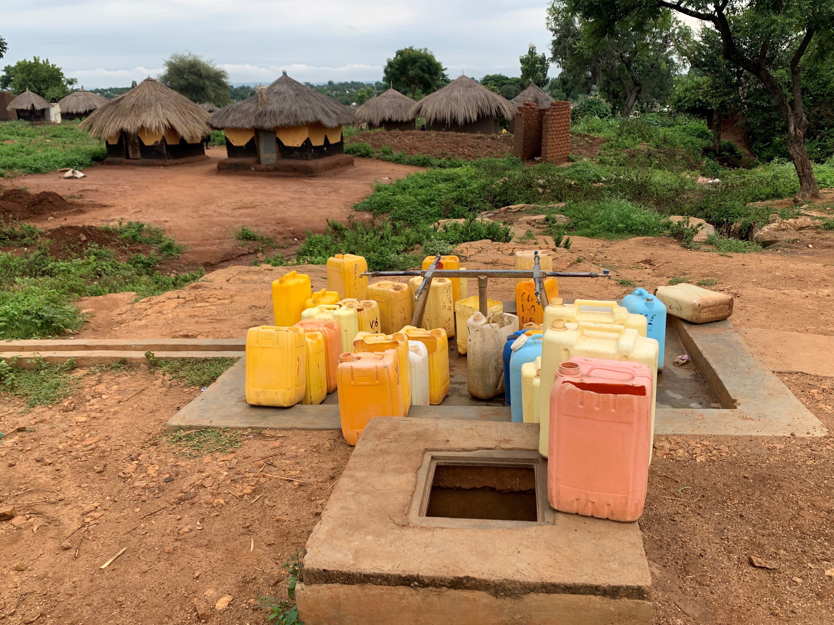
Community water well in Bidibidi, Zone Two - Village Six
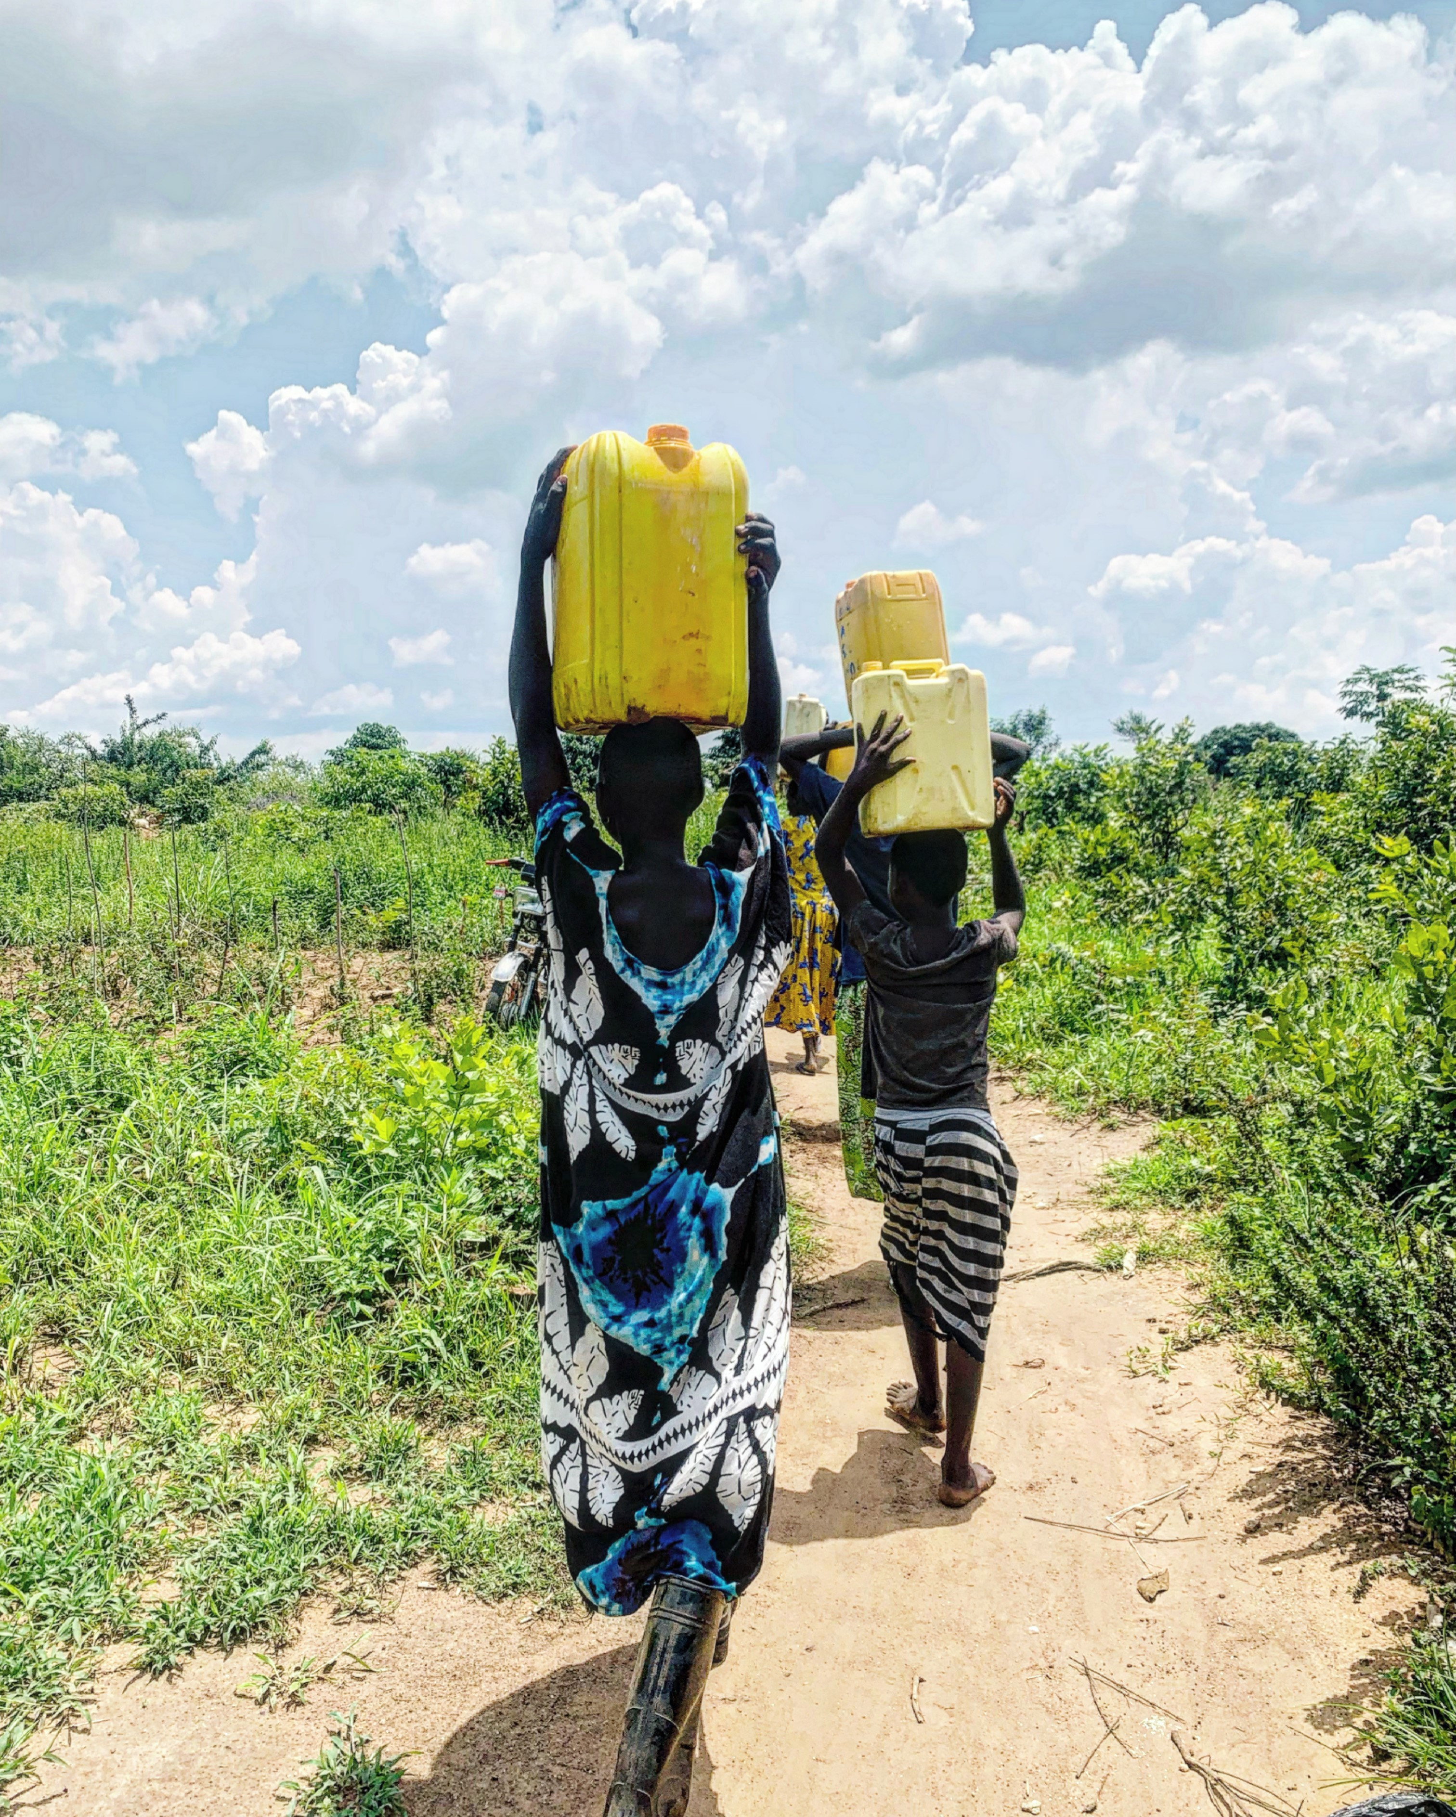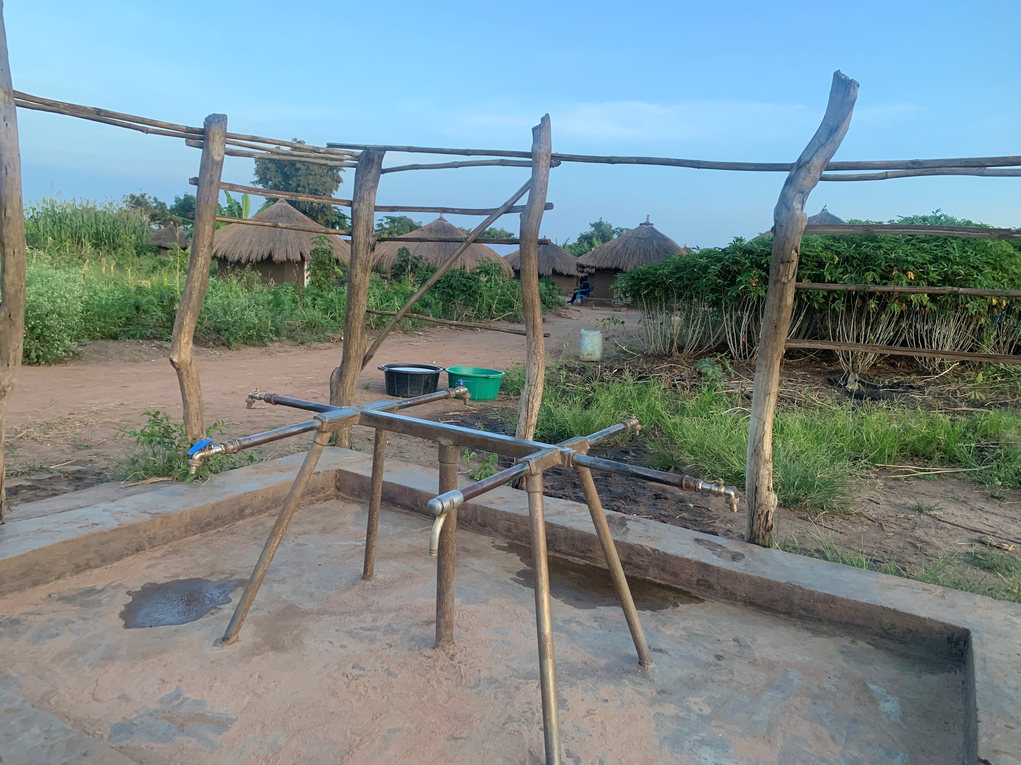Community water well in Bidibidi, Zone Two - Village Two.
This well was broken for two weeks, but was later fixed.
Group of girls carrying water from a local river in Picture taken later in the evening after it ran out of water due Bidibidi, Zone Two because their nearest water
point was not working. to high demand for water in the village.
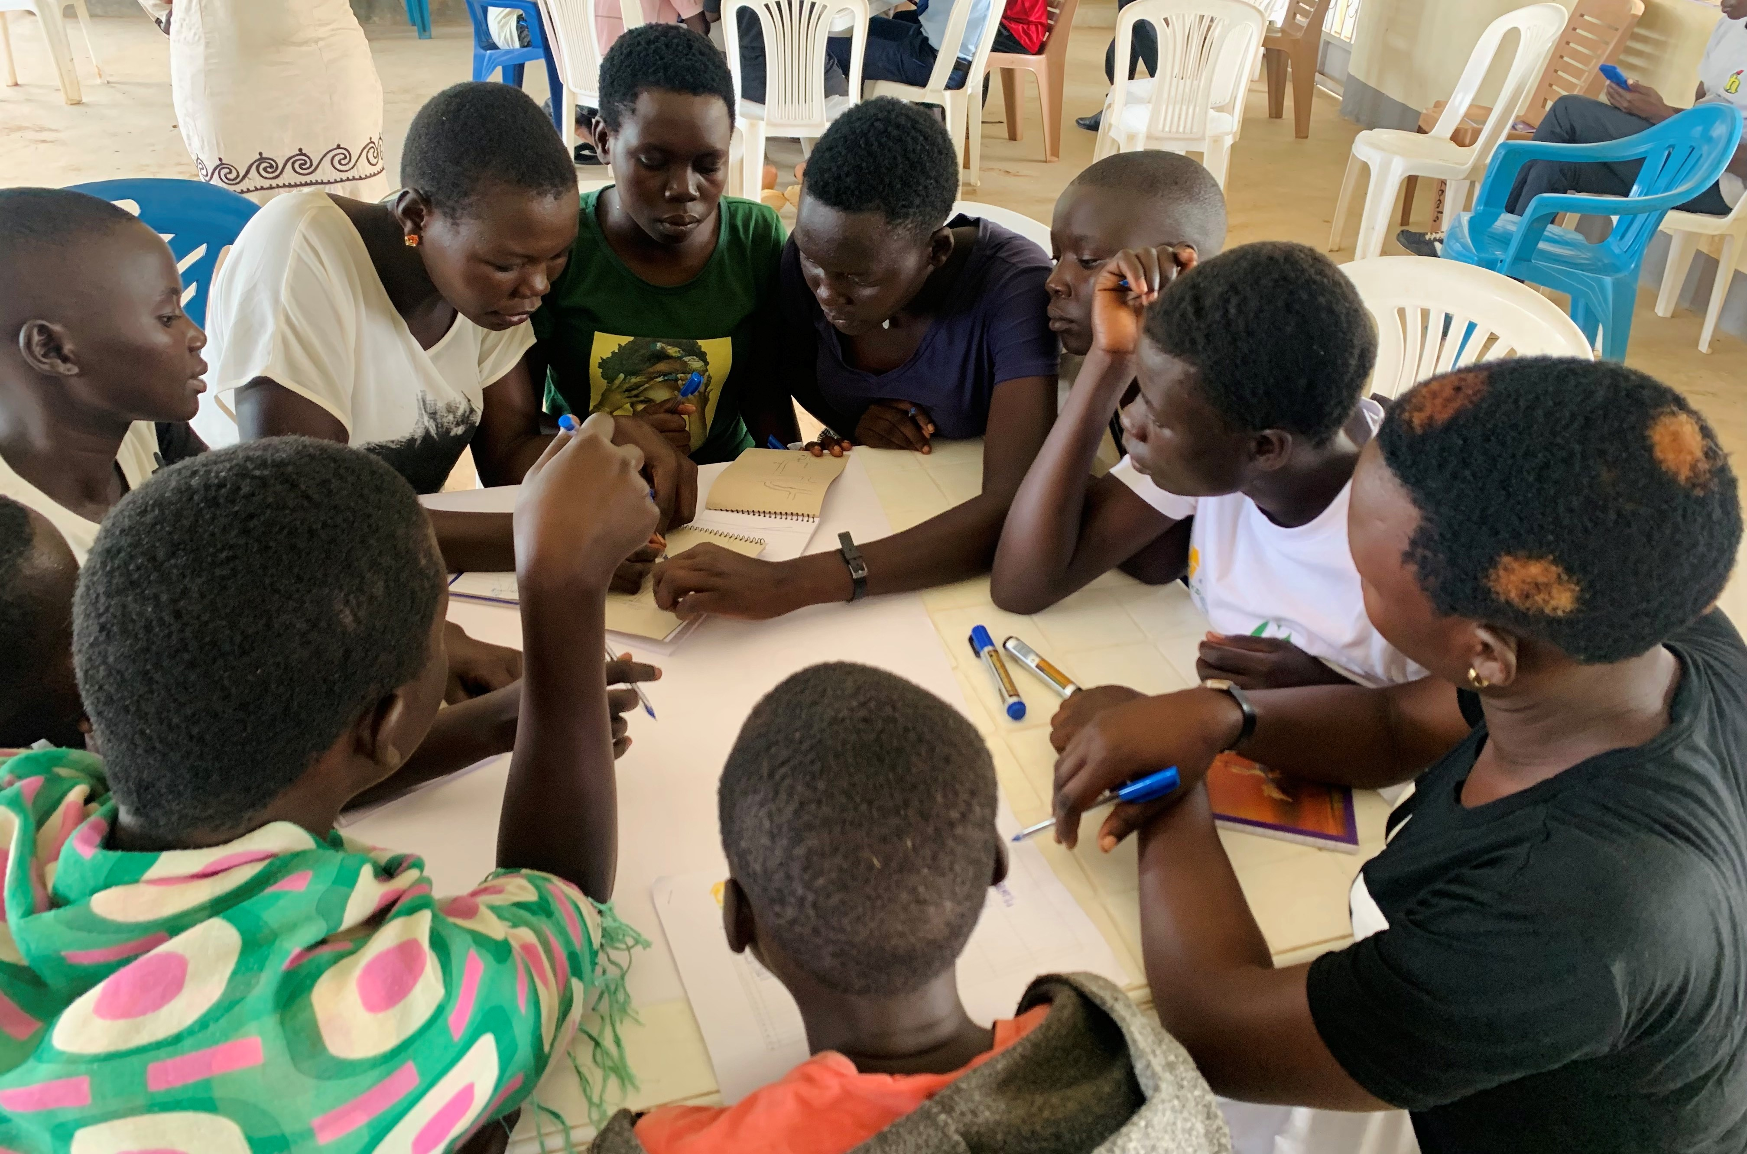
August 2022 Focus Group: girls in Bidibidi working on community mapping exercise at the Sina Loketa Community Youth Center.
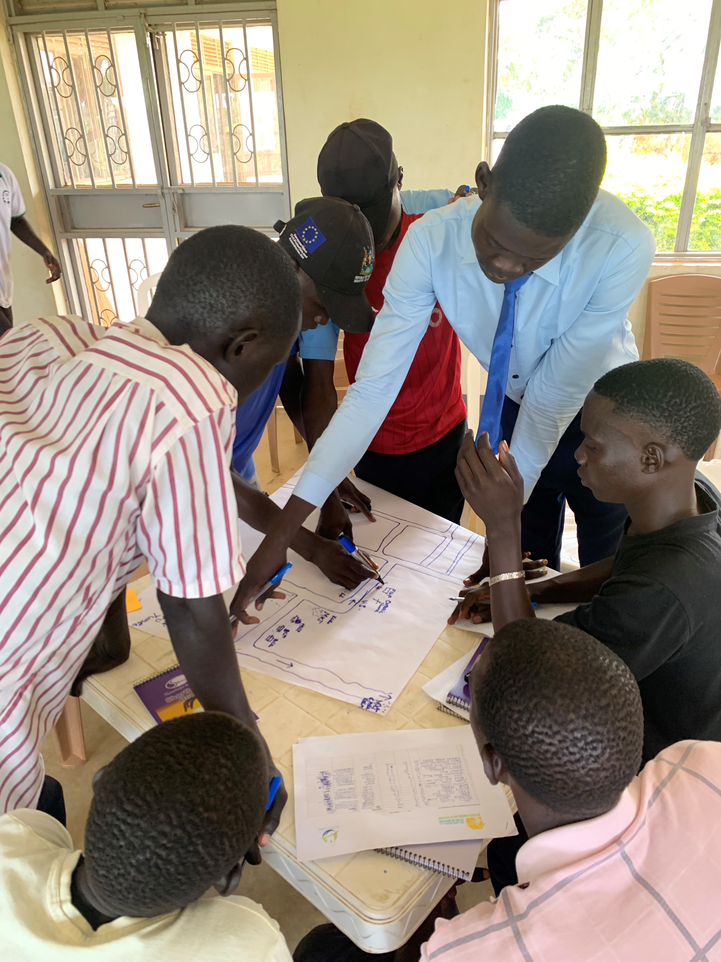
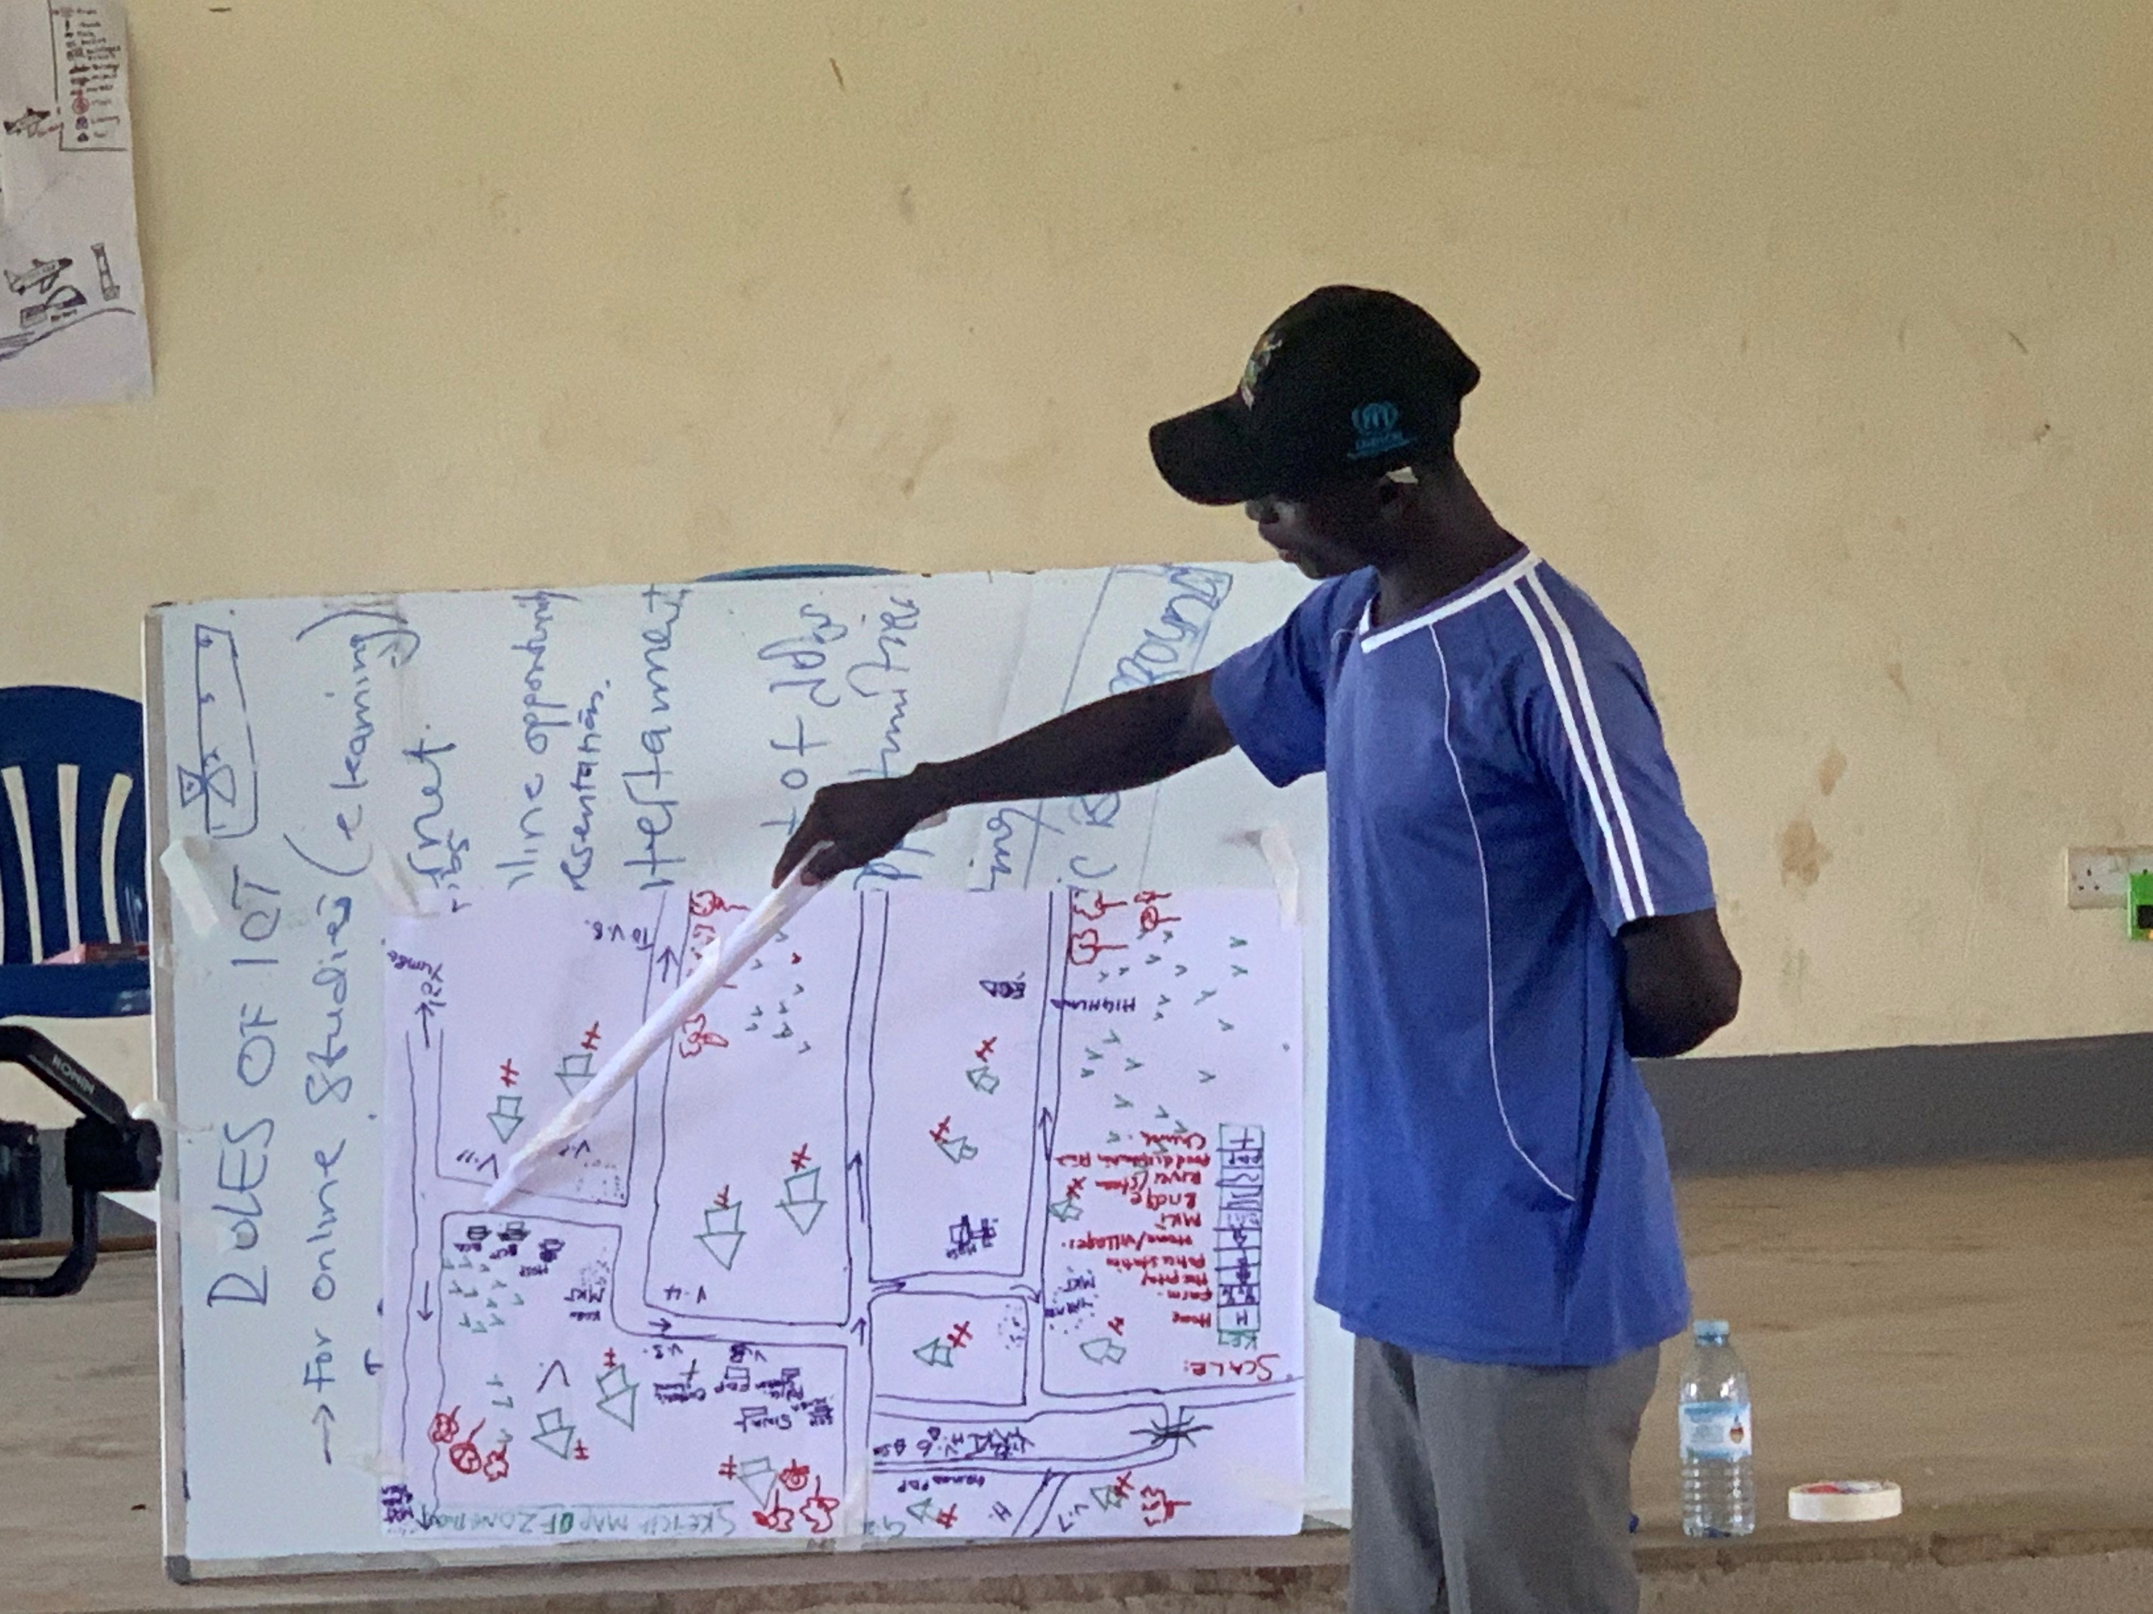
August 2022 Focus Group: Youth in Bidibidi presenting his groups community mapping exercise outcomes.
August 2022 Focus Group: Group of boys in
Bidibidi working on the community mapping exercise at the Sina Loketa Center.

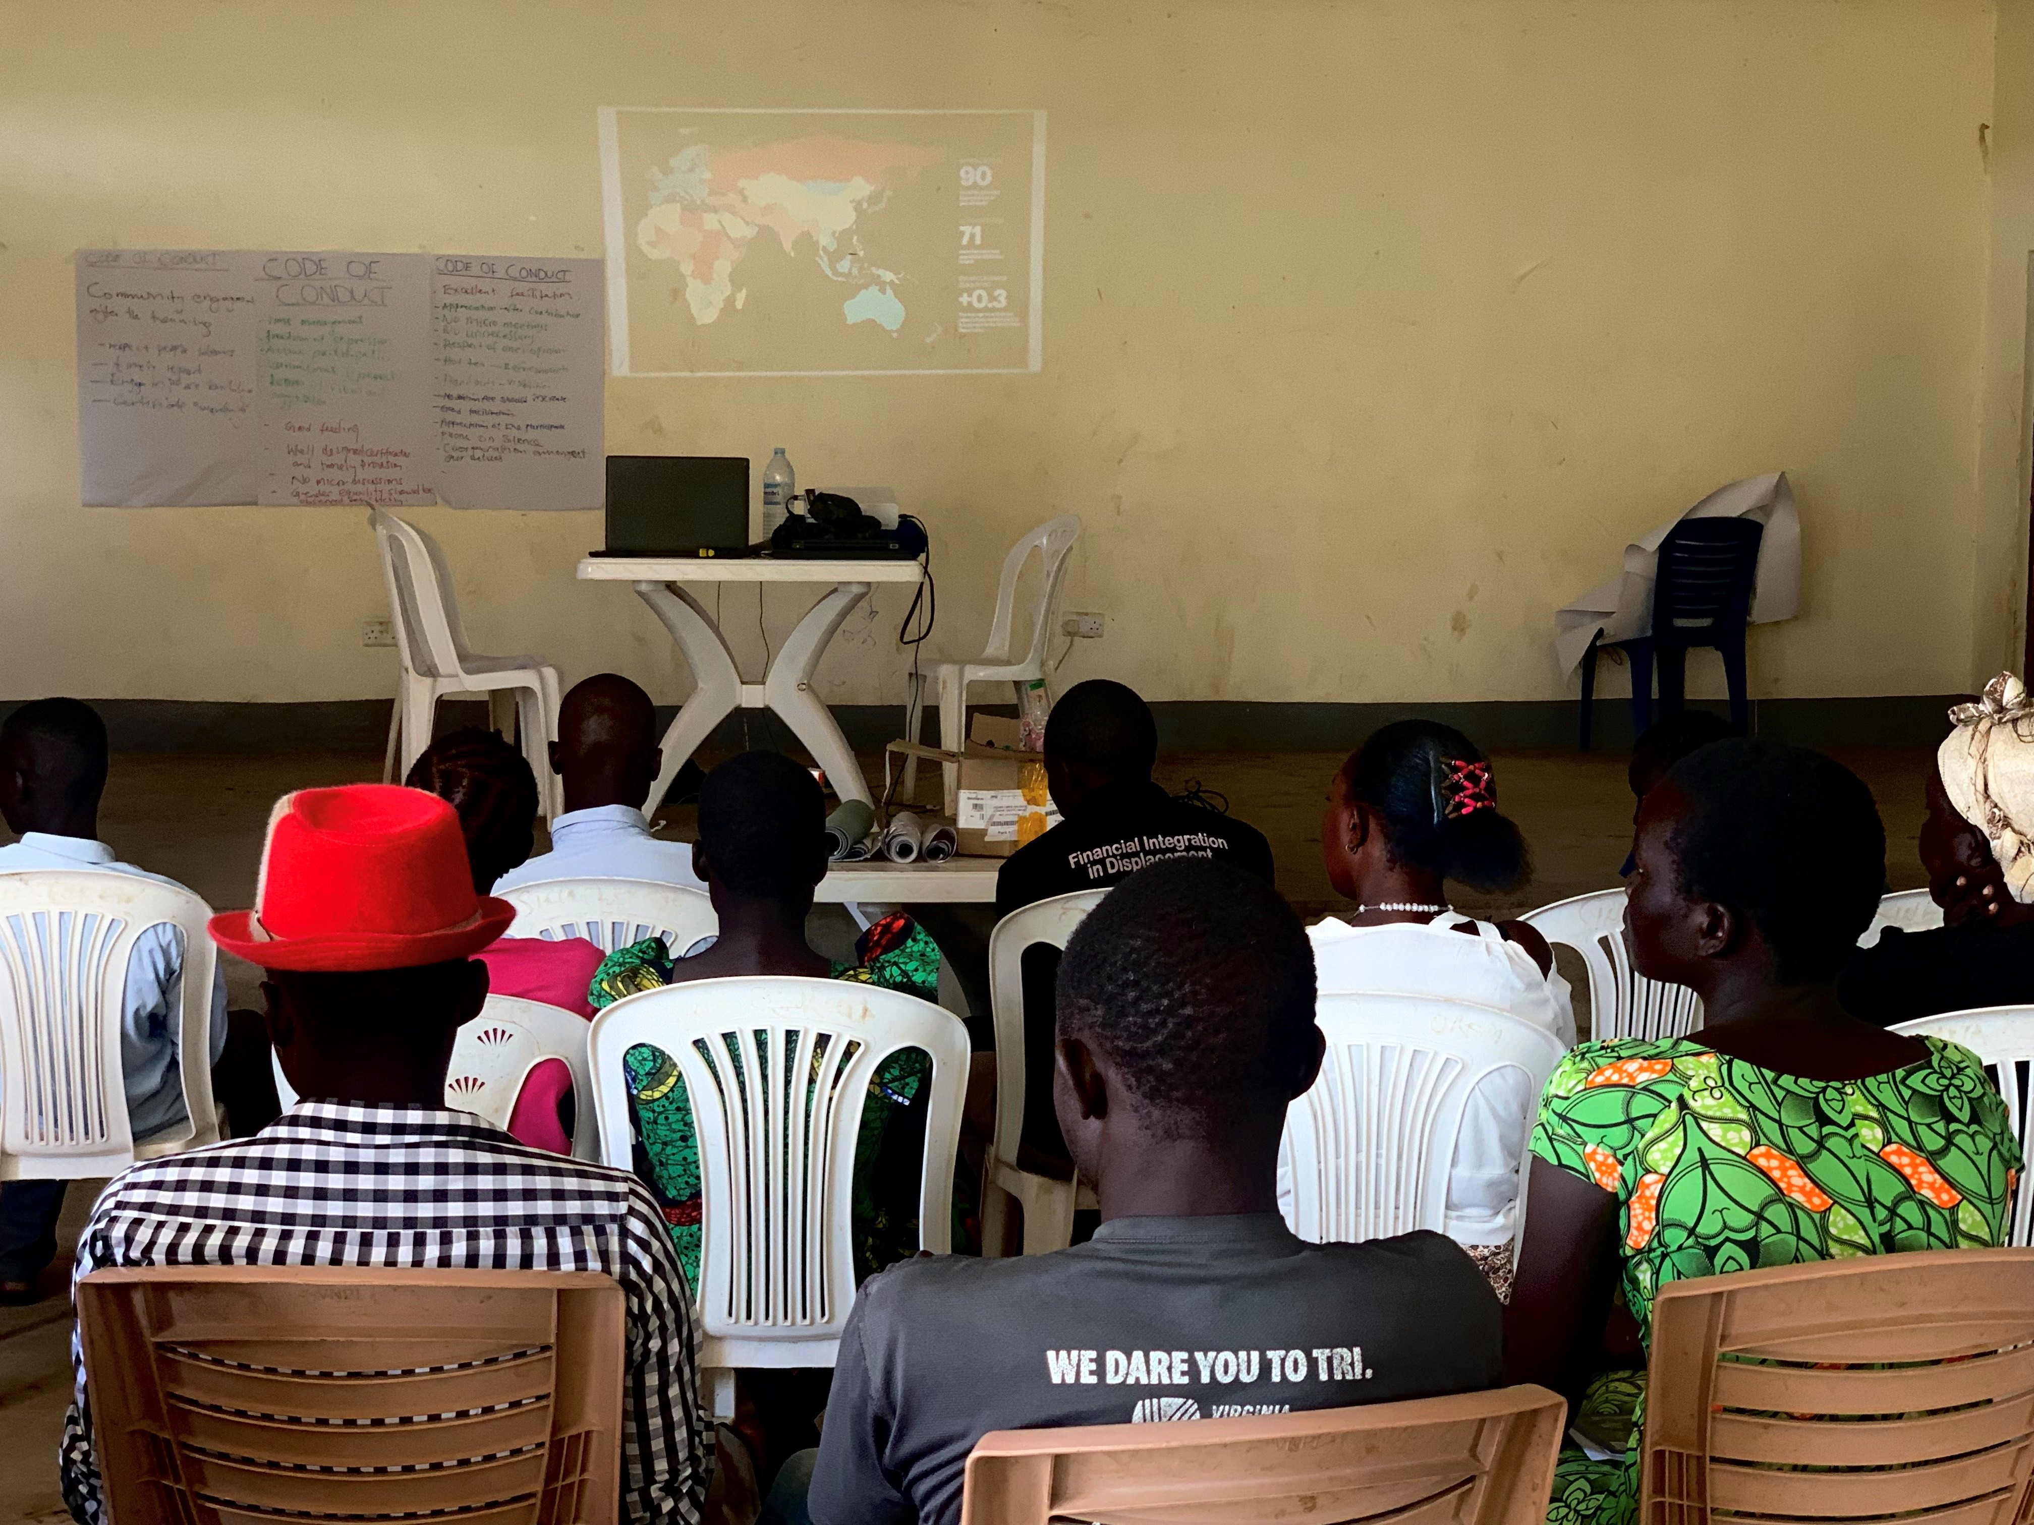
October IEP Positive Peace Training workshop: participants watching presentation on the Global Peace Index.
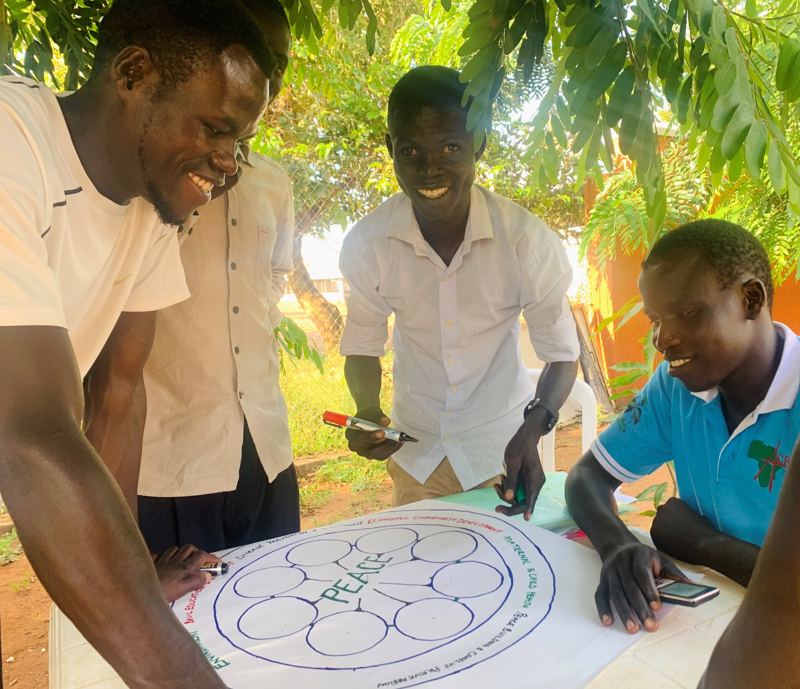
Participants in Bidibidi working on a positive peace poster at the Sina Loketa Community Youth Center.
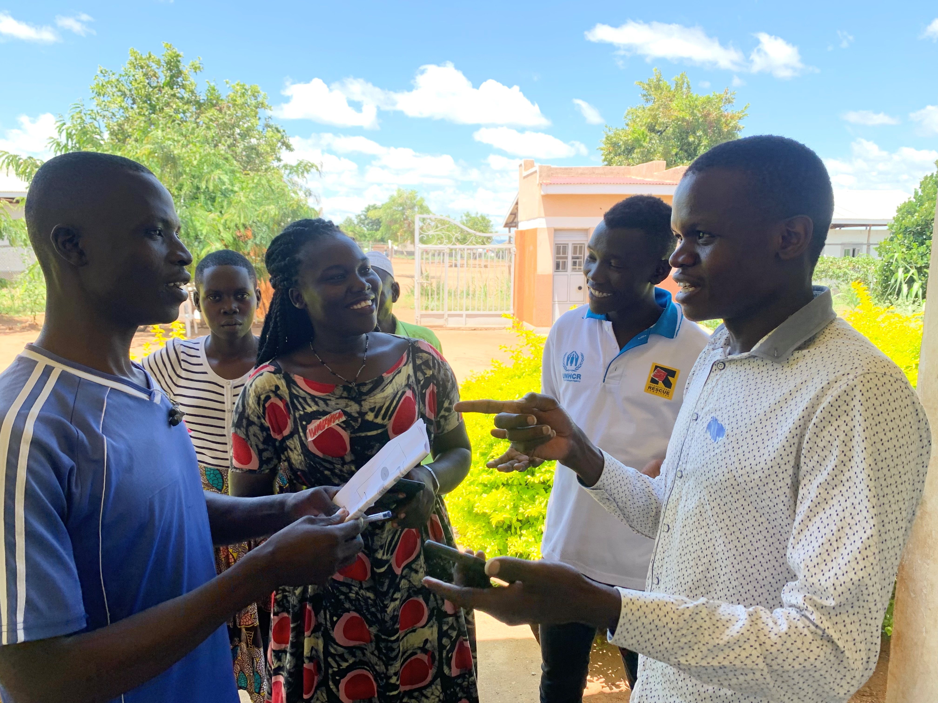
Positive Peace Trainees deliberating over
community resources during IEP Pillar Island activity.
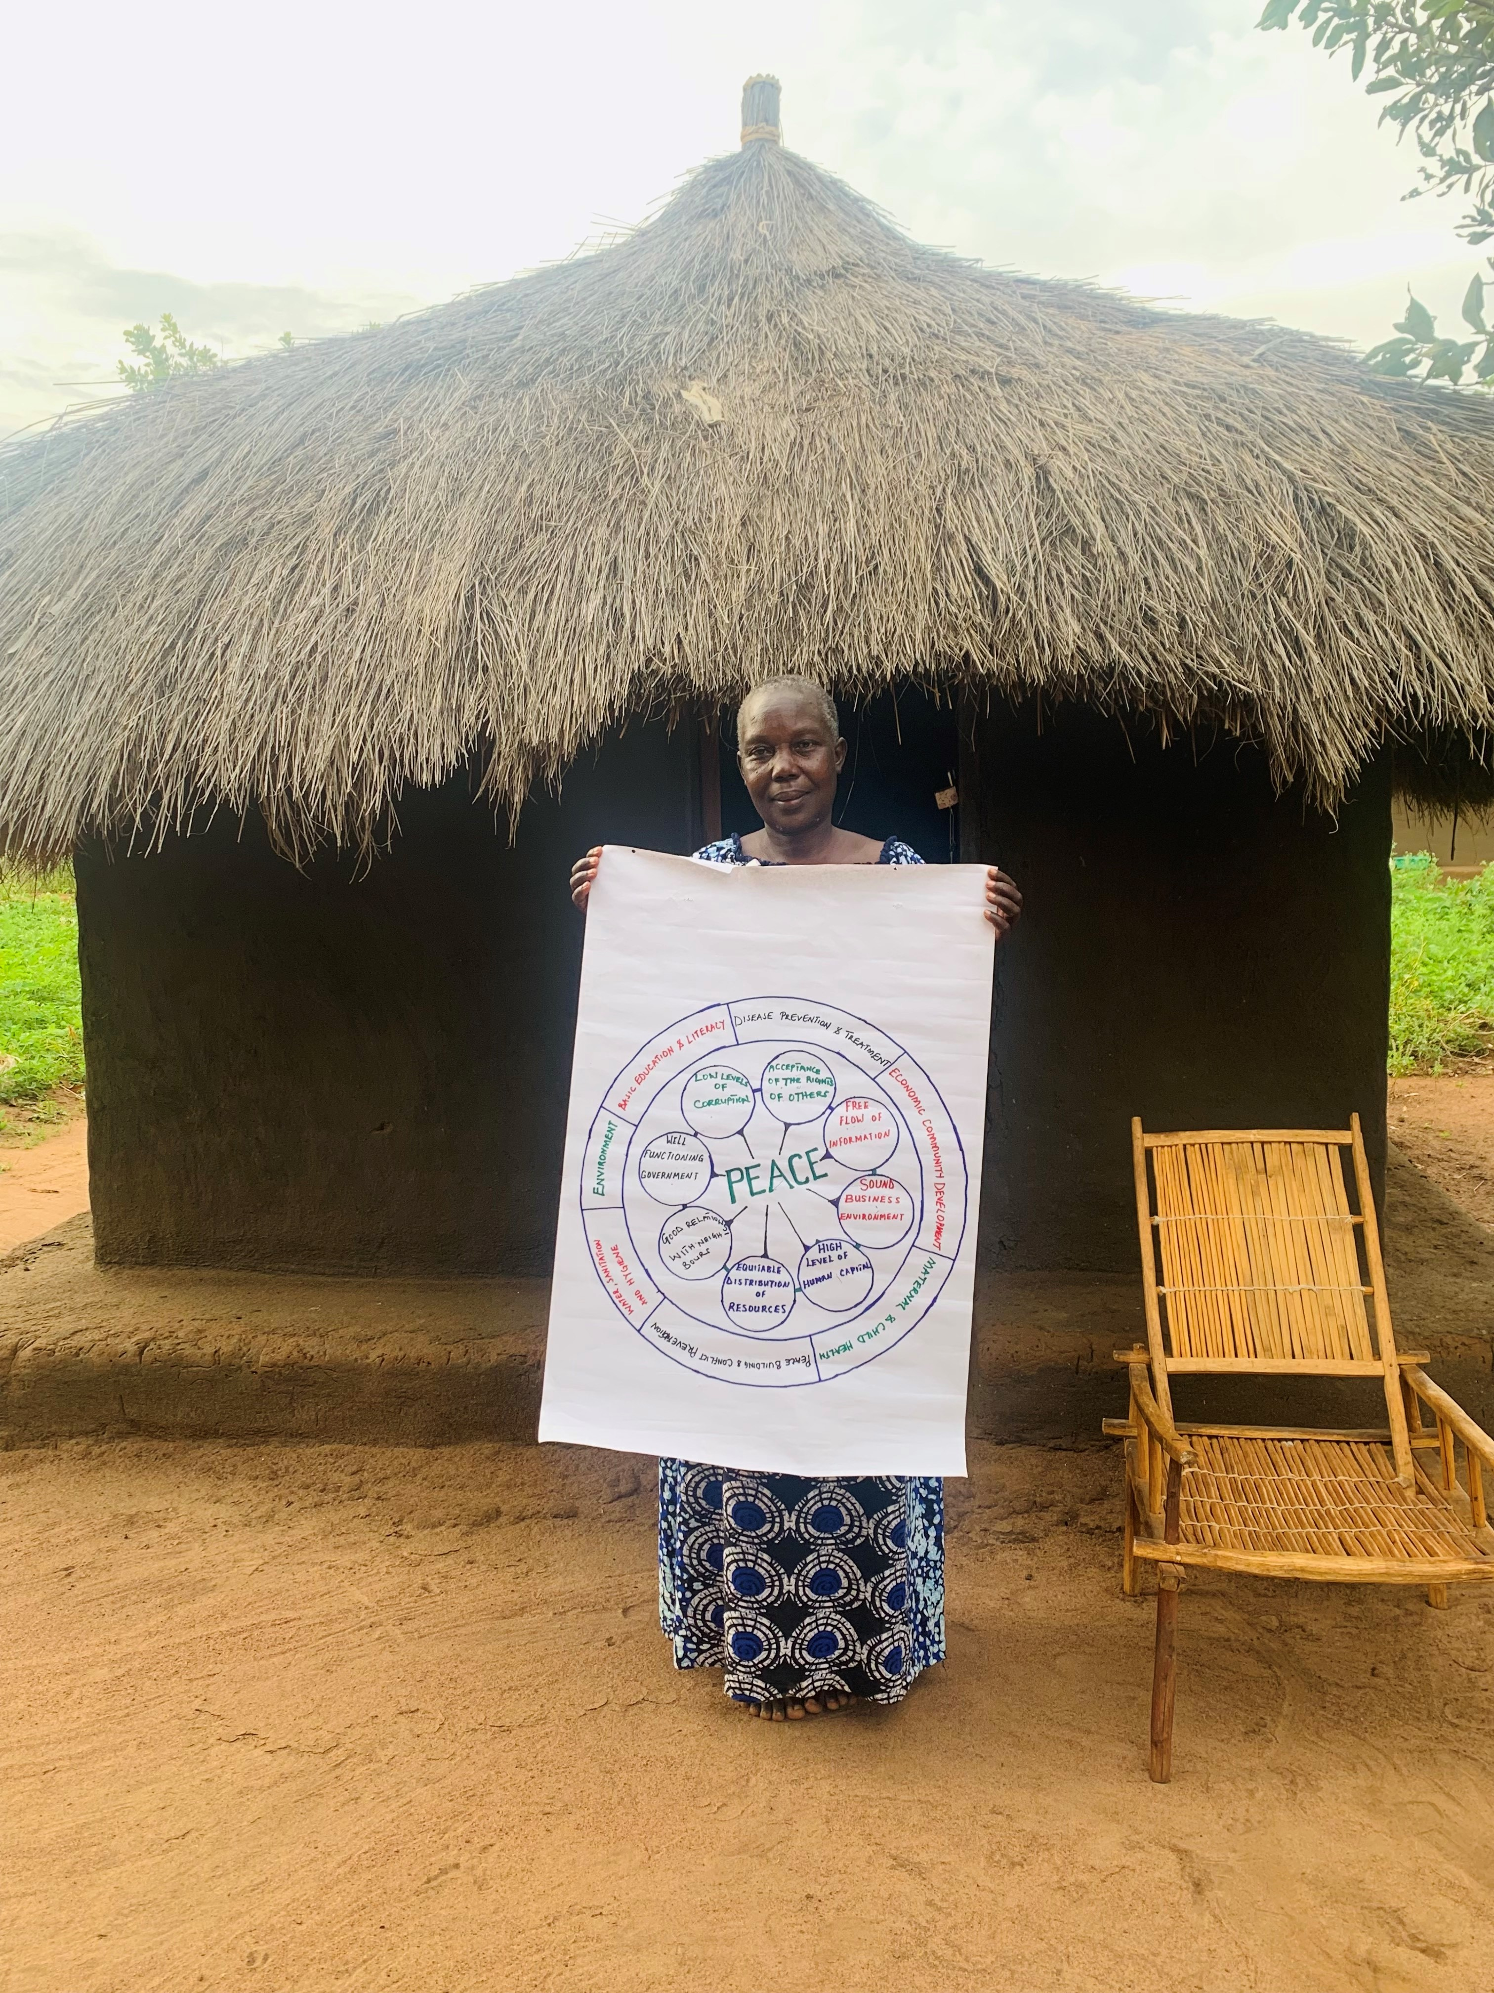
Home visit and interview about IEP
Positive Peace workshops with local women’s leader Mama Joyce in Bidibidi.
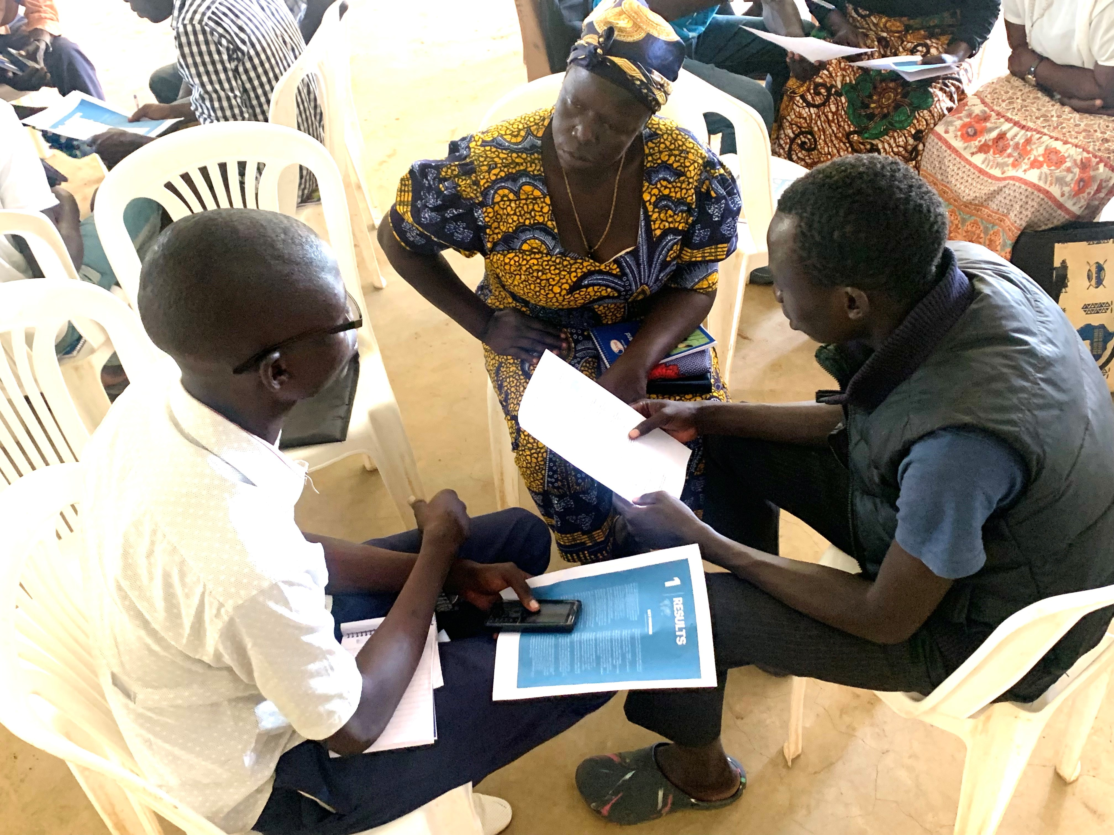
Small group breakout session during IEP Positive Peace
Training. Participants discussing key at
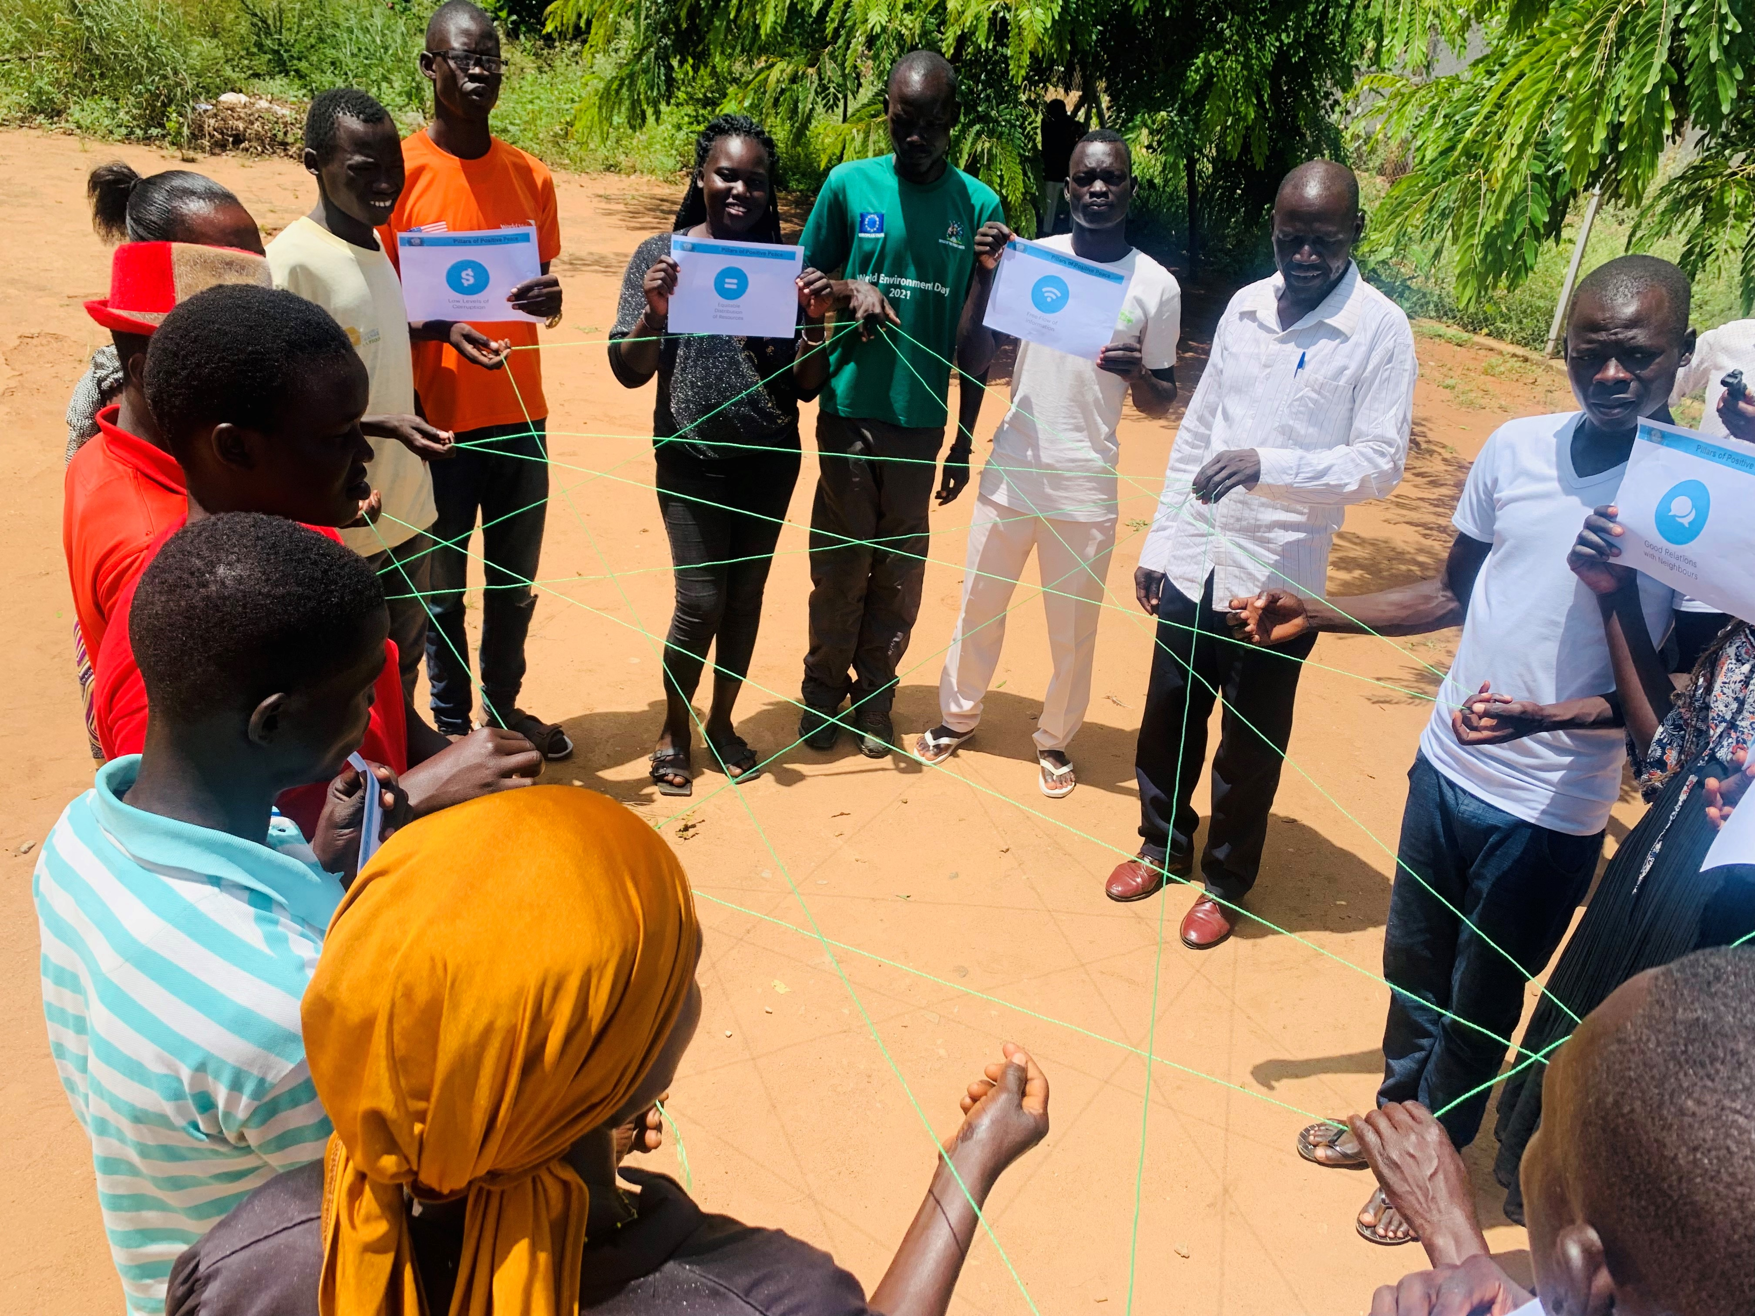
October 2022: Positive Peace Trainees participating in IEP yarn activity on the Eight Pillars of Peace and Systems Thinking.
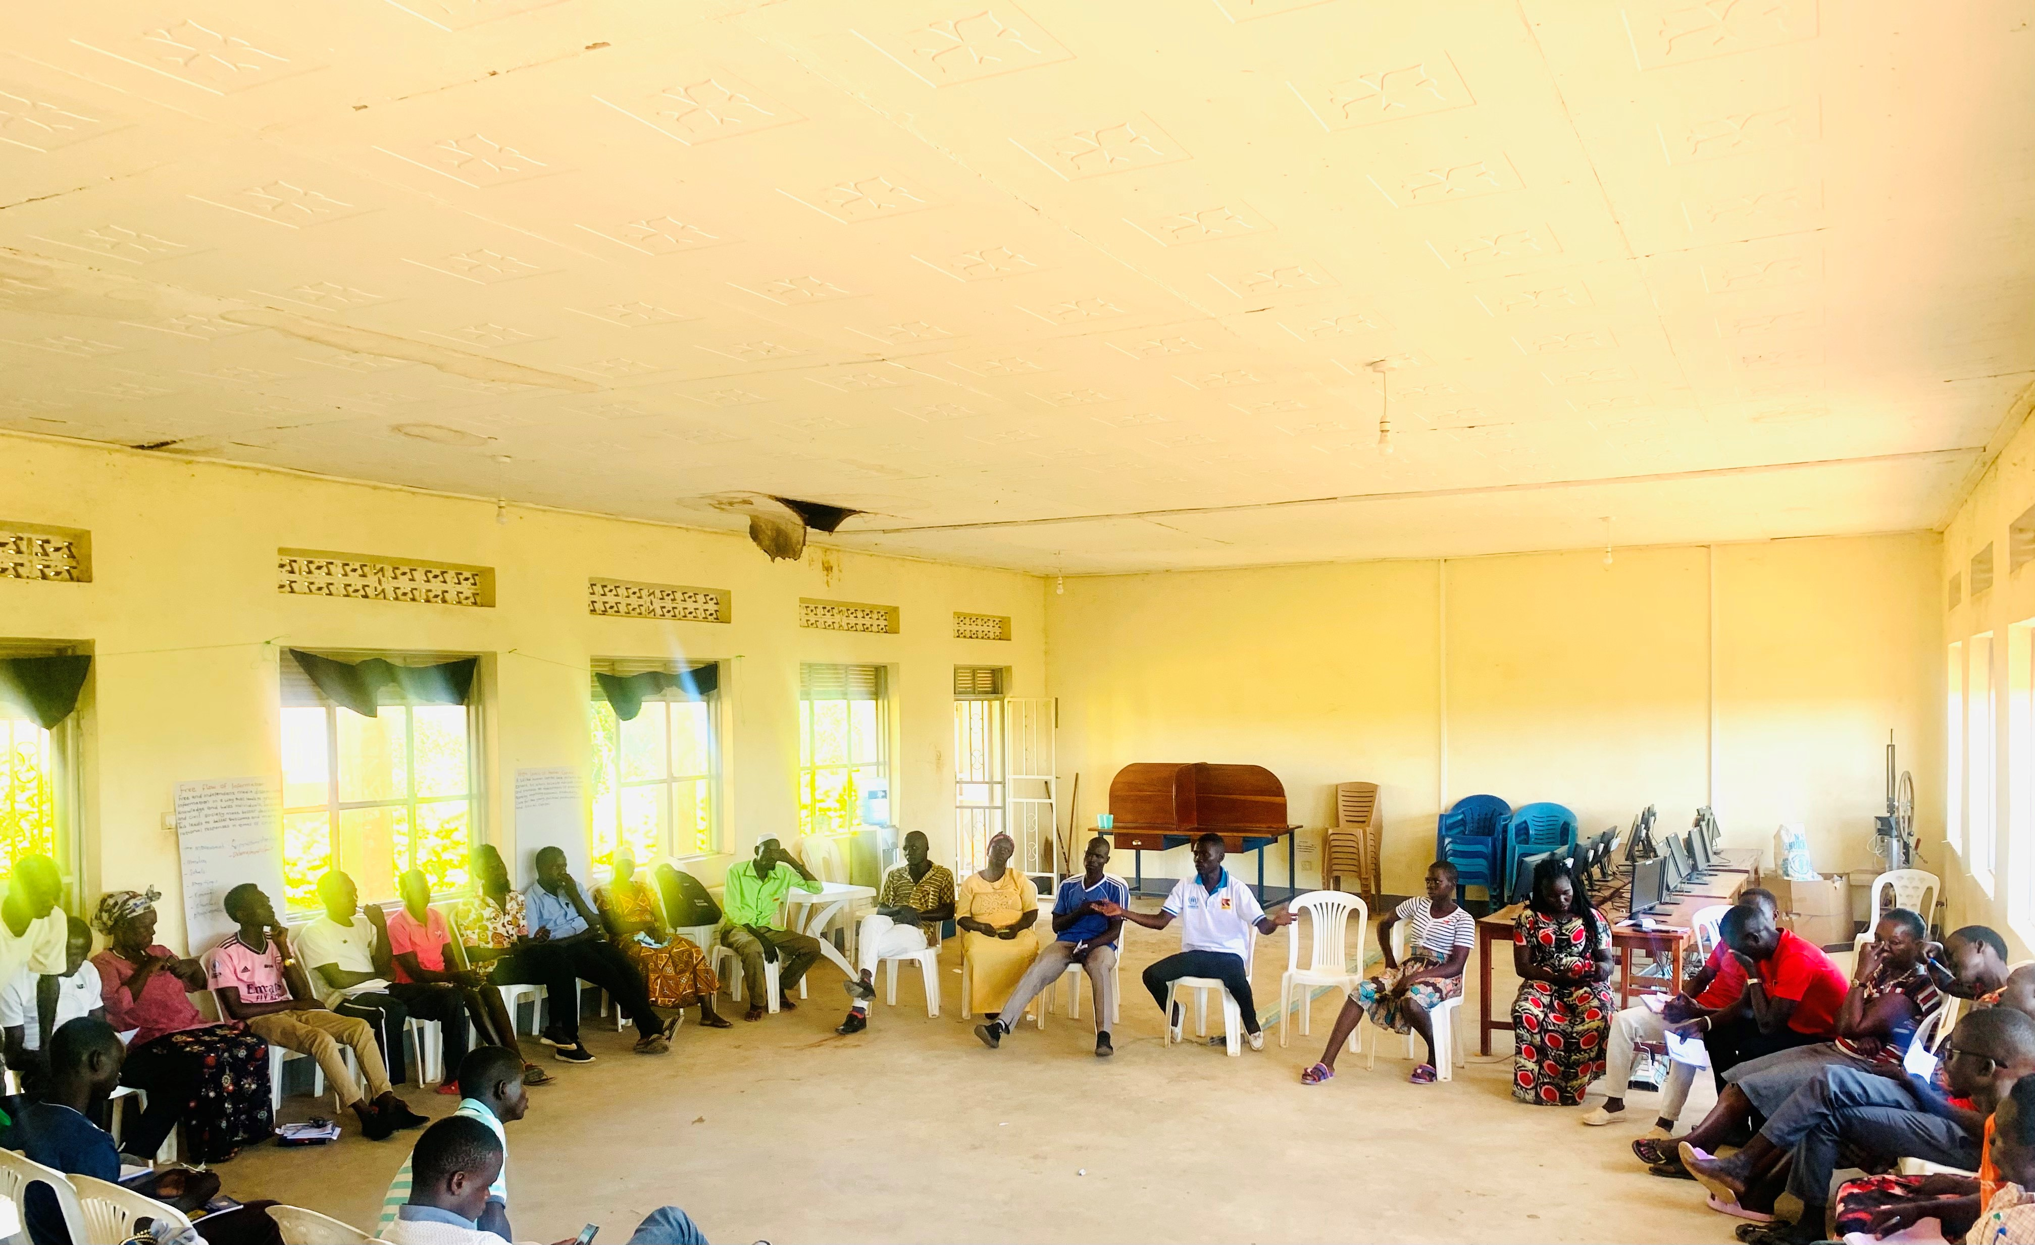
October 2022: Positive Peace Trainees engaging in group discussion after participating in one of the group activities.
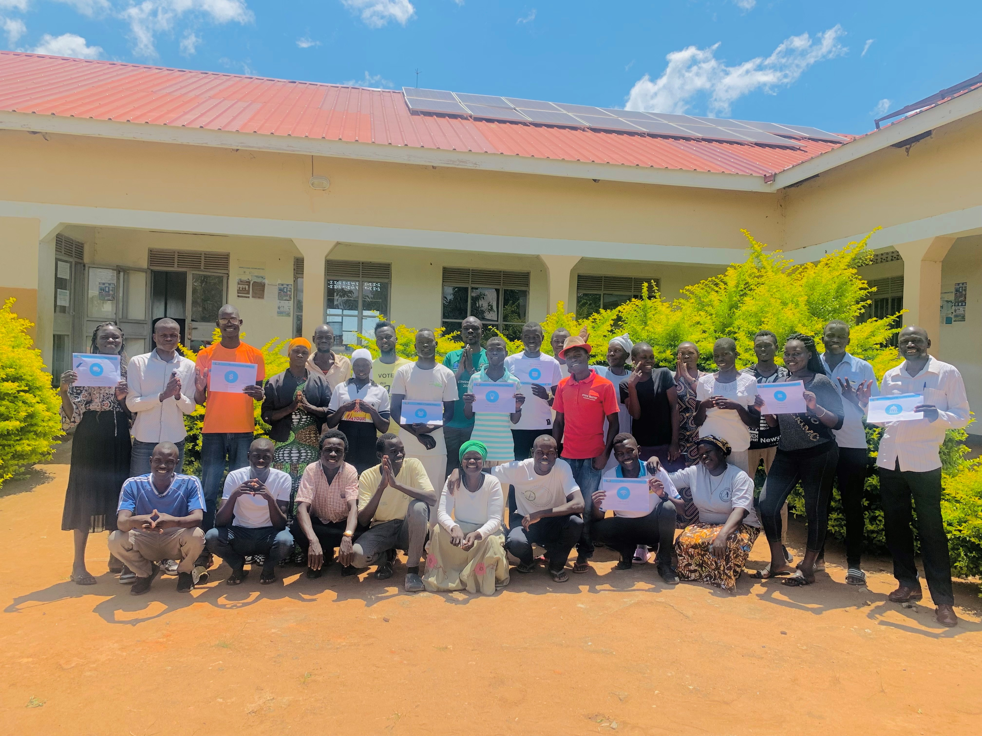
October 2022: Group picture of some of the Positive Peace Trainees after an activity.
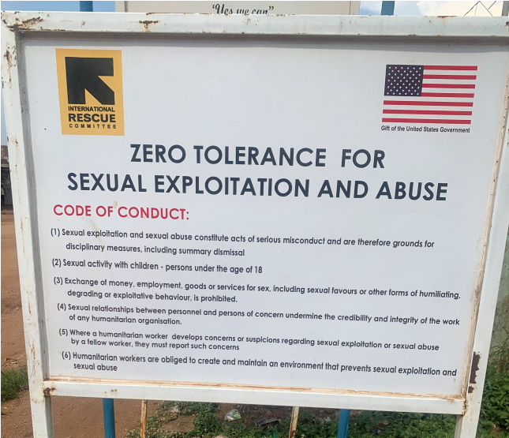
International Rescue Committee placard on Zero Tolerance for
Sexual Exploitation and Abuse in
Bidibidi Zone One, located on main road in one of the village centers.
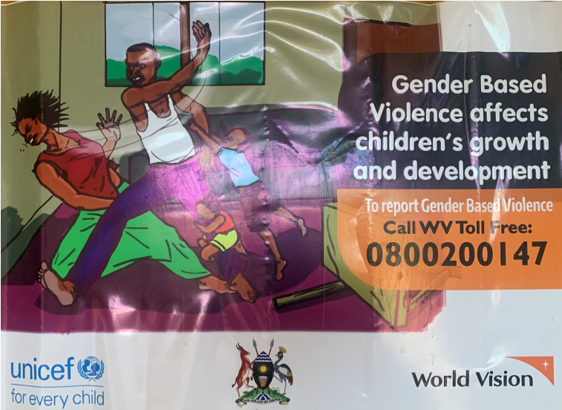
UNICEF and World Vision poster on Gender Based Violence in Bidibidi Zone two, located on wall of a mobile money kiosk.
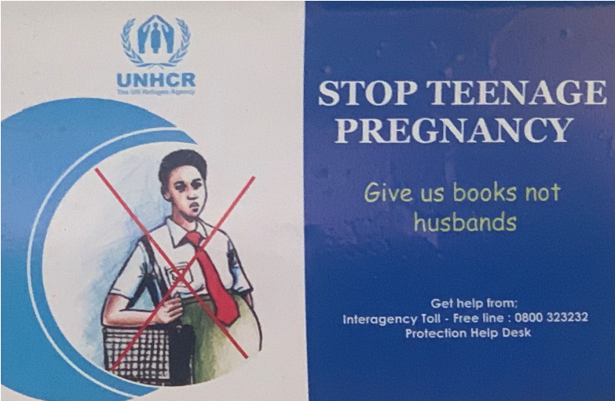
UNHCR poster on Teenage Pregnancy in
Bidibidi Zone two, located on wall of a local pharmacy.

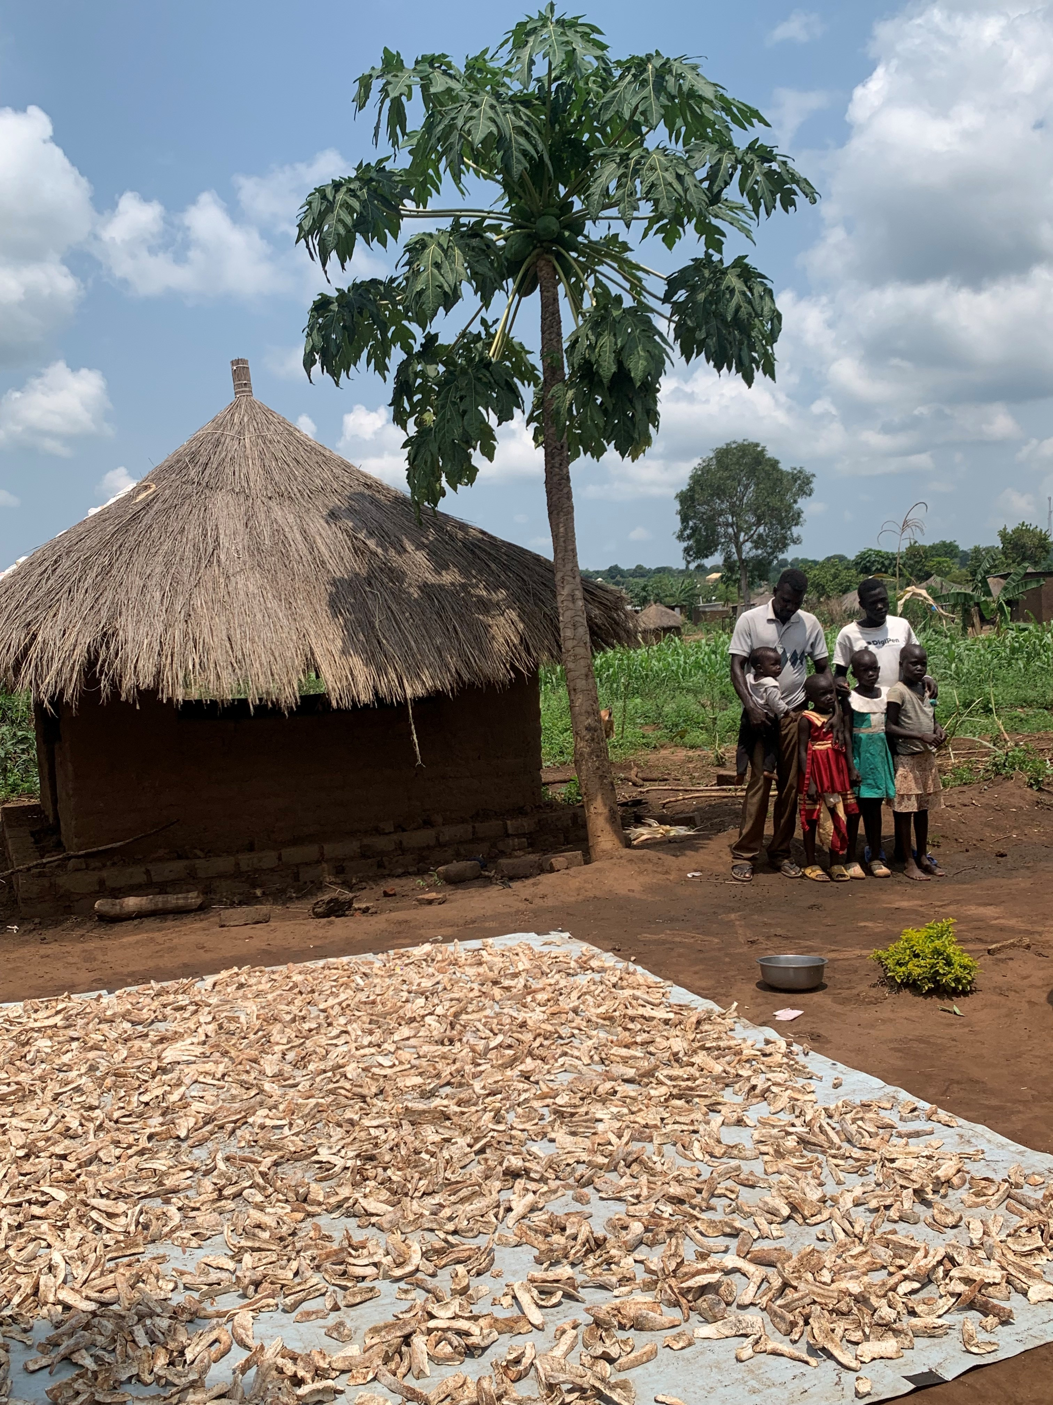
Sina Loketa Agro-Farm field visit and meeting with local farmer and entrepreneur in Bidibidi, Zone Two. Farmer drys and processes cassava for income and to help address food insecurity problems in the community
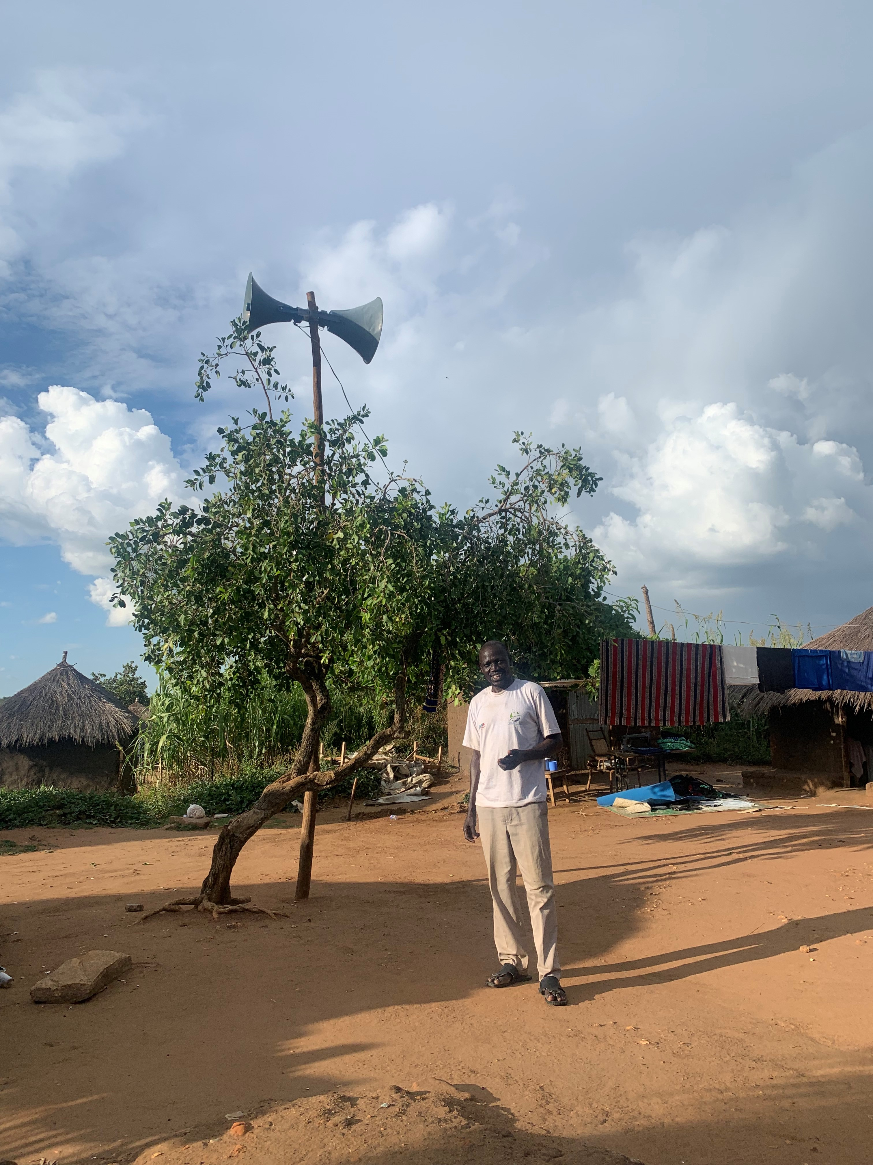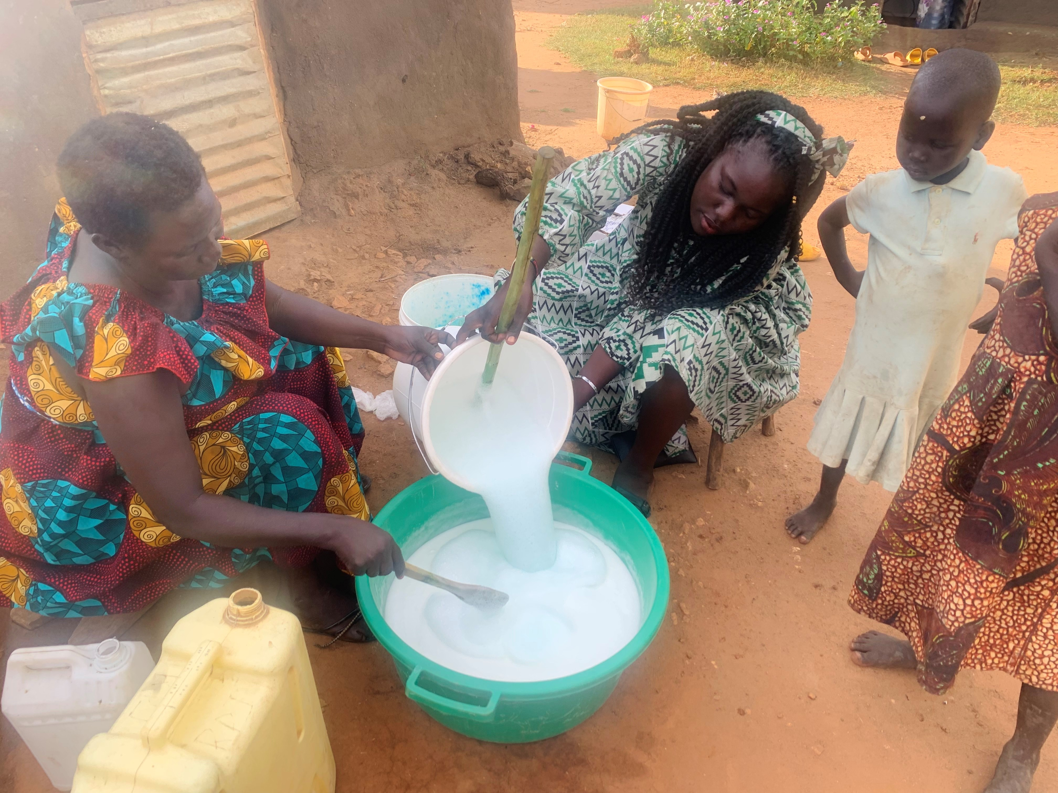

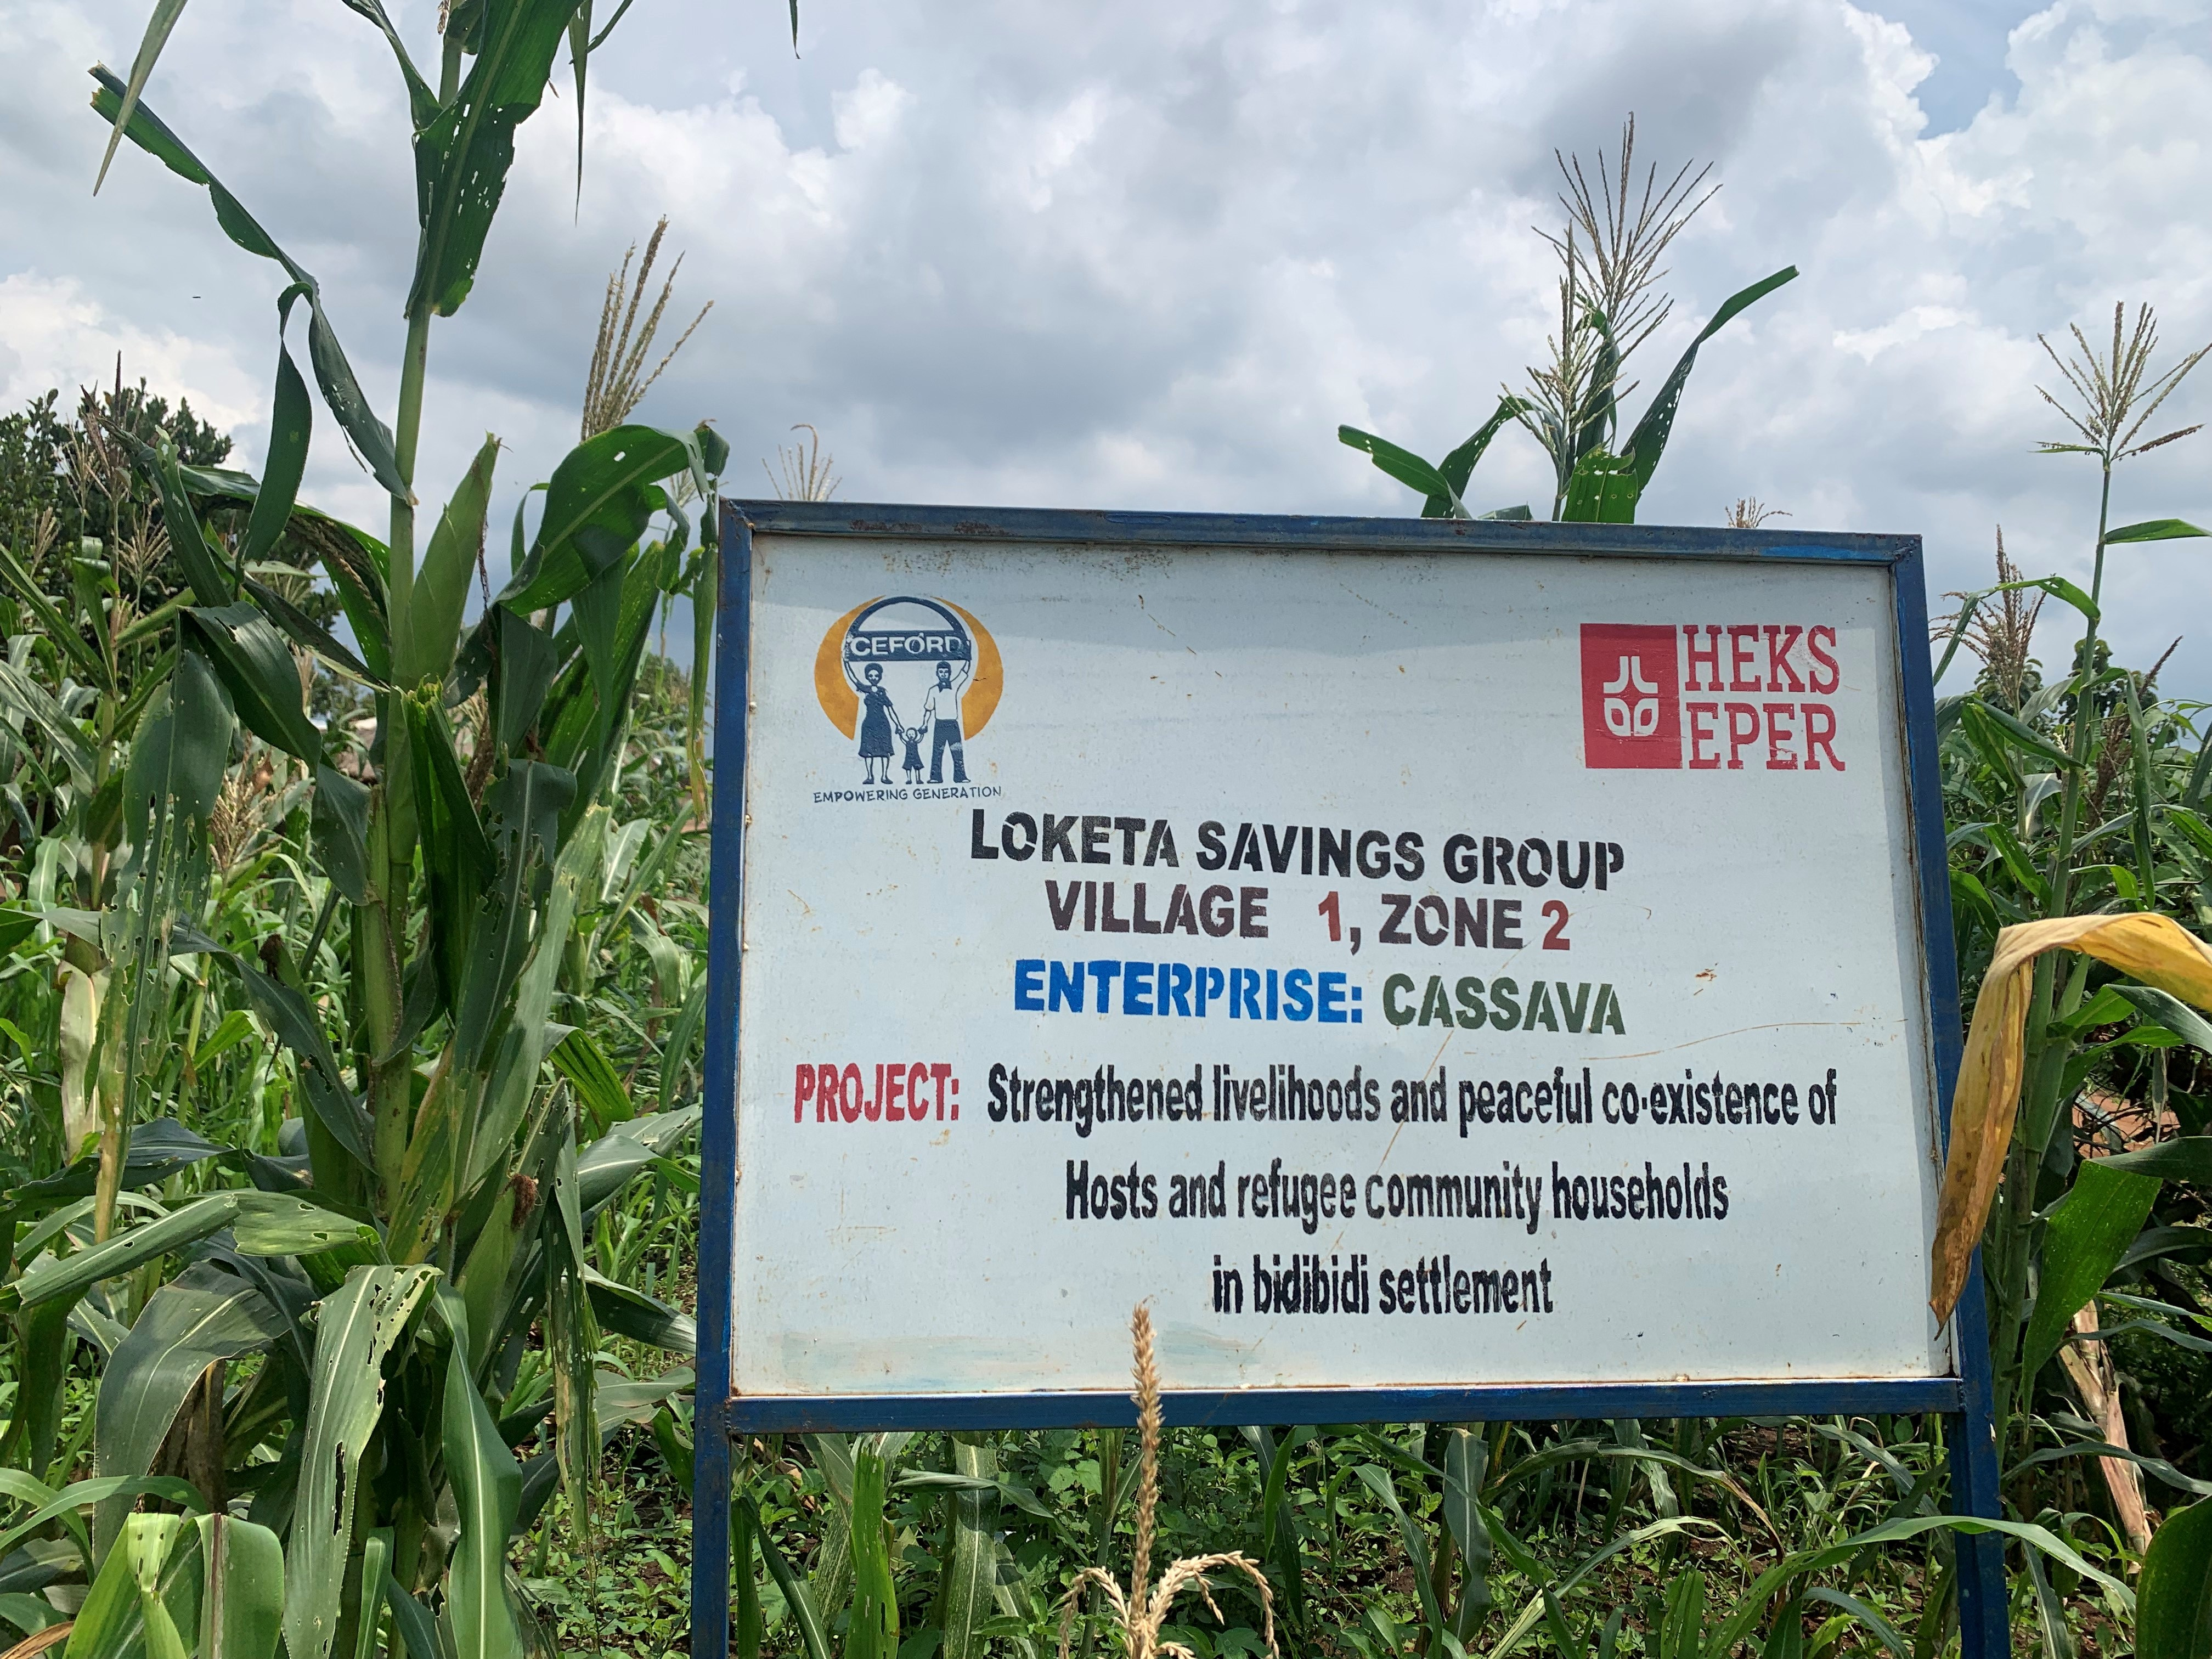
Sina Loketa Agro-Farm field visit and meeting with local farmer in Bidibidi. Cassava project placard in Village One.

Community Peace Mediator Mr. Hakim standing in front of his speakers for the
Salama Community Radio Project. He uses the system to broadcast and spread awareness on mental health, PSEA, and peacebuilding in Bidibidi, Zone Two.
Clara helping Mrs. Lomoro make liquid soap and exchanging tips while two young girls watch. Clara and Mrs. Lomoro both make soap as a means to generate income for their families.

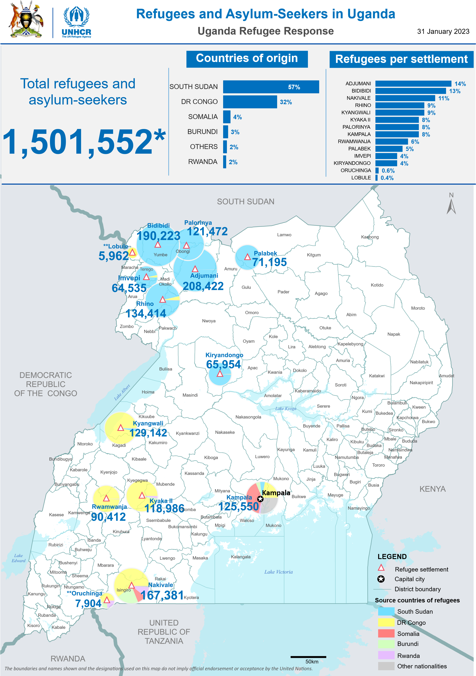
* The total population figures are provisional and are expected to change following the completion of the verification exercise in Kampala and three months grace period in all locations.
** Oruchinga and Lobule symbols not to scale
Population data: proGres (OPM) Author: UNHCR Representation in Uganda Feedback: ugakaimug@unhcr.org For more info, please visit: www.ugandarefugees.org

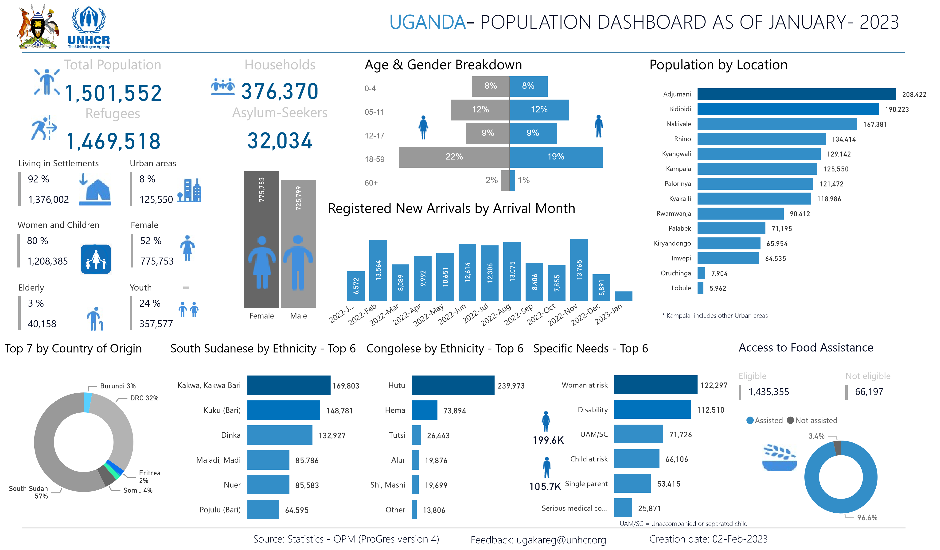

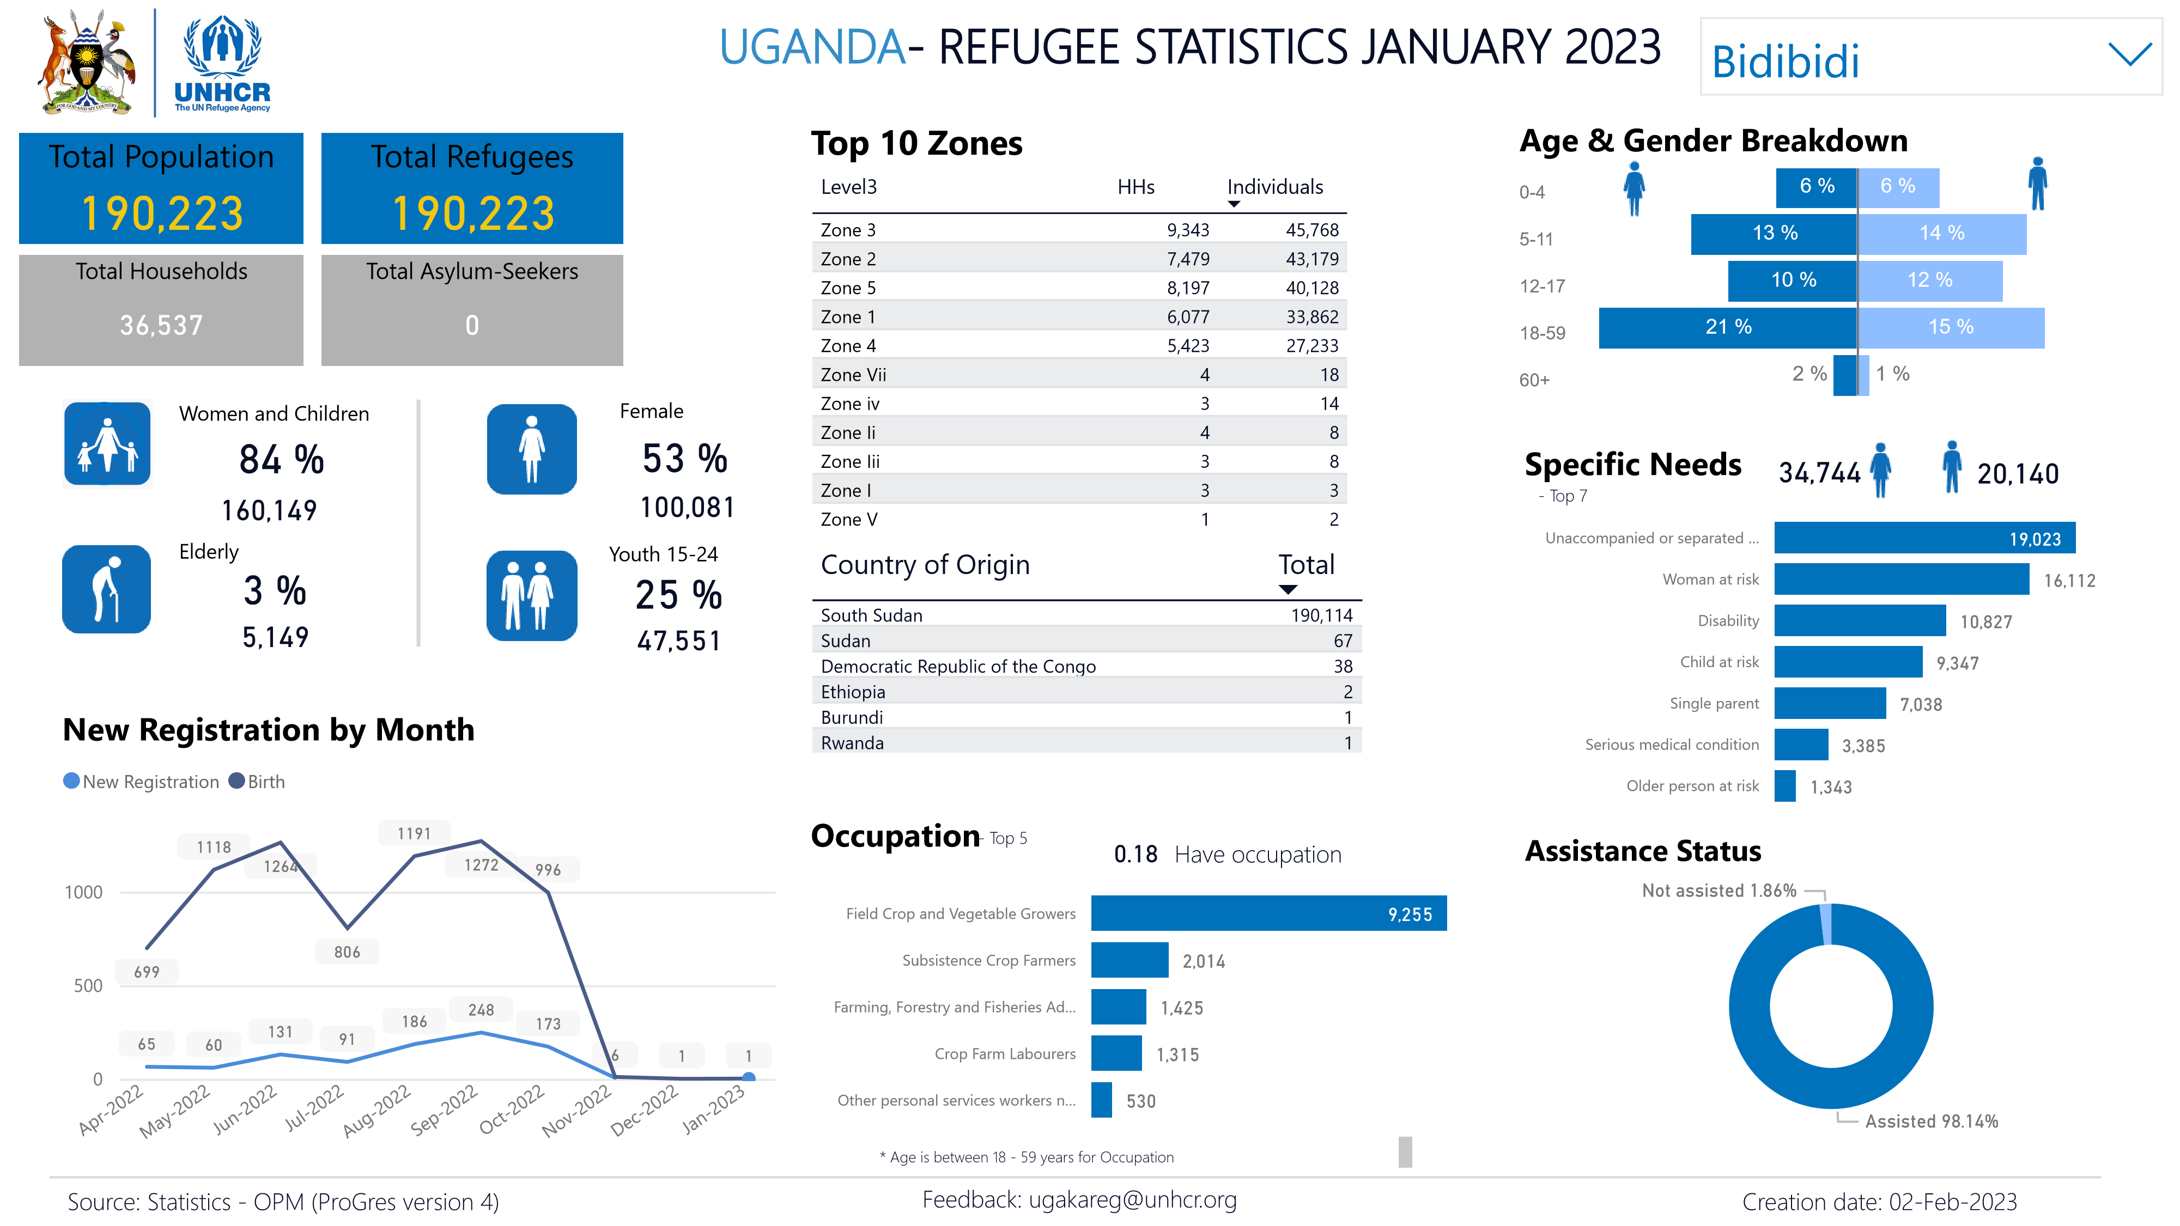

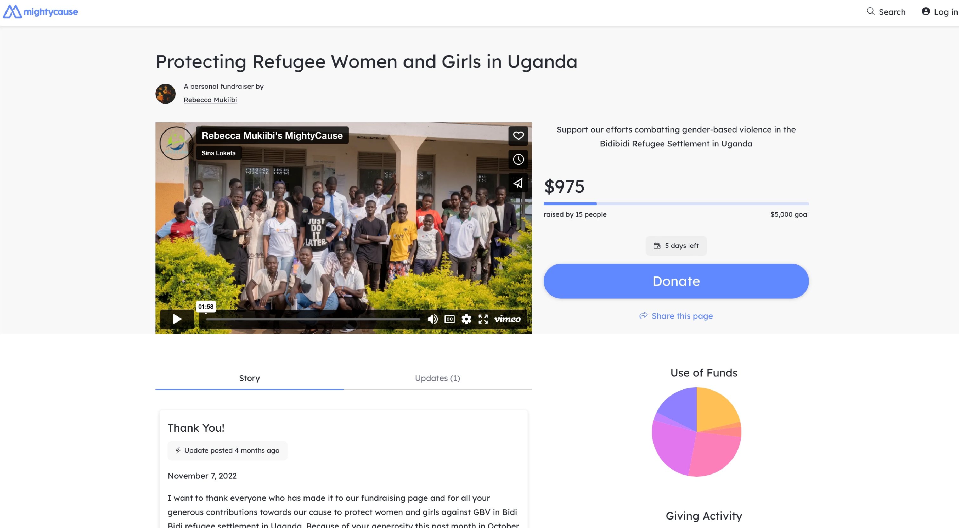
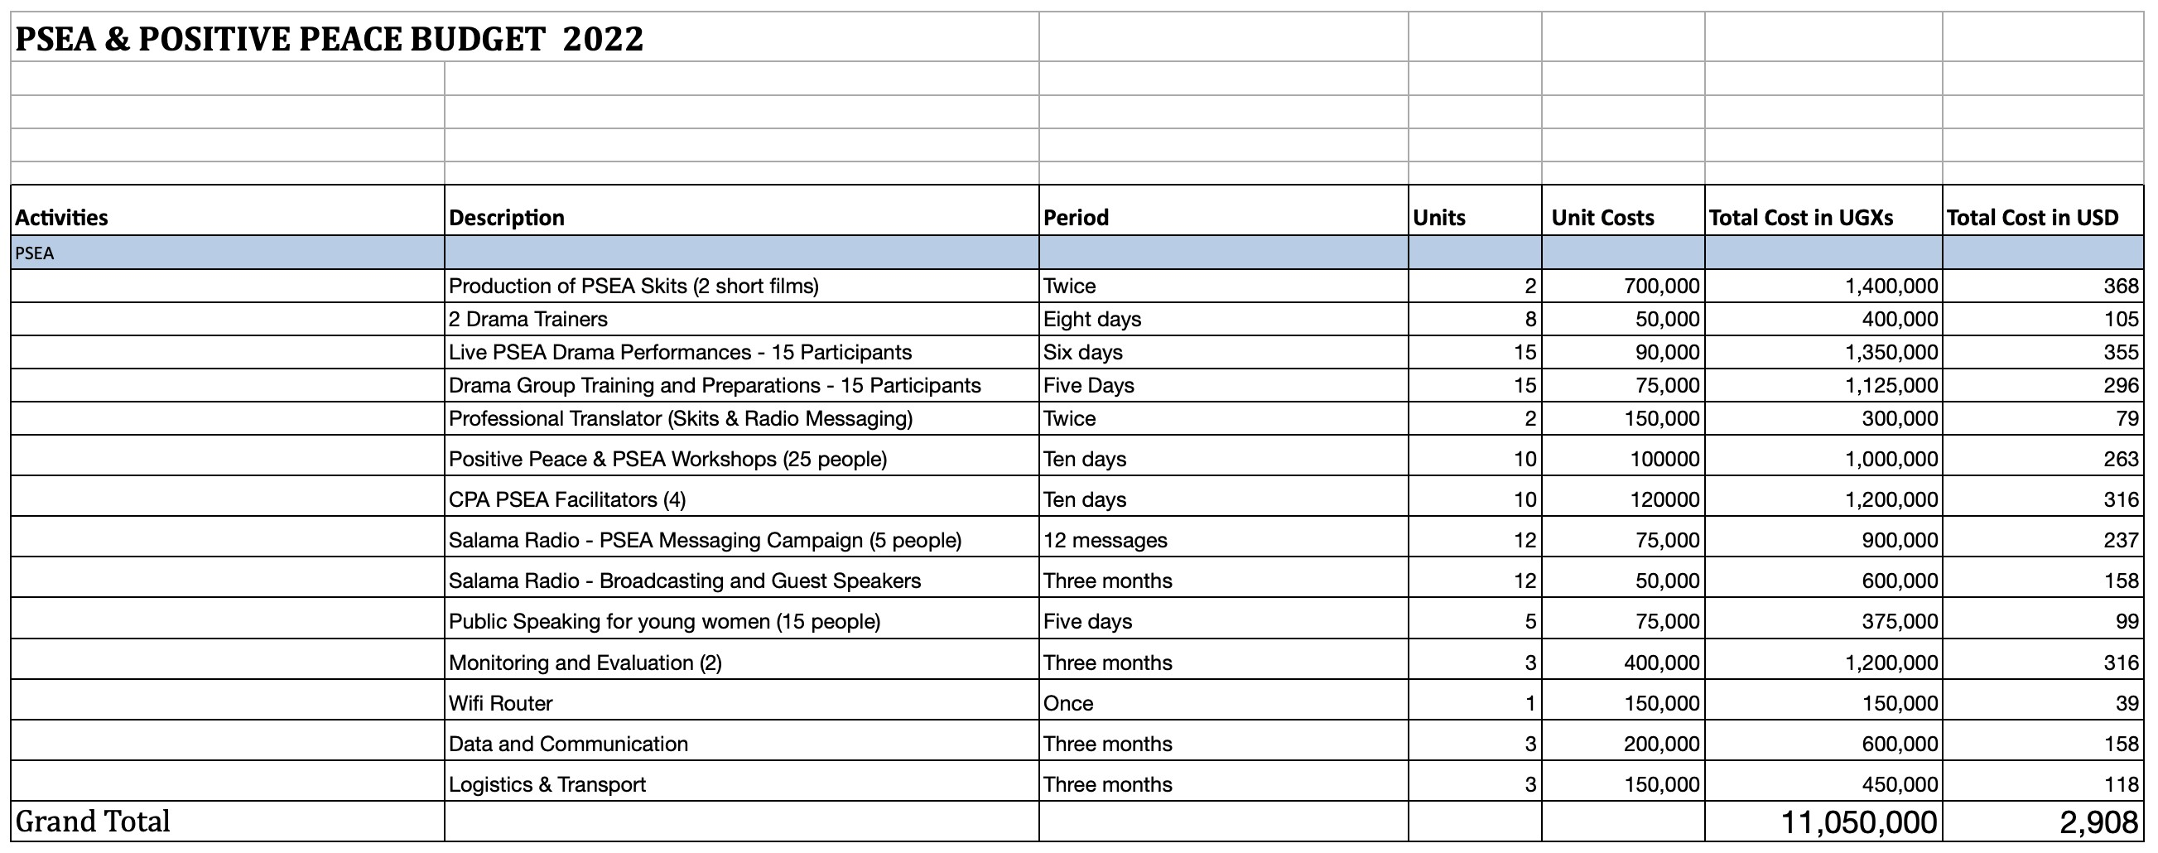

United Nations High Commissioner for Refugees. (2023). Refugee statistics. UNHCR. Retrieved January 30, 2023, from https://www.unhcr.org/refugee-statistics/
United Nations High Commissioner for Refugees. (n.d.). Emergencies. UNHCR. Retrieved January 28, 2023, from https://www.unhcr.org/en-us/emergencies.html
UNHCR - REACH, & Mbabazi, E. R. (2022). (rep.). Uganda Refugee Operation - Participatory Assessment 2021. Retrieved August 2022, from https://www.impact-repository.org/document/reach/f4b20e8d/ UNHCR_REACH_Participatory-Assessment-2021.pdf.
United Nations High Commissioner for Refugees. (2022). (rep.). UNHCR EHAGL Operational Update OctoberDecember 2022. Retrieved January 29, 2023, from https://data.unhcr.org/en/documents/details/98903.
MSN. (2022, September 10). Opm stops admitting refugees in Adjumani. New Vision. Retrieved September 20, 2022, from https://www.msn.com/en-xl/news/other/opm-stops-admitting-refugees-in-adjumani/ar-AA11HgWt? ocid=finance-verthp-feeds.
Lwanga-Lunyiigo, S. (1993). “Uganda's long connection with the problem of refugees: From the Polish Refugees of World War II to the Present". Makerere Institute of Social Research. Pg. 1
Lwanga-Lunyiigo, S. (1993). “Uganda's long connection with the problem of refugees: From the Polish Refugees of World War II to the Present". Makerere Institute of Social Research.
Hutton, L. (2018). Envisioning a Stable South Sudan. BlurrIng The lines: Ethnicity, Governance, and Stability in South Sudan. Africa Center for Strategic Studies, 25-30. https://www.jstor.org/stable/resrep19226.7
https://reporting.unhcr.org/document/3838
MSN. (2022, September 10). Opm stops admitting refugees in Adjumani. New Vision. Retrieved September 20, 2022, from https://www.msn.com/en-xl/news/other/opm-stops-admitting-refugees-in-adjumani/ar-AA11HgWt? ocid=finance-verthp-feeds.
h#ps://www.unhcr.org/news/stories/2020/1/5e2a85b4/suicides-rise-among-south-Sudanese-refugeesuganda.html
UNHCR - USA. (n.d.). Protracted refugee situations explained. How to Help Refugees - Aid, Relief and Donations. Retrieved 2022, from https://www.unrefugees.org/news/protracted-refugee-situations-explained/
UNHCR. (2010). (rep.). UNHCR Global Report 2010 - Uganda. Retrieved December 2022, from https:// www.unhcr.org/4dfdbf4b0.pdf.
Seff, I., Leeson, K. & Stark, L. Measuring self-reliance among refugee and internally displaced households: the development of an index in humanitarian settings. Confl Health 15, 56 (2021). https://doi.org/10.1186/ s13031-021-00389-y

