

**MAKERERE UNIVERSITY- ROTARY PEACE CENTER**

**ROTARY PEACE FELLOWSHIP- COHORT IV**

**SOCIAL CHANGE INITIATIVE REPORT**

**NAME: RICHIE OLAKA**

**TITLE: BUILDING DIALOGUES WITH NATIONAL GOVERNMENT ADMINISTRATION OFFICERS ON INTEGRATION OF POSITIVE PEACE PILLARS TO LAW ENFORCEMENT IN KENYA**

**DATE: JANUARY – SEPTEMBER 2023**

# **ABSTRACT**

National Government administration officers in Kenya are the link between Policing and Military agencies and the Citizens. Rather that approaching, crime, conflicts and insecurity from the criminal justice lenses they view the vices more holistically with greater emphasis on the root causes of conflicts and criminality rather than mere prosecution which is often adversarial. Being the chair of multiagency security teams in their areas of jurisdiction, National government administration officials are well placed to champion new approaches within the existing multiagency security arrangement. This Social Change Initiative had integration of positive peace pillars into law enforcement as the overall objective of the initiative. The more specific objectives that guided the Initiative included the following; to build knowledge levels on positive peace among national government administration officers, to create awareness peace among national government administration officer on each of the eight positive peace pillars, to create an understanding of how the positive peace pillars relate to day-to-day law enforcement peace by national government administration officers and come up with modalities in which they can be applied, and to Create Positive Peace Ambassadors out of the national government administration officers that the Social Change Initiative will have interacted with. This Social Change initiative used a participatory approach with group discussions and case studies being employed as the main methods for engaging. National government administration Officers were selected and converged for dialogue around the theme of the engagement. This was a dialogue rather than a training. The facilitator did not come from a point of ‘all knowing’ but rather from a point of facilitating and guiding the participants to have conversations and dialogues around the themes. This social change initiative set out to have dialogues with at least 50 national government administrative officers on modalities of integrating the positive peace approach to law enforcement. The national Government administrative officers reached were then expected to further become ambassadors of the approach and engage other officers on how this approach can be integrated to law enforcement. The first objective was realized, with a total of 69 national government administration officers from different parts of the country participating in the dialogues, the Second objective was realized when selected participant gave feedback and participant testimonies on how they were able to comprehend and integrate the pillars of positive peace in their day-to-day engagement. The third objective was realized when participants were able to discuss and bring out examples of how they can be able to apply the pillars of positive peace to day-to-day law enforcement. The final objective of this social change initiative was to create positive peace ambassadors from the participants. At the conclusion of the dialogues the participants gave a commitment to become ambassadors of the approach and convey the message to other people in the peace and security sector. This social change Initiative stands as a significant milestone in the work of National Government Administration officials in Kenya, arming them with the invaluable tools of the positive peace approach. Throughout the comprehensive program, participants delved into the intricate dimensions of positive peace and its profound implications for effective governance and nation-building. The diverse range of modules, spanning from conflict analysis to collaborative decision-making, provided a comprehensive understanding of the intricate relationship between peace, development, and proficient public administration. Adopting this approach, officials were poised to address conflicts not merely as disruptions, but as opportunities for inclusive dialogue and sustainable progress. This Social Change Initiative came up with the following recommendations; the need for institutional Integration and that there is need to pprioritize engaging directly with communities. The overriding sustainability plan for this initiative lies in institutional Integration.

**Table of Contents**

ABSTRACT 2

CHAPTER ONE 4

INTRODUCTION AND BACKGROUND 4

PROBLEM STATEMENT 5

GOALS AND OBJECTIVES 6

CHALLENGES AND MITIGATION STRATEGIES 7

THEORY OF CHANGE 8

CHAPTER 2 9

THEORETICAL UNDERPINNINGS 9

THE POSITIVE PEACE APPROACH 9

METHODS AND DESIGN 10

CHAPTER 3 12

INTERVENTIONS AND ACTIVITIES 12

KEY FINDINGS AND IMPACT 13

CONCLUSION 14

RECOMMENDATIONS 15

SUSTAINABILITY PLAN 16

APPENDICES 18

# **CHAPTER ONE**

# **INTRODUCTION AND BACKGROUND**

Kenya’s Security architecture is designed in an all-inclusive manner with the National Security Council that is chaired by the President and commander in chief of the defense forces at apex of all security sector policy and execution endeavors. Members of the National Security council include, the President, the Deputy President, the Cabinet Secretary for Interior and National Administration, the Cabinet Secretary Ministry of Defense, the Cabinet Secretary National Treasury and Planning, Head of Public Service, the Chief of Defense Forces, Director General National Intelligence Service, and the Inspector General of Police. This organ is advised by the National Security Advisory Committee which is comprised of senior technical Officers in the Security Sector. The National Security council then cascades downwards in line with the countries administrative structure running from regions all the way to Sub-Locations at the grassroot.

The National Government Administrative Structure then becomes the organ mandated under delegated authority from the President to chair and coordinate Security within the establishment all the way to the grassroot level. At the County Level for example, we have the County Security Committee whose membership is the County Commissioner as the chair, the County Intelligence Officer, the County Police Commander, and other Unit Commanders at that level including the Directorate of Criminal Investigations, the Critical Infrastructure Protection Unit, the Kenya Forest Service and the Kenya Wildlife Service.

Figure : A National government administration officer at the rank of Assistant County Commissioner

The Kenya National Government Administration structure is domiciled at the Ministry of Interior and National administration. This is the former Provincial Administration structure. Its history dates back to colonial era as stated by Oyugi (1994), that Provincial Administration was instituted by colonial authorities as a country’s institution whose activities included general representation of the executive’s authority at the grass root level, coordination of the government’s activities in the field and presiding committees at the grass root levels.

The change of Provincial Administration’s name to National Government Administration was part of restructuring as advocated in the Kenyan Constitution promulgated in the year 2010. It stipulated in Section 17 of the Sixth Schedule on Transitional and Consequential Provisions, that within five years after the effective date, the National Government shall restructure the system of administration commonly known as the provincial administration to accord with and respect the system of devolved government established under this Constitution (Constitution of Kenya, 2010). The transformed system of administration was enacted through the National Government Co- ordination Act, No.1 of 2013. The objective of the Act was to institute an administrative and institutional framework for co-ordination of National Government roles at the National and County levels of government’s operations, in accordance to the Kenyan Constitution.

In the changed system, the structure is headed at the regional level by the Regional Commissioner (RC), previously known as Provincial Commissioner (PC); County headed by County Commissioner (CC); Sub-County previously known as District headed by Deputy County Commissioner (DCC), previously known as District Commissioner (DC); and Ward previously known as Division, headed by the Assistant County Commissioner (ACC) previously known as District Officer (DO). The Chiefs and Assistant Chiefs, who are in charge of locations and sub-locations respectively, retained their titles and areas of jurisdiction.

In-light of the foregone explanation, it goes without saying national government administration officers are at the core of security management, peace building ipso facto. Cognizant of this fact, this social change initiative chose to harness this potent and comparative advantage in enshrining positive peace within the National security rubric.

# **PROBLEM STATEMENT**

National Government administration officers in Kenya are the link between Policing and Military agencies and the Citizens. Rather that approaching, crime, conflicts and insecurity from the criminal justice lenses they view the vices more holistically with greater emphasis on the root causes of conflicts and criminality rather than mere prosecution which is often adversarial. Being the chair of multiagency security teams in their areas of jurisdiction, National government administration officials are well placed to champion new approaches within the existing multiagency security arrangement. There however exists a training gap on the extents to which these officers are equipped with especially new and evolving knowledge on how to best tackle the ever-mutating peace and security demands. Peace and security cannot be viewed from the traditional lenses of deterring physical attacks or threats to life and property, contemporary trend go yonder. Integration of the positive peace pillars in peace building is one such comprehensive approach that needs to be incorporated. Security too has to be viewed from wider lenses that are all encompassing rather that the now habitual skewness to physical threats at the exclusion of contemporary issues such as climate change, food insecurity, political insecurity, bad governance, extremism, among other challenges. In order to fill this gap, this social change initiative sought to build on and develop discussions around these critical areas with integration of positive peace pillars into law enforcement as a compass. Rather than the training approach where a facilitator assumes an all-knowing role, this social change initiative was cognizant of the fact that participants had a vast repository of existing knowledge acquired both theoretically and from practice in the area of peace building and conflict transformation. The Initiative therefore chose to open up the space for dialogue on the themes with the aim of building consensus on how the positive pillars could be integrated to law enforcement.

# **GOALS AND OBJECTIVES**

This Social Change Initiative had integration of positive peace pillars into law enforcement as the overall objective of the initiative. The more specific objectives that guided the Initiative included the following;

1. To build knowledge levels on positive peace among national government administration officers.
2. To create awareness peace among national government administration officer on each of the eight positive peace pillars.
3. To create an understanding of how the positive peace pillars relate to day-to-day law enforcement peace by national government administration officers and come up with modalities in which they can be applied.
4. To Create Positive Peace Ambassadors out of the national government administration officers that the Social Change Initiative will have interacted with.

# **CHALLENGES AND MITIGATION STRATEGIES**

The implementation of this social change initiative anticipated that the main challenge will be funds for the travel logistics. The national government administrative structure is countrywide and as such it would be difficult to reach out entirely to the vast structures. In order to mitigate this challenge, this social change initiative will work with a small group of officers which is easy to reach to. The assumption will be that the officers who will benefit will then become positive peace ambassadors and disseminate the knowledge to others within their rank and file. Due to budgetary constraints, the social change initiative had to be undertaken in close proximity to the capital as this served to cut on the logistical cost for implementation.

# **THEORY OF CHANGE**

National government administration officers play a huge role in peace building. Often there have been cases where effective peace building measures and interventions have not been realized due to skill and knowledge gaps.

The outcomes that this initiative envisaged after training the national government administration officers in the area of peace building is one in which their approach to peace takes in to account the positive peace pillars.

This initiative intends to achieve the inclusion of positive peace, other more are specific outcome in the areas of jurisdiction of the trained National Government Administration Officers include; improved communication, enhanced understanding between different groups, increased collaboration, reduced violence among other benefits of the by-in to this approach.

The main activities here involved having dialogue sessions with the national government administration officers to gain consensus on how the pillars of positive peace could best be integrated into law enforcement by the administration officers.

The main assumption is that after finding Conesus on how to integrate the positive peace pillars to law enforcement, the officers will go ahead and implement this approach. Further, the initiative assumed that the trained national government administration officers will become ambassadors of this approach to their colleagues.

Effectiveness of this initiative will be measured by the number of national government administration officers that will participate in the dialogues and also their willingness to further become ambassadors of this approach.

# **CHAPTER 2**

# **THEORETICAL UNDERPINNINGS**

# **THE POSITIVE PEACE APPROACH**

The main theoretical underpinning for this Initiative will be the positive peace approach. Positive Peace theory is a conceptual framework developed by the Institute for Economics and Peace (IEP) to understand and promote the conditions that lead to long-lasting peace and well-being in societies. It goes beyond the traditional focus on the absence of violence (negative peace) and emphasizes the presence of factors that contribute to social harmony, cooperation, and resilience. The main sub sects of this theories are as follows;

**Multidimensional approach**

Positive Peace theory identifies multiple interrelated factors that contribute to peace. These factors encompass a wide range of social, political, economic, and cultural elements that collectively create an environment conducive to peaceful coexistence.

**Pillars of Positive Peace**

The theory identifies eight pillars or domains that are essential for building and maintaining Positive Peace. These pillars include well-functioning government, sound business environment, equitable distribution of resources, acceptance of the rights of others, good relations with neighbors, free flow of information, high levels of human capital, and low levels of corruption

**Systems Thinking**

Positive Peace theory recognizes the interconnectedness of these pillars. It emphasizes that improvements in one area can have positive effects on others, creating a reinforcing cycle that enhances overall peace

**Resilience and Adaptability**

A society characterized by Positive Peace is more resilient to internal and external shocks, such as economic downturns or natural disasters. The presence of strong institutions, social cohesion, and equitable development contributes to a society's ability to adapt and recover.

**Preventive Approach**

Positive Peace theory promotes a proactive approach to conflict prevention. By addressing the root causes of conflict and investing in the pillars of Positive Peace, societies can reduce the likelihood of violent conflicts occurring in the first place.

**Long-term Sustainability**

Positive Peace theory focuses on creating lasting peace that extends beyond short-term solutions. By addressing systemic issues and fostering a positive environment, societies are better positioned to maintain peace over time

**Measurement and Indices**

The Institute for Economics and Peace developed the Global Peace Index (GPI) as a tool to measure and assess the levels of peace in different countries. The GPI incorporates indicators from both negative and positive peace aspects, providing a comprehensive view of a society's peace status.

# **METHODS AND DESIGN**

This Social Change initiative used a participatory approach with group discussions and case studies being employed as the main methods for engaging. National government administration Officers were selected and converged for dialogue around the theme of the engagement. This was a dialogue rather than a training. The facilitator did not come from a point of ‘all knowing’ but rather from a point of facilitating and guiding the participants to have conversations and dialogues around the themes.

This Initiative chose to use group discussions since they offer a myriad of benefits that make them an indispensable tool for fostering learning, critical thinking, and effective communication. Firstly, these discussions bring together diverse perspectives and experiences, creating an environment where participants can learn from each other's unique insights. This diversity stimulates critical thinking as individuals engage with differing viewpoints, leading to a deeper exploration of topics and more well-rounded conclusions. Moreover, active participation in group discussions enhances the retention of information, as individuals are more likely to remember and internalize concepts they actively engage with, creating a dynamic and immersive learning experience.

Group discussions play a pivotal role in skill development. They provide a platform for refining communication skills such as articulation, active listening, and persuasive discourse. Participants learn to express their thoughts clearly and succinctly, honing their ability to convey complex ideas effectively. These discussions also nurture conflict resolution skills, as participants navigate differing opinions and learn to engage in constructive debates. As individuals collaborate to find common ground or innovative solutions, they develop teamwork and harmonious working.

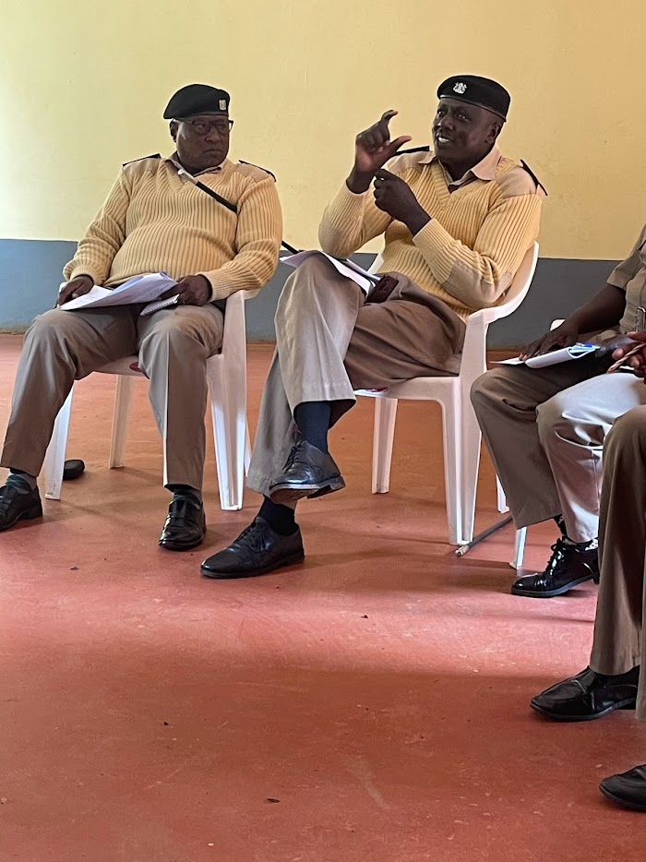

Lastly, group discussions foster social interaction and empathy. Participants connect with peers who share similar interests, cultivating networks and relationships that extend beyond the discussion itself. Through exposure to diverse perspectives, individuals develop empathy as they gain a deeper understanding of others' experiences and viewpoints. This empathetic engagement is crucial in cultivating an open-minded and inclusive mindset, essential for effective communication and building bridges across cultural, social, and ideological divides. Overall, the benefits of group discussions extend far beyond mere discourse, enriching learning, and skill development.

Figure 2: A participant Contributing to a group discussion

After the group discussions, the participants are expected to be ambassadors of the approach and spread the concept to other actors within the peace and security sector. The National Government administration is very huge and vast, since this social change initiative was time and resource bound, it is expected that the participants will continue spreading the message.

# **CHAPTER 3**

# **INTERVENTIONS AND ACTIVITIES**

This social change initiative set out to have dialogues with at least 50 national government administrative officers on modalities of integrating the positive peace approach to law enforcement. The national Government administrative officers reached were then expected to further become ambassadors of the approach and engage other officers on how this approach can be integrated to law enforcement.

The positive peace approach in peace building emphasizes more than just the absence of conflict; it centers on the creation of conditions that foster sustainable harmony and well-being within societies. This approach recognizes that true peace is not simply the absence of violence, but the presence of justice, equity, and social progress. By addressing root causes of conflict, such as inequality, poverty, and social injustices, the positive peace approach aims to build a foundation upon which conflicts are less likely to arise. This proactive stance helps to break the cycle of violence and create lasting peace by encouraging societies to invest in education, healthcare, social infrastructure, and participatory governance

One of the key advantages of the positive peace approach is its focus on building resilient communities that are equipped to handle challenges and disputes without resorting to violence. By empowering individuals and communities with education, economic opportunities, and participatory decision-making, this approach lays the groundwork for conflict prevention and mitigation. Moreover, the positive peace approach fosters a sense of social cohesion, trust, and empathy among different groups, which contributes to the long-term stability of societies. By addressing the underlying structural issues that can lead to conflicts, this approach creates a more inclusive and equitable environment, where all members of society have a stake in maintaining peace. Ultimately, the positive peace approach not only helps prevent conflicts but also builds a stronger, more harmonious foundation for societies to thrive. This initiative thus worked on the assumption that integration of this approach would go a long way in fostering positive peace. The methodologies used to relay this method included group discussions and case studies as alluded to.

# **KEY FINDINGS AND IMPACT**

This Social Change Initiative had sought to fill meet the following objectives;

1. To build knowledge levels on positive peace among national government administration officers.
2. To create awareness peace among national government administration officer on each of the eight positive peace pillars.
3. To create an understanding of how the positive peace pillars relate to day-to-day law enforcement peace by national government administration officers and come up with modalities in which they can be applied.
4. To Create Positive Peace Ambassadors out of the national government administration officers that the Social Change Initiative will have interacted with

The first objective was realized, with a total of 69 national government administration officers from different parts of the country participating in the dialogues. These dialogues were designed to be participatory and engaging to ensure that the participants get the most out of them. Rather than a training approach where the facilitator takes an imposing and all-knowing role, this initiative designed a dialogue format often with small groups of National government administration officers to allow for meaningful participation and interaction. A participatory approach in training holds paramount importance as it fosters active engagement, ownership, and empowerment among participants. By involving trainees in the planning, design, and execution of training programs, their unique perspectives, experiences, and expertise are acknowledged and integrated. This not only enhances the relevance and effectiveness of the training content but also cultivates a sense of investment and commitment. A participatory approach encourages open dialogue, knowledge-sharing, and collaborative problem-solving, creating a dynamic learning environment. Moreover, participants are more likely to retain and apply the acquired knowledge and skills when they have actively contributed to the learning process. Overall, a participatory approach transforms training sessions into inclusive, learner-centered experiences that lead to more meaningful and sustainable outcomes

The Second objective was realized when selected participant gave feedback and participant testimonies on how they were able to comprehend and integrate the pillars of positive peace in their day-to-day engagement. Participant feedback is a crucial element in any learning or training program, as it serves as a compass guiding continuous improvement. The insights and perspectives shared by participants provide valuable information about the effectiveness of the training content, methods, and facilitation. This feedback not only helps trainers refine their approaches to better suit participants' needs and learning styles but also ensures that the training remains relevant and aligned with the evolving goals and challenges of the participants. By actively seeking and acting upon participant feedback, training programs can create a virtuous cycle of enhancement, ultimately leading to higher engagement, better retention of knowledge, and more meaningful skill acquisition among participants

The third objective was realized when participants were able to discuss and bring out examples of how they can be able to apply the pillars of positive peace to day-to-day law enforcement. Discussions go a long way in assessing retention abilities and the interest levels raised around the themes under study.

The final objective of this social change initiative was to create positive peace ambassadors from the participants. At the conclusion of the dialogues the participants gave a commitment to become ambassadors of the approach and convey the message to other people in the peace and security sector.

# **CONCLUSION**

This social change Initiative stands as a significant milestone in the work of National Government Administration officials in Kenya, arming them with the invaluable tools of the positive peace approach. Throughout the comprehensive program, participants delved into the intricate dimensions of positive peace and its profound implications for effective governance and nation-building. The diverse range of modules, spanning from conflict analysis to collaborative decision-making, provided a comprehensive understanding of the intricate relationship between peace, development, and proficient public administration. Adopting this approach, officials were poised to address conflicts not merely as disruptions, but as opportunities for inclusive dialogue and sustainable progress. The immersive case studies and dynamic group discussions underscored the importance of fostering social cohesion, promoting equitable development, and nurturing transparent governance practices.

As the participants return to their vital roles, they carry with them the insights that the positive peace approach encompasses more than conflict resolution—it encompasses the proactive creation of an environment where citizens can flourish, institutions can thrive, and justice can prevail. The principles of empathy, cultural sensitivity, and strategic communication that were explored during the Initiative serve as the bedrock of ethical and efficient governance. Their newfound ability to identify and address sources of tension, channel diverse perspectives into collaborative solutions, and build bridges between communities lays the foundation for a harmonious and prosperous nation.

The initiative also encouraged participants to reflect on their learning journey and commit to ongoing growth. Embracing the positive peace approach demands a continuous dedication to skill refinement, adapting to evolving challenges, and consistently seeking feedback from the citizens they serve. By fostering an environment of trust and open dialogue, the officials uphold the principles of democracy while instilling confidence in the governance process. Every interaction, policy decision, and initiative undertaken by them holds the potential to positively impact society, contributing to the very essence of the nation's progress.

In essence, the positive peace approach is not merely a theoretical concept—it serves as a guiding compass for roles as agents of change, custodians of justice, and advocates for unity. As participants embark on their transformative journeys, they understand that their commitment to nurturing a society rooted in compassion, equity, and collaboration will resonate through generations, leaving an indelible mark on the trajectory of the nation's growth

# **RECOMMENDATIONS**

This Social Change Initiative came up with the following recommendations;

1. **Institutional Integration;** There should be established a mechanism to integrate the positive peace approach into your daily operations and decision-making processes. Collaborate with relevant government departments to incorporate these principles into policies, programs, and strategies. Foster a culture of cooperation and information sharing to create a holistic approach to positive peace implementation.
2. **Community Engagement;** there is need to pprioritize engaging directly with communities to understand their needs, concerns, and aspirations. Foster participatory decision-making processes that involve local stakeholders in policy formulation and implementation. This inclusive approach not only promotes ownership but also helps in tailoring solutions to community-specific challenges.
3. **Partnerships;** there is need to champion partnerships with civil society organizations, academia, international agencies, and non-governmental organizations that specialize in conflict resolution, peacebuilding, and community development. Collaborative efforts can leverage expertise and resources for more impactful outcomes

If embraced, these recommendations will serve to ensure the positive peace approach becomes an integral part of Kenya’s governance framework, leading to tangible community relations, conflict resolution and societal well-being.

# **SUSTAINABILITY PLAN**

The overriding sustainability plan for this initiative lies in institutional Integration which can be achieved as follows;

**Dedicated Unit Establishment;** To ensure the institutionalization of the positive peace approach within the National Government Administration, a dedicated unit should be established. This unit will serve as the central hub responsible for overseeing, coordinating, and facilitating the integration of positive peace principles into government operations. Comprising experts in conflict resolution, governance, and community engagement, the unit will collaborate with various departments to develop strategies, guidelines, and policies that reflect the positive peace ethos. This approach will institutionalize positive peace as a core pillar of governance, fostering a holistic and sustainable framework for addressing conflicts and promoting harmonious relations.

**Inter-Agency Collaboration:** Integration of the positive peace approach will rely on robust interdepartmental collaboration. The newly established unit will work closely with key departments to identify opportunities for embedding positive peace principles within existing practices. Regular interdepartmental meetings, workshops, and knowledge-sharing sessions will be organized to facilitate cross-functional dialogue, encouraging the exchange of experiences and successful strategies. By fostering a culture of collaboration and mutual support, the positive peace approach will become ingrained in the fabric of government activities.

**Capacity Building and Training Cascading:** A critical aspect of institutional integration is ensuring that positive peace principles are cascaded effectively throughout the entire National Government Administration. The dedicated unit will develop a comprehensive training program designed to equip officials at all levels with the requisite knowledge and skills. This program will be integrated into existing training curricula and supplemented with refresher courses, workshops, and e-learning modules. By enhancing the capacity of officials across the organization, the positive peace approach will be consistently applied in diverse scenarios, solidifying its long-term integration

**Monitoring and reporting Mechanism:** A robust monitoring and reporting mechanism will be established to track the progress and impact of the institutional integration of the positive peace approach. Regular assessments will gauge the extent to which positive peace principles have been incorporated into government functions, policies, and initiatives. Data collected will be analyzed to identify areas of success and opportunities for improvement. Periodic reports detailing the achievements, challenges, and future plans related to the positive peace approach will be presented to senior leadership and disseminated among departments. This transparent approach to reporting will ensure accountability, enable course corrections, and showcase the tangible benefits of institutional integration.

In conclusion, the sustainability plan for the institutional integration of the positive peace approach underscores the commitment of the National Government Administration officials in Kenya to embedding the principles of peace, collaboration, and effective governance within the core fabric of their operations. By establishing a dedicated unit, fostering interdepartmental collaboration, implementing robust capacity-building initiatives, and developing monitoring and reporting mechanisms, the positive peace approach will thrive as an enduring and transformative force in shaping a harmonious and prosperous society.

# **APPENDICES**

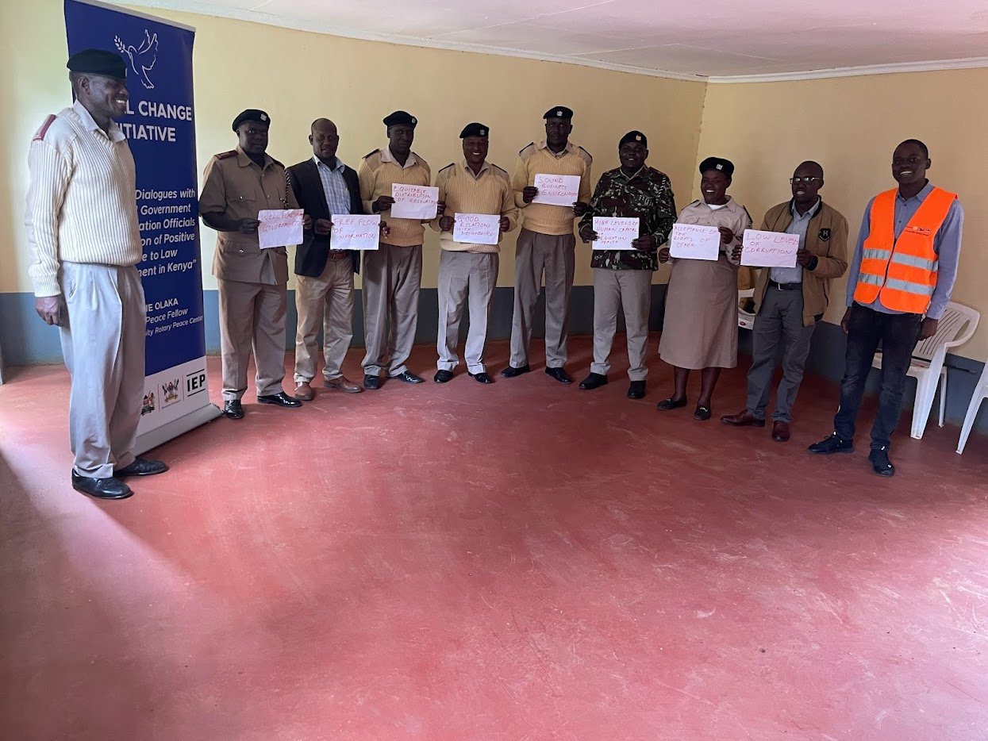

Figure 3:Participants at Kipkaren Division holding cards inscribed with the different Pillars of Positive Peace

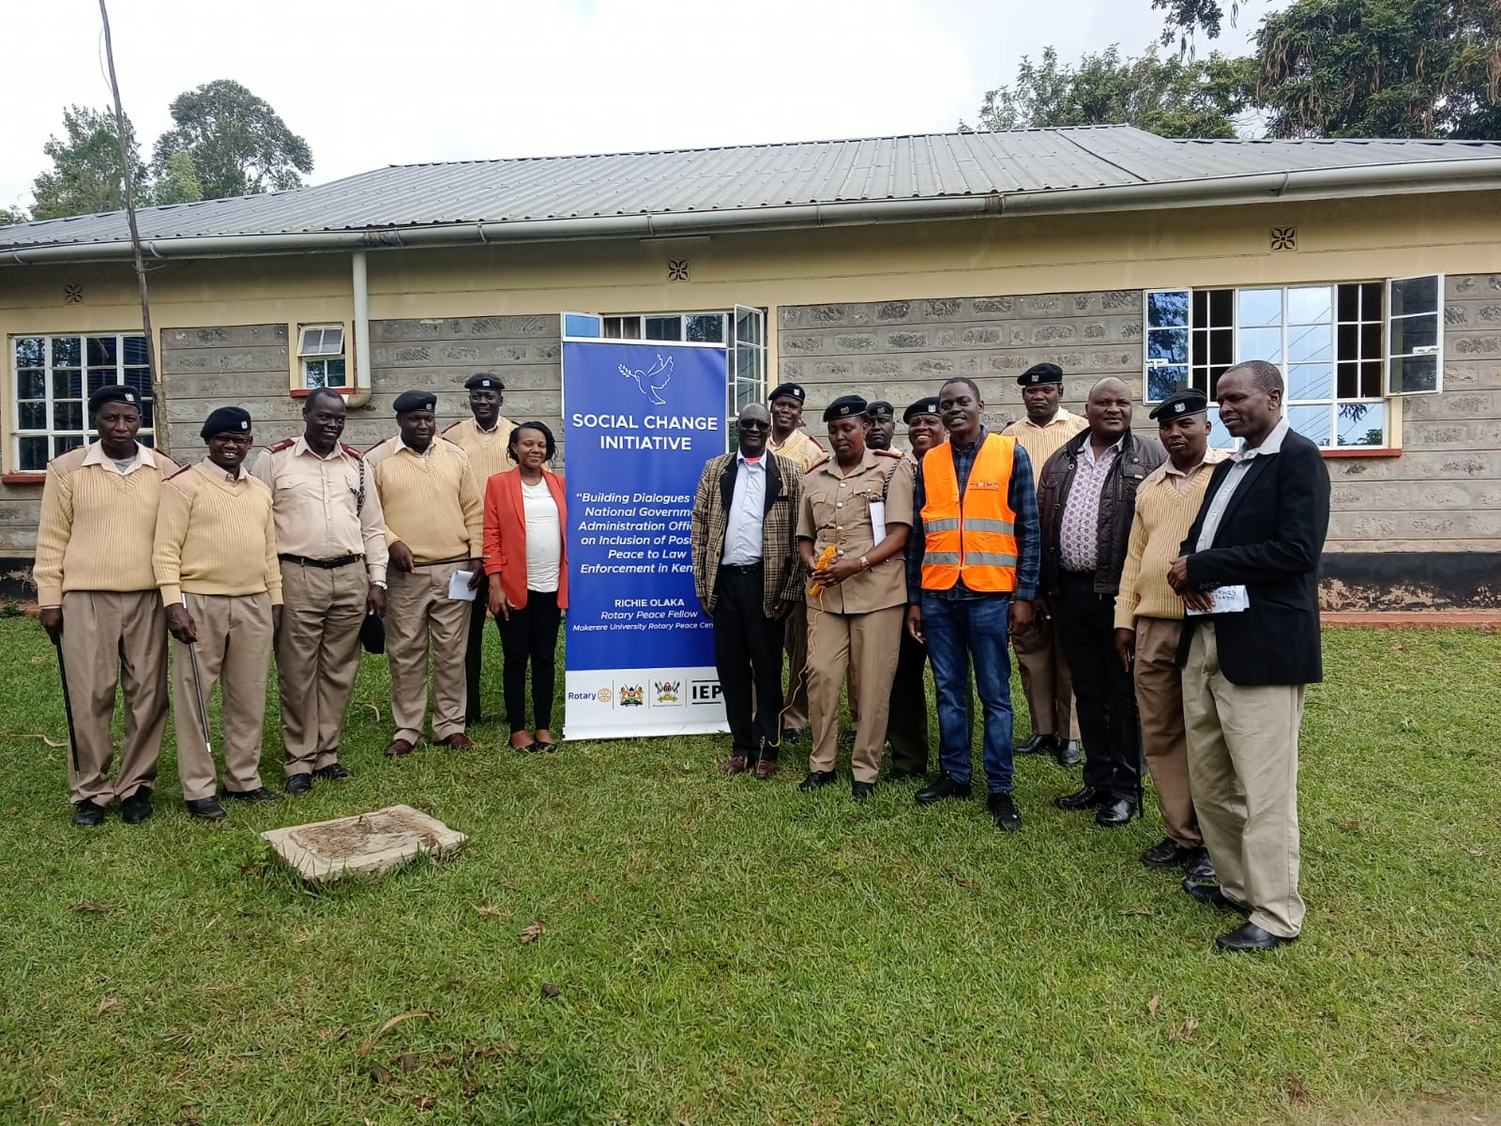

Figure 4: Participants after a dialogue at Soi Division in Uasin Gishu County

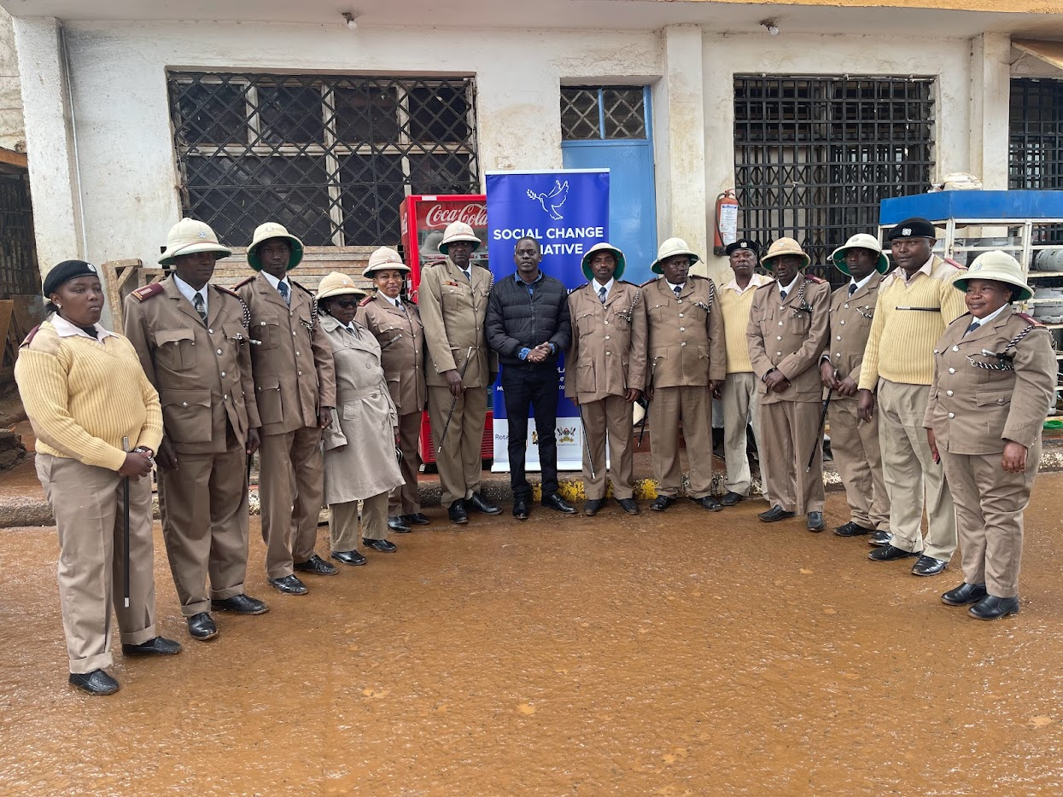

Figure 5: National Government Administration Officers at Othaya, Nyeri County pose for a Photo after a training Session

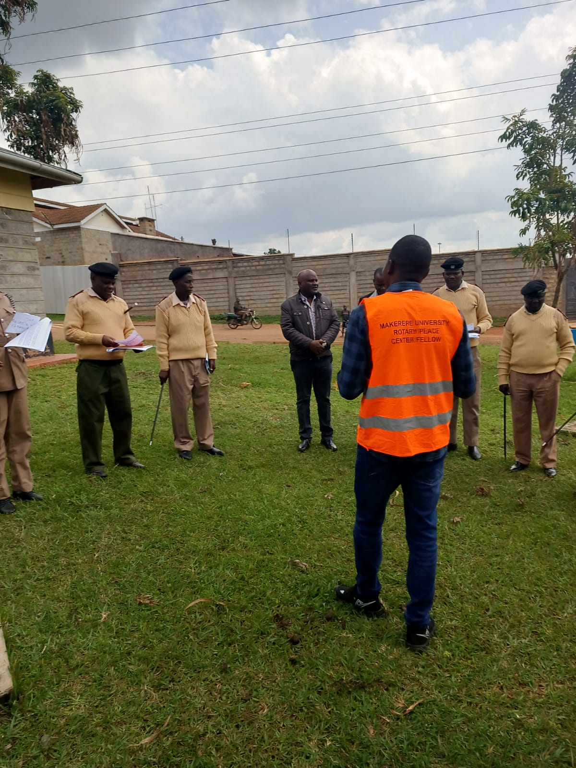

Figure 6:Group activity with participants at Soi Division

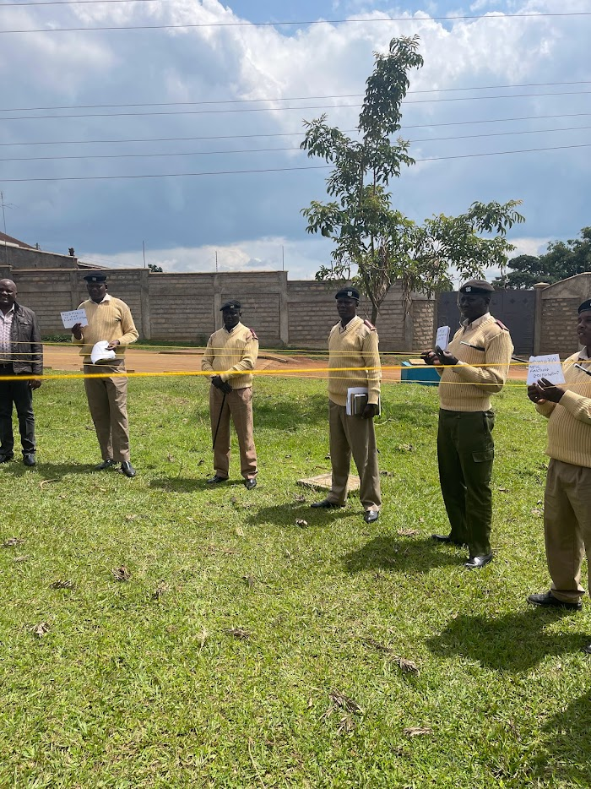

Figure 7: Participants taking part in a group activity

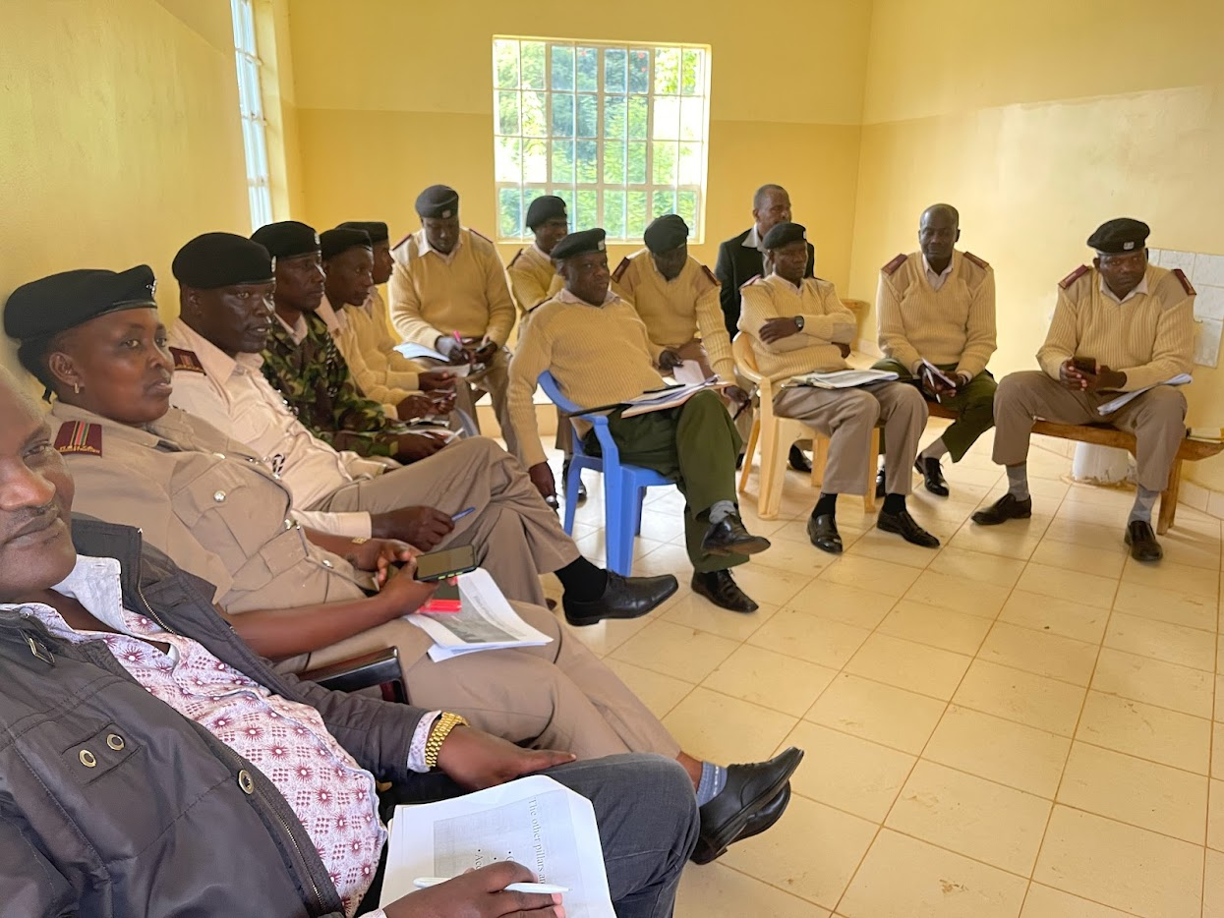

Figure 8: National Government Administration officers following a discussion at Soi Division