# THE ROLE OF WATER, SANITATION and HYGYIENE IN PEACE BUILDING

**Location:** LUPWE, LUMBU AND TAKUM COMMUNITIES IN TARABA STATENIGERIA

16 JULY - 20 DECEMBER, 2022

# ABSTRACT/SUMMARY

This Social Change Initiative (SCI) was carried out in the Lumbu, Lupwe and Takum communities of Taraba State. It examines the cause of WASH (Water, Sanitation and Hygiene) related conflicts and try to suggest possible solutions, resolution mechanisms or how they can be totally avoided. This was achieved with the efforts of the communities who teamed up to birth ***WASH for PEACE*** which became a strong voice advocating for the rights of all humans to access to water and that of the girl child to education just as that of her male counterpart.

At the end of the SCI, two boreholes were constructed, a borehole was reactivated and water was given to community members for free and at same time, the message of Peace was spread.

**CHAPTER ONE**

# Introduction and Background

Sometimes it can be hard to imagine that something as ordinary as water can be so powerful. We know, for example, that access to clean water can transform the everyday lives of individuals, eliminating diseases, freeing up women to earn an income and allowing children to go to school.

Throughout history, water has been a trigger or source of conflict, as nations wrestle for sovereignty over key waterways, groups fight for access to crucial water sources, and populations are forced to leave their homes due to water scarcity. It’s been weaponized to control populations and gain political leverage, and water infrastructure is often a casualty of conflict, being intentionally or unintentionally destroyed. But more and more, water is also playing a crucial role in peace and conflicts, especially as water becomes scarcer with increasing populations, overuse, mismanagement, and climate change.

Water, sanitation and hygiene service delivery if not correctly implemented, could cause more conflicts to an already fragile situation (Bush, 1992). As an example, when the US army was supporting the United Nations in delivering aid to 100,000 drought-stricken people in Mogadishu, there was fear that water and food aid was being manipulated and looted.

# Problem Statement

In some communities of Taraba state, it is a taboo for boy to fetch water for household chores, with unclean water sources miles away from villages, women and girls are often forced to spend hours each day simply finding and transporting water. It is not safe for women and girls to fetch water in the very early hours of the morning. The daily average walking for clean water is three hours. The typical container used for water collection in Africa, the jerry can, weighs over 40 pounds when it is completely full. With much of the day being already consumed by meeting basic need, there is no enough time for much else. This daily hardship puts the lives of girls at risk of rape, abduction, and even lack of school education, while women do not have time to do a trade and earn a living. The scenario in the Takum and Ussa communities is slightly different as boys can be involved in fetching water but the sources are also far off from their homes.

# Goals and Objectives

1. To spread and promote the message of Peace and the Pillars of Peace.
2. To advocate for the rights of the girl child to be educated.
3. To educate on proper use and management of WASH facilities.
4. To improve the existing and provide more WASH facilities.

# Challenges and Mitigation Strategies

1. Delay in carrying out the project due to incessant crisis that persisted for about three months.
2. Change of project location: Incessant attacks by herders/bandits caused severe crisis in my original locations kept disrupting normal activities causing mass exodus of communities from their homes. I had to change location to more peaceful communities within Takum local government headquarters and areas near the military barracks where victims ran to seek refuge with families, friends while some had to occupy government schools and churches which had to serve as Internally Displaced Persons (IDP) camps.
3. Difficulties in accessing the government and political leaders to advocate for provision of WASH facilities and/or to improve the existing ones in communities to abate or reduce the suffering of the people. I had to go through political aides with many failed appointments.
4. Insecurity and fear of the unknown: I employed the services of community police (vigilante) as escort to project sites at Lumbu and Lupwe communities which are 12km and 7km respectively from Takum metropolis. Though very short distance but the journey can be long due to fear and the very bad road.
5. Lack of funds: I had to use my personal savings while few family members contributed little sum as their support to pay for all expense.

**CHAPTER TWO**

# Literature Review

Peace is a sine qua non for development, progress and unity. This explains why every society from time desire peace and every religion including African traditional religion (Afrelism) advocate peace in their doctrines. The term *peace* features predominantly in the two leading religions in the world, Christianity and Islam. For example, the salutation ‘*Shalom*’ is as popular among the Christians and Jews as ‘*Asalam Aleikum*’ is among the Muslims. Both terms mean, ‘*Peace be unto you*’ (Albert, 2008:33).

Without peace we cannot make any form of advancement in education, in our places of work and even in our homes. A human being cannot make any progress too if he or she does not make peace with himself or herself. Peace must be made with the environment, except necessary one should not kill or destroy the fauna (animals) and the flora (plants) communities. Water bodies (rivers, oceans, seas, and creeks) should not be polluted too. Mountains and other natural formations should be respected. This means that peace is not a desire but it is a must! It is foundation for human progress in all ramifications. A popular Hausa proverb put this notion of peace thus: *Salama maganin zaman duniya* (Peace is the forerunner of healthy human existence). The view here is that without peace, the community cannot have prosperity in any sector, including everyday practices such as planting and harvesting of crops.

The traditional definition of peace is the absence of war, or absence of violence. However,

Richmond et al (2010:8) emphasized that, “peace is more than the absence of war and it involves freedom, justice, conflict resolution, non-violence, community building and democratization of authority.” The encyclopedia of violence, peace and conflict (1999) by Laser et al defined peace as the state of mutual harmony between people or groups especially in personal relations, the normal freedom from civil commotion and violence of a community, public order and serenity, a state of tranquility or serenity.

WASH is an acronym which stands for Water, Sanitation and Hygiene. WASH planning in fragile and conflict affected situations is a complex process. However, if effectively done and correctly implemented, WASH strategies often yield positive results both in terms of provision of the required services in the communities as well as community-level conflicts respective areas (MacGinty, 2014; OCHA, 2019).

Gender-related conflicts are also essential to reflect on this regard. For example,, ‘Women and girls bear the most burden of WASH, yet they are often excluded from planning, delivering and monitoring community WASH activities because of having less power, resources, time, and status than their male counterparts’(SIDA, 2019).

Additionally,

Well-intentioned water projects may unintentionally lead to significant conflict. Project rules may insist that a water supply is used only for drinking water, yet people usually need water for multiple uses. This ‘hidden’ conflict is leading cause of poorly functioning water systems as people draw more water from the system, leaving others with purposes leaving others with inadequate or non-existent service. Some disputes may be ad hoc, whereas others may be structural and embedded in society (Visscher, 2008)

Conflict situations often leave states in state of fragility (Menkhans, 2017). In such circumstances, states have weak institutional capacity to provide critical public goods and services such as water and hygiene (Chitiyo and Radar, 2012). Fragile states are generally found in developing countries, are characterized by inadequate state capacity and are often unstable regimes.

# Theoretical Underpinnings

Sustainable water projects that bond, bridge, and link communities are critical for building community resilience. They help prepare communities to not confront increasing risks to water insecurity, but also conflicts, water-related or otherwise. That is why it is important to continue progress towards Sustainable Development Goal 6 of clean water for all by 2030. Specifically, Target 6.A aims to expand water and sanitation support to developing countries, including through water harvesting, desalination, water efficiency, wastewater treatment, recycling and reuse technologies.

While Target 6.B really gets at how WASH projects can build resilience and peace. It aims to support and strengthen the participation of local communities in improving water and sanitation management, because it is only through their participation that they become stronger as a community to withstand the threats of water scarcity.

This Social Change Initiative is committed to accelerating equitable access to clean water, sanitation and hygiene services to contribute to SDG6. This will only be achieved through advocacy and collaboration.

# Change Theory and how it was applied

The Theory of Change that was applied was advocacy and collaboration. Advocacy was carried out to traditional leaders on the disadvantage of the practice which prevents the male child from fetching water for household chores resulting to the female child not being able to attend school and leading to cases of rape, unwanted pregnancy and early marriage. It was further escalated to political and community leaders on the need to provide and improve WASH facilities in these communities as it will bring about lasting peace. Religious leaders were also not left out in this process which gave opportunity to a lecture on peace during the 2022 Reformed Church of Christ for Nations (RCCN) National Women Conference.

Peace-building can occur at localized level as well as at a national or even international level. Peacebuilding interventions also include the work of humanitarian organizations such as those involved in the provision of WASH services.

# Methods and Design

1. Interviews: Oral interviews were conducted on both individuals and groups in communities were this project was carried out. This was done to ascertain needs assessment.
2. Planning together with communities: This was suggested as one of the ways of resolving WASH related conflicts. Together with some community stakeholders (representatives of men, women, youths, people living with disabilities and school children) we discussed how to come up with possible solutions to these crisis. After several suggestions, it was agreed that an organization be formed which will be a voice and an advocate for peace building and conflict transformation in relation to Water, Sanitation and Hygiene. That day, a non-governmental organization, “***WASH for PEACE***” was birthed! This Social Change Initiative project was carried out as a team (organization).
3. Localized Memorandum of Understanding: There was an agreement between the communities and the owners of these private water outlets facilitated by WASH for PEACE that while these owners freely give water, the facilities (taps, pipes, pumps, reservoirs) would be properly managed.

**CHAPTER THREE**

# Interventions and Activities

1. **Advocacy to traditional leaders**: In Nigeria, traditional leaders are the custodians to the traditions and customs of the people in all communities thereby, making them the doorway into the communities. Advocacy and courtesy had to be carried out to them to seek their permission, blessing and cooperation in the communities.
2. **Familiarization of communities**: A familiarization of the communities where this social change initiative was to be carried out was done. This was to understand the root causes of crises in relation to Water, Sanitation and Hygiene (WASH) and the possible solutions which were achieved by interviewing members or the communities (men, women and children alike).
3. **Advocacy to the Representatives of the National Assembly**: although it was difficult accessing the representatives, through their aides after many failed attempts, we were able to meet and advocate for provision of WASH facilities in our communities as lack of it is a serious source of conflict. The representative responded by saying the visit was apt and the request was in line with the provisions in the constituency’s act as one of the projects to be carried out and is already contracted. A month later, equipment and machines were moved to sites and work began in earnest. By the end of December 2022, two solar powered boreholes with reservoirs and taps were drilled, constructed and completed while one borehole which had a damaged 10kvA pump was replaced at Lupwe and Lumbu communities.
4. **Peace Lecture during RCCN National Women Conference**: the advocacy to the Reformed Church of Christ for Nations (RCCN) leadership gave opportunity to give a lecture on the Peace and Pillars of Peace during the 2022 National Women Conference which held in November 2022. To efficiently and effectively communicate the lecture, the participants were divided into small groups where 25 women were earlier trained were the teachers. The lecture held for 40 minutes in small groups while I finally summarized to the whole conference in the next 20 minutes. It was agreed that the participants will further spread the message of peace to their communities. The conference had participation of 3,189 participants across the nation.
5. **Educating students on Peace and the Pillars of Peace**: A 2-day lecture was held with the students of Veenstra Reformed Theological Seminary (VRTS), LupweTakum in Taraba State on Peace and the Pillars of Peace. As seminarians, they have a mandate to ensure that there is peaceful co-existence amongst members of the communities they would serve as clergies. Therefore, when the school management was approached, they agreed that it was needful that this lecture held as it will boost their knowledge on peace and conflict resolution. Surprisingly, participation was from both staff and students.
6. **Rally**: A rally was planned but could not hold due to herders/farmers clashes which erupted in the community.
7. **Collaborations/ Partnerships**: There were some individuals in Takum community that were able to construct boreholes in their personal residential houses were requested to give water to community members which they willingly obliged but with a localized MoU that the WASH facilities (taps, pumps, reservoirs) will be properly managed.

# Key Findings/ Impact

1. Since it was not possible to get funding from any organization, I made available all funds for travels, refreshment and logistics from my personal savings and donations from family and friends.
2. There was a change in the cultural belief that house chores are only meant to be carried out by the female gender but that the female child has as much right to education as her male sibling. It became an exciting ‘new’ hobby for the boys as they carried out this chore with joy as they respected their female counterparts.
3. The Peace Lecture had great impact especially at a time like this when most of the people had been affected with crises. It was both a means of healing and finding solutions to the incessant conflicts that keep arising in the communities and was agreed that participants will spread the message of peace.
4. Dilapidated and vandalized WASH facilities such as pipes, taps, and pumps were either improved or replaced by the government through the communities Representative in the National Assembly while two (2) new solar powered boreholes were constructed in Lupwe and Lumbu communities.
5. Community members were willing to share their resources to with those who didn’t have and broke the dichotomy of the rich and poor.
6. Community members now began owning the WASH facilities thereby properly managing them and protecting them from vandalization.

**CHAPTER FOUR**

# General Conclusion

Individuals and communities can actually be involved in peace building and conflict transformation which in the real sense does not require huge efforts such as use of weapons. The little kindness we show to each other through equitable sharing and managing the scarce natural resources, is the greatest path to peace. As in the words of Desmond Tutu, “Do your little bit of good where you are; it’s those little bits of good put together that overwhelm the world.”

# Recommendations / Implications for Policy

This Social Change Initiative recommends that;

1. Community members should own the WASH facilities provided by the government. By owning them, they will properly manage the facilities and protect them from vandalization.
2. The government, organizations and able individuals should provide water and WASH facilities to the communities where they are lacking and improve the existing ones.
3. The government, organizations and individuals should make and implement policies that will contribute, fund and support machineries towards ensuring that Peace Building and Conflict Transformation is given serious attention as it is the only vehicle that will drive the world’s economy and bring about harmony in our communities and the world at large.

# Sustainability Plan

There is an ongoing plan so that ***WASH for Peace*** will keep collaborating and partnering with non-governmental organizations such as Women in Water Sanitation and Hygiene (Women in WASH), Nigeria Council of Women Societies (NCWS), Taraba Advocacy and Rehabilitation Foundation (TARe Foundation), political leaders, traditional leaders, religious groups, hospitals, schools, youth groups and Taraba Water and Sewerage Corporation (TAWASCO) which is a government water utility to educate, advocate, improve, provide and properly manage WASH facilities to enhance peaceful coexistence in our communities.

# APPENDICES

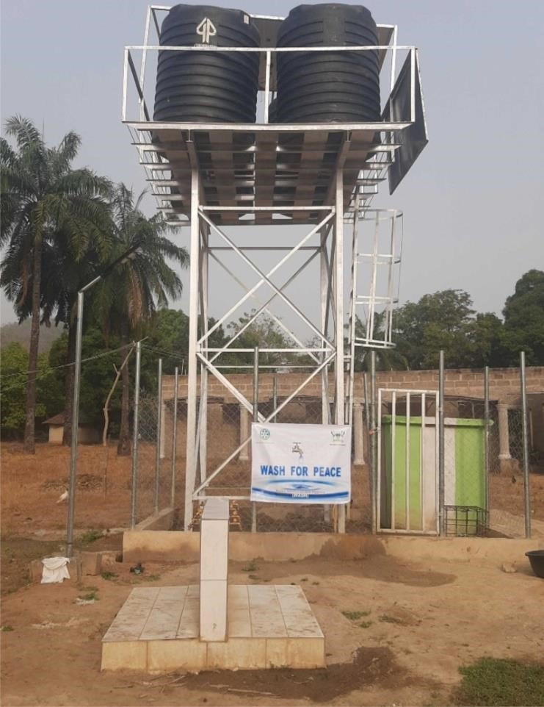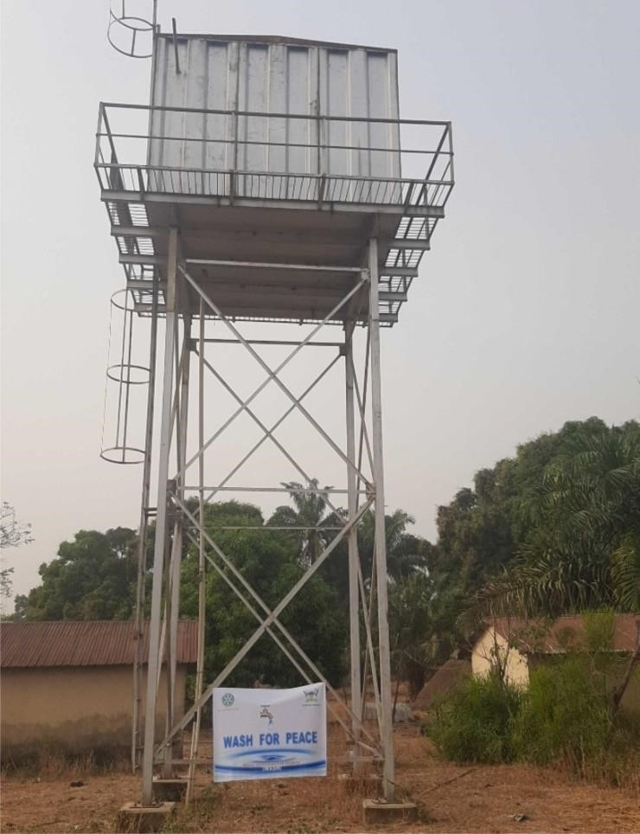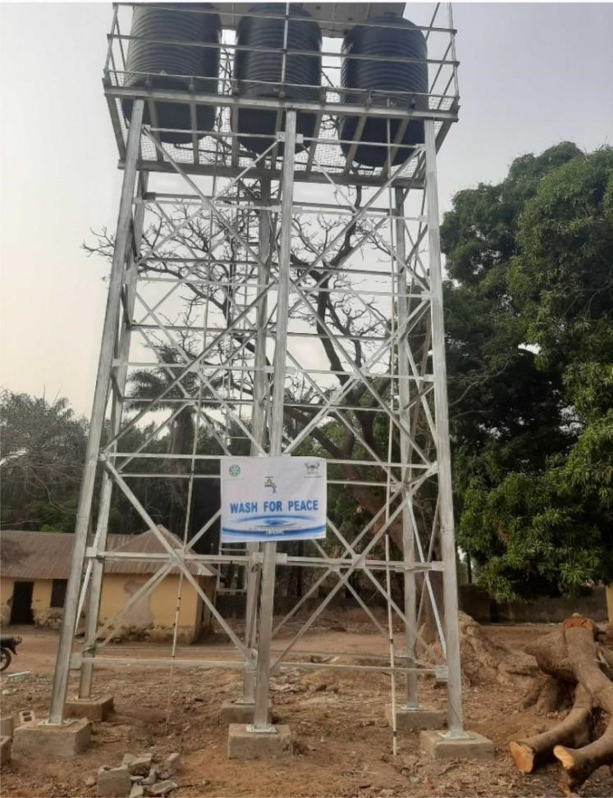

NEWLY BOREHOLE CONSTRUCTED AT LUMBU COMMUNITY

A BOREHOLE

WHO’S

DAMAGED PUMP WAS REPLACED

NEWLY CONSTRUCTED WATER FACILITY AT VRTS, LUPWE

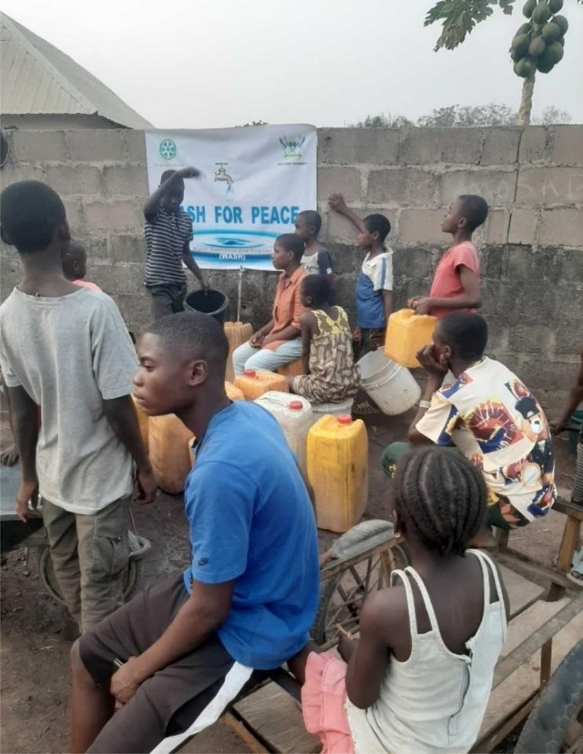

WATER FREELY SHARED WITH THE WHOLE COMMUNITY BY ONE MEMBER OF THE COMMUNITY

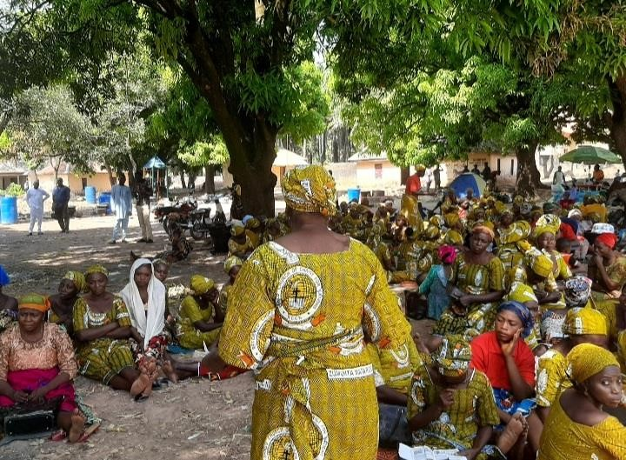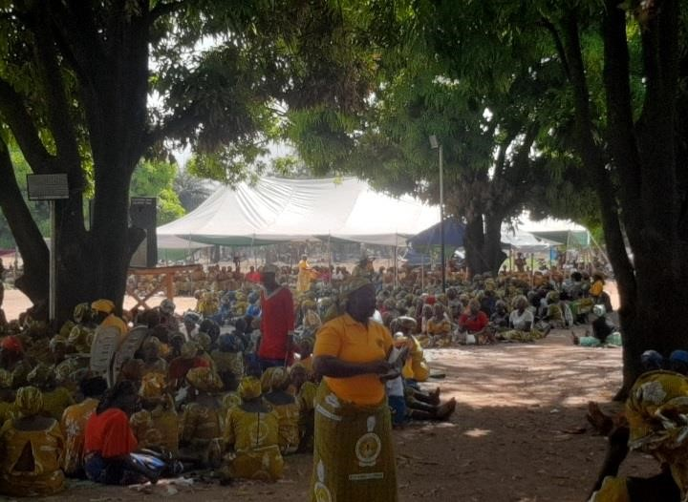

PEACE LECTURE DELIVERED AT 2022 RCCN NATIONAL WOMEN CONFERENCE

PEACE LECTURE DELIVERED AT 2022 RCCN NATIONAL WOMEN CONFERENCE

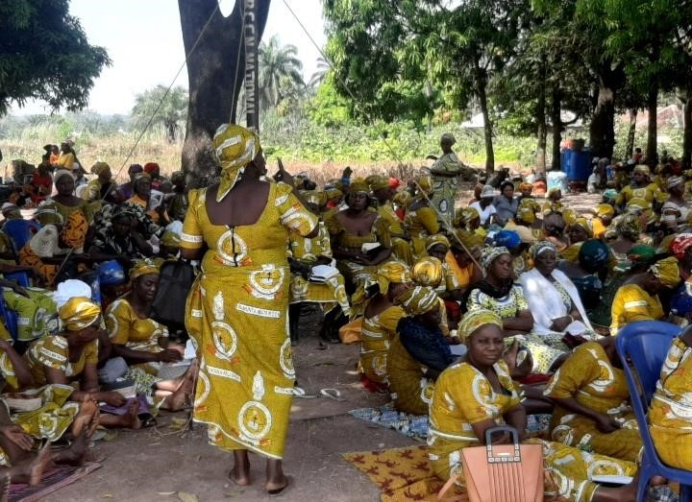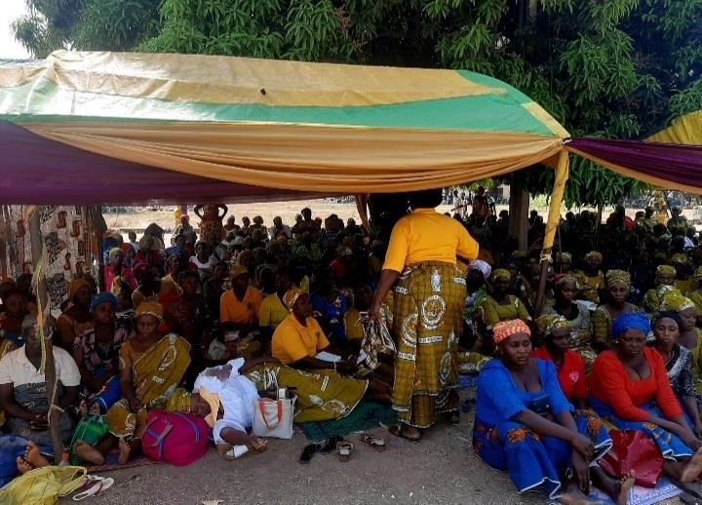

PEACE LECTURE DELIVERED AT 2022 RCCN NATIONAL WOMEN CONFERENCE

PEACE LECTURE DELIVERED AT 2022 RCCN NATIONAL WOMEN CONFERENCE

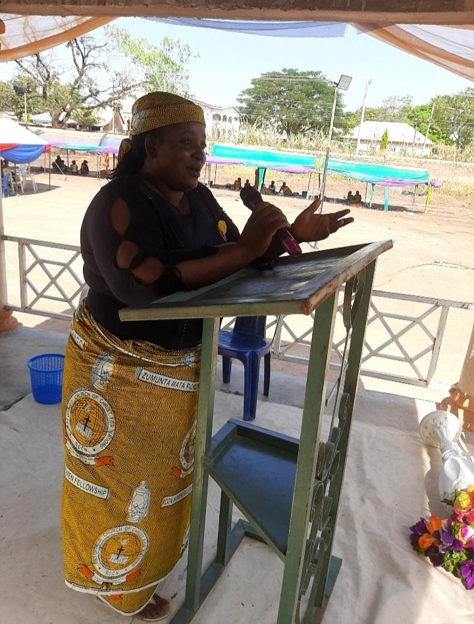

SUMMARY OF PEACE LECTURE DELIVERED AT 2022 RCCN NATIONAL WOMEN CONFERENCE

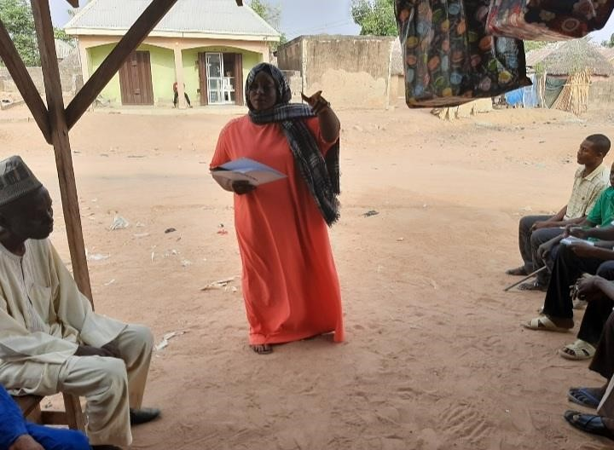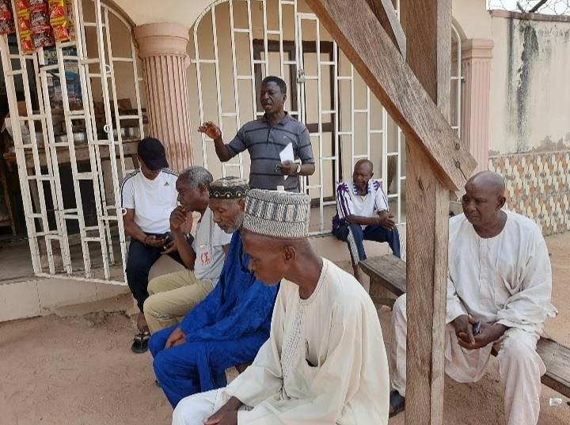

MEETING WITH COMMUNITY STAKEHOLDERS

MEETING WITH COMMUNITY STAKEHOLDERS

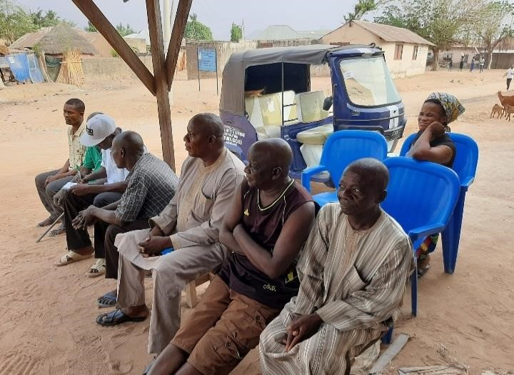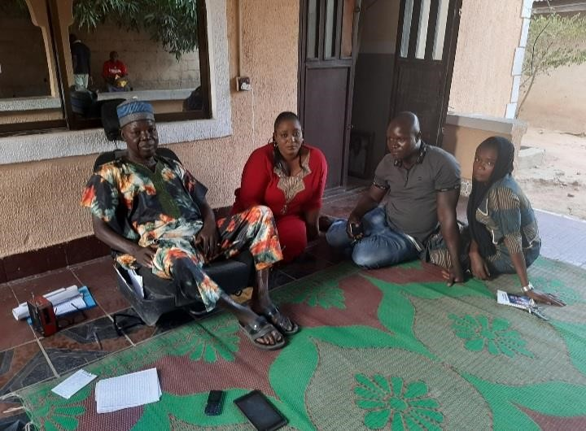

MEETING WITH COMMUNITY STAKEHOLDERS

MEETING WITH COMMUNITY STAKEHOLDERS

# References

Nancy Lindborg (2017) *The Essential Role of Women in Peacebuilding*, United States Institute of Peace

Rifkatu Ali (2016) Causes of Conflict

Galtung 2011) *Peace and Conflict Studies as Political Activity* (Galtung, 2011)

Baker M (2018) *Translation and Conflict, a Narrative Account*, 2nd ed. London: Routledge.