Facilitating Access to Inner-city and Rural Education in Kyebando, Kisalosalo and Degaya, Kalagala, Uganda

Eleanor Rose Curl MSc
REG NO: 2021/HD03/23273X

Rotary International Peace Centre, Makerere University
Postgraduate Diploma In Conflict Transformation And Development Of Makerere University

February 2021 to February 2022

CONTENTS
Abstract v
Chapter One: General Introduction 1
1.1 Introduction 1
1.2 Background 1
1.3 Problem Statement 4
1.4 Goals and Objectives 5
1.5 Challenges and mitigation strategies 7
Chapter Two: Literature Review, Theory, and Methods 9
2.1 Introduction 9
2.2 Literature Review 9
2.3 Theoretical Underpinnings 11
2.4 Change Theory and how it was applied 13
2.5 Methods and Design 15
Chapter Three: Interventions, Activities and Key Findings 18
3.2 Interventions and Activities 18
3.3 Key Findings and Impact 21
Chapter Four: Conclusions, Recommendations, Implications for Policy 24
4.1 General Conclusions 24
4.2 Recommendations and Implications for Policy 25
4.3 Sustainability Plan 26
References 28
Appendices 29

Abstract

The importance of a population having quality basic education has broader implications for society. Provision of basic education increases human capital and productivity. Consequently, there is a rise in socioeconomic conditions, and the risk of civil unrest and conflict is lowered. However, in Uganda accessing of education at primary school level remains difficult for many, especially in deprived areas. I had been working with several communities and collaborating with international Non-Governmental Organisations in Uganda prior to the commencement of the Rotary International Peace Fellowship of February 2021. Two of these communities informed me that the education of their children and future generations was their primary concern. With this knowledge, I proceeded to work with the two communities, one inner city and one rural, to devise a project which would aim to improve access to primary education and would start income generating businesses to increase the self-sustainability of the educational institutions.
This Social Change Initiative Project was implemented in Kyebando, Kisalosalo, and Degaya, Kalagala, inner-city and rural communities, respectively. These goals included: mobilisation of partnerships, facilitation of income generating businesses and the building of a primary school, and facilitation of an increase in quality of education and the foundations for self-sustainability. Despite facing challenges of a global pandemic, a sharp decline in the economy and incomes, loss of funding, and loss of livestock, the goals this project have been achieved.

Chapter One: General Introduction

Introduction

This social initiative is about facilitating the provision of primary education to two communities in Uganda. One rural community, Degaya village near Kalagala town and one inner-city slum, Kyebando, Kisalosalo in Kampala. I have raised financial support to facilitate the Non-Governmental Organisation Nest of Joy to build a primary school in Degaya village and set up an income generating business. I have also raised fiscal aid to establish income generating businesses for Happy Hammys Academy, a primary school in Kyebando Kisalosalo slum, to enable future self-sustainability. Additional funds have been raised so that up to date textbooks and school supplies have been brought for the pupils and a cookhouse has been built. Further, I have assisted in building partnerships so that the inner-city school can create better relations between the teachers and the community and have formed business associations in order to provide a better foundation for the sustainability of the project. This initiative has also been about providing fiscal support for skills training at the Nest of Joy skills centre. The centre will then be able to continue to offer and expand skills training of hairdressing, crafting, tailoring, cooking with modern equipment, and computer training for the beneficiaries who reside at the centre and the community. Funds were also obtained for the inner-city school so that Happy Hammys Academy could start to provide additional training and after school sessions in skills such as animal husbandry, crafting, and shoe making.
The overarching aim of the social initiative was to build a school in Degeya village and enable Happy Hammys Academy to become self-sufficient and independent. My role has been to facilitate online fundraising, and to support the two communities, the core teams, the Director of Nest of Joy, Mr Musa Kayiwa and the Headmistress of Happy Hammys Academy, Miss Jamilah Spears to develop and implement a strategic direction that would lead to positive sustainable development of the projects.

Background

Many communities in Uganda have limited access to the Government primary and nursery schools. Many communities are incredibly diverse, comprising of families from multiple regions of Uganda as well as refugees. The community and private initiatives have therefore become a strong pillar in the provision of education to the children of Uganda. The communities of this project are an example of such initiative.

Nest of Joy

Nest of Joy was founded by Musa Kayiwa in Degaya and officially became a registered charity in 2020. Kayiwa understands what it is like to have to struggle to obtain an education due to the financial difficulties faced by his family. Kayiwa spent his childhood selling fruits on the highways of Kampala and experienced abuse on the streets until one day he was assisted by a stranger who had an agreement with a local school and who helped supplement his school fees. The vision of this charity is to assist sexually and physically abused children and adolescents, and those at risk of abuse and trafficking due to social deprivation and to provide them with the opportunity to access education and skilling. Nest of Joy intends to help increase access to education and life skills in Degeya community. I have been actively involved with the care of beneficiaries’ and the development of the NGO as an advisor and the UK representative for the past two years. The NGO has seen a substantial growth in the implementation of social initiatives since becoming a registered charity and launching the www.nestofjoy.org website. Sponsorship for multiple children has been found and spaces at schools have been obtained. The skills centre in the village of Degaya is now open and providing teaching of hairdressing, crafting, farming, and computer skills to 20 students some of which are pictured in Appendix A with myself and Kayiwa. 12 beneficiaries’ live at the centre and 8 students who return home each day attend the lessons all are females aged between 13 to 18 years old. All the students have experienced sexual or physical abuse. During the Covid-19 lock down many emergency community outreach food projects were initiated by the Nest of Joy to assist in prevention of violence and abuse in the community due to lack of resources. The 2021/2022 Rotary Peace Fellow project at the Nest of Joy is the building of a primary school which could serve the local farming community and the expansion of income generating businesses and improvement of the skills centre.

Happy Hammys Academy

Happy Hammys Academy was founded in Kyebando, Kisalosalo, Kampala by Jamilah Spears in 2018 to provide education to a community that struggled to access schooling. Happy Hammys Academy provides schooling from nursery to primary 6 for the diverse community of Kyebando, Kisalosalo. Spears observed how although private nursery schools are attended by many children, the dropout rate is very high due to familial poverty, and this compelled her to establish the school. Due to lack of funds and limited spaces at government-funded schools, Happy Hammys Academy, has for many, became the last hope for the provision of education for future generations in the Kyebando, Kisalosalo community. Happy Hammys Academy has often provided free education and has been especially focused on making provisions for girls in the higher classes such as primary 5 and 6. 394 children were attending the school and being given a proper meal every school day before Covid-19. During the first lockdown in Uganda, when schools were first closed on March 22, 2020, Happy Hammys Academy lost all its private funding. Consequently, the school was unable to keep up payment of the rent on its former building and was facing closure. The school had to change premises and find new ways to support itself in order to remain open.
As a private school in a deprived area of Kampala, Happy Hammys Academy has always faced sustainability problems and tried to raise funds through the schools facebook page. Many people living in the community are unable to consistently pay even minimal school fees. It was because of this that I was originally introduced to the Headmistress of Happy Hammys Academy whilst I was working as the UK representative for the NGO Nest of Joy. The founder of Just A Hub, an NGO supporting refugees from the Democratic Republic of Congo through art and music with whom I was collaborating at the time made the initial introduction before the Covid-19 pandemic. Happy Hammys Academy Headmistress had asked for help in developing the school and for support in her efforts to provide education in the community.
I was contacted by the Headmistress again during the first lockdown in Uganda when the school was facing closure. As the values of the school and the circumstances of the beneficiaries were aligned with the vision of Nest of Joy, it was agreed by the Director of Nest of Joy and myself that I would facilitate an additional outreach initiative, and in collaboration with the core team at Happy Hammys Academy devise a plan as to what assistance could reasonably be provided. Before I returned to Uganda in February 2021, communication with the Headmistress of Happy Hammys Academy was conducted via the social media platform Facebook. The Headmistress supplied me with information about the school and how it was reduced to renting a room in a communal building. The single classroom was not large enough for the number of pupils, multiple age groups were being taught in the same classroom, and some were being taught in the corridors. The smells from cooking, people washing in the corridors, and the noises from the other families living in the building did not allow for a conducive learning environment. The pupils of Happy Hammys Academy come from the surrounding slum. The majority are from the Buganda region but there are students from all regions of Uganda. Lessons are conducted in English so that all students can understand. All the pupils come from families facing financial difficulties, living in homes where there is often not enough food. The school has been struggling to provide any food for the students; this was affecting pupils’ concentration and resulting in many leaving early to try and source for food.
In February 2021, I began the Fellowship at the Rotary Peace Centre of Makerere University. An integral part of the post graduate diploma was the implementation of a social initiative. I decided that my social initiative would involve the facilitation of education. Education has been established in community development academic literature and in the field of social development on a global scale as essential to socio-economic growth and thus foundational to conflict transformation and peace development (Jones, 2011; Rutaremwa & Bemanzi, 2013; Deininger, 2003; Grogan, 2007). The fellowship enabled me to spend time with my NGO, Nest of Joy, and work with the director to formulate plans for the construction of a primary school and expansion of the income generating businesses at the skills centre. My time in Uganda also allowed for meetings between myself and the Headmistress Jamilah Spears as seen in appendix B. These meetings enabled us to devise plans for the project at Happy Hammys Academy and agree upon the overarching goals of the project at the inner-city school.

Problem Statement

In many rural and slum communities like Degaya, Kalagala and Kyedando, Kisalosalo, parents are often not able to afford clothes or food and thus education is a luxury. Many children miss out on education entirely because of inaccessibility, due to distance, or must continuously change schools as parents are unable to afford payments and thus rack up debts at multiple schools. Education is often viewed as a financial burden which can negatively impact pecuniary stability. Although the Ugandan government introduced Universal Primary Education (UPE) in 1997, the number of schools are inadequate, and education is often substandard (Grogan, 2008). To attend school, often uniforms are required, and other basic materials are needed, often these are unaffordable. Girls are educated less than boys because it is perceived that they can stay at home to care for the house and other children whilst parents go to work. Many girls never get the opportunity to have an education as they start working as housemaids from a young age. Girls also often drop out when they start to menstruate because they cannot afford the personal hygiene products that they need to be able to attend school. Despite many families desiring to educate their female children, travelling on foot to schools in rural and urban communities is often very dangerous, especially for adolescent girls, and families are not willing to take this risk in order to educate their daughters.
There are many reasons why all children should complete primary education. There is evidence that a population with basic education is more innovative and thus productivity increases (Jones, 2011; Rutaremwa & Bemanzi, 2013; Deininger, 2003; Grogan, 2007). Consequently, infrastructure grows and the socio-economic situation of those in poverty improves, helping to mitigate social tensions and thus averting conflict. Data on the effects of education also highlights the positive impact on public health, the reduction in teenage pregnancies, and the decrease in incidents of gender-based violence (Rutaremwa & Bemanzi, 2013).
Resilience in communities is low, Covid-19 has negatively impacted social order and positive peace has declined. The combined social initiative of providing education in the rural community of Degaya and supporting Happy Hammys Academy to provide education and additional skilling training to the next generation is intending to make a change in the communities through increasing opportunities for pecuniary mobility.

Goals and Objectives

The overarching project and thus my involvement with facilitating access to inner-city and rural education initiative has a two-year timeframe, with both schools thereafter continuing indefinitely through self-sustainability with the support of the community.
However, within the year’s timeframe of the Rotary Peace Fellowship there are three distinct goals to be implemented in overlapping phases.
- To mobilise partnerships for Happy Hammys Academy and Nest of Joy
- To facilitate income generating businesses for Happy Hammys Academy and build a primary school at the Nest of Joy
- To facilitate an increase in quality of education and the foundations for self-sustainability for Happy Hammys Academy and Nest of Joy.
The intention of Goal 1 for both Nest of Joy and Happy Hammys Academy is to ensure that developments will have ongoing support, beyond the life of the current, through encouraging and progressing business partnerships, collaborations with other organisations, and fostering participation of the community.
One of the partnerships established was the Parent Teacher Association (PTA). The objective in forming a PTA and organising meetings is to enhance more active participation from parents. The PTA will also establish what levels of school fees the families of the pupils will be financially contributing. Greater involvement of the parents will result in stronger ownership of the school and greater support of teachers in the move towards self-sustainability. Parents will also be more engaged and invested in the education of their children which will result in better attendance and a reduction in the number of children dropping out of school.
In helping to facilitate regular teacher meetings we provided the opportunity for teachers to organise teaching strategies, timetables, and the alternative life skill classes. Consequently, the teachers will feel greater affiliation with the school, more integral to its success, and the curriculum will be more efficient. This will result in more commitment and input from the teachers, improving the quality of the education provided.
The objective of Goal 2 is that through online fundraising and donation drives, enough funds will be acquired to pay for the labour and materials for the building of the primary school at the skills centre of the Nest of Joy and to cover the cost of starting two income generating businesses at Happy Hammys Academy. Thus, guaranteeing the increase in access to education at the two sites which will increase the level of numeracy and literacy in the community resulting in economic growth.
Goal 3 will be achieved through the objective of successfully sourcing additional funding to secure sufficient donations so that resources can be allocated for up-to-date text books, school supplies, and materials for the extra curriculum programs at Happy Hammys Academy to increase the quality of education provided. Increasing the size of Nest of Joy’s income generating businesses will ensure consistent sources of additional income and will enable materials for skills training to be bought in the future.
The Goals and their objectives will ensure the financial security and sustainability of the two communities’ projects and will ensure that children in both communities have access to a good standard of education and skilling.

Challenges and mitigation strategies

Government restrictions brought in to adhere to Covid-19 Standard Operation Standards (SOPs) in Uganda, which were introduced to combat the Covid-19 pandemic, threatened the implementation of the projects. The mandatory closure of schools has greatly impacted both rural and inner-city communities in Uganda. The closure of schools has meant that all children are incredibly behind in their schoolwork, which has left those without quality education at an even greater disadvantage. Despite Happy Hammys Academy attempting to deliver schooling in line with restrictions, all pupils are behind the curriculum, and schooling has been very fractured. The Nest of Joy has also been struggling to assist the beneficiaries who had been attending schools to have access to some form of teaching.
Restrictions on movement meant getting building supplies to the rural community was a challenge and therefore this was put on hold until travel was allowed. This delayed the commencement of the building of the primary school at the skills centre; however, as soon as restrictions were lifted the team of construction workers put in great efforts, even working weekends to try and make up time.
I had planned to return to Uganda to have physical meetings with both communities and personally assist in the implementation of the projects. However, restrictions on international travel made this non-viable. Remote management of the projects has been a challenge. It has impacted my ability to efficiently monitor progress. Thus, the provision of additional assistance and motivation at essential moments for my partners to achieve goals has been lacking. My inability to be onsite has negatively impacted the outreach program in Kyebando at Happy Hammys Academy more than it has at Nest of Joy because after a year of working with the rural community, a tighter relationship, trust, and greater understanding had already been developed. A plan of increased communication between both directors and myself was implemented in order to mitigate the risks of delayed implementation of activities. However, in the case of Happy Hammys Academy the agreed upon plan to increase communication has not always proved to be effectively implemented.
The reduction in interest to assist new projects due to international economic decline has also become very evident throughout the year. The challenge of securing funds during a global economic downturn was increased by the lack of interest from larger charitable organisations. Although I made many attempts to engage Rotary clubs throughout the UK and abroad, there has been little to no interest in supporting the projects. One Rotary club even described the project as “too difficult”. These challenges have been mitigated by increasing attention to social media engagement and encouraging the involvement of individual funders and through encouraging some of the initial funders to implement their own fund-raising initiatives so that more people were reached, and more fiscal resources could be sourced.
The World Bank reports that the Ugandan economy suffered a sharp contraction due to the pandemic and growth had slowed to its slowest pace in over three decades (World Bank Group, 2021). This economic decline was evident in both the rural and urban communities. The government restrictions considered necessary to curb the pandemic had a financial impact on the Nest of Joy and Happy Hammys Academy because both national and international funders either removed or decreased their fiscal support. Businesses in which Nest of Joy and Happy Hammys Academy hold independent investments have also been returning a lower fiscal return. Families with children at Happy Hammys Academy who had previously been able to pay fees consistently, are no longer able to do so and the number of pupils who now cannot pay anything towards their schooling has increased, due to many parents losing their jobs. This has resulted in a substantial decrease in core income for Happy Hammys Academy.
The loss of almost all the chickens at the Nest of Joy due to the virus Newcastle disease has been a considerable challenge. However, a new private funder for replacement roosters and hens was found. The director and I devised a new program for vaccination of the poultry. The beneficiaries were then taught how to vaccinate the chickens. Consequently. the possibility of similar challenges relating to poultry diseases are reduced, if not entirely mitigated.

Chapter Two: Literature Review, Theory, and Methods

2.1 Introduction

To ensure that countries actively work towards providing equitable academic opportunities the UN has incorporated Quality Education as goal four of the Sustainable Development goals (UN Department of Economics and Social Affairs, 2015). Despite Uganda introducing Universal Primary Education (UPE) in 1997, many children do not receive education of good quality or are not able to complete their primary education due to financial difficulties. Research into the accessibility of quality primary education in Uganda has highlighted the need for increasing the number of schools, textbooks and equipment, and boosting the number of qualified teachers (Jones, 2011; Rutaremwa & Bemanzi, 2013). The theory that this project bases its strategies of implementation on is the Asset-Based Community Development Theory. Thus, the methods used to achieve the project goals aimed to always involve the community to ensure the sustainability of the project.

2.2 Literature Review

The campaign for equitable access to education is based on moral arguments, however the underlying reason that education is so important is economical (Jones, 2011; Rutaremwa & Bemanzi, 2013; Deininger, 2003; Grogan, 2007). The relation between an educated population and economic growth through increased innovation and productivity, has become a topic of academic literature in the field of social development (Jones, 2011; Rutaremwa & Bemanzi, 2013; Deininger, 2003; Grogan, 2007). The addition of quality education into the sustainable development goals has highlighted how essential educating a population is and has resulted in many countries updating development policies and increasing expenditure on education (Jones, 2011; Rutaremwa & Bemanzi, 2013; Deininger, 2003; Grogan, 2007). Despite many advances being made in the provision of free primary education and equitable access throughout Uganda, there are still many barriers faced by sections of the population (Jones, 2011; Rutaremwa & Bemanzi, 2013; Deininger, 2003; Grogan, 2007).
In 1997, Uganda introduced Universal Primary Education (UPE) which eliminated fees for primary education at government schools. The arguments for this increase in expenditure by the government in the education sector were numerous. The initial investment in primary education is shown to have long term positive output through growth in infrastructure (Jones, 2011; Rutaremwa & Bemanzi, 2013; Deininger, 2003; Grogan, 2007). Provision of education is also shown to increase the population’s understanding of health issues, for example, HIV and aids, thus leading to an increase in the standards of public health (Grogan, 2007). Jones (2011), in a review of education within the women’s empowerment framework also provides evidence to support normative understandings that the longer girls stay in school and the better educated the female population is, the less likely they are to have teenage pregnancies.
Although UPE was a success, in that enrolment increased and research showed that gender disparities in primary school attendance were almost mitigated, there continues to be difficulties in accessing education for many in Uganda (Jones, 2011; Rutaremwa & Bemanzi, 2013; Deininger, 2003; Grogan, 2007). Attending primary school is still an expense that many families cannot afford, as many families are unable to afford the indirect costs of education such as uniforms or shoes, which are usually a requirement for government school attendance. Often there are no government schools in many communities and if there are, there are often too few schools, classrooms, textbooks, and teachers to accommodate all children of eligible age (Deininger, 2003). There are also additional barriers to girls attending primary school especially those who have begun menstruating; for example, location of schools, and thus the major danger that travelling to school presents due to high risk of sexual assault, lack of sanitary products to enable the female adolescents to attend school whilst menstruating, pedagogical practices and underlying gender inequalities and subsequent attitudes, sexual exploitation and abuse within the school environment, lack of income earning opportunities, and domestic responsibilities (Jones, 2011).
There also continues to be a high dropout rate in primary schools as the move from primary to secondary school exacerbates the financial strain on families (Deininger, 2003; Grogan, 2007). Consequentially, the closer to the final primary exams a child gets the more likely they are to leave school (Deininger, 2003; Grogan, 2007; Jones 2011). It is noted that this is because if there is a choice for a family of whether to send the boy child or the girl child to secondary school, than most families would choose to send the boy child because of the underlying cultural beliefs that the women will at some point get married and thus have a husband to provide financial support as the woman has children (Jones, 2011). Therefore, it is not perceived as important for many girls to complete primary education if there is little opportunity to attend secondary education (Rutaremwa & Bemanzi, 2013; Deininger, 2003).
Moreover, data analysed in the literature on primary schooling in Uganda also shows a significant difference in levels of attendance between regions in Uganda and in rural and inner-city areas based on levels of social deprivation and accessibility (Rutaremwa & Bemanzi, 2013) Although initial attendance was found to be higher in urban areas than in rural areas, the dropout rate of pupils from primary education was higher for urban schools than those from rural ones (Rutaremwa & Bemanzi, 2013). The effect of social deprivation and limited infrastructure on school attendance is perceivable in the Northern region of Uganda where the attendance was the lowest throughout all regions’ (Rutaremwa & Bemanzi, 2013). Data shows that those who are living in most poverty were least likely to attend school due to demands of sourcing food, inadequate finances for indirect educational costs, and early entrance into the world of work (Deininger, 2003; Grogan, 2007; Jones, 2011; Rutaremwa & Bemanzi, 2013).
Mobilisation of support at the local level for individual schools and the educational system, in Uganda, has been shown to be effective in increasing accessibility and maintaining attendance at primary schools. The highlighted importance of the longer-term growth of the infrastructure of Uganda due the increase in human capital is essential to expound to communities if equity of educational opportunity is to be achieved at primary school and the benefits of an educated population at the socioeconomic level are to be consolidated.

2.3 Theoretical Underpinnings

I have chosen to employ the theory of Asset-based Community Development (ABCD) in approaching the design and implementation of the social initiative projects (Mathie & Cunningham, 2003). Evidence from the NGO sector around the globe has provide evidence that ABCD is an innovative way to support community driven development in both urban and rural communities and is applicable cross-culturally. ABCD theorises that individuals within communities can organise and implementing the development process themselves and know how to create the opportunities required for their communities to begin to thrive.
I was inspired to utilise this theoretical standpoint during the Rotary Peace Fellowship where it was often discussed how a new approach was need if problems faced in African countries were actual to be resolved. In ABCD theory the attention is placed upon social assets that already exist which is different to the normative approach to community development. The projects of the organisation World Vision adhere to the ABCD theory (Mathie & Cunningham, 2003). The positive impact of the organisations projects is evident, for example, the projects for clean water and improved education infrastructure in Kenya. World Visions implantation of this community project has supported further development in rural communities in the country (World Vision International, 2021). Communities where projects have been implemented are now managing schools and solar powered water pumping systems, the projects are well maintained and are increasing the standard of living for all those living in the area (World Vision International, 2021).
ABCD sits in contrast to Needs-based Community Development (NBCD) where there is the continuing emphasis on needs and undesirable aspects of a community which has a negative impact on the mental resilience of the population and inadvertently restricts innovation. NBCD consists of establishing what a community lacks and how it can be given to the leaders of a community to distribute, whereas ABCD provides a foundation for fostering innovative individuals within a community.
The benefits of implementing projects in accordance with the ABCD theory were originally advocated most by organisations and Governments in the United States of America and the UK (Macleod & Emejulu, 2014). The ABCD theory was first utilised in developmental projects by the UK government during a period of economic crisis in the 2011, when the Government had to cut social welfare. The Government began to focus smaller fiscal resources on encouraging community involvement and empowering the community (Macleod & Emejulu, 2014). The success of this approach within the country was then extrapolated to the international development projects that the UK government funded (Mathie & Cunningham, 2003). The neo-liberal approach to community development then proceeded to garner support from other governments (Macleod & Emejulu, 2014).
Due to the weak social contract of the Ugandan government and local level governors to provide the basic needs for their citizens the need for Ugandan communities to take charge of their own development is apparent. In utilising this theory as the standpoint and foundation for all actions the project becomes a community project rather than something that is done to the community. In following the theory of ABCD, I was able to support individuals in the community to create and seize the opportunity to build sustainable development projects whilst also encouraging active citizen to improve community relationships.

2.4 Change Theory and how it was applied

In line with the theoretical understanding of ABCD, all actions I took and in all interactions with the communities I sought to promote and inspire positive action for change from within the community. The set of methods utilised to mobilise the community members were in order to form a core group, encourage individuals with talents to utilise them in support of the project, encourage the building of relationships between pre-existing local assets, whilst sourcing the required resources to implement the communities’ endeavours from outside the community itself.
In the Degaya community, we held two large meetings in order to initiate community involvement. All attendees were given the opportunity to make suggestions and present ideas for community development. After these meetings the Nest of Joy core team who have been working together to build and sustain the skills centre, came together to discuss opportunities and the possibilities of implementing ideas springing forth from the community. This core team was remobilised to organise and build the new primary school at the skills centre in response to the ideas presented by the community. The adolescents at the skills centre who had an interest or a skill in animal care were encouraged to take responsibility of the income generating businesses and worked hard to learn how to vaccinate when faced with the challenge of a deadly fowl disease. The sharing of resources and the development of relationships with the rural community was also encouraged and have taken root.
The inner-city community of Keybando, Kisalosalo was already starting to mobilise. Happy Hammy’s Academy core team had started to encourage community involvement in the school and had reached out to request support for implementation of social development projects they had devised. To promote the founding of further relationships within the community and increase the interest of the wider community, the community decided to establish a Parent Teacher Association. This has proven to be successful and individuals within this group have utilised their talents in support of the project. On the bases of the ABCD theory after imparting the importance of building asset rich relationships in the community the core team at Happy Hammy’s Academy sought to make a fiscal agreement with a local rabbit farming company in order to ensure sustainability of the income generating businesses.
Through organising PTA meetings at Happy Hammys Academy we have developed better relations between the teachers and the community. The increased participation by parents and the teachers has resulted in a strengthening of their ownership of the school and their involvement in the plans to sustain the school. Consequently, they have been assisting more with the income generating businesses, helping to take care of the animals and assisting in the building of hutches. This has increased the likelihood that the income generating businesses will be a success and continue to subsidise the school’s income.
Initiating business partnerships for Happy Hammys Academy has resulted in a short course of animal husbandry being made available for the income generating business of rabbit farming. These partnerships have also produced a long-term retail outlet for the product and a source of medication should it become necessary in the future.
In organising community meetings and private meetings with the chief of the village, Nest of Joy gained permission from and the support of the local community to build a primary school. The locals helped in the construction of the buildings and often donated food to the workers. The community has displayed great excitement at the prospect of having a primary school in the locality and there are continued discussions with the director of Nest of Joy about how the community can contribute to the school. Most of the villagers are unable to pay the full school fees but have expressed the wish to contribute to sustainability in alternative ways, such as supplying food, so that their children will be able to attend and have a good quality education when the school opens.
Through my work in mobilising fundraisers and private donors through writing individualised reports, producing focused project proposals, and utilising social media, there is now an increased international understanding of the difficulties faced in acquiring an education in Uganda. This has increased the amount of support that we have received and increased the amount we have been able to invest in the project.
The increase in support has allowed for us to purchase up to date textbooks and stationery for Happy Hammys Academy. This resulted in a decrease in pupil to textbook ratio and better-quality teaching in line with current examination preparation. Pupils are now also able to make their own notes and take books home to continue their studies at home and do homework.
The targeted mobilisation of private donors also led to an individual agreeing to implement their own fund-raising initiative after learning that the Nest of Joy had lost most of their chickens due to a virus. This individual raised $1600 which enabled the Nest of Joy to deep clean the farm, vaccinate the remaining stock and purchase and vaccinate new stock. It also replaced profit that the NGO would have made from selling eggs and covered the cost of purchasing eggs consumed by beneficiaries, for the period when there was no egg production.
The implementation of income generating businesses at Happy Hammys Academy has resulted in increased participation of the community and pupils in the running of the school. Pupils are more engaged in the opportunities available and are expressing the desire to learn more about animal husbandry as shown in appendix C. The income generating businesses have also helped to subsidise teacher wages whilst the schools have been closed and no pupils have been paying fees. This has resulted in teachers being able to support their families through this difficult period and enabled them to continue to teach within the boundaries of Government restrictions rather than moving and finding new jobs. Schools are now being allowed to reopen on January the 10th 2022 and Happy Hammys Academy is fully prepared to welcome all their pupils with a full staffing complement.
The Income generating businesses at Nest of Joy have been able to fully supply the beneficiaries with the meat and eggs they need through the new investment and renewal of stock. Now that no income has to be spent on these necessary resources, there has been a positive fiscal reallocation. For example, we have amended the budget to reallocate resources to payment of the increased electricity bills which have arisen due to the commencement of computer classes. Through the implementation of the expansion of the income generating businesses at the Nest of Joy not only has the general standard of living improved but also future opportunities for the beneficiaries have increased through the diversification of the skills taught at the centre in the village.

2.5 Methods and Design

The initial stage of the project design was to conduct a situational analysis. Through holding individual meetings with each community, the director of the Nest of Joy and myself, and the Headmistress of Happy Hammys Academy and myself, the interest of the stakeholders was confirmed. It was during these meetings that the relevance of the project was clarified. The meetings highlighted how simply raising funds to pay for school fees would not resolve the long-term issues faced in providing access to quality education both for the rural and the inner-city communities. In meetings with the core teams at each site, we defined realistic project goals and objectives and determined potential positive outcomes.
Together with the teams from Nest of Joy and Happy Hammys Academy, we deliberated and identified risks and possible constraints on the projects due to lack of resources, Covid-19 restrictions, and the plummeting economy.
We created an outline of the strategy that would be implemented to achieve the objectives and goals and a timeline for when certain achievements should be accomplished. This was then refined in further meetings with the Director of the Nest of Joy and the Headmistress of Happy Hammys Academy, which were conducted online due to my return to the UK. In conference with both parties, we created contingency plans to mitigate potential constraints on the projects. We ensured that our focus for the Nest of Joy was on the construction of the school in the village and the expansion of the rabbit and chicken income generating businesses, and for Happy Hammys Academy that the focus was on the self-sustainability of the school through the commencement of similar rabbit and chicken income generating businesses and the fostering of long-term involvement of the local community.
The directors provided costings for materials and longer-term costs as they were able to secure deals with suppliers on the ground. Once the approximate costs of bricks and other building supplies required, and the fiscal support required for investment in current income generating businesses from the Nest of Joy, and the cost of implementing income generating businesses at Happy Hammys Academy were established, we formulated a budget and I set a target for the online fundraiser. We also agreed upon where we would allocate addition funds raised so that all resources would be allocated efficiently.
I then designed the fundraiser on the online platform GoFundme and set up emailing groups. I sent out the project proposal to my contacts, together with the minimum target of £1000 which was needed to initiate the foundational goals. I ensured that it was understood by investors that any funds raised beyond the initial target would be utilised to accelerate the project and purchase supplies for Happy Hammys Academy and additional resources for the Nest of Joy to improve the quality of education provided at the skills centre and increase the standard of living for pupils, beneficiaries, and the two communities.
The Director of the Nest of Joy organised a team of construction workers who had worked with the organisation in the past and made agreements with suppliers so that construction could commence as soon as the necessary funds were available and materials could be paid for. The Headmistress of Happy Hammys Academy and two teachers went on an animal husbandry course with the chosen business partner, SOA Uganda, so that building of the hutches and coops for the income generating businesses could begin once materials were paid for.
To ensure the proper management of the funds and the monitoring of the progress of the implementation of activities we agreed upon a feasible documentation process. Due to the need to fulfil my role of reporting to funders, we decided that the process of documentation through photos and video updates was the most efficient. This process meant that even in my role of remote management of the project, I could track developments and report to funders.

Chapter Three: Interventions, Activities and Key Findings

3.2 Interventions and Activities

The first activity which was undertaken by the two communities was the establishment of core teams at both sites. Whilst mobilisation of relationships was occurring (Goal 1) we were also preparing activities to help us achieve Goal 2, the facilitation of income generating businesses and the building of the primary school. In July 2021, I started to widely publicise the fundraiser I had created on the online platform gofundme through the social media site facebook. Prospective donors could read about the project and donate by following a link. By August 2021 we had achieved in raising excess of the target and by November we had raised £1555 through the platform. Whist funds were being raised and until February 2022 I also published and sent out the scheduled progress reports to private funders and interested parties every three months outlining the goals and the achievements made at both sites.

Nest of Joy

During the stage of mobilisation of partnerships, it was agreed that at the Nest of Joy, the Director, Musa Kayiwa and myself were to head the organisation of the project whilst Mr Juma Katumba was to manage the construction of the building. The agreement the Director and I have signed covering my responsibilities when working with the Nest of Joy is shown in Appendix I.
In the rural community, we also organised a meeting with the head of the village and requested for his permission to build the primary school at the Nest of Joy; this receiving of permission is in adherence to local custom. The chief readily agreed, and we held a community meeting to announce the project, which got the support of the community. The Director of Nest of Joy and I also contacted previous international donors and requested their support in the project. I also attempted to forge possible collaborations with funding bodies in the UK and Rotary Clubs.
In October 2021 we achieved Goal two at Nest of Joy by completing the construction of the primary school; the school near completion is shown in Appendix D. Being able to purchase a new flock of chickens for the Nest of Joy has increased the yield of the income generating businesses by enabling the beneficiaries to sell excess eggs and meat. The growth of the Nest of Joys income generating businesses is depicted in Appendix E through the pictures of a new generation of stock. We also completed the kitchen and brought gas supplies so that training in modern culinary skills can also begin. We have now begun fund raising and saving donations so that we can purchase a cow to add to our livestock so that we can provide our beneficiaries with milk and enter in the cattle market soon. The has also been an increased awareness of Nest of Joy’s mission as evidenced in the number of requests the NGO for further information about the work that we do and the increased support we have received from individual funders and the community.

Happy Hammys Academy

At Happy Hammys Academy, Spears and myself were to head the project with staff, and the school bursar to support the implementation of activities. The first activity initiated for the mobilisation of partnerships for Happy Hammys Academy was to assist in the formation of a Parent Teacher Association (PTA) and then organise regular meetings. Following this meeting, the teachers established key stakeholders’ input and responsibilities in the implementation of the project. This meeting was also to provide the teachers with a forum to discuss their concerns about their personal situations and the issues facing the school.
Having formed a PTA, the first meeting was held on Friday the 26th of March 2021 and the second meeting on the 31st of May 2021. During the first meeting more general issues were discussed such as syllabus and how we could proceed during times of Covid-19 with the restrictions in place. We discussed what we believed would be possible and agreed at the next meeting to have come to an agreement about what amount each parent could afford to pay per child consistently without it negatively impacting their current standard of living.
During the second meeting the parents thanked the school for continuing to teach the children despite their inability to contribute to the running of the school. They had discussed how much they could afford to contribute to the school and agreed on 1,000 Ugandan Shillings per child every Sunday until they could get more jobs once the economy picked up and restrictions lifted again. The parents expressed the desire to be involved in the poultry project so they could learn additional skills and contribute to the sustainability of the school.
After the PTA meeting had agreed upon what they could afford, we calculated what additional funding the school would be needing to cover costs until the parents could afford more and more pupils could return. We calculated without support from income generating businesses that we would be running at a deficit of 1,207,297 Ugandan Shillings (£242.88; exchange rate 0.0020) every month.
We also sought business partnerships for Happy Hammys Academy so that once the income generating businesses had commenced, there would be an outlet for the meat and the eggs produced. We found that SOA Uganda would provide a week’s course on hutch construction, animal husbandry and medical advice, and we came to a satisfactory business agreement with this company for the long term.
The first activity necessary in order to achieve Goal 2, the facilitation of income generating businesses, was fundraising. I initially undertook an emergency fund raiser in May to cover the school’s debts and wages which teachers had not received since the closing of schools. I sent emails and a slide show presentation to private contacts advocating for the children, informing the general public of the difficulties of accessing education in some communities I was working with. I received £1,400 which was enough to pay the schools rent and wages for five months and to start implementing the projects. Once the target of the online fundraiser was reached we purchased the materials required to build the rabbit hutches and chicken coops and began construction at Happy Hammys Academy. The building took a week and then we sourced the rabbits through the business partnership we had built with SOA Uganda. It was at this time we also purchased building supplies and organised their successful delivery to the site at Nest of Joy.
Happy Hammys Academy income generating businesses are implemented and now functioning effectively with established retail outlets. We have also purchased more school supplies and constructed a new kitchen. This has raised the quality of teaching resources that we are able to provide and the additional nutritional support that we can offer the students. We have also built a fence around the school so that the security of the school and the income generating businesses is ensured as the area within which the school is set has high rates of criminal activity.
The projects’ activities at both sites have culminated in the achievement of Goal 3. The two communities have achieved their goal of facilitating the increase in quality of education through the purchasing text books which align with the current curriculum, reducing the pupil to text-book ratio, purchasing materials for homework and the foundations for self-sustainability, fully functioning income generating businesses for both Happy Hammys Academy and the Nest of Joy.

3.3 Key Findings and Impact

The net positive impact of both the projects are far reaching with more members of both the rural and inner-city communities becoming involved in than initially expected. The implementation of the projects faced challenges, however the enthusiasm of the stakeholders, beneficiaries, and donors met all expectations and thus allowed for success of the project. This increase of engagement from the community and support from donors has highlighted how the advocacy for the education of children and achieving the overarching aim of the projects, increasing access to education and the quality of the education, has had a positive impact on the communities.
One unexpected but key finding was the difference in the efficiency of management of the individual projects. Despite the disparities in management, the initiation of the projects in line with the Asset-based Community Development theory has resulted in the Nest of Joy and Happy Hammys Academy surviving the Covid-19 pandemic cut-backs in funding, when other similar organisations have had to close or reduce the number of beneficiaries’ they support. The successful implementation of the projects has also ensured sustainability of both sites through the creation and expansion of income generating businesses.

Nest of Joy
At the Nest of Joy, the interest in the primary school has been documented by the number of requests made about attendance when the school officially opens. The interest in up-skilling for the older children by the community has also increased and the skills centre has now reached capacity. This increased interest is indicative of improved optimism in the community and the possible growth in the human capital that can be expected through increased access to education and skilling. The donation of rabbits to individual households in the community by the Nest of Joy has also had an impact on the community, especially during the pandemic when the economy has declined, and sourcing food has been especially difficult.
The Nest of Joy has been efficiently run for two years before this project began. During the implementation of this social initiative, we found that the relationship which I have developed with the director and the community of Degaya had a positive impact on the efficiency with which we all worked together to implement the project activities and mitigated challenges that were faced throughout the year.

Happy Hammys Academy

Through the organisation of community and PTA meeting we learnt how interested parents were in initiating skilling and after-school programs to add diversity to their children’s education. It was noted in the meetings that parents understood how important a diverse curriculum and skills set were to their children’s future. We also discovered the extent of the discontent in the education that is being offered by the government approved syllabus and the despair felt at the lack of access to affordable education in the inner-city community of Kyebando, Kisalosalo.
We have received many requests from parents who want to enrol their children for schooling at Happy Hammys Academy since the Government announcement of the re-opening of schools on January 10, 2022. The quality of education provided at Happy Hammys Academy has also increased through the purchase of up-to-date text books, lowering the textbook pupil ratio, and the provision of more school supplies.
My relationship with the Headmistress of Happy Hammys Academy was not so developed when the project began, and this had a negative impact on the management of the social initiative. Reporting of activities and developments were not as frequent as agreed upon and often to receive a report required prompting. The communication deficiency negatively impacted the efficiency of the project and meant that the timeline of activities and goals was not always adhered to. Despite the success of the project at Happy Hammys Academy, more could have been achieved if I had been present to develop a closer relationship with the community and to assist in more efficient management of the project.
Despite the challenges faced the projects have achieved the initial goals and accomplished more than expected. The projects have also fulfilled the goals of the Ugandan government, the African Union, and the UN by increasing access to, and the quality of basic education in Uganda.

Chapter Four: Conclusions, Recommendations, Implications for Policy

4.1 General Conclusions

Despite the lack of interest from outside charitable organisations due to the overarching goal of the project being “to difficult” and extended periods of lockdown due to the global pandemic, the goals and most of the objectives of the project have been achieved.
The project to start income generating businesses and assist in purchase of up-to-date text books and supplies has ensured that children in the inner-city slum of Keybando, Kisalosalo who would not otherwise have had access to education, have a school to attend which will provide them with an education. The project also grew to include the building of a new cook house so that the children can be given a cooked meal daily. The additional funding that was sourced has enable the school to continue to support the teachers and pupils during lock down. The community now believes that if they implement other projects, they too will be successful. This optimism has been inspired through the achievement of securing education for their children and thus helping to increase the human capital of future generations, and their involvement in the implementation of a successful project.
The project in the rural community of Degaya, Kalagala at the Nest of Joy, the building of a primary school and growth of the income generating businesses, has been a success. The school is built and the income generating businesses have grown despite setbacks due to animal diseases. Nest of Joy has been able to donate rabbits to the community so that they can have a personal source of meat they otherwise could not obtain.
The growth in relationships within the rural community and the inner-city community that this project has inspired has been one of the greatest achievements. The success of the projects based upon the Asset-based Community Development Theory has been the growth of the resilience of the community and the realisation of individuals of their strengths and rights.

4.2 Recommendations and Implications for Policy

There are many levels of policy which effect access to education and the quality of the education children of primary school age receive in Uganda.
As discussed since the implementation of UPE by the Ugandan government in 1997 has helped to increase the attendance of children at school. However, the dropout rates remain high, and the quality of education provided is at a low standard. I recommend that the Ugandan government places greater emphasis on increasing expenditure on building schools and teacher training. The government needs to review its education targets and the progress that is being made. The government also needs to review its expenditure to ensure the rights of its population are met. For example, reallocation of resources from the military to education could be considered. The resources could be focused on supplementing scholarship fees at private primary schools whilst new government schools are built, and increasing teacher wages could also work to better the situation of the education system in Uganda. Currently a great deal of resources is being allocated to higher education, arguably this is unequitable allocation when so many children are unable to obtain even a basic primary education. The government investment in higher education and the impact that this has on national productivity needs to be reviewed so that greater understanding of how increasing human capital across the population will accelerate infrastructure growth.
The policy of the African Union also needs to be reviewed. The Continental Strategy for Africa 2016-2025 (CESA 2016-2025) born of Agenda 2063 and the UN Sustainable Development Goals lays out the goals of increasing access and quality of primary education however it does not provide a road map for said development. I recommend that the Union sets goals and objectives and organises meetings to review the implementation of activities required to achieve the goals agreed upon. There is little enforcement or incentive given by the Union to achieving comprehensive basic education. If primary education goals are to be achieved then governments and local councils cannot have impunity when they fail to facilitate the Rights of the Ugandan citizens.
I also recommend that charitable organisations such as the Rotary Clubs of Uganda look to re-allocate their resources to address the real issues faced by communities and not spend so much on projects which aim to tackle problems arising from the real issues. For example, by keeping children in school for longer the incidents of under aged sexual activity is reduced, knowledge of sexual health is increased, and children have greater understanding of gender equity, lowering risk of GBV, consequentially there is a decrease in HIV and Aids. By re-allocating resources to sponsoring a child, building schools, supplementing teachers wages or sponsoring teacher training. The Rotary Clubs could make a greater impact on the general health and human capital in areas of Uganda if the focus of their resources is more efficiently distributed.

4.3 Sustainability Plan

The lasting benefits of both projects after the initial injection of capital which enabled the implementation of the activities to achieve the goals decided upon are blatant. The business and funding partnerships which have been sourced and developed throughout the projects year time frame has ensured continued support. The business partnerships have also provided long-term source of income which overtime can be increase once yield improves.
The building of relations in the communities will also be essential to the sustainability of both projects. The communities are now integral to the projects and have shown in community meetings their interest in supporting the schools and the skilling programs. At Happy Hammys Academy parents are offering to help build additional classrooms and assist in the income generating businesses. At Nest of Joy the community is offering support through providing food and looking forward to paying minimal fees to keep the primary school running efficiently when it opens.
New business ventures and investments are being sort by both Happy Hammys Academy and Nest of Joy to increase income to support the growth of the projects and the quality of education and skilling that they can provide. The reopening of schools on the 10th of January 2022 after two years of schools being officially closed will mean that fees will start to be paid again which is essential for Happy Hammys Academy to continue functioning in conjunction with the income generating businesses.
The advocacy which was conducted to raise funds initially has increased sponsorship of educational opportunities offered by the Nest of Joy which has reduced the output of the NGO thus adding to the sustainability of the project in the rural community.
With all sustainability plans for projects, there is a time when the implementing partner had to reduce support. Having not only ensured the continuation of Happy Hammys Academy through the most difficult of times, but also improving the quality of education and the implementation of income generating businesses I will begin to reduce direct support on the 10th of January. It is at this time when schools reopen, and fees begin to get paid that the school will have a base income in addition to the new sources of income in an improved environment. The increase in human capital and fiscal security should ensure the sustainability of the project without my continued support. I will continue to monitor the progress of the project and assist at times when I can raise funds to continue the improvement of quality of education provided.
The partnership I have with Nest of Joy is slightly different as it is a lifelong relationship. I will be continuing with remote support and organisation of fundraising activities so that the NGO can continue to increase the number of beneficiaries.

References

Deininger, K. (2003). Does Cost of Schooling Affect Enrolment by the Poor? Universal Primary Education in Uganda. Economics of Education Review, 22, 291–305.
Grogan, L. (2008). Universal Primary Education and School Entry in Uganda. Journal of African Economics 18(2), 183 – 211.
Jones, S. (2011). Girls' Secondary Education in Uganda: Assessing Policy Within the Women's Empowerment Framework. Gender and Education, 23(4), 385-413.
Macleod, M., & Emejulu, A. (2014). Neoliberalism With a Community Face? A Critical Analysis of Asset-Based Community Development in Scotland. Journal of Community Practice, 22(4), 430-450.
Mathie, A., & Cunningham, G. (2003). From clients to citizens: Asset-based Community Development as a strategy for community-driven development. Development in Practice, 13(5), 474-486.
Rutaremwa, G., & Bemanzi, J. (2013). Inequality in School Enrolment in Uganda Among Children of Ages 6-17 Years: The Experience after Introduction of Universal Primary Education – UPE. Science Journal of Education 1(4), 43-50.
United Nations Department of Economics and Social Affairs. (2015). Sustainable Development. https://sdgs.un.org/goals. Last accessed on January 16, 2022.
World Bank Group. (2021). Uganda Economic Update: From Crisis to Green Resilient Growth – Investing in Sustainable Land Management and Climate Smart Agriculture. (17th ed.), World Bank Group. https://openknowledge.worldbank.org/handle/10986/35689. Last accessed on January 16, 2022.
World Vision International. (2021). Water projects and improved education infrastructure fosters development in rural Kenya. https://www.wvi.org/stories/kenya/water-projects-and-improved-education-infrastructure-fosters-development-rural-kenya.Last accessed on January 16, 2022.

Appendices

Appendix A: Nest of Joy beneficiaries in the hair salon

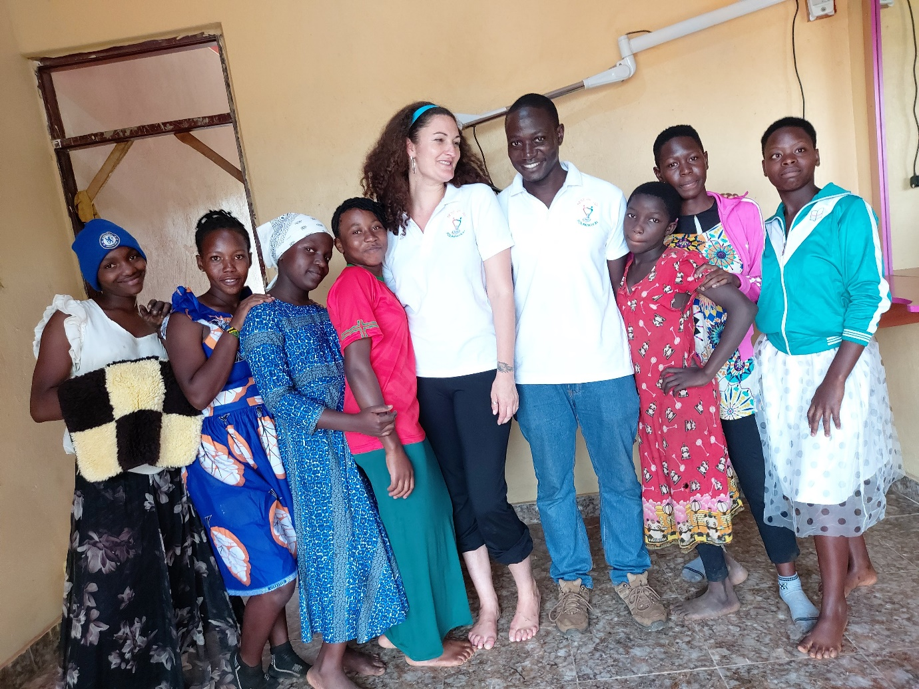
Taken by the Director of the Nest of Joy on 04/05/21

Appendix B: Headmistress of Happy Hammys Academy during a meeting with Eleanor Curl
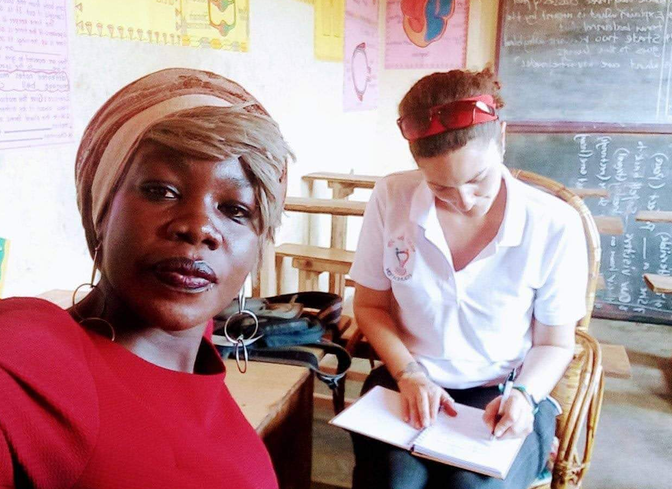
Taken on the 02/04/21

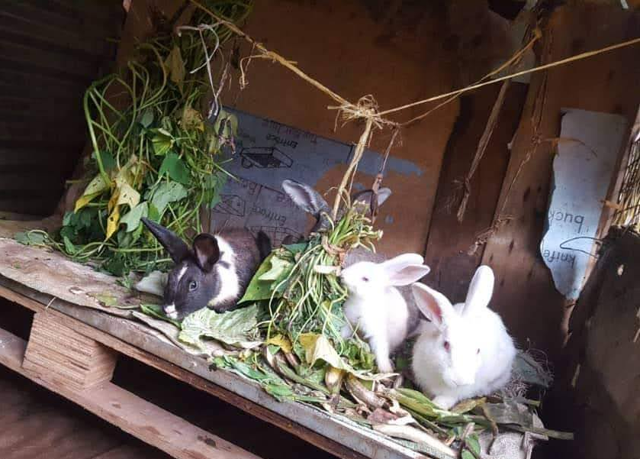
Appendix C: A student of Happy Hammys Academy and the new rabbits

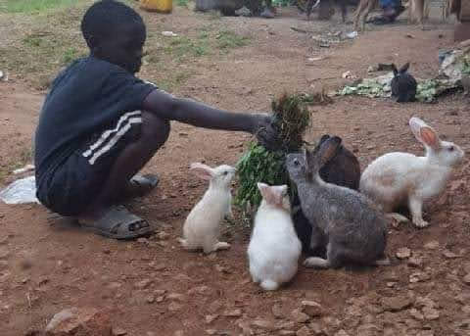

Taken by Headmistress on 03/09/21

Appendix D: Nest of Joy Primary school near completion

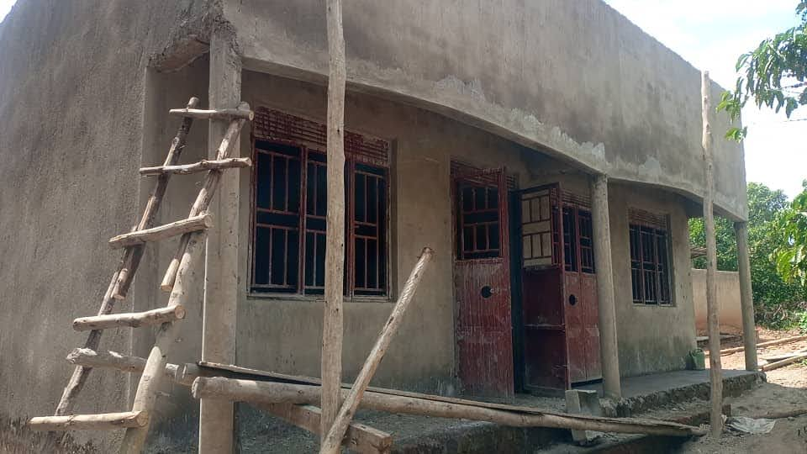

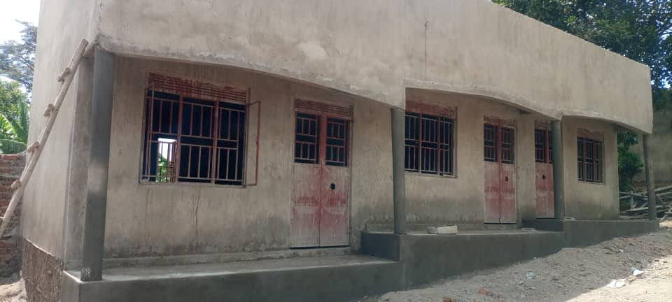
Taken by the Director of the Nest of Joy on 03/10/21

Appendix E: Beneficiaries of the Nest of Joy caring for new-born rabbits and the new chicken coup.
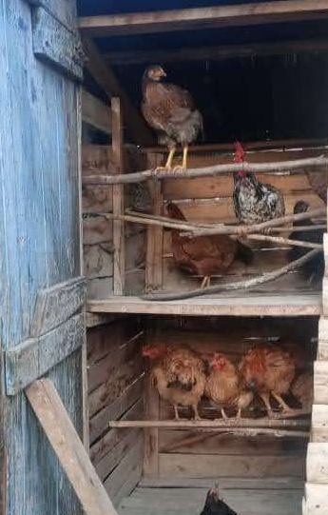
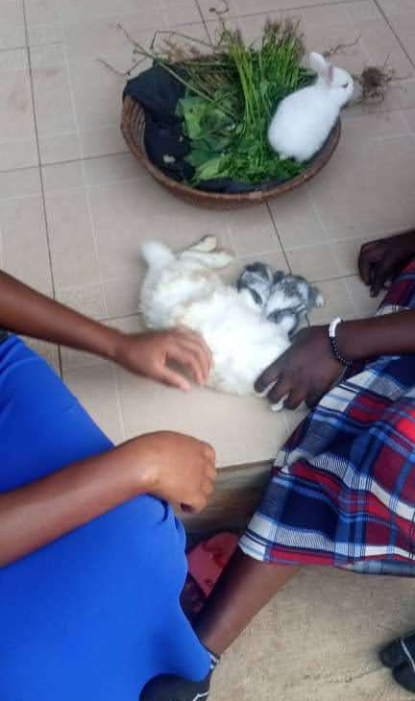

Taken by the Director of the Nest of Joy on 03/10/21

Appendix I: Agreement between Nest of Joy and Eleanor Rose Curl

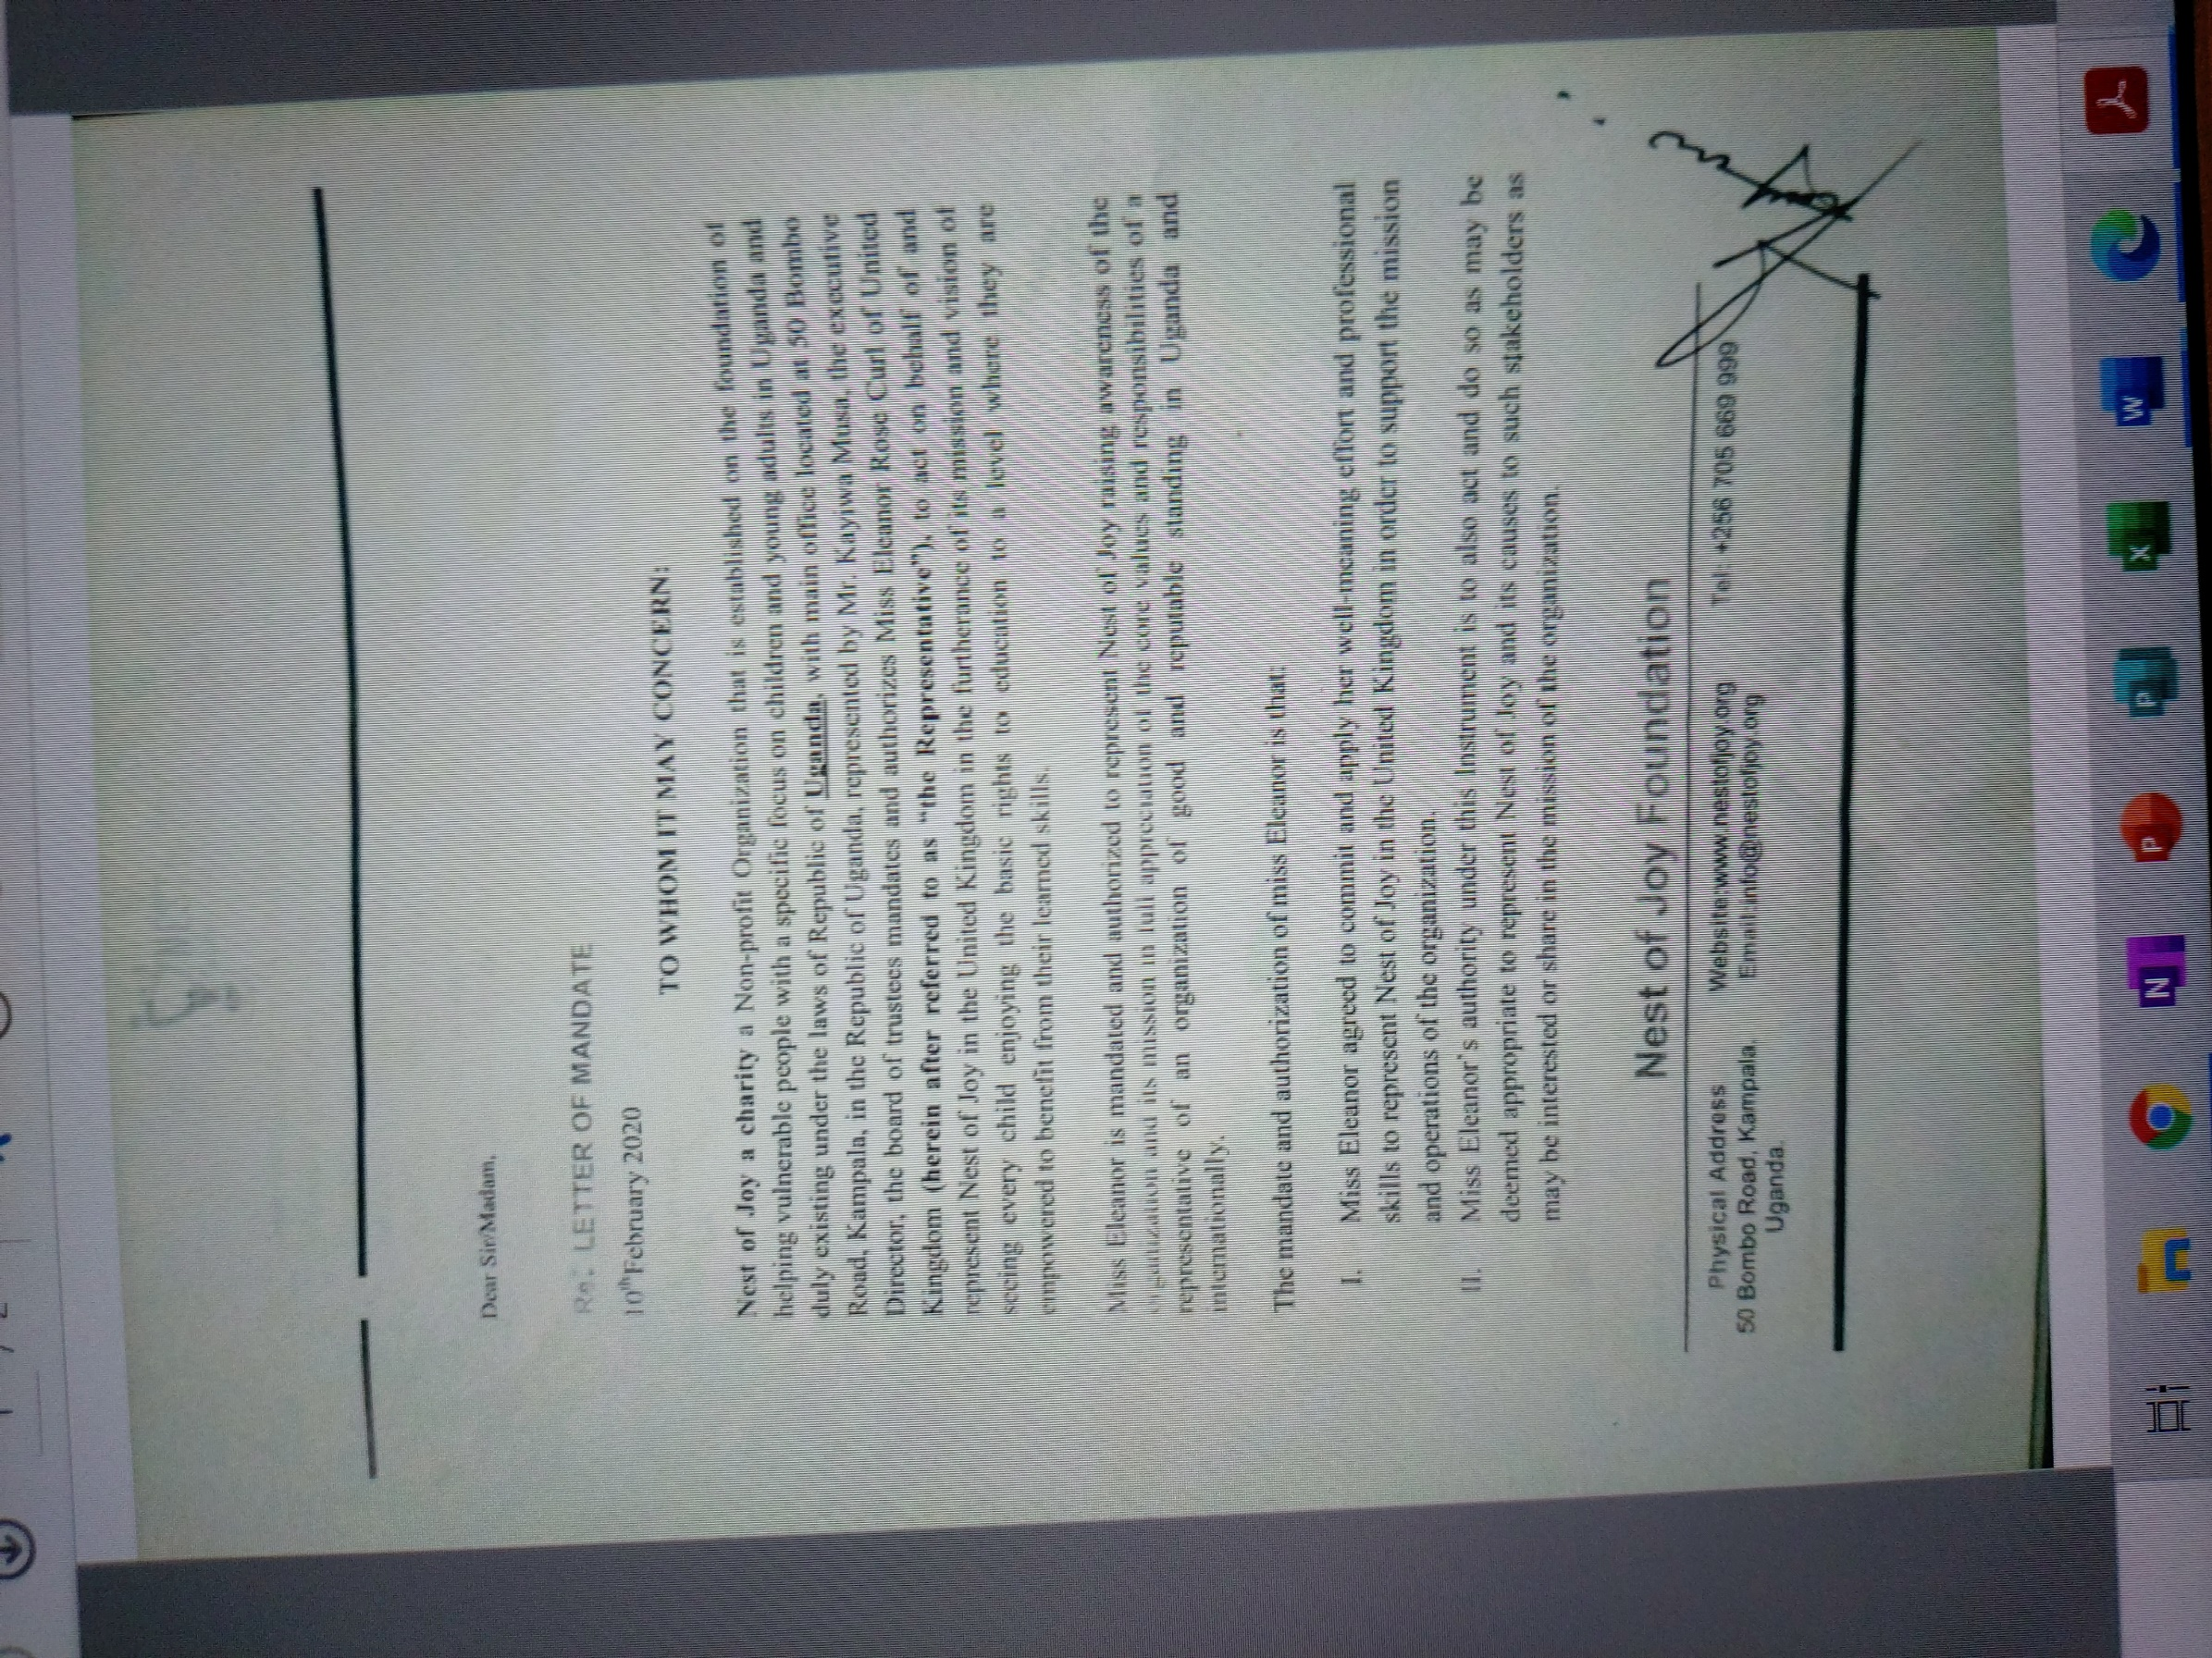
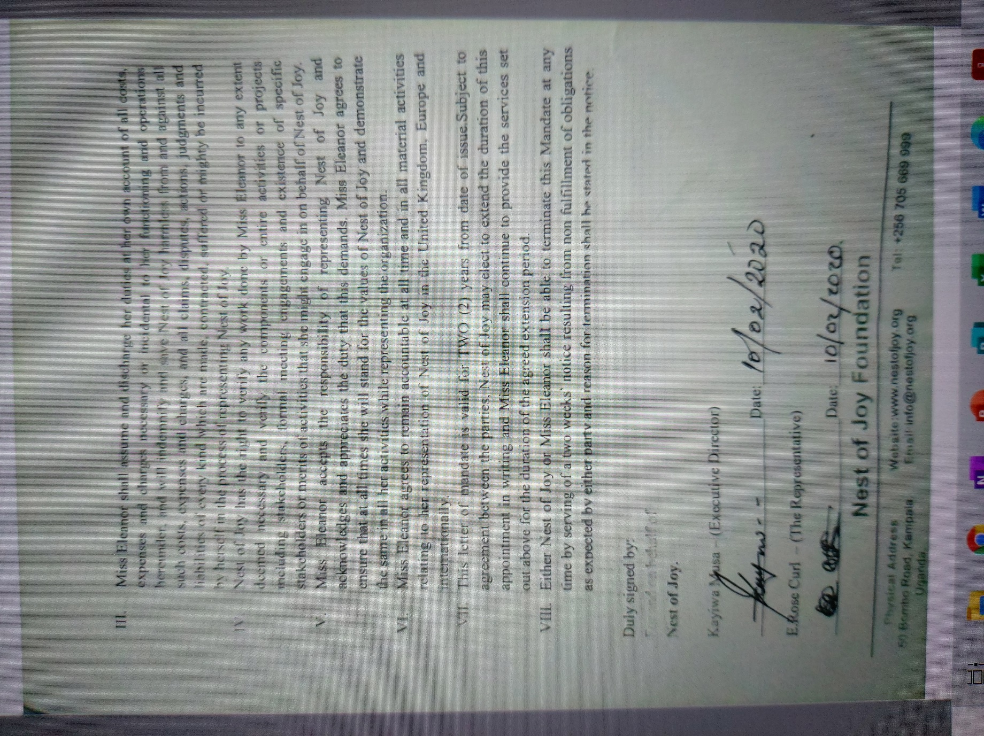

https://www.gofundme.com/f/free-schooling-for-children-of-ugandan slums?utm_source=facebook&fbclid=IwAR2fc-n0cuvhmpKbUbh_30S_u-GedHJ4hidAoyIqpLU69Kmq-hriZLSFYC0.

