**MAKERERE UNIVERSITY ROTARY PEACE CENTRE**

**SOCIAL CHANGE INITIATIVE (SCI) REPORT**

**Title:**

**Enhancing Youth Leadership and Local and National Levels for Sustainable Peace in Cameroon**

10/12/2024

**COHORT 6-2023/24**

**NTANG JULIUS MELENG**

**Implemented in:**

Bum Subdivision, Boyo, North West Region

**From:**

February 1, 2024 to August 31, 2024.

**Academic Mentor**

Dr. Elizabeth Nansubuga

Senior Lecturer, Makerere University, Uganda

**Abstract**

Abstract

Our project titled "Enhancing Youth Leadership at Local and National Levels for Sustainable Peace in Cameroon" was aimed at strengthening youth leadership in Cameroon as a strategy for fostering sustainable peace. Our primary focus area was Bum Subdivision in Boyo Division of the North West Region of Cameroon. The main purpose was to address the critical issue of limited youth involvement in decision making and peacebuilding efforts, exacerbated by ongoing conflict and instability. The project design incorporated capacity-building workshops, mentorship programs, and community dialogue sessions to empower young leaders with the skills and knowledge necessary to participate effectively in decision making and peace processes at both local and national levels. Key activities included training sessions on leadership, conflict resolution, and advocacy, as well as facilitating platforms for youth to engage in peace dialogues and policy discussions. Additionally, mentorship initiatives paired emerging leaders with experienced professionals to provide guidance and support. The project’s key findings indicated significant improvements in the participants' leadership skills, confidence, and ability to engage in decision making and peace building initiatives. The youth demonstrated increased capability in organizing community events and advocating for peace, leading to enhanced local cohesion and dialogue. However, challenges such as limited resources and entrenched local conflicts were identified as barriers to broader impact. In conclusion, the project effectively strengthened youth leadership and engagement in peacebuilding within the Bum Subdivision. It highlights the importance of sustained support and resource allocation to amplify youth voices to sustainable peace, advocating for broader integration of youth viewpoints in national decision making and peace initiatives.

Section One

1. Introduction and Background

The project titled "Enhancing Youth Leadership at Local and National Levels for Sustainable Peace in Cameroon" was designed to address the urgent need for effective youth involvement in peacebuilding processes within conflict-affected regions. Focusing specifically on Bum Subdivision in Boyo Division, North West Region of Cameroon, this initiative sought to cultivate and harness the potential of young leaders to contribute meaningfully to sustainable peace. This introduction outlines the context, purpose, and significance of the project, setting the stage for understanding its objectives and impact. Cameroon has experienced persistent instability and conflict for the past 10 years, from the Boko Haram insurgencies in the Northern regions, insecurity caused by rebels from Central African Republic in the East Region and the North West and South West regions, where ongoing clashes between separatist groups and government forces have created severe socio-political and economic challenges. The North West Region, including Boyo Division, has been notably been affected, with escalating violence disrupting schools, development activities, and undermining social cohesion. Amidst this backdrop, young people have emerged as both victims and potential agents of change, yet their capacity for leadership and contribution to peacebuilding remains underutilized.

Bum Subdivision, a rural area and one of the four subdivisions that make up Boyo Division, exemplifies the complexities faced by conflict-affected regions. The local population has been significantly impacted by displacement, economic disruption, and social fragmentation. Despite these challenges, the youth in Bum Subdivision like in the conflict-affected areas in the country possess a unique potential to drive positive change, given their energy, creativity, and local understanding. However, the lack of structured support and training often limits their ability to assume leadership roles effectively.

1. Problem Statement

Bum Subdivision of Boyo Division, North West Region of Cameroon like many other conflict affected subdivisions in Cameroon has been significantly affected by the current socio-political instability that has in turn negatively affected societal cohesion in the North West and South West Regions. Despite the critical role of youth in driving change, their potential as leaders is currently underutilized. Local youth face numerous challenges including limited access to leadership training, inadequate platforms for civic engagement, and a lack of support structures necessary for fostering their leadership skills. This gap in youth development has largely contributed to the ongoing conflict in the two English speaking regions of the country, the insecurity by rebels in the East and the Boko Haram insurgency in the Northern regions (Lefort-Rieu, Claire, 2024). The current state of youth leadership in Bum Subdivision reflects broader national challenges, where fragmented leadership and insufficient youth involvement in decision-making processes fuel and exacerbate conflict and hinder peacebuilding initiatives. There is a pressing need to enhance youth leadership capacities at both local and national levels to build resilience, promote dialogue, and drive sustainable peace efforts. Addressing this issue involves developing targeted programs that provide leadership training, create opportunities for meaningful civic participation, and establish networks that support young leaders. By empowering youth with the skills and platforms necessary for effective leadership, the project aims to foster a more cohesive and peaceful community in Bum Subdivision and other conflict affected subdivisions, ultimately contributing to stability and sustainable development at the national level in Cameroon.

Top of Form

Bottom of Form

1. Goals and Objectives
2. **Main Objective:**

* Equip Young People with required knowledge and skills to effectively engage in decision-making and peacebuilding processes at local and national levels in Cameroon.

1. **Specific Objectives**

* Build the leadership capacities of young people at both local and national levels in Cameroon.
* Facilitate the active participation and engagement of youths in decision-making and peacebuilding processes at local and national levels.
* Equip youths with advocacy skills to actively participate in, and influence, local and national policies related to peace and development.
* Provide young people with training in conflict resolution and mediation techniques, enabling them to play proactive roles in preventing and resolving conflicts within their communities.

1. **Outputs.**

* 40 Young people equipped with leadership, conflict prevention, mitigation, and resolution skills.
* 40 youths demonstrate a clear understanding of how to engage in local and national peacebuilding and decision-making processes.
* 40 young people actively participating in community-driven peace initiatives.
* 40 Youths actively engage in building networks and collaborating in making youth and development centered policy recommendations.

1. **Outcomes.**

* Increased and demonstrable impact of youth leadership in peacebuilding activities at both local and national levels, with tangible contributions to conflict prevention, resolution, and sustainable peace.
* Improved social cohesion and increased dialogue within local communities, facilitated by the active engagement of empowered youths.
* Significant increase and implementation of policies that reflect the perspective and priorities of young people.

1. Impact

Improved collaboration among young people, government entities, civil society organizations, and other stakeholders.

1. Challenges Faced and mitigation strategies
2. **Challenges**

During the implementation of our Social Change Initiative in Bum Subdivision, we faced a couple of challenges.

* Firstly, the ongoing conflict created a volatile environment, making it difficult to conduct activities safely and consistently. Security concerns often led to disruptions in project timelines and limited the movement of both participants and facilitators. For example, during our final workshop in Konene village on August 13, 2024, Non State Armed Groups (NSAGs) seized out banner
* Secondly, we face the challenge lack of infrastructure and limited resources, including inadequate facilities for training sessions and insufficient materials for educational programs. This scarcity impeded the effective delivery of leadership training and civic engagement initiatives.
* Furthermore, entrenched local and national political tensions complicated collaboration between different stakeholders. Distrust and divergent interests among government entities, civil society organizations, and local leaders hindered coordinated efforts and affected the overall impact of the project.
* To conclude, cultural and socio-economic barriers posed challenges. Many youth faced economic hardships and limited access to education, which affected their ability to participate fully in leadership initiatives that we carried..

To address the above challenges, we adopted the following strategies;

1. **Strategies adopted to mitigate the challenges faced**

To address the challenges encountered during the implementation of the project, several adaptive strategies were employed.

* T begin with, to mitigate security risks, we established strong partnerships with local community based organizations and community leaders. This collaboration ensured safer environments for activities and facilitated timely responses to emerging security threats. We equally approached the NSAGs operating in the project area to explain our mission and how beneficial it could be them.
* To overcome infrastructure and resource limitations, we leveraged community spaces and local resources. Training sessions and workshops were conducted in local Primary School Hall donated by the church, and digital platforms were used to supplement physical materials. This ensured continuous engagement despite logistical constraints.
* Moreover, addressing political tensions required building inclusive coalitions. We engaged with a broad range of stakeholders, including local government representatives; the mayor of Fonfuka municipality in Bum Subdivision, the Divisional Officer, civil society groups, and youth organizations, to foster dialogue and align interests. Regular stakeholder meetings and transparent communication helped build trust and coordination.
* Furthermore, to tackle socio-economic barriers, we incorporated flexible scheduling and supported participants facing economic difficulties with transportation. Scholarships and stipends were offered to ensure broader access to leadership training. These strategies collectively enhanced the project's effectiveness, promoting youth leadership and contributing to sustainable peace in the region.

**Section Two**

1. Literature Review

In the article "Youth and Peacebuilding: Policy Implications of Conflict Resolution in Africa" by Akinyetun, Bakare, and Adedini (2023), published in the Journal of Contemporary Sociological Issues, the authors explore the critical role of youth in conflict resolution across Africa. The study highlights how engaging young people in peacebuilding efforts can transform conflict dynamics and foster sustainable peace. The authors argue that youth possess unique potential to drive change due to their innovative capacities and influence on social movements. They review various policies and programs aimed at integrating youth into peace processes, examining their effectiveness and challenges. The article emphasizes the need for policies that empower youth through education, leadership training, and participation in governance. It also identifies gaps in current approaches, such as the need for more inclusive and context-specific strategies. By analyzing case studies and policy frameworks, the authors provide actionable recommendations for enhancing youth involvement in peacebuilding. Their insights underscore the importance of tailored interventions that address the specific needs and potentials of young people in conflict-prone regions, contributing valuable perspectives to the discourse on conflict resolution in Africa. However, the authors failed to make specific reference how youth leadership can be enhanced in the context of Cameroon within the framework of her two distinctive cultures (French and English), which is the gap our initiative seeks to address.

Also, in their article titled, "Situating the Role of Youth in Indigenous African Peacebuilding Interventions: The Question of Spoilers versus Menders," Osiemo, Maranga, Rono, and Chepkoech (2021) examine the complex role of youth in traditional African peacebuilding efforts. The study differentiates between youths who act as "spoilers," potentially undermining peace initiatives, and "menders," who contribute positively to conflict resolution. By analyzing indigenous peacebuilding practices and youth engagement in these contexts, the authors reveal how local cultural and social dynamics influence the effectiveness of youth contributions. They argue that while youth can play a pivotal role in mending conflicts, they may also become spoilers due to marginalization or lack of appropriate channels for their involvement. The article calls for strategies that recognize and address these dual roles, emphasizing the need for inclusive approaches that leverage the constructive potential of youth while mitigating risks of disruption. The article falls short of holistic strategies that can enhance youth leadership in Cameroon conflict-affected regions which represents the gap our project is addressing.

In the policy brief "Achieving Youth, Peace and Security (YPS) in Cameroon: The Role of Intergenerational Dialogue" by Ngomna and Leke (2023), the authors from Local Youth Corner Cameroon argue for the critical role of intergenerational dialogue in fostering youth, peace, and security. The brief emphasizes that effective peacebuilding in Cameroon requires bridging the gap between younger and older generations. By promoting dialogue, the brief suggests that diverse perspectives can be harmonized, leading to more inclusive and sustainable peace processes. It highlights successful case studies and proposes policy recommendations to institutionalize such dialogues, ensuring that youth voices are integrated into decision-making. The brief also addresses challenges like generational mistrust and the need for structured communication channels. Overall, it advocates for a collaborative approach, stressing that engaging all age groups is essential for achieving lasting peace and security in Cameroon. Our project focuses on building strategies, techniques that can effectively enhance youth leadership in Bum Subdivision which has been dwelled on by the policy brief.

In "Youth as Tactical Agents of Peacebuilding and Development in the Sahel," Agbiboa (2015) explores the transformative role of youth in peacebuilding and development across the Sahel region. Published in the Journal of Peacebuilding & Development, the article highlights how young people can serve as pivotal agents in addressing conflicts and fostering socio-economic growth. Agbiboa examines various youth-led initiatives and grassroots movements that have successfully contributed to peace and development in Sahelian countries. The study underscores the strategic role of youth in bridging divides, advocating for social change, and implementing community-driven projects. However, Agbiboa also identifies challenges such as limited resources, political marginalization, and the need for greater support and recognition from governments and international organizations. The article advocates for policies that enhance youth engagement, including capacity-building programs and inclusive governance structures. By showcasing successful case studies, Agbiboa provides a nuanced understanding of how youth can be effectively mobilized as agents of peace and development in the Sahel region. The article does not tackle the aspect of youth unemployment as a technique of enhancing youth leadership which is one of the key gaps that our project addresses

In "UNESCO and Peace Education: UNESCO's Contributions to the Promotion of Peace Education in Cameroon," Ekah (2021) assesses UNESCO’s role in advancing peace education in Cameroon. The paper outlines UNESCO's initiatives, including curriculum development and teacher training, aimed at fostering a peaceful educational environment. Ekah highlights successes in creating inclusive learning spaces but notes challenges such as inconsistent implementation and limited local adaptation. The study calls for more localized strategies and better collaboration with Cameroonian stakeholders. However, it does not address the role of youth leadership, which our project aims to address.

In "The Cameroon National Youth Service Corps (CNYSC) as an Institutional Tool to Prepare Youths for Nation-Building: A Humancentric Counterterrorism and Nation-Building Perspective," Mbwoge (2024) explores the role of the CNYSC in fostering youth engagement in nation-building and counterterrorism. The author highlights how the CNYSC prepares young people for active participation in national development and security. Mbwoge argues that the program’s emphasis on human-centric approaches equips youth with the skills and values needed for effective nation-building and counterterrorism efforts. The study suggests that strengthening and expanding the CNYSC could enhance its impact on youth and national stability, providing practical recommendations for improvement. The article ignores the role young people play in building sustainable peace in Cameroon which is the gap our project seeks to close.

1. **Theoretical Underpinnings**

We selected a couple of theories that guided the implementation of our project. Amongst them we have;

The theory of Youth Development whose proponents are Jean Piaget, Erik Erikson was developed in the mid-20th century. The theory enhances youth leadership by focusing on holistic growth, fostering skills such as critical thinking, problem-solving, and self-efficacy. It emphasizes providing young people with opportunities to engage in leadership roles, participate in decision-making, and develop their potential. By nurturing these skills through structured programs and real-life experiences, the theory supports the idea that active involvement in leadership roles contributes to personal growth and effective citizenship. This approach builds confidence, fosters resilience, and equips youth with the capabilities needed to take on significant leadership responsibilities and drive positive change in their communities.

To add, the Empowerment Theory, developed in the late 20th century, is primarily associated with Julian Rappaport and Lorraine Gutierrez. Rappaport's work in the 1980s emphasized the role of empowerment in social work and community development, while Gutierrez contributed to its application in diverse social contexts. The theory promotes youth leadership by focusing on increasing individuals' control over their lives and decisions. By fostering self-efficacy and providing resources, skills, and opportunities, Empowerment Theory enables youth to take on leadership roles and drive social change, enhancing their confidence and capacity to influence their communities effectively.

Moreover, Social capital theory examines the value of social networks and relationships in enabling individuals and groups to achieve collective goals. Developed in …by Robert Putnam, and Pierre Bourdieu, the theory emphasizes the importance of social connections and community engagement. Youth participation in leadership and decision-making enhances social capital by fostering networks of trust and collaboration. This theory supports the idea that involving young people in these processes strengthens community bonds and facilitates effective collective action. Social Capital Theory, as a formalized concept, was developed primarily in the late 20th century. While the term "social capital" was used in various contexts before, the theory gained prominence through the works of sociologists Pierre Bourdieu and Robert Putnam. Bourdieu introduced the concept in his 1980 book "The Logic of Practice," where he explored how social networks and relationships contribute to social mobility and access to resources. Robert Putnam further popularized the theory with his 1993 book Making Democracy Work, and his 2000 work Bowling Alone, which examined the decline of social capital and its impact on community engagement and democracy

Furthermore, Participatory Democracy theory which was developed by Carole Pateman, and Robert A. Dahl underpins that the roots of participatory democracy can be traced back to ancient democratic practices in Athens and later theories by philosophers such as John Stuart Mill in the 19th century emphasized the importance of active citizen engagement in governance. The theory gained formal recognition in the mid-20th century. Carole Pateman's influential 1970 book, *Participation and Democratic Theory,* marked a significant contribution by arguing that participatory practices enhance democracy by involving citizens more directly in decision-making processes. Further development occurred with works by scholars like Robert A. Dahl, who explored democratic theory and practices. The theory continued to evolve through the late 20th and early 21st centuries, emphasizing inclusive governance and citizen participation as essential components of democratic systems. Participatory democracy theory directly supports youth involvement in leadership roles and decision-making, arguing that such participation is crucial for a more representative and effective democracy.

Lastly, Transformative Learning Theory, developed by Jack Mezirow, emphasizes how individuals undergo profound changes in perspective through critical reflection and experiential learning. This theory supports youth leadership by fostering self-awareness and critical thinking. Through transformative learning, young people critically examine their beliefs and assumptions, leading to a deeper understanding of themselves and their roles in society. This self-reflection enhances their ability to navigate complex issues and make informed decisions. Experiential learning—such as engaging in leadership roles and community projects—provides practical experience and reinforces theoretical insights, allowing youth to apply their new perspectives effectively. By promoting adaptability, resilience, and a commitment to social change, transformative learning prepares youth to become innovative leaders who can drive positive impact and address societal challenges effectively. Mezirow introduced the theory in the early 1970s, with significant development occurring through his 1978 work, "Education for Critical Consciousness," and later publications. The theory gained broader recognition with Mezirow’s 1991 book, Transformative Dimensions of Adult Learning, which expanded on how adults undergo deep, perspective-changing learning experiences through critical reflection and dialogue. This theory focuses on how transformative learning processes can lead to fundamental changes in individuals' worldviews and understanding, influencing their actions and roles, including leadership.

1. **Theory of Change and how it was applied**

The project “Enhancing Youth Leadership at Local and National Level for Sustainable Peace in Cameroon” sought to foster sustainable peace in the conflict-affected Bum Subdivision of the North West Region of Cameroon. The change theory guiding this project focused on empowering young people to actively participate in decision making and peace-building initiatives and enhance democratic engagement. This report outlines the change theory used and its application throughout the project, detailing how it shaped the activities and outcomes. The theory of change (ToC) for this project was built on the premise that strengthening youth leadership at both local and national levels would lead to improved conflict resolution, enhanced community engagement and participation in democratic processes in the country, and ultimately, sustainable peace. The theory was structured around the following core elements:

**Long-Term Goal:** Achieve sustainable peace and social cohesion through empowered youth leadership.

**Outcomes:** Short-term, medium-term, and long-term outcomes that reflect increased skills, active participation, and ongoing peace-building efforts.

**Activities:** Specific actions designed to achieve these outcomes, including training, community engagement, and networking.

**Assumptions:** Conditions necessary for the theory to hold true, such as youth engagement and community support.

**Indicators:** Metrics to measure progress and success

**Application of the Theory of Change**

1. **Short-Term Outcomes**

The project began with the mobilization of stakeholders within the community and at national level to get their buying in, this included stakeholders at the ministry of Youth Affairs and Civic Education, National Youth Council, Youth and Community Based Associations. We proceeded by conducting a needs assessment to identify gaps and opportunities for youth leadership development in Bum Subdivision. After a need assessment, we proceeded with a series of targeted training workshops aimed at equipping 40 selected youth from the Bum Subdivision with leadership, conflict prevention, resolution, and management skills. These workshops were designed based on the identified needs of the community and the skills gap among the youth. The training included interactive sessions, role-playing, and scenario analysis to ensure that participants could effectively translate their learning into practical applications.

**Moreover,** recognizing the importance of collaboration in driving change, we facilitated the revival and creation of networks among local youth organizations. This was achieved through networking events and partnership-building activities. The establishment of these connections was crucial for fostering a supportive environment and providing youth with resources and platforms to implement their peace-building initiatives. Amongst the networks revived and created were the Bum Youths Cultural and Development Association (BYCUDA) and the Grassland Peace Centre (GRAPEC). BYCUDA is an association of young people from Bum and GRAPEC is a grassroots peacbuilding association that operates across Boyo Division.

**Furthermore,** to boost awareness of the role of youth in peace-building, we organized community outreach events and leveraged national media like Cameroon Radio and Television, Canal 2 International, The Guardian Post Newspaper, and social media. These efforts were intended to highlight the importance of youth leadership in addressing local conflicts and contributing to broader national peace efforts.

1. **Medium-Term Outcomes**

With enhanced skills and networks, the trained youth actively engaged in peace-building activities. They initiated local projects such as community dialogues and conflict resolution workshops, which helped address specific issues within their communities. This active involvement was critical for demonstrating the practical application of their training and reinforcing their role as change agents. Furthermore, the project’s activities led to increased involvement of youth in local governance and community decision-making processes. The youth leaders’ participation in local councils and advisory bodies in community based organizations provided them with a platform to influence policies and advocate for community needs. This engagement did not only empower the youth but also contributed to more inclusive and representative local governance such as in village development organizations.

The application of conflict prevention and resolution skills by the youth resulted in a noticeable reduction in local conflicts. Feedback from community members indicated that more than more than 10 primary schools and 4 secondary schools that have been closed for over 8 years due to the ongoing conflict in the two English regions opened their doors in September at the start of the 2024/2025 academic year. There has been a significant decrease in tensions in areas where youth-led initiatives were active like the IBAM Youths Initiative in the upper part of Bum Subdivisiom. This outcome validated the effectiveness of the training and the practical impact of the youth’s efforts on local peace-building.

1. **Long-Term Outcomes**

In the next 5 to 10 years, the youth will continue to drive peace-building efforts, demonstrating a commitment to long-term conflict resolution and social cohesion. Their sustained involvement in peace initiatives would contribute to a more resilient and harmonious community environment. The project’s success in increasing youth representation in local decision-making bodies and national forums will be a significant achievement. The youth leaders' active participation in these platforms would help promote democratic practices and ensure that youth perspectives were included in policy discussions.

1. **Challenges and Adaptations**

While the theory of change provided a robust framework, the project encountered challenges such as political instability and resistance to change. These challenges were addressed through flexible project strategies, ongoing community engagement, and safety measures for participants. Adjustments were made based on continuous feedback and monitoring to ensure that the project remained responsive to the evolving context.

1. Methods and Design
2. **Methods**

To realize our objectives we adopted a mixed method approach which included contextual needs assessment. We conducted detailed surveys and interviews with youth, community leaders, and local stakeholders in Bum Subdivision to understand local dynamics, challenges, and needs, analyzed specific local conflict issues and youth engagement barriers in the Bum Subdivision. Organized workshops focused on leadership skills, conflict resolution, and community engagement specifically designed for the context of the Subdivision, Supported youth-led initiatives aimed at addressing local conflicts and promoting peace within the community. Moreover, we worked closely with local government bodies, traditional leaders, and community organizations to gain support and ensure alignment with local governance structures. To track the outcomes, we implemented mechanisms for regular feedback from participants and stakeholders to assess the effectiveness of interventions and make necessary adjustments and conducted periodic evaluations to measure the impact of the project on youth leadership and peace in the Subdivision.

1. **Design**

As per the design of our interventions, we designed project activities and materials that were relevant to the cultural, social, and economic context of the Subdivision, involved local leaders and stakeholders in the design and implementation phases to ensure community ownership and relevance and developed a flexible curriculum that can be adapted based on feedback and emerging needs within the Subdivision. We used a combination of in-person workshops, community meetings, njangi houses, and digital platforms like whatsapp to reach a wider audience, build partnerships with local youth groups, and community organizations to leverage existing networks and resources and aligned the project with existing local development and peacebuilding programs like the Bum Development Union Reconciliation Initiative to enhance synergy and effectiveness. For sustainability, we focused and will continue building the capacity of local youth leaders and institutions to ensure sustainability beyond the project's duration and allocate resources strategically to ensure long-term impact and minimize dependency on external support. Lastly, we will use an adaptive management approach to respond to emerging challenges and opportunities in the Subdivision and incorporate lessons learned into the project design and implementation to improve effectiveness and adaptability.

Section Three

1. **Interventions and Activities**

Our SCI which was implemented between January and September 2024 included a range of activities carried within and without the project location. Amongst the interventions we had;

Initial Assessment and Planning: We conducted a comprehensive assessment within the subdivision and amongst young people originating from this community to understand the local conflict dynamics, youth needs, and existing peacebuilding efforts in the Subdivision. Equally, we engaged with stakeholders at national level, local leaders, youth groups, and community organizations to gather input and build support for the project. We further carried out baseline data collection on youth leadership skills, community perceptions, and the impact of conflict to measure progress. Training workshops we organised to equip young people with leadership skills, including conflict prevention, resolution and management techniques, negotiation, and community mediation. These workshops were tailored to address the specific needs and challenges faced by youth in Bum Subdivision.

Moreover, we facilitated community dialogue sessions where youth engaged with community members, including elders, leaders, and other stakeholders, to discuss local issues and explore collaborative solutions towards common conflicts like farmer-grazer conflict that is very common in the subdivision. We engaged in awareness campaigns on the importance of youth leadership in peacebuilding, using local media, community events, and social media platforms like whatsapp and facebook.

Youth-Led Initiatives were equally supported through mentorship aimed at addressing specific community issues and promoting peace. These projects included community manual work on public roads and inter-community sports events. In addition, we established peer support networks and youth councils to provide ongoing support and foster collaboration among young leaders. Networking Events were also organized to connect youth with potential allies and partners, including local and national leaders, to expand their influence and impact within and out of the subdivision.

We regularly monitored the implementation of activities to ensure they were on track and making the desired impact. One of the strategies use was feedback mechanisms to make real-time adjustments, a mid-term evaluation was conducted in July 2024 to assess progress against objectives, gather feedback from participants, and adjust strategies as needed. A final comprehensive evaluation was performed in September 2024 to assess the overall impact of the project, document successes and challenges, and prepare a detailed report with recommendations for future initiatives.

1. **Key Findings/Impact**

In the course of our project and after the execution of some activities, we found out that participants of our workshops demonstrated enhanced leadership skills, including better conflict resolution, negotiation, and some community engagement abilities. This was evident in the post workshop evaluation sessions that we carried out after the trainings. Also, Youth who participated were able to apply these skills in real-world scenarios, contributing to more effective community leadership and peacebuilding. A case in point was the IBAM Youth Initiative created to promote community development in the subdivision. This initiative brought together more than 50 young people across the subdivision that carried out monthly fundraisings, development initiatives in the subdivision, road maintenance, ensured security in the villages and safety of people and property in the face of the ongoing insecurity orchestrated by the overarching conflict.

Equally, the rate of engagement of young people in community development activities increased as demonstrated in the number of young people who registered as members in the IBAM Youth Initiative, and the number who held leadership positions within the Bum Development Union. Furthermore, at least 50% of participants of our leadership workshops successfully engaged with local stakeholders, including elders and leaders, to address local issues collaboratively. Increased awareness and support for youth participation in electoral processes was one of the key findings and impact. Between February and September 2024, more than 4000 young people across the subdivision had either joined a political party or are aware of the importance of the role and importance of political participation of young people. There was equally growing support from local leaders and stakeholders for youth leadership and peacebuilding efforts demonstrated through their presence in youth initiatives like the IBAM Youth Initiative. Many youth-led projects and initiatives continued beyond the project’s official end, indicating successful capacity building and sustainability. Local youth and community organizations demonstrated increased ownership and responsibility for peacebuilding efforts, for example, the IBAM Youth Initiative fully demonstrated ownership and control over the community development initiatives.

Youth in Bum Subdivision were empowered to take on leadership roles, leading initiatives that addressed local challenges and promoted peace. Most importantly, the project contributed to improved relations between different community groups and reduced ethnic or social tensions, especially between the Muslims and Christians. We learned some best practices and lessons that can be shared with other subdivisions in the country and organizations involved in youth leadership and peacebuilding.

Overall, the project’s key findings and impacts highlight the significant progress made in empowering youth, fostering community engagement, and contributing to sustainable peace in conflict-affected areas like Bum Subdivision. The successful outcomes does not only advance local peacebuilding efforts but also provide valuable insights and models for future initiatives.

**Section Four**

1. **General Conclusion.**

The project "Enhancing Youth Leadership at Local and National Level for Sustainable Peace in Cameroon," implemented in Bum Subdivision of the North West Region, was aimed at fostering youth leadership as a cornerstone for sustainable peace in a subdivision and country heavily impacted by conflict for the past eight years and running. During the implementation of the project, several key outcomes were achieved, demonstrating the potential of empowered youth to drive positive change. Amongst the outcomes, we have increased youth engagement in community leadership and interest in political participation. The project successfully engaged 40 youths directly through training workshops and more than 4,000 indirectly, providing them with leadership training, conflict resolution skills, and platforms for active participation in community development. Workshops and awareness campaigns were conducted, focusing on leadership skills, peacebuilding strategies, and civic responsibilities.

Also, the project facilitated partnerships between youth leaders and local development organizations, and created channels for regular communication and collaboration. This engagement has led to the incorporation of youth perspectives in community governance. Youth-led initiatives, including community clean-ups, setting up of vigilantes groups for security and safety of the community have had a tangible impact on the local development and peacebuilding. These initiatives have not only contributed to the physical and social environment but also strengthened the community’s resilience to conflict. The project also included advocacy efforts at the national level, raising awareness about the role of youth in peacebuilding and influencing national policies related to youth engagement and conflict resolution.

The project has demonstrated that investing in youth leadership can lead to significant positive changes in conflict-affected regions not only in Cameroon. The increased capacity of young people to lead and engage in peacebuilding activities has fostered a more inclusive and participatory approach to addressing local challenges. However, challenges remain, including sustaining these gains and addressing ongoing conflicts.

1. **Recommendations**
2. To ensure continued effectiveness, it is essential to provide ongoing support and resources to the local youth associations and Community Peace clubs. This includes regular training, access to funding, and mentorship opportunities to help these structures evolve and adapt to changing needs.
3. Funding for youth initiatives through the National Youth Council and the Ministry of Youth Affairs and Civic Education should be increased and procedures to benefit made easier
4. Broaden the reach of youth leadership programs to include more remote and underserved areas within the North West Region and the rest of the country. This will ensure that the benefits of the project are more widely distributed and that more young people have the opportunity to participate in leadership and peacebuilding activities.
5. Collaborate with educational institutions to integrate leadership and peacebuilding curricula into school programs. This approach will help instill these values in younger generations and build a foundation for long-term peace.
6. Continue advocating for national policies that support youth involvement in peacebuilding. Establishing formal mechanisms for youth representation in national decision-making bodies will ensure that their voices are heard at all levels of governance.
7. Facilitate exchanges and partnerships between youth leaders in different conflict-affected regions of Cameroon. This will enable sharing of best practices, foster solidarity, and create a network of youth committed to national peace and development.
8. Develop comprehensive monitoring and evaluation frameworks to assess the long-term impact of youth leadership initiatives. Regular assessments will help identify areas for improvement and ensure that the projects remain relevant and effective.
9. **Sustainability Plan**

To ensure the sustainability of the project outcomes, a multi-faceted approach is required:

We will continue empowering local stakeholders, including youth associations and community leaders, to take ownership of peacebuilding initiatives. Provide training and resources to build their capacity to manage and sustain these programs independently.

Identify and secure diverse funding sources, including partnerships with local businesses, international donors, and government grants through the ministry of youth affairs. Also, we will work with local and national institutions like the Cameroon National Youth Council, UNESCO, etc, to integrate successful youth leadership programs into formal structures. This would include embedding these programs into school curricula, local government initiatives, and community development plans.

Building and strengthening networks among youth leaders, community organizations, and government bodies would a key priority. These networks will facilitate collaboration, resource sharing, and mutual support, which would contribute to the long-term sustainability of peacebuilding efforts. Furthermore, we will maintain advocacy efforts to ensure that the importance of youth leadership in peacebuilding is recognized and supported at both local and national levels. This includes ongoing engagement with policymakers, media, and the public to sustain awareness and commitment. Moreover, feedback mechanism would be implemented regularly to gather input from participants and stakeholders. This feedback would be used to adapt and improve programs, to ensure they continue to meet the evolving needs of the community and remain effective in promoting peace.

References

Akinyetun, T. S., Bakare, K., & Adedini, S. O. (2023). Youth and Peacebuilding: Policy Implications of Conflict Resolution in Africa. *Journal of Contemporary Sociological Issues*, *3*(1), 68-88.

Osiemo, I., Maranga, F., Rono, A., & Chepkoech, R. (2021). Situating the Role of Youth in Indigenous African Peacebuilding Interventions: The Question of Spoilers versus Menders.

Ngomna, B., & Leke, A. C. (2023). Achieving Youth, Peace and Security (YPS) in Cameroon: the role of Intergenerational Dialogue. *Local youth corner policy brief*.

Mbatna Taiwe, T. D. A. (2022). Peacebuilding through Education: The Case of Cameroon’s Anglophone Crisis.

Agbiboa, D. E. (2015). Youth as tactical agents of peacebuilding and development in the Sahel. *Journal of Peacebuilding & Development*, *10*(3), 30-45.

Ekah, R. E. (2021). UNESCO and Peace Education: UNESCO's Contributions to the Promotion of Peace Education in Cameroon. *International Journal of Peace, Education and Development*.

Mbwoge, E. W. (2024). The Cameroon National Youth Service Corps (CNYSC) as an Institutional Tool to Prepare Youths for Nation-Building: A Humancentric Counterterrorism and Nation-Building Perspective. *Open Journal of Political Science*, *14*(02), 316-328.

Internet links

<https://educationnorthwest.org/sites/default/files/resources/factsheet13.pdf>, consulted on 05/09/2024 at 2:00pm.

<https://onlinesocialwork.vcu.edu/blog/empowerment-theory-in-social-work/#:~:text=People%20may%20feel%20helpless%20in,power%20to%20improve%20their%20lives>., consulted on 05/09/2024 at 02:15pm.

**Pictorial Presentation of Project Activities**

1. 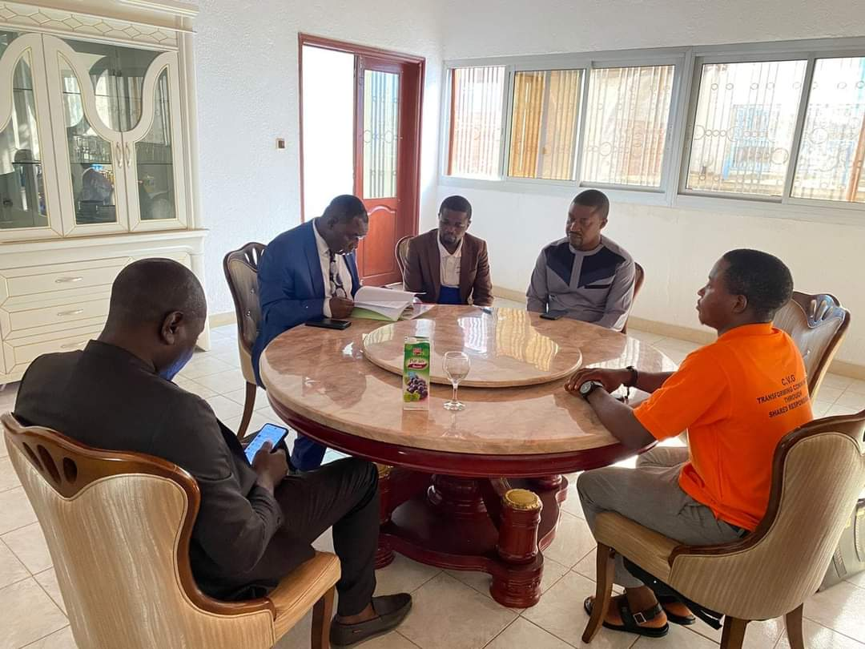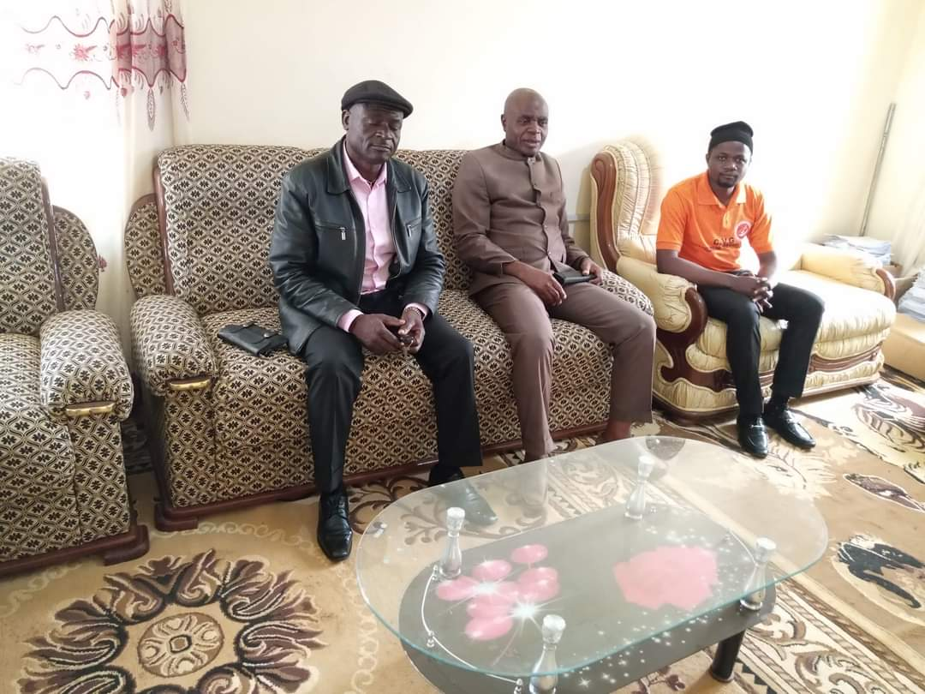Stakeholder Engagement.

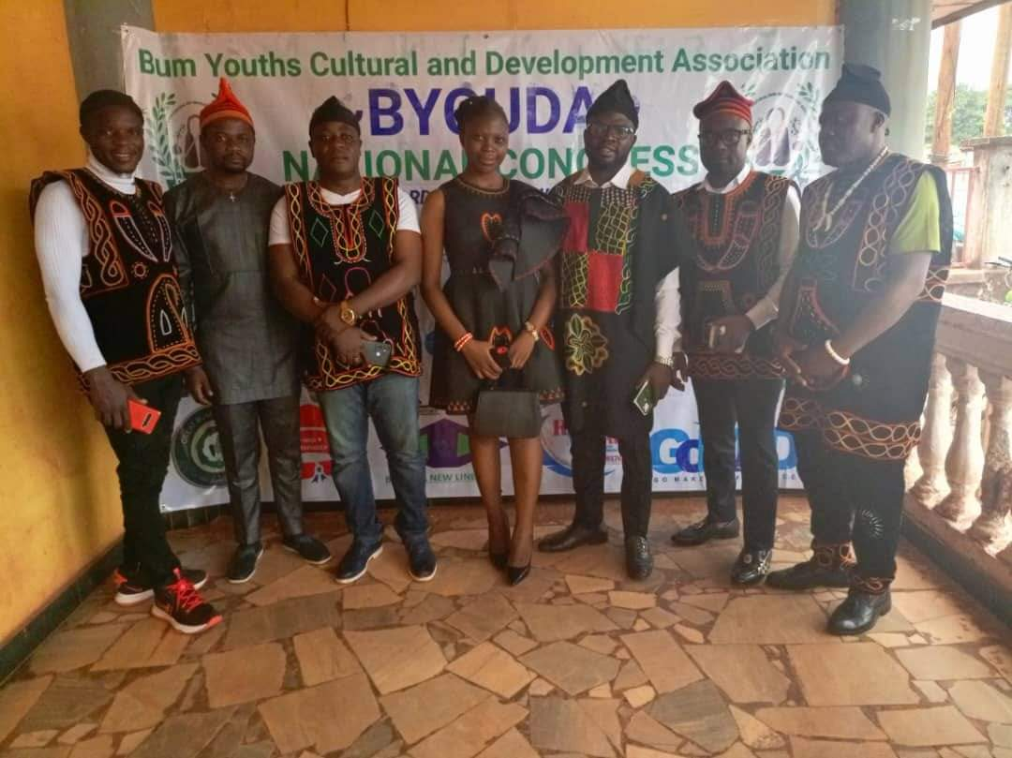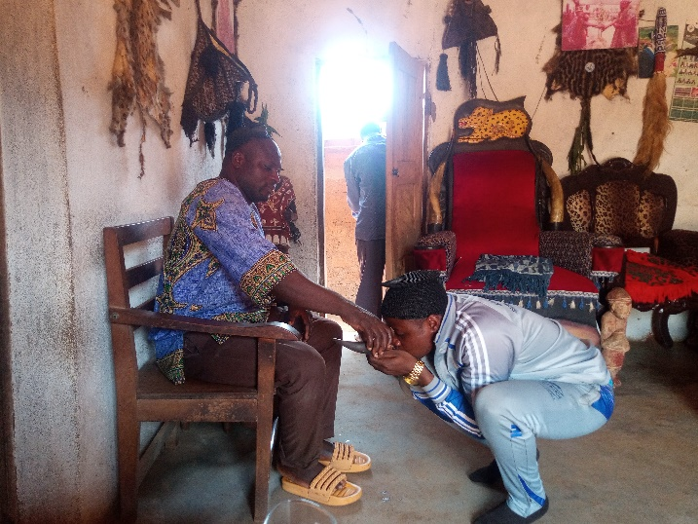

Meeting with Executives Bum Youths Cultural & Development Association in Bafoussam Town to talk about my SCI, March 2024.

Meeting with the King of Mbuk in Bum Subdivision, Boyo Division to talk our my SCI, March 2024

Meeting with the Mayor of Tubah in Mezam Division to talk about my SCI, March 2024

Meeting with the Mayor of Fundong, in Boyo Division to talk about my SCI, March 2024

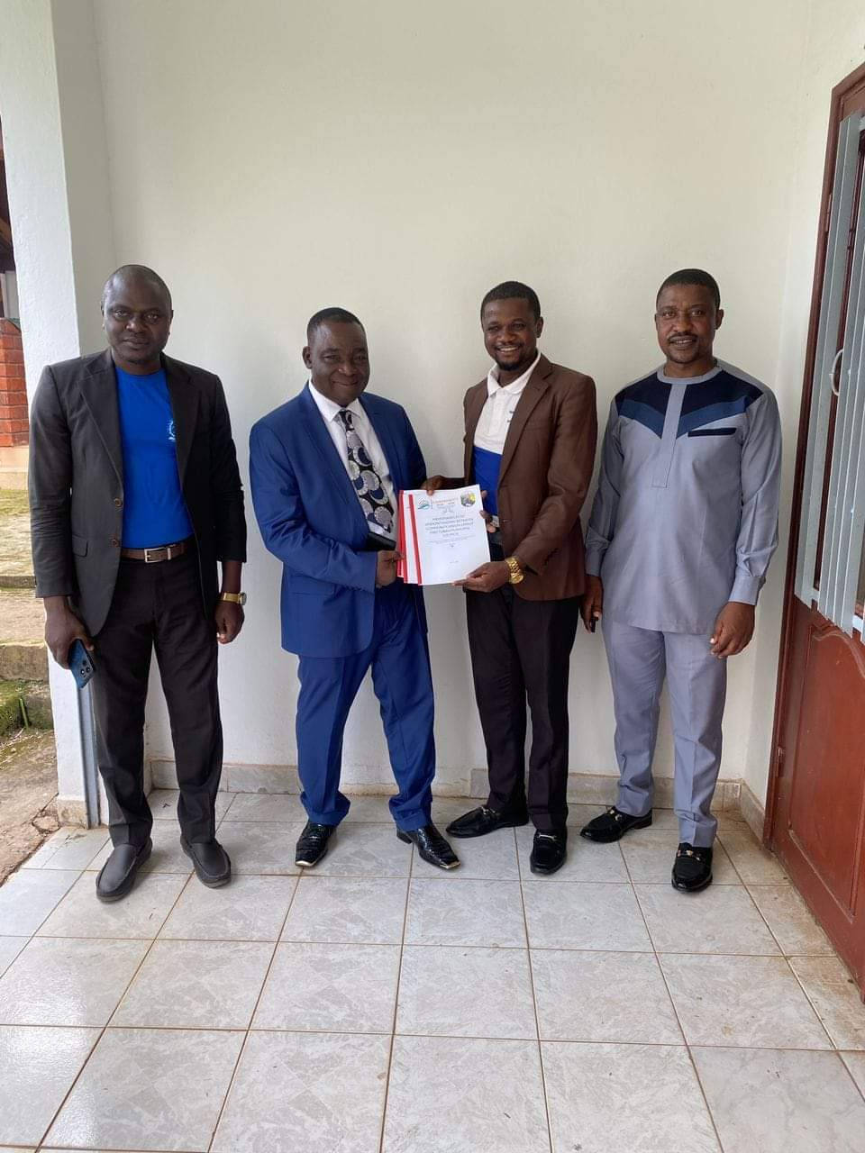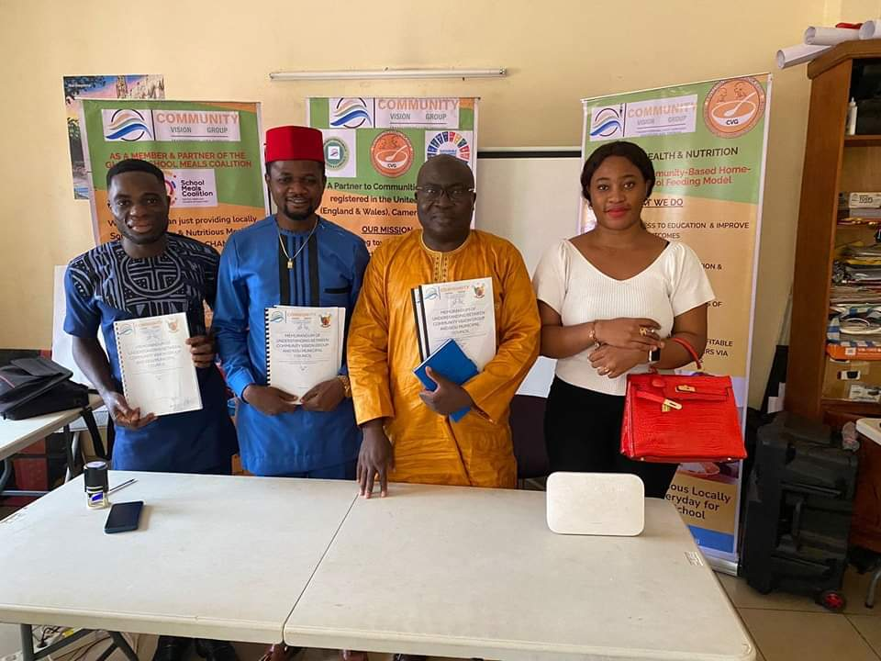

Signing of MoUs with the Mayors of Ndu and Tubah municipalities in the North West Region of Cameroon in June and July 2024 respectively.

1. **Awareness Raising Campaign on the media and in the Community**

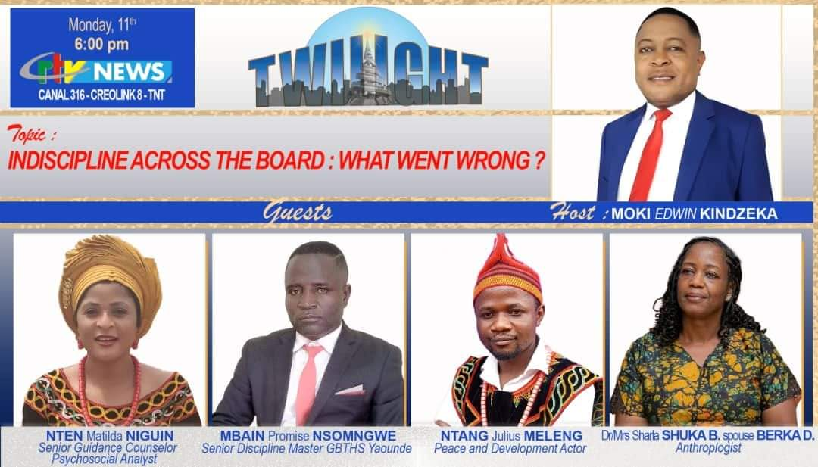

Invited by the State Media to about the role of youth in Indiscipline in schools, February 2024 on Twilight. I dwelled on the role young people play in fueling violence within the school milieu and how school violence which is part of the bigger problem Cameroon is facing can be mitigated.

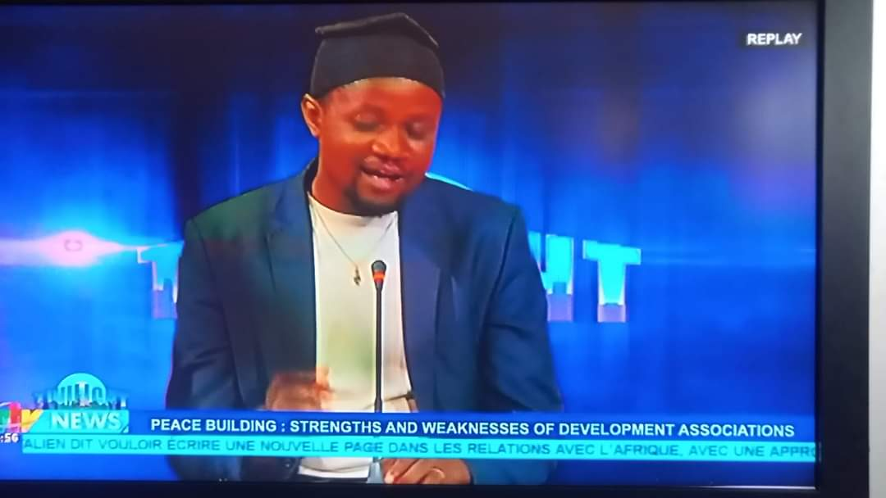

On Cameroon Radio Television (CRTV) expatiating on the weaknesses and strengths of Development Associations in promoting youth leadership and community Development in Cameroon, May 2024

9

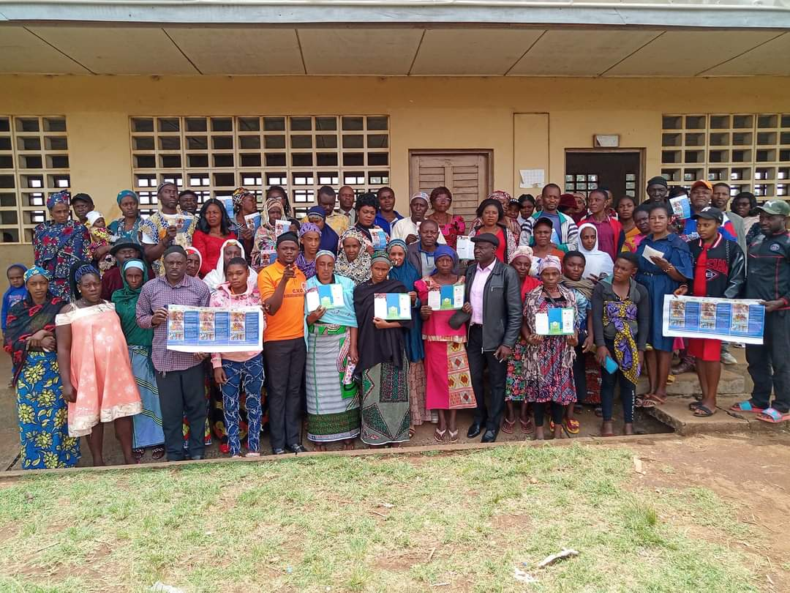

After the invitation to talk about conflict and school violence on state media, Cameroon Radio Television (CRTV), February 2024

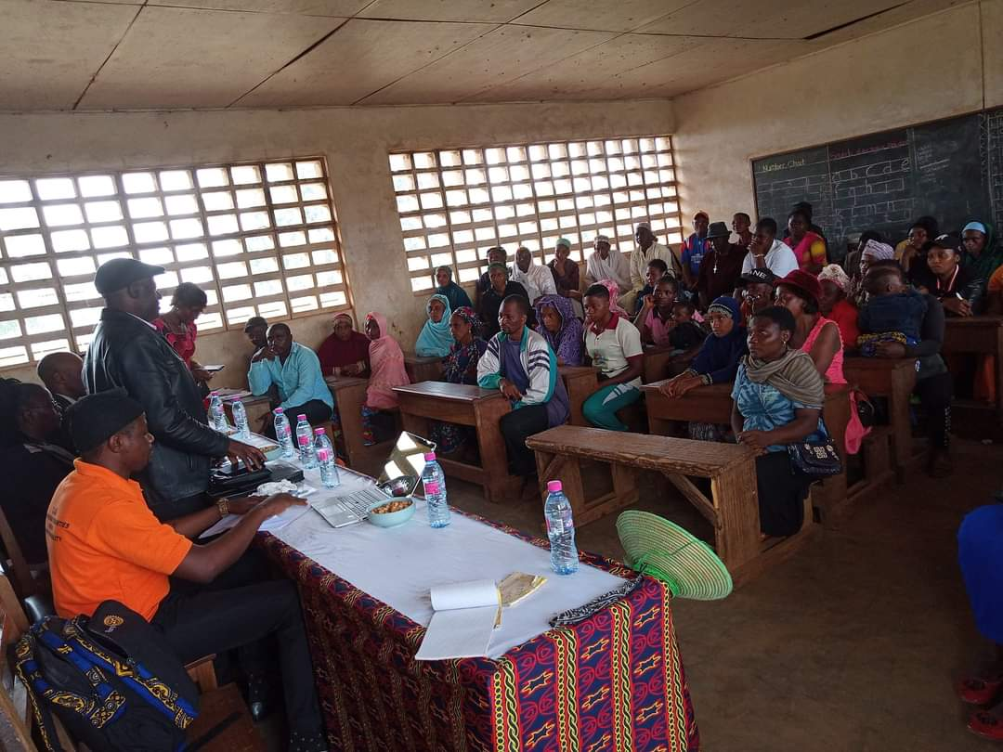

Sensitization of community leaders and stakeholders on the importance of engaging young people in community development, particularly in school management, Fundong, Boyo Division NWR, Cameroon, March 21, 2024

1. **Training Workshops**

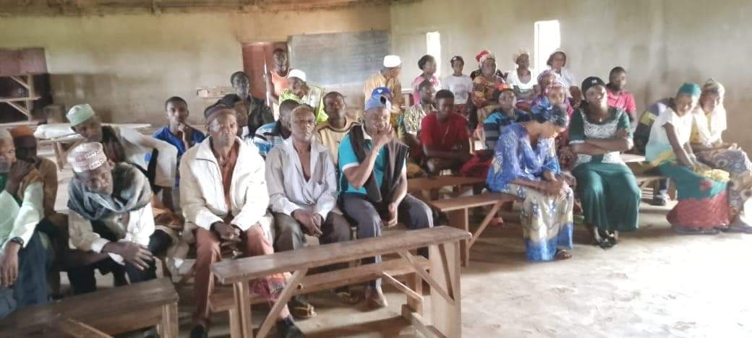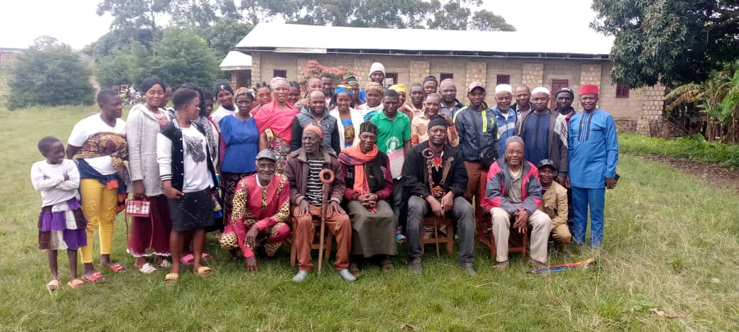

Youth leaders under our mentorship sensitizing community leaders and their peers on the Cameroon electoral process, categories of elections and the importance youth involvement in political processes, Ngunabum village, Bum Subdivision, Boyo, NWR, Cameroon, April 2024.

Training Workshop on Peace and Leadership for Community Leaders and Young people, Bum Subdivision, Boyo Division, NWR, Cameroon, 13th August 2024.

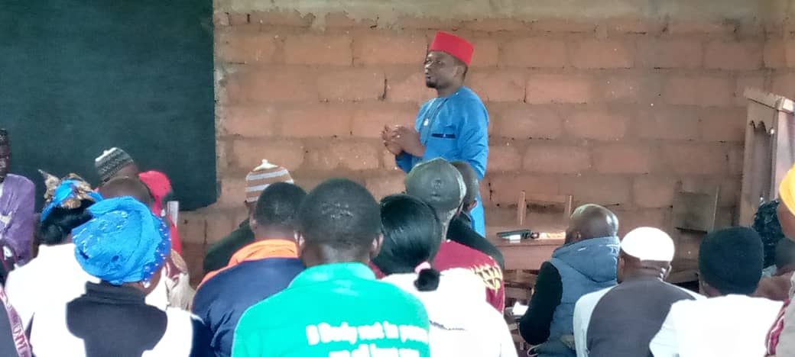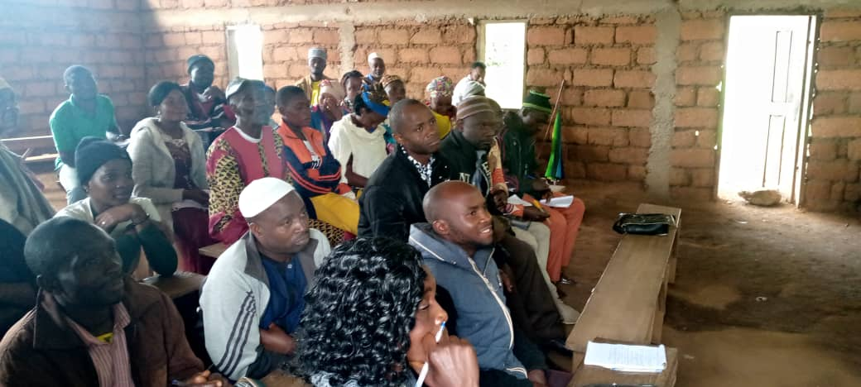

Training Workshop on Peace and Leadership for Community Leaders and Young people, Bum Subdivision, Boyo Division, NWR, Cameroon, 13th August 2024.

Training Workshop on Peace and Leadership for Community Leaders and Young people, Bum Subdivision, Boyo Division, NWR, Cameroon, 13th August 2024.

1. **Post Sensitisation and Awareness Raising Outcomes**

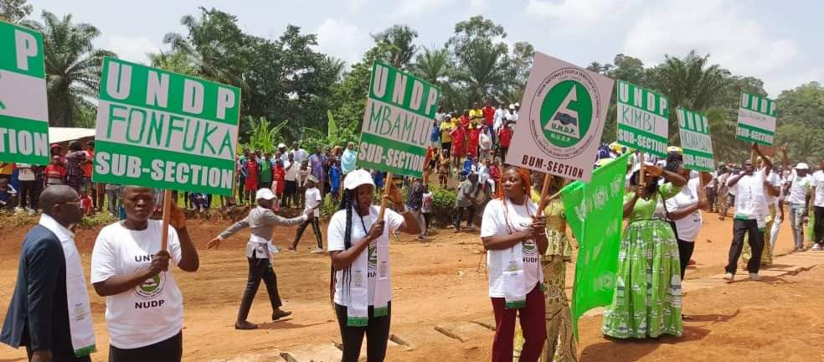

Youth actively engaged march pass on National Day, 20th May 2024 in Fonfuka after the sensitization of youth and community leaders in April 2024, on the Cameroon electoral process, categories of elections and the importance youth involvement in political processes.

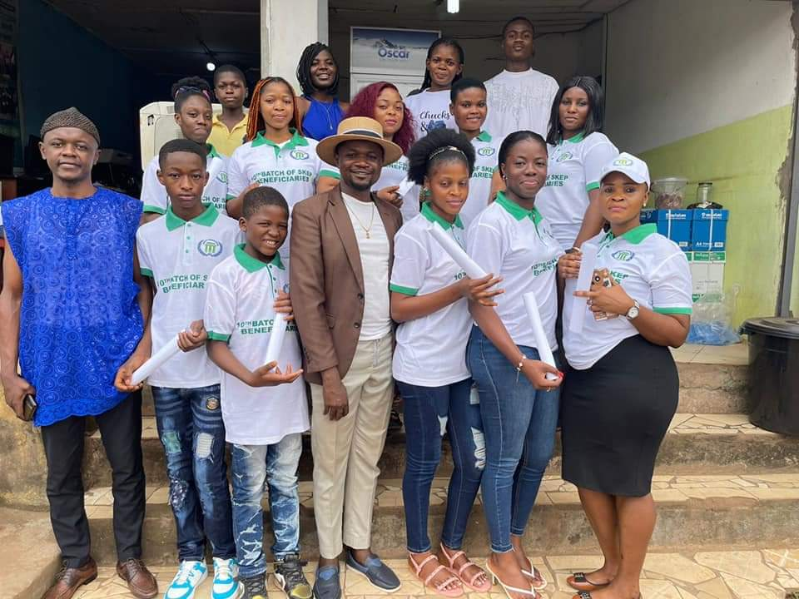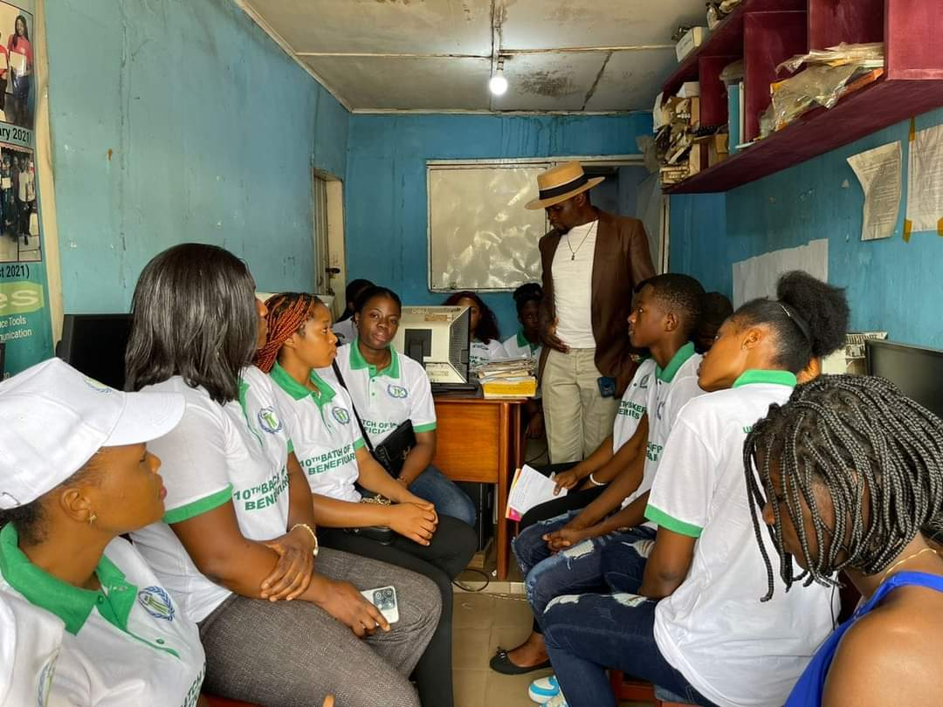

Sensitisation of Unity Foundation Cameroon Skills for Employment and Progress (SKEP) graduates on the Importance of youth participation in political processes, Yaounde, August 2024.

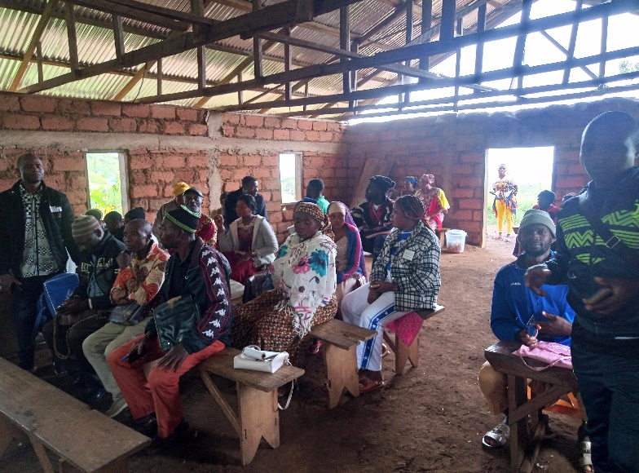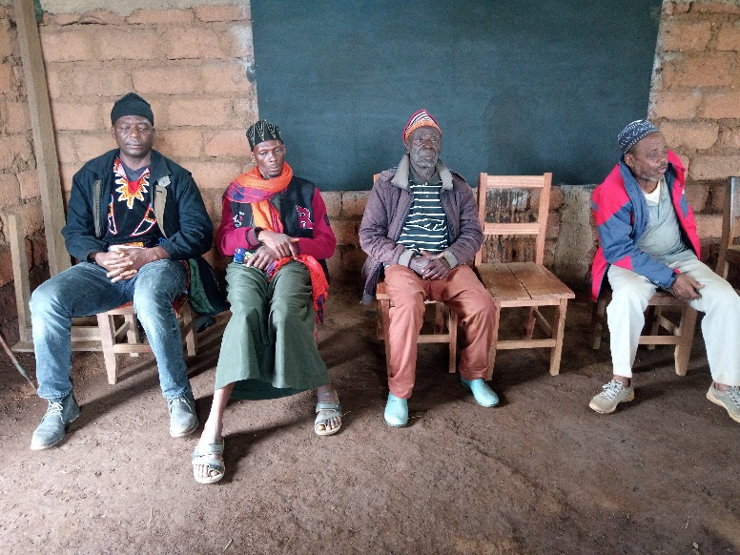

The King of Jull, Village Heads of Ngunabum and Konene and the Chief of the Hausas in Konene attending the Training Workshop on Peace and Leadership, August 13, 2024 in Konene, Bum Subdivision, Boyo Division, NWR, Cameroon

Participants during the Training Workshop on Peace and Leadership, August 13, 2024 in Konene, Bum Subdivision, Boyo Division, NWR, Cameroon

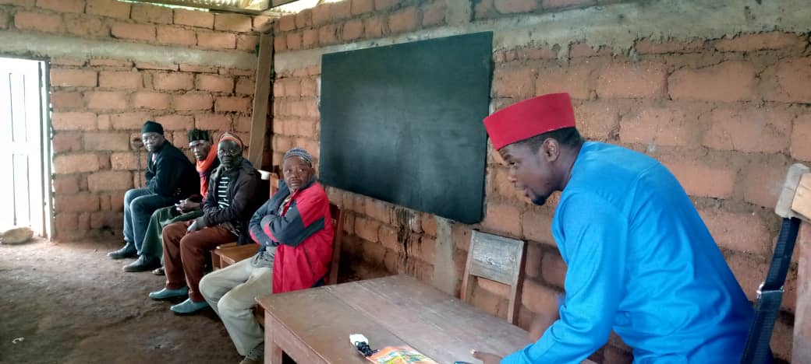

Ntang Julius Meleng facilitating a session on “Leadership Qualities” for Community Leaders during the Training Workshop on Peace and Leadership, August 13, 2024 in Konene, Bum Subdivision, Boyo Division, NWR, Cameroon

Appendices

1. Request for Authorization from the Divisional Officer of Bum Subdivision to Host the Training Workshop on Peace and Leadership.

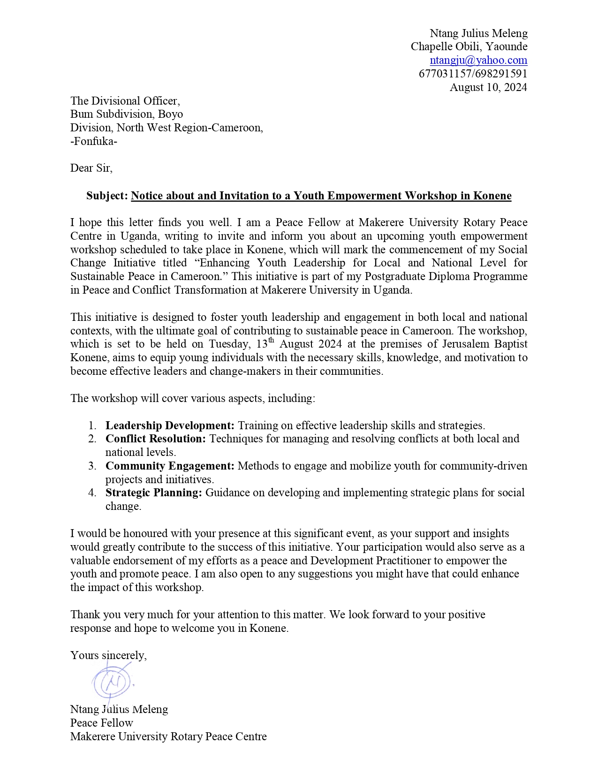

1. Information and Invitation letter to the Lord Mayor of Fonfuka Council, Bum Subdivision, Boyo Division, North West Region of Cameroon.



1. Information and Invitation letter to the President General of Bum Development Union (BDU), Bum Subdivision, Boyo Division, North West Region of Cameroon

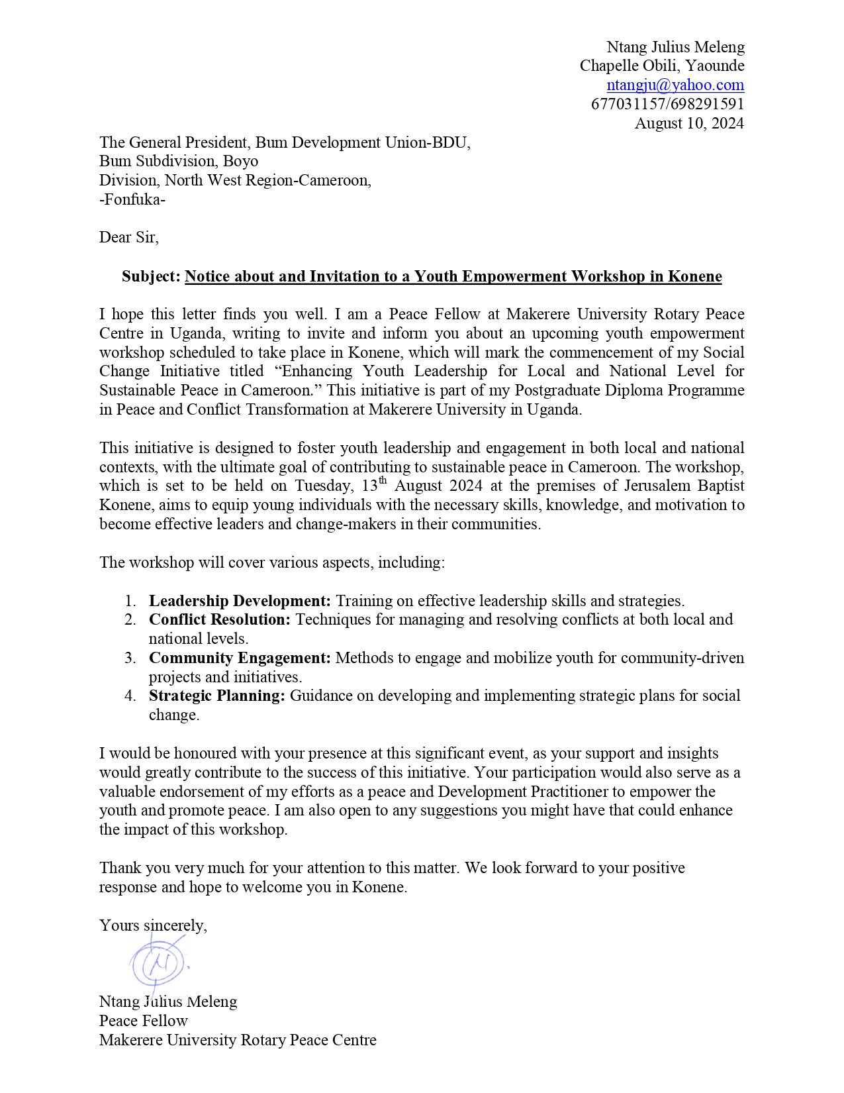

1. Attendance sheet of participants of the Training workshop on Peace and Leadership organized with community leaders and young people in Bum Subdivision, Boyo Division, North West Region of Cameroon.

