**Topic: Prevention of Pre- Election violence among youths in Liberia:**

**A Community Policing Approach**

**‘’A Social Change Initiative (SCI) Implementations Report’’**

**BY: Samuel G. Ford (BA, Pg. CPA)**

**Country: LIBERIA**

**Start & Completed Date: December 2023- August 2023**

**Submitted To: Makerere University Rotary Peace Center**

**Date of Submission: September 2023**

**Table of Contents page(s)**

**Acknowledgement** -------------------------------------------------------------- i

Abbreviation/ Acronym ---------------------------------------------------- ii

Abstract ---------------------------------------------------------------------------- iii

**Chapter One: Introduction**

* 1. Background of the study ----------------------------------------------------- 1
  2. Problem Statement ------------------------------------------------------------ 5
  3. Goals and Objectives---------------------------------------------------------- 6
  4. Challenges and Mitigation Strategies -------------------------------------- 7

**Chapter Two: Literature Review**

2.1. Youth political participation and electoral violence-------------------- 9

2.2. Causes of Electoral Violence ------------------------------------------------- 10

2.3. Strategies to mitigate violence----------------------------------------------- 10

2.4 Theoretical Underpinning --------------------------------------------------- 12

2.5. Change Theory and how it was applied ------------------------------------ 16

2.6. Methods and Design ------------------------------------------------------------ 17

**Chapter Three: Intervention and Activities**

3.1. Introduction ------------------------------------------------------------------- 18

3.2. Key Findings/ Impact -------------------------------------------------------- 23

**Chapter Four: General Conclusion**

4.1. Conclusion ----------------------------------------------------- 25

4.2. Recommendation/ Implication for policy ----------------------- 26

4.3. Sustainability Plan **----------------------------------------------------- 28**

**Reference (S**) ------------------------------------------------------------------ 33

**APPENDIX A –C** Photos of dialogues with political parties’ supporters ----

**APPENDIX D** Testimonies ---------------------------------------------------------- 45

**APPENDIX E** Letter of Permission -------------------------------------------- 46

**Acknowledgement**

I am first and foremost grateful to the Almighty God- for his divine wisdom and his continuous blessings bestowed upon me especially during the period of my academic studies at this prestigious University.

My sincere gratitude are extended to the Director of the Rotary Peace Center Prof. Helen Nkabala, my mentor Dr. Chris Tuhirirwe for their professional advices and supervisions I received from them during the period of this research report.

Furthermore, I would like to express my heartfelt thanks and appreciations to the Rotary International for their tremendous and fullest support to this worthy cost of my academic journey from start to end of this program.

Let me also thank all members of the faculty and support staff for the time and academic training they provided while this work was being prepared.

Special thanks goes to my beloved wife Mrs. Diamond Vah Ford, my lovely kids for their many encouragements, patients and respective support they played in my academic achievements. To God be thy Glory.

i

**Abbreviation/ Acronym**

**CDC** ___________________________________ **Coalition for Democratic Change**

**CJPS ____________________________________ Center for Justice and Peace Studies**

**CRS _____________________________________ Catholic Relief Services**

**CWF ___________________________________ Community Watch Forum**

**CWT _____________________________________ Community Watch Team**

**ECRC _____________________________________ Electoral Conflict Resolution Committee**

**EMB ______________________________________ Election Management Body**

**EU _________________________________________ European Union**

**EVP _______________________________________ Election Violence Prevention**

**LNP _______________________________________ Liberia National Police**

**NEC _______________________________________ National Election Commission**

**UNDP ____________________________________ United Nations Development Program**

**UNMIL ____________________________________ United Nations Mission In Liberia**

**UP _______________________________________ Unity Party**

**USAID ________________________________ United States Aid For International Development**

**USIP __________________________________ United States Institute for Peace**

ii

**Abstract**

This social change initiative (SCI) discusses the prevention of pre- election violence among youths in Liberia: a community policing approach.

Young people have played a crucial role in shaping the political discourse in Liberia, both negatively and positively. On October 10, 2023, Liberians will participate in a crucial presidential and legislative elections in what may become Liberia’s second post-war transition between democratically elected governments. Considering the overwhelming development challenges Liberian institutions face, peaceful elections cannot be taken for granted.

Elections often present significant challenges in countries that recently emerged from violent conflict, but Liberia maybe defeating the odds. Civil society, the police, the electoral commission, international diplomats and – above all- leading Liberian politicians will further determine whether the country’s fragile peace will hold.

Picking electoral violence as a negative component of this political engagement, this report provides a comprehensive analysis as to why young people find themselves enmeshed in violent contestations, before, during and after election periods.

The report further narrates, and discloses how local community elections also enhanced national election as part of the political process including lessons learnt from past elections, and outlined various steps and conflict prevention mechanisms approaches put in place to mitigate potential violence among youths before the October 10, 2023 presidential and general elections in Liberia. The report also evaluates the utility of seven approaches, or tools, commonly thought to reduce—directly or indirectly—the risk of election violence.

iii

**CHAPTER ONE: INTRODUCTION**

**1.1** Background of the study

Elections are key elements of democratic processes. They provide for transparent and peaceful change of government and distribution of power. For this reason, a strong emphasis on democratization as a means to durable peace emerged among international policy circles in the early 1990s. The notion of supporting peacebuilding in tandem with democratization developed as a consequence of the recognition that political repression and discrimination often is the very reason groups took to arms in the first place.

Hence, democratization does not only open up for manifestations of political rights, but is also seen as a response to addressing the root causes of conflict. Support to strengthen institutional capacity to promote democratic norms and to ensure democratic rule of law is now seen as crucial for peacebuilding. Elections and democracy promotion have thus become central strategies to build peace in countries shattered by violent conflict. Yet experiences and recent research suggest that democratization in transitional or war-torn countries, and elections in particular, can become a hindrance rather than a solution to peacebuilding (Snyder 2000, Jarstad and Sisk 2008). In fact, elections can generate conflicts, rather than solving them (Paris 2004, Reilly 2002, Lyons 2005, and Collier 2009).

For several reasons, violence can be an attractive option to influence the electoral process and outcome. In transitional and war-torn countries, incumbents are often manipulating or believed to be tampering with the electoral processes. The opposition parties also have incentives to further their strength through the use of violence. Spoiler group’s intent on disrupting the election may use violence to prevent the election from taking place or to make sure that the election outcome is declared invalid. Such violence is potentially damaging for democratic processes and can undermine progress towards democratization.

1

Electoral violence – beyond direct effects such as hindering people from casting their vote and preventing candidates from participating in the election – can have long-term effects of causing disillusionment and frustration with politics. The absence or presence of political violence during an electoral process is also central to determining the legitimacy of an election. From a conflict prevention perspective, low intensity or localized violence can serve as a ‘training ground’ for more large-scale violence campaigns, including civil war. Managing election-related violence, thus, is important in the long-term effort to build a strong, democratic and peaceful society, based on the rule of law, accountability and transparency. One in five elections in the world turns violent. Election-related violence is not unique to any political system or development level and takes many shapes and forms, from burning ballot boxes and intimidating the opposition to mass violent protests and state crackdowns on peaceful demonstrations.

In rare cases, it is more extreme, such as assassinations of election candidates or mass killings. Tensions often rise long before voters head to the polls—during party nominations and the process of voter registration, and throughout the campaign period—so efforts to prevent election violence need to start early.

In Liberia for example, elections violence is mostly perpetrated by the youths who are mainly used by politicians to execute their political agendas. Therefore, in order to prevent potential threats to pre- electoral violence among youths, it is important to put in place the necessary conflict prevention mechanisms approach to prevent electoral violence before, during, and after elections.

Yet, despite our best efforts, the question remains: how can election violence be most effectively prevented? In anticipation of election violence, government actors and local civil society organizations (CSOs) may educate voters, organize community dialogues, or engage young people as the new generation of political leaders.

International donors, diplomats, and development actors may support local efforts to promote free, fair, and peaceful elections.

2

As seen in the run-up to the 2017 elections in Kenya and Liberia, international actors may provide support to political parties, observe elections, engage in peace messaging, and deploy several other prevention techniques in the hope that some of them will make a difference.

However, little is known about which programs work or how well they work. Concerns about violence during the 2017 presidential and parliamentary elections in Liberia grew in the early planning stages. Initial assessments by the Liberia National Police (LNP) and the US embassy in Monrovia considered the elections at medium or low to moderate risk of widespread political violence.

The uncertain outcome and fears regarding the ability of Liberian institutions to ensure election security and integrity generated concerns that violence might return less than two decades after the end of a horrific civil war. Losing candidates, opposition politicians, and local strongmen were identified as those with the resources to mobilize unemployed youth, members of motorcycle unions (which have a reputation for being easy to recruit for violent or criminal activity), or wartime combatants to commit violence of one sort or another.Disagreement within or between political parties could lead to the destruction of campaign materials or escalate into violent clashes, stirred up by hate speech, inflammatory campaigning, and polarizing language used by politicians and journalists. Violence could result from outbursts during campaigns or protests around the announcement of election results, followed by excessive force on the part of police when facing groups of people protesting the outcome.

Disinformation, suspicion about vote rigging, and technical flaws in the election process could also provoke violence. In a conflict vulnerability assessment published in May 2016, the United States Agency for International Development (USAID) cautioned about a possible rise in political murders, retaliatory killings, and ritualistic killings (such as sacrificing children in the hopes of furthering a politician’s chances) connected to the elections, as well as high rates of sexual and gender-based violence. Catholic Relief Services carried out a survey in March 2016 in which 61 percent of respondents felt that the elections were likely to trigger renewed violence. **3**

Concerns about electoral violence waned as Election Day approached except in Monrovia, where apprehension remained high given the city’s large number of youths and high unemployment rate.

Liberia’s 2023 elections are shaping up to be a major turning point for whether the country continues its progress toward democratic consolidation—and with it prospects for greater stability and economic opportunity—or slides back toward the exploitative governance model and impunity of previous decades.

This SCI report evaluates the utility of seven approaches, or tools, commonly thought to reduce—directly or indirectly—the risk of election violence: election management and administration, security sector engagement, election monitoring, civic and voter education, peace messaging, and voter consultations.

Regarding citizens and police relationship, citizens consider the police a trustworthy security provider. However, Liberian respondents also indicate that police are rarely present to prevent election violence and do not have the necessary resources to guarantee election security. Building a capable police force remains a priority after the withdrawal of the UN Mission in Liberia, which helped provide election security after the civil war. Despite significant capacity-building efforts, the budget and equipment of the Liberian National Police does not match its increased responsibilities for election security, especially in the communities outside of Monrovia. A majority of Liberian respondents (57 percent) have not communicated with police officers about election security, and most (82 percent) think that police officers do not protect all voters and candidates equally.

To bridge this gap, the government of Liberia has initiated support to the Liberia National Police to train two classes of new recruits that will help buttress the strength of the LNP during the October 2023 elections.

**4**

**1.2 Statement of the Problem**

Liberia remains one of the least developed countries worldwide with the current populations of 5,416,431 million as of Tuesday, July 11, 2023, based on World meter elaboration of the latest United Nations data.

There is a pervasive distrust of the youth from older generations, who often view young people as trouble-makers. Many young people suffer from unemployment and are sidelined from the country’s modest development over the last decade, making them easily incentivized with financial assets or tangible goods. There is a precedent of political parties and candidates mobilizing youth – through some form of payment or other incentives – to serve as protesters, campaigners, and, in some instances, hired thugs.

The country was battered by two civil wars (1989–2003) that claimed the lives of 250,000 Liberians. Although Liberians appreciate the political stability of the past fourteen years, but remain cognizant about the risk elections pose to peace.

A nationally representative survey conducted indicated that a majority of Liberians (61 percent) were convinced that election disputes could reignite into violent conflict.

Despite optimistic expectations for peaceful elections, important sources of conflict remain that could escalate into violence. Some of these sources of conflict includes: hate speeches on various social media platforms, political clashes during campaign, voters trucking, electoral fraud, civil disobedience, Violence against women in politics, media propagandas outlets etc. On the other hand, the primary concerns are budget gaps and institutional weaknesses that can prevent the Election Commission and Liberian National Police (LNP) from guaranteeing adequate election administration and security. Any technical mistakes or delays by the National Election Commission, any real or perceived fraud, and a close or tense race may encourage candidates to mobilize their supporters and challenge the election result.

The National Election Commission (NEC) on August 5, 2023 officially declared the opening of general campaign for the October 10, 2023 Presidential and Legislative elections across the country, but it was an unfortunate scene during the first week of the campaign period after the pronouncement by the NEC.

**5**

Supporters of the ruling party and the major opposition political party was seen engaged in a serious violent clashes in Monrovia. The ruling Coalition for Democratic Change (CDC) which is headed by President George Weah and the major opposition Unity Party (UP) is headed by Amb. Joseph Boakai formal Vice President of Liberia. As a result of the violent clashed, fear has been installed among the public that if the necessary measures are not put in place could result into serious chaos admits the signing of the Farmington Declaration that was signed by all contestants affixing their signatures to protect and sustained the high earned peace of Liberia.

The primary risk factor complicating the organization of peaceful elections in Liberia is the existing capacity gaps in the country.

The slow pace of social, economic, and political progress places the country among the least developed worldwide.

Harsh weather conditions further complicate logistics because elections are traditionally organized during the rainy season.

Most LNP officers lack even the basic logistical equipment they need to perform their work.

.

**1.3 Goals and Objectives**

The overall goals and objectives of this social change initiative (SCI) focuses on the implementation of proactive community policing engagements in order to detect, prevent, and mitigate potential threats of electoral violence among youths during the upcoming October 2023 presidential and Legislative elections in Liberia.

This initiative aims to promote peaceful dialogue and prevent confrontation and or violence among youths, to prevent violence against women in politics, to form a strong community policing partnership for building public trust and confidence in the police; to train youths as ambassador for peace, and ensuring a peaceful, safe, and secure environment for violence free elections across all fifteen counties in Liberia.

**6**

The objective of these interactive engagements was to also access the level of preparedness of electoral stakeholders, political parties, civil society organizations, youth groups, political auxiliaries, and the joint security to identify critical challenges, gaps and progress, as well as to constitute explicit measure towards the elections process and enhance a full level of inclusiveness in the electoral management cycle for a smooth conduct of elections and transfer of power.

The Liberia National Police (LNP) is also cognizant that the October 10, 2023 election, it must be vigilant and react immediately to any suspicious activities and or information received from citizens, polling centers, poll workers, political party representatives, civil society observers, national and international observers as well as from the general public. In particular, the police must not allow personal political preferences or associations to affect their professional statutory duties and responsibilities.

**1.4 Challenges and Mitigation Strategies**

Large-scale training of security actors, civil society organizations, and youth groups from various political parties comes with serious challenges, not the least of which is meeting the logistical requirements necessary for the operation which are currently inadequate. The need for adequate skills training in peacebuilding of the above-mentioned stakeholders is very key to mitigating potential elections violence across the country.

To remedies these challenges, this SCI mitigation strategies takes on the nonviolent approaches or resistance strategies which is an integral part of conflict transformation that includes: massive public awareness, dialogue, problem-solving and the restoration of cooperative relationships through mediation, negotiations and restorative justice among conflicting parties through a community oriented policing approach strategies.

This strategy proactively seeks to address the causes and effects of electoral violence mainly among youths as well as other political social issues among youths in communities and finding peaceful solution to avoid violence.

**7**

It is important to note that community policing partnership-building creates a positive atmosphere of trust and confidence between the Police and the community, and is characterized by an active partnership through which crime prevention and reduction, service delivery and community safety issues can jointly be determined, analyzed and addressed, through appropriate solutions, designs and implementation strategies.

The concept of community policing has become a veritable tool of policing in this contemporary society and was introduced to the Liberia National Police in 2004. The Community Policing Section which I head, is a specialized section of the LNP responsible for engaging the communities on violence and crime prevention and safety issues through the concept of community- oriented policing.

As part of the strategies to mitigate and or prevent potential threats of pre- elections violence, this SCI strategies took into considerations training of youths in different modules of peacebuilding, conducted school outreach engagements, community policing engagements, election awareness (“yes to peace no to violence’’), town hall meetings, interactive dialogue among political parties, musical peace theater, dramas, social media ,and media engagements, radio talk show, the development of jingles, flyers etc., to enhance the spirit of partnership for violence free elections among members of the joint security and the general public nationwide . The solution was also to reassure the community through joint community policing foot patrols across communities, through town hall meetings, massive awareness and community entry procedures so as to make the community policing partnership with the communities stronger for the purpose of building public trust and confidence in the police.

8

**CHAPTER 2: Literature Review**

**2.1.** Youth Political Participation and Electoral Violence

The purpose of political participation in any society, either civilized or primitive is to seek control of power, acquisition of power and dispensing power to organize society, harness and distribute resources to influence decision making in line with organized or individual interests (D. Arowolo & Abe, 2003). Violent electoral occurrences in Liberia are occasioned by both strategic and incidental factors.

This trend not only poses a threat to peace and security on the country, but also risks the long-term sustainability of the democratization processes. Electoral violence is revealed in many ways, for instance, intimidation of candidates and voters, physical harassment, assault on journalists, imprisonment and assassinations, confrontations with security forces and attacks on local party headquarters.

A study of African national elections between (Strauss & Taylor, 1990& 2007) revealed some valuable insights into prevalence and severity of election violence, and identified predominant perpetrators of such violence. The study showed that serious election violence (measured by repression and campaigns of violence) occurred in about 19% of African elections during this time, while 39% of elections had less severe forms of violence (primarily harassment) and 42% had no reported election violence.

These findings indicated that the occurrence of serious election violence is not that frequent, but doubtlessly frequent enough to warrant significant concern.

Elections pit incumbents against challengers and both sides are known to use violence, although often at different times and under different circumstances. (Strauss & Taylor, 2007) found that incumbents tend to be the primary perpetrators of election violence before or during elections that they engage in violence in order to influence voting preferences to maintain power, and that incumbents often use the coercive power of the state to this end. Challengers, on the other hand, tend to engage in violence after the election, usually to protest the election outcome, and do so without using state means for violence.

**9**

Most violence takes place either during the pre-election/campaign phase or post-election, rarely does it occur throughout the election cycle. Few studies have been able to rigorously evaluate the causes of election violence or the effectiveness of mitigation strategies as these topics do not feasibly lend themselves to experimentation. Therefore, observational research and qualitative analysis have been relied upon to identify causes, trends and effective election violence mitigation strategies in sub-Saharan Africa.

This type of violence is mostly triggered by the interaction of three principal agents: political parties, elite groups, and youth groups (or party youth wings).

Political participation is the process of gathering and sharing of political information, interaction with politicians, participating in political campaign or taking part in voting exercise, (Dalton, 2008; Evans, 2003).

**2.2. Causes of Electoral Violence**

Introducing contestation into previously closed political systems has increased the likelihood of election violence (Strauss &Taylor, 1990-2007). The post-1990s shift to multiparty democracy in Africa has triggered greater competition in elections, raising the stakes of winning and increasing rivalry between contending parties. Where election violence has taken place, pre-election politics were frequently characterized by rising regional, ethnic, and/or religious polarization (Frazer & Gyimah, 2017). Incumbents are more likely to engage in violence when their position is threatened and their grip on power appears to be slipping. Where electoral races are close, the incentives for use of violence are the greatest.

Stakes can be especially high in post-conflict contexts, where the electoral outcome may determine whether a group is included or excluded in the country’s newly emerging post-conflict power structures.18 Patronage politics amplifies rivals’ interest in winning elections and can raise the risk of violence.

**10**

Election violence arising out of competitive elections has been particularly prevalent in countries with weak institutions, indicating that democratization may in fact increase nationalism and armed conflict.

Where institutions are malleable and corruptible and power can override property (and other) rights, electoral contests offer an opportunity to redistribute access to resources, especially land, but also marketplace rights and trade routes.

Political parties may harness local grievances over access to resources to garner votes, igniting rivalry between different groups and making violence more likely. The risk of election violence can be exacerbated in countries with notable societal and cultural diversity, as is the case with most African countries (Frazer & Gyimah 2015). Poor post-independence management of diversity in many African countries has contributed to marginalization, exclusion, political instability and incidents of conflict. (2014, Strauss & Taylor), “Democratization and electoral violence.

**2.3. Strategies to mitigate election violence**

As with the causes of election violence, few rigorous evaluations of mitigation strategies have been possible, but experience has shown some interventions to be more effective than others. The United States Institute for Peace (USIP) recently undertook a study to assess whether interventions implemented in Bangladesh, Malawi, Moldova, Thailand and Honduras demonstrate a measurable impact on electoral violence.

They found that well trained and disciplined security forces and legitimate and effective electoral administration bodies achieve the greatest reductions in election violence.

The importance of a transparent, accountable, efficient, and independent election management body that acts in compliance with national laws and international obligations on preventing election violence cannot be understated.

To achieve this, adequate and timely funding of the election management body must be a key priority.

**10**

Community policing interventions in Liberia have been found to be an effective way to mitigate crime and conflict generally, and may result in reduced violence and increased trust in the police during elections.

The Liberia National Police (LNP) instituted ‘confidence patrols’, which saw members of the Police Support Unit undertake repeated visits to randomly selected villages to share information on the newly launched Regional Justice and Security Hubs and navigating Liberia’s security and justice sectors. An evaluation of the confidence patrols found that they increased citizens’ knowledge of the police and the Hubs, and had a strong impact on strengthening the security of property rights.

They were also associated with a reduced incidence of simple assault and raised (self-reported) usage of the police and courts for some types of serious crimes. Since lack of trust in the police may be a potential trigger for election violence, efforts such as confidence patrols that build citizen-police trust and show police support of communities are vital. Well-trained election officials at polling stations play a crucial role in ensuring orderly voting, and can be on hand to address issues before they escalate to violence.

Dialogue between election stakeholders is needed to establish codes of conduct ahead of elections, and to facilitate sharing of information, regular meetings, and contingency planning. Fast and effective dispute resolution mechanisms should also be in place to hear complaints as they arise, before suspicion and anger develops into violence. These dispute resolution processes should be affordable and accessible, likely involving initial lodging of grievances with the national election management body, and further recourse to arbitration committees and, possibly, the domestic judicial system.

Inken Von Borzyskowski study of the impact of UN technical assistance to Election Management Body (EMBs) on post- electoral violence in Latin America and Africa between 1990 and 2008 shows that Election Violence Prevention (EVD) activities carried out by the UNDP can reduce electoral violence in the post- electoral period.

**11**

Von Borzyskowski argues that technical assistance improves electoral quality, and thereby reduces opposition concerns about fraud. In addition, state actors, by agreeing to take part in international electoral assistance projects, are sending a signal to non-state actors that they are credibly committed to holding free and fair elections; this in turn increases trust and depresses opposition propensity to stage violent protests after the results have been announced.

**2.4. Theoretical Underpinning**

Electoral violence, while not an Africa-specific phenomenon, is more pronounced on the continent. Globally, it is estimated that violence occurs in roughly 19 percent of elections, with riots and protests accompanying approximately 14 percent of elections.

28 In contrast, violence and intimidation occur in approximately 58percent of elections in Africa. Even more alarming is the fact that since the proliferation of multiparty elections in the early 1990s the vast majority of African countries—86 percent—have experienced electoral violence. Fortunately, extreme cases such as Kenya’s post-election violence are relatively rare—affecting no more than 10 percent of elections held in Africa—but unfortunately, this is not a trend that has substantially decreased over time.

The persistence of electoral violence, even in less deadly forms, may have a significant effect on the development of democracy on a continent where democracy as we know it is a relatively new phenomenon. Complicating things even further, democracy advocates often encourage the adoption of multiparty elections as a means of reducing conflict and promoting political stability. Democracy is often believed to present a peaceful alternative to autocratic rule. Whereas in autocracies there are no mechanisms for the population to influence government behavior short of rebellion or an overthrow of the government, democracy allows individuals periodic opportunities to communicate their preferences to their leaders through regularly scheduled elections.

As such, many argue that democratic regimes should be more stable and less violent than autocratic regimes.

**12**

In the early 2000s, however, researchers such as Snyder (2000) and Fischer (2002) began to take note of the propensity for new democracies and post-conflict countries to experience significant violence either as part of a nation-building exercise or as a consequence of fraudulent and untrusted processes.

In 2009, Paul Collier concluded that pseudo democratic countries, ones in which elections are held but without any of the other substantive features of democracy such as a free press and adherence to the rule of law, often experience more generalized political violence than some of their autocratic counterparts.

Electoral violence is a subset of political violence but it has several distinct features that differentiate it from other forms of political violence. It differs in terms of its timing and intent—namely, influencing electoral outcomes. Coups, rebellions, and repression all take place with no regard to electoral processes.

There is no single definition of electoral violence or generally accepted terminology on this topic. Electoral violence is separated from other forms of political violence by a combination of timing and motive. The time aspect relates to violence carried out during the election period. The objective of electoral violence is to influence the electoral process and in extension its outcome.

There are different categories of electoral violence, based on who the perpetrators are and why the violence occurs, such as: electoral violence between parties, electoral violence of parties against voters, electoral violence of parties against the state, electoral violence of voters against other voters; electoral violence of the state against voters, etc.

The list of possible causes of electoral violence is long. At the most basic level, electoral violence is used to maintain or gain the power by force. Cases where political actors (such as candidates, supporters, protesters, organized crime groups, etc.) use violent tactics include:

**13**

1. **Seeking an electoral advantage** – usually an incentive for those running in high-stakes elections. Such acts of violence are directed against political competitors and their supporters and may include threats, coercion, intimidation, assassinations, etc.
2. **Disruption of elections** – often an incentive for non-contestants. They may be excluded from the electoral process (disenfranchised groups) or they have a special interest in having the elections spoiled or not held at all. Violent tactics can include activities targeting electoral actors, events and materials.
3. **Preventing of election manipulations** – is an incentive for those who share the opinion that the elections were manipulated or rigged. Electoral processes can be designed and implemented in a way that favors one electoral contestant over another. Parties and individuals who feel that the process is being manipulated to their detriment can take action to end such practices, even by using violent means. In addition to opposition parties, protesters may include CSOs and other social groups and individuals who believe that they are exercising their legitimate rights. Violent acts are often directed against government buildings and offices.
4. **Violence in response to initial violence** is also a likely development in all of the above- mentioned scenarios. Even the most righteous protests can involve violent episodes because victims of violence also respond with violence.
5. **Violence against women** is an important feature in all the above-mentioned cases, often motivated by the desire to punish women for participating in the electoral process because their participation threatens the dominance of the male power structure.

14

In a deeper sense, the consequences of electoral violence may include the following:

1. **Undermined civic and political rights and human suffering** – Ranging from disenfranchisement of citizens or groups to vote and compete to the psychological, physical and sexual violence that certain groups may suffer, with short and long-term consequences for victims and their families and communities.
2. **Reducing the trust in democratic processes and institutions** – Electoral violence creates repressive and undemocratic power structures and undermines the quality of democracy both directly (repression/killing of voters, candidates, etc.) and indirectly (limited inclusive participation), as well as through the public perception on legitimacy. In some contexts, elections have already become synonymous for trouble and danger, which implies a negative effect on trust in democratic processes and institutions.
3. **Economic Implications** – Elections are the biggest and the most serious administrative undertaking in democratic societies, and consequently the costs associated with elections can represent a huge financial burden. In some cases, governments are unable to finance elections and depend on international electoral assistance. In addition, electoral competition and election observation involve significant costs for political parties, domestic and international election observation groups.

Electoral violence will not only waste these resources, but will additionally cause the destruction of local communities and infrastructure with numerous negative economic and development consequences (direct and indirect).

15

**2.5. Change Theory and how it was applied**

The impacts, effectiveness, relevance, efficiency and sustainability of a conflict prevention and peacebuilding activity rest to a large extent on the accuracy of its underlying theory of change. Theory of change in this SCI was a flexible approach meant to encourage critical thinking in the design, implementation and evaluation of development activities.

As described by Vogel (2012) “theory of change thinking” is being increasingly used in international development by a wide range of actors. This guidance encourages questioning strategies and activities that impact on peacebuilding and conflict prevention.

Vogel describes theory of change as a process of analysis and learning that produces insight to support critical thinking throughout the programme cycle. It is also a flexible approach that may be helpful in encouraging innovation in programme strategies to respond and adapt to change in the context.

As part of the implementation of this SCI, I firstly identified underlying theories of change and programme assumptions (derived mainly from discussions with local community members, civil society Organizations, Law enforcement officers, etc.) for the SCI: Theory #1: Establishing a new community-level mechanism for handling a range of elections dispute types will contribute to keeping the peace and avoiding incidents that have the potential for escalating into serious violence.

The project created an inclusive structure for community problem solving, and improved communication, respect, and productive interactions among subgroups in the community, and improve the access of disenfranchised groups to decision making.

The SCI also created a new leadership group infused with democratic concepts and provided with critical skills can foster more effective and responsive leadership.

The project provided peaceful dialogue, trainings and capacity building for law enforcement personnel, civil society youths group, community members, and political parties representatives to give them knowledge and new skills in preventing and mitigating potential threats of electoral violence.

16

**Training and peace education**: Training in conflict resolution, human rights, nonviolent communication and related topics in community-oriented policing was done in many communities, and, with dialogue, was one of the most popular approaches to peacebuilding programming.

To a lesser extent, school-based peace education programmes were developed and included human rights education and tolerance education for children. This SCI provided young people with better skills for conflict resolution increases the ability of communities to settle disputes non-violently and reduce the likelihood of election violence.

The SCI also created space for young people to talk and play together, this helps to build relationships and break down stereotypes among young people of different political parties.

Finally, the SCI provided space and opportunities for young people to work together on practical issues across political lines including the protection of women in politics helps to avoid violence against women in politics and break down mistrust and negative stereotypes, as well as develop habits of co-operation.

**2.5 Methods and Design**

The design of this SCI is the combination of qualitative and quantitative methods. This approach however, has helped the researcher to come up with realistic findings, as the SCI seek to analyze Pre- Election Violence Prevention among youth in Liberia: A community policing approach.

Even though this method was developed for this research, the initiative itself depends on qualitative approach because of its context. According to (Kvale, 1996), qualitative approach to research employs more realistic outcomes that may not necessarily be obtained from statistical analysis.

The implementation of this SCI research design, and method started with a baseline survey which was conducted in December 2023, in two counties (Monsterrado and Margibi Counties) to gather empirical facts on public perception of violence in the upcoming October 2023 elections.

17

Findings from the survey was used to strategies approaches to community policing in order to resolve and or prevent critical issues that leads to electoral violence.

The SCI as part of its objectives was to engage various stakeholders to include: communities’ leaders, youth groups, women in politics, motorcyclists’ union, students, political parties’ youth wing leaders, marketers, media, CSO, and people with disabilities on the underlining causes and effects of electoral violence, and at the same time promoting positive peace through training, dialogue, mediation, negotiation, dramas, radio talk show, jingles, media engagement, and organize musical theater for peace etc.

These efforts were supported by messaging documents that ensured a more consistent and professional messages. As part of the SCI objectives which is to mitigate electoral violence among youths, and promote positive peace initiative, the SCI created messaging documents that provided all Community Police Officers with adequate information and talking points to conduct presentations on a wide variety of topics in peacebuilding to targeted groups. Furthermore, as part of the SCI activities a capacity building workshop for police officers and citizens was held. More than 1000 police officers and citizens were trained as peace ambassadors for the upcoming October 10, 2023 elections. The modules of the training program were highlighted on the 8 pillars of positive peace.

.

**CHAPTER: 3 Intervention and Activities**

3.1. Introduction

This SCI activities support interventions in conflict prevention and mitigation of widespread insecurity, human rights violations, and electoral violence before, during, and after the 2023 General Elections in Liberia. In the quarter, I and, my team was able to establish two Electoral Conflict Resolution Committee (ECRC) out of the five committees to consider early warning signs and reporting systems.

As part of the intervention activities to attain empirical facts, a baseline assessment survey was conducted in two major hot spots counties (Monsterrado and Margibi Counties) which are most likely prone to electoral violence.

18

In the quarter and based on the outcome of the survey, I was able to train 50 members of the Community Watch Team (CWF) to serve as eyes and ears for the police on the early warning signs and reporting system.

During the period of December 2022, with support from the Irish Embassy in Monrovia, I facilitated a three-day training session for 50 youths volunteer as part of the Young Ambassador for Peace 2022 peace summit under the theme: “Youth Dialogue and Peaceful Coexistence during Election”. The young ambassadors were drilled through the topic Non- Violent Approach and Dialogue during crisis response.

As part of the SCI, the Purpose of the training was to train young people representing all counties to serve as ambassadors of peace within their respective communities in preventing electoral violence and solving problems that has the propensity of turning into violence. The young ambassadors were taught on various non- violence approaches to preventing elections dispute such as (mediation, dialogue, negotiation and conflict prevention and analysis).

The young ambassadors are now volunteering in their various communities across the country spreading peace messages for peaceful election.

In January 2023, UNDP sponsored project as part of my SCI on the theme: Peaceful electoral environment and community security”. The purpose of this initiative was to train over 2,000 young people representing various political parties, the joint security, and community watch team members nationwide in order to get a clear understanding about preventing conflict through establishing triggers of electoral violence, identify and discuss community violence prevention, human rights approach to community policing to reduce mob and electoral violence in partnership with the police.

The main goal of the SCI was to create a Peaceful electoral environment by supporting interventions on conflict prevention and mitigation of widespread insecurity, human rights violations, and electoral violence before, during, and after the 2023 General Elections in Liberia.

19

The Project strengthens policy reforms and existing Early Warning and Response Page 6 of 24 (EWER) mechanism, including through mainstreaming of human rights, gender, and youth-based approaches, mainly at the grassroots level.

The SCI is currently supporting responses to actual and perceived triggers of electoral violence by integrating a variety of actors into the EWER mechanism.

As head of the Project lead team, we established a dialogue and engagement with stakeholders (Communities leadership, dwellers, Community watch teams, political parties representatives, and law enforcement agencies) to yield their support and then utilized the gains from holistic engagement to implement tangible actions and processes that support, promote, and enhance swift response to early warning signs of electoral violence; while efforts on social media will target information dissemination, and raising awareness.

The end goal of the project was to disclose response mechanisms and referral pathways to the public in instances where early warning signs are established. Additionally, the project has started strengthening community dwellers’ civic engagements at all levels of the project through awareness, civic and voter education campaigns, dialogue, town hall meetings, with the aim of encouraging voters’ participations during the electoral process and establish an Electoral Conflict Resolution Committee (ECRC) to establish early warning signs and systems in different locations across the country.

Day one of the training was focused on key foundation of electoral violence & mitigation strategies – The Liberia National Police (LNP) roles in mitigating election violence and how to stop citizens from coming in conflict with the law. During the presentation with the participants, they pointed out that the police are first responders during electoral violence; therefore, it was important for the LNP to demonstrate neutrality, independence, and professionalism to gain public trust. They noted through their presentations that there are challenges always with getting the required supports for the job but recognized that it shouldn’t undermine the LNP roles in any electoral violence situation and that they must always help to mitigate conflict in a professional way.

20

The second facilitation was focused on conflict analysis and early warning: Root causes to electoral violence and the role of the Ministry of Justice and reporting channel for cases of human rights abuses. Throughout the presentation, I mentioned that the National Elections Commission, GAC, and CSA are key institutions among others that came into being by constitutional mandate, unlike others that were established based on legislative act. Therefore, NEC has the statutory mandate to conduct elections in Liberia but cannot implement these elections without the Ministry of Justice. Along with participants, some definitions of conflict were considered and the different stages of conflicts and root causes were discussed during these sessions, the participants were curious to know basic electoral laws, and how citizens can ensure and work in confirm of the laws. The session was interactive, and the participants were fully involved during the discussion. The project initiative lasted for two months January – February 2023 respectively.

In February 2023, I was hosted by one of Liberia’s popular radio stations OK FM to discuss the purpose of my SCI and the role of the police in the upcoming October 10, 2023 elections. My deliberation grew interest in the public. Many of the callers’ pledged to volunteer their support to peaceful elections, but was however concerned about the neutrality of the police including the trust of NEC in delivering a free and fair elections. In the same vein, I conducted series of training activities with community leaders in Monrovia as it relates to community security and the role of the community watch before, during and after elections.

On March 24, 2023 in collaboration with NAYMOTE Partners for Democratic Development one of the leading civil society organizations in Liberia with support from UN Women, I served as one of the panel discussants to speak on the Role of the Liberia National Police in Preventing Electoral Violence against women. The dialogue was focused on enhancing participants understanding on measures to take in ensuring that women, youths and persons with disabilities are protected, and not victims of electoral violence but are provided a safe space to enhance their participation in the political process.

During my deliberation, I lamented that women face myriad of challenges when they are exercising their political rights.

21

The most alarming of which is perceived increase in violence against women in politics, including violence against women in elections.

I further explained that violence against women in political life, including in and beyond elections, is any act of , or threat of , gender- based violence, resulting in physical, sexual, psychological harm or suffering to women, that prevents them from exercising and realizing their political rights, whether in public or private spaces, including the rights to vote and hold public office , to vote in secret and to freely campaign to associate and assemble, and to enjoy freedom of opinion and expression. Such violence can be perpetrated by a family member, community member and or by the state.

It is against this backdrop the LNP must ensure that the human rights and dignity of all women, and person with disabilities, in politics should be well respected and protected by law without any form of discrimination.

During questions and answers period, participants were manly concern about the neutrality of the police including hotlines to report cases of violence against women in politics.

In response to participants concerned, I quoted the police code of ethic which elaborates that all police officers should avoid being into to politics and that measures ranging to possible dismissal and prosecution if any officer (s) found culpable of such act after investigation. Regarding the issue of reporting cases of violence against women, I refereed the participants to the women situation room. The women situation room focuses on all reported cases of violence against women for immediate response under the initiative of the early warning and early response mechanism which is supported by the Peace building Office in Liberia. The conference brought together young women in politics, political aspirants, and student’s representative, Independent National Election Commission, Person with disabilities, Media, and Civil society groups.

In the month of April 2023, I conducted schools outreach activities under the School Law and Justice program to over 15 schools within Montserrado County.

22

The purpose of these activities was to enlighten students on the basic principle of the rule of law, the role of the police and the role of the citizens in respecting the rule of law for a peaceful and safe environment before, during and after election. In August 2003 with support from UNDP and in collaboration with the Center for Justice and Peace Studies (CJPS), I facilitated trainings for members of the joint security with respect to human rights, rule of law, community policing and their roles and responsibilities before, during and after elections period. I also facilitated dialogues session for peaceful conduct of election among supporters and heads of various political parties within four counties namely: Monsterrado, Nimba, Bong, Margibi, and Lofa Counties respectively. We concluded our intervention with vigorous awareness and clean-up campaign exercises for violence free election. The awareness exercise under the theme: Yes to Peace, No to Electoral Violence brought together community members, civil society organizations, and youths of various political parties. The awareness was also extended in the remaining counties across the country.

**3.2 Key Findings**

A growing number of peacebuilding and conflict prevention strategies was being used by this SCI to mitigate the risk of pre-election violence. Conflict prevention, and intervention activities such as: youth training programs, dialogues, election observation, police training, and civil education, panel discussion, media engagement, radio talk show, town hall meetings, massive public awareness, are just some of the approaches.

A recent collection of qualitative studies edited by Jonas Claes provides a systematic assessment of the success of different types of election violence prevention strategy in preventing electoral violence. On the basis of the case assessed in this SCI findings, the most fruitful types of Election Violence Prevention (EVP) appear to be based on capacity building of state actors such as security sectors and electoral management bodies.

23

Other promising approaches include activities whose target reaches beyond the state, such as long- term voter education activities, training and public awareness among community dwellers, town hall meetings, dialogue, mediation, musical theater, community policing, stakeholders’ engagement and media engagements among others.

These activities implemented by this SCI in this finding proved to be very effective at reducing electoral violence. By contrast, many of the initiatives undertaken by civil society groups to change attitudes towards electoral violence proved less successful. in their conclusion to the volume, Claes and Macdonald note: ‘’Despite the theoretically compelling logic, the measurable impact of citizen- or community – oriented instruments, like peace messaging, voter consultations, and even youth programming, remains small or unclear. This SCI studies have found that the intervention carried out which resulted based on attitude- transformation observed among youths was effective at reducing pre- electoral violence among youths. A number of strategies was used to manage and prevent electoral violence. These strategies are to a varying degree applied by different actors. The actors involved in managing and preventing electoral violence include 1) local and international monitoring and observer missions; and 2) national, regional and local dispute resolution and mediation missions.

The bodies involved in these activities range from public authorities, political parties, an electoral commission, religious organizations, civil society, and non-governmental organizations (NGOs) and traditional authorities such as chiefs or clan leaders. Five main types of strategies can be identified. First, the presence of monitors can be instrumental in preventing electoral violence through naming and shaming mechanisms and by creating awareness of tensions building up. Second, mediation can be carried out in high-tension situations to solve an ongoing election-related dispute. Third, the legal framework and institutional design provides the basis for combating impunity and for creating conditions discouraging violence. Fourth, law enforcement highlights the deterring function of security forces. Fifth, voter-focused strategies emphasize the importance of long-term prevention though the cultivation of democratic norms and tolerance in society at large.

**24**

**CHAPTER 4: Conclusion**

**4.1** General Conclusion

Electoral violence is a significant problem in the contemporary world. When it occurs, violence can undermine participation and confidence in electoral processes, and it can derail emergent democratic institutions. The use of force at election time can also threaten fragile peace- building processes, and it can have negative consequences for the quality of life of victims. It is therefore not surprising that there has been considerable recent effort devoted to addressing this harmful phenomenon, especially by national organizations keen to sustain peace and foster democratic consolidation. This SCI demonstrates that with careful attention to selection issues and to the use of control variables, comparative analysis of a corpus of programme documents can unearth patterns linking EVP interventions to the actual experience of conflict at polling time. The analysis undertaken in this SCI suggests that such interventions can be successful at reducing violence; both EVP interventions strategies based on capacity building and those based on attitude transformation are associated with reduced levels of electoral violence, even controlling for selection effects and a host of other factors known to be associated with violent elections.

Typically, the consequences of institutional design center on the political system and electoral laws. However, an all-encompassing policy for conflict-mitigating measures in the institutional design is especially important in countries with experiences of political violence. More attention needs to be directed at measures which can support the implementation of the legal framework. Without sanctions against those breaking the electoral law, including violence makers, a culture of impunity is upheld. At the same time – in our society which have experienced violence – it can be difficult to ban all those with a violent past from politics. There are for instance a number of activities which can ensure that the code of conduct is known and respected. A peace pledge – which brings together political parties, religious and civil society leaders – to publicly declare a commitment to a code of conduct – is one such instrument.

25

The openness and publicity of peace pledges aim at upholding the standards of free and fair elections. A strong performance by police and election commissioners is key to reducing election violence. At the same time, poorly performing election and security institutions are often responsible for most of the violence.

**4.2 Recommendations/ Implications for Policy**

At any given time, more than a dozen elections around the world are at risk of violence. The success of election programming requires government actors, institutions and international stakeholders to begin designing projects long in advance (often eighteen to twenty-four months in advance) of Election Day. Work on planning, budget requests, and risk assessments should begin as soon as election dates are confirmed.

The following recommendations—directed primarily to the Government of Liberia and the international community but with utility for regional and national agencies—are intended to offer broad avenues for strengthening existing practices or addressing shortcomings and gaps recommended below:

1. That National Security Agencies conduct timely and integrated election risk assessments. The selection of prevention programs should always be informed by timely and integrated violence risk assessments that tie concrete drivers of violence with realistic programming options to achieve the necessary changes.

The findings of integrated or joint assessments to predict and preempt outbreaks of election violence should also be made public for possible interventions.

1. Improve participant recruitment. Programs such as peace messaging, youth programming, and civic education that involve the general electorate or community representatives need either to be inclusive in terms of the participants they recruit, or to deliberately target those communities that are most at risk. Too often, community engagement fails to reach vulnerable communities outside the main urban areas and primarily engages those who are already predisposed to peaceful engagement in elections.

26

1. Invest in regional capacities. In countries where providing international support for law enforcement and electoral commissions is complicated, because of either domestic resistance or limited knowhow, it is preferable to invest in the prevention capacities and coordination mechanisms of regional and sub-regional bodies. Regional organizations or networks such as ECOWAS and the West Africa Network for Peacebuilding have the necessary access, legitimacy, and local knowledge to design training and capacity building tailored to the local context and welcomed by local actors;
2. Implement programming in a timely and sustained way. In Liberia, prevention programming often began too late and concluded soon after Election Day. Many survey respondents and key informants believed that civic and voter education should also expand its reach. Local demand is strong for information about government, political processes, and elections to be made available earlier in the election process, to be offered not only during election campaigns but also between them, and to be targeted at younger generations as well as the older members of the electorate. All too often, efforts to engage youth, educate the electorate, and encourage peaceful engagement in elections fail to last several election cycles. Sustained conflict prevention is the most promising way to ensure peaceful elections because it helps address deeper grievances that spoilers can manipulate to incite violence;
3. Encourage responsible conduct by police and politicians. The need is clear to depoliticize the role of police in security provision and strengthen their professionalism.
4. Capture election violence more systematically. Given the experiences in this elections, and human rights and domestic election monitors with nationwide reach should be trained in capturing early signs of violence more effectively and mapping different types of election violence.

27

Beyond their valuable role in identifying technical challenges and general security concerns, both domestic and international election monitors should be encouraged to capture gender-based election violence and various forms of intimidation more systematically, as well as to make early efforts to manipulate the political system and reduce the competitive nature of elections and;

1. Conduct practice evaluations. New evaluative methods need to be developed that consider the combined impact of various actors that engage in similar prevention activities and try to mitigate risk using the same theory of change. International and domestic prevention actors should assess the impact of preventive engagement beyond their own projects. To ensure they have the desired impact, those actors need to continually question and test the logic behind their work and develop innovative.

**4.3 Sustainability Plan**

How violence is perceived – whether it is politically motivated or not – varies, depending on where you sit and how you are affected. An argument sometimes invoked in relation to violence around election times, is that it is in fact not at all related to the election but instead due to common criminal activities. However, if people believe that violence is politically motivated, it will have political consequences. When politicians and political activists are targeted by violence, the consequence may be that certain political campaigns do not reach all areas in each electoral district and in the country. This constrains the right to freedom of information and is a hindrance to a free political choice. When voters are targeted during registration or around elections, the consequences may be that citizens refrain from voting, or vote for a certain political party out of fear, rather than as a free choice. When electoral violence takes place, adequate support is vital for the development and ‘sustainability of this SCI project during and after elections. The strategies to prevent and manage electoral violence mainly focus on the perpetrators of violence, and the perspectives of the victims of such violence are often neglected. 28

A united approach to support the victims of violence is important so that those affected can cope with the consequences of violence. Strategies directed towards the victims of electoral violence can also prevent violence from negatively affecting the attitudes towards democratic politics, a necessary condition for sustainable peace.

**The following long term plan activities shall be carryout for the sustainability of this SCI Project:**

1. Conduct an analysis of an assessment of how victims are affected by electoral violence and how their different needs (material, physical and psychological) can be addressed.
2. Develop a diversified strategy to accommodate different target groups to prevent severe individual as well as political consequences of electoral violence.
3. Allocate adequate resources to develop a policy and strategies to address the consequences of electoral violence, and to implement and evaluate such policy.
4. Carry out the groundwork for preventing violence during interim periods.
5. Support political party development, citizen education and media training.
6. Continuously monitor volatile areas during and especially around any by-elections.
7. Allocate adequate resources for maintaining monitoring capacity also in between elections.
8. Consider the consequences of the electoral system for the risk of violence, and conduct analyze potential changes to electoral systems, codes of conduct, and other regulations on the electoral process.
9. Design measures and allocate adequate resources for activities which can support the institutional setting and legal framework, for instance through the use of peace pledges.
10. Engage in close collaboration with local actors in order to uncover networks of violence makers and to identify peace-promoting elements.
11. Encourage collaboration between national security forces, local security forces, peace workers, political parties and other relevant actors. 29
12. Train security forces in the electoral law(s) and the codes of conduct.
13. Develop a policy and strategies to address electoral security from a comprehensive perspective encompassing both deterrence and confidence building, and allocate adequate resources to implement and evaluate such policy.
14. Plan electoral violence management in coordination with other peacebuilding initiatives to avoid undermining other actors’ activities.
15. Encourage international violence monitors and peace missions to access information on local peacebuilding initiatives to assess further needs for conflict management before and during an activity, event or mission.
16. In cases where civil society networks are well-developed, support such networks to coordinate the different tasks.
17. Support an independent electoral agency to assess and evaluate different capacities among actors for specific tasks

### Monitoring and education will be continuous activities

Violence related to electoral processes often begins way ahead of elections. In some places, politicians are always potential targets of political violence. Citizens at large may feel constrained to openly and freely voice political views, engage in public debates, and organize themselves politically. In addition to restrictions of political rights, the consequences of such an insecure environment include difficulties in holding politicians accountable. Electoral violence needs to be continuously addressed. Conventionally, there is a focus on national and general elections. For instance, electoral violence monitoring and citizen’s and party education programme are concentrated on the period ahead of such elections. However, by-elections are sometimes even more prone to violence than the general elections, and violence can also take place between elections. Therefore, to prevent and manage seriously the causes and consequences of violence, a policy for electoral violence management – especially monitoring and voter-centered strategies – needs to be carried out on a long-term basis and continue between general elections.

30

### Conflict-mitigating measures in the electoral process design

The institutional design – including the legal framework and the electoral system – constructs incentives and disincentives for electoral violence. Some regulations create especially high stakes for elections. For instance, in majoritarian elections in single-member constituencies, the importance of specific individuals increases their risk of becoming targets of violence. Arrangements for by-elections can create shifts in the power balance, thus raising the stakes and putting certain individuals at risk of intimidation and violence. Under other arrangements, resignations in the interim period are handled though substitutes from the party list. Electoral laws can set out the legal constraints on the use of violence, the mandate and powers of the election management bodies as well as regulations on who may stand in elections. Such laws can also stipulate an electoral code of conduct, which can involve agreement on avoidance of hate speech and other activities that may spur violence and polarization.

### For security – find the right balance between deterrence and confidence-building

Due to high levels of mistrust and insecurity around election times, increased deployment of security personnel is sometimes necessary. Under the conditions when national capacity for security is low, or when domestic security forces are themselves involved in violence, international peacekeepers and police can act as external guarantors. In other cases, domestic security forces – police, military police, intelligence etc – can play important roles in preventing violence around elections both in the short-term and the long-term.

### Coordinate activities to avoid overlap and identify gaps in peacebuilding

The multiplicity of actors involved in prevention and management of electoral violence requires great coordination and role division among local and international actors and among international actors. The prevalence of involving different actors in electoral security and conflict management means that there is a risk of overlap. It is unfortunately no guarantee against some areas being neglected. Such gaps are often due to a lack of coordination in the planning and division of tasks and areas of importance for violence management. 31

There are several positive examples where electoral monitoring has been coordinated among international, domestic agencies and hundreds of civil society organizations to successfully monitor an election. If an independent electoral commission has capacity and legitimacy, such an agency is particularly suited for such coordinating activities. However, the lack of sufficient coordination remains a challenge in many situations of electoral violence.

There is also a risk that different measures and activities undertaken for electoral security may undermine each other. For instance, the deployment of security forces may be necessary in an election, resulting in reinforcements arriving in areas in which they have no prior knowledge about the local context. While this may increase the capacity of the security forces to act in a more neutral and independent manner, it might have the drawback of undermining existing networks of contacts between for instance monitoring agencies in the area and local police. For this reason, it is important that initiatives to promote security take into account existing networks of knowledge and capacities, and are carried out in collaboration with other actors working in the same or related area.

**32**

**References**

Abbink, Jon, & Gerti Hesseling, eds. Election Observation and Democratization in Africa. Basingstoke: Macmillan Press, 1999.

Akah, Pius & Chika, Ikeorji. Youth political participation and Electoral Violence in the 21st Century Nigeria: Bridging the Gap.

B, Reilly (2002), Elections in Post –conflict scenarios: Constraints and dangers.

Collier, Paul. Wars, Guns and Votes: Democracy in Dangerous Places. London: Boldly Head, 2009.

Collier, Paul, and Pedro C. Vicente. ‘’Votes and Violence: Evidence from a field experiment in Nigeria’’. Economic Journal 124, no.574

D. Arowolo & Abe, Political violence and democratization in Nigeria (2003).

Dalton, Russell J. (2008), Citizen Politics: Opinion and Political Parties in Advanced Industrial Democracies, 6th Edition. Washington, DC: CQ Press.

Fitcher, Jeff. ‘’ Electoral Conflict and Violence: A Strategy for study and prevention’’. IFES White Paper, 2002.

Hoglund, Kristine. ‘’Electoral Violence: Causes, Concepts and Consequences. ‘’Terrorism and political violence 21, no.3 2009: 412-27

Hoglund Kristine, Anna Jarstad and Mimmi Soderberg Kovacs. ‘’ The Predicament of Election in War- Torn Societies. ‘’Democratization 16, no.3 2009:530-57.

33

Hoglund Kristine, Anna Jarstad, (Uppsala University).’’ Strategies to Prevent and manage electoral Violence: Consideration for Policy.

International Growth Centre (IGC) Policy Note 2016, Addressing election violence in Liberia. [www.theigc.org](http://www.theigc.org)

Jastad, Anna and Timothy Sisk, Eds. From War to Democracy: Dilemmas of Peacebuilding: Cambridge University Press, 2008.

Jonas, Claes, ‘’Electing Peace: What works in Preventing Election Violence’’, Evidence from Liberia 2017. USIP blog. Accessed <http://www.usip.org/livebranch/2016/03/14/electing-peace-what> -works-in-preventing-election-violence.

Kumar, Krishna ed. Post-conflict Elections, Democratization, and International Assistance. Boulder & London: Lynne Rienner Publisher 1998.

Kvale, S. (1996). Interview Views: An introduction to Qualitative Research.

Lyons, Terrence. Demilitarizing Politics: Elections on the Uncertain Road to Peace. Boulder: Lynne Rienner Published, 2005.

R. Paris (2004). At War’s End: Building Peace after Civil Conflict.

Sarah, Birch & David, Muchlinski (2018) Electoral violence prevention: what works? Democratization, 25:3, 385-403, Published by informal UK Limited, trading as Taylor & Francis Group.

Strauss, Scott & Charlie Taylor, Democratization and electoral violence in sub-Saharan Africa, 1990-2007. ‘’Prepared for delivery at the 2009 Annual Meeting of the American Political Science Association, Sept 2-6, 2009.

34

The Carter Centre International Election Observation in Liberia Pre- Election Statement. July 18, 2016.

The Carter Centre, National Elections in Liberia, Fall 2011: Final Report’’.

Von Borzyskowski, Inker. ‘’Peacebuilding Beyond Civil Wars: UN Election and Election Violence’’. Working paper, 2015.

**35**

**Appendix A: Photos of Dialogue with political parties supporters**

STRENGTHERINING COMMUNITY POLICING ENGAGEMENT THROUGH DIALOGUE AMONG REPRESENTATIVES OF VARIOUS POLITICAL PARTIES TO AVOID VIOLENCE BEFORE, DURING, AND AFTER ELECTIONS, HELD IN MARGI, BONG AND NIMBA COUNTIES

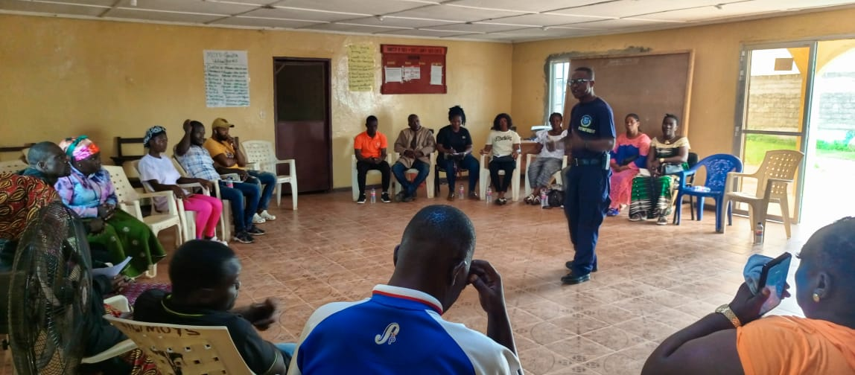

36

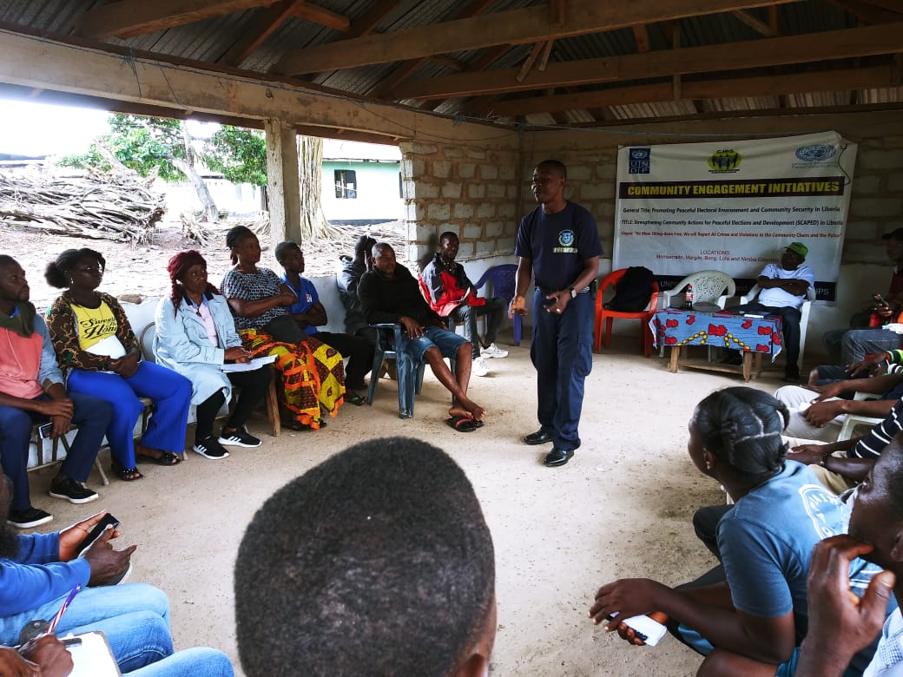

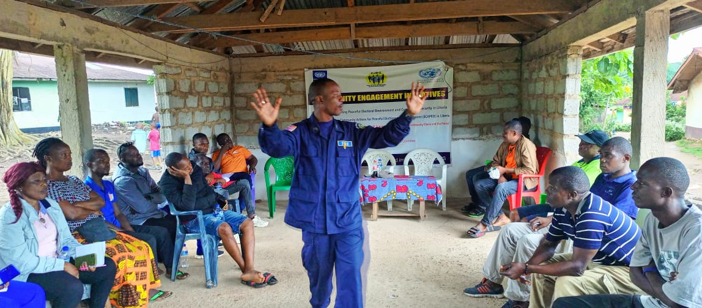

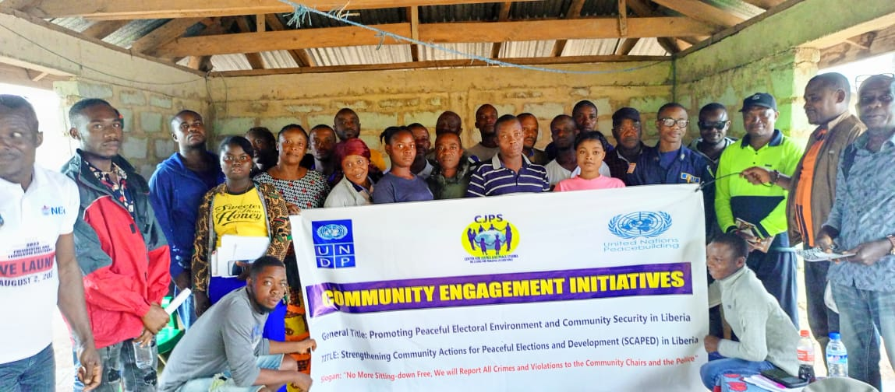

**38**

**APPENDIX B: Photos of Training of the Joint Security**

PROVIDING PEACEUILDING TRAINING IN HUMAN RIGHTS, RULE OF LAW , COMMUNITY POLICING, AND USE OF FORCE FOR MEMBERS OF THE JOINT SECURITY , AND THEIR ROLES AND RESPONSIBILITIES BEFORE, DURING, AND AFTER ELECTIONS HELD IN MONSTERRADO, BONG, NIMBA AND MARGIBI COUNTIES

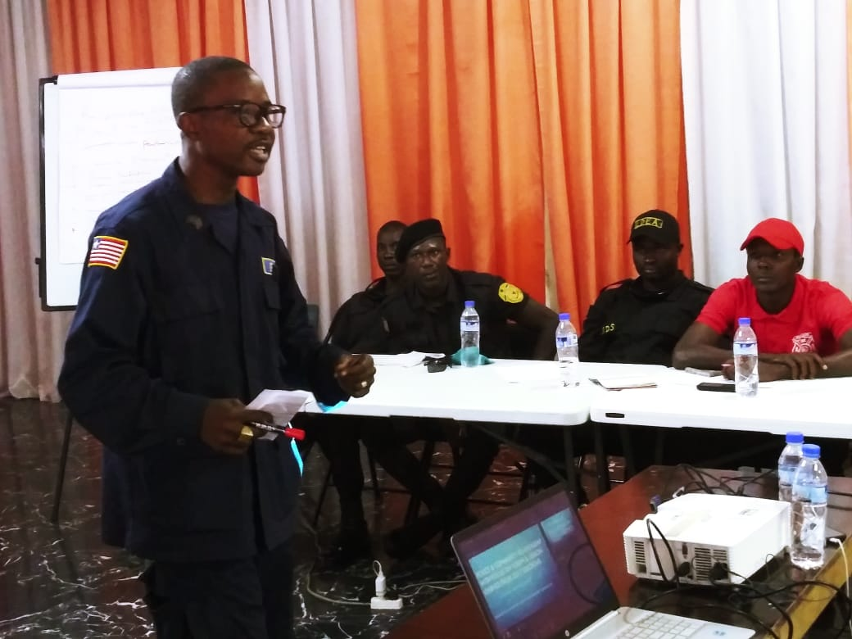

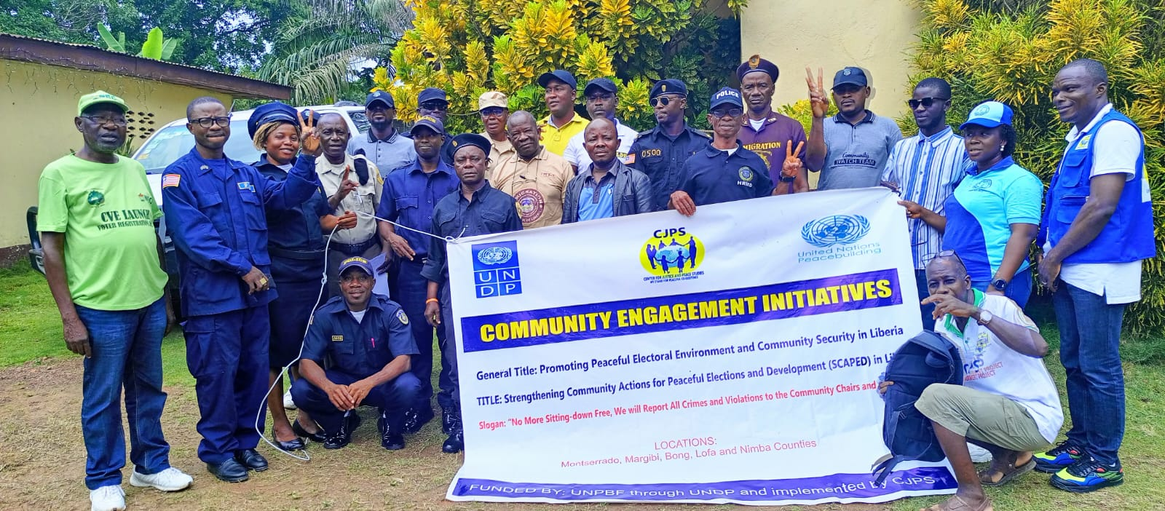

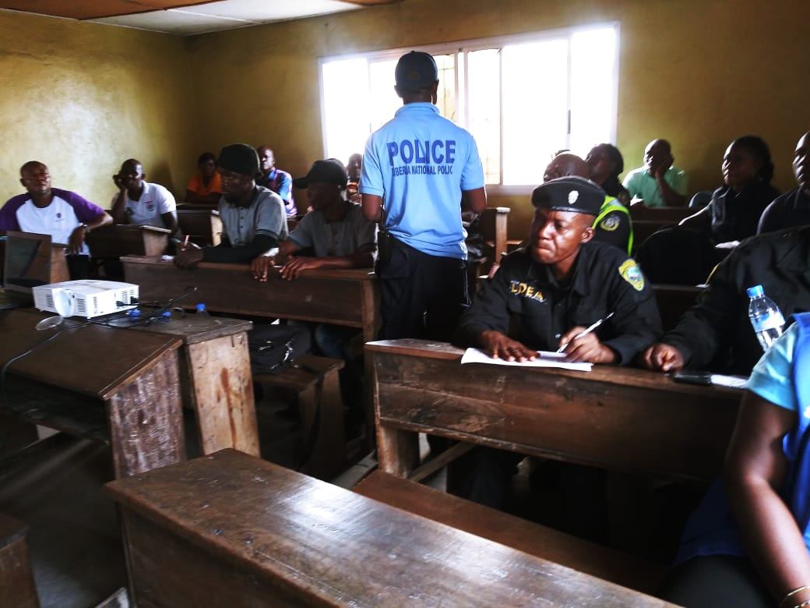

40

**Appendix C: Photos of Training of Students**

ENGAGING STUDENTS IN SECONDARY SCHOOL ON THE IMPORTANCE OF THE RULE OF LAW AND ELECTIONS SECURITY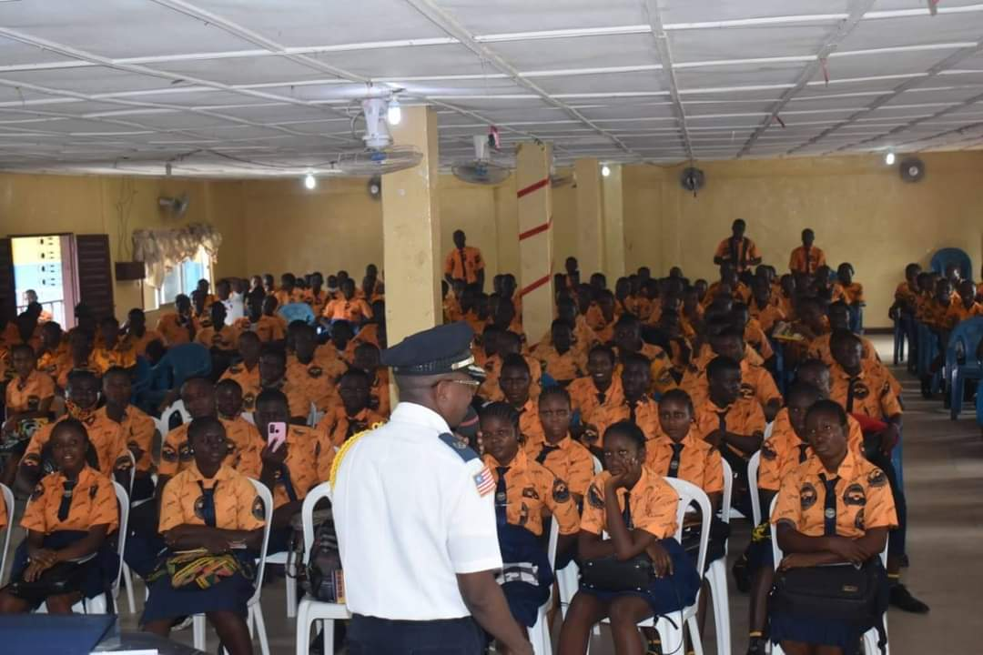

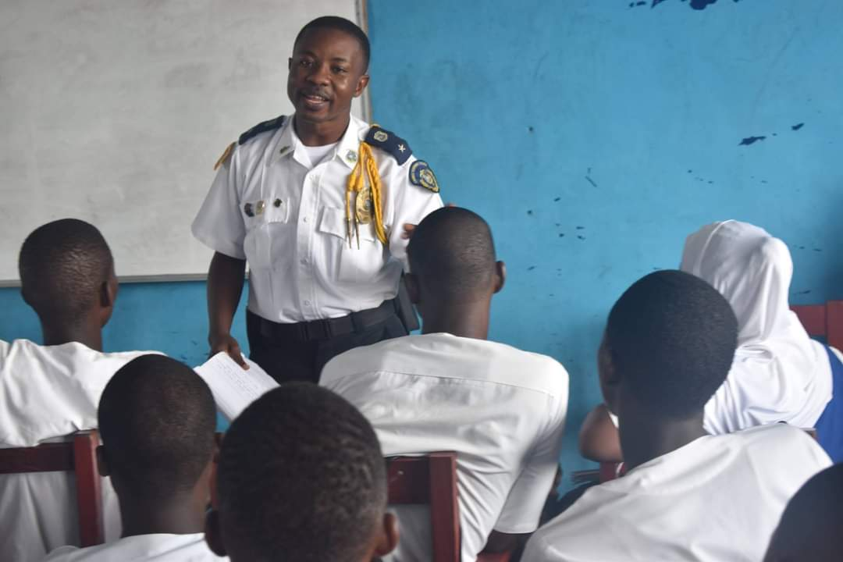

41

TRAINED 50 YOUNG PEOPLE AS PEACE AMBASSADORS TO HELP MITIGATE VIOLENCE 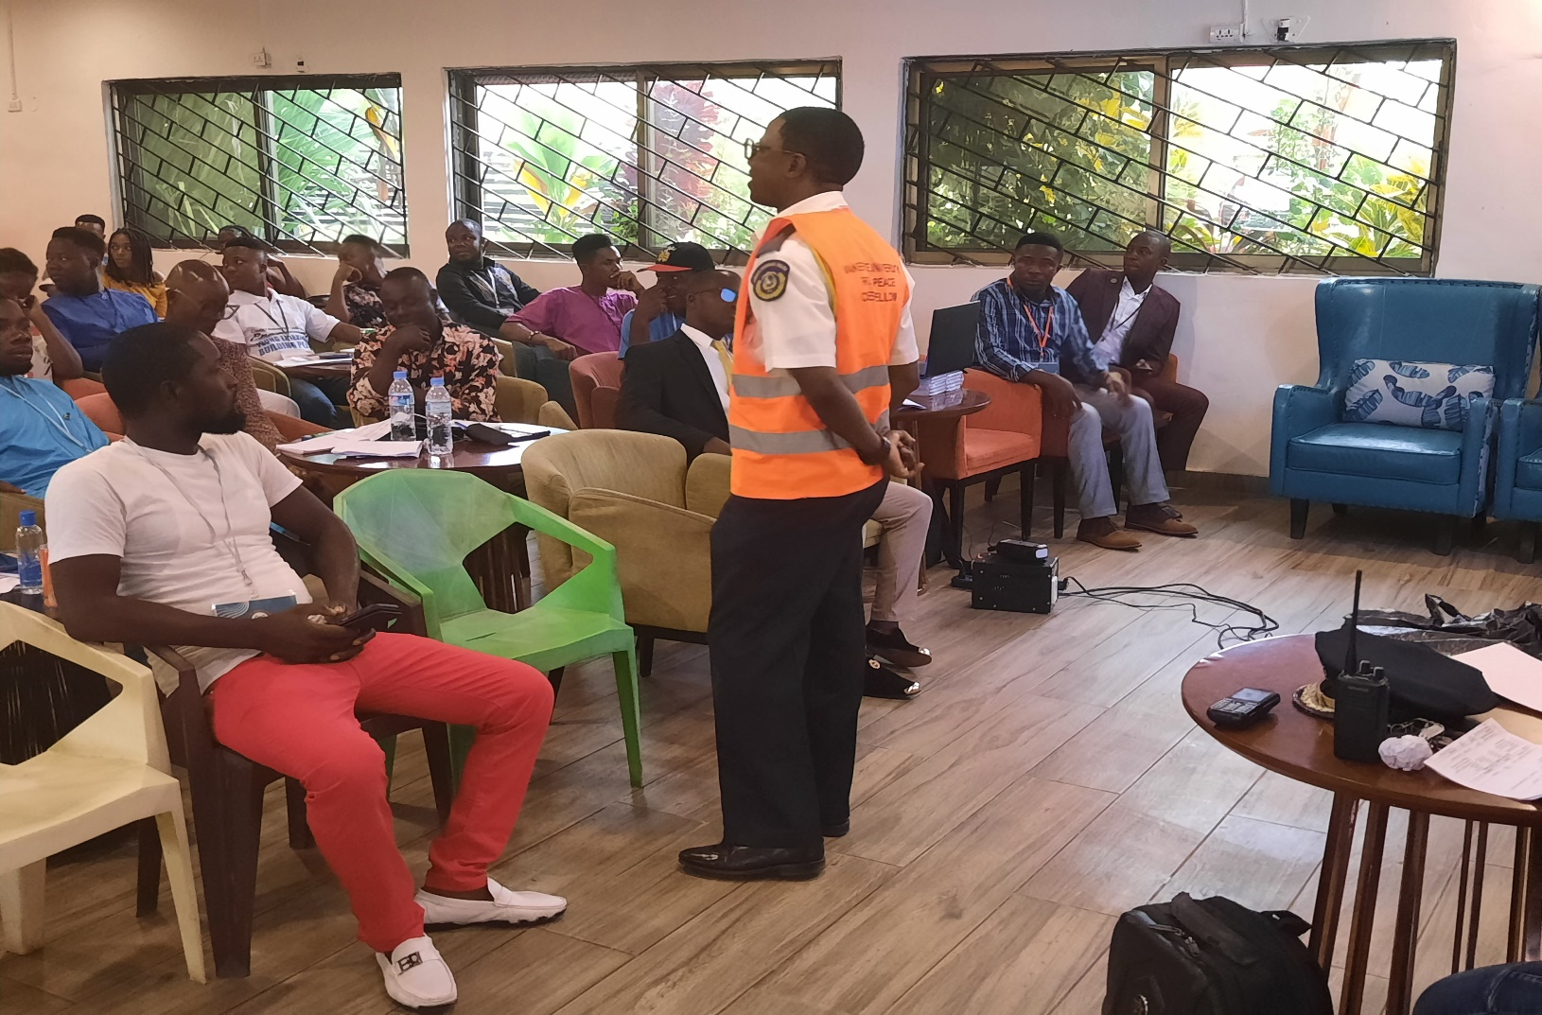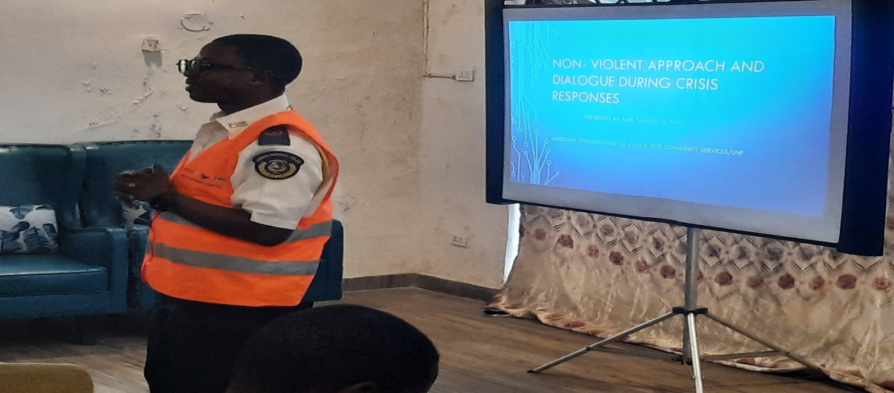

MEDIA ENGAGEMENT FOR PEACEFUL ELECTIONS



44

**Appendix D:** **Testimonies**

Implementing this SCI was a huge challenge for me, but was also a good learning process and experience for me as a senior Law enforcement and peace officer. Seeing myself taking on the role as a peace-builder in a real life situation as it relates to resolving issues of election disputes at the grassroots level in communities was something very practical, and also involves threats to peace and security. The project gave me an eye opener and lessons learnt from grassroots community election, and how community elections is taking similar trend of the national body politics of the National Elections in Liberia.

However, with the knowledge, trainings and skills gained in practical peace-building and conflict transformation at one of Africa’s pride University (Makerere University), I was able to use the necessary conflict tools in mediation to resolve 10 disputed grassroots community elections that would have escalated into serious chaos in some of the volatile communities in Monrovia. One notable conflict was about 9yrs leadership crisis in Jallah Town slum community, which was amicably resolved by utilizing the necessary conflict tools. Based on my intervention, the community has elected their new community leaderships under the chairmanship of Mr. Patrick Karmo. Mr. Karmo informed me that based on my intervention into their crisis, his leadership was able to initiate some major development of some basic social services such as: hospitals, clinics, electricity, latrines, and water facilities.

We were also able to train over 2,500 community leaders and members of the joint security across the country and established an early warning system mechanism for members of the community watch forum to report on electoral violence at the National level.

Based on my hard work in promoting peace, I received the prestigious International Services Awards for my hard work to peace and development in communities. I was awarded the International Service Award by the Adam Kyne International Collegiate Resource Center alongside the Vice president of the Republic of Liberia and the City Mayor. It was a great honored and pride unforgettable moment. 45

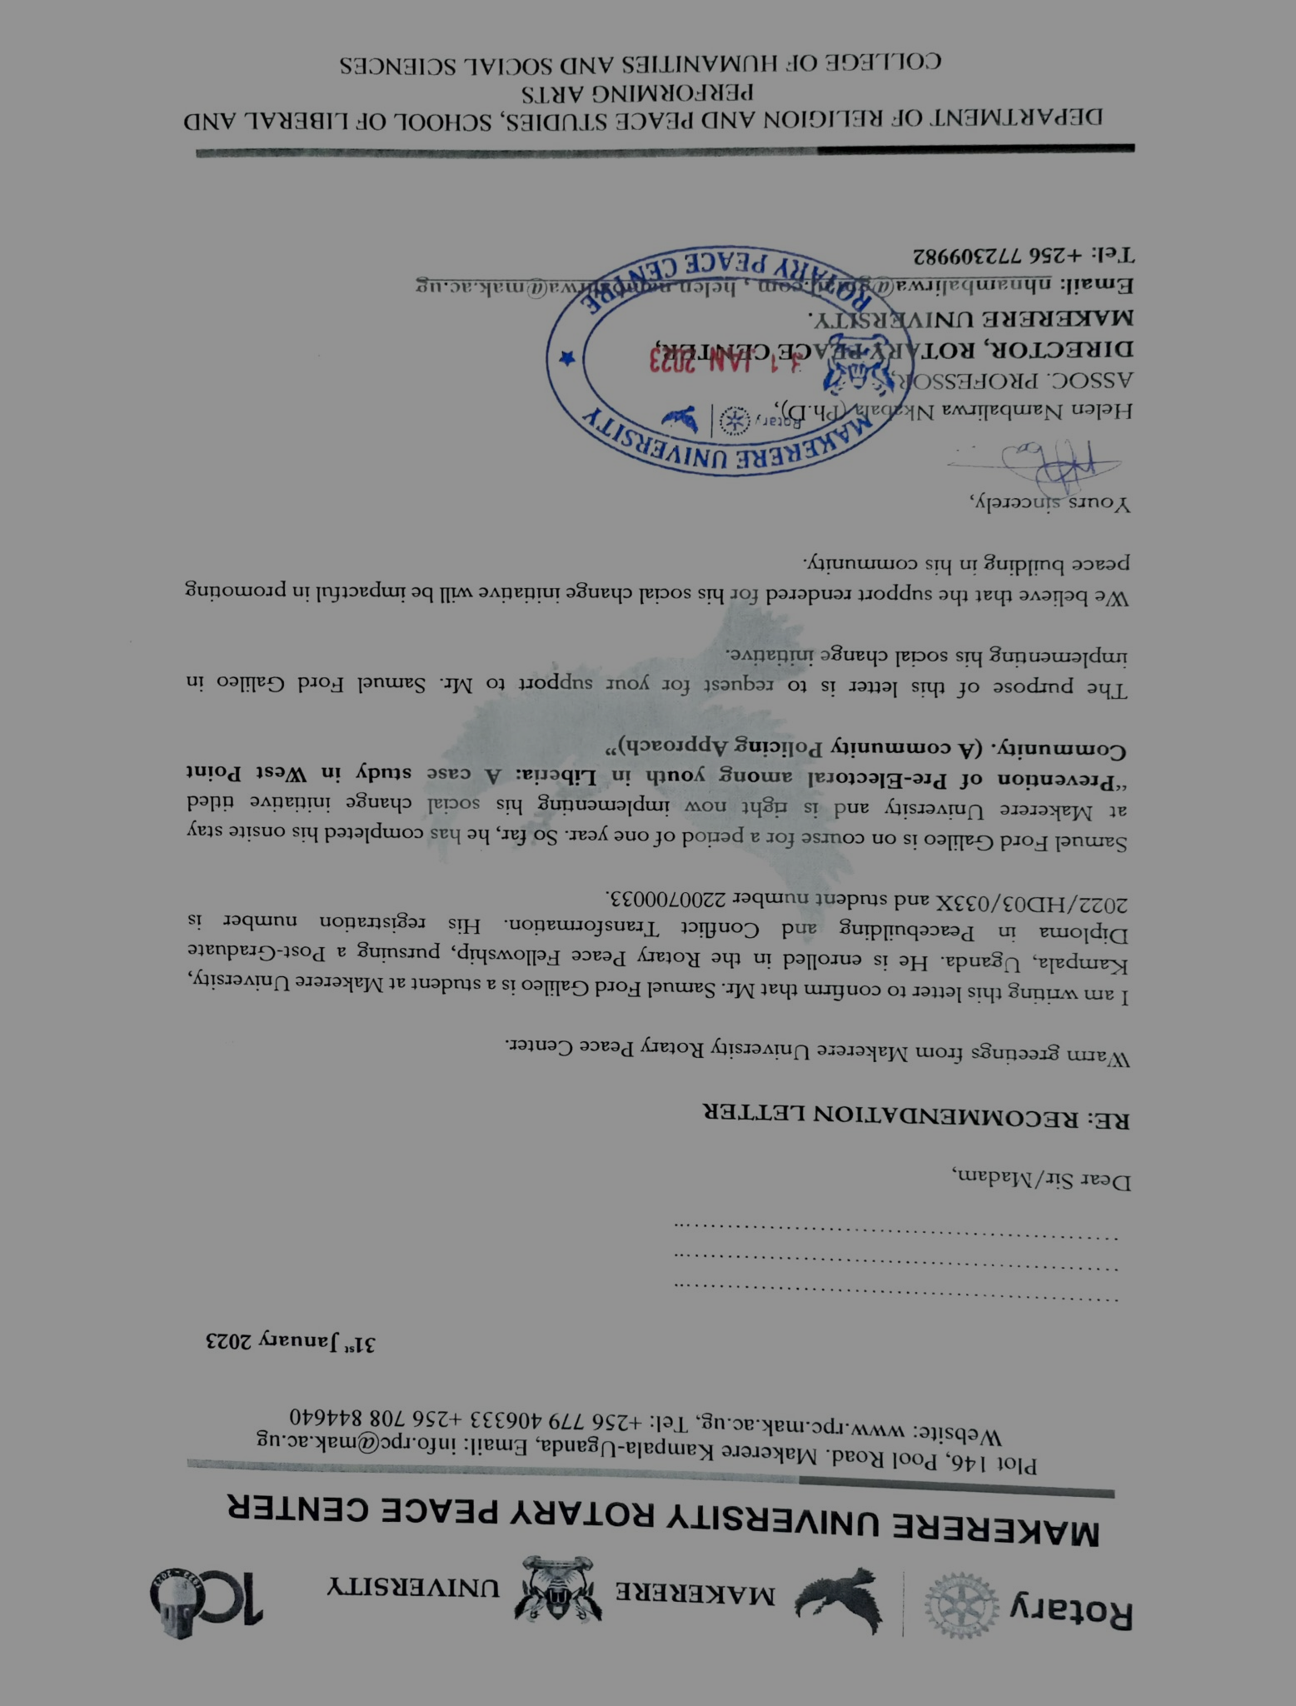**APPENDIX E: Letter from the Peace Centre**

46