

**African Peacemaking Database: A Local Paradigm to Positive Peace  
Seth Kinzie**

September 5, 2022

Locations: Ethiopia, Somalia, Malawi

Research Dates: January 10 – August 31, 2022

**1 – OVERVIEW**

**INTRODUCTION**

As a musician and lover of mathematics, I’ve always been interested in the use of numbers and formula to drive creativity. To quote the great piano composer Johannes Brahms, “Without craftsmanship, inspiration is a mere reed shaken in the wind” (Bashwiner 496). I come from a history of peacemakers and trailblazers, who have taught me the value of following your dreams and developing great ideas until they have borne fruit. My grandmother was the first Church of the Brethren woman licensed to do ministry in the state of Ohio. My parents were involved in the Sanctuary movement in the 80’s, helping shuttle Latin American refugees fleeing violence across the border to take refuge in churches. My mother even brought me as an infant to war-torn El Salvador on a service trip with University Baptist Church of Seattle. Later on, she would continue her Ph.D. in South Africa on feminist visions of conflict transformation, with a focus on the South Africa Truth and Reconciliation Commission. My father was a poet and banjo player, writing songs about peace and injustice throughout my youth. This family history expresses my personal interest in peace and how this inspiration has been passed down through the generations.

As a peacemaker, it’s important to finetune our craft so our instrument can harmonize in various contexts and expressions. I was introduced to African methods of peacemaking in 2010, working with World Peace Embassy – Cameroon, and again in 2020, assisting my mother working with Nigerian clergy on conflict transformation processes. As a lover of data and international metrics, I have wondered, like many, how we can combine statistics and peacemaking into an educational structure that highlights existing peace practices, inspires everyday citizens, nourishes communities, and guides the way to better policies and more empowered citizens. But, perhaps unlike many, I am not impressed with the current direction of peacemaking philosophies that academia is following. To study peace is to study conflict. But the way forward to peace is not through conflict, it is through peace. Too many contemporary analyses of conflict zones do not use a strength-based approach, and thus neglect the generations of knowledge of transforming conflict and promoting community solidarity. The quantity of violence shaping modern culture is overwhelming, but the scope of the violence and its global reach is a recent phenomenon compared to longstanding indigenous methods of dialogue, communication, community practice, and affirming social structures. This comparative view is often neglected, as we mistake the lack of economic development in communities with a lack of internal peace.

With this understanding, in concert with dozens of African scholars, traditional leaders, and grassroots peacemakers, I have developed the African Peacemaking Database (APD). It is an approach to cataloguing and nourishing the myriad, existing personal and communal practices of peace throughout the continent. In this reflection, a *peace practice* is defined as any exercise, philosophy, or tool that promotes harmony, safety, or strong relationships in an individual or collective.

This social change initiative was intended to be the design phase of the APD to determine its feasibility for long-term sustainability. This design stage involved research of local, decolonized, and/or indigenous methodologies for constructing an intracontinental project paradigm. It investigated and pursued partnerships with a variety of stakeholders and organizations from the ground to the African Union to enable long-lasting, flexible pillars that could satisfy the rigors of community-based research and international dissemination. It included my personal exploration throughout central, southern, and northern Ethiopia, Somaliland, Puntland, and northern, central, and southern Malawi. This was for the sake of collectively mobilizing existing peacemakers to form a network of local researchers to continue the exploration, with an understanding of their own context. Lastly, it involved the identification of elders, women, and youth leaders in individual communities in *peace mapping* workshops to gather their daily peacemaking practices, the connecting of elders and youth for indigenous, cultural research papers over the subsequent month in a process called *peace exploration*, and the combining of the research into appropriate categories for future analysis by both local communities and peace and development institutions.

The foundation of the indigenous research paradigm is to target local phenomena, made context-sensitive with locally relevant structures, and is informed by a system of knowledge that is built on relationships. This locally driven, relationship-centric approach drives the research methods, data collection, analysis, and dissemination. Peace is a local experience, and I have found this approach, where communities, as providers of knowledge, become co-collaborators, to be the most relevant way forward for acquiring respectful and accurate data.

This bottom-up framework creates a network where local knowledge a steppingstone for national policy and continental early warning configuration. Place-based strategies that are understood and shaped by local populaces will have a greater impact when they are cycled up to governments and institutions, then back down to the people. Ownership is cemented, as programs are not created by dissociated actors and policies have an aspect of long-term community solidarity, beyond short-term negative peace mitigation.

This framework is made possible by my deep, wide partnerships with African-rooted organizations. United Religions Initiative (URI), the interfaith branch of the UN, provides connections to their cooperation circles. These circles have inter-religious collaboration embedded into their communities, and a passion for peace, offering access to diverse voices in rural areas, where peace philosophies are still strong but often overlooked by researchers. The Institute for Economics & Peace (IEP), African office, provides their development-based, data-driven analysis to structure the qualitative data, and they will formulate top-level policies for the African Union and governments utilizing their positive peace framework. KAICIID Dialogue Centre, with trained, intercultural peace fellows in half of the countries in Africa, offers APD the ability to connect to local experts who can continue the peace mapping in their own country and context, expanding the database to new regions. Two branches of the African Union (AU), Civil Society and Peace & Security divisions, bring us to the top for formulation of policy and database publication. Ultimately, after discussions with Continental Early Warning System (CEWS), we hope to reformulate Early Action policies with Regional Economic Communities to include APD positive peace elements so long-term community solidarity is institutionalized.

**PROBLEM STATEMENT**

My project developed from the following gap: there is no database focused on peacemaking, be it individual or community-based.

The academic focus on peace research, analysis, and ranking has gained considerable clout in the discipline of peace and development studies over the last ten years. These data-driven processes have focused on the institutionalization of peacebuilding and reached its height in the Global Peace Index, an impressive annual report published by the Institute for Economics and Peace. Other examples include the Positive Peace Index, Fragile States Index, Human Rights Index, and the World Happiness Report, to name a few.

There are three main critiques to the work of these databases:

One, the local application is opaque and not participatory. The way forward to practicing peace is missing from these models and places analytics over application, education, and embodiment. These datasets, without exception, come from European-based organizations. A detailed review of the 23 indicators for the Global Peace Index reveal research head offices in Abu Dhabi, London, Geneva, Vienna. Hong Kong, Uppsala, Stockholm, New York, Asheville, Hong Kong, and Dubai, but nothing in Africa (IEP 81). A very select few for the Positive Peace Index, such as Reporters Without Borders and Bertelsmann Transformation Index, have on-the-ground experts who both live in and are from African countries. But on the whole, local presences of these data-collecting organizations are well in the minority. The sources instead focus on government and institutional metrics created by people who do not live in the countries where they are researching. It is time to move on from the “critical but sufficient work of gathering facts” and begin mainstreaming the implementation of traditional modalities of peacemaking into African cultures (Afigbo 21).

Two**,** the gender lens is frequently missing. The Global Peace Index does not include a single gender-sensitive measurement among its 23 indicators. The Positive Peace Index only includes one measurement, the Gender Inequality Index from the UN, as one of its twenty-two indicators. Women must be considered as standard bearers of peace and justice for positive peace to thrive.

Three, the western model of applying universal standards to diverse settings has destructive undertones. We need peace applications that are context-specific and encourage an elicitive response to the specific strengths and cultures of individual communities. This is where a decolonized and indigenous paradigm is important. With this approach, we can begin with the understanding that local cultures have a lot to offer the international community, which lends itself to a transformative experience for both researchers and the researched.

**GOALS AND OBJECTIVES**

The African Peacemaking Database has a variety of goals and objectives, but we will limit ourselves to those within the scope of the Rotary Peace Fellowship. The main objective was the creation of a template for the APD for deeper research in existing countries, further research in other regions of Africa, and partnerships to create its sustainability. All of these were achieved, and I will explain the process.

The first objective was to compile the research, country-by-country, into a coherent framework. This was done throughout significant evaluation and monitoring while traveling abroad, discussions with local peace activists, and finally the creation of a two-tiered research tree. The first branch of the tree (appendix: figure 1) involves daily peace practices, discovered through a process I call peace mapping. The second branch of the tree involves indigenous, historic peace practices created out of relationships between youth and elders in peace exploration. These objectives were possible due to the construction of a council of advisors – African peace, conflict, and interfaith experts who helped guide the methodology. Some of these include (appendix: figure 2):

1. Dr. Bagele Chilisa – *University of Botswana; UNDP Evaluation Advisory Council*
2. Ambassador Mussie Hailu – *United Religions Initiative; Founder of Golden Rule Day; Interfaith Liaison to AU & UN*
3. Mr. Geoffrey Manasseh – *Malawi Interfaith Country Coordinator; KAICIID Fellow*
4. Dr. Jesus Cecilio Akele – *African Union Peace & Security; Southern African Development Community (SADC) Early Warning System*
5. Ms. Hazel Dixon – *African Union CIDO Civil Society*
6. Dr. Barena Bedru – *Ethiopian Libraries*
7. Mr. Solomon Girma – *Positive Peace for Ethiopia*
8. Senator Mohamed Wali – *Somaliland Guurti Council of Elders*
9. Dr. Milton Nyamadzawo – *Institute for Economics & Peace*
10. Mr. Abdullahi Yasin – *Youth Somali Future Peacemaking*

A further objective of the peacemapping workshops was the nourishment of indigenous philosophy and human capital in local communities. By involving small, rural communities in a continent-wide database, we showcase the importance of local knowledge to a wider audience. The relationships with leaders of each community have continued, as we use their place-based expertise throughout the analytic categorization so grassroots leaders can see themselves in the data. In this way, their knowledge becomes a template for other regions of the world to create similar database structures, from the bottom-up, and their traditions become the template upon which the preliminary design scheme is formed. This creates peacebuilding from the root, contextualizing the approach and response to each community we encounter.

The last objective was the sustainability of the APD into a scalable model that can expand to other regions, while incorporating new exploration with existing research. AU – Civil Society has agreed to host the eventual database on their website. IEP has agreed to do technical analysis and classification of the data. Six different cultures of Malawi have spent 3 months with their traditional authorities to discover historic elements of peacemaking within their agricultural, linguistic, music, dance, and reconciliation rituals. URI continues to act as a liaison to connect with local, interfaith communities, driven by African KAICIID peace fellows as lead researchers.

**CHALLENGES / MITIGATION STRATEGIES**

The challenges that I came across while operating a project at this scope were formidable, and I took a flexible, collaborative approach when engaging them. The issue of language and trust was the immediate challenge that arose. To mitigate this, I worked with both a national leader and a local community leader in each research setting. I also worked within the environmental and cultural settings of the Malawi cooperation circles, which wasn’t always possible in Ethiopia and Somalia due to conflict-zones. In Malawi, the majority of our multi-day workshops took place under the community’s sacred tree. Some trees, like the mango, represent community cohesion and reconciliation courts. Other trees, like the white acacia, represent resilience. Community members were encouraged to speak in their local languages, and translation was provided by either the URI community leader or the URI country coordinator. The continuing APD operating budget 2022-2027, which is currently in conversations with Rotary International and Interpeace, has line items for database translation to one non-European national language in each country, in addition to print publications for those who do not have access to the internet.

A second challenge was deciding which countries to chose for seed research as a testbed for a continent-wide project. Ultimately, I decided to focus my resources on countries that were diverse in their ethnic makeup and current state of conflict in an array I called *cultural peacefulness*, which correlated data between the Global Peace Index and the Cultural Diversity Index (appendix: figure 3). Somalia, for example, is a homogeneous culture with a low state of institutional peace. Ethiopia is a highly diverse culture with a medium-low state of institutional peace. Malawi is a medium diverse culture, with a high state of institutional peace. In this manner, I can challenge the assumption that only peaceful governments offer peace. In fact, I found many positive peacemaking strategies in Somalia, where many citizens exist in a nearly stateless environment. The range of practices I found among community peacemakers was impressive, from religious practices to personal time to connection to the environment.

A final challenge I faced was finding appropriate stakeholders to work with to gather the data. The UN-nominated, interfaith cooperation circles, discovered in Ethiopia and fully explored in Malawi, helped shape the way forward. Through their interaction, with workshops of up to 200 people, I noticed that women, youth (ages 18-35), and elders were the three pillars of local society. Within each group, artists, educators, and government officials also played important roles. These connections led me to have personal time with traditional authorities, village headmen and headwomen, and youth leaders who were eager to invest their energy in work that supported peace in their personal lives, communities, and nations.

**2 – THEORY**

**LITERATURE REVIEW**

The articles underpinning this initiative have been characterized by themes of relational methodologies, the idea of indigenous knowledge, evaluations of existing international peace databases, and ways to combine these ideologies into a coherent framework. This database utilizes the conceptual shift that peace is the norm, and it can be found to exist in pockets of both conflict and harmony. The output of the liberal peace paradigm, which requires normative, external, institutional responses to outbursts of violence, has consistently achieved unsatisfactory outcomes (Mahmoud 2). Theorizing peace as the opposite of conflict is a misconception, and there exists evidence to the contrary. A combination of local, regional, national, and international actors is necessary to work with the complex plurality of peace and transform division into a framework with ownership on all sides. I have utilized a strength-based, appreciative inquiry approach that understands the surplus of community capital available in areas that have also suffered from a lack of development.

The recent paradigm of intertwining peace and economics, while an important contribution, has consequently equated underdeveloped cultures with a lack of peacefulness. As stated by preeminent indigenous researcher Linda Tuhiwai Smith, “Implicit in the notion of development is the notion of progress…as societies develop they become less primitive, more civilized, more rational, and their social structures becomes more complex and bureaucratic” (Smith 34). We forget that is perspective comes from a colonized view, and is an assumption taken as fact. The idea of *reclaiming* is an important part of research with historically marginalized groups. Is it possible that development looks differently to others then it looks to us, and that peace on a local level can be found to thrive in countries that historically score low on internationally recognized indices? A significant part of my research journey, after understanding the gap stated in my problem statement, was to allow the methodology to stay open in its beginning stages so that my participants could co-create the format, in a process called the participatory action research. The collaborative discovery from this process has been the existence of peacemaking rituals of a celebratory nature.

The “fatal impact” of the West on Indigenous societies generally has been theorized as a phased progression through (1) initial discovery and contact, (2) population decline, (3) acculturation, (4) assimilation, (5) ‘reinvention’ as a hybrid ethnic culture…Indigenous perspectives also shows a phased progression, more likely to be articulated as: (1) contact and invasion, (2) genocide and destruction, (3) resistance and survival, (4) recovery as Indigenous peoples. The sense of hope and optimism is a characteristic of contemporary Indigenous politics (Smith 101).

Unfortunately, a lot of contemporary research, through the action-based research paradigm, supports the Fatal Impact theory. By studying peace through the lens of conflict (a problem-focused approach), as stated by University of Botswana indigenous research expert Dr. Bagele Chilisa (2019), we allow “scientific vocabularies of deficit” to dominate the conversation, which establish as static the conditions we are seeking to change. In her seminal book *Indigenous Research Methodologies*, Dr. Chilisa encourages researchers to move through the assumed paradigms until finding a relational approach that speaks to your audience. This includes the positivist paradigm’s assumptions of objectivity, the interpretive paradigm’s methods of describing human nature, and the transformative paradigm’s well-intentioned technique of transitioning society through research (p. 25). Beyond a position of neutrality, we find that the role of the researcher reaches into the personal domain of relationships.

One of the aims of postcolonial research theory, posited by Catriona MacLeod and Sunil Bhatia (2008), is to have a liberatory transformative intent. In this context, we understand that the researcher has an obligation to maintain relationships with the community researched. Furthermore, we see research necessarily leads to action within the social gaps discovered, and as provocateur, we begin the role of transformative healer. One reason this develops is due to the understanding of knowledge in local, African settings. In the analytic context, knowledge is information that can be categorized and typed into its appropriate stratum, for the purpose of grasping a particular topic. In the indigenous context, as defined by Ugandan Education professor Dr. Francis Adyanga Akena (2012), knowledge is that which can “detect and resist treatments of injustice”, and is best nourished in a transformative, holistic educational environment (p. 605). These articles do well to show how knowledge can be grounded in liberatory elements. As scholars we have an obligation to allow this discovered information to work its energy through society and culture to uproot outdated power structures and empower marginalized peoples. At the same time, we have to careful not to idealize indigenous ways of ontology and axiology above all others. According to Tim Murithi, Director of the Institute for Justice & Reconciliation in South Africa (2006),

This is because, as with the rest of humanity, African indigenous structures were for the most part exclusionary on the basis of gender. The majority of indigenous women were not included in the primary structures of decision making. This is why we need to combine present notions of gender equality with progressive indigenous norms and principles to create something that is uniquely African (p. 14).

Other academics, like Frances Owusu-Ansah (2013) from the University of Science and Technology in Ghana, note that other indigenous limitations include the “tenacious continuity of practices and beliefs that lack openness and flexibility to necessary or constructive changes” (p. 2). It is important to take knowledge systems as they are and understand their history, utility, and application, while allowing for healthy critiques and shifts as necessitated by their environment. Culture changes, and that change can be facilitated by outside sources, for better or worse. The research community is also increasingly aware that the scope of research and literature has been predominantly performed within Western modes of framing – analytic, categorical, linear, and focused on top-level nation-building. Levelling the playing field would allow the researched to see themselves in the study with greater clarity.

**THEROETICAL UNDERPINNINGS**

The systems of community co-creation, relational ontology, local knowledge, and positive peace form the foundation of the African Peacemaking Database. Additionally, after a one-week seminar with the Institute for Economics & Peace, this practice-oriented database evolved into a critique and local complement to the impressive work of the Global Peace Index.

Community co-creation is an idea posited by Makerere University professors Charles Masembe & Vincent Muwanika, and by Myles Horton of the Highlander Research & Education Center in Appalachia. It is based off the *no-methods approach* where the researcher abandons old roles and follows the guidance of the researched in understanding both the problem and the solutions. We must understand the lived experience of the participants before we can move forward with our data collection. In this context, researchers are learners and the researched are co-researchers. The community are the catalysts for identifying, prioritizing, and responding to challenges using their strengths and human capital. This theory leads to the praxis of the participatory action research mechanism. This catalytic understanding of research allows the researched to co-create the agenda, offers allowances for community involvement in desired social programs, and considers the agency of the participants to be an ultimate consideration of the work (Jackson 4). In my multi-day peace mapping workshops, for example, the Malawi cooperation circles, of their own volition, often danced, sang, and showcased community farms on day one to set the tone for the culture of peace that they wanted to share during the week. Professor Owusu-Ansah further corroborates this point by mentioning how this participatory methodology, “strengthens African values of collective responsibility and affirms the centrality of African indigenous ideals and values as legitimate frames for conducting research” (p.3). Because Afrocentric methods and qualitative methods are complementary, it was natural to incorporate small groups, talking circles, and art presentations, like theater and dance, into the framework of data collection.

Myles Horton (1998), the founder of the civil rights and social justice institution, the Highlander Center in Tennessee, complemented this approach with his workshops from the 50s, 60s, and 70s. Horton would gather African American activists or labor rights unionists together for workshops on securing equal rights. However, once together, he would dismiss academic experts from any leadership roles and tell the people affected by the conflict, who were often uneducated, to create the structure and the content of the workshop from scratch. In this paradigm, students become teachers because through their lived experience they know both the injustice gaps and cultural strengths best.

Instead of thinking that you put pieces together that will add up to a whole, I think you have to start with the premise that they're already together and you try to keep from destroying life by segmenting it, over-organizing it and dehumanizing it. You try to keep things together. The educative process must be organic, and not an assortment of unrelated methods and ideas (p 107).

Here we see a strength-based approach, where the concept of wholeness is inferred. It is the role of the researcher to uncover and nourish it. Horton imaged this format would spread to other centers in America, but it never caught on beyond the South. Its liberatory educational elements did, however, successfully spread to educational workshops in Latin American and Africa, which shared some cultural similarities. He attributed this to heightened academic cultures in western and northeastern USA, where a hyper-rationalist society made it difficult for ‘experts’ to accept that uneducated activists had as much to teach and generate transformation as they did. He also attributed it to the 3rd world-like conditions of Appalachian America, where poverty was rampant, but community power was still strong.

While studying The Global Peace Index and Positive Peace Index, by the Institute for Economics & Peace, in 2021 at Makerere University, and having admired other databases over the last decade, I noticed a number of gaps. On the one hand, its consolidation of peace into a coherent, measurable framework was impressive, and its peace pillars led the way forward to national policies that could meaningfully affect the different socioeconomic realms that affect sustainable peace. At the same time, this is an institutional understanding of peace, with no complement to serve as a measurement to local definitions of peacemaking. And the institutional understanding, analysis and statistical indicators were created by a research committee composed entirely from the west: Australia, New Zealand, Europe, and Russia (IEP 80). Political scientist Keith Gottschalk (2015), of South Africa, says it fails to accurately present how peace is experienced in different parts of the world. International peace advisor Roger McGinty follows this critique by questioning their “unclear measures, restricting themselves to the narrow scope of peacebuilding projects, excluding conflict-affected communities’ own inputs…and for mounting top-down projects originated from the global north.” Furthermore, there is evidence for the need for a “local turn” that centers in on community desires after an overemphasis on institutions and infrastructure (Ozerdam 304).

While the Positive Peace Index performs admirably in finding metrics that support sustainable peace, the Global Peace Index is essentially a measurement of the presence of conflict, where nearly each of the 27 indicators deals with negative peace: homicide, small arms, prison population, bomb access, foreign wars fought, to name a few (Diehl 3). Richard Marcantonio (2017) of the Kroc Institute for International Peace Studies at Notre Dame notes that the academic community needs to make the evolution from positive peace to *quality peace*. This means measurements are expanded to “include variables specified to measure human dignity and quality of life…drawn directly from those that are living and experiencing them.” This makes room for individual attitudes and the direct experience of those living about whom researchers invoke their analysis (p. 97).

Finally, a culture of relational awareness is preeminent in the methodology, since Africanity centers around values and relationships. “Relationships as opposed to individual form an integral part of identity,” where the community takes the lead in identifying the individual. Furthermore, this identity includes both the living and the non-living, so spirituality and cosmological awareness have to be accepted as forms of data in African contexts (Chilisa 319). Because this community spirit is paramount in African knowledge, it also needs to be present in the theory and methodology of the African Peacemaking Database. This includes envisioning, relational accountability, prolonged engagement through the credibility of building community rapport, member checks, the triangulation of peace images, peace mapping daily practices, and peace exploration indigenous rituals. Additionally, the research process must reflect the “African logic of circularity as opposed to the linear logic of traditional Western evaluation methods. The circular nature of African logic represents the interdependence… between the universe and nature” (323). This circular nature I have institutionalized into the organizational structure by continuously recycling research, analysis, and sharing back to the local level.

**THEORY OF CHANGE APPLICATION**

My theory of change, focused on the gap of a community practice database, guided my initiative and evolved as I listened to my targeted audience. By connecting to local peacemaking organizers, I wanted to gather peace images, collect daily peace practices, and encourage youth and elders to work together to explore indigenous peace rituals. Through this design, I wanted to create a template for an African Peacemaking Database that would have the elasticity and scalability to expand in-depth within each country, and to different African countries. From this database model, we promoted the application of non-violence into our daily lives, supported peace education through dissemination, contributed to peacebuilding from the community root, shared database methods with diverse African agencies, and impacted the collective understanding of local peacemaking that emanates to informed policy decisions.

I started my research in Ethiopia, the home of the African Union, so I would have the opportunity to meet with AU officials and other continental agencies to shares ideas and avenues to community involvement. As a non-resident, I took a top-level route, via United Religions Initiative, Positive Peace for Ethiopia, and Rotary International Peace Fellows to connect to people on the ground, and from there began my workshops to collect information that would make its way back up. My original intention was to tier the database through peace stories and peace practices, which was slowly augmented through evaluation with local groups. Peace stories evolved into peace expressions, which can be encoded by dance, music, literature, language, mythology, and games. The peace practice data always had some individual element, but later I discovered that this individual component of peacemaking was contained within community expression. When I connected with groups to collect information, I learned more with each experience to focus on community expressions of peace, i.e. spend more time with the community in the span of the workshops (as an expression of *prolonged engagement*), rather than focusing on particular individuals. In rare instances, I would have time to be one-on-one with *dreammakers*, or people who have embodied the visionary walk of peace, and this experience was helpful for discovering how people have used their “moral imagination”, to quote John Paul Lederach, to embody peace in their personal lives before spreading it to the community (Lederach 21).

The impact of the African Peacemaking Database template, the scope of this social change initiative, is different from the impact of the African Peacemaking Database 5-year roadmap. In the database model, the outputs of discovering community practices, engagement with research communities throughout the year, and initiation of peace exploration research papers between youth and chiefs led to the outcome of a tangible framework that has reasonable sustainability due to partnerships with African Union – Peace & Security, United Religions Initiative, KAICIID, The Institute for Economics & Peace, and Rotary International. The impact on the community level involved the continued nourishment and confidence in community action, and closer relationships between youths and traditional authority, as evidenced by the compiled research papers and increase in communication between the cooperation circles and the national organizations facilitating their activity.

On an institutional level, the sustainability of the template has become possible through role-sharing. In fact, I find it is best that I stay in the role of national facilitator and primarily work on relationships and partnerships so the burden of analytic assessment, data collection, dissemination, and evaluation is all taken by local leaders who understand the context. I will share the specifics of these roles and their outcomes in the following section.

**METHODS & DESIGN**

The expression of indigenous, relational epistemology as a methodology coupled with international, interfaith partnerships as a medium for research sites created a mutually beneficial project framework. As a former director of interfaith organizations working in USA, Cameroon, Pakistan, Austria, and Nigeria, I made contact with the United Religions Initiative, the inter-religious observer NGO of the United Nations. Like Rotary International clubs, URI has formed 250 cooperation circles through Africa, each containing a multiethnic or religious pluralist makeup. With the social hardware provided for diverse views and backgrounds, I was able to tour these villages and organizations to perform peace mapping workshops. Peace mapping, in this paper, is defined as the multi-dimensional, daily expression of peacemaking practices, philosophies, and knowledge sets. My methodology borrowed from a variety of concepts encouraged by Dr. Chilisa Bagele, including postcolonial indigenous ethical theory, appreciate inquiry, desire-centered research perspectives, and community co-creation to “focus on the strengths of the communities, reveal the positive aspects of resilience and acts of resistance, and the survivance needed for social change” (174). In my research settings, I was introduced to the group via a national country coordinator, and my co-facilitator and I were welcomed by a local, cooperation circle leader. In this way, I was given two invitations to the village to foster accountable relationships of trust, involvement, and genuineness.

By studying peace, we study conflict, and this axiom is expressed in community experiences as well. We cannot expect to ask about peace without understanding conflict dynamics in a community. During day one of our peace mapping, the cooperation circle, composed of 20 to 200 people, took time for greetings and sharing of rituals. The schedule and structure of the day was determined by their village chiefs, elders, and women and youth leaders. On day two, we discussed conflict dynamics and listened to the needs of the communities, while my co-facilitator, a native of the country, talked about community capital from his own perspective. On day three, we moved into imagining ourselves as peacemakers, in a process called *envisioning*. The sharing of images and metaphors, small groups, circle discussion, women/elder/youth presentations, and youth theater and art (rehearsed over the previous three days) were all exercised. From these expressions we received the majority of the data, along with the peace rituals espoused on day one. To cap off the week, we facilitated focus group discussions between youth and elder leaders. The results of this connection, in the data branch called peace exploration, were youth-driven research papers exploring indigenous rituals and linguistics of peace in their local culture. The need to involve youth directly in the process of Rediscovering was consistently emphasized by the communities I visited. Through the energy of the youth, we can create the future of which we dream. With youth neglected, there is no hope.

The wisdom of Africa is in the process of dying out with the elders who were familiar with traditions. Future generations have to be given the opportunity to learn about these traditions…there are indigenous traditions for peacebuilding which can teach us a lot about healing and reconciliation, and can create the basis for re-establishing social solidarity (Murithi 28).

Another impact of the APD was the restoration of healthy relationships between different members of society. Traditional leaders and women are the standard-bearers of wisdom and strength. Youth lead the way with new ideas in a new, unfolding reality. So, we encourage the documentation of the historic traditions of peace in whatever form and language they see fit, and we encourage youth to critique and offer new ideas as it relates to the emerging systems they discover.

The vertical/horizontal structure (appendix: figure 4) underpins the success of the Database, speculated over the course of the next five years. After data collection from the two branches, we rely on the Institute of Economics & Peace, Dr. Chilisa’s indigenous research background, and the local community leaders to collaborate on data analysis in the context of each country. IEP can share the findings with the peace and conflict academic community, while URI can share it with the interfaith community. The African Union – CIDO/Peace & Security Offices are advised of policy and social themes created by IEP to add an action-oriented, positive peace Early Action element to the Continental Early Warning System (CEWS), which currently centers on short-term negative peace and conflict mitigation. To add sustainable peace element to countries at risk of violence, created not only from national databanks but from peacemaking practices rooted in local cultures, would add a holistic element to the manner in which the African Union counters regional insecurity. Future peace mapping and peace exploration is centered around yearly retreats sponsored at regional African Union offices, with participation from individual country leads who have already completed KAICIID intercultural peace fellowships in Africa. They will be taught indigenous methodologies, and can tackle local peace and conflict dynamics from their own national contexts, and they can connect to research circles on a tour of their country through URI and Rotary International circles and clubs.

**3 – THE PEACEMAKING DATABASE**

**INTERVENTIONS & ACTIVITIES**

The implementation of the initiative began with the identification of the research countries. As a system based upon the national database model, I used the nation-state as the model upon which the design is structured. When dealing with local communities, the nation-state is a fragile macrocosm for representing individual localities. Nigeria alone has nearly 300 different languages, containing three different African family trees: Afrosiatic, Nilo-Saharan, and Niger-Congo (World Book 415). Rather than taking a regional look at exploring positive peacemaking, I identified three countries that have an array of combined cultural diversity/national peace rankings. In this way, we can attempt to replicate statistical methods that may correlate in the future with other countries composed of similar contexts. The relative proximity between each country, with direct flights from Addis Ababa, made it financially feasible in the context of the narrow research window.

In each country, I let my connections to local peacemaking agencies connect me with individual circles for conversations, workshops, peace expressions, and data intake. In Ethiopia, this was Positive Peace for Ethiopia, a group of a hundred-strong peace activists taught in the positive peace framework by Samson Abeselom Yousaf of the Institute for Economics & Peace. In Somalia, this was through my Rotary Peace Fellows Ahmed Ibrahim, Sharmarke Yusuf, and Mohamed Abdi, via the local senate committee in Somaliland and Mustaqbal Somali Peacemaking in Puntland, and the United Religions Initiative Cooperation Circles in Malawi.

My model making approach was threefold: generate partnerships with top-down agencies to receive feedback and create sustainable partnerships, connect with a plurality of local circles for peacemaking practices, and encourage youth leaders to continue the research on a traditional level by engaging with elders and women over the following two months. To the first point, I immediately made contact with URI – the interfaith branch of the UN, along with African Union Civil Society office, Institute for Economics & Peace, and the All Africa Council of Churches – each of which held a physical presence in Addis Ababa. The response was enthusiastic, with roles laid out with each African organization. AU – Civil Society agreed to disseminate the database on their website and provide technical analysts, IEP connected me to their local representation, Positive Peace for Ethiopia, to organize local workshops throughout the country with women, youth, and elders. They also agreed, through their Zimbabwe office, to act as data analysts once funding was secured.

The All African Council of Churches, through a meeting with director Gordon Simango, suggested the idea of integrating the database with the AU Peace & Security CEWS. To quote conflict prevention expert Dr. Ashad Sentongo from our university lecture, “it’s never too early for Early Warning.” To expand this, it’s also never too early for Early Action. The international community generally considers Early Action a crucial emergency effort to offer communities at risk of violence alternative pathways before escalating to prolonged conflict (Gnanguenon 3). By institutionalizing positive peace community rituals and practices, there is a unique opportunity to transform conflict issues at the root of self and community before it takes on external actors and threats of armed struggle. This idea was suggested to one of the many Regional Economic Communities (REC) that work on EWEA in their region, the Southern African Development Community (SADC) and AU Peace & Security Officer, Dr. Jesus Cecilio, who was encouraged by the complementary quality of APD, and offered more meetings for integration. Here, the possibility of enhanced impact has arisen due to community feedback and top-level incorporation. This impact can address two critiques of the current African Union CEWS model. One, the lack of clarity among the division of labor between the regional systems and the Situation Room does not clearly define roles or present a definition of providing data (Gnanguenon 2). With clearly delineated database upon which to draw quality peace, early action information would be a benefit. Two, “it is difficult for African regional organizations to gain local credibility…this is all the more problematic given that organizations…have stated that they want to become ‘people-centered’, as opposed to ‘state-centered’” (Gnanguenon 18). Providing data that is locally created and locally owned may provide an important, civic opportunity for regional early warning centers.

As time allowed, I was able to expand the length of my meetings with each community to strategize the relationships and commitment between the parties. In Ethiopia, I met with groups of pastors, imams, Rastafarians, women workers, university students, elders, chiefs, the physically disabled, soldiers, and high school youth in northern and southern parts of the country. The civil war in Tigray, and ongoing violence in Oromia, restricted my movement. The political instability also decreased URI’s ability to form cooperation circles over the previous decade, so I relied on connections through Positive Peace for Ethiopia. I traveled to the regions of Addis Ababa, Sidama, Southern Nations, and Amhara during my 45-day stay. In Somalia and Somaliland, my visit was further restricted, as a Westerner, by cultural and political protocols. I travel to Hargeisa, Somaliland, and Bossaso, Puntland for fifteen days to gather peacemaking practices, and met with youth leaders, imams, sheikhs, clan elders, members of the *Guurti* senate, and women leaders. In Malawi, I was able to expand the workshops from afternoons to multi-day, thanks to being issued invitations from six interfaith communities in the three regions of Malawi. Here, the peace mapping workshops took an appropriate shape, and made it easier to connect youth and elders together to work and chronicle their shared peacemaking history, linguistics, and practice.

Finally, the youth research papers that I facilitated, in the experience of peace explorers, took a different flavor in each country. In Ethiopia, I was connected by the recently disbanded Ethiopian Reconciliation Commission to the 217 papers written by youth from every district in the country regarding their traditional forms of reconciliation and conflict transformation. I organized a group of ten members from Positive Peace for Ethiopia to read, categorize, and type by theme, gender, and region the papers for public display. In Somalia, youth from each region wrote a research paper about the traditional roles that elders solve conflict in Somaliland, and they compiled the methods of peace mapping that has already been typed by Interpeace in Puntland. In Malawi, the peace explorers between several youth leaders from the cooperation circle, who had access to a computer, and the village headman/headwoman and traditional authority and/or sector chief, led to a total of six papers. I provided examples of previous papers, but gave the youth the freedom and structure to organize and focus on whatever form of peacemaking that was borne out of their discussions. I also encouraged them to provide their own ideas, and include an illustration of local linguistics of peace when possible.

**KEY FINDINGS**

There are a number of important themes which emerged out of the database model template and the collection of peacemaking practices. First and foremost, I have concluded that there is a way forward for a local database, unranked, which archives the indigenous and contemporary peacemaking knowledge of Africa. After in-depth investigation and discussion with partners, I have not found any similar project that has taken local participation and transformed it into a continental reach. This is a new initiative which has been theorized by various scholars over the year, but without any real-world application. The enthusiasm, zeal, and participation were all strong from both peace institutions and local populaces. I was able to raise $10,000 in seed money for my trip, which (nearly) sustained me for the journey. To be able to continue this work with high-quality research and local ownership, there is a minimum yearly budget of $250,000. This includes:

* A paid staff of four; two directors, an indigenous research advisor, and an administrator
* Trained KAICIID intercultural African peace fellows to be paid as researchers in their country
  + Payment for their peace mapping travel expenses
  + Payment for them to return on tour one year later with the research findings of the country and re-engage individual communities with positive peace next steps
  + Payment for peace explorers’ research expenses
* Funding for a yearly training retreat of 5-6 fellows at a regional African Union office to investigate indigenous research paradigms together
* Translation into a minimum of one local language in each country
* Print/publication expenses in local languages to share to peoples without internet access
* Online database software expenses
* Consulting fees for the Institute of Economics & Peace as data analysts
* Videography in each country for the purpose of local media promotion
* Fiduciary fee to the AU/URI to act as financial liaison

With this long-term vision, an organization could reasonably, but not exhaustively, map indigenous rituals, reconciliation traditions, and daily practices in ½ of the continent in five years. Then, a worthwhile pause would allow for reassessment of the original goals, outcomes, desirability, and integration into existing peace and conflict frameworks.

The findings of the peacemaking practices also raise some inspiring and interwoven points. Generally, my team found six categories within which people visualized and exercised their practice of local peace. These are: *Economic, Personal, Religious, Familial, Traditional,* and *Environmental.* The daily peace practices fall into the entire range of these categories. The traditional, peace exploration papers identify practices that fall into the religious, traditional, environmental, and personal. The peace images land within the economic, religious, familial, personal, and environmental realms. From the research, we notice that the **personal** world, the **religious** world, and the **environmental** world of peace are paramount in all aspects of African life. This is no surprise because, to quote Burkina Faso traditional healer and professor of conflict Malidoma Patrice Somé (1999), “Nature is the foundation of traditional life. Without nature, concepts of community, purpose, and healing would be meaningless” (p. 37). Additionally, while strong institutions are necessary to cement good foundations for lasting harmony, peace is an intensely personal and spiritual experience that begins within.

As these findings have been analyzed by the team of advisors and myself, but not the local communities who created them, I would not publish them for public use. The continued cycling of research back into the local communities who worked with us is beyond the scope of this initiative, but within the vision of the database’s goals. Still, it is a good start, and hints at a reiteration of the impact stated in the previous section. That impact, beyond the beginning of a tangible database in unity with the African Union, is the nourishment and validation of local communities whose traditions can inspire beyond their borders, and which contain bedrock rituals which can nourish their own people. These was self-evident with their feedback. They encouraged continued conversation and expressed gratitude for giving them space to share their values, which had been eroded by industrialization, urbanization, and a lack of interest among the youth. As a western researcher, I take seriously the relationships that were formed and the shared action plans that were gestated by remaining in conversation with these communities on a weekly basis. I organize connections between them and my national liaisons so we can continue to receive their comments on how best to integrate local knowledge into a continental framework for peace education and informed policy decisions. One final impact is the connection of related but disparate international peace organizations for their combined collaboration, including between United Religions Initiative and Rotary International, which share many values but approach peacemaking from different angles, and now have an MOU.

**4 – FINAL THOUGHTS**

**CONCLUSION**

The African Peacemaking Database structures a new style of implementation with theory and history that predates traditional academic research. It is built on the back of grassroots peacemaking efforts by historic leaders such as African Nobel Peace Prize winners Leymah Gbowee, Desmond Tutu, and Albert Luthuli, who encouraged peacemaking to start on a daily level to deliberately break the structures of violence that held back equality and enabled disproportionate power dynamics. This idea utilizes the concept of everyday peacemakers, both as a tool to educate ourselves in exercises of peace, and as a method to showcase what is already being done in diverse political circumstances to support resilient communities. It is my hope that this database format can be replicated in other continents to exist as a local complement to the remarkable statistical analysis and measurement indices that have become the norm over the past twenty years. Further, by beginning this model in Africa, we allow an underrepresented and misunderstood continent to become the model for peace that the Global North can follow. Africa has much to teach. While development and economic might lags behind other regions, its strength lies in strong community roles and rituals. It could teach the rest of the world, especially the United States, how to ingrain relational peace rituals into the fabric of cultures that have become defined by aggressive individualism and competition.

The success of my work lies with the response of organizations at the top and communities at the grassroots. It requires a systematic network of people involved in all levels of local, regional, national, and international peace and conflict frameworks to create the relationships and impact for a project of this scope. The methods to transform cultural and political conflict dynamics rests in the comprehensive embodiment of peace traditions that are taught at the community and national levels. If neglected, we risk losing uncountable knowledge that has the power to promote healthy relationships and individual harmony.

**RECOMMENDATIONS**

The implications for African Union policy are most paramount with this social change initiative. The regional CEWS needs to incorporate a defined framework that can be contextualized in each part of the continent to meet the needs of the people. This involves data that is people and value-driven, and not purely government or UN-based quantitations. Currently, there are 8 regional economic communities (AMU/CEN-SAD/ECOWARN/MARAC/ CEWARN/EACWARN/COMWARN/REWC) that all include overlapping states. Three of them have no working, early warning system, due to political instability or a lack of resources (Gnanguenon 3). Establishing a positive peace element to the existing framework and/or encouraging national legislative bodies to begin teaching database collections of peacemaking in public school would institutionalize indigenous knowledge.

Currently, this body of peace practices is being upheld by the community and by leading knowledge holders. I discovered little support by Malawi, Ethiopian, or Somali governments to maintain these traditions. In fact, after an impressive cooperation between the Ethiopian Reconciliation Commission (ERC) and Tikvah Media to press for youth to create research cataloguing (an idea that preceded mine by one year), and the collection of over 200 research papers, the government stopped funding and disbanded the ERC and created a new, politically motivated commission with an entirely new body, called the Ethiopian National Dialogue Commission (Addis Standard). By incorporating the database within the structure of two African Union offices – Civil Society, which deals with people programs and non-state actors, and Peace & Security, which includes the mandate of the Continental Early Warning System – the database receives significant leverage to encourage and fund national governments to integrate their people’s collected indigenous knowledge into the public domain.

Additionally, there is a need to continue the role of local researchers, who understand best their specific contexts. They can take ownership of the knowledge that is being presented and identify the gaps that foreign researchers may miss in the analysis. Therefore, I recommend a yearly training retreat of existing intercultural peace fellows, which each year focuses on one of the five Africa regions – northern, southern, eastern, western, and central. These fellows would be nominated based on recommendations from KAICIID and the African Leadership Centre. At this weeklong retreat, the APD indigenous advisors, AU CEWS staff, peacemaking activators, and fellows would discuss indigenous research methodologies, learn about existing databases, listen to the fellows about the context of their country’s state of national and local peaces, and develop an action plan in conjunction with Rotary International and URI to tour communities for two months in their home nation. The work would be documented with video and photo, and, one year later, would involve further funding for monitoring, evaluation, and recycling of the nation-wide database findings to the communities for utilizing the positive peace practices to transform existing conflicts.

**SUSTAINABILITY PLAN**

The longevity of the project is dependent upon role-sharing, partnership participation, and conversations with funding agencies. The gravity of the content and scope makes it impossible to continue with a committed funding source. These conversations have begun with Rotary International’s office in Chicago, Interpeace, which previously funded a peace mapping campaign in a single country in Somalia, and the International Peace Institute, which has developed the Brian Urquhart Center for Peace Operations. The width of existing partnerships, with 4 NGOs and two African Union offices, offers credibility and viability to the project. The heads of these offices span three continents in Ethiopia, Illinois, California, Zimbabwe, and Portugal, offering a range of international ownership. Two of the partners have offered a website presence, each with an engagement reach in the millions. The individual investment by African scholars and peacemakers is also substantial, with a council of advisors and volunteer staff composed of Somali, Malawian, Ethiopian, Batswana, Guinea-Bissau, and Zimbabwean nationals. This, alongside local investment in Somaliland, Puntland, Northern & Southern Ethiopia, and all three regions of Malawi, show a buy-in from local stakeholders that generates continuous energy and ideas to keep the database work alive while funding is secured.

The respectful representation and relational axiology methodologies translate as a relationship-centered project where participants and staff listen, help, and support one another in their roles as transformative healers. This is the gift of a local engagement existing with international agencies. The knowledge is not theoretical, but experiential, practical, and time-tested. With international support, the dissemination and theoretical underpinnings can follow the lived experience on a scale that is worthy of the content.

These connections also involve the manner in which the database will analyzed. Cooperation circles leaders, ADP staff, our indigenous advisor, and members of IEP will all collaborate on the way to design, categorize, visualize, and present the information. This allows professionals working with institutional policy to view the database in a coherent framework within which national representatives and international thinktanks can form policy ideas and investments. It also gives local peacemakers and aspiring peace activists the opportunity to see a compendium of daily peace practices that can inform their worldview and apply to their lives as they see fit. Additionally, there is the prospect of sharing peacemaking exercises and concepts between African communities. This is a positive feedback loop where sharing leads to receiving, and the APD prioritizes returning the data back to communities who helped provide and frame the knowledge.

I believe the added value of this database has not been fully mapped or understood at such an early date into the project. The strong vision of trained, local researchers filtering out to explore their own contexts, with an openness to receiving new possibilities of its meaning, lays the groundwork for new discoveries in the future. Is it possible that the Global Peace Index and the African Peacemaking Database could combine into a joint publication that measures and applies peacefulness in a country-by-country format? Could the AU Peace & Security CEWS datasets use these same local communities to create negative peace triggers when issues of youth employment, peace rituals such as song and dance, agricultural subsistence, and religious tolerance are at precariously low levels? Is it possible that URI regions of Latin America, North America, Europe, Asia, and the Pacific would have an interest in replicating this indigenous peacemaking research in their own cooperation circles, and sharing the findings with one another to tune the methods for a more sophisticated world collection?

To conclude, the energy, demand, and resources are available; it is a matter of participation, effort, and mindset. The world’s interest for the local turn in research and civic engagement provides an opportunity for the African Peacemaking Database to help continue the charge in complementing conflict dynamics analysis. In a televised interview with African History (2017), indigenous expert Dr. Chilisa jested, “The Westerners have exhausted their local knowledge, and we haven’t used ours. So this is a time to use our local knowledge and put it forward, and also help those who have exhausted the use of their local knowledge”. There is still much about local knowledge that has yet to be uncovered, despite its ability to restore relationships when harm has been done. Not all of it needs to be in the public domain, but, at the very least, it is important to provide it the opportunity and opening to expand our collective resources for visualizing, promoting, and practicing peace.

**BIBLIOGRAPHY**

Addis Standard. (2022, March 1). News: Ethiopian Reconciliation Commission Dissolves. <https://addisstandard.com/news-ethiopian-reconciliation-commission-dissolves>.

Afigbo, A. E. (1986). Federal Character: Its Meaning and History. Rada Publishing Company.

Africa History. (2017). A Conversation with Professor Bagele Chilisa, an Expert on Indigenous Research Methodology [Video]. Vimeo. <https://vimeo.com/245216628>

Akena, F. A. (2012). Critical Analysis of the Production of Western Knowledge and its Implications for Indigenous Knowledge and Decolonization. *Journal of Black Studies,* 43(6), 599-619.

Bashwiner, D. (2018). The Neuroscience of Musical Creativity. In R. Jung & O. Vartanian (Eds.), *The Cambridge Handbook of the Neuroscience of Creativity,* 495-516.

Chilisa, B. (2013). Indigenous Research Methodologies. SAGE Publications.

Chilisa, B., Major, T. E., Gaotlhobogwe M., & Mokgolodi H. (2016). Decolonizing and Indigenizing Evaluation Practice in Africa: Toward Africa Relational Evaluation Approaches. *Canadian Journal of Program Evaluation,* 30(3), 313-328.

Institute for Economics & Peace. (2022). Global Peace Index 2022: Measuring Peace in a Complex World. *Vision of Humanity*.

Horton, M. (1998). The Long Haul: An Autobiography. Teachers College Press.

Jackson, T. (2016, August 29). Learn from Africa: How to do Indigenous Research. *Medium*. <https://shorturl.at/ENVX6>.

Lederach, J. P. (2005). The Moral Imagination: The Art & Soul of Building Peace. Oxford University Press.

Mahmoud, Y. & Fabiano, C. A. (2022 July 8). Peace as the Norm: Sustaining Peace in Africa. *Global Observatory*. <https://tinyurl.com/3c2dt3uy>

Mercantonio, R. (2017). Peace, Conflict, and Happiness. *International Journal on World Peace,* 34(2), 77-100.

Murithi, T. (2006). African Approaches to Building Peace and Social Solidarity. *African Journal on Conflict Resolution*, 6(2), 9-33.

Owusu-Ansah, F. E., & Mji, G. (2013). African Indigenous Knowledge and Research. *African Journal of Disability,* 2(1), Art. #30, 5 pages.

Özerdem, A. (2019). Happiness as a Measurement and Goal of Peacebuilding, *Global Change, Peace & Security*, 31(3), 303-322.

Patrice Somé, M. (1999). The Healing Wisdom of Africa: Finding Life Purpose Through Nature, Ritual and Commnity. Penguin Putnam.

Sentongo, A. (2021, October 11). State and Non-state Actors in Peacebuilding and Development. Personal Collection of A. Sentongo, University of Makerere, Kampala, Uganda.

Tuhiwai Smith, L. (2021). Decolonizing Methodologies: Research and Indigenous Peoples. Zed Books.

World Book, Inc. (1988). The World Book Encyclopedia: N-O. Scott Fetzer Publications.

**APPENDIX – FIGURE 1**

**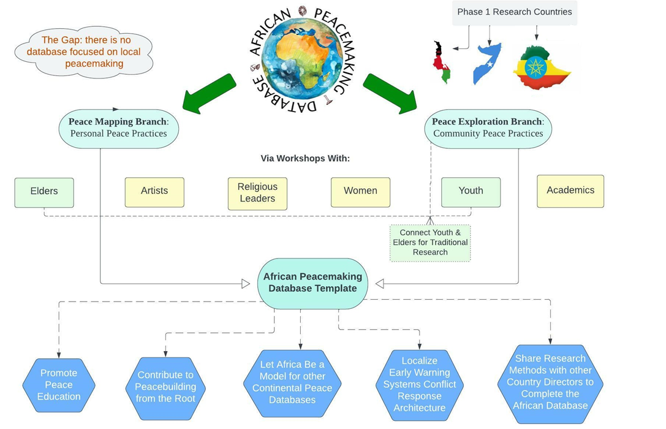  
Two Branches of the Database**Peace Mapping: Daily Practices  
Peace Exploration: Indigenous, Cultural Traditions

**APPENDIX – FIGURE 2**

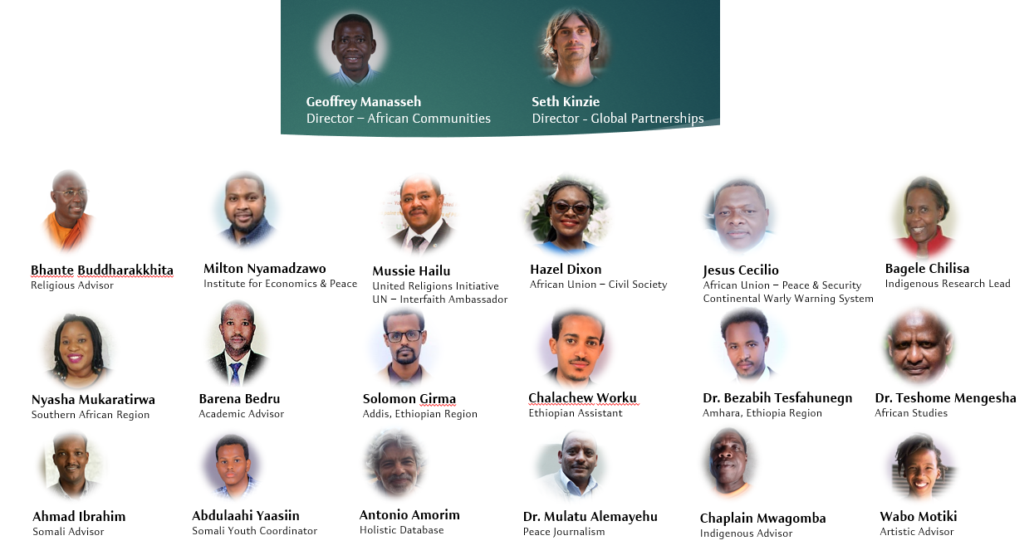**Our Team**

**APPENDIX – FIGURE 3**

**Variety of Countries Chosen for Stage 1 Design**

**APPENDIX – FIGURE 4**

**Structure & Roles of the Database**

**APPENDIX – GALLERY A  
(ETHIOPIA)**

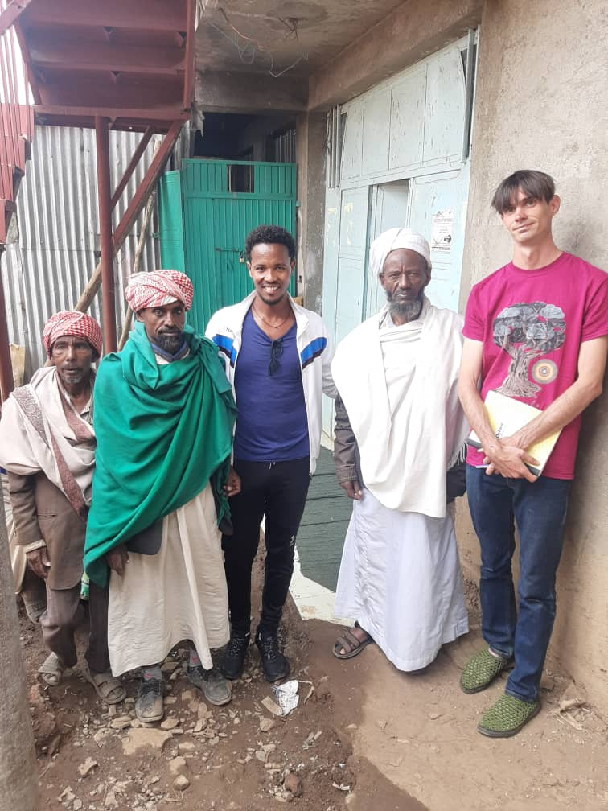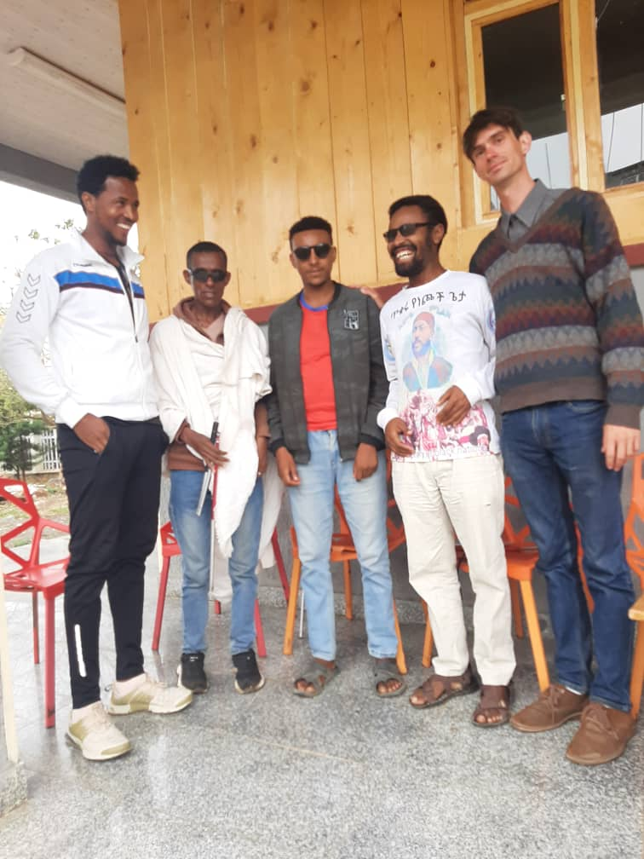

Blind Students Peace Mapping at Gondar University

Meeting with Amhara Mosque Imams

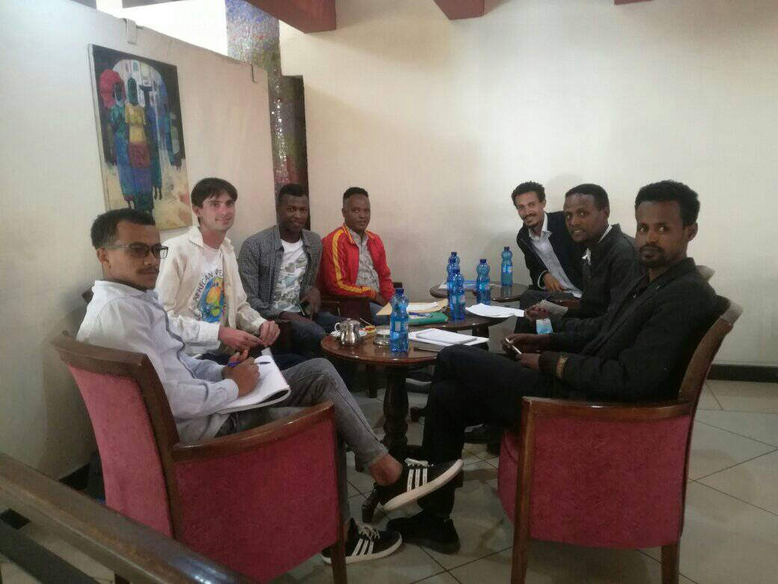

Meeting with Positive Peace for Ethiopia

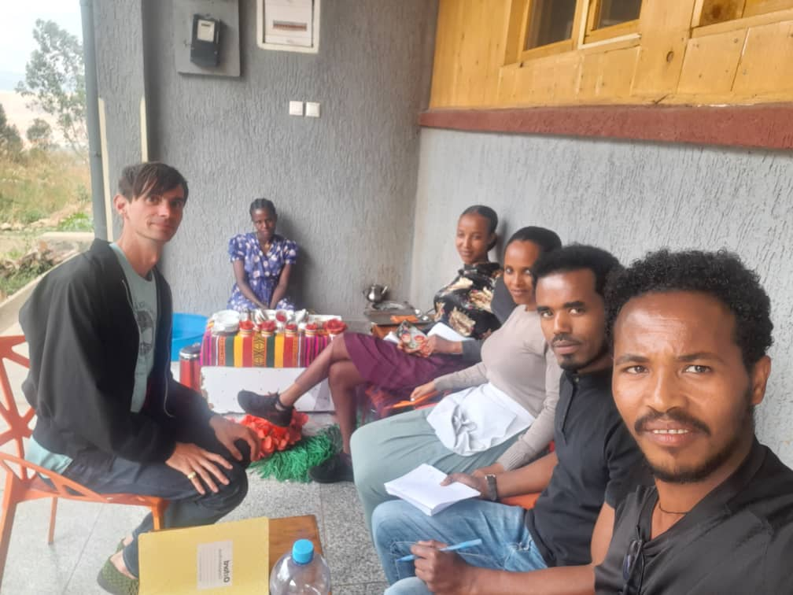

Waitresses in Amhara

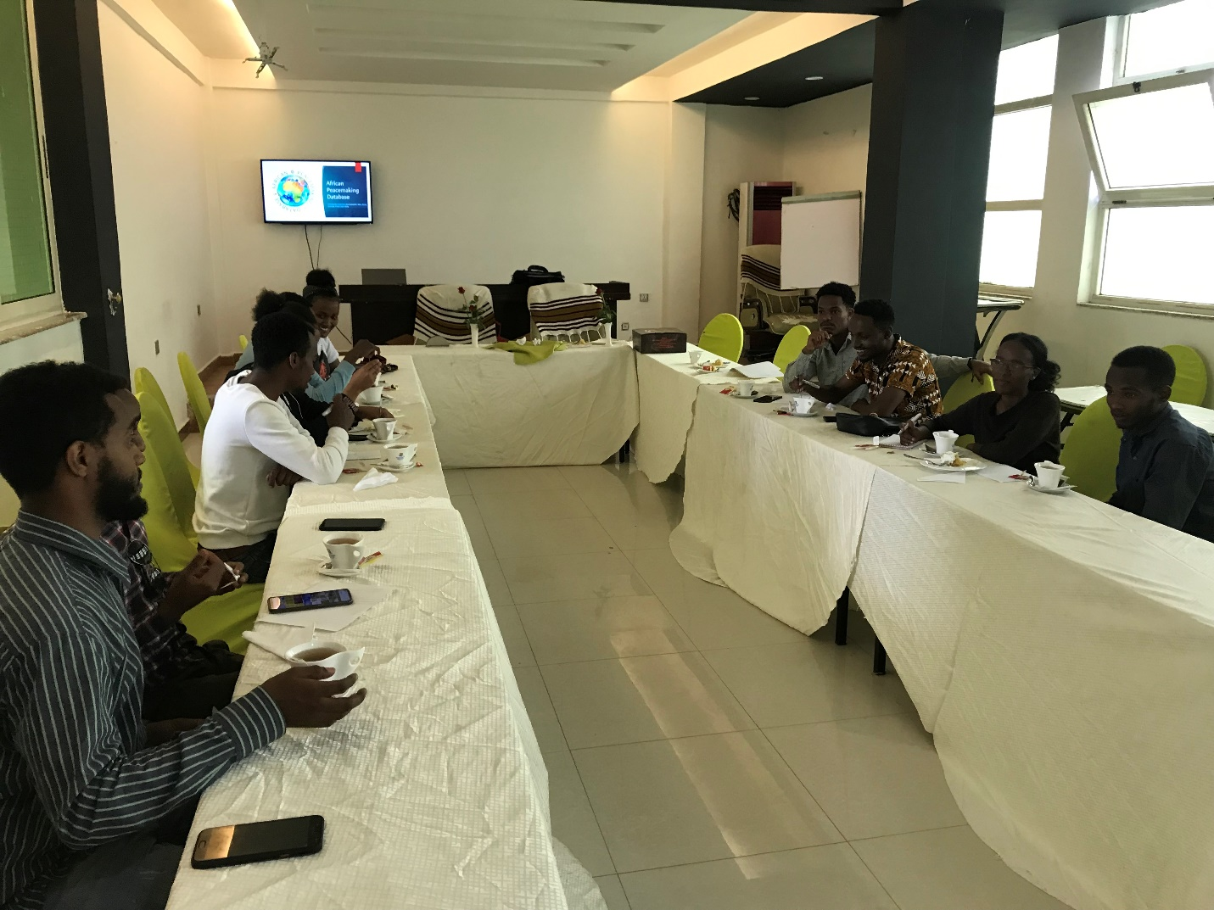

Workshop in Sidama with Youth

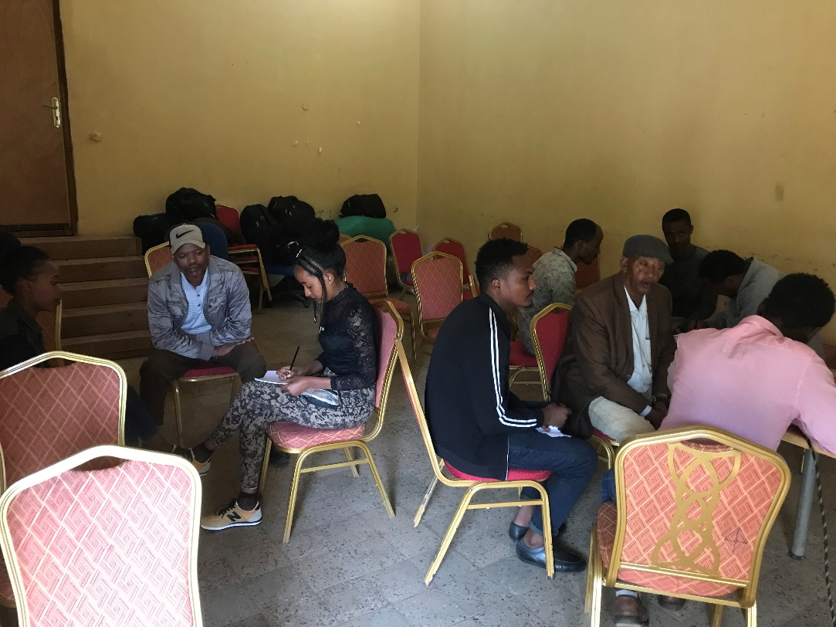

Workshop in Wolayta with Youth/Chiefs

**APPENDIX – GALLERY B  
(SOMALI)**

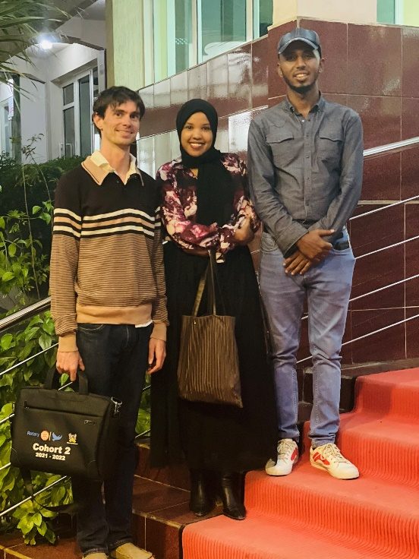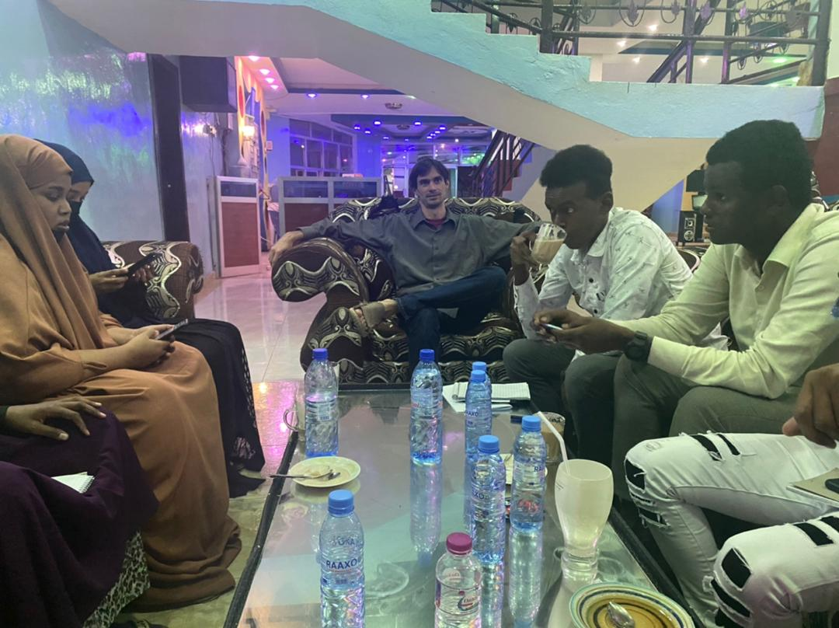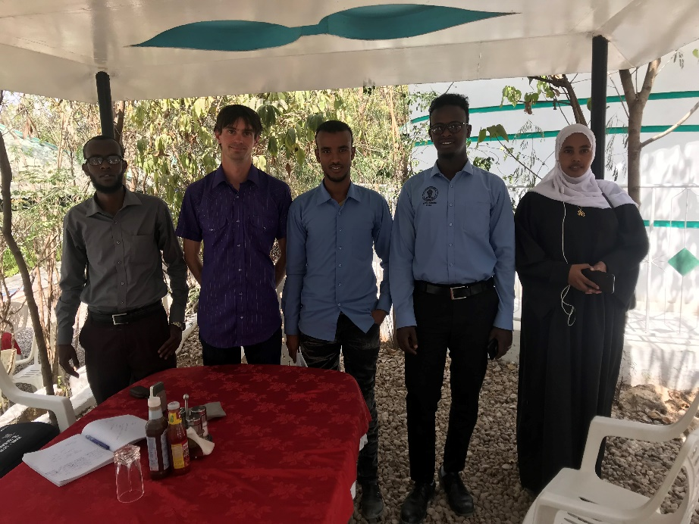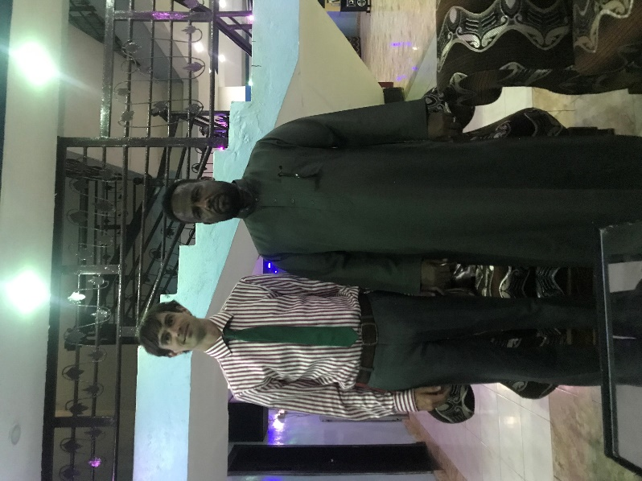  
  
  
  
  
  
  
  
  
  
  
  
  
  
  
  
  
  
  
  
  
  
  
  
  
  
  
  
  
  
  
  
  
  
  
  
  
  
  
**APPENDIX – GALLERY C  
(MALAWI)**

Meeting with Somali Artists

Meeting with Mustaqbal Puntland Youth Group

Workshop with Somaliland Youth Corps

Research with Somali sheikhs

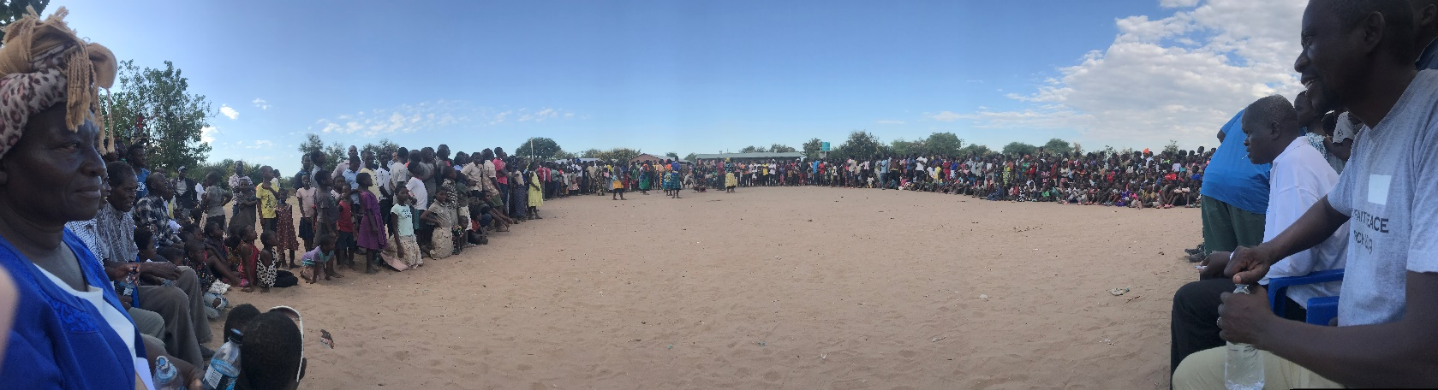

Interfaith Peace March & Workshop in Ntcheu - Central Region

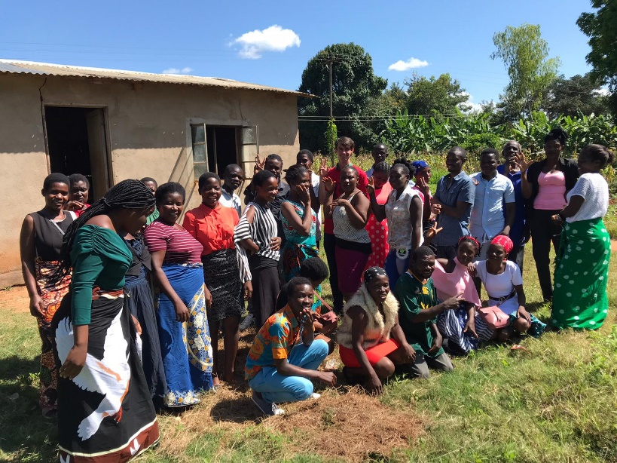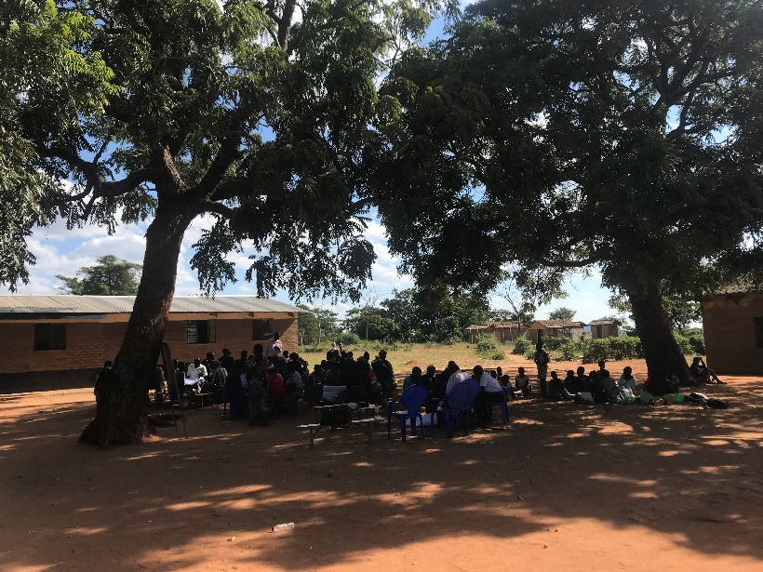

Peace Mapping in Nkhata Bay - Northern Region

Workshop under the trees in Mzimba - Northern Region

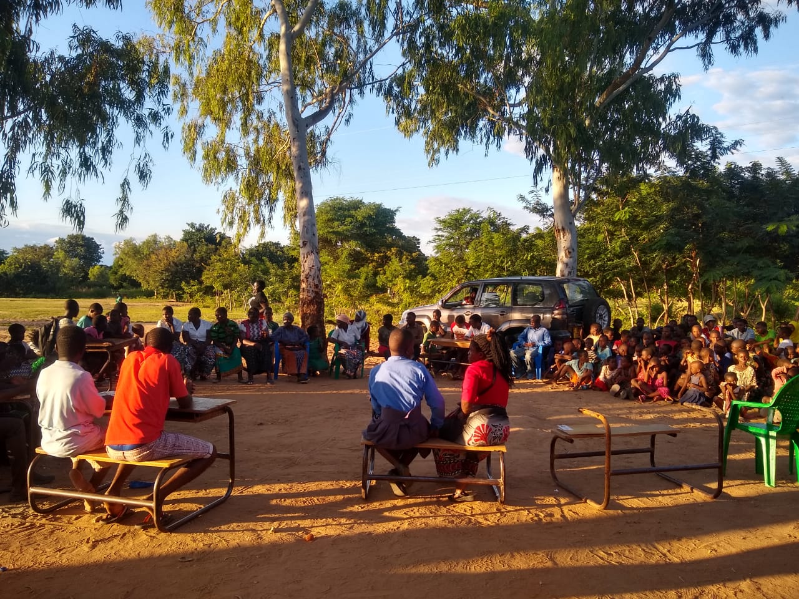

Drama Workshop in Karonga - Northern Region

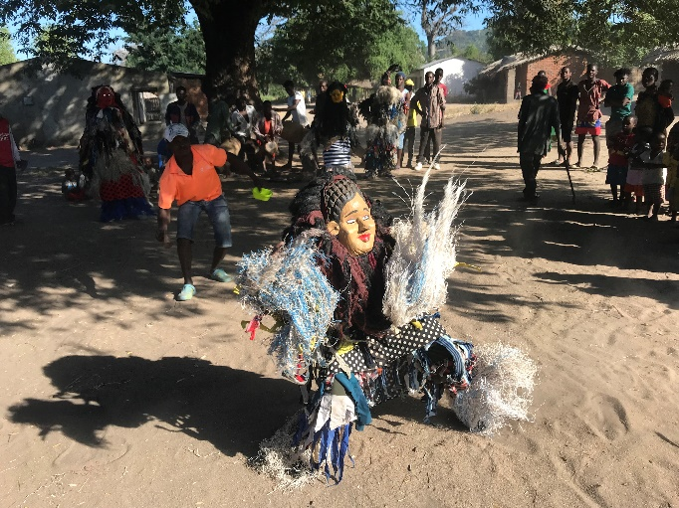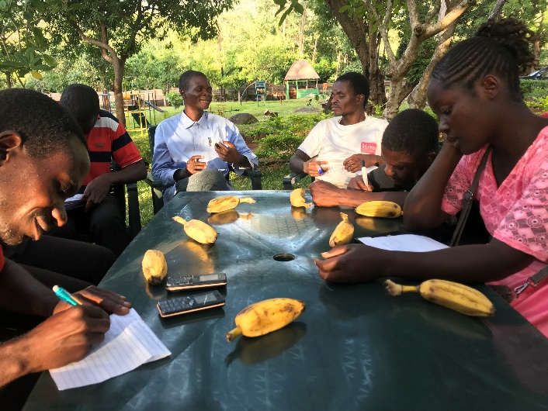

Ceremonial Dance in Nkudzi Bay - Southern Region

Youth Collaboration in Mt. Mulanje - Southern Region