

**SOCIAL CHANGE INITIATIVES IMPLEMENTATIONS**

**ROTARY PEACE FELLOW**

**Title: Empowering Young People as a Positive Force for Transformational Change and Peace Stability in Somalia.**

**Garowe – Somalia**

**November 2021 – September 2022**

**Final report**

**Sharmarke Yusuf**

**CHAPTER ONE**

**Introduction and background**

UNDP’s Somalia Human Development Report for 2012 states that 70% of the population in Somalia was under the age of 30 years. Although they represent the future of Somalia, the youth in Somalia face uncountable economic and social challenges. Since the start of the civil war in Somalia after the collapse of the central government in 1991, the Somali youth bear a heavy brunt of the conflicts in terms of deaths and injuries. On the other hand, they have been and still are the major actors of violence as they serve in the destabilizing forces that have perpetuated conflicts.

The Institute of Economic and Peace (IEP) in its Global Peace index report 2020 ranked Somalia 158 as one of the high intensity affected conflict, terrorism and armed conflict countries and number five in the economic cost of violence countries. Many argue that Somalia could be the next Afghanistan if we don’t change the approach to building a positive peace.

The international and national efforts to build a functioning structure for institutions face many challenges from insurgency and violent extremism caused by the collapse of state institutions—such as those representing the judicial system, social protection and education systems. The resulting emergence of extremism, conflicts between clans, youth unemployment and poverty all are turning the country into chaos.

The violent extremist organizations in Somalia target young people to use their cruel ideology and to carry out missions against humanity and a stable society. They take advantage of a fragile situation in which young people are especially vulnerable due to lack of: effective education (including peace education); social protection; civic engagement; employment opportunity; economic inclusiveness; and equal justice. These young adults are the major actors in the conflicts and insecurity in Somalia, specifically in populated cities and urban areas including Mogadishu and Bosaso as well as other parts of the country. Many Somalian communities are subject to armed terrorists and the extreme violence-based twisted ideology of jihadists and where terrorist groups are active, youth are targeted as primary and front-line fighters.

The role of youth in crime and violent activities is reinforced by many factors that include the lack of alternative social life that can meet their basic needs, and the absence of a structured, effective education system in the country that for more than two decades has rendered many youths to be uneducated and often illiterate.

Because the country offered inadequate opportunities for young people to access education, employment, and economic inclusion, these youth have become insecure and vulnerable to easy enticement into conflicts between parties and groups and attracted to involvement in crime and other harmful situations.  The high numbers of these youth in this state thus pose a big challenge to the social stability of the communities and require security-tailored initiatives and livelihood alternatives to engage them.

This social change initiative proposes to prevent youth radicalization through a transformative peace initiation utilizing a participatory and engaging educational methodology and set of thinking processes known as Theory of Constraints (TOC). The education sector is one of the most critical development intervention areas for fostering and strengthening peace building efforts in fragile states such as Somalia recovering during post conflict. During this crucial time, youth need to develop a growth mindset that fosters critical thinking and positive, constructive decision making.

TOC for Education, a charitable organization established in 1995, and through 27 years of service, has taught the TOC thinking and communication tools and methodologies to over 250,000 education stakeholders in more than 20 countries on 6 continents. The results include a positive impact on over 8 million youth and their mentors who have used the tools in their homes, communities and classrooms. These logical thinking tools and methodology can be used in behavior change training to include conflict resolution and prevention. The tools allow individuals or groups to virtualize the consequences of their actions before they take place through a logical thinking process and to use this analysis to detail plans, tactics and strategies that clarify decisions and ensure their actions lead to desired outcomes.

**Problem Statement: (250 words)**

Youth are the major actors of conflicts and insecurity in Somalia, specifically in populated cities and urban areas including South central and east north of Somalia and other parts of south central and northeastern Somalia. Armed terrorists who are responsible for extreme violence based on a twisted jihadist ideology are still active in the country and target youth in joining armed groups.

The Somali Institute for Development Research SIDRA report on policy analysis dated November 2019 states that youth radicalization has undermined Somalia’s peace, stability and development prospects. This verifies that the existence of the youth radicalization in Somalia has a major impact on the country’s insecurity. It is a significant contributor to undesirable outcomes in factors such as identity crisis, unemployment, low educational level, perceived marginalization, exclusions from community activities and lack of opportunities. Also, interpersonal factors, including contact with peers and social networks promote an environment that leads to violence and community crises.

The UNDP report on 2019 highlights that young people are key to the prevention of violent extremism, and it calls for more investment in ensuring systematic participation of young people in decision making and governance to play practice roles in communities and societies at large.

This Social Change Initiative will engage young people to provide behavioral change training, communication skills and a thinking process for the prevention of radicalization.

**Goals and Objectives: (400 words)**

# Goals

* 20 mixed gender youth in Somalia trained and empowered with social skills (Communication and thinking skills), positive peace education, and conflict resolution tools
* Participants equipped with critical thinking and problem-solving skills that enable them to become productive citizens and peace agents
* Reduced youth vulnerability to participate in extreme violence and radicalization

Objectives

* Sensitize the local authorities and other stakeholders to enable them to identify and address youth drivers and the radicalization process and insecurity associated with antisocial behavior of youth at risk
* Youth trainees attend social rehabilitation training sessions that combine peace and civic education, conflict resolution methods (Theory of Constraints) communication and thinking skills, criminal justice (courts and police) governance (linked to constitution processes), the role of gender, and social behavior
* Youth who may gravitate to crime provided critical thinking and behavioral change tools and social skills to help them become good citizens that contribute to the good of common purpose towards a peaceful and productive Somalia

**Challenges and mitigation strategies: (400 words)**

A TOC Ambitious Target Tool has been used to identify challenges and create an effective plan to overcome the obstacles that block achieving a successful implementation of the intervention.

|  |  |  |  |
| --- | --- | --- | --- |
| **No** | **OBSTACLES** | **OBJECTIVES** | **TACTICS** |
|  | Lack of training facility and venue availability | Well-equipped and comfortable venues are available to conduct training | I will engage with Local organization and Universities to provide comfortable hall |
|  | City climate is very hot, and we have not budgeted for air conditioner | We have funding to prioritize for air conditioners |  |
|  | Insecurity incidents occurs in Mogadishu | Shift training into other cities which are relatively peaceful |  |
|  | Limited international banks in Somalia inhibits fund transferring | Funds sent to my local bank accounts to spend SCI implementation activities | Write support for secure wire transfer to Mentor,  refund and claim for reimbursement |
|  | Considering the local context many organizations pay for participants to attend for similar trainings, consequently the participants for TOC training may expect to be paid training attendance | Participants are motivated to attend | Prior information about training will be given and the value of the training acknowledged |
|  | Too many participants in the training room will make difficulties in grouping and make training less effective | The participants will be 20 people maximum in the training room |  |
|  | Language barrier will occur as the original presentation-PPT is in English | Presentations into the local language |  |
|  | COVID-19 ongoing transmission | I Follow the recommended precautions by the public health institutions |  |
|  | Lack of training manuals and designed power point to deliver TOC Education tools | Arrange and prepare the TOCfE training materials provided and other resources |  |
|  | Lack of sufficient funds to conduct the project | Secure sufficient funds to conduct training | I write a grant request to appropriate partner, support from Kathy Suerken |
|  | Training delivery uses practical and graphic methods that require extra materials | Availability of sufficient training materials (including flipcharts, projector, notebooks, marker pens etcfor targeted audience | I purchase and collect extra training materials |
|  | Language barrier will occur as original presentation-PPT is in English | Translate graphics and presentation in local language |  |
|  | Participants likely to be illiterate and it will be difficult to understand presentations easily | Training will employ practical, simplified and graphic (visual) methods as well as group work presentation tools for CLOUD, Branch and ATT |  |
|  | Lack of training indicators for training report | Designed prequestionnaire and postquestionnaire to measure the outcome of the training |  |

## CHAPTER TWO

**Literature Review (1000 words)**

This chapter discusses a critical review related to intervention in the region and other associated Rotary Peace fellow work as a source of information. The similar content analysis involved studying existing information on empowering young people as a positive force for transformational change through thinking and communications tools.

**The Prevention of Youth Radicalization in Somalia.**

Although radicalization is a complex phenomenon and may have different definitions in diverse situations, for the suitability of this initiative radicalization means the process in which youth and young people may become violent extremists. Referring to Clark McCauley and Sophia Moskalenko, 2008 on Mechanisms of Political Radicalization, they argue that the process by which individuals may become violent extremists is known as radicalization and that in the 21st Century, the process involves several social-psychological distinctions among faith, beliefs, and emotions. Feelings and behavior also contribute to the radicalization process. This intervention creates a sense that the use of effective communication and thinking tools reduces violence which results from the destructive force to commit crime and violate laws and the basic principles of human rights. This intervention changes behavior to respond to the radicalization process through critical thinking tools that provide individuals a space to have an open mind to seize and control the way of expressing feelings and beliefs.

According to a policy brief report on November 2019, by the Somalia Institute for Development Resave and Analysis SIDRA, radicalization is undermining Somalia’s peace, stability and development prospects. The report concludes that young people in Somalia are facing strong demographic growth as the youth present over 70% percent of the population. This demographic growth is combined with one of the lowest schooling rates in the country, causing serious unemployment crises and social integration difficulties for a significant number of youths in Somalia which motivates the young people to join the groups. Therefore, the radical groups observe the challenges that the young in Somalia face regularly and they tailor the radicalization process to exploit youth vulnerabilities.

**TOC Thinking Processes and Tools as Intervention and Prevention**

The Theory of Constraints was created by Dr. Eliyahu M. Goldratt (1947-2011), physicist, inventor, author and philosopher. In 1995 he founded TOC for Education whose specialists have authored textbooks, training manuals and professional articles that have been translated into 14 languages. Central to these publications are 3 TOC analytical tools that can be used separately or as an integrated problem-solving methodology.

**Cloud Method**

Dr. Goldratt’s approach to conflict management is to develop an evaporating cloud as a structured method to resolving all kind of conflicts. A Cloud is defined as a “TOC thinking tool method to analyze different points of view without finger pointing and in a way that enables us to eliminate the conflict without compromising important needs.” (TOC Learning Connection, 2016)

The method was used in Somalia for prevention of early marriage in 2020 whereby one student proposed early marriage while the other person rejected the proposal to avoid the disruption of the education process.

*Abdi wants to marry*

*Asli now*

*Abdi needs not to lose*

*Ashli*

*Living a good life*

*Together as happy family*

*Asli wouldn’t want to marry*

*Abdi at this time*

*Asli needs to continue*

*her Education*

In this case, defining the problem through this method enabled Abdi and Ashli to truly empathize with the other side’s point of view, acknowledge and focus on their ‘good’ needs and an objective they share. Just writing the Cloud turned the conflict from ‘you against me’ to ‘you and me against the problem.” Using the cloud, young people critically think to define the problem by identifying three elements that include the opposing ‘wants and decisions’ that cause the conflict, the underlying Needs that conflicting parts try to meet accordingly through wants and actions and finally the common objective that both want to attain.

A case study in Mexico was documented by Maria de luz pamanes J. De Ninos Pedro Maria Anaya, Mexico regarding violence in the home. Some parents in the school punish their children by striking them really hard. As a result, the children need to stay home and rest on Mondays. The school principal wants parents to stop punishing their children in this manner.

After writing the Cloud with the parents, they expressed some of the assumptions they were making and, in doing so, they realized that the punishments weren’t working to achieve their need and that would have to change approach in managing their children.

**Assumptions between needs and actions raised by principal**

* to punish is not the only way
* Society problems sometimes start from family violence
* It is possible to avoid the violence in the school environment
* It is the responsibility of parents to improve the confidence of children
* That is not a definitive end
* That kind of punishment can end in a sad result
* Children deserve respect like grownups
* There are better way to teach

Parents don’t use severe punishments

Do my responsibility as principal

Work as a team in harmony

Parents use severe punishments

Make the children more responsible

**Assumpions between needs and actions raised by parents**

That was the way that parents were raised

The father is in charge

The father thinks this is best way to correct them

They think children deserve that kind of punishment

Without the punishment, children never learn to be responsible

They think the children will obey better

That’s the only way to make them learn

**AMBITIOUS TARGET TOOL:**

The ambitious target methods are one of the key thinking and communication tools that is used to create an effective plan by overcoming obstacles that block the attainment of a goal. In 2000 and 2001, the Maria E.villareal Primary School Escobedo, Mexico Zulema Mireya, used TOC tools with very problematic groups of students to change their attitudes. In one case, they worked with a group on the Ambitious Target to “Be the best students. “The teacher notes that when the students wrote their obstacles, they blamed others, but when they thought of ways to overcome their obstacles, they took the responsibility for outcomes as noted in their published case study.

**Ambitious Target: Be the best students.**

|  |  |
| --- | --- |
| **Obstacles** | **Intermediate objectives** |
| 1. Grumpy teachers | 1. We listen to the teachers. |
| 2. Lazy students | 2. We are prepared for class. |
| 3. We don’t study. | 3. We study continually. |
| 4. Missed classes | 4. We attend school regularly. |
| 5. We talk in class. | 5. We listen to the teachers. |
| 6. We bother classmates. | 6. We respect each other in class. |
| 7. We get to class late. | 7. We are on time for class. |
| 8. We do not participate. | 8. We gladly participate. |
| 9. No motivation from parents | 9. Parents support and push us  to be better |
| 10. We bother classmates | 10. We respect each other in class. |

The teacher reports that the group has changed: “The students are learning to value themselves. The group was very much in conflict, but now I can see they are growing up because they are using the TOC tools to think through their problems.” (TOC Handbook, Chapter26)

**Negative Branch Tool**

According to Wikipedia, a Negative Branchis an emerging phenomenon from Dr. Eliyahu Goldratt’s *Theory of Constraints* and is defined as a cause-and-effect analysis of a situation. In this regard, the Branch tool is used to anticipate the negative consequences that may occur due to a planned action, and it provides an effective thinking analysis. It’s an important tool for young people and adults to prevent negative outcomes and it helps to determine, prior to execution, that a proposed action will not create more or worse problems than it solves

**I can control my temper after all!**

Example written by inmate from Changi Prison, Singapore during training with Peace Fellow Christina Cheng (class of 2022-23) who has used TOC tools in her work in prisons, (TOC Handbook, chapter 27) family counseling, child trauma, female drug offenders, diasporas and among diverse faith based groups.)

**Negative**

**I will charge in court and end up prison because of my bad temper**

I will not end up in prison

**then police will arrest me (because it unlawful to hurt people**

I will not get arrested

**I will hurt people (because I can’t control my strength**

I will not hurt someone

**POSITIVE**

I will not get into fight

**I will get into a fight (because that’s how I relieve my anger**

**I get angry ….because I want respect**

Then I will not get angry

**When people tell me what to do**

And it’s for my own good

**Theoretical Underpinnings (1000words)**

Theory of Constraints (TOC) is a Theory of Change that applies a set of thinking processes along with common sense methodologies used to logically identify and overcome key limitations that inhibit a person, group or organization from achieving its goal

Theory of Constrains (TOC) as initiated by Eliyahu Goldratt (1947-2011) has a wide range of applications and implementation as its tools can be applied in various forms (Theory of Constraints Handbook) In 1994 Goldratt’s book, “It’s not Luck” he provides a roadmap to discover solutions for complex processes and achieve optimum solutions through a process called “ TOC Thinking Processes.”

In his book Theory of Constraints, Goldratt, writes “Every improvement is a change but not every change is an improvement.” According to TOC, in order to create desired and continuous improvement, we need to be able to answer three questions (Goldratt, 1990):

(1) What to change? *What is the problem?*

(2) What to change to? *What is an effective solution*?

(3) How to cause the change? *How will we implement the solution.*

TOC uses simple, yet powerful logical thinking and communication tools to systematically address each question. As a Theory of Change, the elements of the tools are logically sequenced and the Socratic questioning techniques enable participants to challenge assumptions and take ownership of positive behavioral changes. These thinking and communication processes can be used as a set of integrated tools to prevent conflicts and change the way of thinking to achieve a collective positive decision. Those tools are used in this social initiative to change the perception and negative thinking of young people to prevent radicalization and conflicts.

**Change Theory and How it was applied (700).**

**then**

Decrease youth radicalizations

Goldratt's Theory of Constraints (TOC) was applied through a suite of logical thinking process tools that provide a cause-effect roadmap for change. by addressing three basic questions of What to change, What to change to, and How to cause the change

Life Skills

Employability skills (Job search and applications skills)are developed

Youth have the necessary skills to make change and integrate as peace builders within communities

Youth think critically to determine their actions and realize it is possible to achieve positive goals

TOC methods

Provide behavioral change skills

IF

IF

and

**then**

and

Youth Radicalizations

**Methods**

**then**

IF

Social and problem solving skills

IF

Community volunteer activities

enhance skill and self-confidence

TOC methods

Skills in Action

The social change implementation was structured to enable youth participants to learn the tools as a personal decision making process, to think through consequences of their actions, to overcome obstacles to positive goals and, as a result, to make positive behavioral changes on their own initiative. These TOC methods and training tools are simple, yet effective in resolving deep seated chronic conflicts and in changing learner’s values, attitudes, and behaviors that foster radicalization. In the process, they are empowered to make good decisions, support nonviolence and to spread a culture of peace.

The principles of the training were centered according to the pillars of the Theory of Constraints:

* Inherent simplicity
* All conflicts can be removed
* Don’t blame
* Every situation can be improved.

**Methods and Design (800words)**

The following aspects were employed to ensure an effective, participant centered, and inclusive training and intervention activities based on the TOCfE moral code. As expressed during the August 2022 TOCfE International Club monthly online meeting, the President of TOCfE and founding member of the international club, Mama Kathy Suerken, stated that “The TOC tools were created to find and implement WIN-WIN solutions in which no one gets harmed through our actions. As we strive toward the goal to bring significant improvement to education, the people of TOC for Education will use the TOC tools in the spirit in which they are intended.”

|  |  |
| --- | --- |
| **Methods** | **Criteria / Description** |
| Physical Environment | Safe. Collaborative. Comfortable. Stimulating. Elective.   * A comfortable avenue and seating arrangement which motivates participation and assertiveness of the participants; |
| Training Process | The training process includes:   * Preparation phase (including pre-questionnaire, design & development of participation, recruiting participants). * Implementation (including delivery and debriefing / reflection). * Evaluation and follow up, including assessment of outcomes and impact. |
| Psychological Environment | Safe Spaces. Respect. Availability of Reflective / Personal Spaces. Mechanisms of Support.   * In the line of TOCfE moral, the trainer maintains respect for participants, accepting, supportive |
| Laying the Groundwork | Openness. Enthusiasm. Respect. Diversity.   * The participants have good Introduction, knowing each other as each one is introduced and provides the best name to be called such a nickname or family name. * The ground rules were set through discussion with the participants in order to create a safe space and best use the time; |
| Source of Knowledge | Bottom-up. Diverse (Not One-Fits-All).   * Participants and trainers both bring knowledge to the training. * Communication and thinking tools were provided for participants to use freely and apply to their own issues and circumstances |

**Pathways to Peace – Training Materials**

The training materials were donated through Mid-Bay Rotary Club’s ‘Pathways to Peace’ project and written by Mid-Bay Peace Project Director and District 6940 Peace Fellow Chair. Rotary Club of Mid-Bay Bridge Choctawhatchee Bay was chartered June 29, 1993, is a Peace Builder Club and meets weekly in Niceville, Florida, USA.

The methodology used in the materials is, in the words of former Los Angeles, California school principal, Denise Meyer, “simple enough to be used by kindergartners and profound enough to be used by CEO’s.” (The Why and How of Thinking in School) The tools are visually presented and logically sequenced to enable participants of all ages and abilities to understand, remember and replicate. The methodology enables the underlying theory of change to yield practical, relevant outcomes to participants’ daily lives. Furthermore, the training materials were designed to work with all ages, cultures and political systems The coaching cycle utilizes provoking questions and a sequenced, progressive learning curve to enable participants to take full ownership of their changes in attitudes and behavioral outcomes.

**CHAPTER THREE**

**Interventions and Activities: (1200 words)**

The intervention of social change is designed to engage youth as the major actors of conflicts and insecurity in Somalia.

In this regard, the intervention conducted 10 training sessions and engaged youth who are unemployed and described themselves as the least advantaged sector in the community. Ages between18 to 32 were selected to receive these thinking and commination tools in order to prevent radicalization and extremism violence and to guide them to positive decision making by realizing the consequences of their actions.

The training session activities shifted from Mogadishu to Garowe due to insecurity events and to avoid any risk that could interrupt the intervention participation and risk the lives of youth who were involved in the initiatives. Garowe was relatively safer and gave freedom of participation.

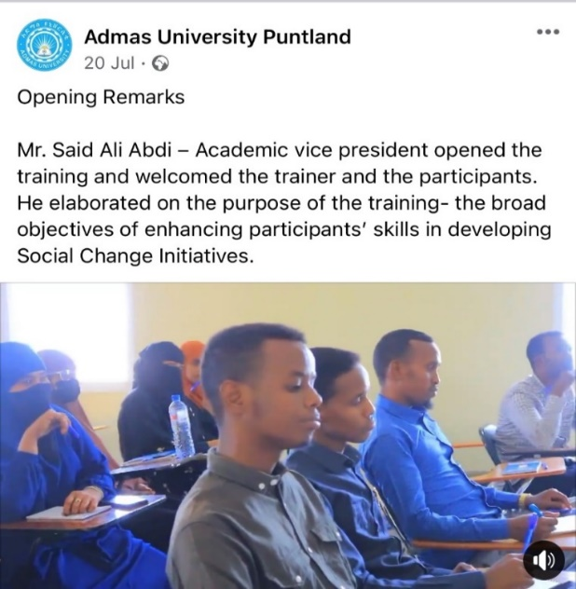The intervention plan included an affiliation with universities to reach out and identify the target participants in Garowe city who would be given the opportunity to be trained in conflict resolution, thinking and communication skills, and to be transformed from being at risk into peace agents. The intervention linked participants with the universities and integrated with the educations sector, where they were welcomed officially by the Academic Vice President of Admas University in Garowe who stated, “Education is the key of life and I am proud that you have the opportunity to participate in Rotary activities and explore more about peace and new skills for making a positive decision” The intervention designed an implementation strategy in a systematic way by effectively delivering the intended training session and tools.

First day orientation activities July 2022

3.BRANCH

**Activities**

The first step before the implementation of the initiatives was engaging with local university and city administrations, youth groups, and others for setting up the training sessions and volunteerism activities and ensuring a thorough understanding of the intervention activities with targeted groups.

The summery of the activities is highlighted in the following table

|  |  |  |
| --- | --- | --- |
| s/n | Planned activities | Status |
| 1 | Undertake the selection and Registration process of the Youth TOC for education tools trainings | Completed |
| 2 | Preparation of training material | Completed |
| 3 | Orientation workshop – Pre-training | Completed |
| 4 | Introduction Positive peace Education |  |
| 5 | TOCfE communication and thinking skills (Cloud, ATT, Branch) | Completed |
| 6 | Employability skills training  Job application and CV written | Completed |
| 7 | Youth integration with the community | Postponed |

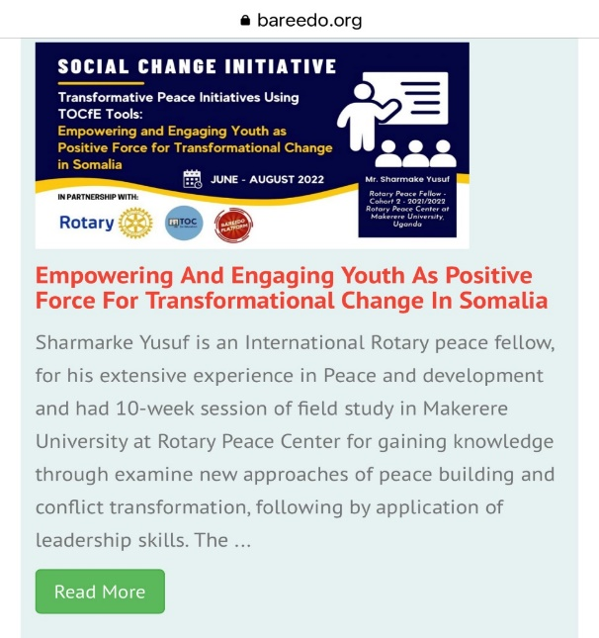**Out-reaching**

Several organizations including Bareedo platforms posted the introduction of intervention for reaching out to the youth and providing a wider understanding of the program in the community to include local and international NGO networks. The Peace Fellow SCI director received a lot of request messages from youth around the country to join the intervention.

**Interactive training sessions.**

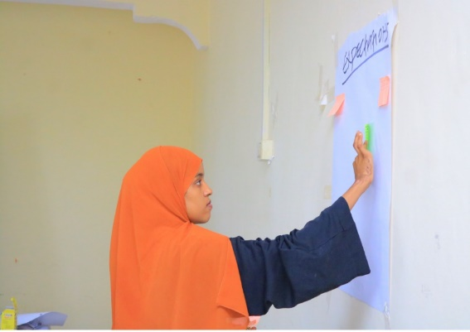Recording the Expectations:

Participants were asked to express their expectations responding why they came to attend the training. And they were requested to write down their expectations on post notes and attach them on a flipchart paper on the wall entitled “expectations” The participants liked posting their expectation without putting names and later the facilitator collected and made a summary of the posted notes.

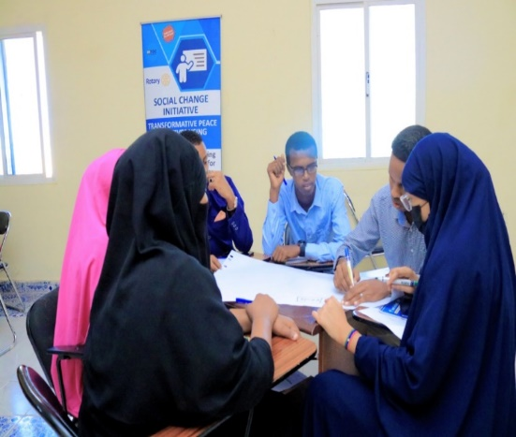**Group discussion.**

Participants were divided into several groups with a different education level and different gender for creating a cooperative atmosphere, where the participants could practice, communicate and listen to each other and gain understanding of their interests and needs.

Youth tend to listen and communicate effectively when they are using TOCfE tools and when using the tools to solve their own problems on preventing a negative decision and achieving a win-win solution.

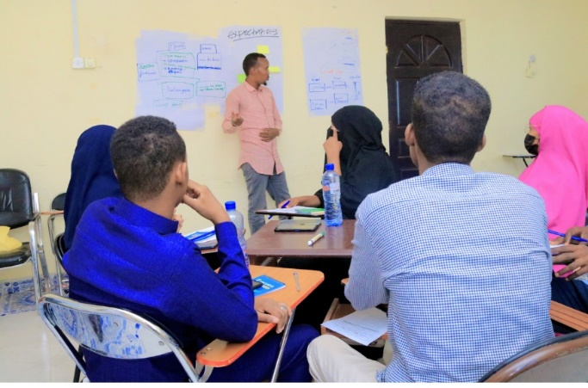Mr. Hasan, one of the participants after using conflict prevention method, explains how it was simple to identify obstacles that surround them and push youth to make wrong decision without thinking critically. “*This method let me listen to myself and my inner thinking that tells me not to take wrong decision which ends up with a negative consequence.*”

**Key findings / impact: (800words)**

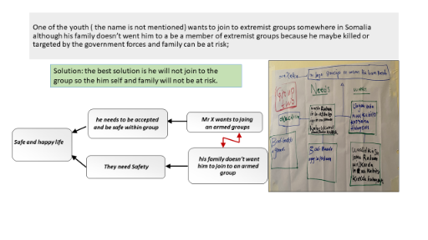Through the application of TOCfE tools and methodologies, participants modified their attitudes towards prevention of youth radicalization and interpersonal conflicts and developed a commitment towards peace and to becoming a peace agent wherever it is needed. Indeed, in one training session, a group of participants wrote a Cloud to analyze a conflict within a particular family related to radicalization.

What a powerful example of the impact this training can have to resolve conflict within families, improve relationships, reduce stress and bring peace of mind to everyone involved in these decisions.

Youth participating in the initiatives affirmed that the main drive of youth to radicalization is weak governance and state fragility that has failed to provide adequate services including quality education, and employment. They also emphasized the lack of inclusion in political and socioeconomic decisions along with the lack of interventions to provide needed social and life skills.

In addressing these issues, the TOC ‘Theory of Change’ provided them with a simple and easy way to identify their social and interpersonal challenges and to develop a strong sense of identity, purpose, and community.

**Impact analysis – Measuring the change and impact**

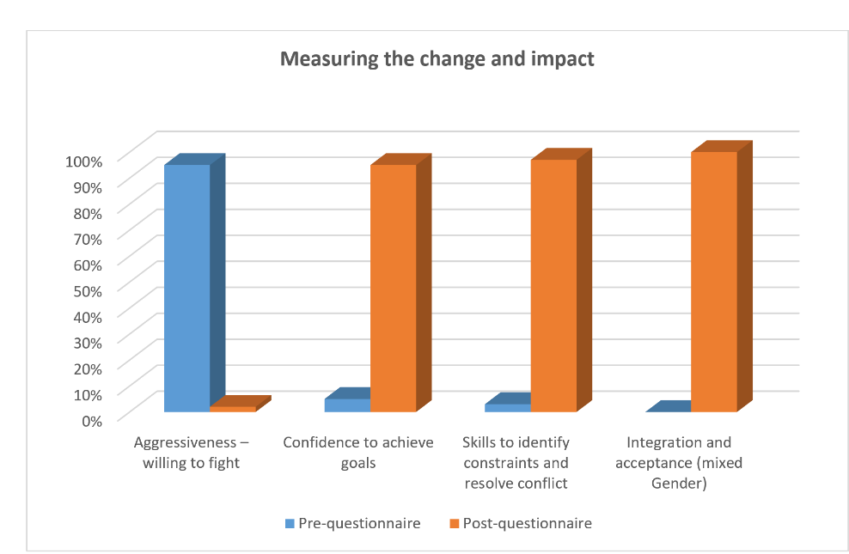The participants received pre questionnaires to measure their attitude and behavior towards either a passive or violent orientation as well as knowledge, critical thinking and skill in resolving conflicts nonviolently, The post questionnaire was given to measure the extent to which the intervention had impact on the behavioral change. The questionnaires were developed to indicate their opinions or feelings about fighting, respect, perception about peace and conflict, confident of achieving goals, making positive decisions and arguments using finger pointing language,

In the pre-questionnaire the participants had the perception that they are powerful with a gun, and willing to fight. One of the participants expressed *“I join armed groups because I want to feel accepted by the group*.” However, in the post questionnaire, the participants showed they are not willing to fight and react but prefer to communicate, negotiate and respond logically--to understand their wants and needs in order to achieve win-win solutions without compromising the important needs

In the assessment done before the intervention, less than 10% of the participants stated that they have confidence to achieve goals, but after the trainings that had equipped them with TOCfE tools, their confidence had increased up to 90% to make decisions, overcome challenges and achieve their intended positive goals. Additionally, according to the results of the pre-questionnaire, participants were lacking the skills to identify constraints and resolve conflicts, but the post-questionnaires show that participants dramatically improved skills and ability to identify constraints and ways to overcomes and resolve conflicts.

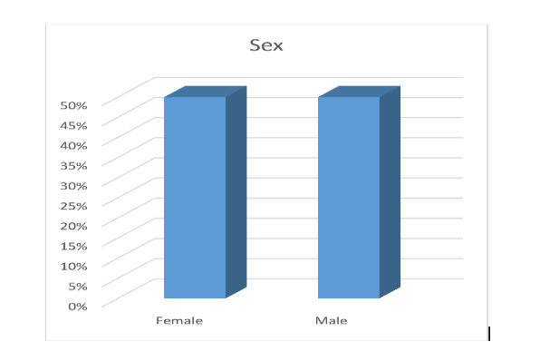**Effect on Gender Identify**

In order to enable gender analysis, this initiative included equal number of males and females. Methodologies were used to encourage participants to work in mixed gender groups. At the beginning of the training session, females were not accepted to sit with boys in working groups and male participants preferred to work in groups of the same gender. However, it has been observed as they became equipped with TOC communication and thinking skills participants changed their perception regarding the difference of gender and worked collaboratively in mixed gender working groups.

**CHAPTER FOUR**

**General Conclusion (300words)**

Theory of Constraints (TOC) created by Dr. Eliyahu M. Goldratt (1947-2011) is a set of unique, logical thinking processes and concrete, practical tools, along with common sense methodologies, which are applicable to all ages, culture and faiths and which can be used to enable favorable change by enabling youth to think critically and make positive, responsible decisions. This social change initiative applied TOC to intervene in the process that leads youth to become violent extremists known as radicalization, as defined by Clark McCauley and Sophia Moskalenko (Mechanisms of Political Radicalization).

In addition to improved self-reflection and internal communication, the training enabled participants to take ownership of solutions and how to implement them. The methodology also enabled them to communicate with others more effectively—to listen to others with empathy and without finger pointing.

The set of thinking and communication tools (Cloud, Logic Branch and Ambitious Target Tool) are effective in preventing youth radicalizations by changing perceptions, attitudes, and behaviors thereby enabling youth to make good decisions and promote nonviolence. Especially noteworthy is an expressed new paradigm of thinking among the participants that value the ideal of peace along with a desire and commitment to spread a culture of peace within their communities.

**Recommendations / Implications for Policy: (500 words)**

The TOCfE tools guide the practitioners through the decision-making process of problem structuring, identification of barriers to be overcome, solution building and implementation of the solution. The participants of the initiatives demonstrated the best usage of the TOC tools on identification of the cause of radicalization and ways to overcome the drivers of youth to armed groups.

The results from these initiatives apply to the Rotary International peace fellowship program. Fellows who have experience in and are committed to international peace and development could use these tools in different sectors including education, conflict prevention, decisions making, and poverty reduction and so on. The inclusion of TOCfE in modules taught for Rotary peace fellows would provide peace fellows ability to apply TOCfE tools in their peace initiatives.

In the words of Peace Fellow Christina Cheng (class of 2022-23) when using these tools in prison populations, “TOC tools are generic enough to be used across different industries and applications but yet specific enough to meet participant’s need irrespective of age, education and culture. They provide a simple, yet logical framework to check one’s thought processes in the language and vocabulary with which one is familiar and comfortable.” (TOC Handbook, Chapter 27)

Since the problem of youth radicalization and gang warfare is becoming more and more a universal concern and, given the success of this initiative, it is recommended that there be more investment in youth engagement and soft skills not only to prevent youth radicalization but also to empower them with tools and the will to unleash their potential as peace agents now and in the future.

**Sustainability plan: (800words)**

The social change initiative participants have formed a volunteer network to continue and train other peers for peace building and conflict resolution using theory of constrains tools and to continue spreading the culture of peace after the end of the initiatives.

The provision of thinking and communication skills to young people in Somalia not only changed their behavior and attitude but it will impact their decision-making process in the future for making positive decisions towards productive societies that will improve the productivity and employability of the youth. Reducing youth radicalization enhances peace and security in the country and neighboring countries.

Despite the demands of his own Social Change Initiative, a Peace Fellow colleague trained TVET school teachers in the TOC critical thinking and communication tools to empower students with critical thinking, dec. on making, and the psychological support to prevent negative decisions and foster positive decisions and wellbeing.

**APPENDICES.**

1. **Implementation strategy**
2. **The list of participants**
3. **Awarded certificates - blank sample**
4. **The consent of the participants**

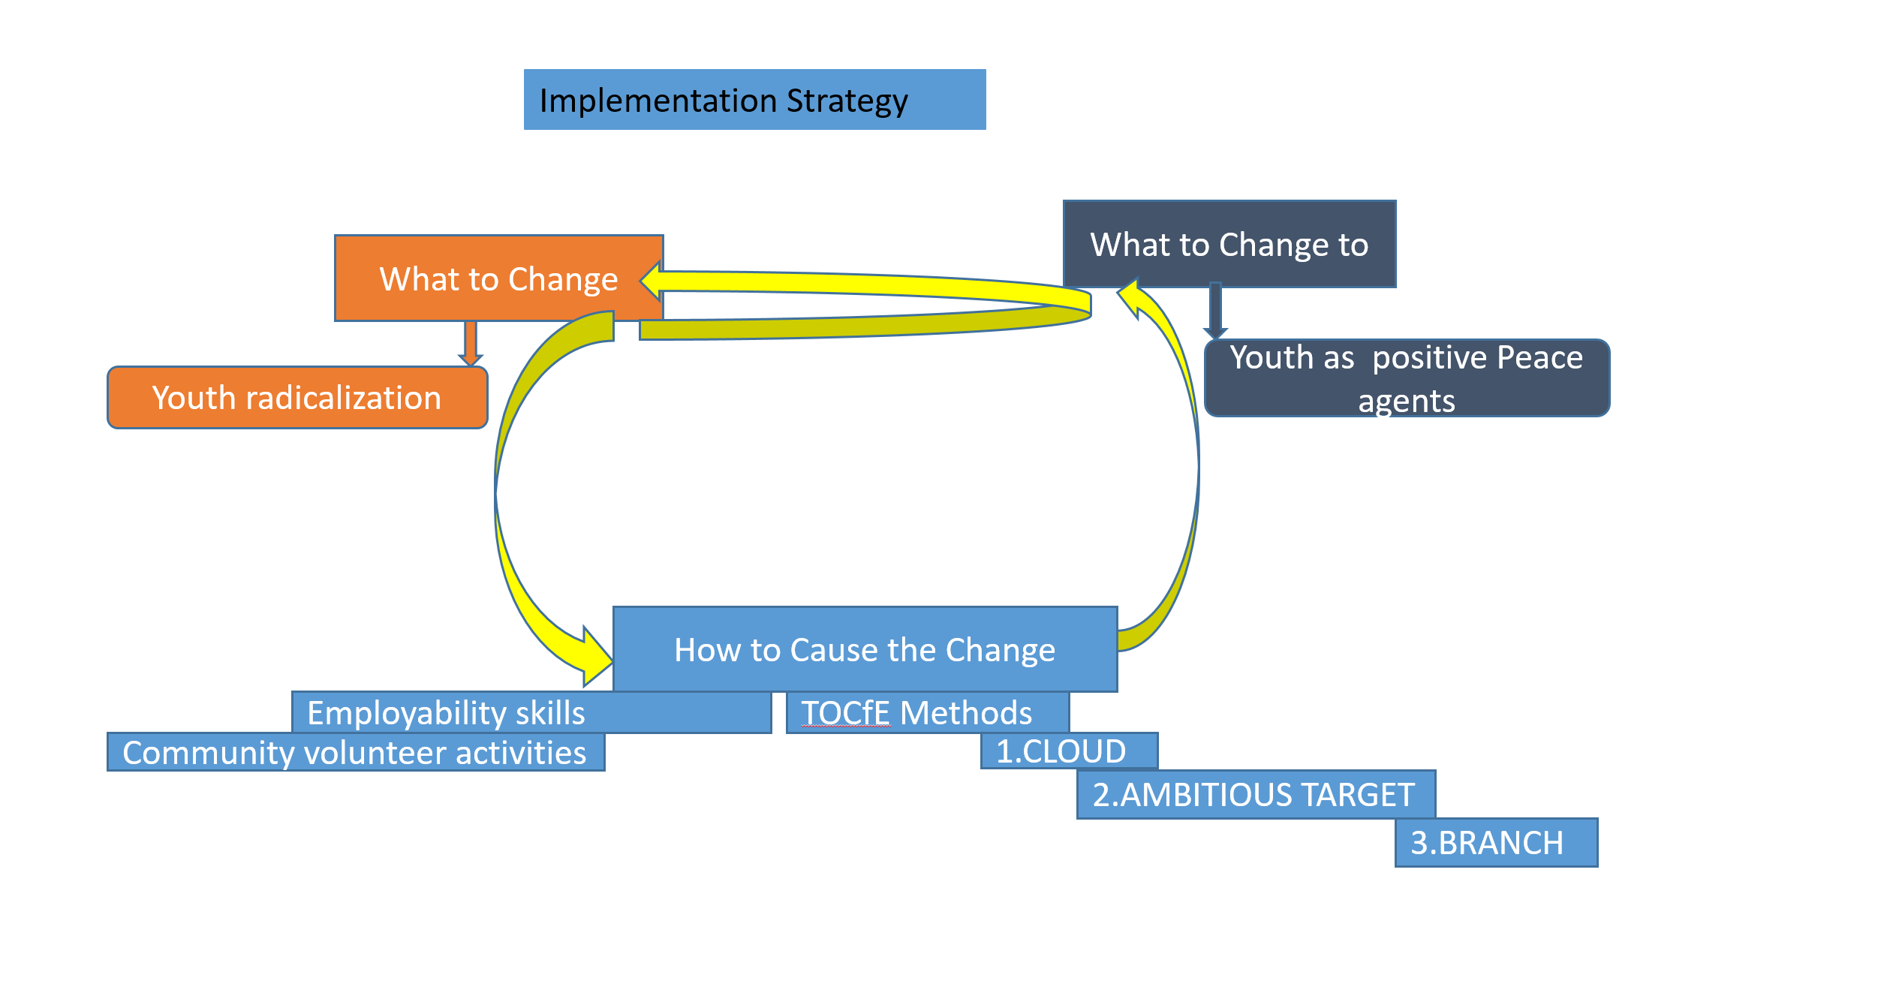**Implementation strategy**

**The list of participants**

|  |  |  |  |
| --- | --- | --- | --- |
| **No** | **Name** | **Cellphone** | **Email** |
|  | Hassan Adan Ahmad | 0907008559 | [Hassansanka123@gmail.com](mailto:Hassansanka123@gmail.com) |
|  | Ahmad Mohamed Mohamud | 0905052741 | [ahmedyareat@gmail.com](mailto:ahmedyareat@gmail.com) |
|  | Abdiqani Abdirashid Mohamed | 0907885822 | [abdiganiciiro@gmail.com](mailto:abdiganiciiro@gmail.com) |
|  | Zamzam Jama Abdi | 0907234487 | [Zamzamjamac123@gmail.com](mailto:Zamzamjamac123@gmail.com) |
|  | Sado Saleban Ahmed | 0907841411 | [Saadosaleebaan112@gmail.com](mailto:Saadosaleebaan112@gmail.com) |
|  | Ayan Mohamed Emi | 0907896855 | [ayaanbadan@gmail.com](mailto:ayaanbadan@gmail.com) |
|  | Ridwaan Ahmad Adan | 0906601983 |  |
|  | Ruwayda Ahmed Ali | 0907233299 | [Ruwaydo728@gmail.com](mailto:Ruwaydo728@gmail.com) |
|  | Ayan Ahmad Ali | 0907575245 |  |
|  | Ruman Abdulkadir Mohamed | 0906397472 | [rumanabdiqaadir123@gmail.com](mailto:rumanabdiqaadir123@gmail.com) |
|  | Fadxa Yasin Ahmed | 0907877025 | [fatxiyasinahmed@gmail.com](mailto:fatxiyasinahmed@gmail.com) |
|  | Maria Mohamed Nur | 0907886852 | [Maanahmed910@gamail.com](mailto:Maanahmed910@gamail.com) |
|  | Bashir Abdi Farah | 0907889205 | [Bashiiralnadaara123@gmail.com](mailto:Bashiiralnadaara123@gmail.com) |
|  | Abdinasir Abdihakim Mohamed | 0906247639 |  |
|  | Abdifutah Said Abshir | 0907352955 |  |
|  | Mohamud Abdullahi Mohamed | 0906904852 | [Maxamuudcabdalla6904852@gmail.com](mailto:Maxamuudcabdalla6904852@gmail.com) |
|  | Abdulkadir Jama Ahmed | 0907152758 | [Abdikadirsange9@gmail.com](mailto:Abdikadirsange9@gmail.com) |
|  | Ali Abdullahi Jama | 0907464077 | [Alibashkax143@gmail.com](mailto:Alibashkax143@gmail.com) |
|  | Hamdi Hussein | 0907886852 |  |
|  | Leila Abdirizak Hassan | 0907959454 | [simanmohamedjamac@gmail.com](mailto:simanmohamedjamac@gmail.com) |
|  | Maryan Abdiweli Ali | 09077840401 | [Maryama.abdi25@gmail.com](mailto:Maryama.abdi25@gmail.com) |

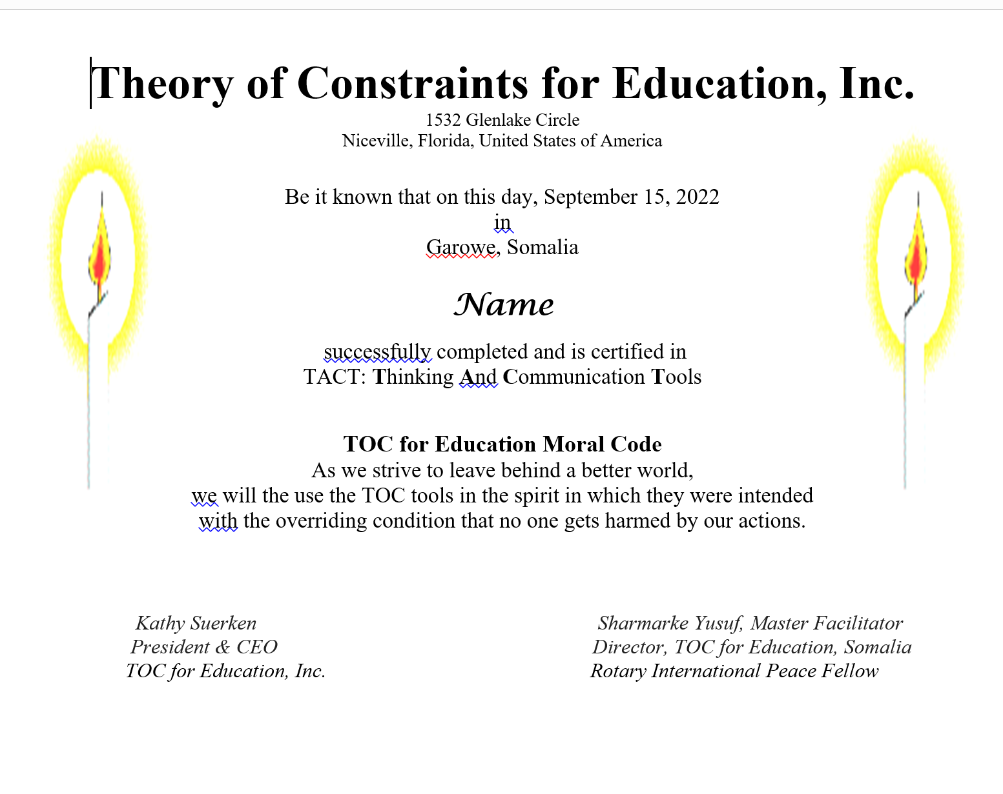**Awarded certificate - blank sample**

**The consent of the Participants**

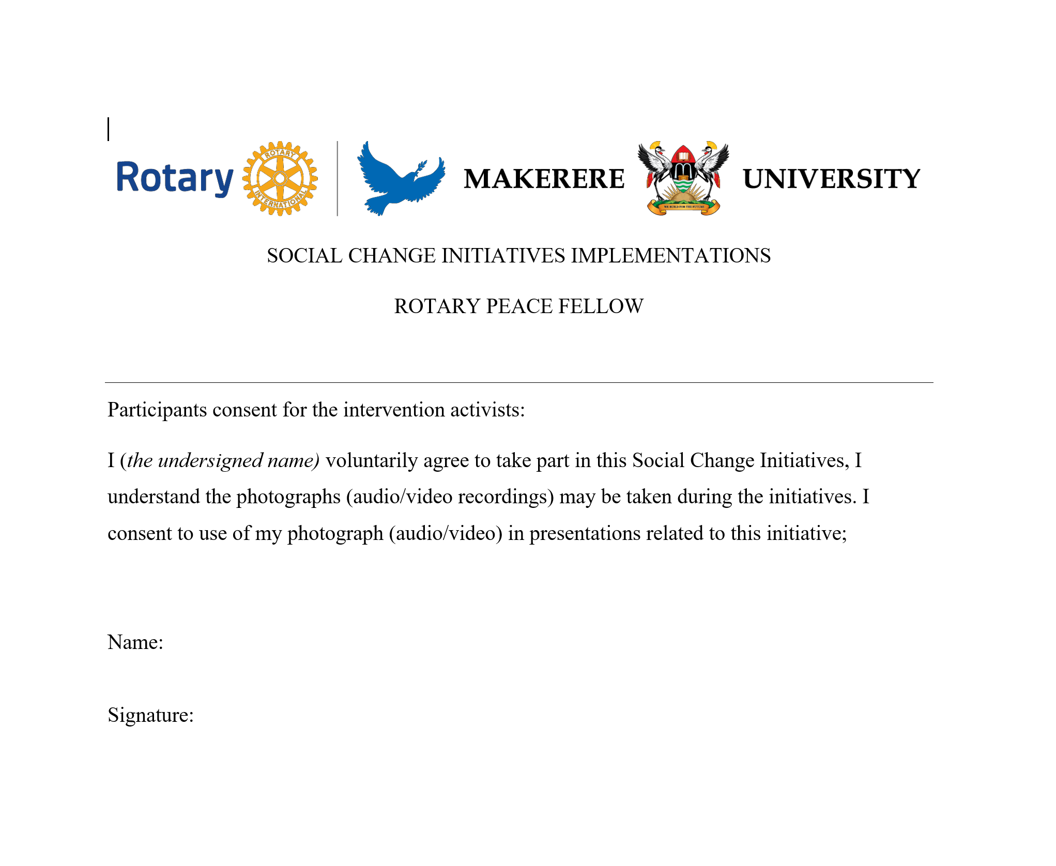

ccccc

