PROMOTING EQUAL, FAIR AND MUTUALLY BENEFICIAL PARTNERSHIPS IN EDUCATION COOPERATION BETWEEN FINLAND AND AFRICAN COUNTRIES

SOCIAL CHANGE INITIATIVE REPORT

SINI PIIPPO ROTARY PEACE FELLOW COHORT 4 2022-2023 MAKERERE UNIVERSITY

Content

Abstract / Summary 2

CHAPTER ONE 2

Introduction and Background 2

Statement of the Problem 4

Goals and Objectives: 5

Challenges and mitigation strategies: 6

CHAPTER TWO 7

Literature Review 7

Theoretical Underpinnings 10

Change theory and how it was applied: 11

Methods and Design: 13

CHAPTER THREE 18

Interventions and Activities: 18

Key findings / impact: 22

CHAPTER FOUR 23

General Conclusion 23

Recommendations / implications for Policy: (500 words) 24

Sustainability plan: 25

APPENDICES 27

Appendix 1: Draft of ethical guidelines 27

Appendix 2: Invitation to the stakeholder discussion on EDUFI website 28

Appendix 3 Stakeholder workshop presentation slides 29

Appendix 4 wordcloud compiled from the feedback shared by workshop participants via the electronic platform 32

Literature 33

## Abstract / Summary

This is a report on the Social Change Initiative *Promoting Equal, Fair And Mutually Beneficial Partnerships In Education Cooperation Between Finland And African Countries*, implemented in Helsinki between January and September 2023.

The main goal of this SCI has been to promote more equal, fair and mutually beneficial partnerships and communication in programmes and projects funded by EDUFI. The main tool to achieve this goal is compiling ethical guidelines for the cooperation with the partners from the Global South. This has been furthered during the implementation of the initiative with the activities, that have included adopting the development of the ethical guidelines as part of the EDUFI’s strategic priorities, collecting internal working group to further this task with representation from different education sectors and actions at EDUFI as well as organizing stakeholder discussion and creating an external expert group to provide their support for the development work. The guidelines will be published on EDUFI website by the end of 2023.

This social change initiative has created a commitment for this development work, which will bear fruit in the coming years, when the dissemination and practical level adaptation of the presented approaches will take place. Developing ethical guidelines for the international collaboration in EDUFI programmes is not an isolated act of creating and publishing one document, but an invitation to on-going dialogue with the partners in different stages of their project cooperation and raising awareness of the ethical aspects to be considered in the collaboration. It creates a heightened focus to be given to the ethical aspects of the collaboration and disseminating best practices of promoting more equal and mutually beneficial partnerships on national level in education sector international cooperation in Finland.

# CHAPTER ONE

## Introduction and Background

My social change initiative is focusing on strengthening the education cooperation between Finland and African countries with the aim of building more links and mutual understanding to tackle global challenges and creating sustainable global development. This is achieved by raising the visibility of the funding opportunities for joint cooperation initiatives among the education communities; by broadening and diversifying the image of African higher education in Finland; by increasing the interest for cooperation and most importantly, being the very focus of my social change initiative, by developing ethical guidelines for cooperation with the partners from the Global South for Finnish actors cooperating under the funding programmes of the Finnish National Agency for Education EDUFI.

I work as a programme manager at the Finnish National Agency for Education EDUFI, a national development agency operating directly under the Ministry of Education and Culture, further referred to as EDUFI. The core tasks of the agency are to develop education and training, early childhood education and lifelong learning and to promote internationalisation in Finland.

One of the two main tasks defined for EDUFI in the legislation is to promote internationalization in Finland. To this end, EDUFI acts as the National Agency for Erasmus+, European Solidarity Corps and Nordplus programmes taking care of the implementation of the programmes in Finland. In addition, EDUFI hosts several national programmes that promote and provide funding for internationalization. These include variety of programmes supporting cooperation with the partners in the Global South in different education sectors.

My position at EDUFI is located at the International Higher Education Cooperation Unit. The agency is working closely with the Finnish higher education community as well as other education sectors in basic education, vocational education and training as well as youth and sport sectors. EDUFI also includes specific expert programmes, such as Education Finland promoting education export as well as The Finnish Centre of expertise in Education and Development FinCEED strengthening the role of Finland in providing solutions for the global learning crisis and enhancing Finnish capacity in education and development cooperation.

My current and previous work tasks at the agency provide an excellent platform for coordinating the development work for the ethical guidelines and support the implementation in several aspects. For example, I have been functioning as the Erasmus+ International Contact Point for the EU funded Erasmus+ programme to increase and support cooperation of Finnish higher education institutions globally with countries outside Europe since 2013. I have also been part of developing a support scheme of threatened scholars arriving from unsafe conditions to continue their careers in Finnish universities and been involved in different national and international cooperation developing higher education in emergencies support activities, collaboration structure and development work.

Since April 2023, I am leading the Global Team of the international higher education unit. The Global team is responsible for the programme management of the higher education cooperation programmes funded with the development cooperation funds of the Ministry of Foreign Affairs of Finland. The programmes, which are the currently active are [Higher Education Institutions Institutional Cooperation Instrument HEI-ICI and the new Higher Education Partnership Programme HEP.](https://www.oph.fi/en/programmes/hei-ici-programme)

Further, I am currently leading cross-sectoral internal working group at EDUFI to increase cooperation with partners from the Global South and especially from African countries, including these sectors into a joint collaboration structure to promote this purpose. This working group is part of the impact programme setting the priorities for the joint work of the agency. This working group is also the main platform for the initiated collaboration to create the ethical guidelines for the cooperation with the partners from the Global South in EDUFI programmes under my social change initiative. The impact programme structure is explained in greater detail in the chapter three of this report.

In 2023 there’s a specific focus set as part of the impact programme of EDUFI on developing more equal and fair partnerships in the EDUFI programmes. As part of this priority area, my social change initiative focuses on developing ethical guidelines for cooperation with partners from the Global South in EDUFI programmes to promote more equal and fair partnership in the framework of the funding programmes of EDUFI. The internal working group acts as the main arena for internal development work towards the ethical guidelines.

These ethical guidelines will be adopted as part of the guidance work EDUFI performs with funded international projects in different education sectors, youth work and sport. However, as my role at the agency and my specific interest lays in the field of international higher education cooperation, this SCI report to some extend is focusing more on the higher education field. This concerns especially the theoretical underpinnings and literature review sections and is based also on the need to focus on one aspect of the complex and vast area of looking at linkages between education and peace.

## Statement of the Problem

The focus of this social change initiative is on education cooperation between Finnish institutions and partners form the Global South. This cooperation is increasing especially with the African countries, and there is a need to actively address the ethical aspects of this cooperation.

There is a strengthened focus given to increasing cooperation with the Global South and especially African countries in the national and international strategies. Following this increased interest, there are more institutions and colleagues entering different cooperation projects. There is also an increasing awareness of the questions related e.g. to decolonizing education, that should be critically applied also when discussing international education cooperation, including addressing the power structures created by funding flows and instruments, as well as the language used in the framework of cooperation. There is an increasing need to look into the aspects of equality and fairness in the international partnerships in the field of education and how these partnerships could best supports equal and fair partnerships and thus sustainable development responding to real needs globally. How can we promote more equal partnerships and ways of collaboration, also in cases where the majority of the funding as well as the funding programme rules guiding the operations and setting limits to activities originate from the Global North, in this case from Finland? This is at the moment the practical framework, in which these guidelines developed under the SCI will be implemented.

As a national level funding agency with links to all education institutions receiving funding through the various programmes in different fields, it is crucial that these ethical aspects of the partnerships and cooperation are highlighted by EDUFI in different stages of the project implementation. Compiling the ethical guidelines to strengthen equal and fair partnerships for cooperation with the Global South and Finnish partners in 2023 is an important step in furthering more equal and fair partnerships between Finnish and Global South partners.

## Goals and Objectives:

As stated above, there is an increased need and interest to address the ethical aspects of international cooperation projects and collaboration between the Global North – in this case especially Finland – and the Global South – in this case especially African countries.

The main goal of this social change initiative is to address this need by creating ethical guidelines for international cooperation projects funded by the Finnish National Agency for Education. By compiling these ethical guidelines, the objective is to raise awareness among the project partners on how to best support more equal and fair ways of collaboration and what kind of aspect they should consider when entering cooperation and also with their long-term partners.

The goal is best achieved in an inclusive preparation process. This concerns the preparation process on the one hand internally at EDUFI, so that all relevant units should be involved in the preparation process. On the other hand, the stakeholders, especially the project partners currently active in the EDUFI programmes need to be involved in the preparation process, to create guidelines that address relevant challenges and topics based on the real-life needs, experiences and expertise of colleagues from different sectors.

The result will be ethical guidelines as a guidance document, which will be published on EDUFI website. These guidelines will then be widely utilized in guidance of the projects funded by EDUFI. This will raise awareness and disseminate best practices to wide range of different cooperation structures.

## Challenges and mitigation strategies:

The activities of the SCI have been integrated in the activities of Finnish National Agency for Education EDUFI and more precisely the cross-sectoral impact group and thus no additional budget is needed. Partly, the analysis and theoretical approach has been developed during my own time and the implementation as part of the EDUFI working group activities. Also all events, such as stakeholder discussion and training events, have been and will be covered with the budget of EDUFI as part of the strategic impact programme activities as described below under the interventions and activities chapter. With the integration of the SCI activities as part of the development work done at EDUFI, the sustainability of the activities in the future is strengthened.

The main challenge of the implementation of the SCI has been the relatively short timeline for the reported activities. The ethical guidelines will be published towards the end of 2023 and when writing this report, the work is still very much on-going with planned activities throughout the autumn of 2023.

On the other hand, this timeline is based on the wide cooperation established at EDUFI between different sectors and units under the dedicated working group in developing the guidelines as well as inclusion of stakeholders in the development work of the ethical guidelines. This wide and inclusive working method for the development of the guidelines creates a more sustainable basis for the ethical guidelines to be adopted by different stakeholders in the day-to-day activities in different international education cooperation projects funded by EDUFI. Internally at EDUFI, it is also crucial to include the experts from different sectors in the development work in order for them to be able to commit to the guidelines in their work in the future. Also, this shows commitment on institutional level at EDUFI for the development of the ethical guidelines, and the next steps in the development work is not based only on my personal activities, even though I will be coordinating the work as part of my regular work tasks.

Another central challenge related to the development of the ethical guidelines is connected to the complexity of the topic at hand: the theoretical aspects, specific aspects on different fields and education sectors as well as the questions on international, national, institutional and individual collaboration structures might all be highly relevant to be discussed in this context but also leave the work scattered and the creation of one joint document for different EDUFI programmes unattainable. Narrowing down the subject and having a practical approach to the concept of the ethical guidelines has been a way to mitigate this risk. The goal agreed at EDUFI has been to without denying the complexities of the issue at hand to maintain a practical hands-on approach, so that the guidelines produced would be as easy accessible for different audiences as possible.

# CHAPTER TWO

## Literature Review

In my social change initiative I am focusing on international education cooperation. In international education cooperation the main goal is to develop the quality of education in joint cooperation efforts. But what is the link to education development and peace? As my specific field is higher education cooperation, in the following I am looking into the academic discussion on the role of higher education and peace.

When discussing higher education’s role in peace and conflict, the focus should not be limited to the conventional definition of escalated violent conflicts but should be seen as a wider understanding of the structural elements behind conflicts and peace. (Paulson and Shields, 2015).

Education and conflict are connected in multiple ways. As many other institutions, higher education can play either constructive or destructive role when it comes to conflicts: it can contribute both in increasing polarization and division as well as in creating more understanding and peaceful development (Millican, 2019 a). There has been extensive research on the connections of education to peace and conflict, but the role of higher education has rarely been in the focus (Milton, 2019 a).

Constructive functions of higher education for peaceful development in society can be developing values of respect, tolerance, and critical thinking in students. Higher education can promote culture of peace and respect for democratic values in its functions and by influencing policies and public opinion. Higher education can have significant role in promoting economic development and employment and providing future perspectives for young people with education opportunities instead of other more destructive options such as military recruitment (Millican, 2019 a).

Higher education’s role in peace and conflict can be approached by looking into higher education’s functions in society. Universities traditionally have a tripartite function: firstly, providing education and teaching; secondly research to create new knowledge; and thirdly community engagement and service to the wider surrounding society (Millican, 2019 a). Contribution to peace and conflict can be linked to all these functions.

Higher education’s role for peace and sustainable development in societies can also be looked at on the global priorities set in the Sustainable Development Goals SDGs. Higher education’s role in development is better recognized in SDGs than in the preceding Millenium Development Goals

MDGs (Milton, 2021). Higher education and its role contributing to peace can be linked especially to SDG4 Ensure inclusive and equitable quality education and promote lifelong learning opportunities for all, which highlights also the importance of equal access to higher education under the target 4.3; importance of promotion of a culture of peace and nonviolence, global citizenship and appreciation of cultural diversity and of culture’s contribution to sustainable development – among several other prioritized areas - under the target 4.7. and the need to provide scholarships for students from developing countries under target 4b. Further, in SDG 16 Promote peaceful and inclusive societies for sustainable development, provide access to justice for all and build effective, accountable and inclusive institutions at all levels higher education can have a significant role to promote sustainable development and rule of law by teaching, research, governance, and external leadership (Milton, 2021; IAU and UNODC, 2021). The role of higher education is not always constructive. Higher education can also have a destructive role and contribute to escalation of conflicts by providing education and promoting values that increase divisions between ethnic groups. One example of this is the Rwandan education system actively promoting anti-Tutsi propaganda before the genocide in 1994 promoting divisions between Hutus and Tutsis (McLean Hilker, 2011). This kind of ethnic disparities in education can have an escalating effect to conflicts (Buckland, 2005).

Universities’ role in conflict causation has been looked at especially from the perspective of provision of higher education: large number of poorly educated young men is often seen as an 5 instabilizing factor. Without education opportunities young men can be easier recruited by nonstate armed groups. Post-conflict enrollment rates decrease the likelihood of new violence. However, this aspect is not uncontested and could be context dependent. In some cases, university students have formed a very active part of non-state armed groups. Also the availability of relevant work opportunities after graduation is a factor. (Milton, 2019 a). Limited and unequal access to higher education can create divisions and conflict in society. (Millican, 2019 a). Wider and more equal access to education has the potential to act as a mechanism to increase understanding between different groups in society – as well as unequal access can fuel conflict (Burke & Millican, 2019). The connections between higher education, peace and conflict are much more complex than stating, that more higher education opportunities would result in more peace. (Milton, 2019 a).

Education should be seen as a one of the key actors in post-conflict reconstruction and peacebuilding (Burke & Millican, 2019). Access to education is a human rights issue, but also closely related to economic and social development (Diamanka and Godwyll, 2008).

International education cooperation is in the core of the work of EDUFI as an organization. Increasing international education cooperation for better quality and access of education as a goal is supported by the current EU policies as well as national level strategies and priority setting on global level.

More specifically, increasing more education cooperation with African countries has been identified as a prioritized area for development in recently compiled strategies both at the EU as well as on national level in Finland. Both of these strategies identify a crucial momentum for building closer partnership with the neighboring continent to create more peaceful and more sustainable future. In the strategies it is proposed to boost the EU-Africa and Finland-Africa academic and scientific cooperation and increase significantly the volume of opportunities made available through i.e. Erasmus+ programme.

The EU’s Africa strategy highlights the importance of the relationship of EU and Africa. According to the strategy, now is a crucial momentum for deepening cooperation to build a more prosperous, more peaceful and more sustainable future. Both boosting education, research and innovation, as well as promoting peace and security are mentioned as priority areas proposed in the strategy. It is further proposed that the EU scales up EU-Africa academic and scientific cooperation, which will significantly increase the volume of opportunities made available through Erasmus+ programme.

The aim of Finland’s joint government Africa strategy is to diversify and deepen Finland's relations with African countries in the next few years. In the strategy, the objective is set for Finland to promotes conflict prevention and resolution by supporting the development of peaceful and democratic societies. Also, it is explicitly mentioned, that higher education institutions and research organisations are encouraged to develop mutually beneficial partnerships with their African counterparts. This is seen as crucial part of creating more links between peoples and communities and better cultural understanding to provide a basis for stronger political and economic relations between Finland and African countries.

Boosting educational cooperation with Africa has also been prioritized in the strategy of the Finnish National Agency for Education. The Ministry of Education and Culture has published a sector specific implementation plan of the national Africa strategy with 45 actions. 18 of these actions have been allocated for EDUFI as the main or one of the organizations central for the implementation of the actions. The impact programme is also responsible of following the implementation of these actions and reporting the progress to the ministry.

Currently also the higher education institutions and other education institutions are starting to develop their strategic planning according to these priorities, and some have already developed their own Africa strategies on institutional level. This creates also a momentum for addressing the ethical perspectives to the cooperation.

## Theoretical Underpinnings

The importance of critically look the education cooperation from the perspective of power imbalance and equality has been addressed in theoretical discussion in the field of international education in the recent years. The topic of ethics and on the other hand decolonizing the international education between the Global South and Global North has been the topic of several conferences and dedicated academic discussions. In the following I am addressing this discussion from the perspective of international cooperation in the field of higher education. The focus is based on my professional role and interest as discussed earlier, even though the social change initiative resulting to the ethical guidelines will address wide variety of sectors EDUFI operates on.

For example, Patel (2023) addresses the need to create – among other actions – ethical frameworks to support of what she calls *humanizing* the international higher education. There has been a rise in interest to address and challenge colonized structures of international higher education, but Patel further addresses these efforts to support decolonization as still driven by the actors from the Global North. Patel states that “resent and future agendas in international higher education continue to be designed and driven by colonial actors” (2023).

Therein lays a critical problem. Higher education and international higher education cooperation should be an inclusive catalyst for change and engage all communities and nations to cooperation and not exclude voices and knowledge. (Patel, 2023)

International cooperation in the field of higher education highlight the importance of valuing different cultures and perspectives. Still, theses discussions do not generally include discussions on decolonization of internationalisation (Fakunle, Kalinga and Lewis, 2022).

The change towards decolonizing internationalization would require strategic – and thus, still more theoretical – level of change as well as policy and more practical level changes. This requires challenging the current understanding and the basis of global cooperation. (Fakunle, Kalinga and Lewis, 2022).

What could this look like in North-South partnerships in higher education cooperation? Internationalisation of higher education is a global phenomenon but continues to be based on practices and concepts from the Northern partners. Decolonial approach can be a useful tool to critically analyze North-South partnerships and to address and challenge imbalances related to knowledge, resources and power in them. There is an increasing call for more mutuality and equality in these partnerships for them to be truly mutually beneficial. (Chasi, 2020).

The reconceptualizing and revisioning of international education cooperation must use the current structures and cooperation methods as a starting point to dismantle the legacy of colonized cooperation (Fakunle, Kalinga and Lewis, 2022). The practical change takes place in partnerships and their day-to-day work. This is why it is critically important to engage the project partners in international education cooperation to this work.

The SCI goals can also be reflected based on the linkages to Pillars of Positive Peace as follows:

The social change initiative aims at increased understanding of ethical aspects of education cooperation projects funded by EDUFI.

This task and the desired results are linked to several pillars of the Positive Peace:

1. Acceptance of the Rights of Others: by advancing more equal and fair partnerships in EDUFI programmes between Finnish actors and partners from the Global South, the SCI promotes respect to the rights of others in an equal manner.
2. Equitable Distribution of Resources: by promoting more equal and fair partnerships, the SCI contributes to more equitable practices in project cooperation, concerning also resources
3. Free Flow of Information: Inclusive access to information is central principle and area of focus in the ethical guidelines developed in the framework of the SCI
4. High Levels of Human Capital: educational cooperation projects and especially when implemented in equal and fair manner, promote the development of human capital globally

## Change theory and how it was applied:

The required changes in order to achieve the goal of more equal partnerships and communication in programmes and projects funded by EDUFI with the adoption of and implementation of the approaches of the guidelines in their cooperation and practical level activities are on different levels.

Firstly, there is a need to ensure the commitment of EDUFI colleagues working with international programmes and initiatives providing funding for the education cooperation with the partners from the Global South to the development work of the ethical guidelines. This is essential, as there is a need to ensure, that the guidelines are applicable and relevant for different sectors and different project types as well as different types of institutions taking part in these programmes. Further, the crucial aspect is the awareness of the EDUFI colleagues working with this programmes on the ethical aspects of the collaboration. Inclusion of EDUFI colleagues from different sectors has been covered in the establishment of internal working group at EDUFI. This working group provides a working platform and structure keeping the experts from different sectors on board and involved in the development work.

Secondly, it is essential to involve the stakeholders – being it the project partners from Finland and globally in the EDUFI programmes – in the development of the ethical guidelines from the very beginning. In order to be useful, the developed ethical guidelines should be based on real-life challenges and situations that the project partners face in their day-to-day cooperation. Otherwise there is a risk of compiling guidelines, that do not have a link to practical level project work and thus will not have an actual effect. Involvement of the stakeholders and their feedback has been implemented in the stakeholder discussion event in May 2023 providing perspectives to the aspects of cooperation and used as a basis to draft the ethical guidelines; establishment of expert group to comment the draft of the ethical guidelines in August 2023 continuing the work throughout the autumn of 2023 as well as including the discussion on the topic of ethical guidelines in coordinators’ meetings organized by EDUFI in various programmes during autumn 2023.

Thirdy, the ethical guidelines should be a living document. Even though the document has been drafted and will be finalized and published by the end of 2023, the work of adopting the approaches included in the guidelines requires continuous work in the coming years. This means raising this issue in the internal EDUFI work; in the guidance events for applicants and selected projects and in external communication. As the discussion continues, the ethical guidelines should remain a document open for updates and corrections. This also keeps the ethical aspects of cooperation on the agenda. This aspect has been planned from the beginning but remains as the essential steps in adopting the guidelines once the first version has been published and is available for the stakeholders.

This theory of change is visualized below in the graph.

Ethical

guidelines

”A

living

document

”

•

Continuous development work needed in the

future for updates

Commitment

and

inclusion

of

variety

of

sectors

and

perspectives

in

the

preparation

process

•

Creation

of

internal

working

group

;

creating

cooperation

structures

and

inclusion

of

perspectives

from

different

sectors

Ensuring

addressing

of

real

-

life

needs

and

perspectives

•

Stakeholder involvement; expert feedback

Keeping

the

approach

relevant

to

the

actors

•

Comprehensive and

inclusive

design

process

## Methods and Design:

The working methods and the design of the social change initiative is described below in the work plan, and in the logical framework matrix.

The SCI was initiated by planting it in the institutional priority setting of EDUFI and its impact programmes, more specifically the impact programme focusing on increasing more equal and fair partnerships with the partners from the Global South in EDUFI programmes. As this was successful, the needed resources and internal and external networks were ensured to implement the planned activities.

The impact programme provided an internal platform at EDUFI with colleagues from different units and departments working with programmes funding cooperation with partners from the Global South. This involvement of different sectors creates commitment and raised awareness among the EDUFI colleagues as well as ensures that the perspectives and expertise from different sectors is utilized and covered in the process.

Stakeholder involvement is a crucially important step in the development process of the ethical guidelines. Main activity this far has been the stakeholder discussion, in which the participants representing a variety of different types of institutions provided their views on one hand the challenges and on the other on identified good practices concerning the following topics: Partnership and cooperation methods and structures; Access to information and transparency and Language and communication.

Based on the input from the stakeholder discussion and internal comments a draft of ethical guidelines was developed (Appendix 1 of this report). This draft will be developed jointly with a recruited expert group representing different sectors as well as in facilitated discussions in different events during autumn 2023, such as the coordinators’ meeting of funded cooperation projects with partners from the Global South in the filed of higher education and vocational education in October 2023 as well as a multi-stakeholder forum for educational development cooperation FInCEED Forum in November 2023.

The document of ethical guidelines will be then published on EDUFI website by the end of 2023. After that the developed guidelines will be used as part of the regular guidance provided by EDUFI for the potential applicants as well as selected projects.

Work Plan

|  |  |  |  |  |  |  |  |  |  |  |  |  |
| --- | --- | --- | --- | --- | --- | --- | --- | --- | --- | --- | --- | --- |
| Task | Jan  202  3 | Feb  202  3 | Mar  202  3 | Apr  202  3 | May  202  3 | Jun  202  3 | Jul  202  3 | Aug  202  3 | Sep  202  3 | Oct  202  3 | Nov  202  3 | Dec  202  3 |
| Fitting the plan to  institutional priorities and |  |  |  |  |  |  |  |  |  |  |  |  |

|  |  |  |  |  |  |  |  |  |  |  |  |  |
| --- | --- | --- | --- | --- | --- | --- | --- | --- | --- | --- | --- | --- |
| workplan of  EDUFI as part of the impact programme  4.1. |  |  |  |  |  |  |  |  |  |  |  |  |
| Forming the  cross-sectoral impact programme |  |  |  |  |  |  |  |  |  |  |  |  |
| Preparing the thematic approach |  |  |  |  |  |  |  |  |  |  |  |  |
| Workshop with stakeholder representative s on ethical guidelines |  |  |  |  |  |  |  |  |  |  |  |  |
| Preparing a draft of the ethical guidelines |  |  |  |  |  |  |  |  |  |  |  |  |
| Setting an  expert guidance  group and  kick-off; working group active until end of  2023 |  |  |  |  |  |  |  |  |  |  |  |  |
| Further finetuning of the guidelines in stakeholder events, such as FinCEED  Forum |  |  |  |  |  |  |  |  |  |  |  |  |
| Disseminatio  n |  |  |  |  |  |  |  |  |  |  |  |  |
| Introducing the guidelines as part of guidance for applicants and projects |  |  |  |  |  |  |  |  |  |  |  |  |
| Analysis of the work and next steps |  |  |  |  |  |  |  |  |  |  |  |  |

|  |  |  |  |  |
| --- | --- | --- | --- | --- |
|  | **PROJECT**  **SUMMARY** | **INDICATORS** | **MEANS OF**  **VERIFICATION** | **RISKS /**  **ASSUMPTIONS** |
| **Goal** | More equal, fair and mutually beneficial partnerships and communication in programmes and projects funded by  EDUFI | Adoptation of the ethical guidelines in the project work in different sectors | Ethical guidelines published on  EDUFI website    Ethical guidelines utilized regularly in guidance events | Funding remains on the current  level or increases    Priorities set for cooperation with Africa on EU, national and |

|  |  |  |  |  |
| --- | --- | --- | --- | --- |
|  |  |  | of EDUFI on  different event | institutional level maintained |
| **Outcomes** | The partnerships adopt and implement the approaches of the guidelines in their cooperation and practical level  activities | Number of  projects  indicating to ethical guidelines used as reference document or highlights the increased focus given to ethical aspects of  cooperation | Reporting  Monitoring  Feedback | The guidelines relevant and wellknown among the projects funded by  EDUFI |
| **Outputs** | Ethical guidelines for education cooperation with the partners form the  Global South  published | Guidelines published on the EDUFI website | Website, documentation | Timetable  maintained as planned; common approach between different education sectors on the themes and approaches covered achieved |
| **Activities** | Production of the ethical guidelines: active working group; organizing stakeholder event ; external expert group active | Event organized  Working group meetings organized  Kick off of expert group | Documentation | Resources remain on the same level    No changes in key personnel |

# CHAPTER THREE

## Interventions and Activities:

The Finnish National Agency plans its activities according to its strategy and action plan. There are four impact objectives set for the work of the organization and these are implemented in specific impact programmes.

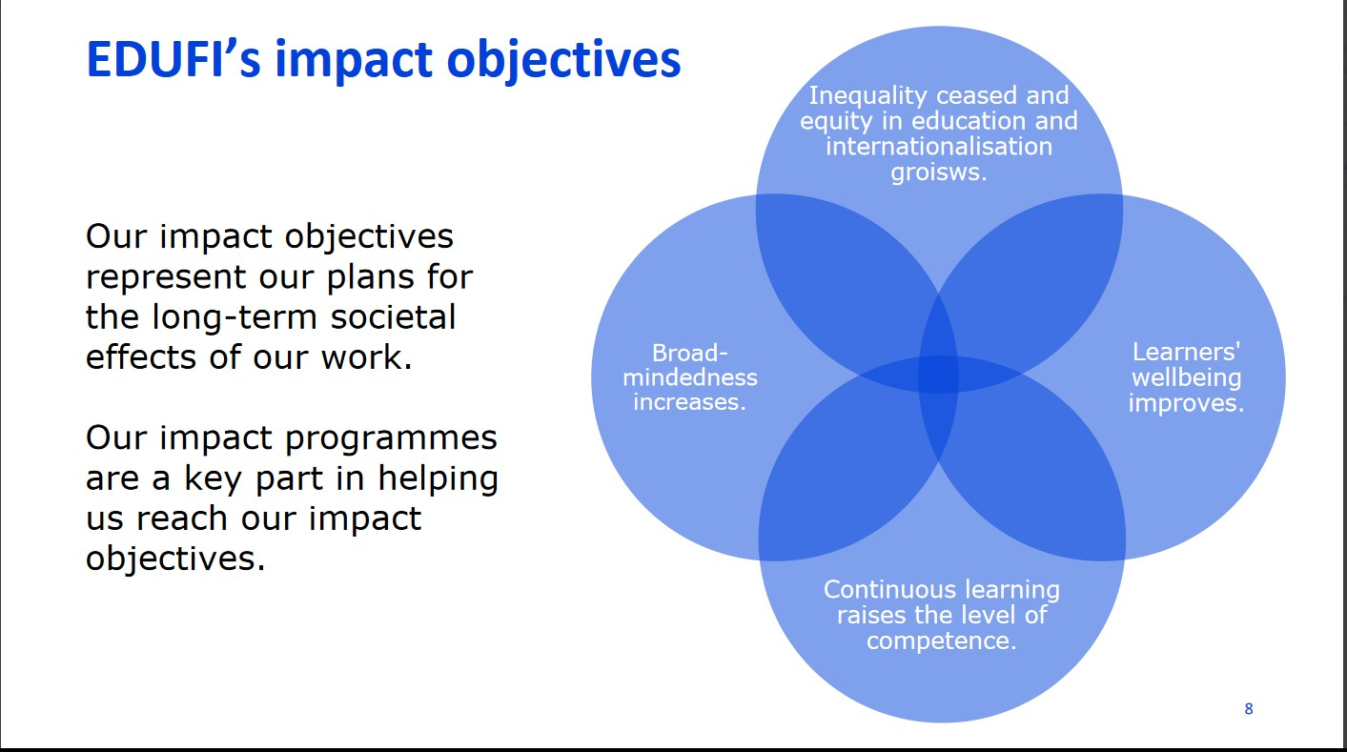

EDUFI’s action plan is structured in prioritized impact programme with specified priority areas and cross-sectoral working groups. I have led the cross sectoral impact programme priority area 4.1. focusing on *Strengthening partnerships, equality of cooperation and ethical ways of cooperation between Finnish and partners from the Global South, especially from Africa* since 2021. It was logical to build the social change initiative into my work at EDUFI and under the framework of this cooperation structure to reach as wide impact as possible. Developing ethical guidelines for cooperation with partners from the Global South was adopted as one of the set result areas for the work of this impact programme priority for the year 2023.

In practice, the impact programmes consist of colleagues from different units of the organisation working jointly towards the set goals in the specified prioritized area of cooperation. Specifically, the following areas of EDUFI’s units are currently, in the year 2023 involved in the joint work of the impact programme priority 4.1.:

* [FInCEED The Finnish Centre of expertise in Education and Development](https://www.oph.fi/en/finceed-finnish-centre-expertise-education-and-development) strengthening the role of Finland in providing solutions for the global learning crisis and enhancing Finnish capacity in education and development cooperation
* [Education Finland](https://www.educationfinland.fi/) promoting education export from Finland
* International Higher Education Cooperation unit working with funding programmes and activities promoting international cooperation of Finnish higher education institutions
* Vocational Education and Training unit
* Basic Education and Early Childhood Education and Care unit
* Internationalisation Services for Vocational Education and Training unit working with funding programmes and activities promoting international cooperation of VET sector
* Internationalisation Services for Youth, Culture and Sports working with funding programmes and activities promoting international cooperation of youth, culture and sports sectors
* Impact Coordination unit
* Organisation level antirasism expert

These units mentioned above have been actively collaborated in implementing the impact programme. They all have activities supporting cooperation with partners from the Global South which link their work together and brings additional value, as expertise from different sectors are brought together. These different units are presented in the picture below.

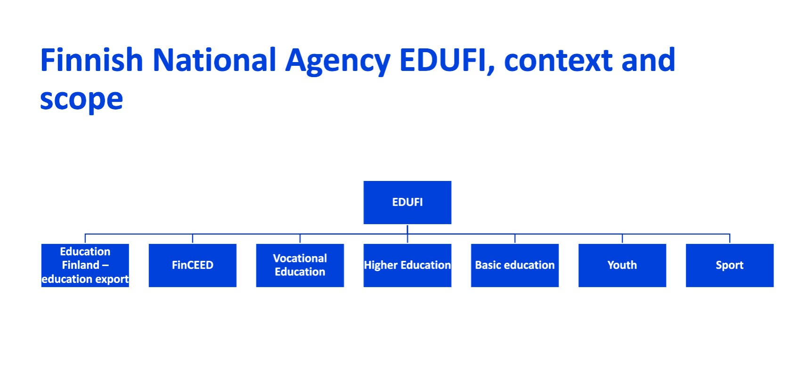

For the development of the ethical guidelines a specific task force was formed from the members of the impact programme. This smaller group, consisting of five colleagues, has been essential in the practical implementation of the actions to develop the ethical guidelines and present the work to the wider group.

The main steps of the implementation of developing the ethical guidelines for cooperation with the partners from the Global South for EDUFI programmes include:

* mapping the international examples of similar guidelines and development work
* organizing a workshop for stakeholders
* forming an expert group to support EDUFI for the development of the guidelines
* developing a draft version of the guidelines
* developing the guidelines with involvement of EDUFI staff internally
* developing the guidelines with involvement of stakeholders from different sectors
* publishing the guidelines
* including the guidelines to guidance practices of the funded projects

The development of the ethical guidelines for the cooperation with the partners from the Global South started as the impact programme was organized and could start its functions in February 2023. First step was to map international peer organization with similar guidelines and instructions. This was partly done already at the end of 2022. Developing this kind of guidelines is internationally an ongoing development in many countries. This mapping was completed and examples were saved on the shared Teams group, with access to all members of the impact programme.

[Workshop with the stakeholders](https://www.oph.fi/en/events/2023/workshop-ethical-guidelines-cooperation-partners-global-south) was organized as an two-hour online session on 10 May 2023.

The workshop was aimed at stakeholders from different sectors who have been taking part in projects funded or coordinated by EDUFI. There were 43 registered participants for the event. The participants represented higher education, vocational education and NGO sectors.

Feedback was collected during the event with the method of group discussions. The groups noted down their experiences and thoughts during the first discussion round on the challenges and on the other discussion round on the good practice and solutions. The feedback was thematically divided in four predefined areas:

* Partnership and cooperation methods and structures
* Access to information and transparency
* Language and communication
* Any other area/topic seen relevant

The participants provided their feedback and thoughts in written format via an electronic platfrom Howspace. On this platform, participants could see other participants’ comments and could also comment them. After the event, the written feedback was uploaded from the platform to be saved and further analysed. This feedback functions as the basis for the development of the guidelines.

The following steps to finalize the guidelines include developing a draft version based on the written feedback collected from the stakeholder event. Then EDUFI will invite experts from different sectors to an expert group providing their comments and expertise to refine the guidelines. The invited experts include representatives of Finnish University Partnership for International Development UniPID, Diaspora Academic Network for Africa Diana ry, as well as representatives of Youth and VET sector expert organisations.

First, there a kick-off event will be organized on 11 September to start the work and then a round of comments and development suggestions provided by the group members in written format. These comments will be then incorporated in the ethical guidelines.

Further, the draft version of the ethical guidelines will be then discussed further with the stakeholders in different events. Two of these events in 2023 include [FinCEED Forum](https://www.oph.fi/fi/finceed-forum-2023-save-date) as well as joint coordinators’ meeting for capacity building programmes on the higher education and vocational education sectors which will be organized on 24 October 2023.

It is important to develop these guidelines in a continuous discussion with the stakeholders. Even though there will be a version which will be published and shared publicly at the end of 2023, this should be seen as a developing document that can be updated in case relevant needs occur, such as based on the feedback of the project actors working with the EDUFI programmes on practical level.

The work on the dissemination of the ethical guidelines will be continued in the following years after 2023, as they will be adopted as part of the guidelines of international funding programmes managed by EDUFI on different sectors as additional guiding principles and tools to support the project implementation. On practical level, this means that the guidelines will be shared with the funded projects coordinators and partners as well as discussed and further developed in the coordinators’ meetings and other events and relevant discussion forums part of the programme management tasks of EDUFI.

These ethical guidelines are targeted not only to the cooperation of the project partners funded by EDUFI programmes, but also as internal guidelines of EDUFI cooperations. This requires also discussions and trainings of the EDUFI staff involved in the international cooperation. This work will continue in 2024 and in the coming years.

## Key findings / impact:

During the development process of the ethical guidelines, it has become evident, that the field of ethical questions and aspects in the international education cooperation is vast and there are a variety of perspectives to be included. Several aspects have been raised in the stakeholder discussions and in internal development work basing on the close cooperation with projects in the funding programmes of EDUFI. Looking into developing more equal and fair partnerships, the following issues and questions can be considered:

* awareness and understanding on the cooperation structures and communication producing unequal positions and power structures. The coordinating institution and their staff might have a long experience of project management, which is required but can also lead to situations, where the voice of partners is not heard sufficiently. How can we support the inclusiveness in project structures?
* funding instruments and their rules and goal-setting can be based on the - in this case - Finnish policies and structures and might not be fully compatible with the partners from the Global South. Even when in many cases explicitly aiming for more equal partnerships and to serve the education development needs in the Global South, these programmes have been mostly structured to fit to the policy priorities set in the Global North. How can we support equality of partnerships in the framework of programmes, in which the priorities are set, rules formulated, and the funding comes from Finland? If this is stated openly and discussed, does this support more equal project cooperation?
* access to information: is relevant information and decisions communicated openly and transparently?
* language used: local and indigenous languages are often not used or taken into consideration in project cooperation. This does not support the inclusive access to information and limits the number of people accessing it directly. Is the same information shared in languages accessible for all participants in equal manner?
* terminology: the understanding of different terminology is often context specific. Has the project consortium made sure, that they understand the main terminology used in a similar manner?
* What kind of language is being used in the cooperation? What is being indicated and what kind of power structures and positions are being communicated with the terms that we are choosing to use? One example here could be the term of so called “third countries” used in EU funding instruments as a technical term identifying partner countries outside Europe. This term positions the speaker as part of the” first world” and creates already a problematic basis for equal discussion.
* inclusiveness: does the project include relevant actors and allow participation and representation to less-advantaged groups, institutions and countries?

These are all aspects that need to be considered and discussed in practical cooperation in the projects. This is the basis and rationale for introducing the ethical guidelines for educational cooperation with the partners from the Global South.

The field of ethical considerations in international project cooperation in the field of education is vast, and there could be a wide variety of approaches and considerations included in this kind of development work. This was also seen in the discussions with the stakeholders in the workshop, where the feedback was provided on several different aspects. The participants also addressed the need to continue the discussions on these topics.

At EDUFI the development work has been narrowed down: even when the on-going discussion on variety of issues as well as theoretical aspects behind the need for the development of the ethical guidelines continues to be beneficial and welcome, the document produced with this work at EDUFI should be more hands-on and practical level guided. The document should be concise and include topics that can be grasped and addressed in projects on different fields and with different budgets and number of cooperation partners. This way the guidelines can be used as an easily approachable summary of aspects to be considered in the project work. This approach also ensures, that the colleagues at EDUFI will initiate and continue the practical implementation of using this document as part of their guidance work with the project partners.

# CHAPTER FOUR

## General Conclusion

The SCI has been successful in coordinating the process towards the ethical guidelines for education cooperation between Finnish and Global South partners. The network internally at EDUFI has been created combining the expertise and perspectives from different sectors creating also stronger commitment to the practical level adaptation of the guidelines. The stakeholder involvement has been facilitated and continues throughout the autumn of 2023.

The activities have made clear, that the ethical aspects of international education cooperation are a highly relevant theme covering a variety of different perspectives and approaches to the topic. Both EDUFI colleagues as well as stakeholders have been active in providing their feedback and have been willing to invest efforts to the further development of the guidelines. This is laying a good basis for the further steps after finalizing the ethical guidelines.

However, it has become evident, that developing the ethical guidelines and especially adopting them on practical level requires more time and efforts in the coming years. Even though the ethical guidelines development process will be published by the end of 2023, the guidelines need to be included in the practical guidance work of EDUFI and this way to the practical level of project partner’s work. As a process this will require further efforts to keep the topic on the agenda. The first steps have been taken already with the wide involvement of different players in the development work towards the ethical guidelines.

It is obvious that the SCI addresses highly relevant topic in the field of international education cooperation and the ethical guidelines will contribute as a useful tool to address these questions in the work of EDUFI and the projects funded by its programmes.

## Recommendations / implications for Policy: (500 words)

The ethical guidelines document will in itself entail the main recommendations to different actors in order to promote more equal, fair and mutually beneficial partnerships between Finnish and Global South partners. These guidelines will be used in opening dialogue on the ethical aspects in different platforms: be it EDUFI’s own operations, cooperation projects funded in different sectors, education export, cooperation of EDUFI and other Finnish actors in wider international cooperation and many others.

However, as has been stated already earlier, the key to successful adoption of the approaches described in the guidelines requires continuous efforts to keep these aspects relevant and on the agenda. The institutionalization of the guidelines is well on the way with the inclusive development process, but the coming years will be crucial when it comes to the practical implementation. It is essential, that the ethical guidelines are seen as an open, living document which requires continuation of dialogue with different stakeholder and more an invitation to discuss and address these aspects of cooperation rather than finalized one document. Otherwise, the achievement of publishing the document could be seen as an ending point of the process, rather than as a start of the actual adaptation of these principles and approaches covered in the document.

The main recommendations challenge also the very fundaments of the cooperation structures. Discussion on decolonization, for example, can open various new approaches to the collaboration networks and structures of international education cooperation. Ethical guidelines are one contribution to initiate these important discussions on different arenas.

## Sustainability plan:

My social change initiative has created a commitment for a development work, which will be ongoing for the coming years. Developing ethical guidelines for the international collaboration in EDUFI programmes is not an isolated act of creating and publishing one document, but an invitation to on-going dialogue with the partners in different stages of their project cooperation. It creates a heightened focus to be given to the ethical aspects of the collaboration and the best practices of promoting more equal and mutually beneficial partnerships.

With this social change initiative, the desired long-term impact the initiative contributes to is to increase the equal and fair ways to cooperate between Finland and African countries to increase the quality of education and to develop joint efforts to solve global challenges. By increasing dialogue on the topic on national level more awareness can be raised among the project actors and education institutions on the ethical aspects to be considered in the cooperation. By resulting to increased links between education institutions as well as people-to-people contacts of students the initiative aims at contributing to building more sustainable and equal development globally. By increasing the quality and inclusiveness of international education cooperation lasting results affecting societies and people on a profound level can be gained.

In concrete terms, the sustainability of the social change initiative is supported by the following factors.

1. EDUFI as a national level agency provides a national level resources, platform and visibility for the guidelines
2. the ethical guidelines are adopted as a guidance document for all EDUFI programmes supporting cooperation with the partners from the Global South
3. the ethical guidelines are not seen as a finalized document, but rather an invitation to an open dialogue to be continued based on the document, which can and should be updated in the future
4. based on the development of the guidelines in internal, cross-sectoral collaboration as well as in close cooperation with the stakeholders in several events and with the establishment of the expert group, the commitment for the work is supported in long-term perspective

With the methods the guidelines are being developed, includes a wide range of education sectors and actors to the development work. This increases the understanding of the guidelines as a set of jointly developed good practices rather than top-down guidance document, which might alienate project partners from the approach. This creates a strong basis for sustainability of adopting the guidelines.

In this social change initiative, the cooperation with various stakeholders and cooperation partners is essential. Partly these stakeholders are included in my existing professional network, but there are also new collaboration partners that are needed for the successful implementation as well as a need to find new ways of working with the existing connections.

An uncertainty concerning the long-term impact the initiative is contributing to, is if supporting and increasing EU-Africa and Finland-Africa connection will remain on the prioritized areas of development on the political agendas. However, as these strategies are published quite recently (2020 and 2021) and will define the priority setting for the coming years, this should not be a big risk.

# APPENDICES

## Appendix 1: Draft of ethical guidelines

**Ethical guidelines draft**

**Trust and building common understanding**

Trust and building common understanding are essential for equal and successful cooperation. Reserve time to get to know each other and structure the planning phase before entering cooperation. This could include discussion on goals and objectives, needs and priorities, roles and responsibilities, shared values and principles, communication and knowledge sharing, funding rules and context related differences, for example, values and norms. Communicate clearly, precisely and often to develop a common understanding.

**Access to information and transparency of decision-making**

Transparent and equal access to information and decision-making requires jointly agreed principles and practices, resources and time from all partners. Document the agreed arrangements in your partnership agreement.

Explore with all the partners what kind of decision-making and communication structures would serve equity and match the context of the partner institutions best.

Create equal possibilities for learning and knowledge sharing. Share the information in short and clear form and utilize the expertise in matters related to the local context, for example the language and communication etc., to ensure the accessibility to information.

**Role of language**

Languages used in the project might affect access to information, possibilities to participate, and play a role in creating power structures. In order to build equal communication, in addition to English, the relevance of local languages should be acknowledged in the project. If local languages are used, ensure interpreters’ and translators’ professionalism.

**Acknowledge the power imbalances**

Recognise and dismantle power imbalances, inequality and privileges between the partners throughout the project. Even when in many cases explicitly aiming for more equal partnerships and to serve the education development needs in the Global South, funding programmes might have been structured based on the operational contexts of the Global North.

Pay attention to possible unequal resources, such as financial, administrative and social capacity, of partners for the collaboration. Rules, regulations and conditions of funding programmes might in some case be challenging to follow within the operational contexts of partners in the Global South. These conditions should be discussed openly with partners in the beginning of the partnership as well as throughout the cooperation to support identifying practical solutions, more equal project cooperation and mutual understanding. It is also important to address openly the project administration structures and the role of coordinating institution to avoid strengthening any unintentional power structures and difficulties in the beginning of the project.

Involve all the partners from the very beginning to formulate and to express their objectives for the project and to share responsibilities. Ensure that the planned actions and results of the project match the actual needs of all partners.

## Appendix 2: Invitation to the stakeholder discussion on EDUFI website

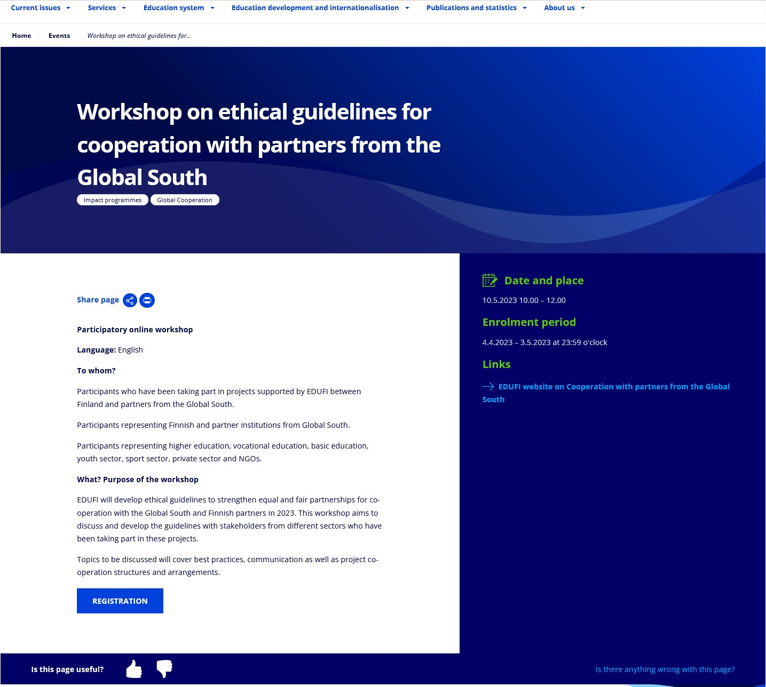

Accessed on EDUFI website: [https://www.oph.fi/en/events/2023/workshop-ethical-guidelinescooperation-partners-global-south](https://www.oph.fi/en/events/2023/workshop-ethical-guidelines-cooperation-partners-global-south)

## Appendix 3 Stakeholder workshop presentation slides

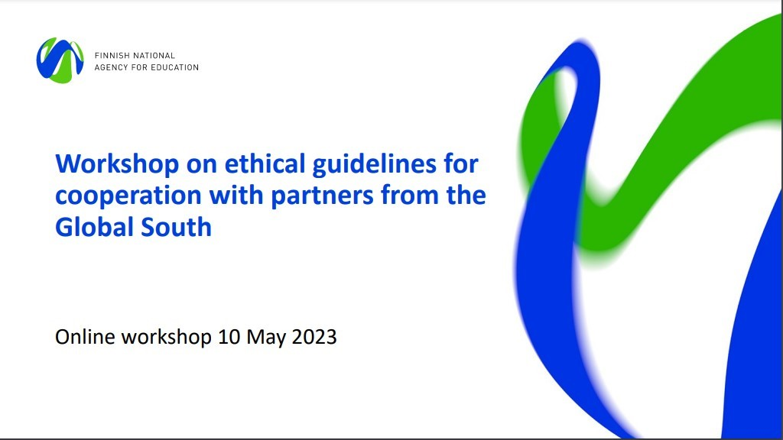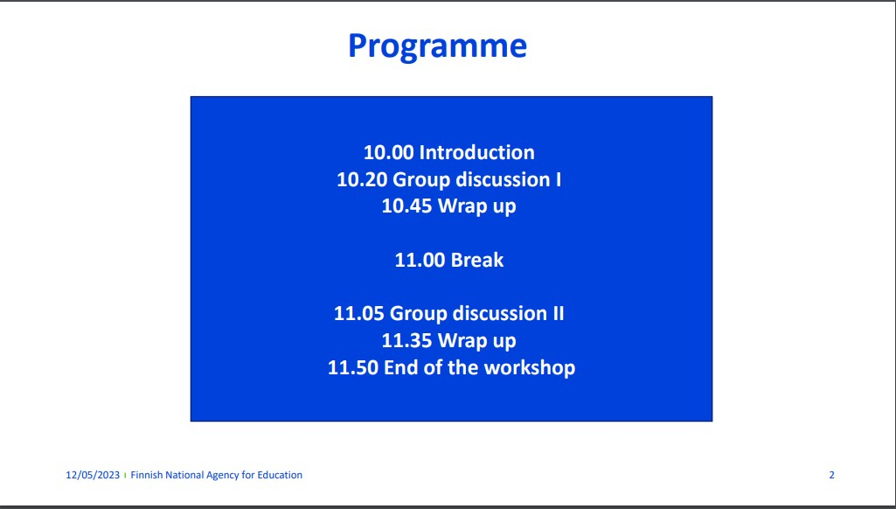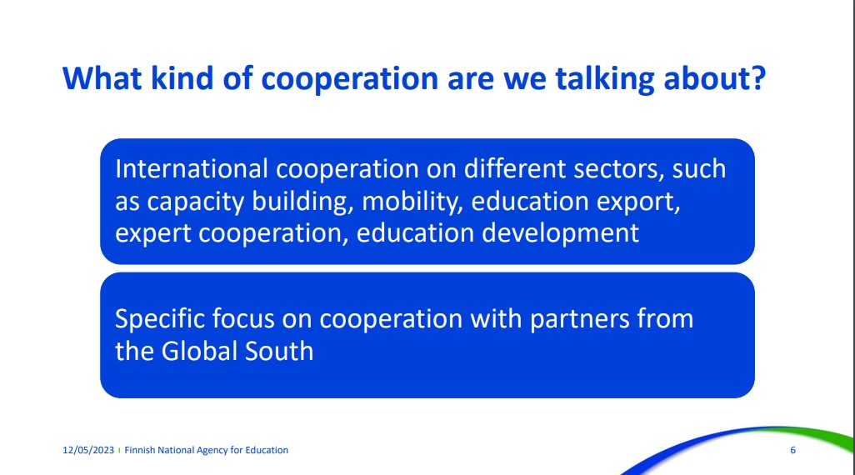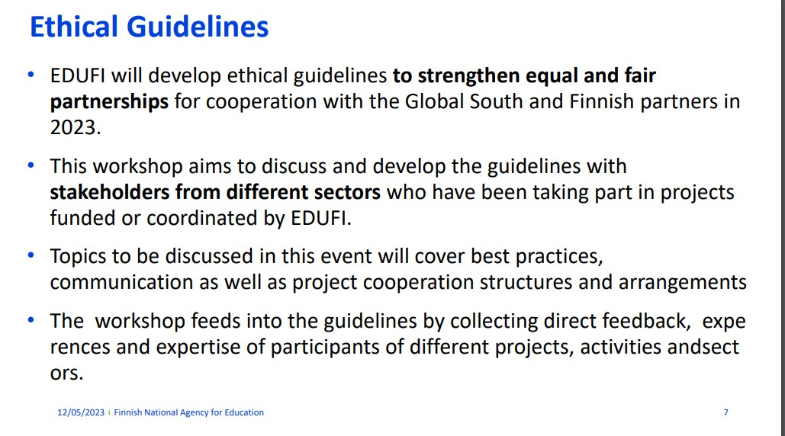

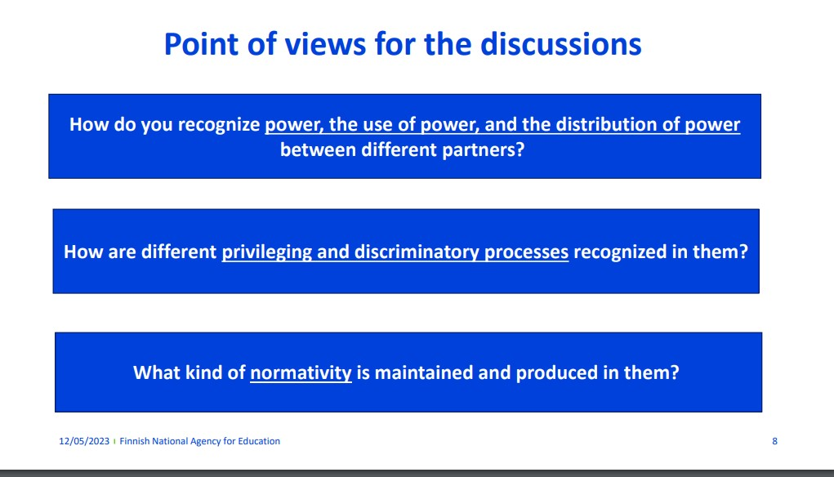

## Appendix 4 wordcloud compiled from the feedback shared by workshop participants via the electronic platform

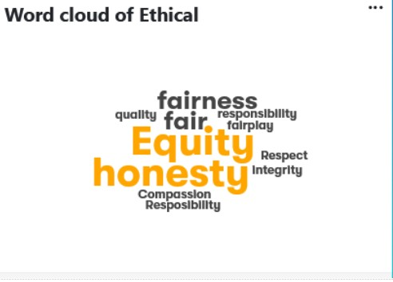

# Literature

Buckland, Peter (2005): Reshaping the future: education and postconflict reconstruction. Washington DC: World Bank.

Burke, Francesca and Millican, Juliet (2019). Working with institutions, academics and students to confront questions of peacebuilding and resistance. In Millican, Juliet (ed.). (2019). Universities and Conflict. The Role of Higher Education in Peacebuilding and Resistance. Routledge.

Chasi, Samira (2020). Decolonisation- A change to reimagine North-South partnerships. University

World News. 27 August 2020.

<https://www.universityworldnews.com/post.php?story=20200826111105105> Accessed 19.8.2023

Diamanka, Fanta ja Godwyll Francis E. 2008. Gender, Poverty, and Female Education in SubSaharan Africa. Teoskessa Francis Godwyll ja SoYoung Kang [eds.]. Poverty, education, and development.

International Association of Universities IAU and United Nations Office on Drugs and Crime

UNODC (2021). Higher Education Engages With SDG 16: Peace, Justice and Strong Institutions. Accessed online at: [https://www.iau-aiu.net/Higher-Education-engages-with-SDG-16-Peace-Justiceand-Strong-Institutions-1314](https://www.iau-aiu.net/Higher-Education-engages-with-SDG-16-Peace-Justice-and-Strong-Institutions-1314)

Millican, Juliet (2019). Introduction. In Millican, Juliet (ed.). (2019). Universities and Conflict. The Role of Higher Education in Peacebuilding and Resistance. Routledge.

Milton, Sansom. (2021) Higher Education and Sustainable Development Goal 16 in Fragile and Conflict-Affected Contexts. *Higher education* 81.1 (2021): 89–108. Web.

Milton, Sansom. (2019). Higher Education, conflict causation and post-conflict peacebuilding. In

Millican, Juliet (ed.). (2019). Universities and Conflict. The Role of Higher Education in Peacebuilding and Resistance. Routledge.

Ministry of Foreign Affairs of Finland (2019). Finland’s Africa Strategy. [https://julkaisut.valtioneuvosto.fi/handle/10024/162978](https://julkaisut.valtioneuvosto.fi/handle/10024/162978%20Accessed%206.4.2023) Accessed 6.5.2023.

McLean Hilker, Lyndsay (2011). The Role of Education in Driving Conflict and Building Peace: The Case of Rwanda. Prospects (Paris) 41.2 (2011): 267–282.

Patel, Fay (2023). Humanising and decolonising international higher education. University World

News 15.4.2023. <https://www.universityworldnews.com/post.php?story=20230413112552762>

Accessed 13.8.2023

World Bank, 2018. LEARNING to Realize Education’s Promise. <https://openknowledge.worldbank.org/bitstream/handle/10986/28340/9781464810961.pdf>Accessed 10.8.2023

[Fakunle,](https://www.universityworldnews.com/fullsearch.php?mode=search&writer=Omolabake+Fakunle) Omolabake;  [Kalinga,](https://www.universityworldnews.com/fullsearch.php?mode=search&writer=Chisomo+Kalinga) Chisomo and [Lewis,](https://www.universityworldnews.com/fullsearch.php?mode=search&writer=Vicky+Lewis) Vicky (2022) Internationalisation and decolonisation: Are we there yet? University World News 30 April 2022.

<https://www.universityworldnews.com/post.php?story=20220429105628369> Accessed 13.8.2023