**SOCIAL CHANGE INITIATIVE IMPLEMENTATION REPORT**

**Shared parenting of infants in prisons: Support for female inmates in Uganda**

**Across Uganda with headquarters at Magigye, Dembe Local Counci, Lugudo Zone, Busukuma Sub-County Kyadondo, P.O.BOX 19199 Kasanganti**

**January 2023 to January 2027**

Contents

Abstract 1

CHAPTER ONE: Introduction and Background 1

Problem Statement 2

Goals and Objectives 3

Challenges and mitigation strategies 3

CHAPTER TWO: Literature Review 4

What is independence to a child: 4

So, how do children build on their own knowledge? 5

What is agency to a child? 5

Differences between child agency and Child independence 6

Teaching independence within a classroom. 6

Limitations to teaching independence and agency within a classroom 7

Negative impacts of not promoting independence and agency 7

Theoretical Underpinnings 7

Change theory and how it was applied 8

Why Systems thinking in shared parenting project? 9

Methods and Design 10

Ethical Considerations 10

CHAPTER THREE: Interventions and Activities 11

Key findings / impact 12

CHAPTER FOUR General Conclusion 13

Future Directions 14

Recommendations / implications for Policy 14

Sustainability plan 15

APPENDICES 15

## Abstract

“Shared Parenting Project” aimed at supporting children of women prison inmates in Uganda. This was one mandatory outcome from the fellowship which I have so worked hard to realise, and a peer reviewed article is to be published from the raw data collected during the Fellowship. As a result of this fellowship, from 16th to 20th May 2024, I attended a training program in Yogyakarta, Indonesia that certifies me as a Peace Activator in Oceania by both Rotary International and IEP. Following this training. Therefore, advocacy for policies that support children affected by parental incarceration is crucial. Research emphasizes the need for systemic changes to address the needs of these children within criminal justice and educational systems. The literature suggests that targeted interventions, community support, and educational programs can significantly improve outcomes for children affected by parental incarceration. Ongoing research and advocacy are essential to develop effective policies and practices that address the unique challenges these children face. A system thinking theory was appropriate to the implementation of this project. I used a mixed method approach to implement this project and findings indicate that when supported children born to inmates can excel and have a voice in their development processes.

## CHAPTER ONE: Introduction and Background

Over 76,000 people are incarcerated in Uganda currently; most of them are probably parents, with about 3,600 being women. Children of prisoners in Uganda an average of 300, (Uganda Prison Services, March 2024) face challenges when their parents or primary caregivers face arrest and incarceration. More so, several children are left in the community where they also need to deal with stigma, inadequate care, school dropout and prejudice when their parents are involved with the Justice system. Uganda Prison Services, intends to set up regional childcare centers within major prison facilities to try to address these challenges. However, the challenge of those left behind in the community, and follow up and support to those who are resettled remains an overwhelming challenge.

UPS Model for Childcare centers provide Day care facilities so far in 4 regions out of 19 aimed at providing incarcerated women with access to affordable, high quality childcare services within prisons, and enable them to engage in vocational skills for their own socio-economic support and transformation. The centers foster early child development, social, emotional and physical development through play and early learning, adequate nutrition, rest, hygiene and sanitation.

The existing four centers were constructed by Organizations working with UPS, and three out of four run and funded by UPS, while the one at Luzira is still run by the founding organization.

One of the partnerships set up a school-based care facility for children of prisoners, both males and females, with capacity to take on a given number of children up to secondary school level. More services are required for children of prisoners, including vocational training and support for education.

Regarding resettlement of children, the family and community where the child comes from take precedence. Where there is no willing relative, different regions utilize existing care facilities in their communities in the Alternative care framework. The resettlement needs target the most critical basing on family circumstances, and then, the prisoners are categorized according to whether; they are convicted or under trial, nature of offence, level of education, age, gender, vulnerability.

Prison population, nature of prisoner’s sentence, and children’s characteristics have a social, psychological and economic bearing on the outcome of the inmates and their children. Uganda Prison Services envisage childcare models that support:

1. **Safety**: - a safe and secure home and caregiving environment, Min of Gender Approved Home Rules accommodation, general environment for Child development, kitchen, Play area Organization structure, legal registration of entity, Staffing and proposed funding source.

2**. Health:** - In-house or access to public medical care services when needed.

3. **Nutrition;** Available resources for safe preparation of nutritious and adequate meals

4. **Sanitation and hygiene**.; Access to safe water, and general hygiene practice

3. **Education:** To ensure each child has access to education and is supported to attend school.

4. **Psychosocial support;** that guarantees emotional wellbeing of children

5. **Family reunification**; through visits to the inmate. This will also involve the families or relatives of the prisoners for family bonding with the children. Counseling and coping initiatives will be supported.

6. **Socio-economic assistance** to families of children under care/ ex-prisoners, to enable children to eventually reunite with their parents.

## Problem Statement

According to prison Act 2006, Subsection 1. Article 59. Female prisoners shall be admitted and confined in special prison, or part of the prison set for female prisoners. Subsection 2. Article 59 Subject to such conditions as may be prescribed, a female prisoner may be admitted into prison custody with her infant. Subsection 3. Article 59 A female prisoner, pregnant prisoner or nursing mother will be provided special facilities needed for their conditions. Sub section 4. Article 56. An infant referred to in subsection (2) shall be supplied with clothing and other necessities of life by the state until the infant attains the age of 18 months in which case the officer in charge shall be satisfied that there is a relative or friend of the infant and willing to support it, cause the infant to be handed over to relatives or friend. The problem statement therefore is infants above 18 months are still living and staying in prisons with their mothers because relatives and friends are not available to take them and give them a different life. Some of the infants that have been handed over to families are experiencing precarious situations. There is a need to have established care for these children following the policy guidelines.

## Goals and Objectives

To carry out mapping and scoping of infants in prisons and the nature of support provided to them

To foster and advocate for the plight of infants in prisons and seek reliable support through project proposal writing and campaigns

To work towards establishing a home for infants without willing families to host them

Establish a holistic curriculum for infants who will be hosted in the established home

To train responsible carers who will manage the home for these infants

Start a not-for-profit organisation – ‘Shared parenting international’

## Challenges and mitigation strategies

Implementing a project focused on supporting children in disadvantaged situations, especially those connected to the prison system, can present several challenges: For the shared parenting project, collaborating with multiple stakeholders (prisons, NGOs, funders) can lead to miscommunication and delays. Inadequate alignment has impacted project progress and reduced effectiveness. In this project I am still trying to secure adequate and sustained funding which apparently is seeming to be difficult, especially in the current complex and competitive grant environments. I have so far established only one centre with only 15 children because of insufficient funds. The scope of the project is limited and can lead cutbacks on services. Navigating legal and regulatory requirements for establishing an NGO can be complex and time-consuming. Shared parenting international is still in the process of being registered.

Nonetheless, to mitigate the challenges, here are some effective strategies to address the challenges

I am working on strengthen stakeholder coordination whereby I have established Establish a regular meetings and clear communication channels. I have also established a shared platform for updates, concerns, and feedback to ensure all parties are aligned using different communication channels including Whatzup.

I also seek a variety of funding sources, including grants, donations, and partnerships with local Rotary clubs. Soon I will establish a robust fundraising strategy that includes outreach to potential donors and grant applications. I am also working in partnership with a law firm to have legal experts in the project to understand requirements and streamline the registration process.

I have built relationships with prison officials and demonstrate the project's benefits to gain easier access. By doing so, I have provided information sessions about the project's goals and how they align with prison rehabilitation efforts. I am also implementing an ongoing support and mentorship for caregivers after initial training sessions. Developed a feedback loop where caregivers can share challenges and successes, fostering continuous improvement. By proactively addressing these challenges with targeted strategies, the project can enhance its chances of success and create a lasting impact on the lives of children in disadvantaged situations.

## CHAPTER TWO: Literature Review

The shared parenting project is aimed at giving a chance to young people who would have otherwise been denied their childhood. From literature, evidence reveals that; parental incarceration has profound effects on children, including emotional, psychological, and social challenges. Studies have also shown that these children often experience stigma, disrupted family structures, and higher rates of mental health issues (Murray, J., & Farrington, D. P. (2008); Lee, J., & Eme, R. (2016). Therefore, the educational programs tailored for children from mothers who are incarcerated can mitigate some of the adverse effects of their circumstances. The project is further aimed at establishing a holistic curriculum that incorporates social-emotional learning have shown positive outcomes (Durlak, J. A. et al., (2011), Boethel, M., & Turner, A. (2009). Programs that provide comprehensive support for families affected by incarceration can help alleviate the stress and stigma associated with parental imprisonment. These programs often focus on parenting skills, mental health support, and community integration (Hagan, J., & Dinovitzer, R. (1999), Wildeman, C., & Western, B. (2010). Thus, Effective community-based programs for at-risk children emphasize collaboration among various stakeholders, including schools, social services, and community organizations. A multi-faceted approach can lead to better outcomes for children. (Garbarino, J., & Costanzo, P. R. (1994), Jaffee, S. R., & Moffitt, T. E. (2003). The sections below bring out the intentions of the project to create independency and agency among children.

### **What is independence to a child:**

Independence is perceived by children as freedom, having the ability to make their own decisions or simply having control over certain things they do. A study undertaken by Kate Adams highlighted that some children look up to adult figures, wanting more of the freedom and independence they have (Adams, 2014). For instance, children want to undertake simple tasks themselves, such as tying their own shoes. These simple tasks not only contribute to building a child’s confidence, but they also slowly introduce independence into children’s lives.  There are limitations however, as to how much independence a child should have. In certain situations, such as crossing a busy street, a higher level of knowledge is required to keep a child safe. For this example, an adult must provide guidance to ensure the child is making the right decision and crosses the street safely.

### **So, how do children build on their own knowledge?**

Most children develop their knowledge and understanding through personal experiences, social constructs and the opinions of peers.  These can influence and build upon a child’s own perceptions throughout their life, including their understanding of what childhood means to them. This can be seen in (Adams, 2014), where various children were asked to describe what a child is in their own words.  A common factor in the responses was the use of words to describe being dependant on and the feeling of being smaller when compared to an adult figure. One child stated that children have less power over an adult, which could potentially affect both their self-worth, as well as their ability to do things confidently and independently in the future.  These responses to being more reliant on others, and the use of physical descriptors that children are ‘smaller’ shows their awareness of personal experiences and feelings.  This can impact a child’s development of independence when their feelings are affecting them further in public spaces.  For instance, within (Adams, 2014), a child states how small she feels when in busy places, with people’s lack of care and acknowledgement, when stepping on the child’s toes. This can make a child feel unseen, potentially affecting their personal voice in later life.

### **What is agency to a child?**

Similar to Independence, agency for children is the process of having control and to negotiate or have a say in decision making. This also relates to the decisions they make towards activities or what occurs within their community.  There has been a gradual change overtime that has seen an increase in children having more freedom to talk to adults and making their own decisions regarding their childhood (Adams, 2014). For instance, they are able to discuss and negotiate with their parents about doing their homework after an hour of play. This not only enables the child to feel like they are able make their own choices, but it also allows them to develop their own style of learning.

There has been a gradual change overtime that has seen an increase in children having more freedom to talk to adults and making their own decisions regarding their childhood (Adams, 2014). For instance, they can discuss and negotiate with their parents about doing their homework after an hour of play. This not only enables the child to feel like they are able to make their own choices, but it also allows them to develop their own style of learning.​

## Differences between child agency and Child independence

Independence is defined as- freedom from the control and influence of others.  Child agency- is about having the ability to make decisions that influence and impact one's life. agency is the capacity to do things, to act on the world, and to make a difference (Oswell 2013). This is in the context of situations with teachers and peers within a school environment, but this can also relate to outside of the school environment with parents and other authoritative figures.

Within a classroom setting student independence can be limited as it is the teacher's role to schedule and organize their student's day. However, depending on the stage of development, the student's ability to perform independent learning tasks will vary to accommodate different levels of learning. For example, separate groups for a worksheet task. Where one group is more independent than maybe others who might need a little more guidance. Whereas child agency is important for their development as this is where they learn the necessary problem solving and decision-making skills and therefore integrated into their learning.

## Teaching independence within a classroom.

Teaching independence is vital for Children’s self-esteem and overall wellbeing. When children have opportunities to make choices, to attempt tasks for themselves, and to take on increasing responsibilities, their sense of self as competent students within the classroom grows.  For example, giving students small and manageable tasks based on their skill level such as putting their bags away or helping to set up an arts and crafts station, this helps them to understand responsibility and gives them a sense of independence as they have completed this task by themselves. This concept of teaching independence in a classroom also closely links to teaching agency within a classroom.

Teaching child-agency is all about giving students a choice and a voice within the classroom. Child agency is vital for development of problem-solving skills and creating educated opinions. These skills are necessary at all levels but mainly in preschool and kindergarten through primary school years. Without teaching the consequences of child agency, such as decision-making, children may struggle with consequences.  This teaches responsibility, and that their choices have consequences.   The shared parenting Centre will help children develop these decision-making skills so they can make good choices and to recognize the responsibilities that come with decision making. Especially in a classroom setting.

## Limitations to teaching independence and agency within a classroom

Teachers tend to avoid offering choices to students because it may not be effective as part of a daily routine, especially from an educator’s perspective where children’s differing opinions can complicate daily structure. This could be due to differing opinions within the classroom. An example of a simple decision students can make that won't interrupt routine is giving a selected choice to students. For example, they can vote on whether the class reads book A or B. this gives them the sense that they made this decision on their own while also keeping control of the outcome. Due to the nature of teaching independence and child-agency caregivers can have some backlash from students as they are learning to test the boundaries and are gaining an understanding of consequences for their decisions

## Negative impacts of not promoting independence and agency

When children have interrupted or negative impact on wellbeing; they usually struggle to complete task independently thus affects their problem-solving skills. Children struggle to form educated personal opinions. These overall impacts student development within the classroom. Showing that teaching independence and child agency is vital within the classroom.

## Theoretical Underpinnings

The 1980s showed a change in how education for students and teaching methods were changed. The focus was on making a difference in the classroom to improve student achievement through restructuring of schools as well as developing and implementing strategies to develop school effectiveness. Primarily through curriculum, teaching strategies and the learning of the students. Developmental theorists began researching and considering how individual children developed and learnt, offering a vital understanding of child development through cognitive, emotional, physical, social and educational from birth to adulthood. Jean Piaget, Lev Vygotsky, Lawrence Kohlberg, Urie Bronfenbrenner, Fredric Skinner, Erik Erickson and Alfred Adler provided individual interpretations into child development and behaviour which helped shape our education system today.

Piagets theory of cognitive development looked at how children processed information through perception and language abilities. Vygotskys theory saw the cognitive development through social interaction and play. Kohlbergs theory was based on behaviour and how children saw right from wrong. Bronfenbrenners theory looked at how the child’s environment assisted with development. Skinners theory was influenced by psychology and developmental with operant conditioning which focused on behaviour with rewards and reinforcers. Ericksons theory of psychosocial development believed that learning happened in stages of individual development in correlation with the social environment over ages and stages of growth. Adlers theory had a more holistic approach which recognised that everyone had a sense of belonging and significance and would learn if they felt encouraged to do so. Professionals in the educational field took parts of these theorists studies to incorporate into their own individual teaching styles. Students were no longer expected to just learn from Direct Instructional teaching, instead based on the theorists, children would also learn through scaffolding and inquiry based learning methods. It became more about the students own self worth of learning and achievement rather than what was expected of them.

The restructure of the educational system also meant that teachers developed a new style of teaching which gave students who performed lower with direct instructions were given an opportunity to be effective and productive learners using these other skills. The remodelling of the educational system explained what was needed for student achievement through a detailed description and began with teachers becoming more aware of how to address the curriculum following the development of the curriculum and standards framework. This enabled a consistency for all year levels and allowed the teachers with a path to follow. It also added value to students for effective and productive learning.

Also in the remodelling of the educational system was the development of the Teachers Union and Teachers Associations which gave teachers and professionals standards to follow as well as recognition for the work they were doing. It set a new standard of teaching as well as assisting with individual student performance and outcomes. Teachers and professionals began having more formal training and education to meet the standards needed, based on what theorists had researched and suggested, to ensure adequate and educational achievement. It is here that teaching began to look more into preparation and presentation as well as collection of data, learning targets and specific assessments to ensure outcomes were met and individual performance was up to standard.

Along with teaching standards was the development of salaries for teachers and professionals based on years of experience. This ensured teachers and professionals were adequately paid for their years of service and provided students with a higher level of education. There became no limit for teaching students who were disadvantaged or struggling as these new teaching methods became effective across the board with teachers focussing on the individual achievements now rather than focusing on trying to address everyone the same. It became an educational success for all as teaching and teaching practices moved forward to ensure all had the same educational achievement.

## Change theory and how it was applied

In this project, A systems thinking theory was used. Systems thinking represents a potent framework for analysing complex phenomena, offering a means to understand the networks of relationships within systems. Derived from the study of biological, ecological, and mechanical systems, the approach has been employed in fields ranging from business management to public health, from manufacturing, logistics to urban planning, though for social systems, systems thinking is still in its early stages of development.

The strength of systems thinking lies in its capacity to reveal patterns, interdependencies, and feedback loops, and thereby model outcomes based on systemic interactions. It offers a particularly useful approach for understanding how changes in one part of a system can flow-on effects throughout the system have, allowing for better decision making and policy making.

This is facilitated by understanding that such systems have momentum and direction. They can be described as moving in virtuous or cycles with stimuli and shocks having cascading effects and social feedback loops amplifying the drivers of either progression or deterioration. By recognising the dynamics that lock systems into such cycles, the cycles can be redirected, either through small scale nudges or large-scale reforms, to produce better social outcomes.

Systems thinking is central to the IEP’s conception of Positive Peace. It represents a holistic approach to understanding and solving complex problems by assessing them in terms of interconnected wholes, rather than breaking them down into isolated components. It is a way of analysing the world which entails focusing on the connections between the relationships and flows of the components of the system to understand the dynamics of the whole.

## Why Systems thinking in shared parenting project?

Interconnectedness is important and understanding the strength of a system when all pillars are stimulated and how small changes can make a difference. “It takes a village to raise a child”

Data vs emotional attachment (we can keep looking at the impact from data as opposed to people’s reactions and actions) if we don’t use a systems thinking. Relating to people’s context and people understanding to their own growth is made possible through the systems thinking.

The role of creativity and storytelling – the systems thinking enable people’s voices to be heard and acknowledged. Enhancing community resilience by increasing levels of positive peace in and around prisons will be made possible by employing the systems thinking.

Sustainability practices and equitable access will be made possible through strengthening all the components. Good practices and how they will be continued will be made apparent using the systems thinking. By employing the systems thinking, we avoid the assumptions that there may be poor relationships due to inequitable distribution of resources. The systems thinking theory ensures participation of all stakeholders in the care for children and young people. Thus, capacity building for women inmates in childcare will be made possible. Above all else communication channels and centre management and continuity will benefit the rest of the community because systems thinking challenges power sharing within partnerships. Thus partners will include mothers and children and their families , government and other community-based organisations, Rotary club international and local peace building organisation.

## Methods and Design

Employing a mixed-methods approach, robust data collection techniques, and ethical considerations has enhanced the effectiveness of this project. By integrating various methods, the project was able to achieve a comprehensive understanding of the needs and challenges faced by children affected by parental incarceration, ultimately leading to more informed interventions and support strategies. According to Creswell, J. W., & Plano Clark, V. L. (2017), Combining quantitative and qualitative methods allows for a comprehensive understanding of the issues at hand. This approach can capture both statistical data and personal experiences of children and caregivers. The selection of participants was based on specific criteria relevant to the project, such as parents currently incarcerated or children living in disadvantaged communities. This ensured that the sample is representative of the target population. I also utilized existing participants to identify and recruit other potential participants, which was useful in hard-to-reach women and children. I have thus developed a logic model outlining the inputs, activities, outputs, outputs, outcomes, and impact of the project. This provides a framework for evaluation. Ultimately, the methods and methodologies including clear quantitative and qualitative indicators were useful to measure success, such as the number of children reached, satisfaction ratings from caregivers, and improvement in educational outcomes.

## Ethical Considerations

I tried to ensure that all participants understood the purpose of the project and provide informed consent before participating. These included families of the inmates and mothers of the participating children. Maintain confidentiality and anonymity of participants’ data to protect their privacy, especially given the sensitive nature of the subject matter was prioritised in this project.

## CHAPTER THREE: Interventions and Activities

**Log Frame**

|  |  |  |  |  |
| --- | --- | --- | --- | --- |
| **Activity** required steps/list of tasks to carry out the SCI | **Target/Objective** the desired result | **Baseline** a reference point to evaluate performance | **Indicators** quantitative or qualitative parameters to assess progress and success | **Means of Verification** methods or tools to collect data that shows the achievement of an indicator |
| Mapping | Identify the potential beneficiaries | 33 Prisons visited to identify the number of children and their age range | 15 Children Identified | Phone calls to the Officers In Charge |
| Project Proposal | Establish a log frame for establishing the children’s center | A full proposal highlighting the roadmap is written | Source funding for the Centre | Reach out to Rotary Club of Sydney and that of Ntinda Uganda |
| A holistic curriculum | To have a systematic program for infants at the Centre/Home | Put up a framework that the curriculum will be based on | A curriculum is written and easy to reference | Visit other early childhood centers and align the curriculum to what they offer |
| Train carer givers | Create awareness on how to care and support children from disadvantaged communities | 10 Carer teachers are trained | 5 trained in the first cohort and 5 more before the end of the year | Use online and face to face trainings |
| ‘Shared parenting international is registered. | To establish a Not-for-Profit Organization that will be responsible for liaising with Uganda Prison services | Shared parenting international constitution is written | Registered NGO | Employee a lawyer and care worker to follow up the registrations |
|  |  |  |  |  |

This table above outlines a project aimed at supporting children in disadvantaged situations, particularly those with ties to prisons.

Visit 33 prisons to identify children and gather demographic data. So far the project has identified 15 children and understand their age range.

The number of children identified (15) serves as a performance reference. This is the baseline number that will be progressively increased. Data collected through phone calls to prison officers confirms the number and details of identified children. Thus these activities have helped in creating a detailed project proposal (log frame) for a children's center. The roadmap to guide the establishment of the center is in place. Outreach efforts documented through communication with Rotary Clubs in Sydney and Ntinda, Uganda. Design a structured curriculum for infants is ongoing.

Comparison visits to other early childhood centers to ensure alignment with best practices has been done. Training for 10 caregiver teachers on childcare best practices has been done. Trainings were both online and in-person sessions. Established a Not-for-Profit Organization. Created a formal entity to work with Uganda Prison Services and the ministry of Gender. A written constitution and legal registration of the NGO in place. Overall, the table outlines a structured approach to achieving specific objectives related to child welfare, emphasizing clear tasks, desired outcomes, benchmarks for evaluation, and methods for verifying success. Each activity is aimed at building a supportive infrastructure for children affected by the prison system.

## Key findings / impact

The projects aimed at supporting children affected by parental incarceration which has yielded to several important findings and impacts that highlight its effectiveness and relevance.

The project successfully identified and documented the unique challenges faced by children with incarcerated parents, including emotional distress, social stigma, and educational setbacks.

This increased awareness has led to more targeted interventions that address specific needs, ultimately improving the quality of support provided.

By mapping potential beneficiaries and connecting them with local services, the project has facilitated better access to educational, psychological, and social resources. Children and families reported higher satisfaction levels and improved well-being due to increased access to necessary support services.

The project established a comprehensive curriculum tailored to the emotional and educational needs of children affected by parental incarceration. Educational outcomes have improved, with children showing greater engagement in learning and better emotional regulation.

Training for caregivers has led to increased awareness and improved skills in providing emotional and practical support to children. Caregivers reported feeling more competent and confident in their roles, contributing to more nurturing environments for the children.

The project fostered collaboration among various stakeholders, including schools, community organizations, and local governments. Enhanced community ties have led to a more supportive network for families, reducing stigma and promoting collective responsibility for children’s well-being.

## CHAPTER FOUR General Conclusion

The project aimed at supporting children affected by parental incarceration addresses a critical social issue with far-reaching implications. Through a comprehensive approach that includes identifying beneficiaries, developing educational curricula, training caregivers, and fostering community support, the project seeks to create a nurturing environment for these vulnerable children. Key findings indicate that children with incarcerated parents face numerous challenges, including emotional distress, social stigma, and educational setbacks. By implementing targeted interventions and holistic support systems, the project can mitigate these impacts and promote resilience among these children.

Successfully mapping and identifying children in need has established a foundation for targeted support. Development of a holistic curriculum tailored to the unique needs of these children can enhance their educational outcomes and emotional well-being.

Training caregivers equips them with the skills necessary to provide effective support, fostering a more nurturing environment. Building partnerships with local organizations and stakeholders has strengthened community ties, promoting a collective responsibility towards the welfare of these children.

## Future Directions

Continued advocacy for policy changes and funding will be vital to support the ongoing efforts to assist children impacted by parental incarceration. This project not only aims to provide immediate support but also seeks to pave the way for systemic change that acknowledges and addresses the complex realities faced by children in these circumstances. Through dedicated efforts, we can foster a brighter future for these children, breaking the cycle of disadvantage and empowering them to thrive.

## Recommendations / implications for Policy

The project aimed at supporting children affected by parental incarceration has several important policy implications that can enhance its effectiveness and sustainability.

Strengthening policies that prioritize the welfare of children with incarcerated parents can ensure that their unique needs are addressed. Advocate for the inclusion of specific provisions in child welfare legislation that focus on the rights and well-being of these children, promoting access to services such as counselling, education, and family support.

Schools need to be equipped to support children affected by parental incarceration, as they may face unique challenges in academic and social settings. Promote the development of training programs for educators on the impacts of parental incarceration and strategies for providing supportive environments. Encourage the integration of social-emotional learning programs within schools.

Policies aimed at improving rehabilitation and reintegration of incarcerated parents can positively affect their children. Advocate for comprehensive programs that facilitate family connections during incarceration, such as parenting classes and family therapy, to maintain bonds and improve outcomes for children.

Adequate funding is crucial for programs targeting the needs of children with incarcerated parents.

Lobby for increased funding to support community-based programs and initiatives aimed at this demographic. Ensure that resources are allocated effectively to reach the intended beneficiaries.

Strong partnerships between government agencies, non-profit organizations, and community groups can enhance the effectiveness of support programs. Promote policies that encourage collaboration among stakeholders to create a comprehensive support network for families affected by incarceration.

By addressing these policy implications, the project can not only enhance its immediate impact but also contribute to systemic changes that support the long-term well-being of children affected by parental incarceration. Collaborative efforts among policymakers, service providers, and community stakeholders will be essential to create a comprehensive framework that supports these vulnerable children and their families.

## Sustainability plan

Ensuring the sustainability of a project aimed at supporting children affected by parental incarceration is crucial for its long-term impact and success.

Seek multiple funding streams, including grants, donations, and partnerships with local Rotary clubs. Develop a comprehensive fundraising plan that includes grant writing, donor engagement, and crowdfunding initiatives. Engage the community actively in the project’s planning and implementation to foster ownership and support. Create opportunities for community members to participate in program activities, volunteer, and provide feedback. Form a community advisory board to guide the project.

Engage in advocacy efforts to influence policies that support the needs of children affected by parental incarceration. Collaborate with policymakers and stakeholders to promote policies that secure ongoing funding and resources for programs serving this population.

By implementing these strategies, the project can establish a solid foundation for sustainability, ensuring that it continues to support children affected by parental incarceration in the long term. A commitment to community engagement, effective partnerships, and continuous evaluation will be key to adapting to evolving needs and maintaining impact over time.

# APPENDICES

References

Boethel, M., & Turner, A. (2009). An overview of the literature on family involvement in children's education. *National Center for Family & Community Connections with Schools*.

Creswell, J. W., & Plano Clark, V. L. (2017). *Designing and Conducting Mixed Methods Research*. Sage Publications.

Durlak, J. A., Weissberg, R. P., Dymnicki, A. B., Taylor, R. D., & Schellinger, K. B. (2011). The impact of enhancing students' social and emotional learning: A meta-analysis of school-based universal interventions. *Child Development*, 82(1), 405-432.

Garbarino, J., & Costanzo, P. R. (1994). Fathers in prison: Implications for children's development. *Child Development*, 65(1), 184-197.

Hagan, J., & Dinovitzer, R. (1999). Collateral consequences of imprisonment for children. *Crime and Justice*, 26, 121-162.

Jaffee, S. R., & Moffitt, T. E. (2003). Life-course persistent versus adolescence-limited antisocial behavior: Clarifying the role of the family in the development of antisocial behavior. *Child Development*, 74(1), 64-80.

Lee, J., & Eme, R. (2016). The impact of parental incarceration on children's mental health: A systematic review. *Journal of Child Psychology and Psychiatry*, 57(9), 933-940.

Murray, J., & Farrington, D. P. (2008). The effects of parental imprisonment on children. *Crime and Justice*, 37(1), 133-206.

Wildeman, C., & Western, B. (2010). Incarceration in fragile families. *The Future of Children*, 20(2), 95-117.

Pictorials Max **5pgs** with descriptions

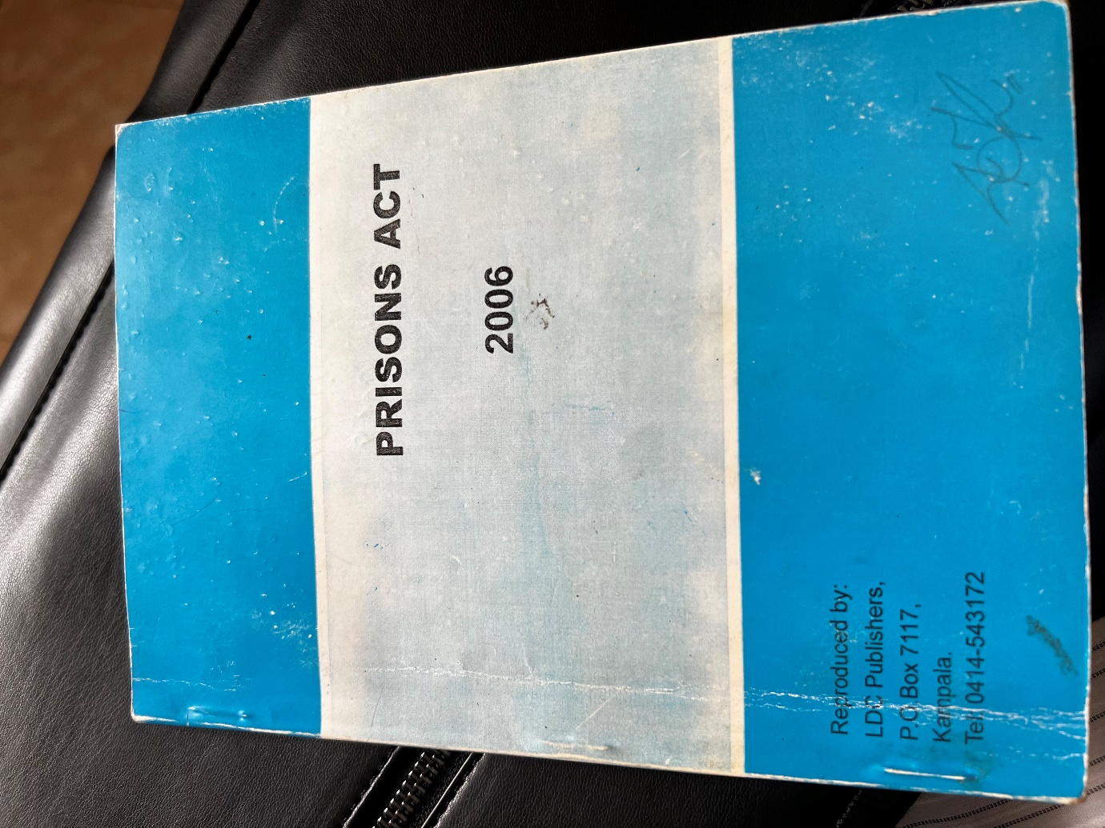

The policy which forms the basis for current policy gaps

28 November2023, Meeting with the Prison Commissioner

.

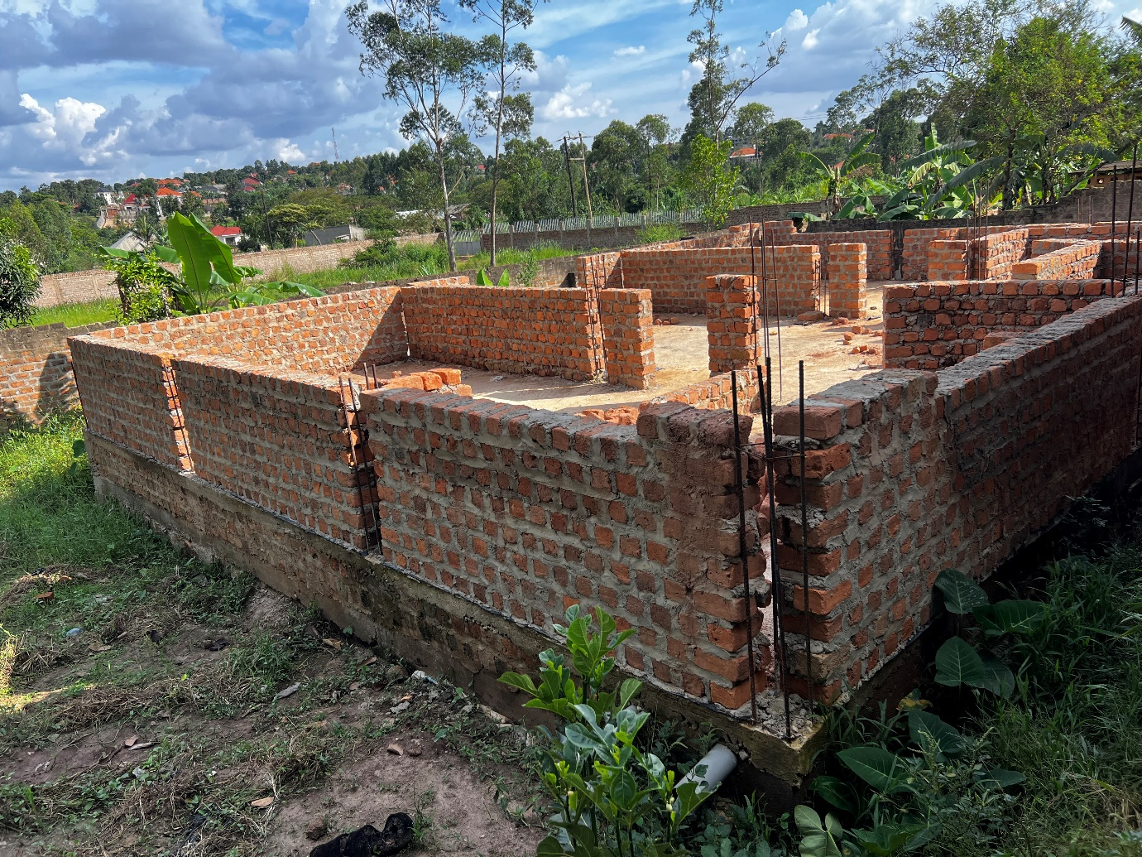

In mates in a general meeting

