|  |  |  |  |  |
| --- | --- | --- | --- | --- |
| **Project Title:** | Empowering Police Officers to become Agents of Positive Social Change in East and West Freetown | | | |
| **Implementor** | Sulaiman Sesay, Rotary Peace Rellow, Cohort 5, Makerere University. | | | |
| **Geographic Coverage** | East and West Freetown. | | | |
| **Project Duration:** | **Start** | May 2023 | **End** | December 2023 |

**ABSTRACT**

This Social Initiative (SCI), is designed to empower Police officers, transforming them into Agents of Positive Social Change in both East and West Freetown. Recognizing the pivotal role of law enforcement plays in shaping societal dynamics, the project sought to shift the police force’s role from traditional enforcement to proactive engagements in fostering community well-being.

The implementation strategy focused on a multifaceted approach, involving training programs for Senior and junior police officers, members of the Civil Society Organizations, community dialogue and engagement between members of the Civil Society Organizations and police personnel.

At the project inception, the Sierra Leone Police, especially those in Freetown, were faced with challenges of public mistrust, corruption and a perceived lack of accountability. The transformative initiative, guided by a theory of change, envisioned that by reshaping police officers’ attitudes, improving community relations, and implementing organizational change or reforms, a positive ripple effect would lead to enhanced social cohesion that will in turn build trust and respect between police and community members forming the basis for accountability of police actions or inactions and creating a conducive environment for the realization of the eight pillars of positive peace.

This change also included improved community-police relations, instances of corruption, and a noticeable shift in the perception of law enforcement, as Police officers will be seen not just as enforcers of law but also as partners in community development.

The intervention strategy involved conducting focus-group discussions with stakeholders in various communities and collaborating with sister institutions such as the Independent Police Complaint Board (IPCB), Anti-Corruption Commission of Sierra Leone (ACC-SL), Office of National Security (ONS), Independent Commission of Peace and National Cohesion (ICPNC), Human Rights Commission of Sierra Leone (HRCSL), the Local Policing Partnership Boards (LPPBs) of the Sierra Leone Police, and the Executive Management Board (EMB) of the Sierra Leone. Training sessions and reflections engagement meetings were to be organised for both Senior and Junior Police officers, emphasising the Positive Peace Framework, Restorative Dialogue and the Concept of African Peace Philosophy. This approach aimed to create a deliberate and conscious forum for dialogue between community members, the police and external oversight institutions, facilitating the resolution of issues without resorting to violence or ant-social behaviours.

The initiative demonstrated that transforming police officers into agents of positive social change is feasible through a combination of community involvement, targeted training and internal reforms. The project success suggests that collaborative efforts between law enforcement and communities can redefine the role of police in any society.

The following were some of the recommendations proposed in this project:

1. Enhance recruitment and training process
2. Strengthen Internal and External Oversight Mechanisms
3. Implement Community Policing strategies
4. Invest in officer welfare and motivation.

The report is divided into four chapters. The first chapter explores the background of the study, providing insight into the research topic, analyzing the statement of problem and outlining the goals and objectives of the research.

Moving on to the second chapter, the researcher reviews relevant literature and explores theoretical underpinnings related to the research topic, referencing specific authors in the process.

The third chapter elaborates on the methodology employed by the researcher detailing aspects such as the study area, research design, data collection methods, data analysis, techniques, and the instruments used, including questionnaires, training sessions, interviews and observations.

The fourth chapter the researcher analyzed the data based on the findings:

1. which include a relatively high percentage of police officer believing that corruption is endemic in the Sierra Leone Police
2. The influence of Senior Police Commanders in demanding kickbacks from junior police personnel serve as a recipe for corruption within the Sierra Leone Police
3. Failure on the part of Police officers to adhere to the rules of engagement during police operations leading to potential harm of death and contributing to civilian deaths
4. That the empowerment of the Independent Police Complaint Board would the professionalism of the Sierra Leone Police.

The researcher analyzed these data to explain the trend of the participants’ opinions and reactions to police activities to represent the quantitative methods. Face-to face interviews and observations were also conducted. The chapter concludes with recommendations and sustainability plan.

.

.

**Chapter One**

* 1. **Introduction**

Goal 16 of the United Nations Sustainable Development Goal (UNSDG) of Agenda 2030 prioritizes on Peace, Justice and Strong Institution. Rotary International aligns with this goal through its commitment to “Promoting Peace through dialogue”. Within the Framework of Positive Peace, focusing on pillars such as ‘Acceptance of the Rights of Others’, ‘Good relations with neighbors’, ‘free flow of Information’ and ‘Low levels of corruption’ contributes to peaceful co-existence and development. While these frameworks do not explicitly mention ‘Security’, the success of these endeavors is intricately tied to ‘Safety and Security. The absence of this crucial factor would make achieving these goals challenging, if not impossible, underscoring the centrality of Security as a principal prerequisite for peaceful co-existence and development. Principal factor, will be difficult, if not impossible for the attainment of these goals, thus giving credence to the primacy of Security which serves as a principal prerequisite for peaceful co-existence and development.

In Sierra Leone, the paramountcy of internal security rests with the police. In situations where community members are in constant confrontations with the police, it prompt necessary questions.

The project aimed to enhance the capacity of Police officers to champion the rights of people in their communities and strengthen the police-community relations to address instances of corruption. This was to be accomplished through training sessions, engagement meetings with Senior and Junior Police personnel of the Sierra Leone Police (SLP), orientation sessions, and engagements with Police officers, community dialogues and reflections meetings involving Sister Agencies and other stakeholders in the community. Key project activities were intended to include training, reflection engagements, and discussions centered on the Positive Peace Framework, Restorative dialogue and Concept of African Peace Philosophy. Target participants included Senior and Junior Police officers from Police Divisions in the Western Area, selected officers from the Complaint, Discipline and Internal Investigations Department (CDIID), Community Relations Department (CRD), Training Department, and members of the Local Policing Partnership Boards (LPPB) in the Western Area, Freetown.

Regrettably, due to the lack of cooperation from the Executive Management Board of the Sierra Leone Police, I was unable to implement the planned activities

This report is divided into four chapters. Chapter 1 tackles the background, providing insight into the research topic analyzing the statement of problems, and outlining the goals and objectives this is followed by chapter 2 which reviews relevant literature and explores theoretical underpinnings related to the research topic, referencing specific authors.

The third chapter elaborates on the methodology employed by the researcher, detailing aspects such as the study area, research design, data collection methods, data analysis techniques, and the instruments used including questionnaire, training sessions, interviews, and observation. In the fourth chapter, the researcher analyzed these data to explain the trend of the participants’ opinions and reactions to police activities to represent the quantitative methods. Face-to face interviews and observations were also conducted. The chapter concludes with recommendations and sustainability plan.

**1.2. Background**

Sierra Leone has grapple with a range of social, political and economic challenges, including issues relating to Institutional reform. The Sierra Leone Police, a key Institution within the Security Sector Reform Programs, underwent significant restructuring supported by both the United Nations Mission in Sierra Leone (UNAMSIL) and the British Government. At the conclusion of these reforms, the Police’s professionalism received commendation. However, a decade and a half later, the narratives surrounding police professionalism have surfaced, dominating headlines in the national News across electronic and print media in Sierra Leone. These issues pose a threat to SDG 16, Rotary Cause’s Goal number 1, and the four pillars of the Positive Peace Framework

For the past fifteen (15) years, allegations abound that police activities in Sierra Leone have been marred by corruption, unprofessionalism, mistrust, arbitrary arrest, and violent confrontations with community members, resulting in casualties among both police officers and civilians. The 2022 Annual Report of the Human Rights Commission in Sierra Leone highlighted instances of arbitrary arrest, unlawful killings, and arbitrary arrest and detention. Based on these statistics, it appears that the Sierra Leone Police has deviated from its Community Policing principles, leading to a breakdown of trust and confidence between the police and the community. The police are increasingly perceived as a “repressive arm” of successive governments in Sierra Leone. Consequently, citizens seek ways to confront police officers during riots or political instability as a means of expressing dissatisfaction the law enforcement.

1.3**. Statement of Problem**

Danny Singh’s (2022) article titled “Causes of Police Corruption and Working towards Prevention in Conflict-stricken” States:

In any given society, policing is fundamental for both law enforcement and criminal justice. The police have a wide-ranging mandate to protect internal security, control riots, and engage with communities to reinforce friendly relations and public trust. Alongside this broad mandate, the respect of human rights, communal relations, and upholding the rule of law are key policing values. Even in highly industrialised societies, human rights abuses, police brutality, police malfeasance, and police corruption and criminality can still exist and hinder the credibility of police departments when exposed (Singh, 2022)

This statement highlights a concerning situation in Sierra Leone, specifically focusing on the tension between the police force and the community, leading to violent clashes. According to Amnesty International Sierra Leone, the August 2022 protests resulted in the tragic loss of twenty protesters and six police officers[1], shedding light on the deep-seated animosity between law enforcement and the community.

Furthermore, the Human Rights Commission of Sierra Leone’s annual report for 2021/2022 reveals disturbing patterns of police misconduct, including unlawful and arbitrary killings, as well as inhumane and degrading treatment and punishment, either directly by the government or on its behalf.[2] This emphasizes a systemic issue within the police force that goes beyond isolated incidents.

External oversight institutions such as the Independent Police Complaint Board, have brought attention to complaints regarding unlawful shootings, corruption, and unprofessionalism within the police force. This suggests a need for comprehensive reforms to address not only individual cases of brutality but also the underlying structural issues contributing to these problems.

Additionally, the statement mentions the Deputy Commissioner of the Anti-Corruption Commission of Sierra Leone, delivering a seminar report on police brutality and unprofessionalism, indicating that concerns about law enforcement conduct are being raised from various quarters.

Consequent upon this, the project will aim at enhancing the capacity of police officers to champion the rights of people in their communities and strengthen police-community relations to address instances of corruption. This will be accomplished through training sessions, engagements meetings with Senior and Junior Police personnel of the Sierra Leone Police (SLP), orientation sessions and engagements with police officers, community dialogues and reflections engagements with Sister agencies such as the Anti-Corruption Commission of Sierra Leone (ACC-SL), the Independent Police Complaint Board (IPCB), the Human Rights Commission of Sierra Leone (HRCSL) and the Independent Commission for Peace and National Cohesion (ICPNC) and other stakeholders on the Concepts of Positive Peace framework, Restorative dialogue and Concept of African Peace Philosophy. The training conducted for Police officers will help to address the issues of professionalism, mistrust, corruption, arbitrary arrest. It will further focus on building the capacity of police officers and promote police-community relations.

The proposed training for the police officers aims to instil a culture of accountability and ethical conduct among police officers. This investment in their development can also contribute to a more competent and effective police force better equipped to handle the complex challenges they face. It will strengthen police-community relations which is crucial in ensuring that the police force operates with support and understanding of the communities they serve. These are crucial steps towards restoring public trust in the police force

**1.4. Goals and Objectives**

**Goals:**

The Human Rights of the Targeted Communities are protected and upheld by Police officers and enjoying a crime free environment

**Objectives**

1. To enhance capacity of Police Officers to promote the rights of the people in their communities.
2. To Strengthen the Police-Community Relations in order to address corruption

**1.5 Challenges and Mitigation Strategies**

1. **Timing**

The implementation timing presented a significant challenge, coinciding with the violence-prone Presidential and Parliamentary elections in Sierra Leone in June 2023. The tense political climate, marked by extreme protest and threats of coups made the country unsafe. The situation hindered the initiation of the project, posing risks to both the safety and effectiveness

**Mitigation Strategy**

Acknowledging the precarious political situation, a meeting was convened with representatives from the implementing partners; the Anti-Corruption Commission of Sierra Leone, Human Rights Commission of Sierra Leone, the independent Commission for Peace and National Cohesion, Office of National Security, and the Independent Police Complaint Board. A unanimous decision was reached to suspend the implementation until security could be guaranteed, prorating the safety involved

1. **Inaccessibility to Police Management Team**

The unstable political situation led the Police to allocate resources to counter threats, making it challenging to engage with the Police Senior Management Team and discuss the project’s progress**.**

**Mitigation Strategy**

Efforts were redirected towards collaborating with the implementing partners who had direct connections with the Police and other Security agencies. The Partners were tasked with facilitating discussions on the feasibility of the project implementation once the security situation improved

1. **Funding**

The electioneering process disrupted funding, with both national and international agencies withholding financial support until after the elections. Securing funding for the project during this period proved to be an insurmountable challenge

**Mitigation Strategy**

In response to funding dilemma, a proactive approach involved leveraging existing relations with implementing partners. A meeting with these partners resulted in a strategic decision by the Human Rights Commission to independently fund one engagement meeting focused on Positive Peace Framework for Civil Society Organizations and Media Practitioners.

Funding for the project was extremely hard to come by. As mentioned earlier, the electioneering process led to funding Agencies both National and International withholding funding until after the elections. I was unable to secure funding for the Project.

**IV. Police Resistance**

Despite efforts to resume the project after the elections, encountering resistance from the Sierra Leone Police hindered progress. The Police unresponsive to collaboration, posed a significant obstacle to advancing the initiative

**Mitigation Strategy**

Attempts were made to engage with the Ministry of Internal Affairs, presenting the Project proposal and garnering commendation. Unfortunately, despite these efforts, the Police remained uncooperative. The Human Rights Commission, recognizing the urgency. Independently funded one engagement meeting to at least initiate a segment of the project.

**CHAPTER 2**

**2.0. LITERATURE REVIEW**

Danny Singh (2022) in an article titled “Causes of Police Corruption and Working towards Prevention in Conflict-stricken States:

In any given society, policing is fundamental for both law enforcement and criminal justice. The police have a wide-ranging mandate to protect internal security, control riots, and engage with communities to reinforce friendly relations and public trust. Alongside this broad mandate, the respect of human rights, communal relations, and upholding the rule of law are key policing values. Even in highly industrialised societies, human rights abuses, police brutality, police malfeasance, and police corruption and criminality can still exist and hinder the credibility of police departments when exposed (Singh, 2022)

The statement above summarized the situation in Sierra Leone with regards to the Sierra Leone Police activities and this has led to violent clashes between Police and members of the community. Amnesty International Sierra Leone, in its annual report stated that in the August 2022 protests in Sierra Leone a total of twenty (20) Protesters and bystanders were killed by Police and Six (6) Police Officers also got killed[3]. This underscores the rancor that exist between Police and the community. The Human Rights Commission of Sierra Leone in its annual report of 2021 and 2022 on police conduct, highlighted issues relating to unlawful and arbitrary killings, inhumane and degrading treatment and punishment by government or on behalf of government[4] The Deputy Commissioner of Anti-Corruption of Sierra Leone in a statement on 13th April 2021 at the annual Anti-corruption Commission and Sierra Leone Police Retreat stated:

“… for over five years now, the Anti-Corruption Commission has been implementing a project called the Pay No Bribe Campaign, which was initially a DFID sponsored project but now bankrolled by the government because of its successes in addressing the culture of corruption in the public service. The pay No Bribe campaign is a 515 hotline established by the Commission where citizens can make calls to report acts of bribery in attaining public services from selected public institutions. Unfortunately, when we analyse these reports on a yearly basis, the Sierra Leone Police Force is always regarded as the most corrupt public institution by the public based on the unprecedented acts of bribery and other acts of petty corruption that a few of members of the force engage in. This unwelcomed perception of the public of the Sierra Leone Police has contributed greatly in reducing public confidence and trust in the force”.

Hubert Williams in an Article titled ‘Core Factors of Police Corruption across the World stated:

“Acts of corruption by people in power have long shaken public faith in government, but loss of public faith is particularly acute when those acts involve the police. That is because the public relies on the police to uphold the law, protect the community and assist it in times of need. Police are also most visible arm of government for most citizens and a yardstick by which they measure authority. When an officer acts illegally, he dishonors both himself and the law and the justice system he represents” (Willimas, December 2002)

Hubert hit the nail on the head by presenting a vivid picture of the situation in Sierra Leone regarding the Policing philosophy of the Sierra Leone. He crowned this picture by stating that “unfortunately, the Organizational Culture of police does encourage some officers to commit acts of corruption” (Willimas, December 2002). Which is exactly the case in Sierra Leone

The Independent Police Complaint Board (IPCB) a Government Oversight Agency over Police in its annual reports (2018-2022) has “A shooting incident where a police officer has discharged firearms or killed a person” to account for 4% to 7% cumulatively of all cases reported, incidents of injuries, assault caused by a police officer account for 6% to 20% cumulatively, whiles Allegations of Fraudulent conversion/Corruption and Bribery account for 10% to 58% cumulatively[5] of all cases reported. That between 60% to 80% of these complaints are in Freetown.

Further to these, a 2016-2017 survey conducted by the Anti-Corruption Commission on Police Response Summary on Services reported (which include Bail, Covering up evidence, Harassment, police report and investigation, suspect arrest, traffic and other) a total of 2679 respondents claimed that they paid bribe to the Police, 281 claimed not to have paid bribe to police officers.[6]

The above information provides an in depth understanding of the situation regarding police relationship with members of the community and this reinforces the bitter relationship between police and members of the community and thus lend credence to Singh’s (2022) assertion that “The police are the initial faces of law enforcement and commence the criminal justice process and thus hold significant responsibility for functioning law and order. As key representatives of the state, the integrity of the police in all societies is pivotal to retain public trust in the rule of law and the preservation of internal security” (Singh, 2022).

The Institute for Human Rights and Developments in Africa in a Report to the Chairperson and Commissioner of the African Commission on Human and Peoples Rights had this to say:

We acknowledge the efforts of the Government of Sierra Leone to introduce reforms in the Sierra Leone Police since the end of the civil war. In spite of these efforts, significant challenges remain, including the lack of accountability for heinous crimes committed by the Sierra Leone Police. In recent years, the Sierra Leone Police have committed a series of human rights violations, ranging from beating up of persons, to unlawful killing of civilians in different parts of the country. The April 29, 2020 unlawful killings of inmates at the Pademba Road correctional facility readily comes to mind. This is in contravention of Article 4 of the African Charter on Human and Peoples’ Rights[7]**.**

**2.1 Theoretical Underpinnings**

Theoretical underpinnings on police corruption and malfeasance are abound and for the purpose of third report, certain theories that fits into the Sierra Leone Police dynamics will be discussed.

1. **The Theory of Predatory Policing**

Sharyn Graham Davies and Andrianus Meliala (2016) in an Artilce titled “A Cultural Constraints theory of police corruption: understanding the persistence of police corruption in contemporary Indonesia described the ‘theory of Predatory Policing’. The authors citing the works of Gerber and Mendelson’s (2008) described the Theory of Predatory Policing as:

“Where police activities are mainly (not to say exclusively) devoted to the personal enrichment and self-preservation of the police themselves rather than the protection of the public or the systemic repression of subordinating groups (Davies, Meliala, & Buttle, 2016)”

The authors went further to clarify that “this occurs when there is widespread corruption and the police serve their own interest rather than that of the governing elites. From this perspective, poorly paid police officers are more likely to become corrupt that those that are in well paid jurisdiction (Davies, Meliala, & Buttle, 2016)”.

The Predatory policing theory underscores the situation faced by Police officers in Sierra Leone. It is no secret that Sierra Leone is one of the most corrupt countries in Africa and the world at large. According to Transparency International, Sierra Leone stands at 110 out 180 countries of the least corrupt Countries for the year 2022[8]. The salary of a junior police officer in Sierra Leone is below $100 per month and that of a Senior Police officer is slightly above $100 per month and with the rising cost of living, police officers are forced to indulge in other illegal and corrupt practices to supplement their meagre salaries. Since independence to present, the job of a Police officer is considered to be the job for mostly dropouts and semi-illiterate individuals. Most recruitment into the Sierra Leone police is based on patronage and recruits owe obligations most often not to the Institutions but to those individuals mostly politicians who facilitated their recruitment into the force. The Police in Sierra Leone is often seen as a place for politicians to keep their thugs as a form of payment for their loyalty to them. This makes room for corruption.

1. **Institutional Theory of Corruption.**

This theory as espoused by Nadeem and Quresh (2020) states that this theory provides organisational perspective to police corruption. Such theory emphasizes on the culture and structure of the organization in which the agent works, instead of the background or motives of the corrupt officials. Accordingly, the theory argues that proper management with clearly defined organizational goals and objectives, effective division of labour and hierarchy of authority are essential to prevent officials from being corrupt, Moreover, a robust system of command and control, an on-going process of accountability, effective communication and mechanism of information to prevent corruption. This breakdown of such organisational attributes on the contrary can lead to individual officials to be corrupt. The solution therefore is successful recruitment, screening, effective policy implementation and constant training, supervision and discipline during the entire tenure of the officer’s service (Nadeem & Quresh, 2020). De Graaf G (2007) in an article titled ‘Causes of corruption: Towards a contextual theory of corruption’ in analysing the Institutional Theory of corruption states ‘…we are looking not the micro level of individual corrupt agents, but the meso level of their respective organizations’ (de Graaf, 2007) De Graaf further stated that:

‘The underlying assumption seems to be that a causal path from a certain culture – a certain group culture – leads to a certain mental state. And that mental state leads to corrupt behaviour. Failure in the “proper machinery” of government, not faulty character, leads public officials to act corruptly. Therefore, it accounts for the context corrupt acts occur in (de Graaf, 2007)’

**2.2. Change Theory and how it was applied**

The genesis of this Social Change Initiative springs from my extensive background as a former Senior Police officer in the Sierra Leone Police. Having navigated the challenges of being a Police officer in both filed and Headquarters roles. I have worked under different Inspector-Generals and various Commanders. Frequently, I found myself critical and sceptical of the administrative systems employed by these Commanders. Additionally, my experiences as an Individual Police Officer in International Peacekeeping mission such as the United Nations, African Union Hybrid Mission in Darfur (UNAMID), provided me with a broader perspective on policing from an International standpoint. Upon returning home, I recognized the potential for Sierra Leone Police to benefit from the insights gained during my tenure with UNAMID.

My Social Change theory is rooted in the belief that the deteriorating relationship between Police personnel and community members, resulting in the loss of lives on both sides, necessitates a paradigm shift. I contend that addressing the threats posed by community members during social upheavals, often fuelled by socio-economic and political conditions, as well as police high-handedness, required a comprehensive approach. I propose that training Police officers in the Concept of Positive Peace Framework, Restorative dialogue, and the Concept of African Peace Philosophy can reshape their approach to social disturbances and daily interactions with the community members. This transformation can lead to a professional Police force adhering to international and national policing standards, emphasizing the principles of respecting, upholding, and protecting the rights of members of the community. This shift aims to foster a positive relationship between the Police and the community, promoting the concept of Community Policing where the community members actively contribute to the safety and security of their areas. This, in turn, build trust and respect between Police and community members forming the basis for accountability of Police actions or inactions and creating a conducive environment for the realization of the eight Pillars of Positive Peace

The role of the Police in any society is not only pivotal, but also precarious, involving interactions with various segments, including politicians, business people, ordinary citizens, and students. Their approach to these interactions, alongside their policing operations, is essential. In implementing the Social Change theory, I initiated training for the Executive Management Board (EMB) of the Sierra Leone Police, comprising the Inspector-General of Police, Deputy Inspector-General, Assistant Inspector-Generals, and Heads of Units and Departments. This Board plays a key role in policy-making. Concurrently, training was planned for personnel from the Community Relations Department, Chaplain Department and the Complaint, Discipline and Internal Investigations Department (CDIID) – An Internal Oversight department within the Sierra Leone Police.

Training sessions on Positive Peace Framework, Restorative dialogue and Concept of African Peace Philosophy were conducted for members of the Civil Society Organisations and Media Practitioners. The goal was to introduce them to these novel concepts and illustrate how their roles can contribute to advancing the Positive Peace Framework and potentially lead to influencing a fundamental shift in government’s policy.

These trainings were not to be conducted isolations. Collaborating with Institutions such as the Anti-Corruption Commission (ACC) of Sierra Leone, Human Rights Commission of Sierra Leone (HRCSL), the Independent Police Complaint Board (IPCB), the Independent Commission for Peace and National Cohesion, the training team aimed to provide a holistic understanding of the Change Initiative. The ACC addresses the dangers of corruption within the Police force and its impact on security and economic development, HRCSL explains how human rights violations threaten state stability, security, and socio-economic implications. The ICPNC contributes insights on the dividends of a peaceful society, while IPCB emphasises participants’ accountability for their actions.

**2.3. Methods and Design**

Research methodology simply refers to the practical “how” of a research study. More specifically, it’s about how a researcher systematically designs a study to ensure valid and reliable results that address the [research aims, objectives and research questions](https://gradcoach.com/research-aims-objectives-questions/). Specifically, how the researcher went about deciding:

**2:3:1** **Study Area**

The Research study was conducted in four strategically selected Police Stations in the East and West of Freetown, Sierra Leone, with particular focus on the two Regional Police Headquarters. The choice of these Stations was based on their significance each being commanded by an Assistant Inspector-General of Police. This strategic selection aimed to capture a diverse and representative sample of the Sierra Leone Police.

**2:2:2** **Target Population**

The target population for this study comprised Police Officers of all ranks stationed at the selected Police Stations in the East and West of Freetown, Sierra Leone. Additionally, members of the Civil Society Organisations (CSOs) operating in Freetown were included in the target population. This inclusive approach ensured a comprehensive understanding of perspectives from both law enforcement and civil society.

**2.2.3. Research Design**

Research design is the overarching plan that guides a research project, encompassing the structure and strategy from the conception analysis. In this study, a mixed-methods approach was employed integrating both qualitative and quantitative research designs.

**Quantitative Approach**

The instrument used comprised questionnaires and surveys as the primary research instruments for the quantitative data collection.

Focus was also applied as a statistical analysis to quantify responses and trends providing numerical insights into the research question.

This approach aimed to gather structured, measurable data from a large sample from a large sample of participants, allowing for statistical analysis and generalizability.

**Qualitative Approach**

Interviews, focus group discussions and case studies formed part of the qualitative research instrument employed. The Focus group discussion approach delved into the richness of experiences, opinions and narratives, capturing the depth and content of the participant’s perspectives.

This approach provided a nuanced understanding of the cultural, social and individual factors influencing police-community relations and the effectiveness of the proposed training initiatives

**Chapter 3**

**3.1. Interventions and Activities**

The Social Change Initiative endeavours to transform the Sierra Leone Police into catalysts for positive social change by addressing issues such as unprofessionalism, public mistrust, corruption, arbitrary arrest and violent confrontations. The selected interventions are designed to enhance the capacity of police officers, foster community relations and combat corruption through training initiatives grounded in the Positive Peace Framework, Restorative Dialogue and the Concept of African Peace Philosophy.

The intervention strategy involved conducting focus-group discussions with stakeholders in various communities and collaborating with sister institutions such as IPCB, ACC, ONS, ICPNC, HRCSL, the Local Policing Partnership Boards of the Sierra Leone Police, and the Senior Management Team of the Sierra Leone. Training sessions and reflection engagement meetings were to be organised for both Senior and Junior Police officers, emphasising the Positive Peace Framework, Restorative Dialogue and the Concept of African Peace Philosophy. This approach aimed to create a deliberate and conscious forum for dialogue between community members, the police and external oversight institutions, facilitating the resolution of issues without resorting to violence or anti-social behaviours.

This strategy also sought to foster mutual understanding, helping community members comprehend the challenges and limitations faced by the police in their duties, while simultaneously enabling the police to understand the issues faced by the community in their interactions with law enforcement. The presence of oversight Institutions served as a reminder of the constitutional mandate and potential consequences for police, both at the community and national levels.

Unfortunately, due to the prevailing security situation in the country, planned activities for objective one, focused on enhancing the capacity of police officers, did not take place. Efforts to involve the police in activities such as training, orientation meetings and engagement meetings proved unsuccessful.

On the positive side, out of the three planned activities for objective two, which aimed to strengthen police-community relations to address instances of corruption, one activity was successfully implemented. A reflection engagements meeting with Civil Society Organisations, including Media Practitioners, was conducted in collaboration with the HRCSL and the IPCB. The training was titled ‘Presentation on Positive Peace Framework for Civil Society Organisations and Media Practitioners. The training emphasized the role of these entities in promoting the concept of the Positive Peace Framework. The event drew participants from thirty-seven individuals representing various Civil Society organisations, Media houses, personnel from HRCSL and the UNDP Human Rights Focal person for Sierra Leone

**3.2. Key Findings/Impact**

Focus is placed on the responses derived from the questionnaires administered to the targeted respondents (Selected Police officers from the Regional West Police Headquarters at Lumley, Central Police Station, Ross Road Police Station and Kissy Police Station) and selected members from the Civil Society Organizations and Media Practitioners in Freetown. Key findings were also based on the observation and interviews conducted and it will also be represented in the qualitative form where discussions were made based on one one-on-one interviews conducted and observations made.

A total of two hundred (200) questionnaires on police relationships and the manner of their operations in the community and with members of the community, were distributed to the Police (100 copies) and Civil Society organizations members (100 copies) in Freetown and a total of One hundred and Ninety-five (195) questionnaires were collected. Below are the Key findings:

1. Out of the 100 responses, 85% of the respondents (police officers) and out of the 95 responses collected 98% of respondents (Civilians) are of the opinion that corruption is endemic in the Sierra Leone Police and this is due to factors ranging from corruption at the recruitment process which is due to no non-screening of applicants, patronage, selling of space to the highest bidder, etc.
2. That the roles, demands and expectations of Senior Police Commanders at the different Police stations serve as a recipe for corruption. Senior Police Commanders expect kickbacks from frontline junior Police Commanders and they in turn demand from their foot soldiers on the field to do whatever they can to provide what is expected by the Senior Police Commanders.
3. 55% of respondents stated that during police operations especially those relating to violent disturbances with members of the community, they hardly follow the rules of engagement (ROE) on the us weapons, lethal or non-lethal response to civil unrest and that even when they do try to follow the Rules of engagement, they are at the risk of being harmed or killed by civilians, thus some of the reasons for civilian deaths in some civil disturbances.
4. 98% of Civilian respondents believed that Police have been extremely heavy-handed in their responses to civil unrest which has led to the deaths of civilians. That these factors have created a strained relationship between Police and members of the community.
5. 75% of respondents stated that professionalism in the SLP could be improved if the Independent Police Complaint Board is empowered to arrest and prosecute Police officers for their actions.

The researcher had discussions and interviews with the various respondents and as well made some observations at the various Police Stations mentioned in Freetown. The researcher as well had face-to-face interviews and interactions with the various respondents.

From the interview conducted by the researcher, the respondents (Police personnel) gave different opinions/reasons as to the declining relationship and eroding of confidence between members of the community and the Police. Emphasis was placed on the attitude of some individual police officers who believe that their sole purpose in the Police Service is to make money.

During the discussion with some respondents working in what might be referred to as ‘lucrative postings( Traffic, Investigations and Border posts), they categorically stated that in most cases, they are constantly under pressure from their Superiors who demand kickbacks in whatever means and that failure to bring in returns to their Superiors in tantamount to transfers. In such a situation, the primary role of protecting life and property of citizens is blurred. Police officers work not for the people of the country but for themselves and their Superiors.

During the workshop with members of the Civil Society Organizations and Media Practitioners on Positive Peace Framework and Civil Society Organizations and Media which looked at how CSOs and Media Practitioners can contribute to the Pillars of Positive Peace in their advocacy work, the following were the key findings

1. A greater percentage of the participants, were for the first time hearing about the Positive Peace framework, the eight pillars of positive peace and the difference in definition between Positive Peace and Negative Peace. According to one participant, she said that she never knew or had knowledge about Positive Peace and Negative Peace. She only knew Peace as an encompassing concept.
2. The training was relevant and timely and a blueprint for CSOs and Media Practitioners to embark on advocacy activities around the Eight Pillars of Positive Peace as a way of achieving peace and development in Sierra Leone.
3. Participants believed that ignorance surrounding the concept of Positive and Negative Peace has had a negative impact on the various facets of the government and the governed and that an all-inclusive Institutional training for Ministries, Departments and Agencies (MDAs) on Positive Peace Framework and the Eight Pillars of Positive Peace will go withering the storm of violence and civil unrest in the country.

**Chapter 4**

**4.1. General Conclusion**

In conclusion, the data presented paints a disheartening picture of endemic corruption within Sierra Leone, manifesting at both individual and institutional levels. Despite the force’s motto proclaiming it as a ‘Force for good’ the evidence suggests a reality tarnished by unprofessionalism, misconduct, corruption, and tragic outcomes. The inherent challenges are further exacerbated by the entanglement of the police force in the divisive political landscape of Sierra Leone

The intertwining of the police force with the political agenda of successive governments erodes its apolitical status and compromises its ability to operate neutrally. The appointment of key leadership positions by the President establishes an allegiance to the ruling political party, thereby blurring the lines between enforcement and political interests. This situation perpetuates a lack of impartiality, influencing police attitudes in their interactions with the community along tribal and regional lines.

The absence of a robust oversight mechanism to hold the police accountable for their actions, both individually and institutionally, exacerbates the problem. The CDIID, designed as the internal oversight arm, has been accused of cover-ups on behalf of police officers, rendering it ineffective and contributing to the prevailing culture of impunity.

Addressing the deeply rooted issues within the Sierra Leone Police requires a multifaceted approach, encompassing reforms in the recruitment process, restructuring of leadership dynamics, and the establishment of a robust independent oversight mechanism. Additionally, efforts to depoliticize the police force and restore public trust are essential for fostering a professional and accountable law enforcement institution. Ultimately, the gaol should be to transform the Sierra Leone Police into a genuine ‘Force for Good’ dedicated to upholding the rule of law, protecting citizen’s rights and fostering positive relations with the communities they serve.

**4.2. Recommendations/Implementation for Policy.**

This paper puts together the following recommendations

1. **Enhance recruitment and Training process**

The recruitment process for police officers plays a pivotal role in shaping the culture and professionalism of the force. It is imperative to implement a thorough and transparent recruitment process that ensures the selection of individuals based on merit, competency, and integrity. This involves screening applicants rigorously to eliminate potential candidates with questionable backgrounds and enforcing strict criteria for recruitment.

Additionally, training programs should be enhanced to instil a strong foundation of ethical conduct, human rights principles, and community-oriented policing. Training should not only focus on technical skills but also emphasize the importance of upholding the rule of law, respecting human rights, and fostering positive community relations. The training curriculum should be regularly updated to address contemporary challenges and promote a culture of accountability and professionalism

1. **Strengthen Internal and External Oversight Mechanisms**

To ensure accountability and transparency within the Sierra Leone Police, both Internal and External oversight mechanisms need strengthening. The Complaint, Discipline and Internal Investigations Department (CDIID) should be empowered with independence, resources, and authority to investigate and address complaints against Police officers thoroughly. This includes addressing any shortcomings in the internal disciplinary process to prevent cover-ups and ensure a fair and impartial investigation

Externally, the Independent Police Complaint Board (IPCB) should be transformed into a fully-fledged Commission with arresting and prosecutorial powers. There is a say in krio “Kill dog bifo dog, leh dog know say die dae”[9] meaning, kill a dog in front of a dog to let the know that there is death. In literary terms, this action suggests setting a precedent to any action. This transformation will empower the IPCB to hold police officers accountable for their actions effectively. Collaboration with other Oversight Institutions such as the Anti-Corruption Commission (ACC) and the Human Rights Commission, can enhance the checks and balances on police conduct.

1. **Implement Community Policing Strategies**

Community policing is a strategy that promotes collaboration and partnership between the police and the community to address public safety issues. Implementing community policing strategies can help rebuild trust and strengthen relationships between the Sierra Leone Police and the communities they serve. This involves fostering open communication, engaging in community outreach programs, and involving community members in the decision-making process related to policing.

1. **Invest in Officer Welfare and motivation**

Improving the welfare and motivation of police officers is essential for cultivating a sense of pride, dedication, and professionalism within the force. Adequate remuneration, housing, and access to healthcare can contribute to a positive work environment. Introducing policies that recognise and reward exemplary service, such as timely promotions, can boost officer’s morale and motivation.

Investing in ongoing training and professional development opportunities ensures that officers remain updated on best practices and ethical standards which are paramount in upholding and protecting the fundamental human rights of the people of Sierra Leone. Additionally, providing counselling and mental health support services acknowledges the stress and challenges associated with policing, contributing to the overall well-being of police personnel,

4.3. **Sustainability Plan**

The sustainability plan for the Social Change Initiative is carefully designed to ensure the longevity and effectiveness of the project’s objectives. Despite challenges faced during the implementation period, the focus remains on strategic partnerships, training programs, and ongoing collaboration with key stakeholders. Here is an in-depth explanation of the sustainability plan:

* **Training of Trainers (TOT) for Police personnel**
* Objective: To embed Positive Peace Framework, Restorative Dialogue and African Peace Philosophy into the training curriculum for new police recruits
* Approach: Working with the SLP Training Department to intensively train Trainers at the Police Training School on the identified concepts.
* Sustainability: Trainers will integrate these concepts into the regular training programs for new recruits, ensuring that the principles become ingrained in the early stages of a police officer’s career.
* **Integration into Daily Police Activities**
* Objective: To make the concept as part of daily police activities and interaction
* Approach: Training personnel from the Community Relations Department, Complaint, Discipline and Internal Investigations Department and Chaplain Section who have daily interaction with police personnel
* Sustainability: Incorporating Positive Peace Framework, Restorative Dialogue, and African Peace Philosophy into daily lectures during morning parades and utilizi8ng these principles in their respective department’s activities.
* **Training Local Policing Partnership Board (LPPB)Members**
* Objective: To enhance the understanding and role of LPPB members in fostering cohesion between the community and the police
* Approach: Providing training on the identified concepts for LPPB members, (especially the Chairperson), who serve as a bridge between the community and the police.
* Sustainability: Empowering civilian members to contribute actively to positive peace by understanding their crucial role in building trust and respect.
* **Institutional Partnership for Institutional Training**
* Objective: To propagate the concept of Positive Peace Framework, Restorative Dialogue and Concept of African Peace Philosophy across government Institutions
* Approach: Forming a team of implementing partners (IPCB, ACC, HRCSL, and ICPNC).
* Sustainability: Monthly meetings and planning sessions to ensure that the proposed activities for the police are implemented when the security situation allows. Institutional collaboration and training programs contribute to the overall sustainability of the project.
* **Incorporating the Concepts into IPCB’S Outreach Programs**

Objective: To reach a wider audience through the IPCB’s extensive outreach programs

* Approach: Integration of Positive Peace Framework, Restorative dialogue and Concept of African Peace Philosophy into IPCB’s training modules
* Sustainability: Training sessions conducted by the IPCB for new Police recruits, leveraging their wider coverage and visibility within the country.
* **Utilizing Police Officers with Master’s degree in Peace and Conflict Resolution from Bradford University**
* Objective: To leverage the expertise and knowledge of police officers with advanced degrees in Peace and conflict, especially from Bradford University and other Universities
* Approach: Forming a special team with Master’s degree holders to conduct workshops and seminars on the identified concepts
* Sustainability; these individuals will use their knowledge in a day-to-day operations and report on the implementation of initiatives ensuring ongoing application and impact.

**References**

Davies, S. G., Meliala, A., & Buttle, J. W. (2016). A Cultural constraints theory of police corruption: understanding the persistence of police corruption in contemporary Indonesia. *Australia & New Zealand Journal of Criminology*, 445-446.

de Graaf, G. (2007). Causes of Corruption: Towards a Contextual Theory of Corruption. *Vrije Universittiet Amsterdam*, 51-52.

Nadeem, M., & Quresh, T. A. (2020). A Study of Economic, Cultural and Political Causes of Police Corruption in Pakistan. *School of Social and Political Sciences, the University of Melbourne*, 1450-1451.

Singh, D. (2022). The Causes of Police Coruption and Working Towards Prevention in Conflict-Stricken States. *LAWS*, 2.

Willimas, H. (December 2002). Core Factors of Police Corruption across the World. *Forum on Crime and Society* , 85.

**Appendices.**

**Pictorials**

**Explaining the Concept of Positive Peace Framework to participants**

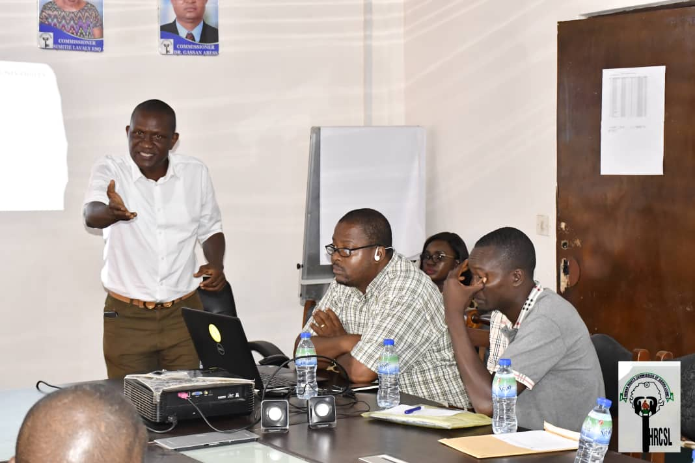

Presentation of Slides on Positive Peace Framework

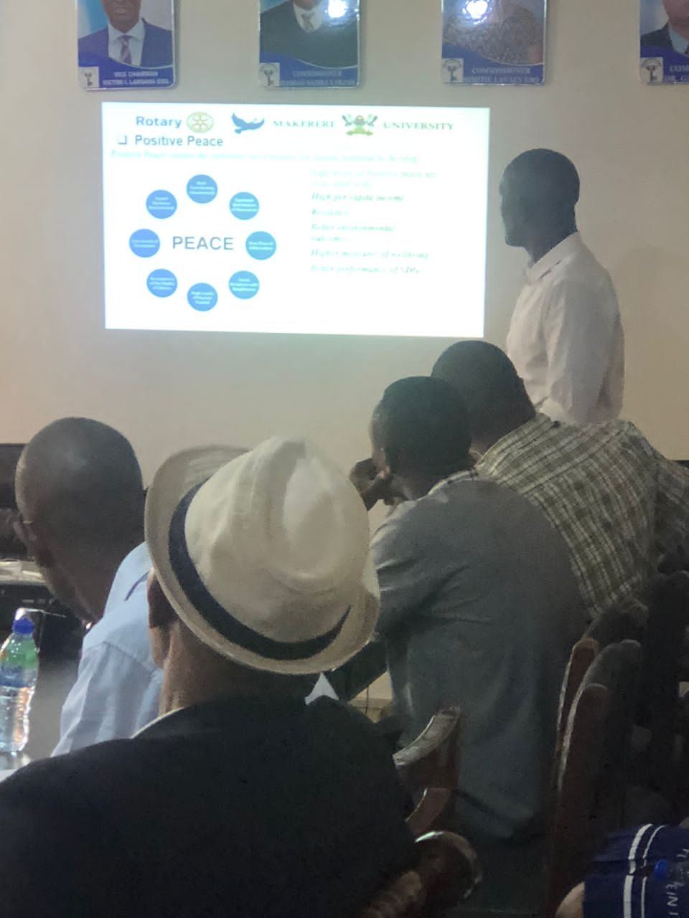

Participants listening attentively to the Presentation

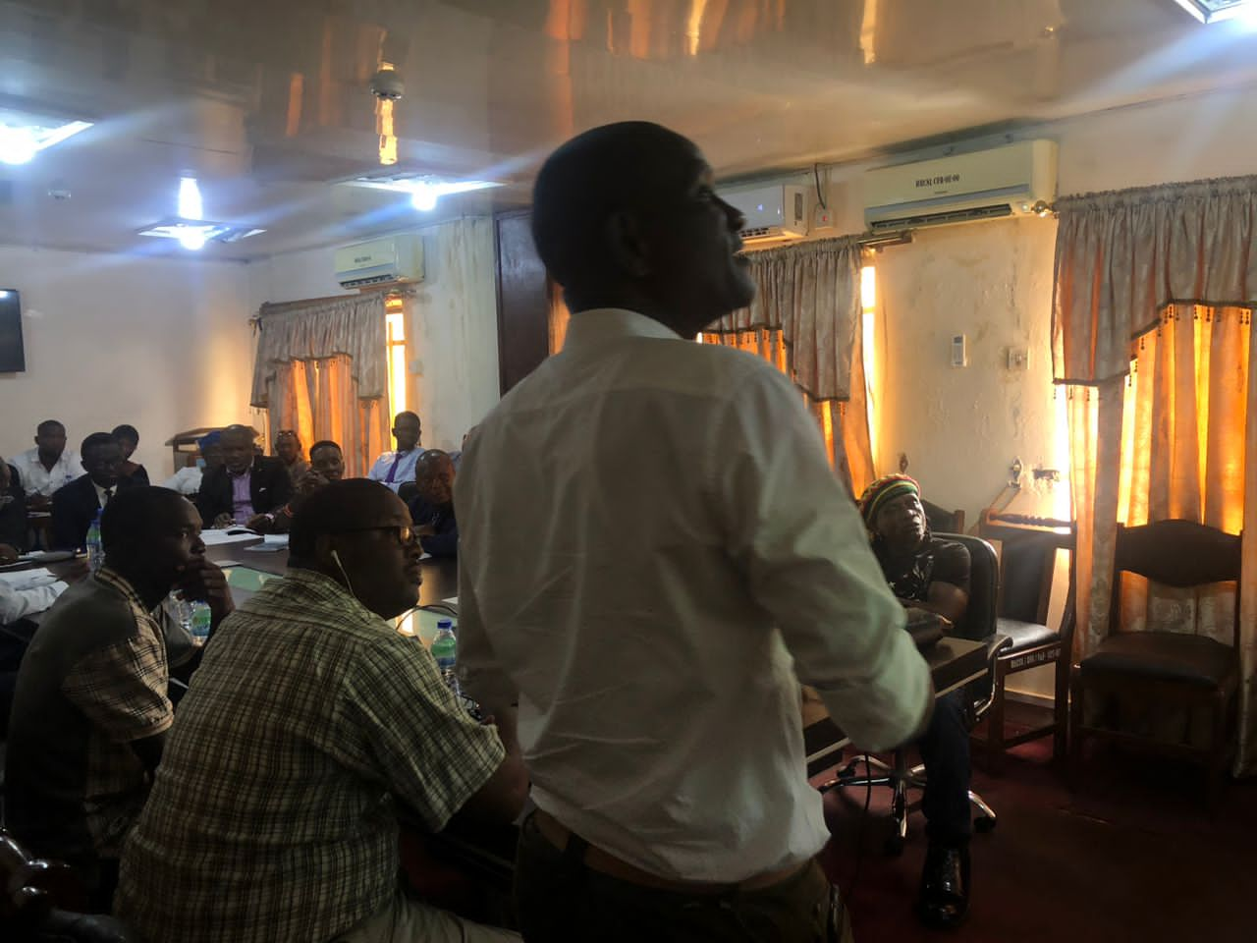

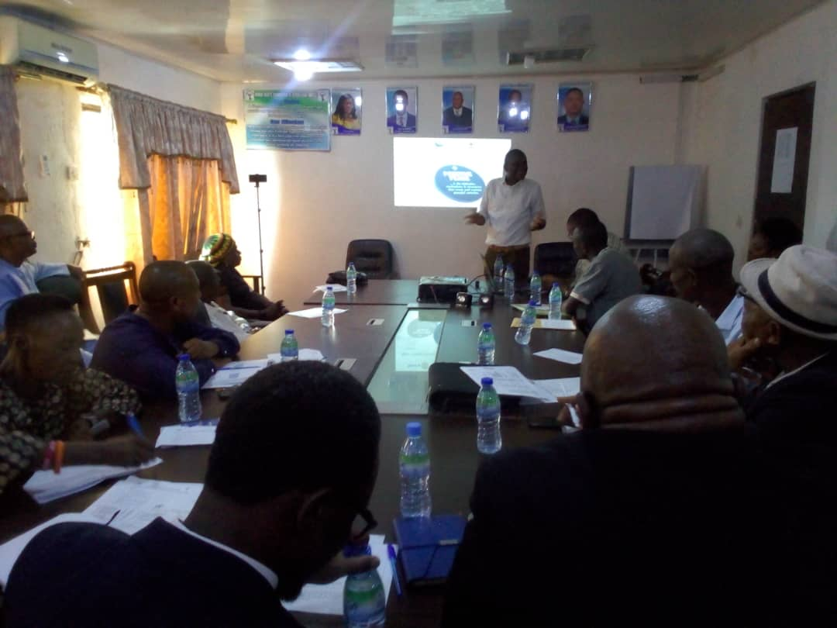

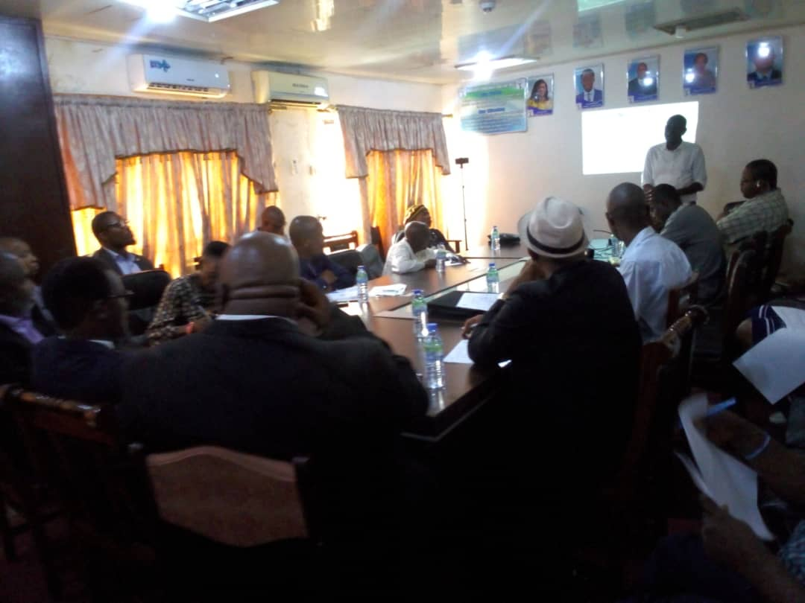

**Participant’s Testimony**

1. The Executive Secretary of the Human Rights Commission of Sierra Leone (HRCSL), in his contribution to the Training, stated that the Presentation should be adopted by all Civil Society Organizations as a Blue Print for the attainment and protection of the fundamental Human Rights of the citizens of Sierra Leone. He further stated that the Police who are primary beneficiary of the Project should be proud, that one of their own was working hard to improve the Professionalism of the Institution. He however expressed his disappointment and frustration on the Senior Management of the Sierra Leone Police in their failure to embrace the training.
2. The United Nations Human Rights Representative in Sierra Leone, stated that considering the national allegations of Police brutality and alleged killings of protesters, the Presentation on Positive Peace Framework would be of immense benefit to the Police if they are ready and willing to embrace the contents therein.
3. Alimamay Njai is Civil Society Movement Activist with over fifteen (15) year experience in Advocay and he was one of the participants. According to him, he had attended various trainings geared towards enhancing his capacity and knowledge Human Rights, Development, Security, conflict resolutions, conflict transformation and conflict mapping. Alimamay Njai stated that, the presentation on Positive Peace Framework is a novelty to him and that the presentation opened a new dimension for him in his Advocacy work. That the presentation, provided a holistic, inclusive and all-encompassing road map for the attainment of peace, security and development in any given society. That his advocacy work had not been streamlined in this direction and with the knowledge gained, his Organization will have to go back to the drawing board and develop a strategy that will include Positive Peace Framework into their Terms of Reference.

**QUESTIONAIRE**

**Makerere University Rotary Peace Centre**

**Social Change Initiative Implementation on Project;**

**Police Officers as Agents of Positive Social Change**

The aim of this questionnaire is to solicit responses from Participants on issues relating to Police Professionalism in the execution of their duties taking into consideration issues of Corruption, unlawful arrest and detention and the effects of these in police/community relationship

A Case Study of the selected Police stations in East and West Freetown

The information given will be treated with confidentiality

Target Group: **Police Officers in the selected Police stations in East and West Freetown**

1. Police Station……………………………….
2. Rank…………………………………………
3. Department/Unit……………………………………...…………………....
4. How long have you been in this Police Station…………………………….
5. How long have you served in your present rank…………………………….
6. How long have you served in your current Department/Unit………………
7. 0 – 1Yr (B) 0 – 2Yrs (C) 0 – 4Yrs (D) 0 – 6Yrs
8. From a scale of 1-5 how would you describe Police/community relationship for the past 5 years
9. Very poor
10. Somewhat Poor
11. Good
12. Somewhat Good
13. Excellent
14. Do you believe the Sierra Leone Police to be corrupt

Yes No

1. What factors would you name that served as recipe for corruption within the SLP?
2. Poor conditions of service
3. Individual corruption
4. Institutional corruption
5. Societal influences
6. How has corruption in the SLP affected their relationship with members of the community in the execution of their duties?
7. Not in any way
8. To some degree
9. Greatly affected
10. Tick the factors which you believe are some of the factors that have led to corruption within the SLP
11. Recruitment
12. Patronage
13. Space selling for recruitment
14. Political Interference
15. Non screening of Applicants
16. How would you describe Police responses during demonstrations/riots/civil unrest
17. Proportional
18. Disproportionate
19. Heavy Handed
20. What role has been the influence of Senior Police Commanders in their various Police stations on issues relating to corruption or corrupt practices?
21. Kickbacks
22. Threats of being transferred
23. Requesting for Sexual favours from female Police Officers for lucrative postings
24. To what extent has refreshers training for Police officers enhanced their Professionalism in the execution of their duties
25. Not sure
26. Not in any way
27. To some degree
28. To a greater degree
29. What in your opinion can help transform the SLP to a more Professional Force that works in the interest of the People of the country?
30. Robustly empower the Complaint, Discipline and Internal Investigations Department
31. Robustly empower the Independent Police Complaint Board to the level of a Commission that has the Power of arrest and Prosecutions of offenders
32. Robustly improve and empower the Community Relations Department
33. Conduct continuous refreshers trainings on Human Rights and other Police/Community related topics for Police officers.

**QUESTIONAIRE**

**Makerere University Rotary Peace Centre**

**Social Change Initiative Implementation on Project;**

**Police Officers as Agents of Positive Social Change**

The aim of this questionnaire is to solicit responses from Participants on issues relating to Police Professionalism in the execution of their duties taking into consideration issues of Corruption, unlawful arrest and detention and the effects of these in police/community relationship

A Case Study of the selected Police stations in East and West Freetown

The information given will be treated with confidentiality

Target Group: **Members of Civil Society Organizations and Media Practitioners**

1. Organization……………………………….

2. Address…………………………………………

3. Designation……………………………………...…………………....

4. How long have you been with this Organization……………………………..

(A)0 – 1Yr (B) 0 – 2Yrs (C) 0 – 4Yrs (D) 0 – 6Yrs

5 .From a scale of 1-5 how would you describe Police/community relationship for the past 5 years

1. Very poor
2. Somewhat Poor
3. Good
4. Somewhat Good
5. Excellent

6.Do you believe the Sierra Leone Police to be corrupt

Yes No

7.What factors would you name that served as recipe for corruption within the SLP?

1. Poor conditions of service
2. Individual corruption
3. Institutional corruption
4. Societal influences

8.How has corruption in the SLP affected their relationship with members of the community in the execution of their duties?

1. Not in any way
2. To some degree
3. Greatly affected

9.Tick the factors which you believe are some of the factors that have led to corruption within the SLP

1. Recruitment
2. Patronage
3. Space selling for recruitment
4. Political Interference
5. Non screening of Applicants

10.How would you describe Police responses during demonstrations/riots/civil unrest

1. Proportional
2. Disproportionate
3. Heavy Handed

11. What role has been the influence of Senior Police Commanders in their various Police stations on issues relating to corruption or corrupt practices?

1. Kickbacks
2. Threats of being transferred
3. Requesting for Sexual favours from female Police Officers for lucrative postings

12. To what extent has refreshers training for Police officers enhanced their Professionalism in the execution of their duties

1. Not sure
2. Not in any way
3. To some degree
4. To a greater degree

13.What in your opinion can help transform the SLP to a more Professional Force that works in the interest of the People of the country?

1. Robustly empower the Complaint, Discipline and Internal Investigations Department
2. Robustly empower the Independent Police Complaint Board to the level of a Commission that has the Power of arrest and Prosecutions of offenders
3. Robustly improve and empower the Community Relations Department
4. Conduct continuous refreshers trainings on Human Rights and other Police/Community related topics for Police officers.

1. Amnesty International Annual Report 2022
2. Human Rights Commission of Sierra Leone Annual Report 2012/2022 pg 2-3
3. Amnesty International Annual Report 2022
4. Human Rights Commission of Sierra Leone Annual Report Pg 2-3
5. Independent Police Complaint Board Annual Reports (2018-2022)
6. Anti-Corruption Commission of Sierra Leone, Sierra Leone Police Response, PNB Sierra Leone Police 26 March 2017.
7. Report by the Institute for Human Rights and Developments
8. Transparency International 2022 Report.
9. Krio is widely spoken lingua franca in Sierra Leone.