KICK OUT CULTISM FROM LEARNING INSTITUTIONS IN NIGERIA

BY

SUNNY ARIBIBIA DADA

REG. NO: 2021/HD03/2008U

A SOCIAL CHANGE INITIATIVE (SCI) REPORT SUBMITTED IN PARTIAL FULFILLMENT OF THE REQUIREMENTS FOR THE AWARD OF THE POSTGRADUATE DIPLOMA IN CONFLICT TRANSFORMATION AND DEVELOPMENT OF MAKERERE UNIVERSITY

DECEMBER 2021

**DECLARATION**

I, Sunny Aribibia Dada do hereby declare that “Kick Out Cultism from Learning Institutions in Nigeria” is entirely my original unaided work, except where acknowledged, and that it has not been submitted before to any other University or institution of higher learning for the award of any academic qualification.

Signed Date: December 2021

SUNNY ARIBIBIA DADA, ROTARY PEACE FELLOW

**APPROVAL**

This Social Change Initiative (SCI) report has been approved for submission to the College of Humanities and Social Sciences by the University Mentor and Supervisor after having thoroughly read through its contents.

…………………………… …………………………….

Dr. Helen Nambalirwa NKabala Date

**Mentor and Supervisor**

………………………… …………………………….

Prof: Tamusuza Nanyonga Sylvia Date

**Mentor** **and Supervisor**

**Title:** Kick Out Cultism from Learning Institutions in Nigeria

**Location:** Port Harcourt, Rivers State

**Date:** December 7, 2021 – February 5, 2022

**Abstract / Summary**

The Social Change Initiative (SCI) is titled: ''Kick Out Cultism from our Schools” The project seeks to mitigate cultism in primary, secondary and tertiary learning institutions, create a safe school space that will guarantee the future of young school children and the need to raise young peace ambassadors who will promote peaceful coexistence in local communities. The specific objective is ‘‘That a safe school space is created and the future of our state is assured.”

The project shall cover a period of three calendar months, that is, December 2021 – February 2022.

**CHAPTER ONE**

**Introduction and Background**

The Niger Delta region is made up of six states namely; Akwa Ibom, Bayelsa, Cross River, Delta, Edo, and Rivers State. After the creation of the Niger Delta Development Commission (NDDC), the states in the region were increased to nine for political and inclusive considerations. The region is surrounded by thick swamps and fresh and salt water rivers. The rivers are a rich source of sea food. The major occupation of the people are farming and fishing. However with the discovery of oil in commercial quantity in 1956, and subsequent exploration activities by government through international oil companies (IOCs), the environment is left prostrate while the rivers became polluted. These twin developments left the people of the region poorer even as they are structurally denied access to oil proceeds.

With the return to democracy in 1999, successive administrations amended the 1999 constitution (as amended), which gave 13% derivation from oil proceeds to oil bearing states, and also created intervention agencies like the Niger Delta Development Commission (NDDC) and Ministry of Niger Delta. The steps provided the hope that the plight of the people will receive considerable shift and also assuage the feelings of marginalization. However, the expectations were not met as the interventions had little or no impact on the region, especially in terms of the delivery of basic social amenities in communities.

The frustrations coupled with corruption in the management of derivation funds led to arms struggle by youths against government and IOCs. However the armed conflict soon evolved into inter gang struggle for supremacy. The struggle for supremacy was exacerbated by the payment of oil royalties by IOCs to gangs in order to prevent the kidnap of oil workers and the decision of government to award oil pipeline surveillance contracts to the violent gangs in the region. Consequently, funds made from the contracts were used to purchase more weapons to consolidate their territorial holds which further increased gang violence in the region. The gangs which are also known as ‘cult groups,’ have since evolved into very powerful political and economic blocs which produce political representatives in government and also controls illegally acquired oil wells.

[1]

In Rivers State, in response to the growing challenge of cult violence, the rivers state government in March 2018, amended the ‘State Anti-cultism law and the Rivers State anti -Kidnap (Prohibition) (Amendment) No.2 Law No.7 of 2018, to include more punitive penalties.’ Part of the provisions of the law stipulates a life imprisonment and death sentence for anyone arrested and confirmed as a cultist. Signing the bill into law, the state governor, Barr Nyesome Wike said the law will address issues of cultism and related violence in the state.

The strict provisions of the anti-cultism law have however not deterred the proliferation of cult groups in the state. According to one of Nigeria’s leading intelligence agency SB Morgan (SBM) Intelligence, more than 100 cult groups in rivers state are fuelling violence which has led to the loss of numerous lives. The report which was based on four sources: the Armed Conflict Location and Event Data Project, the Council for Foreign Relations’ Nigeria Security Tracker, newspapers, and SBM Intel’s own countrywide network of researchers; traced the origin of cult groups in the state to formation of the Supreme Vikings Confraternity (SVC) also known as the Adventurers or the De Norsemen Club of Nigeria at the University of Port Harcourt in 1984. At the latent stage of their formation, they were only restricted to universities and concentrated their activities within campuses. Their main goal was solely the protection of their members. However, their evolution into street gangs which was premised largely on the fight against regional marginalization and the need for better share for the region in the allocation of oil resources, has further expanded the frontiers of their initial objectives.

While the state witnessed a proliferation of cult groups, the emerging patterns where young teenagers and youths are targeted for recruitment represent a sordid state and the degeneration of the challenge. This also portends serious negative implications on the future of the state as most of those targeted are primary and secondary school children who will eventually struggle with their academic performance, drop out of school, or get killed. Teenagers and youths have also become easy prey due to the ‘idealization’ of conflict incentives. Youths readily adopt conflict entrepreneurs as role models and conveniently refer to how such conflict actors live in affluence as a result of compensation from government, through contracts or political appointments.

**Problem Statement**

Recent peacebuilding projects implemented by this Peace Fellow in Bayelsa, Delta and Rivers States, showed that the most prominent conflict driver in the Niger Delta region is cultism. Findings also revealed that cultism shares a nexus with other prominent crimes in the region such as sea piracy, kidnapping, drug abuse, sexual gender based violence (SGBV) and pipeline vandalism.

Facilitated by poverty, economic and political disenfranchisement, and the easy availability of firearms, armed groups fight each other over the control of illegally acquired oil wells (so-called "bunkering") and engaged in violent acts against oil companies, such as kidnapping officials and engaging in other social crimes. In 2003, during the build-up to the presidential election, violence between rival militia groups and against the oil corporations in rivers state, increased considerably. The trend has continued with new violent gangs emerging with disturbing violent behaviours. The most worrying trend however is the expansion of their recruitment network to secondary schools where young pupils from the age of 12 are targeted for recruitment. This was revealed through a Focus Group Discussion (FGD) and Key Informant Interviews (KII) conducted in Rivers State.

The SCI therefore intends to embark on a “Kick out Cultism” campaign across learning institutions through film shows, talk shows, peace education, peace initiatives and the formation of peace clubs in targeted schools; etc. The SCI will also consolidate its campaign by providing transformative dialogue training for students who will become the eventual leaders of the peace clubs; including providing psycho-social support for repentant cultists.

**Goals and Objectives**

The Social Change Initiative has a general and specific objective; they:

General Objective: To end cultism and to raise young peace ambassadors;

Specific Objective: That a safe school space is created and the future of Rivers State is assured

The Social Change Initiative has two main goals. They are:

* Goal 1: Increase in the productivity of young students, attitudinal change towards social vices and better academic performance
* Goal 2: A generation of teenagers and youths will gain knowledge that will enhance their skills in the area of transformative peace and assume important roles in the resolution of conflicts within their schools and

**Challenges and Mitigation Strategies**

The SCI had three main challenges and mitigation responses in the course of implementation. They are:

* Funding and Covid-19 challenges: Due to funding challenges and the challenges of covid-19, none training activities of the SCI was changed to an online attitudinal change and social re-orientation programme. The online activities featured a roundtable and social media campaign against cultism. The roundtable targeted policy makers and duty bearers. The online roundtable also featured discussions around the general issues on cultism in learning institutions and mitigation plans.
* Resistance from conflict entrepreneurs and cult kingpins: This group of persons are highly connected and represented a major obstacle to the implementation of the SCI. However project team deployed the instruments of persuasive advocacy to get the SCI started.
* Some officials of Ministry of Education opposed the SCI due to political reasons and time challenge. The COVID lockdown affected normal school calendar. Schools are now readjusting their calendar to make up for lost time. Due to these reasons, some officials of the ministry of education as expected were not keen in giving the needed approval. However I got a breakthrough when I received a conditional approval from the Commissioner of Education to proceed if individual Heads of Schools can create a space within the school calendar for the SCI. Also, the eventual adoption of some activities under the SCI by some churches and a logistics support from my organization and the Rotary Club of Port Harcourt Mid-Town, District 9141, further added to successful implementation of the SCI.

**CHAPTER TWO**

**Literature Review**

A literature review of some publications including official documentations and reports as well as contributions from articles and publications from independent sources, were used as major data sources for this work. I also conducted Key Informant Interviews (KII) and informal discussions with cultists, community leaders, religious leaders, and heads of school, leaders of youth friendly centres and groups, Rotarians, local NGOs, and journalists and average Nigerians on the street. Most of those spoken to, also participated in the activities organized so far.

All those spoken to, contributed useful data to the SCI and helped shaped the overall achievement of the central objectives.

**Qualitative Analysis**

Several articles, Key Informant Interviews (KIIs) and Focus Group Discussions (FGDs) with relevant sources were done in the build-up to generating data for the SCI. The participants at the FGDs and KIIs were selected from eleven out of the twenty three Local Government Areas of the state. The LGAs are: Khana, Gokana, Port Harcourt, Okrika, Ogu-Bolo, Akuku Toru, Eleme, Ogba-Egbema-Ndoni, Obiakpo, Ikwerre, and Ahoada West, Local Government Areas. Four out of the eleven LGAs are of the ‘Riverine’ political dichotomy while the remaining seven LGAs of the ‘Upland’ political dichotomy. The participants were selected to reflect gender and professional balance. The KIIs which were conducted between July 26 – 31; 2021; were done through mobile phones and informal conversations revealed that teenagers from ages twelve are major targets.

Semi-structured verbal questions were asked to generate data related to cultism in learning institutions and communities, including its impact on academic performance and wellbeing in general.

Findings from the reviews and conversations provided a description of the objectives of the SCI. The FGDs, KIIs and informal discussions were also summarized as they contributed to the objectives of the SCI and revealed in-depth details of the problem. All the participants that participated in the KII also gave consent for the publication of their details in this report including any form of reference or citation of any part or whole thereof of their views.

**Results and Discussions**

Findings from publications, articles, FGDs, KIIs including informal discussions with relevant stakeholders reveal that there is a nexus between cultism and other related crimes in the state such as kidnapping, drug abuse, gender violence, pipeline vandalism and violent conflicts between street gangs. For instance, a report by a Nigeria based peace building organization, Academic Associates PeaceWorks (AAPW) titled: ‘Strategies for Peace in the Niger Delta,’ revealed that cultism in the Niger Delta majorly evolved from violent agitations against international oil companies (IOCs) and the federal government over resource control in the Niger Delta. The report further revealed the 2003 general elections in the state exacerbated the problem as politicians engaged violent youths to rig elections for them.

In a similar report by the United States Institute for Peace (USIP) titled: ‘Report on the Assessment of the Presidential Amnesty Programme (PAP),’ stated in parts: ***“Initially community agitations targeted international oil companies (IOCs) for neglecting their social contract and subsequent environmental degradation. Often, compensation payments for damages to property caused by oil exploration and production activities did not reach the grass roots or were mis-used by various stakeholders. This eventually turned to conflict between the communities and security operatives such as the police and the army and ultimately turned to insurgency against the state, as militia groups emerged to engage security operatives in armed struggle, just as they made political demands on the Nigerian government.”***

A further review on the evolution, spread and motivation of cultism in Rivers State shows that economic and political factors are the most potent drivers stimulating cultism in Rivers State. The economic factors range from fight for for the control of oil wells for the purposes of oil theft and compensations from oil companies. Rapid recruitment into cultism has also been helped by the availability of an army of unemployed youths. In a journal publication titled: ‘Cultism in Rivers State: Causes, Faith-Based Organizations’ Role and the Setbacks;’ lamented the complicity of parents in the escalation of cultism in state. The report further highlighted that the major cause of cultism in schools can be linked to the failure of family values[2].

From the reviews and interviews, four major factors amongst others are primarily responsible for the rise and persistence of cultism in learning institutions in the state. They are:

1. Incessant disruptions to academic calendars
2. The presence of growing variants of ethnic militias occasioned by extreme loyalties to ethnic nationalities;
3. Unstructured learning environment
4. The lack of clear transitional lines for youths

An overview of the findings shows that a lot of the review and people who spoke to me agreed that incessant strike embarked upon by academic unions in response to inadequate funding of the educational sector, is major reason why campus cultism thrives in learning institutions in the state. Although respondents agreed that academic disruptions is nationwide, there is however a need for policy makers in the state to be creative to avert such occurrences in the state.

Another very important finding from the review is the consensus that there is need for a strategic statewide blueprint for youth transitions in education, employment, new life style, family formation and exercising citizenship for the wellbeing of the young. They stated that such a blueprint will serve as a buffer against disruptions in the development of young people.

The review further reveals that rising influence of ethnic loyalties in the country, is contributing to the problem of cultism in the state and the country at large. The findings shows that cultism which share a nexus with other prominent crimes in the state, also have a link to ethnic and street gangs operating in the state. This is even as some key stakeholders informed that unstructured learning environments makes it difficult to quickly detect infiltrations into school environment by criminal elements.

**Theoretical** **Underpinnings**

Three main theories are used for this work. They are

1. Social disorganization theory
2. Strain theory; and
3. Culture conflict theory

All three theories are sub theories of the Social Structure theories. According to criminology researchers from the “Chicago School” of criminology, Clifford Shaw and Henry D. McKay who developed the social disorganization theory in 1942, the Social disorganization theory, states that crime rates are interrelated with issues of social pathology; this theory implies a direct link between residential location as a factor in influencing a person’s inclination towards engaging in criminal behaviour. [3]

However, the Strain theory states that certain strains or stressors increase the likelihood of crime. These strains lead to negative emotions, such as frustration and anger. According to Emile Durkheim who developed the first modern strain theory of crime and deviance, emotions create pressure for corrective action, and crime is one possible response. Crime may be used to reduce or escape from strain, seek revenge against the source of strain or related targets, or alleviate negative emotions.

The Culture conflict theory on its part sates that crime is caused due to the clash of values that arises when different social groups have different ideas of acceptable behavior. In other words, different social groups have different cultural beliefs and ideas that conflict, and this conflict sometimes leads to crime. It was propounded in 1938, by criminologist Thorsten Sellin.[4]

**Change Theory and show how it was applied**

The three theories are most relevant to the objectives of this study, given the emphasis they all placed on the root causes of the problem. The theories were applied in order of their relevance to specific root causes of the problem. While the central social structure theory provides an overview of the general principles of the problem, the sub-theories provided specific responses to the relevant latent factors. For instance, an analysis of the social disorganization theory on the conflict tree, explains the deviant behaviours that are a direct consequence of cultism. These behaviours which include kidnapping, drug abuse, sea piracy, political banditry, gender based violence, etc. are the results of cultism.

The strain theory however identifies the economic challenges that make youths go into cultism and consequently engage in violent crimes. These challenges include: unemployment, incessant disruption to academic calendars occasioned by demands by academic unions for better funding, high rate of inflation which limits the purchasing power of people, lack of rational engagement of the potentials of youths and the lack of transformative blueprint which clearly outlines youth transitions into economic and social freedom.

The culture conflict theory on its part, explains the ethnic dimension that we saw during town hall meetings and the findings which pointed to the fact that one of the major factors driving cultism in the state is the growing influence of ethnic loyalties which is a direct consequence of feeling of oppression and marginalization by prominent entities. A further application of the theory also shows that one of the things that reinforce the cultural variant is the loss of family values within the Niger Delta and Nigeria at large. This challenge is caused by many factors which include: the transfer of parental responsibility of care and mold from parents to teachers, the prevalence of single parenthood in the state and the Niger Delta, and the placement of financial value on community service. Generally the cultural variant is largely motivated by ethnocentric motivations and this is succinctly explained y the culture conflict theory.

**Methods and Design**

Several articles, Key Informant Interviews (KIIs) and Focus Group Discussions [5](FGDs) with relevant sources were done in the build-up to generating data for the SCI. The participants at the FGDs and KIIs were selected from eleven out of the twenty three Local Government Areas of the state. The LGAs are: Khana, Gokana, Port Harcourt, Okrika, Ogu-Bolo, Akuku Toru, Eleme, Ogba-Egbema-Ndoni, Obiakpo, Ikwerre, and Ahoada West, Local Government Areas. Four out of the eleven LGAs are of the ‘Riverine’ political dichotomy while the remaining seven LGAs of the ‘Upland’ political dichotomy. The participants were selected to reflect gender and professional balance. The KIIs which were conducted between July 26 – 31; 2021; were done through mobile phones and informal conversations revealed that teenagers from ages twelve are major targets. Semi-structured verbal questions were asked to generate data related to cultism in learning institutions and communities, including its impact on academic performance and wellbeing in general. The questions are:

1. Is cultism the same as ethnic militias
2. What are the attractions for campus/school cultism in Rivers State
3. What age range is the main target of cultists in primary learning institutions
4. Is cultism a problem of quest for social identity or other latent factors

**Ethics and Data**

During the FGDs and KIIs, participants consent were received to use data generated for educational and programme intervention purposes. However some cultists interviewed in the direct interview (DI), asked that their identities should not disclosed in order to be protected from potential harm from group members.

All data were collected during pre-fellowship and post-fellowship meetings. The meetings include: FGDs, KIIs, DIs, informal conversations and town hall meetings, including online round table meeting. Other sources of data include: Articles review, reports of past relevant interventions, experience from previous interventions, etc. All data obtained were structured to align and contribute to the achievement of this work. Quoted references and reports are also correctly stated in this report.

**Demography Data**

Demographic information including age, sex, familial circumstances, professional circumstances and educational level was collected. The FGDs, KIIs and town hall meetings, had a mix blend of ages 18 – 55. The DI meetings had an age range of 12 – 21. Participants’ professional and social background include: Rotarians, teachers, civil society leaders, civil/public servants, unemployed, illegal oil bunkers, ex-agitators, leaders of ethnic militias, community leaders, youth leaders, women leaders, etc.

**CHAPTER THREE**

Due to funding challenges and the lack of time, only three activities have been implemented. The activities already implemented include an online round-table meeting on cultism in learning institutions, social media campaign against cultism and a joint advocacy/town-hall meeting between church and community leaders. All other initial activities have been adjusted to include two joint training activities for students and community youths and one joint peace campaign to be held in January and first week of February 2022. However one of the partner churches, ‘The Redeemed Christian Church of God,’ have adopted the peace campaign as a special corporate social responsibility (CSR) initiative and will be held on the third Saturdays of every month. This is to be continued beyond the SCI window. In addition, the church has also given me an open invitation to give a peacebuilding talk during their family Sundays held every third Sundays of the month.

Specifically, the planned activities to be in January and first week of February 2022 are as follows:

**Activity 1: Structural Peace Campaigns**

The SCI will embark on public peace campaigns against cultism and non-violence across schools. The campaigns which will contribute to building social cohesion in communities, will be student and youth led. The campaign will feature peace bands and talks.

**Sub-Outputs:**

* Students and youths acquire leadership capacity to become young influencers
* Awareness on the dangers of cultism amongst students and communities is achieved
* Students and youths acquire advocacy capacity to become change agents

**Activity 2.1.2: Technical Training on Transformative Dialogue for Young Peace Ambassadors**

In order to raise a reasonable number of peace facilitators in schools and communities, the SCI will conduct two joint training for students and youths on non-adversarial advocacy, leadership, and non-violent communication techniques.

**Output:**

* Students and youths are equipped with peacebuilding skills to respond to conflict drivers in their schools and communities
* A generation of young people are trained and equipped to become peace facilitators

**Key Findings/Impact**

Although envisaged, the enormity of the structural resistance from conflict entrepreneurs and cult kingpins within the state highlights the social-economic and political dimension of the problem of cultism. Five key findings were made during implementation. The findings shows that incessant disruptions to academic calendars, variants of growing ethnic militias, political corruption, high prevalence of entrepreneurial conflict role models, and unstructured learning environment are majorly responsible for the rise of cultism.

Incessant strike by academic unions over unpaid allowances and educational development funds often leaves students stranded for longer periods of time. While at home, many students are exposed to street gangs who indoctrinate them into societal menaces. The leading academic union in Nigeria which is the Academic Staff Union of Universities (ASUU) has been in a running battle with government over the years. In 2009, the union in conjunction with other unions embarked on a four month strike over poor budgetary allocation to the education sector in the federal government appropriation act. The unions also demanded for a uniform funding for all tertiary institutions in Nigeria including the payment of unpaid earned allowances. In 2021, ASUU embarked on a nine month strike over unpaid earned allowances and better funding for universities. The strikes, which often prolong the graduation period of students, also expose them to street gangs who recruit and use them to cause violence.

Another finding also shows that the challenge of cultism is partly driven by ethnic agitations over economic and political patronage in the state. Rivers State is divided into what is called ‘Upland and Riverine Dichotomy.’ The upland part of the state is dominated by three main major ethnic nationalities which includes Ikwerre, Ogonis, and Orashi ethnic nationalities. The riverine is dominated mainly by the ‘Ijaw’ ethnic nationality. The dichotomy is a political arrangement to balance political power across ethnic nationalities in the state. This is also to ensure that ethnic tensions that usually characterise the political climate in the state are addressed. These agitations and the fight for resource control by ethnic nationalities against the federal government are actively encouraging gangs and youth violence in the state. Research conducted during community engagement revealed that most of the youths who form the ethnic militias have links to known cult groups in the state.

Other findings such as high prevalence of entrepreneurial conflict role models, and unstructured learning environment are also responsible for the thriving challenge of cultism. Unstructured learning environment in particular, makes it possible for non-students to easily access schools and mingle with students. During advocacy visits to some schools, some of the challenges reported by some heads of school informed that one biggest challenge they face was lack of fencing of their schools which makes it possible for criminals to have unfettered access to school premises. They stated that some students invite their cultist friends from the streets to the school who also use that opportunity to indoctrinate and initiate other students.

However, in spite of these findings and even though it may be too soon to start measuring outcomes, the SCI has already recorded some milestones. Speaking during the first town hall meeting, community and church leaders applauded the SCI and pledged to sustain the planned activities of the initiative. For instance, one of the churches, the Redeemed Christian Church of God, Divine Gift Parish and Redeemed Peoples Mega Zone, have adopted the peace campaign of the SCI as a monthly activity to be held every third Saturday’s of the month. The churches also pledged to feature ten minutes talk on dangers of cultism and violent conflict in all their family Sundays. This is a major milestone as it will further contribute to achieving the central objectives of the SCI.

**CHAPTER FOUR**

**General** **Conclusion**

Cultism comes with extreme motivations to cause violent conflict. The challenge of cultism in Rivers State is hydra-headed; it has a root to many other conflicts such as kidnapping, drug abuse, gender based violence, robbery, ethnic conflict, pipeline vandalism and terrorism. To stem the tide, there is need for a concerted effort by duty bearers to urgently address the root causes of cultism as has already been laid out earlier. There is also a need to re-invent pillars of family values; parents should begin to spend quality time with their wards in order to monitor their activities. It is also important to state that society should rewarding conflict behaviours, part of the ways to do this is to ostracize conflict entrepreneurs by rejecting their hand-outs and shaming their deeds.

**Recommendations/Implications for Policy**

The following recommendations are hereby proposed:

1. Need to focus on the five fundamentals of youth transitions: Policy makers should focus on the five fundamental of youth transitions which are: education, employment, new life style, family formation and exercising citizenship for the wellbeing of the young." This is a necessary step towards harnessing and taking advantage of the strong youth population of the country for national growth.

2. Urgent need to address recipes for academic calendar disruptions: There is need for governments at all levels to progressively increase allocation for education in order to meet the UNESCO 26% education appropriation benchmark. This is to ensure that incessant strikes that lead to the disruption of academic calendars on the basis of agitations for proper funding and adequate welfare of staff are addressed.

3. Need for Structural Peace Education: There is an urgent need for government to initiate deliberate mechanisms for structural peace education across all tiers of learning institutions. Structural peace education should target school syllabuses, compulsory peace messaging from religious alters, development of conflict sensitive guideline for media practitioners.

4. Countering Conflict Incentives: There is need for government to prioritize job creation to meaningfully engage idle youths. According to recent data obtained from the National Bureau of Statistics, Nigeria’s unemployment rate as at 2021 stands at 33.3%. However, from the above figure, the data shows that a total of 28.8% of the total figure represent youths from within the age range of 25 – 34 years. This represents a gory picture in terms of availability of youths to could be recruited for violent crimes

5. Raise role models to serve as community influencers: School authorities and policy makers should initiate periodic structured visits, seat-outs, etc. with successful old students to counter the adoption of conflict entrepreneurs as role models. The essence is to also ensure that students learn the art of hard work, dignity in labour and an opportunity to imbibe important social morals.

**Sustainability Plan**

As part of the sustainability plan, one of the churches, the Redeemed Christian Church of God, Divine Gift Parish and Redeemed Peoples Mega Zone, have adopted the peace campaign of the SCI as a monthly activity to be held every third Saturday’s of the month. The churches also pledged to feature ten minutes talk on dangers of cultism and violent conflict behaviour in all their family Sundays. This is a major mile stone as it will further contribute to achieving the central objectives of the SCI. I have also made a commitment to the churches to be available for the peace talks. However the plan is to also raise some students and youths that will provide some of the talks.

**APPENDICES**

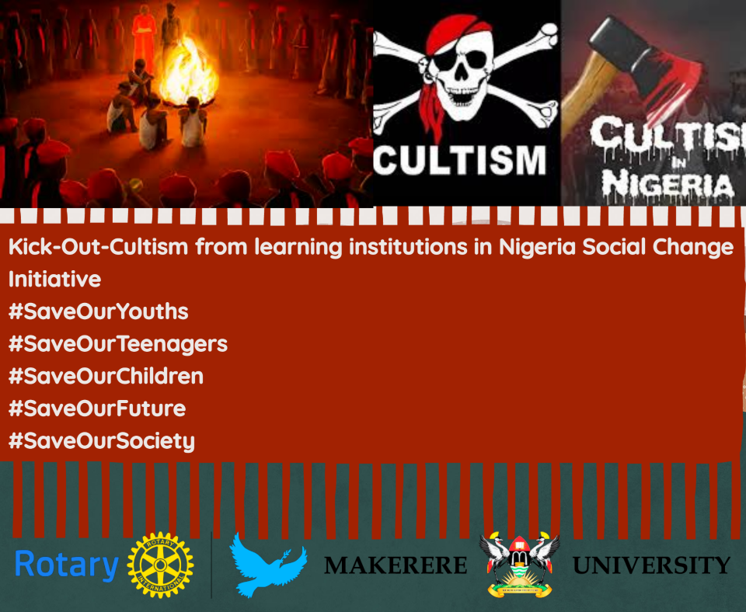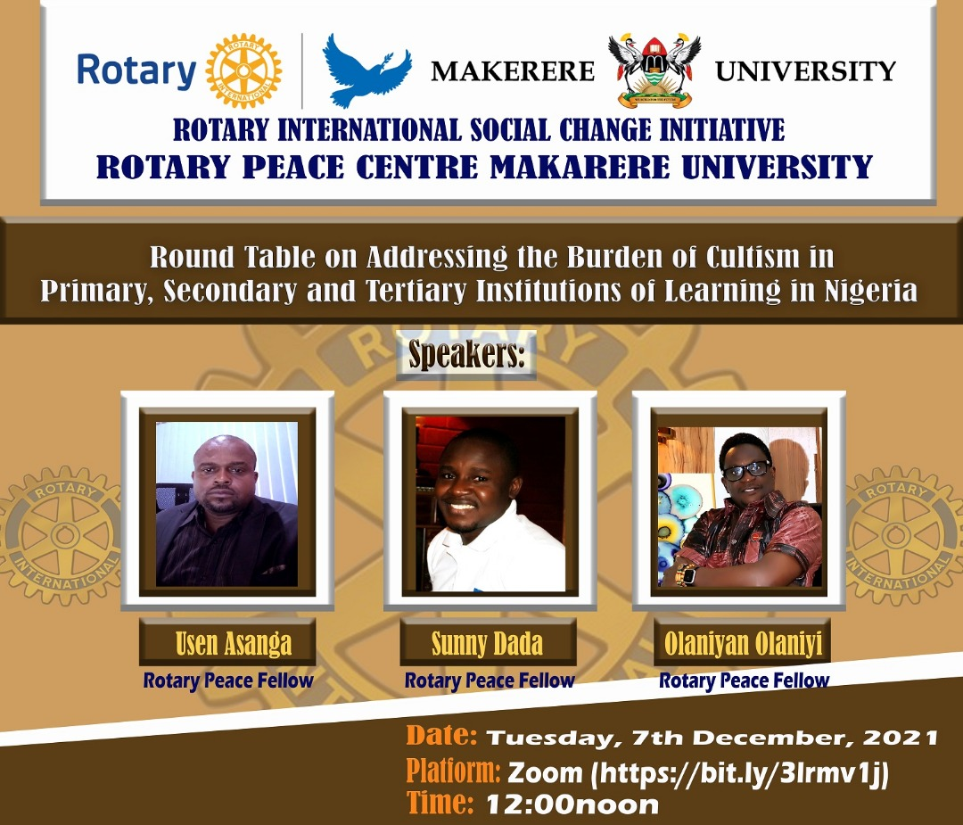

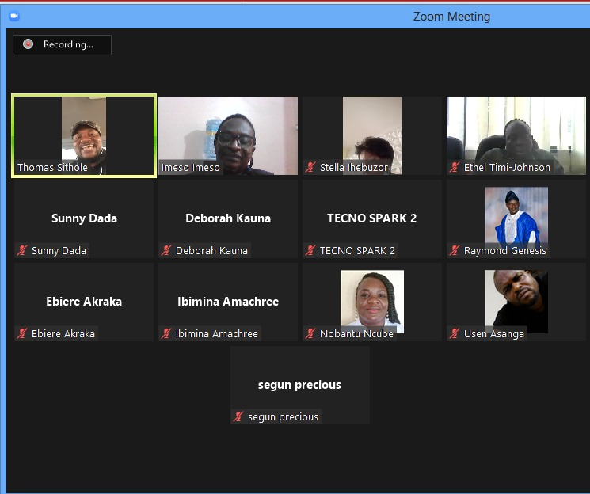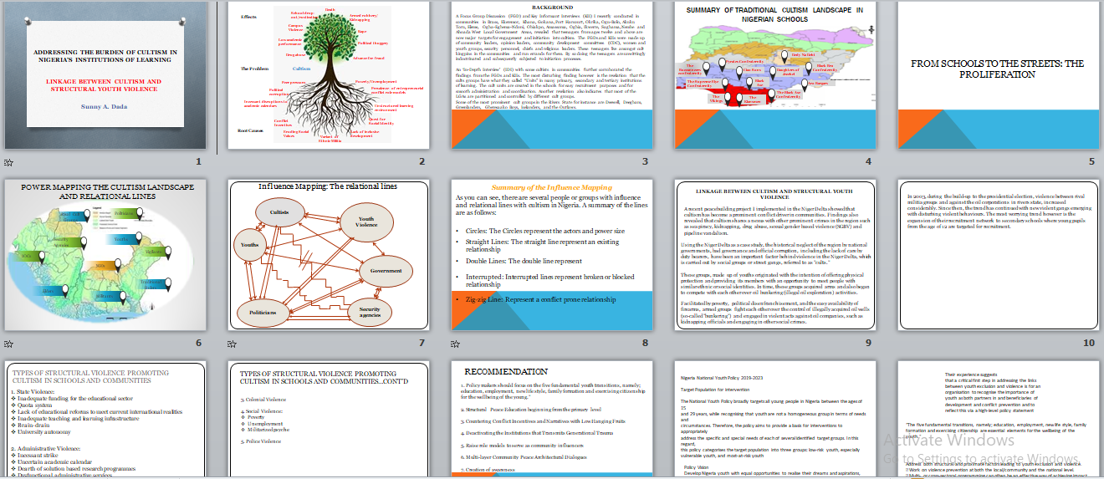

**Flyers used for the Anti-cultism social media campaign and invitation to the Online Round-Table Meeting held Dec 7.**

**Snapshots of participants and presentations at online round-tables**

**Activity Participants’ Success Stories**

Rotarian Ibimina Damina Amachree – Chairperson Rotary District Peace Fellowship Committee and Assistant District Governor, Rotary District 9141

“*I want to thank you for the sacrifices you have put in place in ensuring that peace reign around the world. I want to specially thank our Peace Fellow Sunny Dada, for all the support, all the encouragement he has been giving to the District, and his support to the new peace fellows especially the role he played in their emergence. We hope that in no time he will come and join us to do the full work of Rotary.”*

Dr Kelechi E. Okonta – Lecturer and Director Youth Friendly Centre, University of Port Harcourt

*“This is a very unique initiative that will no doubt address the issue of cultism in our university. As a centre this is also in line with what we are doing; we need more collaboration like this to really face the problem of cultism. Thank you so much and be assured that we shall give you all the support you will need”*

Pastor Olagoke Olatimileyin – Pastor in-charge of Zone, Redeemed Peoples Mega Parish, The Redeemed Christian Church of God

*“This idea is what government ought to be championing. As a church we are also worried about the trend of cultism in our community. Our children are not safe if we do not act on-time. We are happy that there are still young men like you who are ready to risk their lives to do the work you’re doing. We will support you and also ensure that our youths participate in the trainings…We want to beg you to please come and speak to parents during our Family Service. We don’t mind giving you the pulpit to do that.”*

Chief James Ayaowei – Community Leader

*“I want to thank Rotary for bringing this programme to our community; I used to see their sign-board…I didn’t know that they do very good work like this. I want to appeal to you to expand this programme to cover more communities. I will talk to the other community chairmen during our community development committee (CDC) meeting this week to see how we can also support the programme to cover their communities.”*

**Any other relevant Document**

Attached herein is presentation and recorded sessions of online round-table meetings

# Works Cited

Coates, G. (2018). https://journals.sagepub.com/doi/full/10.1177/0265378819878212.

Daily Trust, N. (2018). *Wike Signs 3 Anti-Cultism Bills into Law.* Port Harcourt: https://dailytrust.com/wike-signs-3-anti-crime-bills-into-law.

Eneh, O. C. (2008). *CULTISM IN THE NIGERIAN EDUCATIONAL INSTITUTIONS: INCIDENCE, CAUSES, EFFECTS AND SOLUTIONS.* https://www.researchgate.net/publication/281275497_CULTISM_IN_THE_NIGERIAN_EDUCATIONAL_INSTITUTIONS_INCIDENCE_CAUSES_EFFECTS_AND_SOLUTIONS.

Homework, H. U. (n.d.). *Social Structure Theories, Writing Services.* https://journals.sagepub.com/doi/full/10.1177/0265378819878212.

Lecture Series. (n.d.). *Lecture Series.* https://study.com/academy/lesson/what-is-culture-conflict-definition-theory-example.html.

News, P. (2021). *4 students remanded for belonging to Deegbam cult gang in Rivers.* Port Harcourt: https://pmnewsnigeria.com/2021/11/20/4-students-remanded-for-belonging-to-deegbam-cult-gang-in-rivers/.

Nwosa, H. (2020). *Tension In Rivers As Secret Cults Mass Recruitment Soars In Schools.* Port Harcourt: https://newdiplomatng.com/tension-in-rivers-as-mass-secret-cults-recruitment-soar-in-schools/.

Robert Agnew. (2015). *Starin Theories.* https://www.oxfordbibliographies.com/view/document/obo-9780195396607/obo-9780195396607-0005.xml.

TheGuardian. (2021). *Cultists kill final year student in Rivers varsity.* Port Harcourt: https://guardian.ng/news/cultists-kill-final-year-student-in-rivers-varsity/.

TheGuardian. (2021). *Taming menace of cultism in primary, secondary schools.* https://guardian.ng/features/taming-menace-of-cultism-in-primary-secondary-schools/.

Vanguard, N. (2020). *Bullying, Cultism in secondary schools: A time-bomb exploding before us.* Akwa Ibom: https://www.vanguardngr.com/2021/12/bullying-cultism-in-secondary-schools-a-time-bomb-exploding-before-us/.

1. <https://dailytrust.com/wike-signs-3-anti-crime-bills-into-law>
2. [George C Nche 2019](https://journals.sagepub.com/doi/full/10.1177/0265378819878212)
3. <https://www.homeworkhelpglobal.com/us/our-services/criminology/social-structure-theories/>
4. <https://study.com/academy/lesson/what-is-culture-conflict-definition-theory-example.html>
5. <https://www.oxfordbibliographies.com/view/document/obo-9780195396607/obo-9780195396607-0005.xml>