TRAINING AND COMMISSIONING OF PEACE MONITORS IN GBV PREVENTION, RESPONSE AND COMMUNITY-BASED MEDIATION IN KALANGALA DISTRICT
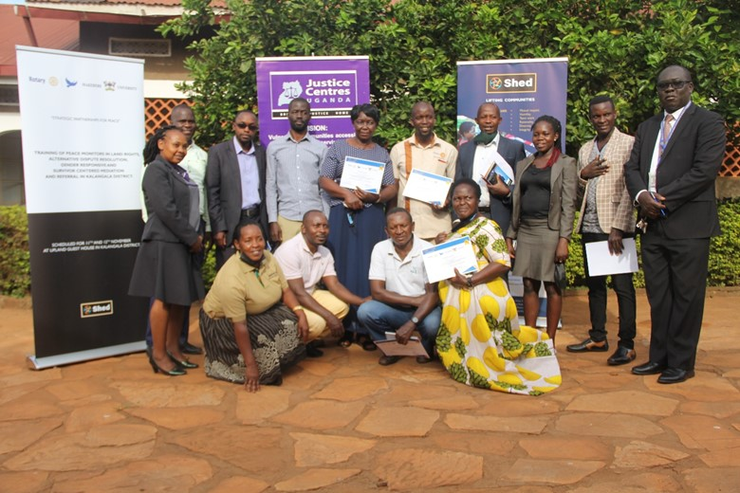
BY: STEPHEN SEMPANDE, ROTARY PEACE FELLOW

DECLARATION

I, Stephen Sempande, do hereby declare that “Hand Holding Initiative (Strategic partnership for improved education outcomes among pupils from remote islands of Kalangala district)” is entirely my original unaided work, except where acknowledged, and that it has not been submitted before to any other University or institution of higher learning for the award of any academic qualification.

Signed………………… Date: January 12, 2022
STEPHEN SEMPANDE, ROTARY PEACE FELLOW

APPROVAL

This Social Change Initiative (SCI) report has been approved for submission to the College of Humanities and Social Sciences by the University Mentor and Supervisor after having thoroughly read through its contents.

…………………………… …………………………….
Dr. Charlotte Mafumbo Date
Mentor and Supervisor

………………………… …………………………….
Prof. Patrick Mangeni Date
Mentor and Supervisor

ACKNOWLEDGEMENT
I could not have accomplished anything without the almighty God who strengthens me, glory and honour I give back to Him. I appreciate Rotary International for the fellowship opportunity as well as the financial and moral support. I acknowledge Makerere University Rotary Peace Centre for the mentorship throughout the journey of this social initiative. In a special way, I express my gratitude and thanks to my University mentors Dr. Charlotte Mafumbo and Prof. Patrick Mangeni for their guidance. I send thanks to my classmate Catherine Baine-omugisha for her support, encouragement and advice in this social initiative. Altogether, we had the best of this fellowship as Peace fellows. I appreciate all the support and guidance from the local authorities in Kalangala, from the Office of the LCV Chairperson, Office of the Kweba, the Judiciary, and to all the participants in the training. I wish to appreciate the financial support from SHED and all the trainers for the selfless services offered during the social initiative activities. In a special way, I want to thank Eng. Ssewankambo Gyaviira for reviewing the report. May God bless them all.

TABLE OF CONTENTS
DECLARATION ii
APPROVAL iii
ACKNOWLEDGEMENT iv
TABLE OF FIGURES vi
ACRONYMS, ABBREVIATIONS AND SYMBOLS vii
ABSTRACT / SUMMARY viii
CHAPTER ONE 1
1.1 BACKGROUND 1
1.2 PROBLEM STATEMENT 3
1.3 GOALS AND OBJECTIVES 4
1.3.1 Goal of the Social Initiative 4
1.3.2 Objectives 4
1.4 CHALLENGES AND MITIGATION STRATEGIES 4
CHAPTER TWO 6
2.1 LITERATURE REVIEW 6
2.1.1 Overview of Gender Based Violence (GBV) and its prevalence in Uganda 6
2.1.2 Community Based Interventions 7
2.2 THEORETICAL UNDERPINNINGS 9
2.2.1 Community participation 9
2.2.2 Ecological model/approach (Root causes of Gender Based Violence) 11
2.3 CHANGE THEORY AND HOW IT WAS APPLIED 12
2.4 METHODS AND DESIGN 14
2.4.1 Participatory planning 14
2.4.2 Focus group discussions (FGDs) 16
CHAPTER THREE 17
3.1 INTERVENTIONS AND ACTIVITIES 17
3.1.1 FGDs AND TRAINING OF PEACE MONITORS: DAY 1 17
3.1.2 FGDs AND TRAINING OF PEACE MONITORS AND FGDs: DAY 2 20
3.2 KEY FINDINGS / IMPACT 22
3.2.1 Findings 22
3.2.2 Impact 23
CHAPTER FOUR 24
4.1 GENERAL CONCLUSION 24
4.2 RECOMMENDATIONS / IMPLICATIONS FOR POLICY 24
4.3 SUSTAINABILITY PLAN 26
REFERENCES 28
APPENDICES 30
Appendix 1: Pictorials 30
Appendix 3: Participant Testimonies 34
3.1 Lists of the Participants for the training of Peace Monitors 34
Appendix 4: Other relevant Documents 38
4.1 Day Programs 38
4.2 STATUS OF CONFLICT RESOLUTION BY KALANGALA PEACE MONITORS 41

TABLE OF FIGURES
Figure 1: Ecological Model 20
Figure 2: Schematic theory of change model 22
Figure 3: Application of change theory in the Social Initiative 23

ACRONYMS, ABBREVIATIONS AND SYMBOLS
ADR Alternative Dispute Resolutions
FGD Focus Group Discussion
GBV Gender-based violence
HIV/AIDS Human Immunodeficiency Virus/Acquired Immunodeficiency Syndrome
IPV Intimate partner violence
MGLSD Ministry of Gender, Labour and Social Development of the Republic of Uganda
SCI Social Change Initiative
SGBV Sexual and gender-based violence
UN United Nations
VAW Violence against Women
VAWG Violence against women and girls
WHO World Health Organization
Peace Monitors Community- Based Volunteers

ABSTRACT / SUMMARY
Gender-based violence (GBV) is a public health problem and one of the most prevalent human rights violations in the world, with estimates showing that approximately 30% of women globally experience it in their lifetime. In Uganda 22% of women experienced sexual violence during lockdown; with GBV cases increasing to 3,280 in the first lockdown; and over 4000 cases of teenage pregnancy being reported since 2020. Statistics from the Police Family and Child protection desk in Kalangala indicated that 40 cases of defilement (21 aggravated), 5 cases of indecent assault, 36 cases of domestic violence were reported between the period of January to October 2021. Recently, practitioners and researchers have taken an interest in community participation as a strategy for addressing VAWG. The goal of this Social Initiative was therefore to enhance prevention and response to gender-based violence among vulnerable women and girls from Kalangala district. The methodology for this initiative was therefore centred on strengthening and leveraging community-based structures in addressing GBV in the district, through rural appraisal techniques, training and equipping of community-based volunteers/ Peace monitors in GBV prevention, Alternative dispute resolution, access to justice concepts, community dialogue and referral pathways. The activities of the initiative were successfully executed, and it served as a platform for collaboration among different players in violence prevention. The Peace monitors were equipped with the necessary skillsets, commissioned, and the local stakeholders expressed optimism. Furthermore, traditional dispute resolution mechanisms for mediation such as the "Bitawuluzi" were recommended and are poised to play a crucial role to play in GBV mitigation within local communities.

CHAPTER ONE

1.1 BACKGROUND
Gender-based violence (GBV) is a public health problem and one of the most prevalent human rights violations in the world (Minckas et al., 2020). It is associated with potential of causing long-term and life-threatening injuries in addition to trauma for victims/survivors (UN Women, 2013). Defined as violence that is directed against a person based on their gender or sex, including acts that inflict physical, mental or sexual harm or suffering, threats of such acts, coercion and other deprivations of liberty; GBV entails the physical, sexual and psychological violence perpetrated or condoned within the family, the general community or by the State and its institutions (UN Women, 2013). In view of the fact that GBV always has greater negative impact on women and girls, it is often used interchangeably with the term Violence against Women and Girls (VAWG). VAWG is widely recognised as a serious form of violence, and attributed with a wide range of health consequences such as HIV infection and death in extreme scenarios (Abramsky et al., 2016). Nevertheless, men also can be victims of GBV (Minckas et al., 2020). Over the years, GBV has become an umbrella term for any harm that is perpetuated against a person’s will based on unequal relations between women and men as well as through abuse of power (MGLSD, 2019).
Intimate partner violence (IPV) is the most common form of violence against women, with recent estimates suggesting that approximately 30% of women will experience it in their lifetime (Minckas et al., 2020). Partner violence is a worldwide phenomenon that constitutes a violation of human rights with a significant impact on women's health. Lamentably, approximately three out of ten women have suffered physical or sexual violence from their partners (UN Women, 2013). Intimate partner sexual violence is reported when the woman is forced into humiliating or degrading acts such as sex and may be accompanied by other forms of abuse having an impact on health with adverse results in both the short and long term (UNHCR, 2012;Enríquez-canto et al., 2020). These can include emotional distress, suicidal thoughts and attempts, addiction to substances such as alcohol and increased risk of acquiring sexually transmitted infections (Enríquez-canto et al., 2020). The prevalence of GBV has been profound in the regions of Africa, the Middle East and Southeast Asia where the abuse is at 37% of the women and girls, followed by the Americas region, where prevalence reaches 29.8% (Enríquez-canto et al., 2020).

According to the UN Women (2020), globally,18% of ever-partnered women and girls aged 15–49 have experienced physical and/or sexual violence at the hands of a current or previous partner in 2020. Furthermore, with COVID-19, there are reports of surges in VAWG around the world reported upwards of 25% in countries with reporting systems in place and for every 3 months of the lockdown; there was an additional 15 million cases of GBV (UN Women, 2020). Since the COVID-19 outbreak, emerging reports confirmed alarming rates of all types of violence against women and girls (VAWG) in countries affected by the pandemic. According to a recent study, domestic violence, whether physical or verbal, increased from 40.6% before the COVID-19 crisis to 52.2% during the pandemic crisis, a rate of increase of 12% in Sub-Saharan countries (UN Women, 2020).
In Uganda, the vast majority of cases reported involve women and girls (UBOS, 2019). During the COVID-19 lockdown, Essential Services Committee of the Ministry of Health, with the support of UNFPA, developed Standard Operating Procedures (SOPs) to ensure continuity of gender-based violence, sexual and reproductive health and HIV services during the pandemic. Woefully, over 4,300 teenage pregnancies were registered in the first four months of the COVID-19 lockdown in the countrywide (UN Women, 2020). Even though large numbers of women and children are victims of either sexual or physical violence from the age of 15, less than 10% report cases formally to police (Nabukeera, 2020). Some societal level factors have shown empirically to be correlated with GBV, including norms relating to the acceptability of wife beating and male authority over female behavior, norms granting men economic and decision-making power in the household. Others are the low levels of autonomy among women, lack of easy access to divorce for women, low literacy rates, low levels of female education, the high levels of poverty and unemployment, and lack of community sanctions against VAWG (Abramsky et al., 2016). In turn, these contexts often impair many of the individual and relationship-level factors associated with increased risk of violence, such as childhood experience of abuse or exposure to violence between parents, attitudes accepting of violence against women, low levels of education, harmful use of alcohol or drugs, economic stress, conflict or dissatisfaction in a relationship, male dominance in the family, and men having multiple partners (Abramsky et al., 2016) . Nevertheless, to date there are little efforts on how interventions might engage with community-level drivers of GBV risk in order to achieve community-wide reductions in violence, especially for a remote island district like Kalangala.

1.2 PROBLEM STATEMENT
Gender-based violence (GBV) is a public health problem and one of the most prevalent human rights violations in Uganda (MGLSD, 2019), and the world at large with an estimated 30% of women experiencing physical or sexual violence in their lifetime (Minckas et al., 2020). The toll is staggering, with the situation aggravated by Covid-19 impacts, widening and deepening the social and economic fault lines along gender. In Uganda 22% of women experienced sexual violence during lockdown; GBV cases increased to 3,280 with only 1,148 reported to police; and over 4000 cases of teenage pregnancy were reported (Nabukeera, 2020). Statistics from the Police Family and Child protection desk in Kalangala indicate that 40 cases of defilement (21 aggravated), 5 cases of indecent assault, 36 cases of domestic violence were reported between the period of January to October 2021. Cconsequences of GBV are devastating; survivors often experience life-long emotional distress, mental health problems, poor reproductive health, and high risk of acquiring HIV/AIDS and in extreme cases leads to death (Abramsky et al., 2016).
Statistics from the judiciary indicated that over 70% of cases in the Kalangala district court are from far islands with complex transport network for victims and witnesses, making the litigation process intricate. Recently practitioners and researchers have taken an interest in community participation as a strategy for addressing VAWG. Such initiatives mobilise communities to challenge social norms and mitigate VAWG (Minckas et al., 2020). Nevertheless, to date there are little efforts in Uganda on how such interventions might engage with local drivers of GBV to achieve community wide reductions in violence, especially for remote island districts like Kalangala. Furthermore, there exists a hurdle of knowledge gaps, weak early warning, referral and response system to GBV in the district. Thus, this initiative targeted addressing the above predicaments.

1.3 GOALS AND OBJECTIVES

1.3.1 Goal of the Social Initiative
The goal of this Social Initiative is strengthening prevention and response to Gender Based Violence among vulnerable women and girls from Kalangala District.
This social initiative therefore targeted addressing existent impediments and foster ADR approaches such as mediation in addressing violence in Kalangala. Furthermore, I envisaged this intervention as best alternative in reducing the pile-up of cases on the already strained judicial system; fostering justice and ensure sustainable peace within the island communities of Kalangala.

1.3.2 Objectives
General objective
The General objective of this social initiative is to strengthen and leverage community-based structures in GBV prevention and response in Kalangala district.
Specific objectives
- To equip community-based volunteers (Peace monitors) with knowledge about GBV and the supporting legal framework.
- To equip Peace monitors with knowledge and skills in promoting access to justice and referral pathways for victims of GBV.
- To enable peace monitors effectively hold open and interactive dialogues as a mechanism identifying early warnings, addressing root causes and grass root remedies to GBV within communities.

1.4 CHALLENGES AND MITIGATION STRATEGIES
Through rural appraisal/ focus group discussions (FGDs), gender-based violence (GBV) survivors in Kalangala singled out the following issues as key drivers of GBV; awareness gaps on GBV issues, limited access to justice, weak response and referral system, absence of legal aid services for the vulnerable, lack of willingness of communities to report abuse, victims fearing to speak up, power imbalance, kinship ties that protects men who sleep with young girls and negative beliefs that getting a girl to bed guarantees humongous fish catch. This confirmed that violence against women and girls (VAWG) was embedded in social contexts and therefore the interventions required strategies that challenged the value systems, norms and social environments that normalise violence.

This social initiative therefore leveraged community participation to dispense a tailored approach as a means of challenging these social dynamics. It is against that back ground that this Social Initiative sought to identify, train and commission Community- Based Volunteers (Peace Monitors) that would lead the way in creating community awareness on GBV, supporting behavioral change through dialogues, supporting timely referral of vulnerable women, girls and GBV survivors to known resources/ supports, supporting prosecution of perpetuators and victim-led mediations. Other challenges to the implementation work were logistical constraints, since the participants had to be facilitated in order to fully participate in the initiative activities with minimal strain. Thanks to SHED for providing the logistical support for this social initiative.

CHAPTER TWO

2.1 LITERATURE REVIEW

2.1.1 Overview of Gender Based Violence (GBV) and its prevalence in Uganda
GBV refers to violence directed against a person based on their gender or sex, including acts that inflict physical, mental or sexual harm or suffering (UN Women, 2013). According to the Ministry of Gender, Labour and Social Development (MGLSD) of the Republic of Uganda, GBV refers to the physical, sexual, economic or psychological violations, which are subjected to individuals, and/or a group of persons based on social expectations of men and women (MGLSD, 2019).
According to a 2020 study in Uganda on the relationship of Covid-19 and GBV, findings revealed that GBV increased in the months of March and April 2020 than in the same months in previous years. In examining the causes of GBV, researchers concluded that GBV was caused by underlying causes such as pre-existing gender inequalities and lamentably, the Covid-19 pandemic aggravated the underlying situation thus maturing into GBV. This therefore highlighted the urgent need for elevating GBV on the same status of priorities during and after crises such as health pandemics (Kabonesa & Kindi, 2020). It is worth noting that GBV exacerbates the inequalities among men and women, girls and boys and compromises the health, dignity and security of those affected (MGLSD, 2019). In that regard, GBV can take several forms including some of the following (UN Women, 2013):
Physical violence: This encompasses; actual, attempted or threatened physical assault or battery; slavery and slave-like practices; and trafficking.
Emotional and psychological violence: Includes verbal abuse and humiliation, such as insults; cruel and degrading treatment; compelling a person to engage in humiliating acts; and placing restrictions on liberty and freedom of movement (confinement). The Uganda Demographic and Health Survey (UDHS) 2006 revealed that 49% of women and 35% of men had experienced emotional violence in Uganda (MGLSD, 2019).
Sexual violence: This entails; actual, attempted or threatened (vaginal, anal or oral) rape, including marital rape, child sexual abuse, defilement and incest, sexual assaults, sexual harassment, forced prostitution, trafficking in persons intimidation and humiliation. Findings from the Uganda Demographic and Health Survey (UDHS) 2016 indicated that 20% of women and 8% of men in Uganda have ever experienced sexual violence since the age of 15 (MGLSD, 2019).
Socio-economic violence: This majorly entails denial of assets and economic livelihoods. It therefore incorporates discrimination and denial of opportunities or services based on sex, gender, or sexual orientation; social exclusion; obstructive legal practices, such as denial of the exercise and enjoyment of civil, social, economic, cultural and political rights, mainly to women and girls. According to a 2017 study by Ministry of Gender, Labour and Social Development of the Republic of Uganda (MGLSD) findings indicated that women are still worse off as far as land and other assets ownership is concerned in Uganda with only 37% of women owning a house alone or jointly with someone else compared to 54% of men (MGLSD, 2019).
Harmful traditional Practices: Include female genital mutilation/cutting (FGM/C); early and forced marriages; dowry related violence; infanticide, sex-selective abortion practices; sex-selective neglect and abuse; and denial of education and economic opportunities for women and girls (UNHCR, 2013; MGLSD, 2019).

2.1.2 Community Based Interventions
These interventions aid in prevention and response to VAWG at community level through use multiple approaches. Reviews of the effectiveness of such interventions found that most of them have been widely applied in the developed world (Richard et al., 2018). However, recent evidence suggests that initiatives involving community mobilization are among the most promising in reducing violence rates in low and middle-income countries (Richard et al., 2018). Since VAWG is rooted in social contexts, mitigation programmes require strategic strategies that challenge the value systems, norms and social environments that normalise violence (Minckas et al., 2020). Community participation provides a way of challenging these social dynamics and has become a darling worldwide of recent from both practitioners and researchers (Minckas et al., 2020).

Community participation is defined as the involvement of people in a given community in projects or initiatives to solve their own problems (Europen Union, 2005). In violence context, community participation focuses on reducing violence of a population through the use of complex interventions that engage multiple stakeholders at all levels ranging from community men, women, youth, religious leaders, police, teachers and political leaders (Richard et al., 2018). Community participation involves communities in decisions about their own future and therefore in such programmes, the emphasis is not with individuals but with the whole community (Hubley, 1990).
Participation can take place at different levels, right from needs assessment, planning, mobilisation, training, implementation, as well as during monitoring and evaluation of an specific intervention in a community (Europen Union, 2005). Community mobilization interventions have complex designs, and can deploy several strategies, from group training to public events and advocacy campaigns. They have been found to very efficient at changing attitudes towards power imbalances among males and females, thereby preventing physical, sexual, and emotional violence (Richard et al., 2018). Additionally, these approaches have been successful in transforming toxic gender norms and they transform members at different levels of society through a gradual and sustainable change (Richard et al., 2018). Further literature provides a five-rung ladder of community participation, which relates to the pathways a social initiative can use to promote participation. The ladder comprises: Information, which involves telling people what is planned; Consultation, which offers options through listening to feedback; Deciding together, encouraging additional options and ideas, and providing opportunities for joint decision-making (Wilcox, 2001). The last two steps are: Acting together, allowing different interests decide together on what is best and forming a partnership for its execution; and last step is Supporting independent community interests, where local groups or structures are offered the resources or other support to develop their own agendas within guidelines (Wilcox, 2001).

One of the best-known models to address social change and reduction of violence against women is the SASA methodology, developed by Raising Voices, a non-government organization based in Kampala Uganda, to prevent VAW and HIV by addressing the balance of power in intimate partner relationships and broader community dynamics (Minckas et al., 2020; Richard et al., 2018). SASA methodology guides the community through a four-phase process of change of Start, Awareness, Support, and Action supporting stakeholders from all levels of the community who participate in each step of the intervention (Richard et al., 2018). Evidence from sub-Saharan Africa, inclusive of the earlier analysis from the SASA showed that community-based interventions could prevent IPV by addressing the underlying contexts from which violence erupts. Nevertheless, little understanding is available on the breadth of impacts such interventions on different types of abuse (Abramsky et al., 2016). Stepping Stones is another participatory community mobilisation intervention that has demonstrated changes in self-reported VAWG related behaviours in short periods with fewer men reporting the perpetuation of intimate partner violence, problem drinking and engagement in transactional sex after only two years. Given the complex and deeply rooted causes and risk factors perpetuating violence, community participation in several group activities is renowned for promoting critical thinking about underlying inequalities between men and women, thereby encouraging community members to transform gender norms and prevent VAWG (Minckas et al., 2020).

Alternative Dispute Resolution (ADR) Mechanisms: Several approaches available for resolving disputes between two or more parties, with the first and most obvious being the courts of law (Agarwal and Owasanoye, 2001). The term "alternative dispute resolution" or "ADR" is used to delineate a wide variety of dispute resolution mechanisms that are short of, or alternative to, full-scale court processes (Brown, et al., 1997). Apart from saving resources and reinforcing the human aspect, ADR has the potential to empower the participants and bring additional benefits that are not available through the litigation process. For example, it can lead to a meeting between parties where an apology is offered and can facilitate aggrieved parties to participate in the creation of new plans of action to prevent a recurrence of disputes (Law Reform, 2008). ADR mechanisms have had promising results globally since they are designed to manage community tension and prevent violence. Such mechanisms may include negotiation, conciliation/mediation and arbitration systems (Law Reform, 2008; Kwadwo, 2013).

2.2 THEORETICAL UNDERPINNINGS

2.2.1 Community participation
This social initiative explores community participation as a key strategy in addressing violence against women and girls (VAWG). To illuminate the theoretical assumptions about how participation can mobilise community to reduce violence against women and girls, our work therefore dwelled on two renown theories of participation and community mobilisation; the Rifkin and Pridmore’s continuum of participation, as well as the Freire’s steps towards achieving critical consciousness (Minckas et al., 2020).

Rifkin and Pridmore continuum of participation involves providing opportunities and experience, to allow community people to be actively involved in the decision making about a given programme (Rifkin and Kangere, 2002). Therefore participation is regarded an empowering process to ensure that individuals feel that they have control over the political, economic and psychological barriers to achieving change within their lives (Minckas et al., 2020). Rifkin and Pridmore’s (2001) theory provides an understanding of community participation as a lever of empowerment. Therefore, community participation ensures that people are actively involved in decisions about policies and activities in a programme (Minckas et al., 2020). For sustainable change, people need to gain confidence through making their own decisions on actions and commitment through empowerment, which is defined as providing opportunities for those without power to gain knowledge, skills and confidence to make choices about their own lives (Rifkin, 2012). It is through this engagement in decision-making processes that individuals realise their potential to foster change in their communities. Rifkin and Pridmore conceptualise participation as a continuum, starting with provision of information (information sharing), ending with the active process where the target beneficiaries influence programmes and grow personally (empowerment) (Minckas et al., 2020).

On the other hand, change makers working with marginalised communities in developing their potential of resisting social injustices such as VAWG have for a long time deployed a strategy guided by the work of Brazilian educationalist Paulo Freire (1970, 1973) (Campbell, 2014). Freire (1973) denotes importance of developing an intellectual understanding of the social circumstances that create disadvantage as a means of motivating the communities to increase their sense of collective confidence and challenge social injustices, such as VAWG (Minckas et al., 2020). The endpoint of such process is critical consciousness. Freire asserts that individuals start from a condition of intransitive thought where they lack complete awareness of the social condition that undermines their wellbeing, and move towards intellectual autonomy, in which they develop ability to think critically about their condition, to recognise the power of collective action to change and improve their lives through critical transitivity (Minckas et al., 2020). Freire theory has been applied in envisaging how VAWG prevention programmes should ideally be developing the individual capacity on critical thinking about the social conditions that contribute to violence, while concurrently, involving individuals in making decisions about policy and activities so that they can see the potential for their actions to bring about broader social and institutional change (Minckas et al., 2020).

2.2.2 Ecological model/approach (Root causes of Gender Based Violence)
Several approaches have aimed at unveiling the mysteries around Gender Based Violence (GBV). However, the ecological framework is by far the most commonly applied model in studying the causes of GBV, thanks to its unique attributes (Enríquez-canto et al., 2020). The Ecological systems was theory originally developed by Urie Bronfenbrenner, and offered a good framework through which community psychologists examined the individuals' relationships within communities and the wider society (Ettekal & Mahoney, 2017).
The ecological approach to abuse conceptualises violence as a multifaceted phenomenon grounded in an interplay among personal, situational and sociocultural factors (Heise, 1998). Ecological model ascertains that there is no single cause of partner violence; rather, the likelihood that a specific man will become abusive or that one community will have a higher rate of violence than another, is a function of many factors that interact at different levels of the “social ecology” (Heise, 2011). Social ecology encompasses aspects of life histories, traumatic scars, personalities as well as the context and situational factors in their day-to-day lives” (Heise, 2011). Nevertheless, it is worth noting that the social ecology may also incorporate messages and norms that friends, family members and social institutions reinforce as appropriate behaviour for men and women, including the acceptability of violence within different contexts. The mind-sets in the communities are often shaped by structural factors such as religious institutions and ideology; the distribution of economic power between men and women, that work to define beliefs and norms about violence and structure women’s options for escaping violent relationships ” (Heise, 2011). Therefore, the ecological model explains partner violence through the interaction of multiple factors that coexist at different levels (Enríquez-canto et al., 2020) as illustrated below.
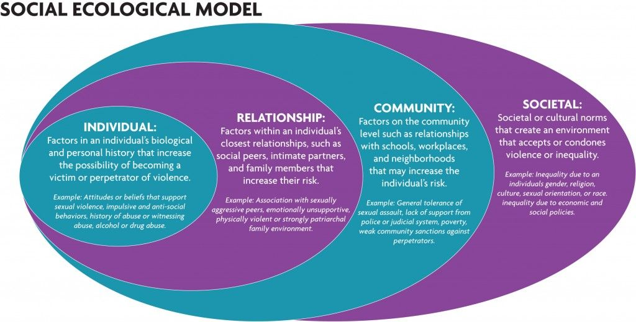
Figure 1: Ecological Model (Source: Kader& Patricia, 2018)
The ecological model underscores the fact that in order to develop strategies for reducing violence risk, it is critical to develop an understanding of the complex interplay of biological, psychological, social, cultural, economic and political factors that increase women’s and girl’s likelihood for experiencing violence as well as men’s likelihood for perpetrating violence (UN Women, 2013).
From that background, a wide scope of aspects had to be well captured. Critical attention was therefore meant to be paid during the training process and ensure that the peace monitors are well equipped with a good understanding of handling the root causes, as well as addressing different GBV scenarios.

2.3 CHANGE THEORY AND HOW IT WAS APPLIED
The term ‘Theory of Change’ first emerged in the 1990s, progressed rapidly and since then, it has increasingly become popular (Intrac, 2017). Change theory is a purposeful model of how an initiative such as a policy, a strategy, a project or program contributes through a chain of early and intermediate outcomes to the intended result (ADB, 2017). It is deployed to promote social change and is often used by companies, philanthropists, nog-profit agencies and government sectors. This theory is a widely used tool for planning, participation and evaluation of change and can help navigate the complexity of social change (ADB, 2017). Right from the start, its purpose was to address some of the difficulties evaluators faced when trying to assess the impact of complex social development programmes (Intrac, 2017). Some of these problems were the poorly articulated assumptions, a lack of clarity about how change processes unfolded, and insufficient attention being given to the sequence of the changes necessary for long-term targets to be reached (Intrac, 2017). Today, the change theory serves as an approach to planning, reflection, learning, and documentation of the change we make as social practitioners; and it is in a sense that it represents the thoughts we conceptualise about how we can support the implementation of desired changes in society (Fagligtfokus, 2015). Nevertheless, some of these ideas need to be constantly tested and refined so that a stronger theories are established in subsequent phases and therefore this theory envisages why social practitioners think certain actions in a project, a social initiative, strategy or program will most likely lead to the desired change (Stein & Valters, 2012; Fagligtfokus, 2015).
Description
In developing theories of change for social initiatives and programmes the entire process is sub-divided into segments to describe the form and context of the subject matter being theorised (Ghate, 2018). The segments can include antecedent causes of the issue being addressed by the social initiative or a programme, with consideration of the context in which the issue arises; as well as a clear description of the intervention proposed; who it is intended for; how it should be delivered in practice, and what results should be expected. Often, this can be represented using an illustration as described in Figure 2. Other details in description can include an explanation why the desired change is expected to occur; elucidation on the mechanisms of change and how phenomena relate to one another using arrows that join the segments, where certain contexts are considered to ‘trigger’ mechanisms that in turn, generate outcomes (Ghate, 2018).
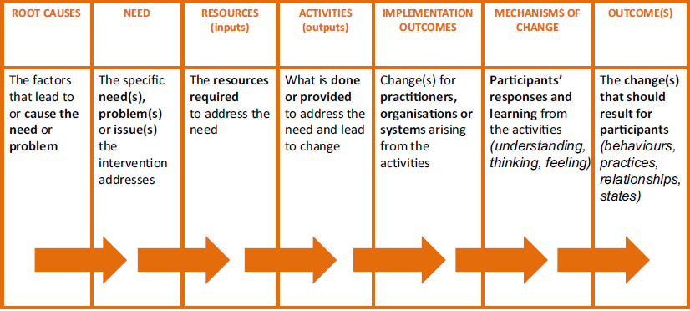
Figure 2: Schematic theory of change model (Source: (Ghate, 2018)
Application
This initiative was developed basing on the fundamentals of Alternative Dispute Resolution (ADR) in order to prevent and address conflicts in Kalangala districts, especially those related to GBV. The theory of change was systematically applied; through recognition of the root causes, the problems/issues at hand, mobilisation of resources, activities and the implementation of the outcomes with a vision of fostering change as illustrated in Figure 3.
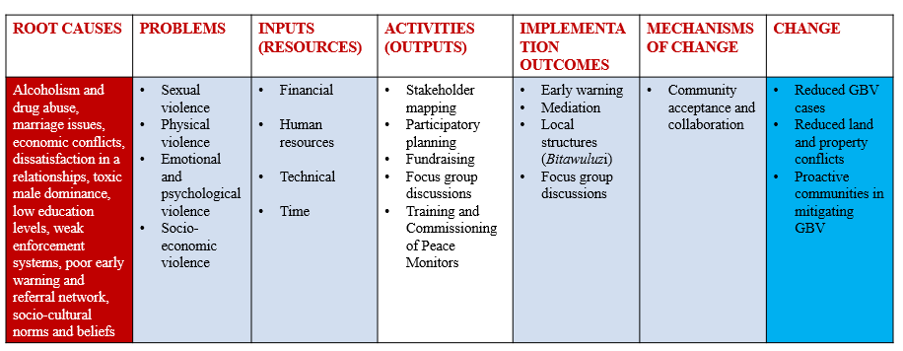
Figure 3: Application of change theory in the Social Initiative

2.4 METHODS AND DESIGN
As a rotary peace fellow, I had to spearhead a series of activities with the aim of empowering and leveraging the existing community-based structures to address GBV paying great attention to ADR mechanisms, increasing access to justice and strengthening referral pathways. This would significantly contribute to the overall aim this social initiative and they ranged from stakeholder mapping, identification of the peace monitors, fundraising, focus group discussions and training of the peace monitors. Joint efforts were a requirement and the key aspect was to ensure collective planning right from the start.

2.4.1 Participatory planning
Planning was crucial as it played an integral role in making important decisions and aided in critical assessment of the goals as well as assessing how realistic they were. Furthermore, planning allowed setting timeframes and defining the measure of performance for this social initiative in preventing VAWG in Kalangala district. In literature, the widely known Conventional Planning Process involves problem identification, definition of goals and objectives, collection of information on which to base decisions, analysis of information and identification of options, formulation of decisions and plans for implementing them, implementation and monitoring and evaluation (Kanth, 2016). However, the Participatory planning process mimics the same Conventional planning process, with the only discrepancy being the participation of stakeholders. Participatory planning paradigm recommends involving the entire community in any community planning process. Thus, the planning is initiated with the identification of stakeholders, analysis of their expectations, assessing their rights and responsibilities, as well as power/group dynamics (Kanth, 2016).
The planning stage of this social initiative took logical steps of situational analysis through the identification of problems, issues and needs; Collection of information on which to base decisions; Analysis; Identification of options; Negotiation with the local authorities and eventually reaching consensus on what needed to be done at different stages of the planned intervention for GBV mitigation in Kalangala. Thus, the design of this intervention and the necessary baseline assessments were based on participatory methods. These were poised superior in the identification of the existing coping mechanisms; individuals or groups at most risk; the major causes as well as consequences of violence in the district. It is worth noting that this Participatory planning processes was based on the transfer and sharing of knowledge and information between and among the wide range of stakeholders, hence effective communication skills were inevitable. The mapping and engaging of the various stakeholders was accomplished through both formal and informal means. Among the communication pathways deployed were phone calls, formal and informal discussions, meetings, emails, text messages and through official letters to the respective offices.
Among the shortlisted stakeholders and peace monitors were local leaders, government officials, cultural leaders, rotary club of Kamapala Ssese, Rotary club of Kalangala Ssese islands, senior Rotarians, women and youth representatives, journalists, elders and community members with high integrity and reputation. The major advantage of this participatory planning process was that it offered an opportunity to create a shared vision of planning interventions and a work plan for addressing violence, more precisely GBV in Kalangala communities with collective contribution of all stakeholders, most importantly community leaders and community members themselves. As an output from the participatory planning process, stakeholders agreed to foster ADR through, focus group discussions (FGD) and training peace monitors to oversee the entire GBV prevention and response process in the district.

2.4.2 Focus group discussions (FGDs)
Focus group discussions involve gathering people from similar backgrounds or experiences together to discuss a specific topic of interest. FGD is a form of qualitative research where questions are asked about their perceptions, attitudes, beliefs, opinion or ideas on the subject matter at hand (Herd, 2016). FGDs can be described as facilitated discussions, held with a small group of people who have specialist knowledge or interest in a particular topic and used to find out the perceptions and attitudes of a defined group of people (Intrac, 2017). FGDs are often led by moderators (interviewers) in loosely structured discussions of various topics of interest. The major advantages of FGDs is that they are free and open discussions among the respondents, resulting in generation of new ideas that can be very useful for decision-making; FGDs are not static and thus the moderator can bring any changes to facilitate the discussion during the discussion. Furthermore, this dynamism allows better results in terms of information derived by a focus group; and non-verbal expressions such as gestures and stimulated activities can provide researcher with useful insights (Herd, 2016).

As per the main target of this social initiative, which was to empower and leverage the existing community-based structures to tackle GBV in Kalangala communities; it required significant amounts of information from various stakeholders. This necessitated several focus group discussions with diverse compositions of people from various community levels. FGDs were deployed at different stages of the social initiative, right stakeholder mapping, participatory planning and implementation of the initiative activities. I realised that in most cases, specific GBV assessments and discussions had to be undertaken by key participants, grounded in the community and equipped with expertise managing gender-based violence. Therefore, the participants in FGDs were the shortlisted stakeholders and peace monitors, who included the local leaders, government officials, women and youth representatives, journalists, cultural leaders, Rotarians, elders and community members with high integrity and reputation.

CHAPTER THREE

3.1 INTERVENTIONS AND ACTIVITIES

3.1.1 FGDs AND TRAINING OF PEACE MONITORS: DAY 1
The two-day training was conducted from 11th to 12th November 2021, at Upland Guest house in Kalangala district and encompassed a series of activities as elucidated below.

3.1.1.1 Inception and Introduction
Started at 8:00am and entailed the arrival & registration of participants as well as the opening prayer, led by Madam Nanyonjo Betty Kabaalu. The trainees were led through the programme, their expectations and fears in the two-day training (see chart containing list expectations and fears). An appointed peace monitor (out-going President Rotary club of Kalangala Ssese, Ibrahim Ssenyonga) moderated the sessions. The participants then introduced themselves.

3.1.1.2 Opening Remarks/expectations from participants
Mr Ssempande Steven a Rotary Peace Fellow of Makerere University was the convener of the training and his organization SHED gave financial and logistical support to the training. He welcomed the participants and gave a brief about the Makerere University Rotary Peace Centre and the relevance of the social initiative. He lamented the rampant cases of gender based violence and land injustices in the district and emphasised the urgent need to address these conflicts right from the root causes through leveraging the existing community structures.
Riding on the positive peace framework, he reiterated the advantages of ADR as compared to litigation for a district like Kalangala, given its unique island geography and complex transport network, deeming court sessions often too expensive and inaccessible. He acknowledged the crucial need for consulting the local people. He further expounded on the expectations from the training, from the lawyers and other speakers to dialogues. He finalised with a discussion about the understanding of both negative and positive peace, as well as his personal philosophy on peace as a raw material and end product for democracy and development.

3.1.1.3 Presentation about Alternative Dispute Resolutions by Owekitiibwa Kweba Kasirye Augustine the Buganda Chief of Ssese County
He emphasised the need to establish a team of Peace monitors/community based volunteers to provide alternative dispute resolutions (ADR) in Kalangala district. He noted that the magnitude of cases in the district that required ADR was enormous and that no organisation could claim to have the capacity of subduing the conflicts occurrences in society and cause remedial actions for the victims. He recognised that 85% of the conflicts could be resolved through ADR, thereby creating space to Justice and Legal Systems (JLS) to expediently dispose criminal and other cases referred to them.
He reported that majority of the conflicts emanated from gender based violence, land as well as property rights disputes. The commonest gender disparities and behavioural characters that fuel gender violence were: sex differences, livelihood sources (labour differences), transient and cosmopolitan lifestyles, marriages (co-habitation), drug abuses and the weak public and social structures. The common land and property rights issues noted were: ownership rights, conflicts on ownership, awareness, boundaries and social safety. The major victims of such conflicts were often women and widows, children, elderly, family, members and tenants. He gave a recap of the existing structures and the lessons learnt, and recommended the restoration of traditional and tested ADR mechanisms known as Bitawuluzi as per the resolution from Buganda Kingdom. He then officially launched the training.

3.1.1.4 Presentation about Peace Monitors by Nakamanya Milly, Legal Officer - SHED
She threw more light on the Probono, and elucidated that it involves free legal services. She then agitated a discussion about the definition of a peace monitor, roles and expectations. Described a peace monitor as an individual who tracks or mediates any issue at hand in order to resolve for peace. Among the roles of a Peace Monitor were mediation, counselling of victims and survivors, follow-up, sensitisation, referral, guiding of people on legal processes, conducting community dialogues (Bimeeza), and early warning systems. The expectations included: handling of conflicts among communities, act as mediators between authorities and demonstrators, build knowledge on how to push forward peace and development, help people reduce violence and build sustainable peace. The session then went for a tea break at 10:00am.

3.1.1.5 Presentation on Marriage, Divorce and Children Rights by Catherine Beinomugisha, Rotary Peace Fellow Makerere University
Her interactive session was kick started by engaging the participants about their understanding of marriage and related issues such as separation and divorce. The audience described marriage as a legal agreement between two people of opposite sex and above 18 years of age, coming together and starting a family. She then discussed the types of marriage, definition of marriage, laws governing marriage in Uganda precisely on church, civil, customary, Islamic and Hindu marriages.
She briefly discussed child rights such as immunization; education; protection from harm, abuse and exploitation; food and shelter among others. Other talking points were about registration of marriages, consequences of marriage, separation and its effects. Lastly, she discussed divorce and its effects, obtaining divorce in court, grounds for divorce in civil and church marriages, divorce in customary marriages and what happens after divorce concerning the children and matrimonial property. The session then went for a Lunch break.

3.1.1.6 Key note address by Dr. Charlotte Mafumbo, Makerere University Rotary Peace Center
She defined Peace Monitors, their roles and expectations. She noted the multiple roles they play ranging from early warning, conflict mapping up to conflict management. She explained Uganda’s geo-politics and the importance of Kalangala, given its unique attributes. She then expounded on the mainstream approaches of peace processes as per the the UNO Security Council approach. Further, she agitated an open discussion about conflict in Kalangala district, factors of instability, and the role of women. The Keynote was then winded with a brain storming session about GBV.

3.1.1.7 Presentation on Land by Counsel Babukiika Regina, JCU Centre Manager-Masaka
This module was intended to equip the participants with a detailed understand of land management and justice in Uganda. In most cases, women are denied access to land and always face forceful evictions. Therefore having the basic knowledge about land laws in Uganda would enable the trainees to acquire skills that might be necessitate guidance to people facing land conflicts and aid them during mediations/negotiation processes. Firstly, she engaged the participants about their understanding of land issues, how they affect the communities and how they have been handling them. In her presentation, the sub-sections were as summarized below:
- Land tenure systems in Uganda
- Lawful and bonafide tenants on land (bibanja holders)
- Other third party claimants on registered land.
- Transfer and registration of registered land.
- Searches and caveats.
- Compulsory acquisition of land.
- Common land conflicts.
- Institutions of land management in Uganda.

3.1.1.8 Departure
Day 1 activities were wrapped up at 4:00pm and all the participants departed.

3.1.2 FGDs AND TRAINING OF PEACE MONITORS AND FGDs: DAY 2

3.1.2.1 Inception
Event started at 8:00am and included arrival & registration of participants. The opening Prayer was led by Mrs. Mukasa, an appointed peace monitor.

3.1.2.3 Presentation on Mediation process by Counsel Babukiika Regina, Justice Centres Uganda Centre Manager-Masaka
She noted that most people conduct mediations, but the quality of the mediation outcome has always been wanting since the mediations often fail due to lack of mediation techniques. In her interactive training session, the participants were be able to appreciate the following:
- What is Mediation?
- Who is a mediator?
- What are the characteristics of a good mediator?
- The advantages/ benefits of mediation
- What are ethical Considerations during mediation?
- The mediation process/techniques

3.1.2.4 Presentation on Gender Based Violence by Counsel Nakamanya Milly, Legal Officer –SHED
The objectives of this session were to:
- Refresh the participants' knowledge on gender and Gender-Based Violence (GBV)
- Educate the participants with the latest issues regarding Gender-Based Violence in Uganda
- Equip the participants with the skills and best practices for tackling GBV cases within their communities
Counsel Milly engaged participants in a FGD about what they understood by GBV, GBV issues within their communities, and how they have been handling such issues.
She then discussed the with participants about the meaning of Sexual & Gender-Based Violence (SGBV); manifestation/categories of SGBV cases, such as Family violence, Community violence and State violence; the forms of Gender-Based Violence such as Economic abuse, Emotional, verbal and psychological abuse, Sexual Violence; Gender Equity and the current Gender Situation in Uganda. Other points of discussion were on the common causes of GBV Violence; effects of Gender Based Violence; reporting Gender Based Violence; handling victims of GBV and the possible challenges in handling GBV cases. The training then went for a tea break at 10:00am.

3.1.2.5 Community Dialogue skills by William Nkumbi, Senior Probation Officer Kalangala District
He first thanked the organisers as well as the participants of the training. He explained the discrepancy between dialogue and debate, and emphasised the importance of giving each of the aggrieved parties a chance to express their thoughts freely during the mediation process. He further reiterated that the interests of all the parties should be well understood from the start. He discussed the benefits of community dialogues. For instance, it aids sorting issues without going to courts of law, gives capacity for people to believe in themselves, allows people to express their opinions and ensures ownership of the outcomes. He guided that for community dialogues, always move towards the solution and aim at changing the heart of the person; focus on using the available resources; set dialogue at neutral grounds; be a respectful good listener, establish ground rules for the dialogue at the start and always stay neutral.

3.1.2.6 Feedback from the trainees
The participants expressed their opinions about the training; the lessons learnt, take homes and appreciated the organising team for the opportunity. They pledged to go back to their communities and implement their peace monitoring roles.

3.1.2.6 Closing Remarks and Commissioning of the Peace Monitors by Chairperson LCV and Magistrate – Kalangala District
The LCV Chairperson, Mr. Rajab Ssemakula thanked the Rotary Peace Fellow, Mr. Stephen Sempande, SHED team, facilitators and all the participants for making the training a success. He lamented the rampant cases of teenage pregnancies, especially in the Covid-19 lockdown, land wrangles, GBV and therefore acknowledged ADR mechanisms such as mediation the way to go. He cautioned peace monitors to lead by example and do the voluntary service. He boosted them and ascertained that God will bless and repay them abundantly.

3.1.1.8 Departure
The 2 days training was concluded on 12th November 2021 at 4:00pm and the participants departed.

3.2 KEY FINDINGS / IMPACT

3.2.1 Findings
Initiative activities facilitated access to a wide range of views, experiences and knowledge from several participants and stakeholders. These ranged from minority or disadvantaged groups, such as women, children or people with disabilities, to local leaders and government officials. This was possible because FGDs and trainings were comprised entirely of people from well-solicited groups for effective representation and ensuring that they discuss their particular needs and opinions in a mixed setting. Furthermore, the initiative activities enabled access to the views of people with the knowledge and expertise and on GBV in the district, ranging from of authorities, security officials, community workers, district health workers and liaison officers.

From the FGDs, I discovered that local structures such as the Buganda government had already appreciated mediation as a key tool for promoting peace within these island communities. The Kweba reported that his office had earlier plans of advancing traditional Ganda ADR mechanisms "Bitawuluzi" within Kalangala district, given the high rates of conflicts, especially during the Covid-19 lockdowns. This was therefore an indicator that this initiative was timely. Various speakers and participants unveiled key critical issues for discussion as well as more tailor made interventions. For instance, the Official from the Director of Public Prosecution Office lamented the geographical set-up of Kalangala district and noted it as one of the major causes of the case backlogs in the district court. He reported that 70-80% of the cases in the district court are from far islands, making transportation of witnesses intricate. He was therefore in unison with previous speakers, trainers and participants that ADR mechanisms such as mediation as the best alternative to reduce on the pile-up of cases on the already strained judicial system, foster justice and ensure sustainable peace within Ssese islands communities.

The participants admitted that the previous knowledge gaps were an obstacle to the ADR approaches in the communities. For instance, the lack of understanding of the land laws, marriage laws, child rights and gender-based violence (GBV) were reported as the catalysts for violence, thus the major setbacks to any mediation processes. Nonetheless, we noted that the local structures were hospitable and more willing to have more collaborations to foster peace in Kalangala, not only through GBV prevention, but also for tackling other violence forms, such as property and dispute conflicts.

3.2.2 Impact
Being the first of its kind in Kalangala district, this social initiative drew together a wide range of stakeholders with the aim of addressing GBV through ADR mechanisms. The activities of the initiative were therefore a wakeup call for different players in violence prevention to execute things a little differently and auspiciously the local authorities pledged their full support for this initiative and its sustainability plan. For instance, the Buganda government appreciated SHED and Rotary for this intervention and consented to leverage the initiative as an opportunity for collaboration to foster peace, through its earlier plan of promoting traditional mediation pathways "Bitawuluzi".
Through this training, the Peace Monitors and other stakeholders were equipped with the necessary skillsets for addressing gender-based violence, ranging from early warning, prevention and handling of different GBV scenarios. The participants expressed their opinions about the social initiative and reported that the training and the discussions had opened their eyes to tackle violence in the communities. They therefore appreciated SHED team for the opportunity and pledged to go back to their communities and implement their roles as peace monitors. For example Mrs Mukasa, an appointed peace monitor testified about how the training empowered her understanding of marriage matters. She reported that before the training, she was often confused about the handling marriage conflicts such as separation, divorce and IPV. Therefore, these focus group discussions and trainings on Alternative Dispute Resolution (ADR) were timely to ensure that knowledge and justice is extended to the grass roots for peace to prevail in these island communities.
Furthermore, as an immediate outcome of this social initiative, the president of Rotary Club of Kampala Ssese agreed to work with Mr. Stephen Sempande, the Rotary Peace Fellow, to conduct legal aid clinics in Kalangala district, during the month of February this year (2022). We are optimistic that initiative will even contribute further secondary impacts for mitigating conflicts in the district.

CHAPTER FOUR

4.1 GENERAL CONCLUSION
There is no doubt that this social initiative had numerous benefits, most of which had not been anticipated. Therefore basing on the initial targets, the activities executed and the key findings, several conclusions can be drawn. Firstly, this initiative unified different players and thus served as a platform for collaboration among several stakeholders in violence prevention. The Peace monitors were equipped with the necessary skillsets, commissioned, and the local stakeholders expressed optimism. However future emphasis should be more directed on the sustainability plan to ensure the candle of preventing GBV in Kalangala never ceases to burn. Furthermore, it can be concluded that traditional mediation pathways such as the "Bitawuluzi", as recommended by Buganda Kingdom can have a crucial role to play in violence mitigation. Nevertheless, my feeling is that more could have been done with the social initiative, especially in training a larger number of peace monitors for extended periods. Lamentably, logistical constraints never gave room for that. Nonetheless, amidst the several challenges, the major target for this social initiative which was to empower existing community structures in prevention and response to GBV in Kalangala district was met even beyond our expectations. Basing on recent feedback, ground dynamics are changing and so far several cases of conflicts have been resolved and settled with the help of the recently commissioned Peace monitors through ADR mechanisms especially mediation, thus another reason for excitement and optimism.

4.2 RECOMMENDATIONS / IMPLICATIONS FOR POLICY
It should be well noted that while this social initiative contributed a number of benefits, there are some important undertakings to be recommended, for sustainability, future works as well as key roles for other players GBV prevention. Firstly and most importantly, during assessments and analysis, emphasis should be on participatory methods. This has to be well reflected in identification of the drivers and consequences of GBV in communities, individuals or groups most at risk as well as tailoring suitable interventions.
Community mobilization: Through community mobilization, the capacity of susceptible individuals in protecting themselves against GBV is amplified. For example, through promoting equal participation of men and women in several community initiatives, the social gaps are bridged, whereby women and girls are empowered through educational and income-generating activities.
Information flow: If well leveraged, information and communication activities can further raise awareness of GBV, combat discrimination and other underlying causes of gender-based violence. Therefore, local authorities, other players and peace monitors should ensure that information about GBV response and prevention is readily available through utilizing locally available communication pathways such as radio stations like Radio Ssese. Such information can include how and where to access relevant assistance and services about GBV. There is further need to support the peace monitors with airtime and data to ease communication as the people clearly understand and appreciate the role they play in the community.
Addressing livelihood aspects: Future interventions should also focus on livelihoods, especially for the poor and marginalised groups, which are more susceptible to GBV. The target should be fostering self-reliance and sustainable livelihoods especially for the victims/survivors of GBV in Kalangala. Such programmes may not only ensure reduction in the GBV risk, but also mitigate its adverse effects through facilitating rehabilitation of its victims.
Referral and response mechanisms: Such mechanisms will be crucial in GBV mitigation. Hence, further efforts should ensure that adequate referral and response mechanisms are in place and well supported for proper functioning. These mechanisms should be framed with clear and acceptable referral as well as reporting mechanisms, but must respect confidentiality as well as the rights of the victims/survivors.
Technical support: This can take various forms such as advice and further trainings to specific special groups such as community leaders, NGOs, law enforcers, health practitioners, social workers, peace monitors and the general community. These extra trainings and technical support can be about human rights, GBV prevention and response among other matters.
Legal and socio-cultural reforms: Often, the prevalence of high rates of GBV has been blamed on the gaps and contradictions in the existing laws and policies in Uganda. This calls for urgent review of our national laws, regulations, policies and practices. The practices can entail our traditional and cultural practices, which agitate discrimination against women and girls. Nevertheless, such reform processes are often complicated; requiring necessary consultations with stakeholders and the entire process has to be backed with statistical facts.

4.3 SUSTAINABILITY PLAN
Sustainability is key and ensures that the goals and mission of any social initiative are realised for longer timeframes through continued commitment. The sustainability plan for this initiative will therefore focus mainly on building the capacity of the local Kalangala communities through fostering ADR mechanisms as opposed to litigation for civil cases; collaborations with community support systems, particularly women’s/youth groups and organizations, including encouraging and supporting other social systems. Through the alliance with the Buganda government, the Kingdom will direct extra emphasis towards resumption of the cultural structures of conflict prevention, locally referred to as the Bitawuluzi, for mediation interventions. In summary, the sustainability plan for this initiative will be based on long-term collaborations and partnerships with local authorities and the already existing community based structures. The major aim for this is to ensure that the Kalangala communities own this social initiative, and utilise it to dictate a better future for themselves and next generations.
Coordination and Collaboration: Our vision is to ensure that GBV is addressed at local community level. Therefore, this will entail smooth coordination with existing structures, as well as other relevant stakeholders. This will include establishing a GBV committee and Standard operating procedures for addressing GBV in the district. Furthermore, the roles and responsibilities of different actors will be agreed upon, outlined and implemented at the right timings. Through coordination and collaboration, the social initiative hopes to work with a wide range of stakeholders. This will ensure that gender concerns are taken into proper account and integrated in planning and programming activities at different levels in the district. These can range from education, physical planning, health as well as security. Further discussions and engagements will be held especially with potential funding sources in order to secure logistical support for the peace monitors.
Long-lasting solutions: A wide range of approaches and innovative ways will be executed to ensure the initiative sustainability. For instance, the initiative will seek advocacy for public support on the general cause of mitigating GBV in Kalangala. Advocacy will also entail relevant actors, inclusive of both national and local authorities, cultural or religious structures, law enforcement officials, NGOs, among others, to foster effective prevention and response to GBV in the district and the nation at large. Future plans will therefore contain tools and measures to prevent and respond to GBV, but more importantly will provide the necessary treatment and support to the victims/survivors. This will call also ensure that the peace monitors will be aquatinted with relevant codes of conduct and skillsets to handle various forms of GBV in the community. Furthermore, confidential complaints mechanisms will be established, to ensure that critical issues are well handled, investigated, and accorded the necessary followed up.
Safety issues: Security cannot be underestimated in GBV prevention and promotion of peace. Peace monitors and the general community members will be required to take necessary actions in improving the safety and security in their communities; including villages, town centres and the landing sites with key attention to GBV risks. The initiative will sustain efforts to ensure that mechanisms are in place to guarantee the security of GBV victims/survivors and witnesses in order to protect them against further harm. Children protection will also be key and the social initiative is exploring options in ensuring that child victims/survivors are provided with specialised care and appropriate assistance. Our vision is that such responses will be guided by the key principles of the best interests of the child and the child’s right to life, non-discrimination, survival and development and participation. More planned future activities will centered on monitoring and evaluation as well as follow-ups

REFERENCES
Abramsky, T., Devries, K. M., Michau, L., Nakuti, J., Musuya, T., Kyegombe, N., & Watts, C. (2016). The impact of SASA !, a community mobilisation intervention , on women ’ s experiences of intimate partner violence : secondary fi ndings from a cluster randomised trial in Kampala , Uganda. 818–825. https://doi.org/10.1136/jech-2015-206665
Scott Brown, Christine Cervenak and David Fairman (1997). ALTERNATIVE DISPUTE RESOLUTION PRACTITIONERS GUIDE About the Authors.
Campbell, C. (2014). Community mobilisation in the 21st century : Updating our theory of social change ? June 2012. https://doi.org/10.1177/1359105313500262
Asian Development Bank. (2017). Theories of Change. 237–243. https://doi.org/10.1007/978-981-10-0983-9
Law Reform, (2008). ALTERNATIVE DISPUTE RESOLUTION. (LRC CP 50 – 2008)
Dti, F. G. D. (2016). Focus Group Discussion. March. Edition, R. (n.d.). Revised edition.
Enríquez-canto, Y., Ortiz-montalvo, Y. J., Ortiz-romaní, K. J., Díaz-gervasi, G. M., & Ortiz-romaní, K. J. (2020). Análisis ecológico de la violencia sexual de pareja en mujeres peruanas. 51(01), 287–300.
Ettekal, A., Mahoney, J. L., & Education, A. (2017). The SAGE Encyclopedia of Out-of-. April. https://doi.org/10.4135/9781483385198.n94
Deborah Ghate, (2018). Developing theories of change for social programmes: co-producing evidence-supported quality improvement. Palgrave Communications, 2018. https://doi.org/10.1057/s41599-018-0139-z
Heise, L. (1998). Violence Against Women. An Integrated, Ecological Frameworkhttps://doi.org/10.1177/1077801298004003002
Heise, L. Lori (2011). WHAT WORKS TO PREVENT PARTNER VIOLENCE ? An evidence overview.
UN Women (2013). Violence against Women in Conflict, Post-conflict and Emergency Settings International, B. T., Framework, L., & Conflict, A. (2013). Violence against Women in Conflict , Post-conflict and Emergency Settings. December.
Kabonesa, C., & Kindi, F. I. (n.d.). ASSESSING THE RELATIONSHIP BETWEEN GENDER BASED VIOLENCE AND COVID-19 PANDEMIC IN UGANDA ,.
G. Rajani Kanth (2016). Participatory Planning. Ideas and Processes in the Context of Utilising PRA Techniques
Richard L., Blackwell, A., Contreras-urbina, M., Olson, E. L., & Siebert, S. (2018). A Community-Based Intervention to Prevent Violence against Women and Girls in Haiti A Community-Based Intervention to Prevent Violence against Women and Girls in Haiti. August 2018.
Madinah, N. (2020). Original Paper The Gender Issues in Uganda : An Analysis of Gender-Based Violence , Asset Ownership and Employment in Uganda. 3(3), 131–150. https://doi.org/10.22158/uspa.v3n3p131
Minckas, N., Shannon, G., & Mannell, J. (2020). The role of participation and community mobilisation in preventing violence against women and girls : a programme review and critique ABSTRACT. Global Health Action, 13(1). https://doi.org/10.1080/16549716.2020.1775061
UN Women (2020). GENDER-BASED VIOLENCE IN AFRICA DURING THE COVID-19 PANDEMIC.
Participation, C. (1999). Chapter 12 Community participation. 177–188.
Reference, A. L., Supply, W., Samjtatifln, A. N., Story, I. C., & But, F. (1990). Community Participation Theory and Practice in Health m w mm. October, 5–9.
Rifkin, S. B. (2011). Translating Rhetoric to Reality: A review of community participation in
health policy over the last 60 years. 1–20. London School of Economics, Colorado School of Public Health
Susan B Rifkin, Maria Kangere, (2002). What is Participation ? January 2002.
Stein, D., & Valters, C. (2012). UNDERSTANDING THEORY OF CHANGE IN INTERNATIONAL DEVELOPMENT. 1(August).
Fagligtfokus (2015). March, 1–71. How to navigate towards positive change in complex social settings
Intrac (2017). THEORY OF CHANGE.
Uganda Bureau of Statistics (UBOS) (2019). UGANDABUREAU OF STATISTICS 2019 STSTISTICAL ABSTRACT.
Wilcox, D. (2001). Community participation and empowerment : putting theory into practice. 21.

APPENDICES

Appendix 1: Pictorials
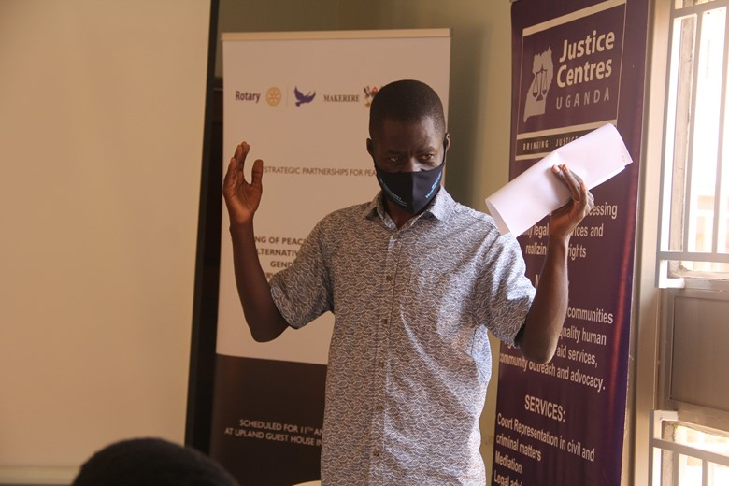
Mr. Stephen Sempande, the Rotary Peace Fellow from Makerere University Rotary Peace Center giving Opening Remarks
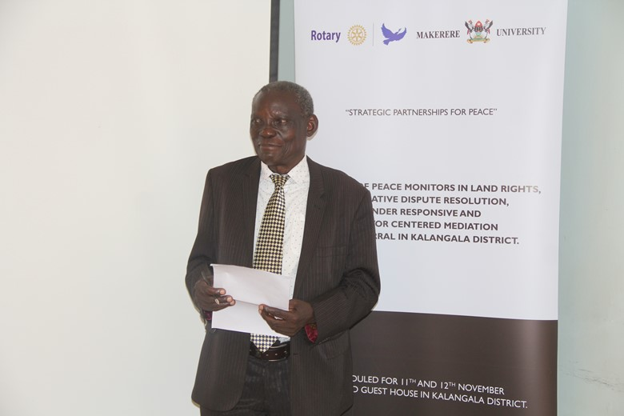
Owekitiibwa Kweba Kasirye Augustine, the Buganda Chief of Ssese County giving a
Presentation about traditional Alternative Dispute Resolution mechanisms
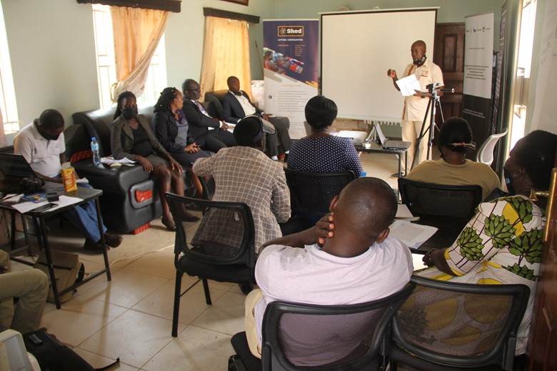
Mr. Ssenyonga Ibrahim (outgoing club President) moderating a session, during the training
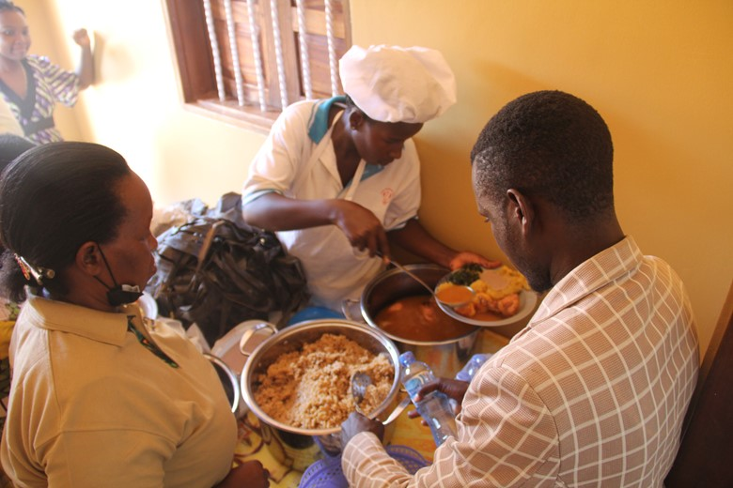
Participants during a Lunch break
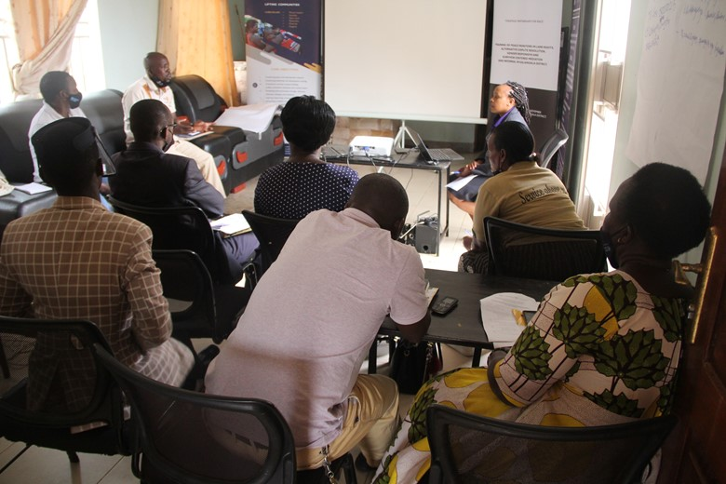
Counsel Babukiika Regina, JCU Centre Manager-Masaka conducting a session about land

Kalangala district LCV Chairperson, Mr. Rajab Ssemakula hading over a Certificate to Mrs Mukasa an appointed peace monitor, after completion of her training

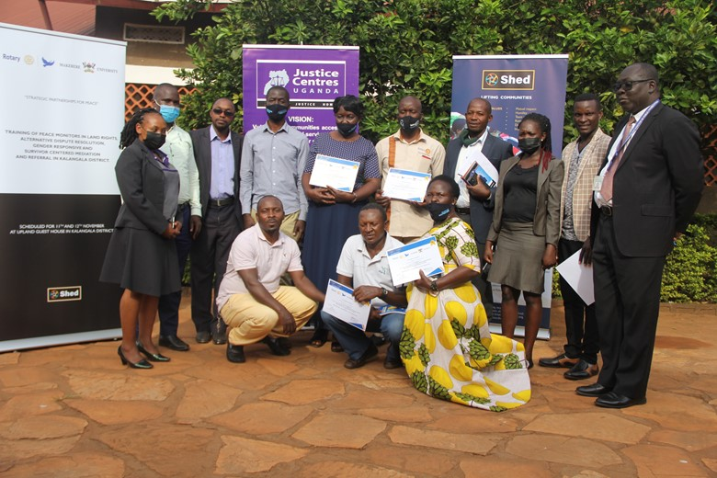
Participants pose in a group photo after completion of the training
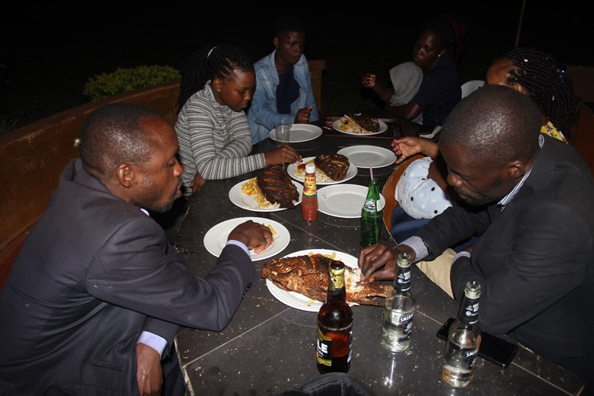
The SHED team together with participants enjoyed the yummy delicacy of Ssese islands

Appendix 3: Participant Testimonies

3.1 Lists of the Participants for the training of Peace Monitors
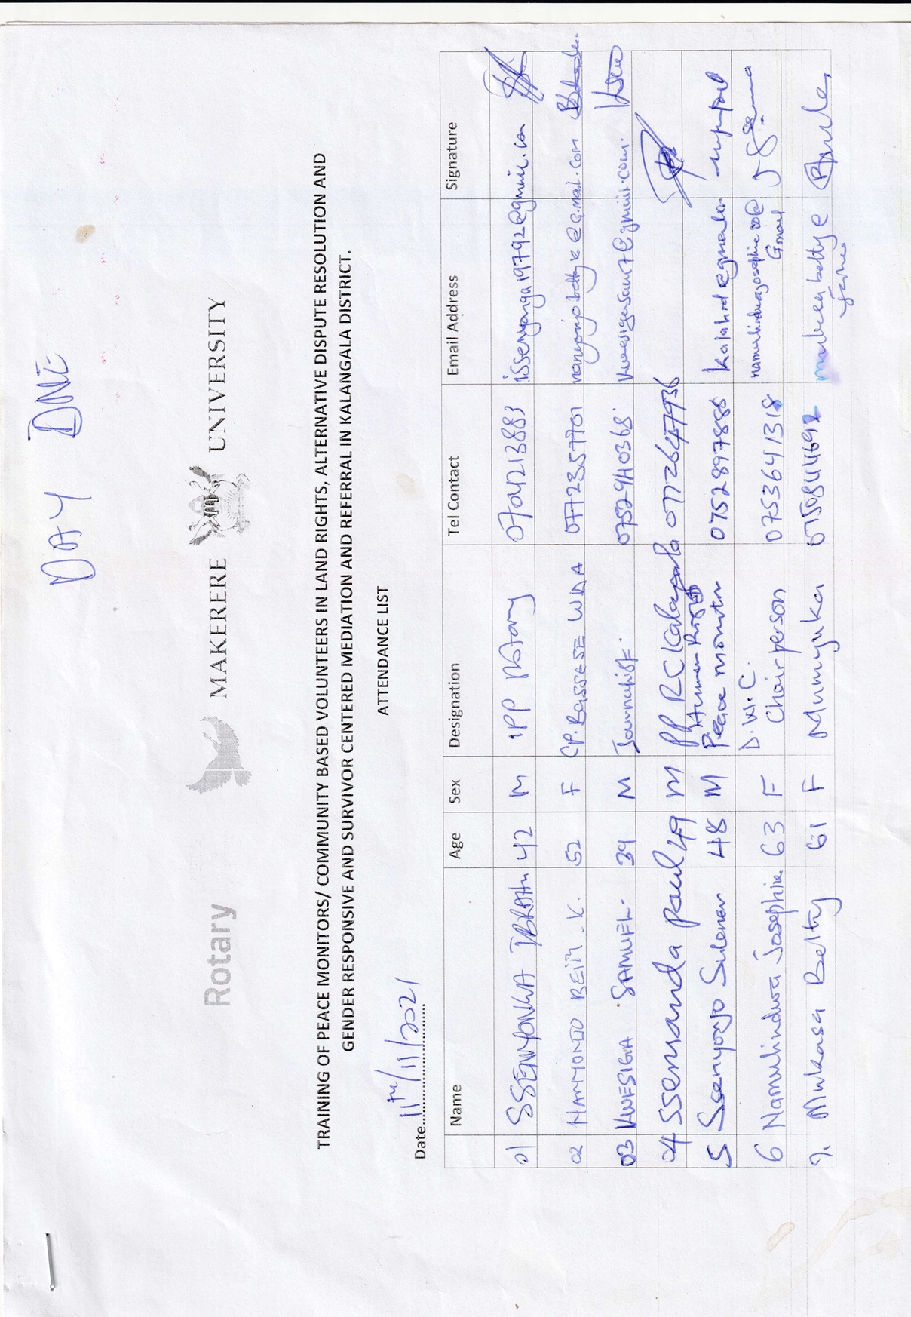
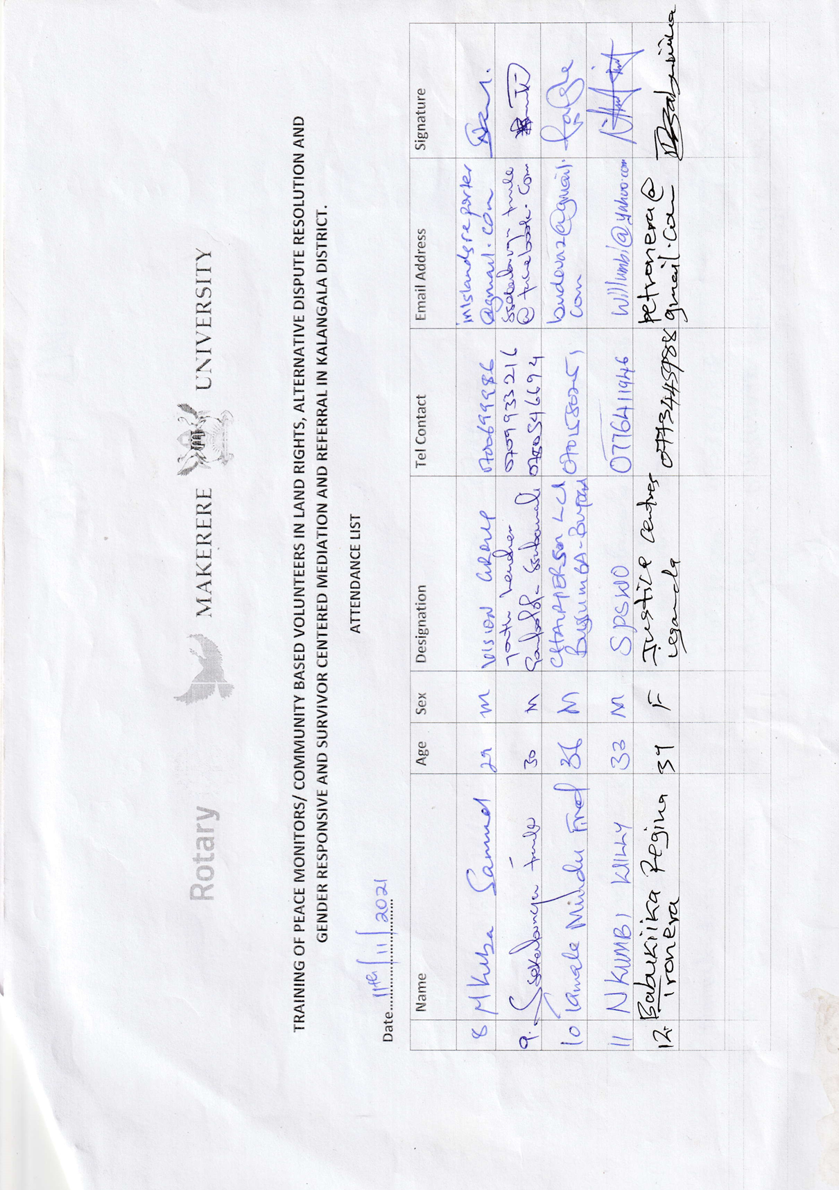
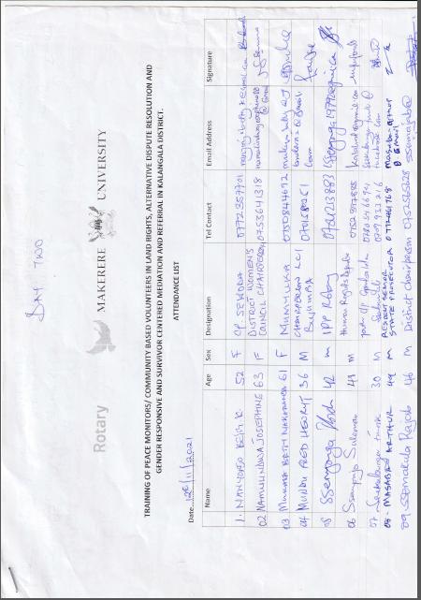


Appendix 4: Other relevant Documents

4.1 Day Programs

DAY 1 PROGRAM FOR TRAINING OF PEACE MONITORS /COMMUNITY BASED VOLUNTEERS (CBVs)
11TH NOVEMBER AT UPLAND GUEST HOUSE IN KALANGALA DISTRICT
TIME | ACTIVITY | IN-CHARGE
8:00-8:30am | Arrival & registration of participants and other invited guests. | Appointed Peace monitor
8:30-8:35am | Opening Prayer | Appointed Peace Monitor
8:35-8:45am | Introduction by participants | Appointed Person
8:45-9:00am | Opening Remarks/expectations from participants | Stephen Sempande  Rotary Peace Fellow  Makerere University Rotary Peace Center
9:00am-9:30am | Key note address | Dr. Charlotte Mafumbo  Makerere University Rotary Peace Center
9:30-10:00am | Presentation about Peace Monitors  -Who is a Peace Monitor?  - What are the roles of a Peace Monitor?  -Expectations | Nakamanya Milly  Legal Officer - SHED
10:00-10:30am | Break Tea | All participants
10:30-11:45am | Presentation on Access to justice and Referral Pathway  (Before the presentation, the presenter should;  Ask participants what they understand by access to justice,  Ask the participants whether they have any access to justice issues within their communities,  Let the presenter note down the issues,  Ask the participants how they have been handling such issues within their communities,)  Highlight the objective of the presentation | Babukiika Regina Tronera  Centre Manager/Advocate  (Justice Centres Uta NDA)
11:45-1:00pm | Presentation on Marriage and Divorce and Children Rights  (Before the presentation, the presenter should;  Ask participants what they understand by marriage  Let the presenter note down the issues affecting the community members under this topic)  Highlight the objective of the presentation | Babukiika Regina Tronera  Centre Manager/Advocate  (Justice Centres Uganda)
1:00-2:00pm | Lunch | All participants
2:00-3:40pm | Presentation on Land  (Before the presentation, the presenter should;  Ask participants what they understand by land  Let the presenter note down the land issues affecting the community members under this topic and how they have been handling them)  Highlight the objective of the presentation  Land tenure systems in Uganda  Lawful and bonafide tenants on land (bibanja holders)  Other third party claimants on registered land.  Transfer and registration of registered land.  Searches and caveats.  Compulsory acquisition of land.  Common land conflicts.  Institutions of land management in Uganda. | Herbert Walusimbi -  Senior Legal officer  (LAC-LDC Legal Aid Clinic)
4:00pm | Departure | All participants

DAY 2 PROGRAM FOR TRAINING OF PEACE MONITORS /COMMUNITY BASED VOLUNTEERS (CBVs)
12TH NOVEMBER AT UPLAND GUEST HOUSE IN KALANGALA DISTRICT
TIME | ACTIVITY | IN-CHARGE
8:00-8:30am | Arrival & registration of participants and other invited guests. | Appointed Peace Monitor
8:30-8:35am | Opening Prayer | Appointed Peace Monitor
8:35-8:50am | Recap of previous training | Stephen Sempande  Rotary Peace Fellow  Makerere University Rotary Peace Center
8:50-10am | Presentation on Gender Based Violence  (Before the presentation, the presenter should;  Ask participants what they understand by GBV,  Ask the participants whether they have any GBV issues within their communities,  Let the presenter note down the issues and how they have been handling such issues within their communities,)  Highlight the objective of the presentation | Babukiika Regina Tronera  Centre Manager/Advocate  (Justice Centres Uganda)
10:00-10:30am | Break Tea | All participants
10:30-1:00pm | Presentation on Succession  (Before the presentation, the presenter should;  Ask participants what they understand by succession,  Let the presenter note down the issues and how they have been handling such issues within their communities,)  Highlight the objective of the presentation | Herbert Walusimbi -  Senior Legal officer  (LAC-LDC Legal Aid Clinic)
1:00-2:00pm | Lunch | All participants
2:00-2:30pm | Presentation on Mediation process  What is mediation?  Characteristics of a mediator  Advantages/ benefits of mediation  Ethical considerations  Mediation process
2:30-3:00pm | Role Play | All participants
3:00-3:30pm | Community Dialogue skills | William Nkumbi  Senior Probation Officer  Kalangala District
3:30-4:00pm | Closing Remarks and Commissioning of the Peace Monitors | Chairperson LCV and Magistrate – Kalangala District
4:00PM | Departure | All participants

4.2 STATUS OF CONFLICT RESOLUTION BY KALANGALA PEACE MONITORS
NO. | CASE | LOCATION | STATUS
1 | GBV:  GBV between the female district councilor and the husband over education, where the councilor was battered seriously and wounded. She went to police but the CLO advised her to look for a person who can help her to reconcile them and it happened that the name of Ibrahim Ssenyonga was fronted and he was approached. After 6 days of intervention and discussion both side came to agreement and made promises to each other | KTC | Both reconciled and among a few action plans included never to batter her again, she was accepted to go back to school, improve on the time committed on political activities and home requirements to the husband among others. To date they are fine and moving on with their family life.
2 | Child negligence. The father of two daughters aged 14 years went out of control after finding that the girls were standing with the boys outside in wired hours of the night. He decided to beat them seriously and locked them out of the house for two nights, an act that was exposing them to more danger. A concerned senior citizen approached a peace monitor and the father and daughters were reconciled | Buggala | The father and the daughters are living in peace although with restrictions.
3 | GBV  A man identified as Mukeeka fought his wife after the wife checked his phone and found out love messages and she decided to destroy everything in the house. The wife after wards reported to police and a warrant of arrest was issued to Mukeeka. However, Mukeeka went to the area peace monitors who intervened and the case was settled amicably. | Bujjumba 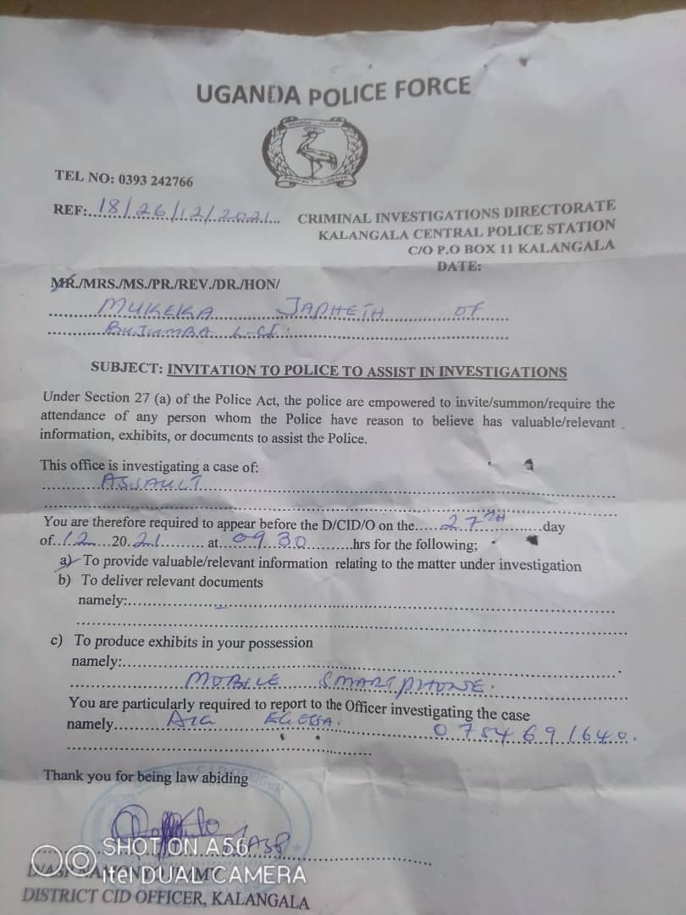 | The issue was settled and the conflict was reconciled and now are together still as husband and wife and cautions still were made.
4 | Lost daughter in Kissujju Kagoonya with high suspicion of having seduced by boys to get into marriage than going back to school | 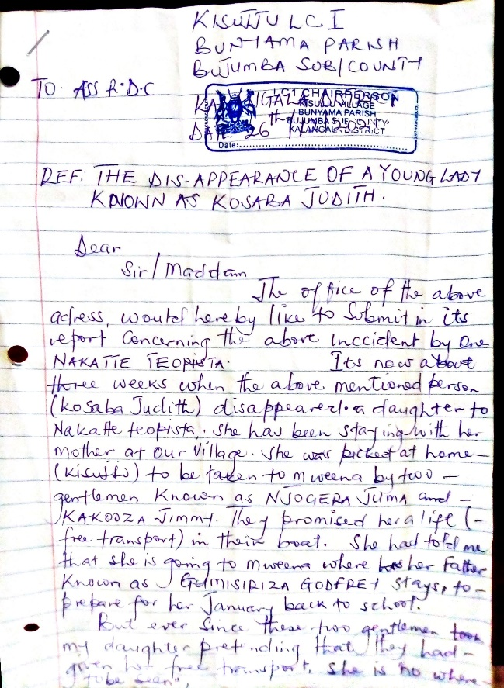 | A warrant of arrest was issued to the two suspects by the office of the DISO Kalangala but its execution needed 20 liters of petrol which the area councilor and the mother could not afford at the moment and the concern was forwarded to the Bujjumba peace monitors.
 |  | 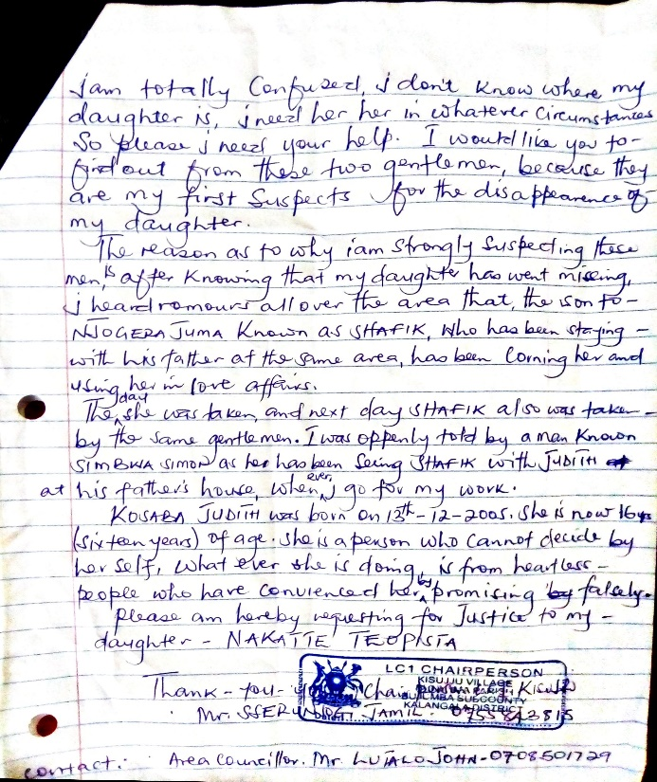
Other peace monitors were still in holidays for the end of year celebrations however, some had small issues of family wrangles to sort out. The cases presented above when contacted the peace monitors seemed worth to mentioning about.

Challenges faced by peace monitors:
- Poor network and difficulty in island connectivity.
- Lack of transport, airtime for follow-up and Data for reporting timely.
- Over expectation of community members from the peace monitors.
- Family ties among the island communities where issues to be followed have attachments to different family members hence hiding the truth in the disguise of keeping family secrets.
Recommendations:
- There is need to support the peace monitors with airtime and data to ease communication as people clearly understand and appreciate the role they play in the community.
By: Ibrahim Ssenyonga
Coordinator, Kalangala peace monitors.

