

## MAKERERE UNIVERSITY ROTARY PEACE CENTER

**ROTARY INTERNATIONAL PEACE FELLOWSHIP PROGRAM UGANDA, KAMPALA**





**SOCIAL CHANGE INITIATIVE (SCI) REPORT**

**RE-EDUCATEING PEACE: BUILDING PEACEFUL COMMUNITIES THROUGH**

**PEACE EDUCATION IN SOUTHWEST ETHIOPIA**

**BY: TESHOME MENGESHA**

**Cohort II**

**Table of contents**

**Table Pages**

**Chapter One: Introduction** **4**

1.1. Introduction and Background of the SCI 4

1.2. Problem Statement 5

1.3. Goals and Objectives 6

1.4. Challenges and Mitigation Strategies 7

**Chapter Two: Literature Review** **8**

2.1. Concept of peace education 8

2.2. Theoretical underpinnings of peace education 9

2.3. Change Theory 12

2.4. Methods and design 14

**Chapter Three: Interventions and Activities** 15

3.1. Activities 15

3.2. Key findings 22

**Chapter Four: Conclusion, Recommendations and Sustainability Plan** **24**

4.1. General conclusions 24

4.2. Recommendations 25

4.3. Sustainability Plan 25

References…………………………………………………………………………………………………28 Annexes……………………………………………………………………………………………………29



## ABBREVIATIONS

AU- African Union

FEAPD- Federation of Ethiopian Associations of Persons with Disabilities

NGO-Non-governmental Organization SCI-Social Change Initiative

SDGs-Sustainable Development Goals

RPF-Rotary Peace Fellowship

RI-Rotary International



# CHAPTER ONE: INTRODUCTION

# 1.1. Introduction and Background of the SCI

My social change initiative (SCI) is focusing on transforming community based conflicts through providing peace education. The purpose of the SCI is to create a peaceful community who can able to live together and respect each other. The project implementation site is located in South- west Ethiopia particularly in two local villages and one urban area.

The rationale for this SCI is based on various factors. Before many years ago, the community in that particular village lives together with less conflict situations and no discrimination. They respect and support each other through their social norms and they also educate their children about peace which they call it as ‘moral values’. As the community leaders mentioned, such tolerance and the culture of living together come through teaching the young generations mainly boys and girls about the values of peace, tolerance and living together on one hand, and on other hand, addressing the dangerousness of conflict and violence. But, later on many of the young generations refused to follow the traditional ways of learning about the value of peace from their parents through informal education. When such gaps have created in between the young generations and their parents, the incident of conflict started not only within the same family but also in between different groups of the community members. The young boys identified themselves in different identity groups such as tribe, religious and clan and trigger violence among the identified identity groups.

In addition to the identity problems, local communities involve in violence for many different reasons. Some of these violence resolve in short period of time and others stay for longer times. Some of the reasons for community violence are related with resources and others are not. Sometimes intra-group and inter-group conflict among local village areas also have increasingly become the major features of the areas that create various humanitarian and security challenges to local governance for long periods of time (Ginnetti & Frank, 2014, Hagmann & Mulugeta, 2008). One of the potential reasons for the inter-group and intra-group conflict among the local communities is the weak local government administration that contributes to the violence. In addition to that poverty and the condition of living reinforce especially youths to be involved in the violence.

In addition, Ginnetti & Frank (2014) explored how ethnic based conflicts in the local community area influence the risks of instability of live that:

*Ethnic conflicts have been found to increase the risk of political instability, which has affected healthy mobility and the threat of armed conflict (real or perceived). Displaced families due to violence have been separated from their resource base when community members force to settle near sources of security.*

Similarly, Ngang et al. (2018) express how local community areas suffer from the intra-group and inter-group conflicts that:

*Conflicts have led to the loss of many human lives and the displacement of various groups. The old, women, and children seem to bear the brunt of these socio-economic and politically integrated forms of violence.*

Therefore, this social change initiative (SCI) focuses on re-educating peace to local communities with different age groups and educational status to help them to re-think about their past, present and future conditions in relation to creating sustainable community.

The SCI implemented in Southwest Ethiopia in Dawro Zone which is about 500 Kilometers away from the nations’ capital, Addis Ababa. A total of 205 participants (30 youths, 30 teachers and supportive staff and 145 community representatives) have attended the peace education though training and workshop.

The theme of this SCI is laid on Sustainable Development goal 16 (SDG16) states ‘Peace, justice and strong institutions’ and AU, Agenda 2063 address “Dialogue-centered” conflict prevention & resolution, a culture of “peace and tolerance” shall be nurtured in Africa’s children and youth through “peace-education”.

# 1.2. Problem Statement

The communities in the project site have a culture of educating their children and youth about

‘moral values in the past many years. Any child in the village has to pass through the system of attending and completing moral values through informal educational structure before he/she register to formal education. According to the village elders, the education of moral values plays key role in the past in sustaining their peace. It also contributes for the future life of their children.

Currently, due to various reasons educating moral values to children and youth have been ignored. The gaps in educating moral values resulted youth and children to be the victims of community violence. On one hand, they themselves involve in the conflict, and on the other hand, they trigger conflict among the local communities. Indeed, majority of the youth become criminals and lost opportunity to attend their formal education. On top of that, many youths in the village drop their education before they finish primary school.

Peace education activities promote the knowledge, skills and attitudes that help people to prevent the occurrence of conflict, resolve conflict peacefully, or create social conditions conducive to peace. Core values of nonviolence and social justice are central to peace education. Nonviolence is manifested through values such as respect for others’ rights, freedom and trust. Social justice is realized by principles of equality, responsibility and solidarity that can be gained through various social factors.

In order to achieve these ideals, peace education programmes addresses a wide range of themes. These include nonviolence, conflict resolution techniques, democracy, disarmament, gender equality, human rights, environmental responsibility, history, communication skills, coexistence, understanding each other and tolerance of diversity. Peace education can be delivered to people of all ages, in both formal and informal settings. Programmes exist at local, national, and international levels, and in times of peace, conflict, and post-conflict.

# 1.3. Goal and Objectives

### 1.3.1. Goal of the SCI

The primary goal of peace education is to address community based conflict and minimize the risks that can be erupted from the violence. In addition to that peace education seeks to reduce violence and promote peacebuilding using various techniques and approaches such as appreciating the concept of peace, addressing fears, provide timely information about the security situations, understand the consequence of violence, develop intercultural understandings, and explore different views toward peace education and in turn to build peaceful communities.

### 1.3.2. General and specific objectives of the SCI

The general objective of this SCI is to create a space for relationship building between different community members and in turn create peaceful community.

The Specific Objectives of this SCI is to create awareness about peace education through peace workshop, training and working groups. It is also aimed to improve the skills and understandings of the local communities in relation to peace and in turn to inspire them to practice the culture of living together and tolerance.

# 1.4. Challenges and Mitigation Strategies

There are several challenges during the operation of the SCI program. Some of the major challenges are related with getting the buy-in of all the concerned bodies along the implementation process. For instance, community resistance to participate in the training sessions, adjustment of school program with peace education training program and less attention of local government to support the project are some of the critical problems faced during the implementation period. Another challenge was related with security situations. The ongoing conflict in different parts of the country reinforced several security problems in the project implementation areas. The last, but not the least problem was financial constraints. Frequent traveling to project site, event organizing and communication cost have severely challenged the process of implementing the project.

Several mitigation strategies have been adopted to tackle the above mentioned challenges such as thorough discussion with influential community leaders and religious figures have improved the attitudes of the community members toward the project. Communicating with the local government representatives has also improved the situations. In order to get clear security information, following both public and private media and contacting with local government security sectors have been applied. The financial challenges have been solved through creating a partnership with local NGO and also the local government office of peace and security covered the refreshment costs of the training sessions held at urban areas.

# CHAPTER TWO: LITERATURE REVIEW

# 2.1. Concept of peace education

Peace education is defined as a philosophy and a process involving skills such as listening, problem-solving, cooperation and conflict resolution (Harris, 1996). The process of peace education means empowering people with skills, attitude and knowledge to create a better and safer world (Harris and Morrison, 2003). The philosophy of peace education, on the other hand, teaches people nonviolence, love, compassion, and reverence for all life (Harris and Morrison, 2003).

The major purpose of peace education is to confront indirectly violence in societies by teaching people about its causes and providing them with knowledge of alternatives (Harris, 2002). Peace education also seeks to transform the present conditions by changing social structures and patterns of thought that have created them (Reardon, 1988). One of the major aims of peace education is to create in the human consciousness a commitment to the ways of peace. Communities who have participated in peace education learn how to deal with conflicts nonviolently by motivating people to choose peace when faced with conflict. It can be argued that education about nonviolence can help counter violence largely. As Galtung pointed it out years ago, the goal of peace education should not be just to stop the violence, but rather to prepare children psychologically to learn how nonviolence can provide the basis for a just and sustainable future (Galtung, 1976).

The simplest meaning of peace education refers to teaching about peace: what it is, and how to achieve it. The main idea here is to generate and transfer information about issues of peace and conflict, as well as peacemaking and conflict resolution. The basic assumption is that the more people study and learn, the more capable they are to address the problems on all levels. Studying the problems in details helps with producing alternative ways of resolving conflicts as well. It is argued that in order to change the world for better we must begin by educating people.

G. Salomon (2002) argues that the scholarly aspect of the field of peace education is not as developed as its practical aspect. This fact results in some conceptual confusion related to its definition and goals that are well indented but not very clear. Insufficient empirical examination of the field does not allow us to perceive how effective the practice of peace education is. He also argues that there are basic conceptual distinctions between different types of peace education as they rely on different programs in different regions (Salomon, 2002).

Moreover, G. Salomon (2002) argues that peace education is not a single entity at least because peace itself has more than one meaning, as well as it is contingent on a context in which peace education takes place. Above all, as aforementioned, there is a distinction between positive and negative peace, where the former denotes collaboration, integration, and cooperation, and the latter denotes the absence of violence (Galtung, 1996). A second distinction relates to the sociopolitical context where peace education occurs (Rouhana and BarTal, 1998). These might be regions of intractable conflicts, regions of ethnic or racial tensions, and regions of tranquility and cooperation. A third distinction pertains to the levels: local and global. Moreover, another distinction can be made between the political, economic, and social status of peace education participants. The most important distinction out of all these, according to Salomon (2002), is the sociopolitical one that determines the challenges peace education faces, its goals, as well as its ways of treating the different subgroups of participants.

Peace education is a broad field that combines many different academic fields, as well as it is taught in very different places such as day care centers, high schools, universities and informal places at villages and local community levels. Jan Maasen defines the main questions for peace education that are related to its contribution to the extension of the peace culture, as well as prevention of social polarization (Maasen, 1996). In this sense, peace education is essential for the service of human betterment in moral and ethical sense.

# 2.2. Theoretical underpinnings of peace education

Peace education is the process of acquiring the values, the knowledge and developing the attitudes, skills, and behaviors to live in harmony with oneself, with others, and with the natural environment. Peace education is about helping communities to understand and transform conflict in their own lives, in the societies and in the world at large. It is part of all learning areas and is reinforced by people treating each other in positive ways in classrooms, playgrounds and in their families and communities. James Page suggests peace education be thought of as "encouraging a commitment to peace as a settled disposition and enhancing the confidence of the individual as an individual agent of peace; as informing the community on the consequences of war and social injustice; as informing the community on the value of peaceful and just social structures and working to uphold or develop such social structures.

During the past century, there has been growth in social concern about horrific forms of violence, like genocide, modern warfare, ethnic hatred, racism, sexual abuse and domestic violence, and a corresponding growth in the field of peace education where educators, from early child care to adult, use their professional skills to warn fellow citizens about imminent dangers and advise them about paths to peace.

Scholars have different views and ideas toward the theory of peace education. The following theoretical views are selected for the purpose of interrelating peace education with the ideas of SCI.

### 2.2.1. The Integrative Theory of Peace

The Integrative Theory of Peace (ITP) is based on the concept that peace is, at once, a psychological, social, political, ethical and spiritual state with expressions at intrapersonal, interpersonal, intergroup and international areas of human life. The theory holds that all human states of being, including peace, are the outcome of the main human cognitive (knowing), emotive (loving) and conative (choosing) capacities (Danesh, 1997) which, together, determine the nature of our worldview. Within the framework of a peace-based worldview, the fundamental elements of a culture of peace, such as respect for human rights and freedom, assume a unique character draws from the existing body of research on issues of psychosocial development and peace education, as well as a developmental approach to conflict resolution.

### 2.2.2. Worldview and education

One of the main functions of education is its considerable contribution to the formulation of our worldview, which in turn provides the necessary framework for all our life processes—our thoughts, feelings, choices and actions. Worldview construction is an inherent aspect of the development of human consciousness and is therefore an inevitable and essential aspect of development of human individuals and societies alike. Every individual and every society has a worldview shaped. Thus, peace is the ultimate outcome of our transition from self-cantered and anxiety-ridden insecurities of survival instincts and dichotomous tensions of the identityformation processes to a universal and all-inclusive state of awareness of our fundamental oneness and connectedness with all humanity and in fact, with all life (Huitt, 1999).

### 2.2.3. Goals of Peace Education

Peace education is a purposeful activity, the main aim of which is to achieve certain short- and long-term goals related to peace and nonviolence at all levels starting from interpersonal to societal and global. Peace educators must address the immediate dangerous situations in the world, as well as to create in human consciousness the permanent structures that strengthen basis of peaceful coexistence which is instrumental for transformation of human values to promote nonviolence (Harris and Morrison, 2003). Harris and Morrison (2003) discuss both short and long-term goals of peace education. The immediate tense situations should be addressed in the classrooms or workshops, the longer-term goals, however, are to create permanent human consciousness about peaceful coexistence helping to transform human values to promote nonviolence. Peace education warns people about the danger of their own destructive fantasies, and develops alternatives that make people peaceful in terms of their mind and behavior.

The wide variety and diversity of the goals of peace education show that it is a broad field combining many different academic disciplines. The process of liberating people from the old ways of thinking that bring about aggression is not easy and straightforward, rather it requires great effort and ability that rest upon hard work and careful elaboration of a number of disciplines religious beliefs, philosophical concepts, political ideologies and particular life experiences and environmental characteristics.

### 2.2.4. Worldview and power

A significant and closely related element in the development of worldview is power. Central to the development of a worldview, in addition to the inevitable development and expansion of human consciousness, is the role of power in the formation of worldview, which is due to (1) the ubiquitous attraction to power in all human relationships in the earlier stages of development of both the individual and the society, and (2) power’s intimate relationship to issues of survival, security and identity formation. All these issues—survival, security, identity—have direct relationship with subjects of conflict, war and peace. Power gives the illusion of security and supremacy and consequently is both the most sought after and the most abused element in human interactions. Power is sought to ensure safety and peace for oneself and one’s group.

However, because power at best provides limited peace based on the dichotomous concepts of otherness and contention, it is usually open to abuse and gives rise to new conflicts and wars.

Thus, every occasion of limited peace—for oneself and one’s group—is punctuated by periods of conflict and war with others, and a durable peace is a relatively rare occurrence in human history.

### 2.2.5. Teaching Peace Education

Teaching peace education essentially is not different from teaching conflict resolution. However, it can be different at certain points, since both of them involve many different disciplines. Both of them are about philosophy and process, but unlike conflict resolution, peace education is primarily about a realization of the power of nonviolence and a wish to promote social change (Harris, 2002). Peace education also contributes to the in-depth analysis of root causes of the problems that bring about severe conflicts. Without understanding more fully the root causes of problems, for example, violence, formulating effective means to deal with it would be difficult. Therefore, it can be argued that peace education starts with studying world order with its character and institutions. Peace education, therefore, provides the learners with an awareness of the problems that confronts the world people rather than people of certain regions or countries.

### 2.2.6. Addressing Community Conflicts through Peace Education

Many scholars believe that education is a possible solution to conflicts at any levels, including ethnic conflicts (Bekerman and McGlynn, 2007). Sustained education is considered as necessary toward peace, but it is not sufficient by itself, since it depends on political, economic and social structures. Peace education needs to struggle against dysfunctional human relationships, as well as commit itself to more critical approaches through which it may disclose the historical forces and political structures that generate and sustain conflict in our world. In the contemporary world the notion of societal peace has become more elusive, although the number of post-conflict states is growing which are turning from violence to political diplomacy in order to remove the enmity that has divided them (Johnson, 2007). However, as Johnson (2007) argues, relying on diplomacy as the major channel toward peace is less than satisfactory. In divided states, for example, “where deeply entrenched distrust of “the other” has impeded political progress toward peace settlement. Political diplomacy alone is not able to mend the walls of division” (Johnson, 2007).

Therefore, to build sustainable peace in divided societies a dramatic change in the collective worldview is needed, and a reframed understanding of the other must be developed (Johnson, 2007). Then, education as a primary conduit for the transmission of knowledge, culture and values in general and peace education in particular must be systematically integrated and politically contextualized (Johnson (2007). Systemic approaches of peace education must include engagement at multiple levels of government, education ministry, political party systems, labor unions, commercial enterprise, school and university, and family and community.

# 2.3. Change Theory

Theory of Change is essentially a comprehensive description and illustration of how and why a desired change is expected to happen in a particular context. It is focused in particular on mapping out or “filling in” what has been described as the “missing middle” between what programs or change initiatives do (its activities or interventions) and how these lead to desired goals being achieved. It does this by first identifying the desired long-term goals and then works back from these to identify all the conditions (outcomes) that must be in place (and how these related to one another causally) for the goals to occur. These are all mapped out in an outcome framework.

The SCI applied the following framework of change theory in order to easily understand and achieve the desired goal and objectives.

**Impact:** Building a peaceful community who live together, tolerate each other and respect the rights of others through strengthening good neighborhood.

**Outcomes**: Improved skills of local communities on issues related to peacebuilding and conflict mitigation

**Output:** Improved norms, values and attitudes of local communities toward peace education and developed guidelines and manuals for the purpose of local community training programs

**Activities:** Planning,identify, analyzing and communicating stakeholders, designing and developing training guideline on peace education, conduct training, monitoring and evaluating training outcomes and maintain follow-up mechanism for sustaining the project.

Specifically, the process of the SCI comprised the following routines in each of the above mentioned change theory cycles. **Inputs**

* Human: Trainer, Trainee/local community members, supporters (local government, local NGO and local traditional institutions, religious organizations, Churches and business entities in the respective urban areas
* Material/financial: Training manual, pre-training and post-training evaluation questionnaire, agenda, banner, marker, flipchart, financial resource that have been utilized

## Activities

**Preparation Phase:** Planning, identifying, analyzing and communicating all stakeholders who have contributions on the process of implementing SCI

**Execution phase:** Implementing the initiative

**Monitoring and evaluation phase:** Monitor, evaluate and design a sustainability plan **OUTPUTS**

* Trained community members, improved norms, values and attitudes of the local communities toward peace education **Outcome**
* Increased awareness of local communities toward peace education
* Improved practices of living together and tolerance each other
* Increased enrolment of children at schools and decreased number of dropouts and repeaters **Impact**
* Peaceful community, tolerance and increased culture of living together
* Sustainable community who able to live together in a peaceful manner
* Decreased conflict incidents
* Improved academic achievement of students

# 2.4. Methods and design

The SCI project applied a field work approach because it helps to manage the process of observing and collecting data about people, culture, and actual phenomenon in the everyday surroundings of the target community rather than in the semi-controlled environments of a lab or classroom.

The SCI field work mainly applied qualitative research method because qualitative research is used to understand how people experience the actual surroundings. While there are many approaches to qualitative research, it tends to be flexible and focus on retaining rich meaning when interpreting data.

Therefore, the work done in the field included surveying, group discussion and interviewing on semi-structured questionnaires. Following the field work, intervention mechanisms applied various methods to alleviate the challenges of the local community in order to re-educating peace and re-building the broken relationships. The practical application tools included training, workshop and consultation meeting with various community members.

# CHAPTER THREE: INTERVENTIONS AND ACTIVITIES

This chapter comprises of the major activities implemented and key findings. Before, directly narrate the major activities and key findings, it would be essential to inform the fundamental themes that the SCI has been laid.

My SCI based fundamentally on two positive peace pillars and African views of conflict resolution and peacebuilding. The two positive peace pillars are ‘good relationship with neighbors’ and ‘accept the rights of others’. In the project implementation site, there is a problem of having good relationship with each other. Community leaders confirm that while their children and youth involve in conflict, parents also revenge each other. Sometimes, the conflict may increase to group and even may escalate into clan level.

Therefore, educating peace for youth and children motivates in reminding the values of peace and in turn help them to make good relationship with their neighbors. In addition, youths in the village do not accept the rights of others. They abuse the rights of minorities in the community. Therefore, re-educating peace to community does not only help the youths to refrain themselves from conflict but also it helps and encourages them to be part of the conflict prevention process in the village.

Another most valuable theme which the SCI laid was incorporation of African views of conflict resolution and peacebuilding. The community in Southwest Ethiopia in general and the specific community in Dawro (where the SCI implemented) has norms and values which was transferred from their ancestors. One of these values is solving conflict using their traditional institutions such as Idir, Mahiber, Debo, Ikub and Ootiya. These traditional institutions apply power in order to punish or reward the community members in the village.

They play key roles in shaping the behaviors of young boys and girls. Therefore, the SCI intervention approaches mainly focused the two mentioned positive peace pillars and the African traditional ways of conflict resolution and peacebuilidng issues throughout the implementation of the project.

# 3.1. Activities

This SCI comprised of five major activities:

Activity one: Planning, identifying, analyzing and communicating with stakeholders

Activity Two: Developing training manuals

Activity Three: Conducting training

Activity Four: Monitoring and evaluating the processes

Activity Five: Follow-up, compiling report and designing sustainability plan

## Activity one: Planning, identifying, analyzing and communicating with all stakeholders who have contributions on the process of implementing SCI

* Planned, identified, analyzed and communicated stakeholders such as local community leaders, clan chiefs, religious masters, traditional religious leaders, local NGOs working in the site, local governments (District, Kebele, Village), school communities (teachers, students, administrative staffs and parents and a total of 7 institutions and 37 influential persons have been selected and communicated
* The identification, analysis and communication with these stakeholders helped to get the buy-in of the community and gain support from the local government officials.



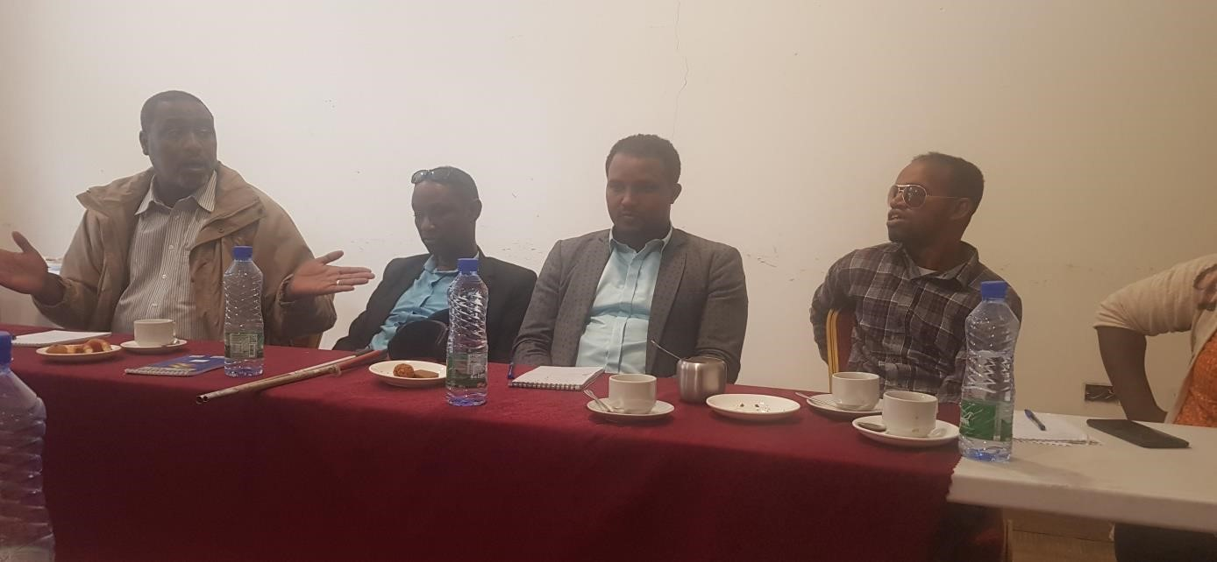

Picture 1: Source, photo by own, April 2022: first meeting with local government officials

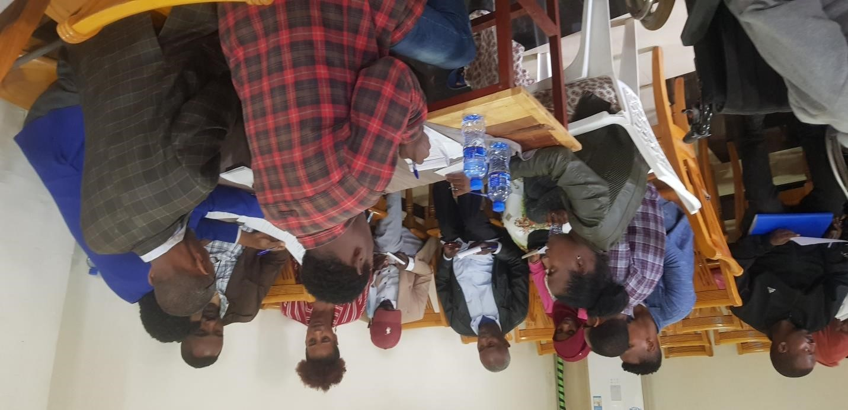

Picture 2: Source, photo by own, May 2022: Introduction session with school communities at Gozo Shasho Primary School (Dawro Zone, Southwest Ethiopia)



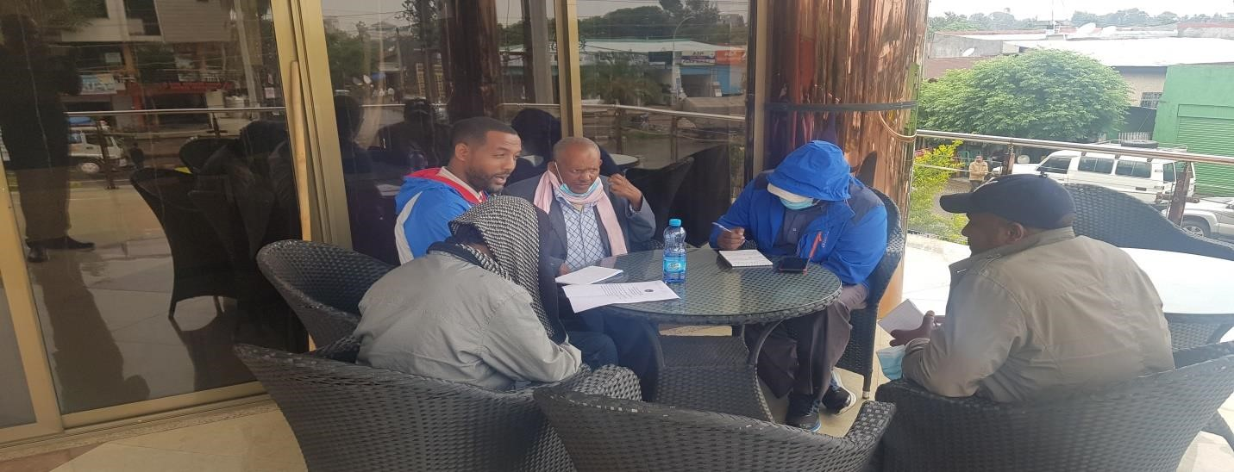

Picture 3: Source, photo by own, May 2022: Consultation meeting with community leaders

## Activity Two: Development of training manual

The training manual aimed to transfer skills and knowledge on basics of peace education was developed. The training manual accounts 25 pages which comprised four parts: general overview of the training manual, concept of conflict, concept of peace and approaches in mitigating conflict through peace education. The training manual was first developed by the SCI initiator and then edited by professional person in order to ensure that the material is relevant for the expected trainees mainly at the local areas. The training material was also translated into the local Amharic and Afan Oromo languages by volunteers.

After translation, the material was printed for training of trainers (ToTs) who are expected to provide step-down training for other community members at grassroots community level (coverage page of the training manual is attached in the Annex).

## Activity Three: Conducting training

Implementing training session has passed the following specific steps:

* Preparing training manual (printing, sharing with trainers)
* Identifying venues, facilitating logistics
* Ensuring security issues with local governments
* Identifying and inviting participants

After completion preparations, actual training program was held at two stages. First, training of trainers (ToT) has been held for two consecutive days for fifteen participants drawn from local community members, teachers and youths.

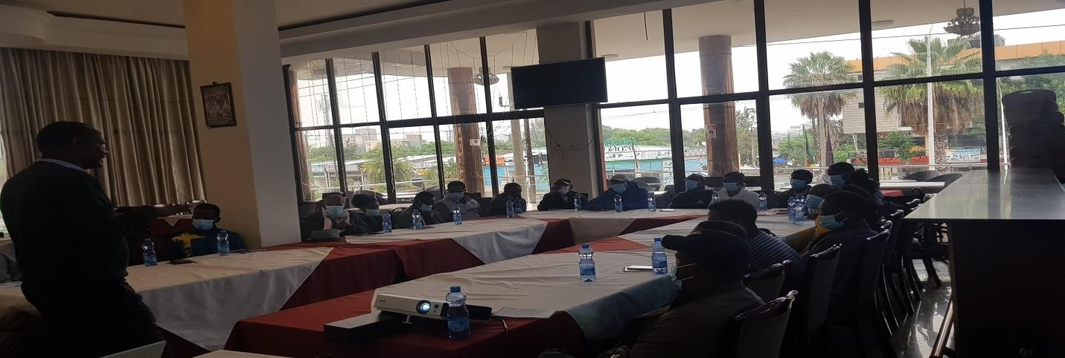

Picture 4: Source, photo by own, June 2022: ToT training on progress at DawroZone, Tarcha local town

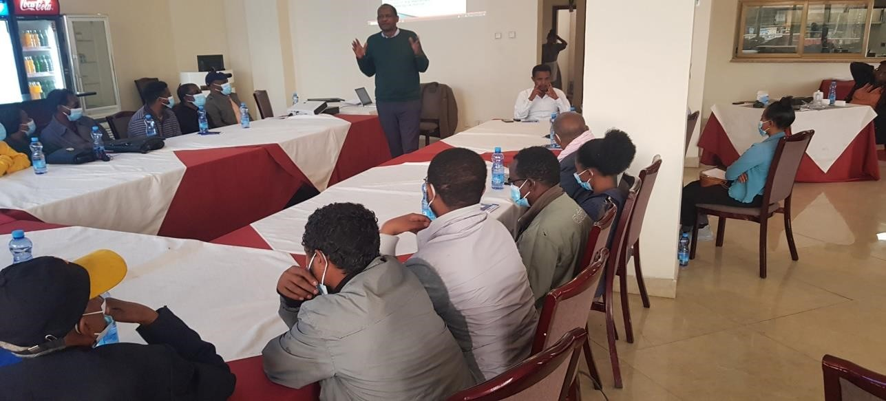

Picture 5: Source, photo by own, June 2022: ToT training on progress at Dawro Zone Tarcha Town

* Step-down training sessions were held at villages and schools by those who attended ToT program and supervised by SCI initiator
* A total of 205 participants, male 140 and female 65 have attended peace education training for two days at 4 venues
* The training session took a total of 16 hours in order to cover the whole portions of the manual
* The methodology of the training used presentations, practical exercises, group work, open debate and questions, use of drawings and illustrations, videos, role plays and energizers
* Before and after the training session, pre and post training evaluation questions have been completed by those who can able to fill out the questionnaires.

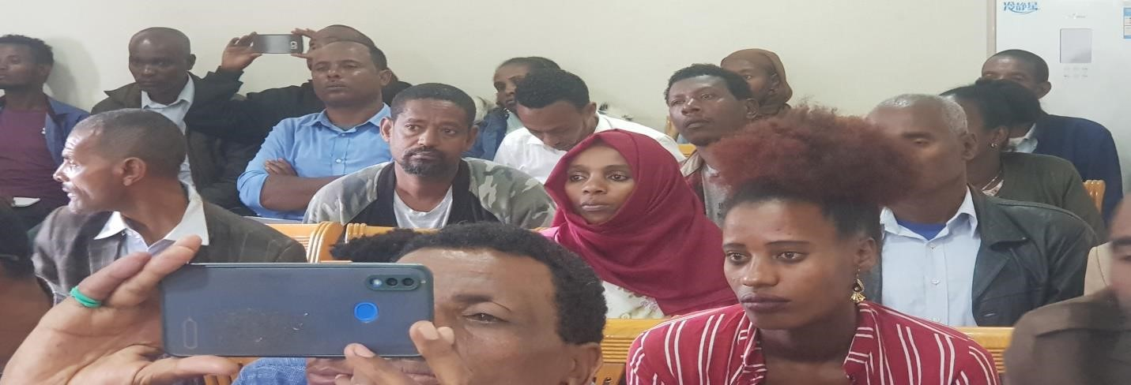

Picture, 6: Source, photo by own, July 2022: Step-down training at school compound

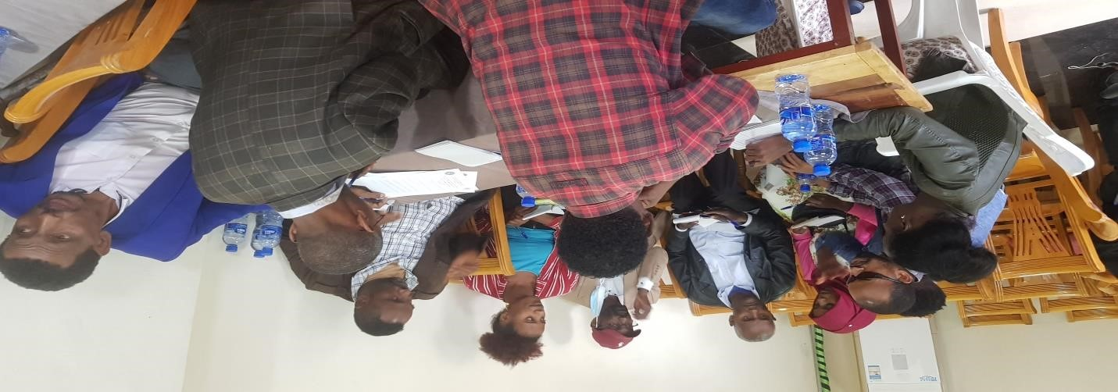

Photo by own, July 2022: Group discussion after presentation at School compound

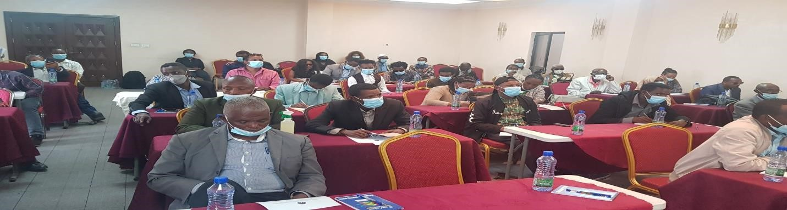

Picture 7: Source, photo by own, July 2022: Training session at one of the local village at the hall of local Church

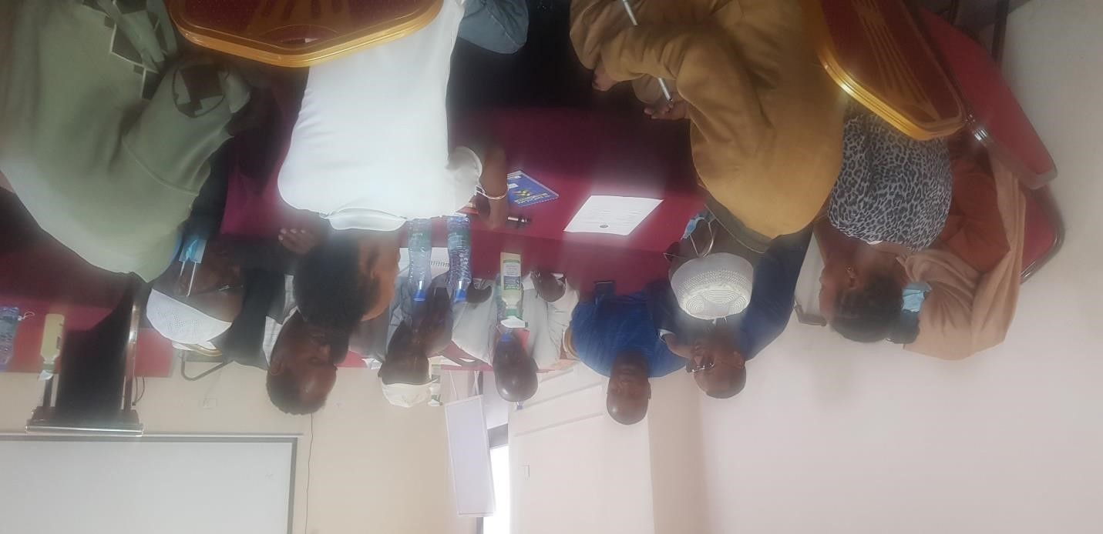

Picture 8: Source, photo by own, July 2022: Group discussion after presentation inside local church hall

## Activity Four: Monitoring and evaluating the processes

This activity has several routines performed both during and after the training sessions:

* Supervisory team of five members from different groups of the communities have established to monitor the daily activities
* The team supervised, followed and evaluated all the processes during and after the session and complied a report for the SCI initiator,
* Review meeting has been done with the local government, community leaders and school directors to ensure that the project undergone as per the plan or not
* Final report has collected from each training session and complied as a SCI report

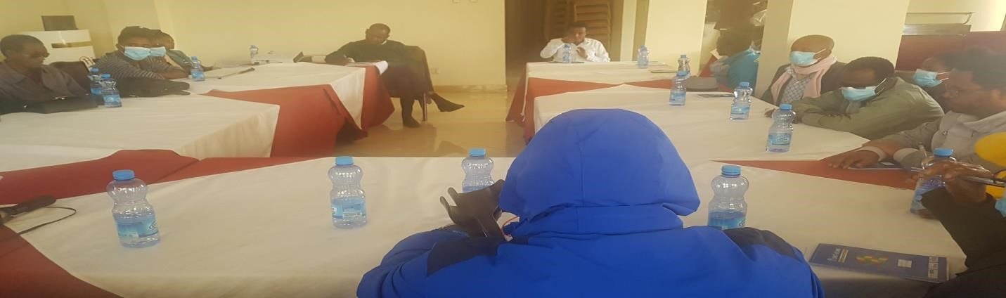

Picture 9: Source, photo by own, August 2022: Review meeting at project site, Dawro Zone Tarcha Town

**Activity Five: Follow-up, compiling report and designing sustainability plan** Some of the activities completed at this stage are:

* Designed a follow-up and project suitability plan and discussed with concerned individuals and groups how to sustain the initiative
* Established a project sustainability coordinating team from various villages sand schools which comprised 7 committee members,
* Provided thorough orientation for the selected committee members how to mobilize the local community and keep the training program for future
* Networked the committee with the local government so that they can work together in order to sustain the project

In general, the SCI addressed the above mentioned five major activities which contained several routines under each of them.

# 3.2. Key findings

Based on the analysis of the survey data collected, training programs conducted, interviews made with selected correspondents, desk review and overall discussions so far, the following major points are drawn as key findings.

1. The overall status of good relationships among the local communities found to be poor and there has been frequent conflict incidents between different groups of community in the village
2. Despite its initiation at higher level government officials, the issue of peacebuiling and its outcome so far is not satisfactory. There are multiple issues in relation to the appropriate implementations of peace education at formal and non-formal manners for the community.
3. The concept of ‘people-centered’ development peace education has not been exercised in these particular areas. Various training programs were criticized for its weaknesses of missing bottom-up development planning approach. Hence, the role of training in changing the lives of the local community has not been achieved in these particular areas.

The effect resulted that the communities have experiencing several conflict incidents.

1. The local violence or community based conflict is reinforced by different factors. Some of these driving factors are internal and others are external. It was clearly showed that the main driving factors of the community conflict are marginalization, scarcity of natural resources, lack of job opportunity for youths and identity based political movements.
2. Community involvement in the peace projects and cooperation agendas with the local communities is one of the crucial factors for successful achievements of peace education. The overall data showed that the involvement of communities in the process of peace education was not well planned, managed and coordinated. Data showed that local communities have no spaces to share their ideas, contribute their efforts and engage for the sustainability of peace and development.
3. There are huge amounts of intra-group and inter-group conflict incidences in the SCI implementation site. Communities found themselves in certain identity groups that in turn become potential sources for community based conflicts.
4. Peace education is considered as one of the potential methods in order to mitigate the community based conflicts.
5. The local community members believe that informal training sessions can help them to understand the values of peace and in turn to teach their children and youths.
6. Local school settings are considered as one of the most important entity that can amplify, advocate and influence the local communities and their families to stand for peaceful village and communities
7. Traditional institutions such as Edir, Equb, Debo and Ootiya have huge contributions in building peaceful communities. African Traditional approaches of peacebuilding and conflict resolution also plays a key role in building peaceful community.
8. Local government lacks structured, organized and planned ways of implementing projects that can directly impact the living conditions of local communities.
9. The level of poverty, living conditions, housing and lack of infrastructure at local community level fuels the level of conflict

# CHAPTER FOUR: CONCLUSION, RECOMMENDATIONS AND SUSTAINABILITY PLAN

# 4.1. General conclusions

The SCI addressed various intertwined and complicated issues regarding community conflicts between the local communities. The community of the project areas faced various social, economic and political crisis that emanate from several factors.

Numbers of conflict incidences have recorded in the project areas in the past decades. The uncertainties of local areas certainly impact the quality of life of the people across the village. Many of the people suffer loss of life either because of intra-group or inter-group community conflicts or various illicit movements in the region.

The commitment of the central government towards these areas was not withstanding. The people of the local areas remain marginalized. On the other hand, this area is one of the most fertile and productive regions that would able to cover maximum amount of agricultural and livestock markets in the country and beyond.

Conflict among various communities in the areas took long decades. The state focuses on political agendas rather than people of the local communities. There are huge gaps in understanding the economic advantage of local people and its traditional ways of life by the various actors.

# 4.2. Recommendations

Implementation of peace education would be successful in participation of all actors and stakeholders in process of designing, planning, developing and implementing the program. Furthermore, participation of the stakeholders would be more dynamic, cognizant of changing circumstances and adjustable in accordance with these changing circumstances. The following recommendations are provided as measures to be taken at various levels.  **Local level**

* The local government with its respective offices would work in more collaborative ways to tackle the community based conflicts and transform it to sustainable peace.
* The local government would ensure consistent support through effective provision of services and appropriate infrastructure that help the community to shift their attention from violence to development
* Local communities and governance actors would create a space for local communities to participate and contribute for ongoing development projects and cooperation among the local communities
* Clear institutional platforms and management systems would be maintained at the local level that encourage and motivate peace education
* The peace education program would be supported by various stakeholders ranges from government to NGOs and the local community would be at the center of the program
* Churches and Mosques at the local levels would give attention to the provision of peace education among their own teachings

## Private sectors and community based local institutions

* Contribute for prevention and management of criminal activities and work for the better implementation of peace education at local levels
* Private sectors would support local communities in mobilizing traditional values and exploiting indigenous knowledge to contribute for peacebuilding process
* Local community leaders would assist local governments in providing ideas, skills and information toward peace education **National and regional governments**
* Ensure coherence policies and strategies to build peace among various actors through advocating peace education
* Promote context-based technical support to build capacity of the local communities toward planning, designing and implementing peace education
* Establish conducive working environmental setup for inclusion of local communities in the process of peace education
* Establish integration platform between urban, towns and rural villages to learn lessons on best practices of peace education
* Create common standards for the citizenship and service delivery issues for local communities.
* Support and maintain local schools in both physical and knowledge management so that they can be the center of excellence for peace education

# 4.3. Sustainability Plan

The suitability of this SCI can be ensured through the following mechanisms:

* Designing a follow-up and project suitability plan and discuss with concerned individuals and groups regularly how to sustain the initiative
* Establishing a project sustainability coordinating team from various villages and schools which comprised different committee members who will take full responsibility of the project
* Providing thorough and clear orientation for the selected committee members how to mobilize the local community and keep the peace education training program for future
* Networking the committee with the local government so that they can work together in order to sustain the project
* Creating communication channel (social media platform) in order to communicate easily and share the progressive reports and challenges facing
* Designing review meeting session quarterly and evaluating the strengths and weaknesses and take appropriate actions
* The school administrators are consulted to take the initiatives of continuity of training of youths inside and outside the schools on the peace education
* Similarly, the local community leaders are trained how to keep the continuity of discussion and informal training about the importance of peace to their community members and their entire families
* By strengthening institutions at school level ‘peace club’ is established at the end of training and the peace club facilitates the training session on regular basis for students and staffs of the school, and at village level the already existing ‘traditional institutions’ (there are strong traditional institutions which considered as the assets of that community) take the initiatives of facilitating regular discussions and informal training sessions toward the importance of peace education
* Joint committee members from both the schools and the village leaders are selected and create a norm (bylaws) that help them working together on the impertinence of peace education to their children, youth and the whole community members
* The joint committee meets with the SCI implementer via phone and other communication methods (email, text message) and share ideas, lessons learned and report the progress in the change of attitudes by the trained participants
* The SCI implementer will check twice a year on a kind of review meeting with the joint committee members in person at the project site to see the status of peacefulness of the village and the application of knowledge gained from training.



## REFERENCE

A. Swatuk, L., Mengiste, A., & Jembere, K. (2008). *Conflict Resolution and Negotiation Skills for Integrated Water integrated Water Resources Management*. International Network for Capacity Building in Integrated Water Resources Management.

Abdalla, A. (Ed.). (2019). *A Model for Conflict Analysis* (1st ed., Vol. 1). University for Peace.

Berghof Foundation Operations GmbH. (2017). *National Dialogue Handbook: A Guide for Practitioners* (1st ed., Vol. 1). Berghof Foundation Operations GmbH.

Caritas International. (2002). *Peacebuilding: A Caritas Training Manual*. Caritas International.

Close, S. (n.d.). *UNTAPPED PEACEBUILDERS: INCLUDING PERSONS WITH DISABILITIES IN BUILDING PEACE*. Conciliation Resources.

*CONFLICT MONITORING TRAINING: Training Guide in Conflict Analysis, Monitoring and Reporting* (2nd ed., Vol. 3). (2013). Charline Burton.

Equitas International Centre for Human Rights Education. (2018). *Conflict mitigation using a human rights-based approach: A guide for taking action to mitigate religious and ethnic conflict: Vol. I* (I ed.). Equitas International Centre for Human Rights Education.

Farea Hussein, A. F., & Al-Mamary, Y. H. S. (2019). Conflicts: Their Types, And Their Negative And Positive Effects On Organizations. *INTERNATIONAL JOURNAL OF SCIENTIFIC & TECHNOLOGY RESEARCH*, *8*(08), 10–13.

Galtung, J. (1964). *The Structural Theory of Aggression*. SAGE Publications.

Galtung, J. (1969). Violence, Peace, and Peace research. *Journal of Peace Research*, *6*(3), 167– 191. http://www.jstor.org/stable/422690

Murray, E., & Stigant, S. (2021). *National Dialogues in Peacebuilding and Transitions CREATIVITY AND ADAPTIVE THINKING*. United States Institute of Peace.

National Unity nd reconciliation commission. (2006). *Training Manual on conflict Management* (1st ed., Vol. 1). National Unity and reconciliation commission, Republic of Uganda.

OSCE Office for Democratic Institutions and Human Rights (ODIHR). (2019). *Guidelines on Promoting the Political Participation of Persons with Disabilities* (3rd ed., Vol. 2).

OSCE Office for Democratic Institutions and Human Rights (ODIHR).

SENTONGO, A. S. H. A. D. (2021, October 15). *Localizing Peace: Methods and approaches (Conflict Analysis Tools and techniques)* [Slides]. Slidewebsite.

https://www.makerereuniverity.rotarypeacecenter.org

**ANNEX ES**

## Annex 1: Map of the Project site

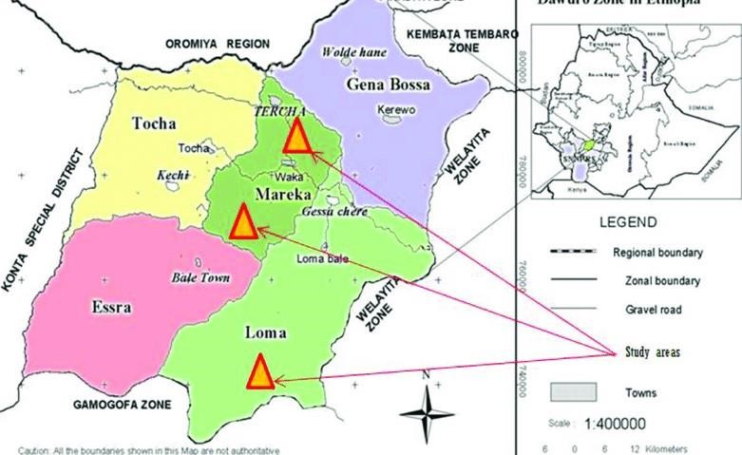

Source: Dawro Zone Culture ad sports Department

Annex 2: Photo of one of the Rural Village



Source: Own Photo

Annex 3: Photo of Urban area of the project site



Source: Own Photo

Annex 4: Cover page of the training manual



1. SCI REPORT:RE-EDUCATING PEACE: BY TESHOME MENGESHA

1. SCI REPORT:RE-EDUCATING PEACE: BY TESHOME MENGESHA