Strengthening Young Influencers’ Participation in Countering Fake News & Hate Speech in Nigeria.

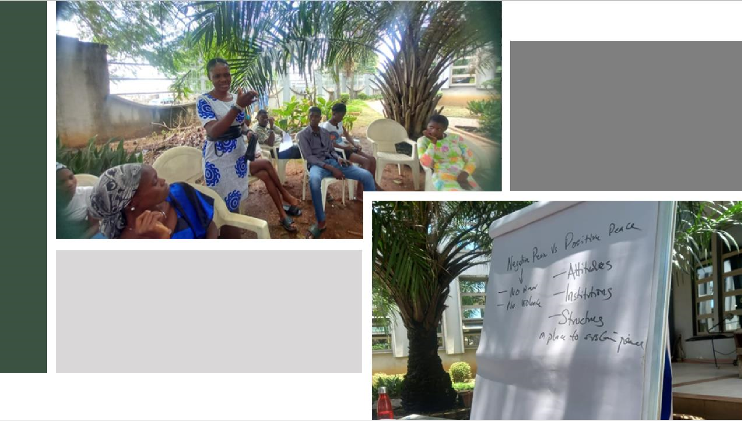

*A Social Change Initiative Report*

*By* **Usen Asanga**

*September 2023*

**TABLE OF CONTENT**

CHAPTER ONE 2

1.1. Introduction and Background 2

1.2. Problem Statement 3

1.3. Goals and Objectives 4

1.4. Challenges and mitigation strategies 5

CHAPTER TWO 5

2.1. Literature Review 5

2.2. Theory of Change 6

2.3. Methods and Design 6

CHAPTER THREE 7

3.1. Intervention Activities 7

3.1.1. Selection of participants 8

3.1.2. Training of Participants 8

3.1.3. Network Building 10

3.2. Key Findings/ Impact 10

CHAPTER FOUR 11

4.1. General Conclusion 11

4.2. Recommendations/implications for Policy 12

4.3. Sustainability plan 12

REFERENCES 13

APPENDICES 15

Appendix 1: Pictorials 15

Appendix II: Training Agenda 18

Appendix III: Workshop Attendance 19

Appendix IV: Testimonials 22

# CHAPTER ONE

## 1.1. Introduction and Background

This report describes the Social Change Initiative (SCI) implemented in the Ikorodu area of Lagos in Nigeria, and submitted to the Makerere University Rotary Peace Centre, in partial fulfillment of requirements for the award of the Post Graduate Diploma in Peace Building and Conflict Transformation under the Rotary Peace Fellowship Program. The SCI titled

“Strengthening Young Influencers Participation in Countering Hate Speech and Fake News in

Nigeria”, was implemented between July and September 2023 to contribute to efforts towards countering fake news and hate speech in online spaces, by building the assets of a cohort of young influencers to enable their active participation in countering fake news and hate speech.

Fake news and hate speech are two major challenges that threaten peace, security, and democracies globally. While these phenomena are not new to Nigeria’s democracy, the rise of social media has amplified their prevalence, particularly on Facebook, WhatsApp, and Twitter (Ibrahim, A. M, 2022). In the words of former president Goodluck Johnathan during the 2023 elections peace conference in Abuja, *“...the biggest threat to democracy now is the issue of propaganda, fake news and hate speech”.*

With a population of over 200 million people and 250 different ethnic groups, Nigeria is an overly diverse country in terms of ethnic orientations, cultural practices, and religious beliefs (Uzoka, 2021). This multi-ethnic, religious, and regional composition provides a perfect environment for fake news and hate speech to thrive, breeding enmity and threatening national unity and peaceful coexistence (*How Disinformation Deepens Hate Among Nigerians*, n.d.). Both fake news and hate speech have the potential to undermine the social cohesion, human rights, and civic engagement of citizens, especially during sensitive periods such as elections.

In a bid to tackle the menace of fake news and hate speech, governments worldwide, including Nigeria, have been taking measures mainly through enacting policies and legal frameworks that prohibit the generation and spread of fake news and hate speech. However, while these efforts are aimed at protecting citizens and institutions from the harmful consequences of fake news and hate speech, important questions are being raised about the limits of free speech and the role of the state in its regulation. The extant fake news and hate speech laws in Nigeria have been criticized by citizens, and tagged as being repressive, and aimed at silencing dissenting opinions. Despite these laws, there continues to be a proliferation of fake news and hate speech in Nigeria, along with the looming threat to the country’s unity. Legal measures alone have proven to be insufficient to solve the problem of fake news and hate speech and have in fact contributed to generating more conflicts. There is therefore a need for governments and other actors within societies to complement these laws with non-legal strategies such as investing in media and information literacy for citizens and providing incentives to citizens to adopt ethical and responsible practices when exercising their free speech rights.

This Social Change Initiative is therefore aimed at contributing to alternatives to legal measures in Nigeria to address the problem of fake news and hate speech by identifying and equipping young influencers with relevant skills and tools to participate actively in countering fake news and hate speech in online and community spaces.

## 1.2. Problem Statement

The advent of social media is indeed a significant breakthrough in the field of ICT and portends enormous benefits to the actualization of people’s right to express their ideas and thoughts. According to datareportal.com, at the beginning of 2022, there were 109.2 million internet users in Nigeria, out of which 31.6 million are active social media users who have embraced this opportunity to connect to the world *(Kemp, S. 2022)*. Globally, social media is a veritable tool in the hands of citizens to challenge inequalities in society and attempt to hold leaders accountable. Social media has been effectively used in Nigeria to mobilize resources and citizens to support causes such as the #NotTooYoungToRun, #ENDSARS and #BringBackOurGirls campaigns.

It is fair to say that online activism has come to stay as a legitimate channel for political action and a tool for driving social change, especially for young people and women (Kylie Copper 2003). However, like a double-edged sword, social media has also aided the proliferation of fake news and hate speech like never before. Oftentimes, social media platforms have served as breeding grounds for hate speech and incitement to violence. Hate speech and fake news constitute a pervasive problem in Nigeria, contributing to inter-ethnic and inter-religious tensions and political violence. Considering the ethnic diversity in Nigeria, a single act of violence fueled by disinformation can spark several violent reprisals (Hassan, 2023).

In a bid to eliminate this threat to the Nation’s peace, security, and democracy, the government of Nigeria has responded by introducing laws and regulations such as Cybercrime (Prohibition, Prevention, Etc.) Act 2015 and the National Broadcasting Commission (NBC) Code. The highly controversial Anti-Hate Speech and Social Media Bill was also introduced by the Federal government in 2019 to regulate the use of social media in Nigeria and impose penalties on those who spread hate speech or fake news. These laws and regulations have been criticized for potentially stifling free speech and further violating citizens' fundamental human rights.

The use of legislation as a response to fake news and hate speech differs from country to country in terms of legal content, however, striking a balance between ensuring freedom of speech and the control of fake news and hate speech online is a challenge (*Countering Hate Speech Online | EEA Grants*, n.d.). Despite the myriad of laws, fake news and hate speech still persist in Nigeria. This inadequacy of the laws to stop the proliferation of fake news and hate speech calls for complementing alternative strategies to ensure that the fight against fake news and hate speech does not undermine the right of citizens to free speech.

## 1.3. Goals and Objectives

The overall objective of the initiative is to build capacity and an enabling environment for young influencers in the Ikorodu area of Lagos state to actively participate in countering fake news and hate speech in online and community spaces. This goal is supported by two specific objectives as follows:

1. To train and set up a network of young influencers on countering fake news and hate speech.
2. To support the initiatives and awareness campaigns of the young influencers in schools, youth groups, communities and online spaces against fake news and hate speech.

## 1.4. Challenges and mitigation strategies

* Apathy among young people to drive social change in Nigeria was observed. Young people's participation in the 2023 general elections process in Nigeria was very impressive: from participating in pre-election dialogues, political campaigns, elections monitoring, and voting. Young people 15- 34 years old makeup nearly 40% of Nigeria’s population, and around 76% of newly registered voters in the last elections were young people (ISSAfrica.org, 2023). However, despite the increased participation of young people in the electoral process, many young Nigerians were disappointed by the unexplained gaps in the electoral process and the general outcome of the elections leading to a loss of faith in the

nation’s democratic process and institutions. Many of the young influencers who were invited to participate in the program were reluctant, claiming that trying to create social change in Nigeria is a waste of time.

To mitigate this challenge, the program identified young influencers who are already engaged in the social change space, leveraging the facilitators’ relationships and networks within the community. Members of Ikorodu Youth Advocacy Cluster, a group of young influencers already engaged through the Youth Powered Ecosystem for Adolescent Health project supported by USAID in the area, were specifically targeted. The program also engaged youth facilitators from Ikorodu Youth Hub, and student leaders from the Lagos State University of Technology (Formerly Lagos State Polytechnic) in Ikorodu.

* The project was also constrained by lack of funds. Funding was required for participants' transportation/ lunch and venue. To mitigate this challenge, the number of participants was reduced from 40 to 30 persons, and a partnership with the Methodist Church (Ikorodu Diocese) secured a free venue for the training activity.

# CHAPTER TWO

## 2.1. Literature Review

Young people have played crucial roles in various social change movements throughout history and continue to do so today. Some examples from history include the Arab Spring, Black Lives Matter, Not Too Young to Run, and the Anti-Apartheid Movement where young people led campaigns and protested against institutions and perceived injustice in society. These examples highlight the historical and ongoing impact of young people as agents of social change. The energy, passion, and innovative approaches that young people have make them vital contributors to addressing pressing social and political issues.

Obviously, legislation alone is not sufficient to stop the generation and consumption of fake news and hate speech, however, available evidence suggests that equipping young social media users with information and media literacy skills can contribute to reducing the proliferation of fake news and hate speech in society.

## 2.2. Theory of Change

Going by the established evidence that young people are viable agents of social change, and more so if they are equipped with the requisite skills and incentives, this initiative was premised on the assumption that IF young people are equipped with the knowledge and skills to develop online campaigns and understand the importance of fact-checking and reporting fake news and hate speech, AND if they are networked with peers and motivated, THEN they will be in a better position to take a more active role in countering fake news and hate speech in online and community spaces.

The training therefore served to equip the participants with knowledge and skills relevant to countering fake news and hate speech particularly online, and the coalition building served and continues to serve as a support base to strengthen engagement of the trained young influencers in combating fake news and hate speech online.

## 2.3. Methods and Design

The social change initiative was designed to complement legislation in countering fake news and hate speech in Nigeria. The project targeted young community influencers including WhatsApp group administrators and social media influencers in the Ikorodu area of Lagos with to provide training on media literacy and skills for fact-checking and content labeling/ tagging. The project also supported the formation of a coalition of young influencers who are actively involved in countering fake news and hate speech online. The initiative therefore combined capacity building and coalition building as tools for **empowering**, **organizing**, and **motivating** young community influencers to **act** against fake news and hate speech.

Motivate

Empower

Training

Organise

Network

Building

ACT

Motivate

Since the project participants were also supposed to become game changers in influencing peers and others within their networks, the selection criteria for participants included a high social media followership and administration of a WhatsApp or Telegram group of at least 50 participants. The age range of participants was from 15 – 34 years, and although the initial plan was to involve an equal number of boys and girls, more females signed up than males. This is consistent with findings of a UNV survey that suggests that while men are more likely to volunteer for social change than women, the reverse is the case when it comes to young people (https://www.unv.org/Success-stories/beyond-averages-do-gender-disparities-existvolunteering).

A total of 30 young community influencers were selected following an initial assessment to verify that the participants fit the intended profile. However, 29 actually participated in the program (22 females and 7 males). One of the selected male participants was involved in an accident just before the training and could not participate in the training.

# CHAPTER THREE

## 3.1. Intervention Activities

The initiative involved three key activities.

1. Selection of Participants
2. Training of participants
3. Formation of a youth coalition against fake news and hate speech.

### 3.1.1. Selection of participants

The project was designed to target young community influencers between the ages of 15 and 35 years in Ikorodu, an area with a population of over 1 million residents in Lagos state (Nigeria, 2022). However, due to funding constraints, the target was reduced to 30 participants, although a total of 29 young influencers; 22 females, (75.9%), and 7 males (24.1%), eventually participated in the initiative. The youngest participant was 15 years, the oldest was 34 years, while the median and average age were 18 and 20 years respectively.

The tables below show the gender and age distribution of the project participants.

|  |  |  |  |
| --- | --- | --- | --- |
| **Age Range** | **Nos** |  | **Percentage** |
| 15 - 20 years | 21 |  | 72.4% |
| 21 - 25 years | 5 |  | 17.2% |
| 26 - 30 years | 2 |  | 6.9% |
| 31 years and above | 1 |  | 3.4% |

Table 1.a. Table showing the age distribution of participants.

|  |  |  |
| --- | --- | --- |
| **Sex** | **Nos** | **Percentage** |
| Male | 7 | 24.1% |
| Female | 22 | 75.9% |

**TOTAL 29**

Table 1. b. Table showing gender distribution of participants.

### 3.1.2. Training of Participants

The 29 young community influencers participated in a 2-day training which covered key areas of positive peace, fake news, hate speech, media literacy, and skills building for fact-checking and reporting. An agenda for the training can be found in Appendix II of this report.

Baseline data was drawn from participants by administering questionnaires to participants that focused on collecting data around the participants' baseline knowledge and skills and social media habits and preferences. On relevant knowledge and skills, the participants scored an average of 41.9% in the pretest. Further analysis also showed that while the participants had a fair knowledge of what fake news and hate speech meant, but they had little knowledge of the role that citizens could play in addressing the spread of fake news and nearly no knowledge of positive peace.

The table below shows the level of knowledge of the participants at baseline.

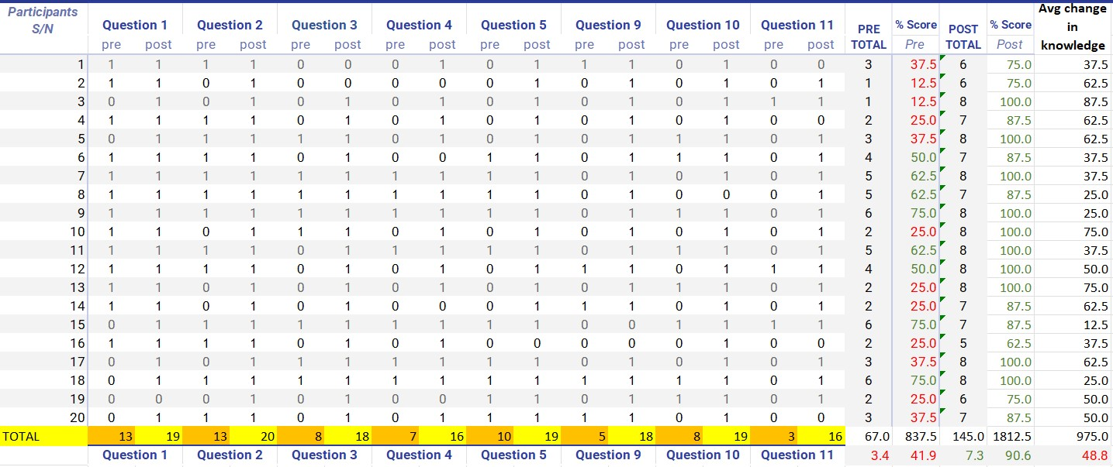

Table 2. Table showing participants' pre and post-test scores and analysis

The training covered sessions on positive peace, understanding fake news and hate speech, the role of young people in countering fake news and hate speech; developing online campaigns, fact checking and reporting.

Aha moments at the workshop were as follows.

1. After the session on hate speech, a participant made the following remarks: *“I am so used to hate speech and I just realized what hate speech is and how it affects society. It will be hard for me to stop it but I will try my best. But as someone who is known for hate speech,*

*I think it will be hard to convince other people to stop it”*.

1. Another participant asked, *“If hate speech is made by someone who shares the same identity, can it still be called hate speech? Also, where do we draw the line between hate speech and normal insults?”*.

The above remarks opened up an opportunity for a discussion by participants. In conclusion, the opinion of another participant that as an influencer and habitual hate speech offender, when people see you become an advocate against it, it is more likely to convince them to follow you, was agreeable to most of the participants.

On the line between hate speech and “regular insults”, participants were reminded that hate speech is when the insult undermines someone or a group of people based on their identity, even if the offender shares the same identity.

### 3.1.3. Network Building

In order to enable continuous engagement of the trained participants and support, the participants were networked by way of a WhatsApp group where they can continue to be mentored by the Peace Fellow. Through the group, discussions from the training continues, and experiences and learning are shared daily to group motivate the cohort of trained young influencers for the task ahead.

## 3.2. Key Findings/ Impact

Young people in Nigeria are very suspicious of the laws made by the government to control fake news and hate speech, and they see these laws as a disguised attempt to stifle their freedom of speech. Prior to the training, the baseline assessment showed that participants had a fair knowledge of what constitutes fake news and hate speech, but there was a clear lack of understanding of what the role of young people should be in addressing the problem. There was also nearly no knowledge of what positive peace means, and what the pillars of positive peace are.

An interesting detail from the workshop was the impact of watching and dialoguing over the

“Ghosts of Rwanda” on the participants. During the discussion, the participants were in visible shock at the extent of man’s inhumanity to man displayed by the various actors in the 100 days of extreme violence. Reflecting on the hate speech spawned by many prominent Nigerians and supposed statesmen around the 2023 elections in Nigeria, it was clear how easily the country could erupt in similar violence, considering the ethnic rivalry and tension that surrounded the elections and post-election period.

While young people have a role to play in checking the spread of fake news and hate speech, most of them are not equipped with the requisite knowledge, skills, and tools to do so. This initiative raised awareness among the participants and helped spark discussions about what role young influencers can play in the fight against disinformation. For instance, the participant who confessed to being a serial hate speech offender experienced a turning point that resonated with other participants.

There was an overall average increase in knowledge of 48.9% (From an average pretest score of 41.9% to an average post-test score of 90.6%) at the end of the 2-day workshop. Most importantly, the participants also learnt the value of fact-checking before sharing posts on social media and also committed to taking the time to flag fake news and hate speech whenever it is spotted online. These actions have already been taken by participants, including creating content to sensitize *Netizens* on the problem of fake news and hate speech.

# CHAPTER FOUR

## 4.1. General Conclusion

Young people, particularly those who have a lot of influence on their peers, can play a big part in curbing the spread of fake news and hate speech if they themselves are educated and motivated. The initial results of the program on the participants attest to this. This is also in line with available evidence. For instance, in the publication *5 Ways to Counter Hate Speech in the Media through Ethics and Self-regulation* by Poni Alice JameKolok, education on media ethics is key, and this should focus on social and cultural rights of individuals and groups, including free speech rights, and the responsibilities and social implications that accompany these rights (https://plus.google.com/+UNESCO, 2016)

## 4.2. Recommendations/implications for Policy

The government should invest in programs that sensitize and educate citizens, particularly the youth, on what constitutes fake news and hate speech and the dangers they pose to democracy and peaceful societies. It is important that citizens, particularly young people understand and can access their rights to free speech, while also acknowledging the responsibility that comes with these rights. Programs that support media and information literacy and empower young people to become more actively involved in countering fake news and hate speech online should also be considered by the government and development partners.

Finally, fake news thrives where legitimate sources of information are not effective. Governments through relevant agencies should ensure that citizens have access to genuine information, as the absence of this, helps fuel speculation and the spawning of fake news.

## 4.3. Sustainability plan

The project identified some young influencers who are passionate about change and are already involved in promoting social change in their communities. These trained participants have become members of a community of advocates who will use their skills and existing platforms to promote the education and involvement of their peers in countering fake news and hate speech.

The project also identified already funded programs working to address fake news and hate speech in Nigeria and will leverage such opportunities to support the trained youth in areas of continuous capacity building and experience/ knowledge sharing through the coalition. Beyond the SCI, the Peace Fellow is working with partners such as the Rotary Club in Uyo to scale up the program to other locations in Nigeria.

# REFERENCES

*Beyond averages: do gender disparities exist in volunteering?* (2021, March 4). UNV.

[https://www.unv.org/Success-stories/beyond-averages-do-gender-disparities-existvolunteering](https://www.unv.org/Success-stories/beyond-averages-do-gender-disparities-exist-volunteering)

Carnegie, M. (2022, August 7). Gen Z: How young people are changing activism. *BBC*

Countering hate speech online | EEA Grants. (n.d.)[. https://eeagrants.org/news/counteringhate-speech-online](https://eeagrants.org/news/countering-hate-speech-online)

Hassan, I. (2023). Dissemination of disinformation on political and electoral processes in Nigeria: An exploratory study. *Cogent Arts & Humanities*, *10*(1). <https://doi.org/10.1080/23311983.2023.2216983>

https://plus.google.com/+UNESCO. (2016, April 29). *5 ways to counter hate speech in the Media through Ethics and*. UNESCO. [https://en.unesco.org/5-ways-to-counter-hatespeech](https://en.unesco.org/5-ways-to-counter-hate-speech)

ISSAfrica.org. (2023, April 4). *Nigeria’s youth take center stage in the 2023 polls - ISS*

*Africa*. ISS Africa. [https://issafrica.org/iss-today/nigerias-youth-take-centre-stage-in-the2023-polls](https://issafrica.org/iss-today/nigerias-youth-take-centre-stage-in-the-2023-polls)

Kemp, S. (2022). Digital 2022: Nigeria — DataReportal – Global Digital Insights.

*DataReportal – Global Digital Insights*[. https://datareportal.com/reports/digital-2022nigeria](https://datareportal.com/reports/digital-2022-nigeria)

Kylie Copper (2003). Effectiveness of Online Activism: Who it is Effective For, What Issues it is Effective for, and What Time Period it is Effective for.

[https://scholarsarchive.library.albany.edu/cgi/viewcontent.cgi?article=1042&context= honorscollege_pos](https://scholarsarchive.library.albany.edu/cgi/viewcontent.cgi?article=1042&context=honorscollege_pos)

Nigeria, G. (2022). As Ikorodu becomes Nigeria’s 12th largest city. *The Guardian Nigeria*

*News - Nigeria and World News*[. https://guardian.ng/opinion/as-ikorodu-becomes-nigerias12th-largest-city/](https://guardian.ng/opinion/as-ikorodu-becomes-nigerias-12th-largest-city/)

Worklife[. https://www.bbc.com/worklife/article/20220803-gen-z-how-young-people-arechanging-activism](https://www.bbc.com/worklife/article/20220803-gen-z-how-young-people-are-changing-activism)

Gagliardone, I. (2019). Defining online hate and its “public lives”: what is the place for “extreme speech”? International Journal of Communication, 13, 3068–3087

# APPENDICES

## Appendix 1: Pictorials

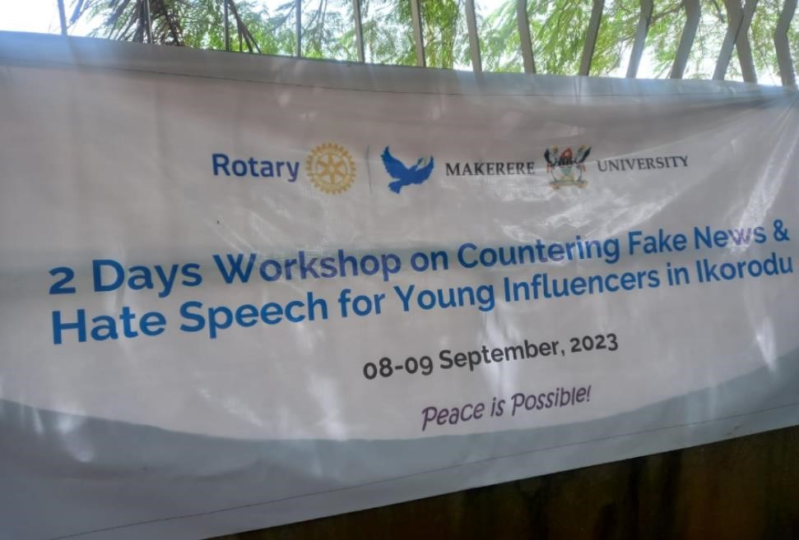

The Workshop Event Banner

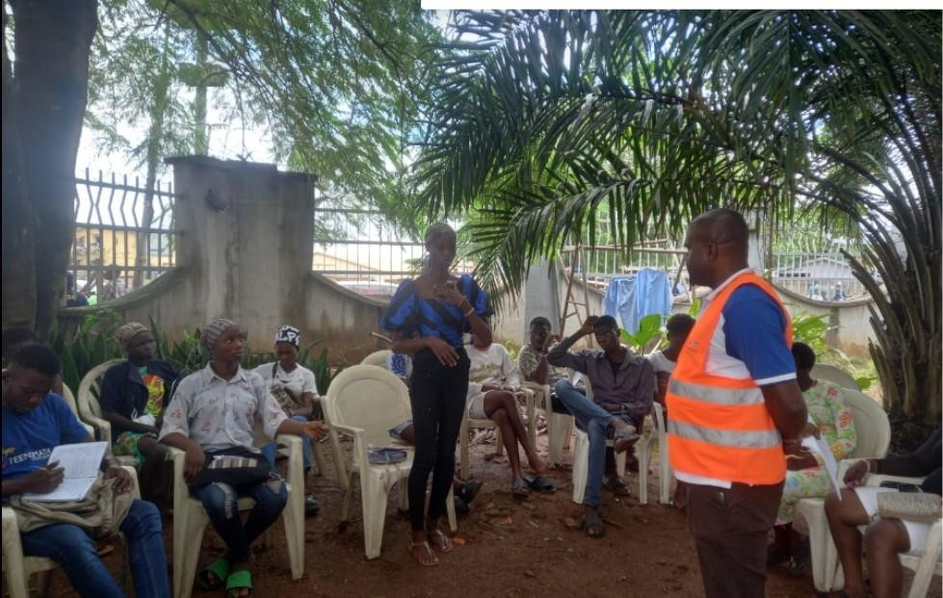

A Participant Making a Point During the Workshop

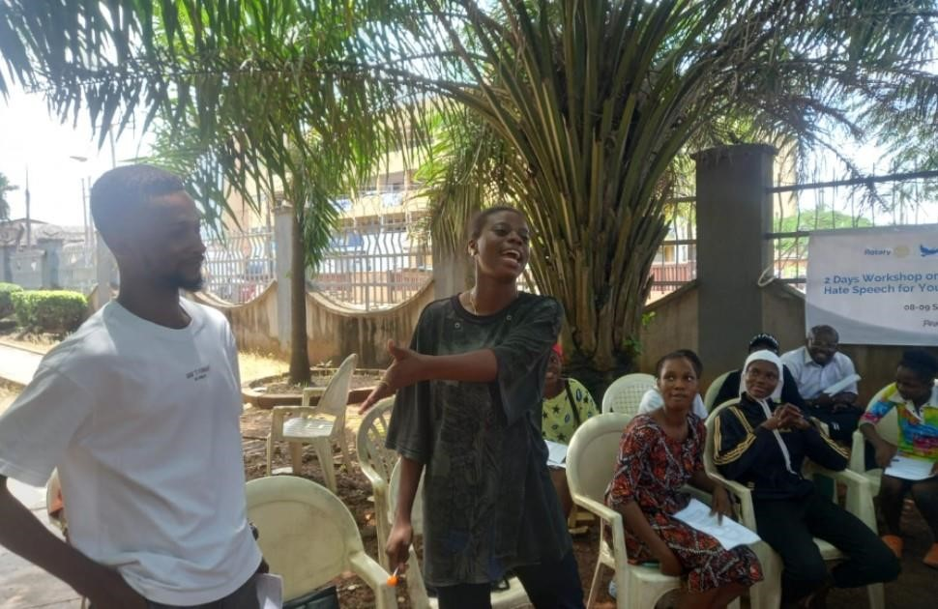

Role Play on Hate Speech by Participants During the Workshop

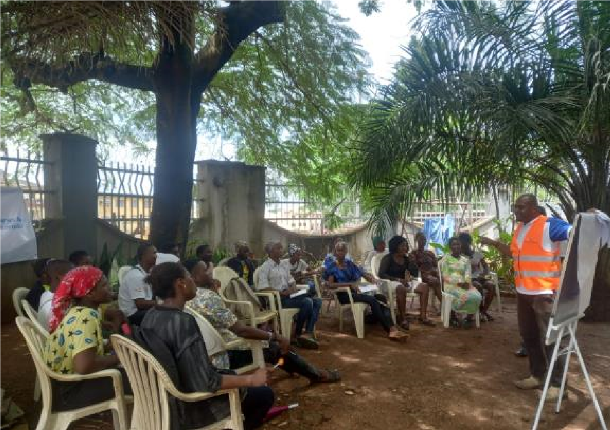

Workshop in Session

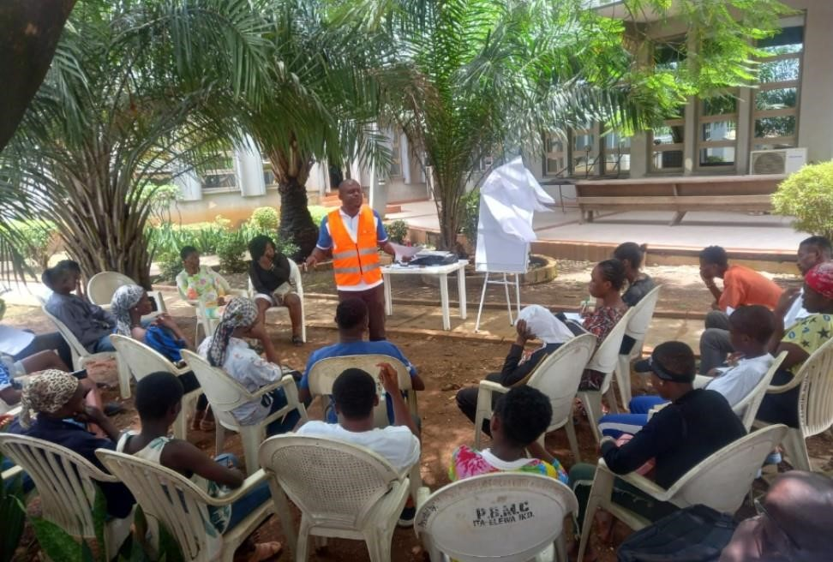

A Cross Section of Participants During the Workshop

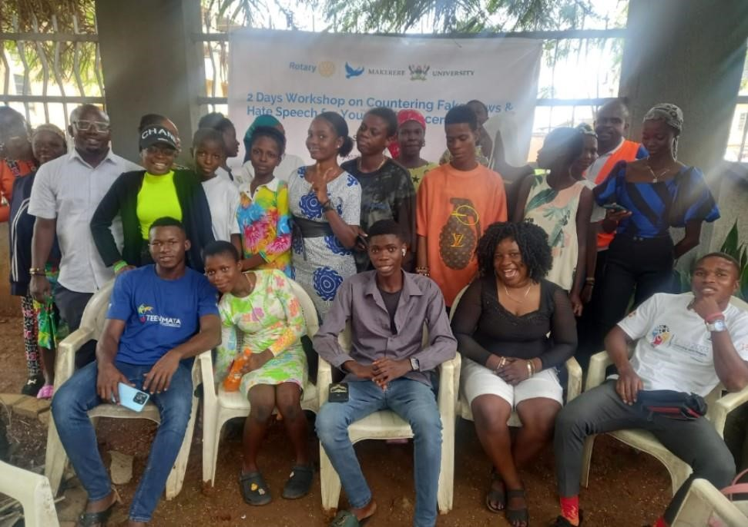

Group Photograph with Participants at the Workshop

## Appendix II: Training Agenda

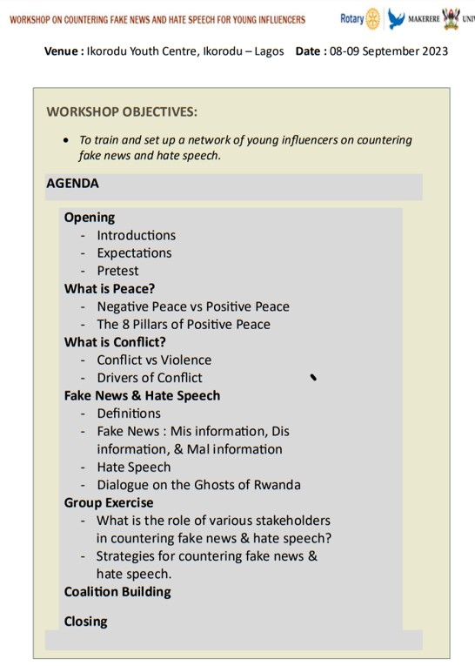

## Appendix III: Workshop Attendance

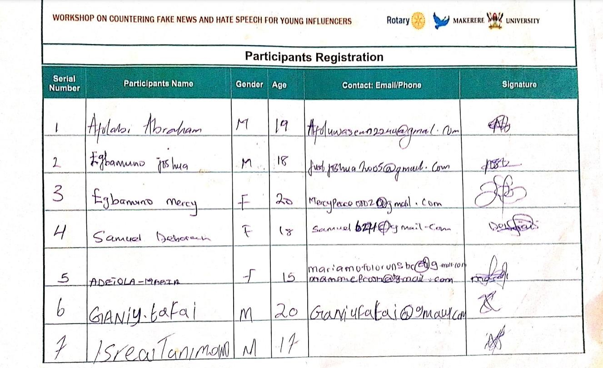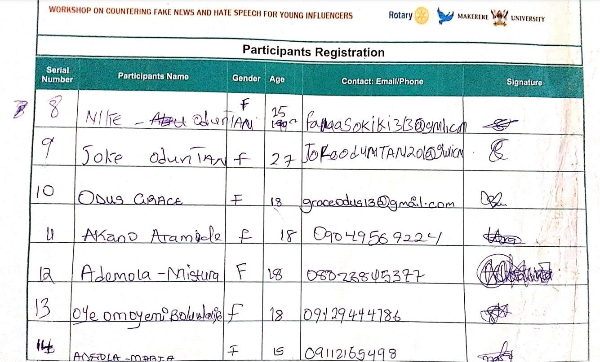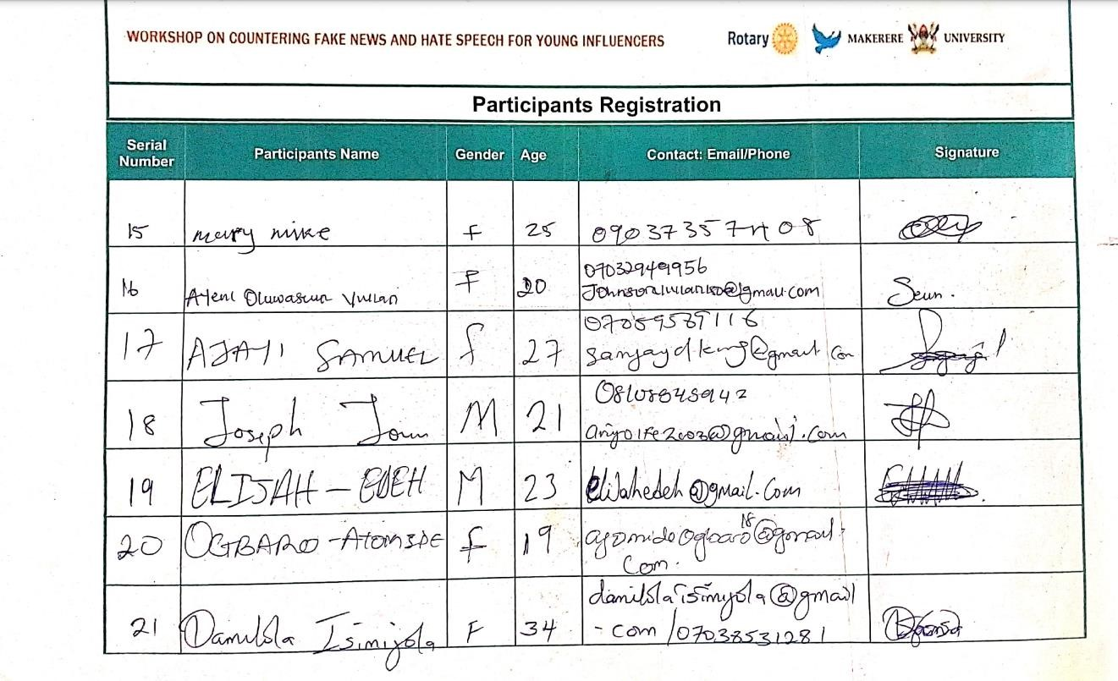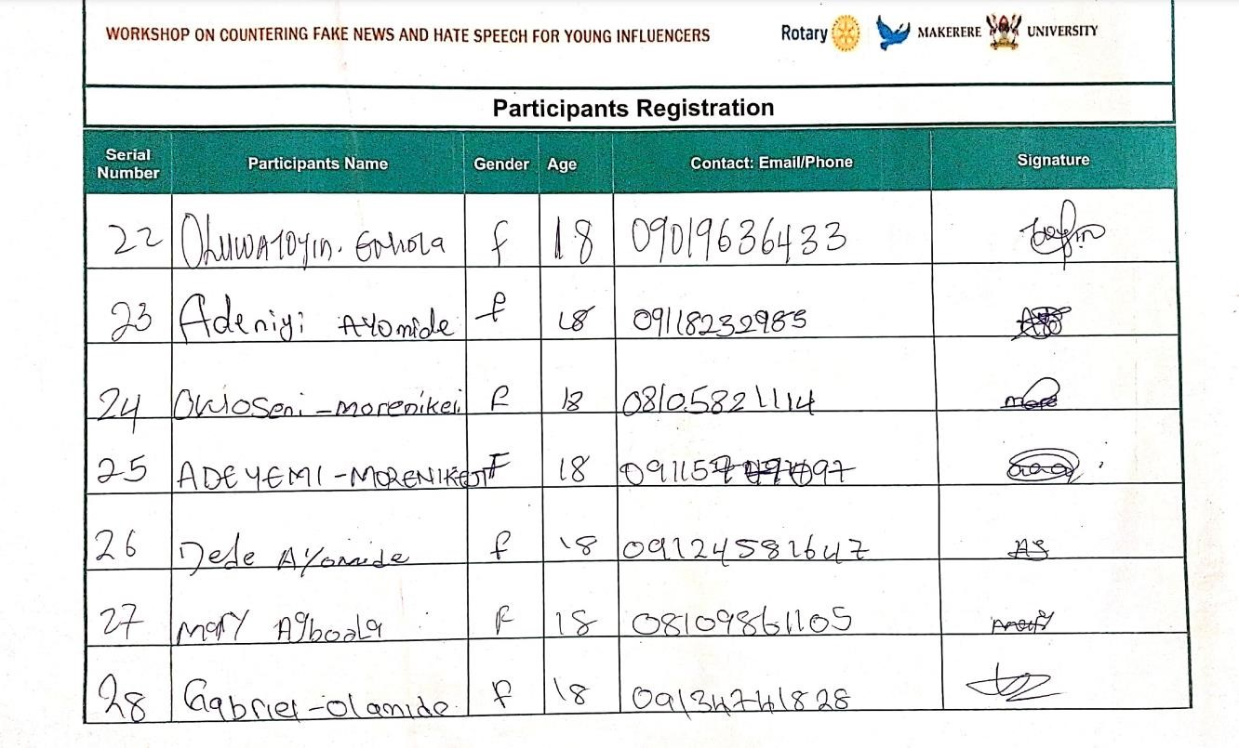

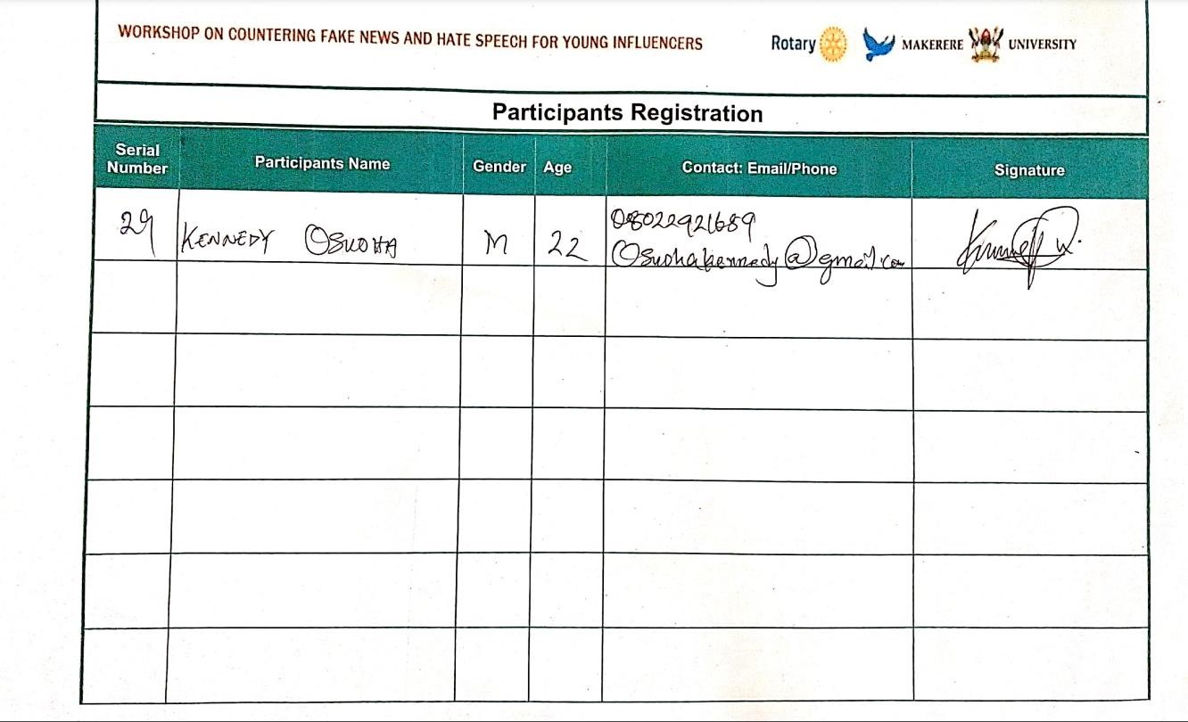

## Appendix IV: Testimonials

*“This training has benefitted me immensely by giving me useful knowledge on how I can contribute to peace in my community. I have never had any training on peace building before now, and with the knowledge I now have, I am determined to play my part in stopping the spread of fake news and hate speech by talking to my friends and school mates about what I have learnt, and also making sure that I cross check any information before posting on social media” -* **Mercy, Female, Student, 20.**

*“I didn’t know that some of the things I usually say to people and post on social media is actually hate speech. I felt bad that as a leader, I am showing a bad example. The concept of positive peace is very interesting to learn, I hope we can all work together to strengthen all the pillars of positive peace in Nigeria. We are doing poorly on all the pillars. The good neighbourliness pillar that would have been good is now eroding with our posture towards Niger on their ongoing conflict –* **Damilola, Female, Youth Coach, 34.**

*I am happy that I volunteered for this program. I nearly missed this training because of a singing engagement I had in Victoria Island, and I have no regrets. Thank you, Rotary Club for this opportunity to learn and network with very amazing people” –* **Kennedy, Male, Footballer & Musician, 22.**

*Fake news and hate speech is a big problem, especially during the last elections in Nigeria. You could see the way people who have lived together for years in Lagos were divided based on ethnicity and saying unprintable things to each other. This hatred needs to stop. Nigeria belongs to all of us and we have no other country than Nigeria. I am happy that the Youth Advocacy Cluster is involved in this program. We will drive it. –* **Elijah, Male, Ikorodu YAC Member, 23.**